**Appendix 1.**

**Figure A.1 Example Profile**

**Appendix 2. Unconditional Effects**

**Figure A2.1 Marginal Means: Forced Choice**

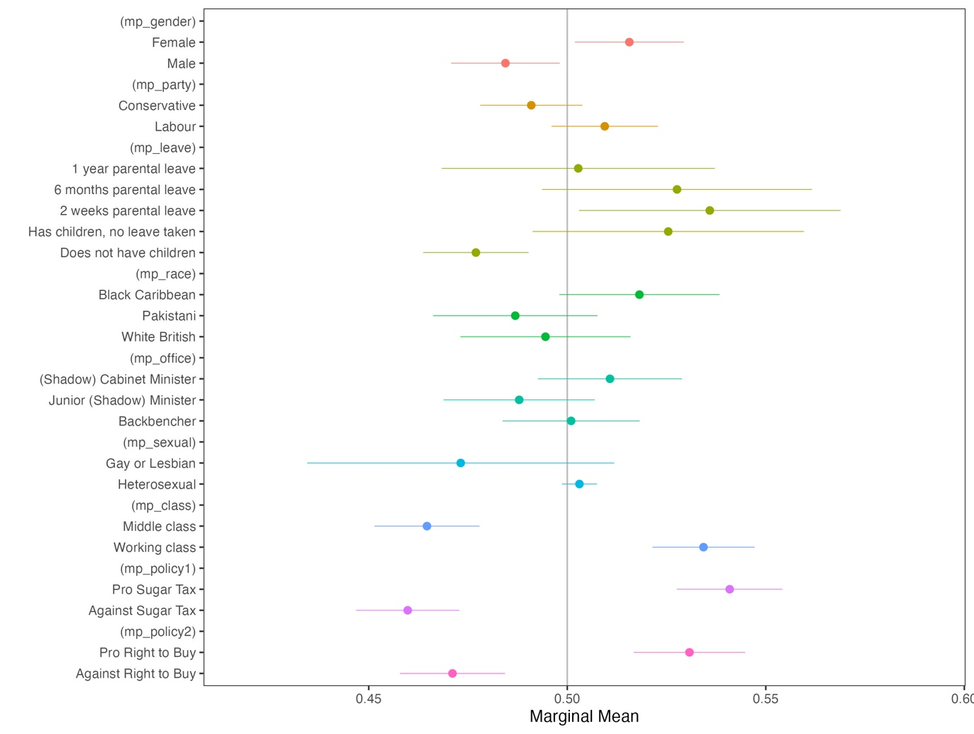

**Figure A2.2 Marginal Means: Job Approval**

**Figure A2.3 Full AMCE Plots Forced Choice**

**Figure A2.4 Full AMCE Plot Job Approval**

**Table A2.1 Full AMCE Model Forced Choice (Baseline no children)**

| Attribute | Level | Estimate | Std. Err | z value | Pr(>|z|) |  |
| --- | --- | --- | --- | --- | --- | --- |
| Class | Middle class | -0.071 | 0.012 | -6.064 | 0.000 | *** |
| Gender | Female | 0.034 | 0.013 | 2.645 | 0.008 | ** |
| Leave | Has children, no leave taken | 0.054 | 0.018 | 3.000 | 0.003 | ** |
|  | 2 weeks parental leave | 0.057 | 0.018 | 3.151 | 0.002 | ** |
|  | 6 months parental leave | 0.049 | 0.018 | 2.690 | 0.007 | ** |
|  | 1 year parental leave | 0.030 | 0.019 | 1.624 | 0.104 |  |
| Office | Junior (Shadow) Minister | -0.017 | 0.014 | -1.234 | 0.217 |  |
|  | (Shadow) Cabinet Minister | 0.016 | 0.014 | 1.193 | 0.233 |  |
| Party | Conservative | -0.029 | 0.012 | -2.428 | 0.015 | * |
| Policy 1 | Pro Sugar Tax | 0.081 | 0.012 | 6.673 | 0.000 | *** |
| Policy 2 | Pro Right to Buy | 0.052 | 0.012 | 4.239 | 0.000 | *** |
| Race/ Ethnicity | Pakistani | 0.001 | 0.016 | 0.061 | 0.952 |  |
|  | Black Caribbean | 0.033 | 0.016 | 2.098 | 0.036 | * |
| Sexuality | Gay or Lesbian | -0.042 | 0.019 | -2.205 | 0.027 | * |

**Table A2.2 Full AMCE Model Forced Choice (Baseline children no leave)**

| Attribute | Level | Estimate | Std. Err | z value | Pr(>|z|) |  |
| --- | --- | --- | --- | --- | --- | --- |
| Class | Middle class | -0.071 | 0.012 | -6.064 | 0.000 | *** |
| Gender | Female | 0.034 | 0.013 | 2.645 | 0.008 | ** |
| Leave | Does not have children | -0.054 | 0.018 | -3.000 | 0.003 | ** |
|  | 2 weeks parental leave | 0.003 | 0.023 | 0.140 | 0.888 |  |
|  | 6 months parental leave | -0.005 | 0.023 | -0.219 | 0.827 |  |
|  | 1 year parental leave | -0.024 | 0.023 | -1.058 | 0.290 |  |
| Office | Junior (Shadow) Minister | -0.017 | 0.014 | -1.234 | 0.217 |  |
|  | (Shadow) Cabinet Minister | 0.016 | 0.014 | 1.193 | 0.233 |  |
| Party | Conservative | -0.029 | 0.012 | -2.428 | 0.015 | * |
| Policy 1 | Pro Sugar Tax | 0.081 | 0.012 | 6.673 | 0.000 | *** |
| Policy 2 | Pro Right to Buy | 0.052 | 0.012 | 4.239 | 0.000 | *** |
| Race/ Ethnicity | Pakistani | 0.001 | 0.016 | 0.061 | 0.952 |  |
|  | Black Caribbean | 0.033 | 0.016 | 2.098 | 0.036 | * |
| Sexuality | Gay or Lesbian | -0.042 | 0.019 | -2.205 | 0.027 | * |

**Table A2.2 Full AMCE Model Job Approval (Baseline no children)**

| Attribute | Level | Estimate | Std. Err | z value | Pr(>|z|) |  |
| --- | --- | --- | --- | --- | --- | --- |
| Class | Middle class | -0.071 | 0.012 | -6.064 | 0.000 | *** |
| Gender | Female | 0.034 | 0.013 | 2.645 | 0.008 | ** |
| Leave | Has children, no leave taken | 0.054 | 0.018 | 3.000 | 0.003 | ** |
|  | 2 weeks parental leave | 0.057 | 0.018 | 3.151 | 0.002 | ** |
|  | 6 months parental leave | 0.049 | 0.018 | 2.690 | 0.007 | ** |
|  | 1 year parental leave | 0.030 | 0.019 | 1.624 | 0.104 |  |
| Office | Junior (Shadow) Minister | -0.017 | 0.014 | -1.234 | 0.217 |  |
|  | (Shadow) Cabinet Minister | 0.016 | 0.014 | 1.193 | 0.233 |  |
| Party | Conservative | -0.029 | 0.012 | -2.428 | 0.015 | * |
| Policy 1 | Pro Sugar Tax | 0.081 | 0.012 | 6.673 | 0.000 | *** |
| Policy 2 | Pro Right to Buy | 0.052 | 0.012 | 4.239 | 0.000 | *** |
| Race/ Ethnicity | Pakistani | 0.001 | 0.016 | 0.061 | 0.952 |  |
|  | Black Caribbean | 0.033 | 0.016 | 2.098 | 0.036 | * |
| Sexuality | Gay or Lesbian | -0.042 | 0.019 | -2.205 | 0.027 | * |

**Table A2.3 Full AMCE Model Job Approval (Baseline children no leave)**

| Attribute | Level | Estimate | Std. Err | z value | Pr(>|z|) |  |
| --- | --- | --- | --- | --- | --- | --- |
| Class | Middle class | -0.071 | 0.012 | -6.064 | 0.000 | *** |
| Gender | Female | 0.034 | 0.013 | 2.645 | 0.008 | ** |
| Leave | Does not have children | -0.054 | 0.018 | -3.000 | 0.003 | ** |
|  | 2 weeks parental leave | 0.003 | 0.023 | 0.140 | 0.888 |  |
|  | 6 months parental leave | -0.005 | 0.023 | -0.219 | 0.827 |  |
|  | 1 year parental leave | -0.024 | 0.023 | -1.058 | 0.290 |  |
| Office | Junior (Shadow) Minister | -0.017 | 0.014 | -1.234 | 0.217 |  |
|  | (Shadow) Cabinet Minister | 0.016 | 0.014 | 1.193 | 0.233 |  |
| Party | Conservative | -0.029 | 0.012 | -2.428 | 0.015 | * |
| Policy 1 | Pro Sugar Tax | 0.081 | 0.012 | 6.673 | 0.000 | *** |
| Policy 2 | Pro Right to Buy | 0.052 | 0.012 | 4.239 | 0.000 | *** |
| Race/ Ethnicity | Pakistani | 0.001 | 0.016 | 0.061 | 0.952 |  |
|  | Black Caribbean | 0.033 | 0.016 | 2.098 | 0.036 | * |
| Sexuality | Gay or Lesbian | -0.042 | 0.019 | -2.205 | 0.027 | * |

**Appendix 3. Difference in Marginal Means by MP Sex**

**Figure A3.1 Job Approval (related to Figure 2 in paper)**

**Appendix 4. Average Marginal Interaction Effects**

**Figure A4.1 Forced Choice**

**Figure A4.2 Job Approval**

**Appendix 5: Additional Pre-Registered Analysis**

*Secondary Hypotheses: Other MP Demographics*

In pre-registered hypotheses it was expected that for MPs who take parental leave the demographics and level of office of MPs will mediate any effects. It is thought that traditionally under-represented groups will be punished more for leave-taking than the dominant group. Marginal means analyses were used to examine the effect of these demographics on the dependent variables.

.

**Figure A5.1. Marginal Means by MP Demographics**

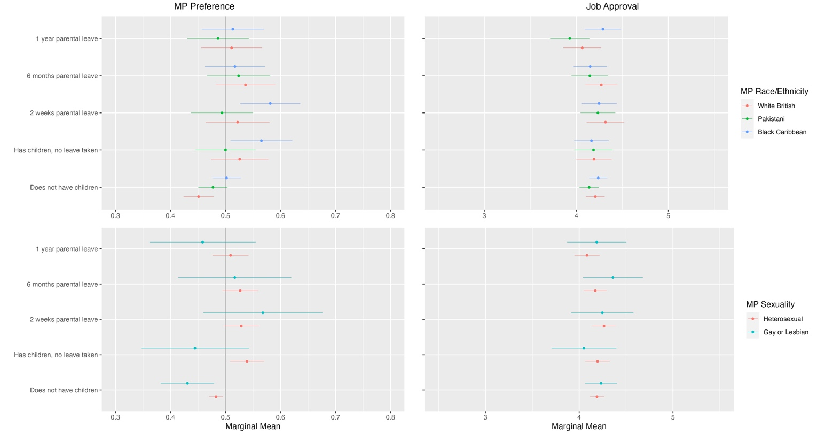

Although an overall pattern in racialised differences is hard to detect, it is the majority race, white MPs, who receive punishment for not having children. Black Caribbean MPs receive a parenthood benefit but once the ‘costs’ of parenthood become too high – above 2 weeks of parental leave – this parenthood benefit is lost. For Pakistani MPs there is no effect of parenthood. In terms of MP sexuality, it was expected that being in a same-sex marriage would have a negative effect when MPs take leave as a gay or lesbian MPs deviate from more ‘norms’. This negative effect does present itself when gay or lesbian MPs have children and do not take leave or take a year of leave – although non-significant in both cases, there is a negative effect compared to straight MPs. Models on job approval in the Appendix show there is no significant effect of MP race or sexuality.

**Figure A5.2 Marginal Means of Trait Variables by MP Race/Ethnicity**

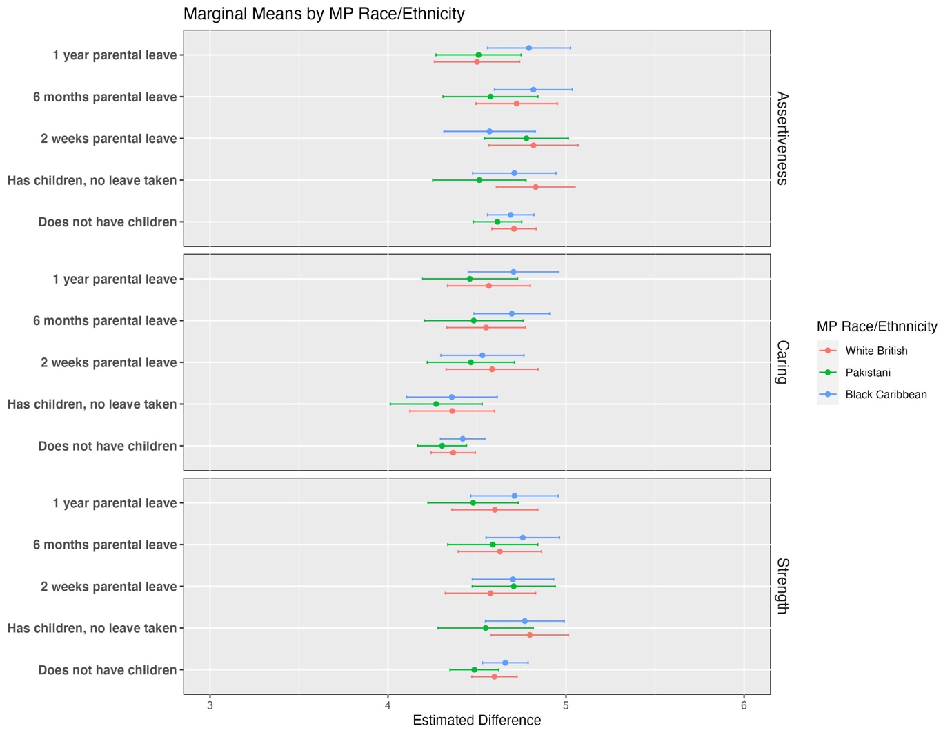

**Figure A5.3 Marginal Means of Trait Variables by MP Sexuality**

In Figure A4.2 marginal means are shown for the trait variables by MP race/ethnicity and Figure A4.3 shows the same for MP sexuality. Overall no clear patterns emerge, differential judgements are not being made about the strength, assertiveness or caring of MPs by their race or sexuality dependent on their parenthood or the length of parental leave taken.

Figure A4.4 shows the marginal means for the forced choice dependent variable and job approval rating dependent on the party of MPs. Although there are no clear differential effects happening here, at the extremes there are some party differences. Conservative MPs are more likely to be punished for not having children or for taking long lengths of parental leave. This may be that Conservatives receive a higher punishment for not conformed traditional family norms.

**Figure A5.4 Marginal Means by MP Party**

*Level of Office*

Figure A4.5 shows the marginal means for the forced choice variable and the job approval ratings. There is little evidence for the hypothesis made, no clear consistent pattern of punishment for leave taking is seen for MPs in higher levels of office.

**Figure A5.5 Marginal Means by MP Level of Office**

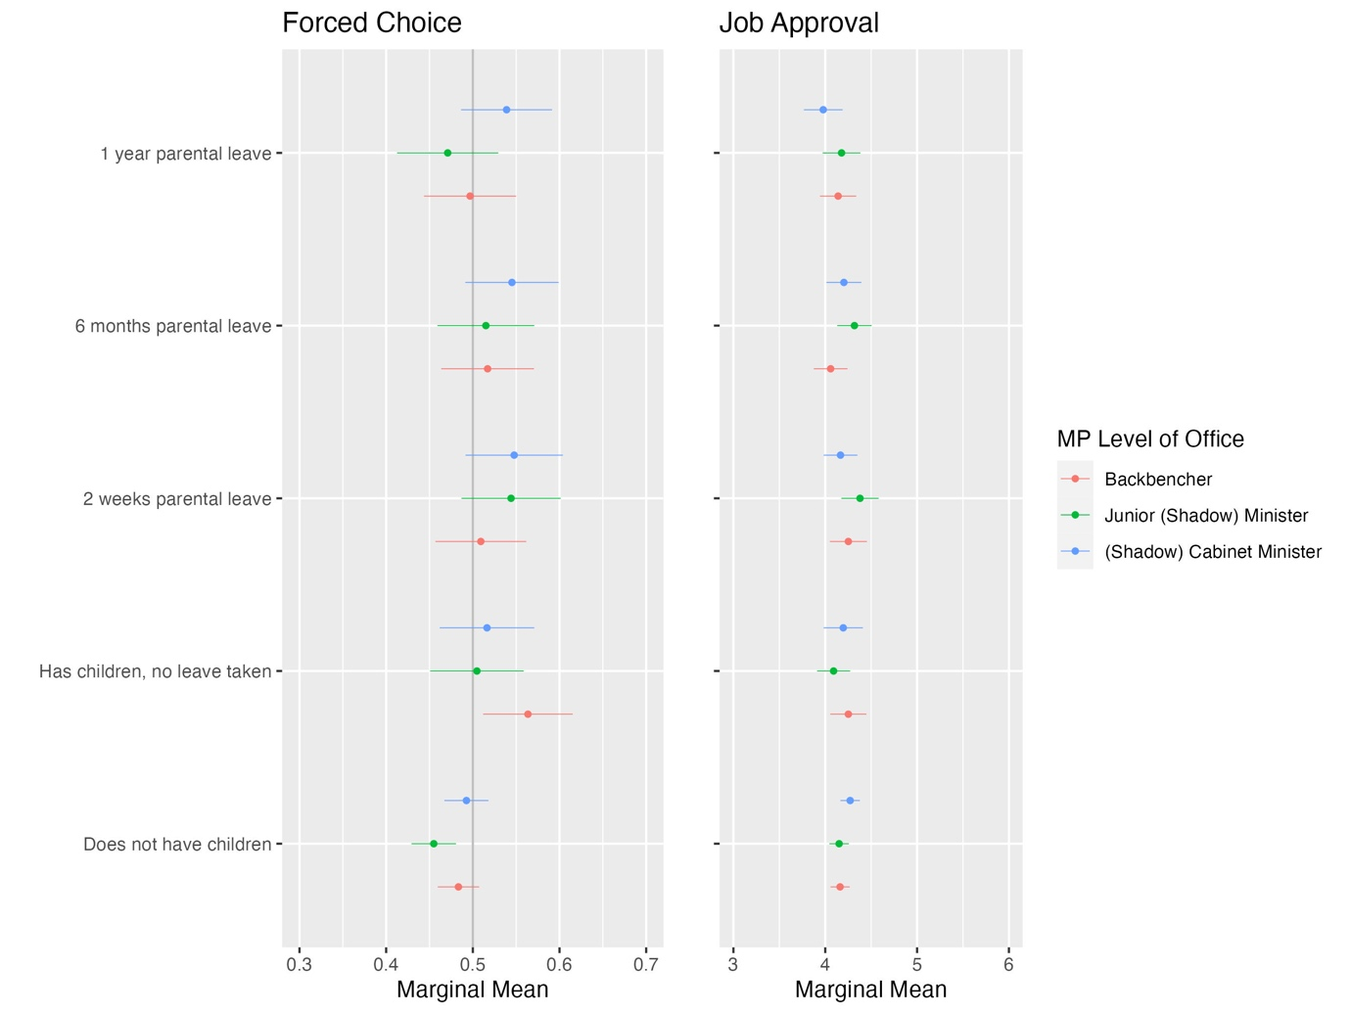

**Appendix 6: Pre-Registered Hypotheses**

The main text is structured around a set of empirical expectations rather than specific hypotheses about the attributes. However, in the pre-registered document, hypotheses are made. To be transparent, the pre-registered hypotheses are restated here and conclusions on whether I reject or accept them. We emphasise that this makes no difference to our conclusions in the paper.

|  |  |
| --- | --- |
| **Hypotheses** | **Conclusion** |
| *General Hypotheses:* |  |
| MPs taking parental leave will have a negative effect on MP choice and job approval relative to not taking leave and not having children. | Rejected |
| Longer periods of parental leave will have a negative effect on MP choice and job approval relative to shorter lengths of leave. | Rejected |
| *Traditional Stereotyping Hypotheses:* |  |
| Taking parental leave will have a negative effect on MP choice and job approval for both men and women MPs compared to not taking leave and not having children. | Rejected |
| Any negative effect of taking parental leave will be larger for men MPs than women MPs. | Rejected |
| Leave-taking mother MPs will be rated as more caring, less assertive, and weaker than non-leave taking mothers and childless women MPs. | Rejected |
| Leave taking father MPs will be seen as more caring, less assertive, and weaker than non-leave taking fathers and childless men MPs. | Rejected |
| *Politicised Parenthood Hypotheses:* |  |
| Taking parental leave will have a positive effect on job approval and overall MP choice for both men and women MPs relative to not taking leave and not having children. | Partially Accepted (for MP choice) |
| Leave-taking mother MPs will be seen as more caring, more assertive and stronger than non-leave taking mothers and childless women MPs. | Rejected |
| Leave-taking men MPs will be rated as more caring, less assertive and weaker than non-leave taking men MPs and childless men MPs. | Rejected |
| *Secondary Hypotheses: Other MP Demographics:* |  |
| Of MPs who take parental leave, an MP being from a Black or Pakistani background will have a negative effect on MP choice and job approval relative to an MP being from a White British background. | Rejected |
| Of MPs who take parental leave, an MP being in a same-sex marriage will have a negative effect on MP choice and job approval relative to an MP being in a heterosexual marriage. | Rejected |
| Of MPs who take parental leave, an MP being in a higher level of office will have a negative effect on MP choice and job approval relative to a lower level of office. | Rejected |
| *Secondary Hypotheses: Respondent Demographics:* |  |
| Respondents with children will rate leave-taking MPs higher on job approval and MP choice than respondents without children. | Rejected |
| Women respondents will rate leave-taking MPs higher on job approval and MP choice than men respondents | Rejected |