Targeted genetic sequencing analysis of 223 cases of pseudomyxoma peritonei treated by cytoreductive surgery and hyperthermic intraperitoneal chemotherapy shows survival related to GNAS and KRAS status

Short Title:
PMP targeted sequencing analysis

Authors:
Jane Gibson^{1,2}*, Reuben J Pengelly³, Amatta Mirandari¹, Konstantinos Boukas⁴, Sophia Stanford ⁵, Thomas Desmond Cecil ⁵, Faheez Mohamed ⁵, Sanjeev Paul Dayal ⁵, Alexios Tzivanakis ⁵, Brendan John Moran ⁵, Alex Mirnezami ¹, Norman John Carr ^{3a}, Sarah Ennis^{3a}.
ª NJC and SE contributed equally

Affiliations:
- Cancer Sciences, Faculty of Medicine, University of Southampton, Southampton, UK.
- Bio-R Bioinformatics Research Facility, Faculty of Medicine, University of Southampton, Southampton, UK.
- Human Development and Health, Faculty of Medicine, University of Southampton, Southampton, UK.
- Wessex Investigational Sciences Hub, Cancer Sciences, Faculty of Medicine, University of Southampton, Southampton General Hospital, Southampton, UK
- Peritoneal Malignancy Institute, Basingstoke and North Hampshire Hospital, Aldermaston Road, Basingstoke, Hampshire, United Kingdom.

Research article

List of abbreviations:
AM: acellular mucin
CC: completeness of cytoreduction
G: grade
LAMN: low grade appendiceal neoplasm
LG: low grade
HAMN: high grade appendiceal neoplasm
HG: high grade
HGSC: high grade with signet-ring cells
HR: hazard ratio
MAC: mucinous adenocarcinoma
NGS: next generation sequencing
PSOGI: Peritoneal Surface Oncology Group International
PMP: pseudomyxoma peritonei
SRC: mucinous adenocarcinoma with signet-ring cells
VAF: variant allele frequency
WHO: World Health Organisation

Novelty and Impact:
A cancer hotspot panel, using next generation sequencing, was applied to one of the largest cohorts of patients with PMP described in the literature. We identified known common variants in GNAS, KRAS and TP53. Other mutations were uncommon but included novel variants in BAP1 and ERBB4. Mutations in GNAS and/or KRAS were significantly associated with survival. The grade of the metastatic peritoneal disease was prognostically more significant than the primary tumour grade.
Abstract

Pseudomyxoma peritonei (PMP) is an unusual condition with unique behaviour caused by a mucinous neoplasm, usually arising from the appendix. The aim of this study was to evaluate the prevalence of genomic alterations in clinical specimens of PMP using a targeted assay and correlate the findings with clinical, pathological and outcome data. Sequencing data from 223 patients were analysed. The median follow-up interval was 48 months. The primary neoplasm was appendiceal in 216 patients, ovarian in 4, urachal in 2 and renal in one. We confirmed common mutations in GNAS and KRAS (42% each) with significant co-occurrence of variants in these genes. TP53 mutations were found in 8%. Other mutations were rare but included novel mutations in BAP1 and ERBB4. Of 17 patients with acellular peritoneal mucin, 6 (35%) were positive for DNA mutations. The non-appendiceal cases generally showed a similar mutational landscape to the appendiceal lesions with GNAS and KRAS commonly mutated, although one urachal lesion showed multi-hit TP53 mutation without variants in either GNAS or KRAS. Survival was significantly associated with the grade of the primary neoplasm, the grade of the peritoneal disease, the completeness of cytoreduction score, and with mutation in either GNAS, KRAS or both. The hazard ratio (HR) associated with mutation in GNAS and/or KRAS was 1.87 (p=0.004). Survival outcome was more closely associated with the grade of the peritoneal disease than with the grade of the primary neoplasm. Our findings support the developing concept that mutational analysis may provide prognostic information in patients with PMP.

Introduction
Pseudomyxoma peritonei (PMP) is a syndrome characterised by the accumulation of mucinous ascites and tumour within the abdominopelvic cavity ^{1,2}. The incidence of PMP is about 2 to 3 per million per year, ^{3,4}. Typical features include abundant mucinous ascites, peritoneal implants of mucinous material, thickening of the omentum (‘omental cake’) and Krukenberg tumours of the ovaries. PMP has unusual features not shared with other types of neoplasm. In particular, it spreads widely through the peritoneal cavity by following the physiological flow of peritoneal fluid, a process that has been named the redistribution phenomenon, and it tends to push its way into underlying organs rather than frank tumour infiltration. Furthermore, at least in its low-grade form, PMP very rarely metastasises to lymph nodes or distant organs ^{5,6}. There is a spectrum of disease varying from indolent low grade to more aggressive variants that are more invasive. Nevertheless, PMP is a malignant condition in all grades: if untreated, it grows relentlessly and ultimately causes death, usually through intestinal obstruction. For this reason, many authors prefer the term ‘mucinous carcinoma peritonei’ to PMP ^{7,8}.
By far the most common cause of PMP is a primary mucinous neoplasm of the appendix. There are four main types of mucinous appendiceal neoplasm according to the Peritoneal Surface Oncology Group International (PSOGI) classification: low grade appendiceal mucinous neoplasm (LAMN), high grade appendiceal mucinous neoplasm (HAMN), mucinous adenocarcinoma, and mucinous adenocarcinoma with signet-ring cells ⁷. When one of these tumours ruptures, neoplastic cells are released into the peritoneal cavity where they can continue to grow and produce PMP. On rare occasions PMP can develop from other primary tumours, for example mucinous tumours of the urachus, ovarian teratomas, intraductal papillary mucinous neoplasms of the pancreas, and mucinous neoplasms arising in retrorectal hamartomas ^{2,9,10}.
The histological grade (G) of PMP is an independent predictor of prognosis ¹¹. There are three grades of PMP in the World Health Organisation (WHO) classification: G1 is low grade, G2 is high grade, and G3 is high grade with signet ring cells ^{12,13}. Tumours with signet-ring cells are designated separately because of their worse prognosis ¹⁴. In PMP of appendiceal origin, the grades of the appendiceal primary and the peritoneal disease are usually the same, but in 4-5% of patients there is discordance in grade. In these cases, it has been found that the grade of the PMP is more closely associated with prognosis, although the evidence is relatively scanty ¹⁵.
In about 10-15% of patients with the PMP syndrome, the intra-abdominal mucin contains no neoplastic cells when it is examined histologically ^{16,17}. This acellular mucin is not graded in the WHO classification. In the majority of such cases the disease does not progress ¹⁸.
Appendiceal neoplasia and PMP are genetically distinct from colorectal carcinoma ^{19,20} . Studies have shown the most frequent mutations in PMP to be in KRAS and GNAS, with frequencies of about 70% and 50% respectively ²¹⁻²³. Most KRAS mutations are found in codon 12 (G12D, G12C, and G12V) and in codon 13 (G13D) ²⁴. TP53 is mutated in some cases, but this finding is usually confined to high grade PMP ^{25,26}. Other genes exhibiting mutation in PMP include FAT3/4, TGFBR1/2, RNF43, PIK3CA, CTNNB1, AKT1, ATM, SMAD4, SMAD2, ARID1A/B, ARID2, RBM10, BRCA2, MML, MLL2/3 and CDKN2A ^{21,24,27-29,30} . BRAF mutations occur occasionally but are uncommon ³¹. Studies using whole-exome sequencing also identified mutations in SMAD3, PRKACA, PRKAR1A, TCHH, HERC2, SPEG, TGFBR2, TTN, MUC17, PMEPA1, AHNAK, AHNAK2, APOB, FCGPB, HRNR and OBSCN ^{20, 32}. One study demonstrated amplification of MYC in a subset of patients³⁰ . In contrast to colorectal carcinoma, it is unusual to find either APC mutations or microsatellite instability in PMP ^{22,28,31,33}. Furthermore, on the rare occasions that microsatellite instability is found in appendiceal neoplasia, it is not generally associated with MLH1 hypermethylation ³⁴.
A study of appendiceal adenocarcinomas found that neoplasms that were KRAS mutant and GNAS wild type were associated with better overall survival than neoplasms with mutations in both genes ¹⁹, and a study of PMP of appendiceal origin found a mutation in any one of TP53, SMAD4, ATM, CDKN2A, PIK3CA or PTEN was associated with worse overall survival ²⁸. However, in general there is little consensus in the literature concerning the prognostic implications of the various genetic mutations, partly because many studies include relatively few patients ^{21,24}.
The optimal treatment of PMP includes complete tumour removal by radical cytoreductive surgery combined with hyperthermic intraperitoneal chemotherapy, with overall 10-year survival of over 50% ^{35,36}. Occasional patients with non-resectable recurrent disease may undergo intestinal transplantation ³⁷. Indicators of likely clinical outcome include the extent of intraperitoneal disease, the histological grade, preoperative serum concentrations of the tumour markers CA125, CA19-9 and CEA, and completeness of tumour removal ^{38,39}. However, these clinical and pathological parameters do not accurately predict outcome in all cases, and a better knowledge of genetic changes in PMP will contribute to the search for improved biomarkers of prognosis ³². Furthermore, because of the unique behaviour of PMP, an increased understanding of its genetic landscape could shed light on mechanisms of metastasis in general and have implications beyond the treatment of this rare condition ⁴⁰.
The aim of this study was to apply next-generation sequencing (NGS) techniques to clinical specimens of pseudomyxoma peritonei by evaluating the prevalence of genomic alterations with a targeted NGS assay, and to correlate the results with clinical, pathological and outcome data. A secondary aim was to compare the survival outcomes in patients with PMP of appendiceal origin according to the grade of the primary tumour compared with the grade of the peritoneal disease.

Materials and Methods
Patient sample collection/criteria
Patients treated at the Peritoneal Malignancy Institute, Basingstoke, UK, were recruited to the study. All patients provided written informed consent. All patients had pseudomyxoma peritonei treated by cytoreductive surgery and hyperthermic intraperitoneal chemotherapy. Ethical approval was provided by the National Research Ethics Service, reference 09/H0504/3.
Samples of tumour were taken intra-operatively during surgery; these samples were snap-frozen and stored in liquid nitrogen until further processing. Histological examination of all specimens was performed by a pathologist with a special interest in the appendix and PMP. The appendiceal primary tumours were classified according to PSOGI criteria as follows (WHO grade in parentheses): LAMN (G1), HAMN (G2), mucinous adenocarcinoma (G2) and mucinous adenocarcinoma with signet-ring cells (G3). The peritoneal disease was classified as: acellular mucin (ungraded), low grade PMP (G1), high grade PMP (G2) and high grade PMP with signet-ring cells (G3) ^{7,41}.
Clinical details were retrieved from a prospectively-maintained database supplemented by reference to the clinical records if required. The presence of any residual disease at the end of the operation was recorded by the surgeon using the completeness of cytoreduction (CC) score: no visible disease (CC0), nodules of residual tumour less than 0.25cm diameter (CC1), nodules 0.25cm to 2.5cm diameter (CC2) and nodules more than 2.5cm diameter (CC3). For modelling, the CC score was dichotomised into CC0/1 and CC2/3, corresponding to a cutoff value of 0.25cm diameter, consistent with findings that this is the most clinically significant distinction ^{35,42}.

DNA extraction, panel design, library preparation and sequencing
DNA was extracted from fresh frozen samples. Firstly, samples were homogenised using a Precellys 24 in 2mL CKMix tissue homogenising tubes (Bertin Technologies SAS) at 5,000 rpm for two 10 second periods. Following homogenisation, DNA was extracted using the QIAamp DNA Blood Mini kit, automated using the QIASymphony platform (Qiagen). DNA samples were quantified using the Qubit Fluorimeter (Life Technologies).
A custom targeted panel was designed for peritoneal malignancies, including those underlying PMP. This panel included 207 key regions across 50 genes frequently mutated across cancers, and the coding regions of six key genes of interest in peritoneal malignancy (BAP1, CDC42, NF2, RNF43, SETDB1 and TRAF7), (supplementary table 1). In addition, 24 SNPs were included to allow verification of sample identity following sequencing ⁴³. The custom panel was generated using an amplicon-based approach (YouSeq, Winchester, UK). Capture and library preparation was performed in accordance with manufacturer’s instructions. Libraries were paired-end sequenced (300cycles) on a NextSeq500. Parallel genotyping of the 24 sample tracking panel was performed using KASP genotyping (LGC Genomics, UK).

Bioinformatic and statistical analyses
Raw sequencing fastq files from 2 runs were merged per sample. Alignment of the merged sequences to the hg38 (release 13) genome was performed using the BWA-MEM module from the Burrows-Wheeler Aligner (BWA) software (v.0.7.17) ⁴⁴, and sorted and indexed using samtools (v.1.16.1). The sorted .bams were trimmed using the bamutil (V1.0.14) filter programme to trim ends of reads where there were >10% mismatches from the reference genome and exclude reads where there were mismatches with a cumulative phred scaled quality of 60.
The trimmed .bams were input into Stitcher (v5.2.9) to merge read pairs followed by variant calling and variant quality score recalibration using Pisces (v5.2.9). These variants were then annotated by the Functotator software (v.4.2.2) using base data sources and output as maf format files. These files were analysed in maftools 2.18.0, in Rstudio (R v4.3.2). Variants were filtered for quality score >100 and variant allele frequency (VAF) >=2.5% (1% for GNAS/KRAS). To exclude known germline variants all variants were filtered to remove those present in gnomAD at a minor allele frequency > 0.0001. Manual curation of all mutated genes was carried out using IGV (v. 2.14.1) and mutations were assessed and tagged for exclusion based on a published standard operating procedure ⁴⁵.
Survival analyses were carried out using the ‘survival’ (3.5-7), ‘survminer’ (0.4.9), and ‘forestmodel’ (0.6.2) R packages in Rstudio (R v4.3.2).

Results
Clinical characteristics
Samples from 263 patients were submitted for analysis. In 223 samples DNA was successfully extracted and good quality sequencing data were achieved (Supplementary Table 2.). The demographic and clinical details of these 223 patients are shown in Table 1. Pre-operative chemotherapy had been received by 36 (16.1%) patients; the others had received no chemotherapy prior to cytoreductive surgery. Follow-up was available for all patients and the median follow-up interval was 50 months.
The PMP originated from a mucinous neoplasm of the appendix in 216 (96.9%) patients (Table 2). The other primary tumours were an ovarian teratoma in 4 patients, a mucinous tumour of the urachus in 2 patients and a mucinous tumour of the renal pelvis in one patient. There were 17 (7.6%) patients with histologically acellular mucin; in 14 of them the primary was an LAMN, in 2 the primary was an appendiceal mucinous adenocarcinoma and in one the primary was an ovarian teratoma. The presence or absence of lymph node metastasis was recorded in 166 (74.4%) patients. Nodal metastasis was present in 18/166 (10.8%) patients; 5 with G1 PMP, 11 with G2 PMP and 2 with G3 PMP. There was discordance between the grade of the appendiceal primary and the grade of the PMP in 7 (3.1%) patients: three G1 primaries were associated with G2 PMP, two G2 primaries were associated with G1 PMP, and two G3 primaries were associated with G2 PMP (Table 2).

Mutational landscape
Of the 223 patients successfully sequenced across cancer hotspot regions, we observed good quality variants in 126 (56.5%) patients. The most commonly mutated genes were GNAS and KRAS at 42% each (Fig 1). Mutations in KRAS were most commonly seen at the known mutation hotpots in codons 12 and 13, and those in GNAS were at the known hotspot in codon 201 (Supplementary Fig 2). TP53 mutations were found in 8% and were more common in high-grade lesions. SMAD4, ERBB4, BAP1 and PIK3CA were detected at rates of 2-4%. Mutations in APC and BRAF were unusual (1% each). Mutated NRAS was found in only one (0.4%) specimen, a mucinous appendiceal adenocarcinoma. In the 17 specimens consisting of acellular peritoneal mucin, 6 (35%) were positive for mutated DNA (Fig 1B).
The 7 lesions of non-appendiceal origin generally showed a similar mutational landscape to the appendiceal lesions, with GNAS and KRAS variants the most frequent, although one patient had no mutation in either gene but did harbour multihit mutation of TP53; this lesion was a mucinous adenocarcinoma of the urachus (Fig 1A). One case of appendiceal mucinous adenocarcinoma also contained multihit mutation of TP53 without mutation in either KRAS or GNAS.

Mutual exclusivity analysis
Mutations in GNAS and KRAS significantly co-occur (adj p-value 2.72x10⁻²¹, odds ratio 22.3). The most mutually exclusive mutations were between GNAS and TP53 although this was not significant (adj p-value 0.9, odds ratio 0.4) (Fig 2). Mutations in NOTCH1 and KIT were also significantly mutually inclusive (adj p-value 0.003), but this was based on very few mutations, where two patients with NOTCH1 mutations both also had mutations in KIT.

Survival analyses
The median survival for all patients with PMP of appendiceal origin was 96 months. Overall median survival for the non-appendiceal group was 51% at 61 months (median survival not reached in this cohort). Modelling survival of patients using key clinical data identified CC score as the factor with most impact. The CC score was available for 218 patients; the median survival of the 175 patients with CC0/1 was 116 months and the median survival of the 43 patients with CC2/3 was 26 months (p = 2.57 x 10⁻²⁰).
For the appendiceal neoplasms, survival rates differed significantly according to the grade of the primary tumour (Fig 3A). Dichotomising the primary tumours into LAMN (G1) and HAMN/mucinous adenocarcinoma/mucinous adenocarcinoma with signet ring cells (HAMN/MAC/SRC) (G2/3) showed the median overall survival for the LAMN group was 115 months and for the HAMN/MAC/SRC group 42 months (p = 4.59 x 10⁻⁶, HR = 4.06). The 5 year survival was 69% and 38% for the LAMN and HAMN/MAC/SRC groups respectively. The 5 year survival for the non-appendiceal group was 69%. Survival was also significantly different between peritoneal disease types (p=3.292 x 10⁻⁸) (Fig 3B). The median survival for low-grade PMP (G1) was 105 months, for high-grade PMP (G2) 42 months, and for high-grade PMP with signet ring cells (G3) 26 months. In the 17 patients with acellular mucin, only 3 experienced recurrence and the 5-year survival rate was 88%, compared with an overall 5-year survival of 59% in the 206 patients with neoplastic cells in the peritoneal mucin (p = 0.035).
We compared survival outcomes of patients with PMP of appendiceal origin when classified according to the WHO grade of the appendiceal primary and according to the WHO grade of the PMP. Patients with acellular peritoneal mucin were excluded. The HR for primary tumour grade was 2.82 (p=9.96x10⁻⁹) while the HR for peritoneal disease grade was higher, 3.82 (p=2.91x10⁻⁹). In the Cox model with both variables included, PMP grade was more closely associated with survival and the primary tumour grade made no further contribution (p=0.0002, Supp Fig 5). These findings show that prognosis is more closely associated with the grade of the PMP than the grade of the appendiceal primary.
Comparing survival rates in patients with and without KRAS and GNAS mutations, individuals harbouring a KRAS variant had poorer survival than those without (p = 0.006, HR = 1.72). Similarly, those carrying a GNAS variant had poorer survival than those without (p = 0.048, HR = 1.48). The next most frequently mutated gene was TP53 (mutated in 17); although there was a trend towards poorer survival in the mutated cases this was not significant (p=0.061). There was no significant association between CC score and genetic mutation in our data.
As mutations in GNAS and KRAS genes frequently co-occur in the same patients, we merged these to create a subset of patients with KRAS and/or GNAS mutations. This subset had significantly poorer survival than those without mutations at either gene (p = 0.001) (Supp. Fig3). When modelling carriage of KRAS and/or GNAS mutational status (excluding cases with acellular peritoneal mucin), genetic variation in these genes significantly contributed to hazard (p 0.004, HR = 1.87) when compared to cases with no mutation in either gene after accounting for CC scoring and peritoneal disease grade (Fig 4B). However, our data indicate they represent a lesser hazard than peritoneal disease grade.

Discussion
As expected, the most common mutations were found in KRAS and GNAS, although at lower frequencies than in some other studies (Fig 1) ^{21,20} . Other mutations in our series have generally been reported previously, although unexpected findings were mutated BAP1 in 2% of patients and mutated ERBB4 in 3%. BAP1 is commonly mutated in other neoplasms, such as malignant mesothelioma and melanoma ^{46,47}. ERBB4, which encodes the tyrosine kinase receptor HER4, has varied effects on cancer development, but mutations in this gene have been implicated in several neoplasms, including melanoma, lung carcinoma and stomach carcinoma ⁴⁸. Of the 4 cases with BAP1 mutation, 3 showed no variants in either KRAS or GNAS, and of the 7 cases with ERBB4 mutation, 4 (all LAMNs) likewise showed no variants in either KRAS or GNAS (Fig. 1A). These findings raise the possibility of novel genetic pathways in PMP that may not involve KRAS or GNAS. Of note in this respect, the targeted hotspot panel was not sufficient to analyse amplifications. Another limitation of the study was a lack of matched normal tissue, which is advantageous in confirming somatic mutation status.
A previous study of mucinous appendiceal neoplasms found wild-type GNAS in 5/6 high grade tumours, raising the possibility that high grade lesions may not arise from low grade tumours ²⁰. We found GNAS mutations in 18/54 (33%) of high grade lesions and 73/162 (45%) of low grade lesions Figure 1A); this difference was not significant in our data (p=0.18). For patients with PMP, a potential implication of wildtype KRAS is the possible use of drugs such as cetuximab in treatment. A retrospective study of patients with appendiceal adenocarcinoma showed no survival benefit from cetuximab or panitumumab ⁴⁹. However, in a xenograft mouse model of high grade PMP, the KRAS^{G12D} inhibitor MRTX1133 was associated with a marked reduction of tumour growth ⁵⁰. It could be hypothesised that sequencing of percutaneous or laparoscopic biopsies might identify patients with PMP who could benefit from cetuximab or panitumumab prior to surgery to improve CC0 rates, and further studies in this area are indicated.
Other candidates for targeted therapy are neoplasms with BRAF mutations. In a study of patient-derived organoid and xenograft mouse models of PMP, the BRAF^{V600E} inhibitor encorafenib reduced cell viability and tumour growth⁵¹ . Although BRAF mutation in appendiceal neoplasia is rare, the subset of patients harbouring such a mutation might benefit from this treatment and further research is needed.
The low frequency of APC and BRAF mutation in our series is in keeping with the findings of others and supports the concept that these genes are mutated rarely in pseudomyxoma peritonei, in contrast to colorectal carcinomas ^{22,28,31,33,20}. This emphasises the fact that colorectal and appendiceal neoplasms are genetically distinct.
In the 17 specimens consisting of acellular peritoneal mucin, 6 (35%) were positive for mutated DNA (Fig 1B). PMP with acellular mucin has an excellent prognosis ¹⁸. In some cases, it may be that the mucin does contain neoplastic cells, but at such a low concentration that they are missed by routine histopathological assessment. Alternatively, the mucin may be genuinely acellular because the neoplastic cells do not survive after extrusion from the appendix. The detection of mutated DNA in histologically acellular mucin could be consistent with either scenario. In a study of three patients with acellular peritoneal mucin associated with LAMNs harbouring mutated KRAS, the KRAS mutation was detected in cell-free DNA in the mucin from all three patients ¹⁷.
There is little consistent evidence in the literature about the prognostic impact of genomic alterations in PMP ^{19,21,24}. Our data showed poorer survival was associated with either KRAS mutation ((p = 0.006, HR = 1.72) or GNAS mutation (p = 0.048, HR = 1.48). Furthermore, the subset of patients with KRAS and/or GNAS mutations had a significantly worse survival than those without mutations at either of these established genes (p = 0.001) (Supp. Fig3). TP53 variants were associated with a trend towards poorer survival, consistent with the findings of others ²⁸. However, this was not statistically significant in our data (p=0.061). Nevertheless, TP53 mutations were more likely to be found in high grade lesions: they were identified in 9/54 (17%) of high grade neoplasms and 7/162 (4%) of low grade neoplasms (p = 0.007) (Figure 1A), in keeping with other studies ^{25, 31,20} .
The associations between the various clinical features and survival in our results were generally as expected in the light of previous studies ^{11,35,36}. The CC score influenced survival more than any other factor in our data, and the appendiceal neoplasms showed better overall survival in the LAMN (G1) subgroup compared with the HAMN/MAC/SRC (G2/G3) subgroup. The non-appendiceal subgroup demonstrated an intermediate survival in this small set of patients (n = 7). The grade of the pseudomyxoma peritonei was also significantly associated with survival, and patients with acellular mucin had the best outcome. Survival was more closely associated with the grade of the peritoneal disease than the grade of the primary tumour in cases of PMP of appendiceal origin (Supp Fig 5). This finding supports the practice of grading the primary and peritoneal disease separately in patients with PMP ¹⁵.
Our results demonstrate the importance of KRAS and GNAS variants in the oncogenesis of PMP, and are consistent with the conclusions of others that TP53 appears to be associated with high grade disease. The relative rarity of mutations in other genes suggests we need to look beyond the genes analysed in panels such as the one used in our study to identify other genes that may be commonly involved. The starting point for many studies of the genetics and pathology of appendiceal mucinous neoplasms and PMP is the assumption that they are similar to colorectal carcinoma, but there are many important clinical, pathological and genetic differences between them ¹⁹. We speculate that widening the range of genes studied by NGS sequencing may not only improve prognostic data but also provide insights into the unique behaviour of these tumours. A possible pointer in this direction is our documentation of novel variants in BAP1 and ERBB4. We have also demonstrated that meaningful genetic information can be obtained from PMP that is histologically acellular. Further work in the genetics of PMP may enlighten the whole field of peritoneal metastatic disease, a frequent and clinically difficult condition in patients with common primary cancers of gastrointestinal origin.

Author Contributions
JG, RP, AM conducted the analysis, KB conducted the sequencing. SS, TC, FM, SD, AT, BJ, AM collected patient samples and clinical data, SS coordinated the project. AM, NC, SE conceptualised the project and secured financial support. NC drafted the paper, all authors reviews and contributed to the final paper. The work reported in the paper has been performed by the authors, unless clearly specified in the text.
Acknowledgements and further disclosures
We wish to thank Emily Arbuthnot for clinical data coordination and administration; Stephen Doherty from Wessex Medical Laboratory Services (Southampton) for technical support, and YouSeq for targeted panel design.
The authors acknowledge the use of the IRIDIS High Performance Computing Facility, and associated support services at the University of Southampton, in the completion of this work.
The authors acknowledge the Faculty of Medicine BIO-R, at the University of Southampton for their support and assistance in this work.
Ethical approval was provided by the National Research Ethics Service, reference 09/H0504/3.
This research study is funded by Mesothelioma UK, and the Peritoneal Malignancy Institute Basingstoke. The collection of patient samples was supported by the Pelican Cancer Foundation.
The authors declare no relevant Conflicts of Interest.
The data that support the findings of this study are available on request from the corresponding author. The data are not publicly available due to privacy or ethical restrictions.

References
1. Moran BJ, Cecil TD. The etiology, clinical presentation, and management of pseudomyxoma peritonei. Surg Oncol Clin N Am. Jul 2003;12(3):585-603. doi:10.1016/s1055-3207(03)00026-7
2. Carr NJ. New insights in the pathology of peritoneal surface malignancy. J Gastrointest Oncol. Apr 2021;12(Suppl 1):S216-S229. doi:10.21037/jgo-2020-01
3. Smeenk RM, van Velthuysen ML, Verwaal VJ, Zoetmulder FA. Appendiceal neoplasms and pseudomyxoma peritonei: a population based study. Eur J Surg Oncol. Feb 2008;34(2):196-201. doi:10.1016/j.ejso.2007.04.002
4. Patrick-Brown T, Carr NJ, Swanson DM, Larsen S, Mohamed F, Flatmark K. Estimating the Prevalence of Pseudomyxoma Peritonei in Europe Using a Novel Statistical Method. Ann Surg Oncol. Jan 2021;28(1):252-257. doi:10.1245/s10434-020-08655-8
5. Sugarbaker PH. Pseudomyxoma peritonei. A cancer whose biology is characterized by a redistribution phenomenon. Ann Surg. Feb 1994;219(2):109-11. doi:10.1097/00000658-199402000-00001
6. Jarvinen P, Lepisto A. Clinical presentation of pseudomyxoma peritonei. Scand J Surg. 2010;99(4):213-6. doi:10.1177/145749691009900406
7. Carr NJ, Cecil TD, Mohamed F, Sobin LH, Sugarbaker PH, Gonzalez-Moreno S, Taflampas P, Chapman S, Moran BJ, Peritoneal Surface Oncology Group I. A Consensus for Classification and Pathologic Reporting of Pseudomyxoma Peritonei and Associated Appendiceal Neoplasia: The Results of the Peritoneal Surface Oncology Group International (PSOGI) Modified Delphi Process. Am J Surg Pathol. Jan 2016;40(1):14-26. doi:10.1097/PAS.0000000000000535
8. Bradley RF, Stewart JHt, Russell GB, Levine EA, Geisinger KR. Pseudomyxoma peritonei of appendiceal origin: a clinicopathologic analysis of 101 patients uniformly treated at a single institution, with literature review. Am J Surg Pathol. May 2006;30(5):551-9. doi:10.1097/01.pas.0000202039.74837.7d
9. Yoshizaki Y, Gohda Y, Inagaki F, Kataoka A, Takemura N, Miyazaki H, Igari T, Kiyomatsu T, Yano H, Kokudo N. A case of pseudomyxoma peritonei arising from a perforated intraductal papillary mucinous neoplasm that underwent cytoreductive surgery and hyperthermic intraperitoneal chemotherapy. Clin J Gastroenterol. Feb 2024;17(1):188-197. doi:10.1007/s12328-023-01890-y
10. Taguchi A, Rokutan H, Oda K, Tanikawa M, Tanimoto S, Sone K, Mori M, Tsuruga T, Kohsaka S, Tatsuno K, Shinozaki-Ushiku A, Miyagawa K, Mano H, Aburatani H, Ushiku T, Osuga Y. Genetic diagnosis of pseudomyxoma peritonei originating from mucinous borderline tumor inside an ovarian teratoma. BMC Med Genomics. Mar 7 2022;15(1):51. doi:10.1186/s12920-022-01188-x
11. Huang Y, Alzahrani NA, Chua TC, Morris DL. Histological Subtype Remains a Significant Prognostic Factor for Survival Outcomes in Patients With Appendiceal Mucinous Neoplasm With Peritoneal Dissemination. Dis Colon Rectum. Apr 2017;60(4):360-367. doi:10.1097/DCR.0000000000000719
12. Misdraji J, Carr N, Pai R. Appendiceal mucinous neoplasm, Digestive System tumours. 5th edition ed. World Health Organization classification of tumours; 5th. International Agency for Research on Cancer, World Health Organization; 2019.
13. Misdraji J, Carr N, Pai R. Appendiceal adenocarcinoma, Digestive System tumours. 5th edition ed. World Health Organization classification of tumours; 5th. International Agency for Research on Cancer, World Health Organization; 2019.
14. Shamavonian R, Lansom JD, Karpes JB, Alzahrani NA, Morris DL. Impact of signet ring cells on overall survival in peritoneal disseminated appendix cancer treated with cytoreductive surgery and hyperthermic intraperitoneal chemotherapy. Eur J Surg Oncol. Jan 2021;47(1):194-198. doi:10.1016/j.ejso.2020.11.134
15. Memon AA, Godbole C, Cecil T, Dayal S, Moran B, Tzivanakis A, Mohamed F, Carr NJ. Overall Survival is More Closely Associated with Peritoneal than Primary Appendiceal Pathological Grade in Pseudomyxoma Peritonei with Discordant Pathology. Ann Surg Oncol. Apr 2022;29(4):2607-2613. doi:10.1245/s10434-021-10994-z
16. Al-Azzawi M, Misdraji J, van Velthuysen MF, Shia J, Taggart MW, Yantiss RK, Svrcek M, Carr N. Acellular mucin in pseudomyxoma peritonei of appendiceal origin: what is adequate sampling for histopathology? J Clin Pathol. Apr 2020;73(4):220-222. doi:10.1136/jclinpath-2019-206213
17. Garcia-Olmo D, Olmedillas-Lopez S, Cortes-Guiral D, Villarejo P, Lopez Rojo I, Guadalajara H, Garcia Gomez-Heras S, Garcia-Arranz M. The role of mucin cell-free DNA detection as a new marker for the study of acellular pseudomyxoma peritonei of appendicular origin by liquid biopsy. Ther Adv Med Oncol. 2020;12:1758835920928233. doi:10.1177/1758835920928233
18. Roxburgh CS, Fenig YM, Cercek A, Shia J, Rassam RM, Paty PB, Nash GM. Outcomes of Low-Grade Appendiceal Mucinous Neoplasms with Remote Acellular Mucinous Peritoneal Deposits. Ann Surg Oncol. Jan 2019;26(1):118-124. doi:10.1245/s10434-018-7003-7
19. Foote MB, Walch H, Chatila W, Vakiani E, Chandler C, Steinruecke F, Nash GM, Stadler Z, Chung S, Yaeger R, Braghrioli MI, Shia J, Kemel Y, Maio A, Sheehan M, Rousseau B, Argiles G, Berger M, Solit D, Schultz N, Diaz LA, Jr., Cercek A. Molecular Classification of Appendiceal Adenocarcinoma. J Clin Oncol. Mar 10 2023;41(8):1553-1564. doi:10.1200/JCO.22.01392
20. Alakus H, Babicky ML, Ghosh P, Yost S, Jepsen K, Dai Y, Arias A, Samuels ML, Mose ES, Schwab RB, Peterson MR, Lowy AM, Frazer KA, Harismendy O. Genome-wide mutational landscape of mucinous carcinomatosis peritonei of appendiceal origin. Genome Med. 2014;6(5):43. doi:10.1186/gm559
21. Lund-Andersen C, Torgunrud A, Fleten KG, Flatmark K. Omics analyses in peritoneal metastasis-utility in the management of peritoneal metastases from colorectal cancer and pseudomyxoma peritonei: a narrative review. J Gastrointest Oncol. Apr 2021;12(Suppl 1):S191-S203. doi:10.21037/jgo-20-136
22. Stein A, Strong E, Clark Gamblin T, Clarke C, Tsai S, Thomas J, George B, Mogal H. Molecular and Genetic Markers in Appendiceal Mucinous Tumors: A Systematic Review. Ann Surg Oncol. Jan 2020;27(1):85-97. doi:10.1245/s10434-019-07879-7
23. Pietrantonio F, Perrone F, Mennitto A, Gleeson EM, Milione M, Tamborini E, Busico A, Settanni G, Berenato R, Caporale M, Morano F, Bossi I, Pellegrinelli A, Di Bartolomeo M, de Braud F, Baratti D, Bowne WB, Kusamura S, Deraco M. Toward the molecular dissection of peritoneal pseudomyxoma. Ann Oncol. Nov 2016;27(11):2097-2103. doi:10.1093/annonc/mdw314
24. Murage NW, Ahmed NM, Underwood TJ, Walters ZS, Breininger SP. The genetic profile and molecular subtypes of human pseudomyxoma peritonei and appendiceal mucinous neoplasms: a systematic review. Cancer Metastasis Rev. Mar 2023;42(1):335-359. doi:10.1007/s10555-023-10088-0
25. Zhu X, Salhab M, Tomaszewicz K, Meng X, Mathew C, Bathini V, Switzer B, Walter O, Cosar EF, Wang X, Lambert LA, Hutchinson LM. Heterogeneous mutational profile and prognosis conferred by TP53 mutations in appendiceal mucinous neoplasms. Hum Pathol. Mar 2019;85:260-269. doi:10.1016/j.humpath.2018.11.011
26. Noguchi R, Yano H, Gohda Y, Suda R, Igari T, Ohta Y, Yamashita N, Yamaguchi K, Terakado Y, Ikenoue T, Furukawa Y. Molecular profiles of high-grade and low-grade pseudomyxoma peritonei. Cancer Med. Dec 2015;4(12):1809-16. doi:10.1002/cam4.542
27. Pengelly RJ, Rowaiye B, Pickard K, Moran B, Dayal S, Tapper W, Mirnezami A, Cecil T, Mohamed F, Carr N, Ennis S. Analysis of Mutation and Loss of Heterozygosity by Whole-Exome Sequencing Yields Insights into Pseudomyxoma Peritonei. J Mol Diagn. Sep 2018;20(5):635-642. doi:10.1016/j.jmoldx.2018.05.002
28. Wald AI, Pingpank JF, Ongchin M, Hall LB, Jones H, Altpeter S, Liebdzinski M, Hamed AB, Derby J, Nikiforova MN, Bell PD, Paniccia A, Zureikat AH, Gorantla VC, Rhee JC, Thomas R, Bartlett DL, Smith K, Henn P, Theisen BK, Shyu S, Shalaby A, Choudry MHA, Singhi AD. Targeted Next-Generation Sequencing Improves the Prognostication of Patients with Disseminated Appendiceal Mucinous Neoplasms (Pseudomyxoma Peritonei). Ann Surg Oncol. Nov 2023;30(12):7517-7526. doi:10.1245/s10434-023-13721-y
29. Munari G, Businello G, Mattiolo P, Pennelli G, Sbaraglia M, Borga C, Pucciarelli S, Spolverato G, Mescoli C, Galuppini F, Sommariva A, Bellan E, Lonardi S, Loupakis F, Luchini C, Dei Tos AP, Fassan M. Molecular profiling of appendiceal serrated lesions, polyps and mucinous neoplasms: a single-centre experience. J Cancer Res Clin Oncol. Jul 2021;147(7):1897-1904. doi:10.1007/s00432-021-03589-4
30. Ang CS, Shen JP, Hardy-Abeloos CJ, Huang JK, Ross JS, Miller VA, Jacobs MT, Chen IL, Xu D, Ali SM, Baumgartner J, Lowy A, Fanta P, Ideker T, Millis SZ, Harismendy O. Genomic Landscape of Appendiceal Neoplasms. JCO Precis Oncol. 2018;2doi:10.1200/PO.17.00302
31. Gleeson EM, Feldman R, Mapow BL, Mackovick LT, Ward KM, Morano WF, Rubin RR, Bowne WB. Appendix-derived Pseudomyxoma Peritonei (PMP): Molecular Profiling Toward Treatment of a Rare Malignancy. Am J Clin Oncol. Aug 2018;41(8):777-783. doi:10.1097/COC.0000000000000376
32. Lin YL, Zhu JQ, Ma RQ, Meng W, Wang ZY, Li XB, Ma R, Wu HL, Xu HB, Gao Y, Li Y. Whole-Exome Sequencing Identifies Mutation Profile and Mutation Signature-Based Clustering Associated with Prognosis in Appendiceal Pseudomyxoma Peritonei. Mol Cancer Res. Jan 2 2024;22(1):70-81. doi:10.1158/1541-7786.MCR-22-0801
33. Nummela P, Saarinen L, Thiel A, Jarvinen P, Lehtonen R, Lepisto A, Jarvinen H, Aaltonen LA, Hautaniemi S, Ristimaki A. Genomic profile of pseudomyxoma peritonei analyzed using next-generation sequencing and immunohistochemistry. Int J Cancer. Mar 1 2015;136(5):E282-9. doi:10.1002/ijc.29245
34. Taggart MW, Galbincea J, Mansfield PF, Fournier KF, Royal RE, Overman MJ, Rashid A, Abraham SC. High-level microsatellite instability in appendiceal carcinomas. Am J Surg Pathol. Aug 2013;37(8):1192-200. doi:10.1097/PAS.0b013e318282649b
35. Chua TC, Moran BJ, Sugarbaker PH, Levine EA, Glehen O, Gilly FN, Baratti D, Deraco M, Elias D, Sardi A, Liauw W, Yan TD, Barrios P, Gomez Portilla A, de Hingh IH, Ceelen WP, Pelz JO, Piso P, Gonzalez-Moreno S, Van Der Speeten K, Morris DL. Early- and long-term outcome data of patients with pseudomyxoma peritonei from appendiceal origin treated by a strategy of cytoreductive surgery and hyperthermic intraperitoneal chemotherapy. J Clin Oncol. Jul 10 2012;30(20):2449-56. doi:10.1200/JCO.2011.39.7166
36. Govaerts K, Lurvink RJ, De Hingh I, Van der Speeten K, Villeneuve L, Kusamura S, Kepenekian V, Deraco M, Glehen O, Moran BJ, Psogi. Appendiceal tumours and pseudomyxoma peritonei: Literature review with PSOGI/EURACAN clinical practice guidelines for diagnosis and treatment. Eur J Surg Oncol. Jan 2021;47(1):11-35. doi:10.1016/j.ejso.2020.02.012
37. Reddy S, Punjala SR, Allan P, Vaidya A, Borle DP, Geiele H, Udupa V, Smith A, Vokes L, Vrakas G, Mohamed F, Dayal S, Moran B, Friend PJ, Cecil T. First Report With Medium-term Follow-up of Intestinal Transplantation for Advanced and Recurrent Nonresectable Pseudomyxoma Peritonei. Ann Surg. May 1 2023;277(5):835-840. doi:10.1097/SLA.0000000000005769
38. Kusamura S, Baratti D, Hutanu I, Gavazzi C, Morelli D, Iusco DR, Grassi A, Bonomi S, Virzi S, Haeusler E, Deraco M. The role of baseline inflammatory-based scores and serum tumor markers to risk stratify pseudomyxoma peritonei patients treated with cytoreduction (CRS) and hyperthermic intraperitoneal chemotherapy (HIPEC). Eur J Surg Oncol. Aug 2015;41(8):1097-105. doi:10.1016/j.ejso.2015.04.005
39. Taflampas P, Dayal S, Chandrakumaran K, Mohamed F, Cecil TD, Moran BJ. Pre-operative tumour marker status predicts recurrence and survival after complete cytoreduction and hyperthermic intraperitoneal chemotherapy for appendiceal Pseudomyxoma Peritonei: Analysis of 519 patients. Eur J Surg Oncol. May 2014;40(5):515-520. doi:10.1016/j.ejso.2013.12.021
40. Pretzsch E, Neumann J, Niess H, Pretzsch CM, Hofmann FO, Kirchner T, Klauschen F, Werner J, Angele M, Kumbrink J. Comparative transcriptomic analyses reveal activation of the epithelial-mesenchymal transition program in non-metastasizing low grade pseudomyxoma peritonei. Pathol Res Pract. Feb 2024;254:155129. doi:10.1016/j.prp.2024.155129
41. Carr NJ, Bibeau F, Bradley RF, Dartigues P, Feakins RM, Geisinger KR, Gui X, Isaac S, Milione M, Misdraji J, Pai RK, Rodriguez-Justo M, Sobin LH, van Velthuysen MF, Yantiss RK. The histopathological classification, diagnosis and differential diagnosis of mucinous appendiceal neoplasms, appendiceal adenocarcinomas and pseudomyxoma peritonei. Histopathology. Dec 2017;71(6):847-858. doi:10.1111/his.13324
42. Arjona-Sanchez A, Munoz-Casares FC, Casado-Adam A, Sanchez-Hidalgo JM, Ayllon Teran MD, Orti-Rodriguez R, Padial-Aguado AC, Medina-Fernandez J, Ortega-Salas R, Pulido-Cortijo G, Gomez-Espana A, Rufian-Pena S. Outcome of patients with aggressive pseudomyxoma peritonei treated by cytoreductive surgery and intraperitoneal chemotherapy. World J Surg. Jun 2013;37(6):1263-70. doi:10.1007/s00268-013-2000-2
43. Pengelly RJ, Gibson J, Andreoletti G, Collins A, Mattocks CJ, Ennis S. A SNP profiling panel for sample tracking in whole-exome sequencing studies. Genome Med. 2013;5(9):89. doi:10.1186/gm492
44. Li H, Durbin R. Fast and accurate long-read alignment with Burrows-Wheeler transform. Bioinformatics. Mar 1 2010;26(5):589-95. doi:10.1093/bioinformatics/btp698
45. Barnell EK, Ronning P, Campbell KM, Krysiak K, Ainscough BJ, Sheta LM, Pema SP, Schmidt AD, Richters M, Cotto KC, Danos AM, Ramirez C, Skidmore ZL, Spies NC, Hundal J, Sediqzad MS, Kunisaki J, Gomez F, Trani L, Matlock M, Wagner AH, Swamidass SJ, Griffith M, Griffith OL. Standard operating procedure for somatic variant refinement of sequencing data with paired tumor and normal samples. Genet Med. Apr 2019;21(4):972-981. doi:10.1038/s41436-018-0278-z
46. Guo G, Chmielecki J, Goparaju C, Heguy A, Dolgalev I, Carbone M, Seepo S, Meyerson M, Pass HI. Whole-exome sequencing reveals frequent genetic alterations in BAP1, NF2, CDKN2A, and CUL1 in malignant pleural mesothelioma. Cancer Res. Jan 15 2015;75(2):264-9. doi:10.1158/0008-5472.CAN-14-1008
47. Murali R, Wiesner T, Scolyer RA. Tumours associated with BAP1 mutations. Pathology. Feb 2013;45(2):116-26. doi:10.1097/PAT.0b013e32835d0efb
48. El-Gamal MI, Mewafi NH, Abdelmotteleb NE, Emara MA, Tarazi H, Sbenati RM, Madkour MM, Zaraei SO, Shahin AI, Anbar HS. A Review of HER4 (ErbB4) Kinase, Its Impact on Cancer, and Its Inhibitors. Molecules. Dec 5 2021;26(23)doi:10.3390/molecules26237376
49. Raghav KP, Shetty AV, Kazmi SM, Zhang N, Morris J, Taggart M, Fournier K, Royal R, Mansfield P, Eng C, Wolff RA, Overman MJ. Impact of molecular alterations and targeted therapy in appendiceal adenocarcinomas. Oncologist. 2013;18(12):1270-7. doi:10.1634/theoncologist.2013-0186
50. Vazquez-Borrego MC, Granados-Rodriguez M, Bura FI, Martinez-Lopez A, Rufian-Andujar B, Valenzuela-Molina F, Rodriguez-Ortiz L, Haro-Yuste S, Moreno-Serrano A, Ortega-Salas R, Pineda-Reyes R, Michan C, Alhama J, Romero-Ruiz A, Arjona-Sanchez A. Antitumor effect of a small-molecule inhibitor of KRAS(G12D) in xenograft models of mucinous appendicular neoplasms. Exp Hematol Oncol. Dec 8 2023;12(1):102. doi:10.1186/s40164-023-00465-4
51. Martinez-Quintanilla J, Cabot D, Sabia D, Arques O, Group PM, Verges J, Chicote I, Bijelic L, Group PM, Cabellos L, Alcantara AM, Ramos I, Barrios P, Crusellas O, Palacio LM, Group PM, Camara JA, Barriuso J, Group PM, Jimenez JJ, Munoz-Torres P, Nonell L, Flores R, Medico E, Guaglio M, Group PM, Ros J, Elez E, Tabernero J, Aziz O, Deraco M, Palmer HG, Group PM, Group PM. Precision Oncology and Systemic Targeted Therapy in Pseudomyxoma Peritonei. Clin Cancer Res. Sep 13 2024;30(18):4082-4099. doi:10.1158/1078-0432.CCR-23-4072

Figure Legends
Figure 1. Oncoplot of mutations grouped by A) primary tumour and B) by peritoneal disease.
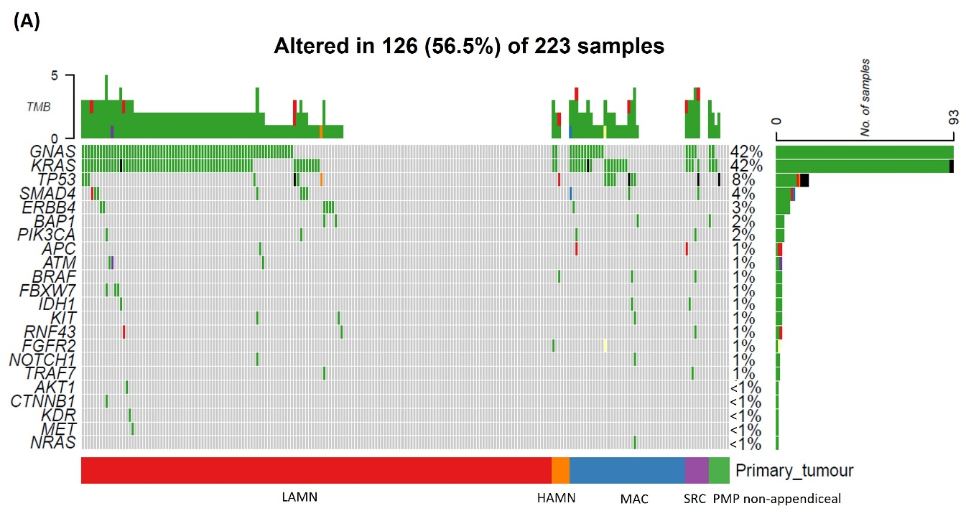
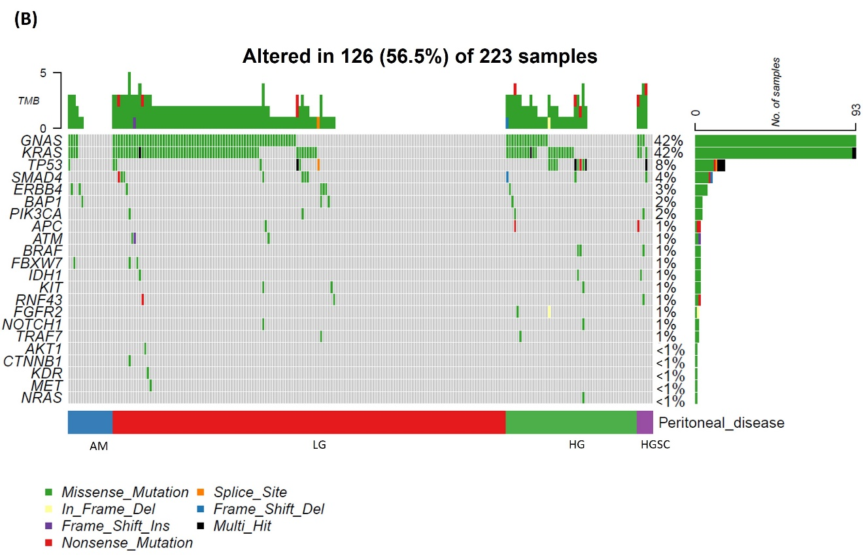
Figure 2. Mutual exclusivity and co-occurrence of mutations.
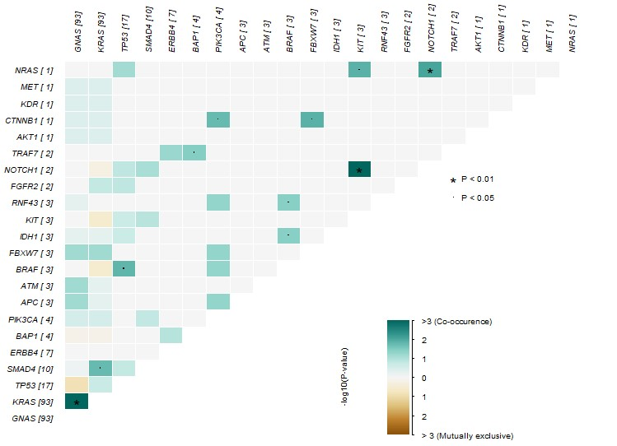
Figure 3. Kaplan-Meier Survival plot, stratified by A) primary tumour and B) peritoneal disease.
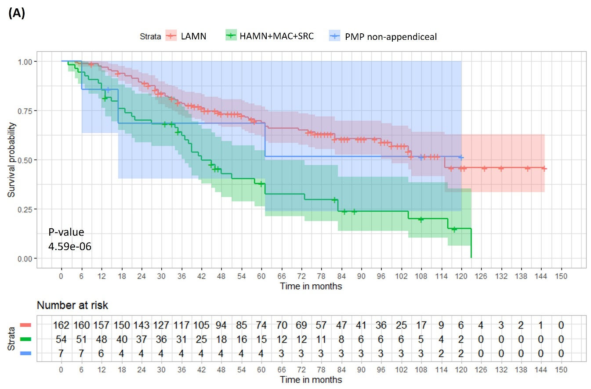
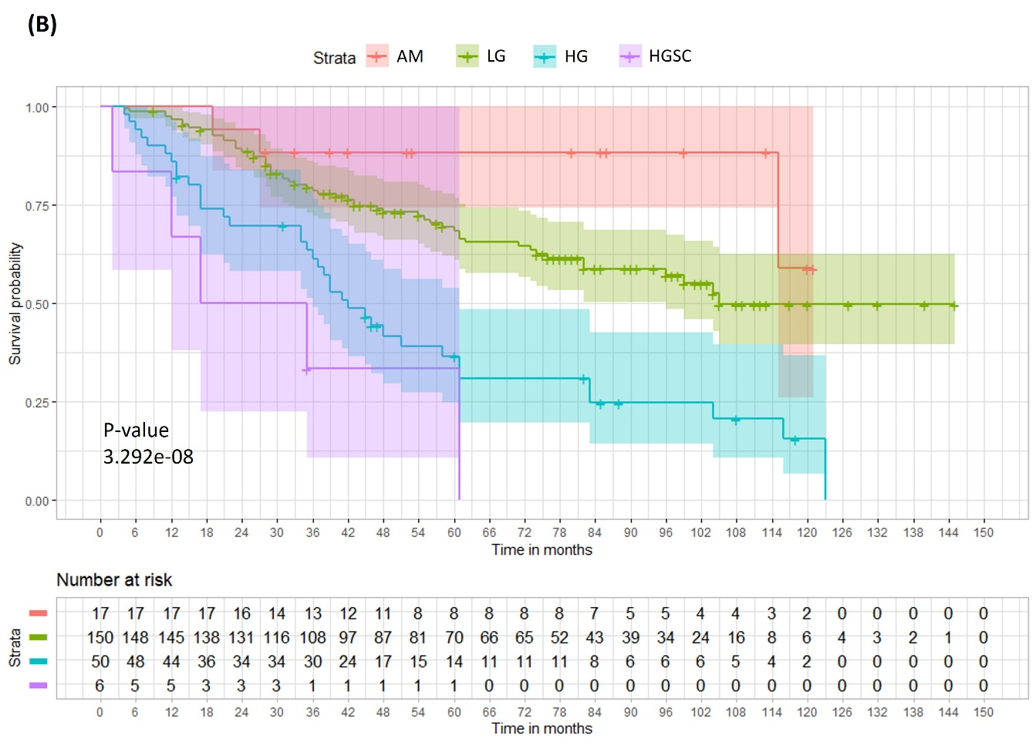
Figure 4. Cox proportional hazards multivariable model forest plot(s) A) Including CC score and primary tumour and B) Including peritoneal disease type with acellular mucin (AM) excluded.
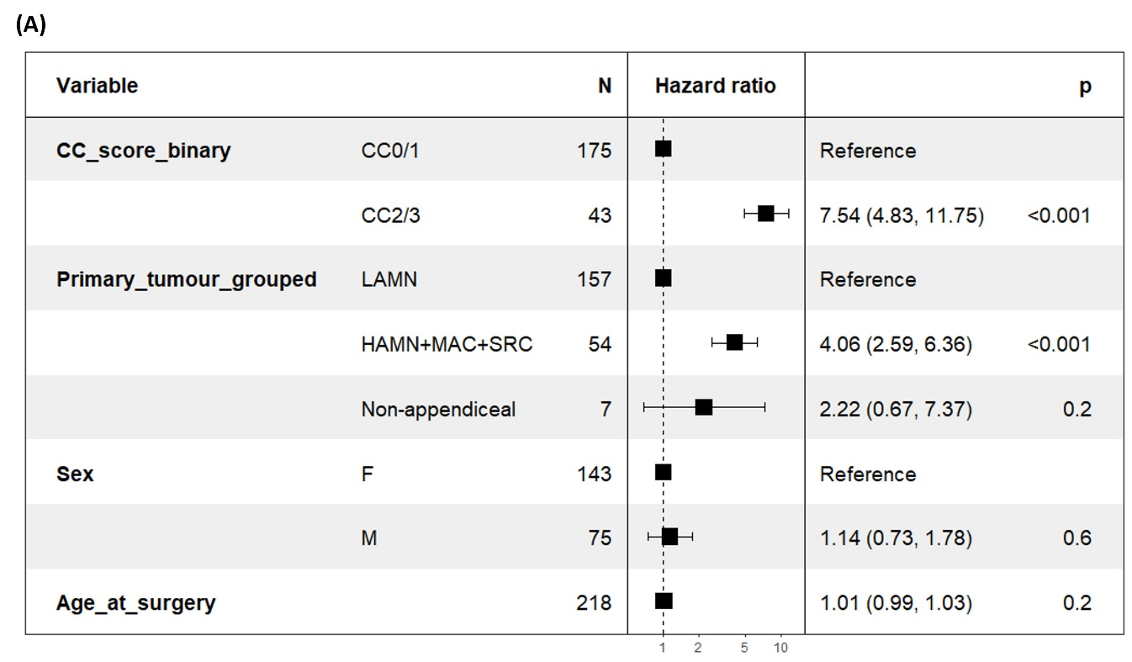
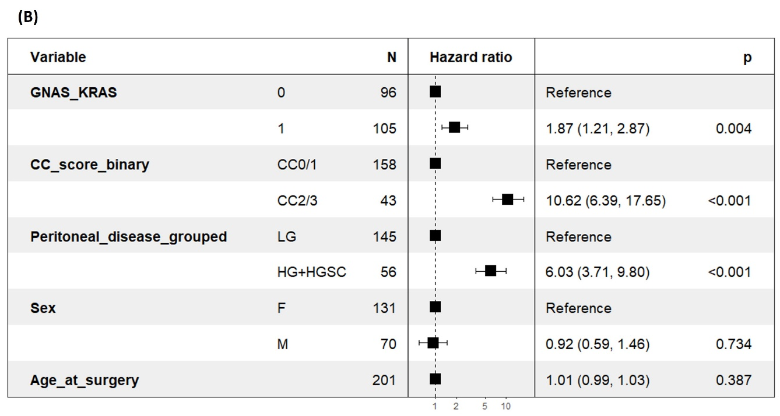
Tables
Table 1. Patient/sample demographic and clinical data according to the grade of the peritoneal disease. (AM: acellular mucin; LG: low grade; HG: high grade; HGSC: high grade with signet ring cells; MAC: mucinous adenocarcinoma; SRC: mucinous adenocarcinoma with signet ring cells).
 | AM  (N=17) | LG (G1)  (N=150) | HG (G2)  (N=50) | HGSC (G3)  (N=6) | Overall  (N=223)
Age at surgery
Mean (SD) | 61.4 (11.1) | 57.6 (12.0) | 55.6 (13.3) | 50.0 (17.0) | 57.2 (12.5)
Median [Min, Max] | 60.0 [43.0, 76.0] | 58.0 [30.0, 85.0] | 55.0 [27.0, 84.0] | 49.0 [32.0, 78.0] | 57.0 [27.0, 85.0]
Sex
F | 12 (70.6%) | 104 (69.3%) | 29 (58.0%) | 2 (33.3%) | 147 (65.9%)
M | 5 (29.4%) | 46 (30.7%) | 21 (42.0%) | 4 (66.7%) | 76 (34.1%)
Time from first surgery to follow up (months)
Mean (SD) | 68.5 (35.9) | 61.9 (33.8) | 46.7 (34.0) | 27.0 (21.1) | 58.1 (34.6)
Median [Min, Max] | 53.0 [19.0, 121] | 57.5 [4.00, 145] | 40.0 [4.00, 123] | 26.0 [2.00, 61.0] | 50.0 [2.00, 145]
CC score
CC0 (no residual disease) | 9 (52.9%) | 33 (22.0%) | 24 (48.0%) | 2 (33.3%) | 68 (30.5%)
CC1 (< 0.25cm) | 8 (47.1%) | 76 (50.7%) | 21 (42.0%) | 2 (33.3%) | 107 (48.0%)
CC2 (0.25 - 2.5 cm) | 0 (0%) | 8 (5.3%) | 1 (2.0%) | 0 (0%) | 9 (4.0%)
CC3 (> 2.5 cm) | 0 (0%) | 28 (18.7%) | 4 (8.0%) | 2 (33.3%) | 34 (15.2%)
Missing | 0 (0%) | 5 (3.3%) | 0 (0%) | 0 (0%) | 5 (2.2%)
Primary site
Appendix | 16 (94.1%) | 147 (98.0%) | 47 (94.0%) | 6 (100%) | 216 (96.9%)
Ovarian teratoma | 1 (5.9%) | 2 (1.3%) | 1 (2.0%) | 0 (0%) | 4 (1.8%)
Urachus | 0 (0%) | 1 (0.7%) | 1 (2.0%) | 0 (0%) | 2 (0.9%)
Kidney | 0 (0%) | 0 (0%) | 1 (2.0%) | 0 (0%) | 1 (0.4%)
Primary tumour
LAMN | 14 (82.4%) | 145 (96.7%) | 3 (6.0%) | 0 (0%) | 162 (72.6%)
HAMN | 0 (0%) | 0 (0%) | 6 (12.0%) | 0 (0%) | 6 (2.7%)
Appendiceal MAC | 2 (11.8%) | 2 (1.3%) | 36 (72.0%) | 0 (0%) | 40 (17.9%)
Appendiceal SRC | 0 (0%) | 0 (0%) | 2 (4.0%) | 6 (100%) | 8 (3.6%)
PMP non-appendiceal | 1 (5.9%) | 3 (2.0%) | 3 (6.0%) | 0 (0%) | 7 (3.1%)
Pre-op CA19.9 (U/mL)
Mean (SD) | 48.6 (66.8) | 862 (2570) | 376 (965) | 266 (378) | 679 (2190)
Median [Min, Max] | 16.0 [6.00, 251] | 187 [0, 20400] | 121 [0, 6040] | 48.0 [3.00, 879] | 127 [0, 20400]
Missing | 1 (5.9%) | 5 (3.3%) | 4 (8.0%) | 0 (0%) | 10 (4.5%)
Pre-op CA125 (U/mL)
Mean (SD) | 25.1 (20.3) | 58.2 (61.3) | 75.2 (181) | 74.3 (36.9) | 59.9 (100)
Median [Min, Max] | 18.0 [3.00, 73.0] | 38.0 [2.00, 403] | 25.3 [4.00, 1260] | 75.5 [15.0, 122] | 34.5 [2.00, 1260]
Missing | 0 (0%) | 6 (4.0%) | 1 (2.0%) | 0 (0%) | 7 (3.1%)
Pre-op CEA (ng/mL)
Mean (SD) | 25.2 (66.1) | 61.9 (154) | 50.2 (151) | 13.6 (18.6) | 55.0 (147)
Median [Min, Max] | 4.70 [0.500, 272] | 21.0 [0.500, 1650] | 9.70 [0.500, 890] | 6.85 [2.30, 51.0] | 15.0 [0.500, 1650]
Missing | 0 (0%) | 6 (4.0%) | 1 (2.0%) | 0 (0%) | 7 (3.1%)

Table 2. Grade of pseudomyxoma peritonei according to type of primary neoplasm. (AM: acellular mucin; LG: low grade; HG: high grade; HGSC: high grade with signet ring cells; MAC: mucinous adenocarcinoma; SRC: mucinous adenocarcinoma with signet ring cells).

 |  | Peritoneal disease
 |  | AM | LG (G1) | HG (G2) | HGSC (G3)
Primary tumour | LAMN (G1) | 14 | 145 | 3 | 0
Primary tumour | HAMN (G2) | 0 | 0 | 6 | 0
Primary tumour | Appendiceal MAC (G2) | 2 | 2 | 36 | 0
Primary tumour | Appendiceal SRC (G3) | 0 | 0 | 2 | 6
Primary tumour | Non-appendiceal primary | 1 | 3 | 3 | 0

Supplementary material
Supplementary table 1. Sequencing panel targets
Supplementary Table 1. Target Regions (hg38)
chr1 | 22078430 | 22078509 | PoolA_CDC42_22404923_22405002
chr1 | 22078510 | 22078568 | PoolB_CDC42_22404991_22405061
chr1 | 22078569 | 22078624 | PoolA_CDC42_22405050_22405117
chr1 | 22081683 | 22081772 | PoolB_CDC42_22408176_22408265
chr1 | 22081773 | 22081820 | PoolA_CDC42_22408238_22408313
chr1 | 22086367 | 22086435 | PoolB_CDC42_22412860_22412928
chr1 | 22086436 | 22086509 | PoolA_CDC42_22412921_22413002
chr1 | 22086537 | 22086609 | PoolB_CDC42_22413030_22413102
chr1 | 22086626 | 22086706 | PoolA_CDC42_22413119_22413199
chr1 | 22086707 | 22086786 | PoolB_CDC42_22413188_22413279
chr1 | 22086787 | 22086853 | PoolA_CDC42_22413268_22413346
chr1 | 22086854 | 22086914 | PoolB_CDC42_22413335_22413407
chr1 | 22089907 | 22089995 | PoolA_CDC42_22416400_22416488
chr1 | 22089996 | 22090063 | PoolB_CDC42_22416474_22416556
chr1 | 22091396 | 22091476 | PoolA_CDC42_22417889_22417969
chr1 | 22091477 | 22091546 | PoolB_CDC42_22417958_22418039
chr1 | 43349298 | 43349415 | CHP2_MPL_1
chr1 | 114709565 | 114709648 | CHP2_NRAS_3
chr1 | 114713884 | 114713963 | CHP2_NRAS_2
chr1 | 114716069 | 114716153 | CHP2_NRAS_1
chr1 | 150927617 | 150927709 | PoolA_SETDB1_150900093_150900185
chr1 | 150927710 | 150927772 | PoolB_SETDB1_150900174_150900248
chr1 | 150927773 | 150927841 | PoolA_SETDB1_150900237_150900317
chr1 | 150927842 | 150927924 | PoolB_SETDB1_150900306_150900400
chr1 | 150927925 | 150928001 | PoolA_SETDB1_150900390_150900477
chr1 | 150929869 | 150929953 | PoolB_SETDB1_150902345_150902429
chr1 | 150929954 | 150930021 | PoolA_SETDB1_150902418_150902497
chr1 | 150930022 | 150930094 | PoolB_SETDB1_150902486_150902570
chr1 | 150930095 | 150930158 | PoolA_SETDB1_150902559_150902634
chr1 | 150939897 | 150939977 | PoolB_SETDB1_150912373_150912453
chr1 | 150939978 | 150940051 | PoolA_SETDB1_150912442_150912527
chr1 | 150941291 | 150941375 | PoolB_SETDB1_150913767_150913851
chr1 | 150941376 | 150941454 | PoolA_SETDB1_150913840_150913930
chr1 | 150942514 | 150942607 | PoolB_SETDB1_150914990_150915083
chr1 | 150942608 | 150942688 | PoolA_SETDB1_150915072_150915164
chr1 | 150942689 | 150942759 | PoolB_SETDB1_150915153_150915235
chr1 | 150942782 | 150942855 | PoolA_SETDB1_150915258_150915331
chr1 | 150942856 | 150942912 | PoolB_SETDB1_150915318_150915388
chr1 | 150942958 | 150943037 | PoolA_SETDB1_150915434_150915513
chr1 | 150943038 | 150943107 | PoolB_SETDB1_150915502_150915583
chr1 | 150943833 | 150943920 | PoolA_SETDB1_150916309_150916396
chr1 | 150943921 | 150943993 | PoolB_SETDB1_150916385_150916469
chr1 | 150943994 | 150944059 | PoolA_SETDB1_150916458_150916535
chr1 | 150944869 | 150944956 | PoolB_SETDB1_150917345_150917432
chr1 | 150944957 | 150945026 | PoolA_SETDB1_150917421_150917502
chr1 | 150945027 | 150945110 | PoolB_SETDB1_150917495_150917586
chr1 | 150945111 | 150945187 | PoolA_SETDB1_150917580_150917663
chr1 | 150946846 | 150946935 | PoolB_SETDB1_150919322_150919411
chr1 | 150946936 | 150947000 | PoolA_SETDB1_150919400_150919476
chr1 | 150947001 | 150947071 | PoolB_SETDB1_150919463_150919547
chr1 | 150949093 | 150949185 | PoolA_SETDB1_150921569_150921661
chr1 | 150949186 | 150949269 | PoolB_SETDB1_150921657_150921745
chr1 | 150949270 | 150949332 | PoolA_SETDB1_150921732_150921808
chr1 | 150949354 | 150949432 | PoolB_SETDB1_150921830_150921908
chr1 | 150949433 | 150949500 | PoolA_SETDB1_150921891_150921976
chr1 | 150949501 | 150949585 | PoolB_SETDB1_150921967_150922061
chr1 | 150950427 | 150950523 | PoolA_SETDB1_150922903_150922999
chr1 | 150950524 | 150950575 | PoolB_SETDB1_150922959_150923051
chr1 | 150950591 | 150950672 | PoolA_SETDB1_150923067_150923148
chr1 | 150950673 | 150950735 | PoolB_SETDB1_150923135_150923211
chr1 | 150950769 | 150950842 | PoolA_SETDB1_150923245_150923318
chr1 | 150950843 | 150950911 | PoolB_SETDB1_150923307_150923387
chr1 | 150950912 | 150950994 | PoolA_SETDB1_150923376_150923470
chr1 | 150950995 | 150951048 | PoolB_SETDB1_150923449_150923524
chr1 | 150951049 | 150951118 | PoolA_SETDB1_150923513_150923594
chr1 | 150951295 | 150951377 | PoolB_SETDB1_150923771_150923853
chr1 | 150951378 | 150951447 | PoolA_SETDB1_150923842_150923923
chr1 | 150951448 | 150951515 | PoolB_SETDB1_150923912_150923991
chr1 | 150959149 | 150959232 | PoolA_SETDB1_150931625_150931708
chr1 | 150959233 | 150959301 | PoolB_SETDB1_150931697_150931777
chr1 | 150959302 | 150959372 | PoolA_SETDB1_150931763_150931848
chr1 | 150960542 | 150960631 | PoolB_SETDB1_150933018_150933107
chr1 | 150960632 | 150960713 | PoolA_SETDB1_150933096_150933189
chr1 | 150960713 | 150960793 | PoolB_SETDB1_150933189_150933269
chr1 | 150960794 | 150960860 | PoolA_SETDB1_150933258_150933336
chr1 | 150960884 | 150960966 | PoolB_SETDB1_150933360_150933442
chr1 | 150960967 | 150961049 | PoolA_SETDB1_150933433_150933525
chr1 | 150961049 | 150961140 | PoolB_SETDB1_150933525_150933616
chr1 | 150961158 | 150961250 | PoolA_SETDB1_150933634_150933726
chr1 | 150962068 | 150962153 | PoolB_SETDB1_150934544_150934629
chr1 | 150962520 | 150962611 | PoolA_SETDB1_150934996_150935087
chr1 | 150962612 | 150962685 | PoolB_SETDB1_150935076_150935161
chr1 | 150962686 | 150962753 | PoolA_SETDB1_150935150_150935229
chr1 | 150962945 | 150963041 | PoolB_SETDB1_150935421_150935517
chr1 | 150963042 | 150963087 | PoolA_SETDB1_150935469_150935563
chr1 | 150963088 | 150963152 | PoolB_SETDB1_150935553_150935628
chr1 | 150963153 | 150963225 | PoolA_SETDB1_150935617_150935701
chr1 | 150963487 | 150963568 | PoolB_SETDB1_150935963_150936044
chr1 | 150963569 | 150963644 | PoolA_SETDB1_150936033_150936120
chr1 | 150963645 | 150963691 | PoolB_SETDB1_150936094_150936167
chr1 | 150963943 | 150964037 | PoolA_SETDB1_150936419_150936513
chr1 | 150964038 | 150964119 | PoolB_SETDB1_150936504_150936595
chr1 | 150964174 | 150964261 | PoolA_SETDB1_150936650_150936737
chr1 | 150964262 | 150964337 | PoolB_SETDB1_150936726_150936813
chr1 | 150964338 | 150964410 | PoolA_SETDB1_150936802_150936886
chr10 | 43113619 | 43113734 | CHP2_RET_1
chr10 | 43114427 | 43114562 | CHP2_RET_2
chr10 | 43118347 | 43118445 | CHP2_RET_3
chr10 | 43120099 | 43120239 | CHP2_RET_4
chr10 | 43121867 | 43121985 | CHP2_RET_5
chr10 | 87864451 | 87864543 | CHP2_PTEN_1
chr10 | 87925502 | 87925617 | CHP2_PTEN_2
chr10 | 87933057 | 87933163 | CHP2_PTEN_3
chr10 | 87952048 | 87952175 | CHP2_PTEN_4
chr10 | 87957747 | 87957863 | CHP2_PTEN_5
chr10 | 87957910 | 87958023 | CHP2_PTEN_6
chr10 | 87960939 | 87960990 | CHP2_PTEN_7
chr10 | 87961028 | 87961143 | CHP2_PTEN_8
chr10 | 121498439 | 121498531 | CHP2_FGFR2_4
chr10 | 121515208 | 121515321 | CHP2_FGFR2_3
chr10 | 121519904 | 121520030 | CHP2_FGFR2_2
chr10 | 121520094 | 121520199 | CHP2_FGFR2_1
chr11 | 533813 | 533930 | CHP2_HRAS_2
chr11 | 534221 | 534308 | CHP2_HRAS_1
chr11 | 108247039 | 108247138 | CHP2_ATM_1
chr11 | 108249089 | 108249164 | CHP2_ATM_2
chr11 | 108252789 | 108252891 | CHP2_ATM_3
chr11 | 108267205 | 108267298 | CHP2_ATM_4
chr11 | 108284357 | 108284453 | CHP2_ATM_5
chr11 | 108299730 | 108299829 | CHP2_ATM_6
chr11 | 108301636 | 108301740 | CHP2_ATM_7
chr11 | 108302904 | 108302976 | CHP2_ATM_8
chr11 | 108310176 | 108310233 | CHP2_ATM_9
chr11 | 108330189 | 108330266 | CHP2_ATM_10
chr11 | 108333908 | 108333957 | CHP2_ATM_11
chr11 | 108335005 | 108335089 | CHP2_ATM_12
chr11 | 108335797 | 108335901 | CHP2_ATM_13
chr11 | 108347289 | 108347417 | CHP2_ATM_14
chr11 | 108354823 | 108354905 | CHP2_ATM_15
chr11 | 108365316 | 108365413 | CHP2_ATM_16
chr11 | 108365460 | 108365558 | CHP2_ATM_17
chr12 | 25225616 | 25225724 | CHP2_KRAS_3
chr12 | 25227327 | 25227430 | CHP2_KRAS_2
chr12 | 25245253 | 25245370 | CHP2_KRAS_1
chr12 | 112450315 | 112450424 | CHP2_PTPN11_1
chr12 | 112489032 | 112489157 | CHP2_PTPN11_2
chr12 | 120993569 | 120993656 | CHP2_HNF1A_1
chr12 | 120994208 | 120994296 | CHP2_HNF1A_2
chr13 | 28018443 | 28018526 | CHP2_FLT3_4
chr13 | 28028139 | 28028242 | CHP2_FLT3_3
chr13 | 28034091 | 28034211 | CHP2_FLT3_2
chr13 | 28035957 | 28036047 | CHP2_FLT3_1
chr13 | 48345088 | 48345176 | CHP2_RB1_1
chr13 | 48349004 | 48349119 | CHP2_RB1_2
chr13 | 48367466 | 48367588 | CHP2_RB1_3
chr13 | 48368462 | 48368575 | CHP2_RB1_4
chr13 | 48379618 | 48379738 | CHP2_RB1_5
chr13 | 48381390 | 48381469 | CHP2_RB1_6
chr13 | 48452970 | 48453042 | CHP2_RB1_7
chr13 | 48459692 | 48459798 | CHP2_RB1_8
chr13 | 48463711 | 48463796 | CHP2_RB1_9
chr13 | 48465014 | 48465096 | CHP2_RB1_10
chr14 | 104775097 | 104775182 | CHP2_AKT1_2
chr14 | 104780109 | 104780246 | CHP2_AKT1_1
chr15 | 90088593 | 90088722 | CHP2_IDH2_1
chr16 | 2163824 | 2163926 | PoolA_TRAF7_2213825_2213927
chr16 | 2163927 | 2164016 | PoolB_TRAF7_2213918_2214017
chr16 | 2164017 | 2164058 | PoolA_TRAF7_2213958_2214059
chr16 | 2165822 | 2165917 | PoolB_TRAF7_2215823_2215918
chr16 | 2165918 | 2165996 | PoolA_TRAF7_2215903_2215997
chr16 | 2167982 | 2168077 | PoolB_TRAF7_2217983_2218078
chr16 | 2168078 | 2168155 | PoolA_TRAF7_2218067_2218156
chr16 | 2168156 | 2168234 | PoolB_TRAF7_2218145_2218235
chr16 | 2170615 | 2170721 | PoolA_TRAF7_2220616_2220722
chr16 | 2170722 | 2170817 | PoolB_TRAF7_2220714_2220818
chr16 | 2171175 | 2171263 | PoolA_TRAF7_2221176_2221264
chr16 | 2171264 | 2171338 | PoolB_TRAF7_2221249_2221339
chr16 | 2171503 | 2171600 | PoolA_TRAF7_2221504_2221601
chr16 | 2172130 | 2172226 | PoolB_TRAF7_2222131_2222227
chr16 | 2172227 | 2172315 | PoolA_TRAF7_2222216_2222316
chr16 | 2172365 | 2172456 | PoolB_TRAF7_2222366_2222457
chr16 | 2172457 | 2172524 | PoolA_TRAF7_2222432_2222525
chr16 | 2172525 | 2172583 | PoolB_TRAF7_2222492_2222584
chr16 | 2172584 | 2172643 | PoolA_TRAF7_2222559_2222644
chr16 | 2173113 | 2173209 | PoolB_TRAF7_2223114_2223210
chr16 | 2173209 | 2173306 | PoolA_TRAF7_2223210_2223307
chr16 | 2173307 | 2173387 | PoolB_TRAF7_2223290_2223388
chr16 | 2173388 | 2173472 | PoolA_TRAF7_2223377_2223473
chr16 | 2173479 | 2173578 | PoolB_TRAF7_2223480_2223579
chr16 | 2173579 | 2173633 | PoolA_TRAF7_2223553_2223634
chr16 | 2173735 | 2173823 | PoolB_TRAF7_2223736_2223824
chr16 | 2173824 | 2173908 | PoolA_TRAF7_2223810_2223909
chr16 | 2173928 | 2174023 | PoolB_TRAF7_2223929_2224024
chr16 | 2174024 | 2174117 | PoolA_TRAF7_2224018_2224118
chr16 | 2174192 | 2174275 | PoolB_TRAF7_2224193_2224276
chr16 | 2174276 | 2174359 | PoolA_TRAF7_2224268_2224360
chr16 | 2175040 | 2175136 | PoolB_TRAF7_2225041_2225137
chr16 | 2175137 | 2175213 | PoolA_TRAF7_2225126_2225214
chr16 | 2175232 | 2175322 | PoolB_TRAF7_2225233_2225323
chr16 | 2175323 | 2175403 | PoolA_TRAF7_2225312_2225404
chr16 | 2175404 | 2175476 | PoolB_TRAF7_2225393_2225477
chr16 | 2175512 | 2175613 | PoolA_TRAF7_2225513_2225614
chr16 | 2175614 | 2175692 | PoolB_TRAF7_2225603_2225693
chr16 | 2175763 | 2175862 | PoolA_TRAF7_2225764_2225863
chr16 | 2175863 | 2175934 | PoolB_TRAF7_2225850_2225935
chr16 | 2175935 | 2176007 | PoolA_TRAF7_2225924_2226008
chr16 | 2176022 | 2176121 | PoolB_TRAF7_2226023_2226122
chr16 | 2176122 | 2176146 | PoolA_TRAF7_2226064_2226147
chr16 | 2176178 | 2176269 | PoolB_TRAF7_2226179_2226270
chr16 | 2176270 | 2176361 | PoolA_TRAF7_2226259_2226362
chr16 | 2176385 | 2176484 | PoolB_TRAF7_2226386_2226485
chr16 | 2176502 | 2176604 | PoolA_TRAF7_2226503_2226605
chr16 | 2176605 | 2176677 | PoolB_TRAF7_2226584_2226678
chr16 | 2176692 | 2176779 | PoolA_TRAF7_2226693_2226780
chr16 | 2176780 | 2176852 | PoolB_TRAF7_2226761_2226853
chr16 | 2176853 | 2176950 | PoolA_TRAF7_2226851_2226951
chr16 | 2176951 | 2177033 | PoolB_TRAF7_2226940_2227034
chr16 | 2177034 | 2177105 | PoolA_TRAF7_2227006_2227106
chr16 | 2177106 | 2177193 | PoolB_TRAF7_2227104_2227194
chr16 | 2177194 | 2177288 | PoolA_TRAF7_2227183_2227289
chr16 | 2177305 | 2177396 | PoolB_TRAF7_2227306_2227397
chr16 | 2177407 | 2177509 | PoolA_TRAF7_2227408_2227510
chr16 | 2177510 | 2177580 | PoolB_TRAF7_2227499_2227581
chr16 | 2177581 | 2177669 | PoolA_TRAF7_2227572_2227670
chr16 | 2177670 | 2177760 | PoolB_TRAF7_2227662_2227761
chr16 | 2177761 | 2177833 | PoolA_TRAF7_2227738_2227834
chr16 | 2177892 | 2177978 | PoolB_TRAF7_2227893_2227979
chr16 | 2177979 | 2178050 | PoolA_TRAF7_2227968_2228051
chr16 | 2178103 | 2178209 | PoolB_TRAF7_2228104_2228210
chr16 | 68801700 | 68801794 | CHP2_CDH1_1
chr16 | 68812122 | 68812248 | CHP2_CDH1_2
chr16 | 68813297 | 68813399 | CHP2_CDH1_3
chr17 | 7670606 | 7670717 | CHP2_TP53_8
chr17 | 7673698 | 7673833 | CHP2_TP53_7
chr17 | 7674191 | 7674294 | CHP2_TP53_6
chr17 | 7674863 | 7674980 | CHP2_TP53_5
chr17 | 7675035 | 7675165 | CHP2_TP53_4
chr17 | 7675199 | 7675283 | CHP2_TP53_3
chr17 | 7676033 | 7676167 | CHP2_TP53_2
chr17 | 7676536 | 7676642 | CHP2_TP53_1
chr17 | 39723960 | 39724087 | CHP2_ERBB2_1
chr17 | 39724701 | 39724808 | CHP2_ERBB2_2
chr17 | 39725072 | 39725200 | CHP2_ERBB2_3
chr17 | 58354870 | 58354966 | PoolA_RNF43_56432231_56432327
chr17 | 58354991 | 58355085 | PoolB_RNF43_56432352_56432446
chr17 | 58357424 | 58357519 | PoolA_RNF43_56434785_56434880
chr17 | 58357520 | 58357595 | PoolB_RNF43_56434869_56434956
chr17 | 58357750 | 58357848 | PoolA_RNF43_56435111_56435209
chr17 | 58357868 | 58357962 | PoolB_RNF43_56435229_56435323
chr17 | 58357963 | 58357990 | PoolA_RNF43_56435259_56435351
chr17 | 58358037 | 58358125 | PoolB_RNF43_56435398_56435486
chr17 | 58358126 | 58358193 | PoolA_RNF43_56435470_56435554
chr17 | 58358219 | 58358314 | PoolB_RNF43_56435580_56435675
chr17 | 58358315 | 58358345 | PoolA_RNF43_56435613_56435706
chr17 | 58358664 | 58358760 | PoolB_RNF43_56436025_56436121
chr17 | 58358770 | 58358848 | PoolA_RNF43_56436131_56436209
chr17 | 58360112 | 58360205 | PoolB_RNF43_56437473_56437566
chr17 | 58360206 | 58360276 | PoolA_RNF43_56437555_56437637
chr17 | 58360698 | 58360795 | PoolB_RNF43_56438059_56438156
chr17 | 58360821 | 58360918 | PoolA_RNF43_56438182_56438279
chr17 | 58360938 | 58361020 | PoolB_RNF43_56438299_56438381
chr17 | 58362491 | 58362586 | PoolA_RNF43_56439852_56439947
chr17 | 58362598 | 58362688 | PoolB_RNF43_56439959_56440049
chr17 | 58363206 | 58363287 | PoolA_RNF43_56440567_56440648
chr17 | 58363288 | 58363363 | PoolB_RNF43_56440635_56440724
chr17 | 58363514 | 58363609 | PoolA_RNF43_56440875_56440970
chr17 | 58363610 | 58363671 | PoolB_RNF43_56440938_56441032
chr17 | 58370854 | 58370952 | PoolA_RNF43_56448215_56448313
chr17 | 58370953 | 58371000 | PoolB_RNF43_56448279_56448361
chr17 | 58371001 | 58371079 | PoolA_RNF43_56448354_56448440
chr17 | 58415279 | 58415366 | PoolB_RNF43_56492640_56492727
chr17 | 58415367 | 58415439 | PoolA_RNF43_56492716_56492800
chr17 | 58415501 | 58415595 | PoolB_RNF43_56492862_56492956
chr17 | 58415596 | 58415663 | PoolA_RNF43_56492946_56493024
chr18 | 51048730 | 51048843 | CHP2_SMAD4_1
chr18 | 51049187 | 51049307 | CHP2_SMAD4_2
chr18 | 51054821 | 51054932 | CHP2_SMAD4_3
chr18 | 51058182 | 51058308 | CHP2_SMAD4_4
chr18 | 51059882 | 51059991 | CHP2_SMAD4_5
chr18 | 51065445 | 51065561 | CHP2_SMAD4_6
chr18 | 51067030 | 51067149 | CHP2_SMAD4_7
chr18 | 51076659 | 51076749 | CHP2_SMAD4_8
chr18 | 51078289 | 51078404 | CHP2_SMAD4_9
chr19 | 1206979 | 1207105 | CHP2_STK11_1
chr19 | 1220312 | 1220451 | CHP2_STK11_2
chr19 | 1220482 | 1220604 | CHP2_STK11_3
chr19 | 1221238 | 1221333 | CHP2_STK11_4
chr19 | 1223016 | 1223145 | CHP2_STK11_5
chr19 | 3118884 | 3118975 | CHP2_GNA11_1
chr19 | 17834808 | 17834925 | CHP2_JAK3_3
chr19 | 17837178 | 17837265 | CHP2_JAK3_2
chr19 | 17843326 | 17843416 | CHP2_JAK3_1
chr2 | 29209707 | 29209814 | CHP2_ALK_2
chr2 | 29220742 | 29220863 | CHP2_ALK_1
chr2 | 208248380 | 208248482 | CHP2_IDH1_1
chr2 | 211424180 | 211424265 | CHP2_ERBB4_8
chr2 | 211665327 | 211665455 | CHP2_ERBB4_7
chr2 | 211712075 | 211712185 | CHP2_ERBB4_6
chr2 | 211713564 | 211713690 | CHP2_ERBB4_5
chr2 | 211722409 | 211722514 | CHP2_ERBB4_4
chr2 | 211725040 | 211725142 | CHP2_ERBB4_3
chr2 | 211787995 | 211788081 | CHP2_ERBB4_2
chr2 | 211947351 | 211947444 | CHP2_ERBB4_1
chr20 | 37403264 | 37403366 | CHP2_SRC_1
chr20 | 58909342 | 58909449 | CHP2_GNAS_1
chr20 | 58909508 | 58909617 | CHP2_GNAS_2
chr22 | 23791767 | 23791877 | CHP2_SMARCB1_1
chr22 | 23801014 | 23801124 | CHP2_SMARCB1_2
chr22 | 23803291 | 23803411 | CHP2_SMARCB1_3
chr22 | 23834073 | 23834204 | CHP2_SMARCB1_4
chr22 | 29603957 | 29604052 | PoolA_NF2_29999946_30000041
chr22 | 29604053 | 29604140 | PoolB_NF2_30000030_30000129
chr22 | 29636677 | 29636765 | PoolA_NF2_30032666_30032754
chr22 | 29636766 | 29636832 | PoolB_NF2_30032743_30032821
chr22 | 29636833 | 29636913 | PoolA_NF2_30032811_30032902
chr22 | 29639061 | 29639153 | PoolB_NF2_30035050_30035142
chr22 | 29639154 | 29639237 | PoolA_NF2_30035134_30035226
chr22 | 29642142 | 29642220 | PoolB_NF2_30038131_30038209
chr22 | 29642221 | 29642291 | PoolA_NF2_30038198_30038280
chr22 | 29642292 | 29642351 | PoolB_NF2_30038259_30038340
chr22 | 29654598 | 29654689 | PoolA_NF2_30050587_30050678
chr22 | 29654690 | 29654754 | PoolB_NF2_30050659_30050743
chr22 | 29655554 | 29655640 | PoolA_NF2_30051543_30051629
chr22 | 29655640 | 29655727 | PoolB_NF2_30051629_30051716
chr22 | 29658121 | 29658214 | PoolA_NF2_30054110_30054203
chr22 | 29658215 | 29658289 | PoolB_NF2_30054192_30054278
chr22 | 29661113 | 29661202 | PoolA_NF2_30057102_30057191
chr22 | 29661203 | 29661285 | PoolB_NF2_30057180_30057274
chr22 | 29661286 | 29661359 | PoolA_NF2_30057263_30057348
chr22 | 29661360 | 29661427 | PoolB_NF2_30057337_30057416
chr22 | 29664928 | 29665016 | PoolA_NF2_30060917_30061005
chr22 | 29665017 | 29665070 | PoolB_NF2_30060987_30061059
chr22 | 29668307 | 29668395 | PoolA_NF2_30064296_30064384
chr22 | 29668396 | 29668471 | PoolB_NF2_30064374_30064460
chr22 | 29671783 | 29671871 | PoolA_NF2_30067772_30067860
chr22 | 29671872 | 29671903 | PoolB_NF2_30067801_30067892
chr22 | 29673240 | 29673328 | PoolA_NF2_30069229_30069317
chr22 | 29673329 | 29673394 | PoolB_NF2_30069297_30069383
chr22 | 29673465 | 29673556 | PoolA_NF2_30069454_30069545
chr22 | 29674810 | 29674898 | PoolB_NF2_30070799_30070887
chr22 | 29674899 | 29674968 | PoolA_NF2_30070864_30070957
chr22 | 29678137 | 29678224 | PoolB_NF2_30074126_30074213
chr22 | 29678225 | 29678279 | PoolA_NF2_30074193_30074268
chr22 | 29678280 | 29678353 | PoolB_NF2_30074257_30074342
chr22 | 29681357 | 29681436 | PoolA_NF2_30077346_30077425
chr22 | 29681437 | 29681506 | PoolB_NF2_30077414_30077495
chr22 | 29681507 | 29681577 | PoolA_NF2_30077484_30077566
chr22 | 29681578 | 29681630 | PoolB_NF2_30077550_30077619
chr22 | 29682944 | 29683035 | PoolA_NF2_30078933_30079024
chr22 | 29683036 | 29683107 | PoolB_NF2_30079013_30079096
chr22 | 29694647 | 29694739 | PoolA_NF2_30090636_30090728
chr22 | 29694740 | 29694831 | PoolB_NF2_30090721_30090820
chr3 | 10142082 | 10142170 | CHP2_VHL_1
chr3 | 10146503 | 10146622 | CHP2_VHL_2
chr3 | 10149735 | 10149843 | CHP2_VHL_3
chr3 | 37025717 | 37025842 | CHP2_MLH1_1
chr3 | 41224539 | 41224656 | CHP2_CTNNB1_1
chr3 | 52402193 | 52402288 | PoolA_BAP1_52436209_52436304
chr3 | 52402406 | 52402503 | PoolB_BAP1_52436422_52436519
chr3 | 52402533 | 52402612 | PoolA_BAP1_52436549_52436628
chr3 | 52402613 | 52402671 | PoolB_BAP1_52436603_52436687
chr3 | 52402672 | 52402750 | PoolA_BAP1_52436676_52436766
chr3 | 52402786 | 52402883 | PoolB_BAP1_52436802_52436899
chr3 | 52402884 | 52402930 | PoolA_BAP1_52436856_52436946
chr3 | 52403041 | 52403133 | PoolB_BAP1_52437057_52437149
chr3 | 52403134 | 52403216 | PoolA_BAP1_52437138_52437232
chr3 | 52403217 | 52403301 | PoolB_BAP1_52437224_52437317
chr3 | 52403507 | 52403595 | PoolA_BAP1_52437523_52437611
chr3 | 52403596 | 52403660 | PoolB_BAP1_52437585_52437676
chr3 | 52403661 | 52403739 | PoolA_BAP1_52437660_52437755
chr3 | 52403759 | 52403841 | PoolB_BAP1_52437775_52437857
chr3 | 52403842 | 52403905 | PoolA_BAP1_52437835_52437921
chr3 | 52404414 | 52404504 | PoolB_BAP1_52438430_52438520
chr3 | 52404505 | 52404590 | PoolA_BAP1_52438511_52438606
chr3 | 52404595 | 52404681 | PoolB_BAP1_52438611_52438697
chr3 | 52405040 | 52405131 | PoolA_BAP1_52439056_52439147
chr3 | 52405141 | 52405232 | PoolB_BAP1_52439157_52439248
chr3 | 52405233 | 52405324 | PoolA_BAP1_52439246_52439340
chr3 | 52405673 | 52405761 | PoolB_BAP1_52439689_52439777
chr3 | 52405762 | 52405851 | PoolA_BAP1_52439769_52439867
chr3 | 52405852 | 52405932 | PoolB_BAP1_52439856_52439948
chr3 | 52405933 | 52405994 | PoolA_BAP1_52439935_52440010
chr3 | 52406187 | 52406282 | PoolB_BAP1_52440203_52440298
chr3 | 52406283 | 52406363 | PoolA_BAP1_52440288_52440379
chr3 | 52406364 | 52406438 | PoolB_BAP1_52440369_52440454
chr3 | 52406753 | 52406845 | PoolA_BAP1_52440769_52440861
chr3 | 52406846 | 52406906 | PoolB_BAP1_52440828_52440922
chr3 | 52406907 | 52406972 | PoolA_BAP1_52440909_52440988
chr3 | 52407103 | 52407187 | PoolB_BAP1_52441119_52441203
chr3 | 52407188 | 52407281 | PoolA_BAP1_52441200_52441297
chr3 | 52407297 | 52407393 | PoolB_BAP1_52441313_52441409
chr3 | 52407410 | 52407486 | PoolA_BAP1_52441426_52441502
chr3 | 52407890 | 52407984 | PoolB_BAP1_52441906_52442000
chr3 | 52407985 | 52408077 | PoolA_BAP1_52441999_52442093
chr3 | 52408078 | 52408154 | PoolB_BAP1_52442082_52442170
chr3 | 52408414 | 52408506 | PoolA_BAP1_52442430_52442522
chr3 | 52408507 | 52408585 | PoolB_BAP1_52442511_52442601
chr3 | 52408586 | 52408659 | PoolA_BAP1_52442598_52442675
chr3 | 52409482 | 52409578 | PoolB_BAP1_52443498_52443594
chr3 | 52409596 | 52409692 | PoolA_BAP1_52443612_52443708
chr3 | 52409693 | 52409720 | PoolB_BAP1_52443637_52443736
chr3 | 52409880 | 52409968 | PoolA_BAP1_52443896_52443984
chr3 | 179198988 | 179199093 | CHP2_PIK3CA_1
chr3 | 179199144 | 179199247 | CHP2_PIK3CA_2
chr3 | 179203677 | 179203782 | CHP2_PIK3CA_3
chr3 | 179209618 | 179209737 | CHP2_PIK3CA_4
chr3 | 179210114 | 179210198 | CHP2_PIK3CA_5
chr3 | 179210282 | 179210372 | CHP2_PIK3CA_6
chr3 | 179218236 | 179218317 | CHP2_PIK3CA_7
chr3 | 179221000 | 179221130 | CHP2_PIK3CA_8
chr3 | 179230031 | 179230108 | CHP2_PIK3CA_9
chr3 | 179234209 | 179234309 | CHP2_PIK3CA_10
chr3 | 179234353 | 179234449 | CHP2_PIK3CA_11
chr4 | 1801825 | 1801926 | CHP2_FGFR3_1
chr4 | 1804355 | 1804460 | CHP2_FGFR3_2
chr4 | 1806107 | 1806203 | CHP2_FGFR3_3
chr4 | 1806585 | 1806672 | CHP2_FGFR3_4
chr4 | 1807155 | 1807279 | CHP2_FGFR3_5
chr4 | 54274815 | 54274936 | CHP2_PDGFRA_1
chr4 | 54277935 | 54278028 | CHP2_PDGFRA_2
chr4 | 54278372 | 54278486 | CHP2_PDGFRA_3
chr4 | 54285858 | 54285987 | CHP2_PDGFRA_4
chr4 | 54695489 | 54695618 | CHP2_KIT_1
chr4 | 54725992 | 54726080 | CHP2_KIT_2
chr4 | 54727252 | 54727347 | CHP2_KIT_3
chr4 | 54727410 | 54727529 | CHP2_KIT_4
chr4 | 54728005 | 54728113 | CHP2_KIT_5
chr4 | 54729331 | 54729396 | CHP2_KIT_6
chr4 | 54731271 | 54731358 | CHP2_KIT_7
chr4 | 54733115 | 54733192 | CHP2_KIT_8
chr4 | 54736508 | 54736585 | CHP2_KIT_9
chr4 | 55079922 | 55080041 | CHP2_KDR_9
chr4 | 55080084 | 55080204 | CHP2_KDR_8
chr4 | 55087609 | 55087693 | CHP2_KDR_7
chr4 | 55088912 | 55089001 | CHP2_KDR_6
chr4 | 55094810 | 55094892 | CHP2_KDR_5
chr4 | 55096278 | 55096381 | CHP2_KDR_4
chr4 | 55106786 | 55106904 | CHP2_KDR_3
chr4 | 55113408 | 55113488 | CHP2_KDR_2
chr4 | 55114072 | 55114192 | CHP2_KDR_1
chr4 | 152324259 | 152324340 | CHP2_FBXW7_5
chr4 | 152326126 | 152326217 | CHP2_FBXW7_4
chr4 | 152328204 | 152328325 | CHP2_FBXW7_3
chr4 | 152329701 | 152329774 | CHP2_FBXW7_2
chr4 | 152337750 | 152337871 | CHP2_FBXW7_1
chr5 | 112838175 | 112838265 | CHP2_APC_1
chr5 | 112838861 | 112838969 | CHP2_APC_2
chr5 | 112839447 | 112839571 | CHP2_APC_3
chr5 | 112839619 | 112839746 | CHP2_APC_4
chr5 | 112839871 | 112840006 | CHP2_APC_5
chr5 | 112840044 | 112840165 | CHP2_APC_6
chr5 | 112840224 | 112840338 | CHP2_APC_7
chr5 | 150054031 | 150054129 | CHP2_CSF1R_2
chr5 | 150073429 | 150073510 | CHP2_CSF1R_1
chr5 | 171410498 | 171410612 | CHP2_NPM1_1
chr7 | 55143352 | 55143433 | CHP2_EGFR_1
chr7 | 55154100 | 55154226 | CHP2_EGFR_2
chr7 | 55165270 | 55165360 | CHP2_EGFR_3
chr7 | 55173943 | 55174036 | CHP2_EGFR_4
chr7 | 55174719 | 55174847 | CHP2_EGFR_5
chr7 | 55181273 | 55181397 | CHP2_EGFR_6
chr7 | 55181430 | 55181552 | CHP2_EGFR_7
chr7 | 55191815 | 55191935 | CHP2_EGFR_8
chr7 | 116699562 | 116699647 | CHP2_MET_1
chr7 | 116700102 | 116700216 | CHP2_MET_2
chr7 | 116763078 | 116763197 | CHP2_MET_3
chr7 | 116771825 | 116771943 | CHP2_MET_4
chr7 | 116777374 | 116777488 | CHP2_MET_5
chr7 | 116783354 | 116783438 | CHP2_MET_6
chr7 | 129205223 | 129205347 | CHP2_SMO_1
chr7 | 129206117 | 129206222 | CHP2_SMO_2
chr7 | 129206497 | 129206578 | CHP2_SMO_3
chr7 | 129210429 | 129210522 | CHP2_SMO_4
chr7 | 129211659 | 129211771 | CHP2_SMO_5
chr7 | 140753303 | 140753421 | CHP2_BRAF_2
chr7 | 140781592 | 140781715 | CHP2_BRAF_1
chr7 | 148811615 | 148811699 | CHP2_EZH2_1
chr8 | 38424623 | 38424736 | CHP2_FGFR1_2
chr8 | 38428334 | 38428457 | CHP2_FGFR1_1
chr9 | 5073730 | 5073857 | CHP2_JAK2_1
chr9 | 21970942 | 21971067 | CHP2_CDKN2A_2
chr9 | 21971092 | 21971220 | CHP2_CDKN2A_1
chr9 | 77794460 | 77794582 | CHP2_GNAQ_1
chr9 | 130862908 | 130862991 | CHP2_ABL1_1
chr9 | 130872056 | 130872143 | CHP2_ABL1_2
chr9 | 130872893 | 130873030 | CHP2_ABL1_3
chr9 | 130874921 | 130875018 | CHP2_ABL1_4
chr9 | 136496313 | 136496433 | CHP2_NOTCH1_3
chr9 | 136503311 | 136503427 | CHP2_NOTCH1_2
chr9 | 136504886 | 136504995 | CHP2_NOTCH1_1
chr1 | 67395805 | 67395908 | chr1_67861488_67861591
chr1 | 179551365 | 179551451 | chr1_179520500_179520586
chr10 | 98459503 | 98459600 | chr10_100219260_100219357
chr11 | 16111802 | 16111872 | chr11_16133348_16133418
chr12 | 884698 | 884768 | chr12_993864_993934
chr13 | 38859459 | 38859561 | chr13_39433596_39433698
chr14 | 50302990 | 50303078 | chr14_50769708_50769796
chr15 | 34236735 | 34236819 | chr15_34528936_34529020
chr16 | 70269595 | 70269712 | chr16_70303498_70303615
chr17 | 73201544 | 73201650 | chr17_71197683_71197789
chr18 | 23833822 | 23833910 | chr18_21413786_21413874
chr19 | 10156366 | 10156448 | chr19_10267042_10267124
chr2 | 168932447 | 168932535 | chr2_169788957_169789045
chr2 | 227032244 | 227032353 | chr2_227896960_227897069
chr20 | 6119429 | 6119519 | chr20_6100076_6100166
chr21 | 42903450 | 42903555 | chr21_44323560_44323665
chr22 | 20786960 | 20787071 | chr22_21141248_21141359
chr3 | 4362001 | 4362105 | chr3_4403685_4403789
chr4 | 5748159 | 5748233 | chr4_5749886_5749960
chr5 | 83538746 | 83538847 | chr5_82834565_82834666
chr6 | 146433986 | 146434073 | chr6_146755122_146755209
chr7 | 48410551 | 48410663 | chr7_48450148_48450260
chr8 | 93923688 | 93923763 | chr8_94935916_94935991
chr9 | 97428465 | 97428532 | chr9_100190747_100190814

Supplementary table 2. Sequencing quality and coverage statistics
Supplementary Table 2. Sequencing QC, mapped to targets on the hg38 reference sequence
Sample ID | Total reads | Total mapped | Bases covered at 1x | Median depth | % bases covered at x100
12H12290 | 3791777 | 3513209 | 45551 | 3386.26 | 0.976279
18H29915 | 5569992 | 5076047 | 45617 | 3642.12 | 0.992991
18H31162 | 3951681 | 3092275 | 45511 | 2623.68 | 0.984208
18H40025 | 11995868 | 9425733 | 45551 | 7156.02 | 0.996233
19H37335 | 7270462 | 6529838 | 45551 | 6846.13 | 0.996167
30789600Y | 2718738 | 2593987 | 45512 | 1914.05 | 0.902116
32150382F | 3256447 | 3138438 | 45512 | 3117.02 | 0.967868
32150385G | 3325097 | 3233420 | 45617 | 3021.91 | 0.990757
32150388H | 2802611 | 2697639 | 45511 | 2341.91 | 0.985194
32150391E | 1930560 | 1871142 | 45551 | 1658.17 | 0.910899
32150393W | 3086154 | 2970144 | 45618 | 2803.88 | 0.97617
32150396X | 3643250 | 3536964 | 45513 | 3017.49 | 0.974067
32150399Y | 2108937 | 2018808 | 45619 | 1808.02 | 0.949864
32150401S | 2106521 | 2010163 | 45512 | 1752.13 | 0.957465
32150404T | 2648276 | 2574014 | 45538 | 2023.31 | 0.95902
32150405C | 2332244 | 2267101 | 45551 | 1497.73 | 0.957136
32150407U | 1465040 | 1416865 | 45551 | 1090.99 | 0.916594
32150410R | 2427268 | 2306081 | 45512 | 2146.4 | 0.958954
32150418L | 2773368 | 2684972 | 45512 | 2432.96 | 0.984734
32150422R | 2044042 | 1993229 | 45618 | 1443.69 | 0.928377
32150424J | 2432449 | 2376809 | 45463 | 1446.25 | 0.967715
32150425S | 2240446 | 2157670 | 45385 | 1669.74 | 0.899663
32150431Q | 2046635 | 1956225 | 45512 | 1074.88 | 0.947104
32150434R | 1643509 | 1592913 | 45464 | 678.26 | 0.898743
32150437S | 1891433 | 1802797 | 45464 | 1427.09 | 0.954661
32153310B | 2508960 | 2370141 | 45620 | 2242.8 | 0.946929
32153323K | 1506641 | 1431863 | 45511 | 1144.1 | 0.920295
32153324T | 2923448 | 2747852 | 45657 | 2526.62 | 0.976323
32153327U | 1471856 | 1436415 | 45511 | 613.85 | 0.878483
32153328D | 1872174 | 1756250 | 45551 | 1528.11 | 0.916221
32153329M | 1972351 | 1908548 | 45465 | 1412.65 | 0.930195
32153330R | 1188205 | 1157953 | 45464 | 584.13 | 0.879643
32153368J | 2305529 | 2203372 | 45504 | 1851.91 | 0.957355
32153375Q | 2101751 | 1999752 | 45551 | 1786.99 | 0.959458
32153380E | 2983537 | 2886846 | 45466 | 2349.4 | 0.972687
32153384P | 2021501 | 1939827 | 45464 | 1532.49 | 0.951222
32153385X | 2419115 | 2292325 | 45657 | 1862.95 | 0.961823
32153391V | 1672759 | 1627267 | 45464 | 904.82 | 0.924742
32153396P | 1638060 | 1536422 | 44200 | 696.69 | 0.511477
32153436A | 2089385 | 2020281 | 45465 | 1144.53 | 0.908205
32153438S | 1630357 | 1597157 | 45512 | 567.44 | 0.878877
32153440F | 2597646 | 2528847 | 45465 | 1576.05 | 0.941607
32153446H | 2796626 | 2692543 | 45551 | 2142.09 | 0.957245
32153468Q | 2693639 | 2594746 | 45657 | 2065.28 | 0.964539
32153469Y | 2408295 | 2274661 | 45514 | 1990.6 | 0.966861
32153470D | 2059366 | 1924573 | 45523 | 1627.37 | 0.948419
32153471M | 2336666 | 2211800 | 45514 | 1950.52 | 0.963948
32153472V | 1309890 | 1230340 | 45571 | 795.61 | 0.878307
32153473E | 1461878 | 1408141 | 45571 | 967.81 | 0.924479
32153477P | 2446651 | 2293612 | 45511 | 2174.56 | 0.974198
32153478X | 1860894 | 1746476 | 45551 | 1787.08 | 0.953741
32153479G | 2428205 | 2324834 | 45611 | 2089.05 | 0.968197
32153482D | 2178704 | 2072953 | 45511 | 1675.58 | 0.970409
32153483M | 1650027 | 1556044 | 45442 | 1024.87 | 0.856142
32153510P | 1417123 | 1284287 | 45512 | 1396.05 | 0.946842
32153511X | 1605064 | 1454855 | 45467 | 966.99 | 0.879753
32153512G | 3897472 | 3209541 | 45512 | 2968.35 | 0.991567
32153513Q | 1575995 | 1450194 | 45570 | 706.45 | 0.890792
32153514Y | 2450376 | 2301549 | 45570 | 1241.47 | 0.919967
32153515H | 2173437 | 2022913 | 45512 | 1561.14 | 0.955449
32153516R | 2041850 | 1913912 | 45511 | 1144.25 | 0.935036
32153517A | 2070403 | 1889450 | 45538 | 1307.06 | 0.928312
32153520W | 2773762 | 2620906 | 45511 | 2109.69 | 0.97387
32153523X | 2990839 | 2737334 | 45520 | 2293.37 | 0.963488
32153581B | 2678986 | 2467768 | 45551 | 2186.26 | 0.963072
32153583T | 1685449 | 1601949 | 45513 | 1278.78 | 0.941234
32153584C | 966612 | 949522 | 45512 | 163.29 | 0.685343
32153585L | 1986060 | 1862210 | 45513 | 1510.78 | 0.948572
32153586U | 1485937 | 1453256 | 45424 | 217.83 | 0.743188
32153588M | 1383867 | 1350799 | 45507 | 289.3 | 0.791528
32153589V | 1054209 | 1031536 | 45406 | 305.58 | 0.806378
32153593B | 1542833 | 1468439 | 45468 | 968.27 | 0.889368
32153594K | 2842393 | 2572419 | 45551 | 2529.55 | 0.953172
32153596C | 1853949 | 1771216 | 45511 | 1348.78 | 0.956238
32153597L | 2091407 | 1954074 | 45504 | 1431.55 | 0.916397
32153599D | 3305692 | 3000457 | 45464 | 2266.04 | 0.94993
32153600N | 1616895 | 1569734 | 45465 | 716.81 | 0.910308
32153601W | 2377944 | 2182323 | 45551 | 2223.63 | 0.968394
32153602F | 1363903 | 1309424 | 45512 | 750.09 | 0.871736
32153607Y | 2488236 | 2323240 | 45630 | 1800.12 | 0.946272
32153611E | 1162476 | 1054491 | 45512 | 634.56 | 0.86878
32153614F | 2672467 | 2525604 | 45551 | 1571.07 | 0.952536
32153616X | 1691664 | 1444771 | 45506 | 1156.53 | 0.893639
32153617G | 1099616 | 1034798 | 45388 | 879.6 | 0.894384
32153620D | 1642409 | 1465811 | 45551 | 1353.12 | 0.87719
32153621M | 2502647 | 2337474 | 45576 | 1797.86 | 0.922267
32153624N | 2738996 | 2589905 | 45512 | 2053.08 | 0.957508
32153625W | 1168127 | 1128099 | 45511 | 747.62 | 0.867224
32153626F | 2095853 | 1950063 | 45511 | 1846.45 | 0.933043
32153627P | 2041847 | 1899972 | 45515 | 1360.75 | 0.949667
32153628X | 2788281 | 2626976 | 45512 | 2257.53 | 0.963904
32153674B | 2574284 | 2295740 | 45576 | 1908.39 | 0.955077
32153675K | 3002561 | 2491446 | 45512 | 2122.07 | 0.978973
32153676T | 3081880 | 2721668 | 45551 | 2419.13 | 0.975841
32153677C | 2497299 | 1734291 | 45551 | 1470.02 | 0.959217
32153680Y | 3235818 | 2516419 | 45551 | 2393.11 | 0.966379
32153683A | 3153725 | 2827556 | 45551 | 2652.81 | 0.974636
32153686B | 3146869 | 2646122 | 45512 | 2446.24 | 0.971986
32153687K | 3133698 | 2817952 | 45513 | 2427.19 | 0.975797
32153688T | 5800081 | 3509876 | 45512 | 2572.78 | 0.984799
32153689C | 2988040 | 2504091 | 45551 | 2597.08 | 0.98147
32153692Y | 2022018 | 1443998 | 45551 | 1212.11 | 0.825127
32153694R | 3002991 | 2737242 | 45570 | 2410.58 | 0.959326
32153695A | 3007826 | 2721922 | 45465 | 2198.56 | 0.969139
32153698B | 3080637 | 2859377 | 45504 | 2591.95 | 0.965788
32153699K | 3067436 | 2771833 | 45511 | 2913.07 | 0.97341
32153702M | 3113732 | 2618530 | 45504 | 2279.97 | 0.983441
32153704E | 3385960 | 2809152 | 45514 | 2544.54 | 0.966861
32153706W | 3388409 | 2232546 | 45550 | 1881.56 | 0.957224
32153707F | 3588982 | 3160104 | 45657 | 3165.53 | 0.972972
32153710C | 2322309 | 2042708 | 45551 | 1779.88 | 0.942833
32153711L | 4782784 | 3146356 | 45618 | 2147.87 | 0.980068
32153712U | 3159862 | 2625388 | 45512 | 2309.92 | 0.968285
32153713D | 2758272 | 2505750 | 45551 | 2030.93 | 0.959874
32153718W | 2490844 | 2237871 | 45512 | 2049.27 | 0.977199
32153741J | 1941348 | 1826716 | 45551 | 1715.91 | 0.962502
32153742S | 2424224 | 2228350 | 45551 | 2203.04 | 0.960881
32153745T | 657728 | 529389 | 45465 | 432 | 0.792251
32153748U | 2614265 | 2260862 | 45657 | 2023.48 | 0.974176
32153749D | 3186643 | 2527726 | 45512 | 2052.4 | 0.958713
32153750H | 2645635 | 2396471 | 45465 | 2022.58 | 0.970081
32153751R | 3964364 | 2992409 | 45465 | 2522.88 | 0.983682
32153752A | 3901764 | 2935217 | 45551 | 1820.92 | 0.967102
32153753J | 1516739 | 1482348 | 44027 | 39.37 | 0.515529
32153754S | 1509115 | 1433293 | 45310 | 134.19 | 0.638733
32153755B | 3554098 | 2573666 | 45502 | 2202.75 | 0.954946
32153756K | 3381610 | 2726181 | 45514 | 2480.22 | 0.9802
32153757T | 3813652 | 2630812 | 45463 | 1759.69 | 0.961582
32153759L | 3555618 | 2930926 | 45551 | 2670.11 | 0.984208
32153760Q | 3150621 | 2412975 | 45270 | 1534.5 | 0.807364
32153778S | 3342337 | 2967604 | 45512 | 2619.72 | 0.971176
32153779B | 2033936 | 1883231 | 45512 | 1107.68 | 0.94855
32153782X | 3655631 | 3010074 | 45551 | 2129.99 | 0.962984
32153783G | 3634983 | 3188311 | 45504 | 2625.76 | 0.928728
32153784Q | 3448810 | 3207750 | 45551 | 3189.88 | 0.976586
32153785Y | 3876880 | 2910271 | 45618 | 1635.96 | 0.967277
32153786H | 2139970 | 1955148 | 45464 | 1781.02 | 0.964692
32153787R | 2785161 | 2435696 | 45473 | 956.23 | 0.943709
32153789J | 2482007 | 1962312 | 45602 | 1746.78 | 0.96064
32153790N | 1496334 | 833850 | 43192 | 345.6 | 0.476958
32153792F | 3312442 | 2679438 | 45535 | 2682.7 | 0.976389
32153794X | 2611722 | 2358103 | 45466 | 2156.09 | 0.956523
32153797Y | 3510987 | 2727998 | 45551 | 2524.4 | 0.962656
32153800B | 2980363 | 1959071 | 45551 | 1351.19 | 0.909979
32153804L | 2093541 | 1994714 | 45512 | 1144.19 | 0.897867
32153808V | 2683255 | 2545408 | 45514 | 2417.08 | 0.948353
32153809E | 1477835 | 1429723 | 45465 | 1077.03 | 0.898305
32153810J | 1575449 | 1545347 | 45551 | 416.72 | 0.841708
32153814T | 3740142 | 2283225 | 45512 | 1731.87 | 0.950368
32153815C | 4677194 | 3997175 | 45551 | 3382.45 | 0.945133
32153817U | 2967123 | 2566908 | 45551 | 2024.05 | 0.956873
32153822J | 3529406 | 3275624 | 45551 | 3042.93 | 0.976213
32153823S | 4160086 | 3838750 | 45657 | 3570.8 | 0.965963
32153824B | 1908967 | 1832456 | 45463 | 1039.12 | 0.938694
32153825K | 2828834 | 2684201 | 45551 | 2078 | 0.972687
32153826T | 1875350 | 1774827 | 45468 | 1309.68 | 0.957946
32153827C | 2411378 | 2106453 | 45512 | 2067.88 | 0.965722
32153828L | 2799202 | 2517399 | 45512 | 2313.78 | 0.976761
32153829U | 2755621 | 2477465 | 45618 | 2227.84 | 0.932408
32153833A | 1123876 | 970076 | 42287 | 443.9 | 0.47974
32153834J | 1739484 | 1633866 | 44455 | 855.52 | 0.771355
32153835S | 2595118 | 2411382 | 45504 | 1971.48 | 0.917689
32153838T | 2650067 | 2444030 | 42977 | 1575.8 | 0.829617
32153842Y | 1746163 | 1582013 | 45512 | 1413 | 0.94441
32153843H | 3345740 | 3027483 | 45618 | 2845.29 | 0.967671
32153844R | 3347495 | 3079207 | 45539 | 2872.46 | 0.960312
32153845A | 2647808 | 2434207 | 45657 | 2381.97 | 0.976038
32153848B | 3163648 | 2925552 | 45551 | 2787.83 | 0.983463
32153849K | 1812423 | 1663508 | 45521 | 1697.43 | 0.947323
32153851X | 3808280 | 3540540 | 45551 | 3442.96 | 0.981251
32153852G | 1047424 | 967580 | 45382 | 856.97 | 0.823112
32153853Q | 2762241 | 2619534 | 45511 | 2389.24 | 0.978097
32153854Y | 2984696 | 2722972 | 45504 | 2229.37 | 0.959151
32153857A | 2511538 | 2408173 | 45551 | 1188.49 | 0.927589
32153858J | 1157868 | 1059383 | 45511 | 850.16 | 0.81446
32153863X | 2038018 | 1962193 | 45512 | 1301.95 | 0.943972
32153868R | 1242940 | 1171829 | 45512 | 1012.08 | 0.883148
32153870E | 1557678 | 1464098 | 45512 | 1504.63 | 0.933503
32153874P | 1886432 | 1809875 | 45512 | 1475.33 | 0.939679
32153876G | 2265585 | 2186675 | 45465 | 1866.32 | 0.962108
32153877Q | 2092327 | 2004748 | 45513 | 1638.52 | 0.960903
32155113A | 1245757 | 1122893 | 45551 | 1122.98 | 0.903846
PMP-102-11 | 3501507 | 3376086 | 45504 | 2777.38 | 0.977506
PMP-121-11 | 3976871 | 3579709 | 45551 | 3176.52 | 0.979608
PMP-13-10 | 3882730 | 3618438 | 45512 | 2718.06 | 0.984799
PMP-143-12 | 4265511 | 3963301 | 45551 | 2998.42 | 0.969139
PMP-149-12 | 3391320 | 3141204 | 45551 | 2715.68 | 0.970256
PMP-17-10 | 5274544 | 5004345 | 45551 | 4470.71 | 0.993626
PMP-18-10 | 5440694 | 5129265 | 45551 | 4564.74 | 0.994962
PMP-187-12 | 4475159 | 4036028 | 45519 | 3376.91 | 0.98837
PMP-258-13 | 4907557 | 4616711 | 45551 | 3391.85 | 0.987055
PMP-263-13 | 5242481 | 4458946 | 45551 | 3782.09 | 0.993407
PMP-267-13 | 5101707 | 4480832 | 45657 | 3974.64 | 0.991042
PMP-272-13 | 5575764 | 4961463 | 45551 | 4905.47 | 0.994283
PMP-29-10 | 4774762 | 4561303 | 45551 | 3947.15 | 0.994283
PMP-309-13 | 5517408 | 4863568 | 45513 | 2879 | 0.984339
PMP-318-14 | 4485092 | 4328041 | 45618 | 4145.17 | 0.996364
PMP-380-14 | 6416197 | 5683250 | 45551 | 5415.42 | 0.996605
PMP-410-14 | 3662388 | 3569525 | 45463 | 850.37 | 0.912454
PMP-425-15 | 4042751 | 3826435 | 45512 | 3282.44 | 0.98653
PMP-429-15 | 4727523 | 4535955 | 45551 | 3096.36 | 0.988348
PMP-43-10 | 2647171 | 2573591 | 45512 | 1746.68 | 0.968372
PMP-436-16 | 3129967 | 2938827 | 45657 | 2488.75 | 0.966948
PMP-44-10 | 4222771 | 4058937 | 45512 | 3693.96 | 0.992356
PMP-468-16 | 5356668 | 5042184 | 45657 | 4411.62 | 0.983441
PMP-484-16 | 4475511 | 4047822 | 45657 | 4301.99 | 0.987581
PMP-49-11 | 4654652 | 4376076 | 45551 | 3844.49 | 0.991786
PMP-510-17 | 6388824 | 5096345 | 45551 | 4532.89 | 0.994656
PMP-51-11 | 3959992 | 3776655 | 45657 | 3541.75 | 0.986902
PMP-534-17 | 4392825 | 4128409 | 45516 | 4026.4 | 0.993604
PMP-538-17 | 3431344 | 3270772 | 45551 | 2258.05 | 0.962196
PMP-55-11 | 4620711 | 4313631 | 45512 | 4170.47 | 0.995795
PMP-558-17 | 6301313 | 5387048 | 45551 | 5631.17 | 0.994459
PMP-56-11 | 3091756 | 2972858 | 45504 | 2507.06 | 0.968591
PMP-575-17 | 3129543 | 3037189 | 45464 | 1051.72 | 0.932386
PMP-582-17 | 6094309 | 5678064 | 45657 | 5149.31 | 0.984493
PMP-62-11 | 3544434 | 3428579 | 45512 | 2250.44 | 0.971614
PMP-66-11 | 4786891 | 4590683 | 45551 | 3953.93 | 0.989027
PMP-76-11 | 2898768 | 2778600 | 45617 | 2597.74 | 0.984142
PMP-81-11 | 3905098 | 3784749 | 45512 | 2962.63 | 0.986464
PMP-82-11 | 3559864 | 3392771 | 45512 | 3151.19 | 0.983704
PMP-88-11 | 4497747 | 4275049 | 45610 | 3648.06 | 0.995291
PMP-97-11 | 3739069 | 3462202 | 45551 | 3443.23 | 0.989333

Supplementary figure 1. Variant allele frequency of curated mutations.
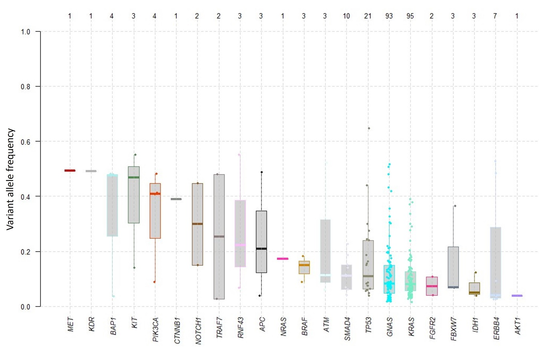
Supplementary figure 2. Lolliplots for mutations present in GNAS and KRAS.
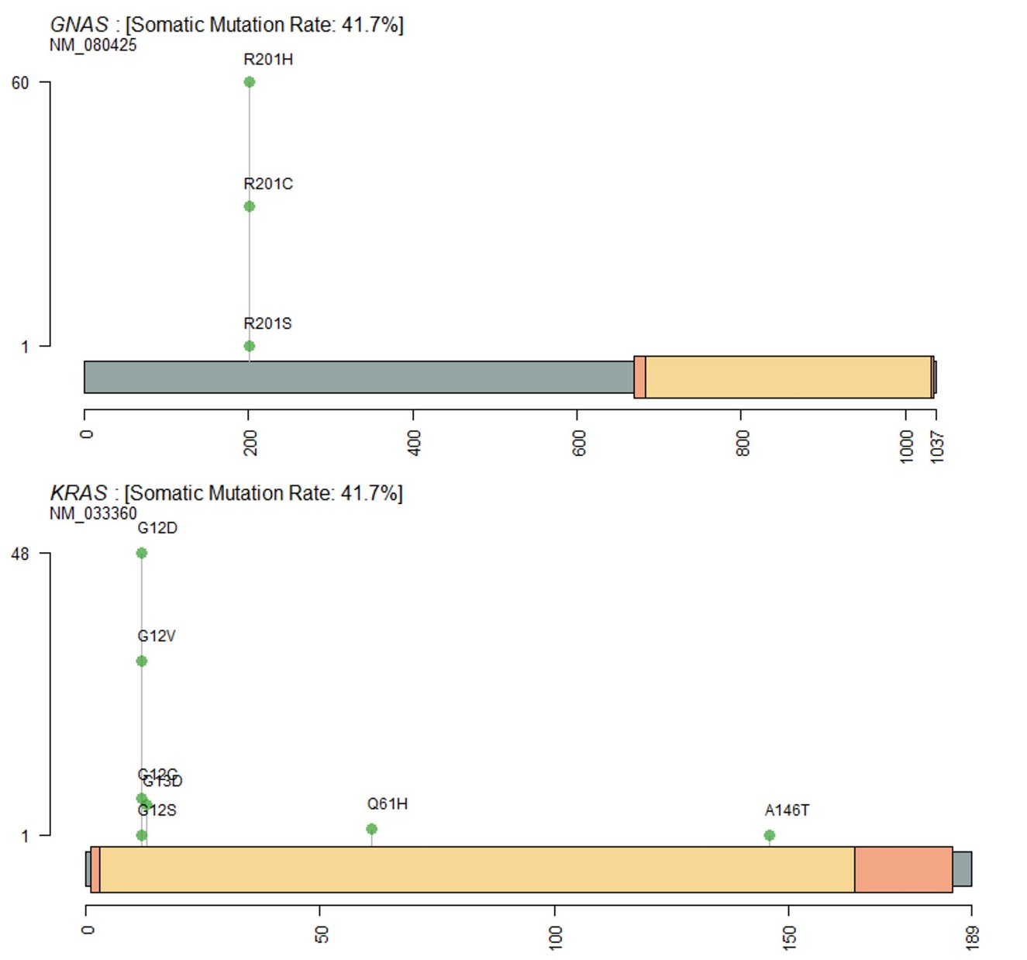
Supplementary figure 3. Kaplan-Meier Survival plot for patients with mutations in KRAS and or GNAS versus the rest.
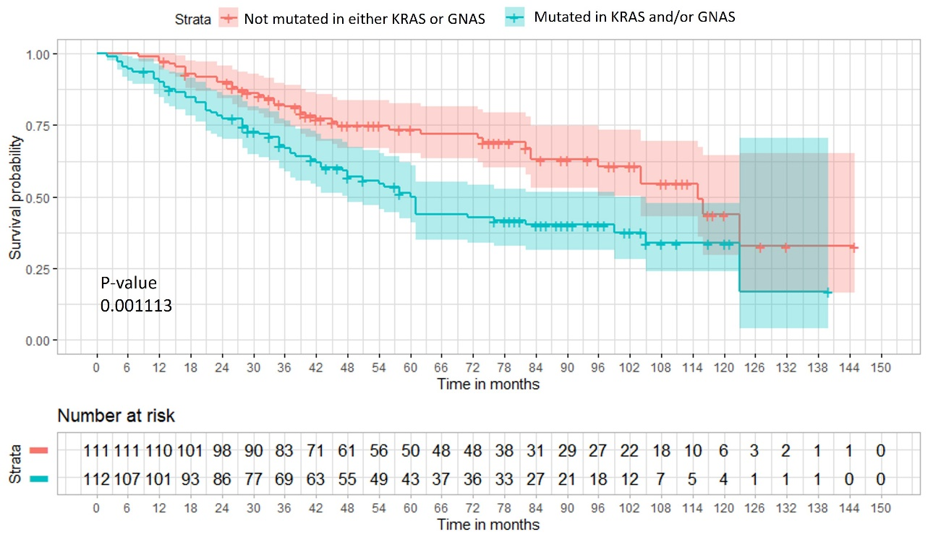
Supplementary figure 4. Cox proportional hazards multivariable model forest plot including primary tumour type.
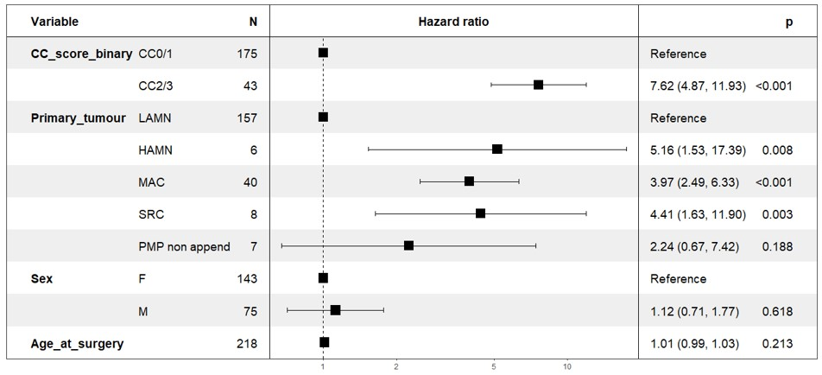
Supplementary figure 5. Cox proportional hazards multivariable model forest plot including primary tumour and peritoneal disease grades. Primary tumour grades codes as 'LAMN'= '1', 'HAMN'= '2', 'MAC' = '2', 'SRC' = ‘3’ (PMP non appendiceal excluded), and peritoneal disease grades as 'LG'= '1', 'HG'= '2', 'HGSC' = 3’ (AM excluded).
