A Career Ecosystem Perspective on Societal and Organizational Characteristics and Careers to the Top in Higher Education

Cite:
Dlouhy, K., Biemann, T., & Baruch, Y. (2025). A Career Ecosystem Perspective on Societal and Organizational Characteristics and Careers to the Top in Higher Education. Human Resource Management Journal, DOI: 10.1111/1748-8583.12580

Abstract
The context in which careers develop is attracting increasing scholarly attention. Building on career ecosystem theory, we examine how societal and organizational actors within career ecosystems influence the development of careers. In our study of university leaders in 60 countries, we find that career trajectories are more similar within than across countries and that the overall organizational context relates to the similarity of career trajectories within the career ecosystem. We identify six distinct career patterns to the top of organizations within the ecosystem of higher education (e.g., “university president” or “rector”). Furthermore, we identify several societal and organizational characteristics that are related to the prevalence of specific career patterns. Key findings include that academic leaders’ careers tend to follow career patterns within the same organization in countries with low power distance, low labour market flexibility, and low meritocracy, as well as in universities with less research focus. Our findings add to the literature on career ecosystems and advance the understanding of career paths to the top of organizations, using the case of academic careers.

KEYWORDS. Career patterns, organization leaders, culture, higher education, job sequencing

PRACTITIONER NOTES
What is currently known:
- Societies and organizations provide the context in which careers evolve.
- Dominant career paths vary across societal and organizational contexts.
- Little is known about career paths to the top of organizations in higher education, and about timing and sequencing of mobility and positions.

What this study shows:
- Careers across countries are more dissimilar than careers within countries.
- Careers evolving within the same organization are more common in societies with lower levels of power distance, labour market flexibility, and meritocracy.
- Careers evolving within the same organization are more common in universities with less research focus.
- Previous job experience is more important in societies with high uncertainty avoidance.

Implications of the study findings for practitioners:
- Diverse career patterns lead to the top of organizations in the higher education sector in different societies.
- Career patterns of successful leaders should be considered when searching for future leaders.
- Characteristics of the organization should be considered when designing career management systems.

INTRODUCTION
University leaders have a significant impact not only within but also beyond their organizations by influencing industry, politics, and society (Carree et al., 2014). As the higher education sector grows in relevance and size, more work is being devoted to understanding careers within academia (Jeong et al., 2020; Kraimer et al., 2019; Zacher et al., 2019). However, while a great deal of research has focused on CEOs’ careers (Hamori & Kakarika, 2009; Koch et al., 2017; Koyuncu et al., 2017), little attention has been paid to the career paths of those reaching the highest hierarchical position in higher education organizations (Baruch & Hall, 2004). Evidence from the USA suggests the existence of specific patterns in career paths to the top of higher education organizations (Singell & Tang, 2013; Wessel & Keim, 1994), but different paths might exist in other countries. Moreover, prior research predominantly analyzed leaders’ careers through the lens of boundaryless career theory (Guan et al., 2019), emphasizing individual agency. Furthermore, the context in which careers develop has started to receive attention in the HRM literature (e.g., Andresen et al., 2020; Benson et al., 2020; Knappert et al., 2021; Smale et al., 2019), but how societal and organizational characteristics shape careers in higher education remains largely neglected.
We address these shortcomings by employing a career ecosystem perspective (Baruch, 2015; Baruch & Rousseau, 2019) which offers a comprehensive view of careers from multiple perspectives and at different levels. Applying this theoretical perspective enables us to take into account the context in which careers of leaders in higher education develop, considering both societal and organizational factors (Baruch & Rousseau, 2019). Our first research question is: Do societal (i.e. countries) and organizational actors within career ecosystems affect individuals’ careers? Our second research question is: What career patterns lead to the top of higher education organizations, and does the prevalence of these patterns differ depending on the characteristics of the career ecosystem? To answer our research questions, we examine objective, longitudinal career data of 280 university leaders from 60 countries.
We contribute to the career ecosystems framework by being among the first to empirically test this theoretical perspective. First, we integrate all three key actors in career ecosystems (Baruch & Rousseau, 2019)—individuals, organizations, and societies—within the higher education context. We, thus, clarify how organizational and societal characteristics influence the types of career paths that can be taken to achieve leadership positions in higher education institutions. By applying sequence analysis to examine individuals' entire career trajectories, we introduce a methodological approach that enables a detailed exploration of the timing and sequencing of academic career moves, while also allowing for the testing of similarity hypotheses. Second, academia is a key sector in many countries (Jeong et al., 2021), and the selection and succession planning of university leaders is an important HRM endeavor (Kaulisch & Enders, 2005). By focusing on academic careers in different countries around the globe, we also answer the call for an examination of career paths to the top of organizations in diverse societal and organizational contexts (Andresen et al., 2021; Baruch & Sullivan, 2022; Koch et al., 2017; Mayrhofer et al., 2020). Third, we contribute to expanding the contextual perspective on HRM (e.g., Benson et al., 2020; Biemann et al., 2023; Knappert et al., 2021; Smale et al., 2019). While previous literature has mostly focused on how societal macrostructure affects individuals’ career goals and behaviors through HR regulations and practices, we show how it affects individuals’ entire career trajectories. Our findings further enrich the literature on organizational career systems (Sonnenfeld & Peiperl, 1988). The career patterns that we identify can be linked to specific career systems that differ in terms of talent management or an emphasis on contribution versus loyalty. Overall, our study is highly relevant for individual academics aspiring to leadership roles in academia, such as university president. For HRM professionals in academia, our research provides practical implications for succession planning. Moreover, for HRM professionals outside of academia, our research offers valuable insights that connect country-specific characteristics to career trajectories.

THEORETICAL BACKGROUND AND HYPOTHESES

Career ecosystems
To account for the contextual embeddedness of careers, an examination is needed of individuals as agentic entities, their embeddedness in a social and geographic space, and their development over time (Mayrhofer et al., 2020). We, therefore, base our theoretical rationale on career ecosystem theory. Introduced to management studies by Iansiti and Levien (2004), the ecosystem theory refers to ‘a system that contains a large number of loosely coupled (interconnected) actors who depend on each other to ensure the overall effectiveness of the system’ (p. 5). A career ecosystem is a social system of employment and career-related development and opportunity that emerges from interdependencies among actors (Baruch & Rousseau, 2019). The principal actors in a career ecosystem are individuals, organizations, and societies (Baruch, 2015). Actors interact with each other and are interconnected and interdependent (Iansiti & Levien, 2004).
Individual actors can remain in the same organization or society, move elsewhere, or pursue different career outcomes (Guan et al., 2019). Organizational actors plan and manage the careers of their employees through HRM practices and policies (Bagdadli et al., 2021; Baruch & Peiperl, 2000; Quigley et al., 2024). Societal actors are mostly countries, governments, and other systems (e.g., the legal scheme) that regulate and apply rules to individuals’ careers and organizations’ career management systems (Kaše et al., 2020) and that come into being through collective intentions and values. Career ecosystems are initiated by bottom-up processes (Gribling & Duberley, 2021) whereby individual actors participate in labour markets (Baruch & Rousseau, 2019). These processes create career structures, building on what different actors bring to the system and receive in return. At the same time, top-down processes also operate in career ecosystems, as societal actors add regulations to the system and, thus, shape the structuring of career activity.
Individuals make vocational choices depending on their personal background and the feedback that they receive from a career ecosystem. Individuals’ careers are shaped and structured by values, norms, beliefs, and practices constructed within the ecosystem (Cooper et al., 2021). Accordingly, the career ecosystem will influence the types of trajectories and, hence, the final positions that individual can aim for and attain. The rewards offered by organizations, societies, or institutions within countries are a major factor in these choices. Career patterns, which can be classified in terms of characteristics such as organizational mobility or occupational activity can, thus, represent ecosystem structures. In different career ecosystems, different career patterns will be prevalent, as career profiles are social artefacts containing the expectations of the broader environment about prior career experiences (Jeong et al., 2021). Overall, similar career ecosystems will produce similar careers.

Careers in higher education
Extant research has shown that some managerial career patterns are more likely to be found in specific contexts (Vinkenburg & Weber, 2012). In higher education institutions, distinct career ladders to top positions such as “university president” or “rector” have been identified (Biemann & Datta, 2014; Wessel & Keim, 1994). Academic and administrative career patterns are predominant. While ascending via the academic career ladder, individuals often lead a research field, serve in editorial roles, and lead scholarly societies, which is considered a classical path in academia (Benz et al., 2021; Hakala, 2009). The ability to ‘make it’ via this path depends mostly on one’s track record of publications (Beigi et al., 2018). When ascending via the administrative ladder, an extensive administrative background from inside or outside academe is required (Singell & Tang, 2013; Wessel & Keim, 1995).
Career patterns of leaders of academic institutions who previously worked outside the higher education system are less common and have been posited to be more complex (Biemann & Datta, 2014). Moreover, careers in academic institutions are often characterized by long-term employment relationships (Baruch & Hall, 2004). Thus, we argue that the ecosystem in which careers evolve shapes the nature and number of unique career patterns—specifically, in our study, career patterns to the top of academic organizations (Baruch, 2013). In Figure 1 (based on Baruch and Rousseau, 2019), we present a conceptual model that depicts how different variables (at the individual, organizational, and societal levels) relate to each other in this ecosystem.

Societal actors in career ecosystems
Countries are societal entities that we consider important actors in career ecosystems. It has been suggested that their impact on careers works via the education system, training mechanisms, legal constraints, and cultural attributes that shape the nature of what is considered a desirable, acceptable, and fulfilling career (Baruch, 2015). Societal effects on careers may occur through resource flows that institutions in societies make possible (Baruch & Rousseau, 2019). To succeed in specific career ecosystems, such as the public sector in China, individuals are often required to demonstrate political loyalty or cultural appropriateness (Yao & Baruch, 2024). For example, in prior studies, Scherer (2001) and Brzinsky-Fay (2007) found that the first five years in the careers of graduates differ between countries due to different education and training systems. Moreover, individual actors’ career goals and career planning behaviors have been shown to be affected by the societal macrostructure in countries (Andresen et al., 2020), and Biemann and Wolf (2009) already found that careers of top managers varied across Denmark, Germany, Japan, the UK, and the USA. Since the establishment of universities, the country-specific context has defined the structure of the career system in higher education (Altbach, 2009). Even within Europe, comparisons between countries suggest significant variations in the ways in which universities are governed (Paradeise et al., 2009). We suggest that country characteristics will lead to the formation of specific career trajectories which will, accordingly, differ from career trajectories in other countries. Thus, we hypothesize:
Hypothesis 1. Careers are more dissimilar across countries than within countries.
Societal culture is an important characteristic of societal actors (Baruch, 2015) and can influence careers through a societal legitimization and regulation of career practices, values, and norms (Smale et al., 2019). It will affect preferences for career-related behavior valued by individual and organizational actors within a specific career ecosystem. There have been calls for research endeavors on how societal culture affects career paths (Baruch & Sullivan, 2022; Mayrhofer et al., 2020). For example, career mobility is inhibited in collectivistic cultures with high uncertainty avoidance (Claes & Ruiz-Quintanilla, 1998); career proactivity is more important for subjective financial success in cultures with high in-group collectivism, high power distance, and low uncertainty avoidance (Smale et al., 2019); and loyalty to one organization is rewarded in societies that score high on institutional collectivism, such that individuals engage in less career mobility (Peretz & Fried, 2012).
HRM practices, such as those for succession planning or staffing (Biemann et al., 2023; Knappert et al., 2021), are usually in line with the cultural context in the respective countries. Moreover, individuals will make similar career choices due to similar career goals and preferences. Careers have been shown to include similar actions and moves in similar societal cultures depending on how different types of career mobility or experiences are valued in those cultures (Benson et al., 2020; Smale et al., 2019) and, in particular, in the academic context (Miller et al., 2005). Therefore, we suggest that individuals’ career trajectories depend on societal culture, such that in countries with more dissimilar cultures, they will be more dissimilar. Furthermore, as individuals with certain career trajectories will be viewed as adhering more strictly to the cultural values within a society, particular societal cultures will favor the prevalence of specific career patterns.
Hypothesis 2a. Dissimilarity in societal culture is positively related to dissimilarity in careers.
Hypothesis 2b. Societal culture is related to the prevalence of specific career patterns.
Labour markets are the landscape in which careers take place (Baruch, 2015). Societal actors such as countries intervene in labour market-related activities in ways that influence the aspirations and actions of organizations and individuals—for example, through the encouragement of talent flow (Baruch & Rousseau, 2019). National governance is responsible for and can influence norms of behavior or legal constraints that relate to career behavior and career outcomes—for example, by providing unemployment benefits and welfare programs that may encourage individuals to take risks associated with career moves (Bagdadli et al., 2021). In a study across 85 countries, Botero and colleagues (2004) showed that the regulation of labour market flexibility affects labour force participation and individual employment. In a study by Biemann and colleagues (2021), selection practices were more similar in countries with similar regulatory contexts. Overall, regulations and practices for selection, promotion, layoffs, or mobility will shape individuals’ careers. Thus, we expect individuals’ career trajectories to be more dissimilar in countries that have more dissimilar labour market characteristics. Moreover, certain types of career trajectories will be more common in countries with particular labour market characteristics.
Hypothesis 3a. Dissimilarity in labour market characteristics is positively related to dissimilarity in careers.
Hypothesis 3b. Labour market characteristics are related to the prevalence of specific career patterns.

Organizational actors in career ecosystems
Organizations are also important actors in career ecosystems as they shape the structuring of individuals’ career activity (Baruch & Rousseau, 2019). Organizations follow certain business strategies or focus on certain stakeholders; based on this, they deploy an HR strategy with policies and practices, such as executive incentives or talent management (Baruch & Rousseau, 2019). When selecting or promoting employees or choosing leaders, human resource managers usually match leaders’ managerial style or personnel activities with the organization’s business strategy (Muller-Camen & Salzgeber, 2017). Some universities focus on research and international collaborations (Harwood, 2006; Sargent & Waters, 2004), whereas others focus on teaching (Canhilal et al., 2016) or on practical outcomes and entrepreneurship (Klingbeil et al., 2019; Muller-Camen & Salzgeber, 2017). Thus, organizations shape career trajectories by influencing individuals’ career decisions and career moves through certain career systems with particular HR practices and policies (Baruch & Rousseau, 2019; Sonnenfeld & Peiperl, 1988).
For example, selection processes of employees or organization leaders will favor certain career patterns over others (Biemann & Wolf, 2009). In a sample of US law school deans, Jeong and colleagues (2021) found that diversity in organizational size increased dissimilarity among deans’ career profiles. When organizations are dissimilar with regard to their business strategy and to career systems that entail specific HR practices and policies (Sonnenfeld & Peiperl, 1988), the careers of individuals in these organizations will also tend to be dissimilar. Moreover, organizational characteristics will favor the emergence of specific career patterns, as certain types of career trajectories will be viewed as adhering more strictly to the overall HR strategy, and individuals with these types of careers are more likely to be recruited, selected, or promoted.
Hypothesis 4a. Dissimilarity in organizational characteristics is positively related to dissimilarity in careers.
Hypothesis 4b. Organizational characteristics are related to the prevalence of specific career patterns.

METHOD

Sample
We collected career information on university leaders, i.e., the one individual highest in the university hierarchy (e.g., the rector, university president, or vice chancellor) in 60 countries. Universities are organizations that are comparable across countries (Bleiklie, 2014) as there exist worldwide standards through accreditations and rankings, which enables us to study the impact of ecosystem characteristics on careers. Moreover, individuals’ positions in higher education are comparable across organizations and countries (Bentley & Kyvik, 2012). The selected countries were mainly those that participated in the GLOBE study (House et al., 2002), and the selection of individuals was based on university size and on the availability of required career information.
We obtained career information from biographies and curricula vitae on universities’ websites and systematically cross-checked and complemented it with biographical data from personal websites and other sources (e.g., press articles). In some instances, biographical information regarding job spells was incomplete or specifications about start and end dates were missing, particularly in the case of early-career jobs. Individuals were only included in the sample when annual career information was available and when their career history did not contain gaps of more than one year. We constructed a data set that contained every job held from graduation until the top position at the organization was attained, with information on organization name, start date, end date, and job title for each individual.
Our final sample included 280 individuals (239 men and 41 women) from around the globe (33.6% Europe, 28.2% Asia, 17.5% Northern America, 9.6% Latin America, 7.5% Africa, and 3.6% Oceania). The age when individuals were appointed to the highest leadership position was, on average, 54.8 years (SD = 7.6), ranging from 37 to 77 years. The median and mean of leaders per country were 4 and 4.77, respectively. With only two exceptions, all individuals were either nationals of the country in which the university they led was located, or nationals of adjacent countries sharing the same language.

Measures
Careers
Individuals’ career sequences started in the year after they obtained their university degree (e.g., Bachelor’s, Master’s, diploma) and ended in the year when they made it to the leadership position. In each year, they held a position that was coded as one of the following: assistant professor (Ai), associate professor (Ao), dean (De), director (of an university institution; Di), investigator (researcher outside of an university; In), lecturer (Le), post-doc (Pd), PhD student (Ph), full professor (Pr), provost (Pv), researcher (at a university; Rs), university leader (Ul), vice leader (of a university; Vl), or other position outside of academia (e.g., CEO, engineer, politician; Ot). The data coding was carried out by two coders working independently. We checked the reliability of our data by calculating Cohen’s kappa for 10 randomly chosen careers. For this purpose, the second rater searched for the career information of 10 randomly chosen individuals from our sample and then, in a second step, coded their career positions. This resulted in a good kappa value of 0.74 (Fleiss, 1981).
When individuals held more than one position at a time, the information was combined, which is common in research that examines career sequences (Biemann & Datta, 2014). An individual working as a professor at a university and at the same time as an investigator at a company would be coded as InPr, and an individual holding positions as dean and professor would be coded as DePr. Furthermore, we included information on whether individuals were employed at the university at which they eventually made it to the top (1 = yes, 0 = no). Once position and organization information were combined, we had a total of 92 career states—for example, 1DePr for an individual who held positions as dean and professor at the university where they subsequently became a leader – and one state for missing information (see Online Appendix A for details on coded states). Each career state was appended to the previous state, thus forming a career sequence for each individual in our sample (see Online Appendix B for sample sequences).
Societal culture
Data on societal culture were derived from the GLOBE study (House et al., 2002) in which nine dimensions of culture values have been identified. Aggregated values for the cultural dimensions are available on the website of the GLOBE study, along with the following definitions and detailed information on the methodology of the study (https://globeproject.com). Uncertainty Avoidance is the degree to which organizational or societal members diminish the unpredictability of future events through, for example, social norms, rituals, and bureaucratic practices. Future Orientation is the degree of individuals’ engagement in future-oriented behaviors such as deferring gratification, making plans, and investing in the future. Power Distance is the extent to which organizational or societal members agree and expect that power should not be distributed equally. Institutional Collectivism is the degree to which organizational and societal institutional practices encourage and reward collective distribution of resources and collective action. Humane Orientation is the degree to which individuals are encouraged and rewarded for moral behavior such as being altruistic, generous, caring, and kind. Performance Orientation is the extent to which group members are encouraged and rewarded for performance improvements and excellence. In-Group Collectivism is the extent to which individuals show loyalty, pride, and cohesiveness in their families or organizations. Gender Egalitarianism is the degree to which societies or organizations reduce gender discrimination and role differences. Finally, Assertiveness is the extent to which individuals are confrontational, dominant, and aggressive. All dimensions are measured on a 7-point Likert-type scale.
Labour market characteristics
Data on labour market characteristics were derived from the Global Competitiveness Report (Schwab, 2019). Since we were interested in labour market characteristics, we used data from the dimension Labour market, which comprised the two sub-dimensions Flexibility and Meritocracy and Incentivization. Flexibility was calculated from eight items; for example, the extent to which regulations in a country allow for flexibility of hiring and firing practices. Meritocracy and Incentivization was calculated from four items; for example, the extent to which professional managers who were chosen for merit and qualifications hold senior management positions in organizations versus relatives or friends without regard to merit. Each country obtained a value on a continuous scale from 0 to 100 on each these dimensions. Detailed information on the methodology of the study is available on the World Economic Forum’s website (https://www.weforum.org/reports).
Organization characteristics
We retrieved information on organization characteristics from the website of the Times Higher Education (THE, 2019) World University Ranking. This ranking provides comparable information on numerous universities worldwide. It uses performance indicators to evaluate universities based on five areas: Teaching is a measure of the learning experience and quality; Research is a measure of both the quality and quantity of research output based on reputation, research income, and productivity; Citations is a measure of how influential that research is in terms of the number of times work published by academics at the university is cited in other papers; International Outlook is a measure of international-to-domestic ratios across staff, students, and research collaborations; and Industry Income is a measure of how much the university earns from its industrial work (THE, 2019). Each dimension is ranked on a scale from 0 to 100. Detailed information on the methodology is available on https://www.timeshighereducation.com/world-university-rankings.

Data analytic strategy
Calculating dissimilarity of career sequences
Optimal matching analysis computes the dissimilarity for each pair of career sequences in a sample as the number of operations required to transform one sequence into another (Biemann & Datta, 2014; van der Laken et al., 2018). Possible operations are the substitution, deletion, or insertion of an element. Each operation has “costs” which are then added to compute career dissimilarity. The more dissimilar two career sequences are, the more operations are necessary to align one sequence with another.
When computing sequence dissimilarity, different costs for the substitution operations can be used, as some positions are more equal than others. For example, experience as an assistant professor is typically more comparable to experience as an associate professor than to experience as a medical doctor. For this reason, researchers can implement costs that are based on a theoretical rationale (Biemann & Datta, 2014). In our study, we coded each position along three dimensions: (1) research intensity, (2) administrative experience, and (3) current university (see Table 1). We coded research intensity and administrative experience as 1 = high when we considered the respective activity (i.e., research or administrative tasks) a main task in the respective position. When two positions were alike on all three dimensions, the substitution cost was zero. For example, a year as an associate professor at an individual’s current university and a year as an associate professor at the current university received substitution costs of zero, because both positions (1) are research intensive, (2) were not administrative positions, and (3) were both at their current university. If they differed on all three dimensions, the substitution cost was three (e.g., associate professor at current university vs. dean at another university). Based on these rules, we computed the substitution cost matrix which compares all possible positions and indicates low substitution costs for equal positions and high costs for unequal positions (see Online Appendix B for more detail). Following the standard procedure, costs for insertion and deletion (“indel”) operations were set to half of the maximum substitution costs (i.e., 1.5; Biemann & Datta, 2014).
Based on substitution and indel costs, the optimal matching algorithm finds the optimal solution for aligning each pair of sequences. The result of this pairwise sequence comparison is an n × n dissimilarity matrix that contains the dissimilarity between each pair of n career sequences in the sample. The lowest career dissimilarity is zero, while higher values in the matrix indicate higher career dissimilarity.
Calculating cultural, labour market, and organizational dissimilarity
We were interested in relating career dissimilarity among individuals with other dissimilarities. Accordingly, we computed dissimilarity matrices for cultural dissimilarity, labor markets, and university characteristics. To compute cultural dissimilarity, we used the Euclidean distance metric on the nine dimensions of culture (Beugelsdijk et al., 2018). As data on culture were only available at the country level, we constructed a matrix with distances on these cultural dimensions between all countries in our sample. For example, the cultural dissimilarity between Australia and Canada was 0.63, while that between Australia and China was 2.65. Larger values indicate a higher dissimilarity between countries. GLOBE data were available for 56 of the 60 countries in our sample and we, thus, generated a 56 × 56 cultural dissimilarity matrix (see Online Appendix C for an extended example). For the dissimilarity in labour markets, we calculated the Euclidean distance on the two dimensions flexibility and meritocracy and incentivization from the Global Competitiveness Report that we described above. Data were available for all countries in our sample, resulting in a 60 × 60 labour market dissimilarity matrix. For dissimilarity between organizations, we calculated the Euclidean distance of the organization characteristics from the THE ranking on the five dimensions—teaching, research, citations, international outlook, and industry. Only 214 of the 280 organizations in our sample were listed in the THE ranking and we, therefore, generated a 214 × 214 organizational dissimilarity matrix.
Testing relationships between dissimilarity matrices
To relate the dissimilarity matrices, we used the Mantel test, which is common in scientific disciplines such as geography and ecology (Lichstein, 2007) and has been recently introduced to career research (Biemann et al., 2020). The Mantel coefficient is comparable to a Pearson correlation coefficient but takes into account the non-independence of distances in a matrix. This non-independence results from the fact that changing one initial value affects the distances between this value and all other values in the matrix. Consequently, a statistical test that does not take this dependence into account would be biased. The Mantel test addresses this problem via simultaneous permutation of matrix rows and associated columns (Lichstein, 2007). As in the case of other correlations, a positive coefficient indicates that higher distances or dissimilarities in one variable are related to higher distances or dissimilarities in another variable (see Online Appendix D for details). All analyses were conducted using the software R for statistical computing (R core team, 2023). We used the TraMineR package (Gabadinho et al., 2009) for optimal matching analysis and the ecodist package for dissimilarity computation (Goslee & Urban, 2007).

RESULTS

Hypothesis tests with career dissimilarities
We first report the tests for Hypotheses 1, 2a, 3a, and 4a. Examining how societal, labour market, and organizational characteristics are related to the prevalence of different career patterns requires the identification of career patterns as an additional step that we will take before reporting the tests for Hypotheses 2b, 3b, and 4b. In Hypothesis 1, we predicted that careers are more dissimilar across countries than within countries. The mean career dissimilarity for individuals from the same country was 33.47, while the mean career dissimilarity for individuals from different countries was 40.05. A t-test revealed a significant mean difference (p < .001). As tests that do not take into account the non-independence of dissimilarities might be biased (Lichstein, 2007), we also applied a bootstrapping approach. The hypothesis was supported if the true mean career dissimilarity of 33.47 was smaller than the value from 95% of random draws (i.e., p < .05). Based on 100,000 random draws from the matrix with mean career dissimilarities across countries, the bootstrapped cut-off value was 36.17. Thus, Hypothesis 1 was supported.
To test Hypothesis 2a, a matrix with cultural dissimilarity was related to a matrix with mean career dissimilarities of individuals in each country. As GLOBE measures for culture do not vary within countries, we aggregated the career dissimilarity of individuals to the country level by computing the mean career dissimilarity as an average of the career dissimilarities of all pairs of individuals from two countries (see Online Appendix D). From the 60 countries in our sample, full data were only available for 56 countries, resulting in two 56 × 56 matrices. For the two matrices (cultural dissimilarity and mean career dissimilarity), the Mantel correlation coefficient r_{Mantel} of -0.01 was not significant (p > 0.05), so that Hypothesis 2a was not supported.
To test Hypothesis 3a, a matrix with labour market dissimilarity was related to a matrix with mean career dissimilarities of individuals in each country. As with Hypothesis 2a, we aggregated career dissimilarity to the country level and generated two 60 × 60 matrices, as labour market data were available for all 60 countries. The Mantel correlation coefficient r_{Mantel} of -0.05 was not significant (p > 0.05); hence, Hypothesis 3a was not supported.
To test Hypothesis 4a, a matrix with organizational dissimilarity was related to a matrix with career dissimilarities of individuals. Full data were available for 214 organizations; thus, we had two 214 × 214 matrices for the Mantel correlation. Dissimilarity in organization characteristics was positively and significantly related to dissimilarity in careers (r_{Mantel} = 0.07, p < 0.01), so that Hypothesis 4a was supported.

Career patterns to the top of higher education organizations
Using the Ward clustering algorithm that has been recommended for use in optimal matching analysis (Biemann & Datta, 2014), we derived six clusters from the career dissimilarity matrix. We chose six clusters based on measures of the quality of a cluster solution (i.e., Point Biserial Correlation, Hubert’s Gamma, Hubert’s C, Average Silhouette Width (Studer, 2013)). Each cluster contains individuals with similar careers, thereby forming six differing career patterns. Those are depicted in the tempograms in Table 2. The vertical axes indicate the share of individuals in research-intensive positions (top row), in administrative roles (middle row), and in their current organization (bottom row); the horizontal axes indicate career years. For example, in pattern 1, nearly all careers started with a position characterized by high research intensity, involving no administrative roles, and not at the current organization. In addition, it is evident that most of the individuals following this pattern moved into administrative positions relatively late in their careers, mostly starting in career year 20 or later. In Table 3, we show example sequences for each career pattern. We identified the most prototypical career sequence for each career pattern, i.e., the sequence that was closest to the center of the respective pattern. Each three-digit-code in the table represents a career year, often starting with some years as a PhD student (coded with Ph) at another university (coded with 0). Table 4 depicts descriptive information on the six career patterns, and Online Appendix E shows the prevalence of career patterns across countries.
Pattern 1: Researcher from outside
This pattern (n = 72) describes the careers of individuals who have spent most of their career undertaking research at another organization before reaching the top at their current organization. In pattern 1, the median career length before getting to the top at the current organization is 34 years. Individuals spent an average of 22.80 years in research positions, took over administrative roles for an average of 10.12 years, and were employed at their current university for an average of 2.57 years before getting to the top of that organization.
Pattern 2: Researcher from inside
Individuals following this pattern (n = 64) spent almost their entire career as a researcher at their current organization (23.70 years), which distinguishes this pattern from pattern 1. The amount of time spent in research positions in this pattern is 25.59 years, and 7.72 years for administrative positions. The median career length is 31 years.
Pattern 3: Administration expert from inside
This cluster (n = 48) comprises individuals with a median career length of 35 years who spent most of their careers at the current organization and moved into administrative positions relatively early, indicated by an average of 18.19 years of experience in administrative roles.
Pattern 4: Administration expert from outside
Individuals following this pattern (n = 44) started very early in their careers to gather administrative experience at one or more other organizations before being appointed as leader in their current organization. The median career length is 30 years.
Pattern 5: Fast-track outsider
This pattern (n = 39) has two phases. Individuals spent the first 5 to 10 years of their career as researchers at other organizations but then quickly took over administrative roles. This pattern has the shortest median career length of 19 years.
Pattern 6: Late career practitioner
This is the least frequent pattern (n = 13) and comprises individuals who moved into the leadership position late in their careers, mostly with little or no research and administrative experience (e.g., CEO, engineer, politician). The pattern is characterized by the highest median career length of 45 years, mostly spent outside academia.

Hypothesis tests with career patterns
We hypothesized that societal culture, labour market, and organizational characteristics would differ across career patterns. Thus, we computed ANOVAs to compare the differences among mean values in the six patterns that we previously identified, as well as t-tests for pairwise comparisons. The results are shown in Table 5.
For societal culture, we found pattern differences for uncertainty avoidance (F = 3.60, p < .01), future orientation (F = 5.08, p < .001), power distance (F = 2.90, p < .05), performance orientation (F = 2.30, p < .05), and gender egalitarianism (F = 3.59, p < .01) as reported in Table 5. The other four dimensions of societal culture did not differ significantly across patterns. Thus, Hypothesis 2b was partly supported. There are also noteworthy differences across patterns; for example, administrative experts from inside (pattern 3) and outside (pattern 4) were more prevalent than researchers from outside (pattern 1) and fast-track outsiders (pattern 5) in societies with high uncertainty avoidance. Researchers from outside (pattern 1) were more prevalent in societies with higher power distance than researchers from inside (pattern 2) and administrative experts from inside (pattern 3). Late career practitioners (pattern 6) were prevalent in countries with high uncertainty avoidance and high future orientation, and with low gender egalitarianism. Moreover, the highest percentage of women (19.4%) was found in pattern 1, which was prevalent in countries with high gender egalitarianism.
A comparison of labour market characteristics across career patterns revealed significant differences for both flexibility (F = 2.87, p < .05) and meritocracy and incentivization (F = 3.56, p < .01), which supports Hypothesis 3b. Researchers from outside (pattern 1) and fast-track outsiders (pattern 5) were more prevalent in labour markets with higher flexibility and meritocracy than researchers from inside (pattern 2), administrative experts from inside (pattern 3) and administrative experts from outside (pattern 4).
Regarding organizational characteristics, there were significant differences across patterns for citations (F = 3.71, p < .01) and international outlook (F = 2.48, p < .05), but not for the other three organizational characteristics, such that Hypothesis 4b was partly supported. A closer inspection reveals that, for example, researchers from outside (pattern 1) were more prevalent in universities with higher scores in teaching, research, citations, and international outlook than the two insider patterns, researcher from inside (pattern 2) and administrative expert from inside (pattern 3).

DISCUSSION
The use of sequence analysis methods and a global sample allowed us to answer the call for an examination of careers to the top of higher education organizations (i.e., to the position as “university president” or “rector”) in diverse societal and organizational contexts (Andresen et al., 2021; Koch et al., 2017; Mayrhofer et al., 2020). Answering our first research question, our study shows that societal and organizational actors within career ecosystems affect individuals’ careers. Prior research has shown that career trajectories differ among single countries (Biemann & Wolf, 2009; Brzinsky-Fay, 2007; Scherer, 2001), and our results support these findings on a larger scale across 60 countries. Relating to our second research question, we identify six career patterns to the top of academic organizations—(i) researcher from outside, (ii) researcher from inside, (iii) administrative expert from inside, (iv) administrative expert from outside, (v) fast-track outsider, and (vi) late career practitioner—and show that the specific dimensions of societal culture, the labour market, and organizational characteristics impact the emergence of career patterns.

Theoretical implications
In our study, we find support for and expand career ecosystem theory (Baruch, 2015; Baruch & Rousseau, 2019) in the higher education sector. We show that there are distinct career trajectories that different societal and organizational actors prefer (Baruch & Rousseau, 2019). However, we find that only overall dissimilarity in organizational characteristics—not overall dissimilarity in societal culture and labour market flexibility—relates to overall dissimilarity in individual careers. This indicates that the impact of organizational actors may be linked more directly to the development of career trajectories than to the impact of societal actors. Moreover, while overall dissimilarity in societal culture and labour market characteristics was not related to overall dissimilarity in careers, our findings, nevertheless, imply that societal actors are important through factors like cultural values and labour market characteristics for the formation and prevalence of specific career patterns.
Our results indicate which career trajectories are more conventional or valued for leaders in higher education in specific societal cultures. For example, in societies with high uncertainty avoidance, previous experience in a job and a stable employer–employee relationship seem to be chosen and valued by the actors in the ecosystem. Overall dissimilarity in culture was not related to overall dissimilarity in careers, possibly due to the four cultural dimensions—i.e., institutional collectivism, in-group collectivism, humane orientation, and assertiveness—that did not differ across career patterns and, thus, did not seem to affect career behavior. Interestingly, our results in this context thus counter previous findings that career mobility is affected by collectivism in societies (Claes & Ruiz-Quintanilla, 1998; Peretz & Fried, 2012). Moreover, in societies with lower labour market flexibility and meritocracy, ascent to the top within the organization was more common, while entry from outside the organization was valued in societies with higher labour market flexibility and meritocracy. Thus, we add to previous findings that societal governance influences norms of career behavior (Bagdadli et al., 2021). Thus, despite cultural differences, the careers that individuals pursue and how they progress in these careers might be quite similar, and other factors might shape careers more than cultural differences do.
Regarding organizational characteristics, we found differences in the importance of prior career experiences in different organizations. Although organizations in higher education usually expect academics to simultaneously conduct high-quality research, teach students, and perform administrative duties (Baruch, 2013), there are differences in the relative levels of importance conferred on these duties in different organizations (Canhilal et al., 2016). Previous studies have shown that the predominant career pattern for leaders in the ecosystem of higher education in the USA is an academic career pattern (Wessel & Keim, 1994), and that research institutions place emphasis on research success (Beigi et al., 2018; Benz et al., 2021; Singell & Tang, 2013). Notably, our findings show that this applies to other countries too, but that, in addition to research, other types of experience matter as well, and that this depends on organization characteristics. However, this particularly applies to those universities whose researchers are highly cited across academia and who aim at attracting international students. They are more likely to hire leaders from outside; those can be either senior (researcher from outside pattern) or more junior individuals (fast-track outsider pattern).
The career patterns that we identified in the higher education sector were different from those of corporate CEOs or leaders, where, for example, an “expert” (i.e., research) role would not lead to the top of an organization (e.g., Hamori & Kakarika, 2009; Koch et al., 2017). Perhaps this might be due to less competition for academic versus corporate leadership positions, or due to different motivations of individuals who aspire to such a leadership role. Moreover, although it has been argued that the higher education ecosystem offers several opportunities for boundary crossing across countries (Carraher et al., 2014), we did not find evidence suggesting a global career model. Almost all the individuals in our sample were nationals of the country where the university that they managed was located. Furthermore, the findings on the late career practitioner pattern support the notion that leaders of academic institutions who previously worked outside the higher education system are not so common (Biemann & Datta, 2014). This is the pattern with the longest time to the top, and individuals following it might have a strong attachment to their professional identity and, therefore, decide to not retire (Altman et al., 2020) but to change to another industry where their management skills are still sought. Our findings can also be linked to the literature on career systems (Sonnenfeld & Peiperl, 1988) as the career patterns that we identified fit different organizational career strategy models. For example, pattern 2 Researcher from inside might be found in an “Academy” career system identified by Sonnenfeld and Peiperl (1988) that emphasizes entry at early career stages and individual contribution, while pattern 3 Administration expert from inside might be preferred in a “Club” that emphasizes entry at early career stages and corporate service. The other patterns might be found in a “Baseball team” type of career system where entry happens at different career stages and where celebrity talent or expertise specialists are hired.

Practical implications
Our ﬁndings have implications for different types of organizations. Top management, boards, and other governance bodies should consider what characteristics of their organization they want to emphasize in the future, and how their career system (e.g., the HR practices and HR policies that they use with regard to recruitment, selection, or internal talent development) fits their strategy (Sonnenfeld & Peiperl, 1988). Depending on the type of organization, there are several career patterns that could characterize a suitable candidate for the leadership role. Thus, career patterns might be another element to help organizations identify suitable leaders in addition to, for example, interests (Hoff et al., 2020) or personality (Do & Minbashian, 2020) in succession planning. We also deliver practical implications for HRM professionals involved in talent identification and succession planning within academic institutions. When looking for future talent, universities should determine what type of future leaders they need, as applying the appropriate career practices (Baruch & Peiperl, 2000) is instrumental in strategic HRM. This can be particularly important in academia, where university leaders are selected by committees that may partially consist of professors, i.e., non-HR professionals, in some countries (Paradeise et al., 2009). Universities seeking to improve teaching, research, or international outlook might prioritize hiring external individuals with more diverse experiences as leaders.
Our study might also be relevant for head-hunter firms on which many organizations rely to select their future leaders (Reis & Grady, 2018). For HR agencies, we identify career patterns that they can look for when searching for academic leadership for different types of universities and which can be included in the process of identifying success profiles for leaders. Moreover, as we find that the organizational context is especially important for career management, individuals should gather information on the type of organization that they want to lead early on, as doing so will enable them to navigate their career in the right direction. Although this study lacks a reference group of non-leaders against which to compare the individuals in our sample, some tentative implications can be derived for individuals as well. Becoming a university leader is a possible career goal for academics who seek objective career success and wish to make an impact on an organization that generates knowledge, educates students, and influences industry, politics, and society (Carree et al., 2014). The career patterns that we identified might function as career scripts and help individuals to best position themselves to lead a given university with specific organizational characteristics inside a specific country. For example, individuals who want to lead a university that performs high on both teaching and research should not expect to be appointed from within but, rather, be prepared to change organizations during their career. In societies with high uncertainty avoidance, individuals who want to make it to the highest administrative rank in a university should take an administration path. In contrast, individuals in countries with more flexible and meritocratic labor markets might focus on acquiring diverse experiences and be open to external opportunities.

Limitations and avenues for future research
Our findings should be interpreted in light of their limitations. First, individuals in our sample were leaders of some of the largest and most prestigious universities in their respective countries, which ensured comparability. However, future studies should examine careers of individuals at other hierarchical levels and in other ecosystems, as specific cultural or labour market characteristics might affect career development differently than in higher education. For example, in career ecosystems that are more volatile or that require more HR practices directed at training and development, labour market flexibility might be an even more important factor for career development. Moreover, for most countries, we included a relatively small number of individuals. Although future research might try to gather a more comprehensive sample, in smaller countries, this issue will remain due to a lower number universities (e.g., in the Czech Republic). Furthermore, we did not have information on the characteristics of all organizations in our sample, particularly in the case of universities that did not meet the inclusion criteria of the THE ranking. Future research might consider other measures of organizational characteristics, focusing particularly on recruitment, selection, career development, and performance management practices to better understand how the characteristics of career systems affect career development. For instance, similar sequence analysis methods could be employed to test whether organizations with more structured and merit-based recruitment processes result in more similar career trajectories among their employees compared to organizations with more flexible or informal selection practices. Furthermore, future research could explore the relative importance of different HR practices, as well as country-level characteristics such as laws and regulations, on career development.
Future research in career ecosystem theory should explore the relationships among individuals, organizations, and societies depicted in Figure 1 to further uncover the underlying mechanisms that drive outcomes at various levels. Employing qualitative research methods might offer a deeper understanding of how HR policies and processes within career ecosystems facilitate different actors’ perception of “ideal” careers or career scripts. Exploring how specific HR strategies within organizations impact talent flows and human capital development could reveal critical insights into the organizational-level factors that facilitate or hinder individuals’ career advancement. Additionally, investigating the role of societal culture and labor market characteristics in shaping career trajectories across different industries can help in identifying the boundary conditions of career ecosystem theory. By focusing on under-researched factors, such as the impact of legal systems or regulatory environments on organizational succession plans, future studies could provide a more comprehensive understanding of how these societal and organizational factors interact to produce varied career patterns.
Moreover, HRM researchers should strive to consider the societal and organizational contexts when studying careers to the top among disadvantaged populations (Reis & Grady, 2018), as females were underrepresented in our study. Most career ecosystems around the globe are similar in the opportunities available to and constraints faced by women or minorities in the sense that it is harder and less likely for them to reach managerial positions (for example in STEM; Quigley et al., 2024), and higher education organizations are no exception (Treviño et al., 2018). Future research could therefore explore how the career trajectories of women and members of minoritized groups are influenced by the specific characteristics of different career ecosystems. Furthermore, as individuals are looking to fulfil a variety of career success dimensions (Briscoe et al., 2021), it might be a fruitful avenue for further research to complement our study—which focuses on objective career data and individuals’ hierarchical advancement—with studies that use subjective career data and focus on, for example, learning experiences or positive work relationships. Such studies might assess in more detail which interactions and interdependencies exist in career ecosystems, and how career trajectories relate to recruitment, selection, or training and development practices to inspect and scrutinize their characteristics more closely. Furthermore, putting a focus on specific characteristics of positions within or outside academia that might provide individuals with distinct aspects of human or social capital would be an interesting avenue for future research. Additionally, future studies should place greater emphasis on sustainable career ecosystems, which foster sustainable outcomes for individuals, organizations, and society at large (Donald et al., 2024).
To conclude, we examined the career paths of individuals who reached the highest hierarchical positions in organizations within the ecosystem of higher education. Further research on this topic is needed, as members of the academic sector within countries and, in particular, its leaders are responsible for shaping the human capital of future generations (Baruch, 2013). Overall, the career ecosystem perspective that we applied as an overarching theoretical framework can be used to understand progress and success in careers within other organizational fields and industries.

REFERENCES
Altbach, P.G. (2009). Peripheries and centers: Research universities in developing countries. Asia Pacific Education Review, 10, 15–27.
Altman, Y., Baruch, Y., Zoghbi-Manrique de Lara, P., & Viera-Armas, M. (2020). Baby boomers at the cusp of their academic career: Storming ahead, hanging on, or calling it a day. Studies in Higher Education, 45(7), 1335–1350.
Andresen, M., Apospori, E., Gunz, H., Suzanne, P. A., Taniguchi, M., Lysova, E. I., … & Zikic, J. (2020). Careers in context: An international study of career goals mesostructure between societies’ career‐related human potential and proactive career behaviour. Human Resource Management Journal, 30(3), 365–391.
Andresen, M., Lazarova, M., Apospori, E., Cotton, R., Bosak, J., Dickmann, M., ... & Smale, A. (2022). Does international work experience pay off? The relationship between international work experience, employability and career success: A 30‐country, multi‐industry study. Human Resource Management Journal, 32(3), 698–721.
Bagdadli, S., Gianecchini, M., Andresen, M., Cotton, R., Kaše, R., Lazarova, M., ... & Reichel, A. (2021). Human capital development practices and career success: The moderating role of country development and income inequality. Journal of Organizational Behavior, 42(4), 429–447.
Baruch, Y. (2013). Careers in academe: The academic labour market as an eco-system. Career Development International, 18, 196–210.
Baruch, Y. (2015). Organizational and labor markets as career ecosystem. In A. De Vos & B.I.J.M. van der Heijden (Eds.), Handbook of Research on Sustainable Careers (pp. 364–380). Edward Elgar Publishing.
Baruch, Y., & Hall, D. T. (2004). The academic career: a model for future careers in other sectors?. Journal of Vocational Behavior, 64(2), 241–262.
Baruch, Y. & Peiperl, M. (2000). Career management practices: An empirical survey and implications. Human Resource Management, 39(4), 347–366.
Baruch, Y., & Rousseau, D. M. (2019). Integrating psychological contracts and ecosystems in career studies and management. Academy of Management Annals, 13(1), 84–111.
Baruch, Y., & Sullivan, S. E. (2022). The why, what and how of career research: a review and recommendations for future study. Career Development International, 27(1), 135–159.
Beigi, M., Shirmohammadi, M., & Arthur, M. (2018). Intelligent career success: The case of distinguished academics. Journal of Vocational Behavior, 107, 261–275.
Benson, G. S., McIntosh, C. K., Salazar, M., & Vaziri, H. (2020). Cultural values and definitions of career success. Human Resource Management Journal, 30(3), 392-421.
Bentley, P. J., & Kyvik, S. (2012). Academic work from a comparative perspective: A survey of faculty working time across 13 countries. Higher Education, 63, 529-547.
Benz, P., Bühlmann, F., & Mach, A. (2021). The transformation of professors’ careers: standardization, hybridization, and acceleration?. Higher Education, 81(5), 967–985.
Beugelsdijk, S., Ambos, B., & Nell, P.C. (2018). Conceptualizing and measuring distance in international business research: Recurring questions and best practice guidelines. Journal of International Business Studies, 49, 1113–1137.
Biemann, T., & Datta, D. (2014). Analyzing sequence data: optimal matching in management research. Organizational Research Methods, 17, 51–76.
Biemann, T., Mayrhofer, W., & Koch‐Bayram, I. (2023). Embedded in context: How time and distance affect the convergence of personnel selection practices. Human Resource Management Journal, 33(1), 47-68.
Biemann, T., Mühlenbock, M., & Dlouhy, K. (2020). Going the distance in vocational behavior research: Introducing three extensions for optimal matching analysis based on distances between career sequences. Journal of Vocational Behavior, 119, 103399.
Biemann, T., & Wolf, J. (2009). Career patterns of top management team members in five countries: an optimal matching analysis. International Journal of Human Resource Management, 20, 975-991.
Bleiklie, I. (2014). Comparing university organizations across boundaries. Higher Education, 67(4), 381–391.
Botero, J. C., Djankov, S., Porta, R. F., & Shleifer, A. (2004). The regulation of labor. The Quarterly Journal of Economics, 119(4), 1339–1382.
Briscoe, J. P., Kaše, R., Dries, N., Dysvik, A., Unite, J. A., Adeleye, I., ... & Zikic, J. (2021). Here, there, & everywhere: Development and validation of a cross-culturally representative measure of subjective career success. Journal of Vocational Behavior, 130, 103612.
Brzinsky-Fay, C. (2007). Lost in transition? Labour market entry sequences of school leavers in Europe. European Sociological Review, 23(4), 409–422.
Canhilal, S.K., Lepori, B., & Seeber, M. (2016). Decision-making power and institutional logic in higher education institutions: A comparative analysis of European universities. Research in the Sociology of Organizations, 45, 169–194.
Carraher, S.M., Crocitto, M.M., & Sullivan, S. (2014). A kaleidoscope career perspective on faculty sabbaticals. Career Development International, 19, 295–313.
Carree, M., Della Malva, A., & Santarelli, E. (2014). The contribution of universities to growth: Empirical evidence for Italy. The Journal of Technology Transfer, 39, 393–414.
Claes, R., & Ruiz-Quintanilla, S.A. (1998). Influences of early career experiences, occupational group, and national culture on proactive career behavior. Journal of Vocational Behavior, 52, 357–378.
Cooper, R., Baird, M., Foley, M., & Oxenbridge, S. (2021). Normative collusion in the industry ecosystem: Explaining women’s career pathways and outcomes in investment management. Human Relations, 74(11), 1916-1941.
Do, M. H., & Minbashian, A. (2020). Higher-order personality factors and leadership outcomes: A meta-analysis. Personality and Individual Differences, 163, 110058.
Donald, W. E., Van der Heijden, B. I., & Baruch, Y. (2024). Introducing a sustainable career ecosystem: Theoretical perspectives, conceptualization, and future research agenda. Journal of Vocational Behavior, 151, 103989.
Fleiss, J.L. (1981). Statistical methods for rates and proportions. Wiley.
Gabadinho, A., Ritschard, G., Studer, M., & Müller, N. S. (2009). Mining sequence data in R with the TraMineR package. http://mephisto.unige.ch/pub/TraMineR/doc/TraMineR-Users-Guide.pdf
Goslee, S. C., & Urban, D. L. (2007). The ecodist package for dissimilarity-based analysis of ecological data. Journal of Statistical Software, 22, 1–19.
Gribling, M., & Duberley, J. (2021). Global competitive pressures and career ecosystems: contrasting the performance management systems in UK and French business schools. Personnel Review, 50(5), 1409–1425.
Guan, Y., Arthur, M. B., Khapova, S. N., Hall, R. J., & Lord, R. G. (2019). Career boundarylessness and career success: A review, integration and guide to future research. Journal of Vocational Behavior, 110, 390–402.
Hakala, J. (2009). The future of the academic calling? Junior researchers in the entrepreneurial university. Higher Education, 57, 173–190.
Hamori, M., & Kakarika, M. (2009). External labor market strategy and career success: CEO careers in Europe and the United States. Human Resource Management, 48, 355–378.
Harwood, J. (2006). Engineering education between science and practice: Rethinking the historiography. History and Technology, 22, 53–79.
Hoff, K. A., Song, Q. C., Wee, C. J., Phan, W. M. J., & Rounds, J. (2020). Interest fit and job satisfaction: A systematic review and meta-analysis. Journal of Vocational Behavior, 123, 103503.
House, R.J., Javidan, M., Hanges, P., & Dorfman, P. (2002). Understanding cultures and implicit leadership theories across the globe: an introduction to project GLOBE. Journal of World Business, 37, 3–10.
Iansiti, M., & Levien, R. (2004). Strategy as ecology. Harvard Business Review, 82, 68-81.
Jeong, Y. C., Leblebici, H., & Kwon, O. (2021). How institutional and ecological forces shape the career profiles of organizational leaders: An analysis of US law school deans, 1894–2009. Human Relations, 74(9), 1370–1395.
Kaše, R., Dries, N., Briscoe, J. P., Cotton, R. D., Apospori, E., Bagdadli, S., ... & Fei, Z. (2020). Career success schemas and their contextual embeddedness: A comparative configurational perspective. Human Resource Management Journal, 30(3), 422–440.
Kaulisch, M., & Enders, J. (2005). Careers in overlapping institutional contexts: The case of academe. Career Development International, 10(2), 130–144.
Klingbeil, C., Semrau, T., Ebers, M., & Wilhelm, H. (2019). Logics, leaders, lab coats: a multi‐level study on how institutional logics are linked to entrepreneurial intentions in academia. Journal of Management Studies, 56(5), 929–965.
Knappert, L., Peretz, H., Aycan, Z., & Budhwar, P. (2023). Staffing effectiveness across countries: An institutional perspective. Human Resource Management Journal, 33(1), 17–46.
Koch, M., Forgues, B., & Monties, V. (2017). The way to the top: Career patterns of Fortune 100 CEOs. Human Resource Management, 56, 267–285.
Koyuncu, B., Hamori, M., & Baruch, Y. (2017). CEOs’ careers: emerging trends and future directions. Human Resource Management, 56, 195–203.
Kraimer, M.L., Greco, L., Seibert, S.E., & Sargent, L.D. (2019). An investigation of academic career success: The new tempo of academic life. Academy of Management Learning & Education, 18, 128–152.
Lichstein, J.W. (2007). Multiple regression on distance matrices: a multivariate spatial analysis tool. Plant Ecology, 188, 117–131.
Mayrhofer, W., Smale, A., Briscoe, J., Dickmann, M., & Parry, E. (2020). Laying the foundations of international careers research. Human Resource Management Journal, 30(3), 327–342.
Miller, C. C., Glick, W. H., & Cardinal, L. B. (2005). The allocation of prestigious positions in organizational science: Accumulative advantage, sponsored mobility, and contest mobility. Journal of Organizational Behavior, 26(5), 489–516.
Muller-Camen, M., & Salzgeber, S. (2005). Changes in academic work and the chair regime: The case of German business administration academics. Organization Studies, 26, 271–290.
Paradeise, C., Reale, E., Bleiklie, I., & Ferlie, E. (2009). University governance. Springer.
Peretz, H., & Fried, Y. (2012). National cultures, performance appraisal practices, and organizational absenteeism and turnover: A study across 21 countries. Journal of Applied Psychology, 97, 448–459.
Quigley, N. R., Broussard, K. A., Boyer, T. M., Fishman, S. M., Comolli, N. K., Grannas, A. M., ... & Vickers, K. (2024). Differentiated career ecosystems: Toward understanding underrepresentation and ameliorating disparities in STEM. Human Resource Management Review, 34(1), 101002.
R Core Team (2023): R: A Language and Environment for Statistical Computing. R Foundation for Statistical Computing, Vienna, Austria. Retrieved from https://www.r-project.org/
Reis, T.C., & Grady, M.L. (2018). Women as university presidents: Navigating the administrative labyrinth. Leadership and Research in Education, 4, 97–113.
Sargent, L.D., & Waters, L.E. (2004). Careers and academic research collaborations: An inductive process framework for understanding successful collaborations. Journal of Vocational Behavior, 64, 308–319.
Scherer, S. (2001). Early career patterns: A comparison of Great Britain and West Germany. European Sociological Review, 17(2), 119–144.
Schwab, K. (2019). The Global Competitiveness Report 2019. World Economic Forum. https://www3.weforum.org/docs/WEF_TheGlobalCompetitivenessReport2019.pdf
Singell, L.D., & Tang, H. (2013). Pomp and circumstance: University presidents and the role of human capital in determining who leads US research institutions. Economics of Education Review, 32, 219–233.
Smale, A., Bagdadli, S., Cotton, R., Dello Russo, S., Dickmann, M., Dysvik, A., ... & Unite, J. (2019). Proactive career behaviors and subjective career success: The moderating role of national culture. Journal of Organizational Behavior, 40(1), 105–122.
Sonnenfeld, J. A., & Peiperl, M. A. (1988). Staffing policy as a strategic response: A typology of career systems. Academy of Management Review, 13(4), 588–600.
Studer, M. (2013). WeightedCluster Library Manual: A practical guide to creating typologies of trajectories in the social sciences with R. LIVES Working Papers, 24. https://doi.org/10.12682/lives.2296-1658.2013.24
THE Times Higher Education (2019). World University Ranking. www.timeshighereducation.com/world-university-rankings.
Treviño, L.J., Gomez-Mejia, L.R., Balkin, D.B., & Mixon, F.G. (2018). Meritocracies or masculinities? The differential allocation of named professorships by gender in the academy. Journal of Management, 44, 972–1000.
van der Laken, P., Bakk, Z., Giagkoulas, V., van Leeuwen, L., & Bongenaar, E. (2018). Expanding the methodological toolbox of HRM researchers. Human Resource Management, 57(3), 751–760.
Vinkenburg, C.J., & Weber, T. (2012). Managerial career patterns: A review of the empirical evidence. Journal of Vocational Behavior, 80, 592–607.
Wessel, R.D., & Keim, M.C. (1994). Career patterns of private four-year college and university presidents in the United States. Journal of Higher Education, 65, 211–225.
Yao, C., & Baruch, Y. (2024). Understanding Careers in China: The Relevance of Evolving Work-Life Values and Culture. In Work-Life Research in the Asia-Pacific: Implications for Justice, Equity, Diversity, and Inclusion (pp. 183–207). Springer Nature.
Zacher, H., Rudolph, C.W., Todorovic, T., & Ammann. D. (2019). Academic career development: A review and research agenda. Journal of Vocational Behavior, 110, 357–373.

TABLE 1. Positions in university leaders’ careers.
Position | Years coded | Research position  (yes = 1; no = 0) | Administration position  (yes = 1; no = 0)
Assistant professor | 489 | 1 | 0
Associate professor | 462 | 1 | 0
Dean | 805 | 0 | 1
Director (academic organization) | 1,497 | 0.5 | 1
Full professor | 1,745 | 1 | 0
Graduate student | 464 | 1 | 0
Investigator (no academic organization) | 121 | 1 | 0
Lecturer | 694 | 1 | 0
Other (no academic organization) | 1,433 | 0 | 0
PhD student | 889 | 1 | 0
Postdoctoral researcher | 303 | 1 | 0
Provost | 208 | 0 | 1
Researcher (academic organization) | 153 | 1 | 0
University leader ª | 97 | 0 | 1
Vice university leader | 513 | 0 | 1
Total | 9,873
ª Previous position as university leader (rector, university president, or vice chancellor) at another university.
TABLE 2. Tempograms of career patterns.
Pattern 1:  Researcher  from outside | Pattern 2: Researcher  from inside | Pattern 3:  Administration  expert from inside | Pattern 4:  Administration expert from outside | Pattern 5:  Fast-track outsider | Pattern 6:  Late career  practitioner
Research intensity
high medium low
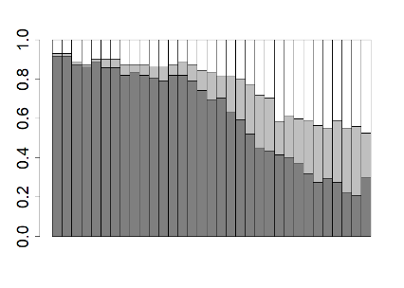 | 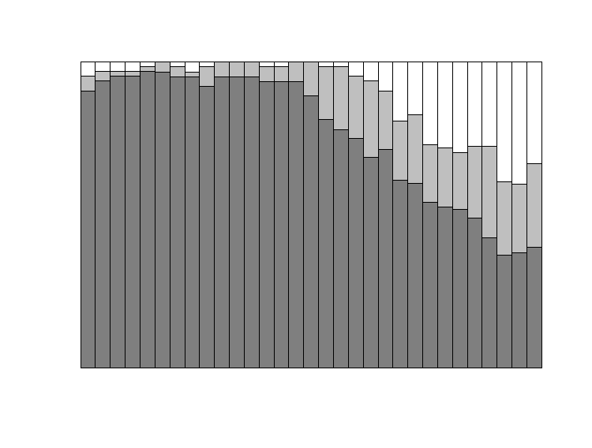 | 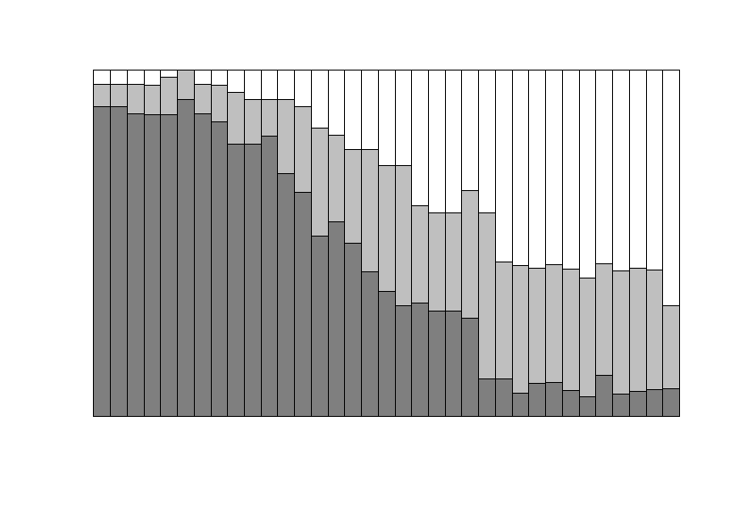 | 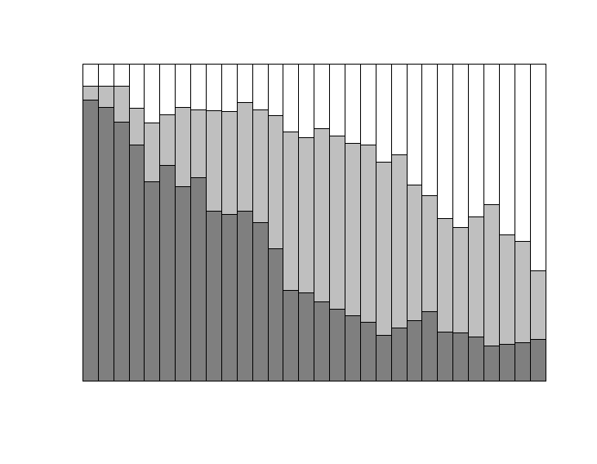 | 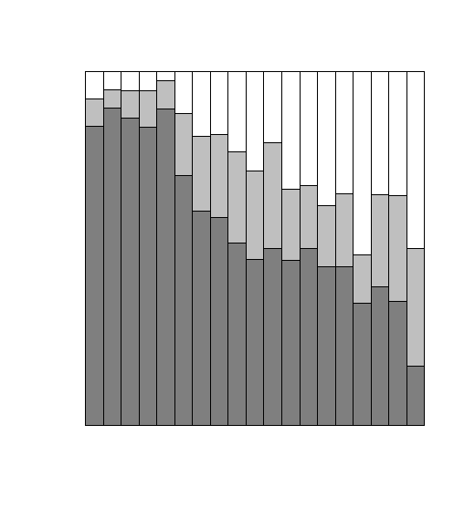 | 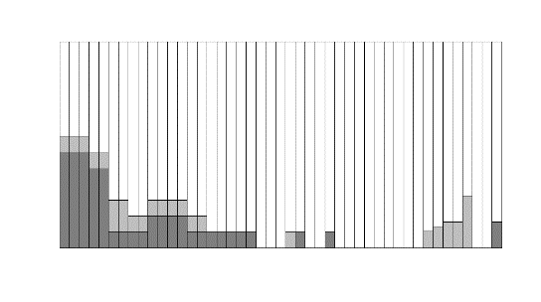
Administration experience
yes no
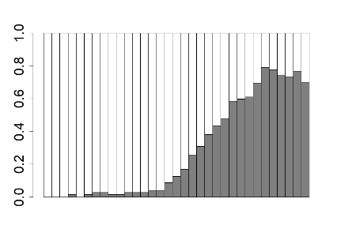 | 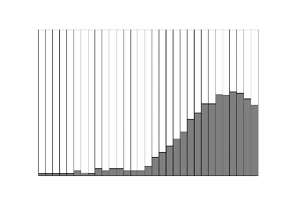 | 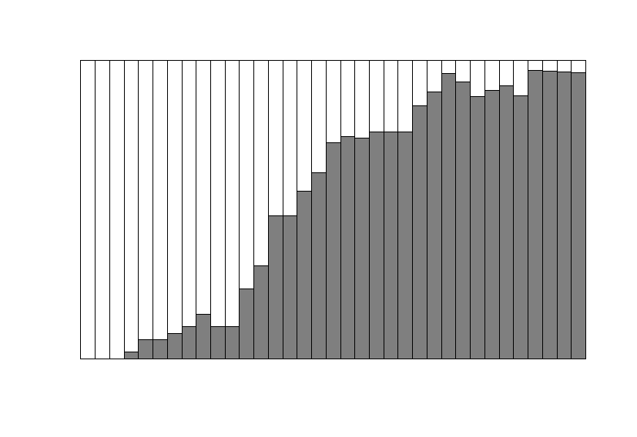 | 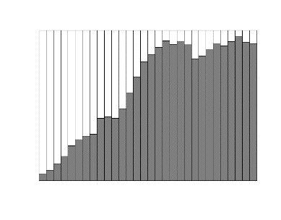 | 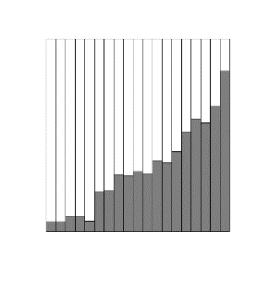 | 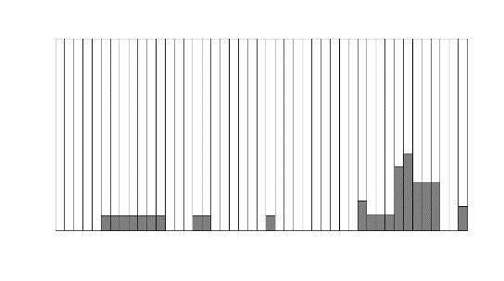
Current organization
yes no
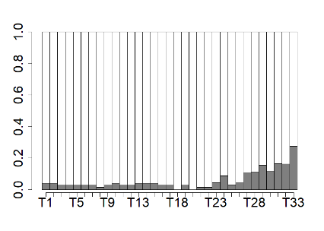 | 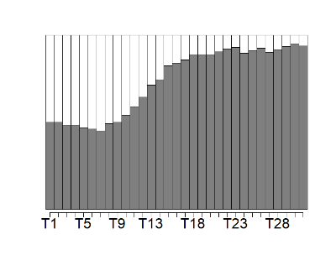 | 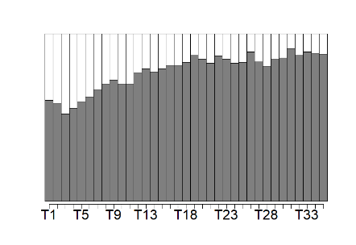 | 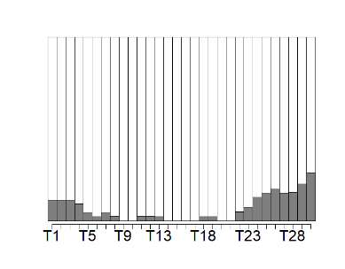 | 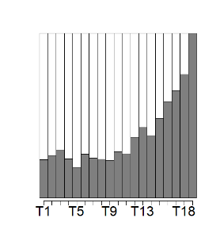 | 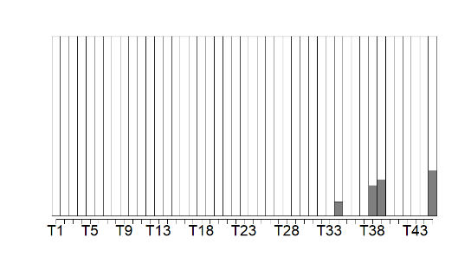

TABLE 3. Prototypical career sequences.
Pattern 1: Researcher  from outside | 0Ph-0Ph-0Ph-0Ph-0Ph-0Pd-0Le-0Le-0Le-0Le-0Le-0Le-0Le-0Le-0Le-0Le-0Le-0Ao-0Ao-0Ao-0Pr-0Pr-0De-0De-0De-0Vl-0Vl-0Vl
Pattern 2: Researcher  from inside | 0Ph-0Ph-0Ph-0Ph-0Pd-0Pd-0Ai-0Ai-0Ai-0Ai-1Le-1Le-1Le-1Le-1Le-1Le-1Ao-1Ao-1Ao-1Ao-1Ao-1Ao-1Pr-1Pr-1Pr-1Di-1Di-1Di-1Di
Pattern 3: Administrative expert from inside | 1Gr-1Gr-1Gr-1Pr-1Pr-1Pr-1Pr-1Pr-1Pr-1Pr-1Pr-1Di-1Di-1Di-1Di-1Di-1Di-1Di-1Di-1Di-1Di-1DiPv-1DiPv-1DiPv-1Di-1Di-1De-1De
Pattern 4: Administrative expert from outside | 0Ph-0Ph-0Ph-0Ai-0Ai-0Ai-0Ai-0Ao-0PrOt-0PrOt-0PrOt-0Pr-0Di-0Di-0Di-0Di-0Di-0Di-0Di-0Di-0Di-0Pv-0Pv-0Pv-0Pv-0Pv
Pattern 5: Fast-track outsider | 0Gr-0Gr-0Gr-0Ph-0Ph-0Pd-0Ot-0Ot-0Ot-0Ot-0Ot-0Ot-1Di-1Di-1Di
Pattern 6: Late career practitioner | 0Ot-0Ot-0Ot-0Ot-0Ot-0Ot-0Ot-0Ot-0Ot-0Ot-0Ot-0Ot-0Ot-0Ot-0Ot-0Ot-0Ot-0Ot-0Ot-0Ot-0Ot-0Ot-0Ot-0Ot-0Ot-0Ot-0Ot-0Ot-0Ot-0Ot-0Ot-0Ot-0Ot-0Ot-0Ot-0Ot-0Ot-0Ot-1De
Notes. 0 = position at other organizations, 1 = position in current organization; Ai = Assistant Professor; Ao = Associate Professor; De = Dean; Di = Director; Gr = Graduate student; In = Investigator; Le = Lecturer; Ot = Other (no academic organization); Pd = Postdoctoral researcher; Ph = PhD student; Pr = Full Professor; Pv = Provost; Rs = Researcher (academic organization); Ul = University leader; Vl = Vice university leader.

TABLE 4. Characteristics of career patterns.
 | Pattern 1: Researcher from outside | Pattern 2: Researcher from inside | Pattern 3: Adm. expert from inside | Pattern 4: Adm. expert from outside | Pattern 5: Fast-track outsider | Pattern 6:  Late career practitioner
Cluster size | 72 | 64 | 48 | 44 | 39 | 13
Min/med/max length (years) | 19 / 34 / 53 | 22 / 31 / 45 | 22 / 35 / 51 | 18 / 30 / 48 | 8 / 19 / 39 | 34 / 45 / 56
Positions and current organization by cluster (in years):
Research positions | 22.80 | 25.59 | 19.46 | 16.32 | 11.56 | 5.08
Administrative positions | 10.12 | 7.72 | 18.19 | 18.61 | 6.82 | 3.15
Current organization | 2.57 | 23.70 | 26.21 | 2.43 | 8.31 | 1.23
Individual characteristics by cluster
Women (in %) | 19.4 | 15.6 | 14.6 | 11.4 | 10.3 | 7.7
Mean age at appointment | 55.6 | 53.8 | 56.0 | 52.8 | 49.3 | 70.7

Table 5. Career patterns and ecosystem characteristics.
 | Mean/ standard deviation | Pattern 1: Researcher from outside | Pattern 2: Researcher from inside | Pattern 3: Adm. expert from inside | Pattern 4: Adm. expert from outside | Pattern 5:  Fast-track outsider | Pattern 6: Late career practitioner | F-values from ANOVA
Societal culture by cluster (N = 274)
Uncertainty avoidance | 4.43/ 0.61 | 4.33^{(3,4,6)} | 4.39⁽⁶⁾ | 4.57^{(1,5)} | 4.63^{(1,5)} | 4.24^{(3,4,6)} | 4.80^{(1,2,5)} | 3.60**
Future orientation | 5.40/ 0.36 | 5.35⁽⁶⁾ | 5.39⁽⁶⁾ | 5.45⁽⁶⁾ | 5.41⁽⁶⁾ | 5.30⁽⁶⁾ | 5.83^{(1,2,3,4,5)} | 5.08***
Power distance | 2.74/ 0.30 | 2.81^{(2,3)} | 2.65^{(1,6)} | 2.67^{(1,6)} | 2.75 | 2.75 | 2.88^{(2,3)} | 2.90*
Institutional collectivism | 4.61/ 0.48 | 4.55 | 4.64 | 4.68 | 4.67 | 4.48⁽⁶⁾ | 4.71⁽⁵⁾ | 1.34
In-group collectivism | 5.64/ 0.33 | 5.61 | 5.60 | 5.67 | 5.67 | 5.66 | 5.73 | 0.72
Humane orientation | 5.44/ 0.22 | 5.39⁽²⁾ | 5.48⁽¹⁾ | 5.47 | 5.42 | 5.47 | 5.45 | 1.42
Performance orientation | 5.93/ 0.32 | 5.92 | 5.84^{(4,5,6)} | 5.90⁽⁶⁾ | 6.00⁽²⁾ | 5.98⁽²⁾ | 6.09^{(2,3)} | 2.30*
Gender egalitarianism | 4.65/ 0.45 | 4.75^{(2,4,6)} | 4.56^{(1,5,6)} | 4.64⁽⁶⁾ | 4.55⁽⁵⁾ | 4.79^{(2,4,6)} | 4.32^{(1,2,3,5)} | 3.92**
Assertiveness | 3.91/ 0.67 | 4.00 | 3.74⁽⁶⁾ | 3.87 | 4.02 | 3.93 | 4.16⁽²⁾ | 1.45
Labor market characteristics by cluster (N = 280)
Labor market flexibility | 61.5/ 9.20 | 64.6^{(2,3,4)} | 60.4^{(1,5)} | 60.4^{(1,5)} | 59.8^{(1,5)} | 64.5^{(2,3,4)} | 63.0 | 2.87*
Meritocracy and incentivization | 69.6/ 11.6 | 73.2^{(2,3,4)} | 67.0^{(1,5)} | 68.4^{(1,5)} | 67.4^{(1,5)} | 73.7^{(2,3,4)} | 69.8 | 3.56**
Organizational characteristics by cluster (N = 214)
Teaching | 43.04/ 22.45 | 46.4 | 38.5 | 42.2 | 42.9 | 47.1 | 36.1 | 0.99
Research | 43.16/ 25.92 | 48.2⁽²⁾ | 38.2⁽¹⁾ | 39.8 | 43.2 | 48.4 | 32.3 | 1.35
Citations | 65.37/ 28.31 | 75.6^{(2,3,4)} | 57.6^{(1,5)} | 59.1^{(1,4,5)} | 60.5^{(1,3)} | 73.8^{(2,3)} | 57.3 | 3.71**
Industry income | 52.13/ 18.69 | 51.7⁽⁶⁾ | 52.9⁽⁶⁾ | 52.9⁽⁶⁾ | 51.5⁽⁶⁾ | 52.2⁽⁶⁾ | 38.5^{(1,2,3,4,5)} | 0.88
International outlook | 59.65/ 22.81 | 66.6^{(2,3,4)} | 55.7⁽¹⁾ | 53.9^{(1,5)} | 56.2⁽¹⁾ | 65.0⁽³⁾ | 55.6 | 2.48*
Notes. A superscripted number in parentheses for cluster values indicates a significant mean difference with another cluster based on a t-test with p < .05 (for example, uncertainty avoidance is significantly lower in pattern 1 than in patterns 3, 4, and 6);
* p < 0.05; ** p < 0.01; *** p < 0.001.

Factors Policies & Processes Outcomes
Career trajectories/career patterns
e.g., socio-demographics, personality, human capital, social capital
e.g., education, career decisions, career moves, promotions
Individual

e.g., talent flows, human capital development
Organization characteristics (e.g., research-oriented)
e.g., HR strategy, talent management, promotion strategy, succession plans

Organization

e.g., competitive advantage, wealth creation, national well-being
Societal culture (e.g., assertiveness)
Labor market characteristics (e.g., flexibility)
e.g., legal system, regulatory system, government involvement
Society

Note. Adapted from Baruch and Rousseau (2019). Constructs examined in this study are bold.

FIGURE 1. The Academic Career Ecosystem

Country names (number of individuals in sample): Albania (3), Argentina (3), Australia (7), Austria (5), Belgium (3), Bolivia (3), Brazil (3), Canada (6), China (4), Colombia (3), Croatia (3), Czech Republic (5), Denmark (3), Ecuador (3), El Salvador (3), Ethiopia (4), Finland (3), France (5), Georgia (3), Germany (7), Greece (3), Guatemala (3), Hong Kong (5), Hungary (4), India (7), Indonesia (4), Iran (3), Ireland (6), Israel (5), Italy (4), Japan (8), Kazakhstan (3), Korea (the Republic of) (5), Kuwait (3), Malaysia (3), Mexico (3), Namibia (1), Netherlands (the) (6), New Zealand (3), Nigeria (3), Norway (1), Philippines (the) (3), Poland (5), Portugal (5), Russia (5), Saudi Arabia (2), Singapore (4), Slovenia (3), South Africa (3), Spain (5), Sweden (5), Switzerland (7), Taiwan (5), Thailand (2), Turkey (5), the United Kingdom (9), the United States of America (40), Venezuela (3), Zambia (2), Zimbabwe (5).
For three countries, there were two observations in the GLOBE survey (Switzerland and French Switzerland, Eastern and Western Germany, and black and white samples of South Africa). We included universities from Switzerland and Western Germany only and used the values of the black sample for South Africa.
See Online Appendix B for an extended example. For an introduction to optimal matching analysis, we refer the interested reader to Biemann and Datta (2014) and van der Laken et al. (2018).
A university may not be ranked for two reasons: either it does not fulfil the inclusion criteria for the rankings, or it did not score highly enough to be included. A university is not included if it does not teach undergraduates, if it teaches only one subject, or if it produces fewer than an average of 200 research papers a year (THE, 2019).

