**Estimating biophysical and biochemical parameters using Sentinel-2A and Near-proximal sensor data in Behali Reserve Forest (BRF) in Assam**

**Bishal Kanu¹, Dr. Bikash Ranjan Parida¹, * Somnath Bar¹**

¹Department of Geoinformatics, School of Natural Resource Management, Central University of Jharkhand, Ranchi-835222, India.

* Correspondence author.

**Abstract**

Tropical forests are most active and diversified ecosystem on the globe, play a significant role in maintaining the ecological balance. Forest biophysical and biochemical parameters are critical to monitoring vegetation growth and assessing forest health. The integration of near-proximal sensor (NPS) data and satellite data has provided efficient perspective for the rapid, detailed, and reliable assessment of the forest's biophysical and biochemical parameters. The objective of this study is to map and model biophysical and biochemical parameters of forests in Behali Reserve Forest, Eastern Himalaya. The red-edge bands of the Sentinel-2A sensor were used in this study to derive both biophysical and biochemical parameters. Furthermore, NPS data were combined with satellite observation to modelled and map leaf chlorophyll content (Cab) and nitrogen (N) contents using empirical methods. The key findings indicate that Normalized Difference Red-Edge index (NDRE) and measured leaf Cab and N have significant positive associations, with R2 of 0.88 and 0.89, respectively. Forests leaf area index (LAI) ranged from 0 to 5.5 m2m-2, the healthy dense forests having LAI ≥ 4.5 (54.6sq/km of total forest area). The NAOC (Normalized Area Over Reflectance Curve) index based empirical model Cab content of dense forests ranged between 30 and 45 μg/cm2. The leaf NBI content demonstrated a similar pattern like leaf Cab. The N content of dense forest’s leaf was estimated between 40 and 70(unitless). The combined satellite and handheld NPS instruments have demonstrated a robust and efficient method of monitoring the health of forests. As the biophysical and biochemical parameters provide critical information about a forests landscape, which could be critical for forest conservation, plantation, monitoring and management.

**Keywords:** leaf chlorophyll content, leaf nitrogen, LAI, NAOC, biochemical

**1. Introduction**

Forests are a delicate blanket of Earth surface, have significant controlled in the global climate through carbon and water cycle (Shiferaw et al. 2019). The forests act as a natural climate change defence, absorbing the greenhouse gases (carbon dioxide) and producing oxygen. It contributes to atmospheric detoxification and temperature control, but the increasing forest degradation and deforestation have been diminishing these benefits (Munsi et al. 2012; Olokeogun et al. 2014). As well as, forest prevent soil erosion by reducing the force of rain on the soil surface and absorbing water rather than allowing it to run off and remove topsoil directly (Kaliraj et al. 2012). Also serve as water filters, collecting and storing water and replenishing aquifers underground (Palmate et al. 2017).

Despite covering less than 10% of the land area, tropical evergreen forests are the largest terrestrial reservoir of biological diversity, from the gene to the habitat level (Mahato et al. 2021). Tropical evergreen forests, are home to more than half of all known plant species. It directly contribute to the economy and livelihood of living communities in forest by providing honey, fuelwood, timber, and traditional medicine (Parida and Kumar 2020). As well, it provides critical habitats for a variety of terrestrial flora and fauna, suitable breeding grounds for a variety of terrestrial and avian species. Typically, tropical evergreen and semi-evergreen forest store more carbon than other types of forest. As a result, the biomass of tropical evergreen forests is known as green carbon, and it has remained an important component of carbon change mitigation programmes such as Reducing Emissions from Deforestation and forest Degradation (REDD+) (Twilley et al. 2018). In India, tropical evergreen forest located in Western Ghats, Andaman and Nicobar Island, North-East region of India, some part of Kerala and Karnataka.

Recently, forest and canopy height mapping and retrieving both biophysical and biochemical parameters, such as NDVI (Normalized difference vegetation index), EVI (Enhanced vegetation index), LAI (Leaf Area Index), fraction of photosynthetically active radiation (FAPAR), leaf chlorophyll content, and Nitrogen Balance Index (NBI), among others are significantly assisted by earth observation satellite remote sensing data (Lu, He, and Liu 2018; Pandey et al. 2023). These parameters are critical for assessing the health of forests and quantifying gross primary production (GPP) and carbon content in forest ecosystems. (Roy et al. 2017; Parida and Kumari 2021a) employed red-edge bands of Sentinel-2A sensor and ground-based sensor data to derive both biophysical and biochemical parameters i.e.; leaf chlorophyll content (Cab) and leaf nitrogen (N) using empirical models. (Frampton et al. 2013) employed Sentinel-2 satellite data to quantify vegetation Cab content and LAI and furthermore used to monitor the health and function of vegetation.

Several vegetation sensitive remote sensing indices have been developed for vegetation biochemical and biophysical parameter studies using the visible to near infrared range of satellite bands (Davis and Jensen 1998; Varghese and Behera 2019). The NDVI, EVI, Ratio Vegetation Index (RVI), Soil Adjusted Vegetation Index (SAVI), have illustrated their capability to evaluate vegetation greenness, whereas Normalized Area Over Reflectance Curve (NAOC) and MERIS Terrestrial Chlorophyll Index (MTCI) have deployed to estimate leaf Chl content and other pigments (Ogutu and Dash 2013; Parida and Kumari 2021b). Besides that, some narrow-band vegetation indices, such as the Chlorophyll Absorption Ratio Index (CARI), Transformed Chlorophyll Absorption Ratio Index (TCARI), Modified Chlorophyll Absorption Ratio Index (MCARI), Chlorophyll Vegetation Index (CVI), Green Difference Vegetation Index (GDVI), and others, have indicated exceptional performance in assessing leaf chlorophyll content and other biophysical parameters (Frampton et al. 2013).

Plant productivity, stress, and availability of nutrients could be also quantified and assessed using biochemical factors such as leaf chlorophyll and nitrogen content (Delegido et al. 2011). Through their potential influence on nutritional deficiencies, nitrogen content serves as an indicator of plant stress (Ranjan and Parida 2020). Thus, biophysical and biochemical characteristics can be retrieved from satellite data and integrated into terrestrial ecosystem models to monitor forest health and biomass production efficiency and ecosystem exchanges. The biophysical parameters (NDVI, EVI, and LAI) were frequently used to retrieve fraction of photosynthetically active radiation which is an essential climate variable in land and atmosphere interaction (Verrelst et al. 2012). NDVI is the most widely used vegetation index in vegetation dynamics monitoring, it detects and quantifies the presence of live green and healthy pigments by using reflected light in the visible red and near-infrared spectral region (Eastman et al. 2013; Huang et al. 2021). EVI is similar to NDVI but it is more sensitive in an area with dense vegetation and more responsive to canopy type, canopy structure, plant physiognomy, and LAI (Frampton et al. 2013). Normalized Difference Red-Edge index (NDRE) based on NIR and Red-Edge band is one of the recent development indices used to retrieve the vegetation biophysical parameter which is sensitive to leaf chlorophyll content, stress detection, and plant vigor (Eitel et al. 2011). Like other biophysical parameters, the LAI is the most crucial biophysical parameter associated with plant ecology, photosynthesis, respiration, carbon and nutrient cycling and transpiration, and energy balance (Houborg et al. 2007; Delegido et al. 2011; Wang et al. 2019). RVI and Normalized Area Over Reflectance Curve (NAOC), have also been used to quantify and assess the Cab and other leaf pigments using red-edge spectral reflectance (Delegido et al. 2011; Verrelst et al. 2012). Leaf Cab has a strong relationship with leaf nitrogent content because it is an essential component of chlorophyll (Gholizadeh et al. 2017). Several remote sensing-based studies have demonstated a strong correlation between the reflectance of red-edge and near-infrared bands and leaf chlorophyll (Delegido et al. 2011). The NAOC index can be used to estimate leaf Cab and nitrogent content using red-edge spectral bands from multispectral satellite data, such as Landsat-8, Sentinel-2 and 3, and others satellite data (Feng et al. 2014; Carmona et al. 2015).

There are very few studies that use indices other than the NAOC index to calculate leaf Cab and nitrogen content. The near-proximal sensor has been used by few studies to estimate biochemical parameters Cab and Nitrogen Balance Index (NBI) (Schepers et al. 1992; Bijay-Singh and Ali 2020). Biochemical parameters were compared with multispectral satellite data using this field-based proximal sensor. The NPS data can be also used and combined with multispectral satellite data to measure biochemical parameters (Schepers et al. 1992; Ranjan and Parida 2020). As there are not much litearure available to determine forest health over BRF, it is important to assess both biophysical and biochemical parameters by integrating NPS and multispectral satellite data. The main objective of the present study is to assess both biophysical and biochemical parameters of forests in BRF, located in north-eastern Himalaya by using Sentinel-2A and NPS data.

**2. Study area**

The selected study area is the Behali reserve forest (BRF), located in Biswanath district, Assam comes under the Sonitpur-East Forest division situated at the foothills of the north-eastern Himalaya, along the Assam-Arunachal Pradesh border (Fig.1). It extended from 26º 52' to 26º 57' N latitude and 93º 15' to 93º 53' E longitude with an elevation of 90 to 300 m. BRF has an area of 145.61 km2 and is bounded by the Buroi River from east, Singlijan Reserve Forest from west, Papum Reserve Forest from north, and Borgang Tea Estate, rubber garden, agricultural land, and human settlement from south. The climate in BRF is tropical monsoon with heavy rainfall and high humidity. The climate is characterised by warm summers and moderate winter. The mean annual temperature of BRF is 23.4ºC and the mean annual precipitation is about 1800 mm (Borah et al. 2020). BRF is the only remaining tropical wet evergreen and semi-evergreen forest of Biswanath district of Assam. It comprises of 71 km2 of forest area and accommodates diversified flora and fauna. It is known for its heterogenous forest ecosystem. The BRF is home to around 285+ birds, 275+ butterflies, 23 snakes, 49 mammals, 12 amphibians, 11 turtles, and 11 lizards, and many other diverse flora and fauna species (Borah and Tangjang 2020).

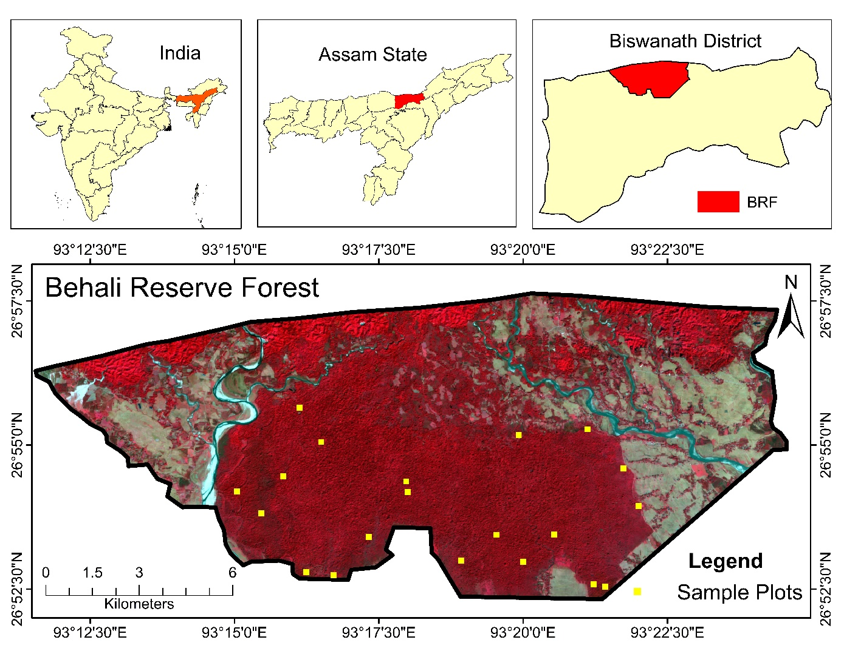

**Fig.1** The location map of study area, Behali Reserve Forest (BRF) in Assam, India. Sentinel-2 False Colour Composite(FCC) showed the location of BRF in Biswanath district of Assam. The yellow boxes are the ground sampling plots.

**3. Materials and methods**

**3.1. Satellite data used**

In the current study, a moderate-resolution surface reflectance imagery of Sentinel-2A satellite data (spatial resolution, 10-60 m; temporal resolution, 5 days) is utilised to estimate Cab content and NBI by integrating near-proximal sensor data, as shown in Table 1. Sentinel-2 was launched by the European Space Agency (ESA) and contains two identical satellites, Sentinel-2A and Sentinel-2B, which were launched in June 2015 and March 2017, respectively. It has a multi-spectral instrument (MSI) sensor with 13 spectral bands ranging from visible (10 m) through near-infrared (NIR) (20 m) to short-wave infrared (SWIR) (60 m). The Sentinel-2A data was obtained from Google Earth Engine (GEE) and was acquired on March 2022. This study utilized spectral band 2 (blue), bands 4 (red), 6 (red-edge), and 8 (NIR) with spatial resolutions ranging from 10 to 20 m. These bands were used to retrieve biophysical parameters i.e., Leaf area index (LAI), Enhanced vegetation index (EVI), and Normalized difference vegetation index (NDRE) from forests as well as biochemical parameters i.e., Chlorophyll and Nitrogen content from leaves.

**Table 1** Data characteristics of satellite image and NPS data used in the study.

|  |  |  |  |
| --- | --- | --- | --- |
| **Dataset** | **Spectral and spatial resolutions** | **Acquisition Time** | **Source** |
| Seentinel-2A | Blue (0.490 µm), 10 m  Red (0.665 µm), 10 m  Red-edge (0.783 µm) , 20 m  NIR (0.842 µm), 10 m | March, 2022 | ESA |
| Near-proximal sensor (NPS) data (Cab, NBI) | - | 5-9 March, 2022 | Field measurements |

**3.2 In-situ data collection using a handheld digital chlorophyll meter:**

A field survey was conducted in BRF from 5-9 March 2022, to measure forest biochemical parameters (i.e., leaf chlorophyll content and nitrogen balance index). A handheld digital chlorophyll metre (Dualex Scientific Tm, made in France) was used to estimate biochemical parameters. It has an internal Global Positioning System (GPS) receiver that allows it to record the geolocation of the sample and provides real-time measurements with a 5% standard deviation accuracy. The data collected from 20 sample plots (dimension of plot: 10×10 m). Each plot comprises an average of 50 observations. The ratio of Cab and flavanol concentration has been used to compute NBI, which is a measures of plant's nitrogen deficiency. The Cab and nitrogen have a very strong linear relationship, whilst Cab and flavanol have the inverse relationship. A higher flavanol value represents a lower nitrogen status of plants, while a lower flavanol value represents a higher nitrogen status of plants.

**3.3. Methods**

The detailed methodological workflow of the study has been presented in Fig. 2. High-resolution Sentinel-2A surface reflectance satellite data were accessed via Google Earth Engine (GEE) platform and then biophysical and biochemical parameters (EVI, NDRE, LAI, Cab and nitrogen content) were derived. The derived indices were integrated with data from near-proximal sensors especially to quantify the forest's biochemical parameters (i.e., Cab, nitrogen). The study's workflow includes satellite data pre-processing, image transformation, regression analysis, and statistical evaluation of estimated Cab content and NBI of forests. In situ Cab content and NBI datasets, as well as satellite data, were used to develop linear regression-based models for Cab and NBI mapping. A brief overview of the workflow is provided below.

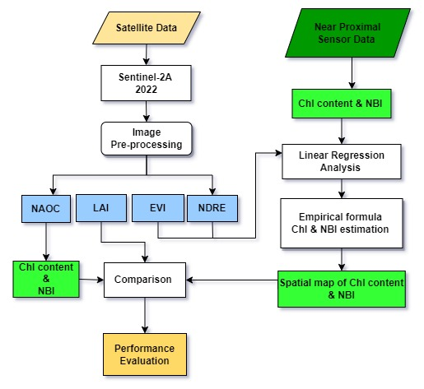

**Fig. 2** Methodology flowchart adopted for this study

**3.3.1. Biophysical parameters estimation**

EVI has used for monitoring vegetation quality and quantity. It is represented as an optimized vegetation index developed by (Liu and Huete 1995) in order to improve the vegetation signal's sensitivity in high biomass areas. The EVI can be determined by using the following equations:

EVI = 2.5 ( NIR - R ) / ( NIR + C1*R – C2*Blue + 1 ) (1)

where, NIR (0.842 µm), R (0.665 µm), and Blue (0.49 µm) are the spectral bands of Sentinel-2A, and band numbers are 8, 4, and 2 respectively. 2.5 is the gain factor, C1 = 6 and C2 = 7.5 are coefficients of aerosol resistance terms. L factor is taken as 1 which represents the canopy background adjustment factor.

NDRE index is a better indicator of health or vigor than NDVI in mid to late-season plants with high accumulation of chlorophyll levels in their leaves because red-edge light is more translucent to leaves than red light (Barnes et al. 2000). The red-edge part of the spectrum is used to detect changes in chlorophyll content within the leaf and throughout the plant canopy. The NDRE can be determined by using the following formula:

NDRE = ( NIR - Red edge ) / ( NIR + Red-edge ) (2)

where, NIR (0.842 µm) and red-edge (0.783 µm) are the spectral bands of Sentinel-2A, and band members are 8 and 7 respectively.

LAI is one-half of the total green leaf area per unit of horizontal ground surface, which is an important structural property of vegetation (Scurlock 2002). Because leaf surfaces serve as the primary edge for energy and mass exchange, important processes such as canopy interception, evapotranspiration, and gross photosynthesis are proportional to LAI (Baret and Guyot 1991).

LAI = 6.753 * ( NIR - R ) / ( NIR + R ) (3)

where, NIR (0.842 µm) and R (0.665 µm) are the spectral bands of Sentinel-2A, and 6.753 is the gain factor.

**3.3.2. Biochemical parameters estimation using NAOC-based method**

The NAOC index is developed by using red-edge spectral region of 643 and 795 nm (Carmona et al. 2015). However, due to the absence of precise spectral bands, the relatively close bands are taken from Sentinel-2A satellite sensors, such as 665 and 783 nm. These two selected bands demonstrated a considarble accuracy in leaf chlorophyll content by combining with NAOC. The following formulas are used to calculate the leaf Cab and NBI :

Chlorophyll (sat) = -3.8868 + 101.94 x NAOC (4)

NAOC = ½ (1 – Red edge / R) (5)

where Chlorophyll (sat) is satellite-based Cab in µg/cm2 and NAOC is Normalized area over reflectance curve. Red-edge (0.783 µm) and R (0.665 µm) are the spectral bands of Sentinel-2A.

NBI(sat)= chlorophyll (sat) / flavonoids(6)

where NBI is satellite-based nitrogen balance index, which is the ratio of chlorophyll (satellite-based) to the flavonoid. Flavonoids are taken from the mean value of 20 samples (i.e. 0.66) from field measurements.

**3.3.3. Chlorophyll and NBI estimation using empirical formula**

Using measured Cab from near proximal sensor (NPS) and NDRE from Sentinel-2A data, a linear regression-based empirical model for estimating leaf chlorophyll content was developed. The correlation coefficient (R2) was found at 0.88 with a p-value < 0.001 (Fig. 3a), where data from 20 samples plots were used. Similarly, an another empirical model for NBI was made by using measured NBI from NPS and NDRE (R2 of 0.89 with p-value < 0.001) (Fig. 3b). The following equations are developed to extract empirical-based spatial maps of Cab and NBI.

Chlorophyll (empirical) = 17.562-41.822 x NDRE(7)

NBI (empirical) = 27.9-60.677 x NDRE (8)

**INSERT Figure 3a and 3b**

**4. Results**

**4.1. Spatial pattern of biophysical parameters (EVI, NDRE and LAI)**

Biophysical parameters are used to monitor vegetation vigor, healths and the water cycle. The EVI of the study area ranged from 0 to 0.9 (Fig.4), with healthy vegetation accounting for more than 0.45 over central part of BRF. The spatial distribution of EVI (more than 0.45) indicated that moderate to dense forest, which covers 63.6 km2 of the forest area. Lower EVI (between 0-0.45) was exihibited on grassland, agricultural land, plantation area, fallowland and barren land. NDRE is a better indicator of vegetation health and vigor than NDVI where a higher chlorophyll content indicates healthy vegetation. NDRE is affected by chlorophyll content in leaves, leaf area variability, and soil background effects. The NDRE map showed that it ranged between 0 to 0.6 (Fig.4) over forest area, where higher NDRE values indicate higher and healthy concentration of leaf chlorophyll content. In this study, an NDRE value ≥ 0.4 indicates dense and healthy forest, as well as a high chlorophyll content vegetations covering 60.4 km2 of forest area. Over BRF, the LAI ranges from 0 to 5.5 (Fig.6) which indicates a sparse vegetation to dense forest. The LAI value more than 4.5 corresponds to healthy moderate to dense forest which was observed over the central parts of BRF, covering an 54.6 km2 area of forest. LAI over sparse vegetation is ranged from 3 to 4.5, whilst lowest LAI observed over the grassland and agricultural land.

. 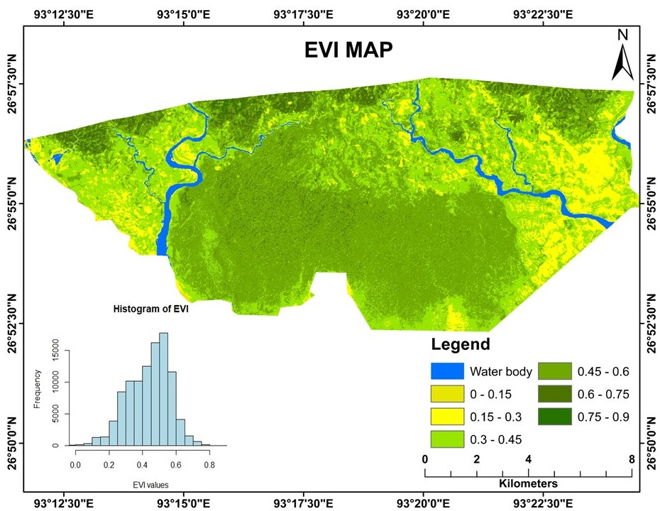

**Fig.4** Spatial distribution of EVI over BRF in March 2022

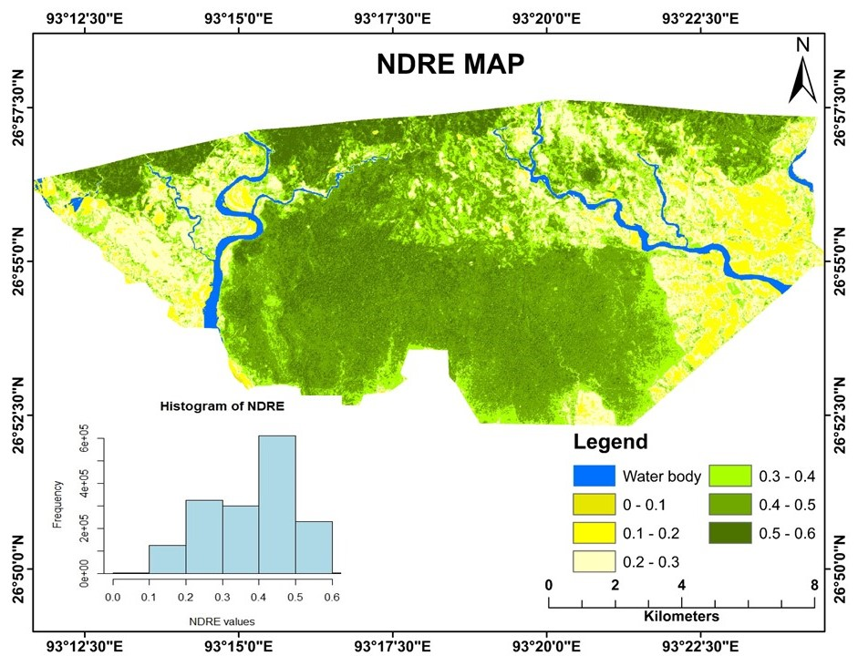

**Fig. 5** Spatial distribution of NDRE over BRF in March 2022

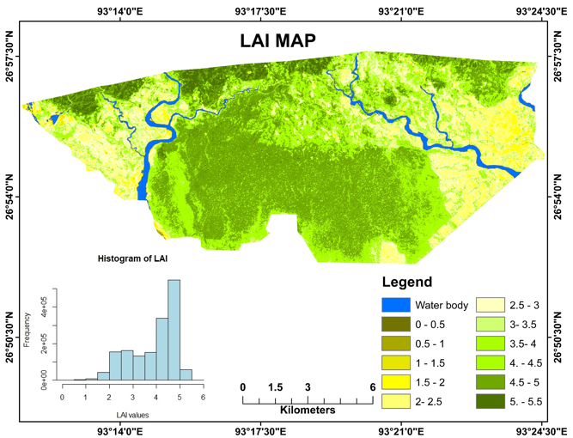

**Fig. 6** Spatial distribution map of LAI over BRF in March, 2022. The corresponding histogram is also shown.

**4.2. Spatial pattern of biochemical Parameters (leaf Chlorophyll content and NBI)**

Biochemical parameters such as leaf chlorophyll content and NBI in vegetation play a significant role in ecological processes, such as primary production and nutrient cycling. In NAOC-based technique, the satellite data play a important role in determining the spitial pattern of chemical properties of vegetations. The spatial map of leaf chlorophyll content based on NAOC index and an empirical method is shown in Fig. 7. The highest chlorophyll was detected in BRF, ranging from 25 to 45 μg/cm2. Over healthy moderate to healthy dense forests, the chlorophyll content exceeded to 30 μg/cm2. Over sparse forests, the chlorophyll content varied from 25 to 30 μg/cm2. The proximate spatial patterns of the NAOC-derived chlorophyll and the empirical-based model are closely associated. However, embirical model resulted relatively lower chlorophyll than the NAOC based satellite index.

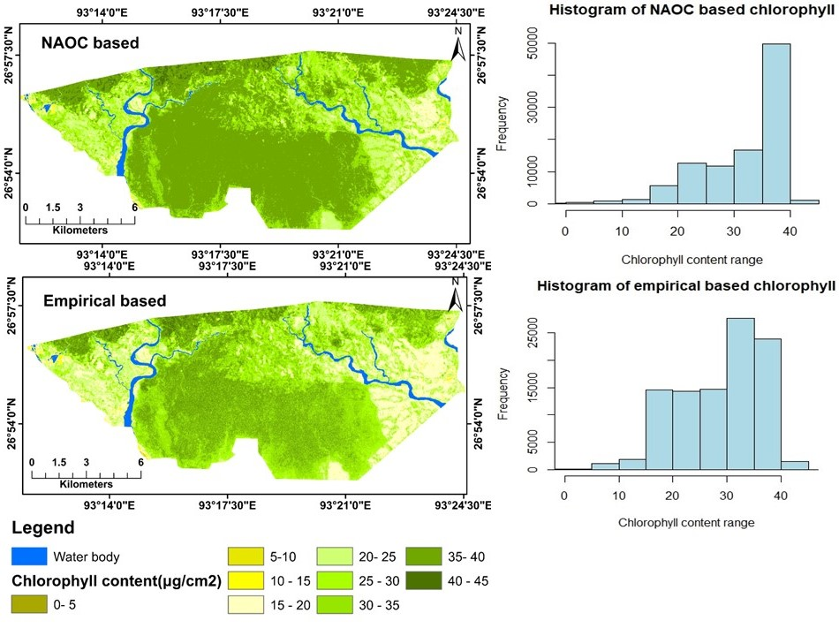

**Fig. 7** Spatial distribution of leaf chlorophyll content over BRF as derived from **(a)** NAOC based and **(b)** Empirical based. The corresponding histogram is also shown.

The NBI is a nitrogen status indicator for the vegetation that was developed using the NAOC index and an empirical method. The spatial distribution of NBI is depicted in Fig.8 and it ranges from 30 to 70 over BRF. In healthy moderate to dense forest, NBI content found more than 40. The spatial patterns of the empirical-based model are quite lower that the NAOC-derived NBI.

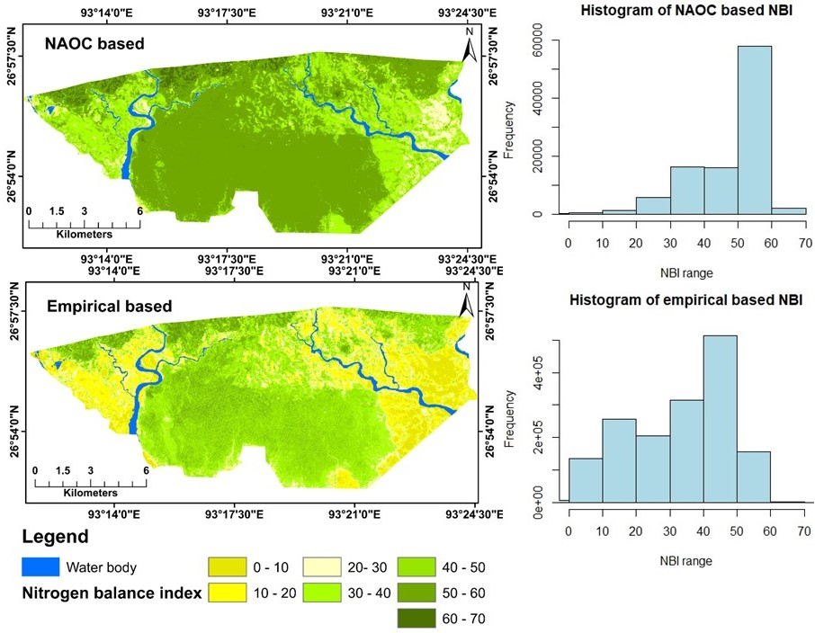

**Fig. 8** Spatial distribution of leaf nitrogen balance index over BRF as derived from **(a)** NAOC based and **(b)** Empirical based

**5. Discussion**

BRF is well known for its significant biodiversity of forest ecosystem and therefore, it is critical to assess and monitor the forest using space-borne satellite data. It has been reported that BRF is experiencing significant human-induced LULC changes as a result of infrastructure development and various economic activities. The current study retrieved various biophysical and biochemical parameters of forests in order to monitor their health conditions. Vegetations biophysical parameters such as EVI, NDRE and LAI were used for forest system monitoring. These biophysical parameters and their ranges are typically within the range that were reported by various studies across diffeerent protected areas (PAs) in India. For instance, ..add 2-3 studies which discusses on LAI, EVI, and NDRI.

For instance, the LAI of the Dibru Saikhowa National Park (DSNP) in Assam, which consists primarily of tropical evergreen and moist-deciduous forest varies from 1 and 5.2 (Marandi and Parida 2021). It is also compatible with studies that indicated between 1.2 and 4.5, particularly in deciduous broadleaf forests (Mahadevan et al., 2008; Xiao et al., 2004).

There have been few studies that has used red-edge spectral bands to derive forests biochemical parameters such as leaf chlorophyll and nitrogen content. add 2-3 studies which discusses on leaf chl and nitrogen.

Using the handheld leaf Chl meter, it has been reported that leaf chlorophyll content ranges from 15 to 70 μg/cm2 in Sholayar forest in Kerela, India (Ahmad et al. 2020).

The red-edge spectral bands between 680 and 750 nm are known to be very sensitive to vegetation conditions and have a stronger relationship with foliage pigments while remaining unaffected by structural properties (Horler et al. 1983; Parida et al. 2022).

Over BRF, NDRE showed close association and sensitivity toward field-based- measured leaf Chl and NBI content. The coefficient of determinants (R2) between NDRE and chlorophyll, EVI and chlorophyll exihibited 0.88 and 0.76, respectively (Fig.9). Similarly, the correlation between NDRE and NBI, EVI and NBI were 0.89 and 0.74, respectively (Fig.9). Leaf chlorophyll and NBI levels are the most important indicators of forest health and stress, as they are directly related to soil, water, environment, and nutrients (Singh and Parida 2019; Parida and Kumari 2021b). The estimated leaf chlorophyll content and NBI by satellite-based NAOC index were validated with field-based measurement data collected with a NPS instrument which revealed a considable connection between the both. The leaf chlorophyll content and NBI of the NPS instrument is reliable, non-destructive, and more accurate, but it was restricted to a narrow spatial coverage at a greater cost, time consumption, and the requirement of a large workforce. Therefore, combining NPS data with satellite data, could provide a reasonal and dynamic way to monitor the health of forests over a larger spatial and temporal scale.

Ground-based measurements used to collect information on forests biochemical parameters using near-proximal sensor data are only useful at a smaller spatial scale. Integration of these measurements with red-edge band satellite data, provides an alternative solution for larger spatial scale. As a result, the methods used to retrieve forests biochemical parameters such as leaf chlorophyll and nitrogen content are extremely useful and effective for assessing their health condition.

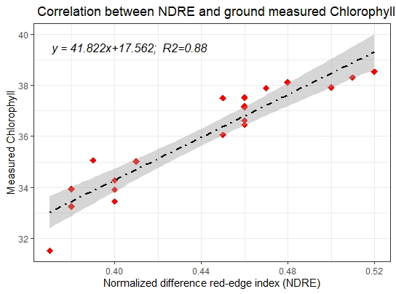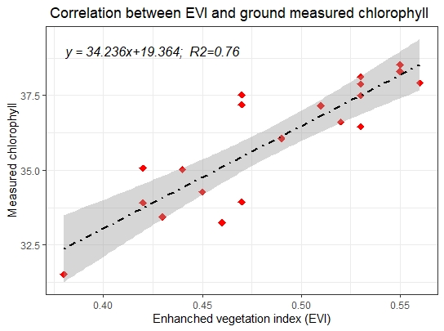

**Fig. 9** Relationship among measured leaf chl content from NPS with **(a)** NDRE and **(b)** EVI.

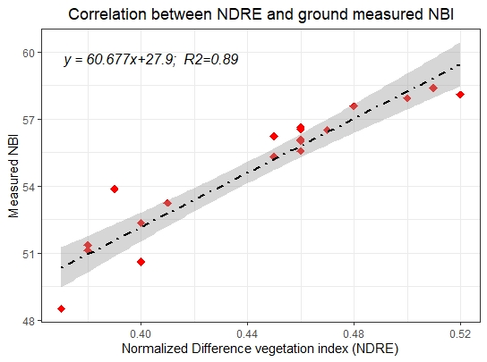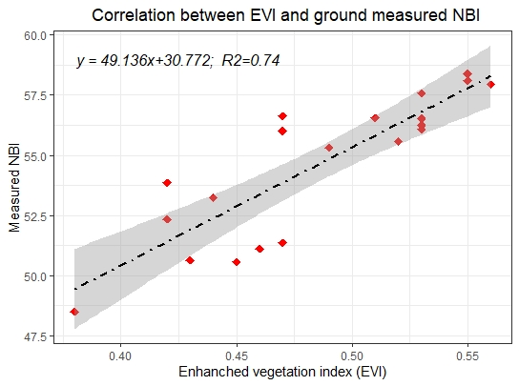

**Fig. 9**  Relationship among measured NBI from NPS with **(a)** NDRE and **(b)** EVI.

However, apart from the utility of red-edge bands in retrieving forests biophysical and biochemical parameters, hyperspectral sensors (e.g., AVIRIS, Hyperion) are typically preferred as strong relationship between leaf chlorophyll and nitrogen content and vegetation indices are demonstrated. The hyperspectral narrow-bands based indices, such as Chlorophyll Absorption Ratio Index (CARI), Transformed Chlorophyll Absorption Reflectance Index (TCARI), Modified Chlorophyll Absorption Ratio Index (MCARI), Green Vegetation Index (GVI), Modified Red Edge Normalized Difference Vegetation Index (MRENDVI) and Green Normalized Difference Vegetation Index (GNDVI) among others) are exihibited greater applications in the domain of vegetation health (Ahmad et al. 2020; Anand et al. 2020). Hyperspectral imaging with an unmanned aerial vehicle (UAV) platform can be more porential for precise forests health monitoring. However, its complex and costly platform may not be easily accessible or feasible. Sentinel-2A satellite data would be more realistic in this context for large area and could be preferred for retrieving forests biophysical and biochemical parameters.

**6. Conclusions**

The current study developed a model framework for mapping and monitoring biophysical and biochemical parameters of forests in BRF using red-edge bands from Sentinel-2A sensors. The NPS data were combined with satellite data for precisely estimate the Cab and N status of forests leaves. The NBI model, which can be used to calculate the leaf nitrogen status of forests, was developed by combining satellite-based data and near-proximal sensor data. The NAOC based index has shown relatively overestimated leaf Cab. A similar pattern was observed for leaf nitrogen content using he NBI model than that of empirical models.

The shortcoing of the this study include a small number sampling plots (20 plots) taken for Chl content and NBI due to limitation the field accessability, which effects accuracy of the model. As well higher spatial resolution satellite data could provide a more accurate and dependable spatial representation of Cab and N content in forests. This study concludes that the NAOC is a reliable method for estimating Chl content. Furthermore, the NBI empirical model has the potential to assess and map leaf nitrogen on a larger scale with the use of flavonol information. The inferences of this study critical for forest conservation, plantation, and management og BRF.

**REFERENCES :**

Ahmad, Shahbaz, Arvind Chandra Pandey, Amit Kumar, Bikash Ranjan Parida, Nikhil V. Lele, and Bimal K. Bhattacharya. 2020. “Chlorophyll Deficiency (Chlorosis) Detection Based on Spectral Shift and Yellowness Index Using Hyperspectral AVIRIS-NG Data in Sholayar Reserve Forest, Kerala.” *Remote Sensing Applications: Society and Environment* 19 (August): 100369. doi:10.1016/j.rsase.2020.100369.

Anand, Akash, Prem Chandra Pandey, George P. Petropoulos, Andrew Pavlides, Prashant K. Srivastava, Jyoti K. Sharma, and Ramandeep Kaur M. Malhi. 2020. “Use of Hyperion for Mangrove Forest Carbon Stock Assessment in Bhitarkanika Forest Reserve: A Contribution Towards Blue Carbon Initiative.” *Remote Sensing* 12 (4): 597. doi:10.3390/rs12040597.

Baret, F., and G. Guyot. 1991. “Potentials and Limits of Vegetation Indices for LAI and APAR Assessment.” *Remote Sensing of Environment* 35 (2–3): 161–173. doi:10.1016/0034-4257(91)90009-U.

Barnes, E M, T R Clarke, S E Richards, P D Colaizzi, J Haberland, M Kostrzewski, P Waller, et al. “COINCIDENT DETECTION OF CROP WATER STRESS, NITROGEN STATUS AND CANOPY DENSITY USING GROUND-BASED MULTISPECTRAL DATA.”

Borah, Dipankar, and Sumpam Tangjang. “Behali Reserve Forest of Assam, Northeast India – Unique Elements of Flora, Its Threats and Protection.”

Borah, Dipankar, Sumpam Tangjang, Abhaya Prasad Das, Ankur Upadhaya, and Puranjoy Mipun. 2020. “Assessment of Non-Timber Forest Products (NTFPs) in Behali Reserve Forest, Assam, Northeast India.” *Ethnobotany Research and Applications* 19 (May). doi:10.32859/era.19.43.1-15.

Carmona, Facundo, Raúl Rivas, and Diana C. Fonnegra. 2015. “Vegetation Index to Estimate Chlorophyll Content from Multispectral Remote Sensing Data.” *European Journal of Remote Sensing* 48 (1): 319–326. doi:10.5721/EuJRS20154818.

Davis, Bruce A., and John R. Jensen. 1998. “Remote Sensing of Mangrove Biophysical Characteristics.” *Geocarto International* 13 (4): 55–64. doi:10.1080/10106049809354665.

Delegido, Jesús, Jochem Verrelst, Luis Alonso, and José Moreno. 2011. “Evaluation of Sentinel-2 Red-Edge Bands for Empirical Estimation of Green LAI and Chlorophyll Content.” *Sensors* 11 (7): 7063–7081. doi:10.3390/s110707063.

Eastman, J., Florencia Sangermano, Elia Machado, John Rogan, and Assaf Anyamba. 2013. “Global Trends in Seasonality of Normalized Difference Vegetation Index (NDVI), 1982–2011.” *Remote Sensing* 5 (10): 4799–4818. doi:10.3390/rs5104799.

Eitel, Jan U.H., Lee A. Vierling, Marcy E. Litvak, Dan S. Long, Urs Schulthess, Alan A. Ager, Dan J. Krofcheck, and Leo Stoscheck. 2011. “Broadband, Red-Edge Information from Satellites Improves Early Stress Detection in a New Mexico Conifer Woodland.” *Remote Sensing of Environment* 115 (12): 3640–3646. doi:10.1016/j.rse.2011.09.002.

Feng, Wei, Bin-Bin Guo, Zhi-Jie Wang, Li He, Xiao Song, Yong-Hua Wang, and Tian-Cai Guo. 2014. “Measuring Leaf Nitrogen Concentration in Winter Wheat Using Double-Peak Spectral Reflection Remote Sensing Data.” *Field Crops Research* 159 (March): 43–52. doi:10.1016/j.fcr.2014.01.010.

Frampton, William James, Jadunandan Dash, Gary Watmough, and Edward James Milton. 2013. “Evaluating the Capabilities of Sentinel-2 for Quantitative Estimation of Biophysical Variables in Vegetation.” *ISPRS Journal of Photogrammetry and Remote Sensing* 82 (August): 83–92. doi:10.1016/j.isprsjprs.2013.04.007.

Gholizadeh, Asa, Mohammadmehdi Saberioon, Luboš Borůvka, Aimrun Wayayok, and Mohd Amin Mohd Soom. 2017. “Leaf Chlorophyll and Nitrogen Dynamics and Their Relationship to Lowland Rice Yield for Site-Specific Paddy Management.” *Information Processing in Agriculture* 4 (4): 259–268. doi:10.1016/j.inpa.2017.08.002.

Horler, D. N. H., M. Dockray, and J. Barber. 1983. “The Red Edge of Plant Leaf Reflectance.” *International Journal of Remote Sensing* 4 (2): 273–288. doi:10.1080/01431168308948546.

Houborg, Rasmus, Henrik Soegaard, and Eva Boegh. 2007. “Combining Vegetation Index and Model Inversion Methods for the Extraction of Key Vegetation Biophysical Parameters Using Terra and Aqua MODIS Reflectance Data.” *Remote Sensing of Environment* 106 (1): 39–58. doi:10.1016/j.rse.2006.07.016.

Huang, Sha, Lina Tang, Joseph P. Hupy, Yang Wang, and Guofan Shao. 2021. “A Commentary Review on the Use of Normalized Difference Vegetation Index (NDVI) in the Era of Popular Remote Sensing.” *Journal of Forestry Research* 32 (1): 1–6. doi:10.1007/s11676-020-01155-1.

Kaliraj, S, S Muthu Meenakshi, and V K Malar. 2012. “Application of Remote Sensing in Detection of Forest Cover Changes Using Geo-Statistical Change Detection Matrices – A Case Study of Devanampatti Reserve Forest, Tamilnadu, India.” *Nature Environment and Pollution Technology* 11 (2): 10.

Liu, Hui Qing, and Alfredo Huete. 1995. “A Feedback Based Modification of the NDVI to Minimize Canopy Background and Atmospheric Noise.” *IEEE Transactions on Geoscience and Remote Sensing* 33 (2): 457–465. doi:10.1109/TGRS.1995.8746027.

Lu, Bing, Yuhong He, and Hugh H. T. Liu. 2018. “Mapping Vegetation Biophysical and Biochemical Properties Using Unmanned Aerial Vehicles-Acquired Imagery.” *International Journal of Remote Sensing* 39 (15–16): 5265–5287. doi:10.1080/01431161.2017.1363441.

Mahato, Ranjit, Gibji Nimasow, Oyi Dai Nimasow, and Dhoni Bushi. 2021. “Assessing the Tropical Forest Cover Change in Northern Parts of Sonitpur and Udalguri District of Assam, India.” *Scientific Reports* 11 (1): 11170. doi:10.1038/s41598-021-90595-8.

Munsi, Madhushree, G. Areendran, and P. K. Joshi. 2012. “Modeling Spatio-Temporal Change Patterns of Forest Cover: A Case Study from the Himalayan Foothills (India).” *Regional Environmental Change* 12 (3): 619–632. doi:10.1007/s10113-011-0272-3.

Ogutu, Booker O., and Jadunandan Dash. 2013. “An Algorithm to Derive the Fraction of Photosynthetically Active Radiation Absorbed by Photosynthetic Elements of the Canopy ( FAPAR ps ) from Eddy Covariance Flux Tower Data.” *New Phytologist* 197 (2): 511–523. doi:10.1111/nph.12039.

Olokeogun, O. S., K. Iyiola, and O. F. Iyiola. 2014. “Application of Remote Sensing and GIS in Land Use/Land Cover Mapping and Change Detection in Shasha Forest Reserve, Nigeria.” *The International Archives of the Photogrammetry, Remote Sensing and Spatial Information Sciences* XL–8 (November): 613–616. doi:10.5194/isprsarchives-XL-8-613-2014.

Palmate, S. S., Ashish Pandey, Dheeraj Kumar, R. P. Pandey, and S. K. Mishra. 2017. “Climate Change Impact on Forest Cover and Vegetation in Betwa Basin, India.” *Applied Water Science* 7 (1): 103–114. doi:10.1007/s13201-014-0222-6.

Pandey, Arvind Chandra, Neha Kumari, Shahbaz Ahmad, Amit Kumar, Purabi Saikia, Bikash Parida, Satendra Kumar Chaudhary, and Nikhil Lele. 2023. “Evaluating Biochemical and Biophysical Characteristics of Tropical Deciduous Forests of Eastern India Using Remote Sensing and In-Situ Parameter Estimation.” *Remote Sensing Applications: Society and Environment* 29 (January): 100909. doi:10.1016/j.rsase.2022.100909.

Parida, Bikash Ranjan, and Preetam Kumar. 2020. “Mapping and Dynamic Analysis of Mangrove Forest during 2009–2019 Using Landsat–5 and Sentinel–2 Satellite Data along Odisha Coast.” *Tropical Ecology* 61 (4): 538–549. doi:10.1007/s42965-020-00112-7.

Parida, Bikash Ranjan, and Anshu Kumari. 2021a. “Mapping Tea Plantations Dynamics during 2000–2020 and Monitoring Biophysical Attributes Using Multi-Temporal Satellite Data in North Bengal (India).” *Arabian Journal of Geosciences* 14 (20): 2096. doi:10.1007/s12517-021-08468-3.

Parida, Bikash Ranjan, and Anshu Kumari. 2021b. “Mapping and Modeling Mangrove Biophysical and Biochemical Parameters Using Sentinel-2A Satellite Data in Bhitarkanika National Park, Odisha.” *Modeling Earth Systems and Environment* 7 (4): 2463–2474. doi:10.1007/s40808-020-01005-3.

Parida, Bikash Ranjan, Amit Kushwaha, and Avinash Kumar Ranjan. 2022. “Synergy of Sentinel-2A and Near-Proximal Sensor Data for Deriving Biochemical Parameters of Paddy at Different Growth Stages.” *Environment, Development and Sustainability* 24 (1): 1048–1068. doi:10.1007/s10668-021-01482-1.

Ranjan, Avinash Kumar, and Bikash Ranjan Parida. 2020. “Estimating Biochemical Parameters of Paddy Using Satellite and Near-Proximal Sensor Data in Sahibganj Province, Jharkhand (India).” *Remote Sensing Applications: Society and Environment* 18 (April): 100293. doi:10.1016/j.rsase.2020.100293.

Roy, P. S., M. D. Behera, and S. K. Srivastav. 2017. “Satellite Remote Sensing: Sensors, Applications and Techniques.” *Proceedings of the National Academy of Sciences, India Section A: Physical Sciences* 87 (4): 465–472. doi:10.1007/s40010-017-0428-8.

Schepers, J. S., D. D. Francis, M. Vigil, and F. E. Below. 1992. “Comparison of Corn Leaf Nitrogen Concentration and Chlorophyll Meter Readings.” *Communications in Soil Science and Plant Analysis* 23 (17–20): 2173–2187. doi:10.1080/00103629209368733.

Scurlock, Jmo. 2002. *Worldwide Historical Estimates of Leaf Area Index, 1932-2000*. ORNL/TM-2001/268, 814100. doi:10.2172/814100.

Shiferaw, Dinku, and K. V. Suryabhagavan. 2019. “Forest Degradation Monitoring and Assessment of Biomass in Harenna Buluk District, Bale Zone, Ethiopia: A Geospatial Perspective.” *Tropical Ecology* 60 (1): 94–104. doi:10.1007/s42965-019-00012-5.

Singh, Nilendu, and Bikash Ranjan Parida. 2019. “Environmental Factors Associated with Seasonal Variations of Night-Time Plant Canopy and Soil Respiration Fluxes in Deciduous Conifer Forest, Western Himalaya, India.” *Trees* 33 (2): 599–613. doi:10.1007/s00468-018-1804-y.

Twilley, Robert R, André S Rovai, and Pablo Riul. 2018. “Coastal Morphology Explains Global Blue Carbon Distributions.” *Frontiers in Ecology and the Environment* 16 (9): 503–508. doi:10.1002/fee.1937.

Varghese, Roma, and M. D. Behera. 2019. “Annual and Seasonal Variations in Gross Primary Productivity across the Agro-Climatic Regions in India.” *Environmental Monitoring and Assessment* 191 (10): 631. doi:10.1007/s10661-019-7796-2.

Verrelst, J., L. Alonso, G. Camps-Valls, J. Delegido, and J. Moreno. 2012. “Retrieval of Vegetation Biophysical Parameters Using Gaussian Process Techniques.” *IEEE Transactions on Geoscience and Remote Sensing* 50 (5): 1832–1843. doi:10.1109/TGRS.2011.2168962.

Wang, Jie, Xiangming Xiao, Rajen Bajgain, Patrick Starks, Jean Steiner, Russell B. Doughty, and Qing Chang. 2019. “Estimating Leaf Area Index and Aboveground Biomass of Grazing Pastures Using Sentinel-1, Sentinel-2 and Landsat Images.” *ISPRS Journal of Photogrammetry and Remote Sensing* 154 (August): 189–201. doi:10.1016/j.isprsjprs.2019.06.007.