Investigating Aerodynamic Behaviour of a Frigate in Waves using CFD

Clement de Geyer d’Orth, and Tahsin Tezdogan
Department of Civil, Maritime and Environmental Engineering, University of Southampton, SO16 7QF, U.K.
t.tezdogan@soton.ac.uk

1 Introduction
The behaviour of ships at sea is significantly influenced by the dynamic marine environment, characterised by the presence of wind, current and waves. The intricate interplay between the ship's hull, superstructures, and the marine surroundings gives rise to complex and disrupted airflow patterns around the vessel. Consequently, a comprehensive understanding of these airflow behaviours is of paramount importance.
In the contemporary era, naval vessels such as frigates have evolved beyond their traditional role as mere transportation vehicles for soldiers. In a world where advanced technology and diverse weaponry play a pivotal role, these ships have transformed into floating bases that accommodate helicopters and drones. In the middle of the 90s, McRuer (1994) showed that the fluctuations of the temporal flow velocity that impacted the pilot workload for landing and take-off operation were those in the range 0.2-2 Hz. Therefore, it is crucial to gain profound insights into the behaviour of airflow to ensure the safe and efficient operation of these sophisticated devices.
To address these challenges, this study investigates the application of hybrid scale resolved turbulence in ship aerodynamics using Computational Fluid Dynamics (CFD). To reduce the computational cost, this study is considering a monophase of constant density air with an Atmospheric boundary Layer (ABL) distribution, without free surface considerations. Furthermore, the ship’s motion is enforced and not free. By considering a wide range of motion parameters, this study aims to highlight general relationships between the motion amplitudes, frequencies, types, and the airwake behaviour.
This study serves as an extension of the previous research conducted by Nisham et al. (2021). The aforementioned study focused on two crucial aspects: the impact of ship motion on airflow and the influence of an Atmospheric Boundary Layer (ABL) on airflow patterns. Building upon their work, in this study we aim to expand our investigation by utilising a more complex and realistic frigate model, as well as exploring new motion types such as pure rolla nd pitch for a wide range of motion parametrs and two wind directions. The obtained results will be validated against the experimental results of Wall et al. (2022) and the CFD results of Yuan et al. (2018) and Setiawan et al. (2022).
2 Methodology

The maritime environment influences a ship's behavior, with wind and waves leading to ship motions. In this study, the motion is uncoupled from the maritime environment, leading to an investigation of two modes of rotational motions (roll and pitch) and a stationary one. Numerous motions parameters are investigated in the study reported in this paper, leading to a total of 130 simulations in total (64 for each motion type plus 2 stationary cases, as presented in Table 1).
The wind is modelled through an ABL following the 1.4 power law (SNAME (2021)), with a reference speed of 20 m/s defined at the helicopter hangar height. Two wind directions are studied, a 0° wind angle for head wind and a 45° wind angle coming port side, for transverse wind.
The simulations are modelled using the Star-CCM+ CFD software as a RANS solver. The NATO Generic Destroyer (NATO-GD) geometry is used as the ship geometry in these simulations (Error: Reference source not found). To follow Nisham, et al. (2021)‘s study, the DES k- model is used to solve the turbulent flow.
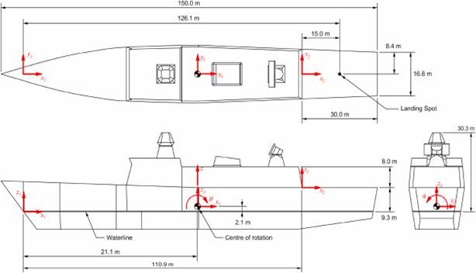
Fig. 1: NATO-GD geometry definition, Owen et al. (2021).
Table 1: Test matrix.
Parameters | Parameters values
Motion | Roll, Pitch
Amplitude (°) | 2.5°, 5°, 7.5°, 10°
Wind direction (°) | 0°, 45°
Motion period (s) | 2, 6, 10, 12.5, 14, 18, 22, 25
Steady case | No motion
The CFD simulations comprise a computational domain (Fig. 2) sufficiently extensive to encompass the relevant physics and an overset domain (Fig. 3) dedicated to handling the ship's motions. The meshing was meticulously designed to capture turbulent airflow, accurately model the ABL, and maintain a suitably low cell count to reduce calculation time and facilitate multiple simulations. On the ship’s hull, the average y⁺ is equal to 110, giving an average of 2.2 millions cells. The time step is chosen to catch the physics of the turbulent airflow. Following Forrest and Owen (2010) and Nisham et al. (2021)‘s recommendations, the simulation‘s time step is selected to be 0.01 s, leading to a CFL number between 0.2 and 0.6 at the measurement location.
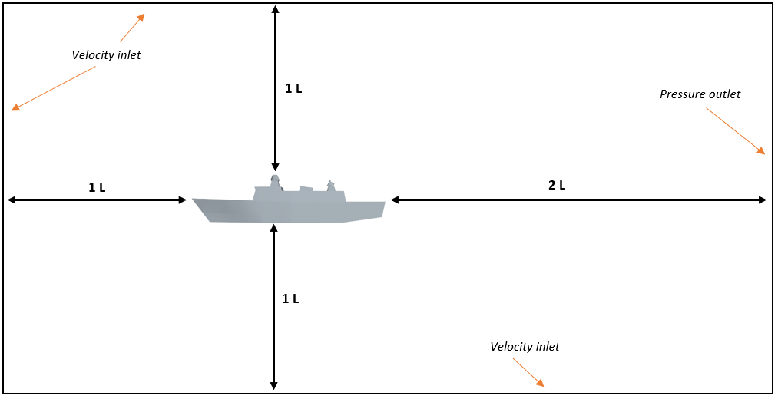 | 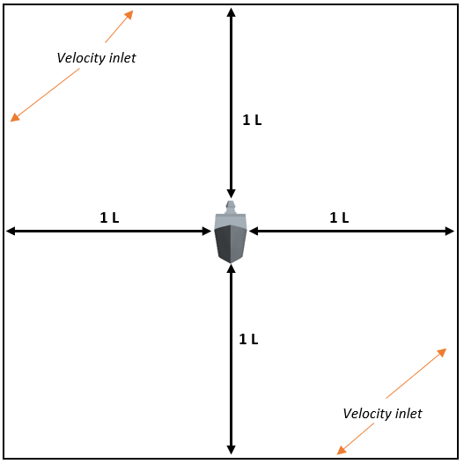
Fig. 2: Dimensions and boundary conditions of the background domain of the computational domain.
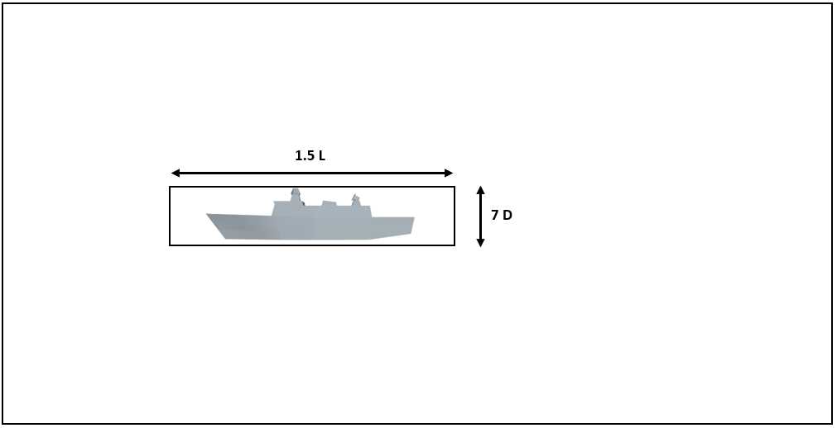 | 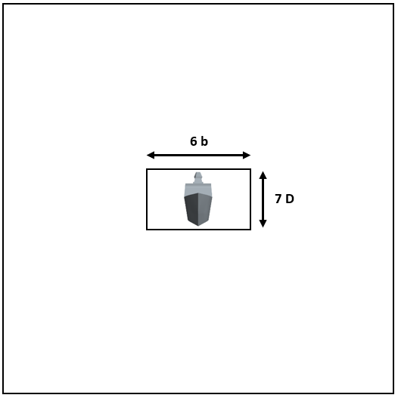
Fig. 3: Dimensions of the overset domain of the computational domain (L: ship length and D: ship depth.
For the data analysis, four physics parameters are investigated:
- The average non-dimensionalised wind speed distribution over the ship’s width for all simulations (V/V∞, where V is the velocity at a particular location while V∞ is the free stream velocity).
- The non-dimentionalised wind speed in the time domain and in the frequency domain (using a Fourier transform), to notice any frequency dependency between the ship motion and this parameter.
- The turbulence intensity (as the root mean squares of the velocity fluctuation over the mean free-stream velocity) distribution over the ship’s width for all the simulations.
- The vertical airwake speed standard deviation distribution to compare with the turbulence criterion of 1.75 m/s (UK Civil Aviation Authority (2023)).
All these analyses aim to investigate the behaviour of the airwake, to draw general conclusions on its behaviour and to state conjectures on route strategies for helicopter operations.

3 Results & Discussions

3.1 Comparison & Validation
While this study does not include a comprehensive grid convergence analysis, the research conducted shows promise in terms of the sensitivity of the results from a CFD perspective. In terms of modelling in the simulations, the ABL implemented in Star-CCM+ is compared to the mathematical one. This comparison proves the sensibility of the implemented one with an average error of 6.5x10⁻³ between the two models, as shown in Fig. 5. The assessment of the simulation's sensitivity from a physics perspective is conducted by comparing the data calculated in this study with the results from previous papers. For the non-dimentionalised wind speed distribution, this paper’s results are compared against (Nisham, et al., 2021) and (Yuan, et al., 2018) for the stationary case (Fig. 4). This comparison reveals similar shapes in the distribution of non-dimensionalised wind speeds but highlights a downward shift of 0.17 in the results of this study. This shift is in good accordance with (Setiawan, et al., 2022)‘s prediction of the non-dimensionalised wind speed behaviour between the SFS2 geometry and the NATO-GD geometry (used in this paper). The comparison in the transverse wind case gives similar results. For the frequency dependency comparison for roll motion, no dependency is observed, which is in good accordance with (Wall, et al., 2022)‘s results. However, for the pitch case, the dependency predicted by the aforementioned study, is not noticed in this paper. This difference can be explained by a geometry difference between the two studies (Canadian Patrol Frigate (CPF) for (Wall, et al., 2022) and NATO-GD for this study). Finally, when comparing turbulence intensity, while a direct magnitude comparison is not meaningful, the overall shape of the distribution appears similar between (Wall, et al., 2022) and this paper. These comparisons instill confidence in the validity of the simulations and models in this study.
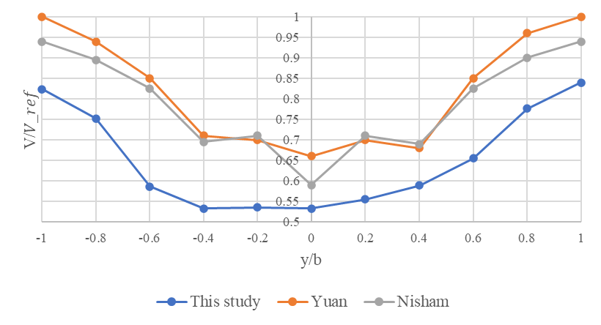  Fig. 4: Comparison of the non-dimensionalised airwake speed distribution across the normalised beam, 0° wind angle. | 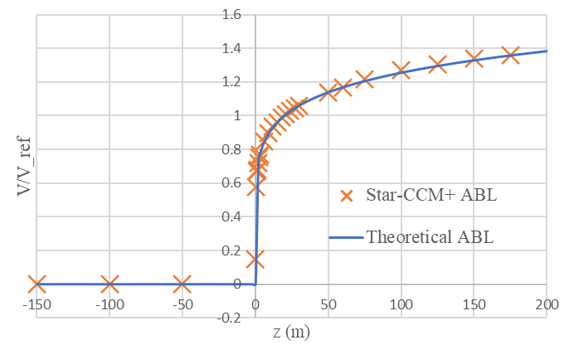  Fig. 5: Comparison of the theoretical ABL to the implemented ABL in Star-CCM+.
3.2 Results & Discussion
For the non-dimensionalised wind speed distribution, it is difficult to draw general conclusions. Nevertheless, for head wind, in the roll case, small motion amplitudes tend to give higher speeds at the edges of the ship’s beam compared to large amplitudes. The inverse behaviour is noticed at the beam centre. For the pitch case, the general result seems to be that high amplitudes leads to higher wind speeds. For transverse wind, the non-dimensionalised wind distribution has a non-symmetrical shape due to the 45° wind angle. In the roll motion case, no sensible conclusion can be made. In the pitch case, the conclusion is the same than for head wind. Therefore, a conjecture can be made for the pitch case: high pitch amplitudes lead to a lower superstructure impact on the helicopter platform. However, some simulations gave unexpected results. To counter this phenomenon, each simulation should be ran multiple time to reach average results for each motion case. The second limitation is that the helideck mapping is incomplete to draw conclusions on the overall airwake behaviour.
The analysis of the frequency dependency of non-dimensionalized wind speed yields more intriguing results. While roll motion in head wind exhibits minimal frequency dependency and no dependency within the 0.2-2 Hz range, pitch motion appears to introduce more significant dependencies. This is particularly evident at the ship's beam's periphery and for motion frequencies falling within or near the 0.2-2 Hz range. For transverse wind, the frequencies dependencies are even clearer. For the roll motion 2 s period motions have a noticeable impact of the non-dimensionalised wind speed. Overall, pitch motion is more affected by frequency dependency than roll motion, as evidenced by the significant impact observed at 6-second and 2-second periods on non-dimensionalized wind speed (Fig. 6). This analysis gives promising results on the investigation of the frequency relationship between the ship’s motion and the airwake speed. To reach even more general conclusions, a more complete mapping of the helideck and more motion type in the range 0.2-2 Hz should be investigated.
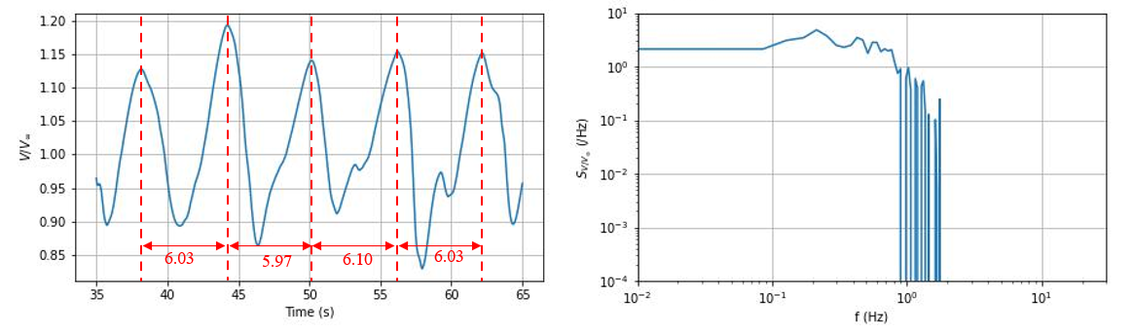
Fig. 6: Pitch, transverse wind, N2, 5° amplitude, 6 s period.
Regarding the turbulence intensity distribution, the shapes align well with the findings in the study by Wall et al. (2022). However, the motion’s parameters do not seem to impact the turbulence intensity. It seems that only the wind direction affects this parameter. This is also the case for the standard deviation of the vertical airwake speed. In terms of turbulence criterion, in head wind, the criterion is never met (for example, see Fig. 7), whereas for transverse wind, it is usually met at port side of the ship (see Fig. 8). This results in a compromise in the case of transverse wind: on the port side, the turbulence criterion is validated due to a reduction in turbulence. However, simultaneously, the airwake speed exhibits a higher frequency dependency due to ship motion in the frequency range of 0.2-2 Hz.

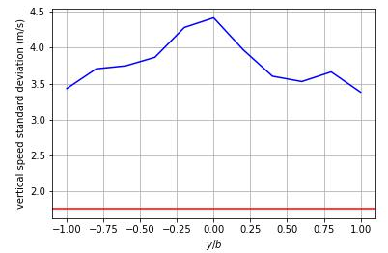  Fig. 7: Turbulence criterion comparison for pitch motion, head wind, 7.5° amplitude, 18 s period. | 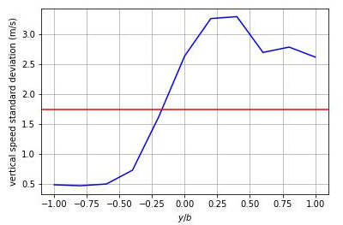  Fig. 8: Turbulence criterion comparison for pitch motion, transverse wind, 2.5° amplitude, 18 s period.
4 Conclusions

The aim and objectives of this research project were successfully achieved, as it unequivocally demonstrates that ship-induced motion in waves has a significant impact on turbulent airwake behaviour.

4.1 Limitations
The primary hypothesis of this research paper is the absence of the free surface for the calculation of the airwake parameters. It was found to be a sensible simplification of the physics of the model, when focusing on the airwake behaviour at the helideck. However, for a more complete simulation of the surrounding area, the airwake is not physically sensible anymore, due to its ability to create a speed profile beneath the ship’s hull. Moreover, as previously discussed, a proper grid convergence analysis of the CFD simulations was not conducted, thus failing to ensure optimised and sensible models.
The test matrix was of interest for this study to investigate a wide range of parameters. As seen in the results, most of the motion periods and amplitudes did not have any noticeable effect on the airwake behaviour. Despite analysing a significant amount of data, many results indicated no significant relationship between motion parameters and airwake behaviour. Furthermore, the frequency range that impacts the pilot workload is 0.2-2 Hz, which only one motion period in this study belonged to. Hence, most data analysis were interesting for general information on the relationship between ship motion and airwake behaviour, but not in terms of their impacts on the pilot workload.
Moreover, a major limitation was the calculation time of the simulations. This aspect led to simplifications of the model and of the physics in this paper. Therefore, this will be a major issue with free-surface consideration in the simulations.
4.2 Recommendations
This research study has identified the parameters of interest for turbulent airwake analysis. Therefore, the following recommendations will address the limitations of this study and guide future research:
- To consider the free surface in the CFD model, to ensure sensible airwake behaviour around the ship.
- To conduct a proper grid convergence analysis of the simulations.
- To investigate the ship’s heave motion in addition to the roll and pitch motions.
- To compute a complete mapping of the helideck and of its surrounding area, to draw practical recommendations for helicopter landing route strategies.
- To focus the study on motion within the frequency range 0.2-2 Hz.
- To investigate the scaling procedure, with Strouhal scaling. This may help to conduct CFD study in the model scale to reduce the computational cost and time.
5 Acknowledgements

Results were obtained using the Iridis High-Performance-Computer of the University of Southampton. This paper is based on the first author's individual MSc research project at the University of Southampton.

References
A. Nisham, M. Terziev, T. Tezdogan, T. Beard and A. Incecik (2021). Prediction of the aerodynamic behavior of a full-scale naval ship in head waves using Detached Eddy Simulation. Ocean Engineering, 222, 108583.
A. Wall, E. Thornhill, H. Barber, S. McTavish and R. Lee (2022). Experimental investigations into the effect of at sea conditions on ship airwake characteristics. J. Wind Eng. Ind. Aerodyn., 223, 104933.
D. McRuer (1994). Interdisciplinary interactions and dynamic systems integration. Int. J. Contr. 59, 3-12.
H. Setiawan, Kevin, J. Philip and J. Monty (2022). Turbulence characteristics of the ship air-wake with two different topside. Ocean Engineering, 260, 111931.
I. Owen, R. Lee, A. Wall and N. Fernandez (2021). The NATO generic destroyer – a shared geometry for collaborative research into modelling and simulation of shipboard helicopter laucnh and recovery. Ocean Engineering, 228, 108428.
J. Forrest and I. Owen (2010). An investigation of ship airwakes using Detached-Eddy Simulation. Comput. Fluids, 39, 656–673.
SNAME (2021). Guidelines for the Reproducible CFD Wind Load Estimations on Offshore Structures.
Technical and Research Bulletin No. 5-4A.
UK Civil Aviation Authority (2023). Standards for offshore helicopter landing areas. CAP 437.
W. Yuan, A. Wall and R. Lee (2018). Experimental investigations into the effect of at sea conditions on ship airwake characteristics. Comp. & Fluids, 172, 29-53.

