Development of a CFD-based Collision Avoidance Model for Maritime Autonomous Surface Ships in Restricted Waters

# Muhammed Talha Ozdenoglu1, Yao Zhang, Stephen Turnock, and Tahsin Tezdogan

Department of Civil, Maritime and Environmental Engineering, School of Engineering, University of Southampton, Boldrewood Innovation Campus, Building 176, SO16 7QF, U.K.

# Introduction

The rise of automation in the maritime industry, driven by the need to enhance safety and efficiency, has led to the development of Maritime Autonomous Surface Ships (MASS). A critical challenge in autonomous ship design is ensuring reliable collision avoidance, particularly in confined or restricted waters such as ports, locks, or narrow channels. These environments involve complex hydrodynamic interactions influenced by factors like waves, currents, and ship proximity, requiring advanced modeling techniques to predict and mitigate risks.

The main objective of this research is to develop a computational fluid dynamics (CFD)-based collision avoidance model specifically tailored for MASS operating in restricted waters. The ultimate goal is to create a model that can accurately simulate real-world conditions, including wave forces, currents, and ship proximity, to ensure safe and efficient autonomous navigation.

To achieve this, the study integrates experimental towing tank data, full-scale CFD simulations, and advanced control strategies, such as Model Predictive Control (MPC), which will allow the ship to make real-time adjustments to its trajectory. Additionally, by comparing traditional resistance estimation methods, such as Holtrop-Mennen and Michell's Thin-Ship Theory, with CFD simulations, the research aims to provide a more reliable prediction of ship behavior under dynamic conditions. This project will result in a robust collision avoidance system for MASS, contributing valuable insights to the future development of autonomous navigation systems.

# Literature review :

The development of control systems for MASS has attracted significant attention, particularly in the areas of path-following and maneuverability under adverse weather conditions. Daejeong Kim et al. (2022) explored control issues for MASS under low-speed conditions using unsteady RANS CFD simulations, highlighting the importance of robust control strategies in varying wave heights.

Tezdogan et al. (2019) further investigated the maneuverability and course-keeping performance of ships in different wave conditions, leveraging CFD techniques to predict hydrodynamic forces affecting ship stability. These studies underscore the potential of CFD simulations in simulating realistic environmental conditions for autonomous ships.

1 Corresponding author.

*E-mail address:* [M.T.Ozdenoglu@soton.ac.uk](mailto:M.T.Ozdenoglu@soton.ac.uk)

Thor Fossen’s (1994) work on guidance and control of ocean vehicles serves as a key reference for applying MPC in path tracking for maritime vessels. Fossen’s research into adaptive control methodologies in disturbed environments is crucial for the real-time control models for MASS in restricted waters.

Predictive models, as explored by Wang et al. (2017) and Guo et al. (2020), offer insights into using wave-based disturbances for path tracking under uncertain environmental conditions. Traditional empirical methods, such as the Holtrop-Mennen method, have been valuable for estimating ship resistance in calm waters. However, their application in dynamic, wave-influenced environments is limited. Therefore, this study emphasizes CFD-based simulations, which provide more accurate predictions for ship behavior in complex sea states, particularly for MASS in restricted waters.

# Methodology

This section presents the methodologies employed in this research, covering numerical simulations, experimental validation, and mathematical modelling.

The study focuses on a ship with a length ranging from 100 to 150 meters, representing a typical size for Maritime Autonomous Surface Ships (MASS) operating in restricted waters. The CFD simulations were conducted using STAR-CCM+ software, with the computational domain designed to capture the essential hydrodynamic interactions. The domain was sufficiently large, extending five ship lengths in all directions from the model, to minimize the effects of boundary reflections in both calm water and regular wave conditions. This low blockage ratio setup was crucial for accurate flow predictions. Figures 1 and 2 illustrate the computational domain and the overset mesh used to accommodate the ship’s motions, respectively.

The meshing strategy was developed to ensure high accuracy while maintaining computational efficiency, resulting in approximately 5.6 million cells. The average non-dimensional wall distance (y+) was controlled around 50, following the recommendations of the ITTC 7.5-03-02-03 guidelines for CFD simulations of full-scale ships (ITTC, 2011). A time step of 0.001 seconds was chosen to resolve the unsteady flow characteristics, based on best practices and prior work on full-scale unsteady flow simulations (Tezdogan et al., 2016).

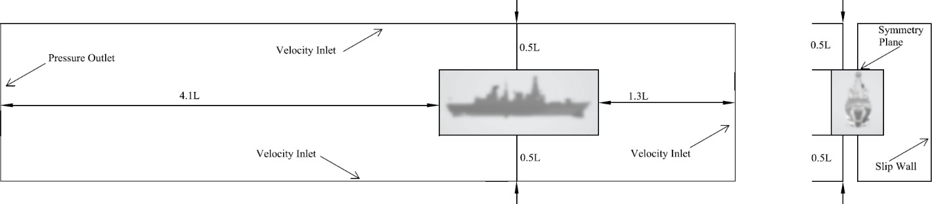

*Figure 1 Dimensions and boundary conditions of the background domain of the computational domain (sample ship) ( L: Ship Length)*

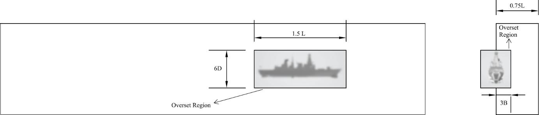

*Figure 2 Dimensions of the overset domain of the computational domain (Sample Ship) ( B: Beam of the Ship, D: Ship Depth)*

# CFD Simulation Setup

The CFD simulations were carried out using STAR-CCM+, focusing on evaluating hydrodynamic behavior in two distinct conditions: flat wave (calm water) and regular wave (for added resistance). These simulations were conducted in the Boldrewood Innovation Towing Tank at the University of Southampton, with dimensions of 138 meters in length, 6 meters in width, and 3.5 meters in depth. The towing tank environment was modeled to closely replicate experimental conditions, providing a benchmark for numerical results and validating the computational models used in this study.

# Numerical Methods: Holtrop-Mennen and Thin-Ship Theory

* **Holtrop-Mennen Method:** The widely adopted empirical model developed by Holtrop (1977), which provides a statistical analysis of performance test results, was utilized in this study to estimate ship resistance in calm water. This method, based on extensive model test data, offers a general estimation of resistance components, including both frictional and residuary resistance. In this study, the method was applied to predict ship resistance over a range of speeds, from 0 to 25 knots, and for various draughts (4.8 m to 5.8 m). While the Holtrop-Mennen method is effective for initial approximations, its accuracy in dynamic environments, such as waves, is limited due to the absence of wave-induced resistance factors. The Maxsurf software was used to calculate the total resistance across a range of ship speeds, and the accuracy of this method was validated by comparison with Computational Fluid Dynamics (CFD) results and towing tank tests.
* **Thin-Ship Theory:** Michell’s Thin-Ship Theory (Michell, 1898), which provides an analytical approach for calculating wave resistance, was also applied in this study. This method relies on assumptions regarding the slenderness of the ship’s form and was implemented using MATLAB for the same draught and speed range as the Holtrop-Mennen method. Thin-Ship Theory is particularly useful for analyzing wave resistance at lower speeds but demonstrates limitations in more complex hydrodynamic environments due to its linear assumptions (Tsubogo, 2014). The comparison of results across different draughts (4.8 m to 5.8 m) highlighted its strengths in the lower draught ranges, where wave-making effects are minimal.

# CFD Simulations

Two distinct CFD simulations were conducted as part of the hydrodynamic analysis:

* + 1. **Flat Wave (Calm Water):** In calm water conditions, simulations focused on the baseline resistance, similar to towing tank experiments without external wave forces. The goal was to isolate the inherent resistance components of the ship model at various speeds, specifically at Froude numbers of 0.22 and 0.36.
    2. **Regular Wave (Added Resistance):** Regular wave conditions were modeled to study the added resistance due to waves at varying frequencies, ranging from 0.45 to 0.75 Hz. This range, corresponding to wavelength-to-ship length ratios (λ/L) from 1.82 to 0.65, was selected to simulate typical wave conditions experienced in operational environments. These simulations are currently ongoing and will provide crucial insights into the ship’s performance in dynamic sea states.

# Towing Tank Tests

Two sets of towing tank experiments were performed to validate the numerical and CFD results:

* + 1. **Flat Wave (Calm Water) Experiments:** Resistance tests were conducted at two Froude numbers (0.22 and 0.36) for a single draught of 5.2m. These experiments served as a benchmark for validating the CFD flat wave simulations and the empirical predictions from the Holtrop-Mennen and Thin-Ship methods.
    2. **Regular Wave (Added Resistance) Experiments:** The added resistance in waves was measured for wave frequencies between 0.45 Hz and 0.75 Hz, matching the conditions used in the CFD simulations. This data will be crucial for validating the CFD model’s performance in predicting added resistance and other hydrodynamic effects.

# Results & Discussions

The results from the numerical methods, CFD simulations, and towing tank experiments were compared to assess their accuracy and reliability for resistance predictions. The primary findings are summarized below:

# Numerical Methods Evaluation:

The numerical analysis using both the Holtrop-Mennen and Thin-Ship Theory methods provided an initial estimate of resistance under calm water conditions. As shown in Figure 3, the Holtrop-Mennen method produced reliable predictions at lower speeds, closely following the CFD results up to 15 knots. However, the Thin-Ship Theory displayed significant deviations at higher speeds, particularly beyond 20 knots, due to its linearized assumptions about wave resistance. These deviations were most pronounced for draughts above 5.2 m, where wave interactions had a more substantial impact on resistance.

# CFD Simulations:

At this stage, we have completed the CFD simulations for flat wave (calm water) conditions. As illustrated in Figure 3, preliminary results suggest a close correlation with the experimental data for the 5.2 m draught case at Froude numbers of 0.22 and 0.36. However, we are still awaiting the completion of the regular wave simulations to compare the added resistance predictions with experimental data and empirical methods. These ongoing simulations will help further refine the accuracy of the hydrodynamic model, particularly in dynamic environments.

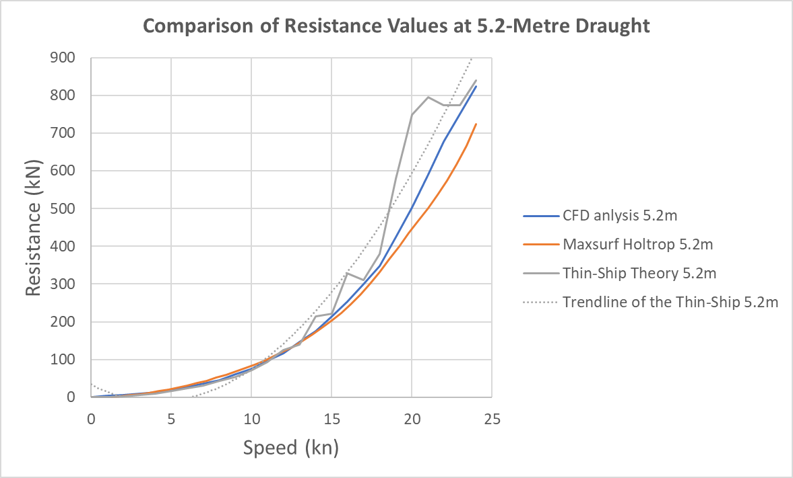

*Figure 3 Resistance comparison for the 5.2m draught case across different methods.*

# Conclusions and Future Work Conclusions:

The comparison of empirical methods and CFD simulations under calm water conditions showed that while traditional methods like Holtrop-Mennen and Thin-Ship Theory are useful for initial resistance estimates, they lack accuracy in complex hydrodynamic environments. The CFD simulations, validated by towing tank experiments, provided a more robust prediction of ship resistance and will serve as the foundation for further control model development.

# Future Work:

Future research will focus on completing the CFD simulations for regular wave conditions and comparing the results with experimental data. Additionally, the Double Body Method will be explored as a potential tool to enhance the accuracy of resistance predictions, particularly in separating viscous resistance from wave-making components. This method, as discussed by Larsson and Raven (2010), will be applied to analyze the form factor more precisely, especially in cases where non-linear hydrodynamic interactions are significant. Incorporating the Double Body Method is expected to improve the overall understanding of ship resistance, particularly for bluff body forms.

The next phase of this research will focus on completing the regular wave condition CFD simulations and comparing them with experimental results. Once these comparisons are validated, the results will also be compared with empirical methods to assess the accuracy of added resistance predictions. Future work will extend this analysis to irregular wave conditions using established spectral methods, such as JONSWAP or ITTC, to simulate more realistic sea states.

Additionally, the research will incorporate **Model Predictive Control (MPC)** strategies for developing a collision avoidance system that complies with the International Regulations for Preventing Collisions at Sea (COLREGs). Drawing on the work of Fossen (2017), particularly in the field of adaptive control for marine vehicles, the control model will be designed to predict and adjust ship trajectories in real time based on wave-induced disturbances and proximity to other vessels.

# Limitations

* + - **Thin-Ship Theory:** As a linearized theory, it fails to account for the non-linear wave interactions that become significant at higher speeds or in short wavelength conditions, resulting in underestimation of resistance.
    - **Holtrop-Mennen:** This method, while effective at lower speeds, struggled with accurate resistance predictions in waves due to its empirical nature and lack of wave resistance components.
    - **CFD Simulations:** Although accurate, the CFD simulations were computationally expensive, particularly in terms of meshing and convergence times. Further optimization of the meshing strategy may be necessary to reduce computational costs for future simulations.

# Recommendations

* + - Conduct further experimental analysis, particularly in irregular waves, to enhance the robustness of the CFD model.
    - Refine the meshing strategy in CFD simulations to improve computational efficiency.
    - Develop and implement the MPC-based control model for autonomous collision avoidance.
    - Investigate the integration of sensor data with CFD simulations for real-time collision avoidance system validation.
    - Include additional ship motions such as heave, roll, and pitch in the future analysis to fully capture the ship’s dynamic response.

# Acknowledgements

The authors would like to thank the University of Southampton for supporting this research through the FEPS scholarship and Dean bursary. Results were obtained using the Iridis High-Performance-Computer of the University of Southampton.

# References

Fossen, T.I. *Guidance and Control of Ocean Vehicles*. John Wiley & Sons, 1994.

Fossen, T.I. "Wave based adaptive control of unmanned surface vehicles subject to disturbances and model uncertainties." *Ocean Engineering*, 197, 106924, 2020.

Guo, W., Li, Y., Fossen, T.I., et al. "Wave based adaptive control of unmanned surface vehicles subject to disturbances and model uncertainties." *Ocean Engineering*, 197, 106924, 2020.

Holtrop, J. "A Statistical Analysis of Performance Test Results." *International Shipbuilding Progress*, February 1977.

ITTC. *Recommended Procedures and Guidelines: Testing and Extrapolation Methods*.

Kim, Daejeong, Soonseok Song, Byongug Jeong, Tahsin Tezdogan, and Atilla Incecik. "Unsteady RANS CFD simulations of ship manoeuvrability and course keeping control under various wave height conditions." *Ocean Engineering*, 2022.

Larsson, L., & Raven, H.C. *Ship Resistance and Flow*. The Netherlands: Society of Naval Architects and Marine Engineers, 2010.

Tezdogan, T., Demirel, Y.K., Incecik, A., and Turan, O. "Full-scale unsteady RANS CFD simulations of ship behavior and performance in head seas due to slow steaming." *Ocean Engineering*, 2019.

Tsubogo, T. "Michell’s Thin Ship Theory Considering the Gradient of Ship Form in Depth Direction."

*Journal of the Japan Society of Naval Architects and Ocean Engineers*, 2014. Turnock, S. *Resistance and Propulsion*. University of Southampton.

Wang, Y., Sørensen, A.J., Cui, W., and Fossen, T.I. "Wave induced roll motion reduction of a monohull vessel using model predictive control." *Ocean Engineering*, 136, 79-87, 2017.