Supplementary material 1. Description of Valedo video games.
Game | Description
Diver  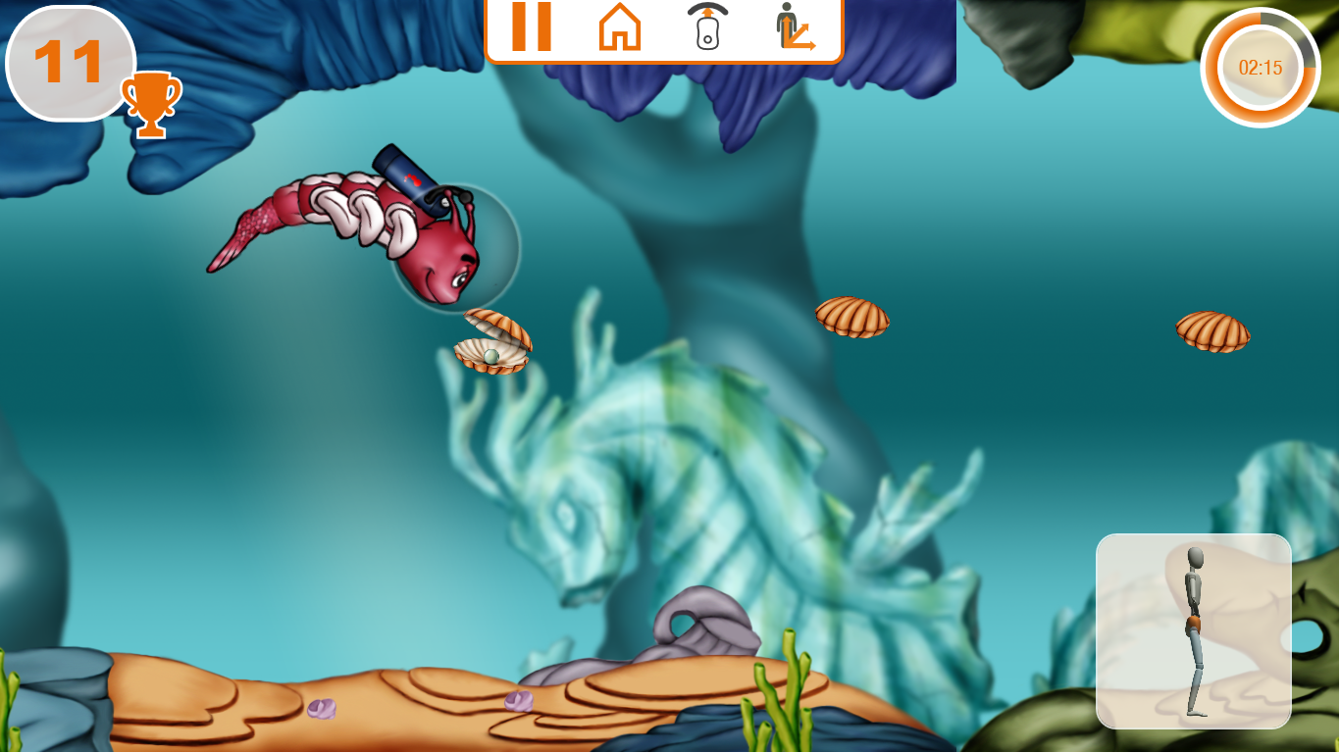 | Goal of training: Trunk mobilization  Participant must execute fine, controlled trunk (flexion/ extension) or pelvic (anterior/posterior tilt) movements in a sagittal plane to make the caterpillar swim up and down to collects the shells and avoid the obstacles.
Glider  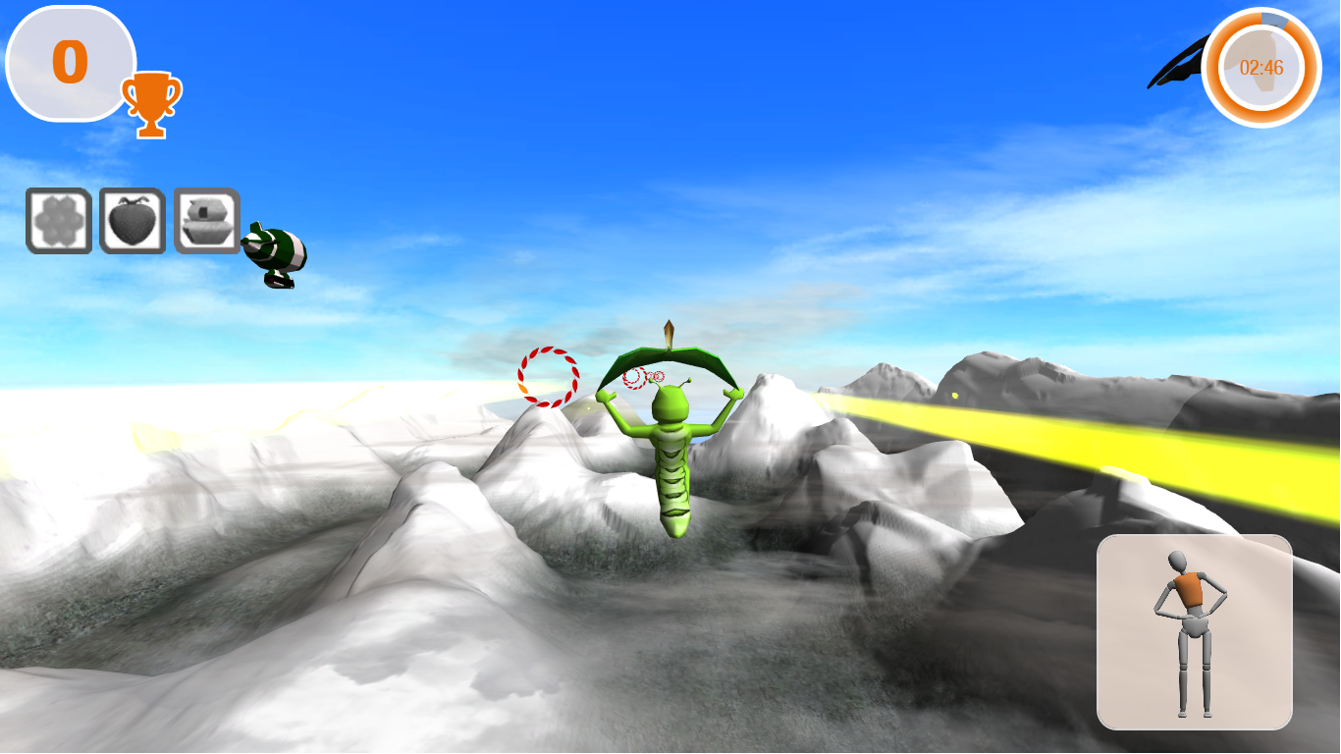 | Goal of training: Trunk mobilization  Participant must execute fine, controlled combined movement of trunk (flexion/ extension and lateral flexion to left and right) or pelvic (anterior/posterior and left/right tilt) movements to fly up and down through the hoops.
Clock  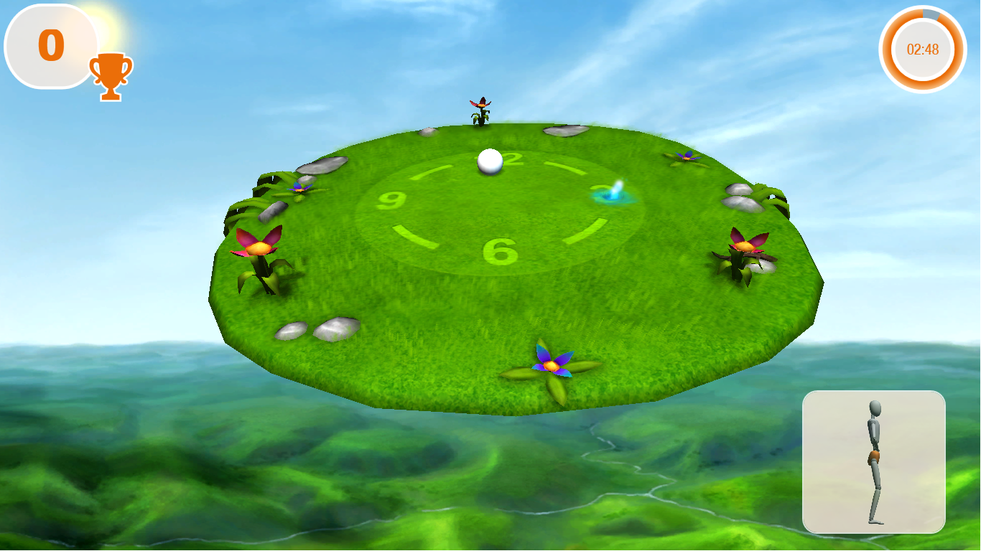 | Goal of training: Movement awareness  Participant must execute fine trunk (trunk flexion/ extension) or pelvic (anterior/posterior tilt) movement to move the platform to the left and right, then return to the midline position.
Colours 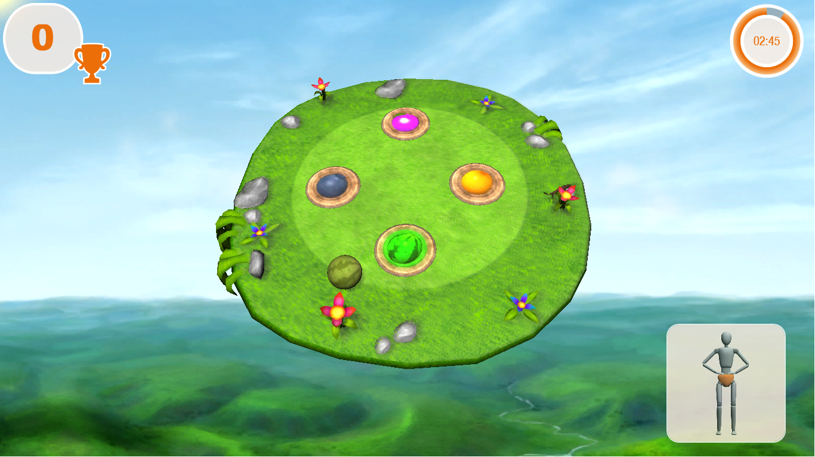 | Goal of training: Trunk mobilization  Participant must execute fine combined movement of trunk (flexion/ extension and lateral flexion to left and right) or pelvic (anterior/posterior and left/right tilt) to move the ball toward the corresponding colour (e.g. green ball to green colour)
Brick-breaker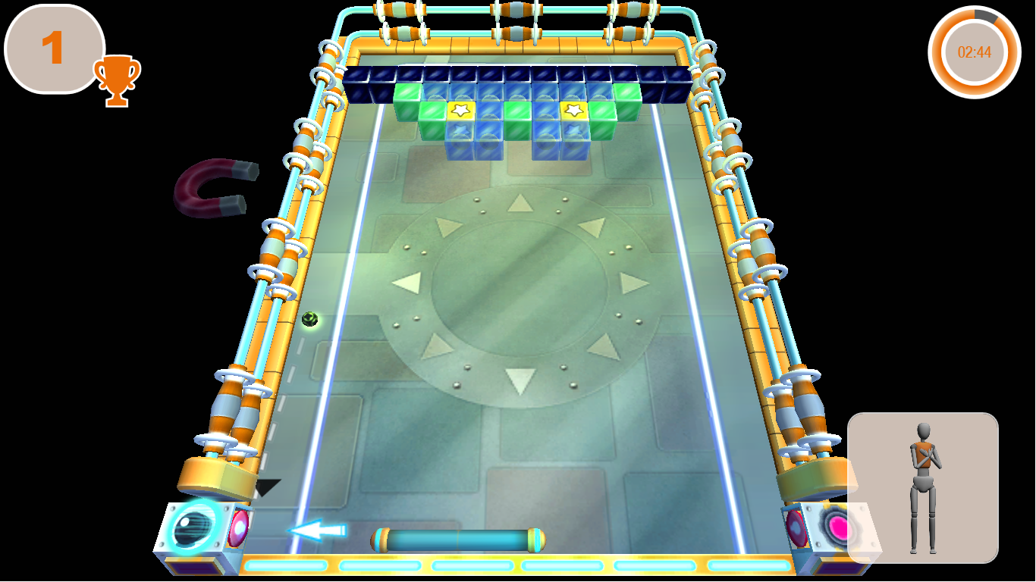 | Goal of training: Trunk mobilization  Participant must rotate trunk the left and right in a controlled manner to avoid losing the ball.
Fruits  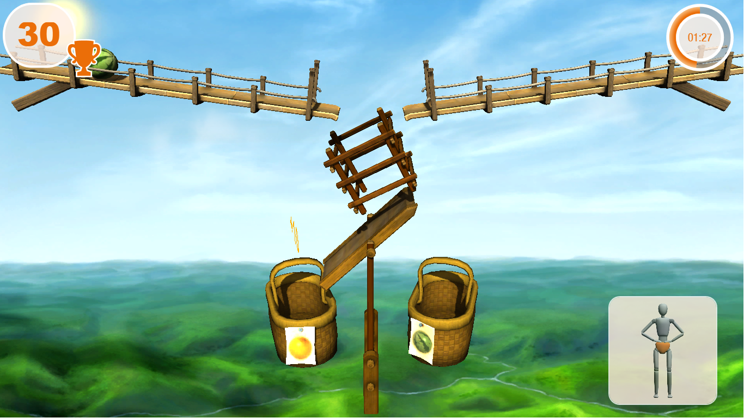 | Goal of training: Movement isolation  Participant must make controlled lateral pelvic tilt movements while keeping the trunk still to put every piece of fruit in a corrected respective basket (e.g. watermelon into the watermelon basket)

Supplementary material 2: Identifying the level of a participant’s ability by researcher based on TIS and BBS results
Levels | Description | TIS and BBS scores | Games
Level 1 | - Able to sit independently for over 10 seconds.  - Able to passively place and hold the non-paretic leg on the paretic leg.  - Able to actively place and hold the paretic leg on the non-paretic leg; backward displacement of the trunk over 10 cm is allowed. | Total TIS ≤ 6  BBS < 45 | Diver  Glider  Clock  Brick-breaker  Practice: from sitting position
Level 2 | - Able to sit independently for over 10 seconds.  - Able to passively place and hold the non-paretic leg on the paretic leg.  - Able to actively place and hold the paretic leg on the non-paretic leg; no backward displacement of the trunk over 10 cm.  - Able to touch bed/table with hemiplegic and non-hemiplegic elbow and return. Moves actively with or without compensations; appropriate shortening or lengthening is not necessary. | TIS static =7  TIS dynamic ≤ 6  BBS < 45 | Diver  Glider  Clock  Colours  Brick-breaker  Fruits  Practice: from sitting position
Level 3 | - Able to sit independently and appropriately shorten/lengthen to touch bed/table with hemiplegic and non-hemiplegic elbow.  - Shortening/lengthening when lifting the pelvis must not be correct.  - Asymmetrical rotation of the upper portion of the trunk.  - Static standing is safe. | TIS static =7  TIS dynamic ≤ 6  BBS ≥ 45 | Diver  Glider  Clock  Colours  Brick-breaker  Fruits  Practice: from standing position
Level 4 | - Able to lift the pelvis from bed/table without compensation.  - Rotation of the lower portion of the trunk is possible with or without compensation.  - Dynamic standing is safe. | TIS static =7  TIS dynamic =10  TIS coordination:1-2=4, 3-4 <3  BBS ≥ 45 | Diver  Glider  Clock  Colours  Brick-breaker  Fruits  Practice: from standing position at medium to hard level

