FULL TITLE: ‘Real-world’ performance of the Confirm Rx™ SharpSense AF detection algorithm: UK Confirm Rx study
SHORT TITLE: Diagnostic performance of the Confirm Rx AF detection algorithm
AUTHORS: Andre Briosa e Gala* MD, Michael T.B. Pope BM BSc, Milena Leo MD PhD, Alexander J. Sharp MBBS BSc, Abhirup Banerjee PhD, Duncan Field MD, Honey Thomas MD, Richard Balasubramaniam Mb ChB PhD, Ross Hunter PhD, Roy S. Gardner MD, David Wilson DM, Mark M. Gallagher MD, Julian Ormerod PhD, John Paisey MD, Nick Curzen PhD, Timothy R. Betts MD

Andre Briosa e Gala
email: a.briosaegala@gmail.com
Department of Cardiology, Oxford University Hospitals NHS Foundation Trust, Oxford, UK
Faculty of Medicine, University of Southampton, Southampton, UK

Michael T.B Pope
Email: mtbpope@doctors.org.uk
Department of Cardiology, University Hospitals Dorset NHS Foundation Trust, Bournemouth, UK

Milena Leo
Email: milenaleo@yahoo.it
Department of Cardiology, Oxford University Hospitals NHS Foundation Trust, Oxford, UK

Alexandre J Sharp
Email: alex.sharp@ouh.nhs.uk
Department of Cardiology, Oxford University Hospitals NHS Foundation Trust, Oxford, UK

Abhirup Banerjee
Email: abhirup.banerjee@eng.ox.ac.uk
Institute of Biomedical Engineering, Department of Engineering Science, University of Oxford, Oxford, UK

Duncan Fields
Email: duncan.field@esneft.nhs.uk
Department of Cardiology, East Suffolk and North Essex NHS Foundation Trust, Colchester, UK

Honey Thomas
Email: honey.thomas@northumbria-healthcare.nhs.uk
Department of Cardiology, Northumbria Healthcare NHS foundation Trust, Wansbeck, UK

Richard Balasubramaniam
Email: richard.bala@uhd.nhs.uk
Department of Cardiology, University Hospitals Dorset NHS Foundation Trust, Bournemouth, UK

Ross Hunter
Email: ross.hunter3@nhs.net
Department of Cardiology, Barts Health NHS Trust, London, UK roy.gardner@glasgow.ac.uk

Roy S Gardner
Email: roy.gardner@glasgow.ac.uk
Scottish National Advanced Heart Failure Service, Golden Jubilee National Hospital, Glasgow, UK

David Wilson
Email: david.wilson45@nhs.net
Department of Cardiology, Worcestershire Royal Hospital, Worcester, UK

Mark Gallagher
Email: mark.gallagher@stgeorges.nhs.uk
Department of Cardiology, St George's University Hospitals NHS Foundation Trust, London UK

Julian Ormerod
Email: julian.ormerod@ouh.nhs.uk
Department of Cardiology, Milton Keynes University Hospital, Milton Keynes, UK

John Paisey
Email: john.paisey@uhs.nhs.uk
Department of Cardiology, University Hospitals Southampton, Southampton, UK

Nick Curzen
Email: nick.curzen@uhs.nhs.uk
Department of Cardiology, University Hospitals Southampton, Southampton, UK
Faculty of Medicine, University of Southampton, Southampton, UK

Timothy Betts
Email: tim.betts@ouh.nhs.uk
Department of Cardiology, Oxford University Hospitals NHS Foundation Trust, Oxford, UK

*CORRESPONDING AUTHOR:
Electrophysiology Research Fellow
Oxford University Hospitals NHS Foundation Trust,
Headley Way, Oxford (UK) OX3 9DU
Email address: andre.gala@ouh.nhs.uk , a.briosaegala@gmail.com
Telephone: +44 1865 220 255
Twitter handle: @briosa_gala
CONFLICT OF INTEREST: ABG, RSG and TB have received financial support for research from Abbott. MTBP received financial support to attend scientific meetings from Acutus Medical. HT received financial support to attend scientific meetings from Abbott, BSCI, Medtronic and Boston Scientific. DW has received financial support to attend scientific meetings. AJS, AB, JRP, ML, NC, MGM, RB, JO and DF– no conflicts in relation to this paper.
FUNDING: none
ETHICS APPROVAL and PATIENT CONSENTED: Exempt from REC within UK Health Departments’ Research Ethics Services, as this is research limited to the use of previously collected, non-identifiable information, where patients have given prior consent at the time of implantable cardiac monitor insertion.
The content of this manuscript adheres to the to Wiley’s Best Practice Guidelines on Research Integrity and Publishing Ethics
IRAS Project number: 297175
CLINICAL TRIALS REGISTRATION: Not applicable
DATA AVAILABILITY: Raw data available upon reasonable request
KEYWORDS: atrial fibrillation; ambulatory monitoring; implantable cardiac monitor; implantable loop recorders; arrhythmia monitoring
WORD COUNT: 4236

ABSTRACT
Introduction: The novel Confirm Rx™ implantable cardiac monitor (ICM) with SharpSense™ technology incorporates a new P-wave discriminator designed to improve AF detection. This study aimed to evaluate the diagnostic performance of the Confirm Rx™ ICM in detecting AF episodes of varying durations.
Methods: We conducted a multicentre retrospective analysis of consecutive patients implanted with a Confirm Rx™ ICM (v1.2) across nine UK hospitals, all with documented AF lasting at least 6 minutes. Electrocardiograms (ECGs) were manually adjudicated by cardiologists. . To account for intra- and inter-reviewer variability, a random sample of 10% of ECGs underwent additional review. Disagreements were resolved by a third reviewer. Diagnostic performance was determined by calculating the gross and patient-averaged positive predictive value (PPV) for AF episodes of different duration. The source of false positive (FP) detection was also categorised.
Results: Overall, 16230 individual ECGs from 232 patients were included. The median AF episode duration was 14 minutes. R-wave amplitude remained stable during follow-up (0.52±0.27 mV [initial] vs 0.54±0.29 mV [end of follow-up], p=0.10). The gross and patient-averaged PPV were 75.0% and 67.0%, respectively. Diagnostic performance (gross) increased with progressively longer AF episodes: 88.0% for ≥ 1 hours, 97.3% for 6 hours and 100% for 24 hours. The main source of FP during tachycardia was T-wave oversensing (54.2%), whilst in non-tachycardic episodes it was predominantly ectopy (71.2%). The AF burden precision was excellent (93.3%).
Conclusion: The Confirm Rx™ ICM diagnostic performance was modest for all AF episodes (75%), with accuracy increasing for longer AF episodes.

ABBREVIATIONS
AF – Atrial Fibrillation
ECG – Electrocardiogram
FP – False Positive
ICM – Implantable Cardiac Monitor
PPV – Positive Predictive Value

INTRODUCTION
Atrial fibrillation (AF) diagnosis relies on electrocardiographic (ECG) documentation of irregularly irregular R-R intervals without any discernible P-wave.¹ Twelve-lead ECGs, Holter monitors, patches and event recorders are routinely employed to detect AF episodes. However, the unpredictable nature of AF results in a relatively low diagnostic yield from intermittent monitoring when compared to prolonged continuous rhythm monitoring with implantable cardiac monitors (ICMs). Recently, there has been a renewed interest in using ICMs for AF diagnosis following cryptogenic strokes^{2, 3} and for monitoring AF burden and recurrence after catheter ablation and cardiac surgery.⁴⁻⁸
Despite their high sensitivity in detecting AF episodes, ranging between 88-96%, the of previous generations of ICMs were limited by the high number of false-positive (FP) episodes.⁹⁻¹¹ All transmissions require careful adjudication to confirm if episodes are correctly classified as AF, which, given the large volume of data collected, is resource-intensive and time-consuming. Moreover, the SARS-CoV-2 pandemic has accelerated the adoption of digital solutions, including increased use of remote monitoring of cardiac devices, leading to further strain on already busy Device clinics.¹² Therefore, the diagnostic utility of ICMs relies on accurate and timely detection of clinically significant arrhythmias whilst minimising FPs.
Technological advancements have led to minimally-invasive ICMs with improved connectivity, remote monitoring capabilities, refined AF algorithms aimed at reducing FP episodes and streamlining workflow. The new Confirm Rx™ ICM (Abbott, Chicago, IL, USA) exemplifies this progress, using wireless telemetry (Bluetooth® and Wi-fi/cellular technology) to communicate with the myMerlin™ smartphone app and transmit data to its secure remote monitoring platform (Merlin.net Patient Care Network). A key feature is the SharpSense™ technology, which incorporates a P-wave discriminator designed to reduced FP detections without compromising AF episode sensitivity. This multicentre, retrospective, real-world study evaluates the diagnostic performance of the Confirm Rx™ ICM with SharpSense™ Technology in detecting AF episodes of varying durations.
METHODS
The study cohort included consecutive patients from nine UK hospitals implanted with a Confirm Rx™ ICM with SharpSense™ technology (version 1.2) with documented AF episodes lasting at least 6 minutes and had over 90 days of follow-up. The ASSERT¹³ study showed increased thromboembolic risk in patients with device-detected AF ≥6 minutes, and subsequent studies using ICMs, such as REVEAL-AF¹⁴ and LOOP¹⁵ studies, used the same cut-off of ≥6 minutes for clinically significant AF episodes. De-identified data was extracted from Merlin.net™ remote monitoring database (Abbott; Chicago, IL) and adjudicated by researchers at the Oxford University Hospitals. All participants provided informed consent through the Merlin.net™ Patient Care Network consent form at the time of their ICM implant, authorising de-identification, pseudonymisation, and data analysis for research purposes. The study was registered and endorsed by Health Regulatory Authority (ID 297175) and received a Research Ethics Committee Review exemption due to its use of previously collected, non-identifiable information.
Device Characteristics and AF algorithm
The Confirm Rx™ ICM with SharpSense™ technology incorporates four new discriminators (three discriminators for bradycardia and pauses and one discriminator for AF) aimed at improving arrhythmia detection accuracy. The original AF algorithm (SJM Confirm), validated against Holter monitors in the DETECT-AF study, demonstrated high episode sensitivity (94%) and patient sensitivity (100%) but only moderate positive predictive value (64%) for AF lasting at least 2 minutes duration.⁹ This algorithm relies on monitoring R-R intervals during a 64-beat rolling window for three conditions to be met: sudden onset, irregularity and large variance. A Markov chains model assesses irregularity by comparing measured R-R intervals to known pattern of AF and non-AF rhythms. A variance model helps differentiate AF from patterned rhythm, such as bigeminy. The new SharpSense™ algorithm enhances AF detection by adding a P-wave discriminator, which aims to reduces FP detection by 97% whilst maintaining sensitivity (unpublished data from Abbott).¹⁶ This discriminator analyses selected P-waves segments from the preceding 30 seconds for their morphology and amplitude. AF is only detected if no consistent pattern in the analysed P-waves emerges. AF episode parameters including AF duration cut-off, ECG trigger priority, alert notification and episode settings are automatically programmed based on the selected reason for monitoring (see Table S1). The nominal R-wave sensitivity has been increased from 0.150 to 0.125 mV.
Confirm Rx™ ICM uses low-energy Bluetooth® for secure wireless communication with the myMerlin™ mobile app. This app act as a conduit for episode transmission to the Merlin.net™ Patient Care Network for remote monitoring.
Episode adjudication and statistical analysis
All adjudicated AF episodes had a corresponding 120-second ECG with heart rate scatterplot, considered representative of the entire episode. A single reviewer (A.B.G, CCDS certified) adjudicated all recordings (episode categorised by the Confirm Rx as AF) and classified them as 'True-AF’ or ‘FP’. To assess for intra- and inter-reviewer variability, a random sample of 10% of stored ECGs was adjudicated by the same reviewer (A.B.G) and a second reviewer (M.T.B.P, CCDS certified). Disagreement were resolved by a third reviewer (T.R.B). The level of agreement between reviewers was calculated using the Cohen’s kappa. All reviewers were blinded to ICM indications.
Sensitivity and specificity cannot be calculated from this study as there is no gold standard, such as a Holter monitor. Therefore, diagnostic performance was evaluated by calculating gross positive predictive value (PPV) and patient-averaged PPV for AF episodes of different durations (6 minutes, 10 minutes, 30 minutes, 1 hour, 3 hours, 6 hours, 12 hours and 24 hours). Gross PPV was computed by dividing all confirmed True-AF episodes by the total number of AF episodes (True-AF and FP) detected by the Confirm Rx, assuming each episode is an independent event. Patient-averaged PPV was calculated by first determining the gross PPV for each patient and then averaging across all patients. Additionally, the investigation of diagnostic performance (PPV) was also extended to predefined groups based on the reason for monitoring, sex, and R-wave amplitude.
FP episodes were further categorised as due to undersensing, oversensing, noise, atrial/ventricular ectopy, or a combination of the above. AF burden (percentage of time in AF) was computed as the duration of all AF episodes (True-AF and FP) detected by the Confirm Rx™ divided by the total duration of follow-up. In contrast, ‘True-AF’ was calculated by dividing the duration of all ‘True-AF’ episodes by the total duration of follow-up. The precision of AF burden then determined by dividing the True AF burden by the total AF burden. We further investigated the performance of AF burden according to ICM implant indication and duration of AF episodes. Statistical analysis was performed using R Statistical Software version 4.0.3. Categorical variables were evaluated for associations using the Fisher's exact test. Non-parametric data from independent groups were compared using the Wilcoxon rank-sum test, while paired t-tests were used for parametric data from dependent groups.
RESULTS
Between August 2018 to August 2021, 232 consecutive patients met the inclusion criteria. A total of 16,230 individual recordings were reviewed, demonstrating excellent intra- and inter-observer agreement with Cohen’s Kappa values of 0.85 and 0.87, respectively. The patient population was predominantly male (46%), with a median age of 67 years (interquartile range [IQR]: 56-77), and a median duration of follow-up was 18 months (IQR: 10-22). R-wave amplitude remained stable with no significant changes from initial implant to end of follow-up (0.52±0.27 mV vs 0.54± 0.29 mV, p=0.10). Implant indications are depicted in Table 1. The median episode duration was 14 minutes (IQR: 9-32), and only 15.1% (2,442 episodes) exceeding 1 hour in 76 patients. Notably, nearly half of these extended episodes originated from a small subset of patients (2.6%) whose Confirm Rx® ICM were implanted to manage AF. The distribution of age and sex according to implant indication is presented in Table S2.
Overall, the gross PPV was 75.0%, and patient-averaged PPV was 67.0% for AF≥ 6 minutes (Table 2). Diagnostic performance (gross PPV) increased with progressively longer AF episodes: 88.0% for ≥ 1 hours, 97.3% for ≥ 6 hours, 99.2% ≥ 12 hours and 100% for ≥ 24 hours (graphical abstract). The AF management cohort, despite having the lowest rate of monthly recordings per patient (1.6), exhibited a significantly higher PPV (95.5% True-AF episodes) compared to other groups (p<0.001) (Figure S2). Conversely, the Palpitations (56.3% PPV) and Suspected AF (44.0% PPV) cohorts had the lowest PPV but a substantially higher frequency of monthly recordings (5.1 and 5.8 recordings/patient/month, respectively) (Table 3 and Figure S1). Importantly, despite variations in PPV between cohorts, the overall trend of improved performance with increasing episode duration remained consistent across all groups (graphical abstract and Table S3).
We found a sex-based difference in both R-wave amplitude and diagnostic accuracy. Men exhibited a statistically higher median R-wave amplitude (0.65 mV) compared to women (0.41 mV). This difference correlated with performance, as men had overall higher PPV for AF detection (83.8%) compared to women (64.3%) (Figure 1). A noticeable trend of increasing gross PPV was observed with increments of 0.2 mV in R-wave amplitude (Table S4 and Figure S2). Episodes with R-wave amplitudes below 0.2 mV had the lowest PPV (53.2%), while those exceeding 1.2 mV achieved a perfect PPV (100%). Further details on PPV and age categories are provided in Table S5 and Figures S3-S5.
A quarter (4,074) of all episodes classified as AF by the Confirm Rx™ were FP detections in 162 (69.8%) patients. Atrial and ventricular ectopy accounted for approximately half (51.0%) of FP episodes, followed by oversensing (19.7%) and combination of mechanisms (26.4%) (Figure 2A). There was statistically significant difference in the rate and distribution of FP episodes according to implant indication (Table S6, Figure S7). Oversensing was responsible for 87.5% of false positives episodes in patients with Confirm Rx for suspected AF. However, for all other implant indications, the predominant source was ectopy, accounting for at least half of the false-positive episodes observed (Figure S7). Examples can be found in Figures S9-S13.
The Confirm Rx™ performance was lower during tachycardic (mean heart rate>100 bpm) episodes (52.1% vs 20.0%, p<0.01; Figure 2B). T-wave oversensing emerged as the primary culprit for FP detections during tachycardia, particularly in cases of atrial tachycardia/flutter with rapid ventricular response. Interestingly, despite the inclusion of a new P-wave discriminator in the AF detection algorithm, atrial and ventricular ectopy remained the leading cause (70.8%) of FP events in non-tachycardic episodes.
During the follow-up of 325 patient-years, a total of 26,137 hours of AF episodes were recorded, translating to an overall AF burden of 0.92%. However, a breakdown of these episodes revealed that 24,404 hours (or 0.86% of the follow-up) represented true AF ("True-AF" burden), with an AF burden precision of 93.3%. The majority of AF episodes (84.5%) were shorter than 1h, and while approximately a quarter of these were classified as FP, their contribution towards the overall AF burden was minimal. In contrast, AF episodes ≥3 hours accounted for 76.4% of time spent in AF, with a very high of ‘True-AF’ proportion of 98.5% (Figure 3). This explains the observed high performance of estimated AF burden. The patient-averaged ‘True-AF’ burden was slightly lower at 82.9%.
DISCUSSION
The main findings from this ‘real-world’ study are: (1) the overall diagnostic performance (gross PPV) was 75.0% and was highest with longer AF episodes; (2) the gross PPV was higher in men (83.8%) compared to women (64.3%); (3) despite a new P-wave discriminator, the dominant mechanism of FP is atrial and ventricular ectopy (51%); and (4) the estimated AF burden for the whole cohort was excellent (93.3%).
Accurate and reliable R-wave sensing remains critical for any AF detection algorithm to minimise FP events caused by oversensing, undersensing, ectopy or noise. The miniaturisation of the Confirm Rx™ allows for a faster and minimally invasive procedure without compromising signal acquisition. The mean R-wave amplitude observed in this study (0.54 mV was comparable to the DETECT-AF⁹ study, that used a larger, prior generation SJM Confirm™ with a different implant technique (0.52 mV). Our findings emphasise the importance of R-wave amplitude for accurate detection. Episodes with amplitudes below 0.25 mV exhibited a significantly higher rate of FP due to oversensing (35.4% of patients), likely caused by increased sensitivity settings required for such low amplitudes. In contrast, noise and undersensing contributed minimally to FP events (2.6%). Moreover, there was a trend of improved diagnostic accuracy with higher R-waves (Figure S2).
Consistent with findings from other implantable cardiac monitors (ICMs), we observed a lower median R-wave amplitude in women compared to men.¹⁷ The difference in cardiac signal characteristics could be attributed to several factors, including suboptimal positioning of the device, being too superficial and not adjacent to the fascia and muscle layer, influenced by anatomical variations between sexes. An additional factor may be signal attenuation caused by the presence of breast tissue. However, this is the first study to demonstrate sex-based difference in the diagnostic performance of the Confirm Rx™. This may explain our observation that women had higher number of FP due to ectopy and a combination of ectopy and undersensing when compared to men (Figure S6 and S8). There are baseline differences between the studied cohorts albeit not statistically significant. Table S2 shows women had a higher number of implants for syncope but a lower number for suspect AF. This variation could potentially influence the observed FP detection patterns.
The refined AF detection algorithm with SharpSense™ Technology may explain the incremental improvement in the AF diagnostic performance for AF episodes of longer duration. As compared to the DETECT-AF⁹, where AF ≥ 5 minutes had an overall gross PPV of 62.8% and patient-averaged PPV of 60.7% , our study with the Confirm Rx™ achieved PPVs of 75% and 66.9%, respectively. Importantly, we observed a gradual reduction in the percentage of FP episodes in episodes of longer duration. AF episodes longer than 1 hour had a PPV of 87.0% for all indications, with higher performance in patients with known AF. Despite being widely used, data on the Confirm Rx AF detection algorithm is sparse. Ip et al. randomised 142 patients to either a Reveal-LINQ ICM or a Confirm Rx.¹⁸ Twenty patients had 1597 episodes of AF ≥ 6 minutes detected by the Confirm Rx, and the patient-averaged PPV was 38%. The SMART Registry, sponsored by Abbott, is an international prospective observational study (NCT03505801) aiming to recruit 2000 patients to assess the safety of Confirm Rx. However, the diagnostic performance of Confirm Rx is not a predefined outcome measure, and a preliminary analysis reports only the incidence of true arrhythmias.¹⁹ A recent publication by Gardner et al.²⁰ showed that rationalising ECG adjudication to up to three "key ECGs" reduces the burden of adjudication, but it did not provide any data on the overall performance of Confirm Rx™.
Positive predictive value varies according to the prevalence of AF in the population being studied and AF algorithm settings. The Confirm Rx™ with SharpSense™ Technology AF detections show similar performance to published data on the Reveal LINQ (Medtronic, Minneapolis, MN) using similar methodology. Mittal et al.²¹ reported a gross PPV of 77.5% following the analysis of 13,199 episodes of ≥ 6 minutes categorised by the LINQ™ as AF. Incremental gains in performance were also observed in AF ≥ 1 hour and, as the authors highlighted, should guide decisions regarding programming AF duration thresholds to reduce the rate of FP episodes. Nonetheless, Afzal et al.¹¹ reported that approximately 99% of ICMs registered in Medtronic’s remote monitoring platform have nominal settings rather than being tailored to patients’ needs. They reported that over a 4-week period the rate of FP transmissions from LINQ™ ICMs with nominal setting (AF ≥ 2 minutes) ranged from 46% in patients with known AF to 86% in those with cryptogenic stroke.
In a subset of patients, such as those with cryptogenic stroke, AF detection would result in appropriate anticoagulation for secondary stroke prevention, and it is therefore reasonable that programming is more aggressive (lower AF duration threshold, higher sensitivity) in accepting a larger volume of FP episodes. Following catheter ablation and/or changes in medication the focus is on burden reduction and correlation of rhythm with symptoms. In research settings, success rates are judged based on freedom of AF of >30 seconds duration, but in the clinical scenario it may be more appropriate to have alerts set to a longer duration, or based on manual transmissions only.²² The Confirm Rx™ AF burden counter includes all episodes, regardless of duration threshold, and cannot be updated following adjudication. This may be considered a limitation; however, we report here that, with SharpSense™ technology, there is a reduction in the rate of FP detections.²³ As longer episodes, which are far more accurate, dominate in AF burden , there will be a reasonable estimation of the ‘True-AF’ burden.
P-wave discriminator analysis is not available during adjudication, which could be potentially valuable to clinicians. In many cases, P-waves were distinctly present during episodes of atrial ectopy and sinus arrhythmia that were incorrectly labelled as AF, and it is unclear if the P-wave discriminators cannot detect these small deflections or if P-waves are incorrectly stacked during the analysis for a consistent P- wave pattern. Conversely, other episodes lacked visible P-wave, yet the heart rate scatterplot clearly showed a regular pattern in keeping with ectopy. The main technical challenge appears to be the low amplitude P-waves in many ECGs. Studies have consistently shown that the ectopy remains the primary source of FP episodes even after the introduction of P-wave discriminators.^{11, 24} As AF detection has historically relied on identifying and analysing R-R intervals, ICMs are primarily designed to accurately sense R-waves and, therefore, the recommended implant location is the left parasternal, 4th intercostal space at a 45-degree angle. The Confirm Rx™ and LINQ™ have both incorporated P-wave discriminators to augment their AF detection accuracy, but their implant location does not maximise the P-wave signal. Indeed, a small study comparing P-wave visibility in patients with Confirm Rx and Reveal-LINQ found that in almost 30% of patients the P-wave was not visible.²⁵ Perhaps a less conventional position at the atrial level to improve P-wave sensing without compromising R-waves, as seen in some ECG patches, may yield better results and is worth exploring. For example, the Carnation Ambulatory Monitor (CAM) is designed to be a P-centric ECG patch, and it is applied more medially near the sternum. A small study comparing the CAM to the Zio-XT patch found that ECGs had higher clarity (100% vs 16%), mostly due to the quality of the P-wave signal.²⁶
The Confirm Rx™ is the first ICM to use Bluetooth® with Wi-Fi/cellular technology and a smartphone app (myMerlin™) to transmit data to its remote monitoring platform. Initial data from an American registry shows a widespread adoption with 97% of 5,666 patients registering the app and 92% sending at least one transmission.²⁷ Using smartphones instead of traditional bedside monitors is more versatile, allowing transmission from everywhere. The mean time from patient-activated episodes to Merlin.net availability was only 2.9 minutes; however, automatic transmission still occurred roughly once a day (mean time 18.5 hours).²⁷ Improved connectivity opens new management strategies if ‘real-time’ transmissions and direct patient-feedback are enabled. For example, a novel concept of ‘pill-in-the-pocket’ oral anticoagulation has been explored in small feasibility studies using ICMs with bedside monitors.²⁸⁻³⁰ In REACT.COM²⁸, 59 patients over a mean follow-up of 1.3 years generated 24,004 transmissions. This workflow is challenging, time-consuming, expensive, and lacks scalability. A more elegant solution is an ICM which connects with patients’ smartphone and alerts them in ‘real-time’ when AF is detected. Although the current AF episode duration threshold that requires oral anticoagulation is unknown, some studies used AF ≥ 1hour.^{28, 31} In this scenario, there may be a reasonable trade-off between shortening the time without OAC and the AF detection performance: approximately 1 in 10 patients would restart OAC inappropriately, likely for a few days, until adjudication confirmed a FP episode.

LIMITATIONS
First, a ‘gold-standard’ ambulatory ECG monitor was not available and hence, metrics such as sensitivity and specificity cannot be derived from our dataset. However, DETECT-AF⁹ reported a high sensitivity for AF episodes making it is unlikely that many AF episodes were missed. PPV is a useful parameter of diagnostic performance and can be used to compare the Confirm Rx™ to other ICMs. Moreover, the limited duration of ambulatory monitoring restricts the analysis of longer AF episodes and the assessment of overall AF burden. Second, we had limited information regarding baseline characteristics, such as body mass index and implant location, which could affect the overall quality of ECG recordings and sensed R-waves. Third, we considered the first 120 seconds of the ECG to represent the entire episode when estimating the performance of AF episode detection and AF burden. Finally, this study reflects UK practice where syncope is the commonest indication for an ICM.The PPV for each cohort should be interpreted with caution due to the imbalance in the number of patients.

CONCLUSION
The diagnostic performance of the AF algorithm in the novel Confirm Rx with SharpSense™ technology was 75%, with the highest accuracy oibserved in longer AF episodes. Confirm Rx performance was significantly better in men than women, with rates of 83.8% and 64.3%, respectively. R -wave parameters were excellent and remained stable during follow-up. The Confirm Rx™ AF detection demonstrates an improved performance compared to its previous iteration. However, ectopy is still accounts for most FP episodes despite the introduction of P-wave discriminators.

REFERENCES
1. Hindricks G, Potpara T, Dagres N, et al. 2020 ESC Guidelines for the diagnosis and management of atrial fibrillation developed in collaboration with the European Association for Cardio-Thoracic Surgery (EACTS): The Task Force for the diagnosis and management of atrial fibrillation of the European Society of Cardiology (ESC) Developed with the special contribution of the European Heart Rhythm Association (EHRA) of the ESC. Eur Heart J 2020.
2. Sanna T, Diener HC, Passman RS, et al. Cryptogenic stroke and underlying atrial fibrillation. The New England journal of medicine Jun 26 2014;370:2478-2486.
3. Ziegler PD, Rogers JD, Ferreira SW, et al. Long-term detection of atrial fibrillation with insertable cardiac monitors in a real-world cryptogenic stroke population. Int J Cardiol Oct 1 2017;244:175-179.
4. Kapa S, Epstein AE, Callans DJ, et al. Assessing arrhythmia burden after catheter ablation of atrial fibrillation using an implantable loop recorder: the ABACUS study. J Cardiovasc Electrophysiol Aug 2013;24:875-881.
5. Mittal S, Pokushalov E, Romanov A, et al. Long-term ECG monitoring using an implantable loop recorder for the detection of atrial fibrillation after cavotricuspid isthmus ablation in patients with atrial flutter. Heart Rhythm Nov 2013;10:1598-1604.
6. Wechselberger S, Kronborg M, Huo Y, et al. Continuous monitoring after atrial fibrillation ablation: the LINQ AF study. Europace Nov 1 2018;20:f312-f320.
7. Charitos EI, Ziegler PD, Stierle U, et al. Long-term outcomes after surgical ablation for atrial fibrillation in patients with continuous heart rhythm monitoring devices. Interact Cardiovasc Thorac Surg Dec 2015;21:712-721.
8. El-Chami MF, Merchant FM, Smith P, et al. Management of New-Onset Postoperative Atrial Fibrillation Utilizing Insertable Cardiac Monitor Technology to Observe Recurrence of AF (MONITOR-AF). Pacing Clin Electrophysiol Oct 2016;39:1083-1089.
9. Nölker G, Mayer J, Boldt LH, et al. Performance of an Implantable Cardiac Monitor to Detect Atrial Fibrillation: Results of the DETECT AF Study. J Cardiovasc Electrophysiol Dec 2016;27:1403-1410.
10. Hindricks G, Pokushalov E, Urban L, et al. Performance of a new leadless implantable cardiac monitor in detecting and quantifying atrial fibrillation: Results of the XPECT trial. Circ Arrhythm Electrophysiol Apr 2010;3:141-147.
11. Afzal MR, Mease J, Koppert T, et al. Incidence of false-positive transmissions during remote rhythm monitoring with implantable loop recorders. Heart Rhythm 2020/01/01/ 2020;17:75-80.
12. Simovic S, Providencia R, Barra S, et al. The use of remote monitoring of cardiac implantable devices during the COVID-19 pandemic: an EHRA physician survey. Europace : European pacing, arrhythmias, and cardiac electrophysiology : journal of the working groups on cardiac pacing, arrhythmias, and cardiac cellular electrophysiology of the European Society of Cardiology 2022;24:473-480.
13. Healey JS, Connolly SJ, Gold MR, et al. Subclinical Atrial Fibrillation and the Risk of Stroke. New England Journal of Medicine 2012;366:120-129.
14. Reiffel JA, Verma A, Kowey PR, et al. Incidence of Previously Undiagnosed Atrial Fibrillation Using Insertable Cardiac Monitors in a High-Risk Population: The REVEAL AF Study. JAMA Cardiol Oct 1 2017;2:1120-1127.
15. Svendsen JH, Diederichsen SZ, Hojberg S, et al. Implantable loop recorder detection of atrial fibrillation to prevent stroke (The LOOP Study): a randomised controlled trial. Lancet;398:1507-1516.
16. Evaluation of Clinic Impact of Confirm Rx 1.2 Algorithm Enhancements. Abbott Document 60098828. April 2019.
17. Swale M, Paul V, Delacroix S. Changes in R-wave amplitude at implantation are associated with gender and orientation of insertable cardiac monitor: observations from the confirm Rx™ body posture and physical activity study. Oct 8 2022;22:439.
18. Ip J, Jaffe B, Castellani M, et al. Accuracy of arrhythmia detection in implantable cardiac monitors: A prospective randomized clinical trial comparing Reveal LINQ and Confirm Rx. Pacing Clin Electrophysiol Nov 2020;43:1344-1350.
19. Quartieri F, Harish M. New insertable cardiac monitors show high diagnostic yield and good safety profile in real-world clinical practice: results from the international prospective observational SMART Registry. May 19 2023;25.
20. Gardner RS, Quartieri F, Betts TR, et al. Reducing the electrogram review burden imposed by insertable cardiac monitors. Apr 2022;33:741-750.
21. Mittal S, Rogers J, Sarkar S, et al. Real-world performance of an enhanced atrial fibrillation detection algorithm in an insertable cardiac monitor. Heart Rhythm Aug 2016;13:1624-1630.
22. Lewalter T, Boriani G. Relevance of Monitoring Atrial Fibrillation in Clinical Practice. Arrhythmia & electrophysiology review Sep 2012;1:54-58.
23. Lee R, Mittal S. Utility and limitations of long-term monitoring of atrial fibrillation using an implantable loop recorder. Heart Rhythm Feb 2018;15:287-295.
24. Ip J, Jaffe B, Castellani M, et al. Accuracy of arrhythmia detection in implantable cardiac monitors: A prospective randomized clinical trial comparing Reveal LINQ and Confirm Rx. Pacing Clin Electrophysiol November 2020;43:1344-1350.
25. Schreiber T, Cretnik A, Schauerte P, et al. P-wave detection performance of the BioMonitor III, Confirm Rx and Reveal Linq implantable loop recorders. J Electrocardiol Mar-Apr 2022;71:62-66.
26. Rho R, Vossler M, Blancher S, et al. Comparison of 2 ambulatory patch ECG monitors: The benefit of the P-wave and signal clarity. Am Heart J Sep 2018;203:109-117.
27. Tilz RR, Shaik N, Piorkowski C, et al. Real-world Adoption of Smartphone-based Remote Monitoring Using the Confirm Rx™ Insertable Cardiac Monitor. The Journal of innovations in cardiac rhythm management Aug 2021;12:4613-4620.
28. Passman R, Leong-Sit P, Andrei AC, et al. Targeted Anticoagulation for Atrial Fibrillation Guided by Continuous Rhythm Assessment With an Insertable Cardiac Monitor: The Rhythm Evaluation for Anticoagulation With Continuous Monitoring (REACT.COM) Pilot Study. J Cardiovasc Electrophysiol Mar 2016;27:264-270.
29. Zuern CS, Kilias A, Berlitz P, et al. Anticoagulation after catheter ablation of atrial fibrillation guided by implantable cardiac monitors. Pacing Clin Electrophysiol Jun 2015;38:688-693.
30. Mascarenhas DA, Farooq MU, Ziegler PD, et al. Role of insertable cardiac monitors in anticoagulation therapy in patients with atrial fibrillation at high risk of bleeding. Europace Jun 2016;18:799-806.
31. Zuern CS, Kilias A, Berlitz P, et al. Anticoagulation after catheter ablation of atrial fibrillation guided by implantable cardiac monitors. Pacing & Clinical Electrophysiology;38:688-693.

Table1. Baseline demographics and episode characteristics.
Patients, n | 232
Males, n (%) | 111 (48%)
Age (years), median (Q1-Q3) | 67 (56-77)
Follow-up (months), median (Q1-Q3) | 18 (10-22)
Number of AF episodes | 16230
Number AF episodes per patient, median (Q1-Q3) | 10 (3 -58)
Implant indication
- AF management | 6 (2.6%)
- Suspected AF | 15 (6.5%)
- Palpitations | 36 (15.5%)
- Syncope | 151 (65.1%)
- Other | 24 (10.3%)
Episode duration (min), median (Q1-Q3) | 14 (8.7-31.9)
R wave amplitude (implant), mean ± SD | 0.52 ± 0.27 mV
R wave amplitude (follow-up), mean ± SD | 0.54 ± 0.29 mV

Table 2. Diagnostic performance of the Confirm Rx™ with SharpSense™ Technology for AF episodes of different duration.
AF: atrial fibrillation. PPV: positive predictive value.
Episode duration | Number of AF episodes detected | Number of True AF episodes | Number of Patients with True AF | PPV  (gross) | PPV  (patient-averaged)
≥ 6 minutes | 16230 | 12171 | 188 | 75.0% | 67.0%
≥ 10 minutes | 10805 | 8289 | 162 | 76.7% | 73.5%
≥ 30 minutes | 4268 | 3518 | 115 | 82.4% | 82.2%
≥ 1 hour | 2441 | 2148 | 76 | 88.0% | 83.4%
≥ 3 hours | 1073 | 1015 | 48 | 94.6% | 95.7%
≥ 6 hours | 622 | 605 | 35 | 97.3% | 98.3%
≥ 12 hours | 371 | 368 | 22 | 99.2% | 98.1%
≥ 24 hours | 160 | 160 | 14 | 100% | 100%

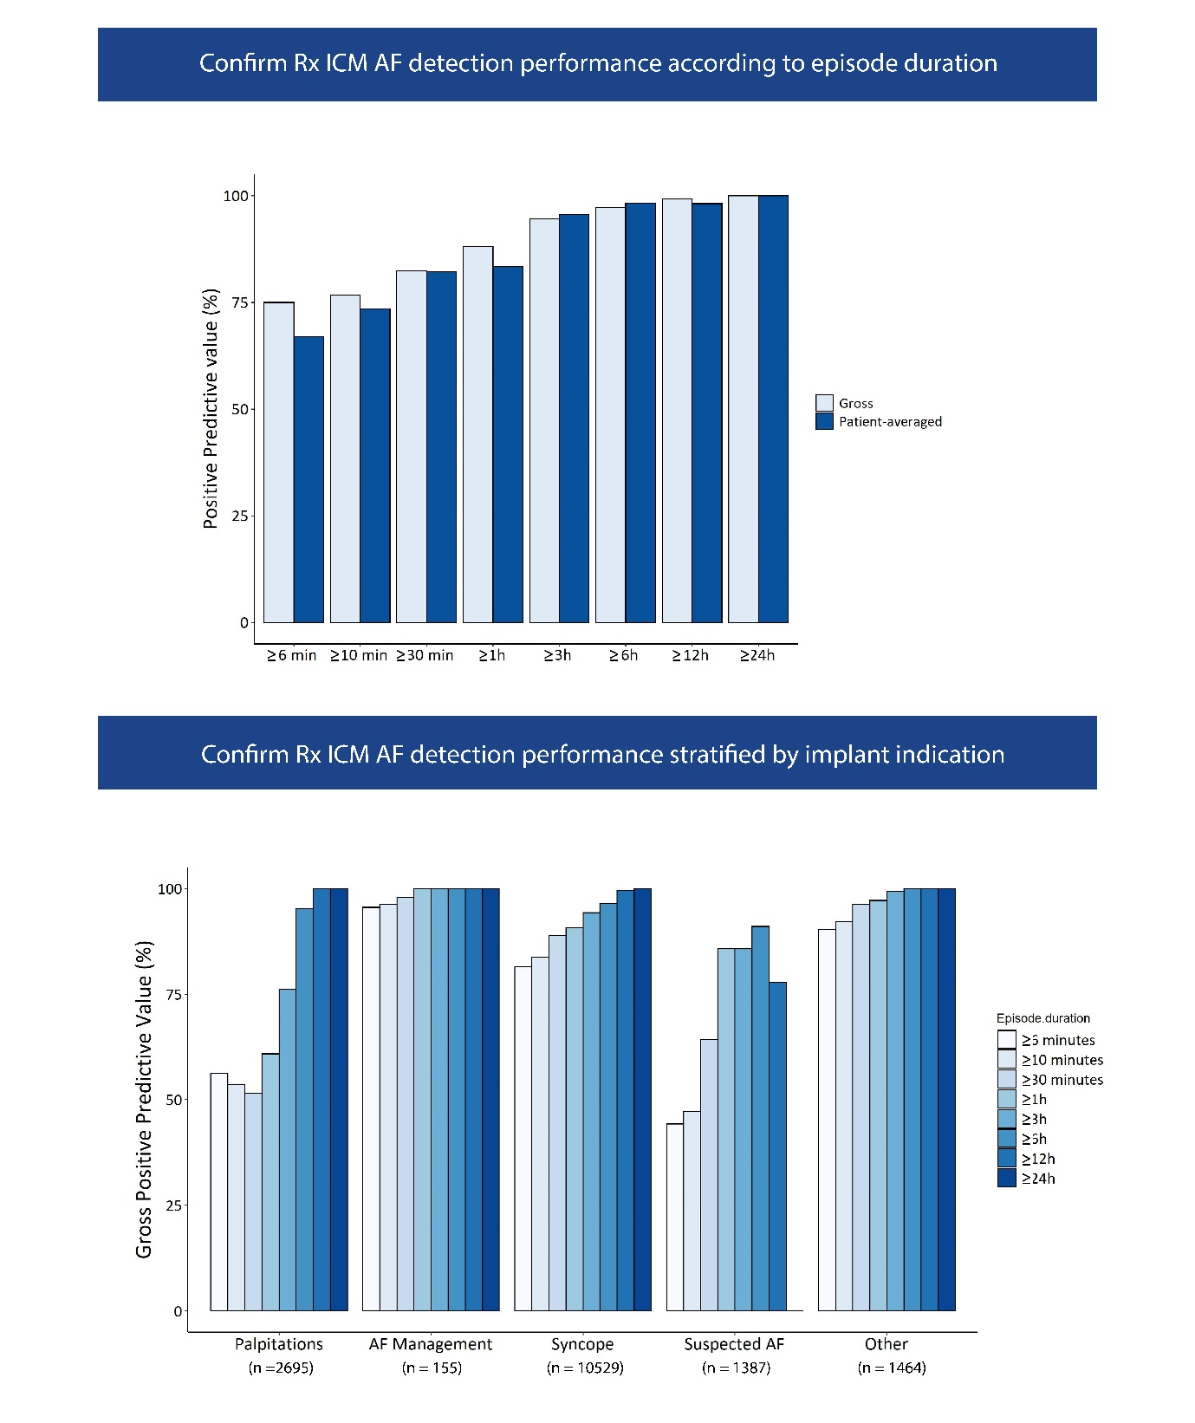
Graphical Abstract. Diagnostic performance of the Confirm Rx SharpSense AF detection algorithm.

 | Reason for Monitoring |  |  |  |  | Total
 | Palpitations | AF Management | Syncope | Suspected AF | Other
Number of episodes of AF detected | 2695 | 155 | 10529 | 1387 | 1464 | 16230
Number of True positive episodes | 1516 | 148 | 8573 | 614 | 1320 | 12171
Positive predictive value (gross) | 56.3% | 95.5% | 81.4% | 44.3% | 90.2% | 75.0%
Positive predictive value (patient-average) | 69.3% | 81.7% | 67.1% | 55.2% | 65.0% | 67.0%
Table 3. Diagnostic performance of the Confirm Rx™ with SharpSense™ Technology as a function of different implant indications.

AF: atrial fibrillation.

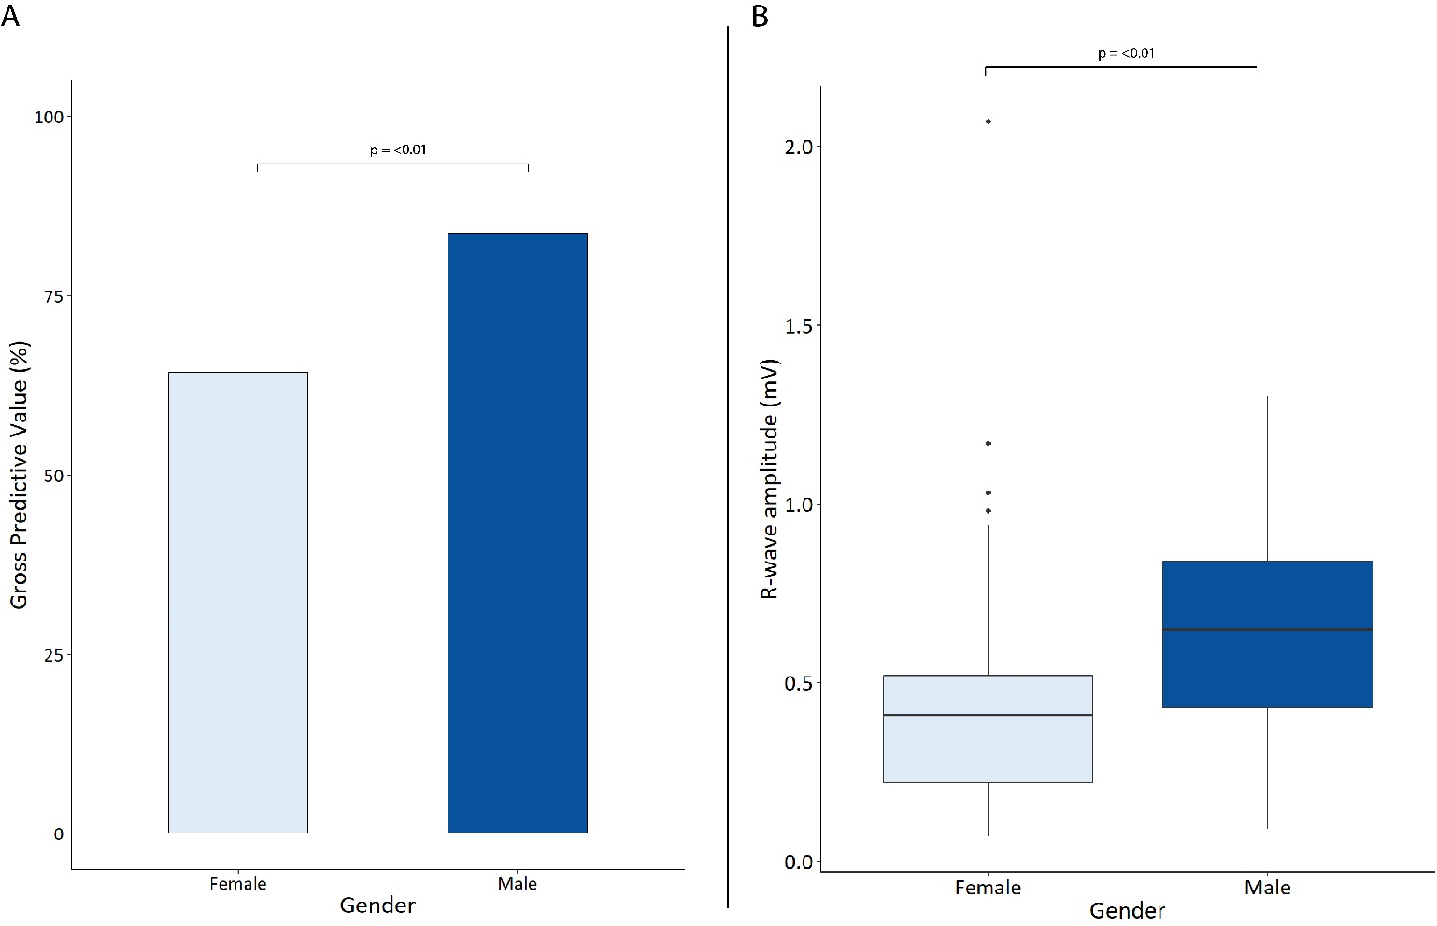
Figure 1. A) Sex-based comparison of gross positive predictive value (PPV) for the Confirm Rx. B) Sex-based comparison of R-wave amplitude for the Confirm Rx.

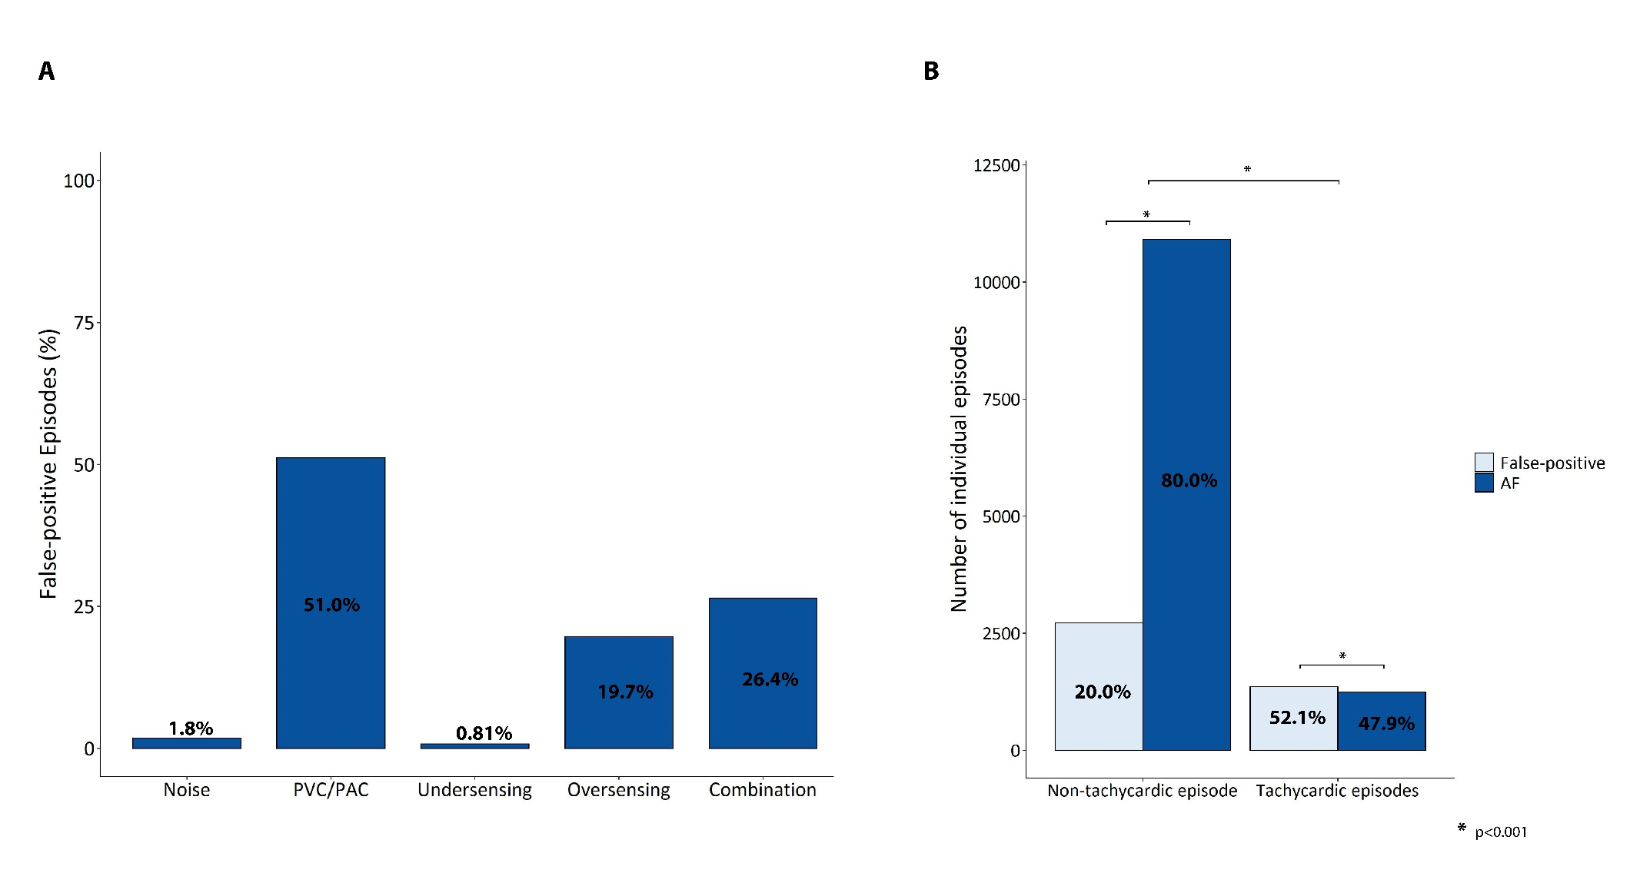
Figure 2. A) Sources of false-positive detections for the whole cohort. B) False-positive episodes in non-tachycardic versus tachycardic episodes (defined as mean heart rate ≥ 100 beats per minute).

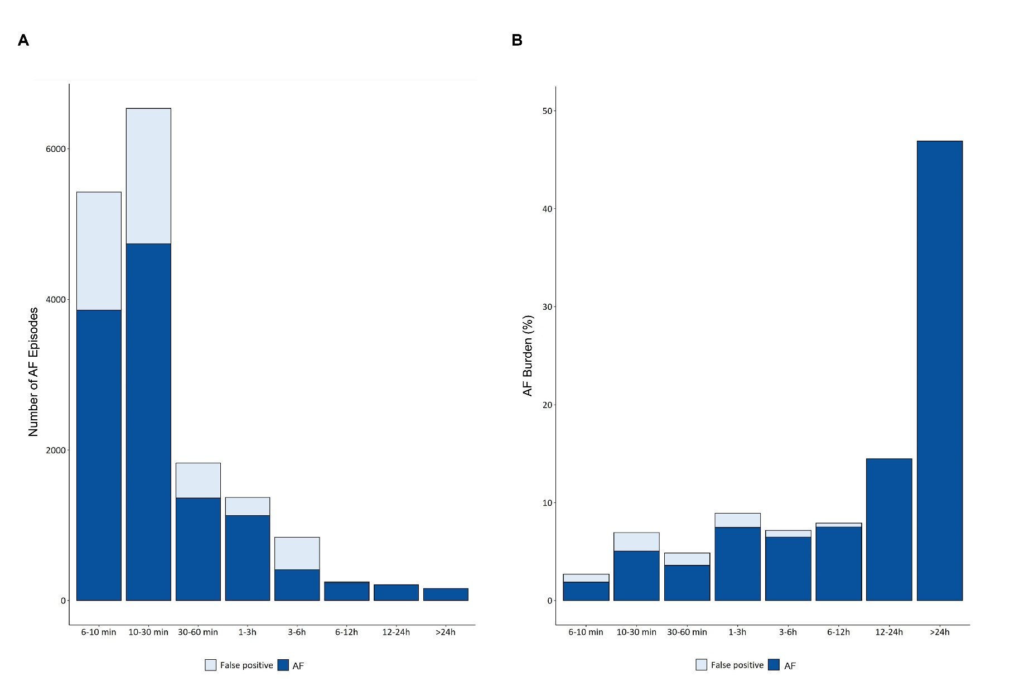
Figure 3. A) Diagnostic performance of the Confirm Rx™ as a function of episode duration; B) Contribution of AF episodes of different duration to overall AF burden.a

