Supplementary Material
‘Real-world’ performance of the Confirm Rx™ SharpSense AF detection algorithm: UK Confirm Rx study

This supplementary material has been provided by the authors to give readers additional information about their work.

Table of contents

Table S1. Confirm Rx settings according to reason for monitoring automatic parameters (from Confirm Rx™ manual [Abbott]). 2
Table S2. Age and sex according to implant indication. 3
Figure S1. Number of recordings per patient month for different implant indications. 4
Table S3. Diagnostic performance of AF detection algorithm for episodes of different durations and according to implant indication. 5
Table S4. Summary of patients and episodes based on R-wave amplitude. 6
Figure S2. Diagnostic Performance of AF Detection Algorithm based on R-Wave Amplitude. 7
Figure S3. Distribution of age category in the study cohort. 8
Table S5. Summary of patients and episodes based on age. 9
Figure S4. R-wave amplitude in different age groups 10
Figure S5. Diagnostic performance of AF detection algorithm based on age. 11
Table S6. False-positive detections according to implant indications. 12
Figure S6. Distribution of types of false-positive detections according to gender. 13
Figure S7. False-positive detections according to implant indications. 14
Figure S8. Number of false-positive episodes according to R-wave amplitude and gender. 15
Figure S9. Example of True-AF episode. 16
Figure S10. Example of false positive episode due to ventricular ectopy. 17
Figure S11. Example of false-positive episode due to oversensing and ventricular ectopy. 18
Figure S12. Example of false-positive episode due to T-wave oversensing. 19
Figure S13 Example of false-positive episode due to undersensing. 20

Table S1. Confirm Rx settings according to reason for monitoring automatic parameters (from Confirm Rx™ manual [Abbott]).

Reason for monitoring | AF duration | AF | Pause | Tachycardia | Bradycardia | Tachycardia sudden onset
Syncope | 6 minutes | Low | High | High | High | On
Seizures | 6 minutes | High | High | High | High | On
Palpitations | 6 minutes | High | Low | High | Low | On
Ventricular Tachycardia | 10 minutes | Low | Low | High | Low | Off
Suspected AF | 6 minutes | High | Low | Low | Low | On
Post AF Ablation | 6 minutes | High | Low | Low | Low | On
AF management | 6 minutes | High | Low | Low | Low | On
Cryptogenic Stroke | 2 minutes | High | Low | Low | Low | On
Other | 2 minutes | High | High | Low | Low | Off

Table S2. Age and sex according to implant indication.
 | Palpitations | AF Management | Syncope | Suspected AF | Others
Age (years) | 54 (37-67) | 70 (63-76) | 72 (57-82) | 67 (57-67) | 64 (57-77)
Sex
Female | 3 (50%) | 12 (52.1%) | 22 (64.8%) | 5 (38.4%) | 64 (42.1%)
Male | 3 (50%) | 11 (47.8%) | 12 (35.2%) | 8 (61.5%) | 78 (54.9%)

¹ Krustal-Wallis test; Fisher exact test

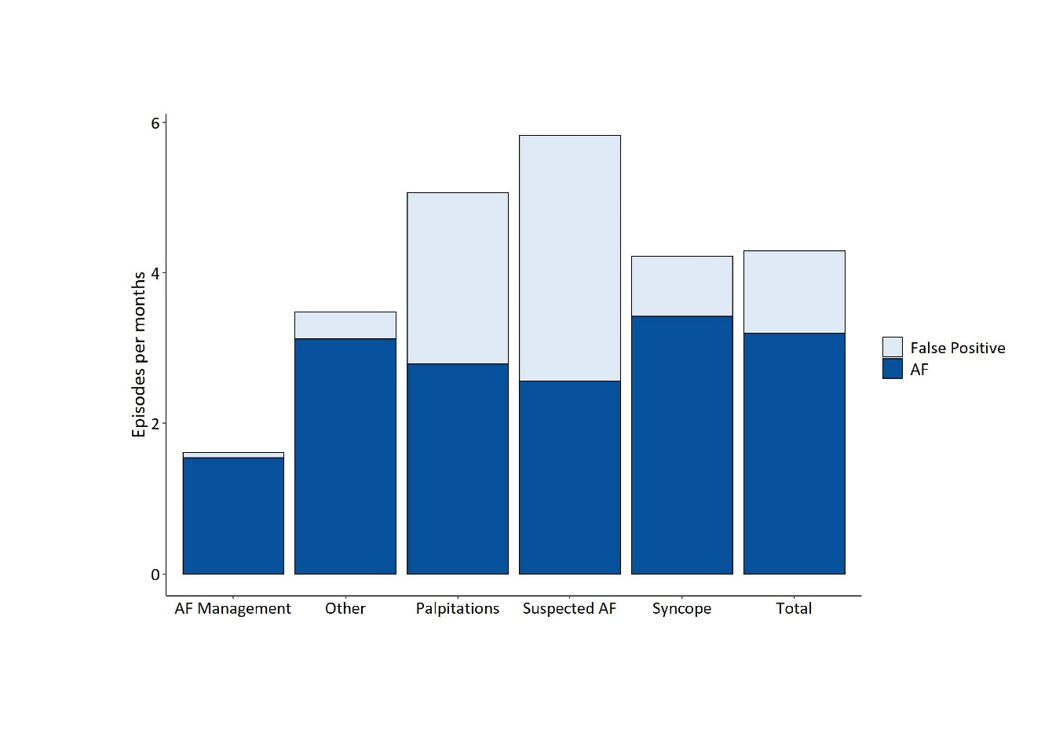

Figure S1. Number of recordings per patient month for different implant indications.

Table S3. Diagnostic performance of AF detection algorithm for episodes of different durations and according to implant indication.

Indication | Episode duration | Number of AF episodes detected | Number of True AF episodes | PPV
Palpitations (n=36) | >6 minutes | 2695 | 1,516 | 56.3%
Palpitations (n=36) | >10 minutes | 1765 | 946 | 53.6%
Palpitations (n=36) | >30 minutes | 656 | 338 | 51.5%
Palpitations (n=36) | >1h | 322 | 196 | 60.9%
Palpitations (n=36) | >3h | 67 | 51 | 76.1%
Palpitations (n=36) | >6h | 21 | 20 | 95.2%
Palpitations (n=36) | >12h | 8 | 8 | 100%
 | >24h | 6 | 6 | 100%
 | >6 minutes | 155 | 148 | 95.5%
 | >10 minutes | 131 | 126 | 96.2%
 | >30 minutes | 97 | 95 | 97.9%
AF Management (n=6) | >1h | 73 | 73 | 100%
 | >3h | 49 | 49 | 100%
 | >6h | 37 | 37 | 100%
 | >12h | 24 | 24 | 100%
 | >24h | 3 | 3 | 100%
 | >6 minutes | 10529 | 8573 | 81.4%
 | >10 minutes | 6817 | 5714 | 83.8%
 | >30 minutes | 2498 | 2221 | 88.9%
Syncope (n=151) | >1h | 1417 | 1286 | 90.8%
 | >3h | 649 | 612 | 94.3%
 | >6h | 404 | 391 | 96.5%
 | >12h | 256 | 255 | 99.6%
 | > 24h | 133 | 133 | 100%
 | >6 minutes | 1387 | 614 | 44.3%
 | >10 minutes | 946 | 447 | 47.3%
 | >30 minutes | 359 | 231 | 64.3%
 | >1h | 161 | 138 | 85.7%
Suspected AF (n=15) | >3h | 36 | 33 | 91.7%
 | >6h | 15 | 13 | 86.7%
 | >12h | 9 | 7 | 77.8%
 | >24h | - | - | -
 | >6 minutes | 1464 | 1320 | 90.2%
 | >10 minutes | 1148 | 1156 | 92.1%
 | >30 minutes | 658 | 633 | 96.2%
 | >1h | 468 | 455 | 97.2%
Other (n=24) | >3h | 272 | 270 | 99.3%
 | >6h | 144 | 144 | 100%
 | >12h | 18 | 17 | 94.4%
 | >24h | 13 | 13 | 100%
AF: atrial fibrillation; PPV: positive predictive value.

R-wave categories  (mV) | Number of patients | Number of AF episodes detected | Number of True-AF episodes
0-0.19 | 20 | 1952 | 1038
0.2-0.39 | 49 | 3757 | 2136
0.4-0.59 | 63 | 4235 | 3589
0.6-0.79 | 29 | 1631 | 1290
0.8-0.99 | 19 | 2440 | 2131
1.0-1.19 | 19 | 498 | 443
1.2-1.39 | 1 | 162 | 162
1.4-1.59 | 0 | 0 | 0
1.6-1.79 | 0 | 0 | 0
1.8-1.99 | 0 | 0 | 0
>2 | 1 | 2 | 2

Table S4. Summary of patients and episodes based on R-wave amplitude.

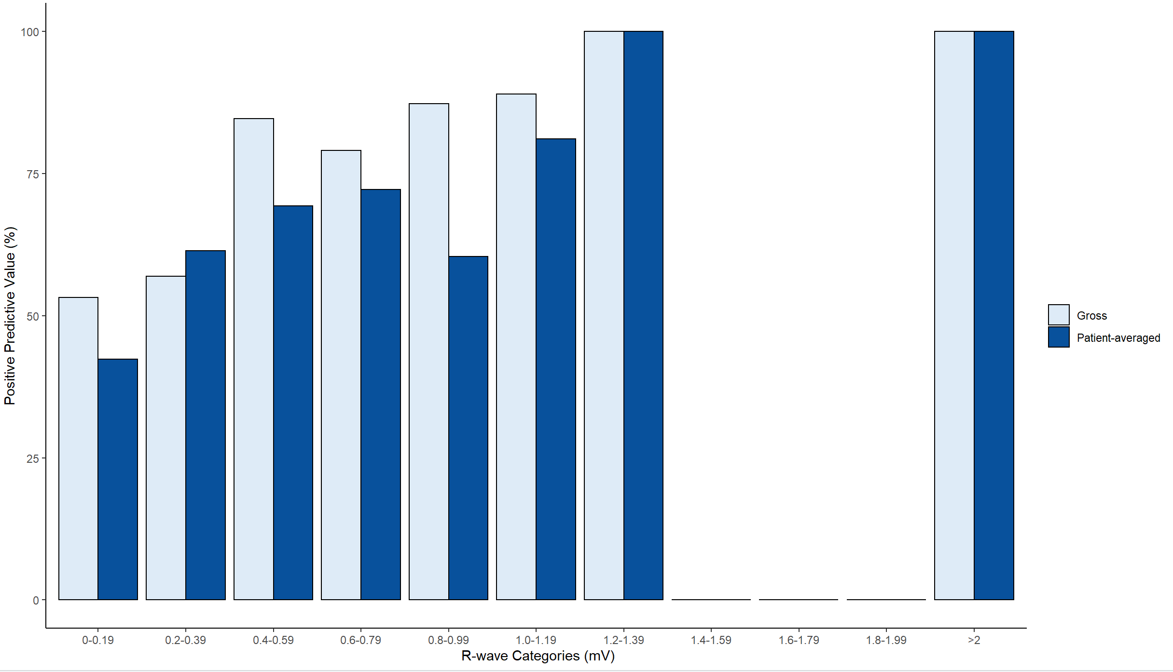

Figure S2. Diagnostic Performance of AF Detection Algorithm based on R-Wave Amplitude.

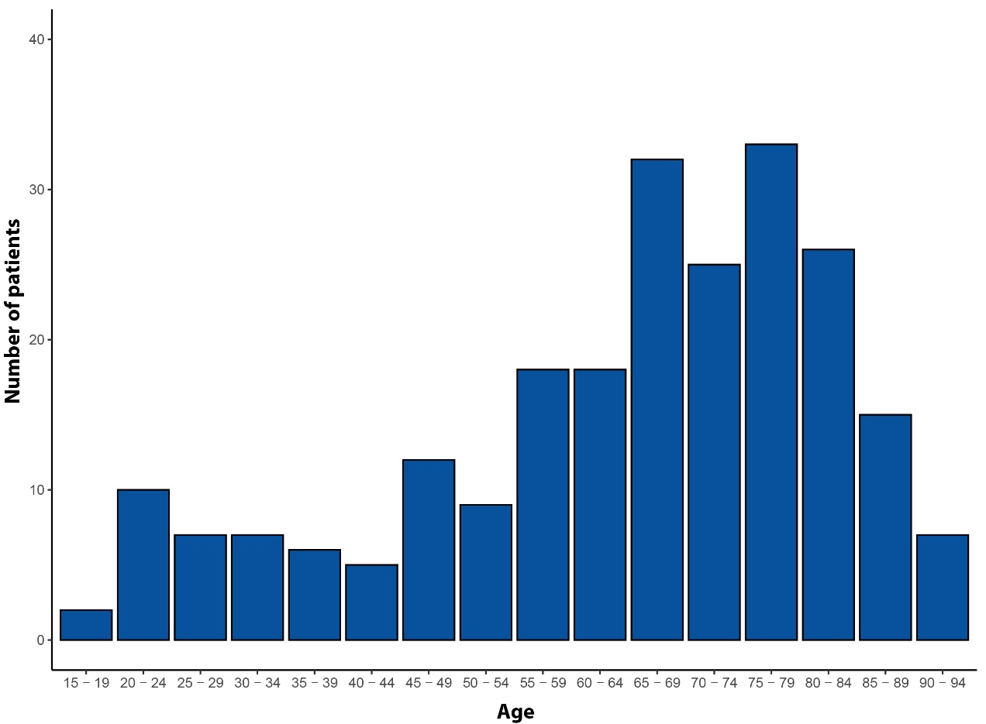

Figure S3. Distribution of age category in the study cohort.

Table S5. Summary of patients and episodes based on age.

Age Categories  (years) | Number of patients | Number of AF episodes detected | Number of True-AF episodes
15 - 19 | 2 | 365 | 333
20 - 24 | 10 | 768 | 704
25 - 29 | 7 | 579 | 497
30 - 34 | 7 | 71 | 52
35 - 39 | 6 | 458 | 280
40 - 44 | 5 | 226 | 158
45 - 49 | 12 | 322 | 142
50 - 54 | 9 | 359 | 202
55 - 59 | 18 | 212 | 148
60 - 64 | 18 | 1073 | 960
65 - 69 | 32 | 2259 | 1,653
70 - 74 | 25 | 2280 | 894
75 - 79 | 33 | 1801 | 1,445
80 - 84 | 26 | 4364 | 3,780
85 - 89 | 15 | 963 | 810
90 - 94 | 7 | 130 | 113

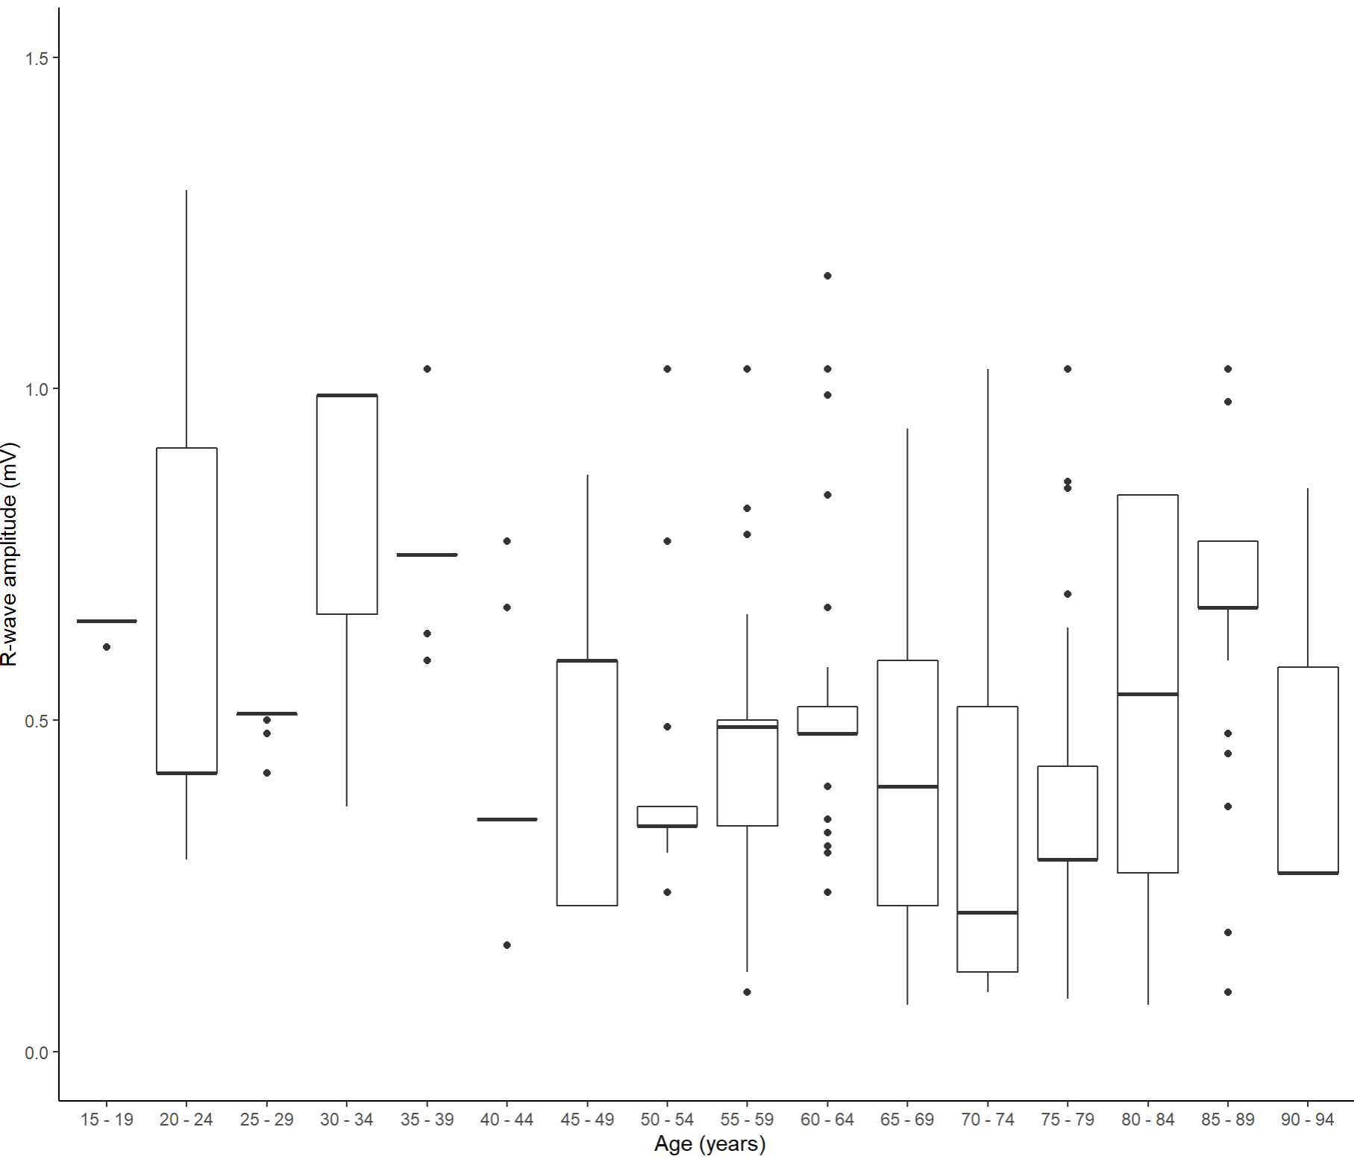

Figure S4. R-wave amplitude in different age groups

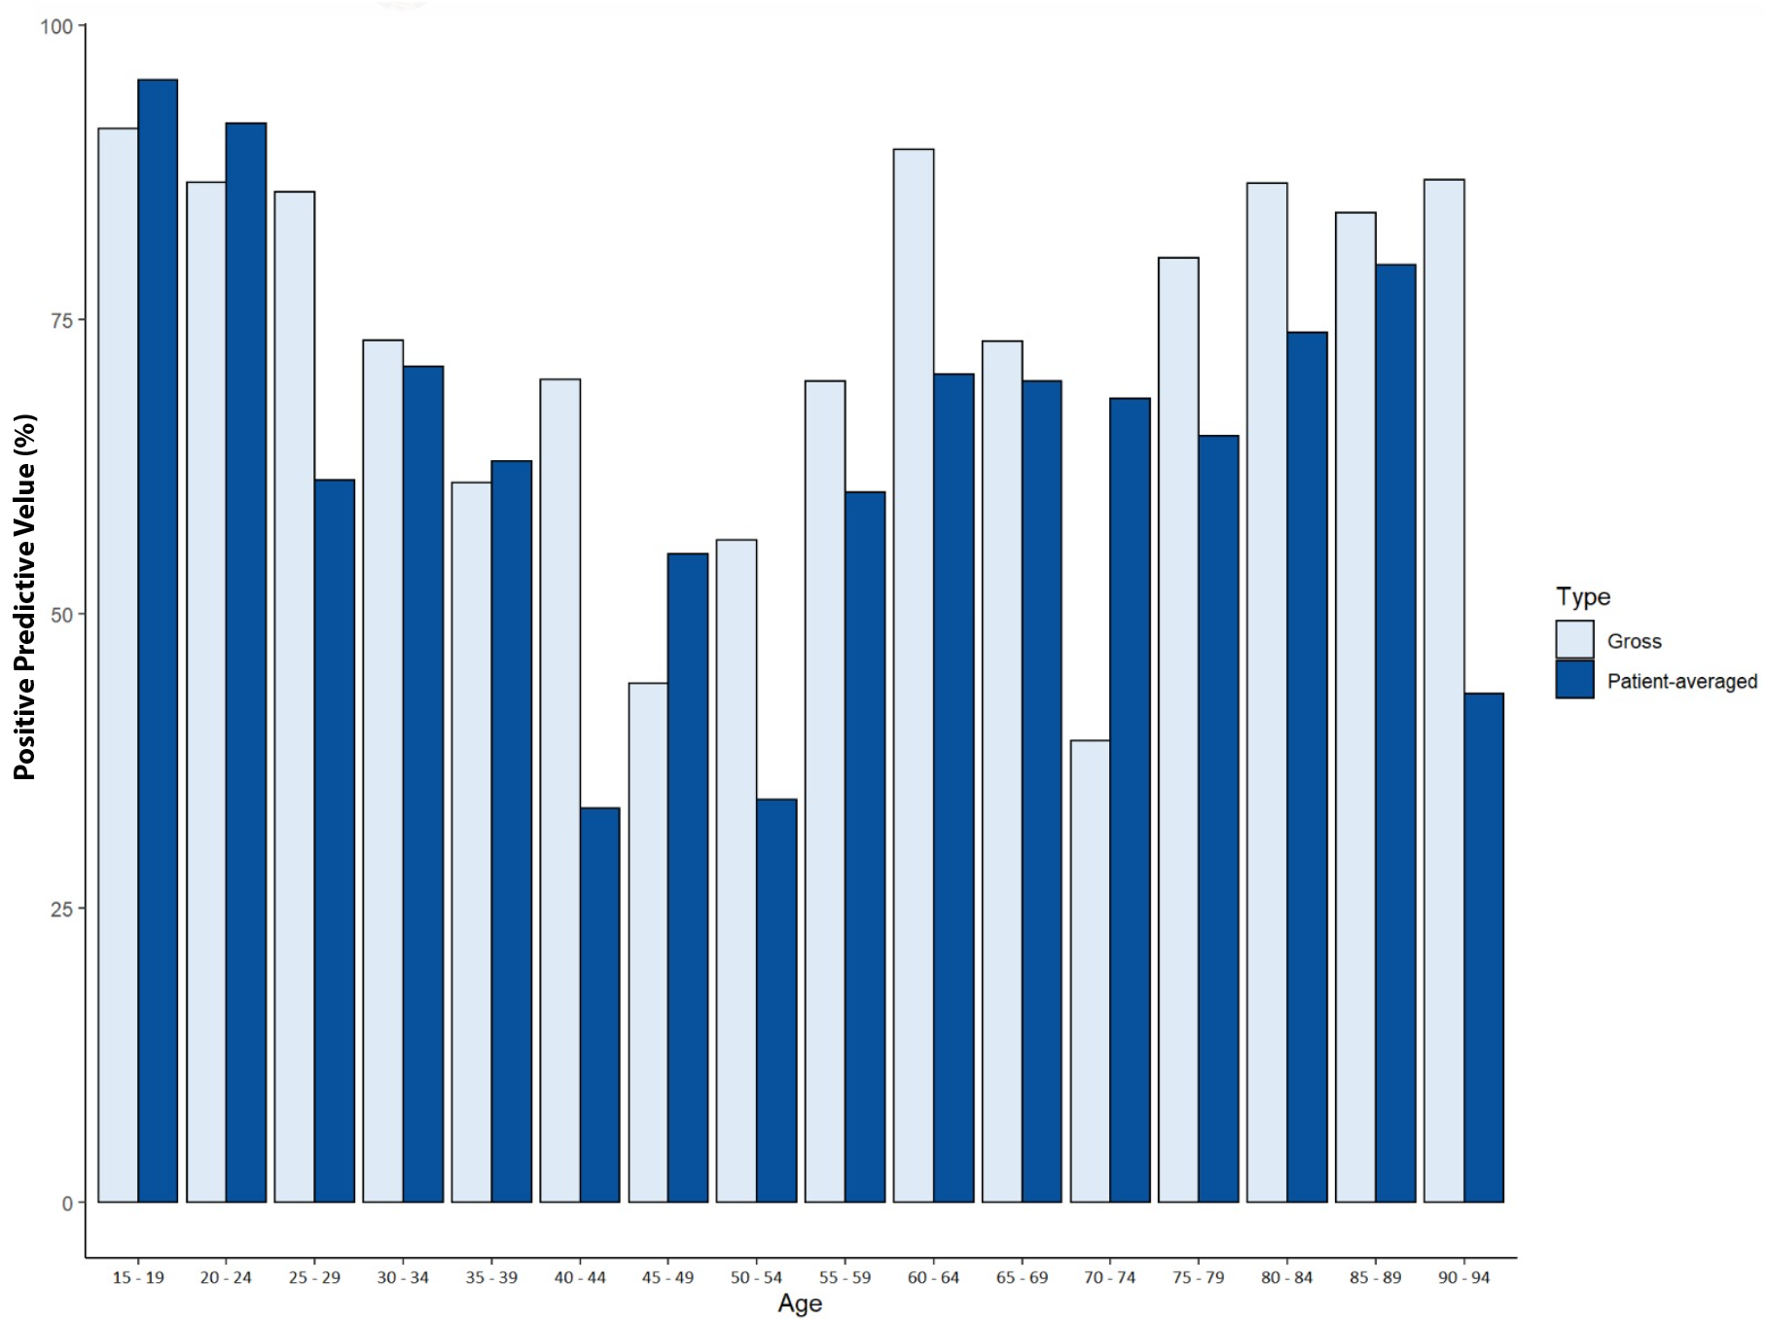

Figure S5. Diagnostic performance of AF detection algorithm based on age.

 | Palpitations | AF Management | Syncope | Suspected AF | Others | p-value¹
False-positive | 1187 (44%) | 7 (4.5%) | 1964 (19%) | 774 (56%) | 146 (10%) | <0.001
True-AF | 1516 (56%) | 148 (95.5%) | 8573 (81%) | 614 (44%) | 1320 (90)% | <0.01

Table S6. False-positive detections according to implant indications.
¹Chi-square test of independence

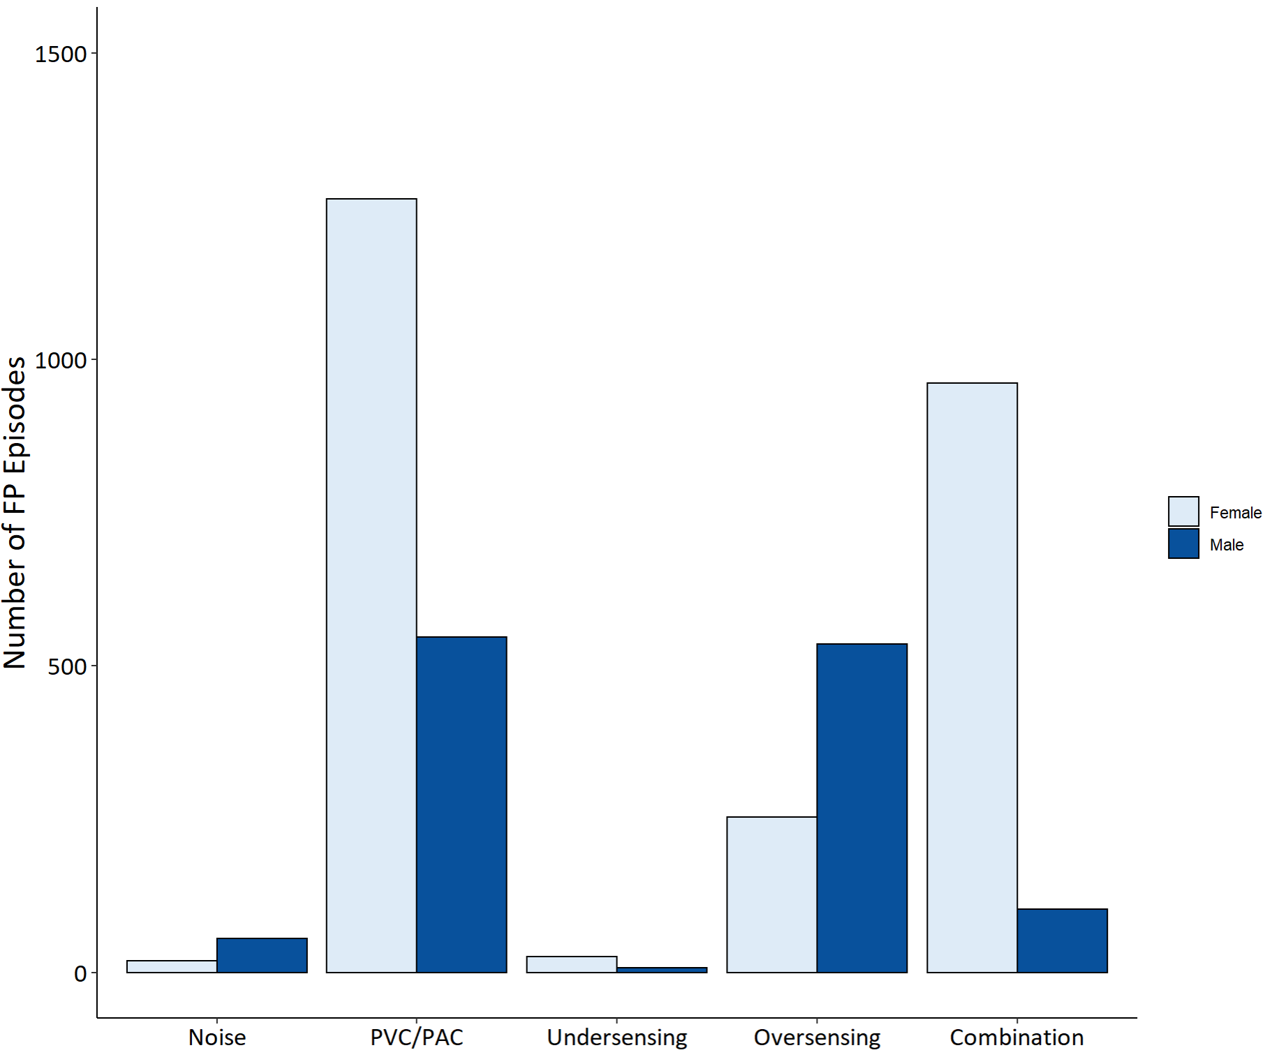

Figure S6. Distribution of types of false-positive detections according to gender.

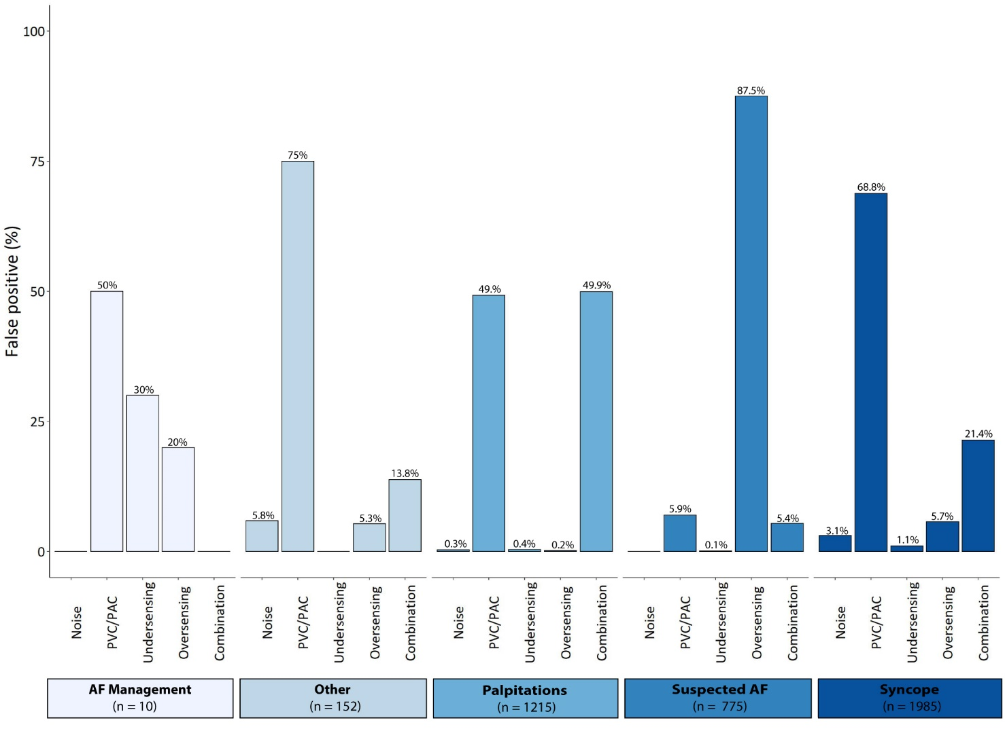

Figure S7. False-positive detections according to implant indications.

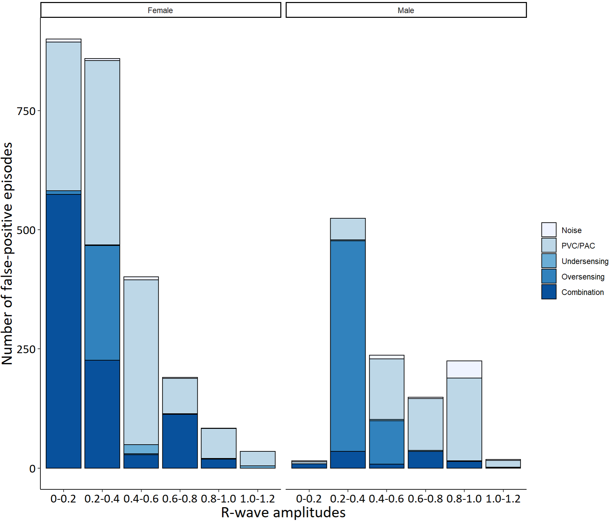

Figure S8. Number of false-positive episodes according to R-wave amplitude and gender.

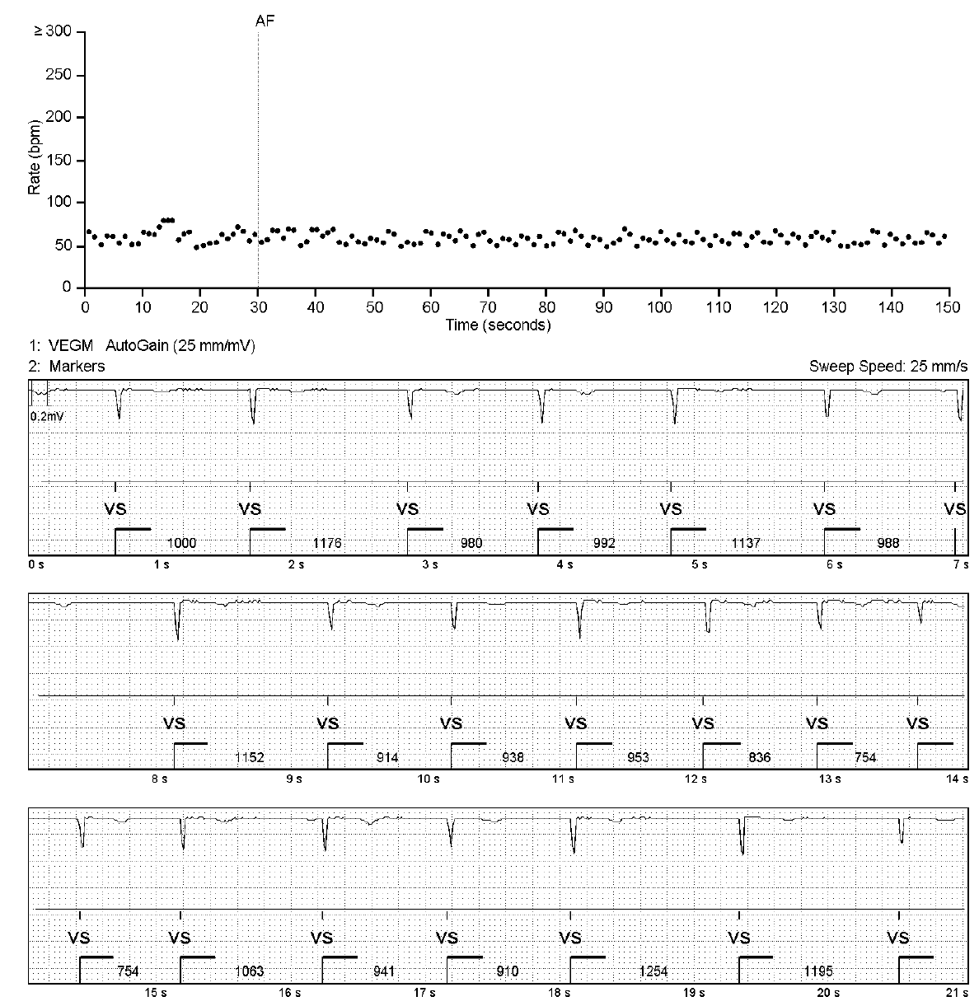

Figure S9. Example of True-AF episode.

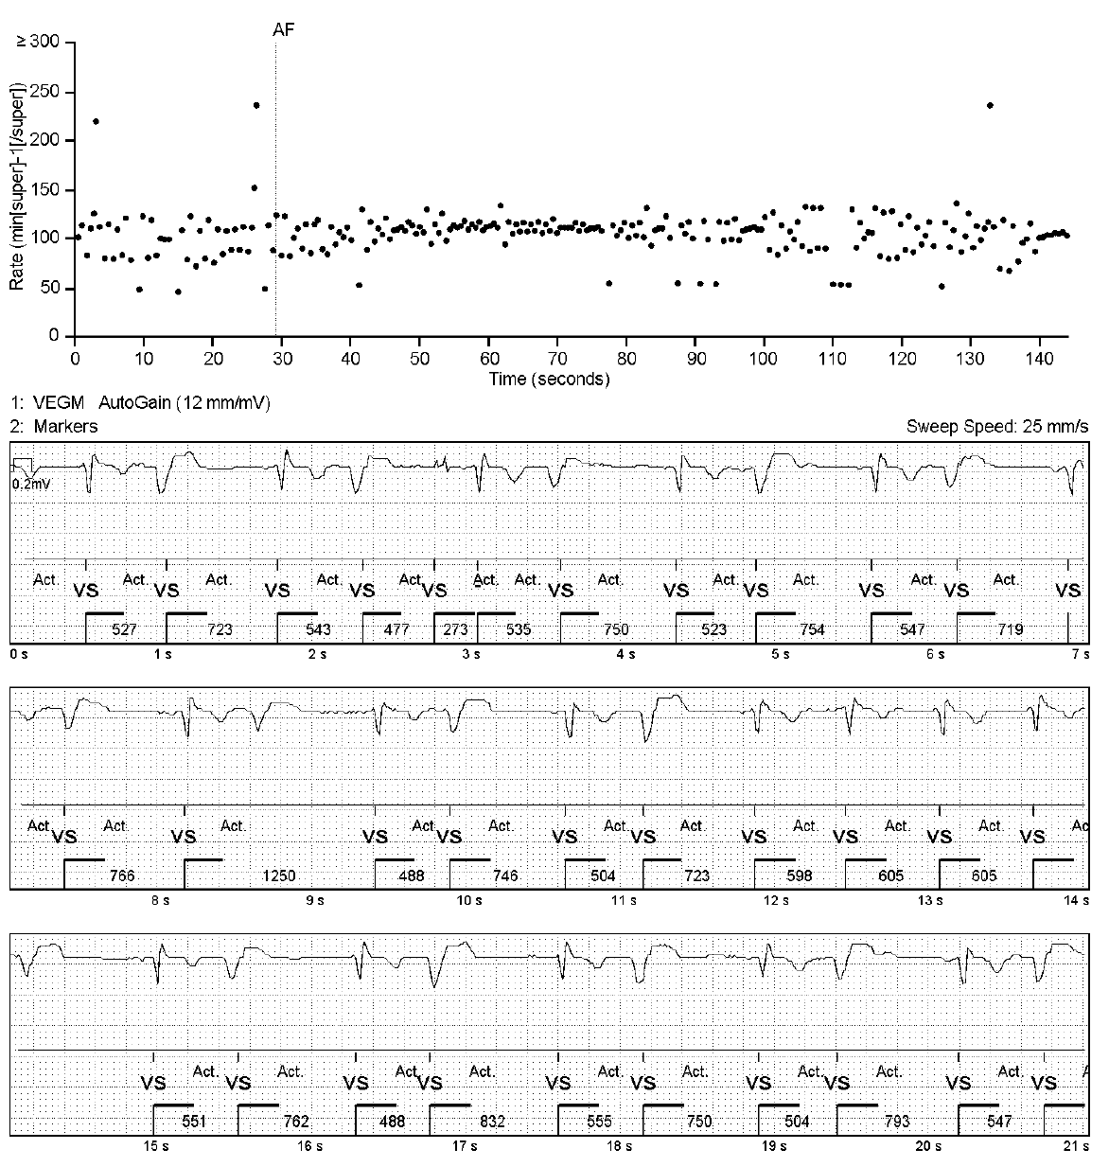

Figure S10. Example of false positive episode due to ventricular ectopy.

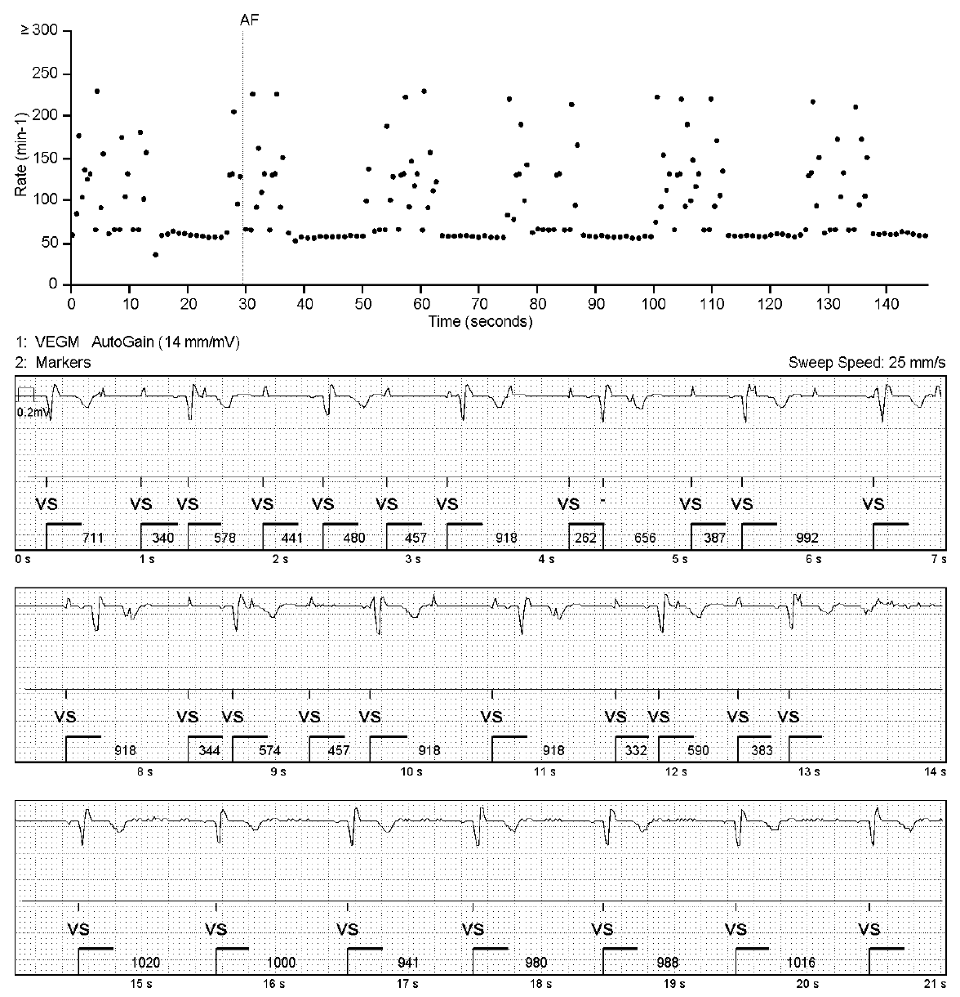

Figure S11. Example of false-positive episode due to oversensing and ventricular ectopy.

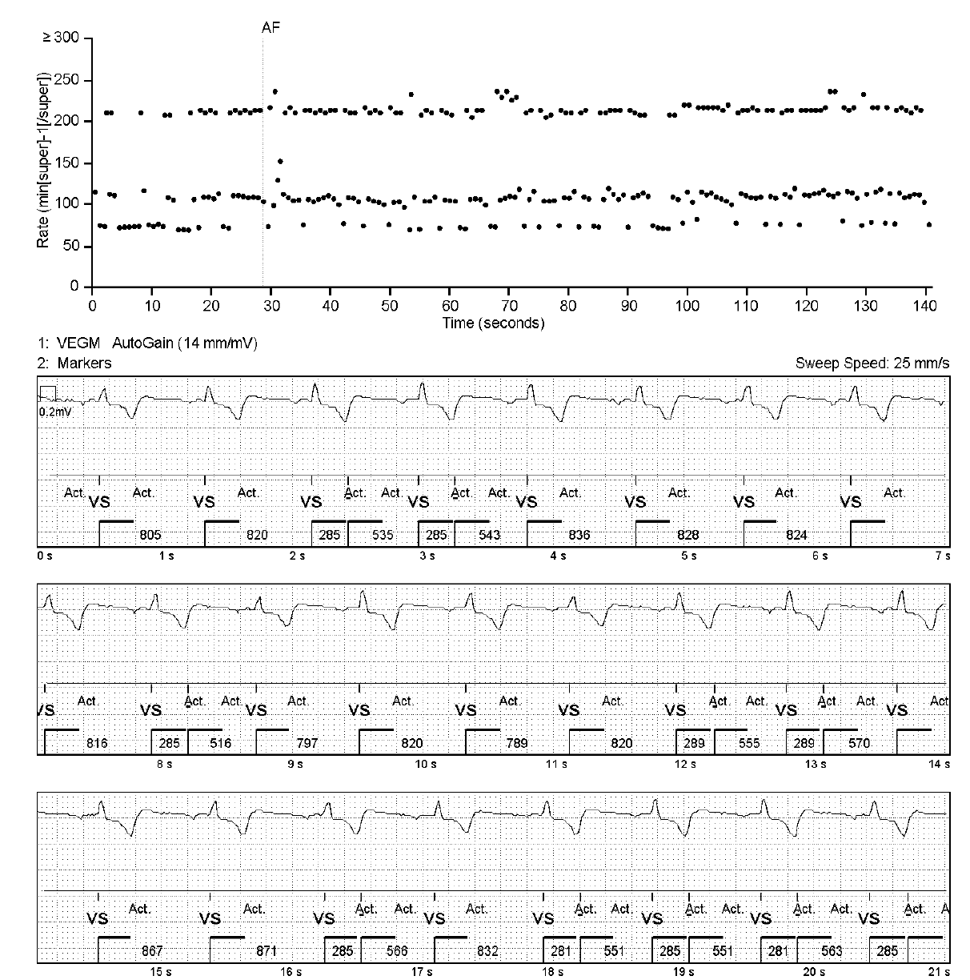

Figure S12. Example of false-positive episode due to T-wave oversensing.

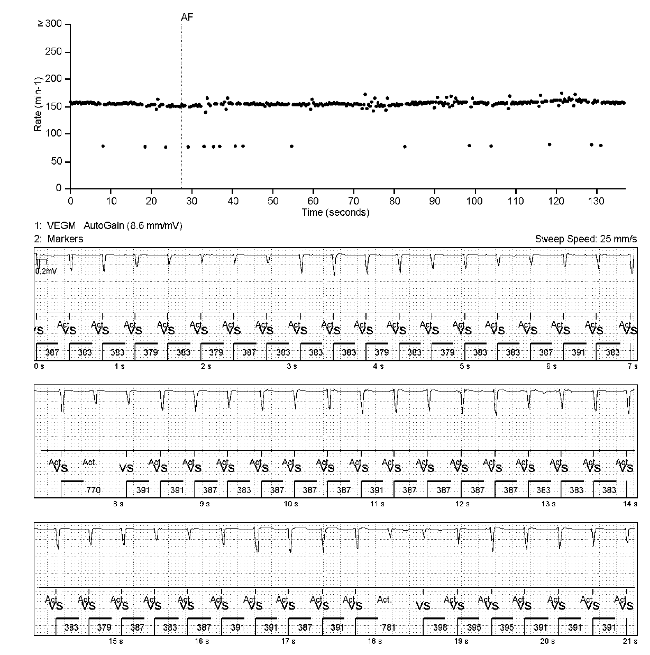

Figure S13 Example of false-positive episode due to undersensing.

