|  |
| --- |
| Joint ISSS-SDS Meeting  “Timeline of Silurian and Devonian environmental and biotic changes”  *12–17 September 2024, Sofia, Bulgaria* |

SHORT COMMUNICATION SUBMISSION FORM

**The deadline for short communication submission is 15 June 2024**

Short communication title:The palaeoenvironmental record through a Devonian-Carboniferous boundary super-monsoon lake

Presenting author: John Marshall

Mark with “X” your preferred presentation mode:

|  |  |  |  |  |  |
| --- | --- | --- | --- | --- | --- |
| Oral: | x | Poster: |  | No preference: |  |

*Poster format – A1 portrait*

*The Organizing Committee will make every effort to retain your presentation mode preference, but the final allocation will depend on the total number of submissions and available time.*

Mark with “X” the Session under which you wish to submit your short communication:

|  |  |  |  |
| --- | --- | --- | --- |
| ISSS: |  | SDS: | x |

*Joint ISSS-SDS Meeting, 12–17 September 2024, Sofia, Bulgaria*

The palaeoenvironmental record through a Devonian-Carboniferous boundary super-monsoon lake

*John Marshall1,Henning Blom2, Grzegorz Niedźwiedzki2, Martin Qvarnström2, Robert Gess3, Jessica Whiteside4, Per Ahlberg2*

*1School of Ocean and Earth Science, University of Southampton, National Oceanography Centre, Waterfront Campus, Southampton, UK, SO14 3ZH;* [*jeam@soton.ac.uk*](mailto:jeam@soton.ac.uk)

*2Department of Organismal Biology, Uppsala University, Norbyvägen 18A, SE-752 36, Uppsala, Sweden,* [*henning.blom@ebc.uu.se*](mailto:henning.blom@ebc.uu.se)*,* [*Grzegorz.niedzwiedzki@ebc.uu.se*](mailto:Grzegorz.niedzwiedzki@ebc.uu.se)*,* [*martin.quavrnstrom@ebc.uu.se*](mailto:martin.quavrnstrom@ebc.uu.se)*, per.ahlberg@ebc.uu.se*

*3****Albany Museum, Grahamstown, Province of the Eastern Cape, Republic of South Africa, robg@imaginet.co.za***

*4Department of Geological Sciences, San Diego State University, 5500 Campanile Drive, San Diego, CA 92182, USA, jhwhiteside@sdsu.edu*

Several Devonian-Carboniferous boundary sections are present in East Greenland (Fig. 1, Marshall 2020). Plant spores from a proximal section of the lake at Rebild Bakker are malformed and provide clear evidence of elevated UV-B accompanying the plant extinctions across the boundary (Marshall et al., 2020).

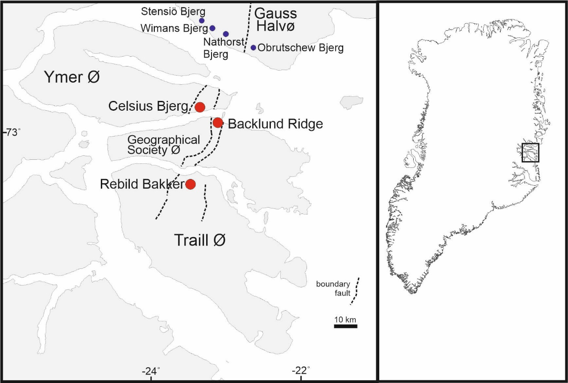

Fig. 1. Location of Devonian-Carboniferous boundary sections in East Greenland

The Devonian-Carboniferous boundary is clearly identified within the 0.5-1.2m thick lacustrine Obrutschew Bjerg Formation at the change from the LN* to VI palynological assemblages. This assemblage change is not merely the extinction of *Retispora lepidophyta*, the most abundant, distinctive and cosmopolitan of the latest Famennian spores but involves a complete restructuring of the terrestrial flora with the disappearance of major clades such as all grapnel tipped spores (*Nikitinsporites*, *Ancyrospora* and *Hystricosporites*), *Rugospora radiata* and *Diducites versabilis*. The surviving spore assemblages are dominated by simple spores that characterise the VI assemblage with recovery taking over 1 myr (Marshall et al., 2019). Significant elements of the late Devonian flora do survive (e.g. the progymnosperm *Protopitys*) but probably as widely dispersed elements. The palaeoequatorial flora that reassembled was dominated by lycopods and seed plants.

In 2022 we revisited Celsius Bjerg on an ERC project funded expedition (101019613 *Tetrapod Origin*) to collect latest Devonian tetrapods in their palaeoenvironmental context. The Obrutschew Bjerg Formation lake sediments were continuously sampled using a backpack drill and large orientated blocks. These samples have been separated into sub-centimetric splits and analysed for palynology, TOC%, calcite% and δ13CTOC together with selected BSEM imagery. The Obrutschew Bjerg Formation on Celsius Bjerg is in an intermediate position with Rebild Bakker being nearest to the lake margin. The deepest/distal section on Stensiö Bjerg show better assemblages of spores during the initial stages of lake flooding including greater resolution of the spore extinctions. However, this section is immediately beneath the sub-‘Permian’ unconformity with the rocks, in consequence, being less coherent than in other sections with a more complete Tournaisian and Viséan sequences. In addition, the section is very much AOM dominated with TOC reaching an astonishing 21% and hence very poor recovery of palynomorphs in much of the lake cycle.

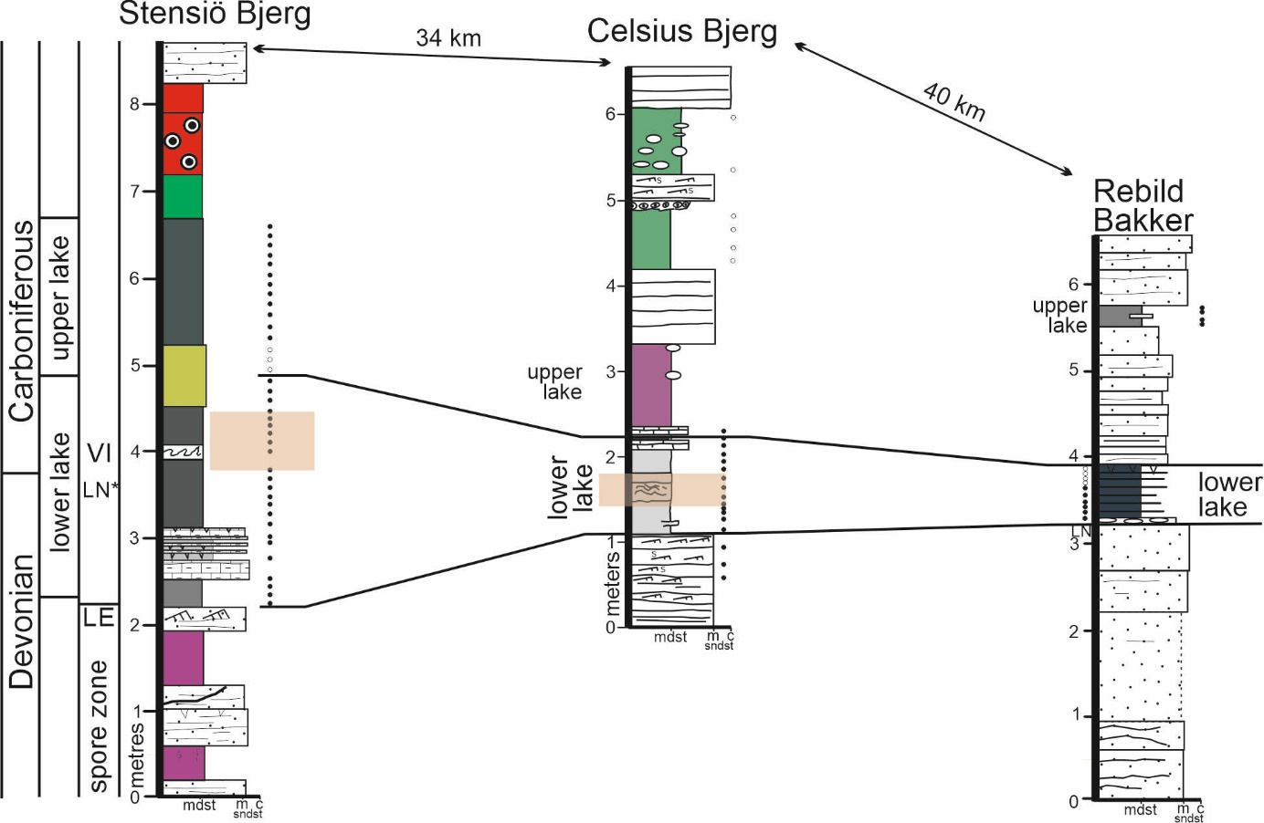

Fig. 2. Logs through the Devonian-Carboniferous boundary sections on Stensiö Bjerg, Celsius Bjerg and Rebild Bakker.

All the Obrutschew Bjerg Formation Devonian-Carboniferous boundary sections mark a profound change within the basin as it moves rapidly from a Givetian to Famennian sequence that was characterised by dryland rivers to one dominated by a deep, wide, stratified permanent lake. The East Greenland Main Devonian Basin lies at the centre of the Old Red Sandstone Continent and in the southern hemisphere arid zone so a change to such humid conditions is entirely unexpected. The mechanism for bringing seasonal moisture into an arid continental interior (Olsen 1993; Marshall et al., 2007) is the strengthening of the monsoon through increased heat within Earth System. This builds up heat within the continental interior that eventually collapses to draw in moisture from the distant marine margins. Hence, the Obrutschew Bjerg Formation is interpreted as marking a hyperthermal event and coincident with the warming that terminated the latest Famennian glaciations.

At Celsius Bjerg the basal third of the lake is not atypical for a Devonian lake showing a TOC of about 1%. Spore assemblages are dominated by *Retusotriletes* spp, *Verrucosisporites nitidu*s and *Grandispora echinata* but without grapnel tipped spores, *Diducites* and *Retispora lepidophyta*. As TOC rises to a mid-point peak at 10%, spores generally disappear with the assemblage becoming AOM dominated. It appears that the lake restructures through the middle third of the cycles and inferred to have become deeper and wider following a strengthening of the pluvial input. Clearly, a threshold has been passed, perhaps driven by intersection of orbital cycles. It is at this change from 2% to higher TOC’s that some spores reappear such as *Retispora lepidophyta* and isolated grapnel tips. This reoccurrence was also identified at the same stratigraphic level at Stensiö Bjerg. One explanation is reworking as the lake expanded its margins. It was hoped that studies of annual lamination in BSEM would give an estimation of duration of the OBF lake. But its apparent that much of the cycle has been subjected to pervasive diagenesis with porosity opening up during bitumen generation at maximum burial leading to formation of albite (e.g., Li *et al.*, 2023) and the loss of obvious lamination. However, some relict lamination can be identified suggesting an annual frequency of ~100 μm with the entire organic rich mudstone part of the cycles occupying about 12kyr. So, it appears that precession is probably the primary control on the lake cycles with the 2 lakes being within an obliquity doublet. In contrast to most Orcadian Basin Middle Devonian lakes there is no pyrite and hence the waters were free of sulphate and much fresher.

The TOC rich interval of the Obrutschew Bjerg Formation can be separated into at least 3 distinct ‘microbial groups’ based on the δ13CTOC values in the AOM. This includes a distinct interval that contains common fish remains including shoals of an early bony fish and predators including a shark implying that the lake was connected to the sea at this time, an estimated distance of 1000 km.

Above this level, TOC% drops to a stable 2% with the palynofacies now dominated by mats of the alga *Botryococcus* with its corresponding distinctive δ13CTOC isotope signature. The waters are now more oxygenated. At and above this level, spores reappear in abundance but are dominated by *Retusotriletes* with *Vallatisporites* and are clearly from the VI palynological assemblage of earliest Carboniferous age.

***Acknowledgements***. The support for ERC Grant 101019613 *Tetrapod Origin* is acknowledged.

**REFERENCES**

Decombeix, A-L., Galtier, J. & Prestianni, C. 2015. The Early Carboniferous progymnosperm *Protopitys*: new data on vegetative and fertile structures, and on its geographic and stratigraphic distribution, *Historical Biology*, **27**:3-4, 345-354.

Li, C., Guo, P., Zhong, K., Xu, J. & Wen, H. 2023. Formation and diagenesis of authigenic silicates in the Late Paleozoic alkaline lake deposits, Junggar Basin, NW China. *Sedimentary Geology* **458**: 106531

Marshall, J., Reeves, E., Bennett, C., Davies, S., Kearsey, T., Millward, D., Browne, M. 2019. Reinterpreting the age of the uppermost ‘Old Red Sandstone' and Early Carboniferous in Scotland. *Earth and Environmental Science Transactions of the Royal Society of Edinburgh,* **109**, 265-278.

Marshall, J. E. A., Lakin, J., Troth, I. & Wallace-Johnson, S. M. 2020. UV-B radiation was the Devonian-Carboniferous terrestrial extinction kill mechanism. *Science Advances*, **6**, eaba0768  
DOI: 10.1126/sciadv.aba0768.

Marshall, J.E.A., Astin, T.R., Brown, J.F., Mark-Kurik, E. & Lazauskiene, J. 2007. Recognising the Kačák Event in the Devonian terrestrial environment and its implications for understanding land-sea interactions. In: Becker, R.T. & Kirchgasser, W.T. (eds) Devonian Events and Correlations. *Special Publication of the Geological Society of London*, **278**: 133-155.

Marshall, J.E.A. 2021. A terrestrial Devonian-Carboniferous boundary section in East Greenland. *Palaeobiodiversity and Palaeoenvironments* **101**, 541-559 doi.org/10.1007/s12549-020-00448-x

Olsen, H. 1993. Sedimentary basin analysis of the continental Devonian basin in North-East Greenland. *Bulletin of the Grønlands Geologiske Undersøgelse*, **168**, 1-80.