**Twenty-Two Centuries of Nostalgia in Classical Chinese Poetry**

Chao Li1, Constantine Sedikides2, Tim Wildschut2, Jianning Dang1, Li Liu1

1Beijing Normal University

2University of Southampton

**Author Note**

Chao Li  http://orcid.org/0000-0001-6849-0964

Constantine Sedikides  [https://orcid.org/0000-0002-7563-306X](https://eur03.safelinks.protection.outlook.com/?url=https%3A%2F%2Forcid.org%2F0000-0002-7563-306X%3Flang%3Den&data=01%7C01%7CC.Sedikides%40soton.ac.uk%7C3b9e425336a24062de8e08d7e5c5e094%7C4a5378f929f44d3ebe89669d03ada9d8%7C0&sdata=4idbNATJbeCwMdHP9O%2FXNCzro8rQU7JO17NCK6fAdMM%3D&reserved=0)

Tim Wildschut  <https://orcid.org/0000-0002-6499-5487>

Jianning Dang  <http://orcid.org/0000-0002-8174-0136>

Li Liu  <http://orcid.org/0000-0002-4898-3013>

The authors acknowledge the financial support provided by the Major Project of the National Social Science Foundation of China (18ZDA332). Chao Li, Jianning Dang and Li Liu, Beijing Key Laboratory of Applied Experimental Psychology, Faculty of Psychology, Beijing Normal University, China; Constantine Sedikidesand Tim Wildschut, Center for Research on Self and Identity, School of Psychology, University of Southampton, United Kingdom. Corresponding author: Jianning Dang or Li Liu, Beijing Normal University, Beijing, China, 100875; Email: jndang@bnu.edu.cn or l.liu@bnu.edu.cn

**Abstract**

A burgeoning literature on nostalgia has identified the construct’s features, affective content, triggers, and psychological benefits across cultures. It has been argued that nostalgia is a fundamental human emotion. If so, these properties of nostalgia ought to be detected historically. We tested this possibility by relying on classical Chinese poetry, a unique vehicle given its historical relevance to ancient life and ability to express emotion. Content analyses of 600 poems revealed that, across dynasties, nostalgia was perceived and experienced similarly to today. In particular, the central (and also peripheral) features of the construct “nostalgia” were similar, the affective tone of nostalgia was mostly positive, its triggers paralleled contemporary ones (with visual stimuli and close others being most salient), and its psychological benefits were the same (with social connectedness being most prominent). The findings point to nostalgia as fundamental human emotion and open up promising directions of inquiry.

*Keywords*: nostalgia, classical Chinese poetry, nostalgia features, nostalgia triggers, nostalgia benefits

|  |  |
| --- | --- |
| *In Ba and Chu, in the desolate rivers and mountains,* | (巴山楚水凄凉地) |
| *Twenty-three years I spent as one utterly forsaken.* | (二十三年弃置身) |
| *Remembering the past, I recite old works in vain,* | (**怀旧**空吟闻笛赋) |
| *Reaching home, nothing of the bygone years remains.* | (到乡翻似烂柯人) |
| *The sunken boat is passed by a thousand sails,* | (沉舟侧畔千帆过) |
| *Ahead of the sick tree ten thousand are thriving.* | (病树前头万木春) |
| *Having heard you sing this song today,* | (今日听君歌一曲) |
| *Let’s drink to keep up our spirits with wine.* | (暂凭杯酒长精神) |

—Liu Yuxi (772-842)

The above is an excerpt from a classical Chinese poem (Zhang, 2022, p. 161), written by Liu Yuxi, a renowned Tang Dynasty (618–907 A.D.) poet. He composed it while being banished from the capital to remote parts of the empire for over two decades. The excerpt conveys nostalgic reverie, as the poet wistfully reflects on his past having experienced years of misfortune. Also, the poem spotlights the Chinese word for nostalgia, *huái jiù* (怀旧). According to Cihai (辞海), an authoritative Chinese dictionary (Shanghai Lexicographical Publishing House, 2019), *huái jiù* referred, and still refers, to missing (i.e., *huái*; 怀) the past time or old friends (i.e., *jiù*; 旧). We ask in this article whether classical Chinese poetry, given its lengthy historical timeline and remarkable continuity (Watson, 1987), can provide a vehicle for exploring the content, triggers, and psychological benefits of nostalgia through the ages. Do the perceptions and experiences of nostalgia identified in contemporary research also manifest in the poems composed by the ancient Chinese? If nostalgia is “fundamental to human nature itself” (McCann, 1941, p. 165), the answer ought to be affirmative.

**Nostalgia**

We review below the literature on the content, triggers, benefits, and valence of nostalgia, defined as a “a sentimental longing or wistful affection for the past” (The New Oxford Dictionary of English, 1998, p. 1266).

***Features of Nostalgia***

Researchers have investigated the features of nostalgia through prototype analyses. A prototype is laypersons’ understanding of a construct “consisting of the most common features or properties of members of that category” (Horowitz et al., 1982, p. 183). According to prototype theory, the central features of a concept are encoded more deeply, and are more cognitively accessible, than the peripheral ones (Cantor & Mischel, 1977; Gregg et al., 2008; Rosch, 1978). Relevant research, conducted with UK and USA samples (Hepper et al., 2012), identified 18 more representative (central) and 17 less representative (peripheral) features of nostalgia (Table 1, first and second columns). The central features indicated that nostalgia is an emotion which emanates from reflecting fondly, but longingly, on personally meaningful memories of social relationships, including childhood or youth, and memorabilia or keepsakes. Notably, a prototype analysis involving a Chinese sample produced similar results (Hepper et al., 2014).

***Triggers of Nostalgia***

Nostalgia is elicited by a variety of external stimuli and subjective states (Table 1, third column). External stimuli include objects or events experienced in one’s childhood (Holbrook & Schindler, 1996; Wildschut et al., 2006), momentous events from one’s life (Wildschut et al., 2006), close others (Wildschut et al., 2006), adverts or visual stimuli (Dang et al., 2024; Lasaleta et al., 2014; Redhead et al., 2023), tastes (Reid et al., 2023), scents (Reid et al., 2015), songs or music (Sedikides et al., 2022), and inclement weather (e.g., cold, wind, rain; Van Tilburg et al., 2018). Subjective states include loneliness (Wildschut et al., 2006), boredom (Van Tilburg et al., 2013), meaninglessness (Routledge et al., 2011), self-discontinuity (i.e., a disconnect between one’s past and present self; Sedikides, Wildschut, Routledge, & Arndt, 2015), negative affect (Wildschut et al., 2006), and death cognitions or fear of death (Routledge et al., 2008; Sedikides & Wildschut, 2018). All of these triggers have been documented in Chinese samples (Hepper et al., 2023; Zhou et al., 2008, 2012, 2019).

**Table 1**

*Prototypical Features, Triggers, and Benefits of Nostalgia*

|  |  |  |  |
| --- | --- | --- | --- |
| Prototypical Features | | Triggers | Benefits |
| Central Features | Peripheral Features |
| Memory/Memories | Comfort/warmth | Objects or events experienced in childhood or youth | Social connectedness |
| The past | Wishing/desire | Momentous events from one’s life | Meaning in life |
| Fond memories | Dreams/daydreaming | Close others | Self-continuity |
| Remembering | Mixed feelings | Adverts or visual stimuli | Future orientation |
| Reminiscence | Change | Tastes | Self-oriented |
| Feeling | Calm/relaxed | Scents | Happiness/wellbeing |
| Personal meaning | Regret | Songs or music |  |
| Longing/yearning | Homesickness | Inclement weather |  |
| Social relationships | Prestige/success | Loneliness |  |
| Memorabilia/keepsakes | Aging/old people | Boredom |  |
| Rose-tinted memory | Loneliness | Meaninglessness |  |
| Happiness | Sadness/depressed | Disillusionment |  |
| Childhood/youth | Negative past | Self-discontinuity |  |
| Sensory triggers | Distortions/illusions | Negative affect |  |
| Thinking | Solitude | Social exclusion |  |
| Reliving/dwelling | Pain/anxiety | Death cognitions or fear of death |  |
| Missing | Lethargy/laziness |  |  |
| Want to return to past |  |  |  |

***Benefits of Nostalgia***

Nostalgia confers important psychological benefits. These are: (1) social connectedness, a sense of bonding or closeness with others (Juhl & Biskas, 2023; Sedikides & Wildschut, 2019); (2) meaning in life, a sense that life is worth living or valuable (Routledge et al., 2012; Sedikides & Wildschut, 2018); (3) self-continuity, a sense of connection among one’s past, present, and future self (Evans et al., 2021; Hong et al., 2021; Sedikides et al., 2016); (4) future orientation, that is, optimism and hope for the time ahead (Cheung et al., 2013; Sedikides & Wildschut, 2020); (5) self-regard, that is, a positive evaluation of one’s self (i.e., high self-esteem; Hepper et al., 2012; Wildschut et al., 2006); and (6) happiness/wellbeing (Hepper & Dennis, 2023; Layous & Kurtz, 2023). All of these benefits had been established in Chinese samples (Hepper et al., 2023; Hong et al., 2022; Kelley et al., 2022; Li et al., 2023; Sedikides et al., 2016; Zhou et al., 2012).

***Valence of Nostalgia***

Nostalgic narratives entail more positive than negative affect, as demonstrated in both Western (Abeyta et al., 2015; Holak & Havlena, 1998; Leunissen et al., 2021; Wildschut et al., 2006) and Chinese (Dang et al., 2024) samples.

**Why We Examine Nostalgia in Classical Chinese Poems**

The literature points to cross-cultural similarities (Hepper et al., 2014, 2023; Sedikides & Wildschut, 2022; Sedikides, Wildschut, Routledge, Arndt, et al., 2015). That is, members of Western and Chinese cultures consider nostalgia as comprising the same features, having similar triggers, conferring parallel benefits, and containing largely positive affect. But this is nostalgia in the present. How was nostalgia experienced in the past? Did nostalgia evoke similar perceptions or feelings through the ages? We turned to classical Chinese poetry for an answer. We did so for three reasons.

First, poetry is essential to Chinese cultural tradition and forms the main body of classical Chinese literature (Xia, 2021). The earliest poetic anthology, *The Book of Poetry* (诗经) contained nearly 300 poems composed between the Western Zhou Dynasty (1046–771 B.C.) and the Warring States Period (475–221 B.C.). Poetic output has continued uninterrupted to the present day (Watson, 1987). Poems played a crucial role in social life and served various purposes in different contexts (Cai, 2008; Wang, 2017). Specifically, poems were represented in daily records as a means of documenting observations, experiences, or feelings in everyday affairs. Also, poems played an educational role; for example, *The Book of Poetry*held a significant place in Confucius’s educational curriculum, contributing to citizens’ moral and intellectual development. Moreover, good poems carried social prestige; attaining poetic proficiency was not only considered honorable but also opened doors to official positions and facilitated career advancement. Finally, poems were used to commemorate and record ceremonial events, as exemplified by the *Record of Rituals* (礼记), which preserves the cultural and ritualistic aspects of ancient Chinese society.

Second, emotion is central to poetry, including Chinese poetry (Hogan, 2017). Poems expressed not only the poet’s emotions, but also collective emotions (Jiang, 2018; see also Cai, 2008; Wang, 2017). For example, in an emblematic work of Chinese literary aesthetics, *The Literary Mind and the Carving of Dragons* (*wén xīn diāo lóng*; 文心雕龙), Liu Hsieh (ca. 465–522) articulates emotions (e.g., joy, anger, sadness, pleasure, resentment) presumably felt by both poets and their contemporary citizens (Liu, 2015).

Third, and most important, scholars have argued that the nostalgia motif is common in classical Chinese poetry (Liu, 1966) and is not confined to particular periods of Chinese history (Xiang, 2015). The ancient Chinese term for nostalgia, *huái jiù* (怀旧), has retained its meaning over the centuries (Zhao, 2009). Itwas frequently used by classical poets to express longing for the past. This theme was so integral to their work that it gave rise to a distinct genre known as *huái jiù shī* (怀旧诗), or nostalgic poetry. This genre focused on reminiscing about the past and reflecting on personal or historical changes, thus highlighting the enduring nature of nostalgia in Chinese literary tradition (Xiang, 2015).

**Method**

***Sample***

We relied on two credible and complementary databases (https://www.xungushici.com and <https://sou-yun.cn/>). Each included more than 600,000 classical Chinese poems, from the Pre-Qin Period (2070–221 B.C.) to the Qing Dynasty (1644–1911). First, we searched and collected poems that contained the word *huái jiù* as part of their title or main text. We arrived at 748 poems. Then, we deleted (1) duplicates, and (2) poems that contained only one of the two characters (i.e., *huái* or *jiù*) of the relevant compound term, as these poems were not nostalgic. Subsequently, we deleted poems that were fragmented or incomplete, being unclassifiable to a particular dynasty. These exclusions cumulatively amounted to 72 poems, leaving a total of 676 poems for coding. They were written by 437 poets (433 men, 4 women).

**Table 2**

*The Distribution of Poems Across Dynasties*

|  |  |  |  |  |
| --- | --- | --- | --- | --- |
| Dynasty (Duration) | *N* of Collected Poems | *N* of Deleted Poems | *N* of Coded Poems | *N* of Nostalgic Poems |
| Han (202 B.C.–220 A.D.) | 1 | 0 | 1 | 1 |
| Wei-Jin Period (220–420 A.D.) | 3 | 2 | 1 | 1 |
| Northern and Southern Dynasties (420–589 A.D.) | 26 | 10 | 16 | 13 |
| Tang (618–907 A.D.) | 73 | 11 | 62 | 53 |
| Song (960–1279 A.D.) | 299 | 22 | 277 | 245 |
| Jin (1115–1234 A.D.) | 2 | 0 | 2 | 2 |
| Yuan (1279–1368 A.D.) | 44 | 8 | 36 | 31 |
| Ming (1368–1644 A.D.) | 184 | 7 | 177 | 158 |
| Qing (1644–1911 A.D.) | 105 | 1 | 104 | 96 |
| Incomplete | 11 | 11 | 0 | 0 |
| Total | 748 | 72 | 676 | 600 |

We illustrate, in Table 2, the dynasties in chronological order and the distribution of the collected (748) and coded (676) poems across dynasties. The first poem appeared in the Han Dynasty (202–220 B.C.), and poems were concentrated in the Tang (618–907), Song (960–1279), Ming (1368–1644), and Qing (1644–1911) Dynasties. Also, we detail in this table the number of exclusion (i.e., deletions of duplicates and incompletes) as well as the final number of poems (i.e., 600—see below) included in our analyses.

***Coding***

We recruited as coders three undergraduate female students (*M*age = 21 years) from [MASKED] University. All of them majored in Ancient Chinese Literature, with a particular concentration on classical Chinese poetry. We provided them with a definition of nostalgia as “a sentimental longing for one’s past.” We also instructed them to read each poem carefully, summarize in writing its main idea, and code it based on their professional understanding of it. Each independently coded all 676 poems. The final coding for each item was based on consensus of at least two of three coders. Disagreement occurred when all three coders produced different coding results; coders resolved disagreements through discussion. In the few cases where they were unable to do so, we assigned a missing value to the relevant category. We note that, across categories, the number of poems on which coders were unable to reach a final agreement ranged from 19 (2.81%) to 99 (14.64%).

Coders coded whether each poem was nostalgic (1 = nostalgic, 0 = non-nostalgic). Specifically, if the poem involved personal nostalgia (i.e., the poet’s reflection on or longing for their own past), it was coded as *nostalgic*. However, if the poem (1) referred neither to a remembrance of the poet’s past nor the emotion of nostalgia, or (2) conveyed historical nostalgia (Marchegiani & Phau, 2010; i.e., the poet’s longing for a time that they did not experience directly or a time prior to their birth), it was coded as *non-nostalgic*. Next, the coders proceeded to code only the 600 resultant *nostalgic* poems (written by 396 poets—

393 men, 3 women) on the following categories.

**Features of Nostalgia*.*** Coders coded whether nostalgic poems encompassed each of the 35 prototypical features (1 = yes, 0 = no) described in Table 1.

**Triggers of Nostalgia**. Coders coded whether nostalgia in poems was triggered by each of the 16 triggers (1 = yes, 0 = no) listed in Table 1.

**Benefits of Nostalgia**. Coders coded whether the poems expressed each of the six nostalgia benefits (1 = yes, 0 = no) described in Table 1. We provided coders with the same definitions of benefits as those on p. 6 (under the subheading *Benefits of Nostalgia*). In particular, we instructed them to code whether the poet expressed the corresponding benefit. For example, we defined *social connectedness* as whether the poet expressed a sense of bonding or closeness with others, and we defined *meaning in life* as whether the poet expressed a sense that life is worth living or valuable.

**Valence of Nostalgia**. Coders coded whether each poem reflected the poet’s positive or negative affect (0 = negative, 1 = positive, 2 = both positive and negative).

***Statistical Strategy***

First, we calculated inter-rater reliabilities for each category. Given that the coders classified each poem into one category among two or three available ones, the data were nominally scaled. A Kappa statistic is often used to compute inter-rater reliability on nominal data. However, sometimes this coefficient is low when coder agreement is high (Gwet, 2008). Hence, we opted for a more trustworthy coefficient, the unweighted AC statistic (i.e., Gwet’s AC1; Gwet, 2008). Landis and Koch (1977) proposed the following, extensively used, criteria for the interpretation of agreement statistic scores: < 0.00 = *poor* agreement; 0.00–0.20 = *slight* agreement; 0.21–0.40 = *fair* agreement; 0.41–0.60 = *moderate* agreement; 0.61–0.80 = *substantial* agreement. We proceeded to analyze the distribution of each coded item across categories. We also examined whether some distribution patterns (i.e., features, benefits, and valence of nostalgia) varied as a function of dynasty. We consider the results pertaining to the Han Dynasty, Wei-Jin Period, Northern & Southern Dynasties, and Jin Dynasty as preliminary due to the low numbers of nostalgic poems (< 30).

**Results**

As stated above, coders initially coded all 676 poems for whether they were nostalgic or not. Out of the 676 poems, 76 were coded as *non-nostalgic* by at least two coders, whereas the remaining 600 poems were coded as *nostalgic* by at least two coders. Therefore, we only include the 600 nostalgic poems in the reported results. We present, in Figure 1, inter-rater reliabilities for features, triggers, and benefits of nostalgia.

**Figure 1**

*Inter-Rater Reliabilities for Central Features (Panel a), Peripheral Features (Panel b), Triggers (Panel c) and Benefits (Panel d) of Nostalgia*

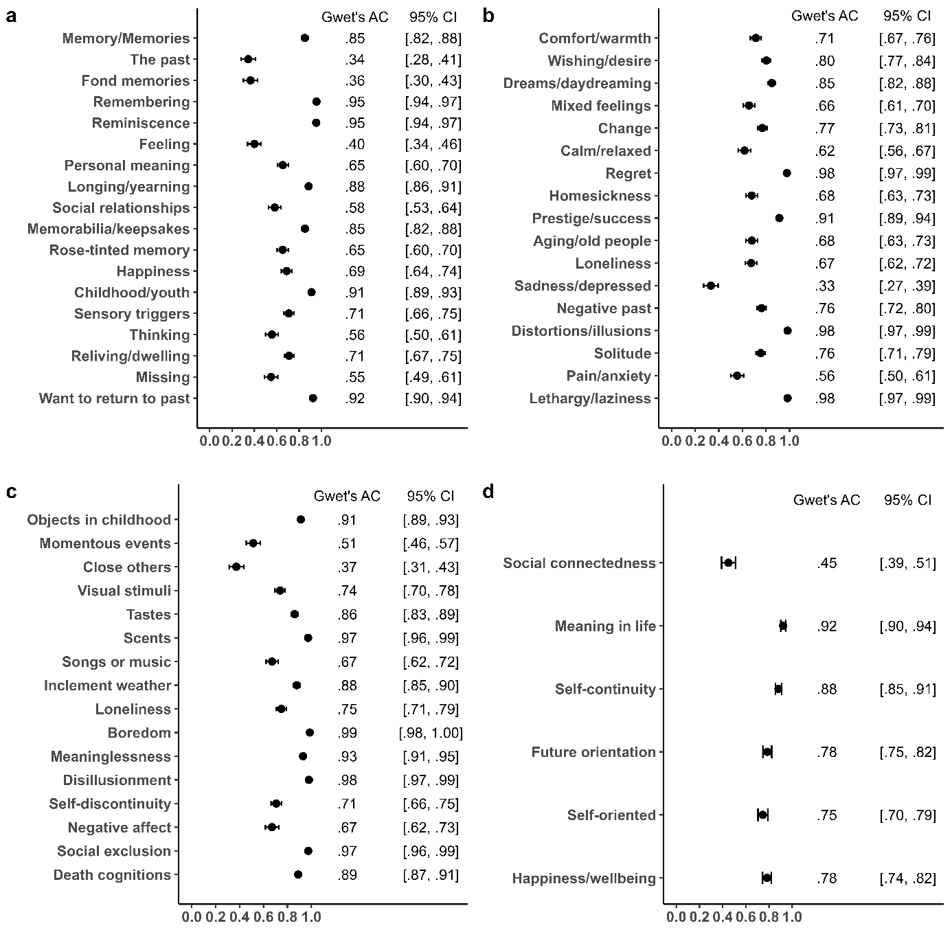

***Features of Nostalgia***

The average inter-rater reliabilities for the 18 central features and 17 peripheral features were substantial (.70 and .75, respectively; Figure 1). Each of the 600 nostalgic poems was characterized by at least one feature. We illustrate, in Table 3, the numbers of poems containing each feature and the rankings of the 35 prototype features. We calculated the rank of each feature in nostalgic poems based on its frequency. The average rank of central features was 14.17, and that of peripheral features was 22.00, showing that more central (than peripheral) features were detected in the nostalgic poems. Put otherwise, this finding validates that the selected 600 poems were indeed nostalgic.

Hepper et al. (2014) instructed students in 18 countries, including China, to rate the prototypicality of the 35 features of nostalgia. We display, in Table 3, the rank-order obtained by these researchers in their Chinese sample. We calculated the rank-order correlation to examine whether the ranking we identified in the poems was comparable to the one reported by Hepper and colleagues in their Chinese sample. It was, *r* = .37, *p* = .029. Further, central features of nostalgia were more common than peripheral ones (i.e., the average rank of central features was higher than of peripheral ones) across all dynasties, except the Han Dynasty (Figure 2).

**Figure 2**

*Average Rankings of Central and Peripheral Features of Nostalgia Across Dynasties*

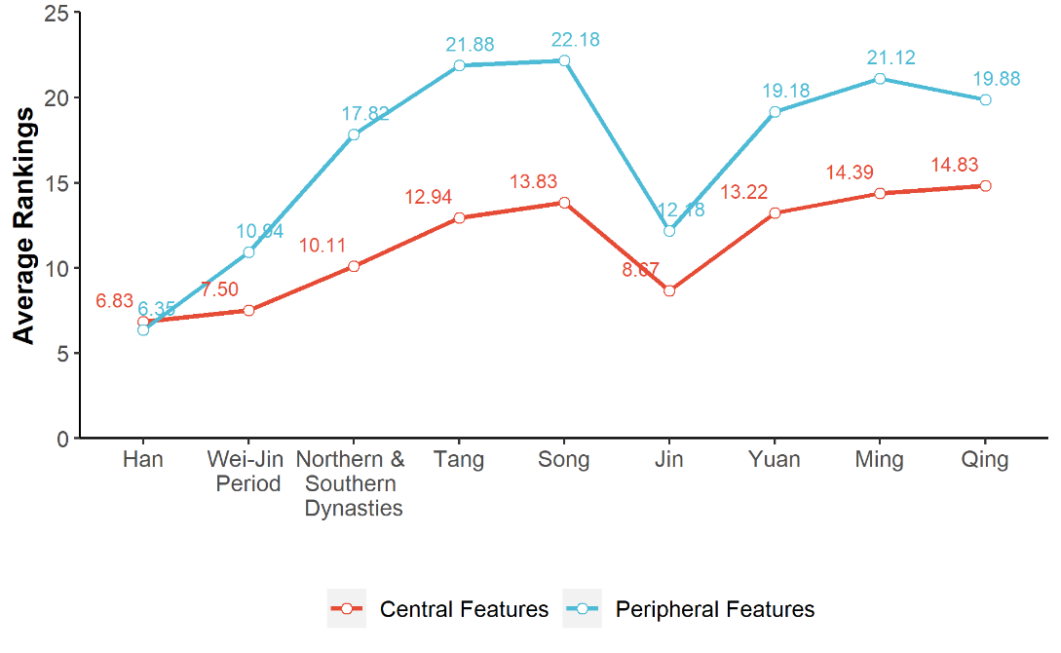

*Note*. The poems from certain dynasties do not encompass all 35 features that we coded. Consequently, the average rankings of the central and peripheral features in those dynasties do not add up to 35.

**Table 3**

*Prototypical Features of Nostalgia*

|  |  |  |  |  |  |  |  |  |  |
| --- | --- | --- | --- | --- | --- | --- | --- | --- | --- |
| Central Features | Poems Containing  the Feature | | Rank of the Feature | | Peripheral Features | Poems Containing  the Feature | | Rank of the Feature | |
| Frequency | Percentage | Poems | Hepper  et al. (2014) | Frequency | Percentage | Poems | Hepper  et al. (2014) |
| Memory/Memories | 573 | 95.50% | 3 | 3 | Comfort/warmth | 64 | 10.67% | 17 | 27 |
| The past | 469 | 78.17% | 6 | 2 | Wishing/desire | 23 | 3.83% | 26 | 33 |
| Fond memories | 167 | 27.83% | 10 | 8 | Dreams/daydreaming | 41 | 6.83% | 22 | 34 |
| Remembering | 593 | 98.83% | 1 | 6 | Mixed feelings | 43 | 7.17% | 20 | 22 |
| Reminiscence | 593 | 98.83% | 1 | 11 | Change | 36 | 6.00% | 23 | 18 |
| Feeling | 536 | 89.33% | 4 | 19 | Calm/relaxed | 82 | 13.67% | 14 | 28 |
| Personal meaning | 73 | 12.17% | 15 | 7 | Regret | 4 | 0.67% | 34 | 21 |
| Longing/yearning | 12 | 2.00% | 31 | 4 | Homesickness | 102 | 17.00% | 13 | 17 |
| Social relationships | 415 | 69.17% | 7 | 20 | Prestige/success | 14 | 2.33% | 30 | 25 |
| Memorabilia/keepsakes | 20 | 3.33% | 27 | 10 | Aging/old people | 131 | 21.83% | 11 | 23 |
| Rose-tinted memory | 61 | 10.17% | 18 | 12 | Loneliness | 105 | 17.50% | 12 | 26 |
| Happiness | 69 | 11.50% | 16 | 15 | Sadness/depressed | 380 | 63.33% | 8 | 30 |
| Childhood/youth | 27 | 4.50% | 24 | 9 | Negative past | 19 | 3.17% | 28 | 24 |
| Sensory triggers | 523 | 87.17% | 5 | 13 | Distortions/illusions | 0 | 0.00% | 35 | 29 |
| Thinking | 42 | 7.00% | 21 | 16 | Solitude | 47 | 7.83% | 19 | 31 |
| Reliving/dwelling | 25 | 4.17% | 25 | 5 | Pain/anxiety | 15 | 2.50% | 29 | 32 |
| Missing | 374 | 62.33% | 9 | 1 | Lethargy/laziness | 5 | 0.83% | 33 | 35 |
| Want to return to past | 11 | 1.83% | 32 | 14 |  |  |  |  |  |

***Triggers of Nostalgia***

The average inter-rater reliability for the 16 triggers was substantial (.80; Figure 1). Of the 600 poems, 589 were characterized by at least one trigger (Figure 3). We present example poems in Table 4. The most frequent trigger was *visual stimuli* (e.g., scenery of sky and mountain in *Pavilion of Xie Gong* by Li Bai), followed by *close others* (e.g., grandfather in *Changshanyu Palace* by Qian Long). Moreover, visual stimuli were the most frequent triggers across nearly all dynasties (Figure 4).

**Figure 3**

*Triggers of Nostalgia*

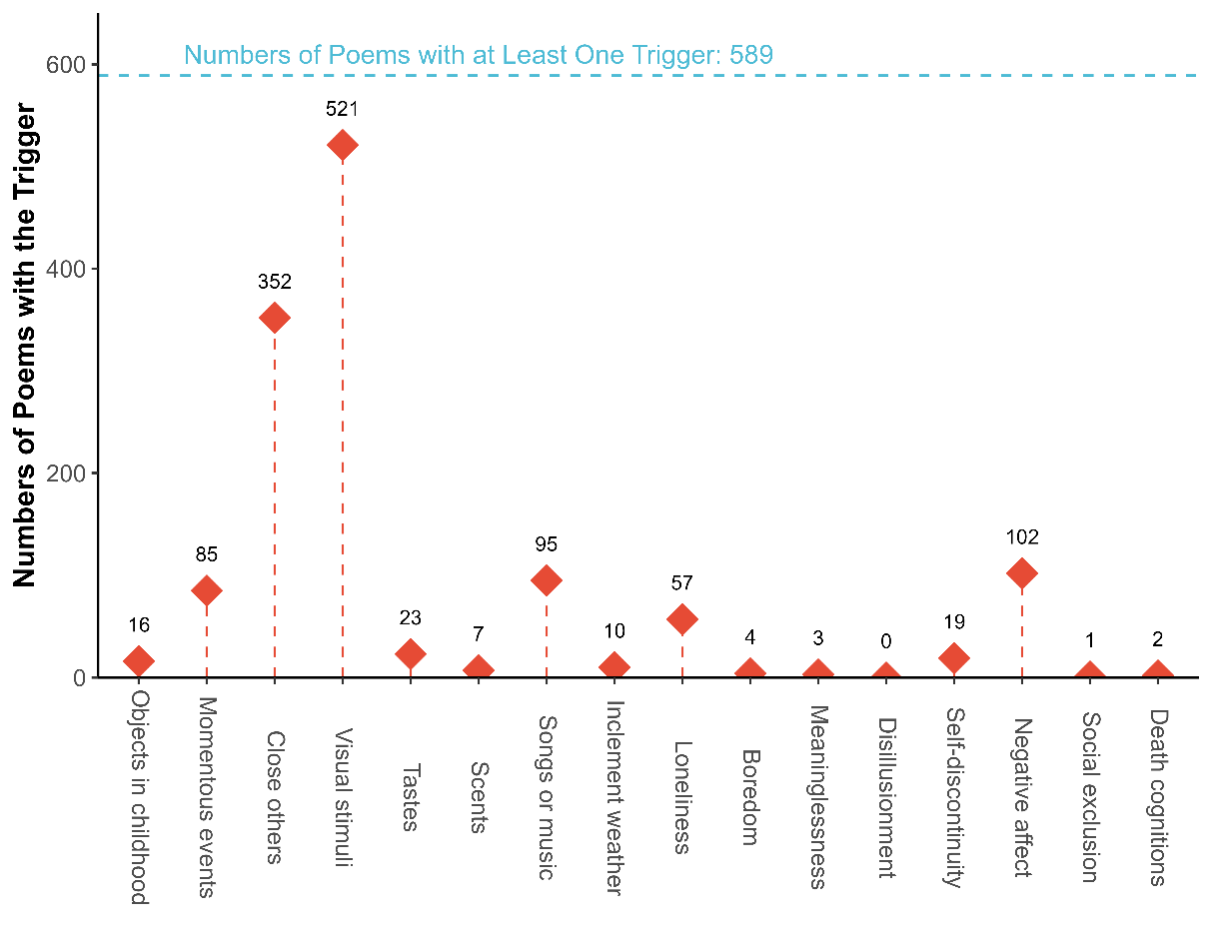

**Figure 4**

*Triggers of Nostalgia Across Dynasties*

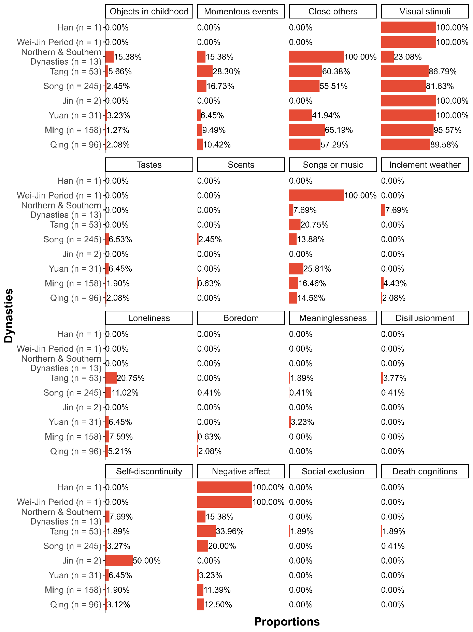

*Note*. Proportions represent the number of poems with each trigger in each dynasty divided by the total number of poems in that dynasty.

**Table 4**

*Example Poems Including Triggers, Benefits, and Valence of Nostalgia*

| Category | Title | Dynasty | Author | English Translation | Chinese Version |
| --- | --- | --- | --- | --- | --- |
| Trigger |  |  |  |  |  |
| Visual Stimuli | *Pavilion of*  *Xie Gong*  谢公亭 | Tang | Li Bai  李白  (701-762) | Xie’s Pavilion is a place of parting, /where the scenery invokes enduring sorrow. /Guests disperse under the azure sky and moon. /Mountains stand empty, and blue waters flow. /In the pond, flowers reflect the spring sun. /By the window, bamboo sings in the autumn night. /The present and the past come together. /Inscribe this poem to recall the journey gone by. | 谢公离别处，风景每生愁。  客散青天月，山空碧水流。  池花春映日，窗竹夜鸣秋。  今古一相接，长歌**怀旧**游。 |
| Close Others | *Changshanyu Palace*  常山峪行宫 | Qing | Qian Long  乾隆  (1771-1799) | In the reminiscence of youth, /I accompanied my grandfather. /I am currently on a tour, /staying by the edge of the Forbidden City. /Having received the gracious dew and cherished the sweet offerings, /I recall the past banquets with a heart full of gratitude. /The autumn wind mourns this day, /yet the pavilions and halls remain as in former years. /The bird’s melody carries a sense of nostalgia, /and the fragrance of flowers proudly displays its charm. /Everlasting admiration for the kindness from elder members, /a lifetime’s burden carried with gratitude. | 忆昔髫龄际，趋陪圣祖前。  于今巡幸至，驻跸故宫边。  湛露曾叨泽，含饴想侍筵。  秋风悲此日，轩屋尚当年。  鸟语如**怀旧**，花香故逞妍。  恩勤终古慕，承显一身肩。 |
| Benefit |  |  |  |  |  |
| Social Connectedness | *Reflections at the Taizhou Lodge*  泰州寓馆感兴 | Ming | Wang Jiankui  王渐逵  (1498-1559) | In the wild pond, June sees lotus blossoms in abundance, /the east wind whispering in solitude all day long. /The water rises peacefully within the tranquil abode, /while flowers bloom on Phoenix Isle. /Within this solitary dwelling, I cherish new dreams, /and in the Southern Mountains, I reminisce about past journeys. /Encounters form friendship, /providing solace to alleviate the long-staying worries. | 六月野荷浒，东风尽日幽。  水生安定宇，花发凤皇洲。  独馆怜新梦，南山**怀旧**游。  相逢总相识，聊以解淹留。 |
| Valence |  |  |  |  |  |
| Positive | *Occasionally Caught in the Fragrance of Books*  偶闻书香 | Ming | Shao Bao  邵宝  (1460-1527) | In youth, I cherished the fresh ink scent of new books, /unhesitatingly borrowing money to buy them. /Seated in my refined abode, /I nostalgically reflect on days gone by, /surrounded by ten thousand volumes within these hallowed walls. | 少爱新书楮墨香，  不辞书价借钱偿。  坐来精舍还**怀旧**，  海鹤诗中万卷堂。 |
| Negative | *Recalling the Old Days at Mianchi*  *in the Same Rhymer as Ziyou's Poem*  和子由渑池**怀旧** | Song | Su Shi  苏轼  (1037-1101) | To what can we liken human life? /Perhaps to a wild swan’s footprints on mud or snow. /By chance its claws imprint the mud. /Before it flies off at random, east or west. /The old monk is dead and a new pagoda built. /The old wall has crumbled, the poem we wrote on it gone. /Do you still remember this rugged mountain path? /The long way, or exhaustion and how the lame donkey brayed? | 人生到处知何似，应似飞鸿踏雪泥。  泥上偶然留指爪，鸿飞那复计东西。  老僧已死成新塔，坏壁无由见旧题。  往日崎岖还记否，路长人困蹇驴嘶。 |
| Both Positive and Negative | *In Response to Zhang Anguo’s Verse Carried by Guo Xialing*  次郭遐龄所携张安国诗韵 | Ming | Zhang Fu  章甫  (1045-1106) | Early in the morning, I host the distinguished guests, /each trying to detain the other at the door. /In times of sorrow, my heart remained resolute, /yet tears flowed uncontrollably when reminiscing about the past. /Wealth and honor may arrive late, /but literary brilliance flourishes with age. /Before the esteemed friends, my health is robust, /and there’s no need for noble titles. | 早作诸公客，过门竞挽留。  忧时心尚壮，**怀旧**涕难收。  富贵来何晚，文章老更优。  尊前身健在，不必问封侯。 |

***Benefits of Nostalgia***

The average inter-rater reliability for the six benefits was substantial (.76; Figure 1). Of the 600 poems, 397 were characterized by least one benefit (Figure 5). The most frequent benefit was *social connectedness* (e.g., building friendship in *Reflections at the Taizhou Lodge* by Wang Jiankui; see Table 4). Moreover, social connectedness was the most frequent benefit across dynasties (Figure 6).

**Figure 5**

*Psychological Benefits of Nostalgia*

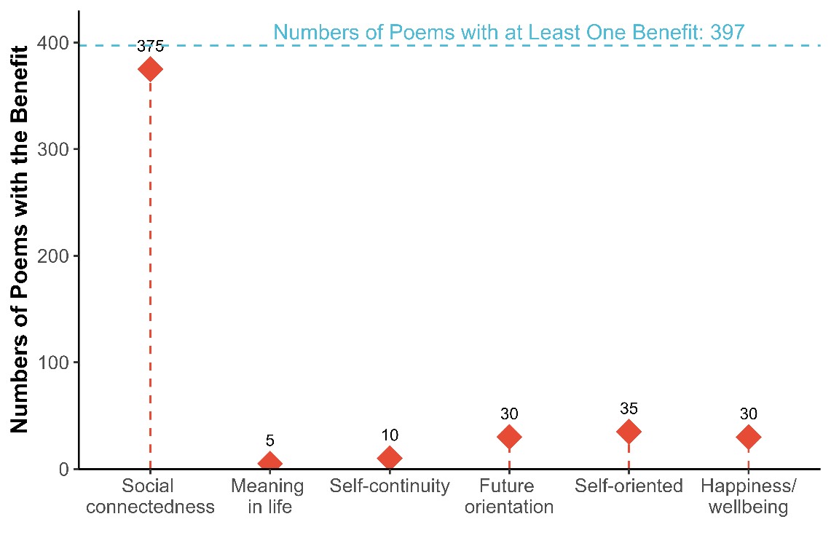

***Valence of Nostalgia***

Inter-rater reliability was moderate (.42, 95% CI [.37, .47]). Coders reached an agreement on 531 of the 600 poems. Poems containing positive affect (53.30%; e.g., feeling freedom and happiness in *Occasionally Caught in the Fragrance of Books*; Table 4) were the most common, followed by poems containing both positive and negative affect (36.53%; e.g., feeling sad about the society yet optimistic about life in *In Response to Zhang Anguo’s Verse Carried by Guo Xialing*), and negative affect (10.17%; e.g., viewing life as rugged and hard in *Recalling the Old Days at Mianchi in the Same Rhymer as Ziyou's Poem*). This pattern held across almost all dynasties (Figure 7).

**Figure 6**

*Psychological Benefits of Nostalgia Across Dynasties*

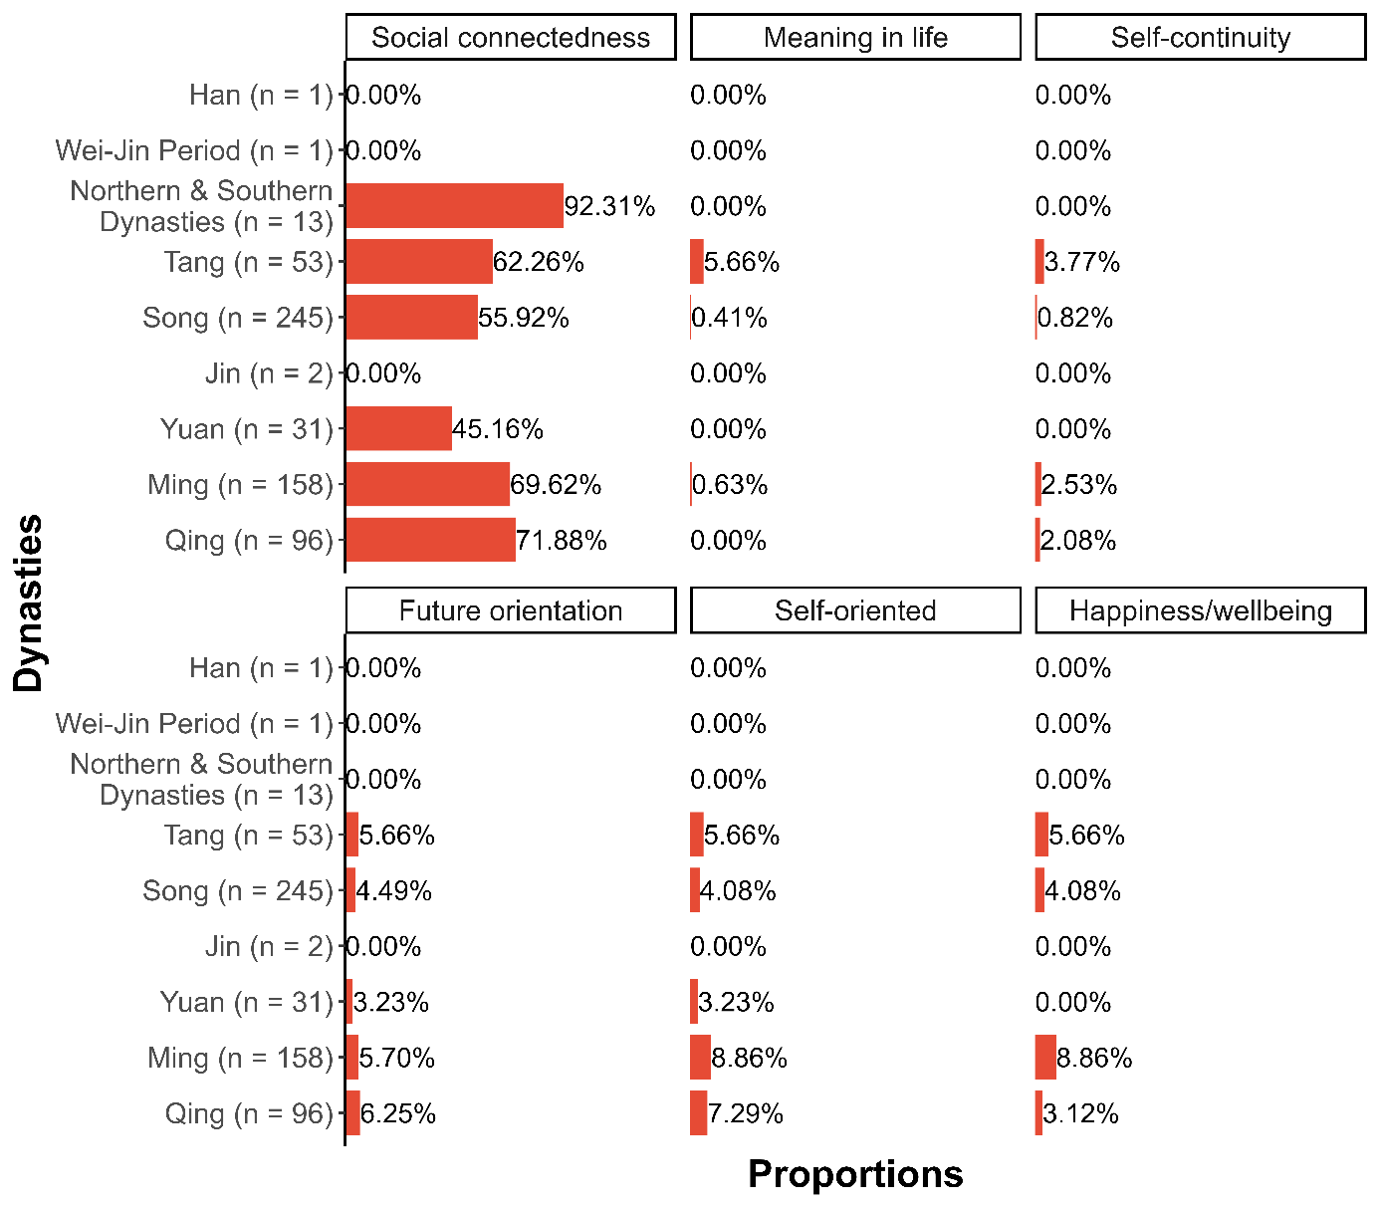

*Note*. Proportions represent the number of poems with each benefit in each dynasty divided by the total number of poems in that dynasty.

**Figure 7**

*Valence of Nostalgia Across Dynasties*

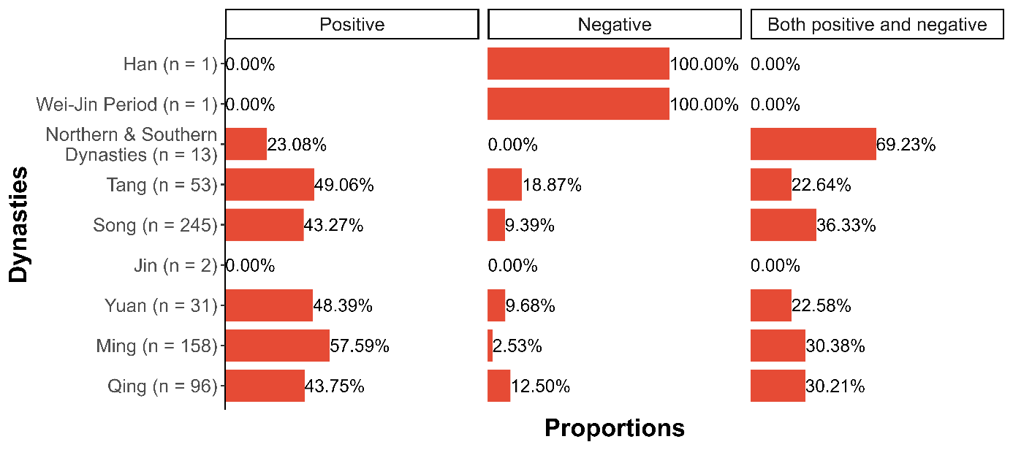

*Note*. Proportions represent the number of poems for each valence in each dynasty divided by the total number of poems in that dynasty.

**Discussion**

Can poetry add to psychological knowledge? We addressed this question by examining whether insights gained from an analysis of classical Chinese poetry are congruent with contemporary literature on nostalgia. Are perceptions and experiences of nostalgia – its features, valence triggers, benefits – diachronic? If nostalgia is a fundamental emotion (McCann, 1941), they ought to be.

To address this issue, we relied on Chinese culture, which possesses roughly 3,600 years of recorded history (with the oracle bone inscriptions of the Shang Dynasty [c. 1600—1046 B.C.] representing the earliest surviving written Chinese) and an uninterrupted, prominent poetic output. Specifically, we searched through databases of classical Chinese poetry comprising more than 600,000 poems. The earliest ones originated between 202 B.C. and 220 A.D. (Han Dynasty), and the latest ones between 1644 and 1911 A.D. (Qing Dynasty). We arrived at 600 nostalgic poems. We characterized them as nostalgic if they included the term ‘nostalgia’ (怀旧) and were judged by coders to express nostalgia. We then subjected them to content analyses.

**Summary of Findings**

The central features of nostalgia in classical Chinese poetry were similar to contemporary ones (Hepper et al., 2012, 2014). That is, nostalgia was perceived historically (i.e., across dynasties) as a past-oriented emotion referring fondly and longingly to meaningful experiences that entailed one’s childhood, close others, or keepsakes. The peripheral features of nostalgia (e.g., comfort, wishing, regret, solitude) were also seen as similar to contemporary ones. Further, the central nostalgia features were positively toned, whereas the peripheral ones were mixed—some were positively toned, some negatively toned. This finding is congruent with modern conceptualizations of nostalgia as a bittersweet, but more sweet than bitter, emotion, and so is the finding that, across dynasties, the poems’ valence was predominantly positive (Hepper et al., 2014; Sedikides & Wildschut, 2023; Wildschut et al., 2006).

The triggers of nostalgia resembled those identified by recent literature (Hepper et al., 2023; Sedikides, Wildschut, Routledge, Arndt, et al., 2015). The most frequent trigger was visual stimuli. A recurrent theme of the Chinese poetic tradition is nature imagery. For example, the theme of natural scenery (e.g., mountains, flowers, trees), accompanied by the poet’s reflection on it, is characteristic of poems in the Song Dynasty (Cai, 2008). Poets used natural scenery as a means to express emotion (Luo & Ye, 2011; Tang, 2014) and also sociality ([Wang](https://www.scirp.org/journal/articles.aspx?searchcode=Qiuping++Wang&searchfield=authors&page=1), 2017); indeed close others emerged in our analysis as the second most frequent trigger.

Finally, all six key psychological benefits conferred by nostalgia (i.e., social connectedness, meaning in life, self-continuity, future orientation, self-oriented, happiness/wellbeing) were identified across dynasties. Social connectedness was the leading benefit. This finding is congruent with a large body of literature pointing to the inherent sociality of the emotion (Batcho et al., 2008, 2023; Juhl & Biskas, 2023; Sedikides & Wildschut, 2019; Wildschut et al., 2006, 2010).

**Implications**

Our work contributes to the literature on the history of nostalgia. Capturing a construct’s historical context is essential to understanding its present-day functionality (Atari & Henrich, 2023). The history of nostalgia in the West is fragmented up to the late 17th century. Despite sporadic references to the its meaning – such as in Homer’s *Odyssey* (written late 8th or early 7th century B.C.), Hippocrates (460–370 B.C.), Julius Caesar (100–44 B.C.), Virgil’s *Aeneid* (written 29–19 B.C.), the Bible (Psalm 137:5–6; New American Standard Bible, 2020), the Anglo-Saxon epic poem *Beowulf* (written 975–1025 A.D.), and Monarchs’ attempts to associate themselves with the “good old days” during the Middle Ages (Young, 2011) – the construct laid dormant. It was invigorated in 1688 by a medical student at University of Basel, Johannes Hofer, who published his dissertation on the topic based on experiences of Swiss mercenaries plying their trade in France. Hofer took a grim view on nostalgia labeling it a medical disease symptomatic of anorexia, emotional lability, weeping, and suicide attempts. More than a century later, nostalgia had morphed into a psychiatric or psychosomatic disorder symptomatic of anxiety, sadness, loss of appetite, insomnia, and fever. In the 20th century, under the grip of psychodynamic approaches, nostalgia was regarded a clinical condition such as a “monomaniacal obsessive mental state causing intense unhappiness” or “mentally repressive compulsive disorder” (Fodor, 1950, p. 25). By the end of the 20th century, nostalgia still retained its negative reputation, although now it was considered an ailment afflicting a few, marginalized populations (e.g., soldiers, seafarers, immigrants). (For reviews, see: Batcho, 2013; Dodman, 2023; Sedikides et al., 2004.) In the 21st century, Hofer’s bleak view of nostalgia came to a halt, as it was challenged by a wealth of empirical findings.

In contrast to nostalgia’s Western history, the construct has been viewed positively across the ages in Chinese culture. The term, which first appeared in Chinese poetry toward the end of the Han Dynasty approximately 1,800 years ago, conveyed sentimental longing for the past, much as it does today. *Huái jiù* evidently experienced few fluctuations, if any, retaining its original positive meaning for over two millennia.

That the historical connotation of nostalgia is more positive in Chinese than Western culture is a call for more research on the topic, which could expand into other East Asian cultures, such as Japanese. For example, the Japanese word for nostalgia, *natsukashii*, appears to have more positive than negative meaning (Jacobsen, 2021). Text analyses of nostalgia’s history in that and other cultures can enrich the literature, as they might uncover ways in which the construct has been shaped by cultural values (e.g., respect for tradition and the past; Wang & Lin, 2009).

**Limitations and Future Directions**

We focused only on one form of literature, classical Chinese poetry. Researchers could analyze other forms of ancient Chinese literature, such as rhyme-prose (赋; Zhang, 2022). Extending the analytic repertoire has the potential to contribute a more complete picture of nostalgia’s history.

To manage the vast databases of classical Chinese poetry, we only retrieved poems that contained the term *huái jiù* and then asked coders to peruse those poems for nostalgic content. It is possible that we missed poems that expressed nostalgia in the absence of the term. Indeed, the nostalgia motif appeared in poems even prior to the Han Dynasty (202-220 BCE). For example, in *The Book of Poetry* (诗经, 1046-221 B.C.), a poem titled “Gathering Thorn-Fern (采薇)” ended with: “It was long ago when we left (昔我往矣) / Fresh willows swayed tenderly (杨柳依依) / And now we come back through (今我来思) / driving sleet tangled in snow (雨雪霏霏) / the road long and deathly slow (行道迟迟) / hunger dire and thirst worse (载渴载饥) / Grief has so slashed our hearts (我心伤悲) / no one could fathom our cries (莫知我哀)” (Hinton, 2010, p. 25). These lines do not contain the word *huái jiù*, but portray the hardship of army life in response to which soldiers feel yearning for their homeland and family. AI technology (e.g., large language models) may be suitable for a more comprehensive treatment of the topic (Frischlich et al., 2023). Alternatively, researchers could concentrate on exhaustively coding poems originating from a particular dynasty. The Tang Dynasty, for example, is a notable choice given that it is regarded as the zenith of traditional Chinese poetry in terms of literary influence and quality (Barnstone & Ping, 2010). Moreover, the overall number of recorded poems from this period is smaller compared to later dynasties such as the Song, Ming, and Qing,[1] making such a project more feasible.

**Concluding Remarks**

We implemented a historical examination of the construct nostalgia, analyzing ancient Chinese poetry. The results were revealing. Nostalgia has been perceived and experienced similarly by Chinese poets and presumably the public across time. The alignment of historical with contemporary conceptions of nostalgia reinforces the view that it is a fundamental human emotion.

**References**

Abeyta, A. A., Routledge, C., & Juhl, J. (2015). Looking back to move forward: Nostalgia as a psychological resource for promoting relationship goals and overcoming relationship challenges. *Journal of Personality and Social Psychology*, *109*(6), 1029–1044. <https://doi.org/10.1037/pspi0000036>

Abeyta, A., Routledge, C., Roylance, C., Wildschut, R. T., & Sedikides, C. (2015). Attachment-related avoidance and the social and agentic content of nostalgic memories. *Journal of Social and Personal Relationships, 32*(3), 406–413. <https://doi.org/10.1177/0265407514533770>

Atari, M., & Henrich, J. (2023). Historical psychology. *Current Directions in Psychological Science, 32*(2) 176–183. https://doi.org/10.1177/09637214221149737

Barnstone, T., & Ping, C. (2010). *The anchor book of Chinese poetry: From ancient to contemporary, the full 3000-year tradition*. Anchor.

Batcho, K. I. (2013). Nostalgia: The bittersweet history of a psychological concept. *History of Psychology*, *16*(3), 165–176. <https://doi.org/10.1037/a0032427>

Batcho, K. I. (2023). Nostalgia in literature and memoir. *Current Opinion in Psychology, 50*, Article 101557. <https://doi.org/10.1016/j.copsyc.2023.101557>

Batcho, K. I., DaRin, M. L., Nave, A. M., & Yaworsky, R. R. (2008). Nostalgia and identity in song lyrics. *Psychology of Aesthetics, Creativity, and the Arts*, *2*(4), 236–244. <https://doi.org/10.1037/1931-3896.2.4.236>

Cai, Z. (2008). *How to read Chinese poetry: A guided anthology*. Columbia University Press.

Cantor, N., & Mischel, W. (1977). Traits as prototypes: Effects on recognition memory. *Journal of Personality and Social Psychology, 35*(1), 38–48. <https://doi.org/10.1037/0022-3514.35.1.38>

Cheung, W. Y., Wildschut, T., Sedikides, C., Hepper, E. G., Arndt, J., & Vingerhoets, A. J. J. M. (2013). Back to the future: Nostalgia increases optimism. *Personality and Social Psychology Bulletin, 39*(11), 1484–1496. [https://doi.org/10.1177/0146167213499187](http://dx.doi.org/10.1177/0146167213499187)

Dang, J., Sedikides, C., Wildschut, T., & Liu, L. (2024). More than a barrier: Nostalgia inhibits, but also promotes, favorable responses to innovative technology. *Journal of Personality and Social Psychology*, *15*(3), 318–328. <https://doi.org/10.1037/pspa0000368>

Dodman, T. (2023). Nostalgia, and what it used to be. [*Current Opinion in Psychology*](https://www.sciencedirect.com/journal/current-opinion-in-psychology)*,* [*49*](https://www.sciencedirect.com/journal/current-opinion-in-psychology/vol/49/suppl/C), Article 101536. [https://doi.org/10.1016/j.copsyc.2022.10153](https://doi.org/10.1016/j.copsyc.2022.101536)

Evans, N. D., Reyes, J., Wildschut, T., Sedikides, C., & Fetterman, A. K. (2021). Mental transportation mediates nostalgia’s psychological benefits. *Cognition and Emotion, 35*(1), 84–95. https://doi.org/10.1080/02699931.2020.1806788

Fodor, N. (1950). Varieties of nostalgia. *Psychoanalytic Review, 37*, 25–38.

Frischlich, L., Clever, L., Wulf, T., Wildschut, T., & Sedikides, C. (2023). Populists’ reliance on nostalgia: A supervised machine learning approach. *International Journal of Communication, 17*, 2113–2137. <https://ijoc.org/index.php/ijoc/article/view/19063/4102>

Gregg, A. P., Hart, C. M., Sedikides, C., & Kumashiro, M. (2008). Lay conceptions of modesty: A prototype analysis. *Personality and Social Psychology Bulletin, 34*(7), 978–992. [https://doi.org/10.1177/0146167208316734](http://dx.doi.org/10.1177/0146167208316734)

Gwet, K. L. (2008). Computing inter-rater reliability and its variance in the presence of high agreement. *British Journal of Mathematical and Statistical Psychology*, *61*(1), 29–48*.* https://doi.org/10.1348/000711006x126600

Hepper, E. G., & Dennis, A. (2023). From rosy past to happy and flourishing present: Nostalgia as a resource for hedonic and eudaimonic wellbeing. *Current Opinion in Psychology, 49*, Article 101547. <https://doi.org/10.1016/j.copsyc.2022.101547>

Hepper, E. G., Ritchie, T. D., Sedikides, C., & Wildschut, T. (2012). Odyssey's end: Lay conceptions of nostalgia reflect its original homeric meaning. *Emotion*, *12*(1), 102–119. <https://doi.org/10.1037/a0025167>

Hepper, E. G., Sedikides, C., Wildschut, T., Cheung, W.-Y., Abakoumkin, G., Arikan, G., Aveyard, M., Baldursson, E. B., Bialobrzeska, O., Bouamama, S., Bouzaouech, I., Brambilla, M., Burger, A. M., Chen, S. X., Cisek, S., Nunes de Souza Neto, E., Demassosso, D., Gutiérrez, R. G., Gu, L., … Zengel, B. (2023). Pancultural nostalgia in action: Prevalence, triggers, and psychological functions of nostalgia across cultures. *Journal of Experimental Psychology: General*. Advance online publication. <https://doi.org/10.1037/xge0001521>

Hepper, E. G., Wildschut, T., Sedikides, C., Ritchie, T. D., Yung, Y., Hansen, N., Abakoumkin, G., Arikan, G., Cisek, S. Z., Demassosso, D. B., Gebauer, J. E., Gerber, J. M., González, R., Kusumi, T., Misra, G., Rusu, M., Ryan, O., Stephan, E., Vingerhoets, A. J. J. M., & Zhou, X. (2014). Pancultural nostalgia: Prototypical conceptions across cultures. *Emotion*, *14*(4), 733–747. <https://doi.org/10.1037/a0036790>

Hinton, D. (2010). *Classical Chinese poetry: An anthology*. Farrar, Straus and Giroux.

Hofer, J. (1934). Medical dissertation on nostalgia (C. K. Anspach, Trans.). *Bulletin of the History of Medicine*, 2, 376–391. (Original work published 1688)

Hogan, P. C. (2017). *Literature and emotion*. Routledge.

Holak, S. L., & Havlena, W. J. (1998). Feelings, fantasies, and memories: An examination of the emotional components of nostalgia. Journal of Business Research, 42(3), 217–226. <https://doi.org/10.1016/S0148-2963(97)00119-7>

Holbrook, M. B., & Schindler, R. (1996). Market segmentation based on age and attitude toward the past: Concepts, methods, and findings concerning nostalgic influences on customer tastes. *Journal of Business Research*, *37*(1), 27–39. http://doi.org/10.1016/0148-2963 (96)00023-9

Hong, E. K., Sedikides, C., & Wildschut, T. (2021). Nostalgia strengthens global self-continuity through holistic thinking. *Cognition and Emotion, 35*(4), 730–737. <https://doi.org/10.1080/02699931.2020.1862064>

Hong, E. K., Sedikides, C., & Wildschut, T. (2022). How does nostalgia conduce to global self-continuity? The roles of identity narrative, associative links, and stability. *Personality and Social Psychology Bulletin, 48*(5), 735–749. <https://doi.org/10.1177/01461672211024889>

Horowitz, L. M., French, R. P., & Anderson, C. A. (1982). The prototype of a lonely person. In L. A. Peplau & D. Perlman (Eds.), *Loneliness: A sourcebook of current theory, research and therapy* (pp. 183-205). Wiley.

Liu, H. (2015). *The literary mind and the carving of dragons*. The Chinese University of Hong Kong Press.

Jacobsen, M. H. (2021). *Intimations of nostalgia: Multidisciplinary explorations of an enduring emotion*. Bristol University Press.

Jiang, L. (2018). *A history of Western appreciation of English-translated Tang poetry*. Springer.

Juhl, J., & Biskas, M. (2023). Nostalgia: An impactful social emotion. *Current Opinion in Psychology*, *49*, Article 101545. <https://doi.org/10.1016/j.copsyc.2022.101545>

Kelley, N. J., Davis, W. E., Dang, J., Liu, L., Wildschut, T., & Sedikides, C. (2022). Nostalgia confers psychological wellbeing by increasing authenticity. *Journal of Experimental Social Psychology, 102*, Article 104379. <https://doi.org/10.1016/j.jesp.2022.104379>

Landis, J. R., & Koch, G. G. (1977). The measurement of observer agreement for categorical data*. Biometrics*, *33*(1), 159–174. <https://doi.org/10.2307/2529310>

Lasaleta, J. D., Sedikides, C., & Vohs, K. D. (2014). Nostalgia weakens the desire for money. *Journal of Consumer Research*, *41*(3), 713–729. <https://doi.org/10.1080/10.1086/677227>

Layous, K., & Kurtz, J. L. (2023). Nostalgia: A potential pathway to greater well-being. Current Opinion in Psychology, 49, Article 101548. <https://doi.org/10.1016/j.copsyc.2022.101548>

Leunissen, J., Wildschut, T., Sedikides, C., & Routledge, C. (2021). The hedonic character

of nostalgia: An integrative data analysis. *Emotion Review, 13*(2), 139–156。 <https://doi.org/10.1177/1754073920950455>

Li, C., Dang, J., Liu, L., Wei, C., & Liang, Y. (2023). The dark side of nostalgia: Yearning for the past fosters bribe‐taking. *British Journal of Social Psychology*, *62*(1), 503–520. <https://doi.org/10.1111/bjso.12582>

Liu, J. J. (1966). *The art of Chinese poetry*. University of Chicago Press.

Luo, Y., & Ye, Y. (2011). *A concise history of Chinese literature*. Brill.

Marchegiani, C., & Phau, I. (2010). Away from “unified nostalgia”: Conceptual differences of personal and historical nostalgia appeals in advertising. *Journal of Promotion Management*, *16*(1-2), 80–95. <https://doi.org/10.1080/10496490903572991>

McCann, W. H. (1941). Nostalgia: a review of the literature. Psychological Bulletin, 38(3), 165–182. <https://doi.org/10.1037/h0057354>

New American Standard Bible. (2020). Lockman.

Redhead, E. S., Wildschut, T., Oliver, A., Parker, M. O., Wood, A., & Sedikides, C. (2023). Nostalgia enhances route learning in a virtual environment. *Cognition and Emotion, 37*(4), 617–632. <https://doi.org/10.1080/02699931.2023.2185877>

Reid, C. A., Green, J. D., Buchmaier, S., McSween, D. K, Wildschut, T., & Sedikides, C. (2023). Food-evoked nostalgia. *Cognition and Emotion, 37*(1), 34–48. <https://doi.org/10.1080/02699931.2022.2142525>

Reid, C. A., Green, J. D., Wildschut, T., & Sedikides, C. (2015). Scent-evoked nostalgia. *Memory*, *23*(2), 157–166. <https://doi.org/10.1080/10.1080/09658211.2013.876048>

Rosch, E. (1978). Principles of categorization. In E. Rosch & B. B. Lloyd (Eds*.), Cognition and categorization* (pp. 27–48). Erlbaum.

Routledge, C., Arndt, J., Sedikides, C., & Wildschut, T. (2008). A blast from the past: The terror management function of nostalgia. *Journal of Experimental Social Psychology*, *44*(1), 132–140. <https://doi.org/10.1016/j.jesp.2006.11.001>

Routledge C., Arndt, J., Wildschut, T., Sedikides, C., Hart, C. M., Juhl, J., Vingerhoets, A. J. J. M., & Scholtz, W. (2011). The past makes the present meaningful: Nostalgia as an existential resource. *Journal of Personality and Social Psychology, 101*(3),638–652. [https://doi.org/10.1037/a0024292](http://dx.doi.org/10.1037/a0024292)

Routledge, C., Wildschut, T., Sedikides, C., Juhl, J., & Arndt, J. (2012). The power of the past: Nostalgia as a meaning-making resource. *Memory*, *20*(5), 452–460. https://doi.org/10.1080/ 09658211.2012.677452

Sedikides, C., Leunissen, J. M., & Wildschut, T. (2022). The psychological benefits of music-evoked nostalgia. *Psychology of Music, 50*(6), 2044–2062. <https://doi.org/10.1177/03057356211064641>

Sedikides, C., & Wildschut, T. (2018). Finding meaning in nostalgia. Review of General Psychology, 22(1), 48–61. https://doi.org/10.1037/gpr0000109

Sedikides, C., & Wildschut, T. (2019). The sociality of personal and collective nostalgia. *European Review of Social Psychology, 30*(1), 123–173. <https://doi.org/10.1080/10463283.2019.1630098>

Sedikides, C., & Wildschut, T. (2020). The motivational potency of nostalgia: The future is called yesterday. *Advances in Motivation Science, 7*, 75–111. <https://doi.org/10.1016/bs.adms.2019.05.001>

Sedikides, C., & Wildschut, T. (2022). Nostalgia across cultures. *Journal of Pacific Rim Psychology, 16*, 1–16. <https://doi.org/10.1177/18344909221091649>

Sedikides, C., & Wildschut, T. (2023). The psychological, social, and societal relevance of nostalgia. *Current Opinion in Psychology, 52*, Article 101609. <https://doi.org/10.1016/j.copsyc.2023.101609>

Sedikides, C., Wildschut, T., & Baden, D. (2004). Nostalgia: Conceptual issues and existential functions. In J. Greenberg, S. Koole, & T. Pyszczynski (Eds.), *Handbook of experimental existential psychology* (pp. 200–214). Guilford Press.

Sedikides, C., Wildschut, T., Cheung, W.-Y., Routledge, C., Hepper, E. G., Arndt, J., Vail, K., Zhou, X., Brackstone, K., & Vingerhoets, A. J. J. M. (2016). Nostalgia fosters self-continuity: Uncovering the mechanism (social connectedness) and the consequence (eudaimonic well-being). *Emotion, 16*(4), 524–539. <https://doi.org/10.1037/emo0000136>

Sedikides, C., Wildschut, T., Routledge, C., & Arndt, J. (2015). Nostalgia counteracts self-discontinuity and restores self-continuity. *European Journal of Social Psychology, 45*(1), 52–61. <https://doi.org/10.1002/ejsp.2073>

Sedikides, C., Wildschut, T., Routledge, C., Arndt, J., Hepper, E. G., & Zhou, X. (2015). To nostalgize: Mixing memory with affect and desire. *Advances in Experimental Social Psychology*, *51*, 189–273. <https://doi.org/10.1016/bs.aesp.2014.10.001>

Shanghai Lexicographical Publishing House. (2019, December). *Online version of Cihai*. Retrieved February 22, 2023, from <https://www.cihai.com.cn/search/words?q=%E6%80%80%E6%97%A7>

Stephan, E., Wildschut, T., Sedikides, C., Zhou, X., He, W., Routledge, C., Cheung, W., & Vingerhoets, A. J. J. M. (2014). The mnemonic mover: Nostalgia regulates avoidance and approach motivation. *Emotion*, *14*(3), 545–561. <https://doi.org/10.1037/a0035673>

Tang, Y. (2014). Translating across cultures: Yi jing and understanding Chinese poetry. *Intercultural Communication Studies*, *23*(1), 187–202.

The New Oxford Dictionary of English. (1998). (J. Pearsall, Ed.). Oxford University Press.

Van Tilburg, W. A. P., Igou, E. R., & Sedikides, C. (2013). In search of meaningfulness: Nostalgia as an antidote to boredom. *Emotion*, *13*(3), 450–461. <https://doi.org/10.1037/a0030442>

Van Tilburg, W. A. P., Sedikides, C., & Wildschut, T. (2018). Adverse weather evokes nostalgia. *Personality and Social Psychology Bulletin*, *44*(7), 984–995. https://doi.org/10.1177/ 0146167218756030

Wang, B. (2017). *Classical Chinese poetry in Singapore: Witnesses to social and cultural transformations in the Chinese community*. Lexington Books.

Wang, C., & Lin, X. (2009). Migration of Chinese consumption values: Traditions, modernization, and cultural renaissance. *Journal of Business Ethics*, *88*(S3), 399–409. <https://doi.org/10.1007/s10551-009-0308-5>

[Wang](https://www.scirp.org/journal/articles.aspx?searchcode=Qiuping++Wang&searchfield=authors&page=1), Q. (2017). The expressive forms of natural imagery in Chinese poetry. [*Advances in Literary Study*](https://www.scirp.org/journal/journalarticles.aspx?journalid=2317)*, 5*(1), 17–21. https://doi.org/[10.4236/als.2017.51002](http://dx.doi.org/10.4236/als.2017.51002)

Watson, B. (1987). *The Columbia book of Chinese poetry: from early times to the thirteenth century*. Columbia University Press.

Wildschut, T., & Sedikides, C. (2022). Psychology and nostalgia: Towards a functional approach. In M. H. Jacobsen (Ed.), *Intimations of nostalgia: Multidisciplinary explorations of an enduring emotion* (pp. 110–128). Bristol University Press.

Wildschut, T., Sedikides, C., Arndt, J., & Routledge, C. (2006). Nostalgia: content, triggers, functions. *Journal of Personality and Social Psychology*, *91*(5), 975–993. <https://doi.org/10.1037/0022-3514.91.5.975>

Wildschut, T., Sedikides, C., Routledge, C., Arndt, J., & Cordaro, P. (2010). Nostalgia as a repository of social connectedness: The role of attachment-related avoidance. *Journal of Personality and Social Psychology*, *98*(4), 573–586. <https://doi.org/10.1037/a0017597>

Xia, C. (2021). Poetry and emotion in classical Chinese literature. In *The Routledge Handbook of Chinese Studies* (pp. 289–303). Routledge.

Xiang, S. (2015). The irretrievability of the past: Nostalgia in Chinese literature from Tang–Song poetry to Ming–Qing san-wen. *International Communication of Chinese Culture*, *2*(3), 205–222. <https://doi.org/10.1007/s40636-015-0027-9>

Young, F. (2011). *T*[*he many-headed monster*](https://manyheadedmonster.com/)*: The history of 'the unruly sort of clowns' and other early modern peculiarities*. Retrieved December 15, 2023 from https://manyheadedmonster.com/2020/02/11/not-what-it-used-to-be-nostalgia-in-early-modern-england/

Zhang, L. (2022). *A history of Chinese literature*. Routledge.

Zhao, J. R. (2009). *怀旧: 永恒的文化乡愁* [Nostalgia: Eternal cultural homesickness]. The Commercial Press.

Zhou, X., Sedikides, C., Mo. T., Li, W., Hong, E. K., & Wildschut, T. (2022). The restorative power of nostalgia: Thwarting loneliness by raising happiness during the COVID-19 pandemic. *Social Psychological and Personality Science, 13*(4), 803–815. <https://doi.org/10.17605/OSF.IO/U5RJB>

Zhou, X., Sedikides, C., Wildschut, T., & Gao, D. G. (2008). Counteracting loneliness: On the restorative function of nostalgia. *Psychological Science*, *19*(10), 1023–1029. https://doi.org/ 10.1111/j.1467-9280.2008.02194.x

Zhou, X., Van Tilburg, W. A. P., Mei, D., Wildschut, T., & Sedikides, C. (2019). Hungering for the past: Nostalgic food labels increase purchase intentions and actual consumption. *Appetite*, *140*, 151–158. <https://doi.org/10.1016/j.appet.2019.05.007>

Zhou, X., Wildschut, T., Sedikides, C., Shi, K., & Feng, C. (2012). Nostalgia: The gift that keeps on giving. *Journal of Consumer Research*, *39*(1), 39–50. <https://doi.org/10.1086/662199>

1. According to one of the databases used in our study (https://sou-yun.cn/), there are 57,033 recorded poems from the Tang dynasty, compared to over 287,000 from the Song, 398,000 from the Ming, and 388,000 from the Qing.