CONSENT FORM
Study title: Does Accounting Change Destroy the Common Good? Evidence from a Comparative Case Study
Researcher name: Shahenda Shehata
ERGO number: 78534
Participant Identification Number (if applicable):
Please initial the box(es) if you agree with the statement(s):
I have read and understood the information sheet and have had the opportunity to ask questions about the study.
I agree to take part in this research project and agree for my data to be used for the purpose of this study.
I understand my participation is voluntary and I may withdraw (at any time except after submission of dissertation) for any reason without my participation rights being affected.
I understand that I may be quoted directly in reports of the research but that I will not be directly identified (e.g. that my name will not be used).
I understand that taking part in the study involves audio recording which will be transcribed and then destroyed for the purposes set out in the participation information sheet.
Name of participant (print name) …………………………………………………………………………
Signature of participant……………………………………………………………………………………….
Date ……………………………………………………………………………………………………….
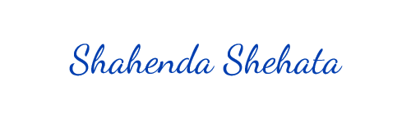
Name of researcher (print name) Shahenda Shehata
Signature of researcher
Date 17/11/2022

