**Title**

High burden of respiratory allergy in children warrants early identification and treatment with allergen immunotherapy

**Authors**

Eckard Hamelmann,1 Péter Csonka,2 Graham Roberts,3 Christian Vogelberg,4 Ewa Cichocka-Jarosz,5 Jocelyne Just,6 Miloš Jeseňák7

**Affiliations**

1. Department of Paediatrics, Children's Center Bethel, University Bielefeld, Bielefeld, Germany.

2. Tampere Center for Child, Adolescent and Maternal Health Research, Tampere University and Tampere University Hospital, Tampere, Finland; Terveystalo Healthcare Oy, Tampere, Finland.

3. The David Hide Asthma and Allergy Research Centre, St Mary’s Hospital, Newport, Isle of Wight, UK; NIHR Biomedical Research Centre, University Hospital Southampton NHS Foundation Trust, Southampton, UK; University of Southampton Faculty of Medicine and University Hospital Southampton, Southampton, UK.

4. Department of Pediatrics, Faculty of Medicine and University Hospital Carl Gustav Carus, Technische Universität Dresden, Dresden, Germany

5. Department of Pediatrics, Jagiellonian University Medical College, Kraków, Poland.

6. Unité d’Allergologie, Hôpital Américain de Paris, Neuilly sur Seine, France, Sorbonne Université, Paris, France; CRESS, Inserm, INRAE, HERA Team, Université Paris Cité.

7. Department of Pediatrics and Department of Clinical Immunology and Allergology, Jessenius Faculty of Medicine in Martin, Comenius University in Bratislava, University Hospital in Martin, Martin, Slovakia.

**Corresponding author**

Name: Eckard Hamelmann

Address: Department of Paediatrics, Children's Center Bethel, University Bielefeld, Bielefeld, Germany

E-mail: eckard.hamelmann@evkb.de

ORCID ID: 0000-0002-2996-8248

**Word count:** ~3,060 [maximum 3,000 words]

**Figures/tables:** 5 [no table/figure limit is stated; the journal encourages figures/tables]

**References:** 62 [maximum 40 references]

### ABSTRACT

Respiratory allergy is a chronic progressive disease, which often begins in childhood and most commonly affects the upper airways, as allergic rhinitis, and lower airways, as asthma. Children with upper respiratory allergy often suffer from allergic multimorbidity (e.g., co-existing asthma and/or atopic dermatitis) and other comorbidities ranging from gastrointestinal disorders (e.g., food allergy) to emotional/mental health disorders (e.g., anxiety). Consequently, the disease burden is considerable and has a profound negative impact on a child’s daily life through sleep disturbances, limitations in daily activities, and impaired school performance.

The true prevalence and associated burden of upper respiratory allergy is most likely underestimated in children. Misdiagnosis and inadequate management can influence the future potential of children and, therefore, early identification of upper respiratory allergy is important to reduce the disease burden, lower the risk of disease progression, and reduce the development of additional comorbidities. A window of opportunity for halting disease progression exists, primarily, for children in early stages of allergic disease. This review provides recommendations on the diagnosis and treatment of children with upper respiratory allergy and offers advice on how to identify children with a high burden of disease who would benefit from early intervention.

Allergen immunotherapy (AIT) is the only causal treatment for respiratory allergy. Unlike symptom-relieving medications, AIT has the potential to modify the underlying cause of allergy and prevent disease progression. In clinical practice, AIT treatment could be considered earlier in the disease course in eligible children, to achieve long-term symptom control and disease modification.

**Keywords**

Allergy and immunology; paediatrics; primary health care; respiratory medicine; therapeutics

### INTRODUCTION

#### The epidemiology of respiratory allergy in children

Respiratory allergy refers to an intolerance of the immune system in sensitised individuals to otherwise harmless inhaled substances (allergens) present in the environment.1,2 The airway inflammation associated with respiratory allergy can affect the upper airways (as allergic rhinitis [AR] or allergic rhinoconjunctivitis [ARC]) as well as the lower airways (as asthma).1 The most common respiratory allergens for AR include grass, tree and ragweed pollen, house dust mite (HDM), and animal dander.2 Respiratory allergy is a highly prevalent disease and evidence suggests that the prevalence is increasing in children,3 although, recent trends show variation between regions.4 Children suffering from respiratory allergy often have co-existing conditions, as illustrated by the EuroPrevall-iFAAM birth cohort study – of 5,572 school children (aged 6–10 years), 13.3% had AR, 8.1% had asthma, 12.0% had eczema, and 7.0% had allergic multimorbidity (at least two allergic diseases).5 Within respiratory allergy, AR is considered an important risk factor for the development of asthma; childhood AR is associated with an up to 7-fold increased risk of developing asthma (versus no childhood AR).6,7 Indeed, it is estimated that 49.5% of children with AR also have asthma,8 and more than 60% of people with asthma diagnosed in childhood have concomitant AR.9

#### The progression of respiratory allergy in children

Respiratory allergy is a chronic progressive disease that often begins in childhood. The concept of an ‘atopic march’ was originally proposed to describe the sequential progression of allergic disease from atopic dermatitis (AD) and/or food allergy in infancy, to asthma and/or AR in childhood and adolescence.10 This model was based on evidence indicating that AD, asthma, and AR have common genetic predispositions (i.e., atopy) and environmental risk factors, as well as shared pathophysiology with dysregulation of the immune system and skin barrier defects.11 Studies have shown that children with comorbid manifestations in early childhood (e.g., eczema, wheezing, food allergy, etc.) have an increased risk of developing AR and asthma later in childhood.12 For example, the risk of developing AR is increased by 4-fold in children with early-onset AD (<1 year of age) versus no AD; the corresponding increased risk for developing asthma is 3.4-fold.13 However, symptom development and progression of allergic diseases in children can be heterogenous in clinical practice, with different disease profiles leading to allergic multimorbidity in children.14

Regardless of the exact course of progression, various factors play a role in the development of respiratory allergy. Skin barrier defects are central to the development of AD, and enhancing respiratory allergen sensitisation by promoting the penetration of antigens (i.e., allergens) and activation of immune responses.11,15 The epithelial barriers, such as the skin and the respiratory mucosa, can be damaged by environmental pollutants, resulting in local inflammation and further barrier disruption.10 Genetic predisposition is an additional important risk factor for allergy development (including multimorbidity) in children.16

#### The burden of upper respiratory allergy in children

Upper respiratory allergy has a considerable negative impact on many aspects of a child’s quality of life (e.g., sleep, social/physical engagement, performance at school).17,18 This burden of disease can be increased by the presence of comorbid allergic diseases, such as AD and asthma, which are strongly correlated with AR.18 The true prevalence and associated burden of upper respiratory allergy is most likely underestimated in children; common colds are frequent and often accompanied by symptoms similar to AR, meaning that the underlying AR may be ignored or misdiagnosed.2,19,20 Self-management of AR symptoms, using over-the-counter medications (e.g., antihistamine and intranasal corticosteroids) without guidance from a medical professional, not only results in the risk of side effects (e.g., rhinitis medicamentosa2), but also represents a missed opportunity for a specific diagnosis, adequate treatment to control the symptoms, and referral to specialists if necessary.21,22 Altogether, the burden of upper respiratory allergy and inadequate management can influence a child’s future development.

Early identification and treatment of upper respiratory allergy in children is important to ameliorate the burden of disease, lower the risk of disease progression (especially from AR to asthma), and reduce the development of additional comorbidities. This review: 1) summarises the clinical evidence for the burden of upper respiratory allergy in children (identified through targeted literature searching); 2) highlights the value of timely and early management; 3) emphasises the importance of clinical management for upper respiratory allergy through early identification of children with a high disease burden and highlighting the clinical relevance of applying AIT in the treatment approach.

### THE NEGATIVE IMPACT OF UPPER RESPIRATORY ALLERGY ON QUALITY OF LIFE

Figure 1 illustrates the many ways in which upper respiratory allergy can affect children’s quality of life.

* + - 1. **Comorbidities**

AR is a chronic inflammatory disease of the upper airways. Consequently, a range of different comorbidities impacting multiple organ systems can develop in children with upper respiratory allergy (Figure 2), all of which can further increase the burden of disease.17,19,23,24

AD and asthma, in particular, are among the most common comorbidities, reported in ≥20% of children with AR.8,23 Evidence suggests that AR can be underdiagnosed in children with asthma27 and that AR can impact the severity and control of asthma.28 Consequently, accurate diagnosis and appropriate treatment of AR in children are important factors. Upper airway problems are also common in children with AR.19 In a paediatric survey, sinus problems were reported for 43% of children with AR and 18% underwent removal of tonsils and/or adenoids.17 In addition, children with AR (triggered by pollen, in particular) can be affected by pollen–food allergy syndrome, which causes oral pruritus upon ingestion of specific food items (e.g., apples).19 The wide-range of other medical conditions that can develop in children with AR emphasises the importance of assessing comorbidities in these individuals.

#### Restriction of daily activities

The nasal and ocular symptoms of upper respiratory allergy affect many aspects of typical daily life for children. For example, limitations in outdoor activities, playing with friends, and in organised sporting activities are approximately 3–5 times more frequent in children with respiratory allergy than in children without respiratory allergy.17 Furthermore, allergic children show a lower preference for participating in certain activities (physical, social, skill-based, etc.) than their non-allergic peers.29 Since AR is often associated with other atopic diseases,23 such as AD and/or asthma, children may also experience activity restrictions and social isolation driven by these comorbidities.30,31

#### Sleep disturbance

Nasal congestion, which often occurs in upper respiratory allergy, is a common cause of mouth breathing that results in snoring in allergic children.17 Mouth breathing may lead to dental malocclusion, which is increased in children with upper respiratory tract disorders, such as AR and sinusitis.32 Furthermore, AR is prevalent in children with sleep-disordered breathing (e.g., obstructive sleep apnoea).33 Other sleep disturbances include, difficulty falling asleep, reduced duration of sleep, nocturnal awakening, and poor sleep quality.17,18 Sleep problems have been reported among the main reasons for seeking medical care in 65.8% of children with AR triggered by HDM.34 Sleep problems can act as a mediator between allergic disease and psychological distress, highlighting the importance of assessing sleep health in children.35

#### Cognitive and learning impairment

The negative effect of upper respiratory allergy on sleep can cause daytime fatigue which, subsequently, impacts concentration and cognitive functioning.17,36 Studies have shown that children with allergies can experience impaired performance at school and difficulties with learning,17,37 and that the learning impairment is worse in children with poor symptom control.18 Learning can also be negatively impacted by the use of sedating symptom-relieving medication.37

#### School absenteeism and reduced productivity

The AR symptoms and associated sleep disruptions can lead to missed school days. One study reported that 32% of children with AR were absent from school at least once per month because they were unwell versus 11% of children without AR.18 Even when children are in school, AR symptoms can impair their productivity,17,18 which can have implications for peer relationships and future employment trajectories.38 Furthermore, students (aged 15‒17 years) with seasonal upper respiratory allergy showed higher odds (almost 1.5-fold) of dropping one or more grades between the winter and summer examinations if they were experiencing allergic symptoms during the summer assessments than students with unchanged/improved grades.37

#### Increased risk of infections

Based on insights into the mechanisms causing allergy,39 respiratory allergy is associated with impairment of the airway epithelial barrier function allowing allergens, bacteria, toxins, and viruses to penetrate the airways and cause respiratory infections. Consequently, the occurrence of frequent and prolonged upper respiratory tract infections (of rhinovirus aetiology or respiratory syncytial virus, in particular) may be a potential indicator of respiratory allergy in childhood. An epidemiological study has shown that atopic children were more susceptible to viral respiratory infections than non-atopic children with the highest susceptibility in atopic children aged 2–5 years.40 Children with AR can also be affected by other infections, such as bronchitis, pneumonia, and otitis media.41

**Increased risk of hospitalisation**

Since AR and asthma often co-exist in children, asthma exacerbation is a common cause of hospital admission in children with AR, and can be triggered by exposure to natural allergens such as grass and birch pollen,42,43 and to viruses.42 Children with asthma and comorbid AR are almost 3-fold more likely to have poor asthma control than children without comorbid AR.44 In a population-based cohort study of more than 9,000 children with asthma, children with comorbid AR incurred higher prescription costs, attended more general practitioner appointments, and experienced more hospitalisations for asthma than children without AR.45

#### Impact on mental and emotional health

The quality-of-life burden of upper respiratory allergy in children can also negatively impact mental health. Children with allergic multimorbidity experience more emotional problems, including poorer emotional health, compared to children without allergic diseases.18,46 In a paediatric survey among 6-15 years old children, having AR was associated with 2.14 days of poor emotional health in the previous month, compared with 0.62 days for not having AR.18 In addition, a causal role of AR in the development of depressive mood has been demonstrated in children and pre-adolescents;25,47 the presence of anxiety was also associated with depressed mood in pre-adolescents.25

#### Developmental and behavioural impairment

Evidence suggests that children with allergic diseases have a higher level of hyperactivity and conduct problems than children without these diseases.46 In addition, atopic disease in childhood (especially allergic multimorbidity) has been associated with an increased risk of developing autistic spectrum disorder and attention-deficit hyperactivity disorder.26 Both genetic and inflammatory mechanisms have been suggested to play a role in the development of behavioural impairments in children with respiratory allergy.26

### REDUCING THE BURDEN OF DISEASE – THE IMPORTANCE OF MANAGING UPPER RESPIRATORY ALLERGY EARLY IN LIFE

With the aim of reducing the burden of disease in children, early diagnosis and intervention is needed to achieve optimal symptom control, as well as to prevent further disease progression.48,49 It has been proposed that a window of opportunity for preventing disease progression and reducing the burden of disease may exist, especially in children at an early stage of allergic disease.49 Key considerations for the diagnosis and management of upper respiratory allergy in children are summarised in Box 1.

#### Diagnosis

A diagnosis of upper respiratory allergy in children is based on:20,24

* a clinical history of recurrent upper airway symptoms in association with allergen exposure (seasonal and/or perennial)
* sensitisation to the suspected allergen is confirmed by the results of appropriate diagnostic testing via skin prick tests and/or testing for allergen-specific immunoglobulin E (IgE) using a blood sample
* supported by findings from physical examination (note: abnormalities may not always be present, e.g., outside the pollen season)

Pollen from grass and trees (especially birch), HDM, and animal dander are among the most common respiratory allergens for allergic children, and can vary according to geographical location (e.g., pollen).48,52 Diagnostic testing should, therefore, consider the most prevalent allergens (seasonal and perennial) in the local area, to identify the causal allergen(s).48

#### Initial treatment

International guidelines and expert opinions recommend antihistamines and/or intranasal corticosteroids, or a fixed combination of both, for first-line treatment of children with upper respiratory allergy;19,20,48,50 these medications provide short-term symptomatic relief only.20,48

#### Allergen immunotherapy

Allergen immunotherapy (AIT) may be considered for children who continue to experience burdensome symptoms that impact quality of life despite regular use of symptom-relieving pharmacotherapy,48 and/or children who experience side effects of current medications. Currently, AIT is the only treatment for respiratory allergy that targets the underlying cause of allergic disease by providing repeated standardised doses of relevant allergens.48 Therefore, AIT not only alleviates symptoms through the induction of immunological tolerance to the causative allergen, but also has the potential to halt the progression of allergic disease (e.g., prevents worsening of symptoms, new sensitisations, and asthma onset).20,48,53 According to guidelines from the European Academy of Allergy and Clinical Immunology (EAACI), a 3-year course of continuous AIT is recommended to achieve long-term symptom control and disease-modifying effects in children with respiratory allergy.19,48 Given the potential for long-term benefits, guidelines suggest that AIT may also be considered in children at early stages of allergic disease, if they wish to take advantage of its ability to alter the natural course of disease.48 Furthermore, AIT may have the added benefit of improving airway epithelial barrier function by reducing the risk of respiratory tract infections requiring antibiotics.41,54

*The growing evidence for allergen immunotherapy in children with upper respiratory allergy*

There is robust and growing evidence from randomised, placebo-controlled trials and real-world evidence studies confirming the efficacy and safety of AIT in children and adolescents with upper respiratory allergy.23,48,55 The clinical evidence for SCIT and SLIT-drops in children has been obtained from relatively small, and old, studies.56 In comparison, large-scale clinical trials of AIT in children and/or adolescents have confirmed the efficacy and safety of SLIT-tablets for AR due to grass (5–12 years) and ragweed pollen (5–17 years), and to HDM (12–17 years).48,57 Ideally, AIT should be initiated early in the disease course in children with AR, and multiple factors should be considered when making the treatment decision: age of the child (aged ≥5 years); causative allergen; severity of symptoms and their impact on daily life; duration of disease and previous treatment with symptom-relieving medication; and existing comorbidities.48,51

Although AIT has been demonstrated to be efficacious and well-tolerated in children, there remains a large proportion of children suffering from upper respiratory allergy,48 worldwide,58 indicating that AIT is still underused in the paediatric population.41 A real-life study has shown that, in children, AIT is often introduced late in the disease course when AR is considerably impacted by comorbidities.23 Restricted access to AIT, reimbursement challenges, and a lack of agreed referral pathways between primary and specialist care, may partly account for the delayed and limited use of AIT.59 Additionally, an Italian questionnaire-based study has reported insufficient knowledge, among paediatricians, of the positioning of AIT in treatment guidelines; approximately half perceive AIT as an adjunctive treatment when symptom-relieving treatment fails.60 Consequently, to ensure timely access to AIT for eligible children, it is essential to encourage the early identification of children with a high burden of disease, and to educate clinicians, children, and their caregivers about the available treatment options. Ideally, AIT initiation should occur prior to the development of comorbidities, such as asthma, in high-risk children with AR (e.g., children with allergic manifestations in early childhood and a parental history of allergy/asthma). However, children with AR and well-controlled asthma can also be considered for treatment with AIT, in light of the evidence showing a reduction in asthma symptoms and asthma medications, in addition to the clinical benefits for AR,48 as can children with partially-controlled asthma.

### EARLY IDENTIFICATION OF CHILDREN WITH A HIGH BURDEN OF DISEASE

Clinicians should consider a range of factors when evaluating the burden of upper respiratory allergy in children (Figure 3). Together with questions addressing the type and severity of symptoms, asking for general information about symptom-related restrictions on the child’s daily life (on sleep, activities, etc.) is important to establish a full picture of the disease burden. Encouraging children and/or their caregivers to document symptoms in a diary can considerably aid the process of information-gathering.

Poor symptom control negatively impacts a child’s quality of life.18 Therefore, in clinical practice, early identification of children with a high burden of upper respiratory allergy is important to: 1) obtain a timely diagnosis; 2) identify the causal allergen and provide optimal management with symptom-relieving medication; 3) to consider AIT earlier in the disease course to relieve the burden and provide long-term and disease-modifying effects.48,49

### CONCLUSIONS

Upper respiratory allergy can significantly affect children’s lives,17,18 and may have ramifications for their future development and life potential. However, the burden of upper respiratory allergy in children is often underestimated and/or addressed too late. Therefore, in the routine clinical consultations with children and their caregivers, it is important to pose appropriate questions that will draw out the essential information needed to form a detailed picture of the impact that upper respiratory allergy and comorbidities have on the quality of life of the child. Furthermore, it is important to perform diagnostic testing to identify the causative allergen responsible for the respiratory symptoms.

Early identification of children with upper respiratory allergy and a high burden of disease (i.e., children who would benefit from optimised management of their condition) is key to providing timely diagnosis and appropriate treatment to obtain symptom control. In clinical practice, it is relevant to consider causal treatment with AIT in eligible children to provide long-term reductions in symptom and medication use, and to modify the course of allergic disease.48 The totality of evidence from randomised, placebo-controlled trials and real-world evidence studies confirms the well-established efficacy and safety of AIT in children.23,48,55 Recent clinical evidence in children has been established for SLIT-tablets,48,53,57 and additional paediatric trials of SLIT-tablets are ongoing (tree pollen),61 or recently completed (HDM).62 To maximise the long-term benefits of symptom reduction and prevention of disease progression, eligible children should receive AIT early in the disease course.23

**Acknowledgements**

Professional medical writing and editorial support was provided by Cambridge – a Prime Global Agency (Knutsford, UK), funded by ALK-Abelló.

**Competing interests**

EH has received grants from the German Ministry of Education and Research (BMBF), Network University Medicine (NUM), Ministry of Health and Social Affairs of Nordrhein-Westfalen (MAGS), and Federal Joint Committee (G-BA), and has received fees for lectures and consulting activities from Abbvie, Aimmune, ALK-Abelló, Allergopharma, Astra Zeneca, Berlin-Chemie, Boehringer Ingelheim, DBV, GSK, Leti Pharma, Novartis, Nutricia, nutrimmun, Sanofi, and Stallergenes. EH is the Vice President of the German Allergy Society (DGAKI) and the President of the German Asthma Net (GAN e.V.).

PC has received fees for consulting activities from ALK-Abelló, Thermo Fisher Scientific, Orion Pharma, and GSK.

GR has received fees for lectures and consulting activities from ALK-Abelló, research support from AstraZeneca, and has been supported by Allergen Therapeutics.

CV has received grants from the German Research Foundation (DFG), and has received fees for lectures and consulting activities from Abbvie, Aimmune, ALK-Abelló, Allergopharma, Astra Zeneca, Allergy Therapeutics, Bencard Allergie, Boehringer Ingelheim, DBV, LETI Pharma, Novartis, Orion Pharma, Sanofi Aventis, and Stallergenes.

EC-J is a member of the ALK-Abelló Paediatric Advisory Board.

JJ is a member of the ALK-Abelló Paediatric Advisory Board, and has received fees for lectures and consulting activities from ALK-Abelló, Stallergenes-Green, GSK, Novartis, Astra Zeneca, and Zambon.

MJ has received consultancy/speaker honoraria from ALK-Abelló, Berlin-Chemie, Stallergenes-Greer, GSK, and Viatris, and is a member of Advisory Boards for ALK-Abelló, Stallergenes-Greer, and Viatris.

**Funding**

ALK-Abelló provided funding for writing and editorial assistance and contributed to the writing and reviewing of the article. The authors did not receive any remuneration for their involvement in the publication.

### REFERENCES

1. European Academy of Allergy and Clinical Immunology (EAACI). Global Atlas of Allergy. EAACI, 2014.

2. European Academy of Allergy and Clinical Immunology (EAACI). Global Atlas of Allergic Rhinitis and Chronic Rhinosinusitis. EAACI, 2015.

3. Asher MI, Montefort S, Björkstén B, et al.; ISAAC Phase Three Study Group. Worldwide time trends in the prevalence of symptoms of asthma, allergic rhinoconjunctivitis, and eczema in childhood: ISAAC Phases One and Three repeat multicountry cross-sectional surveys. *Lancet* 2006;368(9537):733–43. Doi: 10.1016/S0140-6736(06)69283-0.

4. Strachan DP, Rutter CE, Asher MI, et al.; Global Asthma Network Phase I Study Group. Worldwide time trends in prevalence of symptoms of rhinoconjunctivitis in children: Global Asthma Network Phase I. *Pediatr Allergy Immunol* 2022;33(1):e13656. Doi: 10.1111/pai.13656.

5. Sigurdardottir ST, Jonasson K, Clausen M, et al. Prevalence and early-life risk factors of school-age allergic multimorbidity: the EuroPrevall-iFAAM birth cohort. *Allergy* 2021:76(9):2855–65. Doi: 10.1111/all.14857.

6. Tohidinik HR, Mallah N, Takkouche B. History of allergic rhinitis and risk of asthma; a systematic review and meta-analysis. *World Allergy Organ J* 2019;12(10):100069. Doi: 10.1016/j.waojou.2019.100069.

7. Burgess JA, Walters EH, Byrnes GB, et al. Childhood allergic rhinitis predicts asthma incidence and persistence to middle age: a longitudinal study. *J Allergy Clin Immunol* 2007;120(4):863–9. Doi: 10.1016/j.jaci.2007.07.020.

8. Izquierdo-Dominguez A, Jauregui I, et al. Allergy rhinitis: similarities and differences between children and adults. *Rhinology* 2017;55(4):326–331. Doi: 10.4193/Rhino17.074.

9. Pakkasela J, Ilmarinen P, Honkamäki J, et al. Age-specific incidence of allergic and non-allergic asthma. *BMC Pulm Med* 2020;20(1):9. Doi: 10.1186/s12890-019-1040–2.

10. Maiello N, Comberiati P, Giannetti A, et al. New directions in understanding atopic march starting from atopic dermatitis. *Children (Basel)* 2022;9(4):450. Doi: 10.3390/children9040450.

11. Hill DA, Spergel JM. The atopic march: critical evidence and clinical relevance. *Ann Allergy Asthma Immunol* 2018;120(2):131–7. Doi: 10.1016/j.anai.2017.10.037.

12. Goksör E, Loid P, Alm B, et al. The allergic march comprises the coexistence of related patterns of allergic disease not just the progressive development of one disease. *Acta Paediatr* 2016;105(12):1472–9. Doi: 10.1111/apa.13515.

13. von Kobyletzki LB, Bornehag CG, Hasselgren M, et al. Eczema in early childhood is strongly associated with the development of asthma and rhinitis in a prospective cohort. *BMC Dermatol* 2012;12:11. Doi: 10.1186/1471-5945-12-11.

14. Haider S, Fontanella S, Ullah A, et al; STELAR/UNICORN investigators. Evolution of eczema, wheeze, and rhinitis from infancy to early adulthood: Four Birth Cohort Studies. *Am J Respir Crit Care Med* 2022;206(8):950–60. Doi: 10.1164/rccm.202110-2418OC.

15. Leung DYM, Berdyshev E, Goleva E. Cutaneous barrier dysfunction in allergic diseases. *J Allergy Clin Immunol* 2020;145(6):1485–97. Doi: 10.1016/j.jaci.2020.02.021.

16. Gough H, Grabenhenrich L, Reich A, et al.; MAS study group. Allergic multimorbidity of asthma, rhinitis and eczema over 20 years in the German birth cohort MAS. *Pediatr Allergy Immunol* 2015;26(5):431–7. Doi: 10.1111/pai.12410.

17. Meltzer EO, Blaiss MS, Derebery MJ, et al. Burden of allergic rhinitis: results from the Pediatric Allergies in America survey. *J Allergy Clin Immunol* 2009;124(3 Suppl 1):S43–70. Doi: 10.1016/j.jaci.2009.05.013.

18. Bosnic-Anticevich S, Smith P, Abramson M, et al. Impact of allergic rhinitis on the day-to-day lives of children: insights from an Australian cross-sectional study. *BMJ Open* 2020;10(11):e038870. Doi: 10.1136/bmjopen-2020-038870.

19. Roberts G, Xatzipsalti M, Borrego LM, et al. Paediatric rhinitis: position paper of the European Academy of Allergy and Clinical Immunology. *Allergy* 2013;68(9):1102–16. Doi: 10.1111/all.12235.

20. Scadding GK, Smith PK, Blaiss M, et al. Allergic rhinitis in childhood and the new EUFOREA algorithm. *Front Allergy* 2021;2:706589. Doi: 10.3389/falgy.2021.706589.

21. Tan R, Cvetkovski B, Kritikos V, et al. Identifying the hidden burden of allergic rhinitis (AR) in community pharmacy: a global phenomenon. *Asthma Res Pract* 2017;3:8. Doi: 10.1186/s40733-017-0036-z.

22. Wojas O, Krzych-Fałta E, Furmańczyk K, et al. The use of nasal over-the-counter agents in the evaluated Polish population. The underrated role of the pharmacist in patient education on medical treatment in patients with allergic rhinitis. *Postepy Dermatol Alergol* 2019;36(5):524–30. Doi: 10.5114/ada.2019.84289.

23. Fritzsching B, Porsbjerg C, Buchs S, et al. High baseline prevalence of atopic comorbidities and medication use in children treated with allergy immunotherapy in the REAl-world effeCtiveness in allergy immunoTherapy (REACT) study. Front Pediatr 2023;11:1136942. Doi: 10.3389/fped.2023.1136942

24. Scadding G, Hellings P, Alobid I, et al. Diagnostic tools in rhinology EAACI position paper. *Clin Transl Allergy* 2011;1(1):2. Doi: 10.1186/2045-7022-1-2.

25. Audino P, La Grutta S, Cibella F, et al. Rhinitis as a risk factor for depressive mood in pre-adolescents: a new approach to this relationship. *Pediatr Allergy Immunol* 2014;25(4):360–5. Doi: 10.1111/pai.12215.

26. Nemet S, Asher I, Yoles I, et al. Early childhood allergy linked with development of attention deficit hyperactivity disorder and autism spectrum disorder. *Pediatr Allergy Immunol* 2022;33(6):e13819. Doi: 10.1111/pai.13819.

27. Ruokonen M, Kaila M, Haataja R, et al. Allergic rhinitis in school-aged children with asthma - still under-diagnosed and under-treated? A retrospective study in a children's hospital. *Pediatr Allergy Immunol* 2010;21(1 Pt 2):e149-54. Doi: 10.1111/j.1399-3038.2009.00891.x.

28. Deliu M, Belgrave D, Simpson A, et al. Impact of rhinitis on asthma severity in school-age children. *Allergy* 2014;69(11):1515–21. Doi: 10.1111/all.12467.

29. Engel-Yeger B, Engel A, Kessel A. Differences in leisure activities between children with allergic rhinitis and healthy peers. *Int J Pediatr Otorhinolaryngol* 2010;74(12):1415–8. Doi: 10.1016/j.ijporl.2010.09.021.

30. Chamlin SL, Frieden IJ, Williams ML, Chren MM. Effects of atopic dermatitis on young American children and their families. *Pediatrics* 2004;114(3):607–11. Doi: 10.1542/peds.2004-0374.

31. van Gent R, van Essen-Zandvliet EEM, Klijn P, et al. Participation in daily life of children with asthma. *J Asthma* 2008;45(9):807–13. Doi: 10.1080/02770900802311477.

32. Lin SW, Jheng CH, Wang CL, et al. Risk of dental malocclusion in children with upper respiratory tract disorders: a case-control study of a nationwide, population-based health claim database. *Int J Pediatr Otorhinolaryngol* 2021;143:110663. Doi: 10.1016/j.ijporl.2021.110663.

33. Cao Y, Wu S, Zhang L, et al. Association of allergic rhinitis with obstructive sleep apnea: a meta-analysis. *Medicine (Baltimore)* 2018;97(51):e13783. Doi: 10.1097/MD.0000000000013783.

34. Leger D, Bonnefoy B, Pigearias B, et al. Poor sleep is highly associated with house dust mite allergic rhinitis in adults and children. *Allergy Asthma Clin Immunol* 2017;13:36. Doi: 10.1186/s13223-017-0208-7.

35. Sherrey J, Biggs S, Dorrian J, et al. Allergic disease, sleep problems and psychological distress in children recruited from the general community. *Ann Allergy Asthma Immunol* 2022;129(3):366–72. Doi: 10.1016/j.anai.2022.05.008.

36. Jáuregui I, Mullol J, Dávila I, et al. Allergic rhinitis and school performance. *J Investig Allergol Clin Immunol* 2009;19(Suppl 1):32–9.

37. Walker S, Khan-Wasti S, Fletcher M, et al. Seasonal allergic rhinitis is associated with a detrimental effect on examination performance in United Kingdom teenagers: case–control study. *J Allergy Clin Immunol* 2007;120(2):381–7. Doi: 10.1016/j.jaci.2007.03.034.

38. Roger A, Arcalá Campillo E, Torres MC, et al. Reduced work/academic performance and quality of life in patients with allergic rhinitis and impact of allergen immunotherapy. *Allergy Asthma Clin Immunol* 2016;12:40. Doi: 10.1186/s13223-016-0146-9.

39. Akdis CA, Akdis M, Boyd SD, et al. Allergy: mechanistic insights into new methods of prevention and therapy. *Sci Transl Med* 2023;15(679):eadd2563. Doi: 10.1126/scitranslmed.add2563.

40. Stamataki S, Georgountzou A, Papadopoulos NG, et al. Atopic children are more susceptible to viral respiratory infection at the age of 2–5 years old. *Allergy Asthma Proc* 2023;44(1):64–70. Doi: 10.2500/aap.2023.44.220092.

41. Fritzsching B, Contoli M, Porsbjerg C, et al. Long-term real-world effectiveness of allergy immunotherapy in patients with allergic rhinitis and asthma: results from the REACT study, a retrospective cohort study. *Lancet Reg Health Eur* 2022;13:100275. Doi: 10.1016/j.lanepe.2021.100275.

42. Murray CS, Poletti G, Kebadze T, et al. Study of modifiable risk factors for asthma exacerbations: virus infection and allergen exposure increase the risk of asthma hospital admissions in children. *Thorax* 2006;61(5):376–82. Doi: 10.1136/thx.2005.042523.

43. Shrestha SK, Lambert KA, Erbas B. Ambient pollen concentrations and asthma hospitalization in children and adolescents: a systematic review and meta-analysis. *J Asthma* 2021;58(9):1155–68. Doi: 10.1080/02770903.2020.1771726.

44. de Groot EP, Nijkamp A, Duiverman EJ, Brand PLP. Allergic rhinitis is associated with poor asthma control in children with asthma. *Thorax* 2012;67(7):582–7. Doi: 10.1136/thoraxjnl-2011-201168.

45. Thomas M, Kocevar VS, Zhang Q, et al. Asthma-related health care resource use among asthmatic children with and without concomitant allergic rhinitis. *Pediatrics* 2005;115(1):129–34. Doi: 10.1542/peds.2004-0067.

46. Hammer-Helmich L, Linneberg A, Obel C, et al. Mental health associations with eczema, asthma and hay fever in children: a cross-sectional survey. *BMJ Open* 2016:6(10):e012637. Doi: 10.1136/bmjopen-2016-012637.

47. Lu Z, Chen L, Xu S, et al. Allergic disorders and risk of depression: a systematic review and meta-analysis of 51 large-scale studies. *Ann Allergy Asthma Immunol* 2018;120(3):310–7.e2. Doi: 10.1016/j.anai.2017.12.011.

48. Alvaro-Lozano M, Akdis CA, Akdis M, et al. EAACI Allergen Immunotherapy User’s Guide. *Pediatr Allergy Immunol* 2020;31(Suppl 25):1–101. Doi: 10.1111/pai.13189.

49. Gradman J, Halken S. Preventive effect of allergen immunotherapy on asthma and new sensitizations. *J Allergy Clin Immunol Pract* 2021;9(5):1813–7. Doi: 10.1016/j.jaip.2021.03.010.

50. Bousquet J, Reid J, van Weel C, et al. Allergic rhinitis management pocket reference 2008. *Allergy* 2008;63(8):990–6. Doi: 10.1111/j.1398-9995.2008.01642.x.

51. Roberts G, Pfaar O, Akdis CA, et al. EAACI Guidelines on Allergen Immunotherapy: Allergic rhinoconjunctivitis. *Allergy* 2018;73(4):765–98. Doi: 10.1111/all.13317.

52. Stoltz DJ, Jackson DJ, Evans MD, et al. Specific patterns of allergic sensitization in early childhood and asthma & rhinitis risk. *Clin Exp Allergy* 2013;43(2):233–41. Doi: 10.1111/cea.12050.

53. Valovirta E, Petersen TH, Piotrowska T, et al.; GAP investigators. Results from the 5-year SQ grass sublingual immunotherapy tablet asthma prevention (GAP) trial in children with grass pollen allergy. *J Allergy Clin Immunol* 2018;141(2):529–38.e13. Doi: 10.1016/j.jaci.2017.06.014.

54. Woehlk C, Ramu S, Sverrild A, et al. Allergen immunotherapy enhances airway epithelial antiviral immunity in patients with allergic asthma (VITAL Study): a double-blind randomized controlled trial. *Am J Respir Crit Care Med* 2023;207(9):1161–70. Doi: 10.1164/rccm.202209-1708OC.

55. Vogelberg C, Klimek L, Brüggenjürgen B, Jutel M. Real-world evidence for the long-term effect of allergen immunotherapy: current status on database-derived European studies. *Allergy* 2022;77(12):3584–92. Doi: 10.1111/all.15506.

56. Dhami S, Nurmatov U, Arasi S, et al. Allergen immunotherapy for allergic rhinoconjunctivitis: a systematic review and meta-analysis. *Allergy* 2017;72(11):1597–631. Doi: 10.1111/all.13201.

57. Nolte H, Bernstein DI, Nelson HS, et al. Efficacy and safety of ragweed SLIT-tablet in children with allergic rhinoconjunctivitis in a randomized, placebo-controlled trial. J *Allergy Clin Immunol Pract* 2020;8(7):2322-2331.e5. Doi: 10.1016/j.jaip.2020.03.041.

58. García-Marcos L, Asher MI, Pearce N, et al.; The Global Asthma Network Phase I Study Group. The burden of asthma, hay fever and eczema in children in 25 countries: GAN Phase I study. *Eur Respir J* 2022;60(3):2102866. Doi: 10.1183/13993003.02866-2021.

59. Ryan D, Gerth van Wijk R, Angier E, et al. Challenges in the implementation of the EAACI AIT guidelines: a situational analysis of current provision of allergen immunotherapy. *Allergy* 2018;73(4):827–36. Doi: 10.1111/all.13264.

60. Landi M, Meglio P, Praitano E, et al. The perception of allergen-specific immunotherapy among pediatricians in the primary care setting. *Clin Mol Allergy* 2015;13(1):15. Doi: 10.1186/s12948-015-0021-0.

61. ClinicalTrials.gov. A study in children and adolescents with birch pollen-induced rhinoconjunctivitis. NCT04878354. <https://www.clinicaltrials.gov/search?term=NCT04878354>?term=NCT04878354&rank=1. Accessed 30 June 2023.

62. ClinicalTrials.gov. House dust mite allergy trial in children (MATIC). NCT04145219. <https://www.clinicaltrials.gov/study/NCT04145219?term=NCT04145219%20&rank=1>. Accessed 30 June 2023.

### FIGURE LEGENDS

**Figure 1: Factors contributing to the burden of upper respiratory allergy in children**

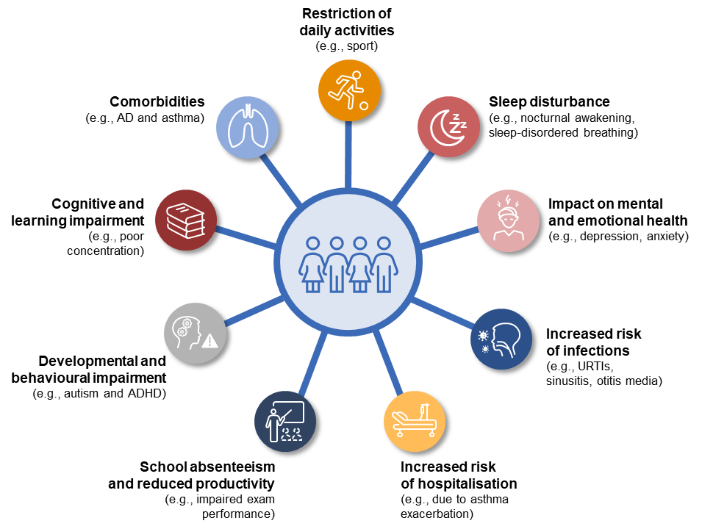

AD, atopic dermatitis; ADHD, attention-deficit hyperactivity disorder; URTI=upper respiratory tract infection

**Figure 2: Comorbidities associated with upper respiratory allergy in children**

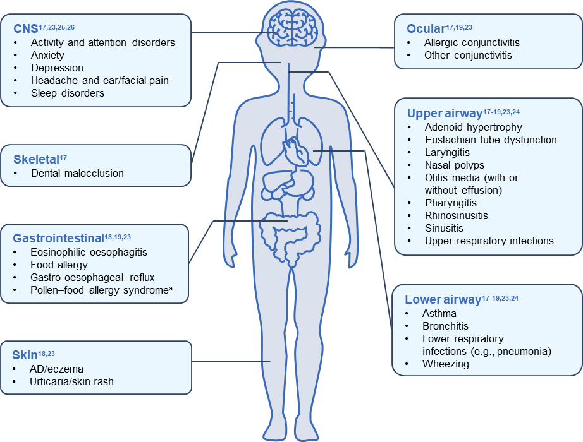

aAlso known as oral allergy syndrome

AD, atopic dermatitis; CNS, central nervous system

**Figure 3: Key factors to consider when identifying children with a high burden of upper respiratory allergy**

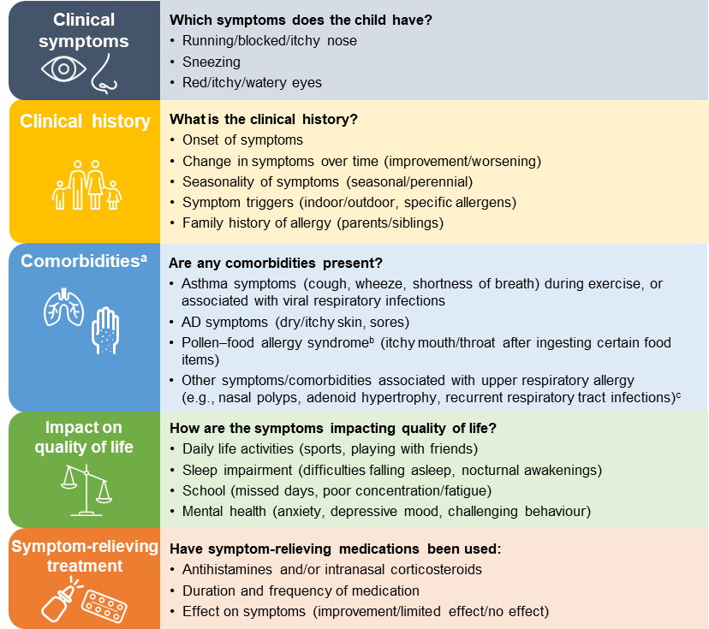

aConsider conducting diagnostic tests where necessary (e.g., spirometry)  
bAlso known as oral allergy syndrome  
cEvaluate possible association of other symptoms/allergic diseases with upper respiratory allergy

AD, atopic dermatitis

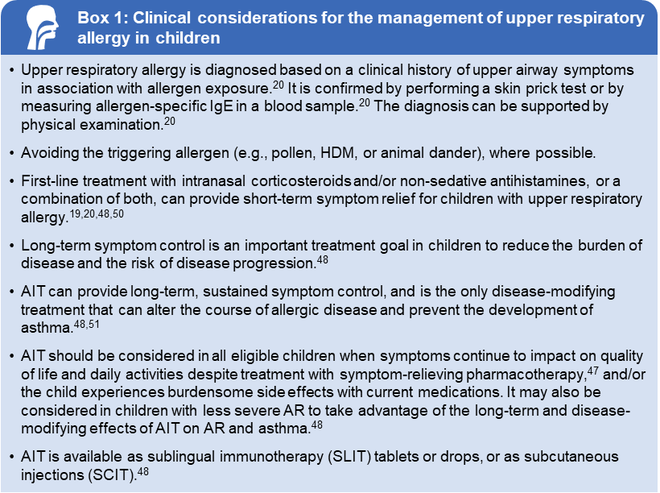

AIT, allergen immunotherapy; AR, allergic rhinitis; HDM, house dust mite; IgE, immunoglobulin E

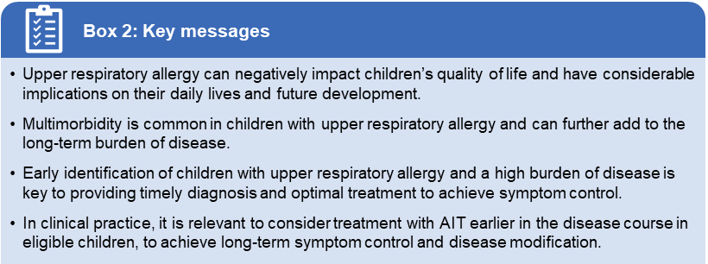

AIT=allergen immunotherapy