Manuscript title: Leadership for teacher retention: Exploring the evidence base on why and how to support teacher autonomy, development, and voice.
Authors’ details:
Dong Nguyen (first and corresponding author) – Durham University, UK. Email address: Dong.Nguyen@Durham.ac.uk
Beng Huat See – University of Birmingham. Email address: b.h.see.1@bham.ac.uk
Chris Brown – University of Southampton. Email address: christopher.brown@soton.ac.uk
Dimitra Kokotsaki – Durham University. Email address: dimitra.kokotsaki@durham.ac.uk

Abstract
Teacher retention has been globally a persistent challenge. School leadership plays a central role in retaining teachers. Drawing on a major review of 355 research outputs, this article develops and discusses an international empirical evidence base specifically on the potential effects and leadership practices of promoting teacher professional autonomy, development, and voice in relation to teacher retention. The evidence suggests that promotion of teacher autonomy, development and voice is likely to interactively enhance teacher well-being, commitment, and retention. It categorically highlights five domains of salient leadership practices to promote these teacher outcomes. The article discusses some gaps in the evidence base and proposes directions for future research to inform the policy and practice on leadership for teacher retention.
Keywords: Leadership, professional development, teacher autonomy, teacher retention, teacher-well-being.

Introduction
Teacher retention has been internationally a persistent challenge. Aligned with previous work (e.g., See et al., 2020), we define teacher retention as (the goal of) keeping qualified teachers in schools and reducing the number of qualified teachers making premature exits from the profession. Failure to recruit and retain qualified teachers has concerning implications for student learning (Sorensen & Ladd, 2018). Supporting teacher retention has therefore found its way to be a crucial topic of enquiry. In this article, “support” refers to providing teachers with intellectual, practical, and emotional assistance to perform their professional duties and responsibilities.
Theoretical perspectives on retaining employees across sectors and in education (e.g., Bronfenbrenner, 1979; Bakker & Demerouti, 2006) has highlighted a number of factors at all levels, from individual to organisational and national levels that influence teacher attrition (as opposite to teacher retention). The previous reviews of the empirical literature have been useful in verifying the broad assumptions of these theoretical perspectives (e.g., Borman & Dowling, 2008; Boyce & Bowers, 2018). The two reviews of empirical evidence by Borman and Dowling (2008) and Nguyen et al. (2019) maintain individual teachers’ characteristics as influencing factors of teacher retention. A multiplicity of organisational conditions makes significant contributions to informing teacher turnover (e.g., Liebowitz & Porter, 2019; Nguyen et al., 2019). These factors pertain to organisational climate, culture, professional development opportunities, and leadership. Factors beyond the organisational settings have major influences on teacher retention as well (See et al., 2020; Nguyen et al., 2019). See et al. (2020), for example, underscore financial incentives as a vital approach to attract and retain teachers in challenging schools.
It is clear from these previous reviews that school leadership is central in retaining teachers. However, no major reviews of empirical research across countries have systematically and centrally focused on the characteristics of school leadership, climate, and culture in relation to teacher retention. The absence of such a systematic, focused exploration of the extant evidence base is a barrier to an in-depth and conceptual understanding of how these organisational characteristics interactively influence teacher retention (Issue 1). For instance, it is evident that school leadership support matters in motivating and retaining teachers in schools. However, we knew little about what leadership practices, through which pathways and with what effects, to potentially contribute to supporting teacher retention. To respond to Issue 1, we were commissioned to conduct a major review of the empirical research evidence specifically on leadership for teacher retention. The current article is part of this larger review.
Interpretation of relevant theories (e.g., Bakker & Demerouti, 2006; Ryan & Deci, 2000) suggests employees’ sense of professional autonomy, development, and voice as a vital cluster of job resources in promoting positive outcomes such as job satisfaction and retention. Single empirical studies in school contexts (e.g., Kraft et al., 2016; Kim, 2019; Ladd, 2011) have found potential links between these factors and teacher retention. The previous reviews have generally asserted the centrality of school leadership in supporting job resources to motivate and retain teachers (e.g., Boyce & Bowers, 2018; Liebowitz & Porter, 2019). Nevertheless, we lack a systematic synthesis of the extant research evidence to enable an in-depth understanding on how school leadership might promote these job resources to motivate and retain teachers (Issue 2). Our systematic search using comprehensive databases, as noted in the review process below, found no previous reviews centring on the current topic of this article. To respond to Issue 2, we focus this article on discussing the leadership strategies to promote teachers’ sense of professional autonomy, development and voice and their potential associated effects. The current article, as part of a major review, draws on the evidence base identified and appraised to address two main research questions (RQ) as follows.
RQ1. How might supporting teacher professional autonomy, development, and voice matter in retaining teachers in schools?
RQ2. How might school leaders support teacher professional autonomy, development, and voice?
Addressing these research questions provides evidence-based insights into effective school leadership to support teacher retention. The next section presents the conceptual framework that informs the current review.
Conceptual framework
To guide this review and presentation of the current article, we developed a basic conceptual framework as visualised in Figure 1. This framework is built on theoretical perspectives (Bronfenbrenner, 1979; Bakker & Demerouti, 2006; Ryan & Deci, 2000) on motivating and retaining employees in organisations across sectors including education. Teacher retention, as defined above, is influenced by a multiplicity of factors, and centrally placed in this framework (Circle 1).
Figure 1. Conceptual framework for the review.
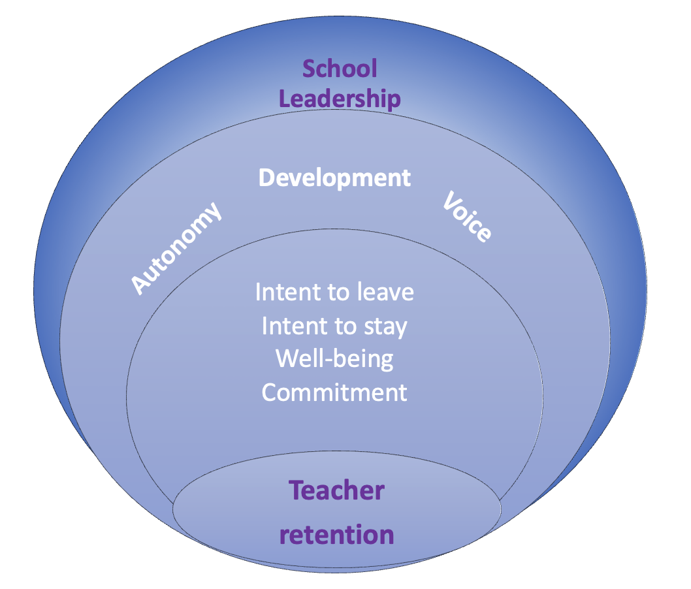
The current framework (Circle 2) considers the concepts and outcomes that are proximally linked, as suggested in the previous reviews (e.g., Madigan & Kim, 2021; Nguyen et al., 2019), with teacher retention. These are: teacher intent to leave / stay, teacher well-being, and organisational / professional commitment. Similar to Liebowitz and Porter (2019), this review conceptualises teacher well-being as a broad term to include teacher job satisfaction and engagement. The logic of Self-Determination Theory (SDT by Ryan & Deci, 2000) and Job Demands and Resources (JD-R by Bakker & Demerouti, 2006) allows us to reason that these outcomes might be influenced by teachers’ sense of professional autonomy, development, and voice.
Conceptually, autonomy concerns two key aspects of employees’ discretion and capacity to make informed decisions (Lamb & Reinders, 2008). Teacher autonomy (Circle 3) is accordingly defined as the freedom and capacity of teachers in making decisions on pedagogical methods, curriculum, assessment of student learning, student discipline, and their own professional development. The effects of autonomy on other teacher outcomes are subject to their preparedness and readiness to exercise their professional discretion, morally and ethically.
Teacher development (Circle 3) hereby refers to activities to be intended to support teachers’ development of professional competences. Building on the literature on organisational behaviour (see a review by Van Dyne, Ang, & Botero, 2003), we conceptualise teacher voice (Circle 3) as intentionally expressing ideas, concerns, and opinions related to their work through channels of communication.
School leadership (Circle 4) in this article is defined as a combination of observable approaches, practices, and/or strategies, related to leadership, management, and development and implementation of school-level policy, enacted by senior leaders in schools. These senior leaders comprise principals / head teachers and vice-principals / deputy head teachers. This positioning of school leadership concurs with the previous reviews (e.g., Liebowitz & Porter, 2019^{R}), suggesting the significant influences of school leaders on supporting various teacher outcomes. It is perfectly likely that there are other factors, beyond the scope and focus of this article, potentially influencing teacher outcomes in Circles 1, 2, and 3.
In summary, the current conceptual framework proposes:
- school leadership may have an influence on the factors of teacher professional autonomy, development, and voice.
- these factors in may influence other teacher outcomes such as organisational commitment and well-being.
- these teacher outcomes may have mutual influences on teacher retention.
Review process
This review process has five iterative stages, as visualised in Figure 2. At the onset of review, we formulated eight criteria for inclusion and exclusion of research outputs, as outlined in Table 1. We included empirical studies (Criterion 1), conducted in public / state school settings (Criterion 2). These studies were published in academic journals, book chapters, and research reports (Criterion 3), from January 2000 to May 2023 (Criterion 4). We chose January 2000 as a starting point to locate more contemporary sources of evidence and to make the scope of this review focused. However, we also engaged with the previous, relevant reviews that included studies published before 2000 (e.g., Liebowitz & Porter, 2019), as detailed further in the next section. The engagement was to justify further the scope of the current review and article, and where applicable, to discuss some specific findings in the section of Findings and overall implications in the section of Discussion and Conclusions. The previous reviews that are cited in this article is marked with “R” (e.g., Liebowitz & Porter, 2019^{R}) in the subsequent parts and reference list. May 2023 was a cut-off point for this current review.
We only shortlisted research outputs that centrally discuss the issues in response to the research questions (Criterion 5). The shortlisted outputs must be based on those studies that centre on school leaders (e.g., principal & vice-principal) and teachers (Criterion 6). These teachers can be in-service, be retired or have left the teaching profession. This review was inclusive of empirical research undertaken in any geographical contexts and included outputs written in English only (Criteria 7 and 8).
Table 1. Inclusion criteria for the current review.
Category of criteria | Included
1. Study design | - Empirical, primary studies  - Reviews of empirical literature
2. School levels | - K-12 settings: Primary/elementary, secondary/middle, high schools.  - Note: K-12 settings typically include schools for students aged from 5 to 18.
3. Types of evidence sources | - Peer-refereed journal articles  - Other publications including research reports, and books / book chapters drawn from empirical research.
4. Timeframe | January 2000 – May 2023
5. Content | A research output centrally discusses the core issues around (1) school leadership OR (2) school culture / climate / structure AND (3) teacher retention.
6. Population | - School leaders  - Teachers
7. Geographical locus | Outputs drawn from empirical research in any countries or nations.
8. Language | Outputs written in English.

Stage 1. Identifying research outputs
We utilised two large academic databases (Scopus and the Web of Science) and two major search engines (Google Scholar and Google) to search for relevant research outputs. These databases and search engines were used due to their multidisciplinary and comprehensive coverage (see Martín-Martín et al., 2018).
This stage formally lasted from 14th April 2023 to 31st May 2023. We piloted an initial search and discussed methodological adjustments, for example, of key words, in early April 2023. We formulated three sets of keywords based on a consideration of the previous key work and reviews (e.g., See et al., 2020^{R}; Liebowitz & Porter, 2019^{R}) and our pilot study. In total, these sets comprise 68 keywords and their synonyms.
- Set 1: keywords related to school leadership such as principal leadership, headship, and school leader.
- Set 2: keywords related to school culture, climate, and structure such as organisational culture, school environment, and working condition.
- Set 3: teacher retention and other related teacher outcomes such as job satisfaction, well-being, intent to stay/leave, teacher shortage, and teacher mobility.
We subsequently combined the research results from all the separate searches into a single Excel file and then removed duplicates. A total of 2,054 outputs results were retained in this stage.
Stage 2. Screening titles and abstracts
This stage involved screening of titles, abstracts and, where available, keywords in the outputs found in Stage 1. Two reviewers scanned the same first 100 results from each search and discussed rationale for inclusion and exclusion of each output. Once we had established an agreement on this practice, we proceeded with scanning the remaining results for each search for immediate relevance. All research outputs that seemed, at face value, to discuss - (i) leadership/management and/or (ii) culture / climate / structure in relation to (iii) teacher retention and/or related outcomes were retained in this stage. We shortlisted 508 research outputs for the subsequent stage. The full texts of these research outputs were downloaded and stored in a folder for reading.
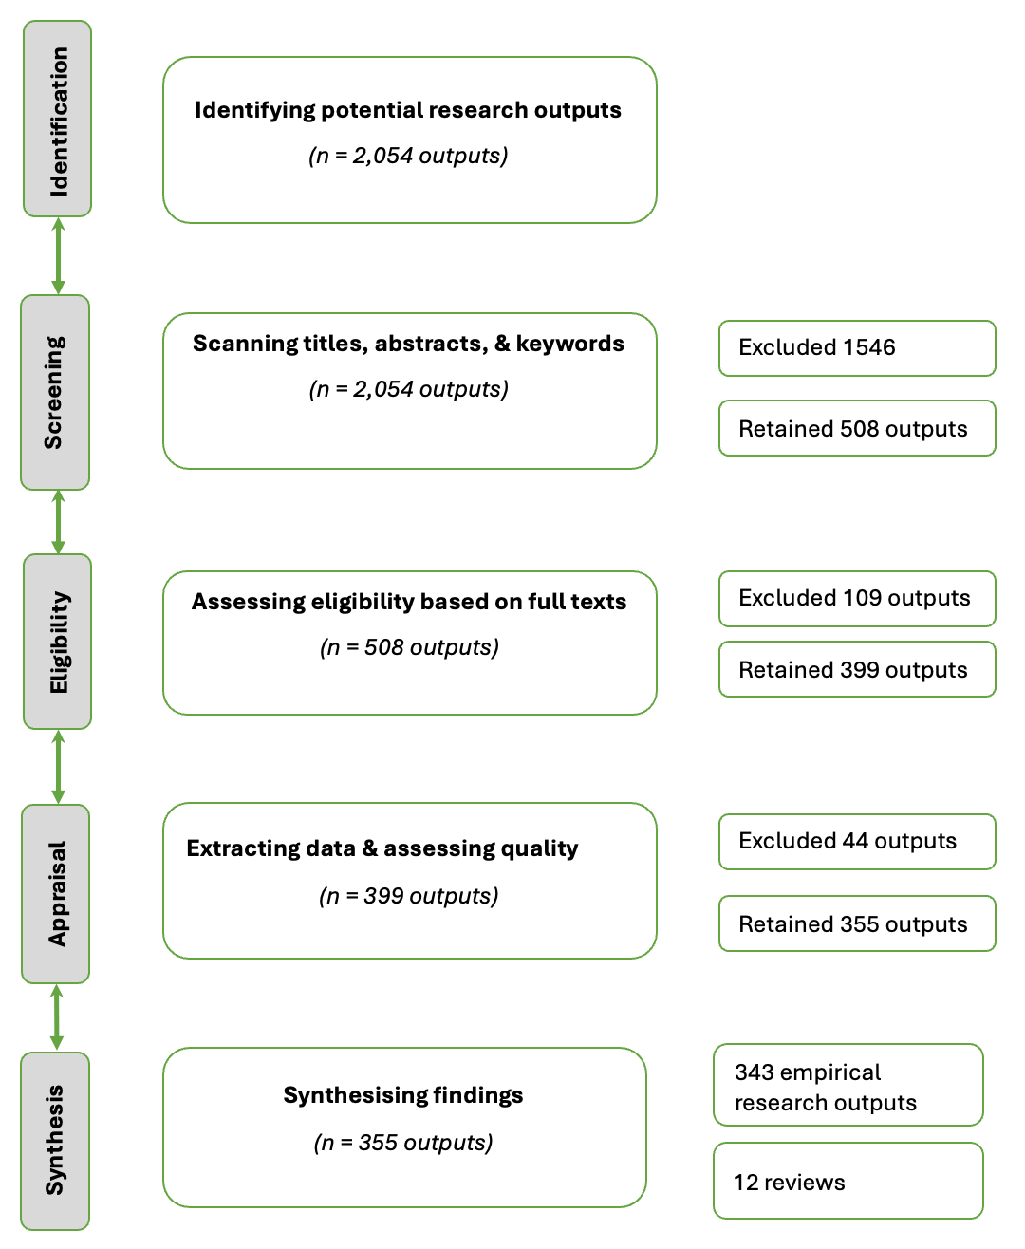
Figure 2. PRISMA flow diagram of steps in the current review.
Stage 3. Assessing eligibility based on full-texts
Full texts of included studies were first read by one reviewer to assess for relevance. Where the reviewer was unsure about its inclusion, the study was double screened by another reviewer. A consensus was reached following some discussions. A further 109 that did not meet the inclusion criteria were excluded at this stage, retaining 399. Key information about each of these studies was extracted in an integrated Excel file. These 399 outputs comprise 386 refereed journal articles, 4 book chapters, and 9 research reports.

Stage 4. Assessing quality of evidence
The current review aims to identify evidence-informed characteristics of school leadership, structure, climate, and culture that support teacher retention. Having considered this key aim and the aforementioned research questions, we used three appraisal tools to assess quality of evidence and research for the purposes of this review.
We used Gorard’s (2021) appraisal tool, to evaluate the strength or credibility of the correlational and causal evidence of the included studies in this review. This appraisal tool has five key evaluation criteria, namely design, scale of study, scale of missing data, data quality, and other threats to validity, as summarised in Appendix 1.
As a complementary evaluation practice, we employed a critical appraisal checklist for qualitative research in Appendix 2 to appraise the outputs drawn from analyses of qualitative (mainly in-depth interview) data that consider teachers’ perspectives and experiences. This practice was inclusive of teachers’ narrative evidence (a) on the factors that might influence their retention, well-being, and organisational commitment, and (b) on leadership practices for promoting teacher autonomy, development, and well-being.
To shortlist the relevant review studies, we utilised an adapted critical appraisal checklist for reviews of empirical research in Appendix 2. This tool has a checklist of eight items that evaluate appropriateness of their adopted methods to search for and appraise studies and synthesise the findings from those shortlisted studies, to respond to the explicitly stated research questions. This exercise was aimed at selecting quality reviews of empirical research evidence on the issues (e.g., teacher mobility) pertaining to this review.
To exercise inter-rater reliability, a random sample of 10% of the total number of these shortlisted outputs were double screened between the reviewers. Any disparities in the assessment and ratings were discussed in moderation meetings to reach an agreement among reviewers.
In this round of quality assessment, we excluded 44 research outputs, rated 0*, because of the undesirable quality. The outputs rated 3* provide stronger correlational and causal evidence than those rated 2* and 1* (see Appendix 2 for further elaboration). We retained 355 outputs upon this stage, as detailed in Table 2.

Table 2. Quality assessment of reviewed outputs.
Number of research outputs | Quality assessment
202 empirical research outputs | 1*
84 empirical research outputs | 2*
5 empirical research outputs | 3*
52 empirical research outputs | Met the appraisal of narrative evidence.
12 review outputs | Met the appraisal of reviews of the empirical literature.

Stage 5. Synthesising evidence
Stage 5 synthesised the evidence relevant to this review from the included studies. This involved (a) identifying the relationships and characteristics of leadership practices in relation to teacher-retention-related outcomes and (b) commenting on evidence generation of (a). In addition, we engaged with teachers’ narrative evidence from the list of included studies. Inclusion of teachers’ narrative evidence was expected to support elaboration of this review’s key findings and/or at considering the diversity of evidence sources.
The key findings and implications presented in the current article are based on a cross-synthesis of research outputs rated 3*, 2*, and 1* and narrative evidence of the relevant outputs retained in Stage 4. To inform readers of the strength and diversity of evidence, we cite publications with an indication of quality rating (e.g., Griffith, 2004^{2*}), as shown in the section of findings. Where we cite a study of teachers’ narrative evidence (NE), there is no indication of quality rating (e.g., Brown & Wynn, 2007^{NE}).

Findings
This section continues the article with a presentation of the evidence on the potential effects and leadership practices of promoting teacher autonomy, development, and voice in relation to teacher retention. It also clarifies the number of research outputs that inform the findings of this article. One research output may contribute to findings and therefore be listed in more than one sub-section below. All articles in the final list of this review contribute insight into the current article. However, not all reviewed publications are cited in this article, given the limited space.
Teacher autonomy
The findings related to teacher autonomy are mainly based on an analysis of 29 empirical research outputs. Teacher autonomy hereby tends to be conceptualised as their sense of professional discretion or control within the classroom, on implementation of school-wide policies and their own professional development (e.g., Pan et al., 2023^{2*}; Liu S et al., 2021^{2*}; Van Droogenbroek et al., 2014^{2*}). The professional areas within the classroom include course content, teaching methods, pace and progression of instruction, classroom management, the amount of homework, and student holistic development.
How supporting teacher autonomy matters
The evidence base suggests associations between teachers’ sense of professional autonomy and their well-being (e.g., Kraft et al., 2016^{3*}; Pan et al., 2023^{2*}; Van Droogenbroek et al. 2014^{2*}) and organisational commitment (e.g., Lee & Nie, 2014^{1*}).
At least five articles found direct associations between teacher’ sense of professional autonomy and some affective teacher outcomes (e.g., Campoli & Conrad-Popova, 2017^{2*}; Lee & Nie, 2014^{1*}; Liu S. et., 2021^{2*}). The analysis of the 2018 TALIS dataset of schools in mainland China, conducted by S. Liu et al. (2021^{2*}), indicated a positive association between teacher autonomy and their job satisfaction. The two studies in the US (Boyd et al., 2011^{2*}; Campoli & Conrad-Popova, 2017^{2*}) suggested that giving teachers’ greater influence on selecting content, instructional materials, and teaching techniques, student evaluation and student discipline might be useful in satisfying and retaining them. Lee and Nie (2014^{1*}) surveyed 304 Singapore teachers and found a link between teacher autonomy and their organisational commitment.
Other studies (e.g., Pan et al., 2023^{2*}; Skaalvik & Skaalvik, 2020^{1*}) evidenced indirect links between teacher autonomy and other affective outcomes. Pan et al. (2023^{2*}) suggested teachers’ perceived autonomy was indirectly related to well-being through the teaching workload. Skaalvik & Skaalvik, (2020^{1*}) identified an indirect link between teacher autonomy and their job satisfaction through teacher emotional exhaustion.
The analyses of interview studies (e.g., Gallant & Riley, 2017^{NE}; Hobson & Maxwell, 2017^{NE}; Brady & Wilson, 2021^{NE}) provided further evidence on the potential benefits of enhancing teacher’s sense of professional autonomy identified in the correlational studies above. Enhancing teacher’s sense of autonomy is likely to support their professional well-being (Brady & Wilson, 2021^{NE}; Hobson & Maxwell, 2017^{NE}). Brady and Wilson (2021^{NE}) interviewed 51 teachers about the types of school-level teacher well-being initiatives. They suggested that the initiatives aimed at maximising teacher feelings of autonomy, development and decreasing heavy workload are instrumental in support teacher well-being. Early career male teachers in Gallant & Riley (2017^{NE}) felt that a good perception of autonomy would stimulate their sense of creativity and professional development.
Leadership practices to support teacher autonomy
The current review highlights the importance of autonomy-supportive school leadership in enhancing teachers’ feelings of professional autonomy, given the potential benefits as discussed above. Two categories of practices associated with autonomy-support leadership are identified as follows.
Supporting teachers’ professional freedom in the classroom. Collie et al. (2020^{2*}) documented autonomy-supportive leadership as a critical factor in influencing teacher well-being and job satisfaction. Autonomy-supportive leadership refers to granting teachers necessary professional freedom and control on their delivery of tasks and considering teacher voice in school-policy decisions. On the contrary, controlling leadership practices would lower teacher’s sense of job satisfaction. Controlling leadership focuses on critiquing teachers on their lesson planning and teaching in professional conversations and disrespecting teacher classroom autonomy (Gamero Burón & Lassibille, 2016^{2*}).
Ebersold et al. (2019^{1*}) suggested that listening to understand how teachers view and do things before making suggestions appears to be a good practice linked with autonomy-supportive leadership. Encouraging teachers and recognising them for innovating their ways of performing educational practices would be useful in enhancing teacher’s sense of autonomy (Lee & Nie, 2014^{1*}). Cooper-Gibson Research (2018^{NE}) interviewed 101 former teachers in the United Kingdom who had left the teaching profession. Their thematic analyses highlighted the importance of school leaders to give teachers freedom on planning their work and marking student work.
Establishing an effective communication structure. A range of reviewed studies (e.g., Player et al., 2017^{2*}; Kraft et al., 2016^{3*}; Van Droogenbroek et al., 2014^{2*}) suggested the significance of establishing an effective communication structure to promote teachers’ sense of autonomy and control of information. Van Droogenbroek et al. (2014^{2*}) argued that effective communication about policy change is critical in enhancing teachers’ perceptions of control of the contexts and needs for change. A good sense of autonomy would enable teachers to cope actively and creatively with changes in schools. This argument is based on an analysis of the responses of 1,878 senior teachers aged from 45 to 65 in Belgium.
Player et al. (2017^{2*}) utilised data from around 3,000 teachers in the United States from two surveys from 2011 to 2013 to explore the relationship between leadership and person-job fit and teacher mobility. The results indicated that teachers who reported positive school leadership were less likely than those who reported weaker leadership to leave a school. “Clear communication of school vision” to teachers was evidenced as one of the key characteristics of positive principal leadership in this study. Similarly, the analysis by Kraft et al. (2016^{3*}) of administrative data in New York, the United States identified “communicating a clear vision and encouraging open communication on important school issues” as a potentially effective practice in retaining teachers.
The narrative evidence by Scallon et al. (2023^{NE}) highlighted “clearly communicating the school’s vision around high-quality teaching” as a potentially effective principalship practice to contribute to low teacher turnover. On the contrary, principals’ implicit expectations for teachers might adversely affect teacher-principal relationships, and this issue could challenge teacher retention (Torres, 2016^{NE}).
Teacher development
The findings in this section draw on an analysis of an analysis of 45 empirical research outputs.
How supporting teacher professional development matters
A range of evidence from correlational studies suggests a positive link between promotion of teacher professional development and their well-being (e.g., Barbieri et al., 2019^{2*}; Gamero Burón & Lassibille, 2016^{2*}; Cha & Cohen-Vogel, 2011^{2*}) and organisational commitment (e.g., Ni, 2017^{2*}). The narrative evidence echoes the potential benefits of quality teacher professional development in promoting their well-being (e.g., Cann et al., 2021^{NE}) and intention to stay in a school (e.g., Zavelevsky et al., 2022^{NE}). This range of evidence strengthens the confidence in the finding, of the previous review by Nguyen et al. (2019^{R}), on the influence of teacher professional development on their decisions to stay or leave a school.
Leadership practices to support teacher development
Leadership for teacher development attends to improving support and opportunities for teachers’ professional growth. This review identifies three categories of leadership practices of supporting teacher development.
Providing instructional support. The reviewed studies evidence three practices or strategies that school leaders can enact to provide teachers with instructional support. Conducting classroom observation and offering constructive feedback on teachers’ classroom and instruction tends to be cited as a positive strategy to develop teachers’ sense of professional growth (Griffith, 2004^{2*}; Kim, 2019^{2*}; Kraft et al., 2016^{3*}; Liu Y et al., 2021^{2*}). The feedback should be worded and delivered with the aim to encourage teachers to innovate their teaching (Boyd et al., 2011^{2*}; Kim, 2019^{2*}). Working collaboratively with teachers to address instructional challenges arising in schools is another practice of demonstrating instructional support (Liu Y et al., 2021^{2*}).
The potential benefits of these practices in retaining teachers are evidenced across a number of cross-sectional studies (e.g., Kraft et al., 2016^{3*}; Griffith, 2004^{2*}; Kim, 2019^{2*}; Liu Y et al. 2021^{2*}). These studies used administrative data from the United States (e.g., Kim, 2019^{1*}) and the TALIS data (e.g., Liu et al., 2021^{2*}) to examine the relationships between (a) instructional support for teachers and (b) teacher job-satisfaction, efficacy, and turnover intentions. For example, Y. Liu et al. (2021^{2*}) drew on an analysis of the 2013 TALIS dataset to examine the relationships between instructional leadership and teacher job satisfaction and self-efficacy. The sample included 104,358 teachers from 6,045 schools in 32 countries. Instructional leadership in this study included leadership practices focussing on supporting teachers’ instruction such as collaborating with teachers to solve classroom discipline issues, conducting classroom observations, and encouraging teachers to innovate their teaching. Instructional leadership is indirectly associated with teacher job satisfaction through the effects of supportive school culture and teacher collaboration.
Studies (Ladd, 2011^{2*}; Player et al., 2017^{2*}; Kim, 2019^{2*}; Kraft et al., 2016^{3*}) in the United States suggested that supporting teachers, especially early career teachers (ECTs), with classroom management skills of student behaviours and enforcement of school rules would contribute to a compound of factors to motivate and retain teachers. The issues of school discipline and classroom management matter in influencing teacher job satisfaction and turnover retentions (e.g., Kim, 2019^{2*}; Kraft et al., 2016^{3*}; Toropova et al., 2021^{2*}).
Promoting professional development opportunities for teachers. Providing teachers with opportunities for and removing barriers to their professional development contribute to retaining teachers (e.g., Barbieri et al., 2019^{2*}; Kraft et al., 2016^{3*}; Ni, 2017^{2*}). This practice is important in keeping teacher professionally engaged and motivated. Barbieri et al. (2019^{2*}) analysed responses from 6,491 teachers in Italy and suggested that school leaders could support teacher well-being with providing professional development opportunities and educational resources for teachers. Dissatisfied teachers in Cha and Cohen-Vogel (2011^{2*}) reported “less useful” professional development opportunities and experiences and less favourable working conditions.
In summary, the evidence, mostly based on cross-sectional research in this review, highlights the importance of supporting teacher development in retaining teachers. The narrative evidence, drawing from analyses of teacher experiences in qualitative research across countries, corroborates this finding. This source of narrative evidence particularly advocates for proactive leadership to promote professional development of ECTs (Brown & Wynn, 2007^{NE}; Scallon et al., 2023^{NE}; Chaaban & Du, 2017^{NE}). Supportive leadership practices for teacher development include encouraging teachers to experiment teaching innovations, leading or actively involving in developing solid mentoring programmes for teachers, and sourcing for teacher professional development opportunities. These practices could potentially contribute to enhanced professional well-being and retention of teachers, especially of ECTs (e.g., Brown & Wynn, 2007^{NE}; Cann et al., 2021^{NE}; Chaaban & Du, 2017^{NE}).
Teacher voice
The findings relevant to teacher voice are based on an analysis of 33 empirical research outputs. How supporting teacher voice matters
A range of narrative evidence calls for promoting teacher voice to enhance their well-being and retention in schools (e.g., Cann et al., 2021^{NE}; Scallon et al., 2023^{NE}; Waddell & Jennifer, 2010^{NE}). The prominent finding across these studies is that teachers tend to have a stronger sense of professional belonging, self-efficacy, and well-being when they have opportunities to participate in school decision making. The evidence also highlights the need for school leaders to recognise teachers as valued contributors to school decision-making process to satisfy and retain them (e.g., Cann et al., 2021^{NE}; Waddell & Jennifer, 2010^{NE}).
The correlational evidence base provides a more nuanced picture of the potential effects of enhancing teacher voice on retention and other teacher outcomes. This range of evidence was derived from two groups of research outputs – the first group utilised TALIS datasets; and the second one drew on other sources of data.
At least seven publications from the first group (e.g., Liu S. et al., 2021^{2*}; Collie et al., 2020^{2*}; Sun & Xia, 2018^{2*}; Torres, 2019^{2*}) used three items in the scale of “participation among stakeholders” in the OECD’s datasets. These items elicit teachers’ views and experiences on the opportunities and culture of shared decision making and responsibility in their schools. The analyses found direct and/or indirect links between teacher voice and retention.
Possible direct links between teacher voice and retention. There appears to be a direct positive relationship between promotion of teacher voice and teachers’ well-being (e.g., Gouëdard et al., 2023^{2*}; Liu S. et al., 2021^{2*}; Lee et al., 2023^{2*}; Collie et al., 2020^{2*}; Sun & Xia, 2018^{2*}) and professional commitment (e.g., Collie et al., 2020^{2*}; Lee et al., 2023^{2*}).
Indirect links between teacher voice and retention depends on mediating factors. The relationship between promotion of teacher voice and those teacher-retention-related outcomes is influenced by a compound of factors such as professional collaboration (Liu S. et al., 2021^{2*}; Liu Y et al., 2021^{2*}; Torres, 2019^{2*}), exchange and co-ordination (Liu S. et al., 2021^{2*}), self-efficacy (Sun & Xia, 2018^{2*}; Torres, 2019^{2*}), and interpersonal trust (Cai et al., 2021^{1*}; Liu et al., 2022^{2*}).
The findings in the second group of publications that draw on analyses of other sources of data beyond TALIS datasets tend to be less consistent.
Possible links between teacher voice and retention. At least six studies in this group identified relationships between teacher voice and their well-being and/or professional development (e.g., Lee et al., 2023^{2*}; Ladd, 2011^{2*}). For example, Lee et al. (2023^{2*}) investigated the extent of teacher influence in the areas of curriculum, performance standards for students, content of professional development programmes for teachers, teacher recruitment, teacher evaluation, school discipline, and budgetary decisions. Their analysis suggested that teacher influence in those areas in schools corresponds positively with their job satisfaction and professional commitment. Ladd (2011^{2*}) analysed an administrative dataset of teachers in North Carolina in 2006 to understand the associations between working conditions and the departures of elementary, middle, and high school teachers. Ladd (2011^{2*}) labelled the scale of Expanded Roles of 8 items that ask teachers about their involvement in selection of instructional materials, assessment, teaching staff recruitment, and school improvement plans. Teacher involvement in these areas was found to be negatively linked with teacher departures, but in middle schools only.
No links between teacher voice and retention. At least two studies in Israel (Da’as, 2021^{3*}) and in South Korea (You et al., 2017^{2*}) found no links between promoting teacher voice and teacher retention. Da’as (2021^{3*}) employed a natural experiment to compare principals’ cognitive and interpersonal skills in (a) schools that implemented an education reform with (b) those that did not. The samples for group (a) were 106 principals and 1,370 teachers. Group (b) had a sample of 101 principals and 1,203 teachers. These participants were randomly selected elementary schools in Israel. Overall, the findings from both groups indicated no association between providing teachers with opportunities to participate in decision making and their sense of job satisfaction. The analysis, by You et al. (2017^{2*}), of the data collected from 2,908 teachers from in South Korea, identified no significant association between involving teachers in the process of making schoolwide decisions and their job satisfaction.
Leadership practices to support teacher voice
Most research outputs in this sub-section centre on identifying the associations between teacher voice (i.e., teacher influence in the school-wide decision-making processes) and outcomes related to teacher retention, with little specificity on leadership practices to enhance teacher voice. However, two categories of practices can be identified from an analytical look across scales and question items used in the studies that identified the positive relationships between promoting teacher influence in school decision making and outcomes relevant to this review. These include creating organisational structures for teachers’ authentic participation in school decisions (e.g., Ladd, 2011^{2*}; Lee et al., 2023^{2*}) and developing a collaborative culture of shared responsibility for school issues (e.g., Gouëdard et al., 2023^{2*}; Liu S. et al., 2021^{2*}).
Discussion and conclusions
This section discusses some insights from the evidence base on school leadership for promoting teacher professional autonomy, development, and voice in relation to teacher retention. Before highlighting the implications, it is important to discuss the limitations of this evidence base and suggestions for future research.
Limitations and suggestions for future research
The current review covers research outputs published in English from 2000 to 2023 - it therefore potentially misses the scholarly writings in other languages and its evidence base risks geographical and cultural bias. This limitation leaves space for the country-specific reviews that consider research outputs, written in other languages, relevant to leadership for teacher retention.
Methodologically, many included studies that specifically analyse models or types of school leadership are correlational in nature and of small-scale (e.g., with around 200 self-selected teacher participants in a big geographical area). Most of these studies tend to focus on leadership styles or models and rarely accounted for other potential factors that could have explained the results.
This limitation is exacerbated by an over-reliance on cross-sectional data. These data fail to account for changes in other potential influencing factors happening at the time of the data collection. For example, changes in education reforms, increased accountability pressure on principals and teachers, and changing patterns of segregation among student bodies and teacher workforces may influence teacher well-being and their turnover intentions. In addition, analyses on cross-sectional data do not support firm causal claims on effective leadership practices for teacher retention. The lack of causal evidence is also well-noted in the previous, relevant review (Liebowitz & Porter, 2019^{R}). The current issues underscore a need for more longitudinal studies and those rigorously employing (quasi)experimental designs and consider a variety of potential factors in analytical procedures.
In this review, the outputs based on analyses of larger-scale administrative datasets from, for example, OECD and the United States, tend to be rated higher in terms of the quality of evidence. Nonetheless, there are two potential issues. First, most of these studies relied on data on teacher intent to stay / leave, rather than actual departure. Second, some studies utilised the data on teachers’ actual departures as an outcome variable, but they employed subjective measurements of independent variables. This methodological issue risks weakening those studies. To support more nuanced conclusions with stronger confidence, the increased use of objective measurements is a necessary next step.
Implications from the review
The analysis of the evidence base above highlights a cluster of professional autonomy, development, and voice as contributory factors to teacher retention. This cluster of factors influence teacher retention through a multiplicity of possible pathways that tend to be indirect. Some studies (e.g., Gouëdard et al., 2023^{2*}) found potential direct associations between these three factors and teacher affective outcomes. Nevertheless, incorporating factors such as teacher efficacy (e.g., Torres, 2019^{2*}), workload (e.g., Pan et al., 2023^{2*}), and interpersonal trust (Liu et al., 2022^{2*}) in the equation tend to make these relationships indirect.
These three distinguishable factors are interactive in influencing teacher turnover intentions. The previous section notes two key intertwisted elements of teacher autonomy: professional discretion and competence in decision making. The degree of teachers’ well-being resulting from their discretion is subject to their professional competence and efficacy. This reasoning implies the need for developmental support to enhance teachers’ professional competence in alignment with respecting their autonomy (argument i). For example, unlike more experienced teachers, ECTs may feel professionally dissatisfied if they are left “solely independent” to decide on the teaching methods and instructional materials for a challenging class. The current review stresses the need for school leaders’ quality professional development support to satisfy and retain teachers, as evidenced in the previous section.
The analysis of evidence in the current review suggests that teacher development can be promoted through direct mentorship and creating a culture of professional learning within and beyond schools. School leaders’ direct instructional support for teachers, however, does not automatically generate positive effects on teacher retention. This support and mentorship should be constructively built on the collaborative basis, in a collegial and intellectual culture of shared responsibility and mutual support.
The less consistent pattern of findings on teacher voice in relation to teacher retention in this review raises three implications. First, the potential effects of promoting teacher voice can be culturally sensitive. While the studies in the US (e.g., Ladd, 2011^{2*}) found links between promoting teacher voice and teacher-retention-related outcomes, those in Israel (Da’as, 2021^{3*}) and South Korea (You et al., 2017^{2*}) found no associations.
Second, the possible effects of teacher voice might be contextually and situationally contingent. Teacher voice tends to be embedded in collective structures such as staff platforms, unions, and staff surveys. These structures offer no guarantee to enhance teachers’ professional wellbeing and retention. The effects of teacher voice are arguably dependent on employees’ feelings of the extent to which their voice influences the decision-making process.
Third, this inconsistency implies a need for more nuanced operationalisation and enhanced specificity of theoretical dimensions of teacher voice. The research outputs drawn from analyses of the same TALIS dataset generate a similar pattern of findings. The findings from the outputs based on the other sources of data are somewhat inconsistent. Distinct forms of employee voice might have differentiated effects on their well-being (e.g., see Shipton et al., 2023).
While autonomy and voice are two distinguishable concepts (Carr & Mellizo, 2013), they are likely related to each other in influencing employee-focused outcomes (argument ii). For example, the empirical evidence in Kao et al. (2022) suggested that job autonomy might positively influence employee promotive voice behaviours intended for organisational improvements. The aforementioned arguments (i) and (ii) and the patterns of findings from this review provide a basis to argue for the potential interactivity of promoting teacher autonomy, development, and voice in influencing teacher-related-retention outcomes (argument iii). Equally important, this review develops five categories of evidence-informed leadership practices to promote teacher autonomy, development, and voice. These are:
- supporting teacher professional freedom in the classroom;
- developing organisational structures for teachers’ participative decision making;
- establishing an effective communication structure;
- providing instructional support for teachers; and
- promoting professional development opportunities for teachers.
Overall, the argument (iii) proposes that these leadership practices might be complementary in influencing teacher retention. The evidence from many studies (e.g., Kim, 2019^{2*}; Kraft et al. 2016^{3*}; Liu Y et al., 2021^{2*}) included in the current review suggests that exercising a combination of these leadership practices is likely to contribute to satisfying and retaining teachers in schools. This proposition would benefit from further empirical verification in future research for stronger confidence.
References
Bakker, A. B., & Demerouti, E. (2007). The job demands-resources model: State of the art. Journal of managerial psychology, 22(3), 309-328. https://doi.org/10.1108/02683940710733115
Barbieri, B., Sulis, I., Porcu, M., & Toland, M. D. (2019). Italian teachers’ well-being within the high school context: evidence from a large scale survey. Frontiers in psychology, 10, 1926. https://doi.org/10.3389/fpsyg.2019.01926
Borman, G. D., & Dowling, N. M. (2008^{R}). Teacher Attrition and Retention: A Meta-Analytic and Narrative Review of the Research. Review of Educational Research, 78, 367-409. https://doi.org/10.3102/0034654308321455
Boyce, J., & Bowers, A. J. (2018^{R}). Toward an evolving conceptualization of instructional leadership as leadership for learning: Meta-narrative review of 109 quantitative studies across 25 years. Journal of educational administration, 56(2). https://doi.org/10.7916/D8HX2VZN
Boyd, D., Grossman, P., Ing, M., Lankford, H., Loeb, S., & Wyckoff, J. (2011). The influence of school administrators on teacher retention decisions. American educational research journal, 48(2), 303-333. https://doi.org/10.3102/0002831210380788
Brady, J., & Wilson, E. (2021). Teacher wellbeing in England: Teacher responses to school-level initiatives. Cambridge Journal of Education, 51(1), 45-63. https://doi.org/10.1080/0305764x.2020.1775789
Bronfenbrenner, U. (1979). The ecology of human development: Experiments by nature and design. Harvard university press.
Brown, K. M., & Wynn, S. R. (2007). Teacher retention issues: How some principals are supporting and keeping new teachers. Journal of School leadership, 17(6), 664-698. https://doi.org/10.1177/105268460701700601
Campoli, A. K., & Conrad-Popova, D. (2017). Invisible threads: Working conditions, interpersonal relationships, and turnover among black female teachers. Black female teachers: Diversifying the United States’ teacher workforce (pp. 117-134). Emerald Publishing Limited. https://doi.org/10.1108/s2051-231720170000006007
Cann, R. F., Riedel-Prabhakar, R., & Powell, D. (2021). A model of positive school leadership to improve teacher wellbeing. International Journal of Applied Positive Psychology, 6, 195-218. https://doi.org/10.1007/s41042-020-00045-5
Carr, M. D., & Mellizo, P. (2013). The relative effect of voice, autonomy, and the wage on satisfaction with work. The International Journal of Human Resource Management, 24(6), 1186-1201.
Cha, S. H., & Cohen-Vogel, L. (2011). Why they quit: A focused look at teachers who leave for other occupations. School Effectiveness and School Improvement, 22(4), 371-392. https://doi.org/10.1080/09243453.2011.587437
Chaaban, Y., & Du, X. (2017). Novice teachers' job satisfaction and coping strategies: Overcoming contextual challenges at Qatari government schools. Teaching and Teacher Education, 67, 340-350. https://doi.org/10.1016/j.tate.2017.07.002
Collie, R. J., Malmberg, L. E., Martin, A. J., Sammons, P., & Morin, A. J. (2020). A multilevel person-centered examination of teachers’ workplace demands and resources: Links with work-related well-being. Frontiers in Psychology, 11, 626. https://doi.org/10.3389/fpsyg.2020.00626
Cooper-Gibson Research. (2018). Factors affecting teacher retention: Qualitative investigation. Department for Education.
Da’as, R. A. (2021). School principals’ skills and teacher absenteeism during Israeli educational reform: Exploring the mediating role of participation in decision-making, trust and job satisfaction. Journal of Educational Change, 22(1), 53-84. https://doi.org/10.1007/s10833-020-09385-0
Ebersold, S., Rahm, T., & Heise, E. (2019). Autonomy support and well-being in teachers: Differential mediations through basic psychological need satisfaction and frustration. Social Psychology of Education, 22, 921-942. https://doi.org/10.1007/s11218-019-09499-1
Gallant, A., & Riley, P. (2017). Early career teacher attrition in Australia: Inconvenient truths about new public management. Teachers and Teaching, 23(8), 896-913. https://doi.org/10.1080/13540602.2017.1358707
Gamero Burón, C., & Lassibille, G. (2016). Job satisfaction among primary school personnel in Madagascar. The Journal of Development Studies, 52(11), 1628-1646. https://doi.org/10.1080/00220388.2016.1187726
Gorard, S. (2021) How to Make Sense of Statistics. Thousand Oaks, CA: SAGE Publications Ltd.
Gouëdard, P., Kools, M., & George, B. (2023). The impact of schools as learning organisations on teachers’ self-efficacy and job satisfaction: A cross-country analysis. School Effectiveness and School Improvement, 34(3), 331–357. https://doi.org/10.1080/09243453.2023.2196081.
Griffith, J. (2004). Relation of principal transformational leadership to school staff job satisfaction, staff turnover, and school performance. Journal of Educational Administration, 42(3), 333-356. https://doi.org/10.1108/09578230410534667
Hobson, A. J., & Maxwell, B. (2017). Supporting and inhibiting the well-being of early career secondary school teachers: Extending self-determination theory. British Educational Research Journal, 43(1), 168-191. https://doi.org/10.1002/berj.3261
Ingersoll, R. M., & Tran, H. (2023). Teacher shortages and turnover in rural schools in the US: An organizational analysis. Educational Administration Quarterly, 59(2), 396-431. https://doi.org/10.1177/0013161x231159922
Kao, KY., Hsu, HH., Thomas, C.L. et al. Motivating employees to speak up: Linking job autonomy, P-O fit, and employee voice behaviours through work engagement. Curr Psychol 41, 7762–7776 (2022). https://doi.org/10.1007/s12144-020-01222-0
Kim, J. (2019). How principal leadership seems to affect early career teacher turnover. American Journal of Education, 126(1), 101-137. https://doi.org/10.1086/705533
Kraft, M. A., Marinell, W. H., & Shen-Wei Yee, D. (2016). School organizational contexts, teacher turnover, and student achievement: Evidence from panel data. American Educational Research Journal, 53(5), 1411-1449. https://doi.org/10.3102/0002831216667478
Ladd, H. F. (2011). Teachers’ perceptions of their working conditions: How predictive of planned and actual teacher movement?. Educational Evaluation and Policy Analysis, 33(2), 235-261. https://doi.org/10.3102/0162373711398128
Lamb, T. E., & Reinders, H. (2008). Learner and teacher autonomy: Concepts, realities and responses. Amsterdam: John Benjamins.
Lee, A. N., & Nie, Y. (2014). Understanding teacher empowerment: Teachers’ perceptions of principal’s and immediate supervisor’s empowering behaviours, psychological empowerment and work-related outcomes. Teaching and Teacher Education, 41, 67-79. https://doi.org/10.1016/j.tate.2014.03.006
Malinen, O. P., & Savolainen, H. (2016). The effect of perceived school climate and teacher efficacy in behavior management on job satisfaction and burnout: A longitudinal study. Teaching and Teacher Education, 60, 144-152. https://doi.org/10.1016/j.tate.2016.08.012
Lee, J. Y., Park, J. H., & Lee, I. H. (2023). The effect of teacher influence relative to principal influence in school decision-making on teacher job attitudes. Educational Studies, 49(3), 529-546. https://doi.org/10.1080/03055698.2023.2174799.
Liebowitz, D. D., & Porter, L. (2019^{R}). The effect of principal behaviours on student, teacher, and school outcomes: A systematic review and meta-analysis of the empirical literature. Review of Educational Research, 89(5), 785-827. https://doi.org/10.3102/0034654319866133
Liu, L., Liu, P., Yang, H., Yao, H., & Thien, L. M. (2022). The relationship between distributed leadership and teacher well-being: The mediating roles of organisational trust. Educational Management Administration & Leadership. https://doi.org/10.1177/17411432221113683
Liu, S., Keeley, J. W., Sui, Y., & Sang, L. (2021). Impact of distributed leadership on teacher job satisfaction in China: The mediating roles of teacher autonomy and teacher collaboration. Studies in Educational Evaluation, 71, 101099. https://doi.org/10.1016/j.stueduc.2021.101099
Liu, Y., Bellibaş, M. Ş., & Gümüş, S. (2021). The effect of instructional leadership and distributed leadership on teacher self-efficacy and job satisfaction: Mediating roles of supportive school culture and teacher collaboration. Educational Management Administration & Leadership, 49(3), 430-453. https://doi.org/10.1177/1741143220910438
Madigan, D. J., & Kim, L. E. (2021^{R}). Towards an understanding of teacher attrition: A meta-analysis of burnout, job satisfaction, and teachers’ intentions to quit. Teaching and Teacher Education, 105, 103425. https://doi.org/10.1016/j.tate.2021.103425
Martín-Martín, A., Orduna-Malea, E., Thelwall, M., and López-Cózar, E. D. (2018). Google Scholar, Web of Science, and Scopus: A systematic comparison of citations in 252 subject categories. Journal of Informetrics, 12(4), 1160–1177. https://doi.org/10.1016/j.joi.2018.09.002
Nguyen, T. D., Pham, L., Springer, M. G., & Crouch, M. (2019^{R}). The factors of teacher attrition and retention: An updated and expanded meta-analysis of the literature. Annenberg Institute at Brown University, 19-149. https://doi.org/10.26300/cdf3-4555
Ni, Y. (2017). Teacher working conditions, teacher commitment, and charter schools. Teachers College Record, 119(6), 1-38. https://doi.org/10.1177/016146811711900606
Pan, H. L. W., Chung, C. H., & Lin, Y. C. (2023). Exploring the predictors of teacher well-being: An analysis of teacher training preparedness, autonomy, and workload. Sustainability, 15(7), 5804. https://doi.org/10.3390/su15075804
Player, D., Youngs, P., Perrone, F., & Grogan, E. (2017). How principal leadership and person-job fit are associated with teacher mobility and attrition. Teaching and Teacher Education, 67, 330-339. https://doi.org/10.1016/j.tate.2017.06.017
Ryan, R. M., & Deci, E. L. (2000). Self-determination theory and the facilitation of intrinsic motivation, social development, and well-being. American psychologist, 55(1), 68-78.
Scallon, A. M., Bristol, T. J., & Esboldt, J. (2023). Teachers’ perceptions of principal leadership practices that influence teacher turnover. Journal of Research on Leadership Education, 18(1), 80-102. https://doi.org/10.1177/19427751211034214
See, B. H., Morris, R., Gorard, S., & El Soufi, N. (2020^{R}). What works in attracting and retaining teachers in challenging schools and areas? Oxford Review of Education, 46(6), 678-697. https://doi.org/10.1080/03054985.2020.1775566
Shipton, H., Kougiannou, N., Do, H., Minbashian, A., Pautz, N., & King, D. (2024). Organisational voice and employee‐focused voice: Two distinct voice forms and their effects on burnout and innovative behavior. Human Resource Management Journal, 34(1), 177-196.
Skaalvik, E. M., & Skaalvik, S. (2020). Teacher burnout: Relations between dimensions of burnout, perceived school context, job satisfaction and motivation for teaching. A longitudinal study. Teachers and Teaching, 26(7-8), 602-616. https://doi.org/10.1080/13540602.2021.1913404
Sorensen, L. C. and Ladd, H. F. (2018) The Hidden Costs of Teacher Turnover. CALDER Working Paper No. 203-0918-1. Arlington, VA: CALDER. https://files.eric.ed.gov/fulltext/ED591843.pdf
Sun, A., & Xia, J. (2018). Teacher-perceived distributed leadership, teacher self-efficacy and job satisfaction: A multilevel SEM approach using the 2013 TALIS data. International Journal of Educational Research, 92, 86-97. https://doi.org/10.1016/j.ijer.2018.09.006
Toropova, A., Myrberg, E., & Johansson, S. (2021). Teacher job satisfaction: the importance of school working conditions and teacher characteristics. Educational Review, 73(1), 71-97. https://doi.org/10.1080/00131911.2019.1705247
Torres, A. C. (2016). The uncertainty of high expectations: How principals influence relational trust and teacher turnover in no excuses charter schools. Journal of School Leadership, 26(1), 61-91. https://doi.org/10.1177/105268461602600103
Van Droogenbroeck, F., & Spruyt, B. (2014). To stop or not to stop: An empirical assessment of the determinants of early retirement among active and retired senior teachers. Research on Aging, 36(6), 753-777. https://doi.org/10.1177/0164027513519449
Van Dyne, L., Ang, S., & Botero, I. C. (2003). Conceptualizing employee silence and employee voice as multidimensional constructs. Journal of management studies, 40(6), 1359-1392.
Waddell, J. H. (2010). Fostering relationships to increase teacher retention in urban schools. Journal of Curriculum and Instruction, 4(1), 70-85. https://doi.org/10.3776/joci.2010.v4n1p70-85
You, S., Kim, A. Y., & Lim, S. A. (2017). Job satisfaction among secondary teachers in Korea: Effects of teachers’ sense of efficacy and school culture. Educational Management Administration & Leadership, 45(2), 284-297. https://doi.org/10.1177/1741143215587311
Zavelevsky, E., Shapira-Lishchinsky, O., Benoliel, P., Klein, J., & Schechter, C. (2022). Ecological school culture for novice teachers’ retention: Principals’ perceptions. Leadership and Policy in Schools, 21(4), 922-937. https://doi.org/10.1080/15700763.2021.1879170

Appendix 1. Criteria for judging the strength of research evidence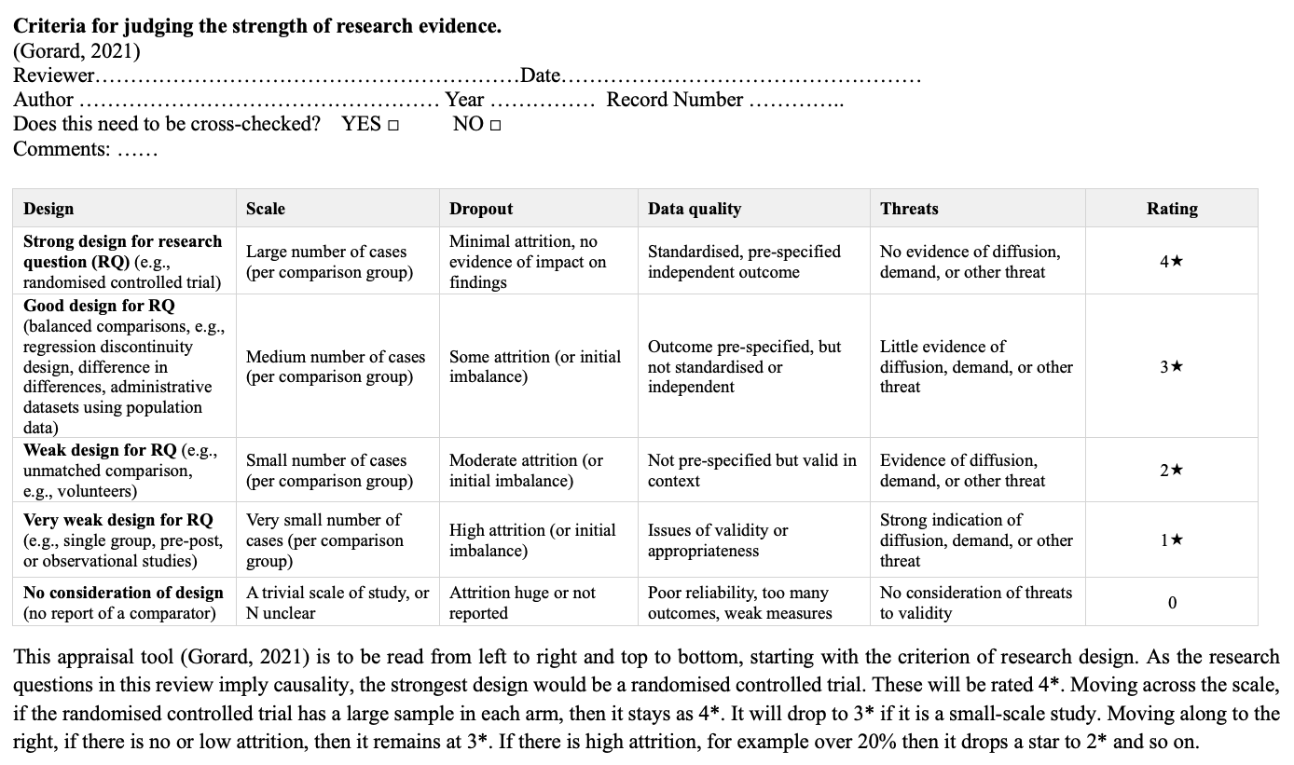
Appendix 2. Critical appraisal checklist for qualitative research & reviews of empirical research
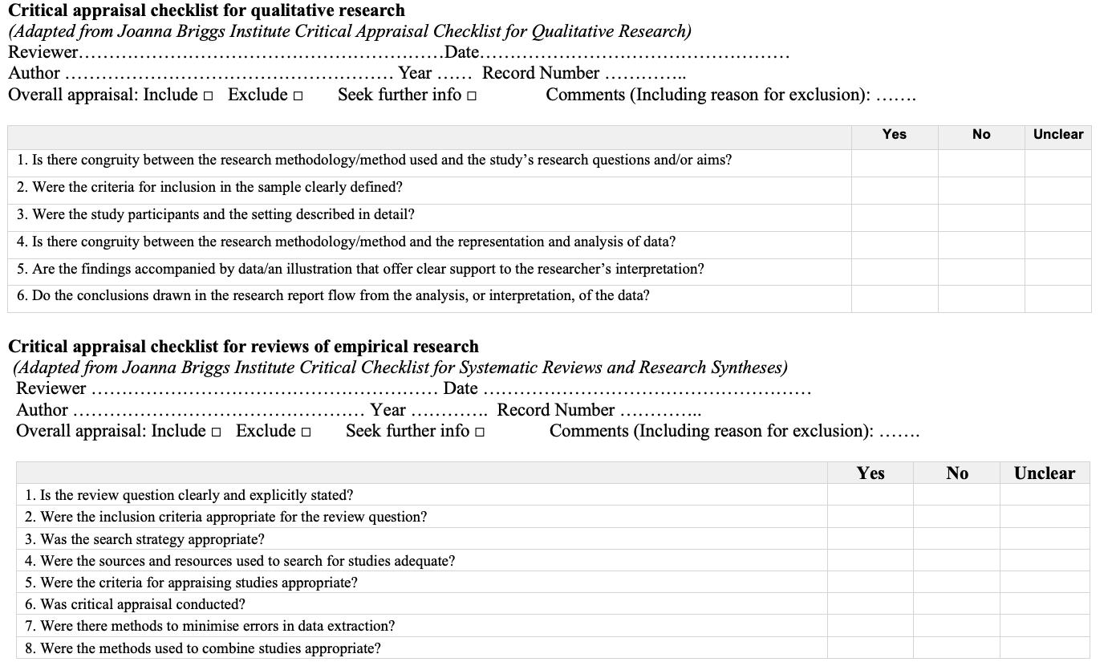

The Teaching and Learning International Survey (TALIS), developed by Organisation for Economic Co-operation and Development (OECD).

