Figure 1: Biological basis and possible impact of progesterone monitoring in a fresh ovarian stimulation cycle and frozen embryo transfer cycle
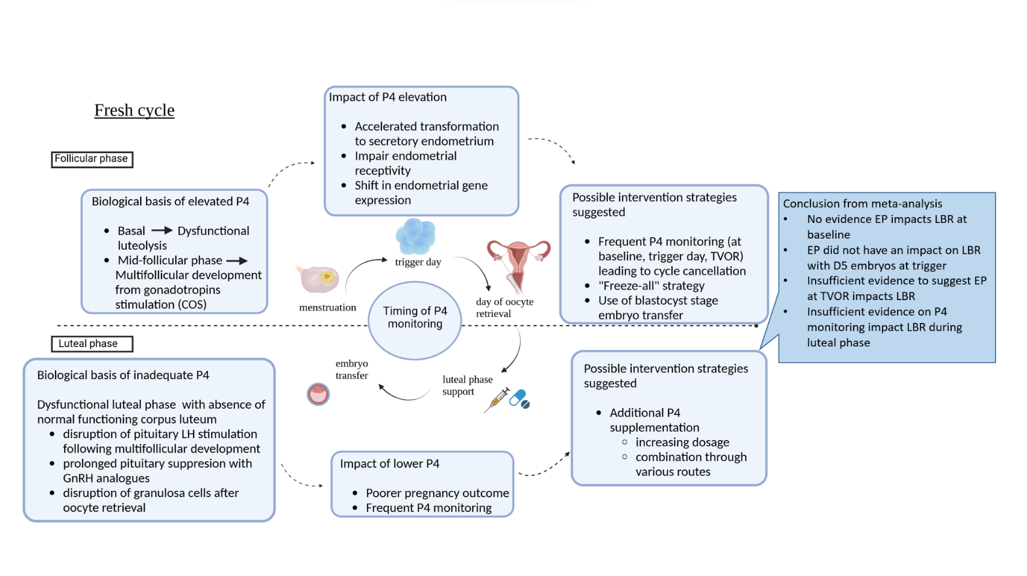

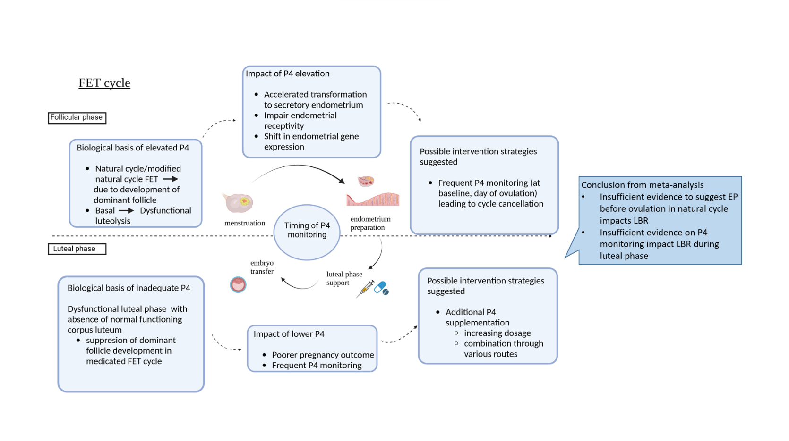

Abbreviations: COS, controlled ovarian stimulation; D5, day 5; EP, elevated progesterone; FET, frozen embryo transfer; GnRH, gonadotropin-releasing hormone; LBR, live birth rate; LH, luteinising hormone; P4, progesterone; TVOR, transvaginal oocyte retrieval

Figure 2: EP vs NEP at basal follicular phase, outcome: LBR and CPR
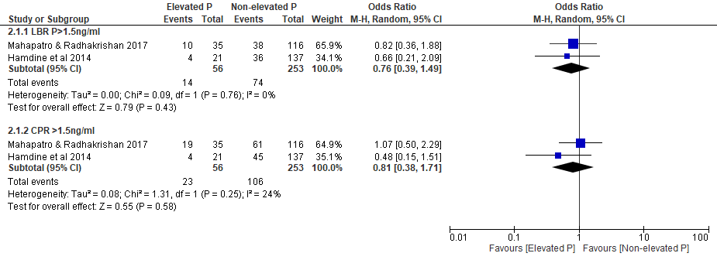
Figure 2: Forest plot of comparison between EP group and NEP group on LBR and CPR at basal follicular phase in fresh COS cycle
Abbreviations: COS, controlled ovarian stimulation; CPR, clinical pregnancy rate; EP, elevated progesterone; LBR, live birth rate; NEP, non-elevated progesterone

Figure 3a: EP vs NEP at ovulation trigger, outcome: LBR
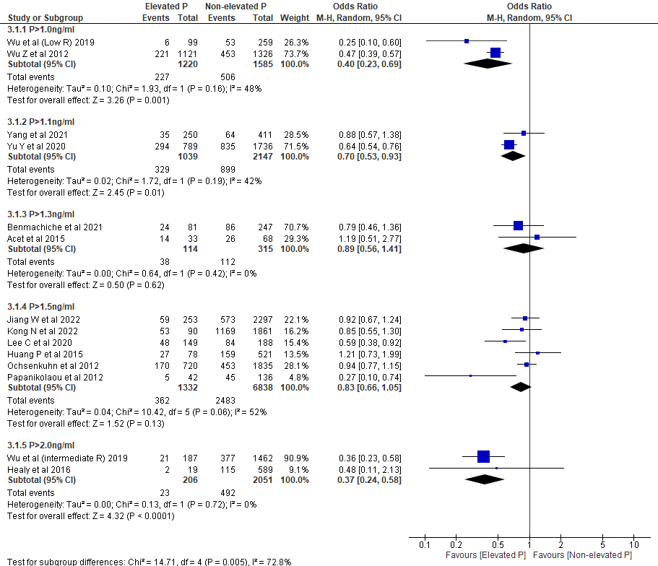

Figure 3b: EP vs NEP at ovulation trigger, outcome: OPR
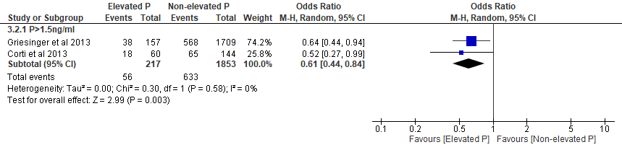

Figure 3c: EP vs NEP at ovulation trigger, outcome: CPR 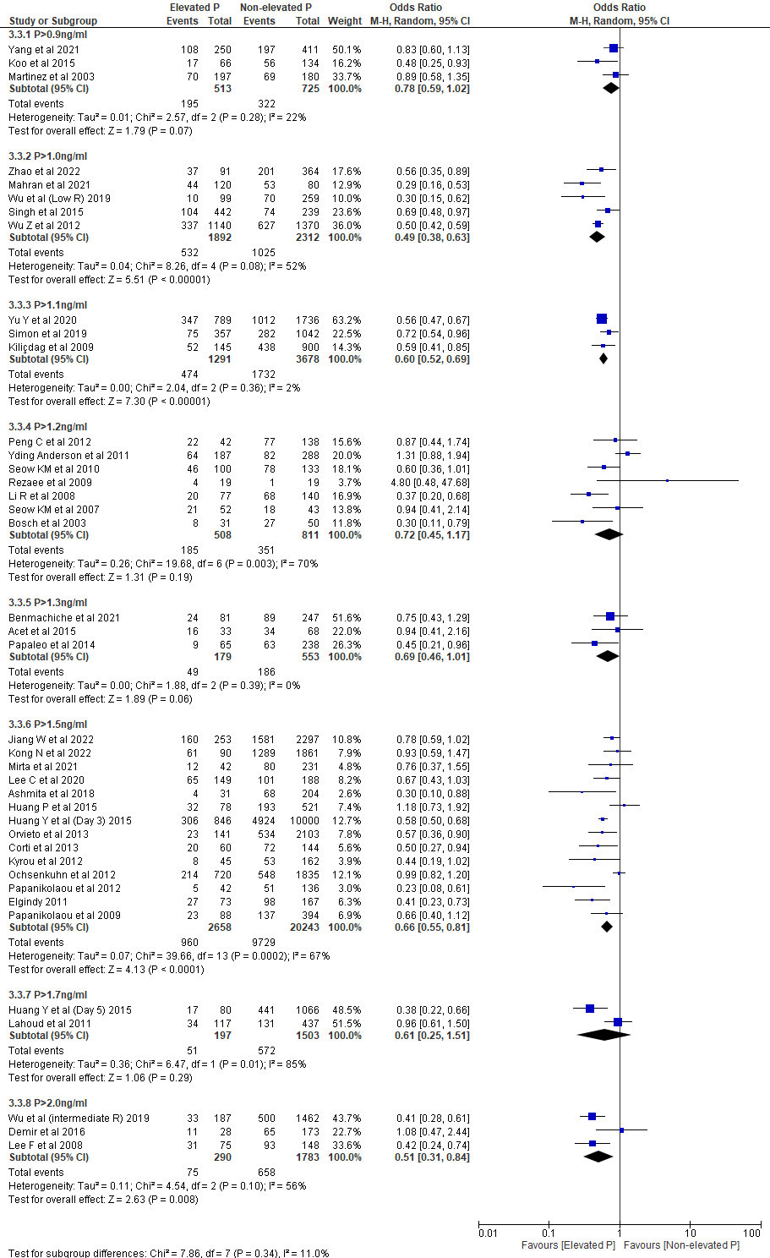

Figure 3d: EP vs NEP at day of ovulation trigger, outcome: MR
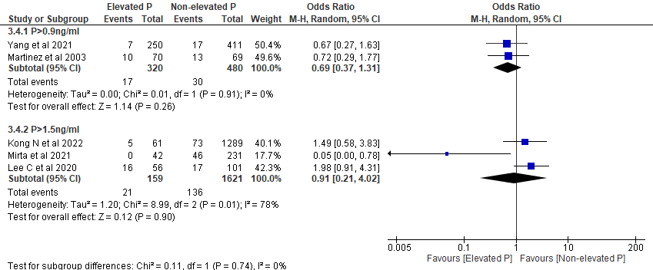

Figure 3a-3d: Forest plot of comparison between EP group and NEP group on LBR, OPR, CPR and MR at day of ovulation trigger in fresh COS cycle
Abbreviations: COS, controlled ovarian stimulation; CPR, clinical pregnancy rate; EP, elevated progesterone; LBR, live birth rate; MR, miscarriage rate; NEP, non-elevated progesterone; OPR, ongoing pregnancy rate

Subgroup analysis
Figure 3e EP vs NEP at day of ovulation trigger (Day 3 embryo), outcome: LBR
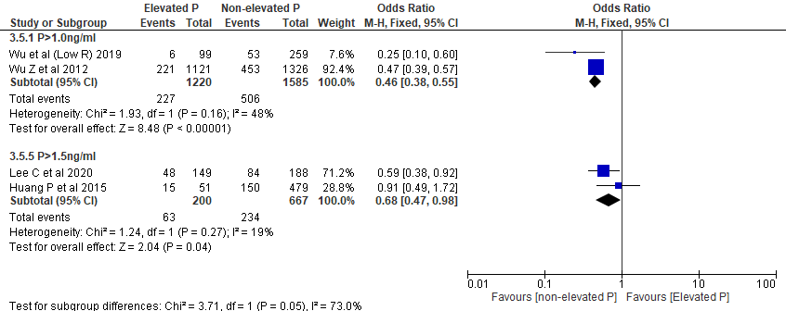

Figure 3f EP vs NEP at day of ovulation trigger (Day 3 embryo), outcome: CPR
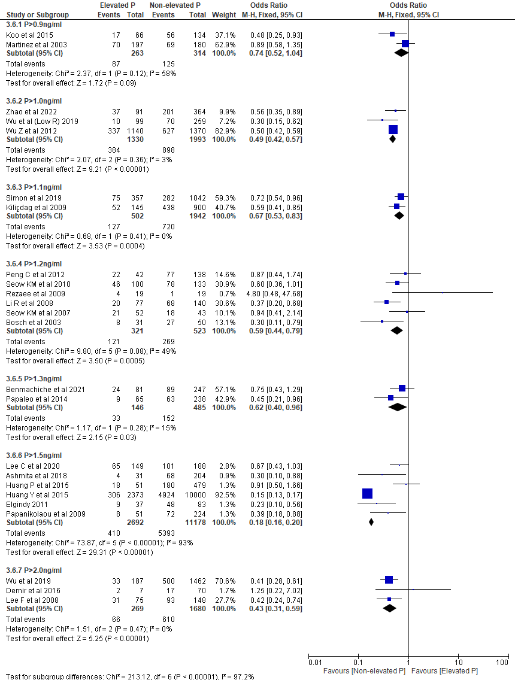
Figure 3e-3f: Subgroup analysis on Day 3 embryo, Forest plot of comparison between EP group and NEP group on LBR and CPR at day of ovulation trigger in fresh COS cycle
Abbreviations: COS, controlled ovarian stimulation; CPR, clinical pregnancy rate; EP, elevated progesterone; LBR, live birth rate; Low R, low responder; NEP, non-elevated progesterone

Figure 3g EP vs NEP at day of ovulation trigger (Day 5 embryo), outcome: LBR and CPR
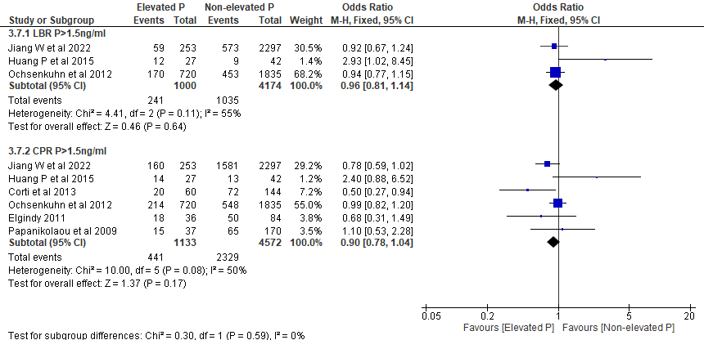
Figure 3g: Subgroup analysis on blastocyst stage embryo, Forest plot of comparison between EP group and NEP group on LBR and CPR at day of ovulation trigger in fresh COS cycle
Abbreviations: COS, controlled ovarian stimulation; CPR, clinical pregnancy rate; EP, elevated progesterone; LBR, live birth rate; NEP, non-elevated progesterone

Figure 4: Inadequate vs adequate P during luteal phase of fresh COS cycle; outcome: LBR, CPR and MR
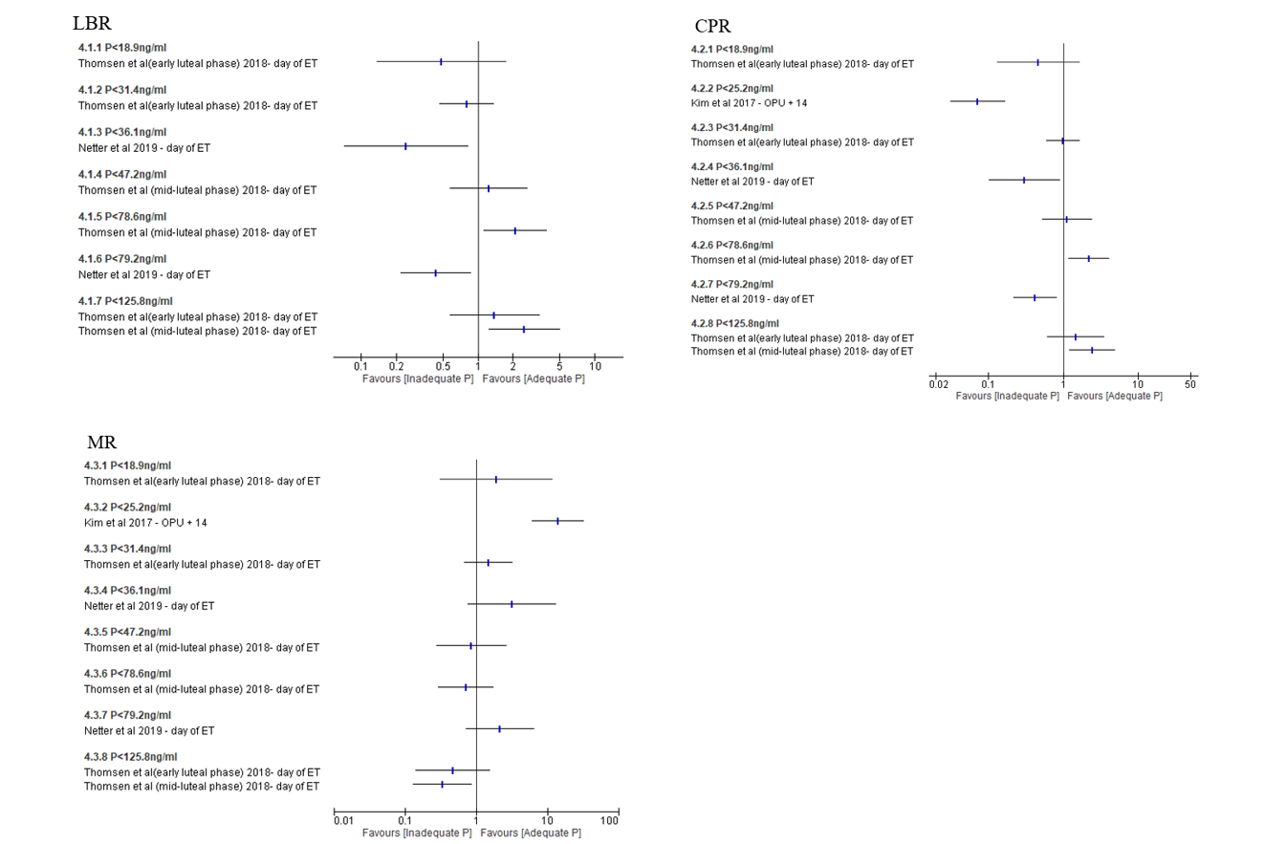
Figure 4: Forest plot of comparison on single studies between adequate progesterone group and inadequate progesterone group on LBR, CPR and MR during luteal phase in fresh COS cycle
Abbreviations: CPR, clinical pregnancy rate; LBR, live birth rate; MR, miscarriage rate; P, progesterone

Figure 5: Inadequate vs adequate P during luteal phase of medicated FET cycle; outcome: LBR, OPR, CPR and MR

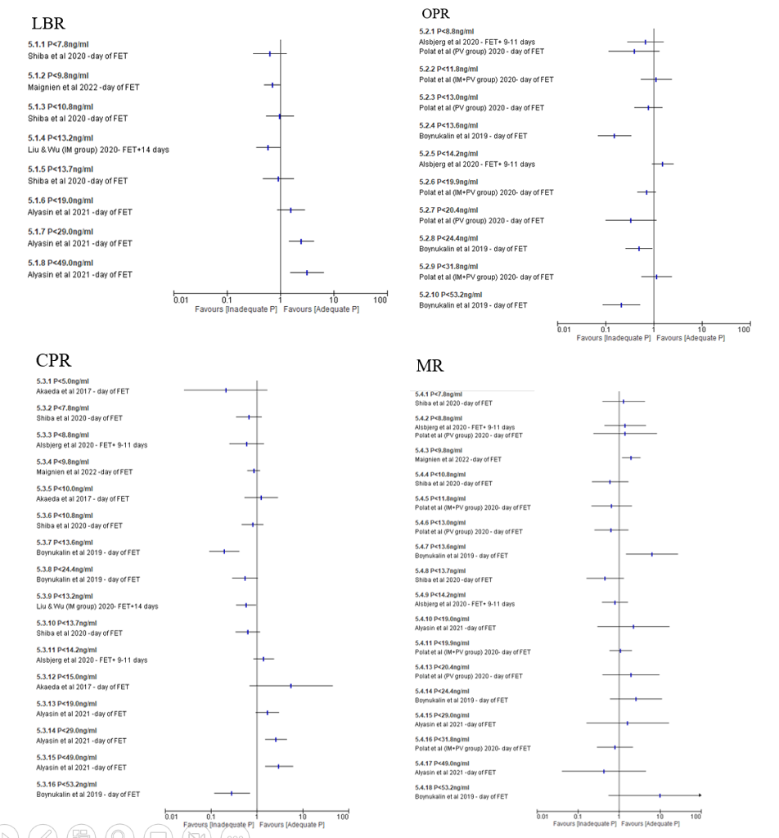

Figure 5: Forest plot of comparison on single studies between adequate progesterone group and inadequate progesterone group on LBR, OPR, CPR and MR during luteal phase in medicated FET cycle
Abbreviations: CPR, clinical pregnancy rate; FET, frozen embryo transfer; LBR, live birth rate; MR, miscarriage rate; P, progesterone

Figure 6: Summary of pregnancy outcomes

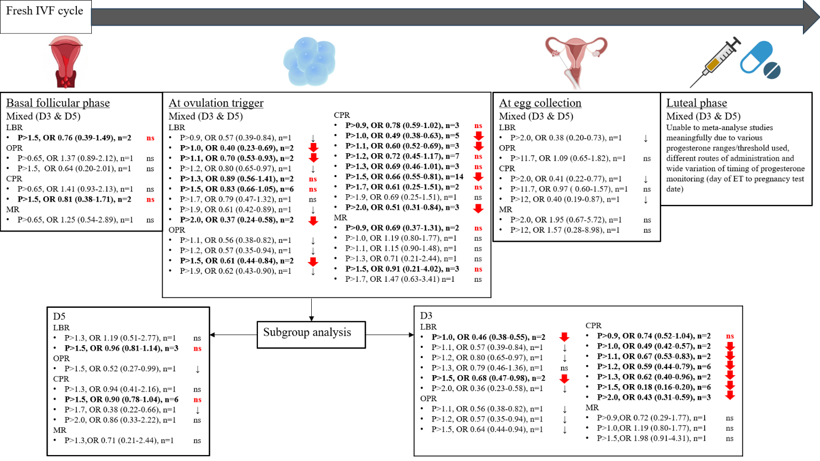

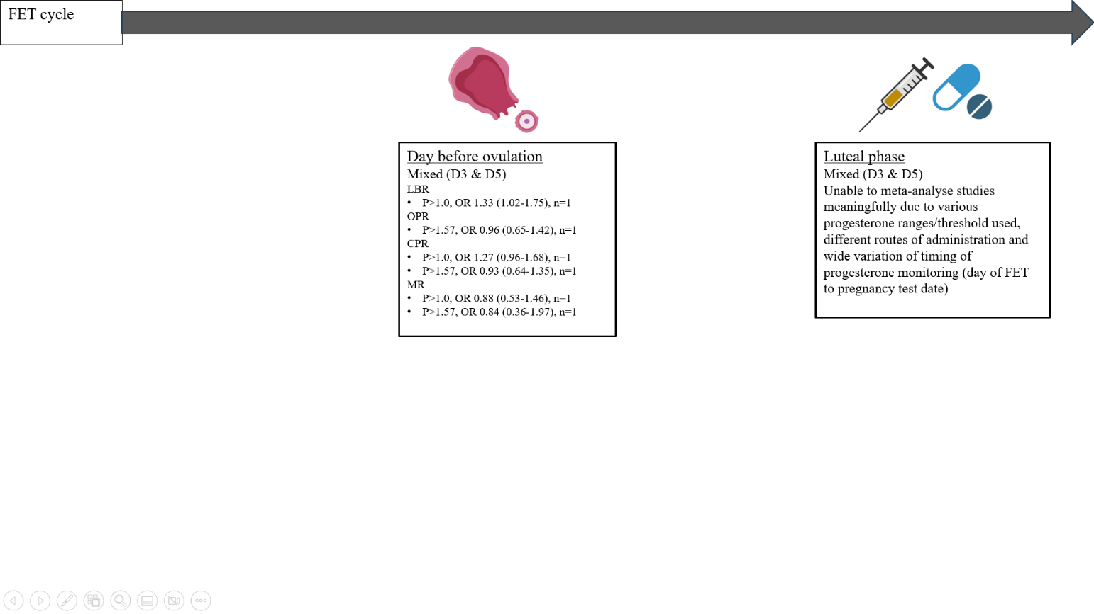
Legend
D3 - day 3 embryo
D5 - day 5 embryo
- significant decrease in meta-analysed studies
- significant increase in meta-analysed studies
ns - not significant in meta-analysed studies
↓ - significant decrease in single studies
Ns - non significant in single studies
n - number of studies
OR - odds ratio
P - progesterone level (ng/ml)

* data presented in OR (95% C.I.)
* threshold in BOLD showed meta-analysed results

A summary of pregnancy outcomes according to different timing of progesterone monitoring at different threshold levels
Abbreviations: CPR, clinical pregnancy rate; EP, elevated progesterone; FET, frozen embryo transfer; LBR, live birth rate; MR, miscarriage rate; NEP, non-elevated progesterone; OPR, ongoing pregnancy rate

