Editor Only  Mss no and title | 59371 Supporting continence care for people living at home with dementia

Strap
Innovation
Substrap
Continence

Keywords: Continence care; online resources; dementia; carers

Headline
Supporting continence care for people living at home with dementia

Standfirst
This article describes the development of the DemCon website, which provides continence resources for health professionals and family carers.

Meta description
Read this article to learn about the development of the DemCon website, which provides continence resources for health professionals and family carers.

In this article…

- The DemCon website for health professionals and family carers is launched
- We explain how nurses can use these website resources
- We offer four recommendations for nurses providing continence advice and support to carers

Key points

- People living with dementia are at high risk of continence problems
- More support with managing these issues is often needed
- A website we are launching offers resources for nurses and other health professionals
- It aims to help them provide continence advice in their day-to-day practice
- The site also offers practical guidance for family carers

Authors

Catherine Murphy, professorial research fellow, School of Health Sciences; Barbara Bradbury, senior research fellow, School of Health Sciences, Mandy Fader, professor of continence technology; Leanne Morrison, associate professor, Primary Care Research Centre, Miriam Santer, professor of primary care research, Primary Care Research Centre, Jane Ward, Patient and Public Involvement member (former carer, lead for Dementia Friendly Hampshire/Alzheimer’s Society Research Network member); all at University of Southampton; Jill Manthorpe, emeritus professor; Helen Chester, research fellow; both at NIHR Policy Research Unit in Health & Social Care Workforce, The Policy Institute, King’s College London.

Abstract
The DemCon website (https://demcon.org.uk) has been developed by University of Southampton and King’s College London researchers to help nurses and other health professionals deliver continence support to family carers and people living with dementia at home. It was developed using a literature review; interviews with health professionals, homecare workers and family carers; and public and stakeholder involvement. The website includes resources for health professionals and guidance for family carers. It is designed to help health professionals initiate conversations with people living with dementia and their family carers about toilet use and continence, and guide them to information to help them to manage well.

Citation

Murphy C et al (2024) Supporting continence care for people living at home with dementia. Nursing Times [online]; 120: 5.

Pull quote

“Family carers would like more guidance from nurses and other health professionals, who in turn are frustrated by the lack of help that they are able to provide due to lack of time, resources or knowledge”

[main article]
Around 850,000 people in the UK are living with dementia and in England around 540,000 family carers support people with dementia at home (NHS England, nd)
For some people, age-related changes can mean that they are more likely to experience mobility problems, limited dexterity and other issues that can limit the ability to use the toilet. However, people living with dementia are at much higher risk of experiencing urinary and faecal continence problems compared with people the same age without dementia (Grant et al, 2013). Furthermore, the number of people living with dementia who have incontinence is likely to be an underestimate due to the stigma and embarrassment that prevents people seeking help (Aldridge et al, 2023).
Dealing with incontinence can be hugely distressing and also the tipping point for family carers, sometimes leading to unwanted moves to care homes (Juliebø-Jones et al, 2021; Young et al, 2020). Family carers would like more guidance from health professionals who, in turn, are frustrated by the lack of help that they are able to provide due to lack of time, resources or knowledge (Murphy et al, 2022; Murphy et al, 2021). Therefore, we developed the DemCon website providing detailed practical care guidance for family carers and information for health professionals.
[crosshead] Developing the DemCon website resources
The aim of the DemCon study, funded by the NIHR (National Institute for Health and Care Research) Three Schools’ Dementia Research Programme, was to develop and test resources to help health professionals deliver continence advice to people living with dementia at home, their family carers and homecare workers. We hope that the resources will enable health professionals in primary care and community settings to feel confident to initiate conversations on continence and to guide people living with dementia and family carers to information that would help them to manage incontinence at home.
There were four phases to the study, as described in Box 1. Work in each phase was guided by the person-based approach to intervention development (Yardley et al, 2015).
Phases 1 and 2 informed the development of a prototype website to host the resources for health professionals, along with those for family carers developed in a previous study (Murphy et al, 2022; Murphy et al, 2021) by members of the research team.
Both sets of resources were refined in consultation with public contributors (including people living with dementia and family carers) and stakeholders (including experts by experience and profession), then tested and finalised in phases 3 and 4.
[crosshead] Findings
Through our work in phases 1 and 2, and our consultations with public contributors and stakeholders, we identified that suitable and appropriate resources for health professionals must take into account that:
- Levels of knowledge about continence management and dementia vary among health professionals and assumptions about existing knowledge should not be made;
- The current healthcare system provides limited time and opportunity for face-to-face discussion and resources need to enable health professionals to act on the guidance within this current system;
- Access to continence services and products varies by local area;
- People living with dementia and carers will be at different points in their dementia journey: some are not ready to have a conversation about continence and dementia, while others want to be well prepared in advance for any future problems, or may be at crisis point;
- There is a valuable role for professionals in referring people to resources and helping them navigate and apply them to their own circumstances.

The website itself had to:

- Contain high-quality, relevant information that people could relate to their own experiences and preferences;
- Present information sensitively in plain English but without being patronising;
- Include links to other sources of useful information;
- Contain a summary of key points for health professionals, with the option to access more detailed information;
- Include information for both family carers and health professionals on what to expect at different stages of dementia, specific causes and continence issues associated with dementia, and practical information about continence products;
- Present information well with sufficient attention given to style, layout, ordering and tone;
- Be easy to use and navigate with clear instructions, indexing and without onerous steps to access or view information;
- Be viewable on mobile devices and include printable information;
- Be freely available on the internet without the use of an account or password.

What also emerged from these discussions was that the website needed two additional sets of resources – one each for people living with dementia, and one for homecare workers – to eventually give a total of four sections.

For people living with dementia, it was suggested that this may include tips on how to stay independent for as long as possible and information to help them to have early discussions with family members or other supporters about what they would like in terms of personal care support when this is needed.

For homecare workers, they need guidance on how to enhance their practical knowledge of providing hands-on support with continence, ideas to help them to have proactive conversations about continence, and suggestions on how to provide advice to family carers.

The focus of the DemCon website was the provision of resources for health professionals and family carers; plans are under way to develop two new sets of resources for people living with dementia and homecare workers over the next two years.

In Phase 3 a prototype website was developed and tested. Initial feedback on the website included:
- Positive feedback that the resources were useful for both health professionals and family carers, providing valuable information at appropriate level and depth;
- Quotes from family carers were seen as particularly helpful in engaging the reader, due to their authenticity and relatability. It was suggested that they could also be spoken and added to the website as an audio option;
- Printable information sheets might be helpful for health professionals to distribute to their patients, for example providing a guide to different continence products;
- Downloadable Illustrations on practical activities could be added to the site to act as prompts in the home, such as hand washing after using the toilet.

Box 2 provides examples of quotes from health professionals anticipating using the website resources in their practice.

Fig 1 shows the resultant website

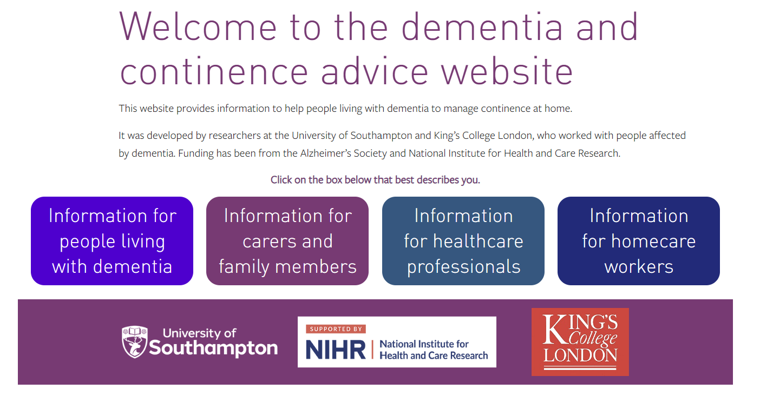

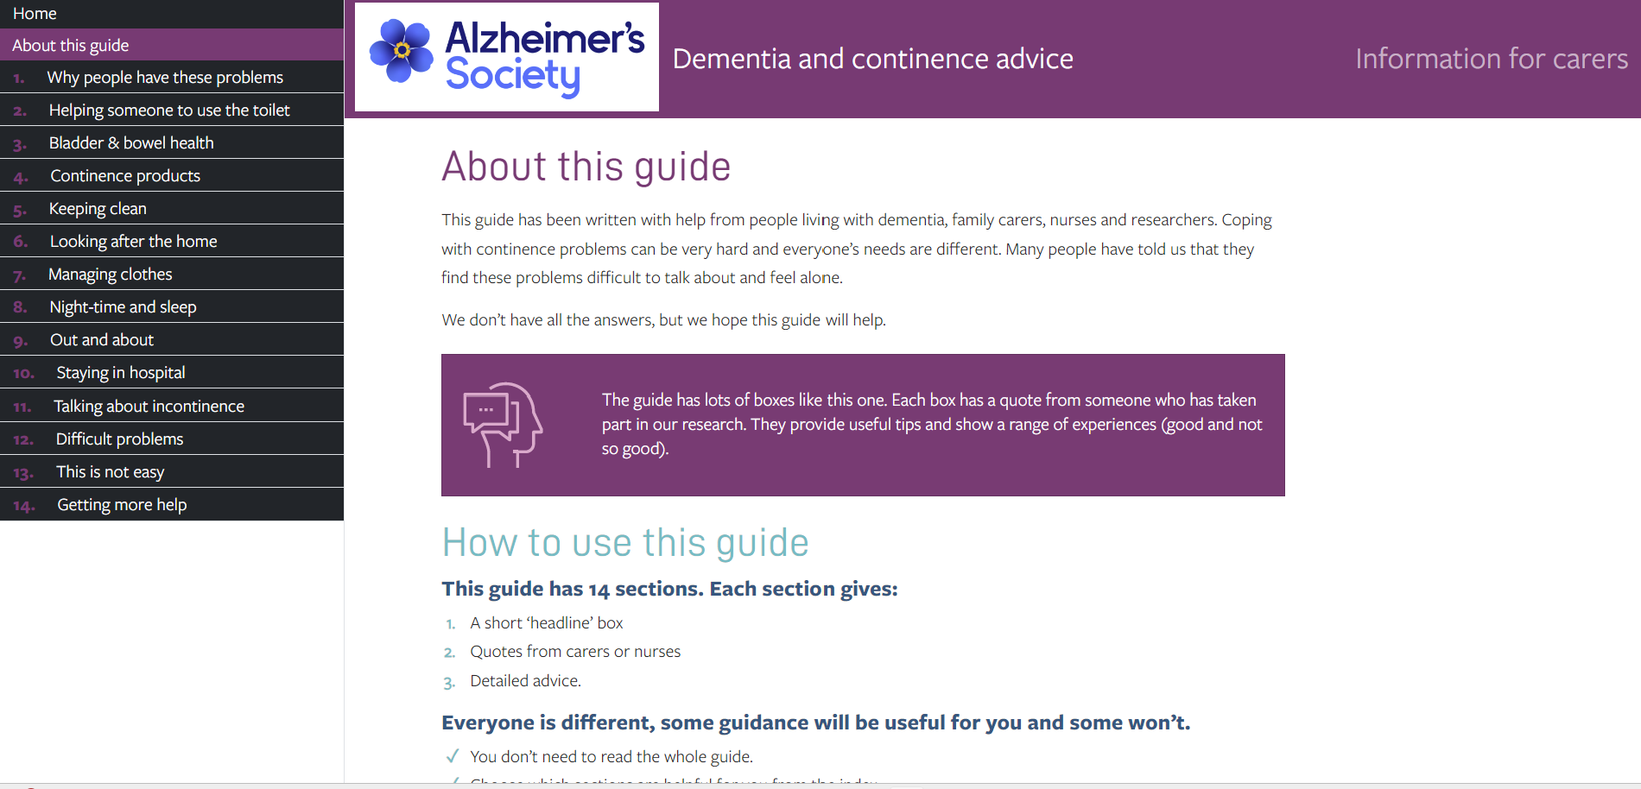

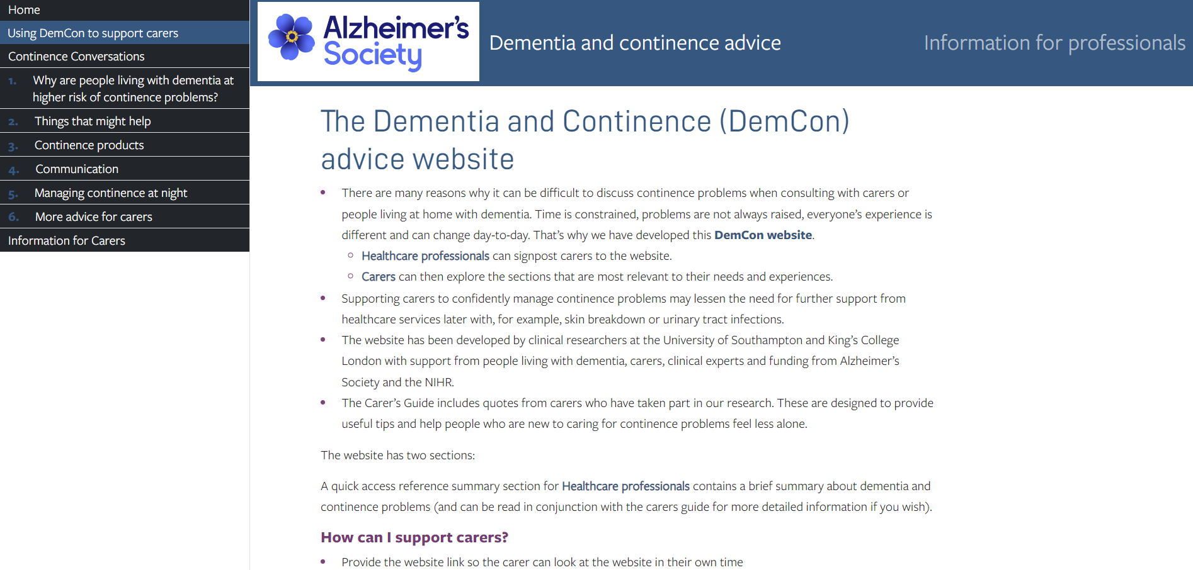
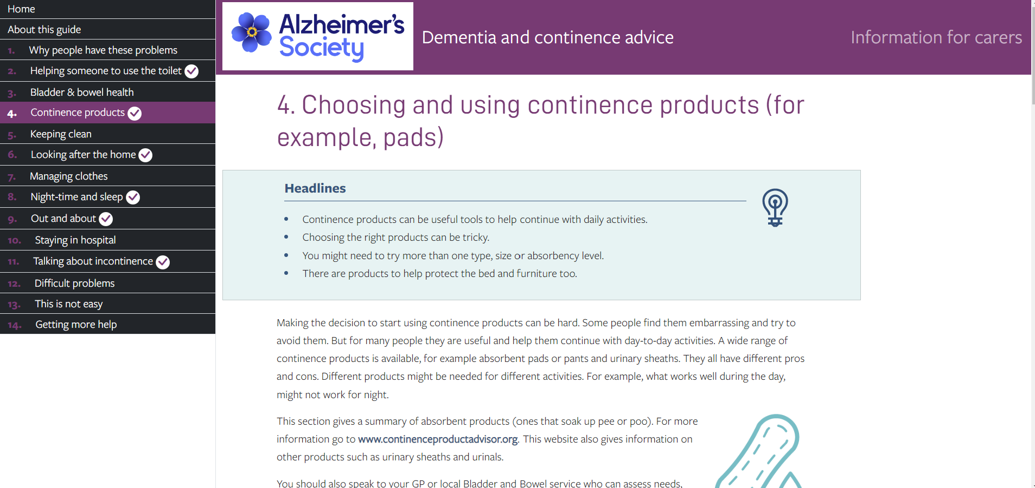
[crosshead] Discussion and recommendations
This article describes the development and testing of the resources on the DemCon website. The purpose of these resources is to improve continence care for people living at home with dementia. One section provides detailed practical guidance for family carers to help them manage a wide range of continence and toilet-use problems plus gives quotes from family carers who have experience of managing these problems. The other section provides evidence-based guidance for any health professional, in particular community nurses, supporting people living with dementia with toilet-use or continence problems, including signposting them to the family carer section of the website.
Health professionals can use the resources in different ways depending on the circumstances. Some examples are given in Box 3 (the nurse should also consider suggesting the carer contacts the local council for a carer assessment).
We know that many people will not mention their concerns about toilet-use or continence problems due to the associated stigma (Murphy et al 2021). Box 4 gives recommendations (‘ASK’) for health professionals providing proactive continence and toilet-use support to people living with dementia and their carers.

[crosshead] Conclusion
The DemCon website resources can be used by any health professional to help provide toilet-use or continence advice to people living at home with dementia and their carers. Carers have long been saying that they need more help with these problems and the DemCon resources help meet this need. In the next phase of this work, we will develop two more sections of the website: bespoke information produced for people living with dementia and another specific to homecare workers. We welcome feedback.

References
Aldridge Z et al (2023) Identifying incontinence and promoting continence in people living with dementia. Nursing Older People; e1451.

https://pubmed.ncbi.nlm.nih.gov/37990584

Bradbury B et al (2024) Healthcare professionals' experiences and views of providing continence support and advice to people living at home with dementia: "That's a carer's job". BMC Geriatrics; 24: 1, 213.

https://pubmed.ncbi.nlm.nih.gov/38424477/

Bradbury K et al (2019) Developing a digital intervention for cancer survivors: an evidence-, theory- and person-based approach. npj Digital Medicine; 2: 85.

https://www.nature.com/articles/s41746-019-0163-4

Grant RL et al (2013) First diagnosis and management of incontinence in older
people with and without dementia in primary care: a cohort study using The Health Improvement Network primary care database. PLoS Medicine; 10: 8, e1001505.

https://pubmed.ncbi.nlm.nih.gov/24015113/

Juliebø-Jones P et al (2021) Understanding the impact of urinary incontinence in persons with dementia: development of an interdisciplinary service model. Advances in Urology; 9988056.
https://doi.org/10.1155/2021/9988056

Murphy C et al (2022) A qualitative study and preliminary model of living with dementia and incontinence at home: beyond containment. Age and Ageing; 51: 1, afab221.

https://academic.oup.com/ageing/article/51/1/afab221/6427234

Murphy C et al (2021) Problems faced by people living at home with dementia and incontinence: causes, consequences and potential solutions. Age and Ageing; 50: 3, 944-954.

https://academic.oup.com/ageing/article/50/3/944/6035277

NHS England (nd) Dementia. england.nhs.uk (accessed 11 March 2024).

https://www.england.nhs.uk/mental-health/dementia

Yardley L et al (2015) The person-based approach to intervention development: application to digital health-related behaviour change interventions. Journal of Medical Internet Research; 17: 1, e30.

https://www.jmir.org/2015/1/e30/

Young Y et al (2020) Permanent transition of homecare recipients with dementia to nursing homes in New York State: risk factors. Geriatric Nursing; 41: 5, 553-558.

https://pubmed.ncbi.nlm.nih.gov/32216955/

Box 1. DemCon study phases
Phase | Description
1 | A systematic review and narrative synthesis of relevant literature undertaken to identify lessons learnt from other similar interventions delivered by health professionals in primary and community settings to people living with dementia and their carers (family carers and homecare workers) (12 relevant papers identified in total).
2 | 31 semi-structured interviews of a wide range of primary care and community health professionals about their experiences of providing support and what might be helpful. Participants included 18 nurses, six of whom specialised in continence, dementia or frailty, and six GPs. In addition, semi-structured interviews were also conducted with 14 homecare workers (Bradbury et al, 2024).
3 | Online resources tested with around 40 family carers, health professionals and homecare workers. Semi-structured interviews helped gain their perspectives on how the website could be improved, including retrospective interviews (with interviewees who had access to the website previously) and ‘think aloud’ interviews (Bradbury et al, 2019) (with interviewees viewing the website for the first time in real-time at the interview). These findings were used to strengthen its real-world usability, usefulness and acceptability.
4 | Resources finalised, made freely available online and publicised with the support of professional and dementia care groups.

Box 2. Potential use of resources – nurse perspectives
“I think any time if we came across a patient and the carer is struggling with managing the patient’s continence, then definitely could recommend it to them and suggest that they have a look. Or family members… it’s not always just carers, it’s family members.” District nurse

“I would have several uses for it. I would certainly use it to refer family and carers to. […] I think the way that it’s laid out and the actual content would be a really good guide for actually developing training both for family, friends but also care staff within care home settings as well.” Nurse consultant – dementia and frailty

“If it was in PDF, we could just print it out and… put a pack together for the patient and post it out to them, or give hand-outs in clinic.” Continence nurse specialist

Box 3. Illustrative examples of using the DemCon website resources in practice

- Mrs Jones was recently diagnosed with dementia and is becoming increasingly confused. At a routine appointment, her husband mentions to the practice nurse that he’s concerned about coping in the future. When asked what worries him most, he says that he doesn’t know how he would manage toilet problems. The practice nurse asks if he would like more information and signposts Mr Jones to the DemCon website.

- A community nurse visits Michael and his daughter at home and notices a smell of urine and that there is a lot of bedding hanging up to dry. When the nurse asks if Michael has any continence problems, his daughter says they are struggling to keep the bed and furniture dry. The nurse shows the daughter the information on furniture and bedding protection on the DemCon website and refers Michael to the bladder and bowel service for assessment.

Box 4. ASK recommendations for using the DemCon resources

A | Ask if there are any problems with getting to or using the toilet. Don’t wait for people to tell you; they probably won’t.
S | Signpost to the DemCon website resources and if possible help the family carer navigate and identify solutions.
K | Keep in mind reversible causes of incontinence, for example UTI or constipation, and refer to specialist services if appropriate.

Fig 1. DemCon website

[screen shot of homepage to be added, with or without Alz Soc logo]

