**Fertility Trends by Birth Order in Britain: Comparison Between England and Wales, and Scotland**

Hill Kulu1, Bernice Kuang2, Sarah Christison1, Ann Berrington2

1 University of St Andrews, UK

2 University of Southampton, UK

**Abstract**

This study uses census-linked administrative data to investigate childbearing trends by birth order in Britain over three decades. This is the first study to investigate longer-term changes in fertility dynamics in Britain by birth order and compare parity-specific fertility by country. First-birth rates declined in the 1990s, slightly increased in the first decade of this century and thereafter decreased. Changes in timing of parenthood are responsible for the changes in first-birth rates. Second- and third-birth rates declined in the 1990s, but remained relatively stable in the first decades of this century. Birth intervals have remained unchanged - changes in quantum are responsible for trends in higher-order-birth rates. Trends over time are similar in England and Wales and Scotland, but with significantly lower second- and third-birth rates in Scotland. Changes in population composition by education and ethnicity explain little of the aggregate fertility trends, or differences between Scotland and England. Both countries have seen very rapid declines in first birth rates, especially among low educated women.

*Keywords: fertility, parity, education, ethnicity, Britain*

**Acknowledgements & Disclaimer**

This research was supported by Economic and Social Research Council grant ES/S009477/1 (Understanding Recent Fertility Trends in the UK and Improving Methodologies for Fertility Forecasting). The authors thank Dr. Joanne Ellison for her contributions to earlier version of this manuscript.

The permission of the Office for National Statistics to use the Longitudinal Study is gratefully acknowledged, as is the help provided by staff of the Centre for Longitudinal Study Information & User Support (CeLSIUS). CeLSIUS is funded by the ESRC under project ES/V003488/1. The authors alone are responsible for the interpretation of the data.

The help provided by staff of the Longitudinal Studies Centre–- Scotland (LSCS) is acknowledged. The LSCS is supported by the ESRC, National Records of Scotland and the Scottish Government. The authors alone are responsible for the interpretation of the data. Census output is Crown copyright and is reproduced with the permission of the Controller of HMSO and the Queen's Printer for Scotland.

**Copyright**

This work contains statistical data from ONS which is Crown Copyright. The use of the ONS statistical data in this work does not imply the endorsement of the ONS in relation to the interpretation or analysis of the statistical data. This work uses research datasets which may not exactly reproduce National Statistics aggregates.

**Ethics**

University of Southampton: Faculty of Social Sciences, Faculty Ethics Committee - ERGO II 56073, 25th March 2020.

University of St Andrews: The School of Geography & Sustainable Development Ethics Committee, acting on behalf of the University Teaching and Research Ethics Committee (UTREC), has approved this application in principle 24th June 2020 (due to covid-related travel restrictions).

All four authors are LS or SLS Approved Researchers; the details about LS and SLS are available on the Calls-Hub website: https://calls.ac.uk/guides-resources/.

**Context**

The first two decades of the 21st century witnessed significant changes in fertility in Europe. While period fertility increased in the first decade, especially in Northern and Western Europe, fertility significantly declined in the second decade and in many countries reached historically low levels (Berrington et al., 2022; Ermisch, 2021, 2023; Hellstrand et al., 2020; Ohlsson-Wijk & Andersson, 2022). Most studies investigating recent fertility decline in Europe emphasise the importance of economic uncertainty (Alderotti et al., 2021; Bueno, 2020; Matysiak et al., 2021; Savelieva et al., 2022), but there is also research underlining the role of ideational change (Lesthaeghe, 2014; Lesthaeghe & Lopez-Gay, 2013), gender inequalities (Goldscheider et al., 2015) and welfare state policies and provisions (Gauthier, 2013; Neyer & Andersson, 2008; Thévenon & Gauthier, 2011). This paper provides new insights as to longer-term changes in fertility dynamics in the UK, providing the first detailed comparison between Scotland, and England and Wales, and within population subgroups according to education and ethnicity. We argue that in order to distinguish between wider explanations for fertility change, we must first understand more precisely the changing demographic components of childbearing from a parity perspective.

Aggregate period fertility measures reflect both the timing and the level of childbearing (or tempo and quantum). For example, the Total Fertility Rate (TFR) may decline because of the postponement of family formation or increased childlessness. The decline may also be caused by decreasing higher order birth rates, either because of the lengthening of birth intervals or a decline in completed family size. Similarly, the TFR may increase due to the stopping of postponement, a decline in childlessness, shortening birth intervals (like in Sweden in the early 1990s see (Hoem, 1990)), or an increase in family size. Fertility timing and levels are often closely related, although not always, e.g. the postponement of family formation is likely to lead to a decline in family size, although not necessarily and early childbearing and low levels of childlessness may nonetheless result in small family size. Therefore, identifying exact changes in childbearing behaviour are of critical importance to understand fertility dynamics. Period fertility may also decline or increase because of the changes in population composition. The role of increased enrolment rates and education level of population (driven by wider societal changes) in a decline in period fertility is a well-known example (Ní Bhrolcháin & Beaujouan, 2012). By contrast, increased numbers of immigrants and ethnic minorities is often considered as a factor behind increased period fertility (Sobotka, 2008; Tromans, 2009).

This study investigates childbearing trends in Great Britain: England and Wales, and Scotland by birth order over the last three decades. The novel contribution of the study is as follows. First, we will determine whether changes in the total fertility rate (TFR) are attributable to the changes in first, second, third or higher-order births, or all of them. Second, we will examine whether and how changes in fertility timing explain fertility trends by parity. Third, we will compare fertility trends by parity between England and Wales, and Scotland. Finally, we will conduct separate analyses by educational level and ethnic origin to understand whether and how changes in population composition explain fertility trends over time and differences across countries.

Mostanalyses of fertility trends use aggregate fertility measures, which are easy to calculate, understand and relate to wider economic, social, political and cultural trends. However, identifying and understanding behavioural changes requires analysis of fertility trends and patterns by birth order (Ní Bhrolcháin, 1987; Rendall & Smallwood, 2003). Childbearing is essentially a sequential process. Individuals may have preferences for a specific family size, but the decision to have a child is made separately for each child. This will depend both on individuals’ and couples’ preferences and socio-economic circumstances. This is the first study to investigate childbearing trends in Britain by birth order over the last three decades and compare parity-specific fertility across the constituent countries. Although the recent fertility change has been studied in detail, the focus has been on England and on the last decade (Ermisch, 2021, 2023). Britain offers a unique opportunity to compare fertility trends and patterns in countries with similar institutional, political and economic environment, but with distinct national identities. Such a comparison is novel in the recent fertility literature, in which studies either compare fertility across European countries (Brini, 2020) or within countries across geographical units (Matysiak et al., 2021; Ohlsson-Wijk & Andersson, 2022).

**Explaining period fertility in Britain**

In 2001, the total fertility rate (TFR) was 1.63. In 2012, after a decade of increase, the figure was 1.93. This consistent increase was particularly noticeable given that in most other European countries fertility fell during the economic downturn of 2008–2011 (Sobotka et al., 2011). Since 2012, fertility has declined to a TFR of 1.60 in 2020 (Berrington et al., 2022). Aggregate fertility dynamics have been similar in the four constituent countries of the UK, but the levels have varied significantly. Rates in Northern Ireland are 5 percent higher than England or Wales (which are more similar) and 10 percent lower in Scotland (Figure 1).

Figure 1. Total fertility Rate in the UK, 1990-2021.

Source: ONS 2021.

There are several competing demographic explanations for the recent changes in UK fertility: changes in the timing of family formation, in population composition, and in the levels of and intervals between higher-order births.

*Changes in the timing of family formation*

The TFR shows the average number of children for a hypothetical cohort of women in a given period of time. However, if the age at childbearing increases then the TFR underestimates cohort fertility (Bongaarts & Feeney, 1998). The stopping of fertility postponement (or, more precisely, deceleration of the rate of postponement) leads to an increase in the TFR. The postponement of childbearing can thus be seen as the cause of low fertility in the 1990s in Europe and the end of fertility postponement as the reason for the upturn experienced by many European countries in the first decade of the 21st century, including Britain (Bongaarts & Sobotka, 2012). A new or further postponement could explain a significant fertility decline since 2012. The role of timing in explaining period fertility trends is indirectly supported by recent studies in the UK and Nordic countries, showing that the decline in first-birth rates explained most of the decline in TFR during the 2010s (Hellstrand et al., 2020; Ermisch, 2021; Ohlsson-Wijk & Andersson, 2022). The postponement of childbearing, versus increased childlessness, is very likely the main reason for a decline in first-birth rates. However, analyses of fertility by cohorts have shown that in Finland, women born in the late 1970s and in the 1980s are projected to have lower lifetime fertility than earlier cohorts (Hellstrand et al., 2020). This suggests that changes in the timing of family formation may account for a substantial part, but not all of recent changes in fertility rates in Britain.

*Changes in higher-order birth levels and intervals*

The upturn in the TFR in the 2000s may have been due to behavioural changes related to second and higher-order births; women were more likely to have a(nother) child, or to have a child after a shorter birth interval. It is possible that childbearing behaviour responded to family friendly policies introduced in the late 1990s (including improved parental leave policies and an expansion of childcare), that have reduced the opportunity costs of childrearing, especially for higher educated women (Sigle-Rushton, 2008). While an increased availability of good quality childcare should reduce the work-family conflict for all women, the reduction of ‘opportunity costs’ and ‘wage penalties’ should be felt the most by highly-educated women with stronger ties to the labour market, thus precipitating a narrowing in educational differences in childbearing. We may also expect to observe some changes in the spacing of birth intervals, although the direction of such changes is more difficult to predict. On the one hand, increased availability of high quality (subsidised) childcare is expected to reduce the pressure to have children within a short time interval, which was the case until recently in the UK when working women had to rely on the combination of expensive childcare offered by the market and informal childcare provided by grandparents or friends (with children) (Ekert-Jaffé et al., 2002). On the other hand, with increased labour force participation rates among women, a growing share of women may not wish to prolong the period of raising young children, which, despite an increased availability of childcare, is still full of interruptions, and complex logistics (Sigle-Rushton, 2008). This may support decreasing differences in the birth intervals between educational groups and a shortening of the birth intervals for all women.

*Changes in population composition*

Increased enrolment in higher education resulted in the postponement of childbearing in European countries and declining period fertility in the 1990s (Frejka & Sobotka, 2008; Neels & de Wachter, 2010; Ní Bhrolcháin & Beaujouan, 2012). UK enrolment rates increased slowly during the first decade of the 21st century, which may explain the cessation of postponement (before further rapid declines in teenage fertility since 2012). With increased enrolment rates in the 1990s, the educational level of British women has increased. Highly educated UK women have lower completed fertility than women with medium or low educational qualifications (Berrington et al., 2015; Kneale & Joshi, 2008), so the upturn in fertility levels in the first decade of the century was surprising in light of educational changes. It is possible that other compositional changes outweighed the fertility-lowering effect of educational changes (e.g. an increased number of immigrants). Alternatively, the fertility levels for highly-educated women may have increased in the 2000s because of the deceleration of postponement of births to older ages and declining fertility differences by educational qualifications, although research to date provides no strong support to the idea of fertility recuperation for highly-educated British women at older ages (Berrington et al., 2015). In contrast, the fertility decline since 2012, possibly due to the postponement of childbearing would be very consistent with changes in educational composition of the UK’s population: increased enrolment rates and education level of the British women.

Immigration to the UK and other European countries has significantly increased since the turn of the century (Raymer et al., 2011). Migrants contribute to increased fertility in the following ways. First, many come from countries where fertility levels are declining, but still high; although the fertility behaviour of migrants changes when they move from one country to another, those who come from high fertility countries still have larger families than women of the country of destination (Andersson & Scott, 2007; Kulu et al., 2017). Second, many female migrants arrive because of marriage or family reunification and have a (first) child soon after migration (and marriage), supporting the well-known relationship between marriage and family formation (Andersson, 2004; Kulu, 2005; Robards & Berrington, 2016). The TFR may thus be high not only for immigrant women who come from high fertility countries, but also for marriage-migrants from low fertility countries because partnered women with short marriage durations are over-represented among them (or in the denominator of the formula for calculation of the TFR) (Toulemon, 2004). Increased numbers of immigrants in the UK may explain the simultaneous upturn of fertility levels in the 2000s (Tromans, 2009).

An increasing number of descendants of post-war labour migrants may also explain upturn in the fertility levels that Western and Northern Europe experienced in the first decade of this century, including Britain. Although fertility levels for descendants of immigrants are usually lower than those for immigrants, for some ethnic groups (e.g. Bangladeshi and Pakistani in Britain) fertility is still considerably higher than that of women with no immigrant parents (or grandparents) (Coleman & Dubuc, 2010; Kulu & Hannemann, 2016). The increased number of immigrants and their descendants suggests that period fertility should have continued to stay relatively high during the second decade of this century. However, since fertility has declined since 2012 the reasons for this decline may be elsewhere.

*Recent changes*

The post-2008 economic recession and subsequent austerity are likely to account for some of the recent fertility decline. Rising unemployment, economic uncertainty and lack of housing affordability may have directly shaped the childbearing plans and behaviour of couples. Further, large cuts in public spending in European countries in the 2010s, including in the UK, reduced social and family-related expenditure and signalled to families that times are hard, creating a pessimistic climate (Sobotka et al., 2011). We do not only expect to observe the postponement of childbearing, but potentially also increasing birth intervals since 2008 or at least after 2012 (i.e. couples wait and see). On the one hand, we might expect fertility rates to decline most among highly-educated women who may perceive childbearing to be an especially risky strategy during recession and economic uncertainty due to very high opportunity costs (Sobotka et al., 2011). On the other hand, recession and subsequent austerity may have hit the lowest educational group hardest; fertility declines at the youngest ages in the UK since 2010 provide some support for this argument (Ermisch, 2021; Berrington et al., 2022). Recent research from Nordic countries also supports that the fertility decline has accelerated among the least educated – those with weaker labour market attachment and lower earnings (Ohlsson-Wijk & Andersson, 2022). Further, fertility has significantly declined not only among those without a degree but also among those with a degree in fields characterised by higher economic uncertainty (Hellstrand et al., 2022).

*Country differences*

At the aggregate level, fertility rates are lower in Scotland than in England and Wales (the latter are relatively similar). The levels are highest in Northern Ireland. Fertility was higher in Scotland than in England in the 1960s and 1970s; however, the fertility decline in Scotland was steeper and since the early 1980s, fertility levels have been consistently lower in Scotland than in England and Wales. For example, in 2021, the TFR was 1.31 in Scotland, 1.49 in Wales and 1.62 in England. The reasons for the country differences are not clear. Previous research found that first-birth rates have been relatively similar in England and Scotland, but that greater delays to second and third births were characteristic of Scotland’s relatively low fertility (Graham et al., 2007). The study emphasised longer birth intervals in Scotland, although it remained unclear whether longer birth intervals ultimately led to lower second- and third-birth levels. Their analysis of fertility intentions showed no evidence that Scottish women intended to have fewer children than English women. However, a recent study by Berrington and colleagues (2023) showed that while there are no differences in intentions to have a first birth, Scottish mothers are slightly less likely to have a firm intention to have additional births.

To sum up, this study investigates the impact of the timing of family formation, the timing and level of higher-order births, and population composition on childbearing dynamics in Britain over the past three decades. Based on previous research, firstly we expect to observe significant fluctuation in the first birth rates, which are likely driven by changes in the timing of family formation. Second, we also expect to observe a change in second-, third-, and also fourth-birth rates, which would largely follow patterns similar to first births: a decline in the 1990s, increase in the 2000s, followed by a new decline in the 2010s. However, it is less clear how much the rates of higher-order births vary over time. It is also less clear whether changes have mostly happened because of birth intervals or higher-order birth levels. Third, we expect to observe similar first-birth rates in England and Wales and in Scotland, but lower second-, third- and fourth-birth rates in Scotland. Again, it is important to determine whether Scottish women simply have longer birth intervals or whether they are also less likely to have a second, third and fourth child. Finally, we expect changes in population composition to play a limited role in recent fertility fluctuations; most educational and ethnic groups are expected to follow largely similar trends, although it is likely that the recent decline in fertility was accelerated among disadvantaged population groups, as in Nordic countries. We are convinced that a detailed examination of the childbearing trends across population subgroups will improve our understanding of how compositional and other factors have shaped the fertility behaviour of women in Britain.

**Methodology**

We examine childbearing trends by birth order, which is necessary to detect underlying changes in fertility patterns (Bhrolchain, 1987; Murphy & Berrington, 1993; Smallwood, 2002). We calculate annual parity-specific fertility rates using hazard regression (or survival analysis) (Hoem, 1987; Kulu & Hannemann, 2016; Ohlsson-Wijk & Andersson, 2022). Our analytical strategy is as follows. For first births, we calculate annual first-birth rates standardised for exact age of woman by fitting a proportional hazards regression model with three covariates: woman’s age, calendar time, and country (England-Wales and Scotland). For second, third and fourth births, we calculate annual parity-specific rates standardised also for duration since last birth (Andersson, 1999; Hoem, 1990; Kulu & Hannemann, 2016). This allows us to determine whether the recent changes in the TFR are attributable to the changes in first, second, third or fourth-birth rates, or all four, and whether this is similar for all Britain’s countries.

Next, we calculate annual first-birth rates by age of woman. This provides us with valuable information on whether the (expected) increase in first birth rates in the first decade of this century is explained by the stopping of postponement of childbearing combined with the ‘recuperation’ effect or rather by an increased share of women who have children. Similarly, we will calculate annual duration-specific rates for second and third births to detect a possible acceleration of childbearing in the past decade and deceleration thereafter. We examine whether there has been a shortening/lengthening of birth intervals or an increase/decrease in parity?

The basic model can be formalised as follows:

$lnh_{i}(t)=\ln{h_{0}}(t)+\sum_{l}{α_{l}x_{il}(t)}+βz_{i}$, (1)

where *hi(t)* denotes the hazard of giving *n*th birth for individual *i* at duration *t*. *h*0(*t*) is the baseline risk, either by an individual’s age (for birth first) or the time since previous birth (for second, third or fourth birth). *xil(t)* denotes time-varying and time-constant covariates such as calendar year and age at previous birth (if any), with parameters *αl* measuring their effect. *zi* is a variable for country, with *β* measuring its impact.

However, the individual-level administrative data used in this paper have to be analysed within a trusted research environment and cannot be merged due to issues of data confidentiality. To overcome this issue, we will use a count data approach to explicitly compare parity-specific fertility rates across UK’s countries adjusted to various covariates (Hoem, 1987; Preston, 2014).

We can specify the baseline hazard as piecewise constant:

$lnh_{0}\left(t\right)=\ln{h_{j}}$ for *t* in $\left[t_{j}, \right.\left.t_{j+1}\right)$ (2)

The basic model in equation 1 then becomes as follows:

$lnh_{jm}=\ln{h_{j}}+\sum_{l}{α_{l}x_{jml}}+βz_{jm}$, (3)

where *hjm* is the hazard for time period *j* (e.g. age group) and (covariate) category *m*. Holford (1980) and Laird and Olivier (1981) have demonstrated that log-linear models for the cell means of contingency tables with Poisson data are equivalent to log-linear hazard models for survival data, with piecewise constant baseline hazard and categorical covariates (Holford, 1980; Laird & Olivier, 1981). The individual-level data will be used to calculate aggregated event-time (or occurrence-exposure) tables for each country, which will be aggregated by different combinations of variables; the country files will then be merged into one common database and the data will be analysed using a Poisson regression model (Kulu et al., 2017). Using this approach, we can explicitly compare childbearing trends by parity in England and Wales and in Scotland.

**Data and their quality**

*ONS LS and SLS*

Vital statistics are useful to calculate aggregate fertility measures, but do not provide sufficient information to examine fertility dynamics by parity; until 2012 in England and 2013 in Scotland, information on birth order was collected only for the births that occurred in marriages (ONS, 2023). Although information on birth order is now available for the births themselves, there are no annual data on the risk population by parity. The risk population has to be estimated using survey data (e.g. Annual Population Survey). Also, only limited information is available on individuals’ socio-economic characteristics. Many researchers have analysed fertility by parity using longitudinal survey data instead (Ermisch, 2021; Ermisch. 2023). However, the analysis of small-scale survey data, sometimes on a specific cohort, has its own limitations. Most importantly, they rarely provide the researchers with reliable information on childbearing trends over time: there is considerable imprecision in the estimates of fertility trends by birth order; the analysis of trends in parity-specific fertility by population subgroups (e.g. education) would be not feasible. Further, the existing longitudinal surveys do not have large enough sample sizes for cross-national comparison. We will use data from the ONS Longitudinal Study (LS), and Scottish Longitudinal Study (SLS). The LS was initiated in 1971 and it contains linked census and vital events data on a 1 per cent sample of the population of England and Wales, currently containing more than 1 million records. The dataset is attractive for fertility research as it contains full fertility histories for women as far back as those who were aged 15 in 1971 and for those who became 15 in subsequent years. The LS thus allows us to calculate parity-specific birth rates, standardised for demographic characteristics (woman’s age and time since the last birth, if any), as well as characteristics collected in the census (education, ethnicity) (Robards et al., 2011). The SLS was initiated in 1991 and contains linked census and vital events data on a 5.3 per cent sample of the population of Scotland, currently containing more than 250 thousand individuals. The datasets allow the construction of fertility histories for women who were interviewed in 1991 and for those who became 16 in subsequent years. The SLS thus allows us to calculate parity-specific birth rates over past three decades standardised for demographic characteristics (the woman’s age and the time since last birth if any), and characteristics collected in the Scottish census.

*Study design and sample*

Our study sample are women born in 1956 and later. They are followed from age 15 in England and Wales and 16 in Scotland. Births are currently linked to both LSs up to 2017. We can construct fertility histories for all women born in 1956 and later. Since 2001, when the oldest women in our sample became 45, we know the parity of (most) women of reproductive ages in England and Wales. We can calculate parity-specific fertility rates earlier than this, e.g. since 1990s when the oldest women in the sample were in their late 30s, which covers most women of reproductive age. The SLS began two decades later in 1991. Fortunately, we can determine the parity of all Scottish women aged 16 to 49 as early as 1991. In SLS data, household members can be linked and their relationship (e.g. mother and her children) can be identified at each census year (including 1991). Still, some caution is needed with the application of the own-child method because for older women some children might have already left the parental home. Therefore, we calculate parity only for women aged 16-35 in 1991, assuming the children of most women that age would still live with them. Nevertheless, parity-specific fertility rates can also be calculated for Scotland since the 1990s.

Individuals enter the study when they become 15 (or 16 in Scotland) or arrive in the UK. We exclude immigrants who arrive aged 15 (or 16 in Scotland) or older from the study as we cannot determine their parity. We thus only analyse fertility of the UK-born women and immigrants who arrived aged 0-15. Individuals exit the study at age 50, death, emigration or lost to follow up. Individuals who are present at one census and absent at the subsequent census are censored at mid-point between censuses. We exclude a small number of women who are not present at any census (but have information on events, such as births) or are untraced (are present at census, but have no information on events). We include the individual’s education and ethnicity in our analysis. We use the following educational categories: High (…), Medium (…) and Low (…). The ethnicity variable is defined as follows: White British and Other. The latter group includes individuals of all other ethnicities either UK-born or immigrants who arrived in the UK during their childhood.

For first births, the risk population is 167,050 women in England and Wales and 53,301 in Scotland; for second births, the risk population is 90,930 and 29,873, for third births 60,750 and 24,372 and for fourth births 18,969 and 6,772, accordingly (Table 1). There are sufficient events to conduct detailed analysis of fertility trends over years by parity.

Table 1. The number of women and births in the study sample.

|  |  |  |
| --- | --- | --- |
|  | Women | Births |
| *First Births* |  |  |
| England & Wales | 167,050 | 92,060 |
| Scotland | 53,301 | 23,352 |
| *Second Births* |  |  |
| England & Wales | 90,930 | 64,840 |
| Scotland | 29,873 | 18,039 |
| *Third Births* |  |  |
| England & Wales | 60,750 | 19,880 |
| Scotland | 24,372 | 6,585 |
| *Fourth Births* |  |  |
| England & Wales | 18,959 | 6,200 |
| Scotland | 6,772 | 1,447 |

Source: Authors’ calculations using ONS LS and SLS.

*Data quality*

Quality of the ONS LS and SLS data can be assessed. We can compare estimates from the vital statistics and those from the two LSs, e.g. on aggregate fertility trends, or on the mean family size by birth cohorts. Our approach is to exploit both vital statistics and census data because of the uncertainty with the size of the risk population in the UK when calculating demographic measures. Estimates based on census data should be most accurate; in census years, the discrepancy between the risk populations from different sources should be minimal as census data are used to correct estimates of vital statistics. Nevertheless, we calculate age-specific fertility rates and the TFR for England and Wales and for Scotland in 2011 using the 2011 census data (10% microdata sample), vital statistics and ONS LS and LS. Our analysis shows that overall, the TFR estimates from alternative sources are relatively similar, but the two LSs’ data may slightly underestimate fertility levels. The reason for the discrepancy might be that some births to the youngest women have not been linked in the LSs data, and some people who give birth in a census year are not captured by the census (for further details, see Ellison et al., 2023).

**Fertility trends in Britain by birth order and country**

*First birth*

Figure 2 presents relative first birth rates separately in England and Wales, and in Scotland over the last three decades. The rates are standardised for women’s age and presented relative to fertility in England and Wales in 2000, which is the reference point. We see that the rates declined in the 1990s, then increased in the first decade of this century, followed by a new decline in the last decade. The trends are very similar in England and Wales and in Scotland.

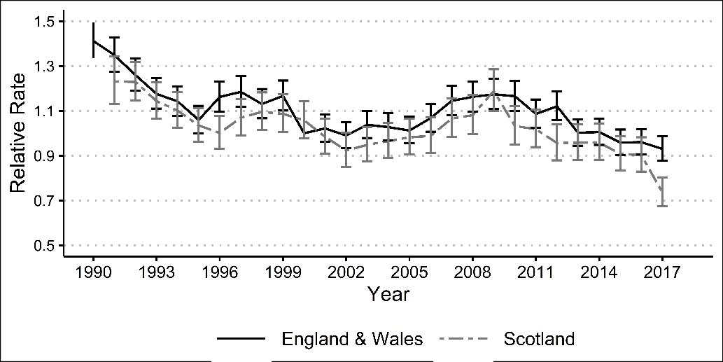

Figure 2. Relative first birth rates in Britain, 1990-2017. Adjusted for women’s age.

Notes: Reference group: England, 2000; 95% CIs.

Source: Authors’ calculations using ONS LS and SLS.

Next, we disaggregate the first birth rates by age. For England and Wales, first birth rates in all ages declined in the 1990s (Figure 3); as we see, this was part of a longer-term decline. In the first decade of this century, the decline continued in ages 15-19. In contrast, first birth rates in all other ages increased. Since the beginning of 2010s, we observe diverging trends: first birth rates have declined in all ages below 30 or even 35; they have increased in ages 35+. Clearly, it seems that the postponement of childbearing, the subsequent stopping of postponement (or a recuperation) and a further postponement have characterised the first birth trends in England and Wales over the past three decades. First birth rates and trends by age are very similar in Scotland.

*England and Wales Scotland*

Figure 3. Relative first birth rates in Britain by age, 1990-2017.

Notes: Reference group: England, aged 30-34, 1996-98; 95% CIs.

Source: Authors’ calculations using ONS LS and SLS.

The trends in the average age at first birth present a consistent story: In the early 1990s, the median age at first birth was around 28 years for both England and Wales and Scotland (Figure 4). The age of family formation increased in the 1990s. However, this increase stopped in the 2000s, reflecting the stopping of postponement (seen in the same time period in Figure 3). The age at first birth may even have slightly declined in the second half of the 2000s. Since then, the median age at first birth has further increased and in the period of 2015-17 it was 31.8 in England and Wales and 32.2 in Scotland.

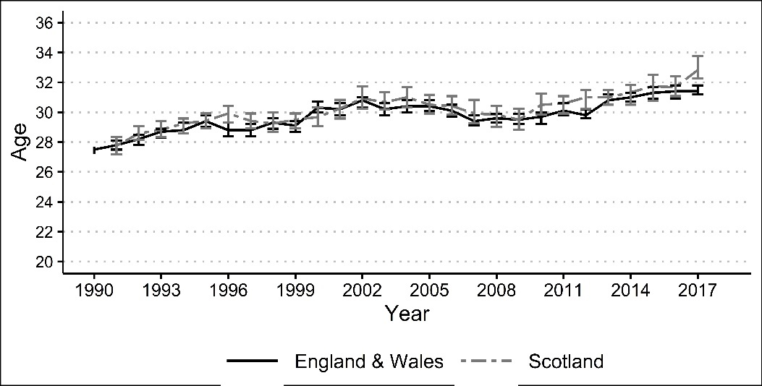

Figure 4. Median age at first birth in Britain by age, 1990-2017.

Notes: 95% CIs.

Source: Authors’ calculations using ONS LS and SLS.

*Second births*

Figure 5 presents relative second birth rates. The rates are standardised for the time since first birth and for women’s age at first birth and are presented relative to fertility in England and Wales in 2000-01. For England and Wales, we see that the second birth rates declined in the 1990s. They slightly increased in the first decade of this century; since then, they have stayed relatively stable. The trends are very similar in Scotland; however, the increase in the first decade of this century was perhaps slightly larger in Scotland than in England and Wales and it seems that second birth rates have declined in Scotland in the most recent period. Nevertheless, overall rates are lower in Scotland supporting that Scottish women are less likely to have a second child than women in England and Wales.

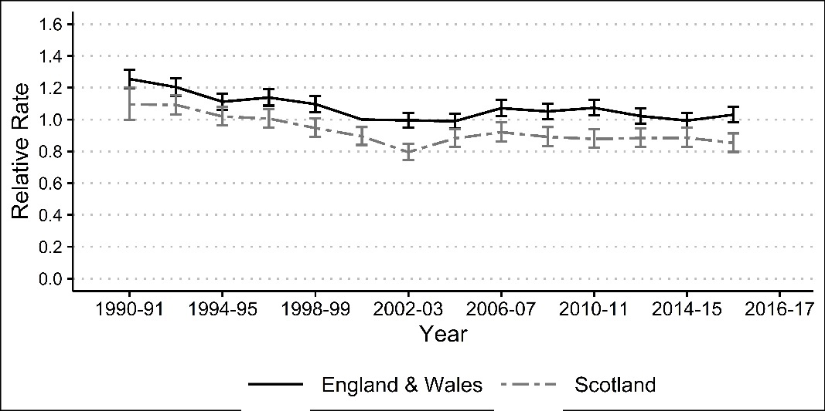

Figure 5. Relative second birth rates in Britain, 1990-2017. Adjusted for time since first birth and women’s age at first birth.

Notes: Reference group: England, 2000-01; 95% CIs.

Source: Authors’ calculations using ONS LS and SLS.

Next, we examine the interval between first and second births. For example, we investigate whether fertility decline happened because the birth intervals changed (i.e. lengthened) in the 1990s or whether all duration-specific rates declined? We see that most women in England and Wales have their second child between 2 and 4 years after their first birth (Figure 6). Interestingly, birth intervals have stayed relatively stable over the years. There is no evidence of lengthening or shortening of intervals (i.e. different time trends by duration since first birth). Clearly, second birth rates declined in the 1990s at all durations suggesting that women experienced a declining likelihood of having a second child. Again, the patterns are relatively similar in Scotland: most women have their second child between 2 and 4 years after their first birth and birth intervals have stayed relatively stable over years. However, overall second birth rates are lower in Scotland, and the difference between England and Wales, and Scotland are more pronounced for second births than for first births.

*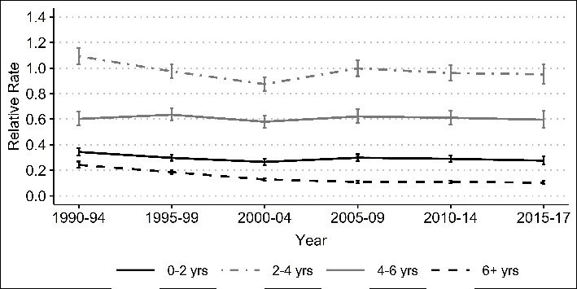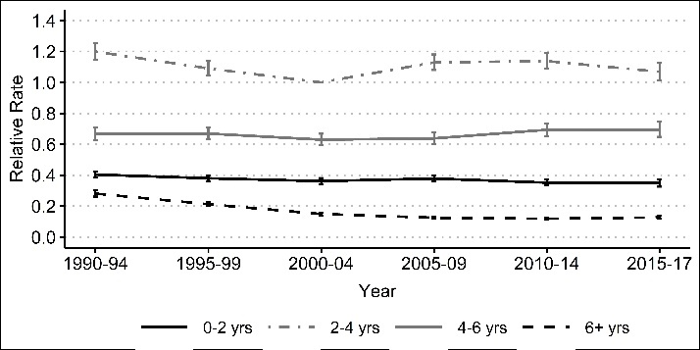England and Wales Scotland*

Figure 6. Relative second birth rates in Britain by time since first birth, 1990-2017. Adjusted for women’s age at first birth.

Notes: Reference group: England, duration 2-4, 2000-01; 95% CIs.

Source: Authors’ calculations using ONS LS and SLS.

*Third births*

Figure 7 presents trends in third birth rates. The rates are standardised for the time since second birth and for women’s age at second birth. For England and Wales, we see that similarly to first and second births, third birth rates significantly declined in the 1990s. We observe an increase in third birth rates since the turn of the century; interestingly, this increase seems to have continued in the second half of the 2010s. The trends in third-birth rates are similar in Scotland. The rates declined in the 1990s, and increased in the 2000s; they stayed stable in the early 2010s, but declined thereafter. The analysis also shows that the likelihood of having a third birth is significantly lower in Scotland than in England and Wales.

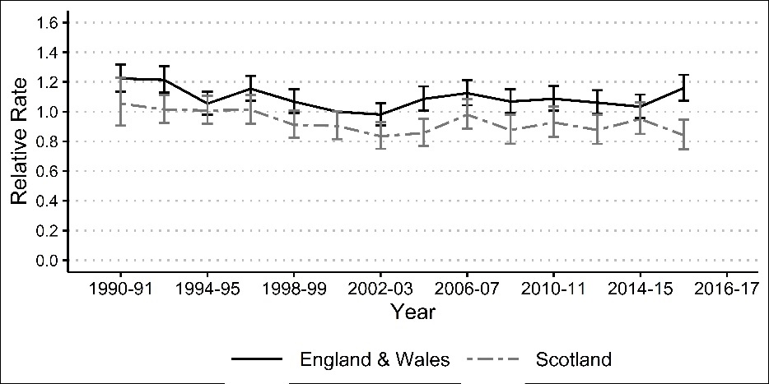

Figure 7. Relative third birth rates in Britain, 1990-2017. Adjusted for time since second birth and women’s age at second birth.

Notes: Reference group: England, 2000-01; 95% CIs.

Source: Authors’ calculations using ONS LS and SLS.

Do we observe any changes in birth intervals? Again, birth intervals have stayed relatively stable both in England and Wales and in Scotland (Figure 8). Clearly, the third birth levels declined in the 1990s, suggesting that women had a declining likelihood of having a third child; however, the likelihood increased in the turn of the century. The likelihood of having a third birth is significantly smaller in Scotland than in England and Wales (except at longer durations when they are the same).

*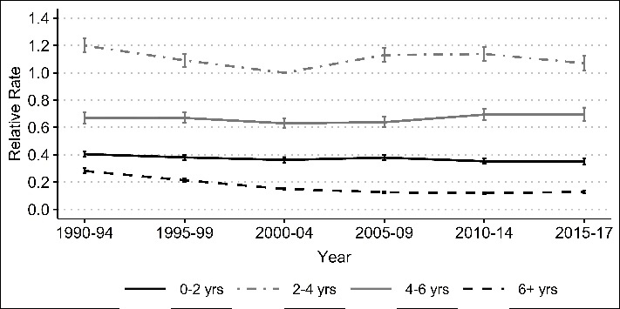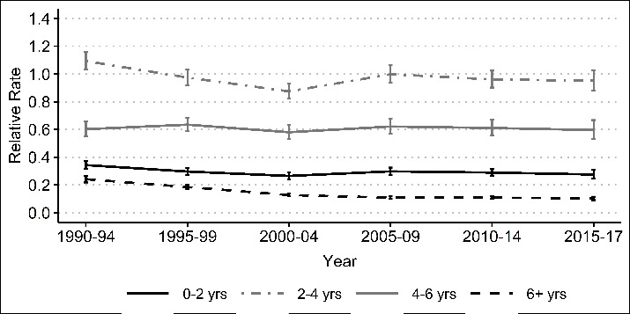England and Wales*  *Scotland*

Figure 8. Relative third birth rates in Britain by time since second birth, 1990-2017. Adjusted for women’s age at second.

Notes: Reference group: England, duration 2-4, 2000-04; 95% CIs.

Source: Authors’ calculations using ONS LS and SLS.

Finally, Figure 9 presents fourth birth rates over three decades. The rates are adjusted for time since the third birth and the women’s age at third birth. We see that both England and Wales and Scotland witnessed an increase in fourth order fertility in the first decade of this century. Since then, there has been a decline, especially for Scotland. Fourth-birth rates are significantly lower in Scotland compared to England and Wales.

Figure 9. Relative fourth birth rates in Britain, 1990-2017. Adjusted for time since third birth and women’s age at third birth.

Notes: Reference group: England, 1998-2003; 95% CIs.

Source: Authors’ calculations using ONS LS and SLS.

**Fertility trends in Britain by birth order, ethnic origin and education**

*First births*

Next, we investigate whether and how much changes in population composition by education and ethnic origin explain fertility trends over the past three decades. We then analyse fertility trends within educational and ethnic origin groups. Figure 10 reports bi-annual first-birth rates with and without adjusting for education and ethnicity. For England and Wales, we see that the patterns slightly change over the years with the adjustments, for Scotland they almost stay the same. Our further analysis shows that the increased share of highly educated women and ethnic minorities (who on average have had lower rather than higher first-birth rates in recent years) explain to an extent the lower first-birth rates in England and Wales in the last decade. In Scotland, the change over years is negligible obviously because the share of ethnic minorities is still relatively low.

*England and Wales Scotland*

Figure 10. Relative first birth rates in Britain with and without adjusting for education and ethnicity, 1990-2017. Adjusted for women’s age.

Notes: Reference group: 2000-01 for each country; 95% CIs.

Source: Authors’ calculations using ONS LS and SLS.

Figure 11 presents first-birth rates over three decades by three educational groups. We have calculated them separately for ages 15 to 29 and 30 to 49. This is because of significant differences in the timing of family formation by educational groups, which complicates the interpretation of average trends. For both countries, we see that low educated women have the highest and highly educated the lowest first-birth rates in ages 15 to 29 (Figure 11a). This is largely expected given that highly educated women start childbearing significantly later than low and medium educated women, so we cannot rule out that differences are due solely to timing. We observe two interesting patterns. First, in the early 1990s, the medium educated had first-birth levels similar to those of low educated women; their fertility levels declined in the late 1990s and since then have been relatively low, i.e. similar to those of women with high education. However, it is not clear whether the change is real or related to the measurement issues (educational level is measured at population censuses, i.e. every ten years). Still, if the former, it is possible that with the expansion of higher education in the second half of the 1990s, many medium educated women also benefited from the new opportunities and participated in further training. Second, first birth rates of low educated women declined in the last decade both in England and Wales and Scotland consistent with theories emphasising the role of economic uncertainty among those with the least resources.

*England and Wales Scotland*

Figure 11a. Relative first birth rates in Britain by education (women aged 15-29), 1990-2017. Adjusted for women’s age.

Notes: Reference group: Low educated, 2000-04 for each country; 95% CIs.

Source: Authors’ calculations using ONS LS and SLS.

Patterns of first-birth rates at ages 30 to 49 by education are largely as expected. For England and Wales, overall, highly educated women have the highest and low educated women the lowest fertility levels (Figure 11b). The patterns are similar in Scotland. Regarding the trends, the decline in the 1990s was the largest among the medium educated, suggesting that they were responsible for a significant portion of the overall decline in first-birth rates in the 1990s. Interestingly, first-birth rates among the highly educated in their 30s increased in the first decade of the century suggesting a recuperation among this population subgroup, which may also explain fertility increase in the 2000s. The rates among the low educated remained stable in England and Wales, but slightly declined in Scotland. Reading the figures 11a and 11b together suggests that first-birth rates of low educated women in Scotland declined in the last decade.

*England and Wales Scotland*

Figure 11b. Relative first birth rates in Britain by education (women aged 30-49), 1990-2017. Adjusted for women’s age.

Notes: Reference group: Low educated, 2000-04 for each country; 95% CIs.

Source: Authors’ calculations using ONS LS and SLS.

Finally, we investigated trends in first births by ethnic origin by distinguishing 1) the white British population and 2) all other ethnicities (including both UK-born individuals and those who immigrated as children). We only studied England and Wales as the size of ethnic minority population in Scotland is small. Figure 12 shows that both white British and ethnic minority had similar first-birth rates in the early 1990s. In the beginning of this century, first-birth rates significantly increased among white British women; the increase was smaller among ethnic minority women, as a result their fertility levels remained lower. Ethnic minority women experienced a fertility decline in the last decade, showing continuously lower first-birth rates.

Figure 12. Relative first birth rates in England and Wales by ethnicity, 1990-2017. Adjusted for women’s age.

Notes: Reference group: White British, 2000-04; 95% CIs.

Source: Authors’ calculations using ONS LS.

*Second births*

Figure 13 shows bi-annual second birth rates relative to the 2000-01 period. The rates are standardised for time since first birth and women’s age at first birth. They are presented with and without adjusting for education and ethnicity, separately for England and Wales, and for Scotland. Again, as with first births we see only marginal changes over time when comparing the results of the two models, emphasizing the limited effect of population composition on second-birth rates. Interestingly, however, the unadjusted rates are slightly lower in the 1990s and higher in the 2010s. This is largely related to the changes in population composition by education, i.e. the increased share of population with high education. However, as we will see, high educated women have higher second-birth rates than low educated, a pattern which requires further investigation and explanation.

England and Wales Scotland*

Figure 13. Relative second birth rates in Britain with and without adjusting for education and ethnicity, 1990-2017. Adjusted for time since first birth and women’s age at first birth.

Notes: Reference group: 2000-01 for each country; 95% CIs.

Source: Authors’ calculations using ONS LS and SLS.

Next, we study second-birth rates by educational level, which are shown in Figure 14. For England and Wales, we see that second-birth rates are consistently higher among highly educated women compared to medium and low educated women who exhibit similar levels to each other. The patterns are relatively similar in Scotland where highly educated women have also the highest second-birth rates. For both cases, we see a decline among medium educated women in the 1990s, similar to the trends we observed for first births. There may be several reasons why second birth rates are higher among highly educated women. First, highly educated women have their first child much later than their medium and low educated counterparts, and overall, second-birth rates decline with age. Second, highly educated women may have shorter birth intervals given that they have children later and have less time to reach desired family size, increasing the second birth rates. Third, highly educated women who become mothers may be a select group and more likely to have a second child than low or medium educated mothers who are less selected into motherhood (Kreyenfeld, 2002).

* England and Wales Scotland*

Figure 14. Relative second birth rates in Britain by education, 1990-2017. Adjusted for time since first birth and women’s age at first birth.

Notes: Reference group: Low educated, 2000-04 for each country; 95% CIs.

Source: Authors’ calculations using ONS LS and SLS.

To test the role of age at childbearing, we compared second-birth rates with and without adjusting for age at first birth. Once we adjust the rates for age at first birth, the differences between the groups increase by a half, suggesting that a significant portion of higher second-birth rates among the highly educated is attributable to the fact that they have children in (older) ages when fertility levels are low (e.g. due to lower fecundity). However, our further analysis revealed that they have relatively high second-birth rates even without adjusting for age at first birth. What is the reason – the timing of second births, i.e. shorter birth intervals or the higher likelihood of having a second child? Figure 15 shows second birth rates by duration since first birth and education and period. For England and Wales, we see that for all three educational groups, second-birth rates follow a rising-falling pattern: they increase and are the highest two to four years since first birth and thereafter decline. However, there are some differences across the groups. Second-birth rates are elevated between two to four years since first birth among highly educated women, suggesting that they do have shorter birth intervals than medium and low educated women. This corresponds to expectations – they have less time to achieve a desired family size (Rendall & Smallwood, 2003). At all other durations their second-birth rates are relatively similar to those of medium and low educated. Briefly, second-birth rates for highly educated women are higher also because of shorter birth intervals, although there seems to also be a selection effect, i.e. highly educated mothers are more likely to have a second child than medium and low educated mothers (Kravdal 2001).

*England and Wales*

*Scotland*

Figure 15. Relative second birth rates in Britain by education and time since first birth, 1990-2017. Adjusted for women’s age at first birth.

Notes: Reference group: Low educated, duration 2-4, 2000-09 for each country; 95% CIs.

Source: Authors’ calculations using ONS LS and SLS.

Finally, we explore the trends in second births by ethnic origin in England and Wales. Figure 16 shows that overall, the trends have been relatively similar among white British and ethnic minority women, except in the 1990s when second-birth rates were higher, although declining among white British women. Since the beginning of this century, second-birth rates have been consistently higher among ethnic minority women, compared to the white British population. Our further analysis (of birth intervals) shows that the former have higher second-birth levels than the latter, i.e. the likelihood of mothers to have a second child.

Figure 16. Relative second birth rates in England and Wales by ethnicity, 1990-2017. Adjusted for time since first birth and women’s age at first birth.

Notes: Reference group: White British, 2000-04; 95% CIs.

Source: Authors’ calculations using ONS LS.

*Third births*

Figure 17 presents third-birth rates in England and Wales and in Scotland between 1990 and 2017. The rates are adjusted for time since second birth and the women’s age at second birth. Again, as with first and second births, the patterns change very little once we also adjust the rates for education and ethnicity. This suggests that changes in the educational and ethnic composition of Britain’s population have played negligible (if any) role in fertility dynamics over the last three decades.

*England and Wales Scotland*

Figure 17. Relative third birth rates in Britain with and without adjusting for education and ethnicity, 1990-2017. Adjusted for time since second birth and women’s age at second birth.

Notes: Reference group: 2000-02 for each country; 95% CIs.

Source: Authors’ calculations using ONS LS and SLS.

Figure 18 shows third-birth rates by educational groups separately for England and Wales and for Scotland. For both England and Wales and for Scotland, we observe higher third-birth rates among highly educated women in the 1990s compared to medium and low educated women. However, since the beginning of the 21st century, the rates have gradually converged across educational groups. It is important to note that the rates are adjusted for age at second birth; if we do not adjust for age at second birth (i.e. only include duration since second birth) then third-birth rates are lower for highly educated women compared to low educated women.

England and Wales Scotland*

Figure 18. Relative third birth rates in Britain by education, 1990-2017. Adjusted for time since second birth and women’s age at second birth.

Notes: Reference group: Low educated, 2000-04 for each country; 95% CIs.

Source: Authors’ calculations using ONS LS and SLS.

Again, we investigate possible differences in birth intervals between educational groups and changes over the years. Figure 19 demonstrates that similar to second births, all educational groups have the highest birth rates two to four years since previous birth. However, the rates are elevated for highly educated women, especially in the 1990s suggesting that the shorter birth intervals largely explained their relatively high third-birth rates in the 1990s and 2000s. Interestingly, there has been a convergence in birth intervals across educational groups, over time.

*England and Wales*

*Scotland*

Figure 19. Relative third birth rates in Britain by education and time since second birth, 1990-2017. Adjusted for women’s age at second birth.

Notes: Reference group: Low educated, duration 2-4, 2000-09 for each country; 95% CIs.

Source: Authors’ calculations using ONS LS and SLS.

Finally, we examine the trends in third-birth rates by ethnic groups distinguishing white British and all other groups. Figure 20 shows that ethnic minority women have higher third-birth rates between 1990s and 2017 compared to white British women. This is very much consistent with previous studies showing that ethnic minority women are more likely to have a third birth (or larger families) (Kulu et al., 2017). Interestingly, however, the differences are consistent over the years and we observe no convergence in the trends between white British and ethnic minority women.

Figure 20. Relative third birth rates in England and Wales by ethnicity, 1990-2017. Adjusted for time since second birth and women’s age at second birth.

Notes: Reference group: White British, 2000-04; 95% CIs.

Source: Authors’ calculations using ONS LS.

**Conclusion**

This is the first study to investigate childbearing in Britain by birth order over three decades and compare parity-specific fertility by country. Britain has offered us a unique opportunity to compare parity-specific fertility trends across countries, which share similar institutional and socio-economic environment, but exhibit distinct national identities. The analysis of the ONS LS and SLS data shows firstly, declining first-birth rates in the 1990s, a small increase in the first decade of this century and a new decline thereafter. Second, the timing of parenthood (postponement or the stopping of it) rather than changes in childlessness has been mostly responsible for the changes in first-birth rates. Third, second-, and third-birth rates declined in the 1990s; second-birth rates remained relatively stable in the first decades of this century, whereas third-birth rates slightly increased. Fourth, birth intervals have remained relative stable; therefore, changes in the second- and third-birth levels are responsible for the trends in second- and third-birth rates. Fifth, both declining first-, second-, and third-birth rates contributed to declining fertility in the 1990s. Changes in first-birth rates have explained most of the fluctuations in aggregate fertility since the turn of the century. Sixth, changes in population composition by education and ethnicity explained little in recent fertility dynamics in Britain. Finally, we observed relatively similar fertility trends and timing in England and Wales and in Scotland, but significantly lower second- and third-birth rates in Scotland.

The study largely supports the findings of previous research in Europe showing that changes in first-birth rates have mostly driven trends in aggregate period fertility (Ermisch, 2021, 2023; Hellstrand et al., 2020; Ohlsson-Wijk & Andersson, 2022). Our aim was not to precisely quantify the role of changes in first births in the dynamics of aggregated fertility; nevertheless, it is clear that TFR trends largely followed the trends in first-birth rates, especially in the past decade. It was also expected that the timing of family formation has played the key role in changing first-birth rates. Our analysis suggests that the postponement of family formation was responsible for a decline in first-birth rates in the 1990s, whilst the stopping of this postponement and recuperation in the early 2000s led to an increase during the 2000s. A new wave of postponement since the early 2010s has been behind the current decline in first-birth rates (Ermisch, 2021). Importantly, however, our analysis showed that the recent decline in first-birth rates and concurrent fertility postponement is not surprising – this is part of a long-term trend, which has been ongoing for the last three decades. What is perhaps more surprising, is the stopping of the postponement in the early 2000s. It is possible that this anomaly was supported by the introduction of family policies and welfare provision in the late 1990s, which helped parents combine work and childcare (Sigle-Rushton, 2008). But this is a topic, which requires further research.

The trends in second- and third-birth rates since the turn of the century are also interesting. They show that despite the postponement of family formation, higher-order birth rates have not declined; they have stayed stable or rather increased. At first glance, we might think that when women have their first child in later ages, they may have a second and third child sooner, inflating second and third-birth rates. However, our analysis showed that this is not the case, birth intervals have not changed much over the three decades. This suggests that second- and third-birth levels have stayed stable or even slightly increased. This suggests that a new pattern has emerged, i.e. women have their first child increasingly later, but once they have a child they are still as likely as in the past to have a second and a third child.

Whilst our findings do not provide definitive evidence as to the underlying explanations of these changing childbearing patterns, the historical timing of the different waves of fertility postponement is consistent with socio-economic rather than ideational explanations. The increase in age at entry into motherhood in the 1990s happened in the context of industrial decline and increased job insecurity, which were the best summarised by the notion of risk society (Beck, 1992). Postponement of first birth ceased when during a period of economic growth and implementation of policies to help combine work and family (Sigle-Rushton, 2008). The second wave of postponement began with the 2008 economic recession, the aftermath of which has continued until recently. Moreover, recent declines in first birth rates have been most obvious among those with least education who would have been most affected by increasing economic and housing insecurity (Tocchioni et al., 2021). However, economic uncertainty would also predict declining second- and third-birth levels, but this was not the case. Further research is required to understand the reasons for this. It is possible that women who have their second and especially third child are increasingly a select group in low fertility societies.

Trends in second- and third-birth rates have been relatively similar across educational and ethnic groups, showing that the group differences among mothers in the likelihood of having a second or third child have persisted over time. We observed some convergence in third-birth rates across educational groups, especially increased similarity in the timing of a third child. In the past, highly educated women had shorter birth intervals than low and medium educated women, but this difference has gradually vanished. Whether this trend is related to government policies, especially increased availability of quality childcare, which has reduced the pressure to have children within short time interval or a gradually declining family size among high educated for ideational or economic reasons remains an open question. Consistently higher third-birth rates among ethnic minorities are consistent with previous research showing that some ethnic minorities have large families, which is related to their family of origin (i.e. they have more siblings), cultural-normative factors (e.g. they are more religious) or the challenges they may face on labour market (e.g. discrimination) so that they focus on childrearing instead (Kulu et al., 2017).

What will happen to fertility rates in the near future. Parity-specific data in the UK are available only until 2017, but we know that aggregate fertility has since then further declined, probably because of even further postponement in first birth as the decline has been the largest among women in their twenties (Berrington et al., 2022). Continued postponement may eventually lead to an increase in the level of childlessness as women have fewer options to conceive with increased age. Recent cohort analysis from Finland shows that some increase in the level of childlessness is likely to happen among cohorts born in the late 1970s and 1980s (Hellstrand et al., 2020). What is going to happen to second and third births with the postponement of family formation? As women will have less time to have children, either the likelihood of having a second and third child will decline in the future or women will have to have a second and third child sooner, suggesting a significant reduction in birth intervals compared to the past. Briefly, most literature focuses on the timing and the level of first births when considering the current and future fertility trends. Our study also emphasises the importance of higher-order births. If first births are increasingly postponed, this will also have consequences for second and subsequent births. So far, the postponement has had little (if any) effect on the timing and the level of second and third births, but with the ever increasing age of first births, this will not necessarily stay the same.

We showed that lower second- and third-birth rates explain lower total fertility in Scotland compared to England and Wales. Although previous studies have already emphasised the role of higher-order births in fertility differences across these UK’s countries, our analysis shows that birth intervals are very similar in Scotland and in England and Wales; hence Scottish women are less likely to have a second and third birth than women in England and Wales. Recent research shows that there might be some small differences in fertility intentions, i.e. Scottish women have less certain intentions that those in England and Wales (Berrington et al., 2023). This study showed that fertility is lower in Scotland than in England and Wales because of lower second-, and third-birth levels. Interestingly, however, the trends in fertility by birth order have been very similar across Britain’s countries over the last three decades, even by population subgroups. This suggests that all countries have been exposed to the same factors that drive the long- and short-term fertility trends. It remains an open question whether these factors are so fundamental that their effect outweighs any country differences or the countries are sufficiently similar in economy, politics and culture despite distinct national identities. Both arguments are probably true given that other high-income countries have experienced a similar rising-falling pattern in period fertility over the last three decades and that there are also differences in the shape and the timing of the patterns across countries. What is certain is that the main challenge to the policy-makers, especially in Scotland, is to reduce the gap between desired and actual family size of mothers and fathers. With gradually increasing age of family formation this will become an increasingly difficult, although not impossible task.

**Literature**

Alderotti, G., Vignoli, D., Baccini, M., & Matysiak, A. (2021). Employment instability and fertility in europe: A meta-analysis. *Demography*, *58*(3). https://doi.org/10.1215/00703370-9164737

Andersson, G. (1999). Childbearing trends in Sweden 1961-1997. *European Journal of Population*, *15*(1). https://doi.org/10.1023/A:1006145610780

Andersson, G. (2004). Childbearing after migration: Fertility patterns of foreign-born women in Sweden. *International Migration Review*, *38*(2). https://doi.org/10.1111/j.1747-7379.2004.tb00216.x

Andersson, G., & Scott, K. (2007). Childbearing dynamics of couples in a universalistic welfare state: The role of labor-market status, country of origin, and gender. *Demographic Research*, *17*. https://doi.org/10.4054/DemRes.2007.17.30

Beck, U. (1992). *Risk Society: Towards a New Modernity*. Sage.

Berrington, A., Ellison, J., Kuang, B., Vasireddy, S., & Kulu, H. (2022). Scenario-based fertility projections incorporating impacts of COVID-19. *Population, Space and Place*, *28*(2). https://doi.org/10.1002/psp.2546

Berrington, A., Kuang, B., Christison, S., & Kulu, H. (2023). *Understanding fertility trends in Britain: Do fertility intentions differ across England, Wales and Scotland? Producing novel science Informing policy Improving knowledge on population change*. https://doi.org/10.5255/UKDA-SN-8099-1

Berrington, A., Stone, J., & Beaujouan, E. (2015). Educational differences in timing and quantum of childbearing in britain: A study of cohorts born 1940-1969. *Demographic Research*, *33*(1). https://doi.org/10.4054/DemRes.2015.33.26

Bhrolchain, M. N. (1987). Period parity progression ratios and birth intervals in England and wales, 1941-1971: A synthetic life table analysis. *Population Studies*, *41*(1). https://doi.org/10.1080/0032472031000142556

Bongaarts, J., & Feeney, G. (1998). On the Quantum and Tempo of Fertility. *Population and Development Review*, *24*(2). https://doi.org/10.2307/2807974

Bongaarts, J., & Sobotka, T. (2012). A Demographic Explanation for the Recent Rise in European Fertility. *Population and Development Review*, *38*(1). https://doi.org/10.1111/j.1728-4457.2012.00473.x

Bueno, X. (2020). Fertility decisions in transition: young adults’ perceptions on fertility three decades apart in Spain. *History of the Family*, *25*(3). https://doi.org/10.1080/1081602X.2019.1686049

Coleman, D. A., & Dubuc, S. (2010). The fertility of ethnic minorities in the UK, 1960s-2006. *Population Studies*, *64*(1). https://doi.org/10.1080/00324720903391201

Ekert-Jaffé, O., Joshi, H., Lynch, K., Mougin, R., & Rendall, M. (2002). Fertility, timing of births and socio-economic status in France and Britain: Social policies and occupational polarization. *Population*, *57*(3). https://doi.org/10.2307/3246636

Ellison, J., Kuang, B., Christison, S., Berrington, A., & Kulu, H. (2023). *Estimating the 2011 total fertility rate for England & Wales and Scotland using alternative data sources Producing novel science Informing policy Improving knowledge on population change SEP 2023*. https://fertilitytrends.wp.st-andrews.ac.uk/.

Ermisch, J. (2021). English fertility heads south: Understanding the recent decline. *Demographic Research*, *45*, 903–916. https://doi.org/10.4054/DEMRES.2021.45.29

Ermisch, J. (2023). The recent decline in period fertility in England and Wales: Differences associated with family background and intergenerational educational mobility. *Population Studies*. https://doi.org/10.1080/00324728.2023.2215224

Frejka, T., & Sobotka, T. (2008). Overview Chapter 1: Fertility in Europe: Diverse, delayed and below replacement. In *Demographic Research* (Vol. 19). https://doi.org/10.4054/DemRes.2008.19.3

Gauthier, A. H. (2013). Family Policy and Fertility: Do Policies Make a Difference? In *Palgrave Macmillan Studies in Family and Intimate Life*. https://doi.org/10.1057/9781137030399_16

Goldscheider, F., Bernhardt, E., & Lappegård, T. (2015). The Gender Revolution: A Framework for Understanding Changing Family and Demographic Behavior. *Population and Development Review*, *41*(2). https://doi.org/10.1111/j.1728-4457.2015.00045.x

Graham, E., Boyle, P., Bouliotis, G., & Gayle, V. (2007). *Why is fertility in Scotland lower than in England?*

Hellstrand, J., Nisén, J., Miranda, V., Fallesen, P., Dommermuth, L., & Myrskylä, M. (2021). Not just later, but fewer: Novel trends in cohort fertility in the nordic countries. *Demography*, *58*(4). https://doi.org/10.1215/00703370-9373618

Hellstrand, J., Nisén, J., & Myrskylä, M. (2020). All-time low period fertility in Finland: Demographic drivers, tempo effects, and cohort implications. *Population Studies*, *74*(3). https://doi.org/10.1080/00324728.2020.1750677

Hellstrand, J., Nisén, J., & Myrskylä, M. (2022). *Educational field, economic uncertainty, and fertility decline in Finland in 2010–2019*. https://doi.org/10.4054/MPIDR-WP-2022-022

Hoem, J. M. (1987). Statistical Analysis of a Multiplicative Model and Its Application to the Standardization of Vital Rates: A Review. *International Statistical Review / Revue Internationale de Statistique*, *55*(2). https://doi.org/10.2307/1403190

Hoem, J. M. (1990). Social policy and recent fertility change in Sweden. *Population & Development Review*, *16*(4). https://doi.org/10.2307/1972965

Holford, T. R. (1980). The Analysis of Rates and of Survivorship Using Log-Linear Models. *Biometrics*, *36*(2). https://doi.org/10.2307/2529982

Kneale, D., & Joshi, H. (2008). Postponement and childlessness: Evidence from two British cohorts. *Demographic Research*, *19*. https://doi.org/10.4054/DemRes.2008.19.58

Kulu, H. (2005). Migration and fertility: Competing hypotheses re-examined. In *European Journal of Population* (Vol. 21, Issue 1). https://doi.org/10.1007/s10680-005-3581-8

Kulu, H., & Hannemann, T. (2016). Why does fertility remain high among certain UK-born ethnic minority women? *Demographic Research*, *35*(1). https://doi.org/10.4054/DemRes.2016.35.49

Kulu, H., Hannemann, T., Pailhé, A., Neels, K., Krapf, S., González-Ferrer, A., & Andersson, G. (2017). Fertility by Birth Order among the Descendants of Immigrants in Selected European Countries. *Population and Development Review*, *43*(1), 31–60. https://doi.org/10.1111/padr.12037

Laird, N., & Olivier, D. (1981). Covariance analysis of censored survival data using log-linear analysis techniques. *Journal of the American Statistical Association*, *76*(374). https://doi.org/10.1080/01621459.1981.10477634

Lesthaeghe, R. (2014). The second demographic transition: A concise overview of its development. In *Proceedings of the National Academy of Sciences of the United States of America* (Vol. 111, Issue 51). https://doi.org/10.1073/pnas.1420441111

Lesthaeghe, R., & Lopez-Gay, A. (2013). Spatial continuities and discontinuities in two successive demographic transitions: Spain and Belgium, 1880-2010. *Demographic Research*, *28*. https://doi.org/10.4054/DemRes.2013.28.4

Matysiak, A., Sobotka, T., & Vignoli, D. (2021). The Great Recession and Fertility in Europe: A Sub-National Analysis. *Institut Für Demographie - VID*, *1*. https://doi.org/10.1553/0x003ccd44

Murphy, M., & Berrington, A. (1993). Construction period parity progression ratios from household survey data. In M. Ní Bhrolcháin (Ed.), *New Perspectives of Fertility in Britain* (pp. 17–33). HMSO.

Neels, K., & de Wachter, D. (2010). Postponement and recuperation of Belgian fertility: How are they related to rising female educational attainment? *Vienna Yearbook of Population Research*, *1*. https://doi.org/10.1553/populationyearbook2010s77

Neyer, G., & Andersson, G. (2008). Consequences of family policies on childbearing behavior: Effects or artifacts? *Population and Development Review*, *34*(4). https://doi.org/10.1111/j.1728-4457.2008.00246.x

Ní Bhrolcháin, M., & Beaujouan, É. (2012). Fertility postponement is largely due to rising educational enrolment. *Population Studies*, *66*(3). https://doi.org/10.1080/00324728.2012.697569

Ohlsson-Wijk, S., & Andersson, G. (2022). Disentangling the Swedish fertility decline of the 2010s. *Demographic Research*, *47*, 345–358. https://doi.org/10.4054/DEMRES.2022.47.12

Preston, D. L. (2014). Poisson Regression in Epidemiology. In *Wiley StatsRef: Statistics Reference Online*. https://doi.org/10.1002/9781118445112.stat05190

Raymer, J., de Beer, J., & van der Erf, R. (2011). Putting the Pieces of the Puzzle Together: Age and Sex-Specific Estimates of Migration amongst Countries in the EU/EFTA, 2002–2007. *European Journal of Population / Revue Européenne de Démographie*, *27*(2). https://doi.org/10.1007/s10680-011-9230-5

Rendall, M. S., & Smallwood, S. (2003). Higher qualifications, first-birth timing, and further childbearing in England and Wales. *Population Trends*, *111*.

Robards, J., & Berrington, A. (2016). The fertility of recent migrants to England and Wales. *Demographic Research*, *34*(1). https://doi.org/10.4054/DemRes.2016.34.36

Robards, J., Berrington, A., & Hinde, A. (2011). Estimating fertility rates using the ONS Longitudinal Study--what difference does the inclusion of non-continually resident members make? *Population Trends*, *144*. https://doi.org/10.1057/pt.2011.10

Savelieva, K., Jokela, M., & Rotkirch, A. (2022). Reasons to Postpone Childbearing during Fertility Decline in Finland. *Marriage and Family Review*. https://doi.org/10.1080/01494929.2022.2083283

Sigle-Rushton, W. (2008). England and Wales: Stable fertility and pronounced social status differences. *Demographic Research*, *19*. https://doi.org/10.4054/DemRes.2008.19.15

Smallwood, S. (2002). New estimates of trends in births by birth order in England and Wales. *Population Trends*, *108*.

Sobotka, T. (2008). Overview chapter 7: The rising importance of migrants for childbearing in Europe. In *Demographic Research* (Vol. 19). https://doi.org/10.4054/DemRes.2008.19.9

Sobotka, T., Skirbekk, V., & Philipov, D. (2011). Economic recession and fertility in the developed world. In *Population and Development Review* (Vol. 37, Issue 2). https://doi.org/10.1111/j.1728-4457.2011.00411.x

Thévenon, O., & Gauthier, A. H. (2011). Family policies in developed countries: A “fertility-booster” with side-effects. *Community, Work and Family*, *14*(2). https://doi.org/10.1080/13668803.2011.571400

Tocchioni, V., Berrington, A., Vignoli, D., & Vitali, A. (2021). The changing association between homeownership and the transition to parenthood. *Demography*, *58*(5), 1843–1865. https://doi.org/10.1215/00703370-9420322

Toulemon, L. (2004). Fertility among immigrant women: new data, new approach. *Population and Societies*, *400*((April 2004)).

Tromans, N. , N. E. & J. J. (2009). Have women born outside the UK driven the rise in UK births since 2001. *Population Trends*, *136*, 28–42.