Fragmented and dealigned: the 2024 British general election and the rise of place-based politics

Will Jennings, University of Southampton
Jamie Furlong, University of Westminster
Gerry Stoker, University of Southampton
Lawrence McKay, University of Southampton

Article for The Political Quarterly

Abstract
While the outcome of the 2024 British general election signalled a resounding repudiation of the incumbent government, returning a 231-seat swing from the Conservatives to Labour, it did not radically overturn the geography of electoral outcomes in England and Wales. Indeed, demographic predictors of party vote for parliamentary constituencies at the aggregate-level mostly represented a continuation of recent trends – as did the areas where the two parties tended to ‘over’- and ‘under-perform’ those predictors. With the Conservative Party’s vote collapsing most in areas where it started highest (and where the Leave vote had been highest in 2016), Labour secured shock victories in relatively affluent parts of the South of England as well as retaking all the ‘Red Wall’ constituencies in the North of England that it had lost in 2019, despite its national vote share only increasing slightly. This represented the other end of the ‘realignment’ observed in 2019 – as the electoral tide went out on the Conservatives the relative weakening of their support in areas with graduates, middle class professionals and mortgage holders came home to roost. The election exposed a fragmented and marginal map, bequeathing a fragile electoral future despite the Starmer government’s large majority in parliament.

While the 2024 British general election marked the end of an era of Conservative rule that had fundamentally reshaped British politics and the British state, it did not wholly reverse patterns of electoral behaviour. In certain respects, the election was a classic valence election, with voters seemingly casting their ballot based on the record of the incumbent rather than due to great enthusiasm for any of the alternatives. After 14 years in office, the Conservative Party was severely punished by the electorate for its conduct and performance on the issues that mattered to them. Following a ‘rally-round-the-flag’ at the height of the Covid-19 pandemic in March-April 2020, the government’s popularity started to deteriorate as economic optimism began to fade after the lifting of pandemic restrictions in summer 2021. It was then badly hit first by the Partygate scandal under Boris Johnson, eventually leading to his removal by Conservative MPs prompted by another scandal, and further damaged by the catastrophic 45-day premiership of his successor, Liz Truss, with her ‘mini-budget’ wrecking the party’s already deteriorating reputation for economic competence. This was compounded by the rising cost of living, struggling public services, anaemic economic growth, and a growing sense that the country was on the ‘wrong track’. And while Brexit had at one time been an electoral elixir for the party, delivering it victory in 2019 on back of the campaign pledge to ‘get Brexit done’, rising legal migration and small boat arrivals had undercut referendum-era promises to ‘take back control’, leaving the party exposed to the challenge from Reform on its right flank. The growing public view that the decision to leave the EU had been wrong and was being handled badly dealt a further blow to the Brexit legacy and seems to have contributed to the further fracturing of Conservative support across the political spectrum.
More widely, the election took place in the context of a mood of deep public distrust in politics and a high level of fatalism about the capacity of government to address major societal, environmental and economic problems. A survey conducted in April ahead of the election found that 82% of people agreed with the suggestion that government tends to offer ‘empty gestures’ instead of tackling important problems. Another YouGov survey for Sky News found that the number of people saying they “almost never” trust the British government to place the needs of the nation above the interests of their own party had nearly doubled – from 26% to 49% – between 2019 and 2024. That disgruntled mood was reflected in the lack of enthusiasm for Labour, and the mobilisation of anti-political sentiment by Reform to secure a record vote for the party or its predecessors (UKIP, and Brexit Party).
While the electoral tide went out on the Conservative Party in 2024 to devastating effect, the structural cleavages that underpin the electoral geography of Britain only shifted slightly. This is consistent with the findings of Furlong and Jennings in The Changing Electoral Map of England and Wales – that while there are elections at which there are accelerations or decelerations, the electoral geography of England and Wales is for the most part characterised by longer term trajectories. Importantly, the result of the 2024 general election was largely consistent with the geography of the 2019 ‘realignment’. As we will show, at the constituency-level demographics predictors of voting did not deviate radically from previous elections, albeit with some notable variations that point to the changing geographical distribution of Labour and Conservative support, and support for challenger parties – notably Reform, the Greens, and the Liberal Democrats. The distribution of Labour’s vote – or more specifically its relative advantage over the Conservatives – did become much more efficient (translating 33.7% of the vote to 63% of the seats), contrary to trends over recent elections.
Several features of the political context contributed significantly to the patterns of voting that were observed. Firstly, the collapse of Conservative support among Leave voters in particular – with many defecting to Nigel Farage’s Reform UK – contributed to a pattern of disproportional swing where the party tended to experience largest falls in its vote where its had started highest. This meant that there was a national swing of 11.0 points from the Conservatives to Labour even though the latter increased its own vote by just 1.7 points (to 34.7%). The splintering of support on the Leave side of the Brexit divide had devastating consequences for the party, as well as being a significant part of the wider electoral fragmentation that occurred.
Secondly, Britain’s electoral and party system continued to come under extreme pressure at the individual level due to the declining partisan loyalties of voters and increased electoral volatility. This was all compounded by the aforementioned high levels of distrust towards the government and politics more generally. This discontented public mood and a lack of enthusiasm for the two main parties was reflected in the lowest combined share of the national vote for the Conservatives and Labour (57.4%) since 1918 and the return to a long-term trend of electoral fragmentation that had been interrupted by Brexit in the 2017 and 2019 general elections. More and more voters were willing to look beyond the main two old parties. Interestingly, this did not lead to significant volatility in electoral geography as at the aggregate level the effect was at most a slight atrophying of certain long-term trends.
Thirdly, the election was characterised by a patchwork of electoral competition across Britain that at least in part reflected party control of devolved administrations and longer-term patterns of campaigning and mobilising in certain places. While the Conservatives were the unpopular incumbent in Westminster, the SNP had been in office in Scotland for 17 years (having been hit first by scandal over the former PM Nicola Sturgeon and then resignation of First Minister Hamza Yousuf), and Labour was the incumbent in Wales (where the First Minister Vaughan Gething was also mired in scandal) and had been in power for 25 years. Alongside this, Reform UK presented a challenge to the Conservatives and Labour especially in former industrial towns (in the sorts of places where UKIP had achieved relatively high vote shares in 2015), while the Greens posed a threat to Labour in more cosmopolitan urban areas (such as Bristol) with higher numbers of younger people, ethnic minorities and graduates at the same time as seeking to unseat Conservative and Liberal Democrat MPs in some specific seats in more suburban and rural settings. Lastly, in a number of urban seats with substantial Muslim communities, Labour faced a challenge to its longstanding dominance from independent candidates and former Labour members/councillors who had defected. There is evidence suggestive of tactical voting, or at the very least strategic non-competition by parties: Labour’s vote increased by 6 points in constituencies where it was in second place to the Conservatives but was unchanged where the Liberal Democrats were the challenger (with their vote share increasing by 9 points in those seats and falling by 1 point in Lab-Con battlegrounds). As such the electoral map consisted of a number of different regional and localised contests rather than a national battlefield.
We organise this article as follows. We firstly show how the socio-demographic foundations of the electoral geography of England and Wales have changed over time, tracking the correlation of the characteristics of places with party vote shares in parliamentary constituencies over time (from 1979 to 2024). We secondly identify areas where parties out- or under-performed the level of support predicted by these characteristics, noting continuities with recent elections. Thirdly we show how the pincer movement faced by the two parties of the challenge from Reform on the right and the Greens (and Liberal Democrats) on the left contributed to a fragmentation of the vote. This has left an uneven geography of party competition, with the ‘effective number of parties’ ranging in some places from a concentrated two-party system to close to a four-party system in others. The growing frustration with the two main parties is constrained within a first-past-the-post electoral system which is in danger of breaking under pressure. This fragmentation, combined with relatively small majorities across a large number of seats, has left the government more vulnerable than their significant majority might suggest at future elections.
In closing, we explore the characteristics of Labour’s marginal seats, seeking to understand the places where the party has been left vulnerable. We show that Labour’s primary threat still comes from the Conservatives, despite much commentary on the challenge from Reform. However, in terms of constituency-level socio-demographics, we show that Labour face a pincer movement – of an electoral threat in predominantly urban, diverse areas and in areas that we have elsewhere referred to as ‘demographically left behind’ – areas with high proportions of older, white residents and more typically working-class occupations.

The changing electoral geography of England and Wales
How have the socio-economic and sociodemographic cleavages that have arguably defined the past half century of British electoral politics – social class, education, age, deprivation, and ethnicity – been reflected in the changing electoral geography of England and Wales? We draw on harmonised demographic and electoral data over the period between 1979 and 2019 to extend the analysis of Furlong and Jennings to the 2024 general election. Bivariate correlations are presented to measure the alignment of key sociodemographic cleavages with the geography of party support. While there undoubtedly have been significant electoral shocks during this period, changes in electoral geography have tended to be gradual, marked by periods of acceleration or deceleration, rather than being characterised by outright reversals.
Starting with social class, there has been a long-term decline in the strength of the positive correlation between the proportion of people in working class jobs (i.e. routine and semi-routine occupations) and Labour’s vote (see Figure 1a). This matches evidence on trends at the individual level. Notably, the sharpest fall in this relationship occurred with Tony Blair’s 1997 landslide, as the party’s electoral coalition widened significantly. Since 2015, the Conservatives had seen an increase in the correlation coefficient to the point that it was marginally positive in 2019. The collapse of the Conservative vote in more working-class constituencies in July 2024 led to a drop in the correlation (and a return to a weakly negative correspondence between social class and distribution of the party’s vote). Nevertheless, the long-term picture remains one of dealignment (rather than realignment) of class-based differences in electoral geography: an area being heavily working-class is not a strong predictor of the Conservative vote share and nor was it in 2019, contrary to what a great deal of commentary would imply.
The reverse of this trend is observed for the relationship between education and the Labour and Conservative vote (see Figure 1b). In 1979, the number of university graduates in a constituency was strongly negatively correlated with Labour’s vote share. This correlation has steadily weakened over time (approaching zero), while the opposite pattern is observed for the Conservatives. Notably, the sharpest declines in the correlation between education and Conservative support occurred in 1997-2001 and 2017-2019. While education had become a negative predictor of the Conservative vote by 2019, it rebounded slightly in 2024 – largely as the party’s gains in areas with lower levels of educational attainment at the previous election were reversed (with many of those voters switching to Reform UK). However, the dealignment of the educational cleavage in British politics remained intact after the general election of July 2024.
There is evidence of a growing age cleavage at the constituency level in British politics (see Figure 1c), similar to that identified at the individual level, which has strengthened since 1997. Labour’s support has decreased in areas with higher proportions of older people (over-65s), and since 2010 increased in those areas with higher proportions of young people (under 30s). In 2019, the correlation between Labour’s vote share and the proportion of people under-30 was at its highest ever level (0.64) since 1979, while the correlation with the proportion aged 65 and over was at its lowest ever level (-0.65). The vote in 2024 saw a slight reversal of this long-term trend. Indeed, the correlation between the proportion of under-30s and Labour’s vote fell back to the level observed in 2010.
In contrast to the trends described for social class, education and age, the correspondence between levels of socio-economic deprivation and the Labour and Conservative vote has remained relatively stable over the 45-year period between 1979 and 2024. Furlong finds that such socio-economic ‘left behindedness’ has been a much more consistent predictor of Labour’s vote than demographic left behindedness characterised by working class populations and employment in former industries. Poor health declined a little as a predictor of Labour's vote in 2024 (see Figure 1d), while there was a slight decline in the correlations for deprivation, social rent, and unemployment, likely a reflection of the simultaneous slight weakening of Labour's vote in more deprived urban centres and the party extending its support into some more dominantly middle-class Conservative heartlands. Lastly, since 1979 there has been a growing positive correspondence between ethnic diversity and Labour vote share and an increasingly negative correspondence with the Conservative vote (see Figure 3e). This long-term divergence notably contracted in 2024, with the correlation coefficient for Labour decreasing from 0.59 to 0.34, and increasing for the Conservatives from -0.54 to -0.37. In the former case this partly reflects the challenge that Labour faced from the Greens and independents in its urban, cosmopolitan strongholds, but also that the party did relatively better in areas with higher proportions of people identifying as white British.

Figure 1(a). Correlation between working class occupations and party vote share, 1979-2024
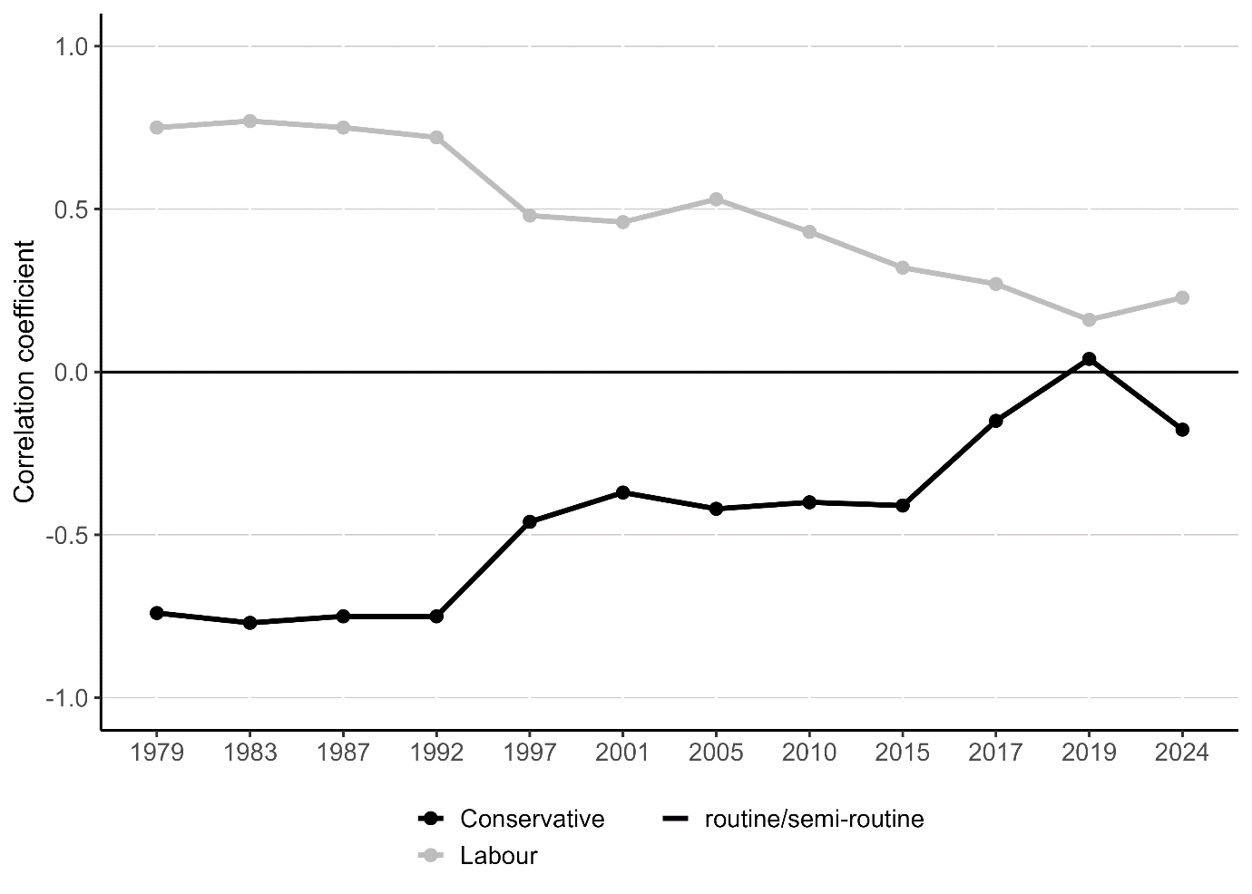

Figure 1(b). Correlation between degree-level qualifications and party vote share, 1979-2024
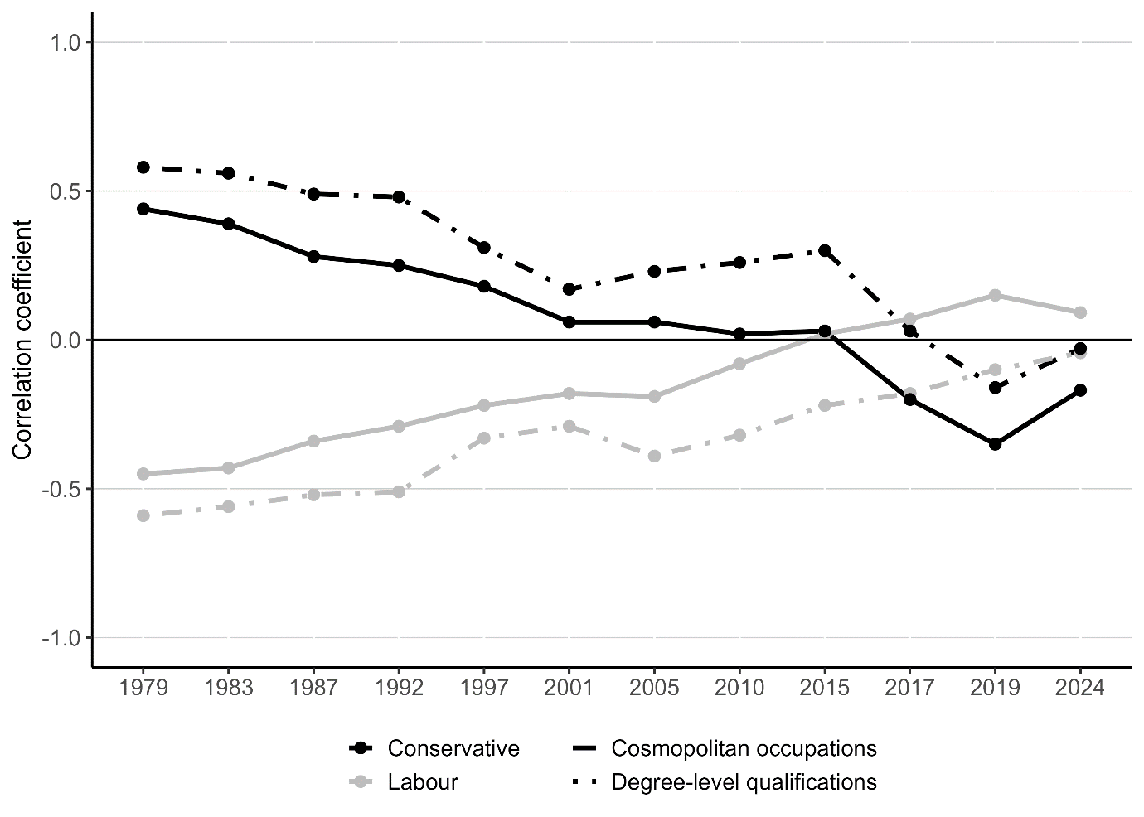

Figure 1(c). Correlation between age and party vote share, 1979-2024
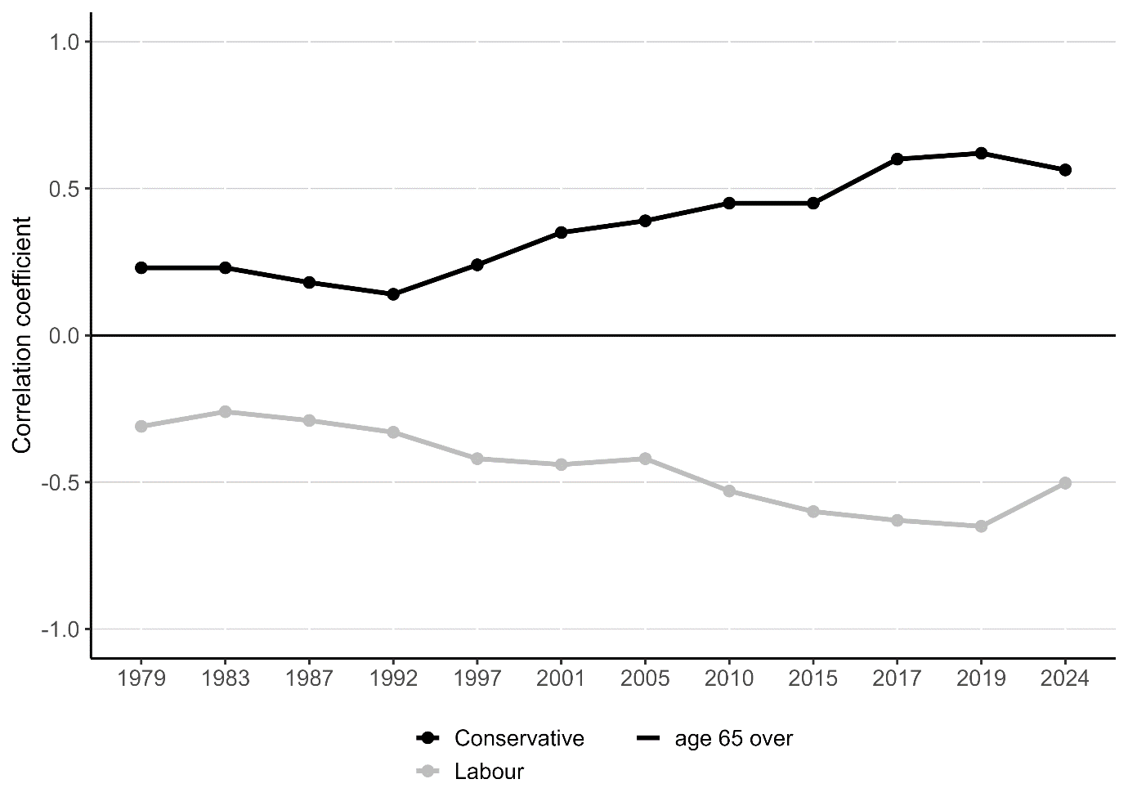
Figure 1(d). Correlation between deprivation and party vote share, 1979-2024
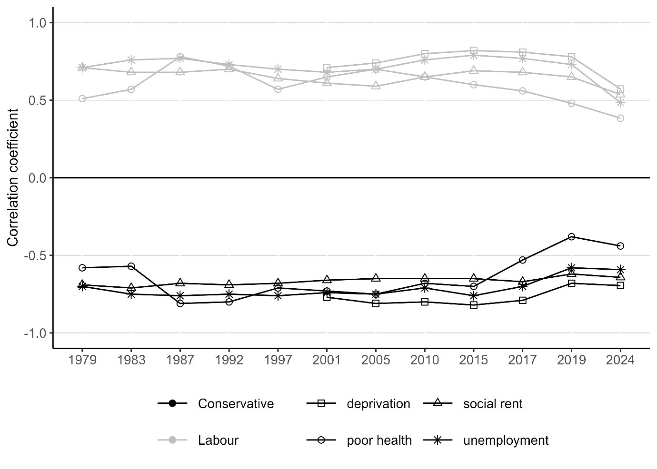

Figure 1(e). Correlation between ethnic minority and party vote share, 1979-2024
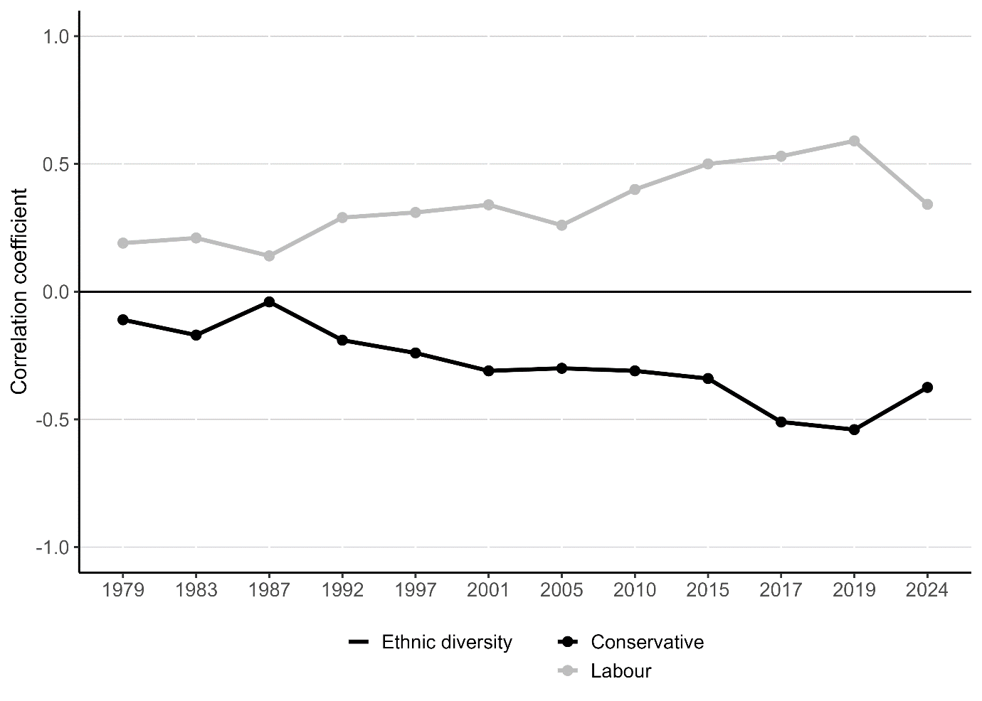
Places where the parties under- or over-perform their demographic predictors
One of the puzzles of electoral geography is the places where voters do not faithfully follow the script set by their social and economic profile. Ahead of the 2019 general election, the ‘Red Wall’ concept introduced by James Kanagasooriam suggested that there were areas where Labour’s vote was higher than implied by socio-demographics alone. Many of these constituencies across Northern England and the Midlands fell to the Conservatives in 2019 as party loyalties weakened over Brexit. Yet even within the so-called ‘Red Wall’ for example, the ‘over-performance’ has never been spatially even; in other words, there are some constituencies and clusters of constituencies where Labour have over-performed and others where they have not. In either case, the areas of Labour ‘over-performance’ has shifted over time, notably between 1979 and 2024 from the former coalfields of Yorkshire, the Midlands, North East, and South Wales to Merseyside and other parts of the North West.
There continue to be places in England and Wales that defy predictions based on their socio-demographic composition. Using a spatial analytical approach known as ‘Local Indicators of Spatial Association’ (LISA), we identify areas where there was statistically significant spatial clustering of Labour and the Conservatives over- and under-performing their vote share predicted by models (i.e. residuals estimated based on a multivariate linear regression of Labour and Conservative vote share on a range of sociodemographic predictors, such as age, social class, education, etc). In Figures 2 and 3 we present maps for the 2019 and 2024 general elections to enable comparison of these two very different electoral contexts. Constituencies with ‘High-High’ values are those that have a high value of the residual and whose neighbours also have a high value; constituencies with ‘Low-Low’ values are those that share low values with their neighbours. For example, for the Conservative residual maps, if a constituency has a High-High value, both it and its neighbours have high positive residuals from the Conservative vote model (i.e. these are areas where the party’s vote is higher than would be predicted based on socio-demographics). There are also two types of spatial outliers. ‘High-Low’ are constituencies with high values of the residual surrounded by neighbouring constituencies with low values (places where there is over-performance in a sea of under-performance for example); ‘Low-High’ indicate the opposite (under-performance surrounded by over-performance).
For Labour (see Figure 2), its cluster of over-performance in 2024 overlapped substantially with that observed in 2019, covering substantial areas across Northern England, including large parts of Merseyside, Manchester, and parts of Yorkshire in and around the Pennines. Notably in 2024 the party’s strong electoral showing spread to include rural parts of the far North of England (as far north as Hexham and North Northumberland, seats it won for the first time ever in 2024). New ‘Low-Low’ clusters appeared in the South of England in 2024 – reaching from the southwestern edge of London across to Devon. These tended to be located in areas where the Liberal Democrats were the main challenger to the Conservatives (and often had historical campaigning roots in constituencies), and where the anti-Conservative vote seems to have aligned behind the party, thus depressing Labour’s vote share below the level predicted.
For the Conservatives, their 2024 vote share exceeded model predictions in a cluster of constituencies to the north of Birmingham, around towns and cities such as Walsall, Wolverhampton, Stafford, and Stoke-on-Trent, as well as on Teesside (see Figure 3). Across both general elections there was a significant increase in clustering of ‘High-High’ values across Lincolnshire – an area where the Conservative Party’s vote has historically tended to be substantially above that predicted by socio-demographics – though the geographical area of over-performance contracted slightly. Even in an election where the party suffered extensive losses, its areas of relative over-performance remained largely consistent with those observed at the previous general election.
Figure 2. LISA cluster map showing statistically significant clustering of standardised residuals (under- and over-performance) from the 2019 and 2024 models predicting Labour vote share
(a) 2019 (b) 2024
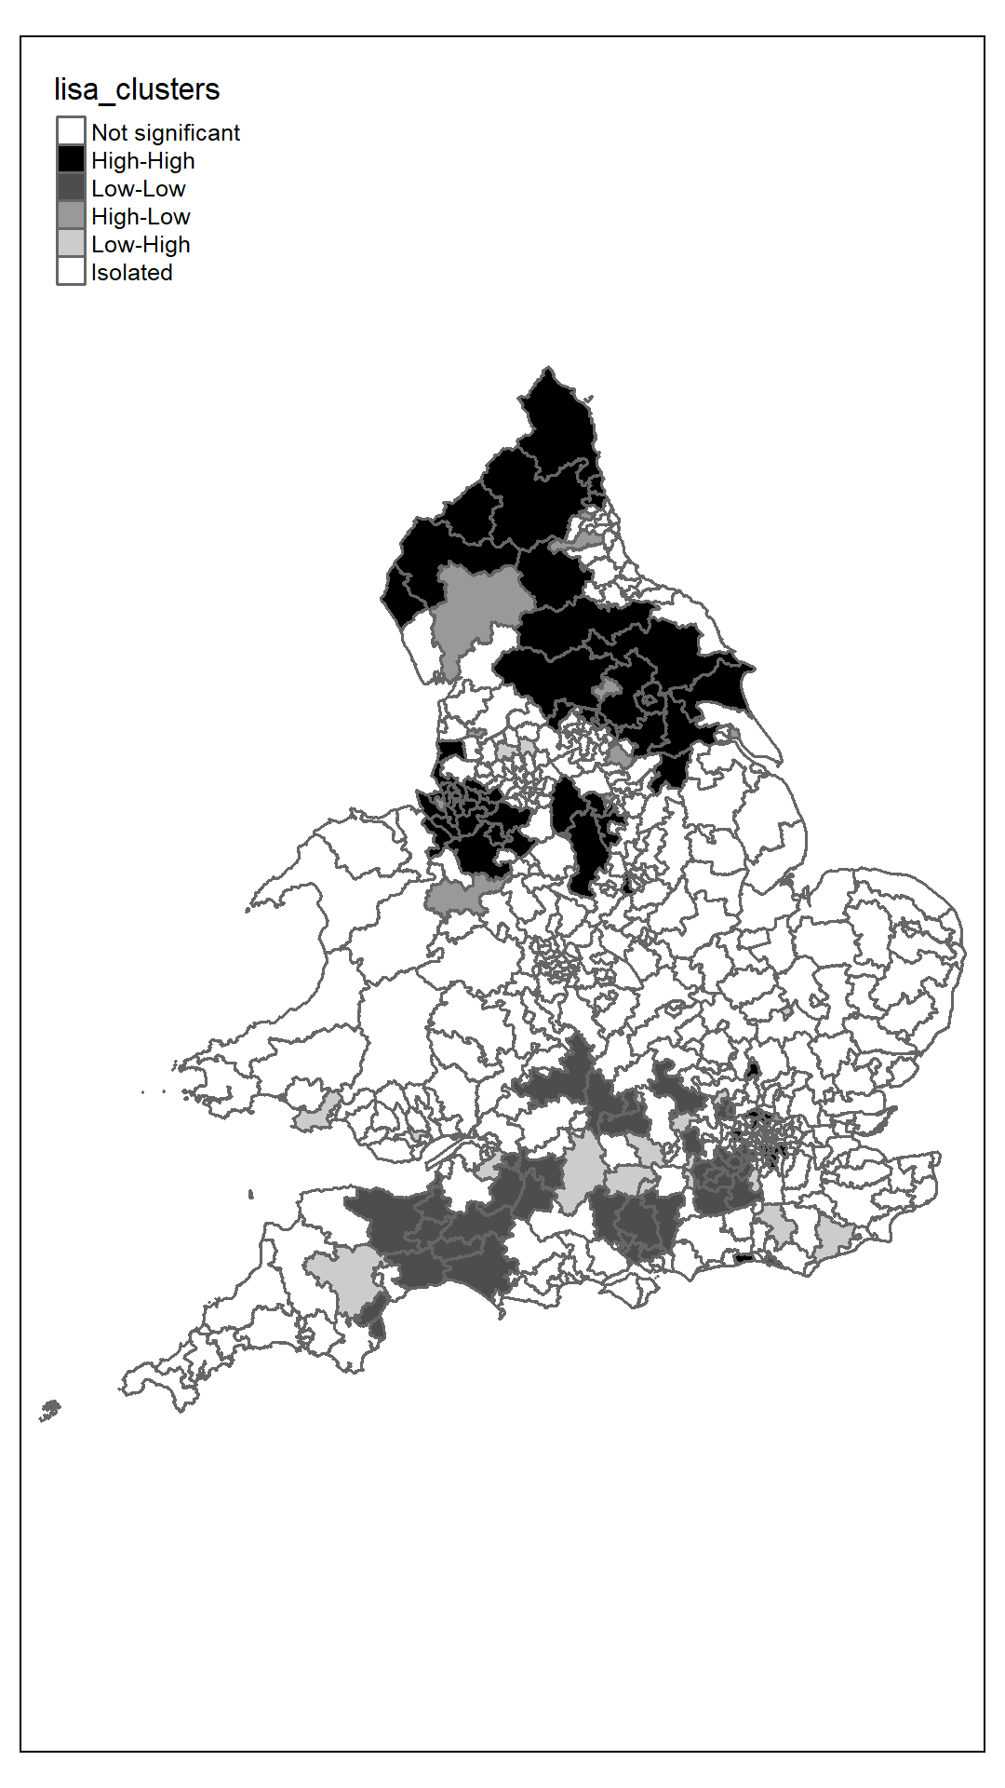
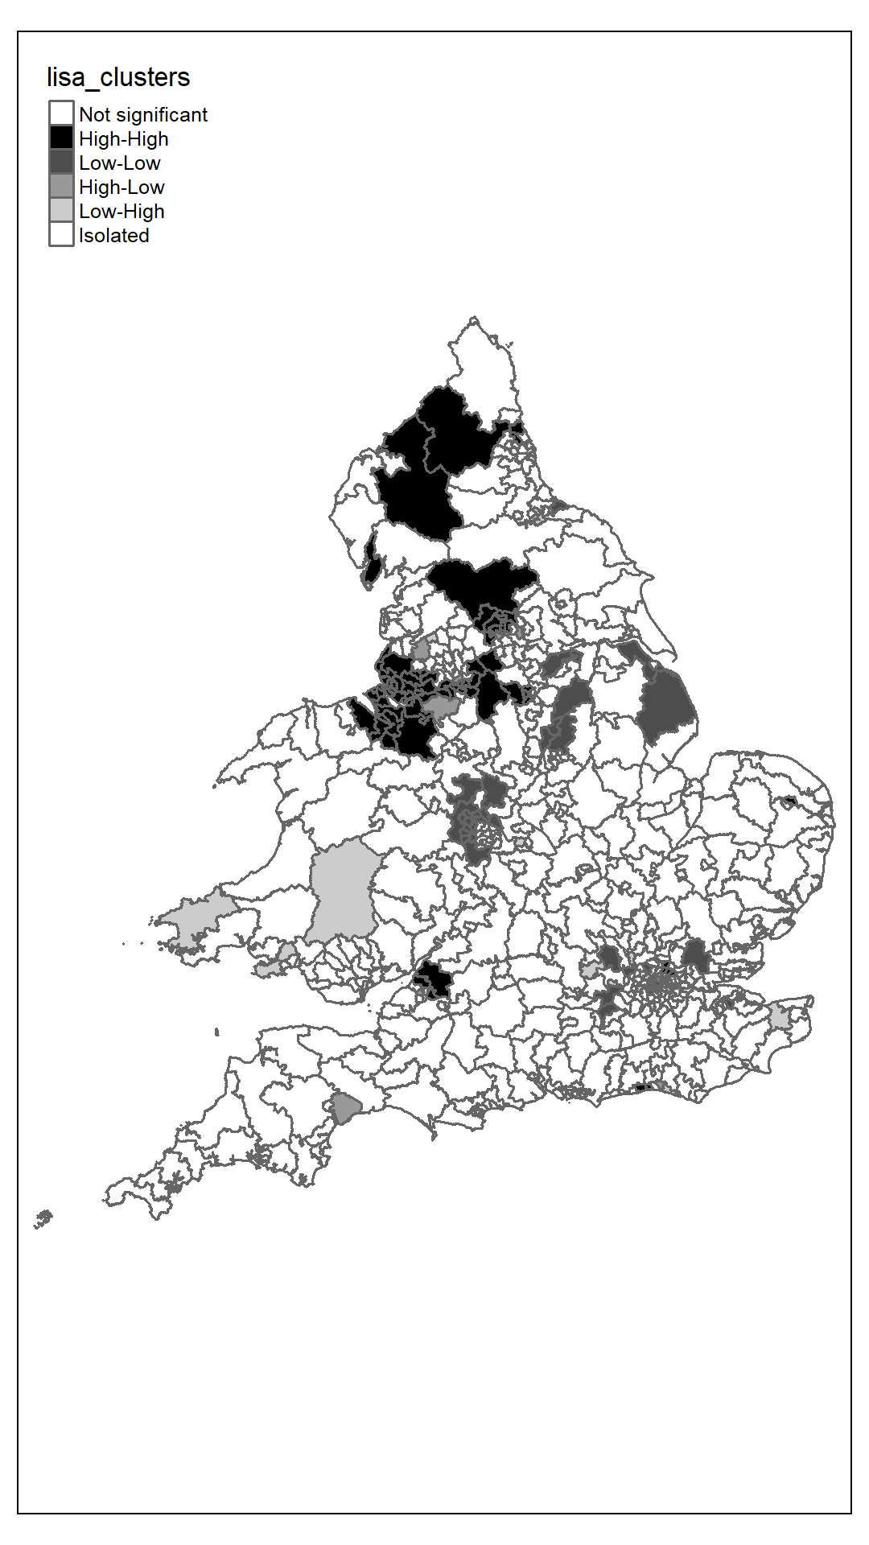

Figure 3. LISA cluster map showing statistically significant clustering of standardised residuals (under- and over-performance) from the 2019 and 2024 models predicting Conservative vote share
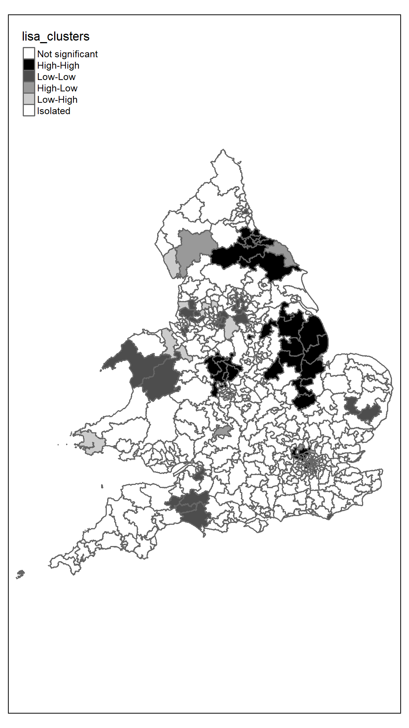
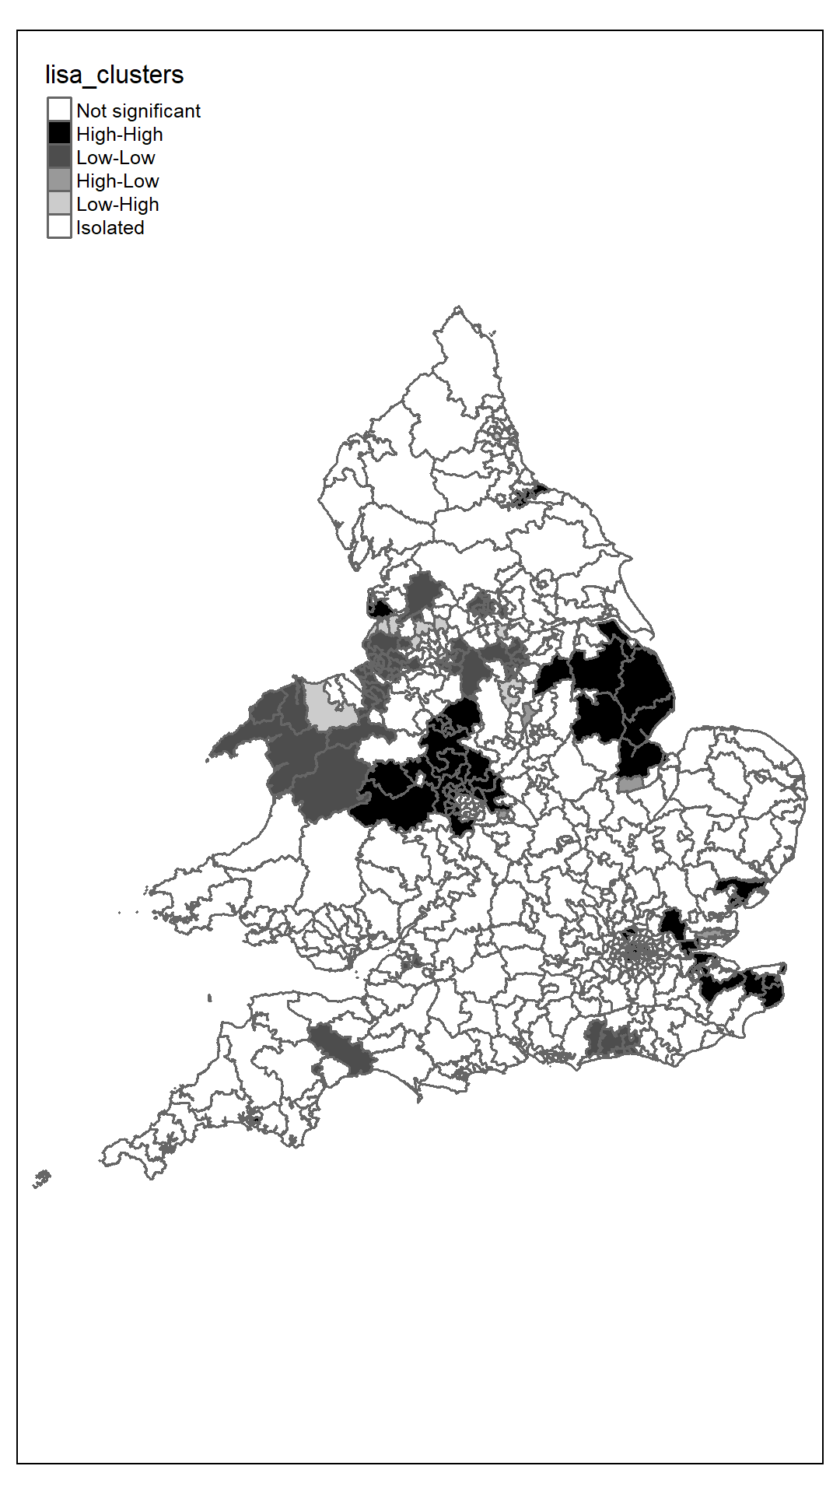
(a) 2019 (b) 2024

A fragmented electoral map
Based on the evidence presented to this point, the underlying geography of Conservative and Labour electoral support might – despite the large swing against the government – appear to have remained largely stable between 2019 and 2024, reflecting long-term trends in the correspondence between the socio-demographic composition of places and party vote share. Similarly, the geographical pattern of under- and over-performance against predictions was characterised by relative continuity despite the very different outcomes of the two elections. The most notable shift in electoral geography at the 2024 general election arguably relates to the increased fragmentation of electoral competition.
The ‘effective number of electoral parties’ (ENP) is a well-established measure of electoral fragmentation. It is designed to capture the dispersion of the vote across parties in a given electoral system or legislative district. In a system or district with two parties, each on 50% of the vote, the effective number of parties would be equal to two. In a district with five parties, each on 20% of the vote, it would be equal to five. There was a substantial increase in electoral fragmentation between the 2019 and 2024 elections. At the national level, ENP increased by more than one party from 3.1 parties in 2019 to 4.5 in 2024 (having been 2.7 in 2017). The average value of ENP by constituency similarly rose from 2.5 parties in 2019 to 3.5 in 2024 (and 2.3 in 2017, an election where the combined Labour and Conservative vote share had reached 84.5% for Great Britain). These represent dramatic changes in such a short period.
In some areas Labour and/or the Conservatives tend to dominate electoral competition, but in other places the vote is spread relatively evenly across several parties competing fiercely. The most fragmented constituency in 2024 was Montgomeryshire & Glyndwr in Wales (ENP = 4.9), while the least fragmented (excluding the Speaker’s seat) was Liverpool Walton (ENP = 1.9). Geographically, we see lowest levels of fragmentation on Merseyside, London, and parts of Yorkshire – all areas where Labour did relatively well – and the central belt in Scotland, where Labour and the SNP tended to dominate the vote. Higher fragmentation is observed in the East of England – tending to correspond to areas where Reform, the Greens and Liberal Democrats challenged the main parties – as well as rural parts of Wales and Scotland, and Cornwall. In terms of socio-demographics, the sorts of place where ENP is higher are characterised by lower population density (i.e. rural areas) (-0.29, p=0.000), a higher 2016 Leave vote (0.30, p=0.000), fewer university graduates (-0.20, p=0.000), and higher rates of outright home ownership (0.28, p=0.000). More urban areas are thus associated with lower levels of fragmentation. It is the more peripheral parts of the country where electoral support has dispersed more heavily. This fragmentation creates considerable uncertainty in relation to patterns of competition at the next election.
Figure 4. Effective number of parties by parliamentary constituency, Great Britain, 2024
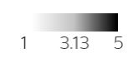
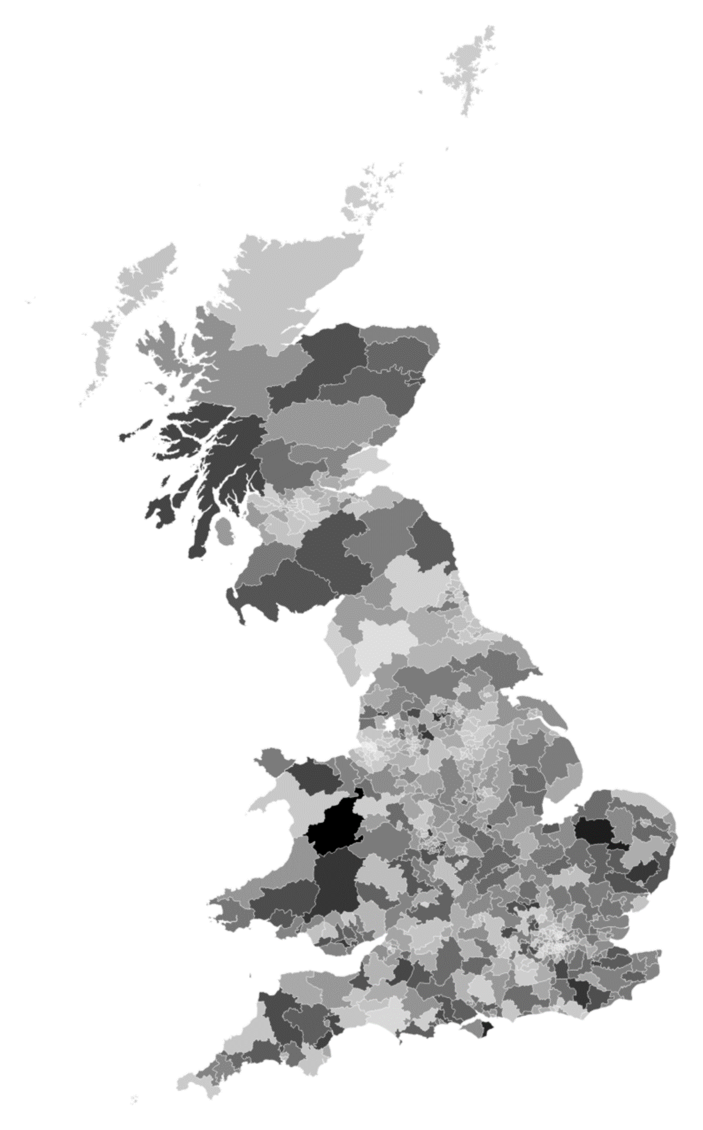

Marginality: the fragility of the electoral future
This fragmented electoral map was also reflected in the growth of the number of marginal constituencies, making Britain’s electoral future more fragile and less predictable. At the 2019 general election there were a total of 135 constituencies in England, Wales, and Scotland with a majority for the winning party of less than 10% (and 63 with a majority under 5%). In 2024, this increased to 217 constituencies with a majority of less than 10% (and 112 under 5%). This increases the vulnerability of Labour, in particular – as the incumbent – to relatively modest swings against it. Despite the rise of Reform and challenge in certain places from the Greens and Independents, the Conservatives continue to be the primary challenger to Labour in the majority of parliamentary constituencies (see Table 1). Specifically, the Conservatives are in second place in 85 out of the 97 most marginal seats (where the majority is under 10%). Reform are second in just 3 of these seats, and the Greens are second in none. It is only once Labour’s majority is above 15% that there are a considerable number of second places for Reform. Most of the Green second places are in the safest Labour-held seats (where the majority is over 25%).
Table 1. Second-placed party in Labour-held seats by marginality of parliamentary constituency, 2024
 | Ultra-marginal (<5) | Marginal (5-9.9) | Somewhat marginal (10-14.9) | Somewhat safe (15-19.9) | Safe (20-24.9) | Ultra safe (25+)
Conservative Party | 43 | 42 | 40 | 31 | 27 | 36
Green Party | 0 | 0 | 2 | 1 | 0 | 36
Liberal Democrats | 0 | 1 | 0 | 1 | 2 | 2
Other | 6 | 2 | 5 | 4 | 0 | 0
ReformUK | 1 | 2 | 7 | 20 | 24 | 35

To better understand the types of places associated with marginality for the Labour government, we estimated a multiple regression model of marginality (the inverse of Labour’s lead over the second placed party) restricted to seats won by Labour in 2024. This reveals that once other factors are controlled for ethnic diversity and employment in manufacturing are both strong predictors of Labour marginality (as also is the Reform vote share), while poor health is the strongest negative predictor of marginality which is consistent with the results presented earlier concerning the strength of correlation between deprivation and Labour’s vote over time.
Figure 6. Standardised predictors of marginality of Labour-held constituencies, 2024
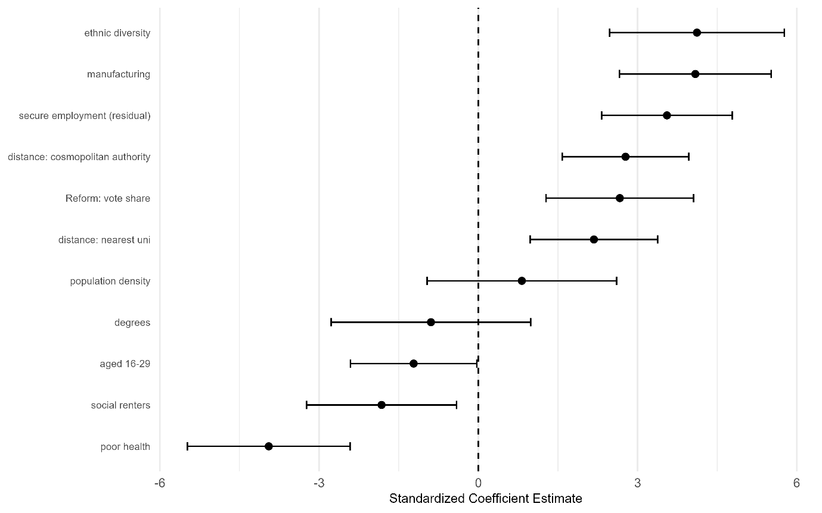

An uncertain, unstable future
With the electorate now more volatile, discontented, dealigned, and fragmented what are the prospects for the new Labour government? Based on an at times politically naïve and stumbling start to their term of office, there is little evidence at present pointing to a reversal of these forces. Indeed, it is difficult to envision a return to the old status quo while the country continues to face challenging fiscal circumstances, decaying public services, and no straightforward reforms to Britain’s economic model that might deliver a boost to national growth and improved living standards for all. As such, the prospects for restoring public faith in politics and the capacity of government to deliver look bleak. At the same time, one might wonder if Britain has been here before, or worse is condemned to live out a never-ending political Groundhog Day. Writing in 1975, as the UK faced another period of economic stagnation, social unrest, divided politics, and overloaded government, the late great Tony King wryly observed:
“It was once thought that Britain was an unusually easy country to govern, its politicians wise, its parties responsible, its administration efficient, its people docile… Now we wonder whether Britain is not perhaps an unusually difficult country to govern, its problems peculiarly intractable, its people increasingly bloody-minded. What has happened? What has gone wrong?”
Perhaps it is simply the case that despite significant structural changes in economy and society, Britain has not found a way to overcome its long-term decline, while class dealignment has further reduced the ‘docility’ of its people. Whether or not the result of this economic malaise, public discontent, and governing overload is another episode of the Great Moving Right Show, remains to be seen. Labour’s immediate challenge of taming Britain’s recurring economic crisis will ultimately determine its electoral future.
How the Conservatives recover from the 2024 general election therefore depends partly on the degree to which the Labour government squanders its already scarce political capital on unpopular policies, fails to deliver on voters’ expectations of improvements in public services and struggles to master the economic crisis. It also depends on the sort of electoral coalition the Conservative Party seeks to assemble, and the geographical distribution of that support. Should it focus on winning back its traditional professional, middle-class base or the Leave-supporting and working-class voters that deserted the party in 2024? To win the next general election it would need to do some of both. Just as Labour faces a pincer movement from Greens and Independents on its left and from the Conservatives and Reform on its right, the Conservatives face a pincer movement from Reform on their right and the Liberal Democrats on their left. It is these forces that are accelerating the dynamics of electoral fragmentation, and which ultimately will shape the geography of the next election.
As we have shown, despite the huge swing against the Conservative government, there was notable continuity in the underlying socioeconomic and sociodemographic predictors of party vote at the constituency level. The election did not mark a clear reversal of the dealignment of social class and education as predictors of support for Labour and the Conservatives, while socioeconomic deprivation remained strongly aligned with the geography of Labour’s vote. Similarly, while there was a slight weakening of the correlation of the electoral geography of England and Wales with age and the size of ethnic minority populations, these were only modest deviations from recent trends. There was similarly continuity between 2019 and 2024 in the areas where the two parties tended to ‘over’- and ‘under-perform’ those predictors. Labour’s vote continued to exceed expectations based on the socioeconomic profile of the electorate in Merseyside and other parts of Northern England – including more rural areas. Even in defeat, the Conservatives continued do better in Lincolnshire, parts of the West Midlands and Teesside than would be suggested by demographics.
Importantly, structural changes in electoral geography can be concealed by large swings of the political pendulum. Labour won back the ‘Red Wall’ in 2024 not because of a structural change in the geography of the party’s vote, but because the electoral tide went out so far for their opponents. Labour’s 2024 majority differs significantly from that won by Tony Blair in 1997 as the size of majorities won in many of those seats in former industrial towns in the North of England is now substantially diminished. For example, in 1997 Labour held Bishop Auckland with a 21,064 vote majority. In 2024, after winning the seat back from the Conservatives this majority stood at 6,672 votes. But the other end of the wedge is that Labour’s vote has grown in places that it was far behind in even at the high point of the 1997 landslide. In Aldershot, for example, Labour was in third place in 1997, 10,062 votes behind the Conservatives. In 2024, the party’s majority stood at 5,683. In both seats, the Reform vote – 9,466 and 8,210 votes respectively – exceeded the gap between the parties.
In contrast to the perhaps surprising continuity in the underlying geographical structure of the vote for Labour and the Conservatives between 2019 and 2024, there has been a clear fragmentation of electoral support, particularly in more peripheral parts of England and Wales. This has left multiple parties competing for power in multiple constituencies and makes the task of national campaigning even more challenging for the parties, as they have to coordinate targeting of different voter groups and different seat types. The relatively large number of seats with small majorities has further left the government far more vulnerable than would be suggested by its parliamentary majority of 174 seats. Despite the threat from Reform being talked up by some commentators, the Conservatives remain the primary challenger – holding second place in most of the most marginal Labour-held constituencies. While Labour’s safest seats tend to have larger ethnic minority populations and lower levels of manufacturing employment, these – and Reform vote share – are a positive predictor of marginality once other factors (such as poor health, social renting and younger populations) are controlled for. This highlights how while Labour’s vote may come under pressure in certain places from the Greens and Reform it is ultimately the Conservatives who are still their primary opponent. It remains difficult, however, to make confident predictions about what the electoral geography of England and Wales might look like at the next general election.

H.D. Clarke, D. Sanders, M.C. Stewart and P.F. Whiteley, Performance Politics and the British Voter, Oxford, Oxford University Press, 2010; J. Green and W. Jennings, The Politics of Competence, Cambridge, Cambridge University Press, 2017.
D. Devine, B. Prosser and G. Stoker, ‘British public more fatalistic about home ownership than climate change – new survey’. The Conversation, June 21, 2024. https://theconversation.com/british-public-more-fatalistic-about-home-ownership-than-climate-change-new-survey-232674
W. Jennings, ‘A crisis of trust in our politics spells trouble for the government’. Sky News Online, 25 April, 2024. https://news.sky.com/story/a-crisis-of-trust-in-our-politics-spells-trouble-for-the-government-13122344
J. Furlong and W. Jennings, The Changing Electoral Map of England and Wales, Oxford, Oxford University Press, 2024.
E.g., G. Evans and J. Tilley, The New Politics of Class, Oxford, Oxford University Press, 2017; E. Fieldhouse, J. Green, G. Evans, J. Mellon, C. Prosser, H. Schmitt and C. van der Eijk, Electoral Shocks: The Volatile Voter in a Turbulent World. Oxford, Oxford University Press, 2020.
D. Sanders, ‘The UK’s changing party system: The prospects for a party realignment at Westminster.’ Journal of the British Academy, vol. 5, 2017, pp. 91–124.
Furlong and Jennings, The Changing Electoral Map of England and Wales.
Ibid.
Evans and Tilley, The New Politics of Class.
P. Sturgis and W. Jennings, ‘Was there a ‘Youthquake’ in the 2017 General Election?’ Electoral Studies, vol. 64, no. 102065, 2020.
J. Furlong, ‘The changing electoral geography of England and Wales: Varieties of “left-behindedness”’, Political Geography, vol. 75, no. 102061, 2019.
'Cosmopolitan' occupations are defined as employment in financial, creative, educational and service sectors characteristic of the modern knowledge economy: finance, real estate, public administration, education, health and social work, service activities (such as in arts and recreation).
J. Kanagasooriam and E. Simon, ‘Red Wall: The Definitive Description’, Political Insight, vol. 12, no. 3, 2021, pp. 8-11.
Furlong and Jennings, The Changing Electoral Map of England and Wales.
The ENP is calculated as the sum of the squared fraction of votes (V) for each party i, divided by one. That is, ${ENP}_{e}=\frac{1}{\sum_{i=1}^{n}{V_{i}^{2}}}$ : See M. Laakso and R. Taagepera, ‘“Effective” Number of Parties: A Measure with Application to West Europe’. Comparative Political Studies, vol. 12, no. 1, 1979, pp. 3–27.
A. King, ‘Overload: Problems of Governing in the 1970s’. Political Studies, vol. 23, no. 2-3, 1975, p. 284.
S. Hall, ‘The Great Moving Right Show’, Marxism Today, January 1979, pp. 14–20.

