Intraspecific variability across seasons and geographically distinct populations can modify species contributions to ecosystems

Abstract
- Environmental change profoundly alters biodiversity and, by extension, species contributions to ecosystem functioning. While it is well-established that these impacts can be geographically and temporally nuanced, most assessments of species contributions to ecosystems assume that species traits are temporally and spatially fixed, and those that do acknowledge intraspecific variability have failed to fully determine its relevance to ecosystem functioning.
- Here, using three geographically distinct populations of sediment-dwelling invertebrates, we combined a laboratory experiment with Bayesian hierarchical modelling to empirically quantify the prevalence of intraspecific trait variability in relation to geographic locality and seasonal conditions. Furthermore, we assessed the role of intraspecific trait variability in mediating sediment particle mixing, nutrient generation and benthic oxygen uptake.
- We found that geographic and seasonal variability in body size and sediment particle reworking modified macrofaunal contributions to sediment total oxygen uptake and nutrient generation. These associations, however, were not consistent across all measured traits and ecosystem functions.
- Our findings highlight asymmetries in both the absolute magnitude and/or direction of species responses to changing seasonal conditions, indicating that the relative functional contributions species make to ecosystems can be temporally or spatially transient and may, therefore, diverge from expectations based on contemporary functional group typologies.
- These findings highlight a critical knowledge gap in our understanding of the key sources of variability affecting functionally important aspects of species behaviour and physiology and call for the development of dynamic ecological assessment and management approaches that account for individual, as well as species, responses to changing environments.

Keywords
Bayesian modelling, Benthic Ecology, Ecosystem functioning, Functional traits, Raunkiæran shortfall.

Introduction
Biodiversity, in particular functional trait composition, influence ecosystem functioning and stability (Loreau et al. 2001; Cardinale et al. 2012). Yet, how intraspecific trait composition and expression vary between populations (Wohlgemuth, Solan & Godbold 2017), and respond to environmental context (Sanders, Solan & Godbold 2024), remains poorly understood. Most trait-based determinations of ecosystem functioning assume that measurable components of an organism’s phenotype (functional traits: morphological, physiological, behavioural) are consistent between individuals, and that an organism’s functional effect will be the same regardless of its location, environment and/or biotic surroundings (Violle et al. 2012; Moran, Hartig & Bell 2016; Zakharova, Meyer & Seifan 2019). However, individuals exhibit phenotypic plasticity and genetic variability (Reusch 2014), enabling acclimation to short-term spatio-temporal pressures (conspecific interactions: Sanders, Solan & Godbold 2024; predator/prey interactions: Schmitz et al. 2015; seasonal changes: Pritzkow et al. 2019) and/or adaptation to long-term challenges (environmental history: Cassidy et al. 2020; climate change: Bjorkman et al. 2018) that can modify functional trait expression. Given a specific context, or set of conditions, individuals within and between populations can further display variability in responses that relate to individual fitness, historical experiences (copepods: Brun, Payne & Kiørboe 2016; invertebrates: Wohlgemuth, Solan & Godbold 2017; Cassidy et al. 2020; fish: Mindel et al. 2016), seasonal timing (Godbold & Solan 2013), and location within their geographic range (Calosi et al. 2017), leading to an additional tier of transient effects on ecosystem properties (Törnroos & Bonsdorff 2012). Hence, the relative positioning and/or shape of species trait frequency distributions frustrate efforts to generalise and scale trait-function relationships to project the most likely ecological outcomes (Garcia et al. 2021).

While it is well known that genotypic and phenotypic responses vary between individuals and with biotic and abiotic context, the wider ecosystem consequences of this variability have received less attention (Des Roches et al. 2018; Raffard et al. 2019; Chacón-Labella et al. 2023). Theory suggests that intraspecific variability may have important implications for ecological processes and ecosystem functioning (e.g. productivity: Hughes et al. 2008; nutrient cycling: Allgeier et al. 2020), but whether these trait-function relationships are consistently observed between different geographic locations and across seasons remains untested. Seafloor ecosystems are the largest continuous habitat on Earth (Snelgrove 1999) and even, small shifts in trait-mediated processes, such as sediment particle mixing (Zhang, Solan & Tarhan 2024) can have broad implications for ecosystem functioning and service provision (e.g. fisheries, climate regulation; Thurber et al. 2014; Des Roches et al. 2021). Hence, it is important to better understand how and when species contributions to ecosystem functioning vary over space and time, as broad-brush assessments based on mean species performance are unlikely to provide a robust representation of the full spectrum of intraspecific genotypic and phenotypic variation.

Here, we quantified the extent of intraspecific trait variability across seasons and geographically distinct populations of sediment-dwelling marine invertebrate species and assessed the relationship (if any) between intraspecific variability and ecosystem functioning. We sampled 3 populations (Plymouth, Newcastle, Oban, UK; Supplementary Fig. 1) of numerically dominant, but functionally contrasting, infaunal marine invertebrates (Amphiura filiformis, Hediste diversicolor and Turritellinella tricarinata), and exposed them in monocultures to summer and winter conditions in a 65-day mesocosm experiment (80 aquaria, 420 individuals; Supplementary Fig. 2). We assessed individual morphological and behavioural traits, contributions to particle reworking and bioirrigation (ecosystem processes), and sediment nutrient release and oxygen uptake (ecosystem functioning). Using Bayesian hierarchical modelling we determined the magnitude and direction of variability in traits, processes and functions, and used this information to generate species, population and season specific probability distributions to address three questions: (1) To what extent does geographic location and season drive intraspecific variability in functional traits? (2) Does the magnitude of intraspecific variability depend on the species, population and/or trait? and, (3) What effect, if any, does intraspecific variability have on species functional contributions to ecosystems? Hence, our study provides a first attempt to empirically assess how both spatial and seasonal variability in intraspecific trait expression impacts seafloor ecosystem functioning.

Materials and Methods
Fauna and sediment collection
We collected individuals of three functionally contrasting species of soft sediment-dwelling macroinvertebrate: the brittle star, Amphiura filiformis, the tower shell, Turritellinella tricarinata, and the ragworm, Hediste diversicolor from three geographically distinct populations around the UK in summer (June/July 2021) and winter (February 2022; see Supplementary Methods for details on species biology and sampling sites). Subtidal populations of A. filiformis and T. tricarinata were collected near Plymouth, UK (50°20'15" N, 4°09'20" W, depth: ~ 10 m), Newcastle, UK (55°06'32" N, 1°23'45" W, depth: ~ 38 m) and a third population of A. filiformis near Oban, UK (56°29'37" N, 5°30'18" W, depth: ~ 35 m) using a combination of van Veen grabs (0.1 m²) and Agassiz trawls. Intertidal populations of H. diversicolor were collected at low tide, from the river Tamar, near Plymouth (50°21'54" N, 4°14'09" W) and the river Blyth, near Newcastle (55°08'02" N, 1°32'45" W; Supplementary Fig. 1; Supplementary Table 1). After collection, each species was transported at low densities in aerated 10 L buckets within 12 h to the National Oceanography Centre Southampton and acclimated to experimental conditions (details in following section) for four weeks.

Experimental design and conditions
We assembled replicate (n = 5) transparent acrylic aquaria (L×W×H: 12 ×12 × 35 cm), containing sediment (10 cm depth, D₅₀: summer = 169 ± 39 μm, winter = 142 ± 28 μm, Supplementary Table 2; organic material content: summer = 4.7 ± 0.2 %, winter = 6.1 ± 0.1 %, Supplementary Table 3) and seawater (~ 22 cm depth, salinity 33, 10 μm filtered, UV sterilised) under summer (16 °C, 16 h L:8 h D cycle) or winter (9.5 °C, 8 h L:16 h D cycle) conditions. These temperatures were chosen based on seasonal sea surface temperature monthly maximum and minimum values observed at the L4 station in the English Channel from 2011 – 2018 (Western Channel Observatory) and fall within ± 2 °C of the seasonal temperatures at all sampling locations (Supplementary Table 1).

Aquaria contained either no macrofauna (n = 5 per season, 10 in total), or monocultures of Amphiura filiformis (three populations, Newcastle, Plymouth and Oban), Turritellinella tricarinata and Hediste diversicolor (both two populations, Newcastle and Plymouth) with individual densities fixed at 6 ind. aquarium⁻¹ (417 ind. m⁻²; well within the wide range of densities observed in British coastal waters; Sanders, Solan & Godbold 2024). As species were held in monoculture, we were able to distinguish the contributions that both individuals and species make to ecosystem processes and functioning. As faunal activity can be dependent on sediment characteristics (Wohlgemuth, Solan & Godbold 2017), we combined and sieved (1000 μm) sediment from all three subtidal locations (1:1:1 ratio) in a seawater bath to remove the macrofauna and allowed it to settle for 24 h to retain a complete size range of sediment particles. Before the addition of fauna, all aquaria were aerated for 24 h before conducting a 70 % water change to remove excess nutrients associated with aquarium assembly. We performed a partial (50 %) water change on each aquarium once a week to minimise the effects of nutrient accumulation. After each water change, aquaria containing macrofauna were supplied with a 1:1 ratio of the microalgae Tetraselmis suecica and Phaeodactylum tricornutum, equating to ~ 12.6 mg week⁻¹ (summer treatment) or ~ 4.2 mg algae week⁻¹ (winter treatments), reflecting sufficient energetic requirements for growth and maintenance (~ 1.1 % ash-free dry mass day⁻¹) and seasonal changes in food availability (Reed et al. 2021; Sanders, Solan & Godbold 2024). Aquaria were maintained under each seasonal condition for a total of 65 days (total n = 80 aquaria, 420 individuals; Supplementary Fig. 2)

Individual response traits
For more details on how we determined individual response traits, ecosystem processes and ecosystem functioning, refer to Supplementary Methods. Burial behaviour, a proxy and relative measure for an individual’s response to its environment (Cassidy et al. 2020), was measured by quantifying the time taken for an individual to complete burial (Burial_{end}). Biomass and body composition are key morphological traits important for secondary productivity and decomposition (Lohbeck et al. 2015). Soft tissue dry mass (M_{dry}), was determined by drying each individual at 60 °C for 24 h and organic mass (M_{org}) was determined by loss on ignition at 450 °C for 12 h (including shell mass for T. tricarinata). The proportion of organic soft tissue mass (M_{org}:M_{dry}) was calculated as:

$M_{org}:M_{dry}=\frac{(M_{dry}-M_{AF})}{M_{dry}}$ Eq. 1

Ecosystem processes
The vertical redistribution of sediment particles within the sediment profile in seafloor ecosystems is known to influence nutrient recycling and oxygen dynamics in marine sediments (Bianchi et al. 2021). Faunally mediated sediment particle reworking was visualised non-invasively by quantifying the redistribution of optically distinct particulate tracers using fluorescent-Sediment Profile Imaging (f-SPI, Solan M. et al. 2004; Supplementary Methods). The median (^{f-SPI}L_{med}, typical short-term depth of mixing) and maximum (^{f-SPI}L_{max}, maximum extent of mixing over the long-term) mixed depth of particle redistribution were calculated for individual aquaria. Surface boundary roughness (SBR) was determined by measuring the vertical range of the sediment-water interface as an indicator of surficial reworking. Faunally mediated transport of porewater in and out of sediments by burrow ventilation is a good indicator of sediment-water solute exchange (Koretsky, Meile & Van Cappellen 2002). Burrow ventilation was measured by determining changes in the seawater concentration of the inert tracer sodium bromide (NaBr, 10 mmol L⁻¹, Forster et al. 1999) over an 8 h period.

Ecosystem functions
Water column macronutrient concentrations (NH₄-N, NO_{x}-N, PO₄-P µmol L⁻¹) were determined in each aquarium after a 10-day incubation period using a Lachat Quikchem 8500 flow-injection auto-analyser following standard colorimetric methods (Grasshoff, Kremling & Ehrhardt 1999). Total Oxygen Uptake (TOU, mmol O₂ m⁻² d⁻¹), an indicator of benthic organic matter mineralisation and community metabolism, was measured as the linear rate of O₂ depletion over 4-8 hours using a fibre-optic oxygen meter (4-channel Firesting-O2) and OXSP5 oxygen sensor spots (Pyroscience, Germany). Temperature and volume corrections were applied, and rates calculated, using the R package RespR (Harianto, Carey & Byrne 2019). Oxygen penetration depth (OPD) and diffusive oxygen uptake (DOU) were derived from sediment depth profiles of O₂ concentration using a dual mounted motorised micromanipulator profiling head (Unisense, Denmark) connected to extra-long OX-500 microelectrode probes with a tip diameter of 500 µm (Revsbech 1989; see Supplementary Methods for calculations). To estimate faunal mediated oxygen uptake (FOU), we subtracted DOU from TOU (Glud 2008), and separated the direct (dFOU, e.g. macrofaunal respiration) versus indirect (iFOU, e.g. microbial) contributions of the sediment meiofaunal/microbial community based on published, temperature corrected faunal respiration rates (Supplementary Table 4).

Data analysis
To obtain the distribution of response traits and associated contributions to ecosystem process and functioning, between populations and seasons, we used a hierarchical mixed effects Bayesian ANOVA (Mitchell & Bakker 2014; Bjorkman et al. 2018). We assumed normal probability distributions and heterogeneous variance structures for individual species, populations and seasons (see Supplementary Table 5 for replication details), and, as prior knowledge of context-dependent species behaviour is not well constrained, the inclusion of weakly-informative priors (Lemoine 2019; Supplementary Table 6) in the ‘brms’ package in R Software version 1.4.1106 (Richardson, Robins & Wang 2017; R Core Team 2023). Specifically, the model structure consisted of fixed terms for species and random terms for population, season, and their interactions, nested within each species:

$T_{Spsi} \sim 0 + β_{1S} + (1|β_{1S}:β_{2p}) + (1|β_{1S}:β_{3s}) + (1|β_{1S}:β_{2p}:β_{3s}) + ε_{Spsi}$ Eq. 2

where T denotes a response trait, ecosystem process or ecosystem function for observation (i), of a species (S), from a population (p), within season (s), such that the species (β_{1S} ), population (β_{2p}), and seasonal (β_{3s}) effects can be determined, with ε_{Spsi} the residual term with assumed normal distribution and mean 0 (Supplementary Methods). We generated posterior probability distributions of trait estimates with Markov Chain Monte Carlo (MCMC) estimation procedures using the Hamilton Markov Chain algorithm (Gelman et al. 2004). Four sampling chains of 5000 iterations were run with the first 1000 discarded as ‘warm-up’ before conducting visual MCMC diagnostics using the R package ‘bayesplot’ (Gabry et al. 2019). Chains were inspected for convergence using trace plots, R-hat values of < 1.05 were checked as a measure of autocorrelation and Effective Sampling Size (ESS) was checked for values < 0.5. Models were validated through graphical posterior distribution predictive checks by visual comparison of simulated and observed data and inspection of model residuals (Supplementary Fig. 5).

We visualised the distribution of response traits, and associated contributions to ecosystem process and functioning, by plotting species-specific posterior distributions of median values for model intercepts (β) ± 95 % credible intervals (CI’s), which represent the 95 % likelihood that the interval contains the ‘true’ model parameter. Species-specific posterior distributions were further decomposed by factor (season or population) by comparing treatment posterior distributions ± 95 % CI’s and overlap with global species median values. Treatments were considered significantly different when CI’s did not overlap with other treatments or with global species median values. Intraspecific variability was quantified by estimating a standardised effect size (ES) relative to species mean values, based on each treatments log response ratio (lnRR: Nakagawa et al. 2023):
$lnRR=ln\left(\frac{m_{i}}{m_{s}}\right)$ Eq. 3
Where ln is the natural log, m_{i} is a mean trait value for a given species’ population in a given season, and m_{s} is the global species mean trait value. Intraspecific variability was further quantified by plotting standard deviations (SD) ± 95 % CI’s for season and population obtained from Bayesian hierarchical model factors, and compared to SD values for species which represented a measure of interspecific variation. After visualising the proportional representation of DOU, dFOU and iFOU, we used linear regression to explore the relationship between FOU and biomass (continuous), season (categorical), and their interactions.

Results
Individual response traits and ecosystem processes
We found that most trait/process distributions, with the exception of proportionate organic mass (M_{org}:M_{dry}) and maximum particle reworking depth (^{f-SPI}L_{max}), showed considerable overlap in expression across species. This correspondence emerges because season and/or population differences broaden overall intraspecific trait distributions (compare species and treatment distributions, upper and lower sections of panels in Fig. 1 and posterior summaries in Supplementary Table 7). We observed that burial behaviour (burial rate: _{log}(Burial_{end})) did not respond consistently to seasonal conditions, between species or populations. For example, all populations of the gastropod Turritellinella tricarinata, buried faster in winter, as did the Plymouth population of the brittle star Amphiura filiformis, whereas Newcastle A. filiformis buried faster in summer. Consequently, population differences were only observed for A. filiformis in summer (Newcastle > Oban > Plymouth; Fig. 1a). Comparisons of dry mass (M_{dry}) revealed that individuals of the polychaete Hediste diversicolor, were 53% larger in summer relative to winter, but did not differ between populations. We did, however, find distinct population differences in T. tricarinata in both seasons (Plymouth > Newcastle) and for A. filiformis in winter (Plymouth > Oban > Newcastle), with Plymouth individuals being 309 % larger than Newcastle individuals (Fig. 1b). In terms of proportionate organic mass (M_{org}:M_{dry}), an indicator of tissue energy content, we found strong interspecific differences (H. diversicolor > A. filiformis > T. tricarinata), but weak intraspecific variability, with seasonal and population differences only prevalent in A. filiformis (Fig. 1c).

Our analyses of ecosystem processes revealed more consistent patterns of expression, with no differences between populations for surface boundary roughness (SBR, Fig. 1d) or median (^{f-SPI}L_{median}, Fig. 1e) and maximum (^{f-SPI}L_{max}, Fig. 1f) particle reworking depths. As with _{log}(Burial_{end}) and M_{org}:M_{dry}, only A. filiformis exhibited population differences in ^{f-SPI}L_{max} (Plymouth > Oban = Newcastle). Seasonal differences were particularly strong for H. diversicolor (SBR and ^{f-SPI}L_{median}, summer > winter) and A. filiformis (SBR, summer > winter in Newcastle and Oban; ^{f-SPI}L_{median}, winter > summer). For burrow ventilation (Δ[Br⁻]), we found no differences in activity between species or seasons, but there were differences in activity for A. filiformis between populations (Oban > Plymouth = Newcastle) during the summer (Fig. 1g).

The log response ratio (lnRR) of population, season and species treatment means, relative to global species means (y = 0, Fig. 2a) was calculated as a measure of the standardised effect size (ES; Supplementary Table 8). We found stark differences in effect sizes which, when visualised, highlight some emergent trends. The direction and/or magnitude of effect size varied with population and/or season. For example, H. diversicolor had a positive effect on ^{f-SPI}L_{median} in summer but negative in winter, and the contribution of A. filiformis to ^{f-SPI}L_{max} ranged from a small (0.2) to large (-2.5) effect size in summer between Newcastle and Oban. These data also revealed that surface sediment particle reworking activity (SBR) was consistently higher in summer across all species and populations, and that individuals from the northern Newcastle population were generally smaller (M_{dry}) than the southern population in Plymouth for all species and seasons (Fig. 2a).

Comparing standard deviations of model factors derived directly from Bayesian hierarchical model statistics (species, population, season) provide an approximate measure of inter- vs intraspecific variability. These data showed that, for most of the traits and ecosystem processes, intraspecific variability (population and/or season) was comparable in magnitude to that of interspecific (species) variability (Fig. 2b and Supplementary Table 9). However, for M_{org}:M_{dry} and ^{f-SPI}L_{max}, interspecific variability was more influential than intraspecific variability, indicating that species identity is a strong moderator of body composition and maximum sediment particle reworking depth.

Ecosystem functioning
We found no effect of population on any of our measures of ecosystem functioning, but there were strong effects of season (posterior summaries detailed in Supplementary Table 10). Nutrient concentrations (NH₄-N, NO_{x}-N and PO₄-P, Fig. 3a-c) and, except for Hediste diversicolor in Newcastle, oxygen penetration depth (OPD, Fig. 3d), were greatest in winter, whilst total oxygen uptake (TOU, Fig. 3e) was consistently higher in the summer. In absolute terms, the most striking effects were associated with H. diversicolor in winter for NH₄-N and NO_{x}-N and in summer for OPD and TOU. Comparing treatments with and without macrofauna, to account for the contribution of the microbial/meiofaunal community, revealed that a given species’ relative contribution to ecosystem functioning can vary seasonally and between ecosystem functions. For example, H. diversicolor and T. tricarinata had a net enhancing effect on [NH₄-N] in winter, but not in summer, whilst H. diversicolor had a net deepening effect OPD in summer, but not in winter.

As contributions to total oxygen uptake (TOU) in marine sediments are the sum of diffusive oxygen uptake (DOU; microbial/meiofaunal activity) and macrofauna-mediated oxygen uptake (FOU), we calculated the proportional contribution of these two processes and, further separated FOU into either direct macrofaunal contributions (respiration; dFOU) or indirect contributions (burrow construction/ventilation and associated stimulatory effects on microbial and meiofaunal activity; iFOU; Fig. 4). Broadly speaking, we found that macrofaunal contributions (FOU) were higher in the summer (67 - 95 % of TOU) relative to the winter (21 - 63 % of TOU) across all species and populations (Fig 4a). Notably, in contrast to T. tricarinata and A. filiformis (21 - 42 %), H. diversicolor contributed more strongly (> 60 %) to TOU in winter. These patterns in FOU consistently reflected intraspecific differences in biomass across populations, but in winter only. When analysed across species and populations, biomass was a good predictor of FOU, however this relationship was ~ 10-fold stronger in summer than in winter (slope: winter = 6.9, summer = 74.4; Fig. 4b).

Discussion
Our findings demonstrate that geographic location and season can drive intraspecific variability in functional traits that are important to sedimentary processes and functioning. Our utilisation of Bayesian inference enabled the generation of trait probability distributions, highlighting that changes in ecosystem processes and functioning are associated with variability at the individual, rather than species level (Wohlgemuth, Solan & Godbold 2017; Cassidy et al. 2020; Sanders, Solan & Godbold 2024). However, we observe inconsistencies in the magnitude of variability and direction of effect between species, populations and traits which can blur definitions of species roles and undermine functional categorisations (Hale et al. 2014; Murray, Douglas & Solan 2014). While most trait-based ecological models assume that individuals and populations within a species show equivalency in trait expression (Green et al. 2022), our study demonstrates that for many traits, intraspecific variability can equal or exceed the range of mean trait values across different species (Siefert et al. 2015). This is important, as these aspects of variability are typically not considered in trait-based analyses and, as we have shown here, can strongly moderate ecosystem processes and functioning. For instances where trait information is available, selection of relevant traits seldom follows a systematic and accepted typology (Schneider et al. 2019; Martini et al. 2021) and often uses fragmented or confounded information (Raunkiæran shortfall, Hortal et al. 2015). In practice, the results are broad trait classifications that are synonymous with taxonomic definitions and assume that traits are applicable under all environmental or ecological scenarios. Failure to recognise such variability is unlikely to lead to robust estimates of species contributions to ecosystem functioning (Wong & Carmona 2021), and have important implications for how we manage (Wilson et al. 2023) and conserve (Des Roches et al. 2021; Nielsen et al. 2021) marine ecosystems.

A consistent feature of our analyses is that inherent differences in trait expression can exist between geographically distinct populations, and can be modified over time (here, season), meaning the functional role of a species may be poorly represented under certain circumstances. A naive resolution to this problem is to adopt the use of continuous rather than categorical traits (Lavorel & Garnier 2002; Keller et al. 2023), but this approach is seldom valid because of complications with seasonal (collection bias Solan et al. 2019, and/or geographical (coverage: Etard, Morrill & Newbold 2020; scaling: Messier et al. 2017) extrapolation of traits, which can rarely be applied consistently across taxa (Bloomfield et al. 2018). Here, with the exception of SBR for season, and M_{dry} for population, we observed inconsistent species responses across all traits and ecosystem processes. These context dependent inconsistencies propagate asymmetries in the direction and magnitude of interspecific trait expression which may adjust the relative functional importance of a species due to shifts in individual trait expressed at a given time or location (Langenheder et al. 2012; Wright, Ames & Mitchell 2016; Sanders, Solan & Godbold 2024). Indeed, our study was conducted on species monocultures, as our objectives were to characterise intraspecific variability in response to different abiotic conditions (seasons) and assess individual and species contributions to ecosystem functioning. It has been shown in marine diatoms that species richness can dampen the positive effects that increased intraspecific genetic diversity has on ecosystem biomass productivity (Thomas et al. 2024). As such, further experiments assessing the effects of intraspecific trait variability on ecosystem functioning at the community level are needed, to explicitly test whether functional dominance deviates across seasonal cycles, or across varying levels of species richness and evenness. Nonetheless, our findings strongly indicate that the contributions species make to ecosystems are not fixed across their geographic range or over the seasonal cycle. Rather, they reflect realised levels of phenotypic plasticity in response to local abiotic and biotic conditions (Henn et al. 2018), as well as constraints imposed by intraspecific genetic diversity (Des Roches et al. 2021).

An important aspect of our study was the simultaneous consideration of traits, process and functioning. Recent discourse has suggested that there are specific limits to the extent to which traits can predict ecosystem functioning (van der Plas et al. 2020), which emphasises the importance of selecting traits that have empirically derived mechanistic links to ecosystem properties (Hagan, Henn & Osterman 2023), whilst recognising that not all traits have functional consequences (Mlambo 2014; Streit & Bellwood 2023). Here, we intentionally included associated traits and processes that, together, are known to influence ecosystem functioning (Bianchi et al. 2021), yet response patterns were not conserved across the trait-process-function hierarchy. Instead, our analyses reveal consistent directional trends across season, but not population, for a single hierarchy (M_{dry} → ^{f-SPI}L_{median} → TOU) and species (Hediste diversicolor). It is important to note, that were we to utilise the same traits to assess individual responses to environmental pressures (rather than their effects on ecosystem functioning; Lavorel & Garnier 2002), we may indeed see more stark differences between populations, for example in performance under thermal stress (Gervais et al. 2021). We interpret our results to mean that strong trait-process-function linkages are transient in time and space, and are most likely to be observed in instances where intraspecific variability and/or per capita contributions are most extreme (Wohlgemuth, Solan & Godbold 2016). If dynamic trait-process-function relationships are widespread, the practice of universally assigning specific traits across multiple species and contexts will limit the confidence with which we can derive conclusions from trait information (Wright, Ames & Mitchell 2016; Streit & Bellwood 2023).

Previous work has indicated that many of the components that moderate individual and species contributions to functioning interact with one another, and that this may alleviate or exacerbate the magnitude and/or direction of effect (Garcia et al. 2021). The burrowing, feeding, irrigation, construction, and locomotory activities (= bioturbation) of benthic-dwelling invertebrates, for example, all influence microbial activities and organic carbon fixation pathways that underpin many ecosystem properties (Booth et al. 2023). Whilst trait-based analyses have been instrumental in building understanding of the pervasive effects that species have on ecosystems (Zakharova, Meyer & Seifan 2019), the relative importance of, and degree of interaction between, different contributors (abiotic: Godbold & Solan 2009; microbial: Grigulis et al. 2013; species richness: Thomas et al. 2024; conspecific density; Sanders, Solan & Godbold 2024) is seldom considered (Chacón-Labella et al. 2023). Here, we firmly establish that relative macrofaunal contributions to sediment oxygen uptake are greater in summer relative to winter, and that these differences are not necessarily attributable to seasonal changes in faunal abundance (Kauppi et al. 2017) and/or biomass (Seguin et al. 2014). These observations are likely a combination of a temperature-dependant reduction in metabolic rates and decreased levels of surficial feeding activity by macrofauna in winter when food is scarcer, supported by our data on seasonal differences in SBR. This highlights that inherent plasticity in behavioural and physiological traits can influence spatial variability in ecosystem functions (e.g. TOU). Although we found larger individuals had a stronger influence on relative sediment oxygen demand in winter, this pattern was either absent or less pronounced during the summer months, suggesting that trait-function relationships do not universally emerge across seasonal or geographic contexts (Wohlgemuth, Solan & Godbold 2017; Cassidy et al. 2020; Mestdagh et al. 2020). Indeed, previous work has shown that environmental properties can have a synergistic (Bjorkman et al. 2018) or antagonistic (Kenna et al. 2017) effect on trait-function relationships, especially when the risk of altered trait expression covaries with environmental forcing (Solan et al. 2004; Godbold & Solan 2013). The challenge that arises is how to determine, and when to incorporate, the most relevant changes in trait expression that matter most for specific ecosystem functions into trait-based assessments of biodiversity and ecosystem functioning (Violle et al. 2012).

Being able to apply trait-based approaches to monitor ecosystems is fundamental to achieving management and conservation targets (Chacón-Labella et al. 2023), yet our analyses reveal that the composition and expression of traits are not universally applicable, and not necessarily directly associated with levels of functioning, as is often assumed. Whilst identifying the mechanistic basis is beyond the scope of the present study, it is tempting to speculate that trait-function relationships may be obscured or weakened by environmental or competitive interactions (Arce et al. 2019). A more pragmatic explanation, however, is that the subset of traits assumed to correspond with ecosystem functioning may be inappropriate, or insufficiently targeted, yielding outcomes that are seldom superior to those achieved with random trait allocations (Wright et al. 2006). This might offer an explanation as to why characterisation of intraspecific trait variability seldom improves projections of ecosystem functioning (Roscher et al. 2018; Pichon, Cappelli & Allan 2022), and why there are low levels of practical implementation (Loureiro et al. 2023). Our study also corroborates the idea that there is a poor literacy about which traits, species interactions and species assemblages are most effective for achieving functional outcomes (Laughlin 2014; Streit & Bellwood 2023). Indeed, the response-effect trait framework (Lavorel & Garnier 2002; Suding & Goldstein 2008), coupled with recent narratives emphasising the need for more continuous measures of individual traits expressed as frequency distributions (Enquist et al. 2015; Kiørboe, Visser & Andersen 2018; de Bello et al. 2021), offer timely solutions to these problems. Failure to embrace sources of inherent temporal and spatial dynamics in key trait-process-function relationships means that the uncertainty and complexity associated with multidimensional systems is not integrated, leading to less robust estimates of the ecological consequences of change (Schrodt et al. 2015). If we are to assess the risks and opportunities of how natural variability and multiple co-occurring anthropogenic activity, within the context of climate change, will affect the status and health of marine ecosystems, efforts must now be directed on determining how and when traits vary and what factors shape the transient nature of trait-function relationships.

Ethics declarations
Ethical compliance. Ethical approval for this study was given internally by the University of Southampton’s ERGO 2 ethical approval system (#64297.A1).

Figures
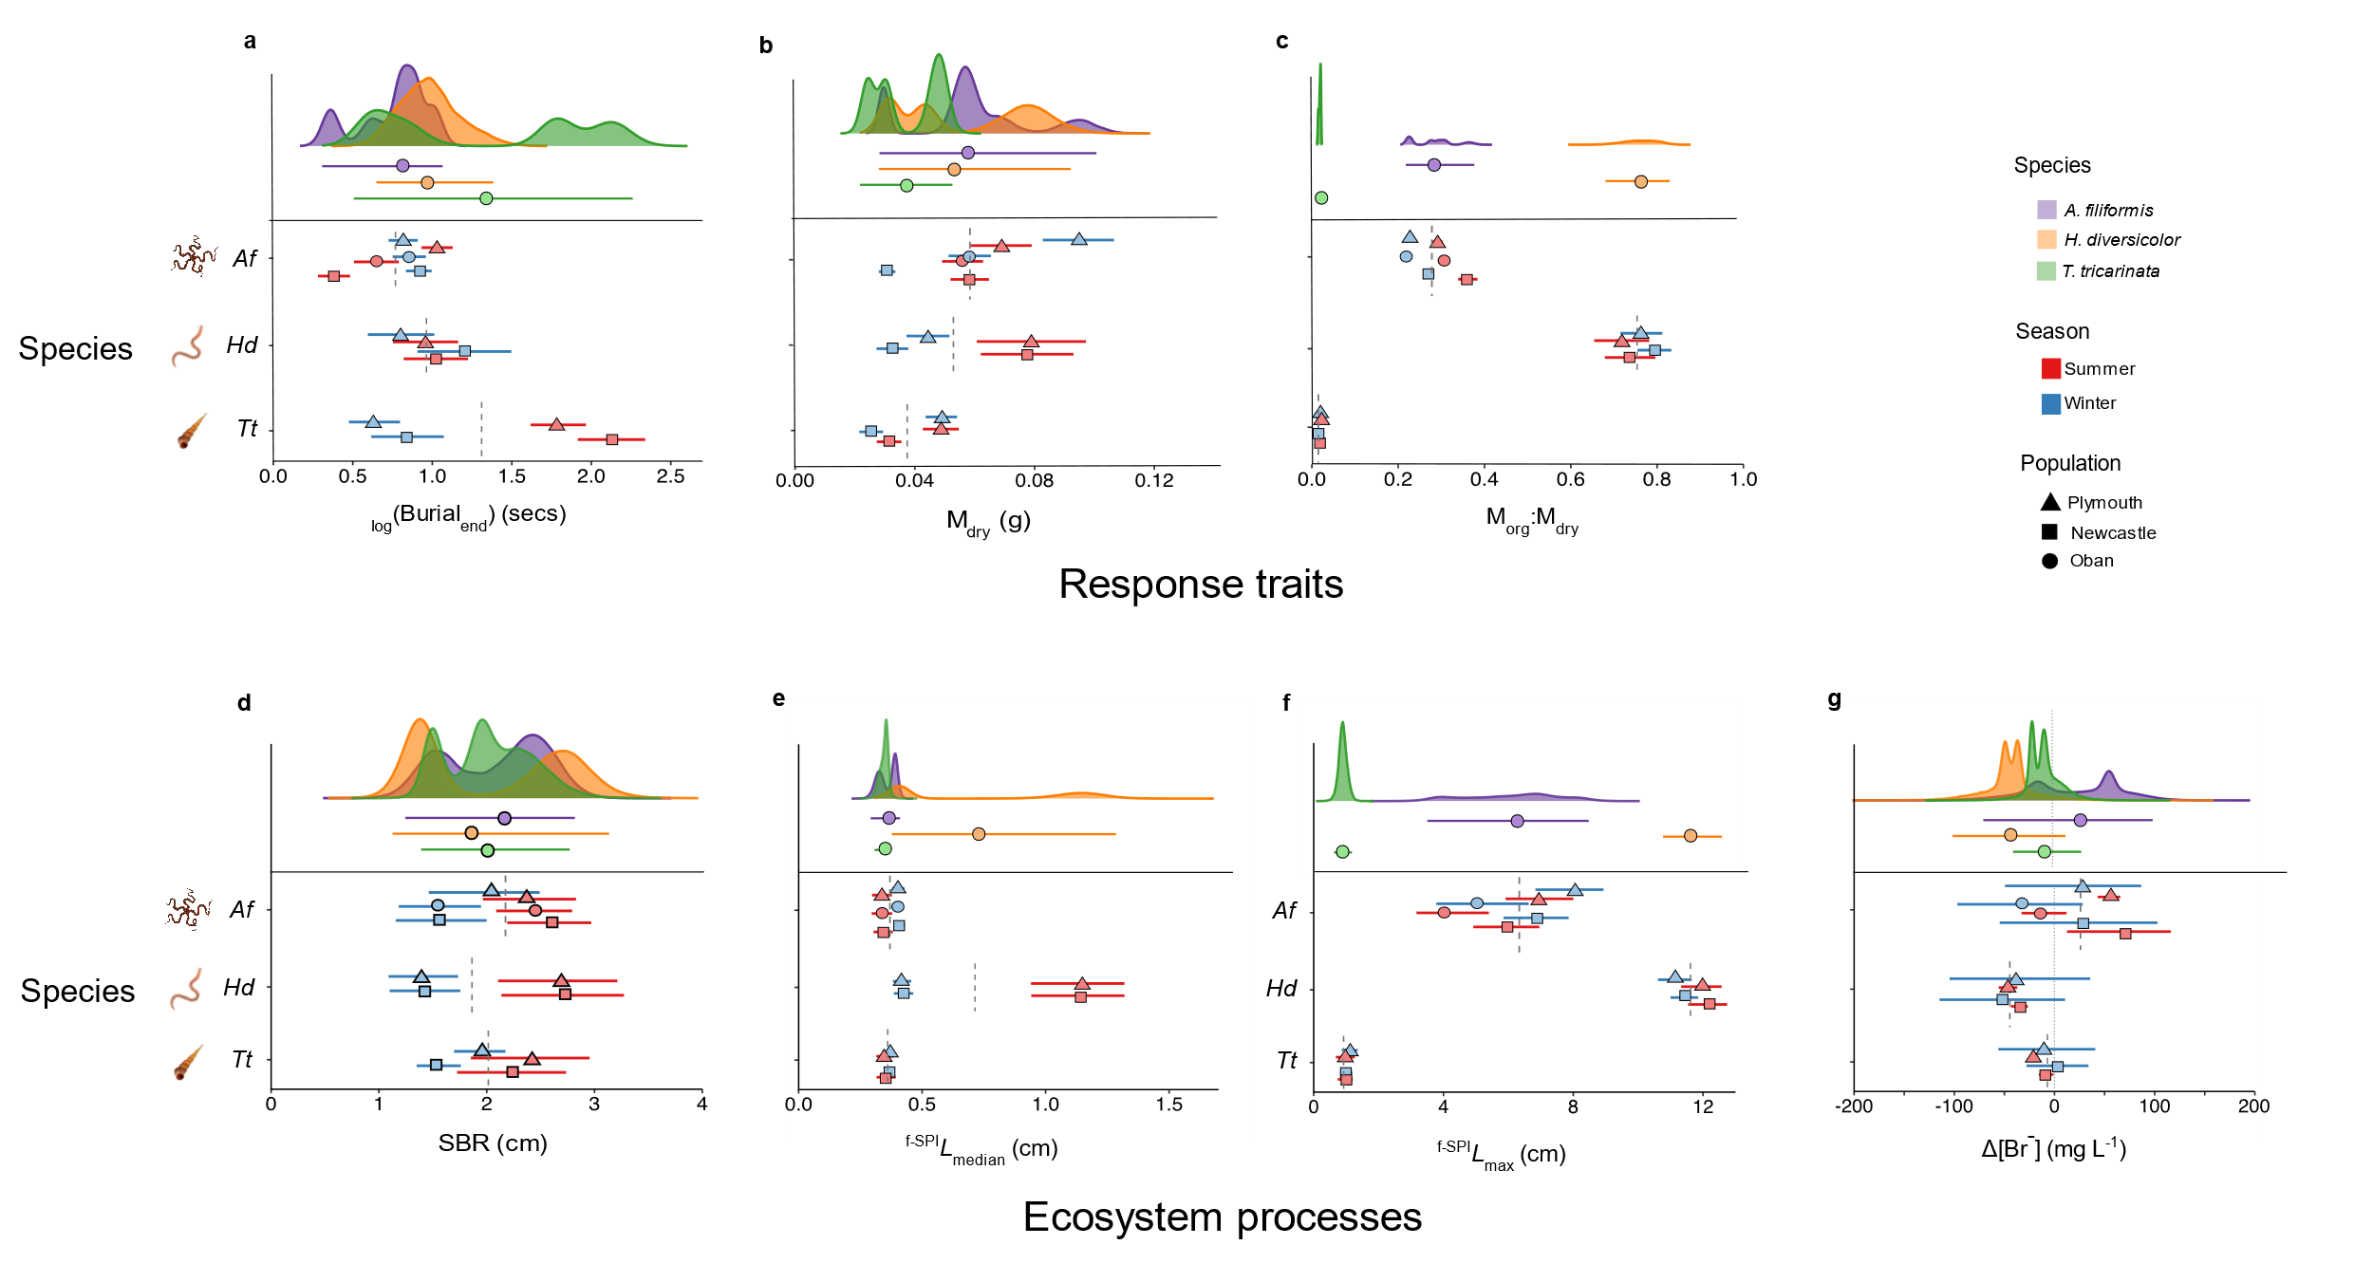Figure 1. Summary of inter- and intraspecific variability in response traits, and associated contributions to ecosystem processes, between populations and across seasons for representative sediment-dwelling marine invertebrates. Data are shown for the (a) time taken for complete burial (_{log}(Burial)_{end}), (b) dry mass of soft body tissue (M_{dry}), (c) proportion of organic soft tissue mass (M_{org}:M_{dry}), (d) surface boundary roughness (SBR), (e) median depth of particle reworking (^{f-SPI}L_{median}), (f) maximum depth of particle reworking (^{f-SPI}L_{max}) and (g) ventilation activity (Δ[Br⁻]: negative values indicate increased activity). In each panel, the upper section shows the posterior probability distributions with median ± 95 % credible intervals for Amphiura filiformis (purple: Af, n = 30), Hediste diversicolor (orange: Hd, n = 20) and Turritellinella tricarinata (green: Tt, n = 20), and the lower section details median values (± 95 % credible intervals, n = 5 per treatment) for different populations (triangle: Plymouth; square: Newcastle; circle: Oban) and season (red: summer; blue: winter). Vertical grey dashed lines represent mean values for each species, irrespective of population and season.

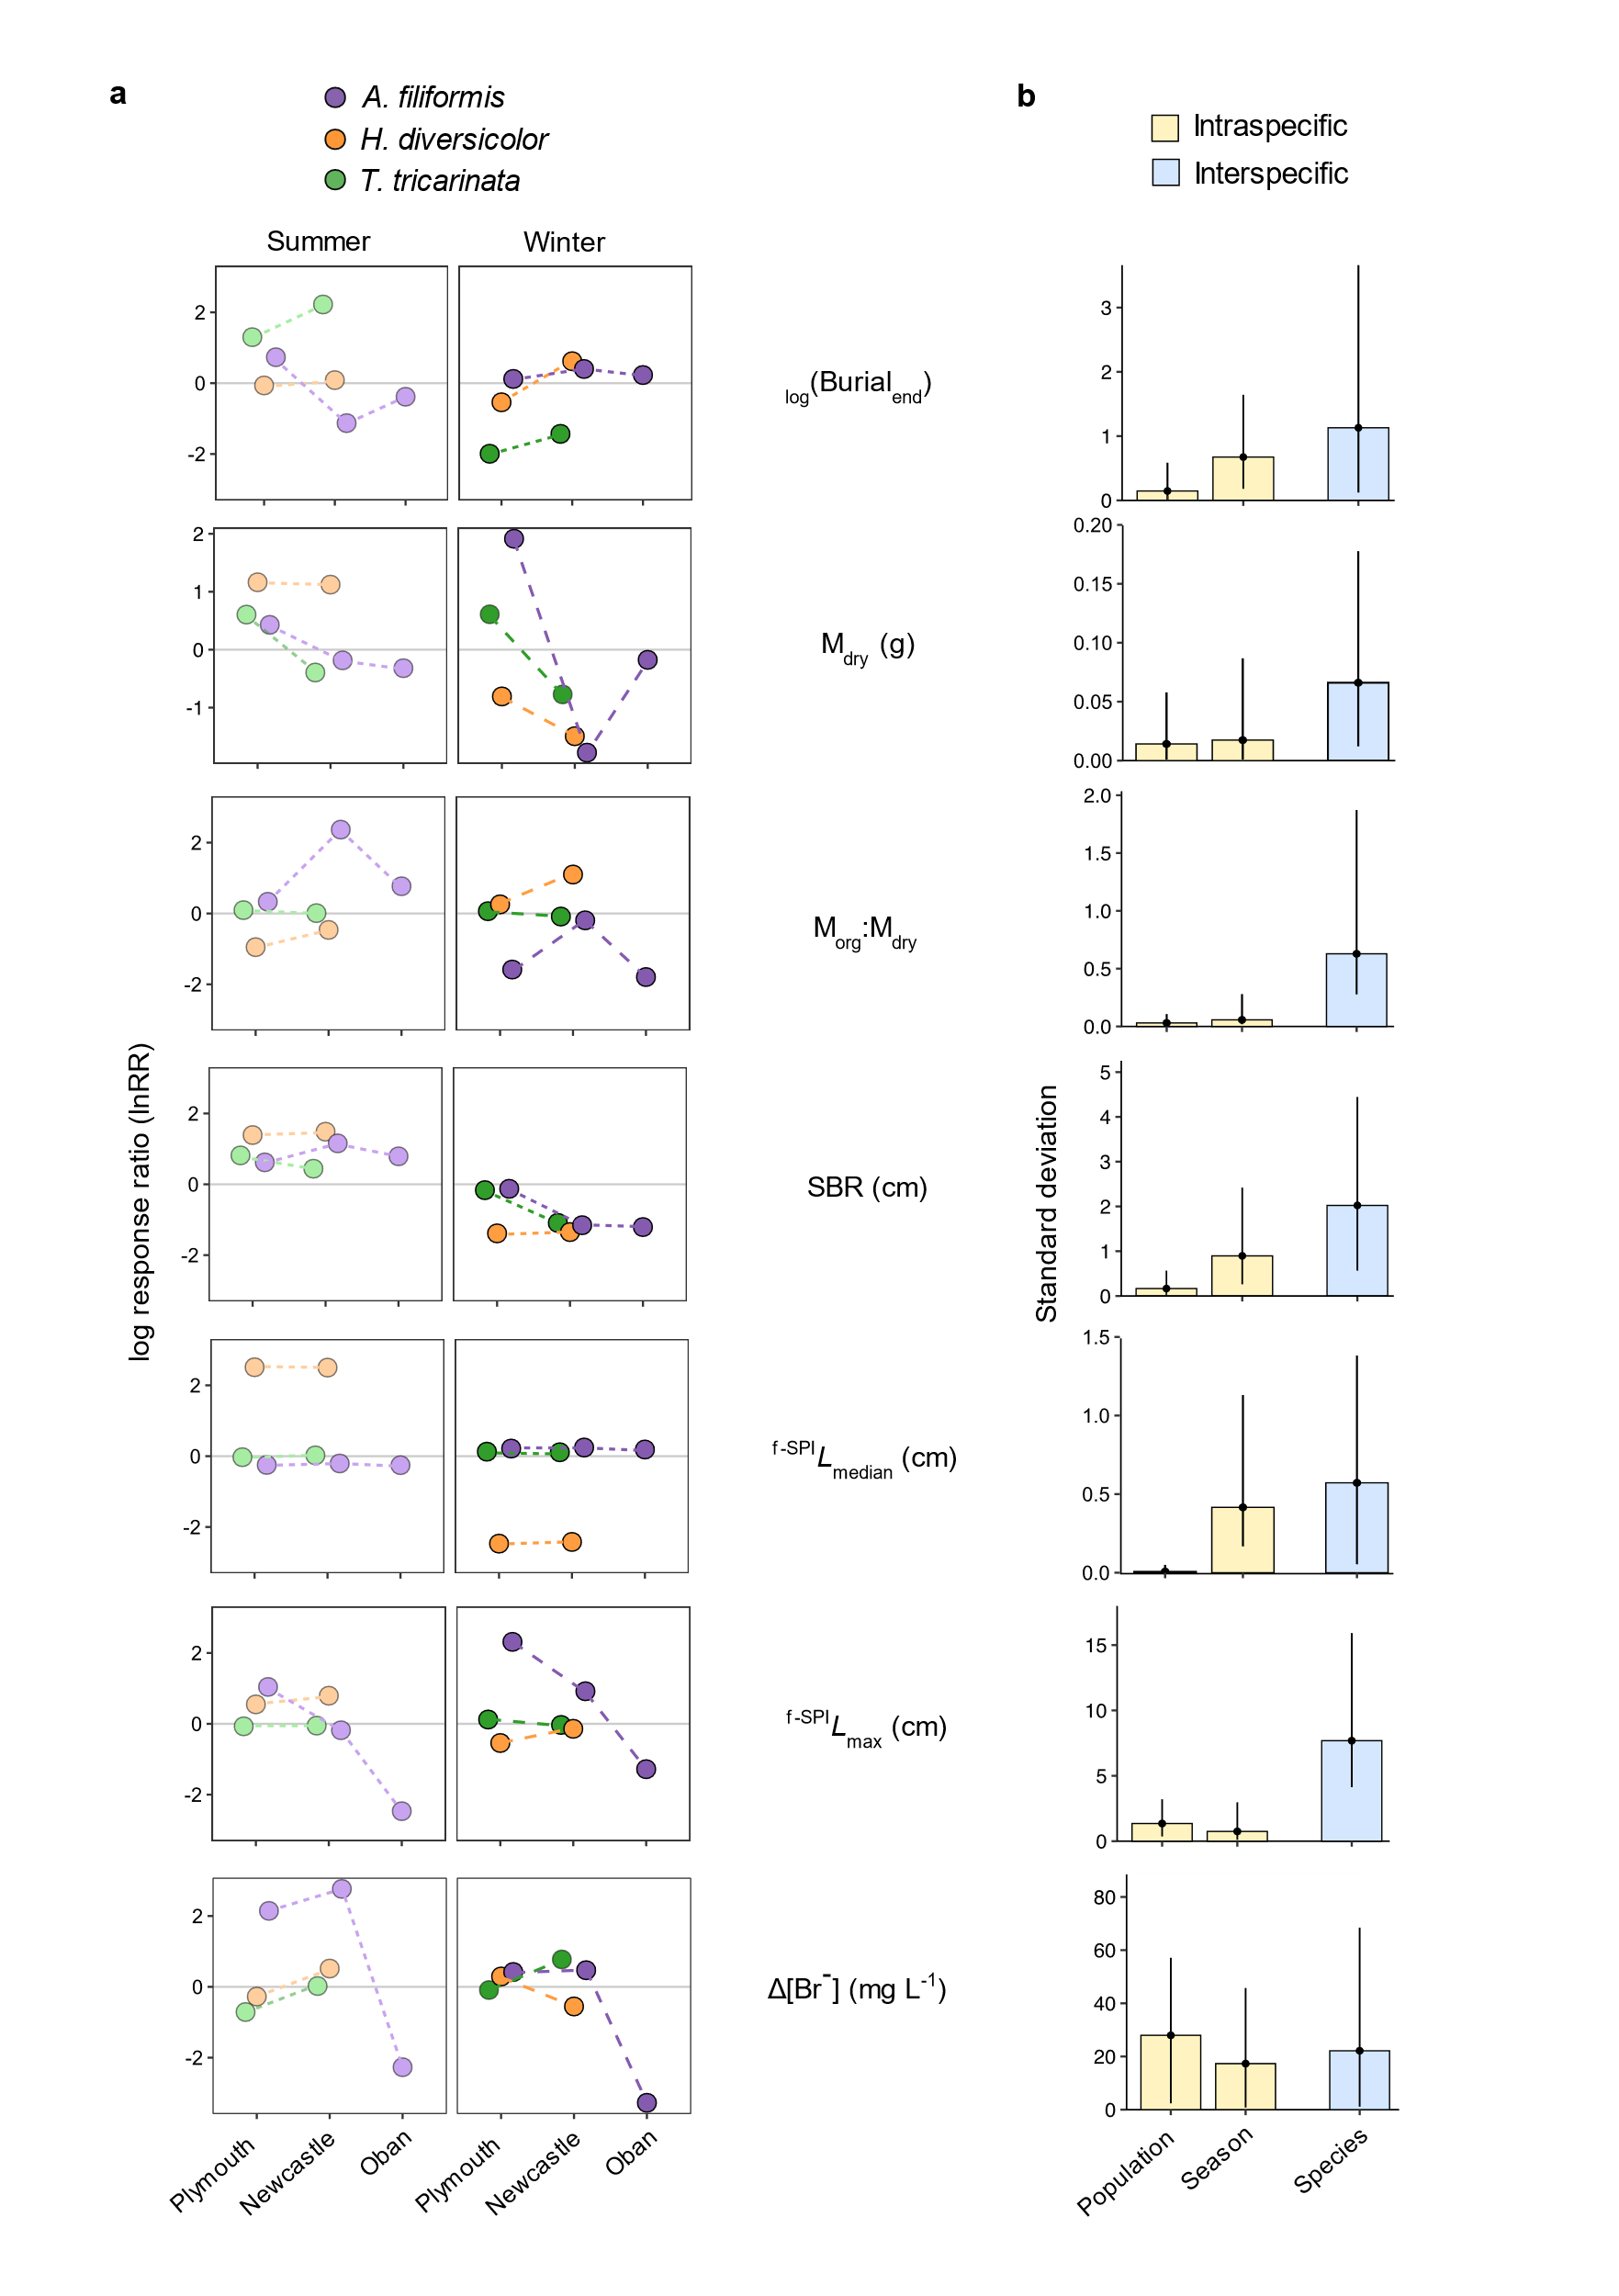
Figure 2. Summary of the magnitude of response traits, and associated contributions to ecosystem processes and intra- vs interspecific variability. Data are shown for the time taken for complete burial (_{log}(Burial)_{end}), dry mass of soft body tissue (M_{dry}), proportion of organic soft tissue mass (M_{org}:M_{dry}), surface boundary roughness (SBR), median depth of particle reworking (^{f-SPI}L_{median}), maximum depth of particle reworking (^{f-SPI}L_{max}) and ventilation activity (Δ[Br⁻]: negative values indicate increased activity). In (a), log response ratios (lnRR, ± 95 % CI, n = 5) a standardised measure of effect sizes, are presented in relation to mean values (set to y = 0) for each species (purple: Amphiura filiformis; orange: Hediste diversicolor; green: Turritellinella tricarinata) and population (Plymouth, Newcastle, Oban) for summer (left panels) and winter (right panels). Dashed connecting lines are to aid visualisation and are not intended to represent trends across a spatial gradient. In (b), standard deviations (SD, ± 95 % credible intervals) derived from Bayesian hierarchical models are shown for intraspecific (yellow: population and season) and interspecific (blue: species) model factors for each response trait, and associated contributions to ecosystem process. A higher SD indicates a stronger effect. For clarity in visualising differences between model factors, upper portions of credible intervals may extend beyond the plot area.
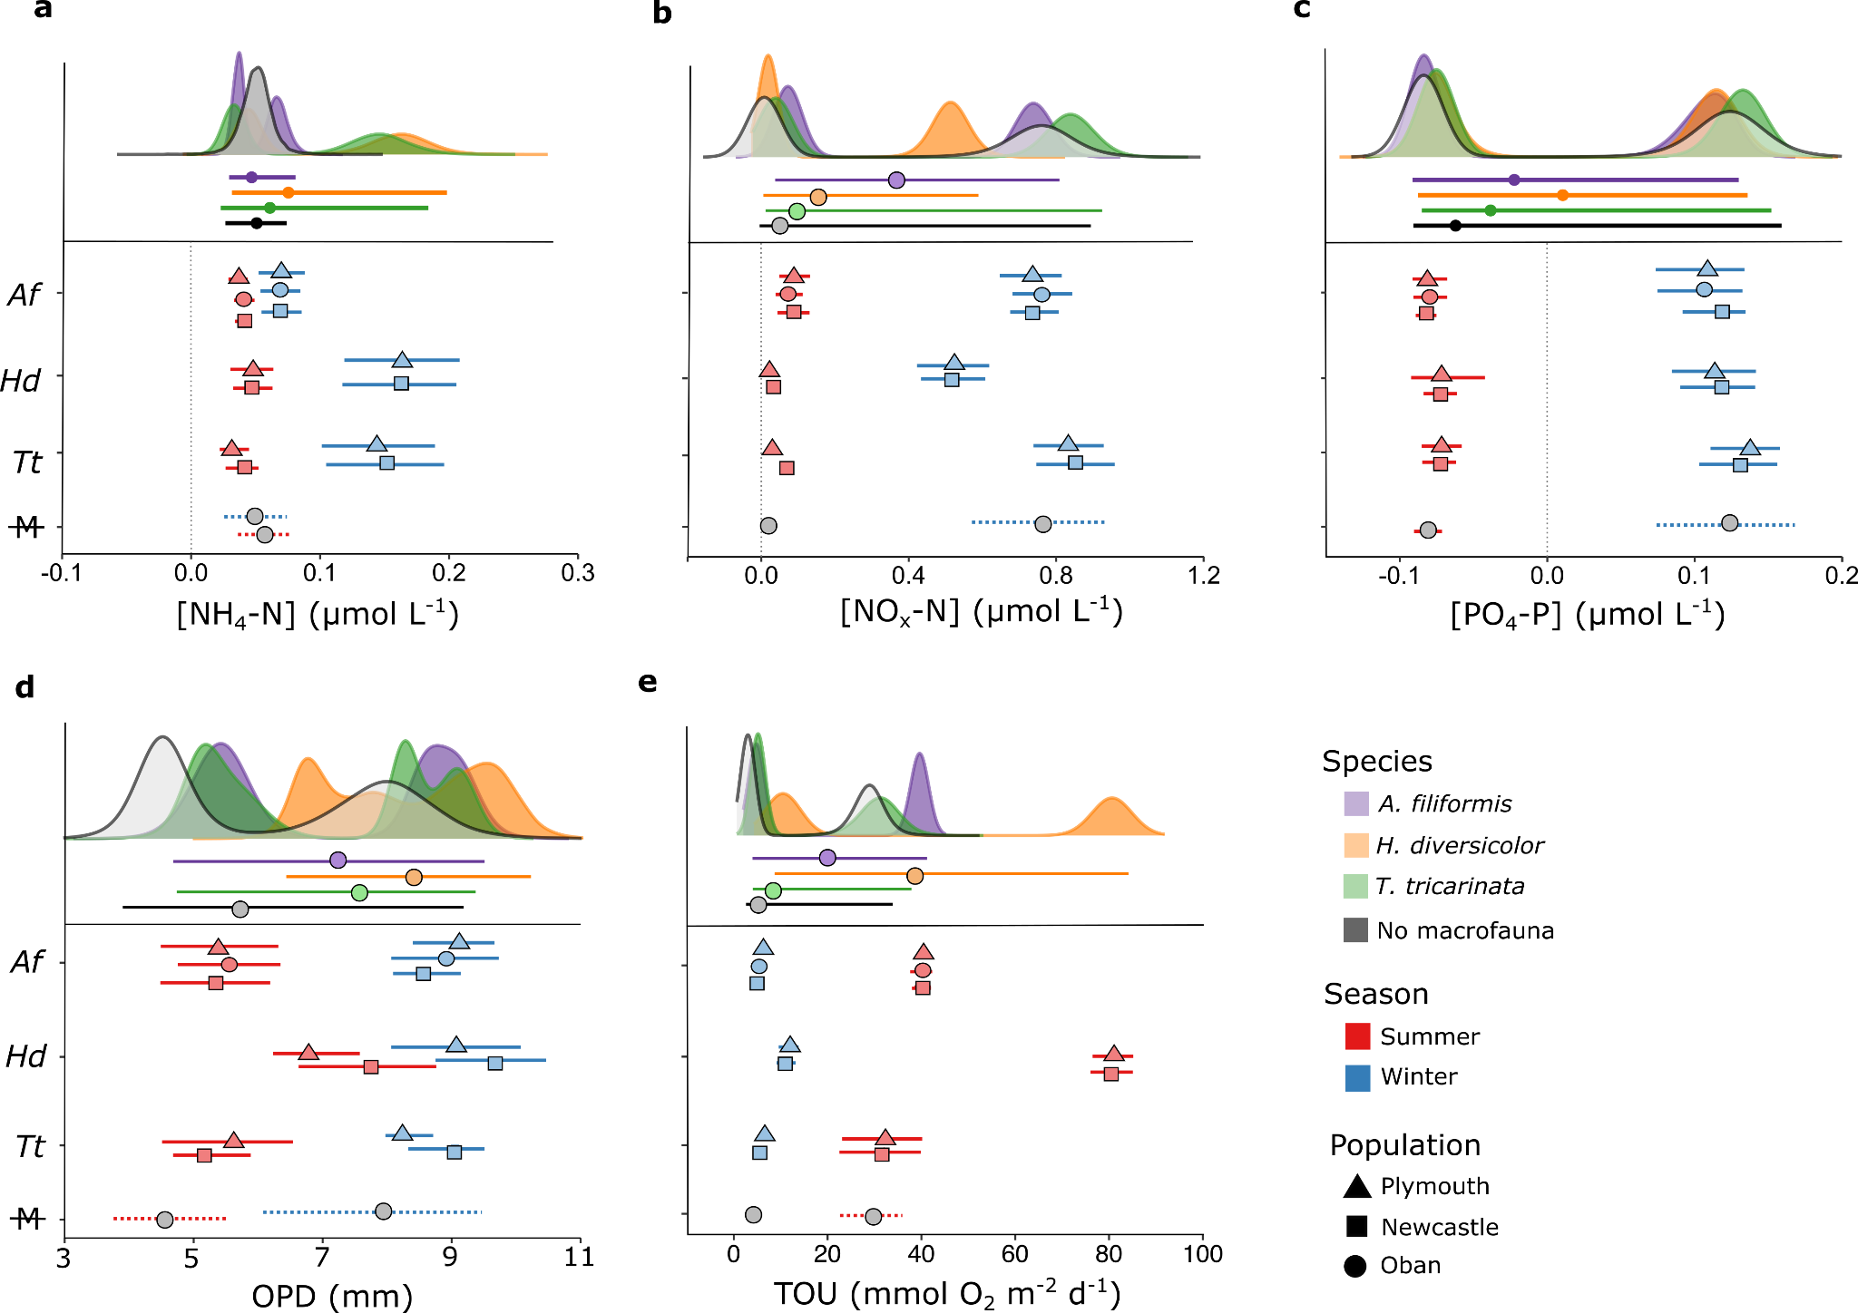
Figure 3. Summary of inter- and intraspecific variability in ecosystem functioning between populations and across seasons for representative sediment-dwelling marine invertebrates. Data are shown for water column concentrations of the macronutrients (a) ammonium-nitrogen, [NH₄-N], (b) nitrate + nitrite nitrogen, [NO_{x}-N], and (c) phosphate-phosphorous, [PO₄-P], (d) oxygen penetration depth (OPD), and (e) total oxygen uptake (TOU). In each panel, the upper section shows the posterior probability distributions with median ± 95 % credible intervals for Amphiura filiformis (purple: Af, n = 30), Hediste diversicolor (orange: Hd, n = 20), Turritellinella tricarinata (green: Tt, n= 20) and sediment containing no macrofauna (grey: M, n = 10), and the lower section details median values ( ± 95 % credible intervals, n = 5 per treatment) for different populations (triangle: Plymouth; square: Newcastle; circle: Oban) and season (red: summer; blue: winter). Vertical grey dashed lines represent mean values for each species, irrespective of population and season. For PO₄-P, nutrient values < 0 μmol L⁻¹ reflect detection error associated with low concentrations that are at, or near, zero.

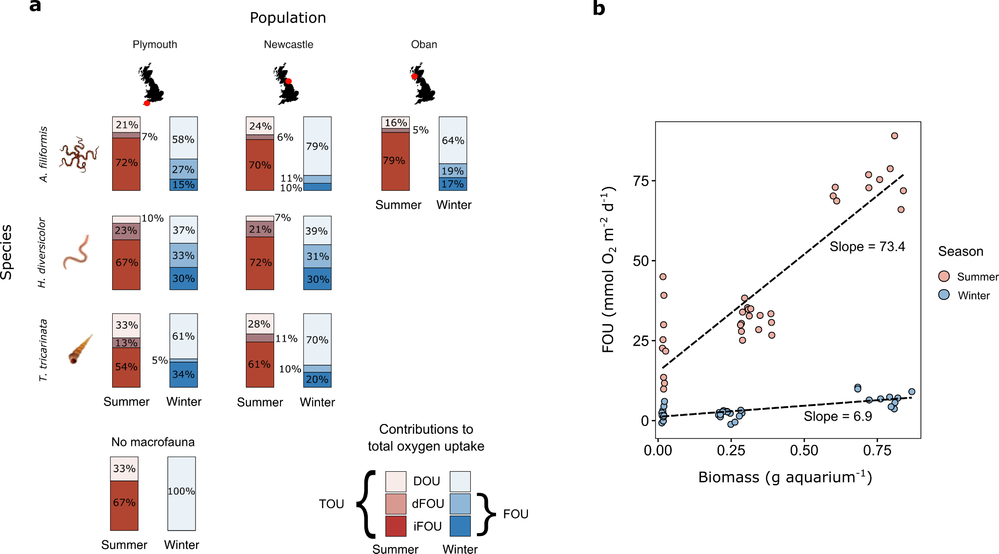Figure 4. Intraspecific variability in the relative contributions of faunal oxygen uptake (FOU) to total sediment oxygen uptake (TOU). In (a), the contributions of the sediment community to TOU are partitioned to separate DOU from the direct (dFOU) versus indirect (iFOU) contributions of FOU in the presence of each species (rows: Amphiura filiformis, Hediste diversicolor, Turritellinella tricarinata; n = 5) from each population (columns: Plymouth, Newcastle, Oban) and for each season (red: summer; blue: winter). In (b), the relationship between biomass (total macrofaunal soft tissue mass of all individuals per aquarium) and FOU for the summer (red) and winter (blue) is shown irrespective of species identity. Dashed lines represent linear regression.

References

Allgeier, J.E., Cline, T.J., Walsworth, T.E., Wathen, G., Layman, C.A. & Schindler, D.E. (2020) Individual behavior drives ecosystem function and the impacts of harvest. Sci. Adv., 6, eaax8329.
Arce, J.A., Alonso, F., Camacho, A. & Rico, E. (2019) Do native white-clawed crayfish impact macroinvertebrate assemblages in Mediterranean limestone headwaters? Knowledge and Management of Aquatic Ecosystems, 420, 33-33.
Bianchi, T.S., Aller, R.C., Atwood, T.B., Brown, C.J., Buatois, L.A., Levin, L.A., Levinton, J.S., Middelburg, J.J., Morrison, E.S., Regnier, P., Shields, M.R., Snelgrove, P.V.R., Sotka, E.E. & Stanley, R.R.E. (2021) What global biogeochemical consequences will marine animal–sediment interactions have during climate change? Elementa: Sci. Anthrop., 9.
Bjorkman, A.D., Myers-Smith, I.H., Elmendorf, S.C., Normand, S., Rüger, N., Beck, P.S.A., Blach-Overgaard, A., Blok, D., Cornelissen, J.H.C., Forbes, B.C., Georges, D., Goetz, S.J., Guay, K.C., Henry, G.H.R., HilleRisLambers, J., Hollister, R.D., Karger, D.N., Kattge, J., Manning, P., Prevéy, J.S., Rixen, C., Schaepman-Strub, G., Thomas, H.J.D., Vellend, M., Wilmking, M., Wipf, S., Carbognani, M., Hermanutz, L., Lévesque, E., Molau, U., Petraglia, A., Soudzilovskaia, N.A., Spasojevic, M.J., Tomaselli, M., Vowles, T., Alatalo, J.M., Alexander, H.D., Anadon-Rosell, A., Angers-Blondin, S., Beest, M.t., Berner, L., Björk, R.G., Buchwal, A., Buras, A., Christie, K., Cooper, E.J., Dullinger, S., Elberling, B., Eskelinen, A., Frei, E.R., Grau, O., Grogan, P., Hallinger, M., Harper, K.A., Heijmans, M.M.P.D., Hudson, J., Hülber, K., Iturrate-Garcia, M., Iversen, C.M., Jaroszynska, F., Johnstone, J.F., Jørgensen, R.H., Kaarlejärvi, E., Klady, R., Kuleza, S., Kulonen, A., Lamarque, L.J., Lantz, T., Little, C.J., Speed, J.D.M., Michelsen, A., Milbau, A., Nabe-Nielsen, J., Nielsen, S.S., Ninot, J.M., Oberbauer, S.F., Olofsson, J., Onipchenko, V.G., Rumpf, S.B., Semenchuk, P., Shetti, R., Collier, L.S., Street, L.E., Suding, K.N., Tape, K.D., Trant, A., Treier, U.A., Tremblay, J.-P., Tremblay, M., Venn, S., Weijers, S., Zamin, T., Boulanger-Lapointe, N., Gould, W.A., Hik, D.S., Hofgaard, A., Jónsdóttir, I.S., Jorgenson, J., Klein, J., Magnusson, B., Tweedie, C., Wookey, P.A., Bahn, M., Blonder, B., van Bodegom, P.M., Bond-Lamberty, B., Campetella, G., Cerabolini, B.E.L., Chapin, F.S., Cornwell, W.K., Craine, J., Dainese, M., de Vries, F.T., Díaz, S., Enquist, B.J., Green, W., Milla, R., Niinemets, Ü., Onoda, Y., Ordoñez, J.C., Ozinga, W.A., Penuelas, J., Poorter, H., Poschlod, P., Reich, P.B., Sandel, B., Schamp, B., Sheremetev, S. & Weiher, E. (2018) Plant functional trait change across a warming tundra biome. Nature, 562, 57-62.
Bloomfield, K.J., Cernusak, L.A., Eamus, D., Ellsworth, D.S., Colin Prentice, I., Wright, I.J., Boer, M.M., Bradford, M.G., Cale, P., Cleverly, J., Egerton, J.J.G., Evans, B.J., Hayes, L.S., Hutchinson, M.F., Liddell, M.J., Macfarlane, C., Meyer, W.S., Prober, S.M., Togashi, H.F., Wardlaw, T., Zhu, L. & Atkin, O.K. (2018) A continental-scale assessment of variability in leaf traits: Within species, across sites and between seasons. Funct. Ecol., 32, 1492-1506.
Booth, J.M., Fusi, M., Marasco, R. & Daffonchio, D. (2023) The microbial landscape in bioturbated mangrove sediment: A resource for promoting nature-based solutions for mangroves. Microb. Biotechnol., 16, 1584-1602.
Brun, P., Payne, M.R. & Kiørboe, T. (2016) Trait biogeography of marine copepods–an analysis across scales. Ecol. Lett., 19, 1403-1413.
Calosi, P., Melatunan, S., Turner, L.M., Artioli, Y., Davidson, R.L., Byrne, J.J., Viant, M.R., Widdicombe, S. & Rundle, S.D. (2017) Regional adaptation defines sensitivity to future ocean acidification. Nat. Commun., 8, 13994.
Cardinale, B.J., Duffy, J.E., Gonzalez, A., Hooper, D.U., Perrings, C., Venail, P., Narwani, A., Mace, G.M., Tilman, D., Wardle, D.A., Kinzig, A.P., Daily, G.C., Loreau, M., Grace, J.B., Larigauderie, A., Srivastava, D.S. & Naeem, S. (2012) Biodiversity loss and its impact on humanity. Nature, 486, 59-67.
Cassidy, C., Grange, L.J., Garcia, C., Bolam, S.G. & Godbold, J.A. (2020) Species interactions and environmental context affect intraspecific behavioural trait variation and ecosystem function. Proc. R. Soc. B., 287, 20192143.
Chacón-Labella, J., Hinojo-Hinojo, C., Bohner, T., Castorena, M., Violle, C., Vandvik, V. & Enquist, B.J. (2023) How to improve scaling from traits to ecosystem processes. Trends Ecol. Evol., 38, 228-237.
de Bello, F., Lavorel, S., Hallett, L.M., Valencia, E., Garnier, E., Roscher, C., Conti, L., Galland, T., Goberna, M., Májeková, M., Montesinos-Navarro, A., Pausas, J.G., Verdú, M., E-Vojtkó, A., Götzenberger, L. & Lepš, J. (2021) Functional trait effects on ecosystem stability: assembling the jigsaw puzzle. Trends Ecol. Evol., 36, 822-836.
Des Roches, S., Pendleton, L.H., Shapiro, B. & Palkovacs, E.P. (2021) Conserving intraspecific variation for nature’s contributions to people. Nat. Ecol. Evol., 5, 574-582.
Des Roches, S., Post, D.M., Turley, N.E., Bailey, J.K., Hendry, A.P., Kinnison, M.T., Schweitzer, J.A. & Palkovacs, E.P. (2018) The ecological importance of intraspecific variation. Nat. Ecol. Evol., 2, 57-64.
Enquist, B.J., Norberg, J., Bonser, S.P., Violle, C., Webb, C.T., Henderson, A., Sloat, L.L. & Savage, V.M. (2015) Scaling from traits to ecosystems: developing a general trait driver theory via integrating trait-based and metabolic scaling theories. Adv. Ecol. Res., 52, 249-318.
Etard, A., Morrill, S. & Newbold, T. (2020) Global gaps in trait data for terrestrial vertebrates. Global Ecology and Biogeography, 29, 2143-2158.
Forster, S., Glud, R.N., Gundersen, J.K. & Huettel, M. (1999) In situ study of bromide tracer and oxygen flux in coastal sediments. Estuar. Coast. Shelf Sci., 49, 813-827.
Gabry, J., Simpson, D., Vehtari, A., Betancourt, M. & Gelman, A. (2019) Visualization in Bayesian workflow. J. R. Stat. Soc. Ser. A. stat. Soc., 182, 389-402.
Garcia, C., Solan, M., Bolam, S.G., Sivyer, D., Parker, R. & Godbold, J.A. (2021) Exploration of multiple post-extinction compensatory scenarios improves the likelihood of determining the most realistic ecosystem future. Environ. Res. Commun., 3, 045001.
Gelman, A., Carlin, J.B., Stern, H.S. & Rubin, D.B. (2004) Bayesian Data Analysis. Chapman & Hall.
Gervais, C.R., Huveneers, C., Rummer, J.L. & Brown, C. (2021) Population variation in the thermal response to climate change reveals differing sensitivity in a benthic shark. Global Change Biology, 27, 108-120.
Glud, R.N. (2008) Oxygen dynamics of marine sediments. Mar. Biol. Res., 4, 243-289.
Godbold, J.A. & Solan, M. (2009) Relative importance of biodiversity and the abiotic environment in mediating an ecosystem process. Mar. Ecol. Prog. Ser., 396, 273-282.
Godbold, J.A. & Solan, M. (2013) Long-term effects of warming and ocean acidification are modified by seasonal variation in species responses and environmental conditions. Philos. Trans. R. Soc. B, 368, 20130186.
Grasshoff, K., Kremling, K. & Ehrhardt, M. (1999) Methods of seawater analysis. John Wiley & Sons.
Green, S.J., Brookson, C.B., Hardy, N.A. & Crowder, L.B. (2022) Trait-based approaches to global change ecology: moving from description to prediction. Proc. R. Soc. B., 289, 20220071.
Grigulis, K., Lavorel, S., Krainer, U., Legay, N., Baxendale, C., Dumont, M., Kastl, E., Arnoldi, C., Bardgett, R.D., Poly, F., Pommier, T., Schloter, M., Tappeiner, U., Bahn, M. & Clément, J.-C. (2013) Relative contributions of plant traits and soil microbial properties to mountain grassland ecosystem services. Journal of Ecology, 101, 47-57.
Hagan, J.G., Henn, J.J. & Osterman, W.H.A. (2023) Plant traits alone are good predictors of ecosystem properties when used carefully. Nature ecology & evolution, 7, 332-334.
Hale, R., Mavrogordato, M.N., Tolhurst, T.J. & Solan, M. (2014) Characterizations of how species mediate ecosystem properties require more comprehensive functional effect descriptors. Sci. Rep., 4, 6463.
Harianto, J., Carey, N. & Byrne, M. (2019) respR—An R package for the manipulation and analysis of respirometry data. Methods Ecol. Evol., 10, 912-920.
Henn, J.J., Buzzard, V., Enquist, B.J., Halbritter, A.H., Klanderud, K., Maitner, B.S., Michaletz, S.T., Pötsch, C., Seltzer, L., Telford, R.J., Yang, Y., Zhang, L. & Vandvik, V. (2018) Intraspecific trait variation and phenotypic plasticity mediate alpine plant species response to climate change. Front. Plant Sci., 9, 1548.
Hortal, J., de Bello, F., Diniz-Filho, J.A.F., Lewinsohn, T.M., Lobo, J.M. & Ladle, R.J. (2015) Seven Shortfalls that Beset Large-Scale Knowledge of Biodiversity. Annual Review of Ecology, Evolution, and Systematics, 46, 523-549.
Hughes, A.R., Inouye, B.D., Johnson, M.T., Underwood, N. & Vellend, M. (2008) Ecological consequences of genetic diversity. Ecol. Lett., 11, 609-623.
Kauppi, L., Norkko, J., Ikonen, J. & Norkko, A. (2017) Seasonal variability in ecosystem functions: quantifying the contribution of invasive species to nutrient cycling in coastal ecosystems. Mar. Ecol. Prog. Ser., 572, 193-207.
Keller, A., Ankenbrand, M.J., Bruelheide, H., Dekeyzer, S., Enquist, B.J., Erfanian, M.B., Falster, D.S., Gallagher, R.V., Hammock, J., Kattge, J., Leonhardt, S.D., Madin, J.S., Maitner, B., Neyret, M., Onstein, R.E., Pearse, W.D., Poelen, J.H., Salguero-Gomez, R., Schneider, F.D., Tóth, A.B. & Penone, C. (2023) Ten (mostly) simple rules to future-proof trait data in ecological and evolutionary sciences. Methods Ecol. Evol., 14, 444-458.
Kenna, D., Fincham, W.N.W., Dunn, A.M., Brown, L.E. & Hassall, C. (2017) Antagonistic effects of biological invasion and environmental warming on detritus processing in freshwater ecosystems. Oecologia, 183, 875-886.
Kiørboe, T., Visser, A. & Andersen, K.H. (2018) A trait-based approach to ocean ecology. ICES J. Mar. Sci., 75, 1849-1863.
Koretsky, C.M., Meile, C. & Van Cappellen, P. (2002) Quantifying bioirrigation using ecological parameters: a stochastic approach. Geochemical Transactions, 3, 17-30.
Langenheder, S., Bulling, M.T., Prosser, J.I. & Solan, M. (2012) Role of functionally dominant species in varying environmental regimes: evidence for the performance-enhancing effect of biodiversity. BMC Ecology, 12, 14.
Laughlin, D.C. (2014) Applying trait-based models to achieve functional targets for theory-driven ecological restoration. Ecol. Lett., 17, 771-784.
Lavorel, S. & Garnier, E. (2002) Predicting changes in community composition and ecosystem functioning from plant traits: revisiting the Holy Grail. Funct. Ecol., 16, 545-556.
Lemoine, N.P. (2019) Moving beyond noninformative priors: why and how to choose weakly informative priors in Bayesian analyses. Oikos, 128, 912-928.
Lohbeck, M., Poorter, L., Martínez-Ramos, M. & Bongers, F. (2015) Biomass is the main driver of changes in ecosystem process rates during tropical forest succession. Ecology, 96, 1242-1252.
Loreau, M., Naeem, S., Inchausti, P., Bengtsson, J., Grime, J.P., Hector, A., Hooper, D.U., Huston, M.A., Raffaelli, D., Schmid, B., Tilman, D. & Wardle, D.A. (2001) Biodiversity and Ecosystem Functioning: Current Knowledge and Future Challenges. Science, 294, 804-808.
Loureiro, N., Mantuano, D., Manhães, A. & Sansevero, J. (2023) Use of the trait-based approach in ecological restoration studies: a global review. Trees, 37, 1287-1297.
Martini, S., Larras, F., Boyé, A., Faure, E., Aberle, N., Archambault, P., Bacouillard, L., Beisner, B.E., Bittner, L., Castella, E., Danger, M., Gauthier, O., Karp-Boss, L., Lombard, F., Maps, F., Stemmann, L., Thiébaut, E., Usseglio-Polatera, P., Vogt, M., Laviale, M. & Ayata, S.-D. (2021) Functional trait-based approaches as a common framework for aquatic ecologists. Limnol. Oceanogr., 66, 965-994.
Messier, J., McGill, B.J., Enquist, B.J. & Lechowicz, M.J. (2017) Trait variation and integration across scales: is the leaf economic spectrum present at local scales? Ecography, 40, 685-697.
Mestdagh, S., Fang, X., Soetaert, K., Ysebaert, T., Moens, T. & Van Colen, C. (2020) Seasonal variability in ecosystem functioning across estuarine gradients: The role of sediment communities and ecosystem processes. Mar. Environ. Res., 162, 105096.
Mindel, B.L., Webb, T.J., Neat, F.C. & Blanchard, J.L. (2016) A trait‐based metric sheds new light on the nature of the body size–depth relationship in the deep sea. J. Anim. Ecol., 85, 427-436.
Mitchell, R.M. & Bakker, J.D. (2014) Quantifying and comparing intraspecific functional trait variability: a case study with Hypochaeris radicata. Funct. Ecol., 28, 258-269.
Mlambo, M.C. (2014) Not all traits are ‘functional’: insights from taxonomy and biodiversity-ecosystem functioning research. Biodivers. Conserv., 23, 781-790.
Moran, E.V., Hartig, F. & Bell, D.M. (2016) Intraspecific trait variation across scales: implications for understanding global change responses. Glob. Change Biol., 22, 137-150.
Murray, F., Douglas, A. & Solan, M. (2014) Species that share traits do not necessarily form distinct and universally applicable functional effect groups. Mar. Ecol. Prog. Ser., 516, 23-34.
Nakagawa, S., Noble, D.W.A., Lagisz, M., Spake, R., Viechtbauer, W. & Senior, A.M. (2023) A robust and readily implementable method for the meta-analysis of response ratios with and without missing standard deviations. Ecology Letters, 26, 232-244.
Nielsen, E.S., Henriques, R., Beger, M. & von der Heyden, S. (2021) Distinct interspecific and intraspecific vulnerability of coastal species to global change. Glob. Change Biol., 27, 3415-3431.
Pichon, N.A., Cappelli, S.L. & Allan, E. (2022) Intraspecific trait changes have large impacts on community functional composition but do not affect ecosystem function. J. Ecol., 110, 644-658.
Pritzkow, C., Williamson, V., Szota, C., Trouvé, R. & Arndt, S.K. (2019) Phenotypic plasticity and genetic adaptation of functional traits influences intra-specific variation in hydraulic efficiency and safety. Tree Physiol., 40, 215-229.
R Core Team (2023) R: A language and environment for statistical computing. R Foundation for Statistical Computing. R Foundation for Statistical Computing, Vienna, Austria.
Raffard, A., Santoul, F., Cucherousset, J. & Blanchet, S. (2019) The community and ecosystem consequences of intraspecific diversity: a meta-analysis. Biological Reviews, 94, 648-661.
Reed, A.J., Godbold, J.A., Grange, L.J. & Solan, M. (2021) Growth of marine ectotherms is regionally constrained and asymmetric with latitude. Glob. Ecol. Biogeogr., 30, 578-589.
Reusch, T.B.H. (2014) Climate change in the oceans: evolutionary versus phenotypically plastic responses of marine animals and plants. Evol. Appl., 7, 104-122.
Revsbech, N.P. (1989) An oxygen microsensor with a guard cathode. Limnol. Oceanogr., 34, 474-478.
Richardson, T.S., Robins, J.M. & Wang, L. (2017) On modeling and estimation for the relative risk and risk difference. J. Am. Stat. Assoc., 112, 1121-1130.
Roscher, C., Schumacher, J., Gubsch, M., Lipowsky, A., Weigelt, A., Buchmann, N., Schulze, E.-D. & Schmid, B. (2018) Interspecific trait differences rather than intraspecific trait variation increase the extent and filling of community trait space with increasing plant diversity in experimental grasslands. Perspect. Pl. Ecol. Evol. Syst., 33, 42-50.
Sanders, T., Solan, M. & Godbold, J.A. (2024) Trait-mediated processes and per capita contributions to ecosystem functioning depend on conspecific density and climate conditions. Commun. Earth Environ., 5, 79.
Schmitz, O.J., Buchkowski, R.W., Burghardt, K.T. & Donihue, C.M. (2015) Functional traits and trait-mediated interactions: connecting community-level interactions with ecosystem functioning. Advances in ecological research (eds S. Pawar, G. Woodward & A.I. Dell), pp. 319-343. Academic Press.
Schneider, F.D., Fichtmueller, D., Gossner, M.M., Güntsch, A., Jochum, M., König-Ries, B., Le Provost, G., Manning, P., Ostrowski, A., Penone, C. & Simons, N.K. (2019) Towards an ecological trait-data standard. Methods in Ecology and Evolution, 10, 2006-2019.
Schrodt, F., Kattge, J., Shan, H., Fazayeli, F., Joswig, J., Banerjee, A., Reichstein, M., Bönisch, G., Díaz, S., Dickie, J., Gillison, A., Karpatne, A., Lavorel, S., Leadley, P., Wirth, C.B., Wright, I.J., Wright, S.J. & Reich, P.B. (2015) BHPMF - a hierarchical Bayesian approach to gap-filling and trait prediction for macroecology and functional biogeography. Glob. Ecol. Biogeogr., 24, 1510-1521.
Seguin, A., Harvey, E., Archambault, P., Nozais, C. & Gravel, D. (2014) Body size as a predictor of species loss effect on ecosystem functioning. Sci. Rep., 4, 4616.
Siefert, A., Violle, C., Chalmandrier, L., Albert, C.H., Taudiere, A., Fajardo, A., Aarssen, L.W., Baraloto, C., Carlucci, M.B. & Cianciaruso, M.V. (2015) A global meta‐analysis of the relative extent of intraspecific trait variation in plant communities. Ecol. Lett., 18, 1406-1419.
Snelgrove, P.V. (1999) Getting to the bottom of marine biodiversity: sedimentary habitats: ocean bottoms are the most widespread habitat on earth and support high biodiversity and key ecosystem services. BioScience, 49, 129-138.
Solan, M., Cardinale, B.J., Downing, A.L., Engelhardt, K.A., Ruesink, J.L. & Srivastava, D.S. (2004) Extinction and ecosystem function in the marine benthos. Science, 306, 1177-1180.
Solan, M., Ward, E.R., White, E.L., Hibberd, E.E., Cassidy, C., Schuster, J.M., Hale, R. & Godbold, J.A. (2019) Worldwide measurements of bioturbation intensity, ventilation rate, and the mixing depth of marine sediments. Sci. Data, 6, 58.
Solan M., Wigham B.D., Hudson I.R., Kennedy R., Coulon C.H, Norling K, Nilsson H.C. & R., R. (2004) In situ quantification of bioturbation using time-lapse fluorescent sediment profile imaging (f-SPI), luminophore tracers and model simulation. Mar. Ecol. Prog. Ser., 271, 1-12.
Streit, R.P. & Bellwood, D.R. (2023) To harness traits for ecology, let’s abandon ‘functionality’. Trends Ecol. Evol., 38, 402-411.
Suding, K.N. & Goldstein, L.J. (2008) Testing the Holy Grail framework: using functional traits to predict ecosystem change. New Phytol., 180, 559-562.
Thomas, P.K., Jacob, M., Acevedo-Trejos, E., Hillebrand, H. & Striebel, M. (2024) Species richness and intraspecific variation interactively shape marine diatom community functioning. Limnol. Oceanogr. Lett., In press.
Thurber, A.R., Sweetman, A.K., Narayanaswamy, B.E., Jones, D.O.B., Ingels, J. & Hansman, R.L. (2014) Ecosystem function and services provided by the deep sea. Biogeosciences, 11, 3941-3963.
Törnroos, A. & Bonsdorff, E. (2012) Developing the multitrait concept for functional diversity: lessons from a system rich in functions but poor in species. Ecol. Appl., 22, 2221-2236.
van der Plas, F., Schröder-Georgi, T., Weigelt, A., Barry, K., Meyer, S., Alzate, A., Barnard, R.L., Buchmann, N., de Kroon, H., Ebeling, A., Eisenhauer, N., Engels, C., Fischer, M., Gleixner, G., Hildebrandt, A., Koller-France, E., Leimer, S., Milcu, A., Mommer, L., Niklaus, P.A., Oelmann, Y., Roscher, C., Scherber, C., Scherer-Lorenzen, M., Scheu, S., Schmid, B., Schulze, E.-D., Temperton, V., Tscharntke, T., Voigt, W., Weisser, W., Wilcke, W. & Wirth, C. (2020) Plant traits alone are poor predictors of ecosystem properties and long-term ecosystem functioning. Nature ecology & evolution, 4, 1602-1611.
Violle, C., Enquist, B.J., McGill, B.J., Jiang, L., Albert, C.H., Hulshof, C., Jung, V. & Messier, J. (2012) The return of the variance: intraspecific variability in community ecology. Trends Ecol. Evol., 27, 244-252.
Wilson, S.M., Moore, J.W., Ward, E.J., Kinsel, C.W., Anderson, J.H., Buehrens, T.W., Carr-Harris, C.N., Cochran, P.C., Davies, T.D., Downen, M.R., Godbout, L., Lisi, P.J., Litz, M.N.C., Patterson, D.A., Selbie, D.T., Sloat, M.R., Suring, E.J., Tattam, I.A. & Wyatt, G.J. (2023) Phenological shifts and mismatch with marine productivity vary among Pacific salmon species and populations. Nat. Ecol. Evol., 7, 852-861.
Wohlgemuth, D., Solan, M. & Godbold, J.A. (2016) Specific arrangements of species dominance can be more influential than evenness in maintaining ecosystem process and function. Sci. Rep., 6, 39325.
Wohlgemuth, D., Solan, M. & Godbold, J.A. (2017) Species contributions to ecosystem process and function can be population dependent and modified by biotic and abiotic setting. Proc. R. Soc. B., 284, 20162805.
Wong, M.K.L. & Carmona, C.P. (2021) Including intraspecific trait variability to avoid distortion of functional diversity and ecological inference: Lessons from natural assemblages. Methods Ecol. Evol., 12, 946-957.
Wright, J.P., Ames, G.M. & Mitchell, R.M. (2016) The more things change, the more they stay the same? When is trait variability important for stability of ecosystem function in a changing environment. Philos. Trans. R. Soc. B, Biol. Sci., 371, 20150272.
Wright, J.P., Naeem, S., Hector, A., Lehman, C., Reich, P.B., Schmid, B. & Tilman, D. (2006) Conventional functional classification schemes underestimate the relationship with ecosystem functioning. Ecol. Lett., 9, 111-120.
Zakharova, L., Meyer, K.M. & Seifan, M. (2019) Trait-based modelling in ecology: A review of two decades of research. Ecol. Modell., 407, 108703.
Zhang, S., Solan, M. & Tarhan, L. (2024) Global distribution and environmental correlates of marine bioturbation. Current Biology, 34, 2580-2593.

