Supplementary material for:

Intraspecific variability across seasons and geographically distinct populations can modify species contributions to ecosystems

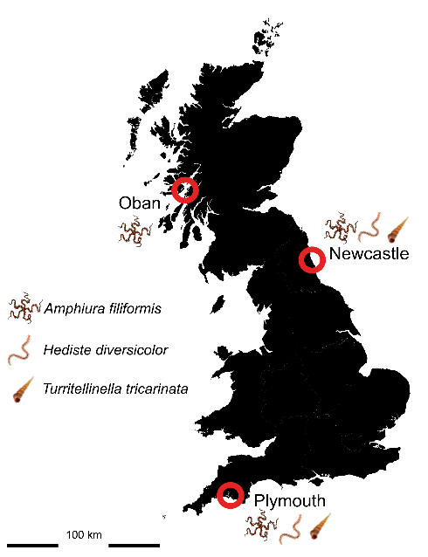
Supplementary Figure 1. The locations of the three soft-sediment marine invertebrate populations around the UK. Sampling locations (Plymouth, Newcastle and Oban) are shown inside red circles with the species collected from each site represented graphically at each location. Fauna and sediment were collected in summer (June/July 2021) and winter (February 2021).

Supplementary Table 1. Summary of three collections sites (Oban, Plymouth and Newcastle, UK). Detailed are the species collected from each site and their coordinates, and for the subtidal sites, the sampling depth and mean summer (August monthly mean) and winter (February monthly mean) temperatures are given based on environmental monitoring data from nearby locations, publicly available from Cefas and Marine Scotland.
Site | Species collected | Coordinates | Seawater depth (m) | Mean summer temp. (°C) | Mean winter temp. (°C) | Reference
Subtidal sites
Oban | Amphiura filiformis | 56°29'37" N, 5°30'18" W | 35 m | 14.3 | 7.6 | Bresnan et al. 2016
Newcastle | Amphiura filiformis, Turritellinella tricarinata | 55°06'32" N, 1°23'45" W | 38 m | 13.9 | 6.0 | Morris et al. 2016
Plymouth | Amphiura filiformis, Turritellinella tricarinata | 50°20'15" N, 4°09'20" W | 10 m | 16.0 | 8.0 | Morris et al. 2016
Intertidal sites
Newcastle | Hediste diversicolor | 55°08'02" N, 1°32'45" W | N/A
Plymouth | Hediste diversicolor | 50°21'54" N, 4°14'09" W | N/A

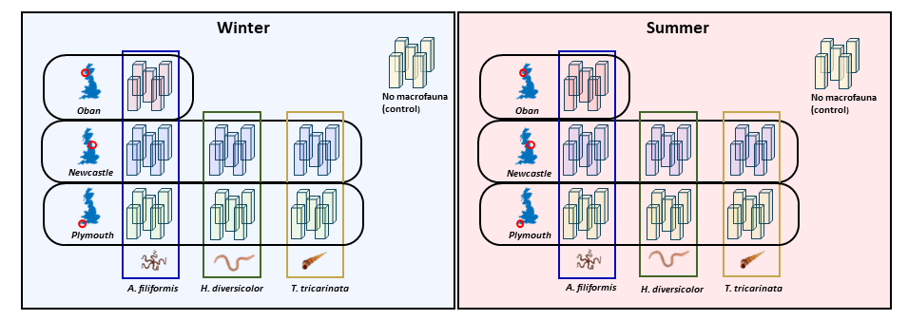

Supplementary Figure 2. Summary of our experimental design, consisting of three species of marine invertebrates (the brittle star Amphiura filiformis, the polychaete Hediste diversicolor and the gastropod Turritellinella tricarinata) sampled from two (Newcastle and Plymouth) or, in the case of A. filiformis, three (Newcastle, Plymouth and Oban) geographically distinct UK populations maintained under summer (16°C, 16h:8h light:dark, diet: 12.6 mg chl-a week⁻¹) versus winter (9.5°, 8h:16h light:dark, diet: 4.2 mg chl-a week⁻¹) seasonal conditions. Control treatments contained no macrofauna. Replication, n = 5 (= 80 aquaria in total). Experimental duration, 65 days.

Supplementary Table 2. Sediment particle size. Analyses of particle size distributions for sediment used in summer and winter experiments. To reduce the effects of site-specific sediment characteristics on trait expression, sediment was collected in each season from all three sampling sites and mixed equally at a 1:1:1 ratio from the three sampling locations: Oban (56°29'37" N 5°30'18" W, depth: ~ 35 m), Newcastle (55°06'32" N , 1°23'45" W, depth: ~ 38 m) and Plymouth (50°20'15" N, 4°09'20" W, depth: ~ 10 m).
Season | Dx (10) in µm | Dx (50) in µm | Dx (90) in µm | Weighted Residual | Residual | Laser Obscurat-ion (%) | inclusive kurtosis | inclusive skewness | Result Below 63 µm (%)
summer | 15.21 | 168.96 | 454.43 | 0.57 | 0.55 | 12.36 | 0.35 | 0.84 | 21.71
winter | 16.02 | 142.28 | 398.22 | 0.46 | 0.44 | 11.68 | 3.66 | 1.72 | 22.87

Supplementary Table 3. Sediment Composition. Results from loss on ignition analyses for determination of relative sediment water, total organic matter content, and a breakdown of relative organic/inorganic constituents and mineral residue for sediment used in summer and winter experiments. To reduce the effects of site-specific sediment characteristics on trait expression, sediment was collected in both summer and winter from all three sites and mixed at a 1:1:1 ratio from the three sampling locations: Oban (56°29'37" N 5°30'18" W, depth: ~ 35 m), Newcastle (55°06'32" N , 1°23'45" W, depth: ~ 38 m) and Plymouth (50°20'15" N, 4°09'20" W, depth: ~ 10 m).

Season | %Water | SD | %Total organic matter | SD | %Carbohydrate | %Carbon | %CaCO3 | %Mineral residue
summer | 29.96 | 0.75 | 4.66 | 0.17 | 2.68 | 1.98 | 7.51 | 87.83
winter | 32.37 | 2.81 | 6.09 | 0.10 | 4.29 | 1.80 | 6.73 | 87.19

Supplementary Table 4. Seasonal respiration rates for calculating components of total oxygen uptake. Mass specific respiration rates (mmol O₂ g⁻¹ d⁻¹) extracted from the literature for Amphiura filiformis, Turritellinella tricarinata and Hediste diversicolor at experimental temperatures present in both seasons (summer = 16 °C, winter = 9.5 °C). Rates are expressed either per gram dry mass (g DM⁻¹), or per gram wet mass (g WM⁻¹). The sum of all individual respiration rates for a given aquarium (dFOU) were subtracted from overall faunally mediated oxygen uptake (FOU) to estimate indirect faunally mediated oxygen uptake (iFOU). See Methods in the main document for further details.

Species | Temperature (°C) | Respiration rate (mmol O₂ g⁻¹ d⁻¹) | g _{DM}⁻¹ or g _{WM}⁻¹ | Reference
Amphiura filiformis | 9.5 | 0.0192 | g_{WM}⁻¹ | (Calder-Potts et al. 2015)
Amphiura filiformis | 16 | 0.036 | g_{WM}⁻¹ | (Vopel et al. 2003)
Turritellinella tricarinata | 9.5 | 0.015 | g_{WM}⁻¹ | (Leung et al. 2021)
Turritellinella tricarinata | 16 | 0.053 | g_{WM}⁻¹ | (Leung et al. 2021)
Hediste diversicolor | 9.5 | 0.252 | g_{DM}⁻¹ | (Galasso et al. 2018)
Hediste diversicolor | 16 | 0.744 | g_{DM}⁻¹ | (Galasso et al. 2018)

Supplementary Table 5. Replication statement. Details of the level of replication including the scale at which the inference is made, the scale at which the factor of interest is applied and the number of replicates.
Scale of inference | Scale at which the factor of interest is applied | Number of replicates at the appropriate scale
Population | Aquarium | 5 replicate aquaria
Population | Individual | 30 (5 replicate aquaria × 6 individuals per aquariua)
Species | Aquarium | 20 (Hediste diversicolor, Turritellinella tricarinata)  30 (Amphiura filiformis)
Ecosystem process | Aquarium | 5 replicate aquaria
Ecosystem function | Aquarium | 5 replicate aquaria

Supplementary Table 6. Bayesian model prior summaries. Summaries for weakly-informative priors and their distributions used for β and sd. N = normal distribution, t = Student’s t-distribution, lb = lower boundary for each model (trait, process or function).

Model | β prior | SD prior
_{log}(Burial_{end}) | $$β\sim N(0, 10)$$ | $$sd\sim t\left(3, 0, 7\right), lb= 0$$
M_{dry} | $$β\sim N(0, 1)$$ | $$sd\sim t\left(3, 0, 7\right), lb= 0$$
M_{org}:M_{dry} | $$β\sim N(0, 1)$$ | $$sd\sim t\left(3, 0, 7\right), lb= 0$$
^{f-SPI}L_{max} | $$β\sim N(0, 12)$$ | $$sd\sim t\left(3, 0, 7\right), lb= 0$$
^{f-SPI}L_{median} | $$β\sim N(0, 12)$$ | $$sd\sim t\left(3, 0, 7\right), lb= 0$$
SBR | $$β\sim N(0, 12)$$ | $$sd\sim t\left(3, 0, 7\right), lb= 0$$
Δ[Br⁻] | $$β\sim N(0, 200)$$ | $$sd\sim t\left(3, 0, 7\right), lb= 0$$
NH₄-N | $$β\sim N(0, 1)$$ | $$sd\sim t\left(3, 0, 7\right), lb= 0$$
NO_{x}-N | $$β\sim N(0, 10)$$ | $$sd\sim t\left(3, 0, 7\right), lb= 0$$
PO₄-P | $$β\sim N(0, 1)$$ | $$sd\sim t\left(3, 0, 7\right), lb= 0$$
OPD | $$β\sim N(0, 10)$$ | $$sd\sim t\left(3, 0, 7\right), lb= 0$$
TOU | $$β\sim N(0, 100)$$ | $$sd\sim t\left(3, 0, 7\right), lb= 0$$

Supplementary Table 7. Bayesian derived posterior summaries for traits and trait-mediated processes. Median values for each species (Turritellinella tricarinata, Hediste diversicolor, Amphiura filiformis), population and season treatment including lower 2.5 % and upper 97.5 % credible intervals for the seven measured individual response traits and effect trait-mediated ecosystem processes: time taken for complete burial (Burial)_{end}, dry mass of soft body tissue (M_{dry}), proportion of organic soft tissue mass (M_{org}:M_{dry}), surface boundary roughness (SBR), median depth of particle reworking (^{fSPI}L_{median}), maximum depth of particle reworking (^{fSPI}L_{max}) and ventilation activity (Δ[Br⁻]). Median values were generated from treatment specific posterior distributions derived from Bayesian hierarchical ANOVA (see Methods in the main document).

Burial_{end}
Species | Population | Season | Median | 2.5% | 97.5%
T. tricarinata | Newcastle | Summer | 2.13 | 1.91 | 2.34
T. tricarinata | Newcastle | Winter | 0.84 | 0.62 | 1.06
T. tricarinata | Plymouth | Summer | 1.80 | 1.62 | 1.97
T. tricarinata | Plymouth | Winter | 0.64 | 0.47 | 0.80
H. diversicolor | Newcastle | Summer | 1.02 | 0.82 | 1.23
H. diversicolor | Newcastle | Winter | 1.21 | 0.90 | 1.50
H. diversicolor | Plymouth | Summer | 0.96 | 0.76 | 1.16
H. diversicolor | Plymouth | Winter | 0.80 | 0.60 | 1.01
A. filiformis | Newcastle | Summer | 0.38 | 0.28 | 0.48
A. filiformis | Newcastle | Winter | 0.92 | 0.84 | 1.00
A. filiformis | Oban | Summer | 0.65 | 0.51 | 0.78
A. filiformis | Oban | Winter | 0.86 | 0.75 | 0.96
A. filiformis | Plymouth | Summer | 1.03 | 0.93 | 1.12
A. filiformis | Plymouth | Winter | 0.82 | 0.72 | 0.91
M_{dry}
Species | Population | Season | Median | 2.5% | 97.5%
T. tricarinata | Newcastle | Summer | 0.03 | 0.03 | 0.04
T. tricarinata | Newcastle | Winter | 0.03 | 0.02 | 0.03
T. tricarinata | Plymouth | Summer | 0.05 | 0.04 | 0.05
T. tricarinata | Plymouth | Winter | 0.05 | 0.04 | 0.05
H. diversicolor | Newcastle | Summer | 0.08 | 0.06 | 0.09
H. diversicolor | Newcastle | Winter | 0.03 | 0.03 | 0.04
H. diversicolor | Plymouth | Summer | 0.08 | 0.06 | 0.10
H. diversicolor | Plymouth | Winter | 0.04 | 0.04 | 0.05
A. filiformis | Newcastle | Summer | 0.06 | 0.05 | 0.06
A. filiformis | Newcastle | Winter | 0.03 | 0.03 | 0.03
A. filiformis | Oban | Summer | 0.06 | 0.05 | 0.06
A. filiformis | Oban | Winter | 0.06 | 0.05 | 0.07
A. filiformis | Plymouth | Summer | 0.07 | 0.06 | 0.08
A. filiformis | Plymouth | Winter | 0.09 | 0.08 | 0.11
M_{org}:M_{dry}
Species | Population | Season | Median | 2.5% | 97.5%
T. tricarinata | Newcastle | Summer | 0.02 | 0.02 | 0.02
T. tricarinata | Newcastle | Winter | 0.01 | 0.01 | 0.02
T. tricarinata | Plymouth | Summer | 0.02 | 0.02 | 0.02
T. tricarinata | Plymouth | Winter | 0.02 | 0.02 | 0.02
H. diversicolor | Newcastle | Summer | 0.74 | 0.68 | 0.80
H. diversicolor | Newcastle | Winter | 0.79 | 0.75 | 0.83
H. diversicolor | Plymouth | Summer | 0.72 | 0.66 | 0.78
H. diversicolor | Plymouth | Winter | 0.76 | 0.72 | 0.81
A. filiformis | Newcastle | Summer | 0.36 | 0.34 | 0.38
A. filiformis | Newcastle | Winter | 0.27 | 0.26 | 0.28
A. filiformis | Oban | Summer | 0.31 | 0.29 | 0.32
A. filiformis | Oban | Winter | 0.22 | 0.21 | 0.23
A. filiformis | Plymouth | Summer | 0.29 | 0.28 | 0.30
A. filiformis | Plymouth | Winter | 0.23 | 0.22 | 0.23
SBR
Species | Population | Season | Median | 2.5% | 97.5%
T. tricarinata | Newcastle | Summer | 2.23 | 1.72 | 2.73
T. tricarinata | Newcastle | Winter | 1.54 | 1.35 | 1.76
T. tricarinata | Plymouth | Summer | 2.41 | 1.85 | 2.96
T. tricarinata | Plymouth | Winter | 1.95 | 1.70 | 2.17
H. diversicolor | Newcastle | Summer | 2.72 | 2.13 | 3.28
H. diversicolor | Newcastle | Winter | 1.42 | 1.10 | 1.75
H. diversicolor | Plymouth | Summer | 2.68 | 2.09 | 3.22
H. diversicolor | Plymouth | Winter | 1.40 | 1.09 | 1.73
A. filiformis | Newcastle | Summer | 2.60 | 2.21 | 2.97
A. filiformis | Newcastle | Winter | 1.57 | 1.16 | 2.02
A. filiformis | Oban | Summer | 2.45 | 2.09 | 2.80
A. filiformis | Oban | Winter | 1.55 | 1.18 | 1.95
A. filiformis | Plymouth | Summer | 2.38 | 1.96 | 2.85
A. filiformis | Plymouth | Winter | 2.02 | 1.47 | 2.50
^{f-SPI}L_{median}
Species | Population | Season | Median | 2.5% | 97.5%
T. tricarinata | Newcastle | Summer | 0.35 | 0.31 | 0.39
T. tricarinata | Newcastle | Winter | 0.37 | 0.35 | 0.39
T. tricarinata | Plymouth | Summer | 0.35 | 0.31 | 0.38
T. tricarinata | Plymouth | Winter | 0.37 | 0.35 | 0.39
H. diversicolor | Newcastle | Summer | 1.14 | 0.95 | 1.32
H. diversicolor | Newcastle | Winter | 0.42 | 0.38 | 0.46
H. diversicolor | Plymouth | Summer | 1.15 | 0.95 | 1.32
H. diversicolor | Plymouth | Winter | 0.42 | 0.38 | 0.46
A. filiformis | Newcastle | Summer | 0.34 | 0.30 | 0.38
A. filiformis | Newcastle | Winter | 0.41 | 0.38 | 0.43
A. filiformis | Oban | Summer | 0.34 | 0.29 | 0.38
A. filiformis | Oban | Winter | 0.40 | 0.38 | 0.42
A. filiformis | Plymouth | Summer | 0.34 | 0.30 | 0.38
A. filiformis | Plymouth | Winter | 0.40 | 0.38 | 0.43
^{f-SPI}L_{max}
Species | Population | Season | Median | 2.5% | 97.5%
T. tricarinata | Newcastle | Summer | 1.00 | 0.75 | 1.21
T. tricarinata | Newcastle | Winter | 1.00 | 0.81 | 1.19
T. tricarinata | Plymouth | Summer | 0.97 | 0.68 | 1.27
T. tricarinata | Plymouth | Winter | 1.11 | 0.87 | 1.36
H. diversicolor | Newcastle | Summer | 12.18 | 11.55 | 12.78
H. diversicolor | Newcastle | Winter | 11.42 | 11.00 | 11.84
H. diversicolor | Plymouth | Summer | 11.97 | 11.33 | 12.57
H. diversicolor | Plymouth | Winter | 11.11 | 10.61 | 11.67
A. filiformis | Newcastle | Summer | 5.95 | 4.90 | 6.99
A. filiformis | Newcastle | Winter | 6.89 | 5.82 | 7.90
A. filiformis | Oban | Summer | 4.11 | 3.18 | 5.45
A. filiformis | Oban | Winter | 5.07 | 3.79 | 6.59
A. filiformis | Plymouth | Summer | 6.95 | 5.90 | 8.01
A. filiformis | Plymouth | Winter | 8.01 | 6.81 | 8.92
∆[Br⁻]
Species | Population | Season | Median | 2.5% | 97.5%
T. tricarinata | Newcastle | Summer | -8.5 | -15.9 | -1.0
T. tricarinata | Newcastle | Winter | 2.8 | -27.6 | 32.6
T. tricarinata | Plymouth | Summer | -20.3 | -25.9 | -14.5
T. tricarinata | Plymouth | Winter | -10.1 | -57.6 | 40.3
H. diversicolor | Newcastle | Summer | -34.7 | -43.8 | -26.4
H. diversicolor | Newcastle | Winter | -52.7 | -115.9 | 11.0
H. diversicolor | Plymouth | Summer | -46.8 | -55.6 | -37.3
H. diversicolor | Plymouth | Winter | -36.4 | -105.5 | 37.6
A. filiformis | Newcastle | Summer | 68.9 | 13.4 | 116.0
A. filiformis | Newcastle | Winter | 26.7 | -56.1 | 104.0
A. filiformis | Oban | Summer | -13.0 | -32.5 | 12.3
A. filiformis | Oban | Winter | -33.0 | -96.0 | 31.1
A. filiformis | Plymouth | Summer | 55.5 | 43.5 | 65.3
A. filiformis | Plymouth | Winter | 24.4 | -53.1 | 85.9

Supplementary Table 8. Standardised effect sizes (log response ratio) for traits and trait-mediated processes. Median log response ratios (lnRR) relative to each species (Turritellinella tricarinata, Hediste diversicolor, Amphiura filiformis) global mean (see Methods in the main document) including lower 2.5 % and upper 97.5 % credible intervals for the seven measured individual response traits and ecosystem processes: time taken for complete burial (Burial)_{end}, dry mass of soft body tissue (M_{dry}), proportion of organic soft tissue mass (M_{org}:M_{dry}), surface boundary roughness (SBR), median depth of particle reworking (^{fSPI}L_{median}), maximum depth of particle reworking (^{fSPI}L_{max}) and ventilation activity (Δ[Br⁻]). Greater deviation from 0 (positive or negative) indicates a larger effect size.

Burial_{end}
Species | Population | Season | Median | 2.5% | 97.5%
T. tricarinata | Newcastle | Summer | 2.197 | -1.282 | 5.439
T. tricarinata | Newcastle | Winter | -1.398 | -4.503 | 1.828
T. tricarinata | Plymouth | Summer | 1.269 | -1.925 | 4.299
T. tricarinata | Plymouth | Winter | -1.967 | -5.170 | 1.429
H. diversicolor | Newcastle | Summer | 0.101 | -2.785 | 3.028
H. diversicolor | Newcastle | Winter | 0.611 | -2.385 | 3.544
H. diversicolor | Plymouth | Summer | -0.069 | -2.924 | 2.884
H. diversicolor | Plymouth | Winter | -0.515 | -3.387 | 2.426
A. filiformis | Newcastle | Summer | -1.108 | -4.007 | 1.976
A. filiformis | Newcastle | Winter | 0.385 | -2.585 | 3.225
A. filiformis | Oban | Summer | -0.368 | -3.274 | 2.585
A. filiformis | Oban | Winter | 0.216 | -2.748 | 3.080
A. filiformis | Plymouth | Summer | 0.705 | -2.369 | 3.549
A. filiformis | Plymouth | Winter | 0.104 | -2.824 | 2.999
M_{dry}
Species | Population | Season | Median | 2.5% | 97.5%
T. tricarinata | Newcastle | Summer | -0.375 | -2.902 | 2.356
T. tricarinata | Newcastle | Winter | -0.718 | -3.295 | 2.085
T. tricarinata | Plymouth | Summer | 0.613 | -2.060 | 3.273
T. tricarinata | Plymouth | Winter | 0.620 | -2.041 | 3.292
H. diversicolor | Newcastle | Summer | 1.068 | -1.787 | 3.877
H. diversicolor | Newcastle | Winter | -1.481 | -4.264 | 1.430
H. diversicolor | Plymouth | Summer | 1.132 | -1.705 | 3.905
H. diversicolor | Plymouth | Winter | -0.808 | -3.472 | 1.893
A. filiformis | Newcastle | Summer | -0.193 | -2.548 | 2.166
A. filiformis | Newcastle | Winter | -1.765 | -4.370 | 1.059
A. filiformis | Oban | Summer | -0.325 | -2.660 | 2.061
A. filiformis | Oban | Winter | -0.198 | -2.581 | 2.163
A. filiformis | Plymouth | Summer | 0.396 | -2.124 | 2.749
A. filiformis | Plymouth | Winter | 1.878 | -1.214 | 4.711
M_{org}:M_{dry}
Species | Population | Season | Median | 2.5% | 97.5%
T. tricarinata | Newcastle | Summer | -0.375 | -2.902 | 2.356
T. tricarinata | Newcastle | Winter | -0.718 | -3.295 | 2.085
T. tricarinata | Plymouth | Summer | 0.613 | -2.060 | 3.273
T. tricarinata | Plymouth | Winter | 0.620 | -2.041 | 3.292
H. diversicolor | Newcastle | Summer | 1.068 | -1.787 | 3.877
H. diversicolor | Newcastle | Winter | -1.481 | -4.264 | 1.430
H. diversicolor | Plymouth | Summer | 1.132 | -1.705 | 3.905
H. diversicolor | Plymouth | Winter | -0.808 | -3.472 | 1.893
A. filiformis | Newcastle | Summer | -0.193 | -2.548 | 2.166
A. filiformis | Newcastle | Winter | -1.765 | -4.370 | 1.059
A. filiformis | Oban | Summer | -0.325 | -2.660 | 2.061
A. filiformis | Oban | Winter | -0.198 | -2.581 | 2.163
A. filiformis | Plymouth | Summer | 0.396 | -2.124 | 2.749
A. filiformis | Plymouth | Winter | 1.878 | -1.214 | 4.711
SBR
Species | Population | Season | Median | 2.5% | 97.5%
T. tricarinata | Newcastle | Summer | -0.375 | -2.902 | 2.356
T. tricarinata | Newcastle | Winter | -0.718 | -3.295 | 2.085
T. tricarinata | Plymouth | Summer | 0.613 | -2.060 | 3.273
T. tricarinata | Plymouth | Winter | 0.620 | -2.041 | 3.292
H. diversicolor | Newcastle | Summer | 1.068 | -1.787 | 3.877
H. diversicolor | Newcastle | Winter | -1.481 | -4.264 | 1.430
H. diversicolor | Plymouth | Summer | 1.132 | -1.705 | 3.905
H. diversicolor | Plymouth | Winter | -0.808 | -3.472 | 1.893
A. filiformis | Newcastle | Summer | -0.193 | -2.548 | 2.166
A. filiformis | Newcastle | Winter | -1.765 | -4.370 | 1.059
A. filiformis | Oban | Summer | -0.325 | -2.660 | 2.061
A. filiformis | Oban | Winter | -0.198 | -2.581 | 2.163
A. filiformis | Plymouth | Summer | 0.396 | -2.124 | 2.749
A. filiformis | Plymouth | Winter | 1.878 | -1.214 | 4.711
^{f-SPI}L_{median}
Species | Population | Season | Median | 2.5% | 97.5%
T. tricarinata | Newcastle | Summer | 0.001 | -3.820 | 3.896
T. tricarinata | Newcastle | Winter | 0.098 | -3.736 | 3.994
T. tricarinata | Plymouth | Summer | -0.043 | -3.873 | 3.881
T. tricarinata | Plymouth | Winter | 0.117 | -3.719 | 4.020
H. diversicolor | Newcastle | Summer | 2.520 | -1.878 | 7.178
H. diversicolor | Newcastle | Winter | -2.415 | -7.106 | 2.270
H. diversicolor | Plymouth | Summer | 2.530 | -1.881 | 7.151
H. diversicolor | Plymouth | Winter | -2.467 | -7.157 | 2.238
A. filiformis | Newcastle | Summer | -0.205 | -4.095 | 3.776
A. filiformis | Newcastle | Winter | 0.245 | -3.687 | 4.226
A. filiformis | Oban | Summer | -0.246 | -4.141 | 3.731
A. filiformis | Oban | Winter | 0.187 | -3.739 | 4.161
A. filiformis | Plymouth | Summer | -0.243 | -4.157 | 3.757
A. filiformis | Plymouth | Winter | 0.215 | -3.723 | 4.194
^{f-SPI}L_{max}
Species | Population | Season | Median | 2.5% | 97.5%
T. tricarinata | Newcastle | Summer | -0.03 | -3.00 | 2.94
T. tricarinata | Newcastle | Winter | -0.02 | -2.98 | 2.95
T. tricarinata | Plymouth | Summer | -0.05 | -3.01 | 2.95
T. tricarinata | Plymouth | Winter | 0.14 | -2.83 | 3.12
H. diversicolor | Newcastle | Summer | 0.80 | -2.21 | 3.80
H. diversicolor | Newcastle | Winter | -0.13 | -3.07 | 2.88
H. diversicolor | Plymouth | Summer | 0.55 | -2.44 | 3.56
H. diversicolor | Plymouth | Winter | -0.52 | -3.50 | 2.58
A. filiformis | Newcastle | Summer | -0.17 | -3.04 | 2.73
A. filiformis | Newcastle | Winter | 0.94 | -1.89 | 3.78
A. filiformis | Oban | Summer | -2.46 | -5.75 | 0.76
A. filiformis | Oban | Winter | -1.30 | -4.51 | 1.84
A. filiformis | Plymouth | Summer | 1.05 | -1.86 | 4.06
A. filiformis | Plymouth | Winter | 2.31 | -0.86 | 5.40
∆[Br⁻]
Species | Population | Season | Median | 2.5% | 97.5%
T. tricarinata | Newcastle | Summer | -0.369 | -1.863 | 1.123
T. tricarinata | Newcastle | Winter | 0.296 | -1.782 | 2.466
T. tricarinata | Plymouth | Summer | -1.171 | -2.834 | 0.242
T. tricarinata | Plymouth | Winter | -0.495 | -3.032 | 2.146
H. diversicolor | Newcastle | Summer | -1.598 | -3.237 | -0.124
H. diversicolor | Newcastle | Winter | -1.623 | -4.603 | 1.425
H. diversicolor | Plymouth | Summer | -2.392 | -4.266 | -0.877
H. diversicolor | Plymouth | Winter | -1.150 | -4.234 | 2.460
A. filiformis | Newcastle | Summer | 2.820 | -0.584 | 5.984
A. filiformis | Newcastle | Winter | 0.901 | -2.868 | 4.811
A. filiformis | Oban | Summer | -1.249 | -3.592 | 0.913
A. filiformis | Oban | Winter | -2.002 | -5.007 | 1.099
A. filiformis | Plymouth | Summer | 3.178 | 1.379 | 5.537
A. filiformis | Plymouth | Winter | 1.381 | -2.431 | 4.964

Supplementary Table 9. Standard deviations for Bayesian hierarchical model factors. Posterior summaries (median with upper 97.5 % and lower 2.5 % credible intervals) for standard deviations (SD) for the three model factors (species, population and season) are shown. Additional model parameter and simulation statistics included are MAD (median absolute deviation), rhat (measure of chain convergence), bulk ESS (effective sampling size) and tail ESS.

Burial_{end}
Factor | SD | MAD | 2.5% | 97.5% | rhat | bulk ESS | tail ESS
Species | 1.08 | 0.65 | 0.11 | 3.88 | 1.00 | 2217 | 1333
Population | 0.14 | 0.13 | 0.01 | 0.57 | 1.00 | 4004 | 5780
Season | 0.67 | 0.37 | 0.13 | 1.68 | 1.00 | 3617 | 3785
M_{dry}
Factor | SD | MAD | 2.5% | 97.5% | rhat | bulk ESS | tail ESS
Species | 0.07 | 0.05 | 0.01 | 0.29 | 1.00 | 2497 | 3308
Population | 0.01 | 0.01 | 0.00 | 0.05 | 1.00 | 2132 | 3665
Season | 0.02 | 0.01 | 0.00 | 0.07 | 1.00 | 2034 | 214
M_{org}:M_{dry}
Factor | SD | MAD | 2.5% | 97.5% | rhat | bulk ESS | tail ESS
Species | 0.62 | 0.30 | 0.15 | 1.81 | 1.00 | 441 | 963
Population | 0.03 | 0.02 | 0.00 | 0.09 | 1.02 | 402 | 673
Season | 0.06 | 0.03 | 0.01 | 0.22 | 1.01 | 353 | 410
SBR
Factor | SD | MAD | 2.5% | 97.5% | rhat | bulk ESS | tail ESS
Species | 2.02 | 0.95 | 0.36 | 4.62 | 1.00 | 4569 | 3502
Population | 0.17 | 0.15 | 0.01 | 0.68 | 1.00 | 4737 | 5792
Season | 0.90 | 0.51 | 0.16 | 2.49 | 1.00 | 3016 | 3878
^{f-SPI}L_{median}
Factor | SD | MAD | 2.5% | 97.5% | rhat | bulk ESS | tail ESS
Species | 0.62 | 0.39 | 0.07 | 2.00 | 1.00 | 1564 | 2283
Population | 0.01 | 0.01 | 0.00 | 0.04 | 1.00 | 2541 | 3506
Season | 0.42 | 0.21 | 0.10 | 1.09 | 1.00 | 1354 | 2424
^{f-SPI}L_{max}
Factor | SD | MAD | 2.5% | 97.5% | rhat | bulk ESS | tail ESS
Species | 7.74 | 2.87 | 2.14 | 16.11 | 1.00 | 5791 | 5440
Population | 1.35 | 0.67 | 0.29 | 3.65 | 1.00 | 3734 | 4284
Season | 0.73 | 0.51 | 0.08 | 2.91 | 1.00 | 3416 | 3674
∆[Br⁻]
Factor | SD | MAD | 2.5% | 97.5% | rhat | bulk ESS | tail ESS
Species | 23.60 | 14.60 | 1.35 | 68.87 | 1.00 | 1605 | 1774
Population | 26.80 | 9.95 | 2.57 | 58.71 | 1.00 | 1688 | 2541
Season | 16.10 | 8.91 | 1.10 | 48.85 | 1.00 | 2802 | 838

Supplementary Table 10. Posterior distribution summaries for ecosystem functions. Median values for each species (Turritellinella tricarinata, Hediste diversicolor, Amphiura filiformis), population and season treatment including lower 2.5 % and upper 97.5 % credible intervals for five ecosystem functions: ammonium-N ([NH₄-N]), nitrate+nitrite-N ([NO_{x}-N]), phosphate-P ([PO₄-P]), oxygen penetration depth (OPD) and total oxygen uptake (TOU). Medians were generated from treatment specific posterior distributions derived from Bayesian hierarchical ANOVA (see Methods in the main document).

[NH₄-N]
Species | Population | Season | Median | Lower 2.5 | Upper 97.5
No macrofauna | No macrofauna | Summer | 0.06 | 0.04 | 0.08
No macrofauna | No macrofauna | Winter | 0.05 | 0.03 | 0.07
T. tricarinata | Newcastle | Summer | 0.04 | 0.03 | 0.05
T. tricarinata | Newcastle | Winter | 0.15 | 0.10 | 0.20
T. tricarinata | Plymouth | Summer | 0.03 | 0.02 | 0.04
T. tricarinata | Plymouth | Winter | 0.14 | 0.10 | 0.19
H. diversicolor | Newcastle | Summer | 0.05 | 0.03 | 0.06
H. diversicolor | Newcastle | Winter | 0.16 | 0.12 | 0.21
H. diversicolor | Plymouth | Summer | 0.05 | 0.03 | 0.06
H. diversicolor | Plymouth | Winter | 0.17 | 0.12 | 0.21
A. filiformis | Newcastle | Summer | 0.04 | 0.03 | 0.05
A. filiformis | Newcastle | Winter | 0.07 | 0.05 | 0.09
A. filiformis | Oban | Summer | 0.04 | 0.03 | 0.05
A. filiformis | Oban | Winter | 0.07 | 0.05 | 0.08
A. filiformis | Plymouth | Summer | 0.04 | 0.03 | 0.04
A. filiformis | Plymouth | Winter | 0.07 | 0.05 | 0.09
[NO_{x}-N]
Species | Population | Season | Median | Lower 2.5 | Upper 97.5
No macrofauna | No macrofauna | Summer | 0.02 | 0.00 | 0.04
No macrofauna | No macrofauna | Winter | 0.76 | 0.57 | 0.93
T. tricarinata | Newcastle | Summer | 0.07 | 0.05 | 0.08
T. tricarinata | Newcastle | Winter | 0.85 | 0.75 | 0.96
T. tricarinata | Plymouth | Summer | 0.03 | 0.02 | 0.05
T. tricarinata | Plymouth | Winter | 0.83 | 0.74 | 0.93
H. diversicolor | Newcastle | Summer | 0.04 | 0.03 | 0.04
H. diversicolor | Newcastle | Winter | 0.52 | 0.43 | 0.61
H. diversicolor | Plymouth | Summer | 0.03 | 0.01 | 0.04
H. diversicolor | Plymouth | Winter | 0.52 | 0.42 | 0.62
A. filiformis | Newcastle | Summer | 0.09 | 0.04 | 0.13
A. filiformis | Newcastle | Winter | 0.74 | 0.68 | 0.81
A. filiformis | Oban | Summer | 0.07 | 0.04 | 0.11
A. filiformis | Oban | Winter | 0.76 | 0.68 | 0.84
A. filiformis | Plymouth | Summer | 0.09 | 0.05 | 0.13
A. filiformis | Plymouth | Winter | 0.73 | 0.65 | 0.82
[PO₄-P]
Species | Population | Season | Median | Lower 2.5 | Upper 97.5
No macrofauna | No macrofauna | Summer | -0.08 | -0.09 | -0.07
No macrofauna | No macrofauna | Winter | 0.12 | 0.07 | 0.17
T. tricarinata | Newcastle | Summer | -0.07 | -0.08 | -0.06
T. tricarinata | Newcastle | Winter | 0.13 | 0.10 | 0.16
T. tricarinata | Plymouth | Summer | -0.07 | -0.09 | -0.06
T. tricarinata | Plymouth | Winter | 0.14 | 0.11 | 0.16
H. diversicolor | Newcastle | Summer | -0.07 | -0.08 | -0.06
H. diversicolor | Newcastle | Winter | 0.12 | 0.09 | 0.14
H. diversicolor | Plymouth | Summer | -0.07 | -0.09 | -0.04
H. diversicolor | Plymouth | Winter | 0.11 | 0.08 | 0.14
A. filiformis | Newcastle | Summer | -0.08 | -0.09 | -0.08
A. filiformis | Newcastle | Winter | 0.12 | 0.09 | 0.13
A. filiformis | Oban | Summer | -0.08 | -0.09 | -0.07
A. filiformis | Oban | Winter | 0.11 | 0.07 | 0.13
A. filiformis | Plymouth | Summer | -0.08 | -0.09 | -0.07
A. filiformis | Plymouth | Winter | 0.11 | 0.07 | 0.13
OPD
Species | Population | Season | Median | Lower 2.5 | Upper 97.5
No macrofauna | No macrofauna | Summer | 4.57 | 5.51 | 3.69
No macrofauna | No macrofauna | Winter | 7.92 | 9.58 | 6.12
T. tricarinata | Newcastle | Summer | 5.19 | 5.88 | 4.70
T. tricarinata | Newcastle | Winter | 9.01 | 9.51 | 8.35
T. tricarinata | Plymouth | Summer | 5.59 | 6.52 | 4.47
T. tricarinata | Plymouth | Winter | 8.28 | 8.69 | 7.97
H. diversicolor | Newcastle | Summer | 7.72 | 8.76 | 6.62
H. diversicolor | Newcastle | Winter | 9.66 | 10.48 | 8.77
H. diversicolor | Plymouth | Summer | 6.81 | 7.57 | 6.24
H. diversicolor | Plymouth | Winter | 9.09 | 10.07 | 8.09
A. filiformis | Newcastle | Summer | 5.34 | 6.20 | 4.48
A. filiformis | Newcastle | Winter | 8.58 | 9.12 | 8.10
A. filiformis | Oban | Summer | 5.55 | 6.35 | 4.73
A. filiformis | Oban | Winter | 8.90 | 9.73 | 8.08
A. filiformis | Plymouth | Summer | 5.38 | 6.33 | 4.47
A. filiformis | Plymouth | Winter | 9.08 | 9.67 | 8.44
TOU
Species | Population | Season | Median | Lower 2.5 | Upper 97.5
No macrofauna | No macrofauna | Summer | -29.54 | -35.92 | -22.60
No macrofauna | No macrofauna | Winter | -3.99 | -4.52 | -3.45
T. tricarinata | Newcastle | Summer | -31.46 | -39.61 | -22.85
T. tricarinata | Newcastle | Winter | -5.82 | -7.16 | -4.63
T. tricarinata | Plymouth | Summer | -31.89 | -39.95 | -23.18
T. tricarinata | Plymouth | Winter | -6.48 | -7.95 | -5.01
H. diversicolor | Newcastle | Summer | -80.62 | -85.05 | -76.00
H. diversicolor | Newcastle | Winter | -11.01 | -13.16 | -9.05
H. diversicolor | Plymouth | Summer | -80.95 | -85.26 | -76.57
H. diversicolor | Plymouth | Winter | -11.74 | -13.89 | -9.55
A. filiformis | Newcastle | Summer | -40.08 | -42.03 | -38.05
A. filiformis | Newcastle | Winter | -5.48 | -6.41 | -4.51
A. filiformis | Oban | Summer | -40.35 | -41.96 | -38.56
A. filiformis | Oban | Winter | -5.71 | -6.35 | -5.09
A. filiformis | Plymouth | Summer | -40.09 | -42.22 | -37.61
A. filiformis | Plymouth | Winter | -6.17 | -7.04 | -5.27

USB powered water pump
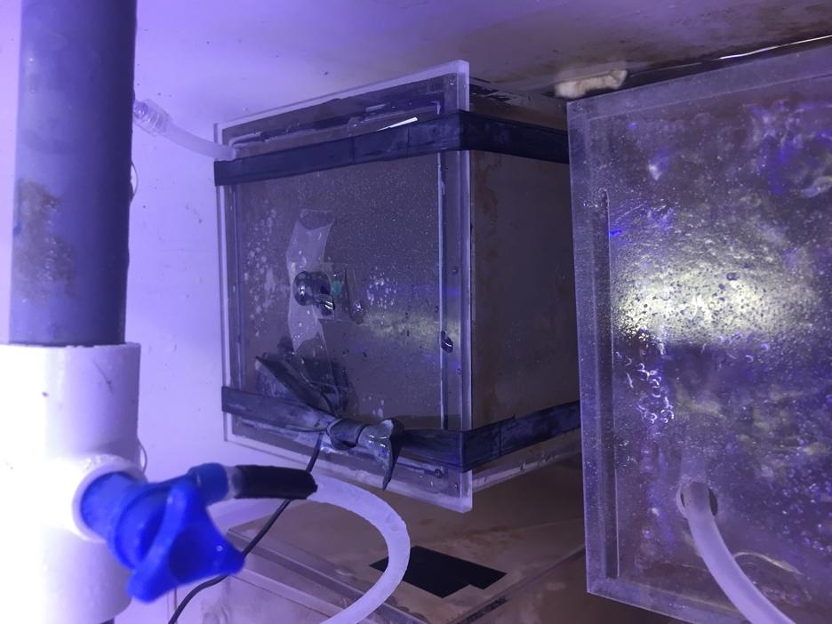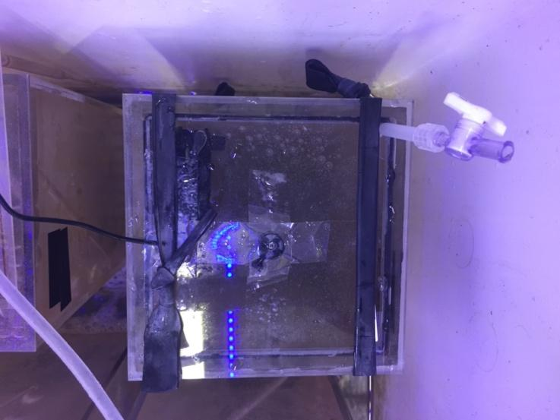
Oxygen sensor dot
Double O-ring and silicone gasket seal
Clamp for oxygen probe
Air bleed valve
Rubber tension straps
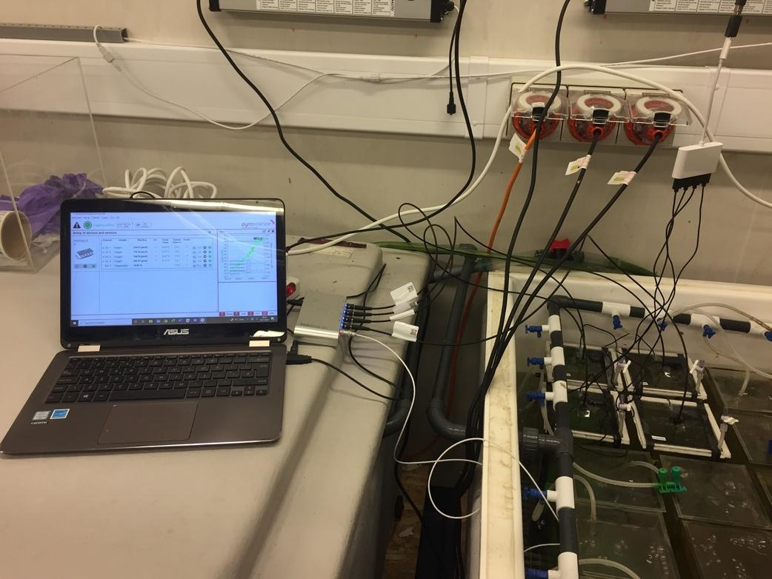
Power for USB powered pumps
Temperature probe
Fibre optic oxygen probe
FireSting® unit

Supplementary Figure 3. Closed respirometry for measuring total oxygen uptake (TOU). Lids were sealed using 2 rubber O-rings and a foam silicone gasket at the mating interface between the lid and the rim of the aquarium. 2 rubber tension bands made from bicycle inner tube were wrapped around the lid and the bottom of the aquaria to maintain a tensioned watertight seal. Oxygen sensor dots are glued to the underside of the lid and screw clamps are glued to the outside to correctly position the probe over the sensor dot. A 5-volt USB powered water pump (flow rate ~ 3 L/min) is glued on the underside of the lid with the outflow positioned horizontally as to not disturb sediment with the power cable coming out of a hole in the lid sealed with silicone. A silicone tube with a quarter turn valve is glued into a hole in the lid to bleed air bubbles out when sealing the lid.
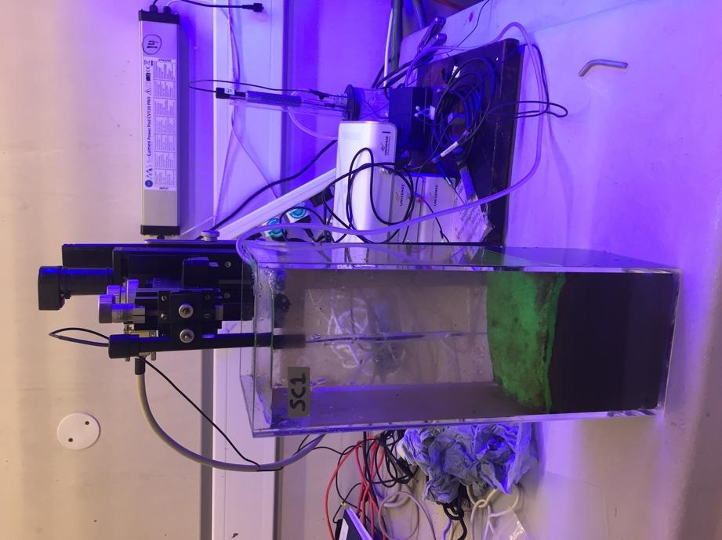

Supplementary Figure 4. Sediment depth profiles for oxygen saturation. Oxygen depth profiles (n = 2 per aquarium) were obtained using a dual mounted motorised micromanipulator profiling head, (Unisense, Denmark) connected to extra-long OX-500 microelectrode probes with a tip diameter of 500 µm. Further details are given in the Methods section of the main document.

Supplementary Methods

Fauna and sediment collection
We collected individuals of three functionally contrasting species of soft sediment-dwelling macroinvertebrates: the brittle star, Amphiura filiformis, an infaunal, filter-feeding echinoderm; the tower shell, Turritellinella tricarinata, a filter and deposit feeding epifaunal gastropod; and the ragworm, Hediste diversicolor, an infaunal polychaete with mixed feeding modes including carnivory, scavenging and filter/deposit feeding. These species provide generality to our findings, as they exhibit widespread geographic distributions, high abundances in soft sediment shelf habitats in the Northeast Atlantic and contribute substantively to sediment biogeochemical processes (Queiros et al. 2013; Clare et al. 2022). Furthermore, both A. filiformis and H. diversicolor have been extensively studied and are known to exhibit temporal and spatial intraspecific variability in a range of functionally relevant morphological, physiological and behavioural traits (Wohlgemuthm Solan & Godbold 2017; Cassidy et al. 2020). We collected these species from three geographically distinct populations around the UK in summer (June/July 2021) and winter (February 2022). Subtidal populations of A. filiformis and T. tricarinata were collected from near Plymouth, UK (50°20'15" N, 4°09'20" W, depth: ~ 10 m), near Newcastle, UK (55°06'32" N, 1°23'45" W, depth: ~ 38 m) and a third population of A. filiformis from near Oban, UK (56°29'37" N, 5°30'18" W, depth: ~ 35 m) using a combination of van Veen grabs (0.1 m²) and Agassiz trawls. Intertidal populations of H. diversicolor were collected at low tide in the lower reaches of estuarine mudflats to minimise freshwater influence, from the river Tamar, near Plymouth (50°21'54" N, 4°14'09" W) and the river Blyth, near Newcastle (55°08'02" N, 1°32'45" W). The sampling locations span a wide geographic range (800 – 1200 km) to ensure little to no connectivity between populations (Fig. 1), but close enough in proximity to experience comparable seasonal variability in temperatures (± 2 °C; Supplementary Table 1). After collection, each species was transported at low densities in aerated 10 L buckets within 12 h to the National Oceanography Centre Southampton and acclimated to experimental conditions (details in main text methods) for four weeks.

Individual response traits

Burial behaviour. At the end of the experiment (day 65), individuals were gently removed from aquaria using a 500 µm sieve, and burial behaviour was determined at experimental densities, in trays containing freshly settled sediment (of the same composition) and 5 cm of overlying water (Sanders, Solan & Godbold 2024). The time taken to complete burial (Burial_{end}) was determined from video recordings using a benchtop mounted USB camera (uEYE USB camera, 1.3 MP, 25 FPS; IDS Imaging Development Systems, Obersulm, Germany). Burial_{end} was defined as the elapsed time from the initiation of burying activity to burial of the disc (A. filiformis), whole body (H. diversicolor) or 50 % of the shell (T. tricarinata).

Soft tissue dry mass and composition. The soft tissue dry mass (M_{dry}), excluding the shell in the case of T. tricarinata, was determined in pre-weighed tin foil boats at 60 °C for 24 h. Foils were placed in a muffle furnace at 450 °C for 12 h to remove organic tissue mass and reweighed to determine ash-free dry mass (M_{AF}; including shell mass for T. tricarinata).

Ecosystem processes
Particle redistribution. The vertical redistribution of sediment particles within the sediment profile in seafloor ecosystems is known to influence nutrient recycling and oxygen dynamics in marine sediments (Bianchi et al. 2021). Faunally mediated sediment particle reworking was visualised non-invasively in individual aquaria using fluorescent-Sediment Profile Imaging (f-SPI, Solan M. et al. 2004). UV-fluorescent green granules (luminophores: D10-D90, 172-324 µm, density 2.35 kg dm⁻³, 60 g aquarium⁻¹, Glass Pebbles Ltd., UK) were introduced (day 35) and the vertical distribution of particles within the sediment profile was characterised using standard threshold analysis of stitched images (n = 4, each side of the aquarium) obtained with a dSLR camera (Canon 400D: 15 s exposure, f5.6, ISO 400, 74 µm pixel⁻¹) under ultra-violet light (Schiffers et al. 2011) after 10 days (day 45). From these data, the median (^{f-SPI}L_{med}, typical short-term depth of mixing) and maximum (^{f-SPI}L_{max}, maximum extent of mixing over the long-term) mixed depth of particle redistribution were calculated. Surface boundary roughness (SBR) was determined by measuring the vertical range of the sediment-water interface as an indicator of surficial reworking.

Burrow ventilation. Faunally mediated transport of porewater in and out of sediments by burrow ventilation is a good indicator of sediment-water solute exchange (Koretsky, Meile & Van Cappellen 2002). Faunal ventilation activity was estimated in each aquarium by determining changes in the seawater concentration of the inert tracer sodium bromide (NaBr, 10 mmol L⁻¹, Forster et al. 1999) over an 8 h period (day 45). [Br⁻] was quantified from filtered (0.45 µm PES filter, Fisherbrand) water samples (~ 5 cm depth) taken after 0 and 8 h using a FIAstar 5000 flow injection analyser (FOSS Tecator, Höganäs, Sweden). As ventilation activity reduces water column [Br⁻] through the exchange of burrow water with the water column, negative values (∆[Br⁻], mg L⁻¹) indicate increased burrow ventilation activity.

Ecosystem functions
Macronutrient concentrations. Water column nutrient concentrations (NH₄-N, NO_{x}-N, PO₄-P µmol L⁻¹) were determined after a 10-day, fully aerated incubation period without water changes (days 45-55). At day 55, a single aliquot of water (15 mL aquarium⁻¹) was taken from ~ 5 cm depth, syringe filtered (0.45 µm PES filter, Fisherbrand) and stored at – 20 °C until analysis. Nutrient concentrations were analysed using a Lachat Quikchem 8500 flow-injection auto-analyser following standard colorimetric methods (Grasshoff, Kremling & Ehrhardt 1999).

Community respiration. Total Oxygen Uptake (TOU, mmol O₂ m⁻² d⁻¹), an indicator of benthic organic matter mineralisation, was measured as the linear rate of O₂ depletion in each aquarium over time. Individual aquaria were sealed using custom made acrylic lids with a double latex o-ring seal and silicone foam gasket (Supplementary Fig. 3). A USB powered water pump (1 Amp, 3 L min⁻¹ flow) was attached to the underside of each lid to maintain water circulation. Oxygen concentrations (µmol L⁻¹) were measured at 1 s intervals, in the dark and at experimental treatment temperature, using OXSP5 oxygen sensor spots (affixed to lid) combined with a fibre-optic oxygen meter (4-channel Firesting-O2; Pyroscience, Germany). We excluded the initial 30 mins of incubation to minimise handling effects, and restricted measurements to when oxygen saturation was ≥ 90 % of initial saturation (Glud 2008). Measurements lasted 4-8 hours and were conducted on days 55-60. Temperature and volume corrections for TOU were applied and rates calculated using the R package RespR (Harianto, Carey & Byrne 2019).

For each aquarium we took two sediment profiles of O₂ concentration (day 60-65) using a dual mounted motorised micromanipulator profiling head (Unisense, Denmark) connected to extra-long OX-500 microelectrode probes with a tip diameter of 500 µm (Revsbech 1989). Microelectrode probe tips were positioned 2 mm above the sediment surface and advanced at 100 µm depth intervals to a maximum depth of 2 mm using standard control software (Sensor Trace Pro v 3.0.6; Supplementary Fig. 4). At each depth interval, electrodes equilibrated for 3 s and measured for 2 s. All cores were surface aerated continuously during profiling and probes were calibrated daily using a 2-point saturation method (100 %, fully aerated seawater; 0 %, Sodium Hydroxide and Ascorbic solution). From these data, we derived the maximum oxygen penetration depth (OPD), defined as the depth at which [O₂] = 0 (Rabouille et al. 2003), and sediment diffusive oxygen uptake (DOU) as:

$DOU= φ × D_{s} × \frac{dC}{dz} (Eq. S1)$

where: φ is surface sediment porosity (0.86, based on sediment particle size (Ullman & Aller 1982) and D_{s} is the whole sediment diffusion coefficient equal to the molecular diffusion coefficient of oxygen corrected for tortuosity (Schulz & Zabel 2006). To estimate faunal mediated oxygen uptake (FOU), we subtracted DOU from TOU (Glud 2008), and separated the direct (dFOU, e.g. macrofaunal respiration) versus indirect (iFOU, e.g. microbial) contributions of the sediment meiofaunal/microbial community. dFOU was calculated by multiplying previously published seasonal respiration rates (mmol O₂ g⁻¹ d⁻¹, Supplementary Table 4) by macrofaunal biomass aquarium⁻¹ (the sum of the soft tissue wet mass of all individuals in an aquarium), leaving iFOU as the net balance (FOU-dFOU).

Bayesian model structure

Bayesian approaches inform on the likelihood of a hypothesis being true based on the probability distribution of observed data based on Bayes theorem:

$$P\left(Y\right)=\frac{L\left(H\right)π\left(H\right)}{π(Y)} (Eq. S2)$$

Where P(H|Y) denotes the conditional (posterior) probability P of a hypothesis H being true given the observed data Y. The quantity L(Y|H) is the likelihood L of the data Y given the hypothesis H and, π(H) and π(Y) are the marginal (prior) probabilities which reflects any available information about the hypothesis or data prior to conducting an experiment (Gelman et al. 2004).

Model formulation

Model intercepts (β) were derived for the ith observation of the pth population at the sth season assuming normally distributed posterior draws for β and population and season specific variance (σ).
$${Trait}_{psi}\sim N\left(β_{ps},\frac{1}{σ_{ps}^{2}}\right) (Eq. S3)$$
We then assumed normally distributed posterior draws for β for group levels season and population, nested within a species level mean (µ_{S}) with species specific variance (σ)

$$β_{ps} \sim N\left(µ_{S},\frac{1}{σ_{S}^{2}}\right) (Eq. S4)$$

Priors

We manually assigned weakly-informative priors for β (mean, sd) and for standard deviation (sd; df, mean, scale) where a lower boundary (lb) of 0 was set as residual variance cannot be negative. Where β has a normally distributed prior distribution sd has a Student’s t-distribution (Gelman et al. 2004, Lemoine 2019). A default prior across all models with a t-distribution for the hyperparameter σ was set as:

$σ\sim t\left(3, 0, 7\right) (Eq. S5)$

a
b

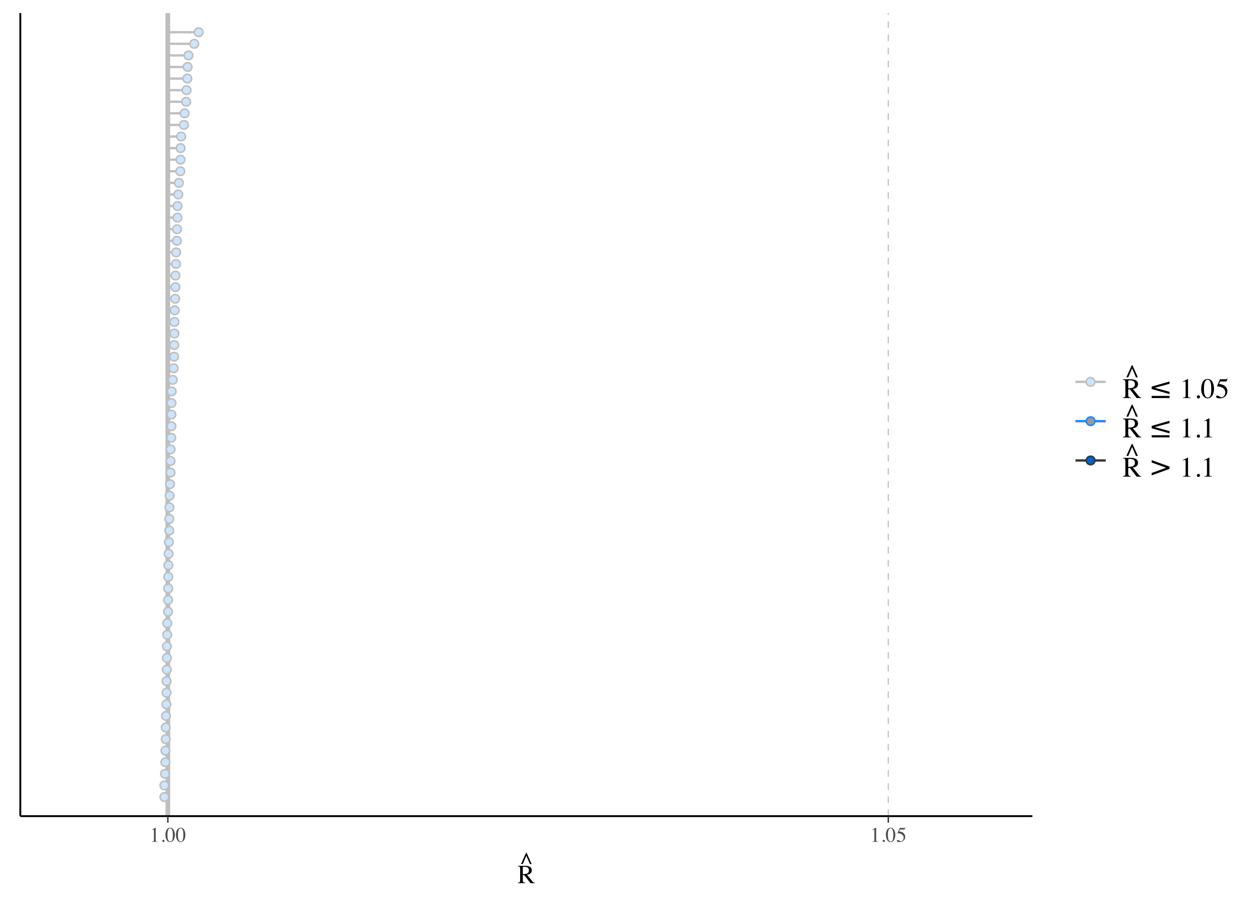
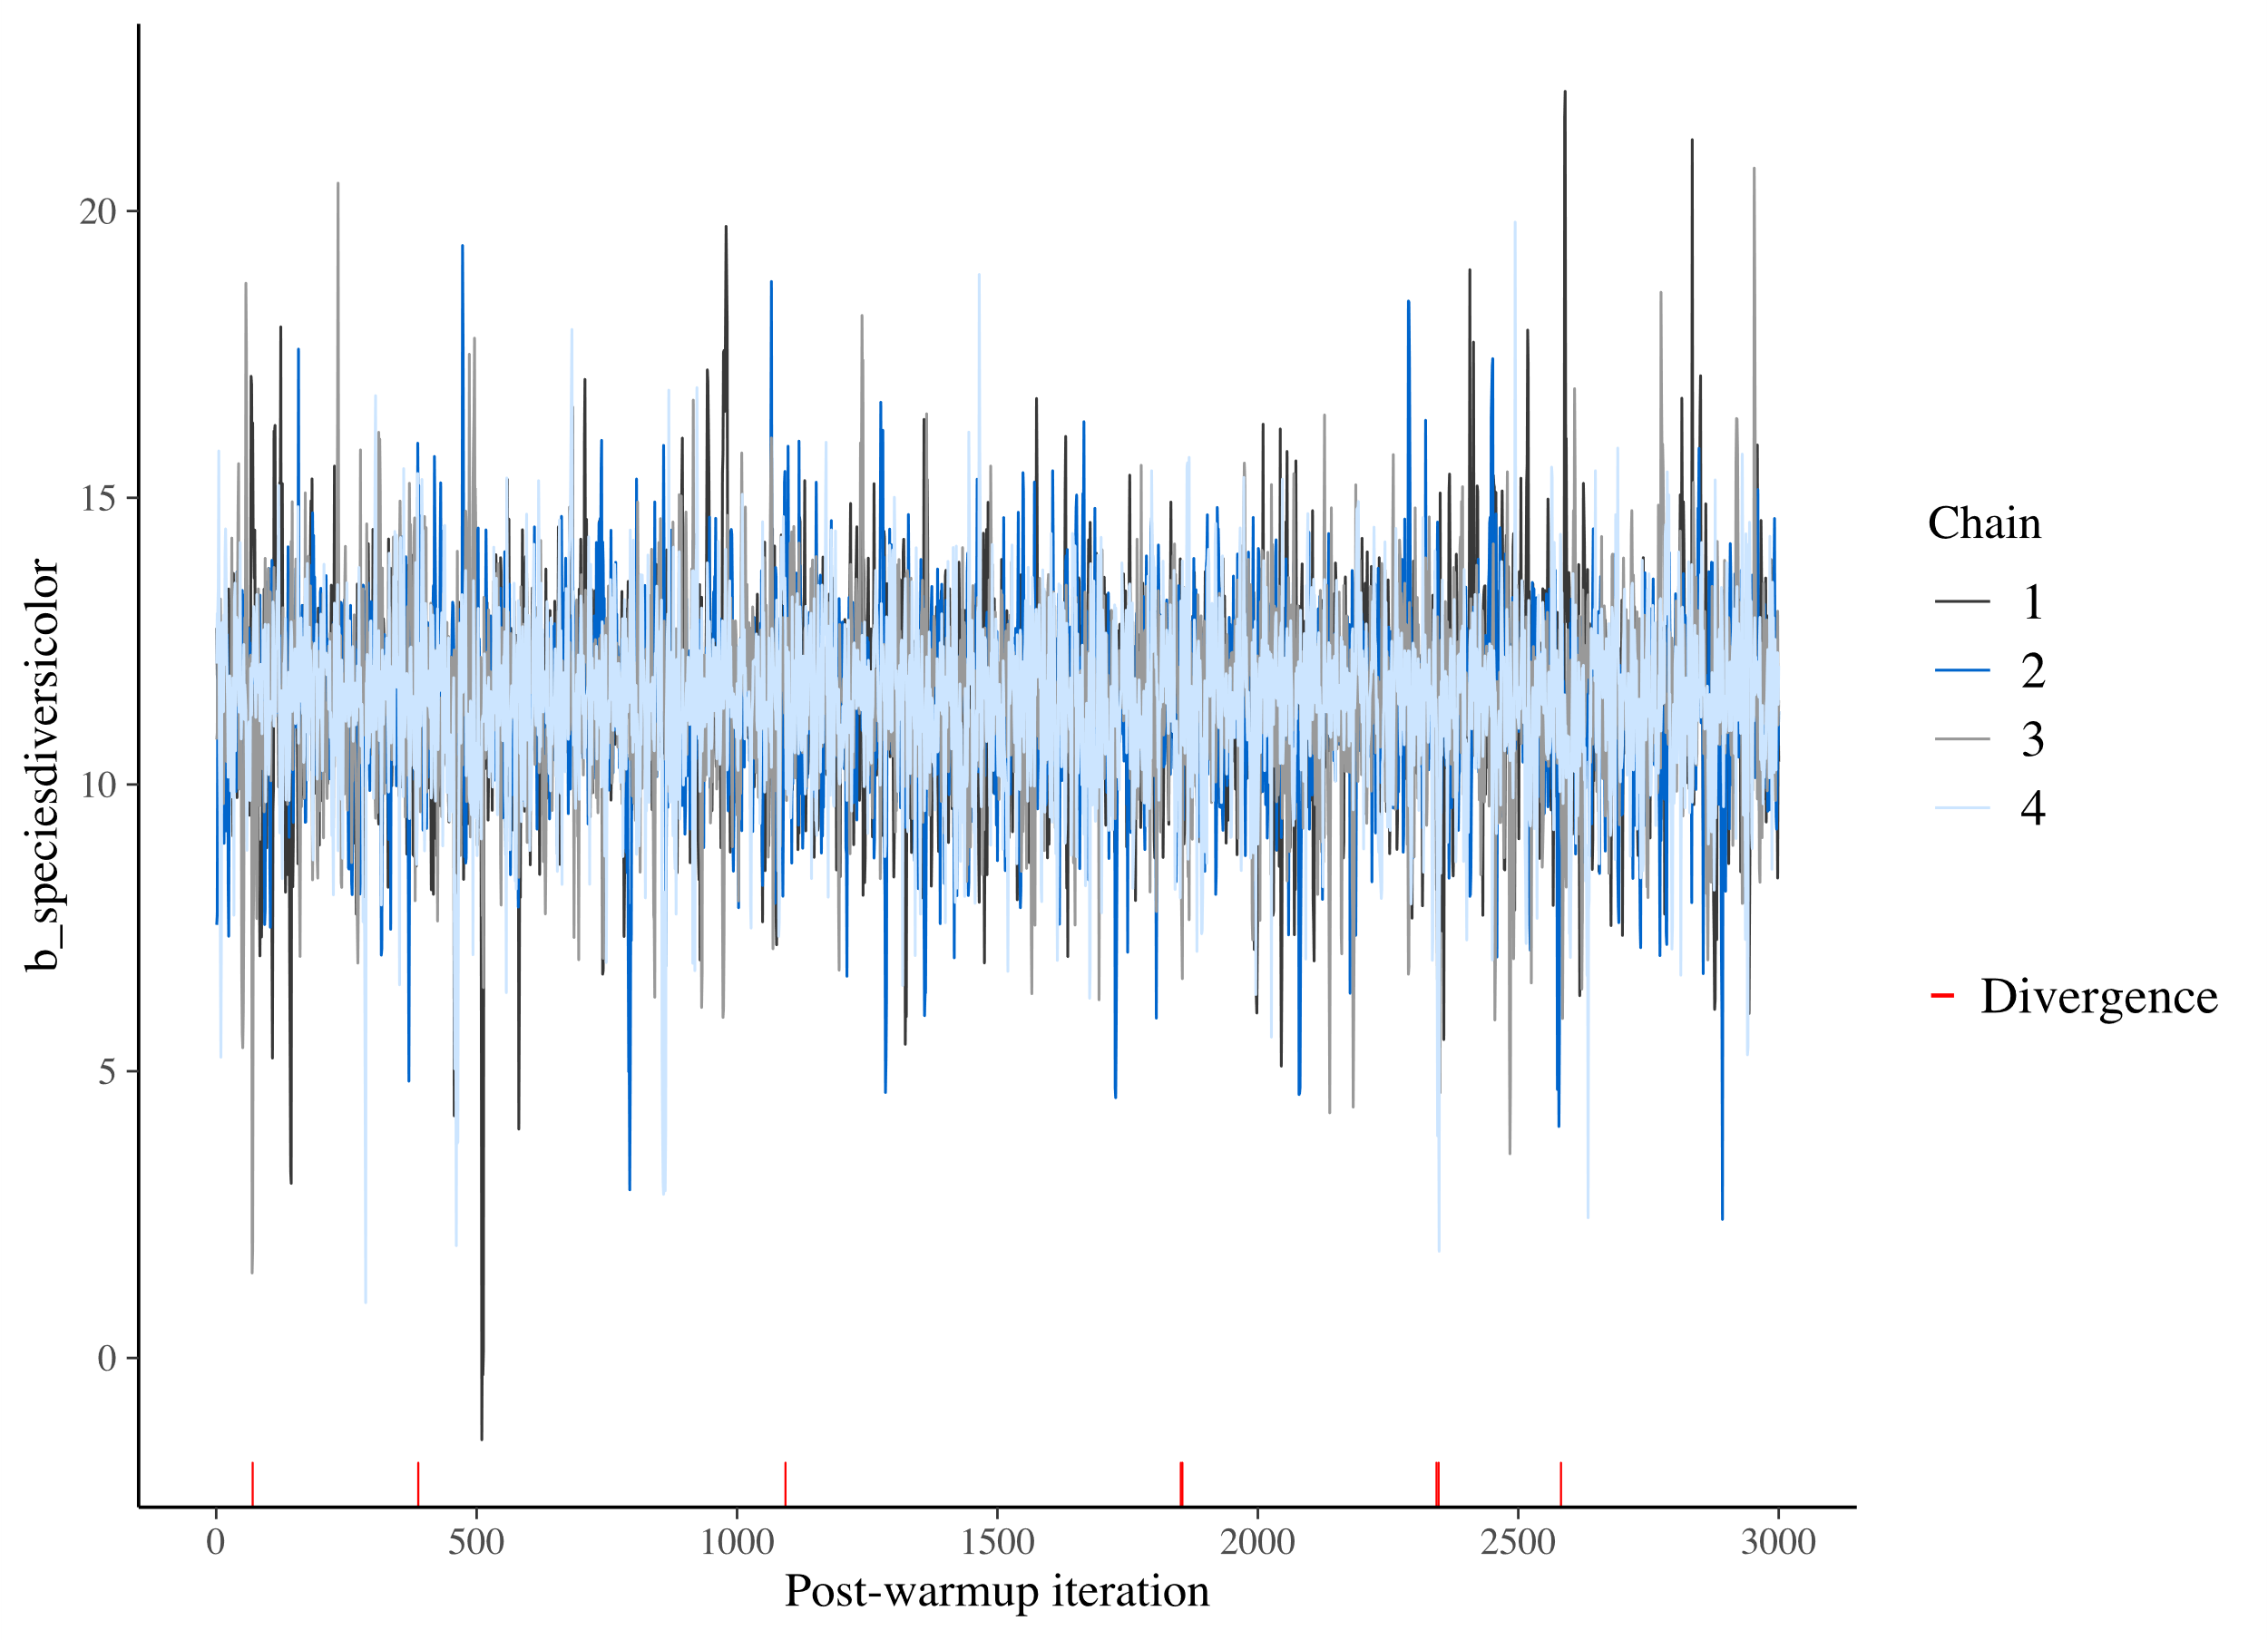

c
d
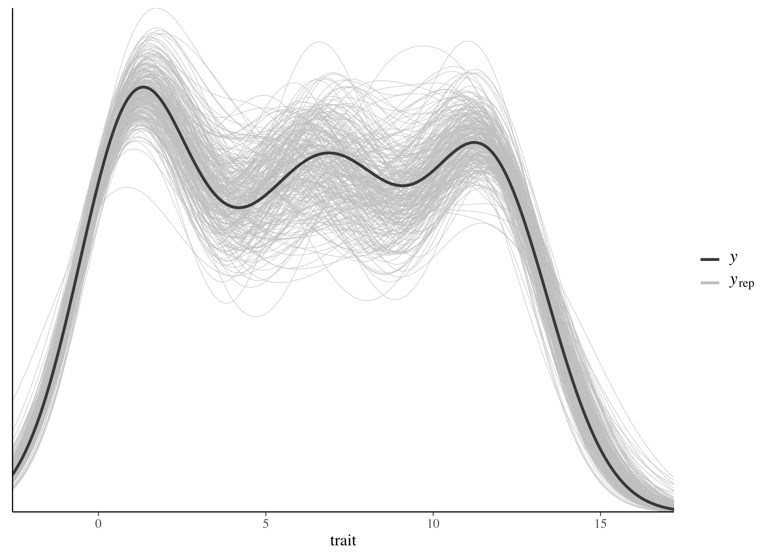
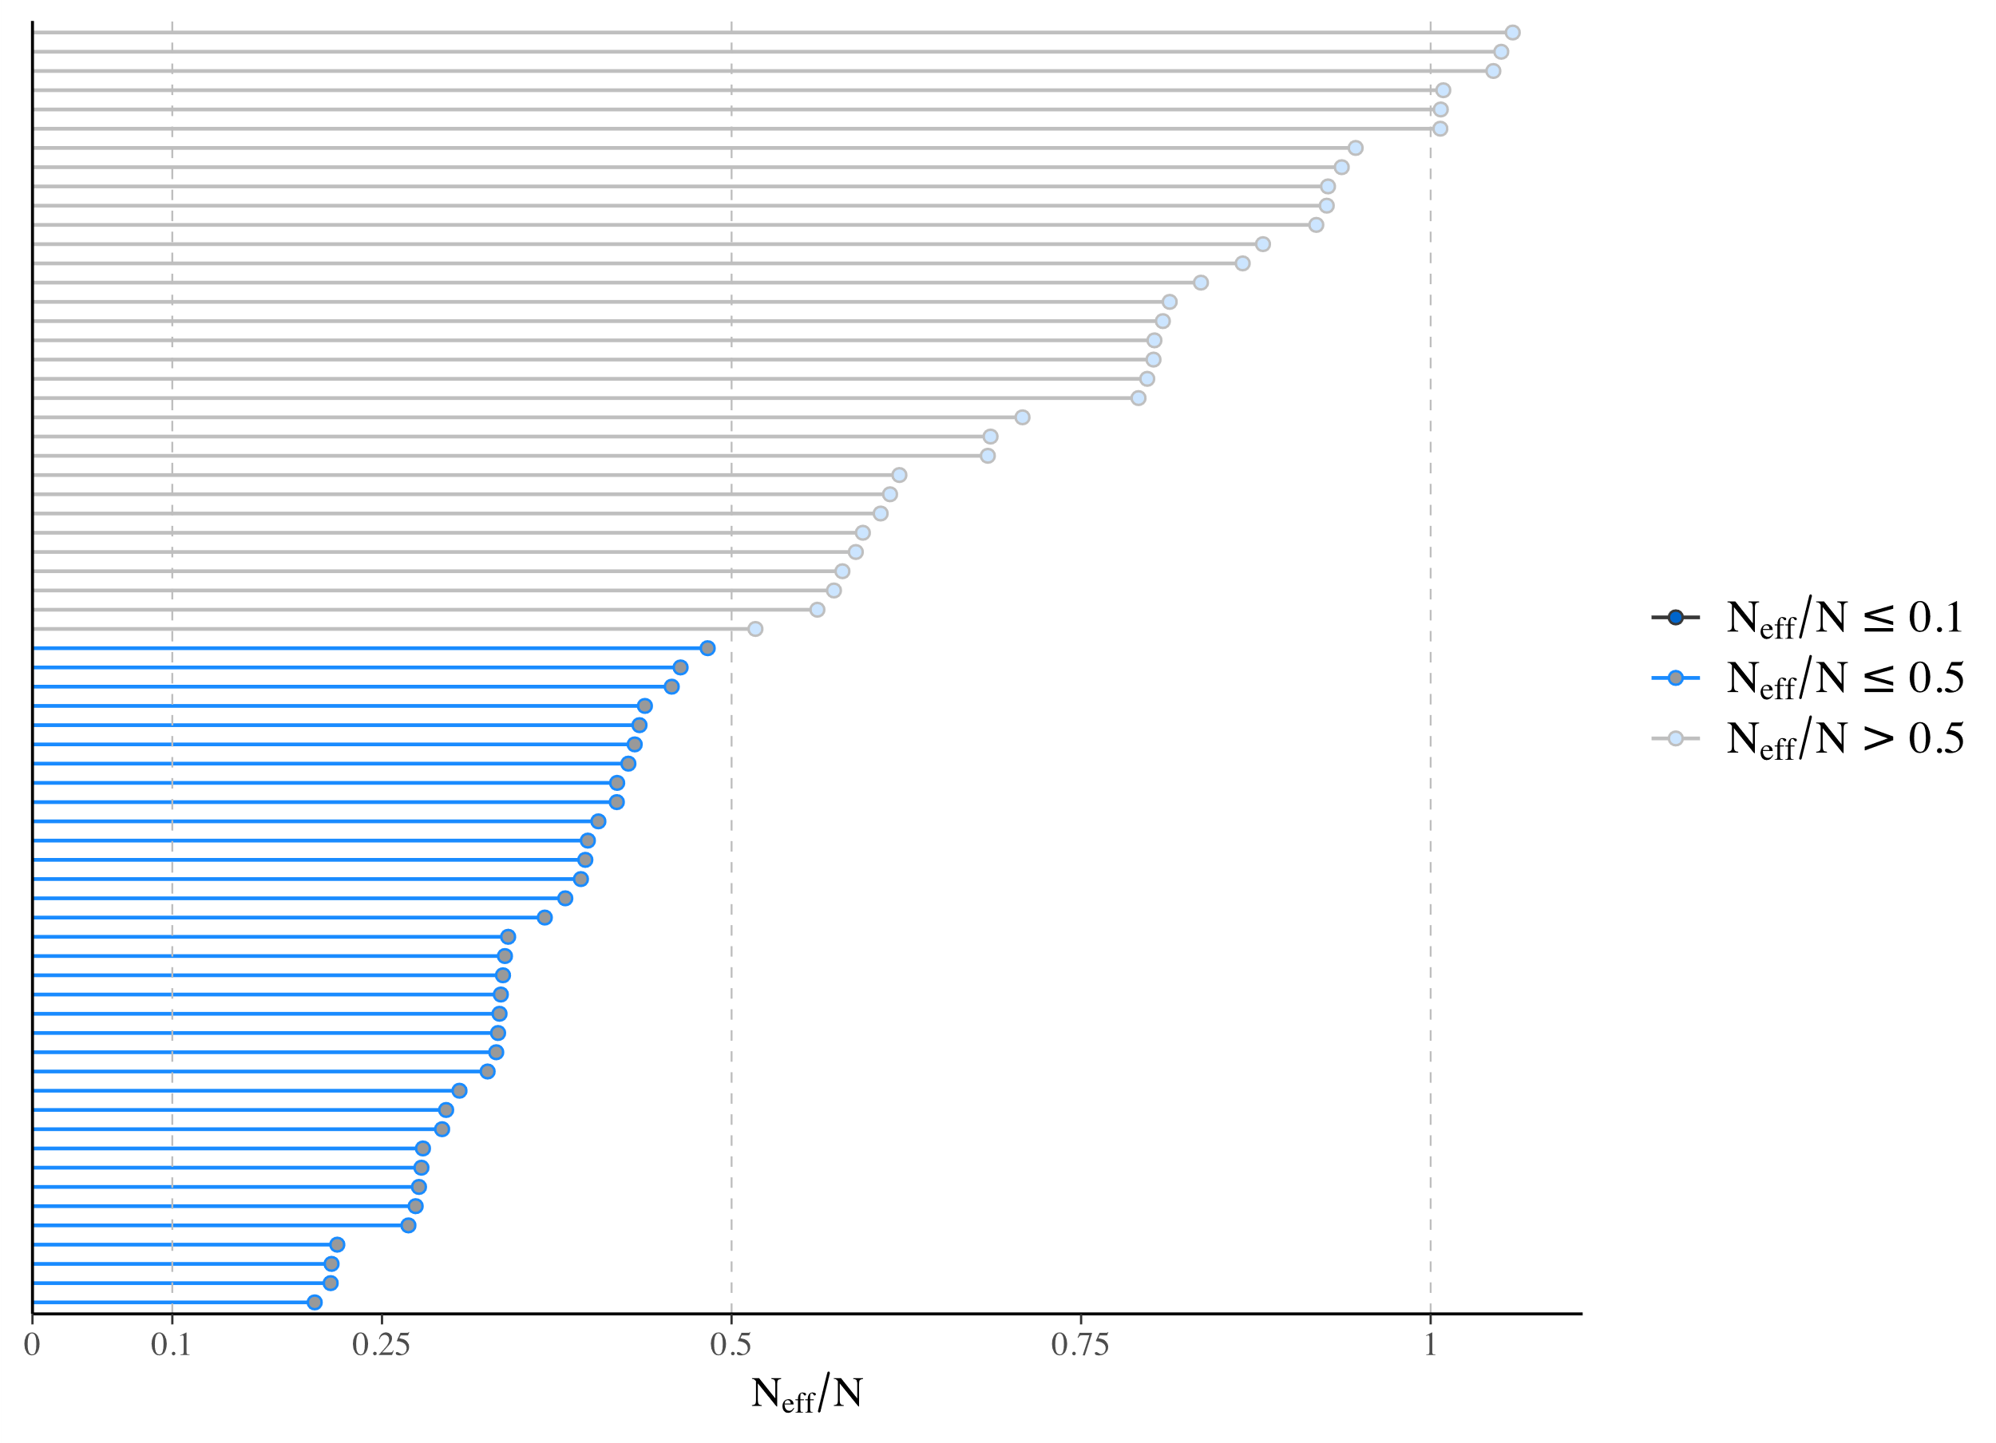

Supplementary Figure 5. Markov Chain Monte Carlo (MCMC) chain convergence and posterior predictive checks. Graphical checks for MCMC chain convergence autocorrelation, effective sampling size (ESS) and posterior distribution vs observed data for Hediste diversicolor for the trait L_{max} is selected as an indicative example. (a) depicts a trace plot showing convergence across all 4 chain simulations, (b) shows rhat values (measures of chain convergence) for all treatments with values < 1.05, (c) depicts ESS values for all treatments and (d) depicts density distributions simulated values for 250 draws (y_{rep}) and observed data (y). These checks were performed for all variables.

Supplementary References

Bianchi, T.S., Aller, R.C., Atwood, T.B., Brown, C.J., Buatois, L.A., Levin, L.A., Levinton, J.S., Middelburg, J.J., Morrison, E.S., Regnier, P., Shields, M.R., Snelgrove, P.V.R., Sotka, E.E. & Stanley, R.R.E. (2021) What global biogeochemical consequences will marine animal–sediment interactions have during climate change? Elementa: Sci. Anthrop., 9.
Bresnan, E., Cook, K., Hindson, J., Hughes, S., Lacaze, J-P., Walsham, P., Webster, L., Turrell, W. R., (2016) The Scottish Coastal Observatory 1997-2013. Scottish Marine and Freshwater Science 7, 26.
Calder-Potts, R., Spicer, J. I., Calosi, P. Findlay, H. S., Widdicombe, S. (2015) A mesocosm study investigating the effects of hypoxia and population density on respiration and reproductive biology in the brittlestar Amphiura filiformis. Mar. Ecol. Prog. Ser. 534, 135-147.
Cassidy, C., Grange, L.J., Garcia, C., Bolam, S.G. & Godbold, J.A. (2020) Species interactions and environmental context affect intraspecific behavioural trait variation and ecosystem function. Proc. R. Soc. B., 287, 20192143.
Clare, D.S., Bolam, S.G., McIlwaine, P.S.O., Garcia, C., Murray, J.M. & Eggleton, J.D. (2022) Biological traits of marine benthic invertebrates in Northwest Europe. Scientific Data, 9, 339.
Forster, S., Glud, R.N., Gundersen, J.K. & Huettel, M. (1999) In situ study of bromide tracer and oxygen flux in coastal sediments. Estuar. Coast. Shelf Sci., 49, 813-827.
Galasso, H. L., Richard, M., Lefebvre, S., Aliaume, C., Callier, M. D. (2018) Body size and temperature effects on standard metabolic rate for determining metabolic scope for activity of the polychaete Hediste (Nereis) diversicolor. PeerJ 6, e5675.
Gelman, A., Carlin, J. B., Stern, H. S., Rubin, D. B. (2004) Bayesian Data Analysis. (Chapman & Hall).
Glud, R.N. (2008) Oxygen dynamics of marine sediments. Mar. Biol. Res., 4, 243-289.
Grasshoff, K., Kremling, K. & Ehrhardt, M. (1999) Methods of seawater analysis. John Wiley & Sons.
Harianto, J., Carey, N. & Byrne, M. (2019) respR—An R package for the manipulation and analysis of respirometry data. Methods Ecol. Evol., 10, 912-920.
Koretsky, C.M., Meile, C. & Van Cappellen, P. (2002) Quantifying bioirrigation using ecological parameters: a stochastic approach. Geochemical Transactions, 3, 17-30.
Lemoine, N. P. (2019) Moving beyond noninformative priors: why and how to choose weakly informative priors in Bayesian analyses. Oikos 128, 912-928.
Leung, J. Y. S., Russell, B. D., Coleman, M. A., Kelaher, B. P., Connell, S. D. (2021) Long-term thermal acclimation drives adaptive physiological adjustments of a marine gastropod to reduce sensitivity to climate change. Sci. Tot. Environ. 771, 145208.
Morris, et al. (2016). Cefas Coastal Temperature Network. Cefas, UK. V1., doi: https://doi.org/10.14466/CefasDataHub.5
Queiros, A.M., Birchenough, S.N., Bremner, J., Godbold, J.A., Parker, R.E., Romero-Ramirez, A., Reiss, H., Solan, M., Somerfield, P.J., Van Colen, C., Van Hoey, G. & Widdicombe, S. (2013) A bioturbation classification of European marine infaunal invertebrates. Ecol Evol, 3, 3958-3985.
Rabouille, C., Denis, L., Dedieu, K., Stora, G., Lansard, B. & Grenz, C. (2003) Oxygen demand in coastal marine sediments: comparing in situ microelectrodes and laboratory core incubations. J. Exp. Mar. Biol. Ecol., 285-286, 49-69.
Revsbech, N.P. (1989) An oxygen microsensor with a guard cathode. Limnol. Oceanogr., 34, 474-478.
Sanders, T., Solan, M. & Godbold, J.A. (2024) Trait-mediated processes and per capita contributions to ecosystem functioning depend on conspecific density and climate conditions. Commun. Earth Environ., 5, 79.
Schiffers, K., Teal, L.R., Travis, J.M.J. & Solan, M. (2011) An open source simulation model for soil and sediment bioturbation. PLoS ONE, 6, e28028.
Solan M., Wigham B.D., Hudson I.R., Kennedy R., Coulon C.H, Norling K, Nilsson H.C. & R., R. (2004) In situ quantification of bioturbation using time-lapse fluorescent sediment profile imaging (f-SPI), luminophore tracers and model simulation. Mar. Ecol. Prog. Ser., 271, 1-12.
Schulz, H. & Zabel, M. (2006) Marine Geochemistry, 2nd revised, updated and extended edn. Springer-Verlag, Germany: Berlin Heidelberg.
Ullman, W.J. & Aller, R.C. (1982) Diffusion coefficients in nearshore marine sediments 1. Limnol. Oceanogr., 27, 552-556.
Vopel, K., Thistle, D., Rosenberg, R. (2003) Effect of the brittle star Amphiura filiformis (Amphiuridae, Echinodermata) on oxygen flux into the sediment. Limnol. Oceanogr. 48, 2034-2045.
Wohlgemuth, D., Solan, M. & Godbold, J.A. (2017) Species contributions to ecosystem process and function can be population dependent and modified by biotic and abiotic setting. Proc. R. Soc. B., 284, 20162805.

ENDS.

