[AAF Volume 49.1 – March 2025]
[Editorial]

How diverse are foster care research and practice?

Dennis Golm
Editor-in-Chief, Adoption & Fostering, UK

Two articles in the current issue of Adoption & Fostering inspired this editorial (Stemp et al., 2025; Unwin et al., 2025). Both explore questions about diversity in foster care. The scoping review by Rachael Stemp and colleagues (2025) explored the diversity among UK foster carers recruited into research studies and what demographic information was commonly reported by researchers. The review focused on studies published since the introduction of the Equality Act (2010), which led to the inclusion of 82 articles. It found that demographic information was reported inconsistently. The most reported characteristic was sex or gender reported by roughly 61% of studies. On the flip side, this means that 39% of studies did not report on this characteristic. None of the studies distinguished between sex and gender, and all studies reported only binary categories or just one gender (i.e., percentage of females). Age and ethnicity were only reported by about a third of studies. The least reported characteristics were sexual orientation, disability and religion (Respectively 7, 2, and 1 out of 82 studies). Most foster carer participants were White (median 93%) and female (mean 80%). The number of studies making a conscious effort to increase diversity or discussing sample representativeness was limited. The ethnicity of foster carers and children in care in England, data also referred to in the scoping review, is reported in Figure 1A (Department for Education [DfE], 2024; Ofsted, 2021). Given that this data were based on a report from 2021, the author acknowledged that it cannot be ruled out that some samples were representative of the foster carer population at the time of publication. The reference data further only includes foster carers in England due to the availability of nationally reported data. While it may therefore not be representative of the UK as a whole, many of the included studies focused on foster carers from England (Stemp et al., 2025). The take-home message is clear: Researchers need to make an effort to recruit more diverse foster carer samples and provide more fine-grained demographic information on their sample. A tool recommended for guidance by the review’s authors is the PRO EDI participant characteristics table (Trial Forge, 2024).
While the scoping review focused on diversity within foster care in research studies, we should also reflect on, and contrast, the diversity and representation of children in care and the foster carers who care for them (see Figure 1A). According to the DfE (2024), children with mixed heritage are over-represented, while children with Asian heritage are under-represented amongst children in care. When contrasting available data on ethnicity from foster carers (Ofsted, 2021) and children, we can see that White foster carers are over-represented and foster carers from non-White backgrounds are under-represented. The available data unfortunately does not allow to further split non-White carers into ethnic subgroups. Having foster carers of a different ethnic background may impact identity development. A study from the Netherlands used a longitudinal qualitative design to explore the ethnic identities of transculturally placed youths in foster care (Degener et al., 2023). The young people’s parents or grandparents had been born in a different country. All of their foster carers were of White West European ethnicity. Their findings showed that ethnic identity fluctuated between the first and the second interview two years later. A strengthening of connections with their foster carers or birth parents was seen as a contributing factor to identifying more with a Dutch or minority ethnic identity. Equally, through a loss of connection to the birth family or new negative experiences with birth parents, young people might move more towards a Dutch cultural identity. At both time points, youths expressed a sense of being different by, for instance, wishing for foster parents with the same skin colour. The young people also reported a growing awareness of racial discrimination and relevant political movements such as Black Lives Matter. These issues were, however, not much discussed in their foster families. This highlights the importance, and even responsibility, of foster carers to educate themselves on topics such as structural and everyday racism and to seek an open conversation with the young people in their care.
One reason why England’s foster care population is less ethnically diverse than the children they care for could be perceived discrimination by prospective foster carers (Chowdhury, 2021). A helpful tool for local authorities might be the BRAC²eD model (Cane, 2023). The tool was developed to help social workers reflect on their own biases towards adopters from minoritised ethnic groups. It provides a set of reflexive questions that could also prove valuable for the recruitment of prospective foster carers.
Aside from the lack of foster carers from minority ethnic backgrounds, the total number of foster care households in England has been steadily declining over the last four years, from 45,370 in 2021 to 42,615 in 2024, a decline of 6% (Ofsted, 2024). The number of children in care during the same time has plateaued (see Figure 1B). The study by Peter Unwin and colleagues (2025) suggests that Disabled people could fill this recruitment gap as a probably underutilised target group for foster carer recruitment. Currently, the number of Disabled foster carers in the UK is not recorded nationally (Unwin et al., 2024), making it hard to truly determine a lack of representation. An earlier analysis of information available on the websites of 496 foster care agencies in England, however, found that only 1.2% mentioned the possibility of Disabled people becoming foster carers, and even fewer agencies featured Disabled people as role models of successful fostering (Torney and Unwin, 2018). This suggests that most foster care agencies in England are not making a conscious effort to recruit Disabled people as foster carers. The aim of the study published in this issue of Adoption & Fostering was to evaluate current practice and potential for change regarding Disabled foster carers. The mixed method study was co-produced with a foster care agency and a university-based group of carers and service users, and supported by a group of Disabled people with lived experience of either being a foster carer or having been in foster care themselves. The study collected information about agency staff knowledge regarding disability issues and the Equality Act before and after a disability equality workshop designed to address identified knowledge gaps. Post-survey data were thematically analysed. The agencies had very low numbers of Disabled foster carers. The pre-workshop survey across three participating foster care agencies with 63 respondents demonstrated that most participants had little to no knowledge about the Equality Act. Sadly, fewer than a third of participants completed the post-workshop survey. The available data here however suggests an increase in knowledge.
Emerging themes from participant statements highlighted perceived barriers and benefits in engaging Disabled foster carers. Perceived barriers, for instance, included gaps in knowledge and confidence and deficit-based views. Some potential perceived benefits included an understanding of disability and increased empathy. The authors make policy and practice recommendations based on their findings including targeting Disabled people in recruitment campaigns and featuring Disabled foster carers to encourage applications by Disabled people. The study very openly discusses problems of recruiting foster care agencies for this research project. For future studies, it would be interesting to explore reasons for foster care agencies not engaging in research focusing on disability in foster care. A clear strength of the study was its co-production design, which should inform similar projects to facilitate disability knowledge in foster care agencies.
To answer the question posed by the title ‘How diverse are foster care research and practice?’, the answer is not enough! Studies like the ones by Stemp and colleagues (2025) and Unwin and colleagues (2025) however offer valuable reflection on diversity issues in foster care and provide a starting point for a discussion. Let’s not shy away from this discussion and talk…

[References]
Cane T (2023) BRAC2eD model: An approach to de-bias decision-making in adoption assessments with prospective adopters from minoritised ethnic groups. Adoption & Fostering 47(1): 58–76. doi: 10.1177/03085759231160785
Chowdhury C (2021) ‘They want to give our children to white people and Christian people’: Somali perspectives on the shortage of Somali substitute carers. Adoption & Fostering 45(1): 22–36. doi: 10.1177/0308575921989827
Degener CJ, Grietens HW and van Bergen DD (2023) Grasping ethnic identity fluctuations of transculturally placed foster youth: A longitudinal study. Qualitative Social Work 22(3): 537–552. doi: 10.1177/14733250221081758
Department for Education (DfE) (2024) Adopted and looked-after children. Available at: www.ethnicity-facts-figures.service.gov.uk/health/social-care/adopted-and-looked-after-children/latest/
Ofsted (2021) Fostering in England 2020 to 2021: Main findings. Available at: www.gov.uk/government/statistics/fostering-in-england-1-april-2020-to-31-march-2021/fostering-in-england-2020-to-2021-main-findings
Ofsted (2024) Fostering in England 1 April 2023 to 31 March 2024. Available at: www.gov.uk/government/statistics/fostering-in-england-1-april-2023-to-31-march-2024/fostering-in-england-1-april-2023-to-31-march-2024
Stemp, R, Izzidien S, Sharma S, Irvine K and Midgley N (2025) How inclusive and representative is research on foster caring in the UK? Findings from a scoping review. Adoption & Fostering 49(1): [page range and doi to be added]
Torney L and Unwin P (2018) Web-Based Review of Disabled Fostering Profile of All English Foster Agencies. University of Worcester, Unpublished.
Trial Forge (2024) PRO EDI: Improving how equity, diversity and inclusion are handled in evidence synthesis. Available at: www.trialforge.org/trial-diversity/pro-edi/
Unwin P, Jones A and Meakin B (2024) Disabled people as foster carers – Closing the recruitment gap and more. Disability & Society: 1–19. doi: 10.1080/09687599.2024.2412274
Unwin P, Jones A and Meakin B (2025) Looking past the stereotypes—Disabled people as foster carers. Adoption & Fostering 49(1): [page rangen and doi to be added].

[Author bio]
Dr Dennis Golm is the Editor-in-Chief of Adoption & Fostering. He is a lecturer in psychology at the University of Southampton, UK, and holds affiliate positions at King’s College London, UK, and Boston Children’s Hospital, USA.

[Figures]
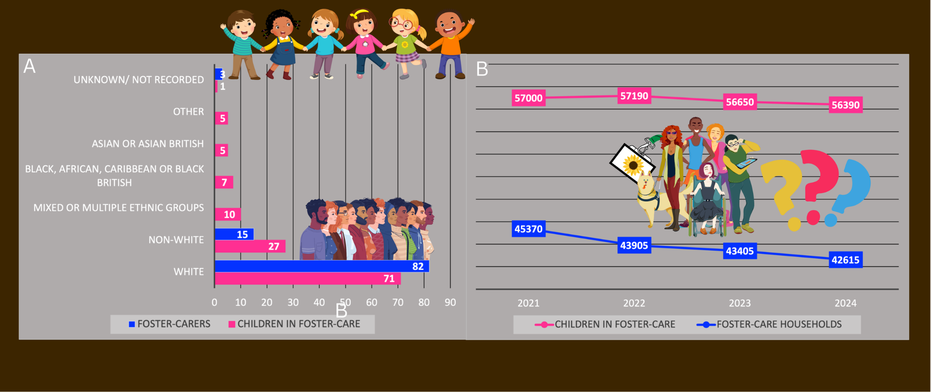
Figure 1. Number of foster-care households and ethnicity of foster carers and children under their care.
A: Number of fostering households and children in foster-care during the last 4 years.
B: Ethnicity of children in care in England (in percent).

