Pollution status, ecological effects, and bioremediation strategies of phthalic acid esters in agricultural ecosystems: A review
Xiao Kong ^{†, 1}, Giovanni Davide Barone ^{‡,1}, Decai Jin §, *, Yiting Mao †, Fengting Nan †, Li Xu ¶, Zhigang Wang ⊥, Ye Deng §, Tomislav Cernava #, ∇
† School of Public Health, Qingdao University, Qingdao 266021, China
‡ Department of Biology, University of Graz, Graz 8010, Austria
§ Key Laboratory of Environmental Biotechnology, Research Center for Eco-Environmental Sciences, Chinese Academy of Sciences, Beijing 100085, China
¶ Institute of Quality Standard and Testing Technology, Beijing Academy of Agriculture and Forestry Sciences, Beijing 100097, China
⊥ Department of Biotechnology, Institute of Life Science and Agriculture and Forestry, Qiqihar University, Qiqihar 161006, China
# Institute of Environmental Biotechnology, Graz University of Technology, Petersgasse 12, Graz 8010, Austria
∇ School of Biological Sciences, Faculty of Environmental and Life Sciences, University of Southampton, Southampton SO17 1BJ, United Kingdom

ABSTRACT
Phthalic acid esters (PAEs) are common organic contaminants in farmland soil across China. These chemicals pose significant carcinogenic, teratogenic, mutagenic, and estrogenic threats to humans and are therefore linked to food safety issues. Over the past decades, numerous studies have assessed the pollution status, ecological impact, and remediation strategies for PAEs in agricultural systems. This enabled a comprehensive evaluation of their environmental burden. Here, we consolidate the latest findings on the distribution, ecological effects, and bioremediation methods of PAEs in farmland ecosystems. In general, plastic agricultural films, municipal biosolids, pesticides, and wastewater irrigation are the primary sources of PAEs pollution. Among different PAEs, di-(2-ethylhexyl) phthalate (DEHP), di-n-butyl phthalate (DnBP), and di-isobutyl phthalate (DiBP) exhibit the highest detection frequencies and concentrations in both soil (with respective mean values of 1.497 mg/kg, 0.626 mg/kg and 0.313 mg/kg) and agricultural products (with respective mean values of 1.06 mg/kg, 0.66 mg/kg and 1.55 mg/kg) across most studies. The presence of these PAEs in agricultural ecosystem can significantly alter soil and plant-associated microbial communities, influencing their interactions and ecological functions, ultimately affecting the yield and quality of agricultural products. To tackle this issue, bioremediation techniques such as microbial degradation and phytoremediation are frequently explored. Especially microbial degradation plays a crucial role in the removal of PAEs in soils. The main known degradation pathways of PAEs in microorganisms are summarized in this work. Overall, the challenges and prospects in managing PAEs pollution in agricultural systems remain significant. This review aims to provide a comprehensive overview of current research on PAEs in China’s agricultural systems and offers insights into potential problems and research directions for future studies.

KEYWORDS: phthalates; farmland system; ecological effects; bioremediation

- INTRODUCTION
Phthalic acid esters (PAEs) are commonly used as plasticizers to increase the softness and plasticity of plastics ¹. PAEs are characterized by good insulation, high strength, excellent corrosion resistance, low cost and easy manufacturing, and are widely used in plastic products, cosmetics, medical supplies, household goods and so on ²⁻⁴. The current global production of PAEs is estimated at 600 to 800 million tons, and the utilization has increased by 1.3% from 2017 to 2022 ^{5, 6}. China is the world’s largest producer, consumer, and importer of plasticizers, accounting for 55% of the total consumption in 2020 ⁷. Since PAEs are linked to plastic molecules through non-chemical bonds, they are prone to detachment from their substrates and subsequent release into the environment, posing a significant threat to environmental health.
Given the widespread utilization of phthalate-containing products, PAEs have been detected across various environmental samples, including soil ^{8, 9}, water ^{10, 11}, sediment ^{12, 13}, plants ^{14, 15}, air ¹⁶, and house dust ^{17, 18}. This widespread presence poses a considerable threat to the environment and public health, garnering increasing concern from governments, researchers, and the public worldwide ¹⁹. PAEs can enter the human body unnoticed through airborne transmission, skin contact, and food chain transmission, leading to potential health hazards ²⁰. Although the exact pathogenesis remains incompletely understood, numerous epidemiological studies have established a significant association between phthalate exposure and various human diseases ²⁰ (Figure 1). Up to now, researchers have found that diseases of different systems such as the reproductive ²¹⁻²³, nervous ^{24, 25}, cardiovascular ^{26, 27}, respiratory ²⁸⁻³⁰, and many other disorders ³¹⁻³⁵ are related to PAEs. Notably, dietary intake is a significant route of phthalate exposure in humans ³⁶. Therefore, agricultural products cultivated in environments contaminated with PAEs merit our utmost attention.
In recent decades, farmlands have been exposed to substantial contamination due to unsustainable agricultural practices, industrial production, urban development, and human activities. PAEs can enter agricultural systems through different sources, encompassing wastewater irrigation, plastic mulching and greenhouses as well as fertilization, solid waste disposal, municipal solid misuse, and other off-site pollution sources (Figure 2) ⁹. Hence, the review aims to i) collect PAEs pollution data focusing on soil, air, and crops, and explore the geographical distribution of PAEs in farmland systems; ii) analyze the ecological effects of PAEs pollution on crops and related ecosystems; iii) evaluate the progress made in soil bioremediation techniques and the biodegradation pathway of phthalates.
- The occurrence of PAEs in agricultural environments
2.1 PAEs pollution in agricultural soil. Numerous studies have examined the extent of PAEs pollution in agricultural soils across various regions of China. For this study, researches related to “phthalate” and “agricultural”, “soil”, “vegetable”, and “air” were searched in the databases such as Web of Science, PubMed, Elsevier ScienceDirect, SpringerLink, and CNKI. Samples that were eventually involved in the analysis were mainly collected from farmland, vegetable fields, orchards, tea gardens, and tobacco-producing areas from 2003 to 2023 in China (Table S1). The distribution of PAEs among different provinces or regions exhibits significant variation. The ∑₆ PAEs (Sum concentration of six United States Environmental Protection Agency (USEPA) priority PAEs, DMP, DEP, DBP, BBP, DOP, and DEHP) ranged from 0 to 1232 mg/kg, with the highest concentration observed in a cotton field located in South Xinjiang ³⁷. This is followed by soil from peri-urban vegetable fields located in Guangdong and a flue-cured tobacco planting base in Guizhou; the ∑₆ PAEs varied from 0.20-33.6 mg/kg and 0.84-25.7 mg/kg, respectively ^{38, 39}. In the northeast of China, PAEs were widely found in black soil from agricultural environments; the 15 measured PAEs (∑₁₅ PAEs) ranged from 1.37 to 4.9 mg/kg. The highest concentration was observed in summer, which might be due to increased agricultural production activities ⁴⁰. Vegetable production is widespread in the Huang-Huai-Hai region (Shandong, Hebei, Tianjin, and Henan). Zhou, et al. ⁴¹ demonstrated that the concentrations of the sixteen PAEs in this region range from 0.052-3.6 mg/kg with a mean value 0.90 mg/kg, this high concentration was attributed to the extensive use of agricultural film. Coastal areas of China, including Shandong, Jiangsu, Zhejiang, Shanghai, Fujian, Guangdong, and Guangxi, were also found to be highly contaminated with PAEs; the concentration of ∑₁₆ PAEs was found to be as high as 9.4 mg/kg ^{9, 19, 42, 43}. Overall, agricultural soils in China are severely polluted with PAEs, with concentrations exceeding the control standards set by the United States for DMP 0.02 mg/kg, DEP 0.071 mg/kg, DBP 0.081 mg/kg, BBP 1.125 mg/kg, DEHP 4.35 mg/kg, and DnOP 1.2 mg/kg. In addition, the pollution level was higher than in many other countries, such as Czech Republic ⁴⁴, France ⁴⁵, United Kingdom ^{46, 47}, and Denmark ⁴⁸. This may be due to the vigorous development of protected agriculture, the use of greenhouses, mulch film, fertilizers, pesticides, and sewage irrigation ⁴⁹.
The pollution status of ∑₆ PAEs in agricultural soils of different provinces is shown in Figure 3 (there are no PAEs pollution data for Tibet). The highest ∑₆ PAEs concentration was found in Xinjiang, followed by Guizhou, Shandong, and Guangxi provinces. In general, the Huang-Huai-hai basin and the Pearl River Basin are the most polluted ones when it comes to PAEs. Among all PAEs, DEHP and DnBP exhibit the highest detection rates and concentrations, with peak values reaching 149 and 58 mg/kg, respectively. DnBP concentrations (mean value) were particularly high in Xinjiang and Hebei provinces (Figure S1). Hainan, Yunnan, Sichuan, Qinghai, Shaanxi, Hubei, Jiangxi, Fujian, Jilin and Taiwan provinces experience relatively minor DnBP pollution, with concentrations lower than 0.081 mg/kg, which is well within established control standards. The pollution pattern of DEHP closely mirrors that of DnBP, with significant pollution observed in Xinjiang, Guizhou, Hebei, Shandong, Jiangsu, Zhejiang, Ningxia, and Heilongjiang. These regional differences in PAEs concentrations may be attributed to varying climatic conditions and agricultural practices. Agriculture is generally more developed in areas close to rivers. Especially in these places, the long-term use of plastic greenhouses and mulching may contribute to higher PAEs emissions. Notably, DiBP, an isomer of DnBP, was frequently found in higher concentrations and detection frequencies in various studies. However, it is not included in the priority-controlled pollutant lists of the United States, Europe, and China. The scarcity of research on DiBP’s basic toxicological data, metabolic pathways, and potential impacts on crops and humans presents a novel research direction for exploring PAEs.
Furthermore, numerous studies have explored variations in PAEs concentrations across farmland, vegetable fields, and orchards ⁵⁰⁻⁵³. Typically, vegetable fields exhibit higher levels of PAEs pollution than farmland and orchard soils. This can be attributed to the frequent use of plastic films in vegetable cultivation. Additionally, seasonal changes also influence the concentration of PAEs in agricultural soils ^{40, 54}. Higher temperatures during summer accelerate the migration of PAEs into the soil, resulting in increased concentrations. The duration of mulching and greenhouse use may also play a significant role in elevating PAEs concentrations: Yi, et al. ⁵⁵ and Zheng, et al. ⁵⁶ both observed that the concentration of PAEs initially rises and then decreases as the duration of mulching and greenhouse use increases. However, Li, et al. ⁵⁷ found no significant correlation between greenhouse use duration and soil PAEs content. This discrepancy can be attributed to various factors, such as the characteristics of plastic films, their dosage, soil properties, degradation rates, and human activities.
2.2 PAEs concentration in the air of plastic greenhouses. Currently, the majority of studies concentrate on phthalate pollution in agricultural soil and vegetables. However, the contamination of PAEs in the air within agricultural systems is also a crucial concern. Especially plastic greenhouses, being semi-closed or enclosed spaces, can accumulate high levels of PAEs in the air, heightening the risk of respiratory exposure to phthalates among individuals. Therefore, it is imperative to investigate the concentrations of PAEs in the air of plastic greenhouses. Wang, et al. ⁵⁸ conducted a study on the concentration of PAEs in the air of plastic agricultural greenhouses and found that the median concentration of ∑₁₆ PAEs was 5305 ng/m³, significantly higher than in the control group. Notably, the gas-phase contained significantly more PAEs than the particle-phase, with DEHP (4780 ng/m³) and DnBP (1001 ng/m³) being the most abundant monomers. Zeng, et al. ⁵⁹ also investigated the distribution of PAEs in plastic greenhouses in Guangzhou and reported a concentration of ∑₁₆ phthalates in the air at 4393 ng/m³, with DEHP, DnBP, and DiBP being the primary compounds. The concentration of PAEs in greenhouse air was significantly higher than that in open fields. Li, et al. ⁵⁴ studied the concentration of PAEs in the air of plastic film greenhouses in Chongqing and found that DEHP was the most dominant PAE, followed by DiBP and DnBP. There were significant differences in PAEs concentration between autumn and spring, possibly due to temperature variations.
Despite the limited number of studies on atmospheric PAEs in agricultural settings, available evidence suggests that the pollution of PAEs in greenhouse air is higher than in open fields. This is primarily attributed to the volatilization of PAEs from plastic films and soil ⁵⁴. However, due to their lower volatility, the concentration of PAEs in the air is generally lower compared to other environments like soil and water ⁶⁰. Additionally, the amount of PAEs in the air is closely associated with temperature, as higher temperatures accelerate the volatilization rate of these compounds.
2.3 Concentrations of PAEs in agricultural products. PAEs migrate into plants through root absorption or leaf intake in agricultural environments, and are subsequently taken in by humans through the food chain, posing potential health risks. Given China’s status as a major agricultural nation, the safety of agricultural products is paramount. Therefore, it is imperative to monitor the contamination of PAEs in major agricultural products. Numerous studies have revealed widespread contamination of different produce by PAEs. Table S2 shows the concentration of PAEs in different plants. Shi, et al. ⁶¹ investigated the pollution status of PAEs in fruit and vegetable samples collected in Zhejiang province. Their results showed that DIBP, DBP, DEHP, and DEP have higher detection rates. Leaf vegetables (∑₆ PAEs 0.05 mg/kg) and citrus fruits (∑₆ PAEs 0.14 mg/kg) harboured the highest total PAEs concentrations. Xiang, et al. ⁶² demonstrated that DEHP was mainly localized in the cortex, phloem, and metaxylem of carrots.
The concentration of different PAE monomers in some plants is summarized in Figure 4. PAEs detected in plants are mainly DEHP, DnBP, and DiBP; these findings align with the detection of PAEs in soil, indicating a positive correlation between PAEs contents in plants and that in soil. Notably, the concentrations of PAEs in crops are often higher than in the corresponding soils, suggesting that PAEs in agricultural soils are not only transferred into plants, but that also biomagnification effects occur ⁹. It’s noteworthy to mention that while the proportion of DEHP in plants was lower than in soils, the content of DiBP was increased. This may be due to DiBP’s lower LogKow and higher water solubility, making it easier for plants to absorb ⁶³. Additionally, plants can accumulate PAEs from the air through their leaves. Different types of fruits and vegetables absorb and migrate PAEs components at different rates ⁵⁹. Root vegetables, rice, leafy vegetables, and beans tend to have higher concentrations of PAEs, indicating their greater capacity for PAEs accumulation. Furthermore, the accumulation of PAEs can vary among different cultivars of the same plant species, potentially due to differences in root exudate profiles, such as low molecular weight organic acids (LMWOAs) ⁶⁴. Furthermore, the content of PAEs in the final agricultural products can also be influenced by various factors, including production and processing methods, transportation and management practices, storage conditions, and packaging materials.
Currently, China has yet to establish a limit standard for PAEs in agricultural products. The United States Environmental Protection Agency (EPA) and the Office of Environmental Health Hazard Assessment (OEHHA) recommend a maximum intake dose of 0.01 mg/kg body weight per day for DBP and 0.05 mg/kg body weight per day for DEHP. Assuming an average weight of 60 kg and a daily intake of 0.5 kg (dry weight) of agricultural products, it becomes evident that the concentration of PAEs in a significant proportion of agricultural products exceeds these standards, posing potential health risks. Therefore, it is crucial, for the sake of food and environmental safety, to establish pollution control standards for phthalates in agricultural products. These standards could refer to the standards of the USEPA or the European Union, but they need to be adapted to the situation in China.
- Ecological effect of PAEs on agricultural environments
3.1 Effect of PAEs pollution on soil ecosystems. The widespread contamination of PAEs in agricultural soils has garnered significant attention due to their adverse impacts on soil ecosystems. This is the case for microbial communities, enzyme activities, and soil properties. Microorganisms, a crucial component of soil ecosystems, play a pivotal role in degrading soil pollutants and maintaining biogeochemical cycles ⁶⁵. They can enhance soil fertility and promote plant growth, thereby serving as the foundation for the stability of terrestrial ecosystems. Consequently, numerous studies have explored the effects of PAEs on soil microbial communities. Kong, et al. ⁶⁶ observed a decrease in the diversity of soil bacterial communities with rising DBP concentrations, whereas the diversity of soil fungal communities was higher than that of the control group ⁶⁷. Zhou, et al. ⁶⁸ also demonstrated that PAEs exert a stronger influence on bacteria than fungi, with DEHP and DBP inhibiting bacterial growth while significantly promoting fungal growth. Wang, et al. ⁶⁹ investigated the impact of DBP on the microbiome and functions of black soils, revealing a decline in the richness and Shannon index of bacterial communities following DBP treatment, whereas the Shannon index of fungal communities increased at lower DBP concentrations. In contrast, Wang, et al. ⁷⁰ showed that DBP in salinized farmland soils decreases the abundance of different soil microorganisms, encompassing bacteria, archaea, and fungi. These findings suggest that PAEs generally decrease the diversity of bacterial communities, while their effects on fungi and archaea vary across studies. While many bacteria can utilize PAEs as a carbon source, the utilization of PAEs by fungi and archaea remains understudied, potentially explaining these discrepancies.
In addition to their impact on microbial diversity and abundance, PAEs significantly influence functional genes, network interactions, and enzyme activity within soil ecosystems. Tao, et al. ⁷¹ conducted a study on the effects of DEHP and DBP on nitrification in black soil, revealing that these contaminants competitively suppress nitrification processes. This suppression manifests in the reduced diversity of soil nitrification microbial communities and the decreased abundance of related genes. Kong, et al. ⁷² demonstrated that soil DBP contamination promotes nitrogen fixation and denitrification processes while inhibiting the nitrification process; this leads to soil nitrogen loss. The same phenomenon was found in a study by Wang, et al. ⁷⁰. Additionally, Kong, et al. ⁷³ demonstrated that DBP increases the network complexity of soil fungal communities through inter-species cooperation. Gao, et al. ⁷⁴ reported that DBP can decrease the activity of enzymes such as protease, polyphenol oxidase, and β-glucosidase while increasing the activity of dehydrogenase, urease, and acid phosphatase. Given that soil enzymes serve as crucial indicators of the soil’s microecological status, these enzymatic activity variations also suggest potential alterations in soil ecological functions.
The physical and chemical properties of soil, such as structure, ventilation, moisture content, pH, and organic content, are also significant for crop quality and yield. The presence of PAEs in soil can have profound effects, leading to a decrease in soil porosity and an increase in bulk density, thereby reducing its permeability and breathability ^{75, 76}. Furthermore, DBP treatment has been shown to decrease soil pH, total nitrogen, and total phosphorus, while having no significant impact on total carbon content ⁶⁶. However, Gao, et al. ⁷⁷ reported that no significant change of soil physical and chemical properties was caused by PAEs. Overall, the presence of PAEs in soil can significantly alter the diversity, distribution, and interactions of key microorganisms, impacting carbon and nitrogen cycles within soil ecosystems, and modifying soil enzyme activity and properties. Nevertheless, the specific patterns and generalisability of these effects remain contested among different studies ⁷⁸.
3.2 Effects of PAEs pollution on agricultural products. Multiple studies have explored the toxicity of phthalates in animals, but it’s imperative not to overlook their phytotoxic effects. PAEs present in soil or air can be directly absorbed by plants, and the accumulation of these compounds can disrupt their normal metabolic processes. For instance, Kong, et al. ⁶⁶ indicated that the height and weight of Brassica napus grown in PAE-contaminated soil was significantly lower than in the control group. Additionally, the nitrate content was elevated, whereas soluble sugars, soluble proteins, and chlorophyll levels did not differ significantly from the control. Similarly, Kumari and Kaur ⁷⁹ demonstrated that the biomass, as well as pigment and protein concentrations decreased in barley after DBP treatment, while the concentrations of carbohydrates, proline, and H₂O₂ increased. Xiao, et al. ⁸⁰ investigated the toxicity of DEHP on cucumber seedlings and reported that DEHP significantly reduced membrane stability and chlorophyll content while enhancing antioxidase activity. Liang, et al. ⁸¹ demonstrated that the growth of capsicum and eggplant was significantly inhibited by PAEs, and that capsicum was more sensitive to PAEs pollution. Overall, PAEs pollution adversely affects agricultural production by affecting crop germination and reducing yield and nutritional value.
In addition to their impact on the physicochemical properties of plants, PAEs can also affect microbial communities associated with plants. Pan, et al. ⁸² conducted a study on the effects of DBP on the bacterial community in the phyllosphere of field mustard and found that DBP altered its composition and the abundance of specific taxa. Similarly, Ge, et al. ⁸³ investigated the effect of DBP on root and shoot endophytic bacteria of Brassica rapa var. chinensis and their results showed that DBP exposure results in disturbance of the endophytic microbial community. Kong, et al. ⁶⁶ investigated changes in the phyllosphere, leaf, and root endophytic bacterial communities of Brassica napus after DBP exposure. They found that the relative abundance of some bacteria changed, but that the α-diversity was not significantly affected. The microbial community associated with plants is crucial for plant health and nutrition, including growth and development, nutrient absorption, resilience under abiotic stress, pollutant degradation, and suppression of plant pathogens ⁸⁴. Therefore, by influencing these microbial communities, PAEs may indirectly affect the health and nutritional value of vegetables and potentially compromise their safety for human consumption by introducing pathogenic microbes.
- Advances in bioremediation approaches of phthalates in soils
There are primarily two approaches for eliminating PAEs from soil: physicochemical remediation and bioremediation. While physicochemical remediation approaches are often expensive and challenging to implement on a large scale, they also often result in soil structure damage and fertility decline. Conversely, bioremediation approaches have emerged as the preferred method for controlling soil PAEs pollution due to their low secondary pollution, superior effectiveness, and cost-efficiency. Bioremediation encompasses various techniques such as microbial degradation, phytoremediation, and multi-method combined remediation.
4.1 Microbial degradation of PAEs. Microbial degradation is the most rapid and effective treatment method for PAEs, and it is also the focus of current research ⁸⁵. At present, researchers have isolated a large number of functional bacteria with high PAEs degradation activity from different environments (Table S3). Moreover, many in-depth studies on their broad spectrum of degradation mechanisms, metabolic pathways and key functional genes were carried out. According to these scientific investigations, bacteria are the main microorganisms that degrade PAEs, showing different degradation effects, degradation spectra, and degradation pathways. For example, Xie, et al. ⁸⁶ isolated a Bacillus sp. strain from activated sludge of a wastewater treatment plant and showed that it can completely degrade 500 mg/L DEHP within 5 days at pH 8.0 and 30˚C. It involved the formation of different intermediate metabolites, including MEHP, DEP, DMP, PA, and PCA. Similarly, Chang, et al. ⁸⁷ isolated a DEHP-degrading Nocardia asteroids strain from electronic waste soil and the removal rate of DEHP (400 mg/L) reached 97.11% within 24 h. They identified the degradation intermediates DBP, MEHP, and 2-ethylhexanol. Xu, et al. ⁸⁸ isolated Paracoccus kondratievae BJQ0001 from Jiuqu (fermentation starter for alcohol production) and showed that it can simultaneously degrade DMP, DEP, DnBP, DiBP, and DEHP. Beyond bacteria, certain fungi also possess the ability to degrade PAEs. For example, Naveen, et al. ⁸⁹ employed Penicillium sp. to degrade PAEs, achieving a removal rate of 99.88% for DBP within 12 days. Savinova, et al. ⁹⁰ demonstrated that Trametes hirsuta can completely degrade BBP within three days and remove 95% of DiBP within 10 days. Although current research on fungal degradation of PAEs is limited, with few identified isolates capable of PAEs degradation, fungal degradation remains a promising approach due to their exceptional enzymatic repertoires. Future research in this area is highly anticipated ⁹¹.
The degrading bacteria and fungi mentioned previously primarily possess the ability to degrade one or a limited number of PAEs types. However, in most polluted environments, multiple PAEs coexist, with indigenous bacteria exhibiting high competitiveness. Consequently, when a single strain is introduced, it faces significant limitations in degrading PAEs in soil. To address this, researchers have explored the utilization of synergistic interactions among different strains within functional communities to achieve broad-spectrum and efficient degradation of PAEs. For example, Kou, et al. ⁹² employed a new bacterial consortium, which included unclassified Comamonadaceae, Achromobacter, and Pseudomonas, from agricultural soil covered with plastic film. This consortium demonstrated superior degradation efficiency towards DEHP compared to individual bacterial strains. Remarkably, the consortium also showed high degradations effect on several other PAEs, including DMP and DBP. Therefore, constructing suitable complex synthetic communities represents a potentially valuable approach for efficiently removing PAEs from contaminated agricultural soil, offering broader application prospects.
Furthermore, many studies on PAEs-degrading microorganisms focused on high substrate concentrations, whereas the actual PAEs content in contaminated farmland soil is significantly lower. Consequently, future research should prioritize exploring the degradation capabilities of bacteria under low PAEs concentrations, thereby enhancing the practical applicability of the involved microorganisms. Additionally, most of the current studies remain confined to laboratory conditions, and the actual application of these microorganisms in polluted soil environments remains uncertain. Therefore, researchers must prioritize addressing the challenges of enhancing the in situ remediation efficiency of functional microorganisms and overcoming limiting factors under field conditions. Solving these bottlenecks is crucial for advancing this research field and achieving practical environmental remediation outcomes.
  - Phytoremediation of PAEs in soil. Phytoremediation, a technique that utilizes plants to directly or indirectly eliminate or accelerate the degradation of pollutants in the environment, exhibits varying remediation effectiveness depending on the type and cultivar of plants employed ⁹³. Liao, et al. ⁹⁴ investigated the remediation potential of 11 plants with DBP and their results indicated that garden lettuce has significant DBP absorption capability and that it could be an ideal plant candidate for DBP phytoremediation. Ma, et al. ⁹⁵ examined the phytoremediation of PAEs through legume-grass intercropping in contaminated agricultural soil. Their results indicated that phytoremediation effectively targeted six PAEs, with alfalfa in monoculture achieving a removal efficiency of up to 90%. Cai, et al. ⁹⁶ studied the potential for phytoremediation of different cultivars of Ipomoea aquatica in DBP-contaminated soils and their results indicated that the removal of DBP in soil is cultivar-specific, with significant variations in the remediation effectiveness of different cultivars. Additionally, Du, et al. ⁶⁴ investigated the accumulation of PAEs with high- and low-PAE accumulating rice cultivars, and demonstrated that the root exudates play an important role in the PAEs accumulation.
Phytoremediation methods have been less explored as of now when compared to microbial remediation. The efficiency of phytoremediation for PAEs is influenced not only by the plant species but also by other environmental factors and interfering agents. Therefore, further research is urgently needed to explore the potential of phytoremediation approaches in eliminating phthalates from the environment and to address the challenges associated with their practical application.
  - Other remediation methods. In addition to microbial remediation and phytoremediation mentioned above, a number of other bioremediation methods are also being studied. For example, Kou, et al. ⁹⁷ successfully immobilized Rhodococcus sp. on waste biochar by a sodium alginate-based embedding method to improve the bacterium’s applicability. Their results indicated that the immobilized particles have good DEHP degradation efficiency, strong stability, and environmental impact resistance. Sun, et al. ⁹⁸ explored the remediation of PAEs-contaminated soil through the immobilization of lipase. They observed that the degradation half-life of PAEs was significantly shortened compared to natural degradation processes. This improvement is attributed to enzymatic degradation of PAEs. The immobilization of enzymes onto inert or insoluble materials preserves enzyme activity, enhances stability and adaptability, and consequently plays a pivotal role in accelerating the removal rate of PAEs from soil. Earthworms have also been employed to accelerate the bioremediation of organic pollutants by direct absorption as well as improving soil properties ^{1, 99}. In addition, combined methods that use bacteria, fungi, plants and other remediation methods concurrently, can also be valuable options to remove PAEs from soils. For example, Wu, et al. ¹⁰⁰ investigated the degradation of DEHP through the synergistic action of plant and microbial communities, demonstrating that combining specific plants and bacteria can effectively enhance the degradation rate of DEHP.
- Biodegradation pathways of PAEs in microorganism
Reasearch on biodegradation pathways of PAEs is helpful to understand the underlying mechanisms of various approaches and has the potential to improve them. The bacterial degradation of PAEs has been extensively studied, and revealed distinct mechanisms among various bacterial species. Typically, the biodegradation of PAEs can be categorized into two stages: the first stage is the hydrolysis of alkyl ester bonds into the key intermediate product PA, and the second stage is the ring-opening cleavage of PA, and finally, a decomposition into small molecules.
The hydrolysis of PAEs’ ester bonds can be divided into three reactions: de-esterification, β-oxidation, and trans-esterification (Figure 5a). De-esterification involves the sequential hydrolysis of two ester bonds, initially converting PAEs to monoesters of phthalates (MAPs) and ultimately to PA. β-oxidation, on the other hand, is a process where long-chain PAEs are hydrolyzed into shorter-chain PAEs (such as DMP and DEP). Subsequently, MAPs and PA are produced through de-esterification. Trans-esterification is a process where the ethyl group of DEP is replaced by a methyl group to form the ethyl-methyl phthalate and DMP. In addition, DMP and DEP can also undergo direct hydrolysis to PA, without the formation of intermediate products ¹⁰¹.
PA can be further decomposed into smaller molecules, and the degradation process differs significantly between aerobic and anaerobic bacteria (Figure 5b). Under aerobic conditions, Gram-positive bacteria can metabolize PA into cis-3,4-dihydro-3,4-dihydroxyphthhalate, 3,4-dihydroxyphthhalate, and protocatechuic acid (PCA). Conversely, Gram-negative bacteria convert PA into cis-4,5-dihydro-4,5-dihydroxyphthhalate, 4,5-dihydroxyphthhalate, and PCA. PCA can undergo two types of ring-opening reactions: meta-cleavage and ortho-cleavage. Through the meta-cleavage, PCA is converted to 4-carboxy-2-hydroxymuconic semialdehyde, 2-hydroxy-4-carboxymucinic semialdehyde-hemiacetal, oxaloacetic acid, and pyroracemic acid., In the ortho-cleavage pathway, PCA is degraded to 3-carboxyl-cis, cis-muconic acid, 3-ketoadipate, succinic acid, and acetyl-coenzyme. The products are eventually converted to CO₂ and H₂O through the TCA cycle, glycolysis, and β-ketoadipic pathways. In addition to aerobic degradation, some anaerobic bacteria can also decompose PAEs. Under anaerobic conditions, PA is transformed into benzoate, adipic acid, acetate, CO₂, and H₂.

Conclusions and future perspectives
PAEs pollution in agricultural systems is widespread in China, and the growing use of plastic greenhouses, plastic film mulching, pesticides, wastewater, biosolids, and various plastics in modern crop production systems exacerbates the problem. The presence of phthalates in agricultural systems not only impacts soil quality but also adversely affects crop yield and quality, soil microbial activity and diversity as well as enzyme activity. Furthermore, phthalates can accumulate in food, potentially exposing humans to these harmful compounds through oral ingestion. To avoid threats posed by phthalates to ecosystems and human health, it is important to reduce and eliminate sources of phthalate emissions and to remediate existing phthalate pollution in the environment. Microbiological degradation, phytoremediation, and immobilization approaches are promising methods for soil PAEs removal. Among them, microbial degradation methods are the most studied, and the degradation pathways of PAEs by bacteria are often known in detail.
Some future trends and prospects are highlighted in the following:
(1) PAEs pollutants in agricultural soils are assumed to mainly occur due to the use of plastic greenhouses, mulching films, pesticides, and wastewater. However, the relative contribution of each of these sources has yet to be evaluated in detail. Hence, there is a pressing need to intensify the source analysis for PAEs in the future and quantitatively assess their distribution patterns and contribution rates in various environments.
(2) The environmental transitions of PAEs within the “soil-plant”, “soil-atmosphere”, and “soil-water” systems require deeper investigation. Additional research on the migration and transformation mechanisms of PAEs across multiple systems is crucial to effectively track their metabolic processes.
(3) Current strategies to address potentially harmful chemicals to human health, such as phthalates, often involve replacing them with structurally similar alternatives. Nevertheless, the long-term health risks associated with these replacements also require further examination. For instance, alternatives to DEHP, including di-(2-ethylhexyl) terephthalate (DEHTP) and di-isopentyl terephthalate (DINCH), have also been shown to be potential health hazards ^{102, 103}. We still need to develop new, safe, and harmless alternatives to PAEs, conducting safety testing before their implementation.
(4) Contaminated soils frequently contain a complex mix of pollutants, including heavy metals, pesticides, and polycyclic aromatic hydrocarbons, alongside PAEs. Future research must prioritize exploring the combined toxicity of these contaminants and developing effective removal strategies when PAEs coexist with other inorganic or organic chemicals in soil.
(5) Current technologies for PAEs remediation, particularly microbial remediation, are still primarily confined to laboratory conditions. Harnessing the degradation capacity of laboratory-screened microorganisms in actual soil environments poses a significant challenge. Therefore, we should focus on further optimizing soil PAEs remediation technologies under field conditions in the future and find suitable low-cost remediation methods for large-scale approaches. This will contribute to effectively reducing or eliminating the harmful impact of PAEs pollutants in the environment.
(6) It is crucial to establish specific limiting concentrations for PAEs in agricultural soil and product standards that meet China’s national standards. These actions will ensure environmental as well as human health.
CRediT authorship contribution statement
Xiao Kong: Investigation, Data curation, Writing-original draft, Visualization; Giovanni Davide Barone: Writing-review & editing, Visualization; Decai Jin：Conceptualization, Methodology, Investigation, Writing-review & editing, Supervision, Funding acquisition; Yiting Mao: Data collecting; Fengting Nan: Data collecting; Li Xu, Zhigang Wang and Ye Deng: Writing-review & editing; Tomislav Cernava: Writing-review & editing, Visualization; All authors have reviewed and approved the manuscript for publication.
Declaration of Competing Interest
The authors declare that they have no known competing financial interests or personal relationships that could have appeared to influence the work reported in this paper.
Data availability
Data will be made available on request.
Acknowledgements
This work was supported by the Natural Science Foundation of Shandong province (grant No. ZR202102210231), and the National Natural Science Foundation of China (grant No. 41977122).

References
(1) Zhen, Z.; Luo, S. W.; Chen, Y. J.; Li, G. Y.; Li, H. J.; Wei, T.; Huang, F. C.; Ren, L.; Liang, Y. Q.; Lin, Z.; Zhang, D. Y. Performance and mechanisms of biochar-assisted vermicomposting in accelerating di-(2-ethylhexyl) phthalate biodegradation in farmland soil. J. Hazard. Mater. 2023, 443, 130330.
(2) He, Y.; Wang, Q. M.; He, W.; Xu, F. L. The occurrence, composition and partitioning of phthalate esters (PAEs) in the water-suspended particulate matter (SPM) system of Lake Chaohu, China. Sci. Total Environ. 2019, 661, 285-293.
(3) Fan, Y. Y.; Chen, H.; Liu, H. J.; Wang, F. L.; Ma, S.; Latipa, A.; Wang, S.; Wang, C. Analysis of phthalate esters in dairy products-a brief review. Anal. Methods 2017, 9 (3), 370-380.
(4) Tuan Tran, H.; Lin, C.; Bui, X. T.; Ky Nguyen, M.; Dan Thanh Cao, N.; Mukhtar, H.; Giang Hoang, H.; Varjani, S.; Hao Ngo, H.; Nghiem, L. D. Phthalates in the environment: characteristics, fate and transport, and advanced wastewater treatment technologies. Bioresour. Technol. 2022, 344, 126249.
(5) Sahoo, T. P.; Kumar, M. A. Remediation of phthalate acid esters from contaminated environment-Insights on the bioremedial approaches and future perspectives. Heliyon 2023, 9 (4), e14945.
(6) Net, S.; Sempéré, R.; Delmont, A.; Paluselli, A.; Ouddane, B. Occurrence, fate, behavior and ecotoxicological state of phthalates in different environmental matrices. Environ. Sci. Technol. 2015, 49 (7), 4019-4035.
(7) Markit, I. H. S., Plasticizers-Chemical Economics Handbook, in: (Ed.)^(Eds.), H.I.S. Markit Ltd., London, United Kingdom, 2021, pp.
(8) Xu, Y. W.; Jia, W. Q.; Hu, A. L.; Wang, J.; Huang, Y.; Xu, J. M.; He, Y.; Lu, Z. J. Co-occurrence of light microplastics and phthalate esters in soils of China. Sci. Total Environ. 2022, 852, 158384.
(9) Wu, J.; Lai, Y. G.; Zhu, H. F.; Yang, X. D.; Ye, X. T.; Zhang, A. P.; Sun, J. Q. Phthalate esters and their metabolites in paired soil-crop systems from farmland in major provinces of eastern China: Pollution characteristics and implications for human exposure. Sci. Total Environ. 2023, 882, 163645.
(10) Ai, S. H.; Wang, X. N.; Gao, X. Y.; Xu, Q. Y.; Li, J.; Liu, Z. T. Distribution, health risk assessment, and water quality criteria of phthalate esters in Poyang Lake, China. Environ. Sci. Eur. 2023, 35 (1), 1.
(11) Wang, X. Y.; Hu, E.; Yang, C. H.; Li, M. Occurrence, distribution and risk assessment of phthalate esters in 51 urban wastewater treatment plants in Shaanxi Province, China. J. Environ. Chem. Eng. 2023, 11 (3), 110075.
(12) Chaudhary, G.; Jasrotia, A.; Raj, P.; Kaur, R.; Kumari, A.; Rajput, V. D.; Minkina, T.; Mandzhieva, S.; Kaur, R. Contamination of water and sediments of Harike Wetland with phthalate esters and associated risk assessment. Water 2023, 15 (6), 1009.
(13) Wang, L.; Liu, Y. Y.; Ding, F. F.; Zhang, Y. W.; Liu, H. F. Occurrence and cross-interface transfer of phthalate esters in the mangrove wetland in Dongzhai Harbor, China. Sci. Total Environ. 2022, 807, 151062.
(14) Fan, Y. C.; Li, T. C.; Zhang, Z. H.; Song, X. Y.; Cun, D. S.; Cui, B. H.; Wang, Y. W. Uptake, accumulation, and degradation of dibutyl phthalate by three wetland plants. Water Sci. Technol. 2023, 88 (6), 1508-1517.
(15) Wang, X. K.; Zhang, Y. X.; Huang, B.; Chen, Z. K.; Zhong, M.; Lu, Q. Q.; Fan, Y. N.; Liu, X. F.; Ji, Q. S. Phthalate pollution andmigration in soil-air-vegetable systems in typical plastic agricultural greenhouses in northwestern China. Sci. Total Environ. 2022, 809, 151101.
(16) Huo, C. Y.; Li, W. L.; Liu, L. Y.; Sun, Y.; Guo, J. Q.; Wang, L.; Hung, H.; Li, Y. F. Seasonal variations of airborne phthalates and novel non-phthalate plasticizers in a test residence in cold regions: Effects of temperature, humidity, total suspended particulate matter, and sources. Sci. Total Environ. 2023, 863, 160852.
(17) Zhang, L.; Navaranjan, G.; Takaro, T. K.; Bernstein, S.; Jantunen, L.; Lou, W.; Mandhane, P. J.; Moraes, T. J.; Scott, J. A.; Simons, E.; Turvey, S. E.; Subbarao, P.; Brook, J. R.; Changotra, R. Di-(2-Ethylhexyl) phthalate (DEHP) in house dust in Canadian homes: behaviors and associations with housing characteristics and consumer products. Indoor Air 2023, 2023, 1-14.
(18) Anake, W. U.; Nnamani, E. A. Levels and health risk assessments of Phthalate acid esters in indoor dust of some microenvironments within Ikeja and Ota, Nigeria. Sci. Rep. 2023, 13 (1), 11209.
(19) Xing, H. H.; Yu, X. L.; Huang, J. H.; Du, X. D.; Wang, M. T.; Sun, J. T.; Lu, G. N.; Tao, X. Q. Characteristics and health risks of phthalate ester contamination in soil and plants in Coastal Areas of South China. Int. J. Environ. Res. Public. Health 2022, 19 (15), 9516.
(20) Sree, C. G.; Buddolla, V.; Lakshmi, B. A.; Kim, Y. J. Phthalate toxicity mechanisms: An update. Comp. Biochem. Physiol. C 2023, 263, 109498.
(21) Sedha, S.; Lee, H.; Singh, S.; Kumar, S.; Jain, S.; Ahmad, A.; Bin Jardan, Y. A.; Sonwal, S.; Shukla, S.; Simal-Gandara, J.; Xiao, J.; Huh, Y. S.; Han, Y. K.; Bajpai, V. K. Reproductive toxic potential of phthalate compounds-State of art review. Pharmacol. Res. 2021, 167, 105536.
(22) Broe, A.; Pottegård, A.; Hallas, J.; Ahern, T. P.; Fedder, J.; Damkier, P. Association between use of phthalate-containing medication and semen quality among men in couples referred for assisted reproduction. Hum. Reprod. 2018, 33 (3), 503-511.
(23) Weng, X. Y.; Zhu, Q. Q.; Liao, C. Y.; Jiang, G. B. Cumulative exposure to phthalates and their alternatives and associated female reproductive health: body burdens, adverse outcomes, and underlying mechanisms. Environ. Sci. Technol. 2023, 57 (22), 8189-8212.
(24) Safarpour, S.; Ghasemi-Kasman, M.; Safarpour, S.; Darban, Y. M. Effects of di-2-ethylhexyl phthalate on central nervous system functions: A narrative review. Curr. Neuropharmacol. 2022, 20 (4), 766-776.
(25) Hlisníková, H.; Petrovičová, I.; Kolena, B.; Šidlovská, M.; Sirotkin, A. Effects and mechanisms of phthalates’ action on neurological processes and neural health: a literature review. Pharmacol. Rep. 2021, 73 (2), 386-404.
(26) Mariana, M.; Feiteiro, J.; Verde, I.; Cairrao, E. The effects of phthalates in the cardiovascular and reproductive systems: A review. Environ. Int. 2016, 94, 758-776.
(27) Zhu, X.; Yin, T.; Yue, X.; Liao, S. G.; Cheang, I.; Zhu, Q. Q.; Yao, W. M.; Lu, X. Y.; Shi, S.; Tang, Y.; Zhou, Y. L.; Li, X. L.; Zhang, H. F. Association of urinary phthalate metabolites with cardiovascular disease among the general adult population. Environ. Res. 2021, 202, 111764.
(28) Song, X. L.; Wang, C.; He, H.; Peng, M. Y.; Hu, Q. K.; Wang, B.; Tang, L.; Yu, F. L. Association of phthalate exposure with pulmonary function in adults: NHANES 2007-2012. Environ. Res. 2023, 207, 116902.
(29) Li, Y.; Ma, N.; Chen, Y. N.; Yu, X. Y.; Peng, Q.; Liu, R. J.; Wu, Y.; Ma, P. Lipid peroxidation changes induced by dibutyl phthalate in allergic asthma mice. J. Environ. Occup. Med. 2023, 40 (2), 209-215.
(30) Huo, S. M.; Li, B.; Du, J. Y.; Zhang, X. L.; Zhang, J.; Wang, Q.; Song, M.; Li, Y. F. Dibutyl phthalate induces liver fibrosis via p38MAPK/NF-xB/NLRP3-mediated pyroptosis. Sci. Total Environ. 2023, 897, 165500.
(31) Xiang, S. T.; Cao, Y. H.; Dong, J.; Li, C.; Qiu, J.; Li, X. The association between urinary phthalate metabolites and serum thyroid function in US adolescents. Sci. Rep. 2023, 13 (1), 11601.
(32) Zhang, H.; Ben, Y. J.; Han, Y. H.; Zhang, Y.; Li, Y.; Chen, X. W. Phthalate exposure and risk of diabetes mellitus: Implications from a systematic review and meta-analysis. Environ. Res. 2022, 204, 112109.
(33) Wu, Q.; Li, G.; Zhao, C. Y.; Na, X. L.; Zhang, Y. B. Association between phthalate exposure and obesity risk: A meta-analysis of observational studies. Environ. Toxicol. Pharmacol. 2023, 102, 104240.
(34) Kang, H.; Lee, J. P.; Choi, K. Exposure to phthalates and environmental phenols in association with chronic kidney disease (CKD) among the general US population participating in multi-cycle NHANES (2005–2016). Sci. Total Environ. 2021, 791, 148343.
(35) Li, Y. Y.; Zheng, N.; Li, Y.; Li, P. Y.; Sun, S. Y.; Wang, S. J.; Song, X. Exposure of childbearing-aged female to phthalates through the use of personal care products in China: An assessment of absorption via dermal and its risk characterization. Sci. Total Environ. 2022, 807, 150980.
(36) Tsai, H. J.; Chen, B. H.; Wu, C. F.; Wang, S. L.; Huang, P. C.; Tsai, Y. C.; Chen, M. L.; Ho, C. K.; Hsiung, C. A.; Wu, M. T. Intake of phthalate-tainted foods and microalbuminuria in children: The 2011 Taiwan food scandal. Environ. Int. 2016, 89-90, 129-137.
(37) Guo, D. M.; Wu, Y. Detemination of phthalic acid esters of soil in south of Xinjiang cotton fields. Arid. Environ. Monit. 2011, 25 (2), 76-79.
(38) Zeng, F.; Cui, K. Y.; Xie, Z. Y.; Wu, L. N.; Liu, M.; Sun, G. Q.; Lin, Y. J.; Luo, D. L.; Zeng, Z. X. Phthalate esters (PAEs): Emerging organic contaminants in agricultural soils in peri-urban areas around Guangzhou, China. Environ. Pollut. 2008, 156 (2), 425-434.
(39) Ma, J.; Lu, Y. G.; Teng, Y.; Tan, C. Y.; Ren, W. J.; Cao, X. Y. Occurrence and health risk assessment of phthalate esters in tobacco and soils in tobacco-producing areas of Guizhou province, southwest China. Chemosphere 2022, 303, 135193.
(40) Zhang, Y.; Wang, P. J.; Wang, L.; Sun, G. Q.; Zhao, J. Y.; Zhang, H.; Du, N. The influence of facility agriculture production on phthalate esters distribution in black soils of northeast China. Sci. Total Environ. 2015, 506-507, 118-125.
(41) Zhou, B.; Zhao, L. X.; Sun, Y.; Li, X. J.; Weng, L. P.; Li, Y. T. Contamination and human health risks of phthalate esters in vegetable and crop soils from the Huang-Huai-Hai region of China. Sci. Total Environ. 2021, 778, 146281.
(42) Wei, L. Y.; Li, Z. H.; Sun, J. T.; Zhu, L. Z. Pollution characteristics and health risk assessment of phthalate esters in agricultural soil and vegetables in the Yangtze River Delta of China. Sci. Total Environ. 2020, 726, 137978.
(43) Sun, J. T.; Pan, L. L.; Zhan, Y.; Lu, H. N.; Tsang, D. C. W.; Liu, W. X.; Wang, X. L.; Li, X. D.; Zhu, L. Z. Contamination of phthalate esters, organochlorine pesticides and polybrominated diphenyl ethers in agricultural soils from the Yangtze River Delta of China. Sci. Total Environ. 2016, 544, 670-676.
(44) Langová, R.; Jarošová, A.; Poláková, Š.; Kos, I. Analysis of phthalic acid esters in agricultural soils. Environ. Monit. Assess. 2020, 192 (2), 92.
(45) Tran, B. C.; Teil, M. J.; Blanchard, M.; Alliot, F.; Chevreuil, M. Fate of phthalates and BPA in agricultural and non-agricultural soils of the Paris area (France). Environ. Sci. Pollut. R. 2015, 22 (14), 11118-11126.
(46) Gibson, R.; Wang, M. J.; Padgett, E.; Beck, A. J. Analysis of 4-nonylphenols, phthalates, and polychlorinated biphenyls in soils and biosolids. Chemosphere 2005, 61 (9), 1336-1344.
(47) Rhind, S. M.; Kyle, C. E.; Kerr, C.; Osprey, M.; Zhang, Z. L.; Duff, E. I.; Lilly, A.; Nolan, A.; Hudson, G.; Towers, W.; Bell, J.; Coull, M.; McKenzie, C. Concentrations and geographic distribution of selected organic pollutants in Scottish surface soils. Environ. Pollut. 2013, 182, 15-27.
(48) Jørgen, V.; Marianne, T.; Lars, C. Phthalates and nonylphenols in profiles of differently dressed soils. Sci. Total Environ. 2002, 296, 105-116.
(49) Puri, M.; Gandhi, K.; Kumar, M. S. The occurrence, fate, toxicity, and biodegradation of phthalate esters: An overview. Water Environ. Res. 2023, 95 (1), 10832.
(50) Wang, H.; Liang, H.; Gao, D. W. Occurrence and risk assessment of phthalate esters (PAEs) in agricultural soils of the Sanjiang Plain, northeast China. Environ. Sci. Pollut. R. 2017, 24 (24), 19723-19732.
(51) Kong, S. F.; Ji, Y. Q.; Liu, L. L.; Chen, L.; Zhao, X. Y.; Wang, J. J.; Bai, Z. P.; Sun, Z. R. Diversities of phthalate esters in suburban agricultural soils and wasteland soil appeared with urbanization in China. Environ. Pollut. 2012, 170, 161-168.
(52) Li, B.; Deng, Y.; Liu, D. H.; Zhu, Y. Q.; Yu, Z.; Yang, G. Y. Health risk assessment of PAEs from agricultural soil and farm products in Zhuhai. Environ. Monit. Manage. Technol. 2023, 35 (1), 32-37.
(53) Chen, Y. Y.; Zhang, G. Q.; Zhang, Y.; Li, M. K.; Hao, J. X.; Xiong, Y. C.; Li, C. X.; Cao, J. Accumulation characteristics and sources of PAEs in agricultural soils in Gansu province. Environ. Sci. 2022, 43 (10), 4622-4629.
(54) Li, Y. T.; Wang, J.; Yang, S.; Zhang, S. Occurrence, health risks and soil-air exchange of phthalate acid esters: A case study in plastic film greenhouses of Chongqing, China. Chemosphere 2021, 268, 128821.
(55) Yi, Y. Y.; Liu, W. Q.; Zhang, Z. D.; Li, X.; Wang, H. N.; Zhang, W. Distribution of PAEs content in film mulched cotton field and its effect on soil bacterial community structure: A case study at desert oasis ecotone in the southern margin of Junggar Basin. J. Arid Land Resour. Environ. 2023, 37 (8), 128-136.
(56) Zheng, S. A.; Xue, Y. H.; Li, X. H.; Duan, Q. H.; Gao, S. B. Phthalate acid esters (PAEs) pollution in soils and agricultural products of vegetable greenhouses in Shouguang City, Shandong Province. J. Agro-Environ. Sci. 2016, 35 (3), 492-499.
(57) Li, Y. S.; Chen, L.; Guo, Q.; Song, X. Y.; Xia, H. Y.; Bing, L. Pollution characteristics of phthalate esters in greenhouse agricultural soil in Xinmin, Shenyang City. J. Agro-Environ. Sci. 2017, 36 (6), 1118-1123.
(58) Wang, X. K.; Zhang, Y. X.; Huang, B.; Chen, Z. K.; Zhong, M.; Wang, W. X.; Liu, X. F.; Fan, Y. N.; Hu, W. Y. Atmospheric phthalate pollution in plastic agricultural greenhouses in Shaanxi Province, China. Environ. Pollut. 2021, 269, 116096.
(59) Zeng, L. J.; Huang, Y. H.; Chen, X. T.; Chen, X. H.; Mo, C. H.; Feng, Y. X.; Lü, H.; Xiang, L.; Li, Y. W.; Li, H.; Cai, Q. Y.; Wong, M. H. Prevalent phthalates in air-soil-vegetable systems of plastic greenhouses in a subtropical city and health risk assessments. Sci. Total Environ. 2020, 743, 140755.
(60) Gao, D. W.; Li, Z.; Wang, H.; Liang, H. An overview of phthalate acid ester pollution in China over the last decade: Environmental occurrence and human exposure. Sci. Total Environ. 2018, 645, 1400-1409.
(61) Shi, M. J.; Zhu, S. J.; Wu, Y. C.; Luo, H. J.; Guo, H. B.; Zhu, X. Y. Pollution status and health risk assessment of phthalate esters in fruits and vegetables in different regions of Zhejiang province. Food Ind. 2023, 44 (6), 326-331.
(62) Xiang, L. L.; Wang, F.; Bian, Y. R.; Harindintwali, J. D.; Wang, Z. q.; Wang, Y.; Dong, J.; Chen, H.; Schaeffer, A.; Jiang, X.; Cai, Z. W. Visualizing the distribution of phthalate esters and plant metabolites in carrot by matrix-assisted laser desorption/ionization imaging mass spectrometry. J. Agric. Food Chem. 2022, 70 (48), 15311-15320.
(63) Wu, X.; Zhu, L. Z. Evaluating bioavailability of organic pollutants in soils by sequential ultrasonic extraction procedure. Chemosphere 2016, 156, 21-29.
(64) Du, P. P.; Huang, Y. H.; Lü, H. x.; Xiang, L.; Li, Y. W.; Li, H.; Mo, C. H.; Cai, Q. Y.; Li, Q. X. Rice root exudates enhance desorption and bioavailability of phthalic acid esters (PAEs) in soil associating with cultivar variation in PAE accumulation. Environ. Res. 2020, 186, 109611.
(65) Yang, Z. N.; Liu, Z. S.; Wang, K. H.; Liang, Z. L.; Abdugheni, R.; Huang, Y.; Wang, R. H.; Ma, H. L.; Wang, X. K.; Yang, M. L.; Zhang, B. G.; Li, D. F.; Jiang, C. Y.; Corvini, P. F. X.; Liu, S. J. Soil microbiomes divergently respond to heavy metals and polycyclic aromatic hydrocarbons in contaminated industrial sites. Environ. Sci. Ecotech. 2022, 10, 100169.
(66) Kong, X.; Jin, D. C.; Jin, S. L.; Wang, Z. G.; Yin, H. Q.; Xu, M. Y.; Deng, Y. Responses of bacterial community to dibutyl phthalate pollution in a soil-vegetable ecosystem. J. Hazard. Mater. 2018, 353, 142-150.
(67) Kong, X.; Jin, D. C.; Wang, X. X.; Zhang, F. S.; Duan, G. L.; Liu, H. J.; Jia, M. H.; Deng, Y. Dibutyl phthalate contamination remolded the fungal community in agro-environmental system. Chemosphere 2019, 215, 189-198.
(68) Zhou, B.; Zhao, L. X.; Sun, Y.; Li, X. J.; Weng, L. P.; Xue, Y.; Li, Y. T. Effects of phthalate esters on soil microbial community under different planting patterns in Northern China: Case study of Hebei Province. Chemosphere 2022, 307, 135882.
(69) Wang, Z. G.; Liu, S.; Xu, W. H.; Hu, Y. L.; Hu, Y.; Zhang, Y. The microbiome and functions of black soils are altered by dibutyl phthalate contamination. Appl. Soil Ecol. 2016, 99, 51-61.
(70) Wang, C.; Yao, X. F.; Li, X. X.; Wang, Q.; Wang, J. H.; Zhu, L. S.; Wang, J. Effects of dibutyl phthalate on microbial community and the carbon cycle in salinized soil. J. Clean. Prod. 2023, 404, 136928.
(71) Tao, Y.; Feng, C.; Xu, J. M.; Shen, L.; Qu, J. H.; Ju, H. X.; Yan, L. L.; Chen, W. C.; Zhang, Y. Di(2-ethylhexyl) phthalate and dibutyl phthalate have a negative competitive effect on the nitrification of black soil. Chemosphere 2022, 293, 133554.
(72) Kong, X.; Jin, D. C.; Tai, X.; Yu, H.; Duan, G. L.; Yan, X. L.; Pan, J. G.; Song, J. H.; Deng, Y. Bioremediation of dibutyl phthalate in a simulated agricultural ecosystem by Gordonia sp. strain QH-11 and the microbial ecological effects in soil. Sci. Total Environ. 2019, 667, 691-700.
(73) Kong, X.; Cernava, T.; Wang, Y. H.; Jin, D. C. Native fungal community remains resilient during bioremediation of DBP pollution by exogenous Gordonia phthalatica QH-11. Sci. Total Environ. 2023, 892, 164532.
(74) Gao, M. L.; Dong, Y. M.; Zhang, Z.; Song, Z. G. Effect of dibutyl phthalate on microbial function diversity and enzyme activity in wheat rhizosphere and non-rhizosphere soils. Environ. Pollut. 2020, 265, 114800.
(75) Tao, Y.; Shi, H. T.; Jiao, Y. Q.; Han, S. Y.; Akindolie, M. S.; Yang, Y.; Chen, Z. B.; Zhang, Y. Effects of humic acid on the biodegradation of di-n-butyl phthalate in mollisol. J. Clean. Prod. 2020, 249, 119404.
(76) Deng, M.; Liu, H. T. Driving factors and potential offshore pollution of plastic mulch residue in farmland in the Yellow River Delta, China. Agriculture, Ecosystems and Environment 2024, 364, 108902.
(77) Gao, M. L.; Chang, X. P.; Xu, Y. L.; Guo, Z. Y.; Song, Z. G. Effects of Fe-Mn impregnated biochar on enzymatic activity and bacterial community in phthalate-polluted brown soil planted with wheat. Environ. Pollut. 2021, 284, 117179.
(78) Zhou, B.; Zhao, L. X.; Wang, Y. B.; Sun, Y.; Li, X. J.; Xu, H. J.; Weng, L. P.; Pan, Z.; Yang, S. D.; Chang, X. P.; Li, Y. T. Spatial distribution of phthalate esters and the associated response of enzyme activities and microbial community composition in typical plastic-shed vegetable soils in China. Ecotoxicol. Environ. Saf. 2020, 195, 110495.
(79) Kumari, A.; Kaur, R. Uptake of a plasticizer (di-n-butyl phthalate) impacts the biochemical and physiological responses of barley. Peer J 2022, 10, e12859.
(80) Xiao, H. Y.; Liu, Y. J.; Yu, H. X.; Yadav, N.; He, J.; Zhang, L. G.; Tan, W. B. Combined toxicity influence of polypropylene microplastics and di-2-ethylhexyl phthalate on physiological-biochemical characteristics of cucumber (Cucumis sativus L.). Plant Physiol. Biochem. 2023, 201, 107811.
(81) Liang, Z. E. N.; Fang, Z. H.; Lv, H. Y.; Li, G. Y.; Shan, Y. Phthalates pollution of vegetable planting bases and its effect on vegetable growth in Changsha. Hunan Agri. Sci. 2018, 9, 33-36.
(82) Pan, J. G.; Jin, D. C.; Jiang, H. M.; Leng, X. Y.; Zhang, A. A.; Bai, Z. H. The phyllosphere indigenous microbiota of Brassica campestris L. change its diversity in responding to di-n-butyl phthalate pollution. World. J. Microb. Biot. 2019, 35 (2), 21.
(83) Ge, J.; Cheng, J. J.; Li, Y.; Li, Q. X.; Yu, X. Y. Effects of dibutyl phthalate contamination on physiology, phytohormone homeostasis, rhizospheric and endophytic bacterial communities of Brassica rapa var. chinensis. Environ. Res. 2020, 189, 109953.
(84) Zhu, Y. G.; Xiong, C.; Wei, Z.; Chen, Q. L.; Ma, B.; Zhou, S. Y. D.; Tan, J. Q.; Zhang, L. M.; Cui, H. L.; Duan, G. L. Impacts of global change on the phyllosphere microbiome. New Phytol. 2022, 234 (6), 1977-1986.
(85) Hai Ming, Z.; Huan, D.; Chun Qing, H.; Sha, L.; Xian Hong, Z.; Xue Jing, H.; Lei, X.; Hui, L.; Yan Wen, L.; Quan Ying, C.; Ce Hui, M.; Zhen Li, H. Bioaugmentation of Exogenous Strain Rhodococcus sp. 2G Can Efficiently Mitigate Di(2-ethylhexyl) Phthalate Contamination to Vegetable Cultivation. J. Agric. Food Chem. 2019, 67, 6940−6949.
(86) Xie, Y. M.; Guo, X. Y.; Liang, Z. W.; Shim, H. Biochemical pathways and enhanced degradation of endocrine disruptor di-2-ethylhexyl phthalate by an indigenous isolate Bacillus sp. MY156. Int. Biodeterior. Biodegrad. 2023, 176, 105523.
(87) Chang, T. T.; Lin, Z. W.; Zhang, L. Q.; Liu, W. B.; Zhou, Y.; Ye, B. C. Efficient biodegradation of di-(2-ethylhexyl) phthalate by a novel strain Nocardia asteroides LMB-7 isolated from electronic waste soil. Sci. Rep. 2022, 12 (1), 15262.
(88) Xu, Y.; Minhazul, K. A.; Wang, X.; Liu, X.; Li, X.; Meng, Q.; Sun, B. Biodegradation of phthalate esters by Paracoccus kondratievae BJQ0001 isolated from Jiuqu (Baijiu fermentation starter) and identification of the ester bond hydrolysis enzyme. Environ. Pollut. 2020, 263, 114-506.
(89) Naveen, K. V.; Sathiyaseelan, A.; Bin Choi, H.; Zhang, X.; Wang, M. H. Biodegradation of dibutyl phthalate in liquid fermentation by endophytic Penicillium species and the toxicity evaluation of the by-product. Sci. Total Environ. 2023, 890, 164403.
(90) Savinova, O. S.; Shabaev, A. V.; Glazunova, O. A.; Moiseenko, K. V.; Fedorova, T. V. Benzyl butyl phthalate and diisobutyl phthalate biodegradation by White-rot Fungus Trametes hirsuta. Appl. Biochem. Micro. 2022, 58 (SUPPL 1), S113-S125.
(91) Naveen, K. V.; Saravanakumar, K.; Zhang, X.; Sathiyaseelan, A.; Wang, M. H. Impact of environmental phthalate on human health and their bioremediation strategies using fungal cell factory- A review. Environ. Res. 2022, 214, 113781.
(92) Kou, L. W.; Chen, H. Y.; Zhang, X. Q.; Liu, S. Q.; Zhang, B. Z.; Zhu, H. N. Biodegradation of di(2-ethylhexyl) phthalate by a new bacterial consortium. Water Sci. Technol. 2023, 88 (1), 92-105.
(93) Oliveira, V.; Gomes, N. C. M.; Almeida, A.; Silva, A. M. S.; Silva, H.; Cunha, Â. Microbe-assisted phytoremediation of hydrocarbons in estuarine environments. Microb. Ecol. 2014, 69 (1), 1-12.
(94) Liao, C. S.; Nishikawa, Y.; Shih, Y. T. Characterization of di-n-butyl phthalate phytoremediation by garden lettuce (Lactuca sativa L. var. longifolia) through kinetics and proteome analysis. Sustainability 2019, 11 (6), 1625.
(95) Ma, T. T.; Teng, Y.; Luo, Y. M.; Christie, P. Legume-grass intercropping phytoremediation of phthalic acid esters in soil near an electronic waste recycling site: A field study. Int. J. Phytoremediat. 2013, 15 (2), 154-167.
(96) Cai, Q. Y.; Mo, C. H.; Zeng, Q. Y.; Wu, Q. T.; Férard, J. F.; Antizar-Ladislao, B. Potential of Ipomoea aquatica cultivars in phytoremediation of soils contaminated with di-n-butyl phthalate. Environ. Exp. Bot. 2008, 62 (3), 205-211.
(97) Kou, L. W.; Chen, H. Y.; Zhang, X. Q.; Liu, S. Q.; Zhang, B. Z.; Zhu, H. N.; Du, Z. M. Enhanced degradation of phthalate esters (PAEs) by biochar-sodium alginate immobilised Rhodococcus sp. KLW-1. Environ. Technol. 2023, 1-14.
(98) Sun, J. Q.; Tian, L.; Zhang, A. P. Remediation of phthalic acid esters contaminated soil by immobolized lipase. Zhejiang U. Technol. 2023, 51 (5), 559-566.
(99) Hao, Y. Q.; Zhao, L. X.; Sun, Y.; Li, X. J.; Weng, L. P.; Xu, H. J.; Li, Y. T. Enhancement effect of earthworm (Eisenia fetida) on acetochlor biodegradation in soil and possible mechanisms. Environ. Pollut. 2018, 242, 728-737.
(100) Wu, K. J.; Fan, Y. X.; Li, Z. A.; Xia, H. P. Contrasting plant-microbe interrelations on soil Di-(2-ethylhexyl) phthalate and pyrene degradation by three dicotyledonous plant species. Acta Agric. Scand. Sect. B Soil Plant Sci. 2017, 67 (2), 175-183.
(101) Liang, D. W.; Zhang, T.; Fang, H. H. P.; He, J. Z. Phthalates biodegradation in the environment. Appl. Microbiol. Biotechnol. 2008, 80 (2), 183-198.
(102) Saad, N.; C., B.; A., P. Di(isononyl) cyclohexane1,2-dicarboxylate (DINCH) alters transcriptional profiles, lipid metabolism and behavior in zebrafish larvae. Heliyon 2021, 2021, e07951.
(103) Vasconcelos, A. L.; Silva, M. J.; Louro, H. In vitro exposure to the nextgeneration plasticizer diisononyl cyclohexane-1,2-dicarboxylate (DINCH): cytotoxicity and genotoxicity assessment in human cells. J. Toxicol. Environ. Health 2019, 82, 526-536.

Figures and legends
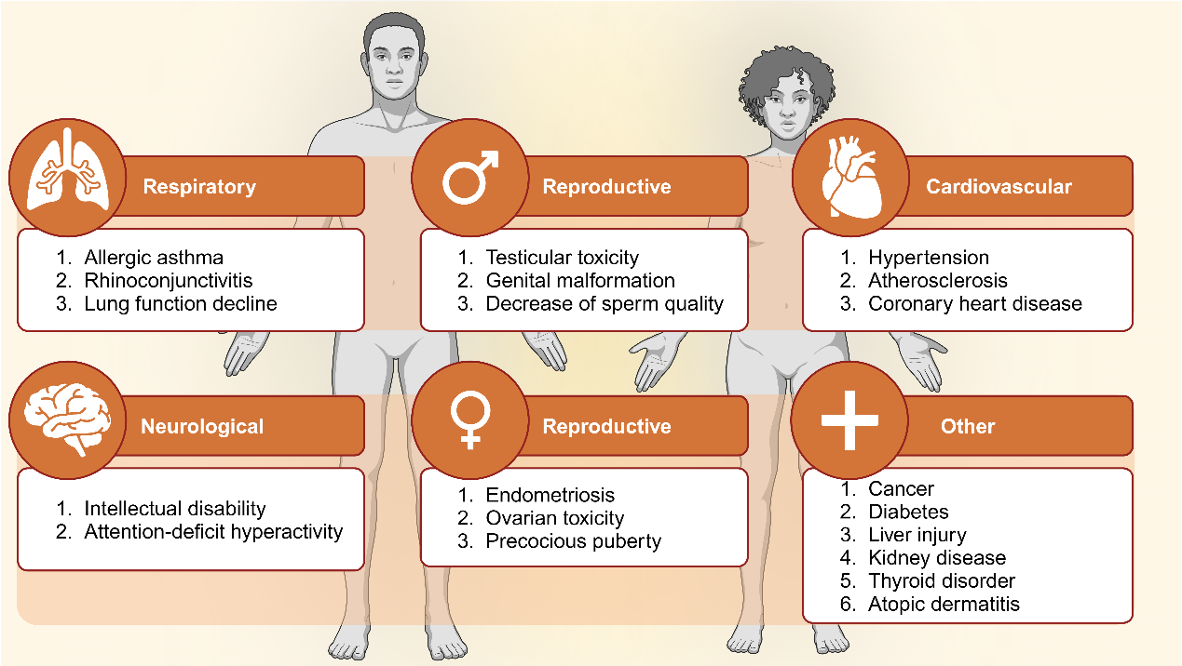
Figure 1. The effect of PAEs on human health. Different types of diseases and disorders have been assigned into six groups depending on the human systems involved. PAEs can cause adverse respiratory, neurological, reproductive (differences between male and female individuals), cardiovascular, and other effects.
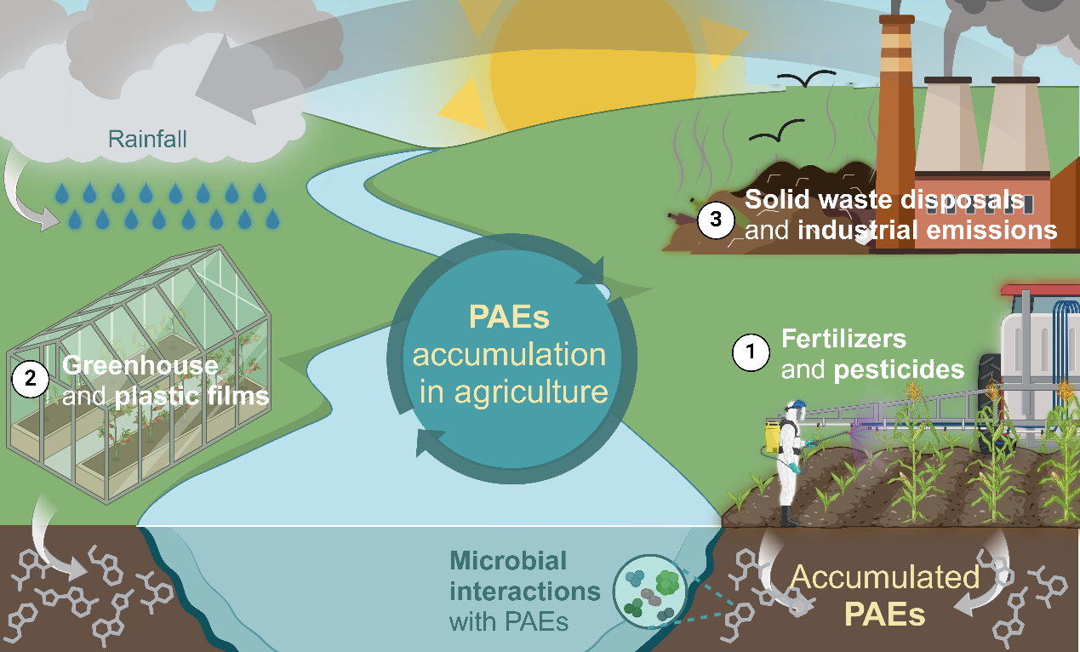
Figure 2. The fate of PAEs in agricultural systems. Three main ways of accumulating PAEs in soil are schematically visualized: 1) Fertilizers and pesticides, 2) plastic greenhouses and mulching films, and 3) solid waste disposal and industrial emissions are recognized as sources of these pollutants.
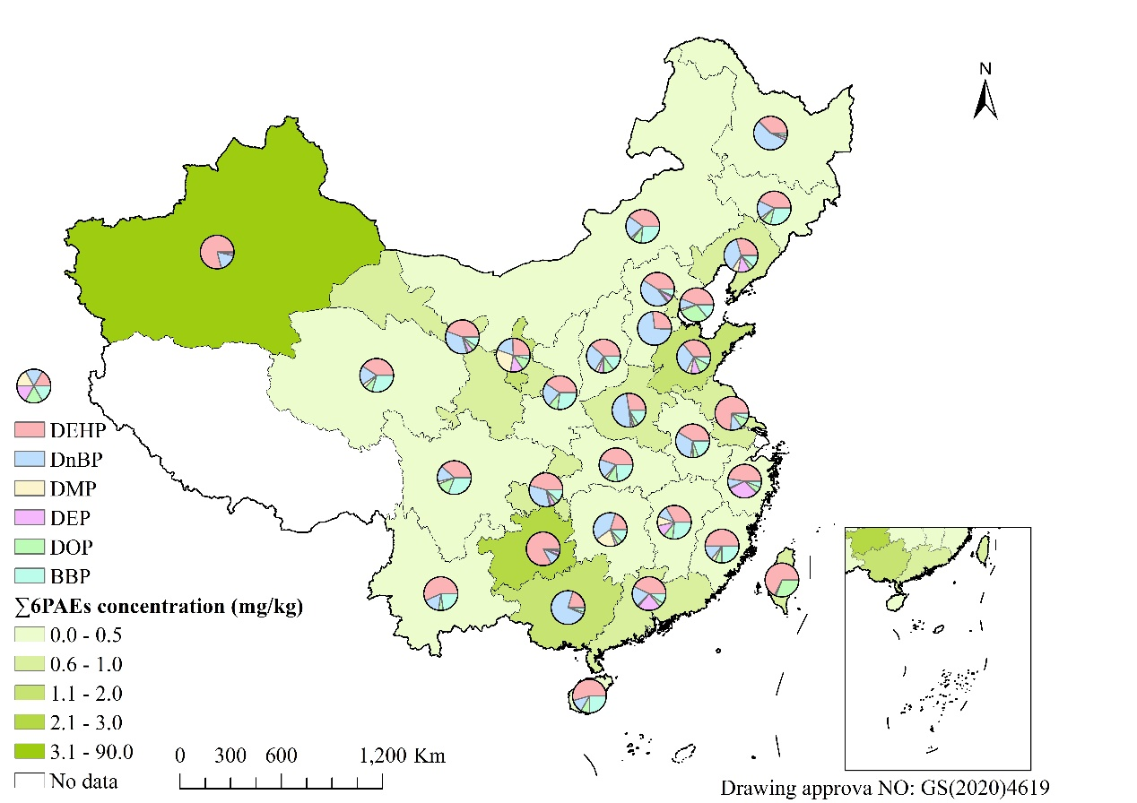
Figure 3. The pollution status of PAEs in China. Map depicting Chinese provinces that were polluted with six different PAEs (DEHP, DnBP, DMP, DEP, DOP, and BBP) over the years.
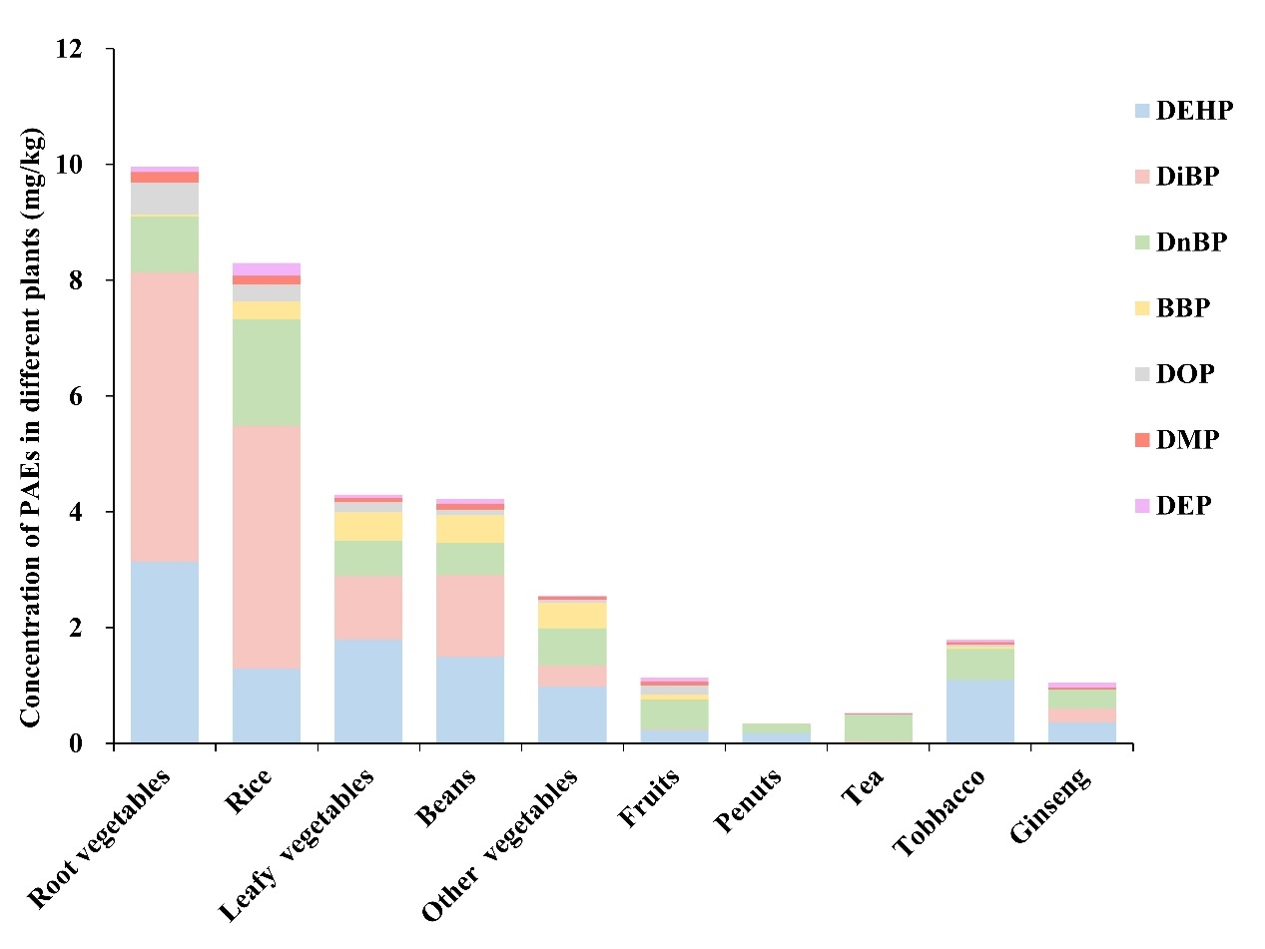
Figure 4. The concentrations of different PAE monomers in various agricultural plants. Ten crop types (root, leafy, and other vegetables as well as rice, beans, fruits, peanuts, tea, tobacco, and ginseng) were previously studied. For each of these, the concentration of seven different PAEs (DEHP, DiBP, DnBP, BBP, DOP, DMP, and DEP) monomers was noted.
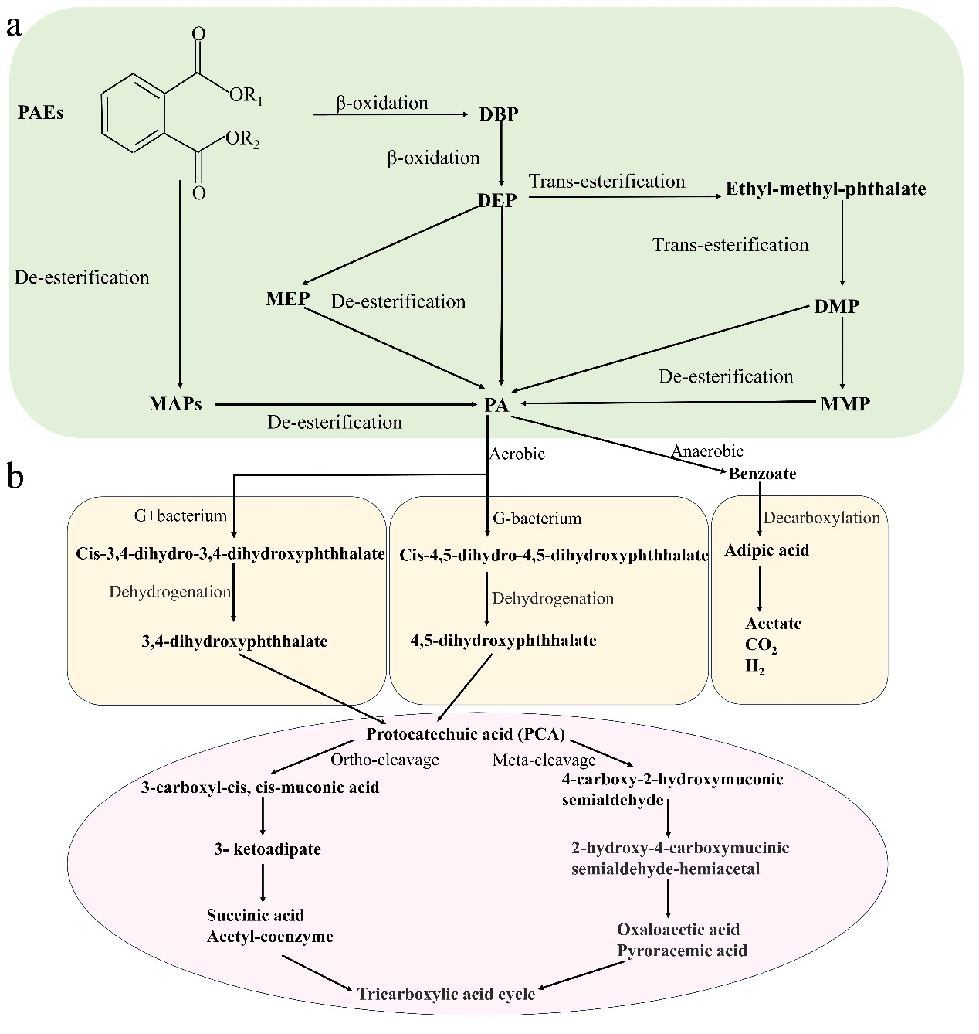
Figure 5. The microbiological degradation pathways of PAEs. a) Hydrolysis pathway of PAEs ester bond. b) Degradation pathway of PA. Abbreviation: PAEs, phthalic acid esters; DBP, dibutyl phthalate; DEP, diethyl phthalate; MEP, monoethyl phthalate; MAPs, monoester of phthalate; MMP, monomethyl phthalate; PA, phthalic acid.

Graphical abstract

¹ These authors contributed equally to this work. *Corresponding author at: Research Center for Eco-Environmental Sciences, Chinese Academy of Sciences, Beijing 100085, China. E-mail address: dcjin@rcees.ac.cn, jindecai19841019@163.com (D. Jin).

