Word Count: 7,689
Abstract word count: 250
Figures: 4
Tables: 2

Title: The aortic-femoral stiffness gradient and cardiovascular risk in older adults.

Running Title: Stiffness gradient and prognosis in older adults.

Keeron STONE^{1,2*}, Simon FRYER³, Barry J. McDONNELL^{1,2}, Michelle L MEYER⁴, James FAULKNER⁵, Mohsen AGHARAZII⁶ Catherine FORTIER⁶, Christopher JA PUGH^{1,2}, Craig PATERSON⁷, Gabriel ZIEFF⁸, Aiden J CHAUNTRY⁹, Anna KUCHARSKA-NEWTON¹⁰, Martin BAHLS^{11,12}, Lee STONER^{9,10}.
- Centre for Cardiovascular Research, Innovation And Development (CURIAD), Cardiff School of Sport and Health Sciences, Cardiff Metropolitan University, Cardiff, Wales, UK
- National Cardiovascular Research Network, Wales, UK
- School of Education & Science, University of Gloucestershire, Gloucester, UK
- Department of Emergency Medicine, School of Medicine, University of North Carolina at Chapel Hill, Chapel Hill, NC, USA
- Department of Sport, Exercise & Health, University of Winchester, Winchester, UK
- Endocrinology and Nephrology Axis, CHU de Québec Research Center, Faculty and Department of Medicine, Université Laval, Quebec City, Quebec, Canada
- Population Health Sciences, Bristol Medical School, University of Bristol, Bristol, UK
- School of Kinesiology, University of British Columbia, British Columbia, Canada
- Department of Exercise and Sport Science, University of North Carolina at Chapel Hill, Chapel Hill, NC, USA
- Department of Epidemiology, The Gillings School of Global Public Health, University of North Carolina at Chapel Hill, Chapel Hill, NC, USA
- Center for Health Promotion and Disease Prevention, University of North Carolina at Chapel Hill, Chapel Hill, NC, USA
- Department of Internal Medicine B, University Medicine Greifswald, Greifswald, Germany
- German Centre for Cardiovascular Research (DZHK), partner site Greifswald, Greifswald, Germany
*Corresponding Author: Keeron Stone. Cardiff School of Sport and Health Sciences, Cardiff Metropolitan University, Cardiff, Wales, UK. Tel: 02920417139. E: kstone@cardiffmet.ac.uk.

ABSTRACT
Background: The aortic-femoral arterial stiffness gradient (afSG), calculated as the ratio of lower limb pulse wave velocity (PWV) to central (aortic) PWV, is a promising tool for assessing cardiovascular disease (CVD) risk; but whether it predicts incident CVD is unknown. Methods: We examined the association of the afSG measures carotid-femoral stiffness gradient (cfSG, femoral-ankle PWV divided by carotid-femoral PWV) and the heart-femoral stiffness gradient (hfSG, femoral ankle PWV divided by heart-femoral PWV), as well as PWV, with incident CVD (coronary disease, stroke, and heart failure) and all-cause mortality among 3,109 participants of the Atherosclerosis Risk in Communities Study cohort (Age: 75±5 years; cfPWV:11.5±3.0 m/s), free of CVD. Cox regression was used to estimate hazard ratios (HR) and 95% confidence intervals (CI). Results: Over a median 7.4-year follow-up, there were 322 cases of incident CVD and 410 deaths. In fully adjusted models, only top quartiles of cfSG (quartile 4: HR 1.43,95%CI 1.03-1.97 and quartile 3: HR 1.49,95%CI 1.08-2.05) and hfSG (quartile 4: HR 1.77,95%CI 1.27-2.48 and quartile 3: HR 1.41,95%CI 1.00-2.00) were significantly associated with a greater risk of incident CVD. Only high aortic stiffness in combination with low lower-limb stiffness was significantly associated with incident CVD (HR 1.46, 95%CI 1.06-2.02) compared to the referent low aortic stiffness and high lower-limb stiffness. No PWVs were significantly associated with incident CVD. No exposures were associated with all-cause mortality. Conclusions: The afSG may enhance CVD risk assessment in older adults in whom the predictive capacity of traditional risk factors and PWV are attenuated.

KEY WORDS
Arterial stiffness; pulse wave velocity; pulse wave velocity ratio; cardiovascular disease; mortality; risk factors; epidemiology

NONSTANDARD ABBREVIATIONS

afSG aortic-femoral arterial stiffness gradient
ARIC Atherosclerosis Risk in Communities Study
BMI body mass index
cfPWV carotid-femoral pulse-wave velocity
cfSG carotid-femoral arterial stiffness gradient
faPWV femoral-ankle pulse-wave velocity
hfSG heart-femoral arterial stiffness gradient
hfPWV heart-femoral pulse-wave velocity
HDL high-density lipoprotein cholesterol

INTRODUCTION
Cardiovascular disease (CVD) risk stratification can be aided by the assessment of arterial stiffness (AS), a measure of biological vascular aging. The most widespread approach is the standalone estimation of aortic stiffness, typically measured as carotid-femoral pulse wave velocity (cfPWV).¹ A greater cfPWV value reflects an increase in aortic stiffness and heightened CVD risk. But this approach ignores the integrated role of medium-sized muscular conduit arteries in the regulation of pulsatile pressure and organ perfusion, and therefore any contribution to CVD risk. The transition from the elastic aorta to a relatively stiffer muscular artery, termed the “stiffness gradient”, combined with lumen narrowing, generates impedance mismatching.^{2,3} This arterial stiffness gradient (a peripheral to central ratio greater than 1 ) is physiologically advantageous as it attenuates the cyclical forward pressure wave into a smooth consistent blood flow, optimising ventriculo-arterial coupling and preventing transmission of highly pulsatile forces to the micro-circulation.^{3,4} A decrease or reversal of the central to peripheral arterial stiffness gradient may augment the transmission of pulsatile forces to the micro-circulation, which can damage target organs (e.g., brain and kidneys), whilst augmenting and hastening arterial wave reflection leading to increased cardiac workload and impaired coronary perfusion.⁴ Accordingly, estimation of the loss of stiffness gradient may confer additional unique prognostic information.⁵
The few studies to investigate its prognostic value have characterized the stiffness gradient as a ratio of carotid-radial PWV and cfPWV. This aortic-brachial stiffness gradient (abSG) was reported to be a better predictor of mortality than cfPWV in dialysis patients,^{6,7} but had no incremental predictive value over cfPWV for CVD events in community-dwelling adults free of overt disease.⁸ The prognostic value of abSG is likely moderated through the specification of the upper-limbs as the stiffness gradient numerator, considering the upper limbs represent a small portion of the arterial vasculature. The lower limbs make up a significant portion of the arterial vasculature and are major sites of wave reflection.⁹ Indeed, contrary to the aforementioned investigations using the abSG,⁸ our group reported that the aortic-femoral arterial stiffness gradient (afSG), a ratio of femoral-ankle PWV (faPWV) of the lower limbs and cfPWV, was negatively and independently associated with prevalent CVD in cross-sectional analysis of healthy older adults, whereas cfPWV was not.¹⁰ In terms of clinical utility, the afSG has also demonstrated excellent repeatability¹¹ and an independence of mean arterial pressure,¹² an inherent limitation of standalone PWV, including cfPWV. However, whether the afSG predicts incident CVD is not known.
The aim of this study was to determine whether the aortic-femoral arterial stiffness gradient was associated with incident cardiovascular outcomes and all-cause mortality in a large community-based cohort of older adults. The afSG was calculated using two approaches: (i) the cfSG, calculated as faPWV divided by cfPWV; and (ii) the heart-femoral arterial stiffness gradient (hfSG), calculated as faPWV divided by heart-femoral PWV (hfPWV).

METHODS
This observational study is reported in accordance with STROBE (STrengthening the Reporting of OBservational studies in Epidemiology) guidelines¹³. Atherosclerosis Risk in Communities (ARIC) participants provided written informed consent, and the study was approved by the Institutional Review Boards at all field centers, coordinating center, central labs and reading centers.

DATA AVAILABILITY STATEMENT
Data availability and detailed policies for requesting ARIC data can be found at https://www2. cscc.unc.edu/aric/pubs-policies-and-forms-pg. Per National Heart, Lung, and Blood Institute policy, all ARIC Study data can be also obtained from the NHLBI BioLINCC repository (https://biolincc.nhlbi.nih.gov/home/).

STUDY DESIGN
The ARIC Study is a population-based, longitudinal cohort of 15,792 men and women aged 45–64 years enrolled between 1987 and 1989 from 4 US communities (Forsyth County, North Carolina; Jackson, Mississippi; suburban Minneapolis, Minnesota; and Washington County, Maryland). Study details have been previously described¹⁴ . Participants were followed up with repeat clinic visits, annual (semi-annual since 2012) telephone interviews and active surveillance of hospitalizations. For this analysis, eligible participants were 6,538 ARIC cohort members who attended the fifth clinical examination (Visit 5, 2011-2013). The visit 5 study examination included interviewer-administered questionnaires to obtain demographic data, medical history and lifestyle information, blood and urine collection, and assessment of vascular risk factors and cardiovascular phenotypes, including PWV. Participants were followed-up from visit 5 until the end points of interest (i.e., cardiovascular event or death) or end of follow-up (administrative censoring on December 31, 2019).

STUDY POPULATIONS
Participants with missing PWV data were excluded from the study (n=1,611). We also excluded participants with the following conditions due to concerns for PWV data quality (n=406): BMI ≥ 40 kg/m², major arrhythmias (Minnesota codes 8-1-3, 8-3-1, and 8-3-2), Minnesota code 8-1-2 with evidence of biased PWV waveforms, aortic aneurysms, abdominal aorta ≥5 cm, history of aortic or peripheral revascularization or aortic graft, aortic stenosis, moderate or greater aortic regurgitation, or ankle-brachial index (ABI) ≥1.5, which indicates incompressible arteries. Additionally, we excluded participants whose self-reported race was other than white or African American due to small sample size (n=14) or those missing ABI or covariate data (n = 452). To examine incident CVD outcomes, we also excluded participants with prevalent coronary heart disease, heart failure, stroke, or peripheral arterial disease (adjudicated as an ABI <0.95) at baseline, which led to a final analytical sample of 3,104 participants (Figure S1 in the online-only Data Supplement). Participants were asked to not consume food or drink, and to refrain from tobacco and vigorous physical activity prior to the visit.

EXPERIMENTAL MEASURES

PULSE WAVE VELOCITY
After participants were supine for 10 minutes, technicians measured cfPWV, hfPWV, and faPWV following a standardized protocol, using the automated cardiovascular screening device VP-1000 Plus (Omron, Kyoto, Japan)¹⁵. A minimum of two measurements were taken per participant and the last two measurements were averaged. The validity and reliability of the VP-1000 Plus for measuring PWV have previously been described.¹⁵⁻¹⁷ The average of left and right faPWV measures was included for analysis. ABI was assessed alongside PWV using the same device. The detailed PWV experimental protocol is available in the online-only Data Supplement.

ARTERIAL STIFFNESS GRADIENT CALCUALTIONS
The cfSG and hfSG variables were calculated by dividing faPWV by cfPWV and hfPWV, respectively. This method emphasizes the model arterial system, whereby in a healthy cardiovascular system arterial stiffness increases between central and peripheral arteries¹⁸. In which case, although no clinical threshold has been identified, a gradient greater than 1.0 may be considered physiologically normal.⁸ When using afSG in this manuscript, we are referring to cfSG and hfSG measures.

OUTCOMES
The primary outcome was incidence of major CVD events, a composite end point that compromised heart failure, coronary heart disease, and stroke. Heart failure, coronary heart disease, and stroke were also examined independently. All cardiovascular outcomes (except coronary revascularization) were adjudicated by physician reviewers.¹⁹ Heart failure was classified as definite or probable acute decompensated heart failure based on hospitalization records.²⁰ Coronary heart disease was defined as definite or probable myocardial infarction, coronary heart disease death, or coronary revascularization procedure. Stroke was defined as definite or probable cases of ischemic or hemorrhagic strokes based hospitalization and death records. All-cause mortality was defined as death due to any cause and was determined through annual cohort follow-up, hospital surveillance, and linkage to the National Death Index. ¹⁹ Outcomes were assessed through December 31, 2019.

COVARIATE MEASUREMENTS
All covariate measures were collected as part of ARIC visit 5 except for attained education level, which was collected at visit 1. The detailed study protocol for covariate measurements is available in the online-only the Data Supplement. Covariates which were a-priori selected included age, sex, race-centre, history of smoking, education level, body mass index (BMI), mean arterial pressure, total cholesterol,²¹ high-density lipoprotein (HDL) cholesterol,^{22,23} triglycerides, fasting glucose, anti-hypertensive medication use, and history of diabetes mellitus.

STATISTICAL ANALYSIS
Statistical analyses were performed using R Statistical Software (R Foundation for Statistical Computing, Vienna, Austria). A 2-sided value of P<0.05 was considered statistically significant. Baseline characteristics were summarized as a population whole and by quartiles of cfSG and hfSG. Due to the different direction of association of the exposures with outcome and for ease of interpretation, data is presented whereby quartile 4 represents worse vascular health, i.e., high PWV or low afSG. Continuous variables are presented as means ± standard deviation (SD) and discrete variables are presented as frequencies and percentages. PWV variables were winsorised at the 1st and 99th percentiles prior to stiffness gradient calculations. To allow for potential non-linear associations,²⁴ PWV and derived cfSG and hfSG measures were categorized into quartiles. Given the J-shaped association between exposures and outcomes, and the lack of steep monotonic associations, the second lowest (quartile 2) served as the reference category in all analyses. The associations between cfSG, hfSG, and PWV measures and the cumulative incidence of the outcomes were illustrated using Kaplan-Meier curves, with survival distributions compared using the log-rank statistic. Cox proportional hazards models were used to estimate associations between exposures cfSG, hfSG and PWV with cardiovascular events and all-cause mortality after adjusting for multiple potential confounders based on their known associations with arterial stiffness, cardiovascular disease, and mortality. Model 1 was unadjusted. Model 2 adjusted for age, sex, and race-field centre. Model 3 adjusted for model 2 variables plus education level, current smoking status, mean arterial pressure, heart rate, history of diabetes mellitus, body mass index, hypertension medication, total cholesterol, and high-density lipoprotein cholesterol. Proportional hazards assumptions were assessed by examining Schoenfeld residuals; no violations were observed.
We conducted several sensitivity analyses. To identify whether any potential association between the afSG and CVD outcomes is driven by the numerator (faPWV) versus the denominator (cfPWV or hfPWV) of the ratio, we examined incidence of CVD events in groups cross-classified by high versus low cfPWV or hfPWV and faPWV, with 5-year age- and sex-specific cutoffs (median), with low cfPWV/hfPWV and high faPWV as referent. In analysis for CVD events as the outcome, we used Fine and Gray's sub-distribution hazard models ²⁵ to consider non-cardiovascular deaths as competing events. The results were consistent with Cox models, so Cox models are presented. Due to unavailable 2018 and 2019 medical records from the Jackson site, administrative censoring was set to 31 December 2017 for this subset of participants. Fine and Gray models considering this loss to follow-up as a competing event and Cox models excluding Jackson participants entirely were consistent with the Cox models presented. Finally, subgroup analysis was performed to examine associations of cfSG and hfSG with cardiovascular events were modified by sex or race, with statistical significance for interactions being tested using likelihood ratio tests.

RESULTS
Descriptive characteristics of the overall study sample and by cfSG quartiles are reported in Table 1. Descriptive characteristics by hfSG (Table S1) quartiles are presented in the online only supplements. Overall, the mean age of participants was 75 ± 5 years, 64% were female, 79% were white, 25% had a history of diabetes and 59% were taking antihypertensive medication.

CARDIOVASCULAR EVENTS
The median follow-up time was 7.4 years (interquartile interval, 6.2;7.9 years; maximum 8.6 years). There were 322 incident cardiovascular events comprising 121 coronary heart disease, 144 heart failure and 105 stroke events, with an incidence rate of 15.7 per 1000 person-years. The cumulative incidence of CVD differed by quartiles for cfPWV, hfPWV, cfSG, and hfSG, but not for faPWV (Figure 1). CVD incidence was similar for quartiles 1 and 2 of all PWV and afSG exposures, exhibiting J-shaped associations with cardiovascular events. Although a higher cfPWV and higher hfPWV (both Q4 vs. Q2 only) were significantly associated with a higher risk of cardiovascular events in crude models (Table S2), these associations were not statistically significant in fully adjusted multivariable Cox models (Figure 2). In contrast, low cfSG and low hfSG were both significantly associated with the risk of cardiovascular events in fully adjusted multivariable models (Figure 3). Specifically, for cfSG, the hazard ratio was 1.49 (95% CI: 1.08-2.05) for Q3 range: 0.99 to 0.82) and 1.43 (95% CI: 1.03-1.97) for Q4 (range: <0.82), compared with Q2 (range: 1.18 to 1.00). For hfSG, the hazard ratio was 1.41 (95% CI: 1.00-2.00) for Q3 (range: 0.97 to 0.83) and 1.77 (95% CI: 1.27-2.48) for Q4 (range: <0.83) compared with Q2 (range: 1.13 to 0.97). There were no significant associations for faPWV (Table S2 and Figure 3). Individual cardiovascular event outcome data are in the online-only Data Supplements (Tables S3, S4 and S5).

ALL-CAUSE MORTALITY
There were 418 deaths, with an incidence rate of 20.4 deaths per 1000 person-years. As for cardiovascular events, cumulative incidence of all-cause mortality differed by quartiles for cfPWV, hfPWV, cfSG, and hfSG, but not for faPWV (Figure 3). Although high cfPWV and high hfPWV (both Q4 and Q3 vs. Q2, all P < 0.05, Table S6) were significantly associated with all-cause mortality in crude models, in fully adjusted Cox models these associations were attenuated and none of the PWV nor afSG variables were significantly associated with all-cause mortality (Figure 4).

SENSITIVITY ANALYSIS
Table 2 presents the risk of cardiovascular events in groups cross-classified by high versus low cfPWV or hfPWV and faPWV. In fully adjusted Cox models, compared with high faPWV and low cfPWV, only low faPWV and high cfPWV demonstrated a significantly higher risk of CVD events with a hazard ratio of 1.46 (95% CI: 1.06-2.02). Cross classification by cfPWV had no effect on the risk of cardiovascular events, with a hazard ratio of 1.01 (95% CI: 0.72-1.42) for high faPWV and high cfPWV compared to high faPWV and low cfPWV. These associations were consistent for hfSG.
Table S7 presents stratified analysis for associations between afSG measures and cardiovascular events by subgroups of sex and race. The J-shaped associations between cfSG and CVD events was more prominent in males than females, but more prominent in females than males for hfSG. There were no statistically significant interactions between cfSG nor hfSG and sex. Associations between a low (Q3 and Q4) afSG (both cfSG and hfSG) and cardiovascular events were more prominent in African American participants than white participants, but there were no statistically significant interactions between cfSG or hfSG and race. Finally, inverting the afSG measures by using cfPWV and hfPWV as the numerator did not impact the associations of the arterial stiffness gradient measures with incident CVD (Table S8).

DISCUSSION
A low afSG was independently and inversely associated with the risk of major incident CVD events in a large cohort of community-dwelling older adults. Standalone PWV measures were not independently associated with incident CVD events in older adults. None of the afSG or PWV measures were significantly associated with all-cause mortality.

COMPARISON TO THE LITERATURE
Few studies have examined whether the stiffness gradient predicts CVD outcomes, all of which focused on abSG.⁶⁻⁸ Niiranen et al⁸ assessed the association of the abSG and major incident CVD events in community-dwelling adults, reporting analogous HRs for cfPWV and abSG. They concluded that the prognostic value of abSG was solely attributable to cfPWV,⁸ considering that carotid-radial PWV was not independently associated with CVD events. These findings contrast those of the current study. We found that cfSG and hfSG, but not cfPWV, hfPWV, or faPWV, were significantly associated with incident CVD events. The discrepancy between findings may be at least partially explained by two factors: survivor bias and the stiffness gradient measurement approach.
Compared to Niiranen et al⁸ the community-dwelling adults in our study were much older (75 vs. 60 yrs.), with a concomitant higher prevalence of co-morbidities, including diabetes (25% vs. 8%). cfPWV does not consistently predict incident CVD events in older adults.^{24,26} One potential explanation for this is survivor bias.^{1,26} Individuals with stiff aortae who are susceptible to dying of CVD at a younger age may be underrepresented in cohort studies, or elderly survivors being less vulnerable to the consequences of aortic stiffening alone. Of note, Niiranen et al⁸ did complete a sub-group analysis of adults aged ≥70 years (n=427). In this subgroup the HR for CVD events was marginally higher for abSG (1.54, 95% CI:1.16-2.04) versus cfPWV (1.39, 95% CI:1.06-1.82).
Contrasting approaches in characterising the stiffness gradient may also have caused the variable findings. Neither crPWV in the study by Niiranen et al⁸ nor faPWV in our study was independently associated with CVD events, highlighting their inconsistent prognostic value.^{27,28} Paradoxically, there was a (not significant) trend for low faPWV to heighten CVD risk; a finding consistent with previous observations.²⁹ Peripheral artery stiffness has been shown to decrease with age, particularly after the 6th decade,³⁰ or with the presence of obesity, diabetes, heart failure, and renal disease.³¹⁻³⁴ This phenomena appears more pronounced in lower versus upper limbs.³⁰ The mechanisms are not well understood but may include compensatory adaptation or outward remodelling of peripheral muscular arteries due to the haemodynamic insult (~high pulsatility) of accepting an incoming bolus of blood from stiff aortae with reduced Windkessel function,^{7,32} vasodilation of the peripheral vasculature due to antihypertensive medication use,³⁵ or simply the presence of lower-limb atherosclerotic stenosis suppressing pulse wave propagation;³⁶ the latter unlikely here given our exclusion for PAD. Regardless, lower peripheral artery stiffness is expected to shift pressure wave reflection sites distally, attenuate wave reflection and augment transmission of high pulsatile forces to the microcirculation;^{4,5,7} potentially worsening the insult of aortic stiffening. As the lower limbs are major sites of wave reflection,⁹ a stiffness gradient comprising faPWV rather than crPWV may theoretically be a more sensitive marker of CVD risk. In support, unlike crPWV in the study of Niiranen et al,⁸ our cross-classification analysis demonstrated that faPWV does contribute to the afSGs prognostic value in older adults as only low faPWV and high cfPWV/hfPWV in combination significantly increased the risk of CVD events.
Identification of the causal pathways for the association of afSG measures with incident CVD events is beyond the scope of this epidemiological study. However, loss of the central to peripheral arterial stiffness gradient is principally expected to augment the transmission of pulsatile forces to the micro-circulation due to the reduced attenuation of the forward travelling wave, whilst also augmenting and hastening arterial wave reflection.^{4,5,7} In addition to pressure dynamics, there may also be disruption to blood flow dynamics in the aorta and its branches.³⁷⁻³⁹ For example, lack of an elastic-to-muscular artery stiffness gradient may decrease the expected femoral reverse and diastolic blood flows, and affect diastolic runoff.³⁷ These alterations in both global and regional pressure and flow patterns may lead to the deregulation of organ perfusion, dysfunction and target organ damage.
In the only other study to investigate the prognostic significance of the stiffness gradient, Fortier et al⁷ assessed the association of the abSG and mortality in 310 dialysis patients. As in this study, cfPWV and the abSG predicted mortality in univariable analysis; but only the abSG remained statistically significant after adjustment for cardiovascular risk factors.⁷ No PWV nor stiffness gradient measures were significantly associated with all-cause mortality in our fully adjusted models. The discrepancy between our findings is likely to due to contrasting population samples. Fortier et al⁷ included only chronic dialysis patients, a cohort with a high level of comorbidities, prevalent CVD including CHD, PAD, and stroke, as well as complex pharmacological treatment approaches. Furthermore, these patients undergo significant remodelling, including a pronounced regression of peripheral arterial stiffness,³² which likely augments loss of the central to peripheral stiffness gradient and further heightens mortality risk. Acutely, fluid retention and hemodialysis can also have a confuscating impact on arterial stiffness.^{40,41}

LIMITATIONS AND STRENGTHS
The limitations and strengths of this study need to be addressed to best contextualize the findings. The predominant inclusion of participants who had survived from baseline (1987-1989) and attended the Visit 5 examination (2011-2013) and were thus likely healthier compared to those who did not participate in the visit, may have generated a bias within the study population⁴². However, the principal aim of the study was to examine the utility of the afSG in the prediction of cardiovascular events among older adults. Given that arterial stiffness and covariate measures were derived from visit 5 only, there is potential for residual confounding by duration of long-term risk factors (e.g., high blood pressure). The device used to determine PWV, the Omron VP-1000 Plus, comprises tonometric (carotid, femoral) and oscillometric (ankle) technologies to assess pulse waves which may limit comparison with applanation or oscillometric only systems, and therefore generalisability of the present findings. However, the Omron VP-1000 Plus demonstrates excellent accuracy and reliability¹⁵ and hybrid systems demonstrate good agreement with tonometry only systems⁴³⁻⁴⁵. The use of height-based formulas to calculate faPWV, rather than the direct measured approach used to determine cfPWV, was validated in a Japanese population and may not be applicable to other racial or ethnic groups, although there is no evidence to indicate their utility may differ between countries and ethnicities. Height-based arterial path length estimation correlates highly with MRI-based path length,⁴⁶ and anchoring arterial path length in a given patient may strengthen clinical application by reducing measurement error. We acknowledged these limitations when designing our approach, but it is also important to recognise that few longitudinal cohort studies are as well characterised as ARIC and fewer still have measured arterial stiffness in the lower limbs. Indeed, a major strength is that this is the first study to examine the association of afSG measures with incident CVD events and does so in a relatively large number of community-dwelling older adults, on whom detailed hemodynamic phenotyping and sufficient extended follow-up to assess clinically relevant outcomes were available.

PERSPECTIVES
It is well established that cfPWV generally confers prognostic value beyond traditional risk factors, however its utility for CVD risk prediction is attenuated and may have limited importance in later life.^{1,47,48} This study extends the literature by demonstrating that the afSG provides cardiovascular risk information beyond traditional risk factors and may replenish the diminished utility of cfPWV when predicting incident CVD in older adults; ensuring that the prognostic value of PWV is maintained across the life course. The added prognostic value likely arises because the afSG considers the integrated nature of the arterial system, specifically the role of medium-sized muscular conduit arteries in the regulation of pulsatile pressure and organ perfusion, and hence, their contribution to CVD risk. These findings therefore support the notion that integrated or composite markers of vascular structure and/or function may best define and assess biological vascular aging for the determination of CVD risk.^{49,50} We measured the afSG using two approaches, cfSG and hfSG. These measures were similarly associated with incident CVD events. But the hfSG approach confers several advantages over cfSG that enhance its clinical viability,⁵¹ including ease of use (e.g., can be automated) and a lower likelihood of confounding. cfSG requires applanation of the carotid artery which can be technically challenging in certain populations, including with obesity and advanced carotid artery atherosclerosis.^{52,53}
Measures of PWV have recently been incorporated within the 2023 European Society of Hypertension (ESH) guidelines where they are recommended as a screening tool for hypertension mediated organ damage (HMOD).⁵⁴ HMOD is associated with a two-fold to three-fold increase in the risk of CVD,⁵⁵ and therefore its presence may influence any decision to initiate or intensify drug treatment. The findings of the present study, in which ~60% of the cohort had hypertension, suggest that the afSG may be a more robust marker of HMOD in older adults than standalone PWV, and therefore be useful in the risk stratification of older patients with hypertension. However, further research is warranted to extend our findings to different populations and to determine incremental value (beyond standard risk markers) and clinical utility (move patients from one risk category to another). Finally, clinical decision-making and work-flow integration need to be considered if afSG, and PWV, are to advance clinical practice implementation⁵⁶.

CONCLUSIONS
The aim of this study was to examine whether the aortic-femoral arterial stiffness gradient, expressed as cfSG and hfSG, was associated with incident cardiovascular outcomes and all-cause mortality in community-based older adults. Both cfSG and hfSG were associated with incident cardiovascular outcomes, whereas central- (cfPWV and hfPWV) and lower-extremity-PWV (faPWV) were not. Further research is now warranted to investigate the prognostic value of the arterial stiffness gradient in middle-aged and younger adults, and to test whether this measure can aid in early risk prediction, risk stratification, and inform clinical decision-making.

SOURCES OF FUNDING AND ACKNOWLEDGEMENTS
The authors thank the staff and participants of the ARIC study for their important contributions. The Atherosclerosis Risk in Communities (ARIC) study has been funded in whole or in part with Federal funds from the National Heart, Lung, and Blood Institute (NHLBI), National Institutes of Health (NIH), Department of Health and Human Services, under Contract nos. (75N92022D00001, 75N92022D00002, 75N92022D00003, 75N92022D00004, 75N92022D00005). Funding was also supported by 5RC2HL102419 and R01NS087541. Dr. Michelle Meyer was supported by R01AG053938 and R01AG061088. Dr. Keeron Stone is supported by the Health and Care Research Wales funded National Cardiovascular Research Network, Wales.

DISCLOSURES

There are no conflicts of interest to declare.

SUPPLEMENTAL MATERIAL

Expanded Materials & Methods, Tables S1-S8, Figure S1, References.

REFERENCES
1. Ben-Shlomo Y, Spears M, Boustred C, May M, Anderson SG, Benjamin EJ, Boutouyrie P, Cameron J, Chen CH, Cruickshank JK, et al. Aortic pulse wave velocity improves cardiovascular event prediction: an individual participant meta-analysis of prospective observational data from 17,635 subjects. Journal of the American College of Cardiology. 2014;63:636-646. doi: 10.1016/J.JACC.2013.09.063
2. Avolio AP, Chen SG, Wang RP, Zhang CL, Li MF, O'Rourke MF. Effects of aging on changing arterial compliance and left ventricular load in a northern Chinese urban community. Circulation. 1983;68:50-58. doi: 10.1161/01.CIR.68.1.50
3. London GM, Pannier B. Arterial functions: how to interpret the complex physiology. Nephrology, dialysis, transplantation : official publication of the European Dialysis and Transplant Association - European Renal Association. 2010;25:3815-3823. doi: 10.1093/NDT/GFQ614
4. Briet M, Boutouyrie P, Laurent S, London GM. Arterial stiffness and pulse pressure in CKD and ESRD. Kidney Int. 2012;82:388-400. doi: 10.1038/ki.2012.131
5. Fortier C, Agharazii M. Arterial Stiffness Gradient. Pulse (Basel, Switzerland). 2016;3:159-166. doi: 10.1159/000438852
6. Bao W, Wang F, Tang W. Aortic-Brachial Stiffness Mismatch and Mortality in Peritoneal Dialysis Patients. Kidney Blood Press Res. 2019;44:123-132. doi: 10.1159/000498876
7. Fortier C, Mac-Way F, Desmeules S, Marquis K, De Serres SA, Lebel M, Boutouyrie P, Agharazii M. Aortic-brachial stiffness mismatch and mortality in dialysis population. Hypertension. 2015;65:378-384. doi: 10.1161/HYPERTENSIONAHA.114.04587
8. Niiranen TJ, Kalesan B, Larson MG, Hamburg NM, Benjamin EJ, Mitchell GF, Vasan RS. Aortic-Brachial Arterial Stiffness Gradient and Cardiovascular Risk in the Community: The Framingham Heart Study. Hypertension. 2017;69:1022-1028. doi: 10.1161/HYPERTENSIONAHA.116.08917
9. Nichols WW, Nichols WW, McDonald DA. McDonald's blood flow in arteries : theoretic, experimental, and clinical principles. 6th ed. London: Hodder Arnold; 2011.
10. Stone K, Fryer S, Meyer ML, Kucharska-Newton A, Faulkner J, Zieff G, Paterson C, Credeur D, Matsushita K, Hughes TM, et al. The aortic-femoral arterial stiffness gradient: an atherosclerosis risk in communities (ARIC) study. J Hypertens. 2021;39:1370-1377. doi: 00004872-202107000-00019 [pii]
10.1097/HJH.0000000000002808
11. Stone K, Fryer S, Faulkner J, Meyer ML, Heffernan K, Zieff G, Paterson C, Lambrick D, Stoner L. The aortic-femoral arterial stiffness gradient demonstrates good between-day reliability. Hypertens Res. 2021. doi: 10.1038/s41440-021-00712-3
12. Stone K, Fryer S, Faulkner J, Meyer ML, Heffernan K, Kucharska-Newton A, Zieff G, Paterson C, Matsushita K, Hughes TM, et al. The aortic-femoral arterial stiffness gradient is blood pressure independent in older adults: the atherosclerosis risk in communities (ARIC) study. J Hypertens. 2021;39:2361-2369. doi: 00004872-202112000-00004 [pii]
10.1097/HJH.0000000000002937
13. von Elm E, Altman DG, Egger M, Pocock SJ, Gotzsche PC, Vandenbroucke JP, Initiative S. Strengthening the Reporting of Observational Studies in Epidemiology (STROBE) statement: guidelines for reporting observational studies. BMJ. 2007;335:806-808. doi: 10.1136/bmj.39335.541782.AD
14. Wright JD, Folsom AR, Coresh J, Sharrett AR, Couper D, Wagenknecht LE, Mosley TH, Jr., Ballantyne CM, Boerwinkle EA, Rosamond WD, et al. The ARIC (Atherosclerosis Risk In Communities) Study: JACC Focus Seminar 3/8. J Am Coll Cardiol. 2021;77:2939-2959. doi: 10.1016/j.jacc.2021.04.035
15. Cortez-Cooper MY, Supak JA, Tanaka H. A new device for automatic measurements of arterial stiffness and ankle-brachial index. Am J Cardiol. 2003;91:1519-1522, A1519. doi: 10.1016/s0002-9149(03)00416-8
16. Meyer ML, Tanaka H, Palta P, Patel MD, Camplain R, Couper D, Cheng S, Al Qunaibet A, Poon AK, Heiss G. Repeatability of Central and Peripheral Pulse Wave Velocity Measures: The Atherosclerosis Risk in Communities (ARIC) Study. Am J Hypertens. 2016;29:470-475. doi: 10.1093/ajh/hpv127
17. Tanaka H, Munakata M, Kawano Y, Ohishi M, Shoji T, Sugawara J, Tomiyama H, Yamashina A, Yasuda H, Sawayama T, et al. Comparison between carotid-femoral and brachial-ankle pulse wave velocity as measures of arterial stiffness. Journal of hypertension. 2009;27:2022-2027. doi: 10.1097/HJH.0B013E32832E94E7
18. London GM, Pannier B. Arterial functions: how to interpret the complex physiology. Nephrol Dial Transplant. 2010;25:3815-3823. doi: 10.1093/ndt/gfq614
19. The Atherosclerosis Risk in Communities (ARIC) Study: design and objectives. The ARIC investigators. Am J Epidemiol. 1989;129:687-702.
20. Rosamond WD, Chang PP, Baggett C, Johnson A, Bertoni AG, Shahar E, Deswal A, Heiss G, Chambless LE. Classification of heart failure in the atherosclerosis risk in communities (ARIC) study: a comparison of diagnostic criteria. Circ Heart Fail. 2012;5:152-159. doi: 10.1161/CIRCHEARTFAILURE.111.963199
21. Siedel J, Hagele EO, Ziegenhorn J, Wahlefeld AW. Reagent for the enzymatic determination of serum total cholesterol with improved lipolytic efficiency. Clin Chem. 1983;29:1075-1080.
22. Friedewald WT, Levy RI, Fredrickson DS. Estimation of the concentration of low-density lipoprotein cholesterol in plasma, without use of the preparative ultracentrifuge. Clin Chem. 1972;18:499-502.
23. Warnick GR, Mayfield C, Benderson J, Chen JS, Albers JJ. HDL cholesterol quantitation by phosphotungstate-Mg2+ and by dextran sulfate-Mn2+-polyethylene glycol precipitation, both with enzymic cholesterol assay compared with the lipid research method. Am J Clin Pathol. 1982;78:718-723. doi: 10.1093/ajcp/78.5.718
24. Kim ED, Ballew SH, Tanaka H, Heiss G, Coresh J, Matsushita K. Short-Term Prognostic Impact of Arterial Stiffness in Older Adults Without Prevalent Cardiovascular Disease. Hypertension. 2019;74:1373-1382. doi: 10.1161/HYPERTENSIONAHA.119.13496
25. Austin PC, Lee DS, Fine JP. Introduction to the Analysis of Survival Data in the Presence of Competing Risks. Circulation. 2016;133:601-609. doi: CIRCULATIONAHA.115.017719 [pii]
10.1161/CIRCULATIONAHA.115.017719
26. Cardoso CR, Ferreira MT, Leite NC, Salles GF. Prognostic impact of aortic stiffness in high-risk type 2 diabetic patients: the Rio deJaneiro Type 2 Diabetes Cohort Study. Diabetes care. 2013;36:3772-3778. doi: 10.2337/dc13-0506
27. van Sloten TT, Schram MT, van den Hurk K, Dekker JM, Nijpels G, Henry RM, Stehouwer CD. Local stiffness of the carotid and femoral artery is associated with incident cardiovascular events and all-cause mortality: the Hoorn study. J Am Coll Cardiol. 2014;63:1739-1747. doi: 10.1016/j.jacc.2013.12.041
28. Mitchell GF, Hwang SJ, Vasan RS, Larson MG, Pencina MJ, Hamburg NM, Vita JA, Levy D, Benjamin EJ. Arterial stiffness and cardiovascular events: the Framingham Heart Study. Circulation. 2010;121:505-511. doi: CIRCULATIONAHA.109.886655 [pii]
10.1161/CIRCULATIONAHA.109.886655
29. Stone K, Fryer S, Faulkner J, Meyer ML, Heffernan K, Kucharska-Newton A, Zieff G, Paterson C, Matsushita K, Hughes TM, et al. Associations of lower-limb atherosclerosis and arteriosclerosis with cardiovascular risk factors and disease in older adults: The Atherosclerosis Risk in Communities (ARIC) study. Atherosclerosis. 2022;340:53-60. doi: S0021-9150(21)01412-X [pii]
10.1016/j.atherosclerosis.2021.10.014
30. Zhang Y, Agnoletti D, Protogerou AD, Topouchian J, Wang JG, Xu Y, Blacher J, Safar ME. Characteristics of pulse wave velocity in elastic and muscular arteries: a mismatch beyond age. J Hypertens. 2013;31:554-559; discussion 559. doi: 10.1097/HJH.0b013e32835d4aec
31. Loehr LR, Meyer ML, Poon AK, Selvin E, Palta P, Tanaka H, Pankow JS, Wright JD, Griswold ME, Wagenknecht LE, et al. Prediabetes and Diabetes Are Associated With Arterial Stiffness in Older Adults: The ARIC Study. Am J Hypertens. 2016;29:1038-1045. doi: 10.1093/ajh/hpw036
32. Utescu MS, Couture V, Mac-Way F, De Serres SA, Marquis K, Lariviere R, Desmeules S, Lebel M, Boutouyrie P, Agharazii M. Determinants of progression of aortic stiffness in hemodialysis patients: a prospective longitudinal study. Hypertension. 2013;62:154-160. doi: 10.1161/HYPERTENSIONAHA.113.01200
33. Mitchell GF, Tardif JC, Arnold JM, Marchiori G, O'Brien TX, Dunlap ME, Pfeffer MA. Pulsatile hemodynamics in congestive heart failure. Hypertension. 2001;38:1433-1439. doi: 10.1161/hy1201.098298
34. Agbaje AO, Barker AR, Tuomainen TP. Cardiorespiratory Fitness, Fat Mass, and Cardiometabolic Health with Endothelial Function, Arterial Elasticity, and Stiffness. Med Sci Sports Exerc. 2022;54:141-152. doi: 10.1249/MSS.0000000000002757
35. Fortier C, Garneau CA, Pare M, Obeid H, Cote N, Duval K, Goupil R, Agharazii M. Modulation of Arterial Stiffness Gradient by Acute Administration of Nitroglycerin. Front Physiol. 2021;12:774056. doi: 10.3389/fphys.2021.774056
36. Yokoyama H, Shoji T, Kimoto E, Shinohara K, Tanaka S, Koyama H, Emoto M, Nishizawa Y. Pulse wave velocity in lower-limb arteries among diabetic patients with peripheral arterial disease. J Atheroscler Thromb. 2003;10:253-258. doi: 10.5551/jat.10.253
37. Hashimoto J, Ito S. Pulse pressure amplification, arterial stiffness, and peripheral wave reflection determine pulsatile flow waveform of the femoral artery. Hypertension. 2010;56:926-933. doi: 10.1161/HYPERTENSIONAHA.110.159368
38. Hashimoto J, Ito S. Aortic stiffness determines diastolic blood flow reversal in the descending thoracic aorta: potential implication for retrograde embolic stroke in hypertension. Hypertension. 2013;62:542-549. doi: 10.1161/HYPERTENSIONAHA.113.01318
39. Hashimoto J, Ito S. Aortic Blood Flow Reversal Determines Renal Function: Potential Explanation for Renal Dysfunction Caused by Aortic Stiffening in Hypertension. Hypertension. 2015;66:61-67. doi: 10.1161/HYPERTENSIONAHA.115.05236
40. Ogunc H, Akdam H, Alp A, Gencer F, Akar H, Yenicerioglu Y. The effects of single hemodialysis session on arterial stiffness in hemodialysis patients. Hemodial Int. 2015;19:463-471. doi: 10.1111/hdi.12277
41. Kocyigit I, Sipahioglu MH, Orscelik O, Unal A, Celik A, Abbas SR, Zhu F, Tokgoz B, Dogan A, Oymak O, et al. The association between arterial stiffness and fluid status in peritoneal dialysis patients. Perit Dial Int. 2014;34:781-790. doi: 10.3747/pdi.2013.00057
42. Zheng Z, Rebholz CM, Matsushita K, Hoffman-Bolton J, Blaha MJ, Selvin E, Wruck L, Sharrett AR, Coresh J. Survival advantage of cohort participation attenuates over time: results from three long-standing community-based studies. Ann Epidemiol. 2020;45:40-46 e44. doi: 10.1016/j.annepidem.2020.03.010
43. Stabouli S, Printza N, Zervas C, Dotis J, Chrysaidou K, Maliahova O, Antza C, Papachristou F, Kotsis V. Comparison of the SphygmoCor XCEL device with applanation tonometry for pulse wave velocity and central blood pressure assessment in youth. J Hypertens. 2019;37:30-36. doi: 10.1097/HJH.0000000000001819
44. Butlin M, Qasem A, Battista F, Bozec E, McEniery CM, Millet-Amaury E, Pucci G, Wilkinson IB, Schillaci G, Boutouyrie P, et al. Carotid-femoral pulse wave velocity assessment using novel cuff-based techniques: comparison with tonometric measurement. J Hypertens. 2013;31:2237-2243; discussion 2243. doi: 10.1097/HJH.0b013e328363c789
45. Kracht D, Shroff R, Baig S, Doyon A, Jacobi C, Zeller R, Querfeld U, Schaefer F, Wuhl E, Schmidt BM, et al. Validating a new oscillometric device for aortic pulse wave velocity measurements in children and adolescents. Am J Hypertens. 2011;24:1294-1299. doi: 10.1038/ajh.2011.147
46. Sugawara J, Hayashi K, Tanaka H. Arterial path length estimation on brachial-ankle pulse wave velocity: validity of height-based formulas. Journal of hypertension. 2014;32:881-889. doi: 10.1097/HJH.0000000000000114
47. Beer C, Alfonso H, Flicker L, Norman PE, Hankey GJ, Almeida OP. Traditional risk factors for incident cardiovascular events have limited importance in later life compared with the health in men study cardiovascular risk score. Stroke. 2011;42:952-959. doi: 10.1161/STROKEAHA.110.603480
48. van Bussel EF, Hoevenaar-Blom MP, Busschers WB, Richard E, Peters RJG, van Gool WA, Moll van Charante EP. Effects of Primary Cardiovascular Prevention on Vascular Risk in Older Adults. Am J Prev Med. 2018;55:368-375. doi: 10.1016/j.amepre.2018.04.048
49. Hamczyk MR, Nevado RM, Barettino A, Fuster V, Andres V. Biological Versus Chronological Aging: JACC Focus Seminar. J Am Coll Cardiol. 2020;75:919-930. doi: 10.1016/j.jacc.2019.11.062
50. Sehestedt T, Jeppesen J, Hansen TW, Wachtell K, Ibsen H, Torp-Pedersen C, Hildebrandt P, Olsen MH. Risk prediction is improved by adding markers of subclinical organ damage to SCORE. Eur Heart J. 2010;31:883-891. doi: 10.1093/eurheartj/ehp546
51. Stone K, Fryer S, Faulkner J, Meyer ML, Zieff G, Paterson C, Burnet K, Kelsch E, Credeur D, Lambrick D, et al. Acute Changes in Carotid-Femoral Pulse-Wave Velocity Are Tracked by Heart-Femoral Pulse-Wave Velocity. Front Cardiovasc Med. 2020;7:592834. doi: 10.3389/fcvm.2020.592834
52. Grillo A, Simon G, Salvi P, Rovina M, Baldi C, Prearo I, Bernardi S, Fabris B, Faini A, Parati G, et al. Influence of carotid atherosclerotic plaques on pulse wave assessment with arterial tonometry. J Hypertens. 2017;35:1609-1617. doi: 10.1097/HJH.0000000000001366
53. Stoner L, Meyer ML, Kucharska-Newton A, Stone K, Zieff G, Dave G, Fryer S, Credeur D, Faulkner J, Matsushita K, et al. Associations between carotid-femoral and heart-femoral pulse wave velocity in older adults: the Atherosclerosis Risk In Communities study. Journal of Hypertension. 2020;Publish Ahead of Print. doi: 10.1097/hjh.0000000000002449
54. Mancia G, Kreutz R, Brunström M, Burnier M, Grassi G, Januszewicz A, Muiesan ML, Tsioufis K, Agabiti-Rosei E, Algharably EAE, et al. 2023 ESH Guidelines for the management of arterial hypertension The Task Force for the management of arterial hypertension of the European Society of Hypertension Endorsed by the European Renal Association (ERA) and the International Society of Hypertension (ISH). Journal of Hypertension. 2023:10.1097/HJH.0000000000003480. doi: 10.1097/hjh.0000000000003480
55. Vasan RS, Song RJ, Xanthakis V, Beiser A, DeCarli C, Mitchell GF, Seshadri S. Hypertension-Mediated Organ Damage: Prevalence, Correlates, and Prognosis in the Community. Hypertension. 2022;79:505-515. doi: 10.1161/HYPERTENSIONAHA.121.18502
56. Stone K, Veerasingam D, Meyer ML, Heffernan KS, Higgins S, Maria Bruno R, Bueno CA, Doerr M, Schmidt-Trucksass A, Terentes-Printzios D, et al. Reimagining the Value of Brachial-Ankle Pulse Wave Velocity as a Biomarker of Cardiovascular Disease Risk-A Call to Action on Behalf of VascAgeNet. Hypertension. 2023;80:1980-1992. doi: 10.1161/HYPERTENSIONAHA.123.21314

NOVELTY AND RELEVANCE

What is new?
The aortic-femoral arterial stiffness gradient is a promising tool for assessing cardiovascular disease risk; but whether it predicts incident events is unknown.

What is Relevant?
The aortic-femoral stiffness gradient is an independent predictor of incident cardiovascular disease events in older adults. Standalone pulse wave velocity measures, including carotid-femoral pulse velocity, do not predict incident cardiovascular disease events in older adults over the medium-term.

Clinical/Pathophysiological Implications?
The aortic-femoral arterial stiffness gradient may be useful for aiding cardiovascular disease risk stratification in older adults.

FIGURE LEGENDS

Figure 1. Cumulative probability of cardiovascular events by quartiles of carotid-femoral pulse wave velocity (A), carotid-femoral arterial stiffness gradient (B), heart-femoral pulse wave velocity (C), heart-femoral arterial stiffness gradient (D), and femoral-ankle PWV (E). Log-rank statistic was used to compare survival distributions between quartiles.

Figure 2. Associations of pulse wave velocity and aortic-femoral arterial stiffness gradient with risk of cardiovascular events. Abbreviations: Carotid-femoral pulse-wave velocity; hfPWV, heart-femoral pulse-wave velocity; faPWV, femoral-ankle pulse-wave velocity; cfSG, carotid-femoral arterial stiffness gradient; hfSG, heart-femoral arterial stiffness gradient; HR, hazard ratio; 95% CI, 95% confidence interval; Q1, quartile 1; Q2, quartile 2, Q3; quartile 3; Q4, quartile 4. Model adjustments: age, sex, race-centre, education, current smoking status, history of diabetes, mean arterial pressure, antihypertensive medication, total cholesterol, high-density lipoprotein cholesterol, and heart rate. cfPWV range (m/s): Q1, <9.4; Q2, 9.4 to 11.0; Q3, 11.0 to 13.1, Q4 >13.1. hfPWV range (m/s): Q1, <9.9; Q2, 9.9 to 11.2; Q3, 11.2 to 12.9, Q4 >12.9. faPWV range (m/s): Q1, <9.9; Q2, 9.9 to 10.9; Q3, 10.9 to 12.0, Q4 >12.0. cfSG range: Q1, >1.18; Q2, 1.18 to 1.00; Q3, >0.99 to 0.82, Q4 <0.82. hfSG range: Q1, >1.13; Q2, 1.13 to 0.97; Q3, >0.97 to 0.83, Q4 <0.83.

Figure 3. Cumulative probability of all-cause mortality by quartiles of carotid-femoral pulse wave velocity (A), carotid-femoral arterial stiffness gradient (B), heart-femoral pulse wave velocity (C), heart-femoral arterial stiffness gradient (D), and femoral-ankle PWV (E). Log-rank statistic was used to compare survival distributions between quartiles.

Figure 4. Associations of pulse wave velocity and aortic-femoral arterial stiffness gradient measures with risk of all-cause mortality. Abbreviations: Carotid-femoral pulse-wave velocity; hfPWV, heart-femoral pulse-wave velocity; faPWV, femoral-ankle pulse-wave velocity; cfSG, carotid-femoral arterial stiffness gradient; hfSG, heart-femoral arterial stiffness gradient; HR, hazard ratio; 95% CI, 95% confidence interval; Q1, quartile 1; Q2, quartile 2, Q3; quartile 3; Q4, quartile 4. Model adjustments: age, sex, race-centre, education, current smoking status, history of diabetes, mean arterial pressure, antihypertensive medication, total cholesterol, high-density lipoprotein cholesterol, and heart rate. cfPWV range (m/s): Q1, <9.4; Q2, 9.4 to 11.0; Q3, 11.0 to 13.1, Q4 >13.1. hfPWV range (m/s): Q1, <9.9; Q2, 9.9 to 11.2; Q3, 11.2 to 12.9, Q4 >12.9. faPWV range (m/s): Q1, <9.9; Q2, 9.9 to 10.9; Q3, 10.9 to 12.0, Q4 >12.0. cfSG range: Q1, >1.18; Q2, 1.18 to 1.00; Q3, >0.99 to 0.82, Q4 <0.82. hfSG range: Q1, >1.13; Q2, 1.13 to 0.97; Q3, >0.97 to 0.83, Q4 <0.83.

TABLES
TABLE 1. Baseline descriptive characteristics of the 3,104 ARIC visit 5 participants overall and stratified by carotid-femoral arterial stiffness gradient quartiles.
 | Overall |  | Q1 |  | Q2 |  | Q3 |  | Q4
 | n = 3,104 |  | n = 776 |  | n = 776 |  | n = 776 |  | n = 776
Continuous Variables (Mean, SD)
Age (years) | 74.8 | (4.8) | 73.7 | (4.6) | 74.3 | (4.7) | 74.9 | (4.7) | 76.2 | (4.7)
Body Mass Index (kg/m²) | 27.7 | (4.5) | 27.0 | (4.2) | 27.6 | (4.4) | 28.2 | (4.5) | 28.0 | (4.6)
Systolic blood pressure (mm Hg) | 130 | (17) | 126 | (17) | 128 | (16) | 131 | (17) | 135 | (17)
Diastolic blood pressure (mm Hg) | 67 | (10) | 67 | (10) | 67 | (10) | 66 | (11) | 66 | (11)
Mean arterial pressure (mm Hg) | 88 | (11) | 87 | (11) | 87 | (11) | 88 | (11) | 89 | (11)
Heart rate (bpm) | 65 | (10) | 63 | (10) | 65 | (10.3) | 65 | (11.0) | 66 | (11)
Fasting glucose (mg/dL) | 109 | (23) | 106 | (18) | 109 | (23) | 112 | (28) | 115 | (31)
Total Cholesterol (mg/dL) | 190 | (39) | 193 | (37) | 193 | (40) | 188 | (39) | 187 | (39)
HDL (mg/dL) | 55 | (14) | 57 | (15) | 55 | (14) | 54 | (14) | 53 | (14)
Triglycerides (mg/dL) | 125 | (62) | 118 | (58) | 126 | (63) | 127 | (63) | 127 | (63)
cfPWV (m/s) | 11.5 | (3.0) | 8.6 | (1.6) | 10.5 | (1.4) | 11.9 | (1.6) | 15.0 | (2.8)
hfPWV (m/s) | 11.5 | (2.3) | 9.4 | (1.7) | 11.0 | (1.5) | 11.9 | (1.6) | 13.7 | (2.2)
faPWV (m/s) | 11.0 | (1.7) | 12.1 | (1.8) | 11.3 | (1.5) | 10.7 | (1.4) | 10.1 | (1.4)
cf-SG | 1.03 | (0.32) | 1.45 | (0.34) | 1.08 | (0.05) | 0.90 | (0.05) | 0.69 | (0.10)
hf-SG | 1.00 | (0.32) | 1.32 | (0.28) | 1.03 | (0.11) | 0.87 | (0.10) | 0.75 | (0.10)
Categorical Variables (No., %)
Female Sex | 1998 | (64) | 520 | (67) | 522 | (67) | 480 | (62) | 476 | (61)
White Race | 2463 | (79) | 653 | (84) | 646 | (83) | 624 | (81) | 540 | (70)
Diabetes | 782 | (25) | 130 | (17) | 165 | (21) | 209 | (27) | 278 | (36)
Antihypertensive Medication | 1827 | (59) | 382 | (49) | 429 | (55) | 481 | (62) | 535 | (69)
Current smoker | 163 | (5) | 45 | (6) | 36 | (5) | 42 | (5) | 40 | (5)
Education
Basic | 322 | (10) | 69 | (9) | 63 | (8) | 75 | (10) | 115 | (15)
Intermediate | 1310 | (42) | 332 | (43) | 315 | (41) | 338 | (44) | 325 | (42)
Advanced | 1472 | (48) | 375 | (49) | 398 | (51) | 363 | (47) | 336 | (43)
Abbreviations: HDL, high-density lipoprotein cholesterol; LDL, cfPWV, carotid-femoral pulse-wave velocity; hfPWV, heart-femoral pulse-wave velocity; faPWV, femoral-ankle pulse-wave velocity; cfSG, carotid-femoral arterial stiffness gradient; hfSG, heart-femoral arterial stiffness gradient. cf-SG quartiles Q1, >1.18; Q2, 1.18 to 1.00; Q3, >0.99 to 0.82, Q4 <0.82.

Table 2. Incidence and risk of cardiovascular events in groups cross-classified by high versus low carotid pulse wave velocity or heart femoral pulse wave velocity and femoral ankle pulse wave velocity.

Carotid-femoral stiffness gradient
 | High faPWV |  | Low faPWV |  | High faPWV |  | Low faPWV
 | Low cfPWV |  | Low cfPWV |  | High cfPWV |  | High cfPWV
n | 742 |  | 815 |  | 807 |  | 740
No. of Events | 66 |  | 88 |  | 78 |  | 90
Mean cfSG (SD) | 1.38 (0.39) |  | 1.08 (0.23) |  | 0.93 (0.18) |  | 0.73 (0.14)
Hazard ratio (95%CI) | ref |  | 1.32 (0.95-1.83) |  | 1.01 (0.72-1.42) |  | 1.46 (1.06-2.02)
P Value | ref |  | 0.101 |  | 0.945 |  | 0.021
Heart-femoral stiffness gradient
 | High faPWV |  | Low faPWV |  | High faPWV |  | Low faPWV
 | Low hfPWV |  | Low hfPWV |  | High hfPWV |  | High hfPWV
n | 745 |  | 813 |  | 804 |  | 742
No. of Events (%) | 70 |  | 86 |  | 74 |  | 92
Mean hfSG (±SD) | 1.30 (0.27) |  | 1.01 (0.18) |  | 0.96 (0.14) |  | 0.75 (0.12)
Hazard Ratio (95%CI) | ref |  | 1.24 (0.90-1.72) |  | 0.97 (0.69-1.36) |  | 1.48 (1.08-2.03)
P Value | ref |  | 0.187 |  | 0.863 |  | 0.015
Abbreviations: HR, hazard ratio; 95% CI, 95% confidence interval. Model adjustments: age, sex, race-centre, education, current smoking status, history of diabetes, mean arterial pressure, antihypertensive medication, total cholesterol, high-density lipoprotein cholesterol, and heart rate.

FIGURES
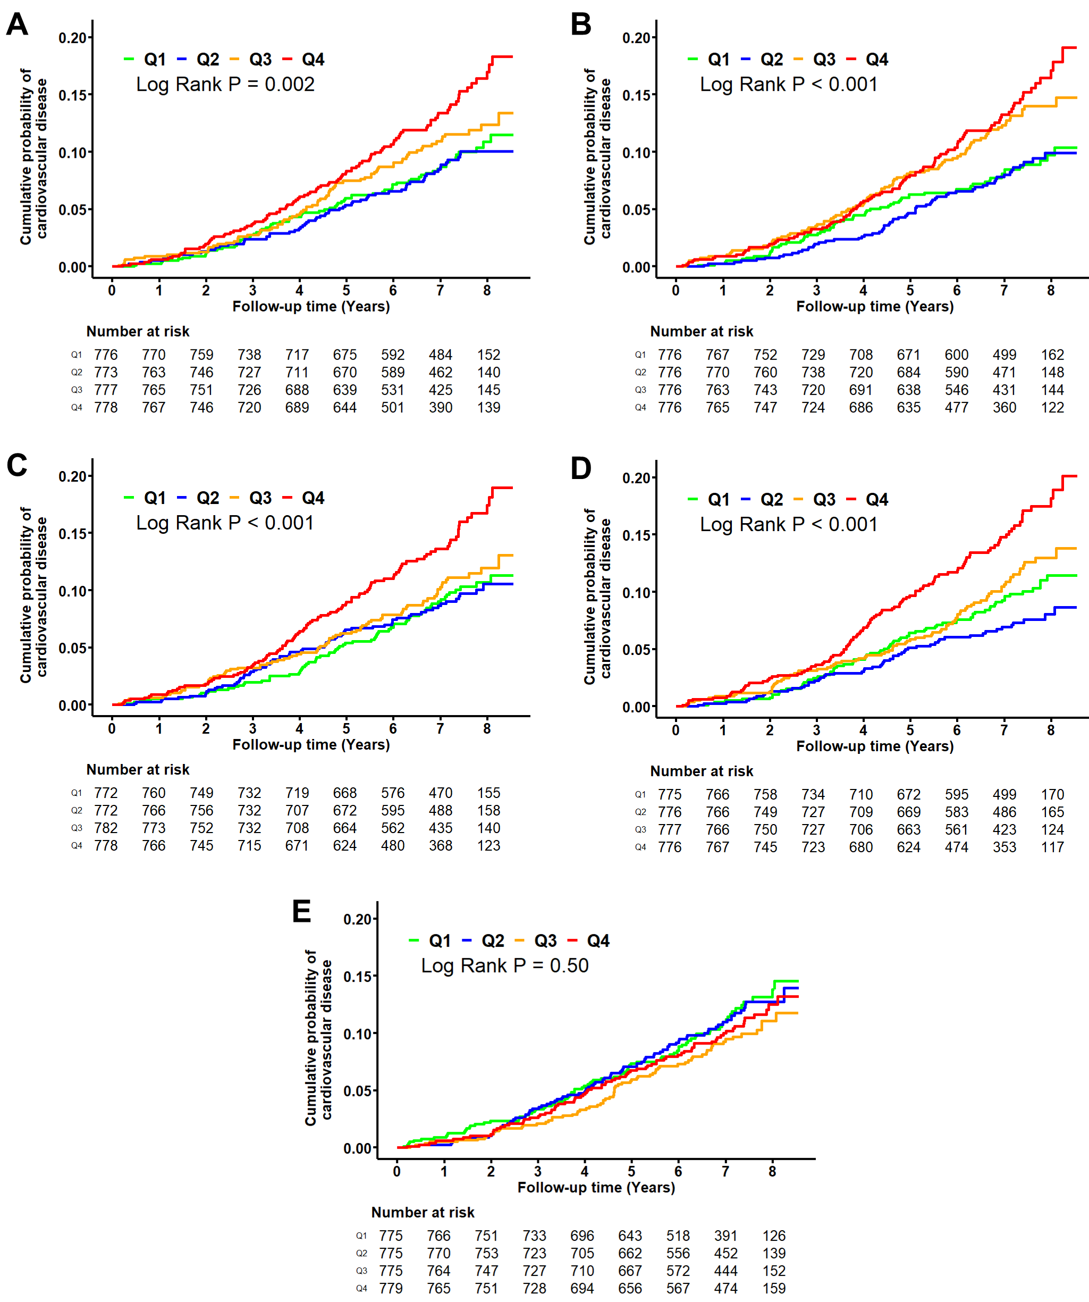
Figure 1. Cumulative probability of cardiovascular events by quartiles of carotid-femoral pulse wave velocity (A), carotid-femoral arterial stiffness gradient (B), heart-femoral pulse wave velocity (C), heart-femoral arterial stiffness gradient (D), and femoral-ankle PWV (E). Log-rank statistic was used to compare survival distributions between quartiles.
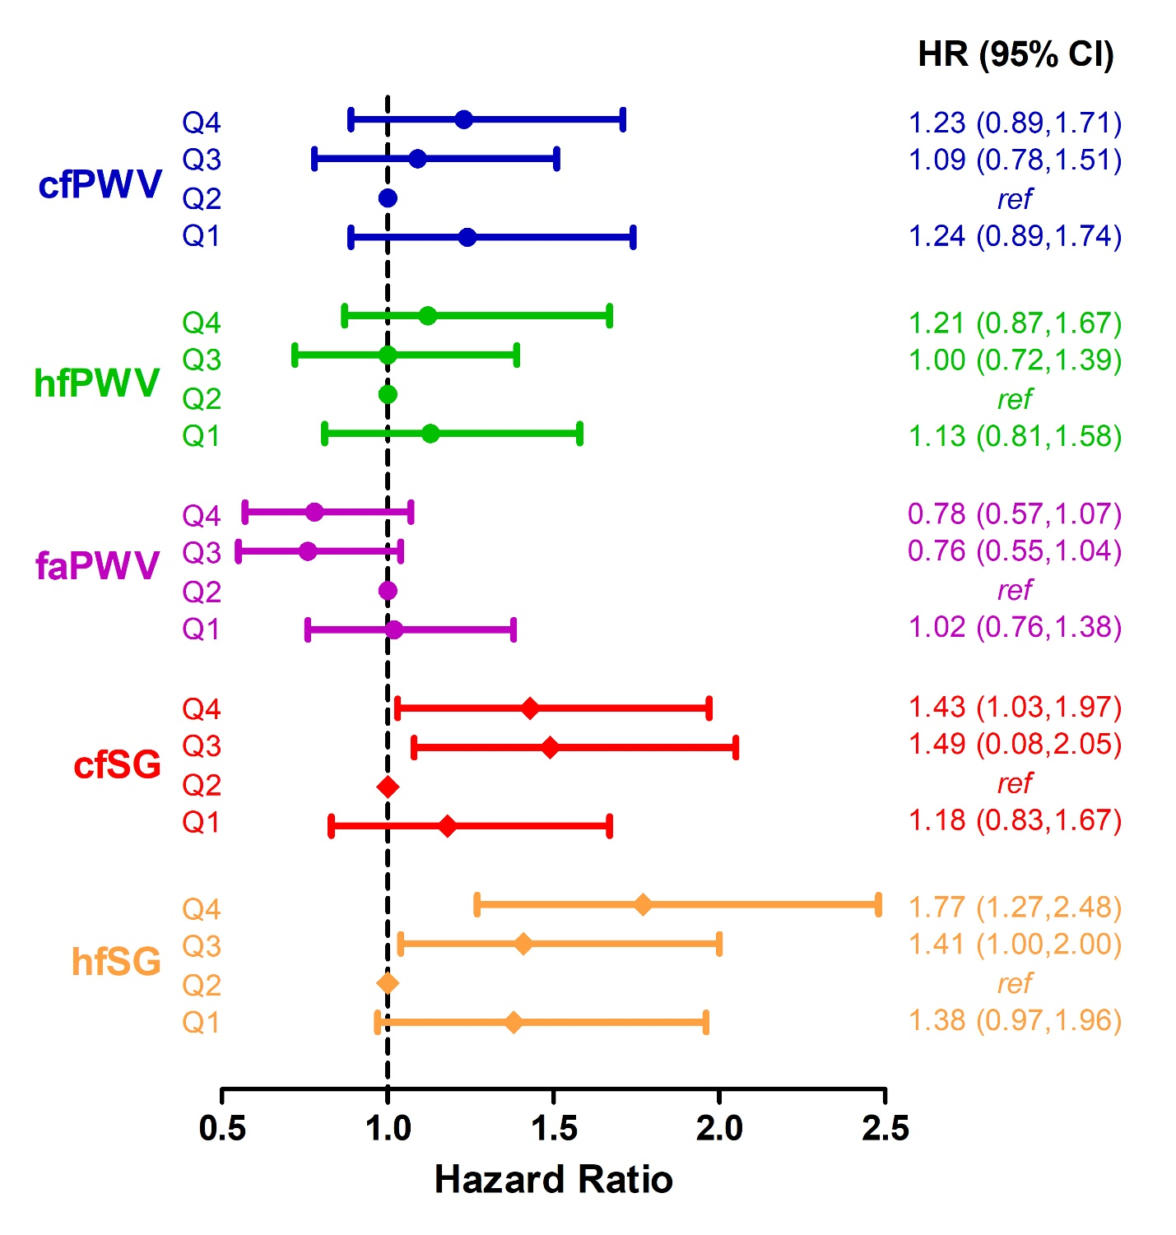
Figure 2. Associations of pulse wave velocity and aortic-femoral arterial stiffness gradient with risk of cardiovascular events. Abbreviations: Carotid-femoral pulse-wave velocity; hfPWV, heart-femoral pulse-wave velocity; faPWV, femoral-ankle pulse-wave velocity; cfSG, carotid-femoral arterial stiffness gradient; hfSG, heart-femoral arterial stiffness gradient; HR, hazard ratio; 95% CI, 95% confidence interval; Q1, quartile 1; Q2, quartile 2, Q3; quartile 3; Q4, quartile 4. Model adjustments: age, sex, race-centre, education, current smoking status, history of diabetes, mean arterial pressure, antihypertensive medication, total cholesterol, high-density lipoprotein cholesterol, and heart rate. cfPWV range (m/s): Q1, <9.4; Q2, 9.4 to 11.0; Q3, 11.0 to 13.1, Q4 >13.1. hfPWV range (m/s): Q1, <9.9; Q2, 9.9 to 11.2; Q3, 11.2 to 12.9, Q4 >12.9. faPWV range (m/s): Q1, <9.9; Q2, 9.9 to 10.9; Q3, 10.9 to 12.0, Q4 >12.0. cfSG range: Q1, >1.18; Q2, 1.18 to 1.00; Q3, >0.99 to 0.82, Q4 <0.82. hfSG range: Q1, >1.13; Q2, 1.13 to 0.97; Q3, >0.97 to 0.83, Q4 <0.83.
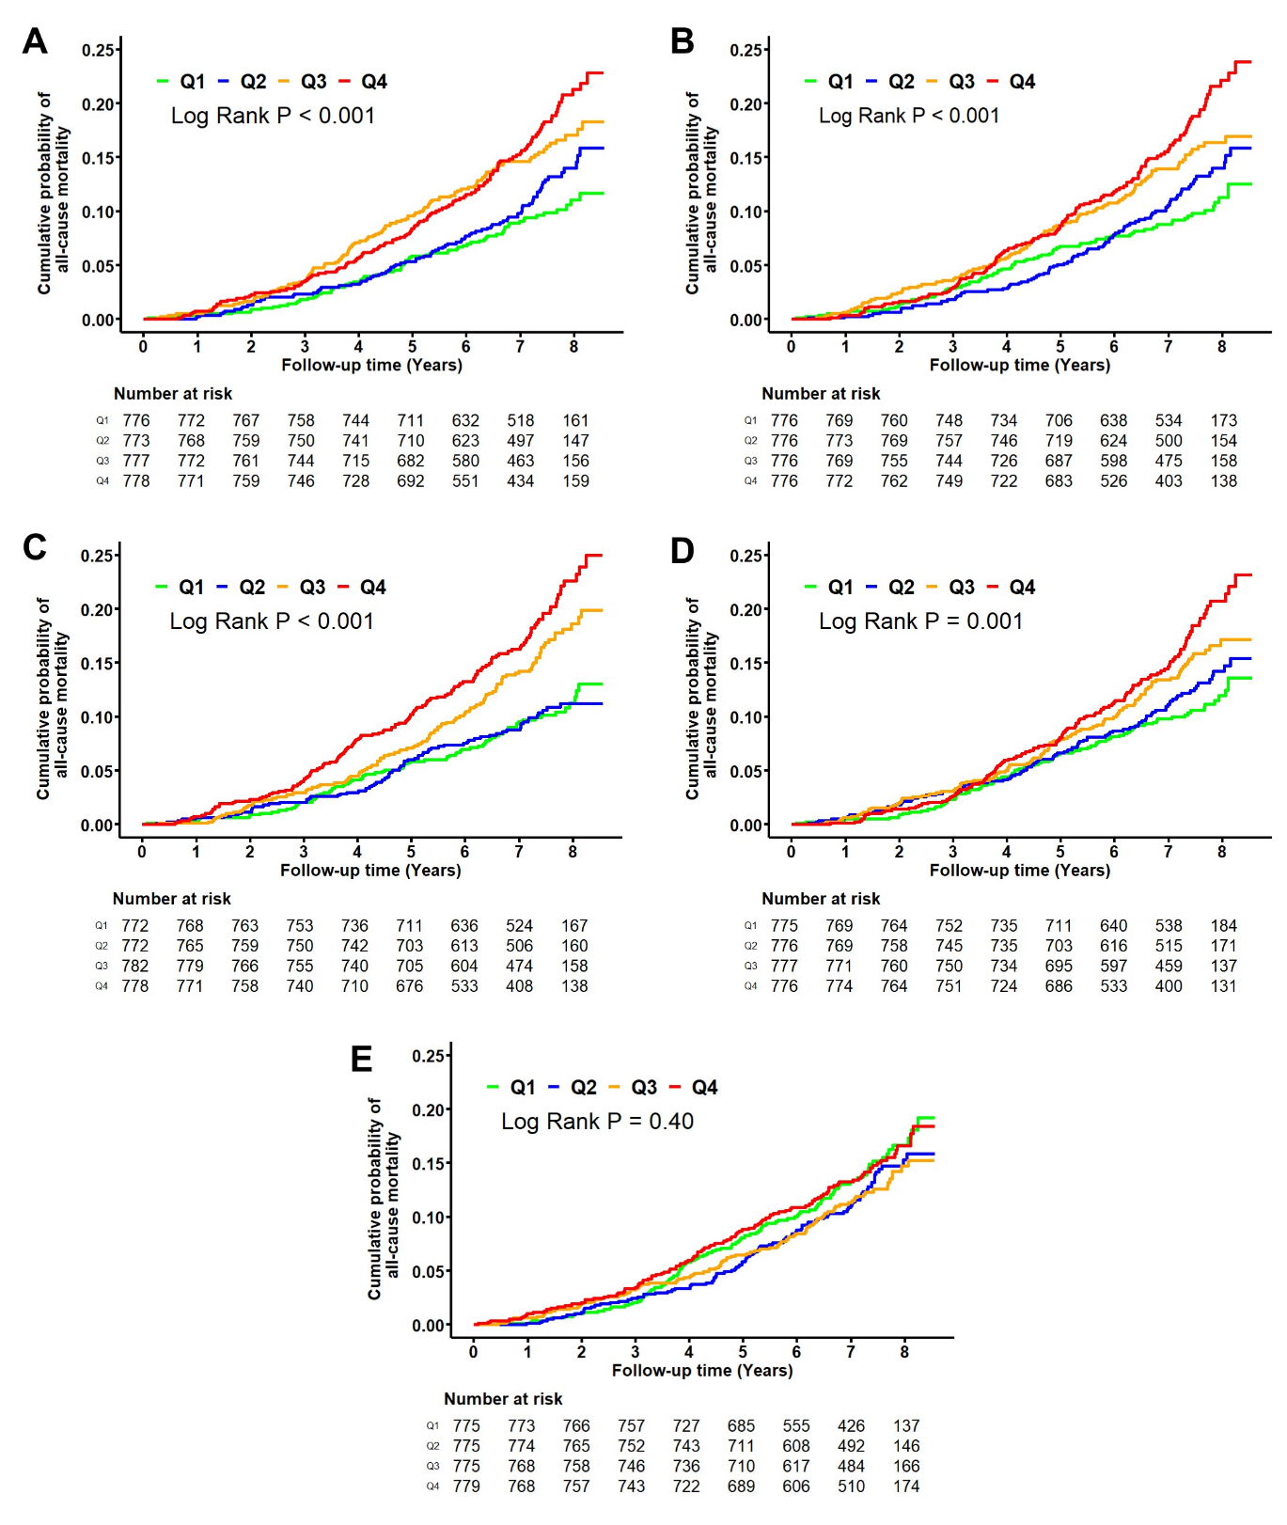
Figure 3. Cumulative probability of all-cause mortality by quartiles of carotid-femoral pulse wave velocity (A), carotid-femoral arterial stiffness gradient (B), heart-femoral pulse wave velocity (C), heart-femoral arterial stiffness gradient (D), and femoral-ankle PWV (E). Log-rank statistic was used to compare survival distributions between quartiles.

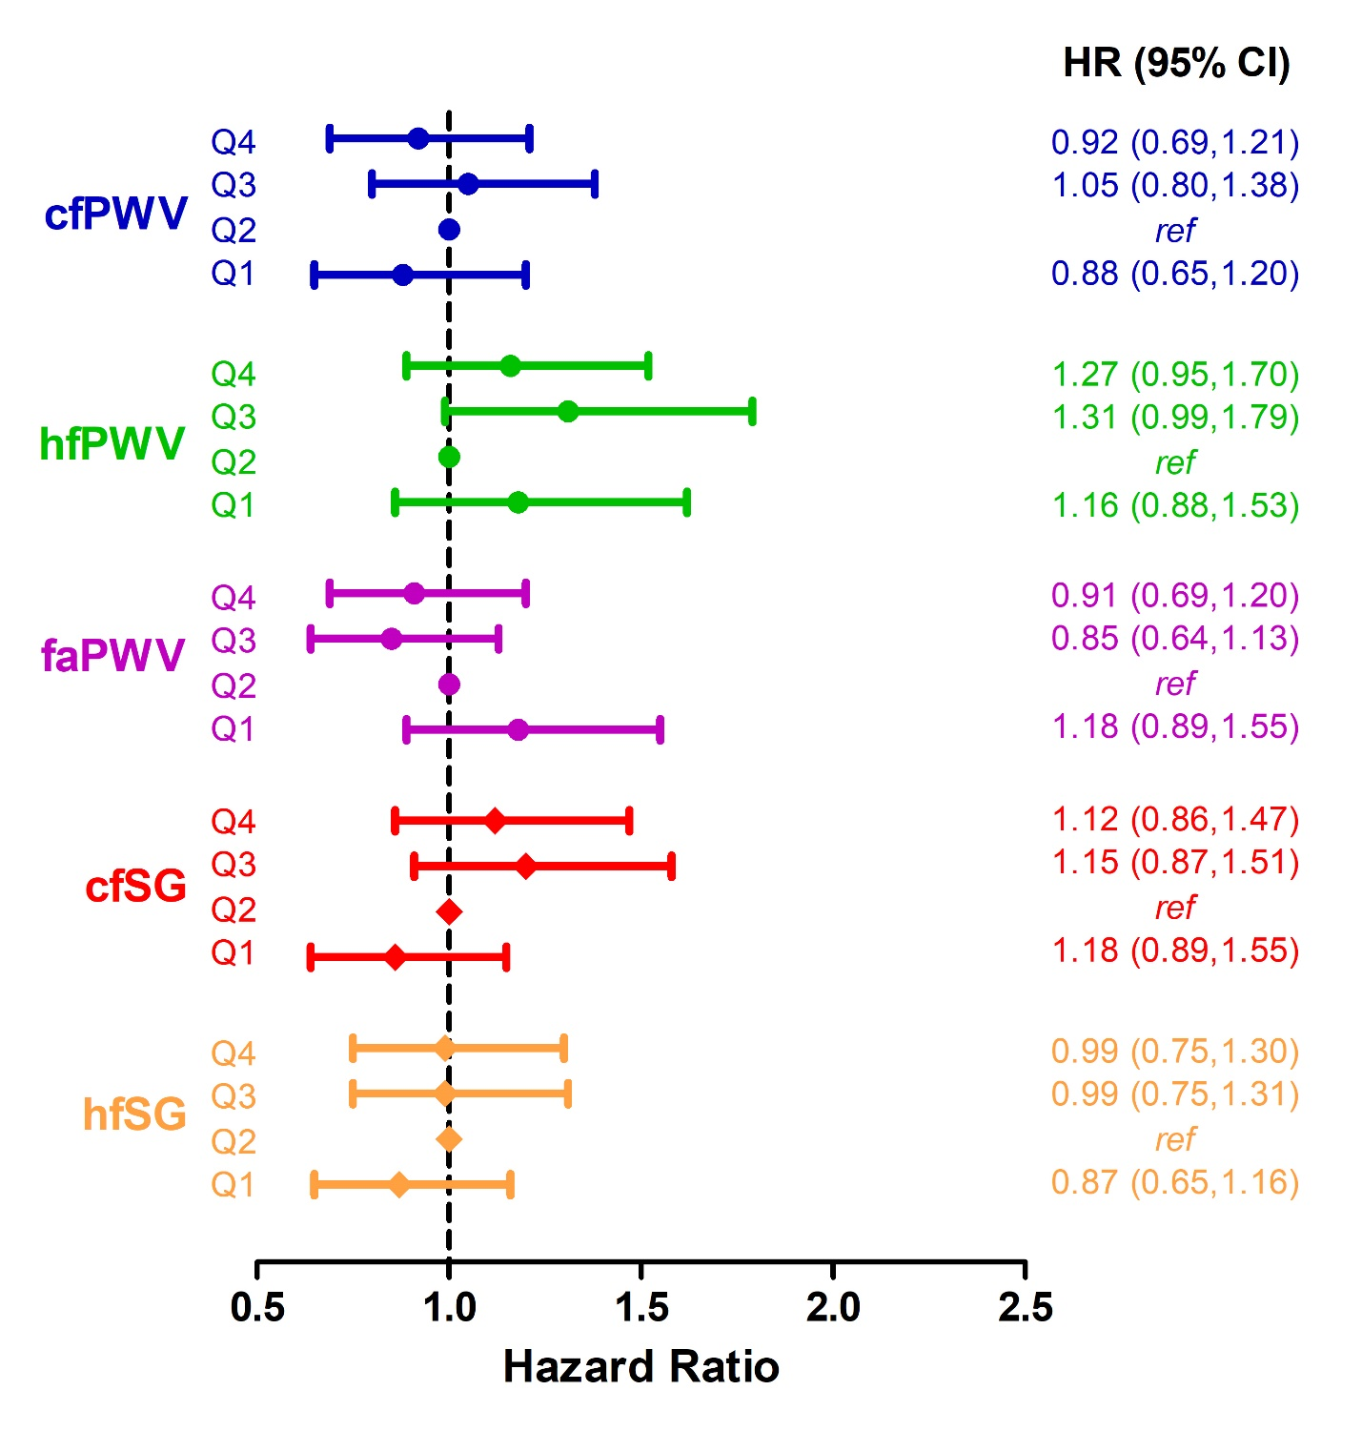
Figure 4. Associations of pulse wave velocity and aortic-femoral arterial stiffness gradient measures with risk of all-cause mortality. Abbreviations: Carotid-femoral pulse-wave velocity; hfPWV, heart-femoral pulse-wave velocity; faPWV, femoral-ankle pulse-wave velocity; cfSG, carotid-femoral arterial stiffness gradient; hfSG, heart-femoral arterial stiffness gradient; HR, hazard ratio; 95% CI, 95% confidence interval; Q1, quartile 1; Q2, quartile 2, Q3; quartile 3; Q4, quartile 4. Model adjustments: age, sex, race-centre, education, current smoking status, history of diabetes, mean arterial pressure, antihypertensive medication, total cholesterol, high-density lipoprotein cholesterol, and heart rate. cfPWV range (m/s): Q1, <9.4; Q2, 9.4 to 11.0; Q3, 11.0 to 13.1, Q4 >13.1. hfPWV range (m/s): Q1, <9.9; Q2, 9.9 to 11.2; Q3, 11.2 to 12.9, Q4 >12.9. faPWV range (m/s): Q1, <9.9; Q2, 9.9 to 10.9; Q3, 10.9 to 12.0, Q4 >12.0. cfSG range: Q1, >1.18; Q2, 1.18 to 1.00; Q3, >0.99 to 0.82, Q4 <0.82. hfSG range: Q1, >1.13; Q2, 1.13 to 0.97; Q3, >0.97 to 0.83, Q4 <0.83.

