Comparing Apples and Oranges in Youth Depression Treatments?

A Quantitative Critique of the Evidence Base and Guidelines

# ABSTRACT

**Objectives:** Should a young person receive psychotherapy or medication for their depression, and on what evidence do we base this decision? In this paper, we test the factors across modalities that may influence comparability between medication and psychotherapy trials.

**Methods:** We included 92 RCTs of psychotherapy and medication for child and adolescent depression (mean age 4-18 years). Using meta-analyses, we compared a) participant characteristics and b) trial characteristics in medication and psychotherapy trials. Lastly, we examined whether psychotherapy controls are well-matched to active conditions.

**Results:** Participants in medication RCTs had higher depression severity and were more frequently male compared to psychotherapy RCTs. There was a dramatic difference in the within-subject improvement due to placebo (SMD=-1.9 (95% CI: -2.10 to -1.7)) vs psychotherapy controls (SMD=-0.6 (95% CI: -0.86 to -0.32)). Within psychotherapy RCTs, control conditions were less intensive on average than active conditions.

**Conclusions:** Medication and psychotherapy RCTs differ on fundamental participant and methodological characteristics, thereby raising questions about their comparability. Psychotherapy controls often involve little therapist contact and are easy-to-beat comparators. These findings cast doubt on the confidence with which psychotherapy is recommended for youth depression, and highlight the pressing need to improve the evidence base.

# KEY MESSAGES

**What is already known on this topic:**

* Psychotherapy is recommended before medication for most cases of depression in children and adolescents, a recommendation that is based on indirect comparisons of outcomes from randomised controlled trials (RCTs) within each treatment modality.

**What this study adds:**

* We examine the validity of these inferences by scrutinising the comparability of psychotherapy and medication RCTs.
* We find significant differences in sample characteristics (namely depression severity and sex composition) and trial design features, such that the within-group effect sizes of medication controls (i.e. pill placebo) are much larger than those for psychotherapy controls, and that medication RCTs feature significantly more trial sites.
* We also examine the quality of controls used in psychotherapy RCTs and find that they are poorly matched to active intervention arms in ways such as human contact hours, and hence represent poor and easy to beat comparators.

**How this study might affect research, practice or policy:**

* Our findings underscore the need for a higher quality evidence base upon which to base treatment guidelines and clinical decision making.

# BACKGROUND

Should a child or an adolescent receive psychotherapy or medication for their depression, and what information should be used to guide decision-making?

For adolescent depression, there are limited head-to-head trials of medication and psychotherapy, and hence recommendations are derived from indirect comparisons of treatment efficacy. The National Institute of Health and Care Excellence (NICE) guidelines for adolescent depression recommend psychotherapy over medication in most cases.[1] This is in keeping with two sources of evidence relating to child and adolescent depression: meta-analyses of medication randomised controlled trials (RCTs) that cast doubt on the efficacy of antidepressants, with the exception of fluoxetine [2]; and meta-analyses of psychotherapy RCTs that conclude psychotherapy to be efficacious.[3] However, a recent network meta-analysis (NMA),[4] an established method of comparing treatments using both direct and indirect (i.e. treatment A with treatment C, via studies that directly compare A with B and B with C) evidence, concluded that only fluoxetine alone and fluoxetine administered together with CBT were significantly more effective than medication- (i.e. pill placebo) or psychotherapy-controls. A large head-to-head RCT comparing modalities found that fluoxetine, alone and in combination with CBT, was superior to pill placebo, though CBT alone was not.[5] Also, the addition of psychotherapy to standard care did not improve outcomes.[6] Given this confusing evidence base, how should we make treatment decisions?

In this paper, we examine whether the existing evidence for adolescent depression treatments can offer valid answers to this question. We provide a conceptual framework and test a series of hypotheses using data from existing trials. Two points are crucial to indirect comparisons of treatment modalities. First, whether the participants in trials are comparable across modalities, or differ in potential effect modifiers. Second, whether key conditions of the trial, such as the effects of control conditions or the number of sites involved, are comparable.

Starting with the first point, comparison between different trials assumes that they sample from populations that are comparable in terms of characteristics that could be effect modifiers. If not, the validity of any comparisons, including those conducted through NMA (which rests on the principal of transitivity, i.e. the requirement that the different sets of randomized trials are similar on average)[7] are questionable.

The assumption that medication and psychotherapy trials sample from comparable population may not be valid as patients and parents often have treatment preferences,[8–10] meaning that there is likely to be a self-selection bias in who participates in psychotherapy and medication trials. Moreover, treatment preferences correlate with clinically-relevant participant characteristics, including severity and sex. Some of these characteristics, such as severity, may moderate treatment response [11,12] and may confound comparisons.

Regarding the second point, differences in trial design may impact outcomes in a differential way between medication and psychotherapy trials.[13] Most obviously, participants in psychotherapy trials are generally unblinded to treatment allocation, with the exception perhaps of trials that compare two equally plausible treatment arms.[14] This creates differential expectations which may favour the psychotherapy active condition, as participants are content to be receiving the “cutting edge” treatment, whilst those in the control are dissatisfied for having missed out (i.e. “disappointment bias”). [15] By contrast, in new antidepressant trials, patients (and raters) were largely unable to judge treatment allocation,[16] suggesting that expectancy effects are well-matched across conditions. Since expectancy is substantially associated with treatment outcomes,[17] if expectancy differs between medication and psychotherapy trials, comparisons between them, including in NMA, become questionable.

Another difference in design is the number of trial sites. The number of sites in medication trials is positively related to the magnitude of placebo response.[18–20] This phenomenon may be due to lower quality of assessments in multi-site trials, with higher rates of classification errors and therefore higher apparent spontaneous remission or regression to the mean.

An inter-related issue concerns the effect of control conditions. Often psychotherapy and medication are compared on the basis of their respective effect sizes (i.e. differences between the active and control conditions for each modality). For these to be comparable, medication and psychotherapy controls ought to be equal in their effects. Otherwise, misleading conclusions could be drawn, e.g. two effect sizes of 40% would be considered equal, even if one arose from a difference of 100% versus 60% and another from a difference of 40% versus 0% (i.e. from different points of reference).

Additionally, control conditions in RCTs should generate counterfactual conditions to the intervention: what would have been the outcome had an individual not received the intervention, with all else being equal.[21] Pill placebo, where the appearance of the drug is faithfully emulated, is an effort for all else to be equal. In psychotherapy trials, control conditions may not be so well matched to the intervention (e.g. in number of contact hours).

# OBJECTIVE

We examine RCTs of psychotherapy and medication for child and adolescent depression (mean age 4-18 years). We posit there are substantial differences between psychotherapy and medication RCTs, making their comparison problematic and examine the following: First, we conduct meta-analyses to compare sample characteristics of medication and psychotherapy trials including: a) baseline depression severity; b) percentage females; and c) mean age. Second, we examine trial characteristics including the efficacy of the control arms, using random-effects meta-regression, and the number of trial sites. Third, we scrutinise the extent to which psychotherapy controls matched the active intervention in ways such as number and frequency of sessions, and hence whether they represent fair pairings from which to draw valid efficacy inferences.

# STUDY SELECTION AND ANALYSIS

The protocol was registered on the Open Science Framework (deviations in *Table S1*).[22] A detailed description of our methods can be found in the Supplement.

## Included studies

We included RCTs identified in a recent meta-analysis of psychotherapy versus control,[3] an NMA examining the efficacy of antidepressants,[2] and an NMA comparing both treatment types [4] for depression in children and adolescents. For the psychotherapy trials, we utilised open data from the previous meta-analysis.[23] For medication trials, we were unable to access the full dataset used in the NMA and hence extracted data from the included studies ourselves.

For medication trials, we also conducted a systematic search for studies published after the final search date of Cipriani et al.’s [2] review up to the final search date of Cuijpers et al’s [3] review to ensure we analysed an equivalently up-to-date database of medication trials. Two authors screened 450 titles and abstracts, and 38 full text records. Seven studies met inclusion criteria and one author completed data extraction for these papers.

## Statistical analysis

### Sample characteristics

We conducted random-effects meta-analyses and tested subgroup differences (psychotherapy vs medication trials) in severity of depressive symptoms, sex and age. Meta-analyses were implemented using R’s meta package.

### Trial design

#### *Measures of effect*

As the measure of effect of each individual study, we used the within-group Standardised Mean Difference (SMD) for the primary depression scale used (selected using the hierarchy in the Supplement).

Where individual studies did not report all data required to calculate the SMD, we imputed missing data according to the methods summarised in this Cochrane Handbook.[24]

For meta-analysis it is necessary to estimate a standard error of the SMD. This requires a correlation between the pre- and post-measures, a statistic typically not reported. To ensure that our results are not biased by misestimation,[25] we simulated n=1000 datasets for different values (0.45 to 0.9) of this correlation and used these datasets in subsequent analyses.

### Multilevel model metaregression

We estimated the pooled SMD for each arm by using multilevel models implemented in R’s metafor package.

We present the SMDs of each of the four treatment arms (medication-control, medication-active, psychotherapy-control, psychotherapy-active) under investigation. The SMDs are the means across the 1000 simulated datasets.

### Number of sites

We also conducted a t-test to compare mean number of trial sites between psychotherapy and medication trials.

### Sensitivity analyses

We conducted sensitivity analyses where we excluded studies that used waitlist as their control and recruited participants with subclinical levels of depression. Next, we included only trials that used the Children’s Depression Rating Scale, Revised (CDRS-R) or the Hamilton Depression Rating Scale (HAM-D) as outcome instruments. Next, we restricted the analysis to studies with variance below 0.02. Further, we tested whether simulated values for the standard error had a substantial influence on the estimation of the differences between the medication and psychotherapy control conditions. We plotted the z-value of the difference between the two coefficients against the number of simulations. We make inference on the stability of the difference, by counting the proportion of times that the z-value is above the critical value of z = 1.645 corresponding to an alpha = 0.05.

Finally, we examined whether differential regression to the mean may account for differences in effect for psychotherapy and medication trials.

### Comparing the control and active arms of psychotherapy trials

We ran t-tests to compare the active and control arms of psychotherapy trials on key variables of interest regarding the intensity of the interventions: the number, duration and intensity of sessions, and the total cumulative hours and duration of the intervention.

# FINDINGS

## Included studies

Data for included studies are summarised in *Table S2* and available on the project repository.[26]

In total, there were 92 RCTs which included 48 active arms and 36 control arms of medication trials; and 67 active arms and 62 control arms from psychotherapy RCTs (see *Figure 1* for summary of sources). Note that the number of active and control arms does not match because some studies feature more than one control or active arm.

Placebo pill was the control condition for all medication trials. In psychotherapy trials, the control arm included 14 waitlist, 28 treatment-as-usual (TAU), and 20 other control conditions.

## Sample characteristics at baseline in medication and psychotherapy trials

Table 1 summarises the results from each of the meta-analyses examining sample characteristics at baseline. The summary statistics are provided for each subgroup and the p-value derives from the test for subgroup differences.

|  |  |  |  |  |  |  |  |  |  |  |  |  |  |  |  |  |  |  |  |  |  |  |  |  |  |  |  |  |  |  |  |  |  |  |  |  |  |  |  |  |  |  |  |  |  |  |  |  |  |  |  |  |  |  |  |  |  |  |  |  |  |  |  |  |  |  |  |  |  |  |  |  |  |  |  |  |  |  |  |  |  |  |  |  |  |  |  |  |  |  |  |  |  |  |  |  |  |  |  |  |  |  |  |  |  |  |  |  |  |  |  |  |  |  |  |  |  |  |  |  |  |  |  |  |  |  |  |  |  |  |  |  |  |  |  |  |  |  |  |  |  |  |  |  |  |  |  |  |  |  |  |  |  |  |  |  |  |  |  |  |  |  |  |  |  |  |  |  |  |  |  |  |  |  |  |  |  |  |  |  |  |  |  |  |  |  |  |  |  |  |  |  |  |  |  |  |  |  |  |  |  |  |  |  |  |  |  |  |  |  |  |  |  |  |  |  |  |  |  |  |  |  |  |  |  |  |  |  |  |  |  |  |  |  |  |  |  |  |  |  |  |  |  |  |  |  |  |  |  |  |  |  |  |  |  |  |  |  |  |  |
| --- | --- | --- | --- | --- | --- | --- | --- | --- | --- | --- | --- | --- | --- | --- | --- | --- | --- | --- | --- | --- | --- | --- | --- | --- | --- | --- | --- | --- | --- | --- | --- | --- | --- | --- | --- | --- | --- | --- | --- | --- | --- | --- | --- | --- | --- | --- | --- | --- | --- | --- | --- | --- | --- | --- | --- | --- | --- | --- | --- | --- | --- | --- | --- | --- | --- | --- | --- | --- | --- | --- | --- | --- | --- | --- | --- | --- | --- | --- | --- | --- | --- | --- | --- | --- | --- | --- | --- | --- | --- | --- | --- | --- | --- | --- | --- | --- | --- | --- | --- | --- | --- | --- | --- | --- | --- | --- | --- | --- | --- | --- | --- | --- | --- | --- | --- | --- | --- | --- | --- | --- | --- | --- | --- | --- | --- | --- | --- | --- | --- | --- | --- | --- | --- | --- | --- | --- | --- | --- | --- | --- | --- | --- | --- | --- | --- | --- | --- | --- | --- | --- | --- | --- | --- | --- | --- | --- | --- | --- | --- | --- | --- | --- | --- | --- | --- | --- | --- | --- | --- | --- | --- | --- | --- | --- | --- | --- | --- | --- | --- | --- | --- | --- | --- | --- | --- | --- | --- | --- | --- | --- | --- | --- | --- | --- | --- | --- | --- | --- | --- | --- | --- | --- | --- | --- | --- | --- | --- | --- | --- | --- | --- | --- | --- | --- | --- | --- | --- | --- | --- | --- | --- | --- | --- | --- | --- | --- | --- | --- | --- | --- | --- | --- | --- | --- | --- | --- | --- | --- | --- | --- | --- | --- | --- | --- | --- | --- | --- | --- | --- | --- | --- | --- | --- | --- | --- | --- | --- | --- | --- | --- |
| Table 1: Sample characteristics at baseline across medication and psychotherapy studies: Results for overall sample and sensitivity analyses   | **Subgroup** | **K** | **Mean** | **SE** | **Lower CI** | **Upper CI** | **T2** | **p-value** | | --- | --- | --- | --- | --- | --- | --- | --- | | **Baseline Severity of Depressive Symptoms\*** | | | | | | | | | | **Overall** |  |  |  |  |  |  | **0.033** | | Psychotherapy | 49 | 0.37 | 0.02 | 0.33 | 0.41 | 0.02 |  | | Medication | 31 | 0.42 | 0.01 | 0.39 | 0.44 | 0 |  | | **Excluding subclinical** |  |  |  |  |  |  | **0.281** | | Psychotherapy | 41 | 0.39 | 0.02 | 0.35 | 0.43 | 0.02 |  | | Medication | 31 | 0.42 | 0.01 | 0.39 | 0.44 | 0 |  | | **Excluding waitlist** |  |  |  |  |  |  | **0.075** | | Psychotherapy | 41 | 0.37 | 0.02 | 0.33 | 0.42 | 0.02 |  | | Medication | 31 | 0.42 | 0.01 | 0.39 | 0.44 | 0 |  | | **Percent Female** | | | | | | | | | | **Overall** |  |  |  |  |  |  | **0.020** | | Psychotherapy | 49 | 61.36 | 2.31 | 56.72 | 66.00 | 260.97 |  | | Medication | 28 | 53.72 | 2.33 | 48.94 | 58.51 | 152.15 |  | | **Excluding subclinical** |  |  |  |  |  |  | **0.035** | | Psychotherapy | 42 | 61.72 | 2.63 | 56.41 | 67.02 | 289.77 |  | | Medication | 28 | 53.72 | 2.33 | 48.94 | 58.51 | 152.15 |  | | **Excluding waitlist** |  |  |  |  |  |  | **0.044** | | Psychotherapy | 41 | 61.38 | 2.60 | 56.12 | 66.63 | 277.58 |  | | Medication | 28 | 53.72 | 2.33 | 48.94 | 58.51 | 152.15 |  | | **Age** | | | | | | | | | | **Overall** |  |  |  |  |  |  | **0.220** | | Psychotherapy | 53 | 14.3 | 0.33 | 13.64 | 14.96 | 5.7 |  | | Medication | 28 | 13.69 | 0.37 | 12.95 | 14.44 | 3.7 |  | | **Excluding subclinical** |  |  |  |  |  |  | **0.249** | | Psychotherapy | 44 | 14.29 | 0.37 | 13.55 | 15.04 | 5.98 |  | | Medication | 28 | 13.69 | 0.37 | 12.95 | 14.44 | 3.7 |  | | **Excluding waitlist** |  |  |  |  |  |  | **0.249** | | Psychotherapy | 45 | 14.29 | 0.36 | 13.56 | 15.01 | 5.82 |  | | Medication | 28 | 13.69 | 0.37 | 12.95 | 14.44 | 3.7 |  | | *Abbreviations: K* = number of studies, *SE* = standard error, CI = 95% confidence interval, T2 = estimate of between-study heterogeneity.  *These are baseline depression scores transformed to reflect percentage of a scale range (see Supplement for detailed description). To take an example, the CDRS gives a possible total score from 17 to 113 (i.e. range of 96). Mean severity was 0.36 for psychotherapy studies and 0.42 for medication studies, which would translate to 51.56 (17 + 0.36 x 96) and 57.32 (17 + 0.42 x 96), respectively, as equivalent scores on the CDRS. | | | | | | | | | |

### Baseline severity

On average, depression severity at baseline was significantly higher in medication trials compared to psychotherapy trials (see *Table 1*). When excluding RCTs that used waitlist as their control, baseline severity remained significantly higher in medication trials compared to psychotherapy trials. This difference did not reach statistical significance when excluding studies that recruited samples with sub-clinical depression.

To ensure that this was not an artefact of variable transformation, we also compared means at baseline in the two instruments, CDRS and HAM-D, on which there was a sufficient number of studies to meta-analyse. As can be seen in *Table* S3 and Table S4, the number of studies is much smaller, but the pattern of differences is the same for the HAM-D and the CDRS, though it does not reach statistical significance for the latter.

### Sex

For this analysis, we excluded the two psychotherapy trials which included entirely female samples (Moeini, 2019; Shomaker, 2016; see *Table S5 for all studies*). As can be seen in *Table 1*, psychotherapy trials featured a significantly higher percentage of females when compared to medication trials. On average, samples were 61.36% (*SE* = 2.31) female across psychotherapy trials and 53.72% (*SE* = 2.33) female across medication trials. Excluding sub-clinical and waitlist control studies yielded similar results.

### Age

As can be seen in *Table 1*, mean age was 14.3 (*SE* = 0.33) across psychotherapy trials and 13.69 (*SE* = 0.37) across medication trials, with no significant between group differences. There were no significant differences in mean age between modalities on further sensitivity analyses.

## Trial design

### Standardised mean differences of control conditions in psychotherapy and medication studies

We applied metaregression to obtain the SMDs and confidence intervals of each of the four study arms. As seen in *Figure* 2 there were substantial differences between the four arms of the meta-analysis with striking differences between the medication and psychotherapy control arms (see *Figure 3* for weighted scatterplot). In particular, pill placebo had an SMD = -1.9 (95% CI: -2.1 to -1.7) whereas psychotherapy controls had an SMD = -0.6 (95% CI: -0.9 to -0.3).

##### *Sensitivity analyses*

We conducted a series of sensitivity analyses . Excluding waitlist control studies (see Figure S3) and sub-clinical studies (see Figure S4) yielded a pattern of results very similar to the overall analyses. Next, we examined the data including only those studies that used the CDRS (see Figure S5) or the HAMD (see Figure S6). Medication control and psychotherapy control conditions remained significantly different, though the small number of studies resulted in less precise estimates of the SMDs. Restricting the analysis to studies with variance below 0.02 yielded a similar pattern of results, but with increased precision in SMD estimates across conditions (see *Figure S9*).Finally, we showed that different values for the pre-post measure correlation had minimal effect on the estimated outcomes (see Figure S10).

##### *Regression to the mean*

We addressed potential regression to the mean by including the baseline score for each depression scale in the linear regression model as per equation 3 in Barnett [27] (see *Table S7, S8*). The difference between the medication control and psychotherapy control arms remained significant.

### Number of trial sites

Average number of trial sites was significantly higher in medication trials (*M* = 35.96, *SD* =25.16) compared to psychotherapy studies (*M* =3.04, *SD* =3.13) (*t* (27.51) = 6.89, *p* =< 0.001). Of those studies with data available, 26 of 28 (93%) medication trials were multisite, compared to 24 of 45 (54%) psychotherapy studies.

## Comparing the nature and intensity of control conditions in psychotherapy trials

|  |  |  |  |  |  |  |  |  |  |  |  |  |  |  |  |  |  |  |  |  |  |  |  |  |  |  |  |  |  |  |  |  |  |  |  |  |  |  |  |  |  |  |  |  |  |  |  |  |  |  |  |  |  |  |  |  |  |  |  |  |  |  |  |  |  |  |  |  |  |  |  |  |  |  |  |  |  |  |  |  |  |  |  |  |  |  |  |  |  |  |  |  |  |  |  |  |  |  |  |  |  |  |  |  |  |  |  |  |  |  |  |  |  |  |  |  |  |  |  |  |  |  |  |  |  |  |  |  |  |  |
| --- | --- | --- | --- | --- | --- | --- | --- | --- | --- | --- | --- | --- | --- | --- | --- | --- | --- | --- | --- | --- | --- | --- | --- | --- | --- | --- | --- | --- | --- | --- | --- | --- | --- | --- | --- | --- | --- | --- | --- | --- | --- | --- | --- | --- | --- | --- | --- | --- | --- | --- | --- | --- | --- | --- | --- | --- | --- | --- | --- | --- | --- | --- | --- | --- | --- | --- | --- | --- | --- | --- | --- | --- | --- | --- | --- | --- | --- | --- | --- | --- | --- | --- | --- | --- | --- | --- | --- | --- | --- | --- | --- | --- | --- | --- | --- | --- | --- | --- | --- | --- | --- | --- | --- | --- | --- | --- | --- | --- | --- | --- | --- | --- | --- | --- | --- | --- | --- | --- | --- | --- | --- | --- | --- | --- | --- | --- | --- | --- | --- | --- |
| *Table 2: Comparing the intensity of active and control arms in psychotherapy studies*   | **Group** | **K** | **Mean** | **SD** | **Cohen's d** | **Upper CI** | **Lower CI** | **t** | **df** | **p-value** | | --- | --- | --- | --- | --- | --- | --- | --- | --- | --- | | **Number of sessions** | | | | | | | | | | | Active | 68 | 12.94 | 11.02 | 0.76 | 0.36 | 1.17 | 4.4 | 106.38 | < 0.001 | | Control | 41 | 5.71 | 6.10 |  |  |  |  |  |  | | **Intensity (sessions per week)** | | | | | | | | | | | Active | 62 | 1.28 | 0.71 | 1.02 | 0.58 | 1.46 | 4.98 | 79.37 | < 0.001 | | Control | 37 | 0.58 | 0.67 |  |  |  |  |  |  | | **Session length (mins)** | | | | | | | | | | | Active | 57 | 65.52 | 31.63 | 1.10 | 0.65 | 1.56 | 5.07 | 68.93 | < 0.001 | | Control | 36 | 29.12 | 35.01 |  |  |  |  |  |  | | **Total intervention hours** | | | | | | | | | | | Active | 59 | 13.80 | 9.88 | 0.95 | 0.51 | 1.39 | 4.8 | 89.86 | < 0.001 | | Control | 37 | 5.17 | 7.63 |  |  |  |  |  |  |   *Abbreviations: K* = number of studies, *SD* = standard deviation, CI = 95% confidence interval, df = degrees of freedom.  *Note:* Statistical significance evaluated using Bonferroni-corrected criterion (α = 0.05/4 = 0.0125). |

Active conditions featured significantly more sessions compared to control conditions (see *Table 2*). Sessions in active conditions were longer and more frequent, resulting in significantly more intervention hours overall. Notably, many control conditions were very poorly described and their intensity could not be quantified, resulting in missing data. We performed a sensitivity analysis where we excluded trials using waitlist controls; with the exception of number of sessions, differences between active and control arms were no longer statistically significant though remained substantial (see *Table S9*).

# CONCLUSIONS AND CLINICAL IMPLICATIONS

We examined whether psychotherapy and medication can be meaningfully compared on the basis of the existing evidence, by looking at factors that influence comparability. First, whether the participants of trials in one modality are comparable to those in another modality. Second, whether conditions of the trial, such as the effects of control conditions or the number of sites involved, are comparable.

Starting with the first question, we found that participants in medication trials are comparable on age but are more likely to be male and have more severe depression compared to those in psychotherapy. This indicates that different people enter medication and psychotherapy trials; as these could be effect modifiers, they may violate basic assumptions of comparability.

Severity is particularly important as it may moderate treatment response, with some evidence suggesting that those with higher baseline scores respond more to antidepressants [28] or that their response to pill placebo is lower.[18] Other studies argue against severity as a treatment moderator, [29,30] however these are within people who have chosen to be in the particular trial and modality. Moreover, severity may represent different subtypes in terms of course of depression and real-life outcomes.[31,32] However, our study cannot demonstrate effect modification, and it cannot be inferred that differences in participant characteristics explain observed differences in effect.

We then asked whether trial design conditions are comparable between modalities. Medication trials were more likely to be multi-site than their psychotherapy counterparts: 93% of medication RCTs were multisite compared to 54% of psychotherapy RCTs. Multi-site trials are associated with higher pill placebo response,[18] and are less common in publicly-funded trials which show lower pill placebo efficacy.[19,20] This aligns with medication trials being more frequently funded by pharmaceutical companies (68% in Zhou [4]), which can introduce bias in the RCT. However, in single-site trials, principal investigators are often intellectually invested in the treatment (in psychotherapy these are often treatments developed by the PI); this is in contrast to the incentive structure in multi-site trials where the number of recruited participants is the primary unit of reimbursement. Concerns about allegiance bias in psychotherapy trials have been raised previously [33]. Psychotherapy trials also tend to receive higher bias ratings compared to medication trials (e.g. 78% against 20% in Zhou [4]), further complicating comparisons.

Second, psychotherapy controls have moderate effect sizes (-0.6) whereas medication controls have very large effect sizes (-1.9). Our analysis could be critiqued for comparing within-arm symptom change per trial. This applies if we were to draw inferences about each arm’s efficacy — where preserving randomisation to balance confounders is critical. Importantly, we do not claim that these differences are genuinely due to efficacy differences; they may well be because people who attend psychotherapy and medication trials are different and respond differently. In either case, the disparity in the response to control conditions is reason for concern about our ability to draw inferences from comparisons of modalities. This is problematic as clinicians and policy-makers often resort to between-group effect sizes to summarise findings.

Our findings are largely in keeping with those of the NMA,[4] which is designed to preserve the randomisation structure. In Zhou et al., the estimates for psychotherapy controls, TAU and waitlist conditions favoured placebo (though CIs were broad because these were indirectly estimated), as did estimates for psychodynamic and behavioural therapy. CBT did not differentiate from placebo, a result that is likely heavily weighted by the results of their direct comparison in the TADS trial.[5] It is possible that any intervention that establishes an alliance between participants and providers are equally beneficial,[34,35] raising questions about whether specific psychological interventions with highly trained therapists are necessary. This should be considered as a null hypothesis against which to test alternatives. We note that the Zhou NMA, an admirable effort to synthesise the literature, reports on issues that may affect transitivity with tests of incoherence showing significant differences.

We next examined whether psychotherapy controls are reasonable counterfactuals to receiving treatment. An obvious disadvantage of psychotherapy trials is that they are typically unblinded and may be inherently impossible to blind. Yet, psychotherapy trials are unlikely to fulfill other basic conditions of the “all else is equal” assumption. In order to test that a psychological treatment is effective per se (e.g. because of the specific techniques) rather than because of generic effects (e.g. pleasant human contact), aspects such as therapist contact time should be matched. Many (23%) psychotherapy RCTs used waitlist controls, which by definition do not match for hours of therapist contact, and are often associated with disappointment bias. TAU and other psychotherapy control conditions varied drastically; 9 RCTs used controls that exactly matched the active arm in total number of contact hours, though several studies used bibliotherapy or online-only control conditions which did not involve any direct therapist contact. Importantly, controls were often poorly described, resulting in difficulties in evaluating their adequacy as counterfactual conditions. Overall, there is poor matching of control to active treatment conditions in psychotherapy RCTs, with the latter typically featuring considerably more contact hours, which may artificially inflate estimates of efficacy.

Given this, the empirical basis for comparing psychotherapy and medication for adolescent depression is weak, and hence it is difficult to generate guidelines and recommend one treatment over another. Alternative reasons for recommending psychotherapy over medication in guidelines (e.g. the presumed better side effect profile), should be clearly stated and supported by evidence. Indeed, our findings have several implications for stakeholders.

First, the grounds for comparison between medication and psychotherapy should be seen as shaky, rather than offering confidence, and there is an urgent need to revisit guidelines and public information in light of the limitations.

Second, the overreliance on easy-to-beat control conditions in psychotherapy trials should prompt consideration of how to create fair comparators. Investment should be directed into providing rigorous evidence that establishes depression psychotherapies as more efficacious than fair controls. There are examples of RCTs where such rigor has been applied in matching active and control arms on variables such as therapist time and provision of homework.[36–38] Moreover, there is a place for comparing interventions to TAU since these represent real-world comparators. However issues of disappointment bias should be addressed to avoid inflating treatment estimates.

Third, our findings make clear the inherent difficulties of comparing psychotherapy with medication trials.[13] The first obstacle is the comparability of the populations taking part. Head-to-head comparisons of psychotherapy with medication are more favourable in this regard, yet even so these trials might sample the population of those who are indifferent to which treatment they receive.[29] Difficulties with blinding of the psychotherapy control would also have to be overcome to draw valid inferences.

It is not surprising that in the scientific discovery process, there are complexities leading to studies with different designs and aims, and therefore to an apples and oranges situation. This does not invalidate the process as such, nor the individual studies, but does raise questions about whether such studies can be summed up and be deemed comparable. This paper is a critique of the latter point.

In summary, our results question the state of knowledge about the efficacy of psychotherapies and the extent to which giving them primacy in the treatment of depression is justified and beneficial for young people. Guidelines should not result from metanalyses on their own. Value-based judgements and conventions are key to clinical and public health practice, and may put into perspective quantitative findings. Yet, there should be transparency in the decision-making. Readers of these guidelines need to be informed about the state of knowledge. In this, quantitative evidence is necessary, though insufficient by itself.

# FOOTNOTES

**Acknowledgements**: The authors wish to thank Professor Georgia Salanti for helpful discussions.

**Contributors:** AS (guarantor) designed and led the project, created the statistical analysis plan, analysed the data, and drafted and revised the manuscript. GK contributed to all stages and drafted sections of the manuscript. CB and DB located and screened studies, and extracted and coded data with DM and IMR. CB also cleaned and prepared data for analysis, edited the manuscript and managed the original submission. RU, MK, LF, CM, SC, and GL critically reviewed and edited the manuscript. RD oversaw the revision process, conducted additional analyses and edited the manuscript.

**Funding:** This project is funded by the Wellcome Trust (grant no. 578195). The study researchers acted independently of the funder.

**Competing interests:** Professor Cortese is supported by NIHR grants NIHR203684, NIHR203035, NIHR130077, NIHR128472, RP-PG-0618-20003 and by grant 101095568-HORIZONHLTH- 2022-DISEASE-07-03 from the European Research Executive Agency. Professor Cortese has declared reimbursement for travel and accommodation expenses from the Association for Child and Adolescent Central Health (ACAMH) in relation to lectures delivered for ACAMH, the Canadian AADHD Alliance Resource, the British Association of Psychopharmacology, and from Healthcare Convention for educational activity on ADHD, and has received honoraria from Medice.

Dr Moreno is supported by the Spanish Ministry of Science and Innovation, Instituto de Salud Carlos III (ISCIII, PI21/01929), CIBER -Consorcio Centro de Investigación Biomédica en Red- (CB/07/09/0023), co-financed by the European Union and ERDF Funds from the European Commission, “A way of making Europe”, financed by the European Union, Madrid Regional Government, European Union Structural Funds, EU Seventh Framework Program, H2020 Program, and Horizon Europe, National Institute of Mental Health of the National Institutes of Health, Fundación Familia Alonso, and Fundación Alicia Koplowitz. Dr Moreno has received honoraria as a consultant and/or advisor and/or for lectures from Janssen, Angelini, Compass, Pfizer, Sunovion, Teva, British Association of Pharmacology, Exeltis, Otsuka, Servier and Nuvelution outside the submitted work.

**Licence:** The Submitting Author has the right to grant, and does grant, on behalf of all authors of the Work, an exclusive licence on a worldwide, perpetual, irrevocable, royalty-free basis to BMJ Publishing Group Ltd (“BMJ”) and its licensees to publish the Work in *BMJ Mental Health* and any other BMJ products and to exploit all rights, as set out in their licence.

**Ethics of approval:** Not applicable.

# References

1 NICE. Depression in Children and Young People: Identification and Management. 2019.

2 Cipriani A, Zhou X, Del Giovane C, *et al.* Comparative Efficacy and Tolerability of Antidepressants for Major Depressive Disorder in Children and Adolescents: A Network Meta-Analysis. *The Lancet*. 2016;388:881–90. doi: 10.1016/S0140-6736(16)30385-3

3 Cuijpers P, Karyotaki E, Ciharova M, *et al.* The Effects of Psychological Treatments of Depression in Children and Adolescents on Response, Reliable Change, and Deterioration: A Systematic Review and Meta-Analysis. *Eur Child Adolesc Psychiatry*. Published Online First: October 2021. doi: 10.1007/s00787-021-01884-6

4 Zhou X, Teng T, Zhang Y, *et al.* Comparative Efficacy and Acceptability of Antidepressants, Psychotherapies, and Their Combination for Acute Treatment of Children and Adolescents with Depressive Disorder: A Systematic Review and Network Meta-Analysis. *Lancet Psychiatry*. 2020;7:581–601. doi: 10.1016/S2215-0366(20)30137-1

5 March J, Silva S, Petrycki S, *et al.* Fluoxetine, Cognitive-Behavioral Therapy, and Their Combination for Adolescents With Depression: Treatment for Adolescents With Depression Study (TADS) Randomized Controlled Trial. *JAMA*. 2004;292:807. doi: 10.1001/jama.292.7.807

6 Goodyer I, Dubicka B, Wilkinson P, *et al.* A randomised controlled trial of cognitive behaviour therapy in adolescents with major depression treated by selective serotonin reuptake inhibitors. The ADAPT trial. *Health Technol Assess*. 2008;12. doi: 10.3310/hta12140

7 Chaimani A, Caldwell \relax DM, Li T, *et al.* Chapter 11: Undertaking Network Meta-Analyses. *Cochrane Handbook for Systematic Reviews of Interventions Version 6.4*. Cochrane 2023.

8 Jaycox LH, Asarnow JR, Sherbourne CD, *et al.* Adolescent Primary Care Patients’ Preferences for Depression Treatment. *Adm Policy Ment Health Ment Health Serv Res*. 2006;33:198–207. doi: 10.1007/s10488-006-0033-7

9 Langer DA, Kritikos TK, Asarnow JR, *et al.* Parent and Youth Preferences in the Treatment of Youth Depression. *Child Psychiatry Hum Dev*. 2021;52:236–47. doi: 10.1007/s10578-020-01006-4

10 McHugh RK, Whitton SW, Peckham AD, *et al.* Patient Preference for Psychological vs Pharmacologic Treatment of Psychiatric Disorders: A Meta-Analytic Review. *J Clin Psychiatry*. 2013;74:595–602. doi: 10.4088/JCP.12r07757

11 Courtney DB, Watson P, Krause KR, *et al.* Predictors, Moderators, and Mediators Associated With Treatment Outcome in Randomized Clinical Trials Among Adolescents With Depression: A Scoping Review. *JAMA Netw Open*. 2022;5:e2146331. doi: 10.1001/jamanetworkopen.2021.46331

12 Lorenzo-Luaces L, Rodriguez-Quintana N, Bailey AJ. Double Trouble: Do Symptom Severity and Duration Interact to Predicting Treatment Outcomes in Adolescent Depression? *Behav Res Ther*. 2020;131:103637. doi: 10.1016/j.brat.2020.103637

13 Del Giovane C, Cortese S, Cipriani A. Combining Pharmacological and Nonpharmacological Interventions in Network Meta-analysis in Psychiatry. *JAMA Psychiatry*. 2019;76:867. doi: 10.1001/jamapsychiatry.2019.0574

14 Calvo A, Moreno M, Ruiz-Sancho A, *et al.* Intervention for Adolescents With Early-Onset Psychosis and Their Families: A Randomized Controlled Trial. *J Am Acad Child Adolesc Psychiatry*. 2014;53:688–96. doi: 10.1016/j.jaac.2014.04.004

15 Relton C, Burbach M, Collett C, *et al.* The Ethics of `Trials within Cohorts’ (TwiCs): 2nd International Symposium: London, UK. 7-8 November 2016. *Trials*. 2017;18:244, s13063-017-1961–0. doi: 10.1186/s13063-017-1961-0

16 Lin Y-H, Sahker E, Shinohara K, *et al.* Assessment of Blinding in Randomized Controlled Trials of Antidepressants for Depressive Disorders 2000–2020: A Systematic Review and Meta-Analysis. *eClinicalMedicine*. 2022;50:101505. doi: 10.1016/j.eclinm.2022.101505

17 Constantino MJ, Arnkoff DB, Glass CR, *et al.* Expectations. *J Clin Psychol*. 2011;67:184–92. doi: 10.1002/jclp.20754

18 Bridge JA, Birmaher B, Iyengar S, *et al.* Placebo Response in Randomized Controlled Trials of Antidepressants for Pediatric Major Depressive Disorder. *Am J Psychiatry*. 2009;166:42–9. doi: 10.1176/appi.ajp.2008.08020247

19 Dechartres A, Boutron I, Trinquart L, *et al.* Single-Center Trials Show Larger Treatment Effects Than Multicenter Trials: Evidence From a Meta-epidemiologic Study. *Ann Intern Med*. 2011;155:39. doi: 10.7326/0003-4819-155-1-201107050-00006

20 Meister R, Abbas M, Antel J, *et al.* Placebo Response Rates and Potential Modifiers in Double-Blind Randomized Controlled Trials of Second and Newer Generation Antidepressants for Major Depressive Disorder in Children and Adolescents: A Systematic Review and Meta-Regression Analysis. *Eur Child Adolesc Psychiatry*. 2020;29:253–73. doi: 10.1007/s00787-018-1244-7

21 Guo S, Fraser MW. Chapter 2: Counterfactual Framework and Assumptions. *Propensity Score Analysis: Statistical Methods and Applications*. SAGE Publications 2014.

22 Stringaris A, Burman C, Bhudia D, *et al.* Comparing Apples and Oranges in Youth Depression Treatments? A Quantitative Critique of the Evidence Base and Guidelines. 2024.

[Dataset] 22 Cuijpers P, Miguel C, Harrer M, Plessen CY, Ciharova M, Kayotaki E. Database of depression psychotherapy trials in children & adolescents with control conditions [Internet]. Metapsy Project. 2023 [cited 2024 October 1]. Available from: https://doi.org/10.5281/zenodo.8097104.

24 Higgins JP, Li T, Deeks JJ. Chapter 6: Choosing Effect Measures and Computing Estimates of Effect. *Cochrane Handbook for Systematic Reviews of Interventions Version 6.4*. Cochrane 2023.

25 Cuijpers P, Weitz E, Cristea IA, *et al.* Pre-post effect sizes should be avoided in meta-analyses. *Epidemiol Psychiatr Sci*. 2017;26:364–8. doi: 10.1017/S2045796016000809

[Dataset] 25 Stringaris A. Apples and Oranges Repository [Internet]. GitHub Repository. 2024 [cited 2024 Oct 1]. Available from: https://github.com/transatlantic-comppsych/apples_oranges

27 Barnett AG. Regression to the Mean: What It Is and How to Deal with It. *Int J Epidemiol*. 2004;34:215–20. doi: 10.1093/ije/dyh299

28 Stone MB, Yaseen ZS, Miller BJ, *et al.* Response to Acute Monotherapy for Major Depressive Disorder in Randomized, Placebo Controlled Trials Submitted to the US Food and Drug Administration: Individual Participant Data Analysis. *BMJ*. 2022;e067606. doi: 10.1136/bmj-2021-067606

29 Tröger A, Miguel C, Ciharova M, *et al.* Baseline Depression Severity as Moderator on Depression Outcomes in Psychotherapy and Pharmacotherapy. *J Affect Disord*. 2024;344:86–99. doi: 10.1016/j.jad.2023.10.047

30 Weitz ES, Hollon SD, Twisk J, *et al.* Baseline Depression Severity as Moderator of Depression Outcomes Between Cognitive Behavioral Therapy vs Pharmacotherapy: An Individual Patient Data Meta-analysis. *JAMA Psychiatry*. 2015;72:1102. doi: 10.1001/jamapsychiatry.2015.1516

31 Lamers F, Beekman ATF, Van Hemert AM, *et al.* Six-Year Longitudinal Course and Outcomes of Subtypes of Depression. *Br J Psychiatry*. 2016;208:62–8. doi: 10.1192/bjp.bp.114.153098

32 Simmonds-Buckley M, Catarino A, Delgadillo J. Depression Subtypes and Their Response to Cognitive Behavioral Therapy: A Latent Transition Analysis. *Depress Anxiety*. 2021;38:907–16. doi: 10.1002/da.23161

33 Dragioti E, Dimoliatis I, Evangelou E. Disclosure of researcher allegiance in meta-analyses and randomised controlled trials of psychotherapy: a systematic appraisal. *BMJ Open*. 2015;5:e007206. doi: 10.1136/bmjopen-2014-007206

34 Cohen D, Deniau E, Maturana A, *et al.* Are Child and Adolescent Responses to Placebo Higher in Major Depression than in Anxiety Disorders? A Systematic Review of Placebo-Controlled Trials. *PLoS ONE*. 2008;3:e2632. doi: 10.1371/journal.pone.0002632

35 Goodyer IM, Reynolds S, Barrett B, *et al.* Cognitive behavioural therapy and short-term psychoanalytical psychotherapy versus a brief psychosocial intervention in adolescents with unipolar major depressive disorder (IMPACT): a multicentre, pragmatic, observer-blind, randomised controlled superiority trial. *Lancet Psychiatry*. 2017;4:109–19. doi: 10.1016/S2215-0366(16)30378-9

36 Bolton P, Bass J, Betancourt T, *et al.* Interventions for Depression Symptoms Among Adolescent Survivors of War and Displacement in Northern Uganda: A Randomized Controlled Trial. *JAMA*. 2007;298:519. doi: 10.1001/jama.298.5.519

37 Liddle B, Spence SH. Cognitive—Behaviour Therapy with Depressed Primary School Children: A Cautionary Note. *Behav Psychother*. 1990;18:85–102. doi: 10.1017/S0141347300018218

38 Rohde P, Clarke GN, Mace DE, *et al.* An Efficacy/Effectiveness Study of Cognitive-Behavioral Treatment for Adolescents With Comorbid Major Depression and Conduct Disorder. *J Am Acad Child Adolesc Psychiatry*. 2004;43:660–8. doi: 10.1097/01.chi.0000121067.29744.41

# 

# FIGURES

*Figure 1: PRISMA chart summarising sources of included studies*

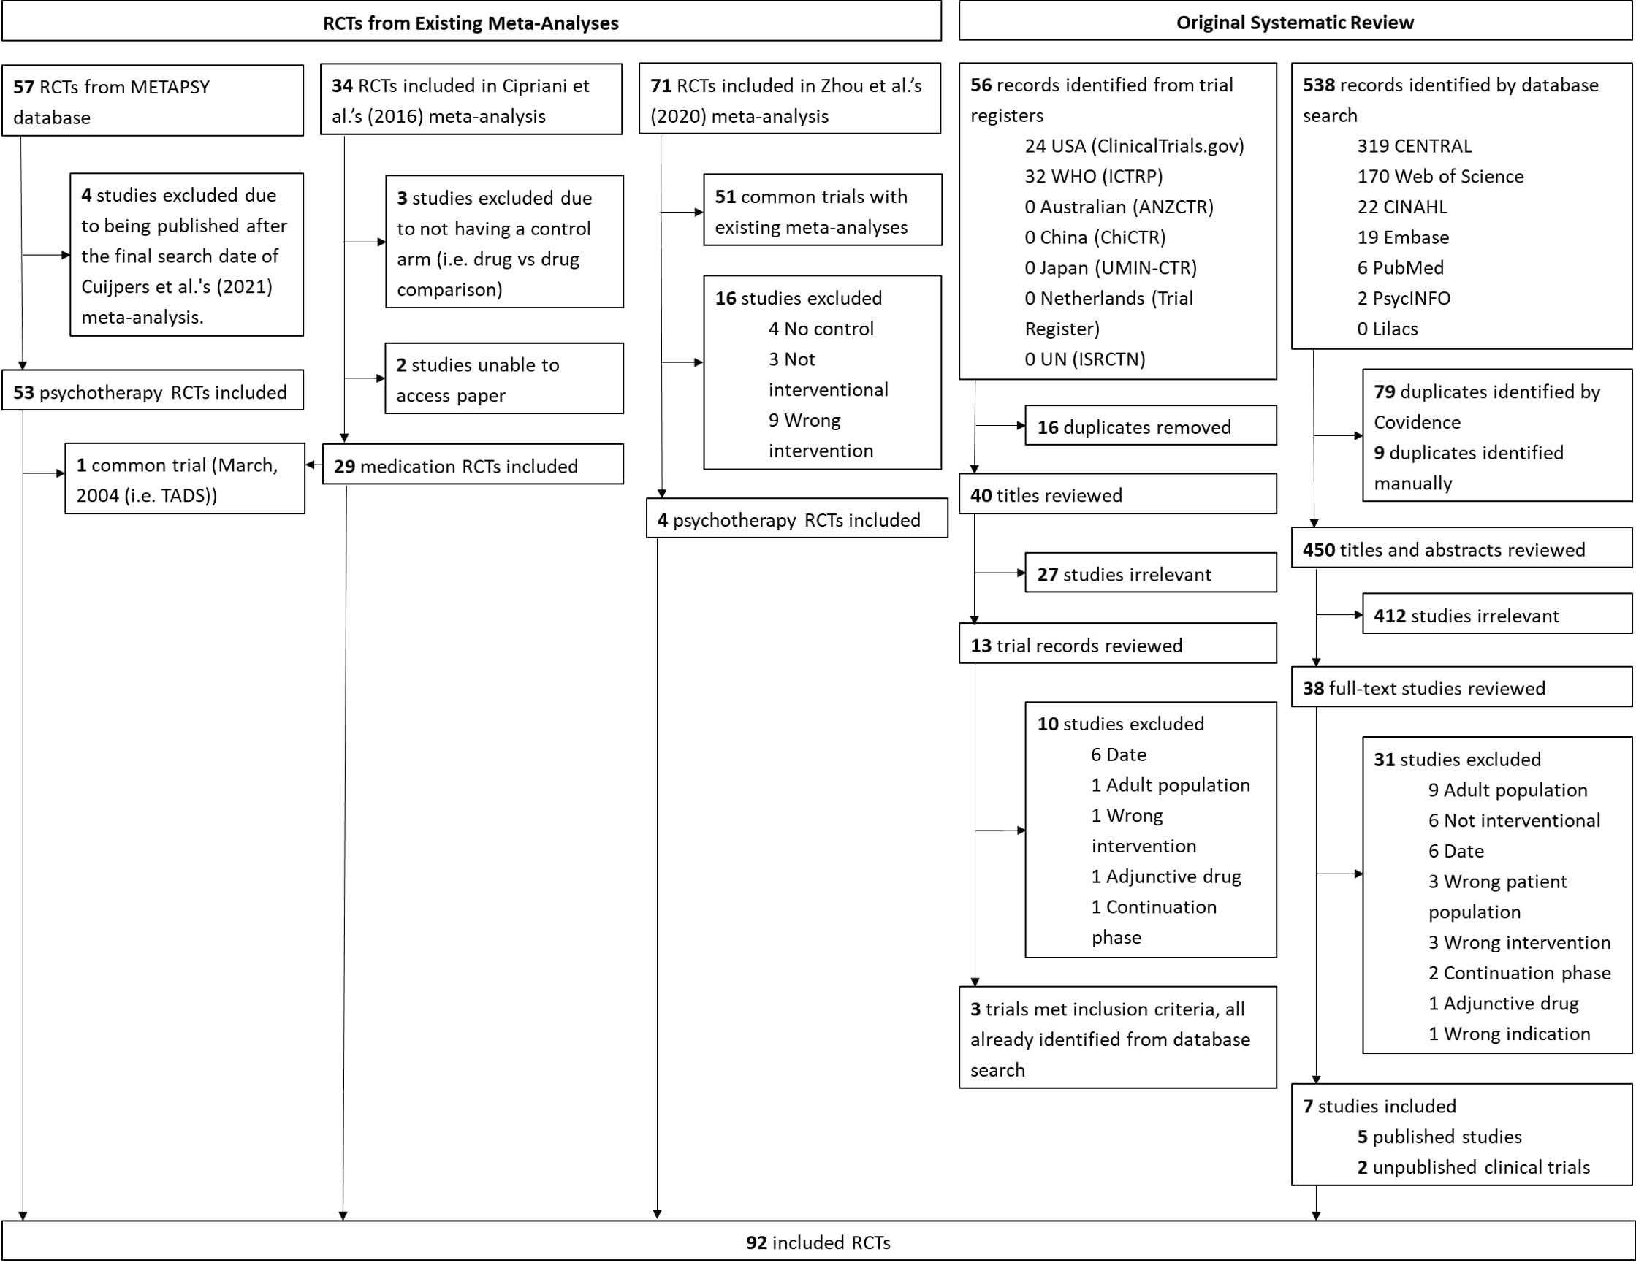

Figure 2: Meta-analytic estimates of within-group changes for overall sample

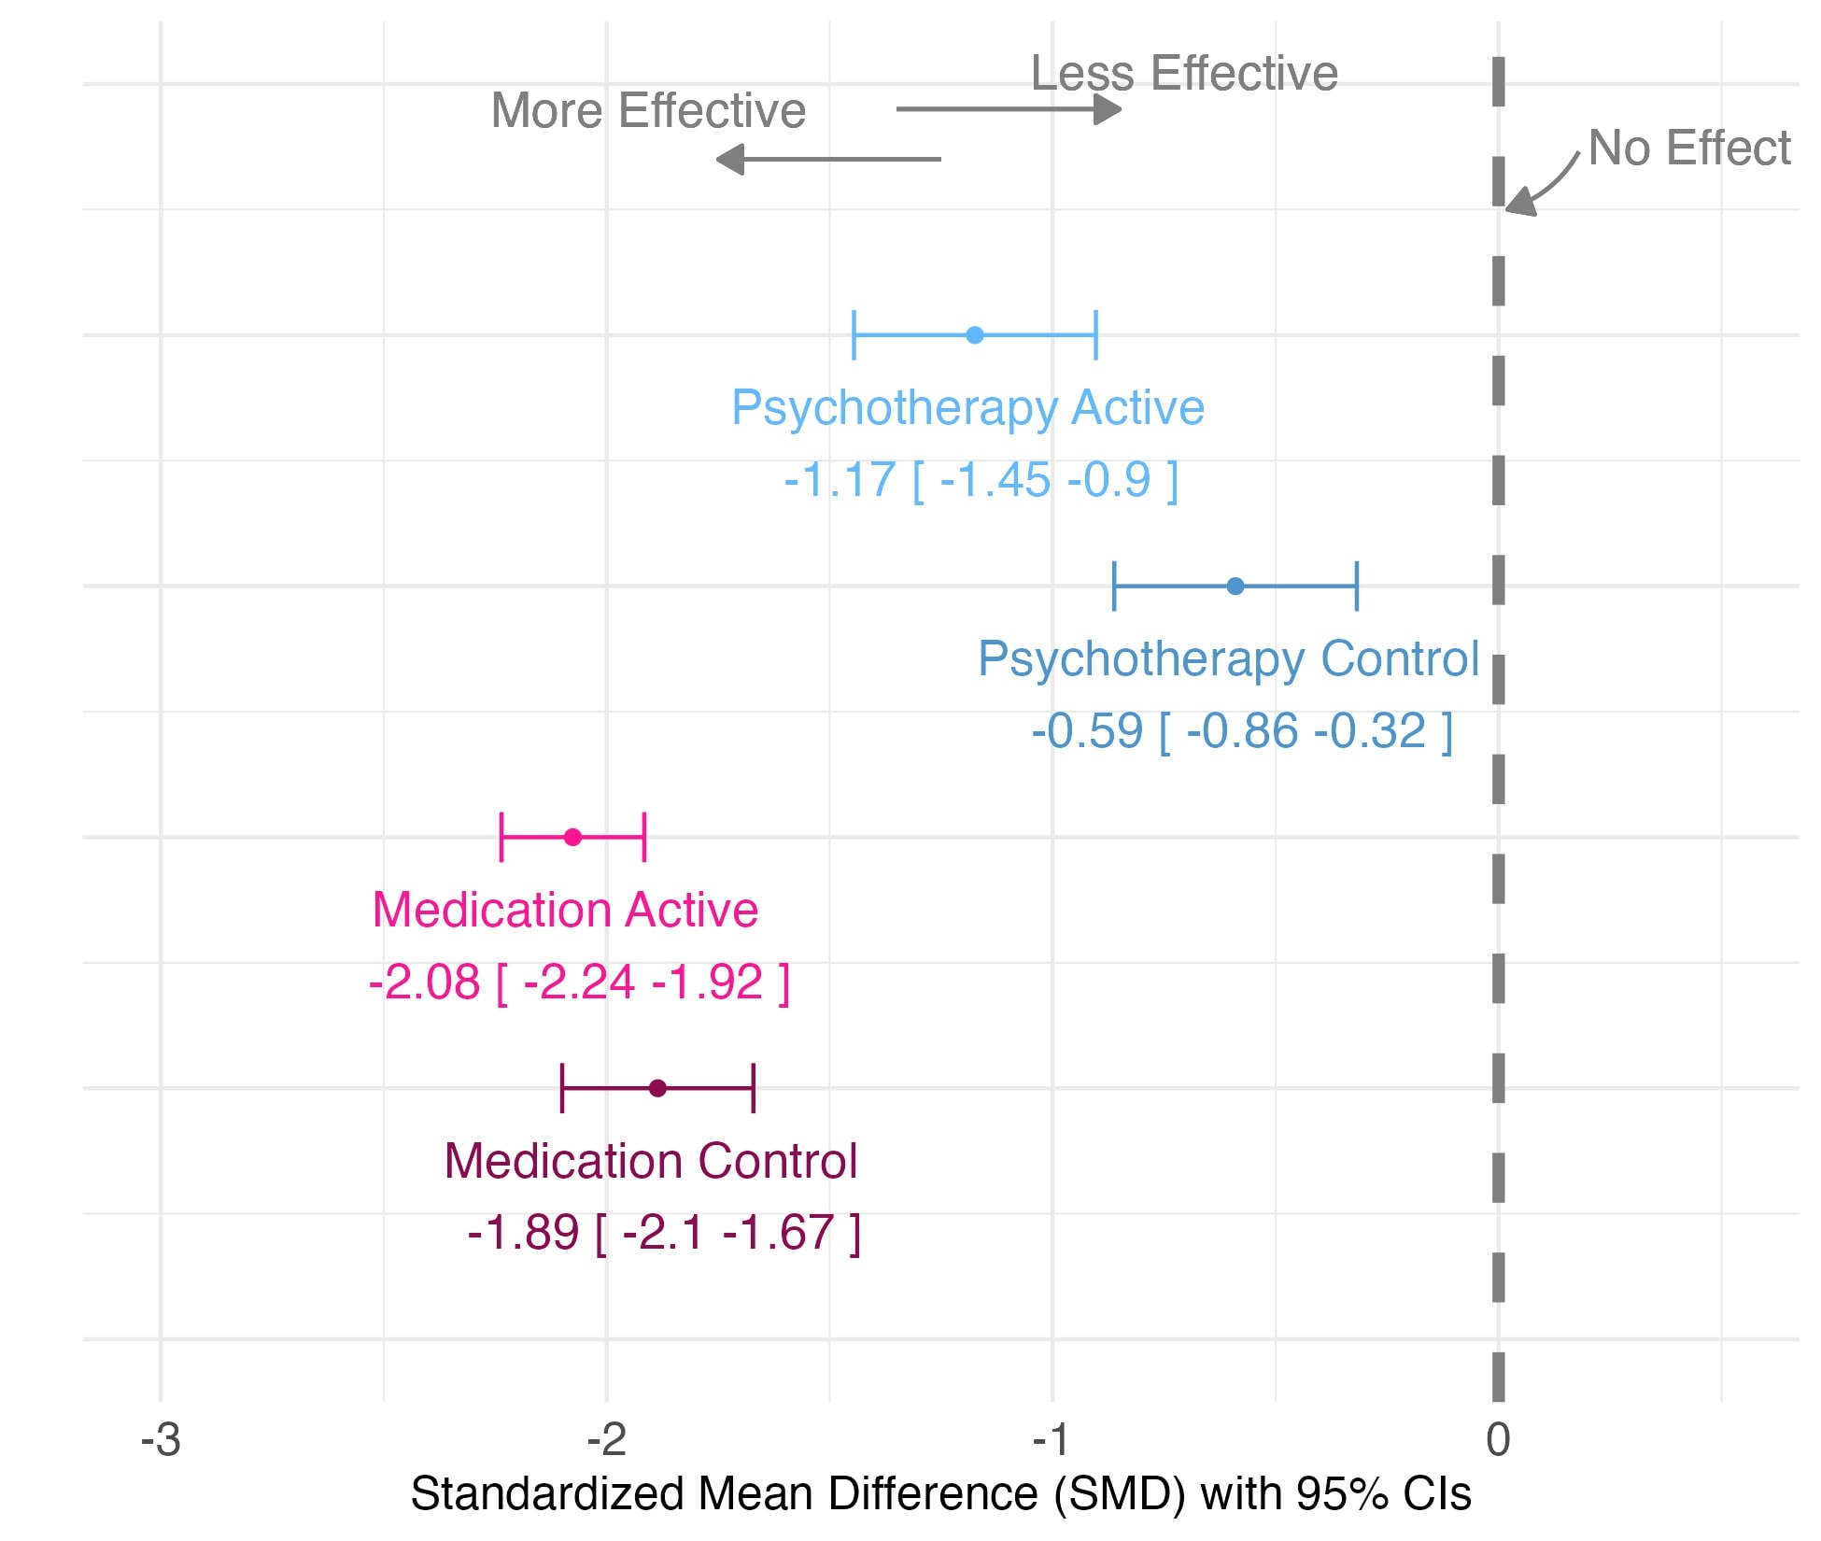

*Figure 3: Pre-post standardised mean differences (SMD) of control arms*

