Systematic Review

Utility of Polygenic Risk Scores (PRS) in predicting pancreatic cancer; A systematic review and meta-analysis of common variant and mixed scores with insights into rare variant analysis

Georgios Ioannis Verras 1,2*, Zaed Hamady 1,2, Andrew Collins 1 and William Tapper 1,*

1 University of Southampton, Faculty of Medicine, School of Human Development and Health, Southampton, UK; giv1m24@soton.ac.uk

2 University Hospital Southampton, Department of General Surgery; W.J.Tapper@soton.ac.uk

**\*** Correspondence: e-mail@e-mail.com; Tel.: (optional; include country code; if there are multiple corresponding authors, add author initials)

|  |
| --- |
| **Citation:** To be added by editorial staff during production.  Academic Editor: Firstname Lastname  Received: date  Revised: date  Accepted: date  Published: date    **Copyright:** © 2024 by the authors. Submitted for possible open access publication under the terms and conditions of the Creative Commons Attribution (CC BY) license (https://creativecommons.org/licenses/by/4.0/). |

**Simple Summary:** Pancreatic cancer remains one of the highest mortality cancers worldwide, with most patients diagnosed at an advanced stage, making curative surgical resection impossible for many. As research efforts focus on early detection, we reviewed the current literature on the use of genetic risk markers and patient risk factors to estimate a person's lifetime risk via polygenic risk scores (PRS) and mixed models which combine PRS with clinical risk factors. Our analysis demonstrates that combining genetic data with patient risk factors significantly improves risk prediction. Through systematic review and meta-analysis, we show that predictive models perform better in populations with Caucasian-ancestry compared to non-Caucasian ancestry. Additionally, increasing the number of genomic markers improves the predictive power of these model. Finally, we consider the potential of rare variants to further enhance the accuracy of these risk prediction models for pancreatic cancer.

**Abstract: Introduction**: Pancreatic cancer remains among the top five causes of cancer-related mortality. Only 18% to 20% of patients present with early-stage, potentially curable disease. Patient risk stratification is critical to increasing the number of individuals eligible for surgery. Polygenic risk scores (PRS), combined with clinical risk factors, offer a promising approach to assess lifetime risk of pancreatic cancer. This systematic review synthesizes the results of all published PRS and mixed models for pancreatic cancer. **Methods:** We systematically searched MEDLINE, Embase, Ovid and Web of Science databases. Odds ratios reported between risk quintiles were transformed to OR per SD increase in risk score. Reported AUCs were synthesized and compared between PRS and mixed models. **Results**: 27 studies were identified for formal synthesis. PRS yielded an OR of 1.40 (1.28-1.53) for pancreatic cancer, while mixed models incorporating clinical risk factors showed a higher OR of 1.58 (1.34 - 1.88). The AUCs for PRS was 0.61 (0.58-0.65), compared to 0.70 (0.61-0.80) for mixed models. The predictive power of PRS models was positively correlated with the number of SNPs included in studies. Ancestry significantly influenced prediction accuracy, with an OR of 1.42 (1.30-1.56) in Caucasian populations compared to 1.21 (0.77-1.90) in Asian populations. **Conclusions:** Adding **c**linical risk factors to PRS models significantly increases their predictive capability. Further research is needed to identify a comprehensive set of risk SNPs, enhance accuracy across diverse populations, and incorporate rare genetic variants. These advancements have the potential to significantly boost the predictive accuracy of PRS and mixed models.

**Keywords:** pancreatic cancer; polygenic risk scores; genetic scores; clinical risk scores; risk stratification; pancreatic adenocarcinoma; risk prediction

1. Introduction

Pancreatic adenocarcinoma is the most common histological subtype of pancreatic cancer, representing approximately 85% of all cases [1–3]. Despite advancements in treatment modalities, including advanced chemotherapy regimens and novel drug delivery approaches [4], surgical management remains the only potentially curative option [1-3]. However, most patients present with late-stage disease which is often inoperable and due to the insidious and asymptomatic progression of the disease [2-6]. Efforts to improve early disease detection through biomarkers and advanced imaging are ongoing but significant improvements in diagnostic rates have yet to be achieved. Early diagnosis is key as this would constitute the disease operable, and thus potentially curable.

Environmental risk factors like tobacco use, obesity, diabetes mellitus, chronic pancreatitis and alcohol consumption are all well-established risk factors for the development of pancreatic cancer [5]. Additionally, pancreatic adenocarcinoma is driven by genetic and epigenetic changes that promote carcinogenesis [5,6]. Up to 10% of patients report an affected first-degree relative, indicating that there is a moderate component of genetic variation in risk of development [6].

1.1. Risk Stratification and Early Detection

Improving early diagnosis hinges on effective risk stratification, which could lead to the development of targeted screening programs. Several research groups have explored the development of polygenic risk scores (PRSs) for predicting risk of pancreatic cancer [9-16]. PRSs estimate an individual’s genetic risk of disease based on the combined effect of single nucleotide polymorphisms (SNPs) identified through genome-wide association studies (GWAS). While individual SNPs usually have weak associations with disease, their additive effect helps assess pancreatic cancer heritability and could be used to stratify patients into different risk prediction categories. Large case-control studies have developed PRS models with varying predictive capabilities and performance. Enhancing these scores by incorporating known clinical risk factors has further increased their predictive performance, especially in specific patient subsets such as patients with diabetes [7,8].

1.2. Expanding the Model with Rare Variants

In addition to common variants, rare genetic variants also play a role in the heritability and progression of pancreatic cancer [9–13]. Incorporating rare variants into polygenic scores has been explored in other diseases such as breast cancer, colorectal cancer and type 2 diabetes [14,15] Studies have also suggested that individuals with low polygenic risk based on common variants are more likely to harbor rare, high-risk variants, [15]. As a result, common variant PRS models could be used to select patients for next-generation-sequencing to identify these rare, disease-associated variants.

1.3. Objective

This systematic review and meta-analysis aims to synthesize the current literature regarding PRS and pancreatic adenocarcinoma. The primary goal is to assess the association between common variant PRS and pancreatic cancer risk by meta-analysis of reported odds ratio (OR) or hazard ratio (HR), and the corresponding 95% confidence intervals. Additionally, we will evaluate the role of rare variants (MAF<0.01) as predictors of pancreatic adenocarcinoma risk.

2. Materials and Methods

This systematic review was conducted in accordance with the Preferred Reporting Items for Systematic Reviews and Meta-Analyses (PRISMA) guidelines. The systematic review protocol for common and rare variants PRS, the formal synthesis of the review results, as well as the meta-analysis were all registered on PROSPERO (ID: CRD42024576795)

2.1. Search strategy

All relevant studies were identified through database searches, as well as citation screening. The systematic review comprised two different searches for easier interpretation and discussion of findings. Firstly, we conducted a systematic search on all studies that had built and assessed a common variants PRS on pancreatic adenocarcinoma, with or without the inclusion of clinical risk factors (mixed scores). Secondly, a separate search was conducted on studies investigating the association of rare variants (MAF<0.01) with pancreatic adenocarcinoma. Due to the lack of studies reporting rare variants as part of the PRS for pancreatic adenocarcinoma, studies investigating rare variant associations were considered separately. For the purposes of both searches, the MEDLINE, Embase, Ovid and Web of Science databases were used. The full search queries for both research questions are presented in Supplemental Tables 1 and 2 respectively. Searches included articles published up to June 3rd, 2024.

2.2. Study selection

For the purposes of this review the initial study search and screening was conducted by GIV at the titles, abstract and full text stages. Further assessment of the included studies at the full text stage was conducted by ZH, WT and AC. Disagreements regarding the evaluation of studies’ quality and relevance were resolved by consensus. Inclusion criteria for both literature searches included: 1) Adult participants aged 18 or older, 2) Pancreatic cancer or adenocarcinoma specifically reported as endpoint outcome, 3) Studies published in English. Studies were excluded if 1) They were of poor design as viewed through the bias and study quality assessment process, 2) were systematic reviews, editorials, opinion articles, letters to the editor or conference papers.

For the first search process regarding PRS with common variants, studies were also excluded if 1) They reported on monogenic associations, 2) they calculated PRS from less than 2 loci, and 3) had a small sample size (defined as <100 individuals). For the systematic review of rare variants in pancreatic cancer, studies were additionally excluded if 1) they included SNPs of MAF>0.01 (as reported in dbSNP) and 2) reported on benign or likely benign variants.

2.3. Quality and risk of bias assessment

The risk of bias of each study was assessed using the Prediction Model Risk Of Bias Assessment Tool (PROBAST). The methodological quality of all studies was also assessed by utilizing the Critical Appraisal Skills Programme (CASP) checklists for methodological rigor. Disagreements between reviewers were resolved by consensus.

2.4. Target outcomes and data extraction

For the purposes of this literature review, we included all studies fitting the above-mentioned criteria, looking into PRS for pancreatic cancer, as well as rare variants associated with the risk of developing pancreatic cancer. The outcome (phenotype) of interest in both cases was the development of pancreatic cancer of any subtype (excluding neuroendocrine tumors), with pancreatic adenocarcinoma being the most investigated. To facilitate data extraction, a specific form was constructed using Microsoft Excel, that included first author name and year of publication, the patient cohort or biobank that each study was based on, clinical risk factors included in mixed scores (in studies investigating PRS + clinical risk factors), the number of SNPs used to construct each PRS, the number of included individuals, the presence of a replication / validation phase following the construction of the PRS, and finally the reported risk estimates for each score, including the 95% confidence intervals. We also extracted tables of information on a “per risk strata” basis from each study, including the number of cases and controls included in the development of each risk score, the risk level and the reported risk estimates.

To complete our systematic review on rare variants associated with pancreatic adenocarcinoma, we extracted information on the genes and rare variants identified by each study. The primary focus was to evaluate the reported effect sizes of these rare variants and the development of pancreatic cancer. However, quantitative synthesis in the form of a meta-analysis was not feasible, as combining summary metrics from associations involving variants in different genes would be difficult to interpret.

2.5. Statistical analysis

The meta-analysis focused on studies reporting on common-variant PRS for pancreatic cancer. We performed a random-effects meta-analysis, using the DerSimonian and Laird inverse variance method to account for variability across studies [12]. Heterogeneity was measured using the Higgins’ I statistic. Where risk estimates were presented as estimates between two categories of PRS-based risk stratification, they were converted to risk per standard deviation using the Greenland and Longnecker approximation[16] a method previously used in PRS meta-analysis. This conversion facilitated synthesis and improved the interpretability of the standardized odds ratios. For each study, the conversion to per-SD risk was undertaken using the doresmeta package in R, and the MAJOR add-on in Jamovi. Where reported, the AUC of each risk score was also included in a separate pooling synthesis and compared between PRS and mixed scores.

To examine the impact of adding clinical risk factors to PRS, creating mixed scores, we performed a subset meta-analysis comparing studies that used PRS alone versus those incorporating clinical risk factors. Chi-squared tests were used to compare pooled results by model type or ancestry.

Between study heterogeneity was further explored by identifying outlying studies contributing significantly to the variance. The find.outliers in the dmetar R package was used to detect studies with 95%CIs lying outside the pooled 95%CI. Outliers were automatically removed to improve consistency. We also assessed heterogeneity based on publication year, population ancestry, and the number of SNPs utilized in each study. Publication bias was visualized and assessed using funnel plots, as well as graded funnel plots.

Sensitivity analyses were conducted on patient subsets by ethnicity to assess differences in model performances between ancestries.

Finally, the effect of publication year and number of SNPs on the reported effect sizes was also assessed by employing meta-regression techniques to the previously mentioned meta-analyses. A linear regression model was fitted, with the number of SNPs or publication year as predictors and the studies’ effect size as the outcome. Meta-regression allows estimation of the effect of number of SNPs and year of publication as regression coefficients, as well as the degree of observed heterogeneity attributed to these variables. All analyses were performed using the R language, and the packages meta, dosresmeta, dmetar, ggrepel and metafor were utilized.

3. Results

3.1. Common-variant polygenic and mixed risk scores on pancreatic cancer

In total, 27 studies were included in the systematic review, regarding common variant PRS studies in pancreatic cancer. Initially, a total of 386 articles were retrieved following the database search, deduplication and citation screening (234 from databases and registers + 152 from other methods). Out of these, 213 were assessed for inclusion, following title screening. The PRISMA flowchart for this literature search can be seen in Figure 1.

Εικόνα που περιέχει κείμενο, στιγμιότυπο οθόνης, γραμματοσειρά, διάγραμμα

Περιγραφή που δημιουργήθηκε αυτόματα

**Figure 1.** PRISMA flowchart for common variant PRS in pancreatic cancer. Taken from Page MJ, Mc Kenzie JE et al [17]

Following removal of duplicates from the three databases, 1472 duplicate records were deleted. From the initial literature search, a total of 76 studies were removed on the basis of lack of referencing pancreatic cancer data, 38 studies failed to report full PRS scores, 43 studies reported only single SNP associations, and another 22 studies were of inappropriate study type for inclusion to the review. An additional 152 studies were retrieved from citation searching and assessed for inclusion in the study, with 5 studies being included in the final synthesis. The included studies in the systematic review regarding common-variant polygenic and mixed scores in pancreatic cancer can be seen in Table 1.

**Table 1.** Studies developing PRS on pancreatic adenocarcinoma.

|  |  |  |  |  |  |
| --- | --- | --- | --- | --- | --- |
| **Author and year** | **Dataset(s) origin** | **Sample Size** | **Clinical risk factors investigated** | **SNPs** | **Summary statistics** |
| **Yuan et al, 2022** [18] | Nurses’ Health Study  HPFS Study  PanScan/ PanC4 | 5107 Cases  8845 Controls | Smoking, Obesity, T2DM (>2 years), Height, Blood Group, Exercise, Alcohol consumption  **No mixed score** | 22 | <60 years OR: 6.91  >70 years OR: 4.12  Top vs bottom centile |
| **Sharma et al, 2022** [8] | UKBiobank | 1042 Cases 10420 Controls | Race, Smoking, DM, Family History, Waist Circumference  **Mixed score + subset analysis** | 49 | HR: 2.738  Top vs bottom quantile |
| **Byrne et al 2023** [5] | UK Biobank | 451 Cases 195822 Controls | Lifestyle Index (Weight, Activity, Dietary profile, smoking status)  **Mixed Score** | 22 | HR: 4.14  Top 5% |
| **Fritsche et al, 2020** [19] | MGI Cohort  UK Biobank Cohort | 1265 Cases 446955 Controls | **No mixed score** | 10 | OR: 1.64 (0.655 – 4.12)  Top 1% |
| **Nodari et al, 2023** [20] | PanScan I, II and III  PANDoRA consortium | 912 Cases  10222 Controls | Smoking, Alcohol Consumption, T2DM  **No mixed score** | 6 | <50 years OR: 2.90 (1.17-7.17)  >50 years OR: 2.44 (1.76-3.38)  5th vs 1st quintile |
| **Galeotti et al, 2021**[21] | PanScan I,II,III and PanC4  dbGaP | 2851 Cases  4810 Controls | Sex, Age, Smoking, T2DM  **Mixed Score** | 30 | PRS OR: 3.24 (2.86-3.67)  Mixed OR: 14.37 (5.57-37.09)  5th vs 1st quantile |
| **Pang et al, 2021** [22] | China Kadoorie Biobank | 585 Cases 512891 Controls | Age, Sex, Alcohol Consumption, Smoking, Education, BMI, Physical Activity, Diabetes (any)  **No mixed score** | 8 | OR: 1.048 (1.05-1.11) per SD increase |
| **Zeng et al, 2023** [23] | UK Biobank | 1129 Cases 340631 Controls | BMI, WC, Physical Activity, Sedentary Time, Dietary Habits, Alcohol Consumption, Smoking  Separate clinical Score: Sex, Age, Education, Socioeconomic Status  **Mixed Score** | 54 | HR: 1.58 (1.47-1.71)  Intermediate vs High PRS  HR: 0.48 (0.41-0.56)  Favorable vs Unfavorable LS |
| **Ke et al, 2023** [24] | UK Biobank  960 patients  257348 controls  (75% training, 25% testing) | 1402 Cases 502387 Controls | Gender, Age, Blood Group, Family history of bowel cancer, Smoking, Alcohol, BMI, Pancreatitis, T2DM, Gallbladder related disease, Hep B infection, Vitamin D deficiency, SLE  **Mixed Score** | 40 | OR: 2.03 (1.65-2.50)  5th quintile vs 1st quintile |
| **Bogumil et al, 2020** [25] | Multiethnic Cohort  Southern Community Cohort Study | 691 Cases  13778 Controls | None | 11 | OR: 2.25 (1.73-2.92)  5th vs 1st quintile |
| **Wang et al, 2020** [26] | Chinese, Single institution | 254 Cases  1200 Controls | Age, Sex | 21 | OR: 1.36 (1.06-1.74) |
| **Nakatochi et al, 2018** [27] | Japanese origin  945 patients, 2109 Controls | 945 Cases  2109 Controls | Smoking  Family history of pancreatic cancer | 5 | OR: 1.98 (1.42-2.76)  1st vs 5th quintile |
| **Lu et al, 2021** [28] | PanScan I, II, III, PanC4  PANDoRA for replication | 8769 Cases  7055 Controls | Sex, Age, Country | 6 |  |
| **Zhu et al, 2024** [29] | UK Biobank  765 cases | 765 Cases 315512 Controls | Smoking (stratification) |  | Non-smk OR: 2.31 (1.69-3.15)  Ever-smk OR: 0.53 (0.30-0.91) |
| **Pierce et al 2023** [30] | PanScan I,II | 1478 Cases  1534 Controls | None | 12 | OR: 0.9 (0.85-1.0) |
| **Hu et al 2024** [31] | UK Biobank | 1402 Cases 409532 Controls | Living status, Number in household, Dietary requirements, Basal metabolic rate, Overall health, Tense, Comparative, Hair Colour, Mean corpuscular haemoglobin, Vascular/heart problems, Reticulocyte count, Physical activity, Anxiety, Waist circumference, Cancer diagnosis, Lymphocyte count, Whole body fat free mass, Highest qualifications, Glycated haemoglobin | - | AUC: 0.549 |
| **Shi et al, 2019** [32] | The Cancer Genome Atlas  Electronic Medical Records and Genomics | 163 Cases 13427 Controls | None | 9 | OR 1.67 (1.1-2.53) per SD increase |
| **Aoki et al, 2021** [33] | Two centers in Brazil | 78 Cases  256 Controls | Sex, Ethnicity, Smoking, Alcohol use, History of pancreatitis  **No mixed score** | 24 | OR: 8.13 (2.95 – 22.43)  5th vs 1st quintile |
| **Graff et al, 2021** [34] | UK Biobank and GERA cohort | 665 Cases 410354 Controls | None | 22 | OR: 1.44 (1.33 – 1.55)  per SD increase |
| **Jia et al, 2020** [35] | UK Biobank | 432 Cases 479652 Controls | None | 22 | HR: 3.37 (2.39 - 4.76)  5th vs 1st quntile |
| **Kachuri et al, 2021** [36] | UK Biobank | 768 Cases 413753 Controls | Family History of Cancer, Smoking, Alcohol Intake, Adiposity | 22 | OR: 1.49 (1.37-1.63)  per SD increase |
| **Klein et al, 2018** [37] | PanC4 | 9040 Cases 12496 Controls | None | 22 | OR: 2.20 (1.83-2.65)  5th vs 10th decile |
| **Meisner et al, 2020** [38] | UK Biobank | 496 Cases 337138 Controls | None | 18 | OR 1.42 (1.22 – 1.63)  per SD increase |
| **Rothwell et al, 2022** [39] | UK Biobank | 478 Cases 366016 Controls | Metabolic Syndrome, Height, Alcohol, Smoking, Education Levels  **Not used for mixed modelling** | 26 | Used only for stratifying.  No separate report |
| **Salvatore et al, 2021** [40] | MGI  UK Biobank | 1089 Cases 430570 Controls | BMI, Alcohol, Smoking  **Mixed Score** | 18 | OR: 2.16 (1.76 - 2.65)  5th vs 1st quintile |
| **Wang et al, 2022** [41] | Penn Medicine Biobank | 46 Cases  6383 Controls | Stratified for age and sex | 18 | OR: 1.023 (0.759 - 1.377)  per SD increase |
| **Dite et al, 2023** [42] | UK Biobank | 851 Cases 376462 Controls | None | 22 | OR: 1.31 (95% CI, 1.264–1.357)  per SD increase |

3.2. Rare variant association studies on pancreatic cancer

For the systematic review of rare variants and pancreatic adenocarcinoma, a total of 21 studies were included in the final list of articles. Initially, a total of 251 studies were assessed following title exclusion, and 19 more were retrieved through citation searching (Figure 2). Forty-six studies were excluded due to investigation of common rather than rare SNPs.

**Figure 2.** PRISMA flowchart for rare variant association analysis in pancreatic cancer. Taken from Page MJ, Mc Kenzie JE et al [17]

Following a full-text assessment, 154 studies were excluded due to low relevance (i.e., not focused on pancreatic cancer, cases studies involving single patients, or investigations of rare molecular and histopathological subtypes of pancreatic cancer). Lastly, five more articles were excluded due to being of an inappropriate type. The remaining studies examining rare variants in relation to pancreatic cancer are listed in Table 2.

**Table 2.** Studies on rare variant associations with pancreatic adenocarcinoma.

|  |  |  |
| --- | --- | --- |
| **Author and year** | **Genes and variants investigated** |  |
| **Saha et al, 2020** [43] | KMT2C, TP53, NM_000546.6(TP53):c.413C>T, SMAD4, CTNNB1, ERBB2, NOTCH1, PARP1, PIK3R1, PIK3CD | |
| **Symonds et al, 2022** [44] | ERCC4, RET, HMBS, EPCAM, MRE11, ATM (rs1555093684), BRCA2 (rs80359537), CDKN2A, CDC73, ERCC4, ERCC5, FANCD2, NM_001018115.3(FANCD2):c.1876C>T, L2HGDH, PMS2, NM_000535.7(PMS2):c.904-2A>G, NM_000535.7(PMS2):c.1882C>T, RB1, CFTR (rs201958172), GBA (rs367968666), HMBS, MRE11, NSD1, PALB2, NM_024675.4(PALB2):c.470C>A, RAD51C, RET, SLC25A13, NM_014251.3(SLC25A13):c.1762C>T (p.Arg588Ter), NM_014251.3(SLC25A13):c.1063C>T (p.Arg355Ter), SLX4, TRIM37, (p.Ser157Ter), NM_000283.4(PDE6B):c.2395C>T (p.Arg799Ter), NM_020975.4(RET):c.[2410G>A;2832C>G], NM_015047.3(EMC1):c.2059C>T (p.Arg687Ter) | |
| **Gentiluomo et al, 2019** [12] | TAS1R2 (rs11261087) | |
| **Tan et al, 2022** [13] | ATM, POLE, BRCA2, TYR03, PABC1, SSC5D |  |
| **Slater et al, 2021** [10] | PCMS c.724G > A, FPC p.(A242T) | |
| **Yang et al 2016** [45] | APC, ATM (rs587779852, rs567060474), BRCA1 (rs28897673), BRCA2 (rs80359537), CASR, CFTR (rs201958172, rs397508725, rs151048781, rs149279509), CPA1, FANCA, MLH1, MSH2 (rs267607911, rs145649774, rs34136999), MSH6 (rs376220212), PALB2 (rs180177100), PMS2 (rs587780046), TP53 (rs145151284) | |
| **Grant et al, 2018** [46] | BRCA2 (rs80359550), PZP, IFNA5, FGFR3 (rs17881656), NM_000059.4(FGFR3):c.10095 | |
| **Obazee et al, 2019** [47] | BRCA2 (rs11571833), CHEK2 (rs17879961) |  |
| **Wieme et al 2021** [48] | ATM, NM_000051.4(ATM):c.1564_1565del(p.Glu522fs),NM_000051.4:c.3756_3757dup,NM_000051.4(ATM):c.6095G>A(p.Arg2032Lys),NM_000051.4:c.6096-9_6096-5del, NM_000051.4(ATM):c.7327C>T(p.Arg2443Ter), NM_000051.4(ATM):c.8494C>Tp.Arg2832Cys), BRCA1, NM_007294.4(BRCA1):c.2411_2412del (p.Gln804fs), NM_007294.4(BRCA1):c.3991C>T(p.Gln1331Ter), NM_007294.4(BRCA1):c.3770_3771del(p.Glu1257fs), BRCA2, NM_000059.4(BRCA2):c.8487+47C>Tc.1989del,NM_000059.4(BRCA2):c.3545_3546del(p.Gln1181_Phe1182insTer), NM_000059.4(BRCA2):c.475G>A(p.Val159Met), NM_000059.4(BRCA2):c.4935del(p.Glu1646fs), NM_000059.4(BRCA2):c.5073dup(p.Trp1692fs), NM_000059.4(BRCA2):c.6275_6276del (p.Leu2092fs), NM_000059.4:c.7415dup, NM_000059.4(BRCA2):c.7480C>T (p.Arg2494Ter), NM_000059.4(BRCA2):c.8167G>C (p.Asp2723His)c.8755-1G>A, NM_000059.4(BRCA2):c.8755-1G>T, CHEK2, NM_007194.4:c.846+4_846+7del, NM_007194.4(CHEK2):c.917G>C (p.Gly306Ala), ERCC4, FANCE, NBN, NM_031483.7(ITCH):c.212+3A>Gc.2263G>T, NM_000535.7(PMS2):c.137G>T (p.Ser46Ile), NM_000535.7(PMS2):c.1840A>T (p.Lys614Ter), NM_000546.6(TP53):c.528C>A (p.Cys176Ter), NM_000488.4(SERPINC1):c.801_805del (p.Lys268fs) | |
| **Yu et al 2022** [49] | ADGRF3 (rs150568284), MAP3K11 (rs35487354), TERT (rs2736098), rs9579139, PRHOXNB, PDX1 (rs9581943), HECTD2 (rs61754654), INPP4A, ABCB1, TAAR6 (rs41298393), SBDS (rs120074160), OR2AT4 (rs145245435), GPR113, chr7-87160645-87160645 | |
| **Hendifar et al 2021** [50] | V600E, BRAF, SND1-BRAF fusions |  |
| **Puccini et al, 2022** [51] | ATM, BRCA1, BRCA2, CDKN2A, FANCA, AD50 |  |
| **Tan et al, 2021** [13] | PALD1, COL4A2 (rs370540848) - CYLC2 (rs139628328), ZFYVE9 (rs749151241) - BRD3 (rs149702159) - BRD4 (rs149982995, rs35676845), LRP1B (rs148734150, rs139901295, rs75995642, rs77234491, rs138996626) | |
| **Horn et al, 2021** [52] | CDK9A nsv6313094 | |
| **Hei Ryu et al, 2021** [53] | ATM (rs587781598, rs780619951, rs1442299125, rs786202800, rs770641163), BRCA1 (rs80357662, rs80357524), BRCA2 (rs80359659, rs80358427), MSH3 (rs539295465), RAD50 (rs778555849), RAD51D (rs1403784434, rs753862052), PALB2 (rs587776527), PMS2 (rs587778618), SPINK1 (rs148954387), TP53 (rs397516436) | |
| **Fujitani et al, 2023** [11] | APC, BRCA2 (rs2072490081), BUB1B (rs28989182), MSH6 (rs63750909), AXIN2, BMPR1A, MSH2 (rs772662439), SMARCA4, TP53 (rs397516436) | |
| **McWilliams et al, 2018** [54] | CDKN2A |  |
| **Kawamoto et al, 2021** [55] | CPA1 (rs267601284, rs782248213, rs184981267, rs201750163), CPB1 (rs1275676207, rs201519774) | |
| **Chen et al, 2019** [56] | TERT-CPLTML (rs35226131), DAB2 (rs2255280) | |
| **Polaski et al, 2021** [57] | TERT (rs377639087) | |
| **Yu et al, 2021** [9] | HECTD2 (rs61754654), CSGALANACT1_DUP_01 (rs34799877), PFAS (rs34778863), PLEKHH1 (rs45616031), INPP4A, TMEM217 (rs34322528), OR2AT4 (rs145245435), PDGFB (rs55634318), GPR113 (rs150568284), SPTBN5 (rs149954264), UBE3B (rs61748069) | |

3.3. Meta-analysis of common variant PRS and mixed scores

In total, 23 PRS-only models and 10 mixed models were included. Figure 3 presents a comparative synthesis of the standardized ORs from these models. Odds ratios per SD ranged from 1.02 to 2.69, with a small study by Ke et al, reporting an OR of 6.3. The pooled OR per SD increase in PRS-only models was 1.40 (95%CI 1.28 – 1.53), while for mixed scores it was 1.58 (95%CI 1.34 – 1.88). Although there was a modest increase in the average OR when clinical risk factors were incorporated, the comparison between the two groups did not reach statistical significance (*p*=0.15) and both subgroups showed considerable heterogeneity (Figure 3). The overall pooled OR across the two study groups was 1.45 (95%CI 1.34 – 1.57).

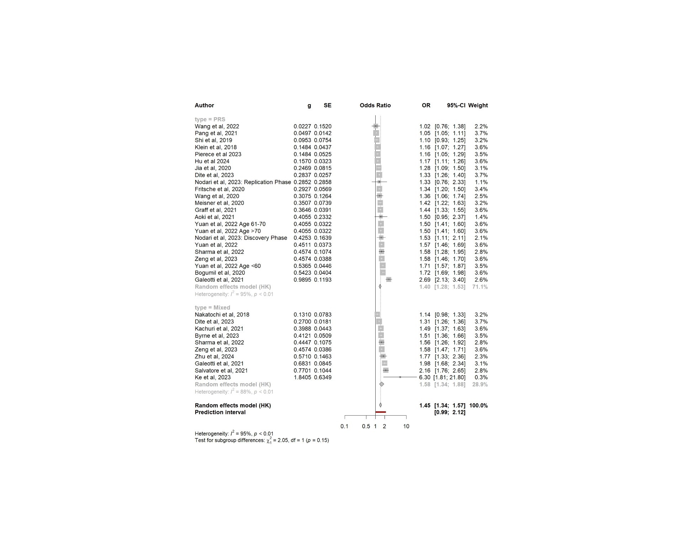

**Figure 3.** Synthesis of polygenic and mixed scores Odds Ratios (OR) and 95% CIs. **Legend**. The size of the rectangle corresponds to study weight, and horizontal lines indicate the confidence intervals.

3.4. Meta-analysis of AUCs from common-variant PRSs

AUC values were reported in 9 PRS-only studies and 6 mixed score studies. A comparative meta-analysis yielded a pooled AUC of 0.61 (95%CI 0.58 – 0.65) for PRS-only models and 0.70 (95%CI 0.61 – 0.80) for the mixed models (Figure 4). The inclusion of clinical risk factors led to a statistically significant improvement in predictive performance (*p*=0.03). The overall pooled AUC across both PRS-only and mixed models was 0.65 (95%CI 0.60 – 0.69), highlighting the benefit of combining genetic and clinical data for more accurate risk stratification.

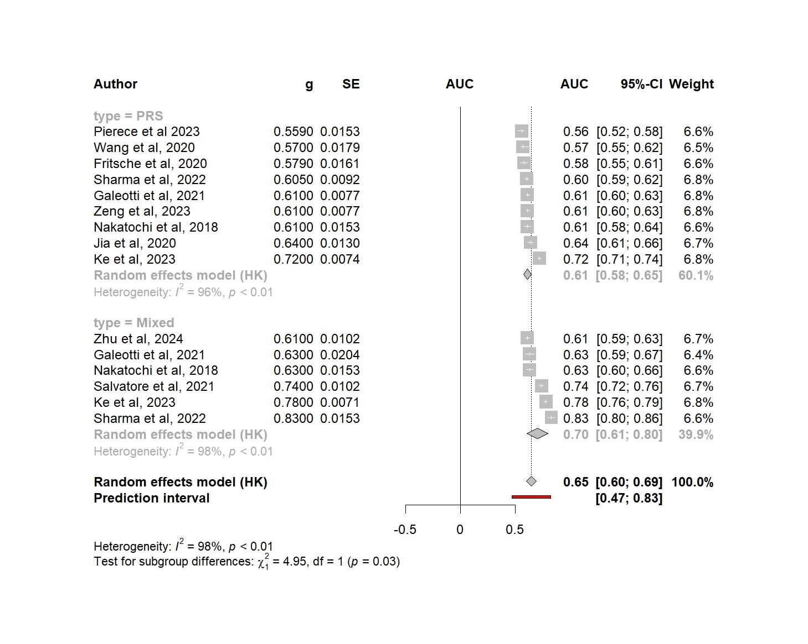

**Figure 4.** Pooled AUC scores by model type. **Legend**. The size of the rectangle corresponds to study weight, and horizontal lines indicate the confidence intervals.

3.5. The effect of ancestry in risk score performance

Most of the included studies developed polygenic and mixed risk scores using data from populations of predominantly Caucasian /European ancestry. Only three PRS models were developed based on individuals of Asian ancestry (Pang et al, Wang et al, Aoki et al). A post-hoc subgroup analysis comparing the scores between ancestry group is shown in Figure 5A.

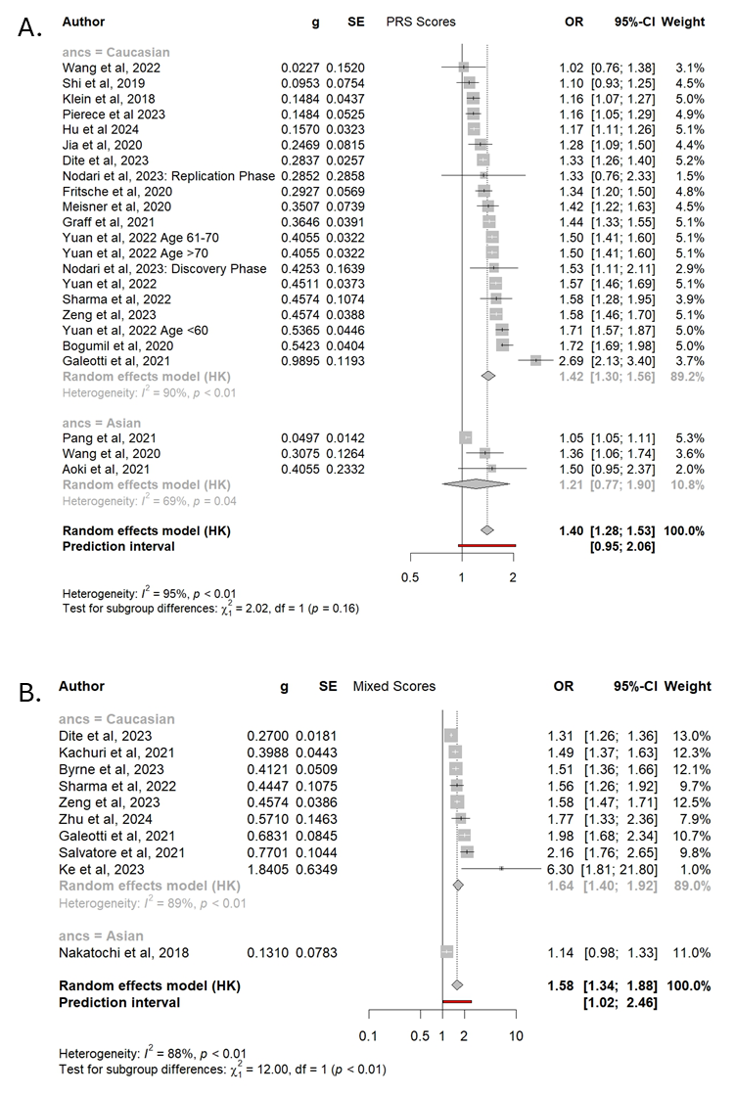

**Figure 5.** Comparison of pooled PRS estimates (A) and mixed scores (B) between Caucasian and Asian populations.

The pooled OR per SD increase in PRS scores for studies of Caucasian ancestry was 1.42 (95%CI 1.30 – 1.56), compared to 1.21 (95%CI 0.77 – 1.90) for Asian-origin populations. Despite the observed OR difference of 0.21 the between ancestry subgroups, the statistical comparison was not significant (p=0.16). Both subgroups, as well as the pooled estimate, exhibited high levels of heterogeneity (Figure 5).

Studies that combined PRS with clinical risk factors had limited representation from Asian populations, with only one study by Nakatochi et al developing a mixed score in this group. The comparison between ancestry subgroups in mixed models revealed a statistically significant difference OR 1.64 (95%CI 1.40 – 1.92) and 1.14 (95%CI 0.98 – 1.33) for the Caucasian and Asian populations respectively. However, this difference in effect size should be interpreted cautiously, as the Asian subgroup consists of a single study. In addition, the adjusted OR per SD increase for Nakatochi et al includes the null value within its 95% CI, further reducing the reliability of the effect size estimate (Figure 5B).

AUC metrics by ancestry exhibited a similar difference as reported for standardized OR increase in PRS and mixed scores. Models developed from Caucasian ancestry populations were found to have higher pooled AUC estimates in prediction of pancreatic cancer occurrence; PRS scores achieved a pooled AUC of 0.62 (95%CI 0.57 – 0.67) with mixed scores exhibiting a calculated AUC of 0.72 (95%CI 0.60 – 0.84) (Supplementary Figures 1 and 2). In contrast, models developed in populations of Asian ancestry achieved inferior predictive scores, with an AUC of 0.59 (95%CI 0.34 – 0.84) and 0.63 (95%CI 0.60 – 0.66) for PRS and mixed scores respectively. The previously exhibited trend of sub-optimal prediction metrics for pancreatic cancer is repeated in AUC metrics.

3.6. Exploring the effect of SNP number and publication year in model performances through meta-regression

The next phase of the post-hoc analysis involves conducting a meta-regression to examine the relationship between publication year and the reported effect size for both common variant PRS and mixed models. This method allows an assessment of how much of the heterogeneity within the meta-analysis can be attributed to publication year. Figure 6 presents bubble plots displaying the study effect sizes (standardized OR) and AUC over publication year. There is a positive correlation between publication year and effect size in most of the associations, as shown by the moderately positive slope of the trend lines.

Εικόνα που περιέχει κείμενο, διάγραμμα, παράλληλα

Περιγραφή που δημιουργήθηκε αυτόματα

**Figure 6.** The effect of publication year on estimated effect sizes for standardized ORs in PRS score studies (A), standardized ORs in mixed score studies (B), AUC in PRS score studies (C), AUC in mixed score studies (D)**.**

There is a moderate positive correlation between publication year and reported PRS effect size, however it does not constitute a significant predictor for this analysis (*p*=0.63). The PRS study by Galeotti et al is identified as an outlier.

A similar association can be seen when plotting effect sizes by publication year for mixed models (Figure 7.B). There is a positive association between publication year and reported standardized OR increase, however publication year is not a significant predictor of effect size estimates (*p*=0.46).

The mixed model study by Ke et al is identified as an outlier of high reported ORs, although of small overall weight in the pooled analysis. Following the regression analysis for publication year as a meta-analysis covariate, there was no heterogeneity attributable to publication year for any of the meta-analyses.

Number of SNPs included in polygenic risk scores is an important potential covariate of increased predictive capability. This was assessed using meta-regression modelling to fit a model utilizing the number of SNPs for each model as a univariable continuous predictor of the reported metrics (OR or AUC).

The number of SNPs included in PRS-only models shows a consistent positive association with increased standardized ORs across studies (Figure 7). Meta-regression analysis confirms that the number of SNPs is a significant predictor of effect size in PRS-only models (*p*=0.043), indicating that incorporating more SNPs tends to improve the predictive power of these scores. However, SNP number was not associated with the effect size of mixed models (*p*=0.408). This suggests that in mixed models, the addition of clinical factors may dilute the impact of SNP count on predictive performance.

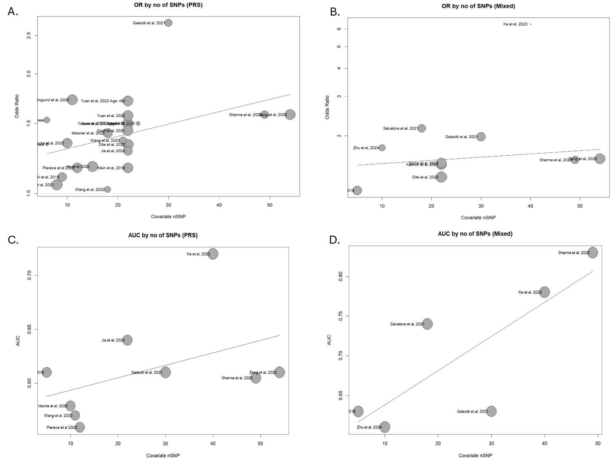

**Figure 7.** Correlation of number of SNPs included and reported study effect size in PRS-only (A) and mixed model studies (B). Correlation of number of SNPs utilized to build risk scores, and reported AUC metrics in PRS-only (C) and mixed score studies (D). **Legend.** The studies by Sharma et al, and Zeng et al are identified as outliers, achieving the highest number of SNPs included.

This analysis also reveals that a proportion of the heterogeneity observed between PRS studies can be attributed to the number of SNPs included in each model. It was estimated that 18.29% of the heterogeneity previously identified (see Figure 3) can be explained by the number of SNPs used in each study. This indicates that SNP quantity is an important factor contributing to the variability in effect sizes reported across different PRS studies.

Conversely, when looking at the effect of SNP number in mixed models, they were not a significant predictor of the standardized increase in OR for pancreatic cancer (*p*=0.54). The association between reported OR and number of SNPs in mixed models can be seen in Figure 7.B.

The same trends can be seen when we look at the association between number of SNPs and reported AUCs from PRS-only and mixed score studies (Figure 7).

Meta-regression analysis for AUCs reported by polygenic and mixed risk scores, did not reveal a significant association between the number of SNPs used and prediction metrics (*p*=0.2368 and 0.0613 respectively). A moderate percentage of between study heterogeneity however could be attributed to number of SNPs for both study subgroups (59.2% for the AUC analysis).

3.7. Addressing heterogeneity through study outlier identification

To further narrow down the source of between-study heterogeneity we conducted a sensitivity analysis to identify outlying studies within the two meta-analyses, that contribute a high degree of heterogeneity. A diagnostic plot of the study’s contribution to the Q-statistic for heterogeneity versus the influence of each study is used to visualize individual contribution to overall heterogeneity (Baujat plot) (Figure 8).

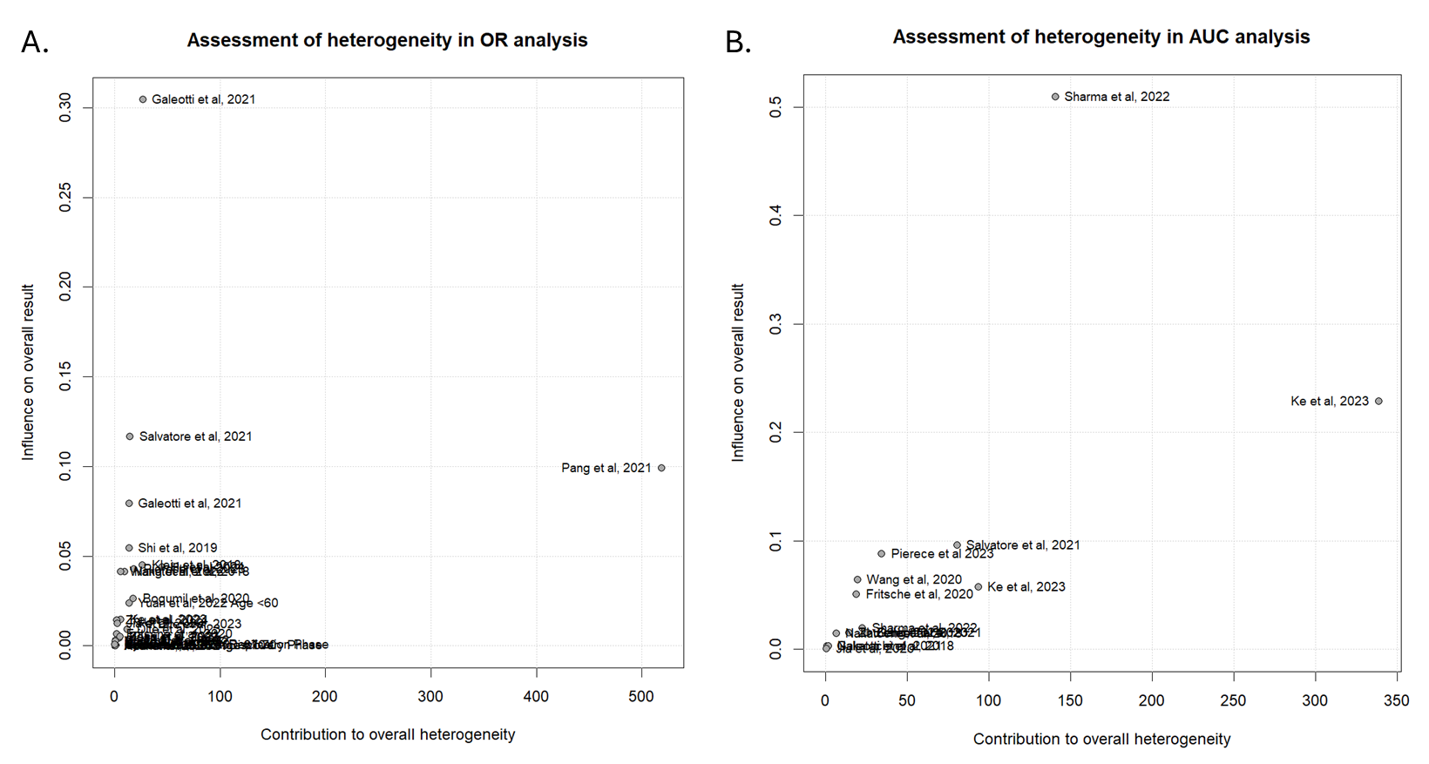

**Figure 8.** Baujat plot of studies utilized in OR analysis (A). Baujat plot of studies utilized in AUC analysis (B).

There are some studies that stand out after plotting individual heterogeneity contributions. The study by Pang et al appears as an outlier of high heterogeneity in the OR meta-analysis. Galeotti et al, is shown to have the highest attributable influence on pooled results, while maintaining low contribution to heterogeneity. For the AUC meta-analysis, the study by Ke et al is identified as an outlying contributor to total heterogeneity of the analysis, while Sharma et al achieves the highest contribution to pooled estimates, with moderate contribution to overall heterogeneity.

Identification and removal of outlying studies of high heterogeneity was performed to assess the degree of heterogeneity individual studies can account for (see section 2.5). For the OR meta-analysis between PRS-only and mixed studies, the studies by Galeotti et al, Ke et al, Nakatochi et al, Shi et al, Klein et al, Yuan et al, 2022, Pang et al, 2021, Bogumil et al, Pierece et al, Hu et al, Salvatore et al were identified as influential outliers and removed from the analysis. The resulting new heterogeneity following exclusion was 71.2% overall. Comparative results of pooled effects following influential study removal can be seen in Supplementary Table 3.

Similarly, for the AUC meta-analysis, the studies by Sharma et al, Ke et al, Pierce et al, and Salvatore et al were identified as influential to heterogeneity and removed to improve heterogeneity. Heterogeneity was reduced from 98% to 47% following exclusion (Supplementary Table 3).

Following the trial of influential study removal, there are some differences between the reported pooled effect estimates of the comparative meta-analyses. For ORs and AUCs alike, the differences between PRS-only and mixed score studies appear to be minimized (Supplementary Table 1). The improvement of standardized ORs in mixed scores is 0.04 from an initial 0.18, with the improvement in AUC estimation being 0.02 from 0.09. Although subgroup and total heterogeneity were reduced for both analyses, the results need to be carefully interpreted, as between-study heterogeneity was still moderately high, and the removal of studies with high attributed heterogeneity, also led to removing influential studies for the observed outcomes, including studies reporting outcomes from big datasets, using large SNP arrays (e.g. Galeotti et al, Sharma et al, Ke et al).

3.8. Addressing publication bias

To assess publication bias in the present study, we looked at the two meta-analyses (OR and AUC) separately. The contour-enhanced funnel plots for the two analyses can be seen in Supplemental Figure 3. The trim and fill method was utilized to correct for observed asymmetry. The Egger’s regression test for funnel plot asymmetry indicates significant asymmetry for the OR meta-analysis (*p*=0.0251). On the contrary, the AUC meta- analysis was not significantly affected by publication bias as expressed by the Egger’s test (*p*=0.2906). Small-study bias appears significant in standardized OR analysis, however the origin of bias must be carefully interpreted (see Discussion).

4. Discussion

4.1. Synthesis of common variant polygenic and mixed risk scores for pancreatic cancer

This systematic literature review and meta-analysis evaluated the performance of risk prediction models for pancreatic cancer, synthesizing data from 23 PRS-only models and 10 mixed models that incorporated both genetic and clinical risk factors. Smoking, diabetes, BMI, age, and sex were included in most models. The pooled OR for PRS-only models was 1.40, which increased to 1.58 for mixed models. While this suggests a potential enhancement in predictive accuracy with the addition of clinical factors, the difference in ORs between the two groups was not significant (p=0.15). In terms of discrimination, AUC values were reported in nine PRS-only models, with a pooled AUC of 0.61, and six mixed-models with a pooled AUC of 0.70. This increase in AUC was significant (p=0.03), indicating that the combination of genetic and clinical data significantly improves their discriminative ability. This is a key finding due to the scarcity of studies comparing AUCs before and after inclusion of clinical risk factors. Of the studies included, only three reported an improvement in the AUC following the addition of clinical risk factors [8,21,27]. While all 3 studies recorded an improvement in the AUC following addition of clinical risk factors, only Sharma et al [8] formally assessed the significance of this improvement, that was in line with the findings of our synthesis.

Improvement of prediction metrics following addition of clinical risk factors to PRSs has previously been observed in several phenotypes including cardiovascular disease, type 2 diabetes and breast cancer [58–61]. The non-significant difference in ORs between PRS-only and mixed models are most likely due to the high levels of heterogeneity seen in both PRS-only (I2=95%) and mixed models (I2=88%), which may reflect varying study designs, population characteristics, and number of SNPs used. These factors impact the comparability of model performanceand indicate that standardization of PRS construction and selection of clinical risk factors is needed. Clinical risk factor selection in mixed model studies is heterogenous, although we can see that age, sex, diabetes and smoking are common denominators in most mixed scores (Table 1). This is likely one of the sources of between-study heterogeneity seen in all meta-analyses and subset analyses conducted. Future research efforts should focus on standardizing the selection of environmental risk factors for model building and emphasize uniformity in their measurement. Among the 27 studies included, 21 sourced their patient populations from large national or multinational biobanks, such as the UK Biobank, PanScan study, PANC I-III biobanks and the GERA cohort. The remaining studies were based on institutional or regional biobanks, which generally had smaller sample sizes and less population diversity that may introduce a higher risk of recruitment and population bias.

Authors have previously proposed the addition of more known clinical risk factors for pancreatic cancer, such as family history, alcohol consumption, history of chronic or acute pancreatitis and more [1–3]. Among these risk factors, there are metrics that remain underutilized in prediction modelling of pancreatic cancer, including exercise status (relative to obesity and BMI), HbA1C levels (relative to diabetes and prediabetes diagnosis), patient history of pancreatitis, socioeconomic index, and dietary habits. Disease cytopathology can be studied as an additional covariate, especially given the recent advancements in automated reporting and creation of repositories[62]. Four studies included family history as a clinical risk factor [8,24,27,36] which has potential benefits for improving risk prediction but may also introduce some potential issues. Family history is a measure of inherited genetic risk which may indicate that some genetic factors are missing from the PRS, but it could also result in the genetic information being double counted and lead to inflated or inaccurate risk estimates. A well-designed mixed model would need to carefully separate out the genetic component of family history from the environmental factors such as shared lifestyle or exposures that also contribute to disease risk. Additionally, these risk factors can be used to perform multi-trait GWAS which simultaneously analyze multiple correlated traits [63,64] such as BMI, diabetes and pancreatic cancer to refine estimated SNP effect sizes and/or detect novel SNPs. Ancestry subgroup analysis shows underrepresentation in non-Caucasian risk prediction modelling. Asian populations had lower prediction metrics (Pooled AUC 0.62 95%CI 0.57 – 0.67) than Caucasians (Pooled AUC 0.72 95%CI 0.60-0.84). Frameworks have been developed to improve model fit by including ancestry-differential effects in mixed populations [60,61]. A simulation study improved prostate cancer prediction by adding African-ancestry SNPs to those significant in Caucasian studies [62]. Despite correction methods, non-Caucasians still have poorer metrics, possibly due to using Caucasian-derived SNPs, smaller sample sizes, and data biases. Mixed ancestry populations are vital for validity, interpretability, and clinical use [60–62]. Incorporation of clinical (environmental) risk factors in mixed model studies is characterized by a lack of uniformity in participant and risk factors selection, an observation that can account for the large, estimated heterogeneity seen in our meta-analysis and can be considered a source of observation bias. It must be noted that selection of risk factors is often dependent on the availability of such from each biobank studied. Uniformity of participant selection criteria such as age, measurement methods and definitions for risk factors (e.g. identification and definition of smokers) would greatly reduce between-study heterogeneity and enhance reproducibility in the future. Bias mitigation strategies must be adopted by all authors when constructing PRS studies. Bias assessment has been adequately addressed in most of the included studies, since the research teams primarily work with anonymized data collected from large regions. Controlling for principal ancestry components is a common process in PRS development to adjust for the effect of between participant relatedness. Random sampling, appropriate power analysis and sample size estimation, robust external validation processes and subgroup analyses are all key components that must be incorporated in future mixed risk score studies.

The number of SNPs used in polygenic risk scores (PRS) varied widely across studies, ranging from 5 to 54 SNPs. Sharma et al. and Zheng et al. included the most SNPs in their PRS, with 49 and 54 SNPs respectively. Although this variation did not significantly impact the effect sizes for pancreatic cancer risk, a greater number of SNPs was significantly positively associated with improved prediction performance (higher OR) in PRS-only models. This association was not observed in mixed models, likely because the clinical risk factors, with larger effect sizes, overshadow the genetic component. In mixed models, the PRS component is treated as a single variable, masking the impact of SNP count in meta-regression analysis. When analyzing AUC metrics, the number of SNPs in PRS showed no significant association with AUC, though larger PRS models suggested a positive trend. The lack of association may stem from AUC's focus on sensitivity and specificity rather than individual SNP effects.

Twin studies estimate that the heritability of pancreatic cancer is approximately 36% [64], with up to 10% of patients have an affected first degree relative [65]However, only 4.1% of the total phenotypic variation is explained by the common variants identified to date by GWAS [63]. Recent findings suggest that rare variants with MAF <0.01 contribute an additional 6.9% to heritability, while common variants account for 13.1% [63]. Predictive models could be enhanced by identifying these rare and common variants through well-powered GWAS and whole-genome sequencing studies and incorporating them into PRS and mixed models. [62,63]

A methodological study by Grund and Sabin [66] provides evidence that risk scores incorporating continuous variables often fail to appropriately transform these variables. As a result, the true effect of these variables may not be adequately captured in the final score. This may explain some of the discrepancy in model performance seen here. Standardizing ORs per unit increase in risk is crucial for comparing predictive performance across studies and subgroups and helps address the lack of variable transformation, which is one of the strengths of this meta-analysis.

Several authors have expanded on the misuse of AUCs and C-statistics in predictive risk scores [67–69], particularly in scores comprised of many biomarkers with relatively small effect sizes. C-statistics and AUCs are proven to be insensitive to the addition of biomarkers with small effect sizes due to the calculation of the rank-order of predicted risks, as opposed to their effect size [68,69]. This observation is particularly true for common-variant PRSs comprised of multiple weighed risk factors, of small individual effect. Therefore, the observed significant improvement in AUC prediction metrics for mixed score studies can be attributed not only to the effect of clinical risk factors, but also to the suppression of the individual effects of SNPs. A possible alternative to this approach is the inclusion of rare variants that tend to exhibit large individual associations.

Low sample sizes hinder detecting large effect sizes from common SNP accumulation in polygenic scores. This is partly due to the difficulty in detecting rare variants linked with the phenotype and uncommon SNP combinations suggesting increased risk. A study by Aoki et al [28] illustrates how ancestry, sample size, and data regionality impact risk estimates. Smaller cohorts and limited regions may exaggerate SNP associations with pancreatic cancer. When risks were converted to standardized ORs, the study wasn’t an outlier, but it showed a wide confidence interval and small weight after synthesis.

4.2. Rare Variant Association in Pancreatic Cancer

Addition of rare variants within common variant polygenic risk scores has also been shown to increase predictive metrics in different phenotypes [17,18]. Due to lack of studies incorporating rare variants as part of genomic risk scores for pancreatic cancer, the present review is limited to individual rare-variant association studies [7]. Pathogenic and likely pathogenic germline variants were identified for the *APC*, *BRCA2, BUB1B, PALB2, STK11* and *ENG* genes [39-52]. Highly penetrant variants of the *APC* and *BRCA2* genes were also implicated in several rare variant association studies in pancreatic cancer patient families [30-35], indicating that they could be potential targets for new associations.

The combination of rare variation is an under-explored concept in risk prediction for pancreatic cancer. For instance, *ERCC4* variants in patients with *CDKN2A* positive status [37] carry a higher burden. On the contrary, in *CDKN2A* negative patients, *ATM, BRCA2* and *PALB2*, genes were found to have the highest number of germline pathogenic variants. Pathway-based aggregation of rare variants is predominant within the relevant studies, specifically for DNA repair pathways (*PALB2, BRCA1, ATM* genes) and tumor suppressor pathways (*CDKN2A, TP53* genes) [37,42,49,51]. Rare variant aggregation appears to be particularly important in familial pancreatic cancer, although their integration in risk prediction models remains a challenge.

Studies investigating rare variants in pancreatic cancer have focused on patient clusters from single or few institutions, recording high effect sizes on risk of pancreatic carcinoma. Most authors conclude that pancreatic carcinoma is highly heterogeneous. Identification of co-segregation in gene variants, is another common finding between studies, that warrants further investigation, as it seems that rare variation between genes might be linked and therefore multiplying the degree of predisposition to disease [10,48,70]. Several studies have suggested that the strength of association between rare variants and pancreatic cancer, can even mean that they constitute potential future treatment targets, or biomarkers for personalized medicine approaches in pancreatic cancer treatment [50–52,71]. Emerging themes and outstanding areas of improvement in rare variant association studies, include the exponentially larger sample sizes required, and timing of sampling sequencing. Assessment of the functional impact of a rare variant, is another hurdle towards clinical translation that is being resolved with in silico approaches of variable effectiveness [71]. Delineation of the functional interpretation of variants has been an important aspect of rare variant analysis in pancreatic cancer. Advances in multi-omic approaches including single-cell omics can help with functional annotation of rare variants [14], and subsequently the construction of more robust polygenic scores [72].

Rare variant inclusion in polygenic risk scores, is generally observed to result in moderate improvement of overall prediction metrics for phenotypes of interest while however significantly improving the classification of outlying individuals in the extremes of selected phenotypes [73–76]. A recent study [73] looking into obesity in a European ancestry population, achieved significant improvement in prediction metrics of PRS scores by adding rare variants to a common-variant PRS. Importantly, the rare variant PRS was able to increase significantly the predictive capacity for individuals at risk of extreme obesity, confirming that rare variants are associated with phenotype outliers, and can be useful in their risk stratification. Similarly, studies on lifetime risk for diabetes incorporating more than 20000 SNPs in rare-variant PRS, exhibited significant improvement in prediction of lifetime diabetes risk based on hemoglobin A1C [74,76]. The effect of rare variants in effectively delineating phenotypic outliers can be seen in the study by Smail et al [77], the results of which indicate that rare variant PRS had an increased prediction risk of 20.8% for obesity, and 62.3% for severe obesity when rare variants were added to common-variant PRS. Risk stratification was also enhanced in cancer studies looking into breast and prostate cancer PRS, when rare variants analysis was incorporated [78,79]. Findings of these studies suggest that rare variants were found in participants within the low deciles of PRS scores, however they were so strongly associated with malignancy risk, that further, selective symptomatic screening can be warranted despite the low overall PRS score. Therefore, rare variation can potentially be utilized for pancreatic cancer risk prediction, possibly being able to identify individuals at risk for early-onset or biologically aggressive disease. Based on the results of robust studies on different malignancies, rare variant incorporation in PRS has a distinct role to play in genetic risk stratification. Large-scale GWAS have indicated that rare variant screening can be valuable in common diseases, in patients with low prior PRS scores [70]. This observation might be more important in rare, but deadly diseases, where a low common-variant PRS score may lead to false reassurance, whereas inclusion of rare variants, can identify patient outliers with increased heritable disease burden, and offer tailored surveillance strategies. [39]

Continuous evolution of risk-based stratification is essential for tackling the challenges pancreatic cancer diagnosis poses. Rare variant association studies can potentially enhance prediction metrics and participant classification, but also, advance individualized treatment strategies. Contemporary research on personalized treatment for pancreatic cancer has revealed that targeted molecular treatments have achieved comparable, and in cases superior survival outcomes compared to traditional chemotherapy regimens[80,81]. A recent pilot study on genomically selected targeted agent combinations [82] showed promising results with most patients achieving partial or complete response. In this context, polygenic risk scores that incorporate variants strongly associated with pancreatic cancer, combined with functional information can potentially be expanded and utilized for individualization of treatment strategies based on germline genetic data in addition to personalized screening. Therefore, construction of complex mixed risk scores has the potential to constitute a source of information regarding treatment in addition to early detection.

5. Conclusions

Within this systematic review and meta-analysis, we obtained a thorough overview of the published studies looking at polygenic risk scores for pancreatic cancer risk prediction. Mixed scores that included clinical risk factors in addition to PRSs were shown to achieve superior discrimination metrics after comparison of the pooled estimates. Standardization of odds ratios revealed a potentially important increase in prediction capacity for pancreatic cancer. The number of included SNPs in each polygenic score was significantly positively associated with performance of prediction score. Ancestry subgroup analysis revealed an underrepresentation of non-Caucasian populations in existing studies, with inferior prediction metrics when SNPs discovered in Caucasian populations were used for risk prediction in Asian populations. We have also presented several qualitative insights from rare variant association studies that indicate a potential for improvement of prediction capacities in patient subpopulations. This is the first synthesis-based study to estimate the pooled effect of polygenic risk scores for the prediction of pancreatic cancer risk, as well as identify score characteristics as potential contributors. Future research should focus on harmonizing methodologies and exploring consistent, comprehensive integration of clinical variables to further enhance the predictive power and clinical applicability of PRS for pancreatic cancer. This approach could enable the development of more robust, universally applicable models that offer meaningful risk stratification across diverse populations, paving the way for more personalized prevention and screening strategies.

**Supplementary Materials:** The following supporting information can be downloaded at: www.mdpi.com/xxx/s1 . Supplemental Table 1: Search strategies for studies on common variant and mixed PRS in pancreatic cancer; Supplemental Table 2: Search strategies for studies on rare variant associations in pancreatic adenocarcinoma; Supplemental Figure 1: Comparison of pooled AUC metrics between Caucasian and Asian ancestry PRS only models; Supplemental Figure 2: Comparison of pooled AUC metrics between Caucasian and Asian ancestry mixed models; Supplemental Table 3: Comparison of pooled study estimates before and after influential heterogenous study removal for OR and AUC reports.

**Author Contributions:** Conceptualization, W.T. and Z.H.; methodology, G.V., W.T., Z.H., A.C.; software, G.V..; validation, W.T., A.C., and Z.H..; formal analysis, G.V..; investigation, G.V., A.C., Z.H., W.T..; resources, G.V., W.T., A.C. .; data curation, W.T., Z.H..; writing—original draft preparation, G.V., W.T..; writing—review and editing, W.T., A.C., Z.H..; visualization, W.T., A.C. .; supervision, A.C., Z.H., W.T..; project administration, G.V.; funding acquisition., A.C., Z.H. All authors have read and agreed to the published version of the manuscript.

**Funding:** This research was funded by the PLANETS Pancreatic Cancer Charity and the University of Southampton.

**Institutional Review Board Statement:** Not applicable.

**Informed Consent Statement:** Not applicable.

**Acknowledgments:** Not applicable.

**Conflicts of Interest:** The authors declare no conflicts of interest

**References**

1. Rawla, P.; Sunkara, T.; Gaduputi, V. Epidemiology of Pancreatic Cancer: Global Trends, Etiology and Risk Factors. *World J Oncol* **2019**, *10*, 10, doi:10.14740/WJON1166.

2. Zhao, Z.Y.; Liu, W. Pancreatic Cancer: A Review of Risk Factors, Diagnosis, and Treatment. *Technol Cancer Res Treat* **2020**, *19*, doi:10.1177/1533033820962117/ASSET/IMAGES/LARGE/10.1177_1533033820962117-FIG1.JPEG.

3. Hu, J.X.; Lin, Y.Y.; Zhao, C.F.; Chen, W.B.; Liu, Q.C.; Li, Q.W.; Gao, F. Pancreatic Cancer: A Review of Epidemiology, Trend, and Risk Factors. *World J Gastroenterol* **2021**, *27*, 4298, doi:10.3748/WJG.V27.I27.4298.

4. Guo, J.; Wang, M.F.; Zhu, Y.; Watari, F.; Xu, Y.H.; Chen, X. Exploitation of Platelets for Antitumor Drug Delivery and Modulation of the Tumor Immune Microenvironment. *Acta Materia Medica* **2023**, *2*, 172–190, doi:10.15212/AMM-2023-0005.

5. Byrne, S.; Boyle, T.; Ahmed, M.; Lee, S.H.; Benyamin, B.; Hyppönen, E. Lifestyle, Genetic Risk and Incidence of Cancer: A Prospective Cohort Study of 13 Cancer Types. *Int J Epidemiol* **2023**, *52*, 817–826, doi:10.1093/IJE/DYAC238.

6. Byrne, S.; Boyle, T.; Ahmed, M.; Lee, S.H.; Benyamin, B.; Hyppönen, E. Lifestyle, Genetic Risk and Incidence of Cancer: A Prospective Cohort Study of 13 Cancer Types. *Int J Epidemiol* **2023**, *52*, 817–826, doi:10.1093/IJE/DYAC238.

7. O’Sullivan, J.W.; Shcherbina, A.; Justesen, J.M.; Turakhia, M.; Perez, M.; Wand, H.; Tcheandjieu, C.; Clarke, S.L.; Rivas, M.A.; Ashley, E.A. Combining Clinical and Polygenic Risk Improves Stroke Prediction Among Individuals With Atrial Fibrillation. *Circ Genom Precis Med* **2021**, *14*, E003168, doi:10.1161/CIRCGEN.120.003168.

8. Sharma, S.; Tapper, W.J.; Collins, A.; Hamady, Z.Z.R. Predicting Pancreatic Cancer in the UK Biobank Cohort Using Polygenic Risk Scores and Diabetes Mellitus. *Gastroenterology* **2022**, *162*, 1665-1674.e2, doi:10.1053/J.GASTRO.2022.01.016.

9. Yu, Y.; Chang, K.; Chen, J.S.; Bohlender, R.J.; Fowler, J.; Zhang, D.; Huang, M.; Chang, P.; Li, Y.; Wong, J.; et al. A Whole-Exome Case-Control Association Study to Characterize the Contribution of Rare Coding Variation to Pancreatic Cancer Risk. *Human Genetics and Genomics Advances* **2021**, *3*, 100078, doi:10.1016/J.XHGG.2021.100078.

10. Slater, E.P.; Wilke, L.M.; Böhm, L.B.; Strauch, K.; Lutz, M.; Gercke, N.; Matthäi, E.; Hemminki, K.; Försti, A.; Schlesner, M.; et al. Combinations of Low-Frequency Genetic Variants Might Predispose to Familial Pancreatic Cancer. *Journal of Personalized Medicine 2021, Vol. 11, Page 631* **2021**, *11*, 631, doi:10.3390/JPM11070631.

11. Fujitani, H.; Eguchi, H.; Kochi, Y.; Arai, T.; Muramatsu, M.; Okazaki, Y. Rare Germline Variants in Pancreatic Cancer and Multiple Primary Cancers: An Autopsy Study. *European Journal of Cancer Prevention* **2023**, *32*, 286–297, doi:10.1097/CEJ.0000000000000787.

12. Gentiluomo, M.; Dixon-Suen, S.C.; Farinella, R.; Peduzzi, G.; Canzian, F.; Milne, R.L.; Lynch, B.M.; Campa, D. Physical Activity, Sedentary Behavior, and Pancreatic Cancer Risk: A Mendelian Randomization Study. *J Endocr Soc* **2024**, *8*, bvae017, doi:10.1210/JENDSO/BVAE017.

13. Tan, M.C.B.; Isom, C.A.; Liu, Y.; Trégouët, D.A.; Lindstrom, S.; Wang, L.; Smith, E.; Gordon, W.; Van Hylckama Vlieg, A.; De Andrade, M.; et al. Transcriptome-Wide Association Study and Mendelian Randomization in Pancreatic Cancer Identifies Susceptibility Genes and Causal Relationships with Type 2 Diabetes and Venous Thromboembolism. *EBioMedicine* **2024**, *106*, 105233, doi:10.1016/J.EBIOM.2024.105233/ATTACHMENT/530153B8-ED49-4BA7-B544-8F22F4866577/MMC3.DOCX.

14. Nam, K.; Kho, M.; Zhou, W.; Mukherjee, B.; Lee, S. Rare Variant Effect Estimation and Polygenic Risk Prediction. *medRxiv* **2024**, 2024.06.23.24309366, doi:10.1101/2024.06.23.24309366.

15. Bolze, A.; Kiser, D.; Schiabor Barrett, K.M.; Elhanan, G.; Schnell Blitstein, J.M.; Neveux, I.; Dabe, S.; Reed, H.; Anderson, A.; Metcalf, W.J.; et al. Combining Rare and Common Genetic Variants Improves Population Risk Stratification for Breast Cancer. *Genetics in Medicine Open* **2024**, *2*, 101826, doi:10.1016/J.GIMO.2024.101826.

16. Greenland, S.; Longnecker, M.P. Methods for Trend Estimation from Summarized Dose-Response Data, with Applications to Meta-Analysis. *Am J Epidemiol* **1992**, *135*, 1301–1309, doi:10.1093/OXFORDJOURNALS.AJE.A116237.

17. Page, M.J.; McKenzie, J.E.; Bossuyt, P.M.; Boutron, I.; Hoffmann, T.C.; Mulrow, C.D.; Shamseer, L.; Tetzlaff, J.M.; Akl, E.A.; Brennan, S.E.; et al. The PRISMA 2020 Statement: An Updated Guideline for Reporting Systematic Reviews. *BMJ* **2021**, *372*, doi:10.1136/BMJ.N71.

18. Yuan, C.; Kim, J.; Wang, Q.L.; Lee, A.A.; Babic, A.; Amundadottir, L.T.; Ardanaz, E.; Arslan, A.A.; Beane-Freeman, L.E.; Bracci, P.M.; et al. The Age-Dependent Association of Risk Factors with Pancreatic Cancer. *Ann Oncol* **2022**, *33*, 693, doi:10.1016/J.ANNONC.2022.03.276.

19. Fritsche, L.G.; Patil, S.; Beesley, L.J.; VandeHaar, P.; Salvatore, M.; Ma, Y.; Peng, R.B.; Taliun, D.; Zhou, X.; Mukherjee, B. Cancer PRSweb: An Online Repository with Polygenic Risk Scores for Major Cancer Traits and Their Evaluation in Two Independent Biobanks. *Am J Hum Genet* **2020**, *107*, 815–836, doi:10.1016/j.ajhg.2020.08.025.

20. Nodari, Y.; Gentiluomo, M.; Mohelnikova-Duchonova, B.; Kreivenaite, E.; Milanetto, A.C.; Skieceviciene, J.; Landi, S.; Lawlor, R.T.; Petrone, M.C.; Arcidiacono, P.G.; et al. Genetic and Non-Genetic Risk Factors for Early-Onset Pancreatic Cancer. *Digestive and Liver Disease* **2023**, *55*, 1417–1425, doi:10.1016/j.dld.2023.02.023.

21. Galeotti, A.A.; Gentiluomo, M.; Rizzato, C.; Obazee, O.; Neoptolemos, J.P.; Pasquali, C.; Nentwich, M.; Cavestro, G.M.; Pezzilli, R.; Greenhalf, W.; et al. Polygenic and Multifactorial Scores for Pancreatic Ductal Adenocarcinoma Risk Prediction. *J Med Genet* **2021**, *58*, 369–377, doi:10.1136/JMEDGENET-2020-106961.

22. Pang, Y.; Holmes, M. V.; Chen, Z.; Kartsonaki, C. A Review of Lifestyle, Metabolic Risk Factors, and Blood-Based Biomarkers for Early Diagnosis of Pancreatic Ductal Adenocarcinoma. *J Gastroenterol Hepatol* **2019**, *34*, 330–345, doi:10.1111/JGH.14576.

23. Zeng, L.; Wu, Z.; Yang, J.; Zhou, Y.; Chen, R. Association of Genetic Risk and Lifestyle with Pancreatic Cancer and Their Age Dependency: A Large Prospective Cohort Study in the UK Biobank. *BMC Med* **2023**, *21*, 1–17, doi:10.1186/S12916-023-03202-0/FIGURES/4.

24. Ke, T.M.; Lophatananon, A.; Muir, K.R. An Integrative Pancreatic Cancer Risk Prediction Model in the UK Biobank. *Biomedicines* **2023**, *11*, doi:10.3390/BIOMEDICINES11123206.

25. Bogumil, D.; Conti, D. V.; Sheng, X.; Xia, L.; Shu, X.O.; Pandol, S.J.; Blot, W.J.; Zheng, W.; Le Marchand, L.; Haiman, C.A.; et al. Replication and Genetic Risk Score Analysis for Pancreatic Cancer in a Diverse Multiethnic Population. *Cancer Epidemiol Biomarkers Prev* **2020**, *29*, 2686–2692, doi:10.1158/1055-9965.EPI-20-0963.

26. Zhang, X.; Yang, Y.; Liu, P.; Wang, P.; Li, X.; Zhu, J.; Mai, W.; Jin, W.; Liu, W.; Zhou, Z.; et al. Identification of Risk Factors and Phenotypes of Surgical Site Infection in Patients After Abdominal Surgery. *Ann Surg* **2023**, *278*, E988–E994, doi:10.1097/SLA.0000000000005939.

27. Nakatochi, M.; Lin, Y.; Ito, H.; Hara, K.; Kinoshita, F.; Kobayashi, Y.; Ishii, H.; Ozaka, M.; Sasaki, T.; Sasahira, N.; et al. Prediction Model for Pancreatic Cancer Risk in the General Japanese Population. *PLoS One* **2018**, *13*, doi:10.1371/JOURNAL.PONE.0203386.

28. Lu, Y.; Gentiluomo, M.; Macauda, A.; Gioffreda, D.; Gazouli, M.; Petrone, M.C.; Kelemen, D.; Ginocchi, L.; Morelli, L.; Papiris, K.; et al. Identification of Recessively Inherited Genetic Variants Potentially Linked to Pancreatic Cancer Risk. *Front Oncol* **2021**, *11*, doi:10.3389/FONC.2021.771312.

29. Zhu, H.; Choi, J.; Kui, N.; Yang, T.; Wei, P.; Li, D.; Sun, R. Identification of Pancreatic Cancer Germline Risk Variants With Effects That Are Modified by Smoking. *JCO Precis Oncol* **2024**, doi:10.1200/PO.23.00355/SUPPL_FILE/DS_PO.23.00355.PDF.

30. Pierce, B.L.; Tong, L.; Kraft, P.; Ahsan, H. Unidentified Genetic Variants Influence Pancreatic Cancer Risk: An Analysis of Polygenic Susceptibility in the PanScan Study. *Genet Epidemiol* **2012**, *36*, 517, doi:10.1002/GEPI.21644.

31. Hu, J.; Ye, Y.; Zhou, G.; Zhao, H. Using Clinical and Genetic Risk Factors for Risk Prediction of 8 Cancers in the UK Biobank. *JNCI Cancer Spectr* **2024**, *8*, doi:10.1093/JNCICS/PKAE008.

32. Shi, Z.; Yu, H.; Wu, Y.; Lin, X.; Bao, Q.; Jia, H.; Perschon, C.; Duggan, D.; Helfand, B.T.; Zheng, S.L.; et al. Systematic Evaluation of Cancer-Specific Genetic Risk Score for 11 Types of Cancer in The Cancer Genome Atlas and Electronic Medical Records and Genomics Cohorts. *Cancer Med* **2019**, *8*, 3196–3205, doi:10.1002/CAM4.2143.

33. Aoki, M.N.; Stein, A.; de Oliveira, J.C.; Chammas, R.; Uno, M.; Munhoz, F.B. de A.; Marin, A.M.; Canzian, F. Susceptibility Loci for Pancreatic Cancer in the Brazilian Population. *BMC Med Genomics* **2021**, *14*, doi:10.1186/S12920-021-00956-5.

34. Graff, R.E.; Cavazos, T.B.; Thai, K.K.; Kachuri, L.; Rashkin, S.R.; Hoffman, J.D.; Alexeeff, S.E.; Blatchins, M.; Meyers, T.J.; Leong, L.; et al. Cross-Cancer Evaluation of Polygenic Risk Scores for 16 Cancer Types in Two Large Cohorts. *Nature Communications 2021 12:1* **2021**, *12*, 1–9, doi:10.1038/s41467-021-21288-z.

35. Jia, G.; Lu, Y.; Wen, W.; Long, J.; Liu, Y.; Tao, R.; Li, B.; Denny, J.C.; Shu, X.O.; Zheng, W. Evaluating the Utility of Polygenic Risk Scores in Identifying High-Risk Individuals for Eight Common Cancers. *JNCI Cancer Spectr* **2020**, *4*, doi:10.1093/JNCICS/PKAA021.

36. Kachuri, L.; Graff, R.E.; Smith-Byrne, K.; Meyers, T.J.; Rashkin, S.R.; Ziv, E.; Witte, J.S.; Johansson, M. Pan-Cancer Analysis Demonstrates That Integrating Polygenic Risk Scores with Modifiable Risk Factors Improves Risk Prediction. *Nature Communications 2020 11:1* **2020**, *11*, 1–11, doi:10.1038/s41467-020-19600-4.

37. Klein, A.P.; Wolpin, B.M.; Risch, H.A.; Stolzenberg-Solomon, R.Z.; Mocci, E.; Zhang, M.; Canzian, F.; Childs, E.J.; Hoskins, J.W.; Jermusyk, A.; et al. Genome-Wide Meta-Analysis Identifies Five New Susceptibility Loci for Pancreatic Cancer. *Nature Communications 2018 9:1* **2018**, *9*, 1–11, doi:10.1038/s41467-018-02942-5.

38. Meisner, A.; Kundu, P.; Zhang, Y.D.; Lan, L. V.; Kim, S.; Ghandwani, D.; Pal Choudhury, P.; Berndt, S.I.; Freedman, N.D.; Garcia-Closas, M.; et al. Combined Utility of 25 Disease and Risk Factor Polygenic Risk Scores for Stratifying Risk of All-Cause Mortality. *Am J Hum Genet* **2020**, *107*, 418, doi:10.1016/J.AJHG.2020.07.002.

39. Rothwell, J.A.; Jenab, M.; Karimi, M.; Truong, T.; Mahamat-Saleh, Y.; Ferrari, P.; Dashti, S.G.; Kühn, T.; Cross, A.J.; Severi, G.; et al. Metabolic Syndrome and Risk of Gastrointestinal Cancers: An Investigation Using Large-Scale Molecular Data. *Clinical Gastroenterology and Hepatology* **2022**, *20*, e1338, doi:10.1016/J.CGH.2021.10.016.

40. Salvatore, M.; Beesley, L.J.; Fritsche, L.G.; Hanauer, D.; Shi, X.; Mondul, A.M.; Pearce, C.L.; Mukherjee, B. Phenotype Risk Scores (PheRS) for Pancreatic Cancer Using Time-Stamped Electronic Health Record Data: Discovery and Validation in Two Large Biobanks. *J Biomed Inform* **2021**, *113*, 103652, doi:10.1016/J.JBI.2020.103652.

41. Wang, L.; Desai, H.; Verma, S.S.; Le, A.; Hausler, R.; Verma, A.; Judy, R.; Doucette, A.; Gabriel, P.E.; Abecasis, G.; et al. Performance of Polygenic Risk Scores for Cancer Prediction in a Racially Diverse Academic Biobank. *Genet Med* **2021**, *24*, 601, doi:10.1016/J.GIM.2021.10.015.

42. Dite, G.S.; Spaeth, E.; Wong, C.K.; Murphy, N.M.; Allman, R. Predicting 10-Year Risk of Pancreatic Cancer Using a Combined Genetic and Clinical Model. *Gastro Hep Advances* **2023**, *2*, 979–989, doi:10.1016/J.GASTHA.2023.05.008.

43. Saha, G.; Singh, R.; Mandal, A.; Das, S.; Chattopadhyay, E.; Panja, P.; Roy, P.; Desarkar, N.; Gulati, S.; Ghatak, S.; et al. A Novel Hotspot and Rare Somatic Mutation p.A138V, at TP53 Is Associated with Poor Survival of Pancreatic Ductal and Periampullary Adenocarcinoma Patients. *Mol Med* **2020**, *26*, doi:10.1186/S10020-020-00183-1.

44. Astiazaran-Symonds, E.; Kim, J.; Haley, J.S.; Kim, S.Y.; Rao, H.S.; Center, R.G.; Carey, D.J.; Stewart, D.R.; Goldstein, A.M. A Genome-First Approach to Estimate Prevalence of Germline Pathogenic Variants and Risk of Pancreatic Cancer in Select Cancer Susceptibility Genes. *Cancers (Basel)* **2022**, *14*, doi:10.3390/CANCERS14133257.

45. Yang, S.; He, P.; Wang, J.; Schetter, A.; Tang, W.; Funamizu, N.; Yanaga, K.; Uwagawa, T.; Satoskar, A.R.; Gaedcke, J.; et al. A Novel MIF Signaling Pathway Drives the Malignant Character of Pancreatic Cancer by Targeting NR3C2. *Cancer Res* **2016**, *76*, 3838–3850, doi:10.1158/0008-5472.CAN-15-2841.

46. Grant, R.C.; Selander, I.; Connor, A.A.; Selvarajah, S.; Borgida, A.; Briollais, L.; Petersen, G.M.; Lerner-Ellis, J.; Holter, S.; Gallinger, S. Prevalence of Germline Mutations in Cancer Predisposition Genes in Patients with Pancreatic Cancer. *Gastroenterology* **2015**, *148*, 556–564, doi:10.1053/J.GASTRO.2014.11.042.

47. Obazee, O.; Archibugi, L.; Andriulli, A.; Soucek, P.; Małecka-Panas, E.; Ivanauskas, A.; Johnson, T.; Gazouli, M.; Pausch, T.; Lawlor, R.T.; et al. Germline BRCA2 K3326X and CHEK2 I157T Mutations Increase Risk for Sporadic Pancreatic Ductal Adenocarcinoma. *Int J Cancer* **2019**, *145*, 686–693, doi:10.1002/IJC.32127.

48. Wieme, G.; Kral, J.; Rosseel, T.; Zemankova, P.; Parton, B.; Vocka, M.; Van Heetvelde, M.; Kleiblova, P.; Blaumeiser, B.; Soukupova, J.; et al. Prevalence of Germline Pathogenic Variants in Cancer Predisposing Genes in Czech and Belgian Pancreatic Cancer Patients. *Cancers (Basel)* **2021**, *13*, 4430, doi:10.3390/CANCERS13174430/S1.

49. Yu, X.; Shi, S.; Yu, X. Immune Microenvironment and Immunotherapy in Pancreatic Cancer: A Narrative Review. *Precis Cancer Med* **2022**, *5*, doi:10.21037/PCM-22-55/COIF.

50. Hendifar, A.; Blais, E.M.; Wolpin, B.; Subbiah, V.; Collisson, E.; Singh, I.; Cannon, T.; Shaw, K.; Petricoin, E.F.; Klempner, S.; et al. Retrospective Case Series Analysis of RAF Family Alterations in Pancreatic Cancer: Real-World Outcomes From Targeted and Standard Therapies. *JCO Precis Oncol* **2021**, *5*, 1325–1338, doi:10.1200/PO.20.00494.

51. Puccini, A.; Ponzano, M.; Dalmasso, B.; Vanni, I.; Gandini, A.; Puglisi, S.; Borea, R.; Cremante, M.; Bruno, W.; Andreotti, V.; et al. Clinical Significance of Germline Pathogenic Variants among 51 Cancer Predisposition Genes in an Unselected Cohort of Italian Pancreatic Cancer Patients. *Cancers (Basel)* **2022**, *14*, 4447, doi:10.3390/CANCERS14184447/S1.

52. Horn, I.P.; Marks, D.L.; Koenig, A.N.; Hogenson, T.L.; Almada, L.L.; Goldstein, L.E.; Romecin Duran, P.A.; Vera, R.; Vrabel, A.M.; Cui, G.; et al. A Rare Germline CDKN2A Variant (47T>G; P16-L16R) Predisposes Carriers to Pancreatic Cancer by Reducing Cell Cycle Inhibition. *Journal of Biological Chemistry* **2021**, *296*, 100634, doi:10.1016/J.JBC.2021.100634.

53. Ryu, K.H.; Park, S.; Chun, J.W.; Cho, E.; Choi, J.; Lee, D.E.; Shim, H.; Kim, Y.H.; Han, S.S.; Park, S.J.; et al. Prevalence and Risk Factors of Germline Pathogenic Variants in Pancreatic Ductal Adenocarcinoma. *Cancer Research and Treatment : Official Journal of Korean Cancer Association* **2023**, *55*, 1303–1312, doi:10.4143/CRT.2023.291.

54. McWilliams, R.R.; Wieben, E.D.; Chaffee, K.G.; Antwi, S.O.; Raskin, L.; Olopade, O.I.; Li, D.; Highsmith, W.E.; Colon-Otero, G.; Khanna, L.G.; et al. CDKN2A Germline Rare Coding Variants and Risk of Pancreatic Cancer in Minority Populations. *Cancer Epidemiology Biomarkers and Prevention* **2018**, *27*, 1364–1370, doi:10.1158/1055-9965.EPI-17-1065/69967/AM/CDKN2A-GERMLINE-RARE-CODING-VARIANTS-AND-RISK-OF.

55. Kawamoto, Y.; Ikezawa, K.; Tabuchi, T.; Morishima, T.; Seiki, Y.; Watsuji, K.; Hirao, T.; Higashi, S.; Urabe, M.; Kai, Y.; et al. Hospital Volume and Prognosis of Patients with Metastatic Pancreatic Cancer: A Study Using the Osaka Cancer Registry. *J Cancer Res Clin Oncol* **2023**, *149*, 12835–12841, doi:10.1007/S00432-023-04966-X/TABLES/2.

56. Chen, F.; Childs, E.J.; Mocci, E.; Bracci, P.; Gallinger, S.; Li, D.; Neale, R.E.; Olson, S.H.; Scelo, G.; Bamlet, W.R.; et al. Analysis of Heritability and Genetic Architecture of Pancreatic Cancer: A PanC4 Study. *Cancer Epidemiol Biomarkers Prev* **2019**, *28*, 1238–1245, doi:10.1158/1055-9965.EPI-18-1235.

57. Polaski, J.T.; Udy, D.B.; Escobar-Hoyos, L.F.; Askan, G.; Leach, S.D.; Ventura, A.; Kannan, R.; Bradley, R.K. The Origins and Consequences of UPF1 Variants in Pancreatic Adenosquamous Carcinoma. *Elife* **2021**, *10*, 1–19, doi:10.7554/ELIFE.62209.

58. Mars, N.; Koskela, J.T.; Ripatti, P.; Kiiskinen, T.T.J.; Havulinna, A.S.; Lindbohm, J. V.; Ahola-Olli, A.; Kurki, M.; Karjalainen, J.; Palta, P.; et al. Polygenic and Clinical Risk Scores and Their Impact on Age at Onset and Prediction of Cardiometabolic Diseases and Common Cancers. *Nature Medicine 2020 26:4* **2020**, *26*, 549–557, doi:10.1038/s41591-020-0800-0.

59. Elliott, J.; Bodinier, B.; Bond, T.A.; Chadeau-Hyam, M.; Evangelou, E.; Moons, K.G.M.; Dehghan, A.; Muller, D.C.; Elliott, P.; Tzoulaki, I. Predictive Accuracy of a Polygenic Risk Score–Enhanced Prediction Model vs a Clinical Risk Score for Coronary Artery Disease. *JAMA* **2020**, *323*, 636–645, doi:10.1001/JAMA.2019.22241.

60. He, Y.; Lakhani, C.M.; Rasooly, D.; Manrai, A.K.; Tzoulaki, I.; Patel, C.J. Comparisons of Polyexposure, Polygenic, and Clinical Risk Scores in Risk Prediction of Type 2 Diabetes. *Diabetes Care* **2021**, *44*, 935–943, doi:10.2337/DC20-2049.

61. Yanes, T.; McInerney-Leo, A.M.; Law, M.H.; Cummings, S. The Emerging Field of Polygenic Risk Scores and Perspective for Use in Clinical Care. *Hum Mol Genet* **2020**, *29*, R165–R176, doi:10.1093/HMG/DDAA136.

62. Yang, Y.; Guan, S.; Ou, Z.; Li, W.; Yan, L.; Situ, B. Advances in AI‐based Cancer Cytopathology (3/2023). *Interdisciplinary Medicine* **2023**, *1*, doi:10.1002/INMD.12048.

63. Suzuki, Y.; Ménager, H.; Brancotte, B.; Vernet, R.; Nerin, C.; Boetto, C.; Auvergne, A.; Linhard, C.; Torchet, R.; Lechat, P.; et al. Trait Selection Strategy in Multi-Trait GWAS: Boosting SNP Discoverability. *Human Genetics and Genomics Advances* **2024**, *5*, 100319, doi:10.1016/J.XHGG.2024.100319.

64. Julienne, H.; Laville, V.; McCaw, Z.R.; He, Z.; Guillemot, V.; Lasry, C.; Ziyatdinov, A.; Nerin, C.; Vaysse, A.; Lechat, P.; et al. Multitrait GWAS to Connect Disease Variants and Biological Mechanisms. *PLoS Genet* **2021**, *17*, e1009713, doi:10.1371/JOURNAL.PGEN.1009713.

65. Yurgelun, M.B.; Chittenden, A.B.; Morales-Oyarvide, V.; Rubinson, D.A.; Dunne, R.F.; Kozak, M.M.; Qian, Z.R.; Welch, M.W.; Brais, L.K.; Da Silva, A.; et al. Germline Cancer Susceptibility Gene Variants, Somatic Second Hits, and Survival Outcomes in Patients with Resected Pancreatic Cancer. *Genet Med* **2019**, *21*, 213–223, doi:10.1038/S41436-018-0009-5.

66. Grund, B.; Sabin, C. Analysis of Biomarker Data: Logs, Odds Ratios and ROC Curves. *Curr Opin HIV AIDS* **2010**, *5*, 473, doi:10.1097/COH.0B013E32833ED742.

67. Baker, S.G.; Schuit, E.; Steyerberg, E.W.; Pencina, M.J.; Vickers, A.; Moons, K.G.M.; Mol, B.W.J.; Lindeman, K.S. How to Interpret a Small Increase in AUC with an Additional Risk Prediction Marker: Decision Analysis Comes Through. *Stat Med* **2014**, *33*, 3946–3959, doi:10.1002/SIM.6195.

68. de Hond, A.A.H.; Steyerberg, E.W.; van Calster, B. Interpreting Area under the Receiver Operating Characteristic Curve. *Lancet Digit Health* **2022**, *4*, e853–e855, doi:10.1016/S2589-7500(22)00188-1.

69. Austin, P.C.; Steyerberg, E.W. Interpreting the Concordance Statistic of a Logistic Regression Model: Relation to the Variance and Odds Ratio of a Continuous Explanatory Variable. *BMC Med Res Methodol* **2012**, *12*, 1–8, doi:10.1186/1471-2288-12-82/FIGURES/3.

70. Lu, T.; Zhou, S.; Wu, H.; Forgetta, V.; Greenwood, C.M.T.; Richards, J.B. Individuals with Common Diseases but with a Low Polygenic Risk Score Could Be Prioritized for Rare Variant Screening. *Genetics in Medicine* **2021**, *23*, 508–515, doi:10.1038/S41436-020-01007-7.

71. Momozawa, Y.; Mizukami, K. Unique Roles of Rare Variants in the Genetics of Complex Diseases in Humans. *Journal of Human Genetics 2020 66:1* **2020**, *66*, 11–23, doi:10.1038/s10038-020-00845-2.

72. Gu, A.; Li, J.; Qiu, S.; Hao, S.; Yue, Z.Y.; Zhai, S.; Li, M.Y.; Liu, Y. Pancreatic Cancer Environment: From Patient-Derived Models to Single-Cell Omics. *Mol Omics* **2024**, *20*, 220–233, doi:10.1039/D3MO00250K.

73. Wang, Z.; Choi, S.W.; Chami, N.; Boerwinkle, E.; Fornage, M.; Redline, S.; Bis, J.C.; Brody, J.A.; Psaty, B.M.; Kim, W.; et al. The Value of Rare Genetic Variation in the Prediction of Common Obesity in European Ancestry Populations. *Front Endocrinol (Lausanne)* **2022**, *13*, 863893, doi:10.3389/FENDO.2022.863893/FULL.

74. Dornbos, P.; Koesterer, R.; Ruttenburg, A.; Nguyen, T.; Cole, J.B.; Leong, A.; Meigs, J.B.; Florez, J.C.; Rotter, J.I.; Udler, M.S.; et al. A Combined Polygenic Score of 21,293 Rare and 22 Common Variants Improves Diabetes Diagnosis Based on Hemoglobin A1C Levels. *Nature Genetics 2022 54:11* **2022**, *54*, 1609–1614, doi:10.1038/s41588-022-01200-1.

75. Lali, R.; Chong, M.; Omidi, A.; Mohammadi-Shemirani, P.; Le, A.; Cui, E.; Paré, G. Calibrated Rare Variant Genetic Risk Scores for Complex Disease Prediction Using Large Exome Sequence Repositories. *Nature Communications 2021 12:1* **2021**, *12*, 1–15, doi:10.1038/s41467-021-26114-0.

76. Aldisi, R.; Hassanin, E.; Sivalingam, S.; Buness, A.; Klinkhammer, H.; Mayr, A.; Fröhlich, H.; Krawitz, P.; Maj, C. Gene-Based Burden Scores Identify Rare Variant Associations for 28 Blood Biomarkers. *BMC Genom Data* **2023**, *24*, 1–11, doi:10.1186/S12863-023-01155-0/FIGURES/5.

77. Smail, C.; Ferraro, N.M.; Hui, Q.; Durrant, M.G.; Aguirre, M.; Tanigawa, Y.; Keever-Keigher, M.R.; Rao, A.S.; Justesen, J.M.; Li, X.; et al. Integration of Rare Expression Outlier-Associated Variants Improves Polygenic Risk Prediction. *The American Journal of Human Genetics* **2022**, *109*, 1055–1064, doi:10.1016/J.AJHG.2022.04.015.

78. Kang, J.H.; Lee, Y.; Kim, D.J.; Kim, J.-W.; Cheon, M.J.; Lee, B.-C. Polygenic Risk and Rare Variant Gene Clustering Enhance Cancer Risk Stratification for Breast and Prostate Cancers. *Communications Biology 2024 7:1* **2024**, *7*, 1–10, doi:10.1038/s42003-024-06995-9.

79. Darst, B.F.; Sheng, X.; Eeles, R.A.; Kote-Jarai, Z.; Conti, D. V.; Haiman, C.A. Combined Effect of a Polygenic Risk Score and Rare Genetic Variants on Prostate Cancer Risk. *Eur Urol* **2021**, *80*, 134–138, doi:10.1016/J.EURURO.2021.04.013.

80. Surg, E.; Neoptolemos, J.P.; Hu, K.; Bailey, P.; Springfeld, C.; Cai, B.; Miao, Y.; Michalski, C.; Carvalho, C.; Hackert, T.; et al. Personalized Treatment in Localized Pancreatic Cancer. *European Surgery 2023 56:3* **2023**, *56*, 93–109, doi:10.1007/S10353-023-00814-X.

81. Huang, X.; Zhang, G.; Tang, T.Y.; Gao, X.; Liang, T.B. Personalized Pancreatic Cancer Therapy: From the Perspective of MRNA Vaccine. *Military Medical Research 2022 9:1* **2022**, *9*, 1–17, doi:10.1186/S40779-022-00416-W.

82. Shaya, J.; Kato, S.; Adashek, J.J.; Patel, H.; Fanta, P.T.; Botta, G.P.; Sicklick, J.K.; Kurzrock, R. Personalized Matched Targeted Therapy in Advanced Pancreatic Cancer: A Pilot Cohort Analysis. *npj Genomic Medicine 2023 8:1* **2023**, *8*, 1–8, doi:10.1038/s41525-022-00346-5.