Synthesis of Mg-Al-Zn alloy nanoparticles via laser ablation and deposited on porous silicon for enhancement in the spectral responsivity

Zainab Raheem ª, Uday M. Nayef ^{a*}, Ahmed S.J. Al-Zubaydi ^{a,b}, Sandeep Sahu ^{c}, Nong Gao ^{b}

^{(a)} School of Applied Sciences, University of Technology-Iraq, Baghdad, Iraq
^{(b)} School of Engineering, Faculty of Engineering and Physical Sciences, University of Southampton, Southampton SO17 1BJ, UK
^{(c)} School of Mechanical and Materials Engineering, Indian Institute of Technology Mandi, India
*Corresponding author: uday.nayef@uotechnology.edu.iq

Abstract
In this research, the nanoparticles (NPs) of Mg-Al-Zn magnesium alloy were prepared using a laser ablation technique in a solution and then deposited on porous silicon. The structural characterization, electrical and spectral properties of the nanoparticles deposited on the porous silicon were investigated. Firstly, the initial alloy was made as a bulk nanostructured alloy using high-pressure torsion processing at a grain size of 100 nm and then subjected to laser ablation at different powers of 500, 600, 700, 800, and 900 mJ, to produce metallic nanoparticles at a minimum particle size of 5.6 nm. Secondly, metallic nanoparticles were deposited on the porous silicon. Porous silicon (PS) was fabricated by photo-electrochemical etching (PECE) on an n-type crystalline silicon (c-Si) wafer with (111) orientation An etching current density of 20 mA/cm² was applied for 15 minutes in an etchant medium of a 20% concentration of HF in the aforementioned etching process. The resultant particles were analyzed using the X-ray diffraction (XRD) technique, scanning electron microscopy (SEM), and UV-visible spectrophotometry, as well as the electrical properties and photodetection studies were achieved here. The XRD data indicated the presence of (Mg-Al-Zn) NPs with a hexagonal wurtzite structure at a distinct diffraction peak at 28.5°. The morphological characteristics of (Mg-Al-Zn) nanoparticles deposited on the porous silicon indicated that the nanoparticle layer predominantly comprises particles with various shapes and sizes, randomly distributed on the porous silicon, with a relatively large particle size of an average of 24.15 nm when using a laser power of 500 mJ in the ablation process. The optical characteristics of the synthesized nanoparticles showed a rise in the value of band gap with the augmentation of wavelength. Voltage-current characterization (V-I) showed there was an ohmic contact between deposited samples and electrodes. The photo-detector investigation yielded spectrum responsivity curves with three distinct zones. The initial region in the curve is ascribed to the assimilation of ultraviolet (UV) radiation by the Mg-Al-Zn NPs. The second region was attributed to the absorption of visible light by the PS layer, whereas the third peak resulted from the edge absorption of the Si substrate. The Mg-Al-Zn NPs/PS photodetector demonstrated a responsivity of 0.41 A/W when using a laser intensity of 900 mJ. The findings of this work open the way for future investigations to utilize such complex metallic systems as in Mg-Al-Zn NPS in photodetectors and optoelectronic devices utilizing complex metallic systems with advanced properties.
Keywords: Magnesium alloy, nanoparticles, laser ablation, photo-detector.

Introduction
Research on nanostructured materials has intensified due to their interesting uses in diverse disciplines such as electronic devices, sensors, dentistry, and medicine [1]. Combining desired physical and chemical inherent features can result in a multifunctional nanostructured materials with advanced properties. Nanostructured magnesium alloys are potential nanostructured materials to be used in optoelectronic devices due to their wide bandgap properties, enhanced surface area and light absorption with low-cost of production. The AZ91 (Mg–9Al–1Zn) magnesium alloy is considered one of the most widely alloy in industry. The alloy is composed of approximately 9 weight percent aluminum, 1 weight percent zinc, and the remaining portion is magnesium [2][3]. Magnesium alloys, recognized as some of the lightest structural metals, are being utilized in the automotive industry to enhance vehicle lightness, fuel efficiency, and environmental sustainability by minimizing harmful emissions. The superior castability, favorable mechanical properties, and corrosion resistance of AZ91 magnesium alloy have become it a preferred choice for manufacturing cast automobile components [4]. Due to their potential applications with desired properties, the synthesis of metal nanoparticle has become widespread these days. For example, the metallic nanoparticles made of magnesium and magnesium oxide are attractive because of their catalytic, optical, and electrical conduction properties [5]. MgO exhibits a large direct band gap, ranging from 5-7.8 eV[6]. This is essential to guarantee that the band offsets are of adequate range to reduce leakage current in metal oxide semiconductor field effect transistor (MOSFET) applications. Furthermore, MgO has been extensively utilized as a stable protective agent to shield the electrode from plasma damage and to enhance secondary electron emission by diminishing the discharge voltage layer in alternating current (AC) plasma display panels (PDPs). This results from their exceptional stability against ion bombardment, excellent electrical insulating characteristics, elevated secondary electron emission coefficient, and significant thermal stability [7]. Diverse fabrication techniques are utilized to synthesize magnesium oxide nanoparticles, including vapor-liquid-solid (VLS), chemical vapor deposition (CVD), plasma enhanced chemical vapor deposition (PECVD), pulsed laser deposition (PLD), laser ablation (LA), molecular beam epitaxy (MBE), and sputtering methods [8]. Laser ablation in liquids is a highly efficient method for the production of metallic nanoparticles, where the ablation can be induced by focusing a high-power laser beam onto a solid target submerged in a liquid for a specific duration [9]. Various types of liquids, including distilled or de-ionized water, ethanol, acetone, ethylene glycol, hexane, and decane, have been utilized as laser ablation medium. Acetone and ethanol are more effective mediums than water for hosting smaller nanoparticles during the laser ablation process with less oxidation effects [10].
Porous silicon (PS) is a widely recognised porous material that could be easily manufactured by the electrochemical process. The method produces silicon crystallites have diameters ranging from a few nanometers to tens of micrometers, depending on the conditions of process. The porous Si material has an interior surface to volume ratio that they may exceed many hundreds of square meters per cubic centimeter [11]. Porous silicas wafer are materials that exhibit chemical and thermal stability, as well as having a consistent pore size, large surface area and a high capacity for adsorption [12]. The variation in synthetic parameters like temperature, reaction time, and the type of silica wafer can alter the formation, size and shape of the silica particles. This can be attained by changing the concentration of surfactants, [e.g., hexadecylamine (HDA), and cetyltrimethylammonium bromide (CTAB], auxiliary compounds [e.g., 1,3,5-trimethylbenzene (TMB), or reaction conditions (solvent, temperature, ageing time, reactant mole ratio, and the pH of the medium). These modifications concurrently influence the thermal, hydrothermal, and mechanical stabilities of the materials [13][14]. The size and regularity of the pores are factors that influence the strength of porous silica material [15].
Nanostructured silicon exhibits distinct physical features compared to its bulk structure, Crystalline silicon or (c-Si) , such as a broad energy gap and a low reflective index, resulting in the highly efficient production of porous silicon (PS) [16]. Optoelectronic devices such as reflectors, solar cells, and photodetectors have utilized mainly the PSi in their materials due to the aforementioned desired properties [17]. In the current investigation, a complex metallic nanoparticles system made of (Mg-Al-Zn) magnesium alloy was prepared by the laser ablation in liquid, followed by the deposition of these NPs on a Si wafer. The parameters of laser ablation technique was found greatly influence the properties of the metallic nanoparticle. Therefore, the optimization of the process were studied to produce high-quality Mg and MgO NPs, ensuring superior UV-detection and consequently, with outstanding detector performance.

Experimental details
Materials
An extruded rod made of Mg-9%Al-1%Zn alloy was used in this investigation with a composition of 9% aluminum and 1% zinc. The alloy was supplied by Magnesium Elektron Company (Manchester, UK). The thin discs were formed by extruding the rod, resulting in initial thicknesses of 1.5 mm and ultimate thicknesses of 0.85 mm. The high-pressure and high-temperature (HPT) processing was carried out at temperatures of 296 K utilizing an HPT facility that has been extensively described in a recent publication [18]. The processing of HPT was performed at a rate of 1 revolution per minute, using 3.0 GPa as an applied pressure at different turns of one turn (N = 1) and ten turns (10 turns)

Preparation of AZ91 NPs /PS
Nanoparticles of AZ91 (Mg-9%wt. Al-1%wt. Zn) magnesium alloy were produced by pulsed laser ablation. The target (AZ91 magnesium alloy) was immersed in a glass vessel containing 3 ml of high-purity ethanol solvent (C₂H₅OH 99.98%) and the height of ethanol was 1 cm above the target and spun on a spin table, a reduction in formed cavities across the target as a result of the laser pulse incident in a single location. the target was ablated using a Nd: YAG laser with a wavelength of 1064 nm at a repetition rate of 1 Hz and a pulse duration of 10 ns. To focus the laser beam, a lens with a focal length of 12 cm was inserted to direct it towards the target surface the laser energies were (500, 600, 700, 800 and 900 mJ) and the pulse number of 200 pulses. The target laser ablation is performed using Nd:YAG laser, as shown in Fig. 1(a) [19]. Secondly The PS layers in this study were fabricated using an n-type (111) orientated silicon wafer with a thickness of 125±0.3 mm and a resistivity of around 0.10–100 Ω.cm. Prior to etching, we commenced by segmenting the silicon wafer measuring 2.5×2.5 cm. Ultimately, the Si wafers were purified to remove any surface impurities. The cleaning process commenced with the removal of dust particles from the surface by periodically washing with ethanol for 5 minutes.
There are several methods for preparing porous silicon including photo-electrochemical etching (PECE)., he system of this process consists of: Teflon cell, Halogen lamp (240 W), DC power supply (WAIBK.PS-1502), Digital ammeter (TEKTORNICS CDM-250), Rubber O-ring, two electrodes and the Hydrofluoric Acid as shown in the figure 1(b) [20]. An n-type silicon wafer serves as the anode electrode, while a gold mish functions as the cathode electrode. The etching solution comprises 48% Hydrofluoric acid (HF), diluted with 99.8% high-purity ethanol (C₂H₅OH) to achieve an approximate concentration of 20% HF. This approach employs a Teflon container because to its strong resistance to HF and to avert any chemical contact with HF. The rubber O-ring is employed before to the upper section of the cell. The latest has a central circular of (1, 2 cm) to let touching the silicon layer. The two electrodes supplied current to the cell. The lower layer consists of stainless steel foil beneath the silicon layer, while the upper layer comprises a gold mesh affixed with the HF solution. The Si wafers were segmented into small pieces measuring approximately 2.5×2.5 cm and washed in ethanol (C₂H₅OH) for 2 minutes using ultrasonic cleaning to eliminate any surface contaminants. The samples were prepared at a current density of J=20 mA/cm², with a hydrofluoric acid concentration of 20%, and an etching duration of 15 minutes. The incorporation of ethanol solution into the etching electrolyte is crucial for diminishing surface tension and enhancing the uniformity and homogeneity of the PS layers by facilitating the removal of hydrogen bubbles post-etching. Subsequently, the sample is rinsed with ethanol for 5 minutes to mitigate hydrogen bubble formation during the etching process. Before the Photo-electrochemical Etching process, Hydrofluoric acid (48%) was mixed with high purity ethanol C₂H₅OH (99.9%) to eliminate hydrogen bubbles at various etching times using the equation (1):
C₁ V₁=C₂ V₂ (1)
C₁ denotes the concentration of HF prior to dilution, V₁ represents the volume of HF alone, C₂ indicates the concentration of HF post-dilution, and V₂ signifies the volume of the HF and ethanol solution.
Lastly, deposition of ((Mg-9%wt. Al-1%wt. Zn) ) NPs/PS via drop casting method Fig. 1(c) shows the Drop Casting method.

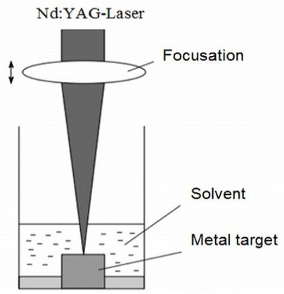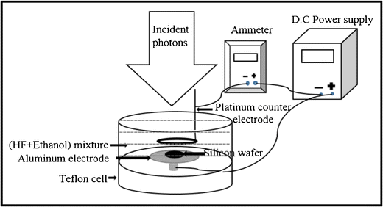
(b)
(a)
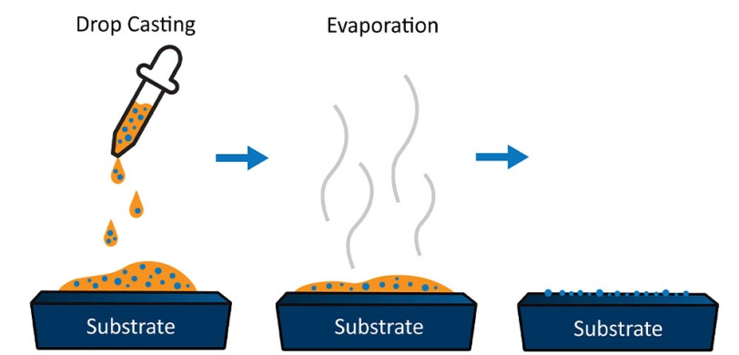
(c)

Figure 1: Schematic illustrations of (a) the pulsed laser ablation process, (b) photo-electrochemical etching process and (c) drop casting method for deposition of Mg-Al-Zn NPs used in this investigation.

Results and Discussion
Structural Properties
The diffraction patterns of AZ91 (Mg-9%wt. Al-1%wt. Zn) magnesium alloy that processed alloy at 296 K in HPT are plotted and shown in Figure2(a). These peaks were found at 2θ =32.39°, 34.61°, 36.89°, 48.11°, 57.89°,63.59°,69.41°,70,73°,73.13° and 78.53° correspond to the (11$\overline{2}$1), (0002), (10$\overline{1}$1), (10$\overline{1}$2), (11$\overline{2}$0), (10$\overline{1}$3), (11$\overline{2}$2), (20$\overline{2}$1), (31$\overline{4}$1) and (22$\overline{4}$2) planes to ($α$-Mg) phase, which is considered the primary phase. XRD of ($β$-Mg₁₇Al₁₂) phase, which is considered the secondary phase has two characteristic peaks at 39.98° and 67.91° which corresponds to the (33$\overline{6}$2) and (22$\overline{4}$0) plane. Figure 2(b) illustrates the XRD pattern of the (Mg-9%wt. Al-1%wt. Zn) NPs that fabricated at 900 mJ energy in the laser ablation and then deposited on porous Si, where the silicon showed a peak at 2θ = 28.5. Diffraction peaks at 2θ =31.10°, 36.89°, and 58.82° corresponding to the (11$\overline{2}$1), (10$\overline{1}$2), and (11$\overline{2}$0) planes of Mg NPs; respectively. XRD of Mg₁₇Al₁₂ NPs has one characteristic peak at 39.14°, which corresponding to the (33$\overline{6}$2) plane. XRD of MgO NPs has one characteristic peak at 35.94° which corresponding to the (111) plane. Residual water or reactivity with the oxygenated solvent itself under high-energy conditions is most likely to reason for the formation of MgO. Because the colors changed, it is clear that the organic solvent changed or broke down because of the laser heating or the reaction with the Mg particles [9]. It is worth mentioning that there is a clearly identifiable peak for SiO₂ at an angle of 2θ=25.63°.

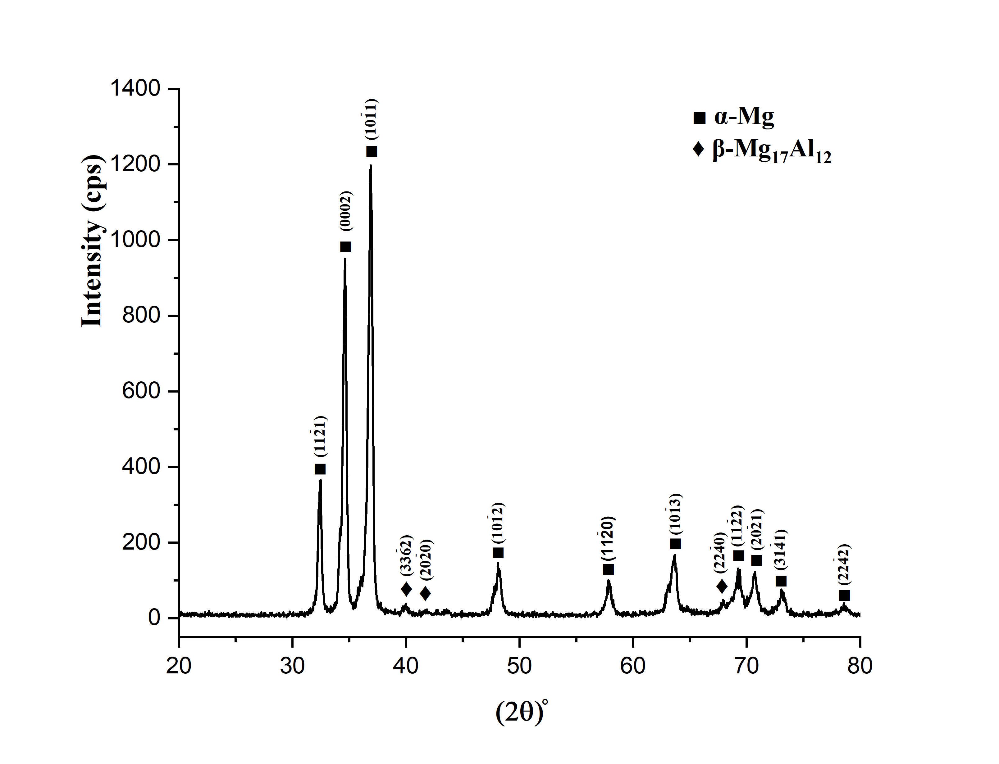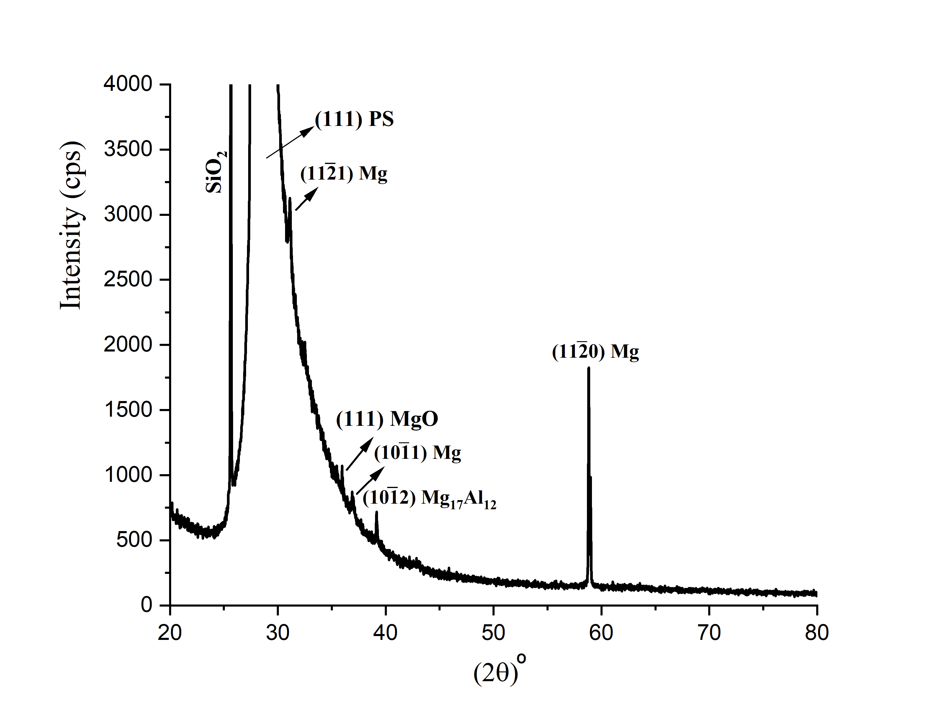
(a)
(b)
Figure 2: XRD diffraction patterns of (a) Mg-Al-Zn alloy (b) (Mg-9%Al-1%Zn) NPs/PS at 900mJ energy.
Three micrographs of Mg-Al-Zn NPs/PS at three different energies of laser ablation of 500, 700, 900 mJ have been selected for analysis at random locations. The analysis has been conducted using SEM micrographs at the same magnification. These micrographs are for (Mg-9%Al-1%Zn) nanoparticles that deposited onto the porous silicon surface using the drop casting technique at a designated temperature. The SEM micrographs in the Figure 3(a,b,c) demonstrate that the (Mg-9%Al-1%Zn) NPs are irregularly shaped nanoparticles that are randomly dispersed across the porous surface of Silicon. The NPS layer, composed of (Mg-9%Al-1%Zn), was incompletely deposited within PS. These Analysis of these micrographs in this investigation was conducted using ImageJ image analysis software (http://imagej.nih.gov/ij/). The laser deposition energy has an effect on the average particle size as illustrated in the Figure 3(e) . Increasing the energy of laser pulse leads to increasing the kinetic energy of ablated particles in the plasma region generated on the surface of target during ablation. When particles are at a greater temperature, the likelihood of them to be sticked together decreases, resulting in the formation of smaller particles and thus, a greater amount of smaller ablated particles Furthermore, the increase in target-to-substrate distances, due to the fact that only smaller particles possessing greater kinetic energy are capable of reaching the substrate surface over extended distances [22]. At a laser energy of 500mJ, the average grain size was approximately 24.154 nm larger than at a laser energy of 900 mJ, which is a difference of about 13.66 nm compared to the average particle size at 700 mJ, which is approximately 23.97 nm explain. The average particle size at 500mJ laser energy is roughly comparable to the average particle size at 700 mJ.
.

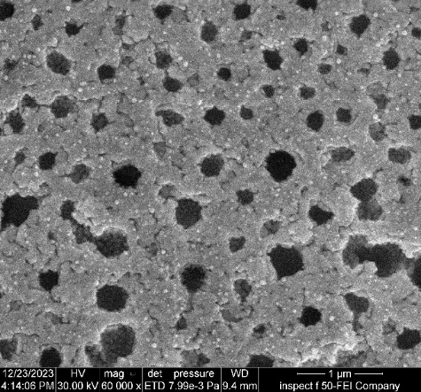
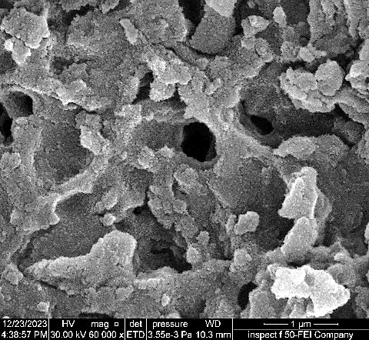
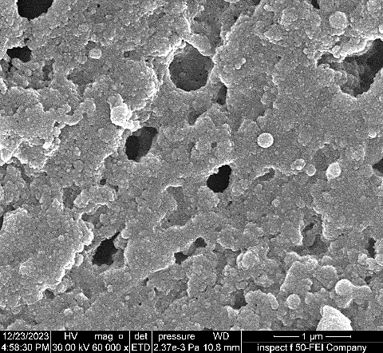
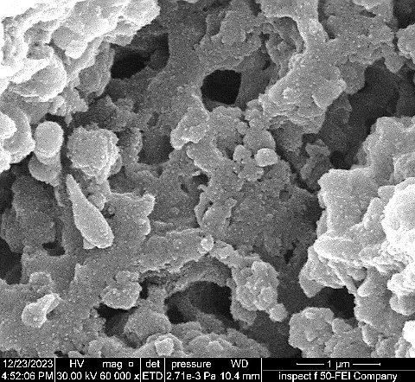
Pores
(a)
Pores
Pores
(Mg-Al-Zn) NPs
(Mg-Al-Zn) NPs
(Mg-Al-Zn) NPs
(b)
(d)
(c)

Figure 3: SEM images of Mg-9%Al-1%Zn NPs deposited on PS (a) PS at etching time 15 min, etching current density 20 mA/cm² and HF 20 % and (Mg-9%Al-1%Zn) NPs/PS at different laser energies (b) 500 mJ, (c) 700 mJ and (d) 900 mJ (e) Average particle size of (Mg-9%Al-1%Zn) NPs/PS at different laser energies

UV–Vis Spectroscopy
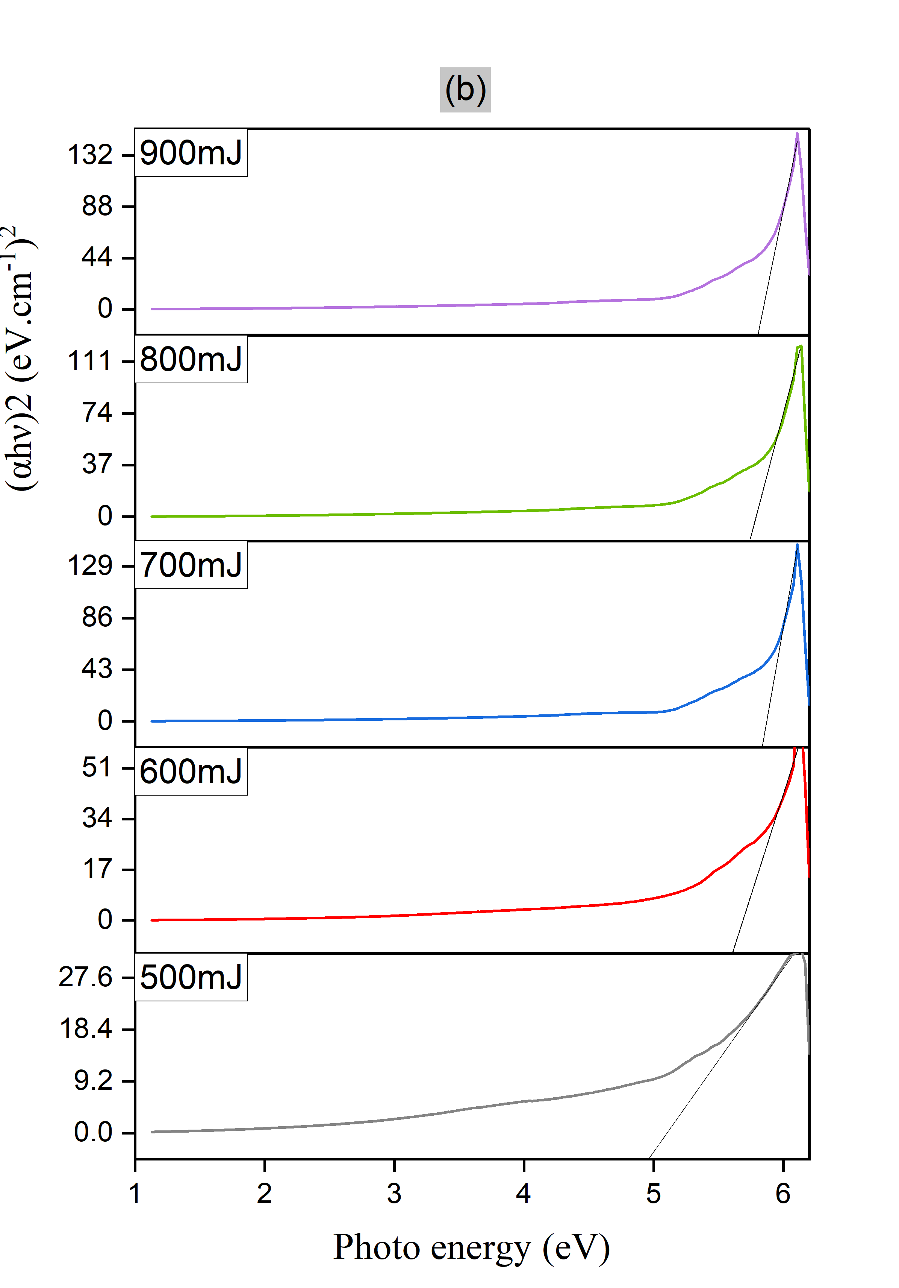
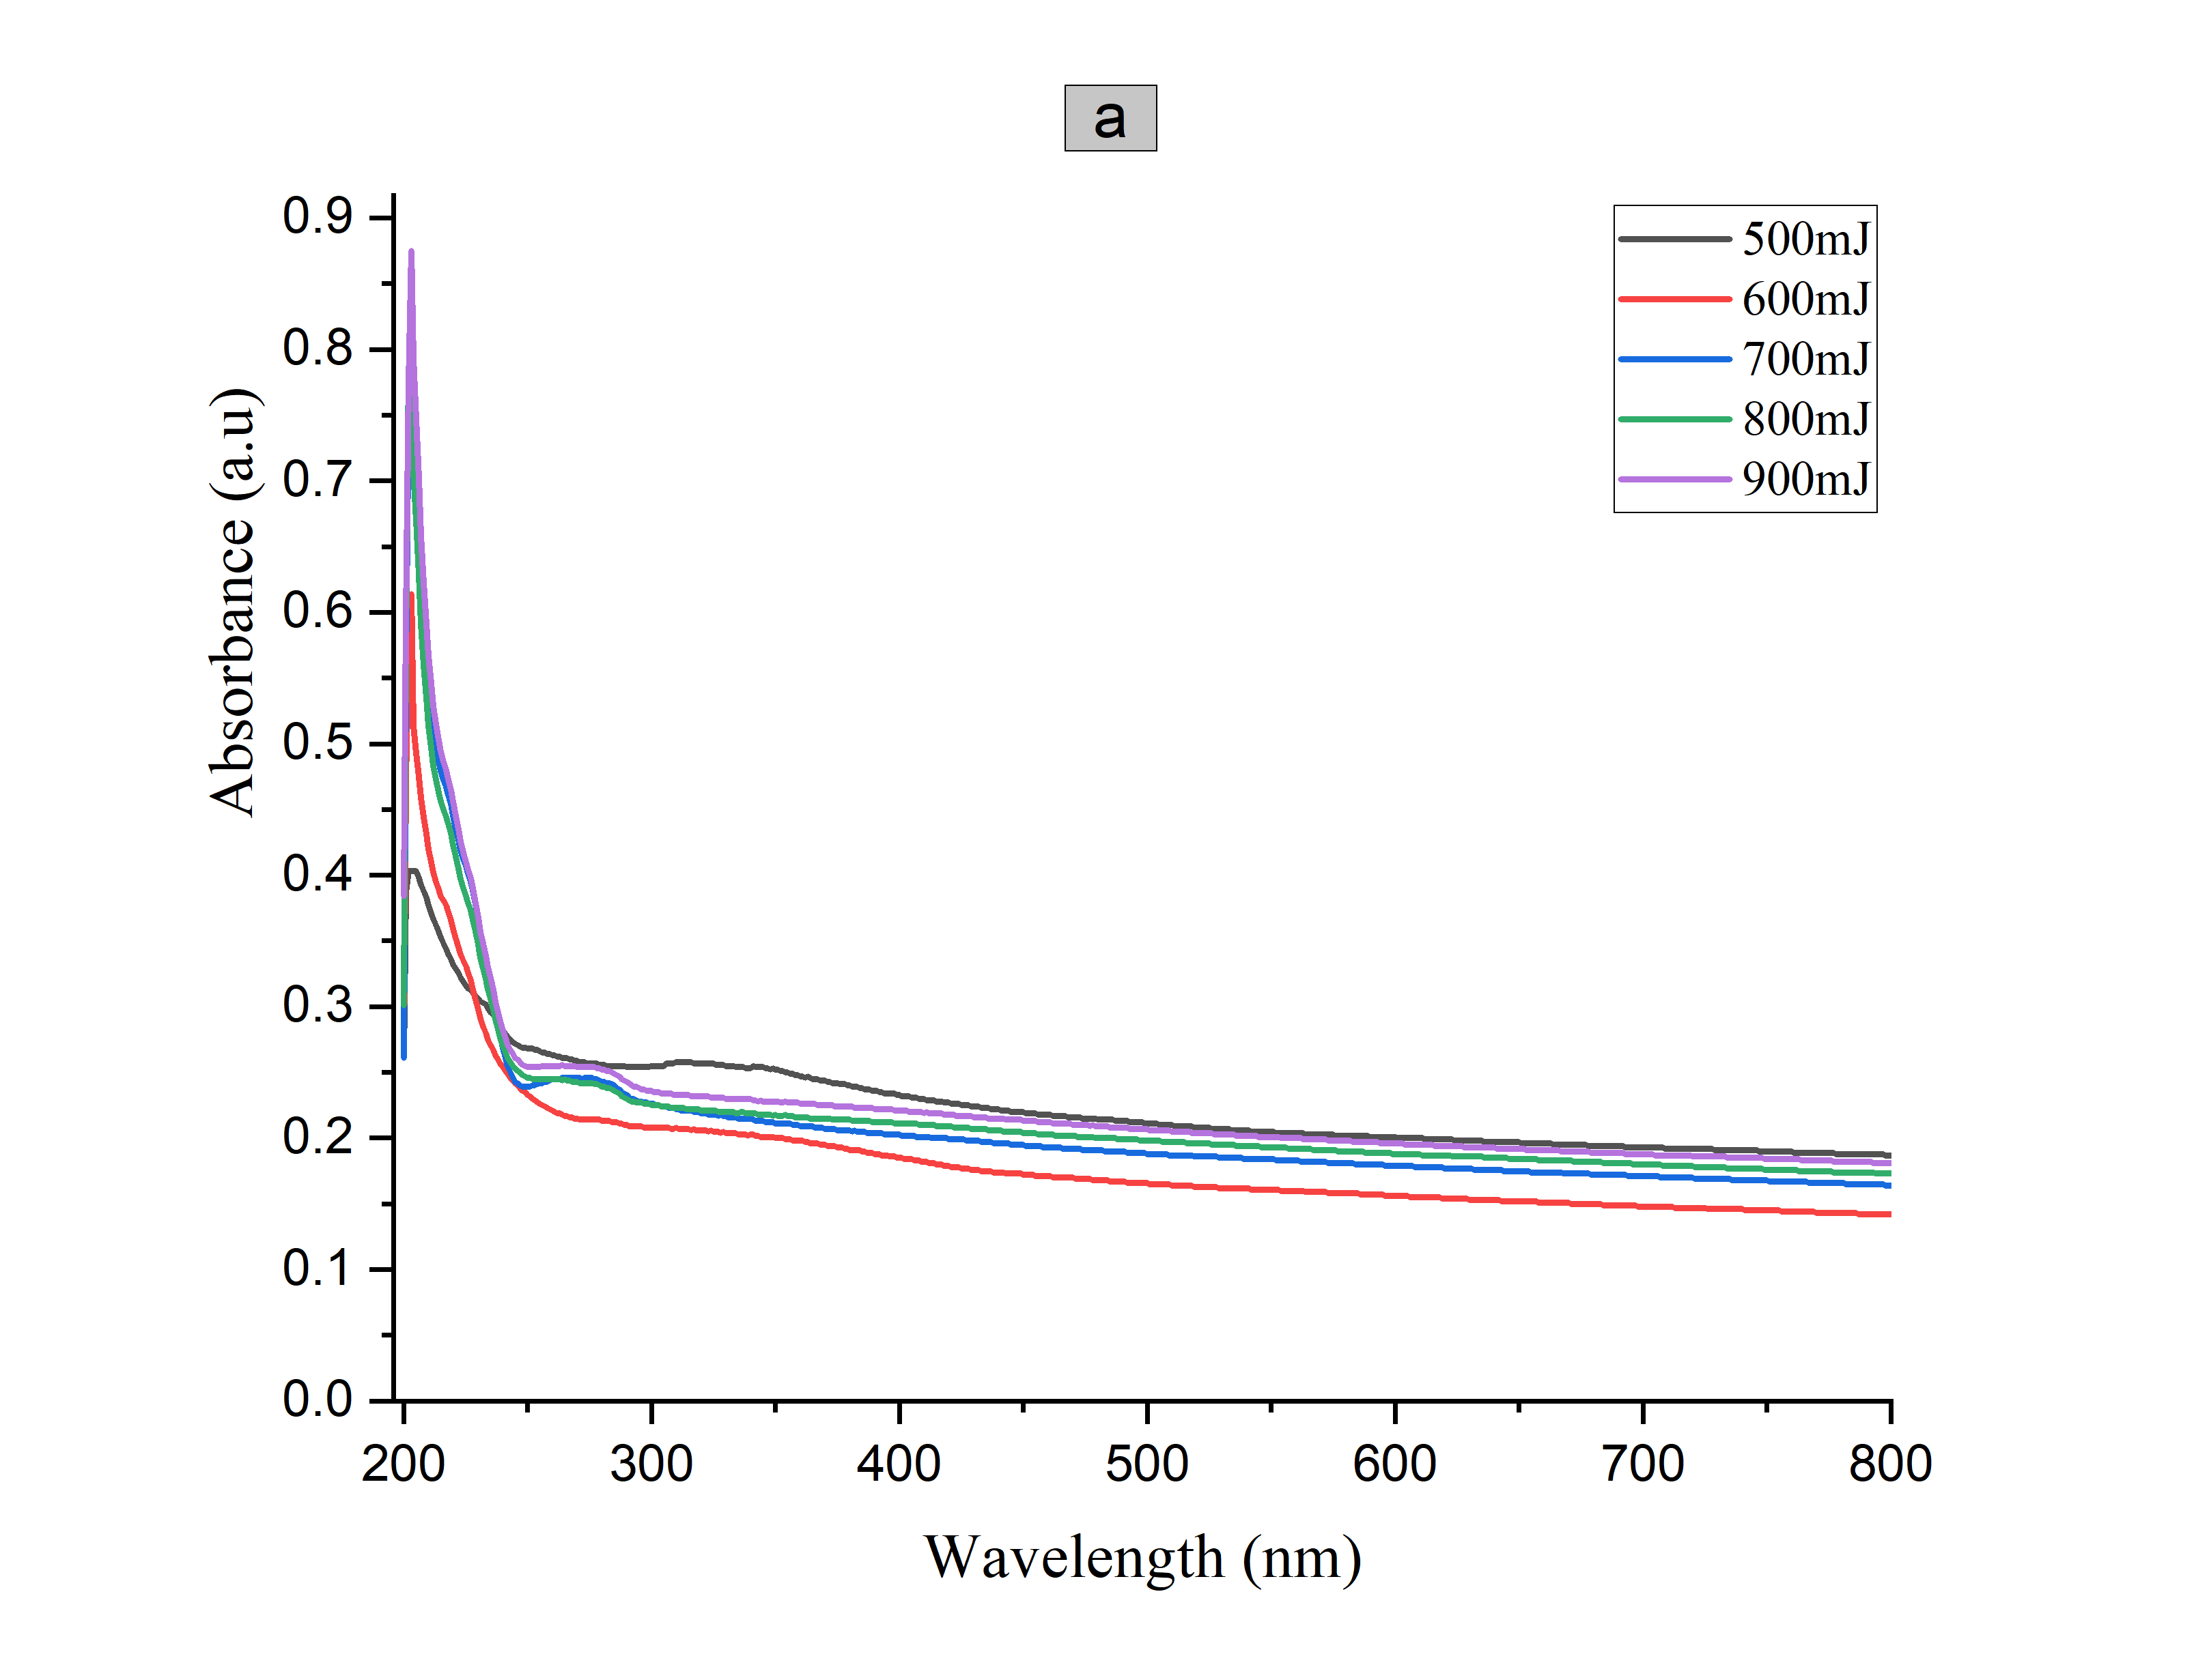
The absorption spectra of Mg-9%Al-1%Zn NPs were observed using different laser energies 500, 700, 600, 800, and 900 mJ and a wavelength of 1064 nm. The number of applied pulses was 200. The intensification of the absorption spectra increased as the laser energy concentration increased. Figure 4(a) demonstrates that the highest level of absorption has been observed at a wavelength of 204 nm for Mg-9%Al-1%Zn nanoparticles [23]. Figure 4(b) displays the relationship between the square of (αhv) and Photo energy (hν) for nanoparticles of Mg-9%Al-1%Zn produced at energy levels of 500, 600, 700, 800, and 900 mJ and the energies of band gap of Mg-9%Al-1%Zn NPs are 5, 5.5, 5.5, 5.7 and 5.8 eV, respectively (Table 1) We observe an increase in energy gap This is attributed to the decrease in particles size as explained in the scanning electron microscopy (SEM) results. It is broadly acknowledged that when the scale of particles decreases, the band gap increases, inflicting the absorption peak to transport towards the shorter wavelength side. This phenomenon arises because of the discrete definition of electricity levels in nanomaterials and an ensuing exchange in levels due to the quantum Confinement effect [24][25]. The results indicate that the optical band gap energy of the Mg-9%Al-1%Zn layer exhibits an increase with higher laser intensity employed during production.

Figure 4: The optical energy gap of laser ablated Mg-9%Al-1%Zn NPs at different laser energy: (a) Absorbance spectra (b) The optical energy gap.

Table 1: The Optical energy gap of Mg-9%Al-1%Zn NPs at different energies of laser abaltion.
Sample | Laser Energy  (mJ) | Energy gap  (eV)
Mg-9%Al-1%Zn NPs | 500 | 5
Mg-9%Al-1%Zn NPs | 600 | 5.5
Mg-9%Al-1%Zn NPs | 700 | 5.5
Mg-9%Al-1%Zn NPs | 800 | 5.7
Mg-9%Al-1%Zn NPs | 900 | 5.8

Electrical Properties
The analysis of the J-V characteristics of Mg-9%Al-1%Zn NPs/PS and PS in the absence of light reveals the electrical properties shown in the Figure (5). It is evident that the current increased upon deposition of Mg-9%Al-1%Zn NPs layer on the surface of PS at various laser energies of 500, 600, 700, 800, and 900mJ. The reason for this is that Mg-9%Al-1%Zn nanoparticles possess a greater conductivity compared (PS).

Figure 5: J-V characteristic for PS and laser ablated Mg-9%Al-1%Zn NPs/PS samples at different energies of laser abaltion.

Figure 6 displays the current under light conditions, with the source of light power intensity ranging from 60 to 260 mW/cm². It exhibits the photo-current density and reverses bias voltage (J-V) characteristics. The experiments were conducted at room temperature. All the figures demonstrate that the rise in photo-current density is an immediate effect of the increase in power intensity, which occurs by an increase in the number of the photo-currents in the depletion area of the energy-produced photo-carriers. Nevertheless, the photocurrent density of Mg-9%Al-1%Zn NPs/PS specimens is above that of PS.

Figure 6: Under illumination the J_{ph}–V characteristics of Mg-9%Al-1%Zn NPs/PS (a) 500 mJ (b) 600 mJ (c) 700 mJ (d) 900 mJ

Spectral responsivity (Photodetector)
Figure 7 displays the spectral responsivity (R_{λ}) ,$Detectivity (D^{*})$ and Quantum efficiency (EQE) for Al/Mg-Al-Zn NPs/PS/n-Si/Al with a bias voltage of 3V in wavelength range starting from 300 to 900 nm. The responsivity (R), external quantum efficiency (EQE) and detectivity ($D^{*}$) were further determined. R is defined as the photocurrent that is generated for every unit of incoming power; EQE is defined as the number of carriers that are produced in the external circuit for every absorbed incident photon, and $D^{*}$ is a figure of merit that is usually used to reflect the sensitivity of the photodetector. According to the equations that follow, these three parameters are defined as follows [26][27][28]:
$R=\frac{∆I}{PA}$..........(1)
$EQE=R\frac{hc}{λe}$ ………..(2)
$D^{*}=\frac{R}{\sqrt{2qJ_{dark}}}$ …………(3)
Where ∆I is the photocurrent defined as the difference between the dark and under illumination current, P the laser power density, c the light velocity , λ the incident light wavelength, e the elementary charge (1.6×10⁻¹⁹ Coulomb); q absolute value of electron charge, $J_{dark}$the dark current density and R represents is a factor calculates the signal of detection in photodetector investigations [15].

The laser ablated (Mg-9%Al-1%Zn) NPs/PS showed three spectral regions of responsivity behaviour: the first two regions lie in visible bands 400-600 nm and third region lie in the near infrared band, i.e., at 800 nm. These three regions of response wavelengths occur due to absorption of light via three materials in the current investigations, which are Mg-9%Al-1%Zn NPs, PS, and Si layers. It is clear that the current materials system of Mg-9%Al-1%Zn NPs/PS gives a new absorption wavelength at 450 nm, with R significant improvement in the responsivity at a wavelength of 600 nm that corresponds to PS via the increase in the energy of laser during ablation process. The detectivity of spectra that shown in Figure 7(b) exhibits development in detective peaks for both PS and c-Si with laser ablated Mg-9%Al-1%Zn NPs as well as at the increase in the energy of laser, as displayed in Figure 7(c). The laser ablated Mg-9%Al-1%Zn NPs/PS that are ablated at energy of 900 mJ showed improved quantum efficiency of magnitudes higher than 120% at all wavelengths of responsivity (R_{λ}) and lesser than MgO/PS values for 56% [29] .
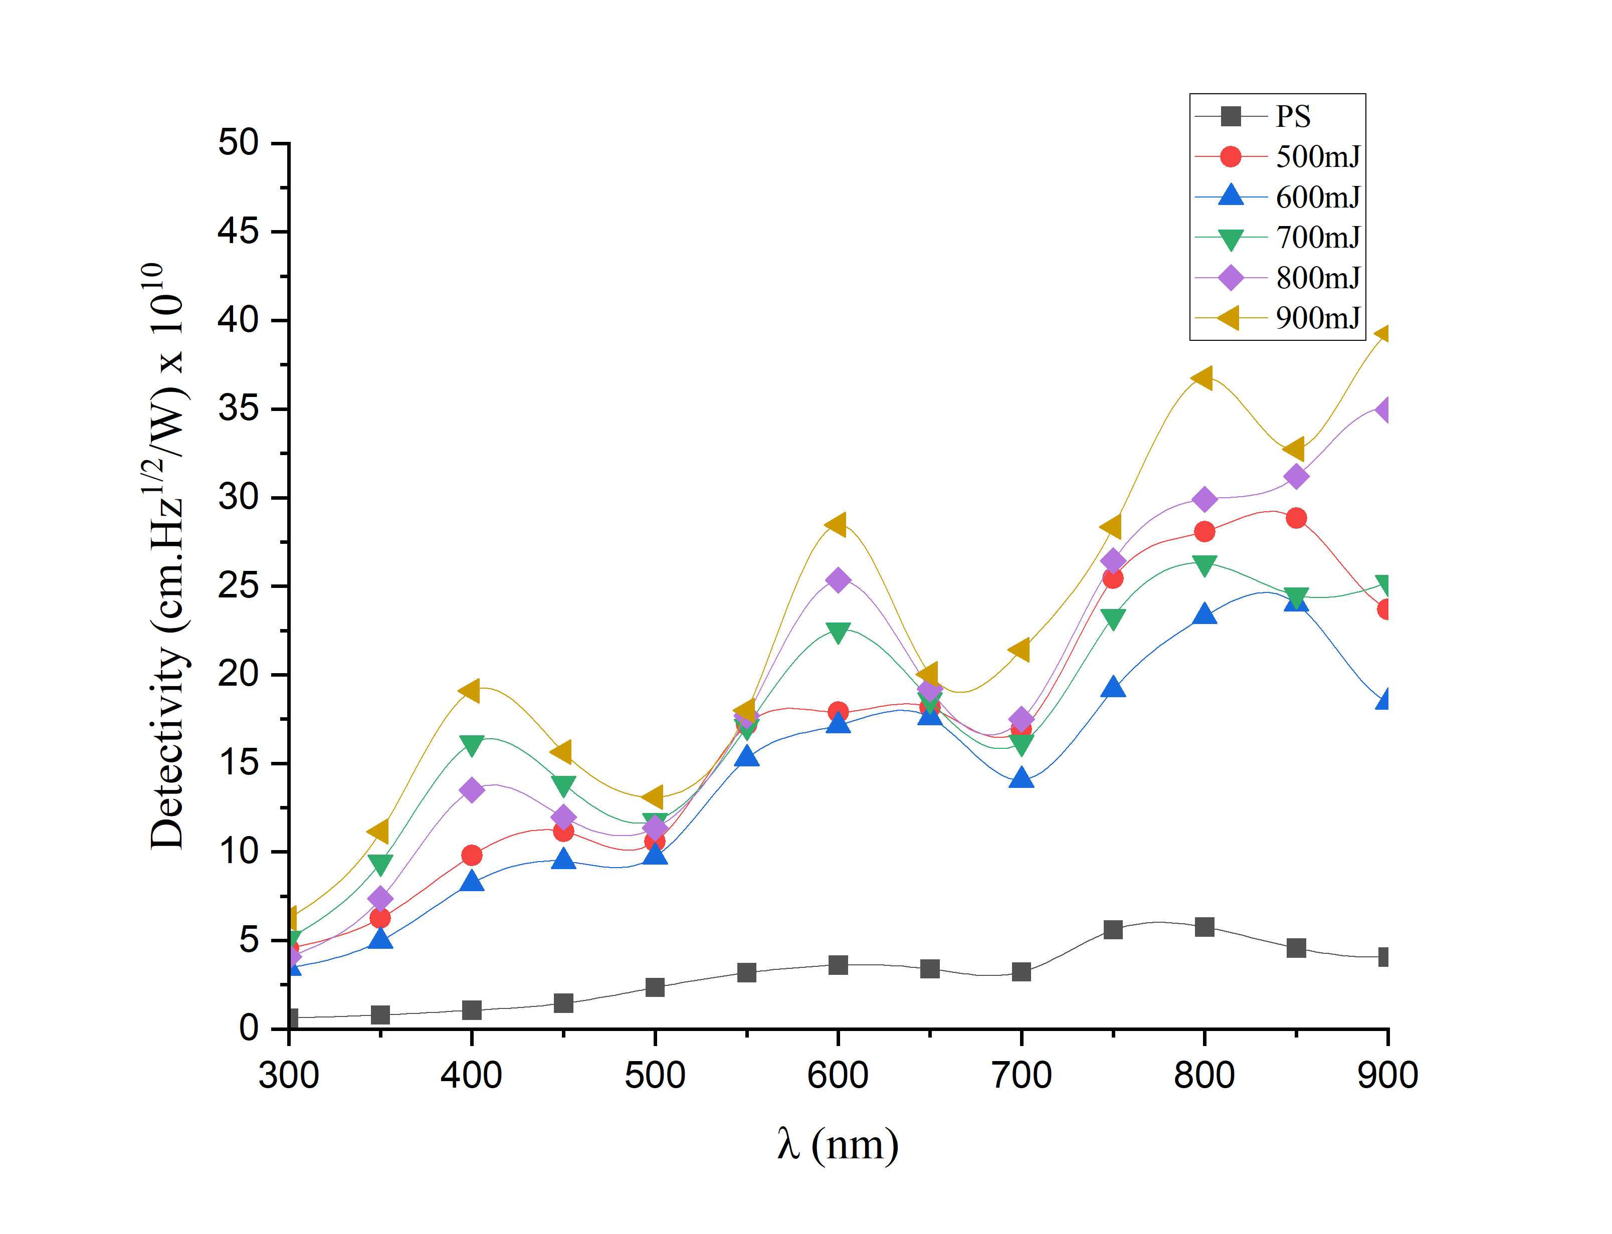
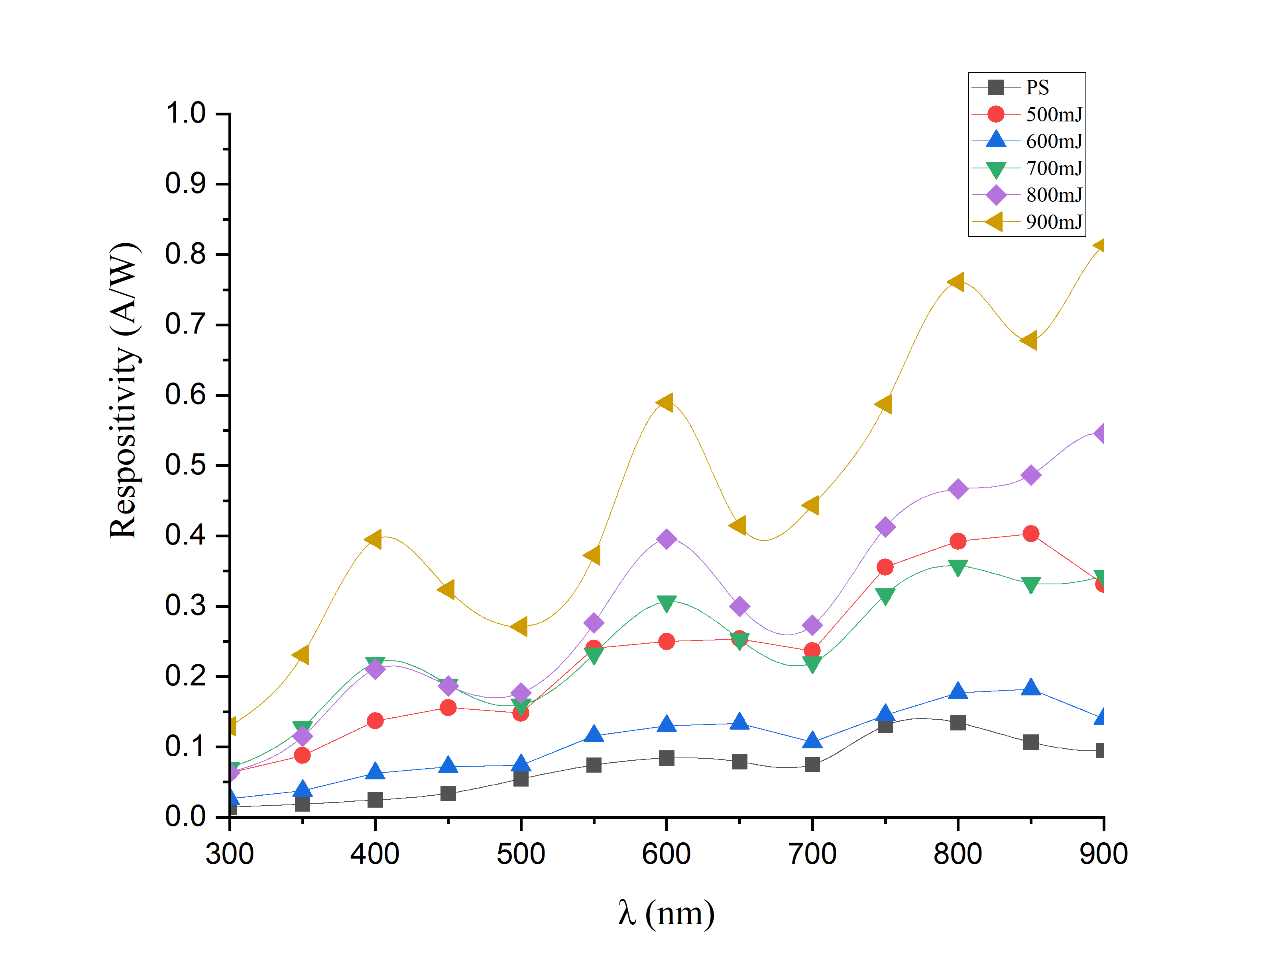
(b)
(a)
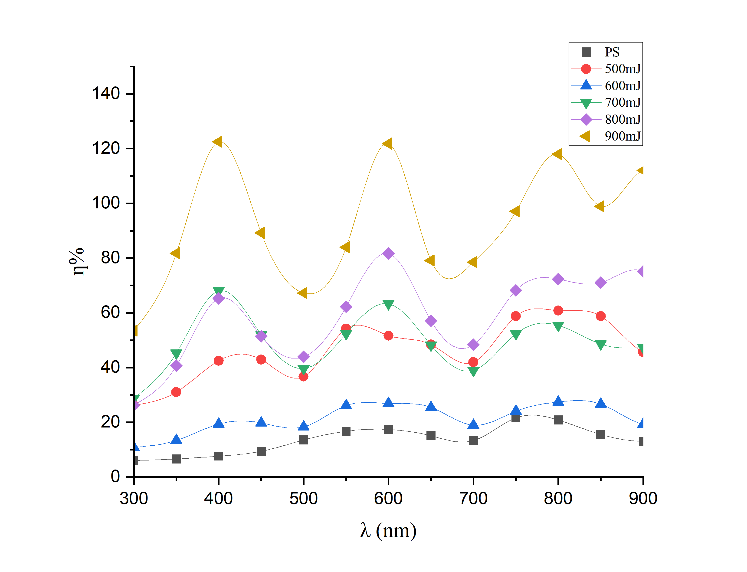
(c)
Figure 7: (a) The Spectral responsivity (b) The Spectral detectivity (c) The Quantum efficiency of PS and Mg-9%Al-1%Zn NPs/PS prepared at different laser energies.

Conclusions
The results confirmed that the technique of laser ablation is a very attractive procedure to improve the properties of Mg-Al-Zn NPs and thus enhance the performance of the fabricated photodetector. The XRD pattern revealed three distinct peaks for Mg NPs, For MgO, one distinct peak for MgO, and one distinct peak Mg₁₇Al₁₂, indicating the laser ablation of these phases from the initial alloy. Structural observations of the laser ablated Mg-Al-Zn NPs deposited on PS wafers, showed the formation of monocrystalline particles with irregular and random distribution, as well as a decrease in the particle size with an increase in the energy of laser in the ablation process.
Researchers studying UV-visible absorption found that as the laser energy goes up, so does the absorption spectrum. The energy bandgap also goes up, from 5 to 5.8 eV, because the particles get smaller. All of the fabricated photodetectors demonstrated high UV detection selectivity and excellent photo response. The J-V characteristics of the Mg-Al-Zn/PS/Si exhibited a significant increase in the current value under illumination of 260 mW/cm². At a wavelength of 400 nm, the fabricated detector exhibited a maximum responsivity and detectivity of 0.41 A/W and 19.93×10¹⁰ cm.Hz¹/²/W; respectively. These findings can be attributed to the Mg-Al-Zn nanoparticles with a tunable feature of the energy bandgap within the region of absorption with the short wavelengths. The structural and optical properties of complex metallic nanoparticles in the current investigation potentially considered as an attractive candidate for optoelectronic devices, with feasibility of controlling the energy gap over wide range of wavelengths.
Authors' contributions
Author contributions ZR-Writing Original draft, Methodology, Investigation, and Formal analysis. UN, AZ -Main Concept, Data interpretation, and supervision. UN, AZ, SS and NG -Writing-Review and editing, Visualization, and Data curation.

Funding
- No funded
Acknowledgments
- The authors would like to thank the University of Technology-Iraq and University of Southampton for the logistic support this work.
Conflicts of Interest
The authors declare have no conflict of interest.
Data Availability
No applicable

References
[1] D. K. Rana, S. K. Singh, S. K. Kundu, R. J. Choudhary, and S. Basu, “Electrical and magnetic properties of polyvinyl alcohol-cobalt ferrite nanocomposite films,” Bull. Mater. Sci., vol. 41, no. 4, 2018, doi: 10.1007/s12034-018-1608-0.
[2] A. Luo and M. O. Pekguleryuz, “Cast magnesium alloys for elevated temperature applications,” J. Mater. Sci., vol. 29, no. 20, pp. 5259–5271, 1994, doi: 10.1007/BF01171534.
[3] Z. Yang, J. P. Li, J. X. Zhang, G. W. Lorimer, and J. Robson, “Review on Research and Development of Magnesium Alloys,” Acta Metall. Sin. (English Lett., vol. 21, no. 5, pp. 313–328, 2008, doi: 10.1016/S1006-7191(08)60054-X.
[4] B. C. Pai, U. T. S. Pillai, P. Manikandan, and A. Srinivasan, “Modification of AZ91 Mg alloys for high temperature applications,” Trans. Indian Inst. Met., vol. 65, no. 6, pp. 601–606, 2012, doi: 10.1007/s12666-012-0166-1.
[5] H. L. Aye, S. Choopun, and T. Chairuangsri, “Preparation of nanoparticles by laser ablation on copper target in distilled water,” Adv. Mater. Res., vol. 93–94, pp. 83–86, 2010, doi: 10.4028/www.scientific.net/AMR.93-94.83.
[6] B. Nourozi, A. Aminian, N. Fili, Y. Zangeneh, A. Boochani, and P. Darabi, “The electronic and optical properties of MgO mono-layer: Based on GGA-mBJ,” Results Phys., vol. 12, no. October 2018, pp. 2038–2043, 2019, doi: 10.1016/j.rinp.2019.02.054.
[7] Y. R. Denny, T. Firmansyah, V. Gustiono, and S. S. Lee, “Effect of substrate temperature on the electronic properties of MGO thin films on Si (100) grown by electron beam evaporation,” Key Eng. Mater., vol. 841 KEM, pp. 243–247, 2020, doi: 10.4028/www.scientific.net/KEM.841.243.
[8] de Jongh, P. E., Wagemans, R. W., Eggenhuisen, T. M., Dauvillier, B. S., Radstake, P. B., Meeldijk, J. D., ... & de Jong, K. P. (2007). The preparation of carbon-supported magnesium nanoparticles using melt infiltration. Chemistry of materials, 19(24), 6052-6057.‏
[9] F. Abrinaei, M. J. Torkamany, M. R. Hantezadeh, and J. Sabbaghzadeh, “Formation of Mg and MgO nanocrystals by laser ablation in liquid: Effects of laser sources,” Sci. Adv. Mater., vol. 4, no. 3–4, pp. 501–506, 2012, doi: 10.1166/sam.2012.1309.
[10] A. Baladi and R. Sarraf Mamoory, “Investigation of different liquid media and ablation times on pulsed laser ablation synthesis of aluminum nanoparticles,” Appl. Surf. Sci., vol. 256, no. 24, pp. 7559–7564, 2010, doi: 10.1016/j.apsusc.2010.05.103.
[11] Razali, N. S. M., Rahim, A. F. A., Radzali, R., Mahmood, A., Yusuf, Y., Zulkifli, F., & Bakar, A. A. (2019). Investigation on the Effect of Direct Current and Integrated Pulsed Electrochemical Etching of n-Type (100) Silicon. Acta Physica Polonica, A., 135(4).‏
[12] M. B. Gawande, Y. Monga, R. Zboril, and R. K. Sharma, “Silica-decorated magnetic nanocomposites for catalytic applications,” Coord. Chem. Rev., vol. 288, pp. 118–143, 2015, doi: 10.1016/j.ccr.2015.01.001.
[13] Z. A. Alothman, “A review: Fundamental aspects of silicate mesoporous materials,” Materials (Basel)., vol. 5, no. 12, pp. 2874–2902, 2012, doi: 10.3390/ma5122874.
[14] Sun, M. H., Huang, S. Z., Chen, L. H., Li, Y., Yang, X. Y., Yuan, Z. Y., & Su, B. L. (2016). Applications of hierarchically structured porous materials from energy storage and conversion, catalysis, photocatalysis, adsorption, separation, and sensing to biomedicine. Chemical society reviews, 45(12), 3479-3563.‏
[15] Shinde, P. S., Suryawanshi, P. S., Patil, K. K., Belekar, V. M., Sankpal, S. A., Delekar, S. D., & Jadhav, S. A. (2021). A brief overview of recent progress in porous silica as catalyst supports. Journal of Composites Science, 5(3), 75.‏
[16] U. M. Nayef and H. A. Khalaf, “Optimization photodetectors from zinc sulfide deposited on porous silicon with different doping metals,” Surf. Rev. Lett., vol. 24, no. 6, pp. 1–7, 2017, doi: 10.1142/S0218625X1750086X.
[17] K. Jawad and B. Hasson, “Developing Strategy for a Successful Antioxidant, Anticancer Activity via an Improved Method Prepared to Porous Silicon Nanoparticles,” J. Appl. Sci. Nanotechnol., vol. 1, no. 4, pp. 1–11, 2021, doi: 10.53293/jasn.2021.3890.1054.
[18] A. S. J. Al-Zubaydi, A. P. Zhilyaev, S. C. Wang, P. Kucita, and P. A. S. Reed, “Evolution of microstructure in AZ91 alloy processed by high-pressure torsion,” J. Mater. Sci., vol. 51, no. 7, pp. 3380–3389, 2016, doi: 10.1007/s10853-015-9652-2.
[19] S. S. Khudiar, U. M. Nayef, and F. A. H. Mutlak, “Improvement of spectral responsivity of ZnO nanoparticles deposited on porous silicon via laser ablation in liquid,” Optik (Stuttg)., vol. 244, no. June, p. 167530, 2021, doi: 10.1016/j.ijleo.2021.167530.
[20] A. M. Alwan, A. A. Yousif, and L. A. Wali, “A Study on the Morphology of the Silver Nanoparticles Deposited on the n-Type Porous Silicon Prepared Under Different Illumination Types,” Plasmonics, vol. 13, no. 4, pp. 1191–1199, 2018, doi: 10.1007/s11468-017-0620-3.
[21] T. Huelser, S. M. Schnurre, H. Wiggers, and C. Schulz, “Gas-phase synthesis of highly-specific nanoparticles on the pilot-plant scale,” Nanotechnol. 2010 Adv. Mater. CNTs, Part. Film. Compos. - Tech. Proc. 2010 NSTI Nanotechnol. Conf. Expo, NSTI-Nanotech 2010, vol. 1, pp. 330–333, 2010.
[22] Salim, E. T., Fakhri, M. A., Ismail, R. A., Abdulwahhab, A. W., Salim, Z. T., Munshid, M. A., & Hashim, U. (2019). Effect of light induced heat treatment on the structural and morphological properties of LiNbO3 thin films. Superlattices and Microstructures, 128, 67-75.‏
[23] A. Nyabadza, M. Vázquez, S. Coyle, B. Fitzpatrick, and D. Brabazon, “Magnesium nanoparticle synthesis from powders via pulsed laser ablation in liquid for nanocolloid production,” Appl. Sci., vol. 11, no. 22, 2021, doi: 10.3390/app112210974.
[24] P. M. Anjana, M. R. Bindhu, M. Umadevi, and R. B. Rakhi, “Antimicrobial, electrochemical and photo catalytic activities of Zn doped Fe3O4 nanoparticles,” J. Mater. Sci. Mater. Electron., vol. 29, no. 7, pp. 6040–6050, 2018, doi: 10.1007/s10854-018-8578-2.
[25] Y. Shen, C. Chang, H. Okada, and M. Murata, “Enhanced photo-response of porous silicon photo- detectors by embeddingTitanium-dioxide nano- particles Enhanced photo-response of porous silicon photo-detectors by,” 2018.
[26] Li, L., Wu, P., Fang, X., Zhai, T., Dai, L., Liao, M., ... & Golberg, D. (2010). Single‐crystalline CdS nanobelts for excellent field‐emitters and ultrahigh quantum‐efficiency photodetectors. Advanced Materials, 29(22), 3161-3165.‏
[27] Gong, X., Tong, M., Xia, Y., Cai, W., Moon, J. S., Cao, Y., ... & Heeger, A. J. (2009). High-detectivity polymer photodetectors with spectral response from 300 nm to 1450 nm. Science, 325(5948), 1665-1667.‏
[28] Li, J., Shen, Y., Liu, Y., Shi, F., Ren, X., Niu, T., ... & Liu, S. F. (2017). Stable high-performance flexible photodetector based on upconversion nanoparticles/perovskite microarrays composite. ACS Applied Materials & Interfaces, 9(22), 19176-19183.‏
[29] N. A. Abdulkhaleq, U. M. Nayef, and A. K. H. Albarazanchi, “MgO nanoparticles synthesis via laser ablation stationed on porous silicon for photoconversion application,” Optik (Stuttg)., vol. 212, no. February, p. 164793, 2020, doi: 10.1016/j.ijleo.2020.164793.

