NTHi Killing Activity is Reduced in COPD Patients and is Associated with a Differential Microbiome

Vancheswaran Gopalakrishnan¹, Ben Sparklin¹, Jung Hwan Kim², Margaret Kehl², Tara Kenny³, Christopher Morehouse¹, Carolina Caceres⁴, Paul Warrener², Ventzislava A. Hristova⁵, Susan Wilson⁶, Harini Shandilya⁶, Arnita Barnes⁶, Alexey Ruzin², Junmin Wang⁷, Lisa Oberg⁸, Bastian Angermann⁸, Christopher McCrae⁸, Adam Platt⁹, Daniel Muthas⁸, Sonja Hess⁵, Christine Tkaczyk¹⁰, Bret R. Sellman², Kristoffer Ostridge^{8, 11}, Maria G. Belvisi¹², Tom M.A. Wilkinson^{11,13}, Karl J. Staples^{11,13}, and Antonio DiGiandomenico¹⁰ on behalf of the MICAII study group

¹Bioinformatics, Research and Early Development, Vaccines and Immune Therapies, BioPharmaceuticals R&D, AstraZeneca, Gaithersburg, USA
²Bacteriology, Research and Early Development, Vaccines and Immune Therapies, BioPharmaceuticals R&D, AstraZeneca, Gaithersburg, USA
³Virology and Vaccine Discovery, Research and Early Development, Vaccines and Immune Therapies, BioPharmaceuticals R&D, AstraZeneca, Gaithersburg, USA
⁴Translational Scientific Management, Research and Early Development, Vaccines and Immune Therapies, BioPharmaceuticals R&D, AstraZeneca, Gaithersburg, USA
⁵Dynamic Omics, Centre for Genomics Research (CGR), Discovery Sciences, BioPharmaceuticals R&D, AstraZeneca, Gaithersburg, MD, USA
⁶Biologics Engineering, Oncology R&D, AstraZeneca, Gaithersburg, USA
⁷Quantitative Biology, Data Sciences and Quantitative Biology, Discovery Sciences, BioPharmaceuticals R&D, AstraZeneca, Gaithersburg, MD, USA
⁸Translational Science and Experimental Medicine, Research and Early Development, Respiratory & Immunology, BioPharmaceuticals R&D, AstraZeneca, Gothenburg, Sweden
⁹VP and Head of Translational Science and Experimental Medicine, Research and Early Development, Respiratory & Immunology, BioPharmaceuticals R&D, AstraZeneca, Cambridge, UK
¹⁰Bacterial Antibodies, Research and Early Development, Vaccines and Immune Therapies, BioPharmaceuticals R&D, AstraZeneca, Gaithersburg, USA
¹¹Clinical & Experimental Sciences, University of Southampton Faculty of Medicine, Southampton, UK
¹²SVP and Head of Research and Early Development, Respiratory and Immunology, BioPharmaceuticals R&D, AstraZeneca, Gothenburg, Sweden
¹³NIHR Southampton Biomedical Research Centre, University Hospital Southampton, Southampton, UK

Corresponding author:
Antonio DiGiandomenico, PhD
Senior Director and Head of Bacterial Antibodies
Research and Early Development
Vaccines and Immune Therapies
AstraZeneca
One MedImmune Way
Gaithersburg, MD 20878
Phone: (301) 398-2401; Fax: (301) 398-8293
e-mail: antonio.digiandomenico@astrazeneca.com

Total body word counts: 3366 words
Abstract (239/250)

Chronic obstructive pulmonary disease (COPD) is a chronic lung disease characterized by airway obstruction and inflammation. Non-typeable Haemophilus influenzae (NTHi) lung infections are common in COPD, promoting frequent exacerbations and accelerated lung function decline. The relationship with immune responses and NTHi are poorly understood. Herein, we comprehensively characterized the respiratory microbiome and mycobiome of patients while investigating microbial dynamics and host immune changes attributable to NTHi killing activity. Mild-to-moderate COPD patients encompassing frequent (P-FE) and infrequent exacerbators (P-IE) and healthy volunteers (HV) were enrolled. Microbial composition, proteomics and NTHi killing activity was analyzed using bronchoalveolar lavage fluid (BALF). In addition, antigen-antibody titers in sera to COPD pathogens were determined using a multiplex assay. Differential abundance analysis revealed an enrichment of Actinobacteria and Bacteroidetes in the BALF of COPD and HV subjects respectively. Significant differences in the IgA titer response were observed against NTHi antigens in COPD vs. HV. Notably, there was also significantly greater killing activity against NTHi in BALF from COPD vs. HV subjects (OR=5.64; 95% C.I. = 1.75 – 20.20; p=0.001). Stratification of COPD patients by NTHi killing activity identified unique microbial and protein signatures wherein Firmicutes, Actinobacteria and haptoglobin were enriched in patients with killing activity. We report that differences in host immune responses and NTHi-killing activity are associated with microbiome changes in mild-to-moderate COPD. This is suggestive of a potential link between microbiome and immune activity against NTHi in the context of COPD pathogenesis even at this disease stage.

Keywords: COPD, Non-typeable Haemophilus influenzae, microbiome, exacerbations
Introduction
COPD is a chronic inflammatory lung disease characterized by heterogenous pulmonary pathologies and is often associated with systemic comorbidities [1]. Inhalation of cigarette smoke, air pollutants, recurrent bacterial infections, and genetic determinants are among its top reported causes [2, 3]. Despite being one of the leading causes of death worldwide [4], current approaches to therapy are primarily focused on symptom management, for which inhaled therapies are widely employed [5]. Additionally, long-term treatment with antibiotics to treat infectious etiologies is not feasible since it is complicated by the development of antimicrobial resistance and adverse events. Regardless, antibiotics have not proven to be successful in reducing hospitalizations or improving lung function [6]. COPD morbidity is also influenced by the frequency of exacerbations, which are often seasonal, and are characterized by a flare up of disease symptoms usually in association with an infectious event [7]. More frequent exacerbations have been implicated in accelerating the rate of lung function decline in COPD [8].
The respiratory microbiome has emerged as an important contributor to COPD pathogenesis and has also been linked with the onset of exacerbation. Emerging evidence suggests that microbial dysbiosis resulting from the persistence and proliferation of pathogenic bacteria in the lower respiratory tract can outcompete commensals and influence host profiles by triggering a dysregulated immune response. Intuitively, colonization with pathogenic bacteria has been associated with a loss of microbial diversity [9], which in turn leads to further infection susceptibility [10]. Consistent with this hypothesis, changes in microbiome community structure and diversity have been linked to host transcriptomic changes [11] and expression of pro-inflammatory cytokines such as IL-8 in the sputum of COPD patients [12].
In addition, differentially enriched bacterial taxa have been identified in disease in both the sputum and bronchoalveolar lavage fluid (BALF) [12-14], and shifts in respiratory microbiome compositions have been noted during exacerbations. While a universal signature has not yet been identified, persistent colonization in the lower airway with non-typeable Haemophilus influenzae (NTHi), and Moraxella catarrhalis (Mcat) have been associated with an inflammatory response and progressive lung function decline both during stable state and during exacerbations [15]. Notably, Haemophilus species have been estimated to be prevalent in up to 70% of COPD patients and have been consistently linked to poorer clinical outcomes [16-19].
Due to the multi-factorial nature of COPD pathogenesis and acute exacerbations, research into novel approaches such as vaccines and long-acting monoclonal antibodies are warranted to treat infectious drivers. Accordingly, NTHi and Mcat have been the focus of therapeutic targeting in COPD, often in combination. Evidence suggests that they aid their mutual existence by counteracting complement-mediated killing and promoting increased resistance to antibiotics [20, 21]. Conserved surface exposed proteins from these pathogens have been investigated as components of an adjuvanted multi-component (three antigens from NTHi and one antigen from Mcat) vaccine designed to reduce the rate of acute exacerbations in moderate to severe COPD in a recent phase II study. The vaccine had an acceptable safety and reactogenicity profile consistent with a prior phase I study [22] and another vaccine study which only used NTHi components [23]. Unfortunately, this vaccine failed to meet its primary efficacy endpoint, further emphasizing the complexity of this space [24, 25].
Herein, we have comprehensively characterized the landscape of the respiratory microbiome and mycobiome in COPD patients versus healthy volunteers (HV) through 16S rRNA and ITS sequencing of BALF and sputum samples. Furthermore, we studied the impact of microbial dynamics as it relates to immune responses in COPD patients to better understand the role of protective immunity in shaping microbial and clinical outcomes in the disease.
Methods
Patient cohort & sample collection
Details about the patient cohort have been previously reported [26-28]. Briefly, mild-to-moderate COPD patients encompassing frequent (P-FE) and infrequent exacerbators (P-IE) and healthy volunteers (HV) comprised of never smokers (HV-NS) and ex-smokers (HV-ES) were recruited into our cohort as part of an AstraZeneca-sponsored study. COPD patients were classified as P-FE if they had a history of >=2 exacerbations, or P-IE if they had history of <=1 exacerbation in the preceding year before enrollment, where exacerbations could be moderate (requiring oral steroids or antibiotics or both) or severe (requiring oral steroids or antibiotics or both plus hospital admission). >=2 exacerbation events have been shown to be a reliable predictor of future exacerbations [29, 30]. Patients reporting an exacerbation event in the one-month preceding enrollment were not included in the cohort. Additionally, subjects using any antibacterial, antiviral or respiratory investigational drug or relevant vaccine up to 30 days prior to the enrollment visit were also not included in the study cohort. The ex-smokers had stopped smoking 6 months prior to enrollment and had at least a 10-pack-years history. All subjects gave written informed consent, and the study was approved by National Research Ethics Service South Central – Hampshire A and Oxford C Committees (LREC no: 15/SC/0528).

Fiber optic bronchoscopy was used for sampling of Bronchoalveolar lavage fluid (BALF) which has been described in detail previously[26]. BALF samples were collected at the time of enrollment, and there were 2 BALF samples collected per patient (Fig. S1). Lobes to be sampled were based on a HRCT metric of small airways disease (E/I MLD) with one lobe being most affected and one being least affected. Sputum samples were obtained by spontaneous expectoration or induced by saline inhalation according to standard methods from all patients also at study entry [26, 27, 31].

Serological measurement of antibody titers to NTHi, Mcat and Streptococcus pneumoniae antigens
Serum samples were evaluated for total IgG, IgA and IgM against recombinant proteins derived from NTHi, Mcat and S. pneumoniae (NTHi proteins E, F, D P6 and PilA; Mcat proteins OmpCD, M35 and UspA2; and S. pneumoniae pneumolysin). After cloning antigen sequences in pET28a, the production of his-tagged recombinant proteins was performed in E. coli after induction with IPTG. E. coli was then lysed followed by purification of proteins from the supernatant fraction using nickel affinity columns. Serum levels of all antibodies against each antigen were performed at Meso Scale Discovery (Rockville, MD).

Luminescent high-throughput NTHi killing assay
Bacteria
The luxCDABE operon from Photorhabdus luminescens was cloned into shuttle vector pACYC184 under the control of the lac promoter. The plasmid was electroporated into RD and maintained by chloramphenicol selection. The resulting strain was named NTHi RD-Lux. NTHi RD-Lux strains were grown on brain heart infusion (BHI) agar plates supplemented with 2 µg/mL Nicotinamide adenine dinucleotide (Sigma cat# 43410) 1 µg/mL chloramphenicol (Sigma cat# C0378) and coated with 10 µg/mL of hemin (Sigma cat # 51280) stock (1 mg/ml in triethanolamine (Sigma cat # 90279) and incubated overnight at 37ºC in 5% CO₂. A small population of the plated culture was used to inoculate fresh BHI broth (Criterion Cat# C5141) supplemented with 5% Fildes (Remel cat# 45039) and 1 µg/mL of chloramphenicol (Sigma cat # C0378). The culture was incubated at 37ºC in 5% CO₂, with shaking at 180 RPM until the culture reached an optical density at 600 nM (OD₆₀₀) of 0.5. One mL of culture was collected and suspended in 1.0 mL of cold assay buffer (RPMI 1640 (Gibco cat# 11835-030) + 2.25 g glucose (Sigma cat# G7021) + 1% BSA (Sigma cat# A9576)). The bacterial suspension was further diluted 1:100 in assay buffer.

Preparation of complement source
Twenty-five mL of NTHi RD-Lux, grown to an OD₆₀₀ of 0.5, was centrifuged at 3724 g for 10 minutes and suspended in 25 mL of baby rabbit serum (Cedarlane cat# CL3441). After a 30-minute incubation on ice, the bacteria was collected by centrifugation for 20 minutes (3724 x g) at 4ºC. The supernatant was vacuum filter sterilized with a 0.2 µm filter, aliquoted and stored at -80ºC until use. On day of assay the absorbed complement was diluted 1:2 in SBA buffer and kept on ice. Control antibodies were prepared at a 4-fold higher concentration than intended for the assay.

NTHi killing assay
Assay components were added to a 384-well plate (Greiner white, cat#781074-25) in the following order: 20 µl of BALF or positive and negative controls; 40 µl of adsorbed complement (1:2); and 20 µl of bacteria (1:100 in assay buffer). Plates were sealed with porous adhesive film for culture plates (VWR cat#60941-086) and incubated for 2 hours at 37ºC in 5% CO₂. Immediately following incubation, luminescence was read on a luminometer (Tecan Spark). The assay was repeated twice

16S and ITS sequencing
DNA extraction
BALF samples were treated with 2 U Turbo DNase (Invitrogen) for 30 minutes at 37ºC to degrade extracellular DNA and reaction stopped with 0.5M EDTA incubated for 10 minutes at 65ºC. Microbial DNA was extracted using Zymobiomics DNA/RNA Miniprep kit (Zymo Research) following the manufacturer’s instructions for DNA purification.

Sputum samples were treated with 1:1 sputolysin (Sigma Aldrich), vortexed for 1 minute and incubated for 15 minutes at room temperature. Homogenized sputum, BALF and scope wash samples were treated with 2 U Turbo DNase (Invitrogen) for 30 minutes at 37ºC to degrade extracellular DNA and reaction stopped with 0.5M EDTA incubated for 10 minutes at 65ºC. Microbial DNA and RNA were extracted in separate fractions using Zymobiomics DNA/RNA Miniprep kit (Zymo Research) following the manufacturer’s instructions.

Library preparation and Sequencing
Amplicon PCR, Library Preparation and sequencing was performed as outlined for 16S [32] and for ITS [33]. Briefly, V4 16S rRNA gene amplicons were assembled using Accu-Prime Pfx SuperMix (Invitrogen) and dual-index primers. ITS rRNA gene amplicons were generated using Accu-Prime Taq DNA Polymerase High Fidelity (Invitrogen) and dual-indexed primers based on the published fungal ITS primer pair ITS86F/ITS4 [33]. SequalPrep Normalization Kit (Invitrogen) was used for amplicon clean up and normalization.

Final amplicons were pooled, and library quantification was determined by qPCR using the NEBNext Library Quantification kit (NEB). Libraries were mixed with PhiX Control v3 (Illumina) and denatured using fresh NaOH before loading on to the instrument. For 16S, libraries were sequenced on an Illumina MiSeq instrument using a 2x 250 base pair reagent Kit v2, whereas for ITS, they were sequenced on an Illumina MiSeq instrument using a 2x 300 base pair reagent Kit v3.

Bioinformatics
After appropriate quality filtering, 16S V4 and ITS amplicons were denoised to amplicon sequence variants or ASVs using DADA2 [34]. Taxonomic classifications of ASVs were done using SILVA [35] for 16S and UNITE [36] for ITS. Estimation of alpha and beta diversities were done using QIIME2 [37]. Differential enrichment analyses to compare relative abundances of taxa were done using LEfSe [38]. Annotated proteomics data generated from the same patient cohort [39] was used to compute differentially expressed proteins between patients with positive and negative killing capacity of NTHi by Limma [40, 41].

Results
The median age of subjects across study groups ranged from 67.5 to 72 years, and the distribution of male and female genders was comparable between groups. As expected, all clinical characteristics were significantly different in the patient groups compared to healthy volunteers (Table S1). Also, 57 medication categories were reported by subjects in our cohort (Table S2).

Table S1: Demographics and clinical table

Group | HV-ES | HV-NS | P-FE | P-IE | p-value
Subjects, n | 20 | 15 | 13 | 17
Male/female, n | 11/9 | 9/6 | 12/1 | 13/4 | 0.0998*
Age, median | 67.5 | 63 | 72 | 70 | 0.0153
Smoking Pack Years, median | 25 | 0.16 | 29 | 51 | 0.0000
BMI (kg/m2), median | 27.69 | 27.95 | 30.71 | 27.81 | 0.7988
POST FEV1 %, median | 100.5 | 103 | 71 | 73 | 0.0000
POST FEV1/FVC, median | 77.5 | 80 | 58 | 57 | 0.0000
HRCT LAA%, median | 5.855 | 4.95 | 9.12 | 14.46 | 0.0001
HRCT E/I MLD, median | 0.8 | 0.8 | 0.84 | 0.88 | 0.0002
ICS users, n | 0 | 0 | 12 | 7
Group | HV-ES | HV-NS | P-FE | P-IE | p-value
Subjects, n | 20 | 15 | 13 | 17
Male/female, n | 11/9 | 9/6 | 12/1 | 13/4 | 0.0998*
Age, median | 67.5 | 63 | 72 | 70 | 0.0153
Smoking Pack Years, median | 25 | 0.16 | 29 | 51 | 0.0000
BMI (kg/m2), median | 27.69 | 27.95 | 30.71 | 27.81 | 0.7988
POST FEV1 %, median | 100.5 | 103 | 71 | 73 | 0.0000
POST FEV1/FVC, median | 77.5 | 80 | 58 | 57 | 0.0000
HRCT LAA%, median | 5.855 | 4.95 | 9.12 | 14.46 | 0.0001
HRCT E/I MLD, median | 0.8 | 0.8 | 0.84 | 0.88 | 0.0002
ICS users, n | 0 | 0 | 12 | 7
* p-value by Fisher’s exact test. All others by Kruskal-Wallis test

Table S2: Summary of medications

Medication | HV.ES (n) | HV.ES (%) | HV.NS (n) | HV.NS (%) | P.FE (n) | P.FE (%) | P.IE (n) | P.IE (%)
5 alpha-reductase inhibitor |  |  |  |  | 1 | 1.89
ace inhibitor | 3 | 5.66 | 3 | 5.66 | 3 | 5.66 | 1 | 1.89
alpha 1-adrenergic blocker |  |  | 2 | 3.77 | 2 | 3.77 | 1 | 1.89
anti-platelet |  |  |  |  | 2 | 3.77
anticholinergic, antimuscarinic | 1 | 1.89 |  |  | 12 | 22.64 | 10 | 18.87
antihistaminic | 2 | 3.77 |  |  | 3 | 5.66 | 1 | 1.89
antimitotic alkaloid | 1 | 1.89 |  |  |  |  | 1 | 1.89
beta-2-agonist | 1 | 1.89 |  |  | 11 | 20.75 | 12 | 22.64
beta-blocker |  |  |  |  | 2 | 3.77
biguanide antidiabetic |  |  | 1 | 1.89 | 3 | 5.66 | 2 | 3.77
calcium channel blocker | 2 | 3.77 | 3 | 5.66 | 2 | 3.77 | 1 | 1.89
calcium, vitamin |  |  | 1 | 1.89
carbonic anhydrase inhibitor |  |  |  |  |  |  | 1 | 1.89
cholesterol absorption inhibitor |  |  |  |  | 1 | 1.89
corticosteroid | 1 | 1.89 |  |  |  |  | 2 | 3.77
corticosteroid, beta-2-agonist |  |  |  |  | 12 | 22.64 | 8 | 15.09
corticosteroid, vitamine d derivative |  |  | 1 | 1.89
dietary supplement | 2 | 3.77 |  |  |  |  | 1 | 1.89
dipeptidyl peptidase-4 (dpp-4) inhibitor¬† |  |  | 1 | 1.89
estrogen steroid hormone | 1 | 1.89
globular tetradecapeptide; agonist of cell surface receptor of guanylate cyclase 2c (gc-c) |  |  |  |  | 1 | 1.89
glucocorticoid |  |  |  |  |  |  | 1 | 1.89
hmg-coa reductase inhibitor | 5 | 9.43 | 1 | 1.89 | 6 | 11.32 | 4 | 7.55
hormone replacement therapy | 2 | 3.77 | 1 | 1.89
hydroxy acids |  |  | 1 | 1.89
laxative | 1 | 1.89 |  |  | 2 | 3.77
lipase |  |  |  |  | 1 | 1.89
loop diuretic | 1 | 1.89 |  |  | 1 | 1.89
mast cell stabilizer |  |  |  |  |  |  | 1 | 1.89
mucolytic |  |  |  |  | 2 | 3.77
neurotoxin |  |  |  |  |  |  | 1 | 1.89
nitrate |  |  |  |  | 2 | 3.77
non-steroidal anti-inflammatory | 2 | 3.77 | 1 | 1.89 | 4 | 7.55 | 1 | 1.89
noradrenergic and specific serotonergic antidepressant | 1 | 1.89 |  |  |  |  | 1 | 1.89
occlusive emollient |  |  | 1 | 1.89
opioid pain killer |  |  | 1 | 1.89 | 1 | 1.89 | 1 | 1.89
peripheral opioid receptor agonist (anti-diarrhea) | 1 | 1.89
peripheral pain killer |  |  |  |  |  |  | 1 | 1.89
peripheral pain killer, opioid pain killer | 1 | 1.89 |  |  | 1 | 1.89 | 2 | 3.77
phenothiazine (neuroleptic) |  |  |  |  | 1 | 1.89
proton-pump inhibitor | 7 | 13.21 | 1 | 1.89 | 4 | 7.55 | 5 | 9.43
ras (rening angiotensin system) inhibitor/angiotensin receptor blocker | 2 | 3.77 |  |  | 2 | 3.77 | 2 | 3.77
selective¬†agonist¬†at the¬†prostaglandin f receptor |  |  |  |  |  |  | 1 | 1.89
selective¬†prostaglandin f receptor agonist | 1 | 1.89
selective serotonin reuptake inhibitor¬†SSRI antidepressant | 2 | 3.77 | 1 | 1.89 | 1 | 1.89 | 2 | 3.77
serotonin-norepinephrine reuptake inhibitor¬†(SNRI) |  |  | 1 | 1.89
sulfonylurea |  |  | 1 | 1.89
terpene | 1 | 1.89
thiazide diuretic |  |  |  |  | 2 | 3.77 | 2 | 3.77
thioxanthene antipsychotic |  |  |  |  |  |  | 1 | 1.89
thyroid hormone | 6 | 11.32 |  |  |  |  | 1 | 1.89
tricyclic antidepressant | 2 | 3.77 | 1 | 1.89 |  |  | 3 | 5.66
vitamin | 1 | 1.89 |  |  |  |  | 1 | 1.89
vitamin a, vitamin d | 1 | 1.89 | 1 | 1.89 |  |  | 1 | 1.89
vitamin d derivative |  |  | 1 | 1.89
xanthine |  |  |  |  | 1 | 1.89
xanthine oxidase enzyme inhibitor | 1 | 1.89 |  |  |  |  | 1 | 1.89

The microbiome and mycobiome were characterized in 130 BAL samples (collected from 65 patients) and 27 sputum samples (Fig. S1-S2, Table S3).

Fig S1: Sample availability and analyses flowchart.

Fig. S2: Schema for patient groups and biospecimen collection

Sample type: BAL
Group |  | HV-NS | HV-ES | P-IE | P-FE
Gender | F | 12 | 18 | 8 | 2
Gender | M | 18 | 22 | 26 | 24
Sample type: Sputum
Group |  | HV-NS | HV-ES | P-IE | P-FE
Gender | F | 2 | 2 | 3 | 0
Gender | M | 3 | 3 | 8 | 10
Table S3: Distribution of microbiome samples by Group and Gender (for 16S analysis)

Alpha diversity of both the microbiome and mycobiome were higher in the sputum compared to the BALF (Fig. 1A, Fig. S3A). Upon comparing microbiome composition, we found a significant clustering effect by sample type (Fig. 1B). In contrast, we observed considerable compositional overlap in terms of fungi, perhaps reflective of the low overall diversity of fungal taxa in these samples (Fig. S3B).

Figure 1: Characterizing the microbial landscape. A) Comparison of alpha-diversity (measured using the Inverse Simpson index) in sputum (n=30) versus BALF (n=65 patiets, 130 samples) samples. p-value by Wilcoxon ranksum test. B) Ordination of beta-diversity (Bray-curtis) distances by principal coordinate analysis (p=0.001). p-value by ANOSIM 999 permutations. Taxonomic landscape at the phylum level in C) BALF (n= 65 patients, 130 samples) and D) sputum (n=27 patients). Taxonomic landscape at the order level in E) BALF (n= 65 patients, 130 samples) and F) sputum (n=27 patients).

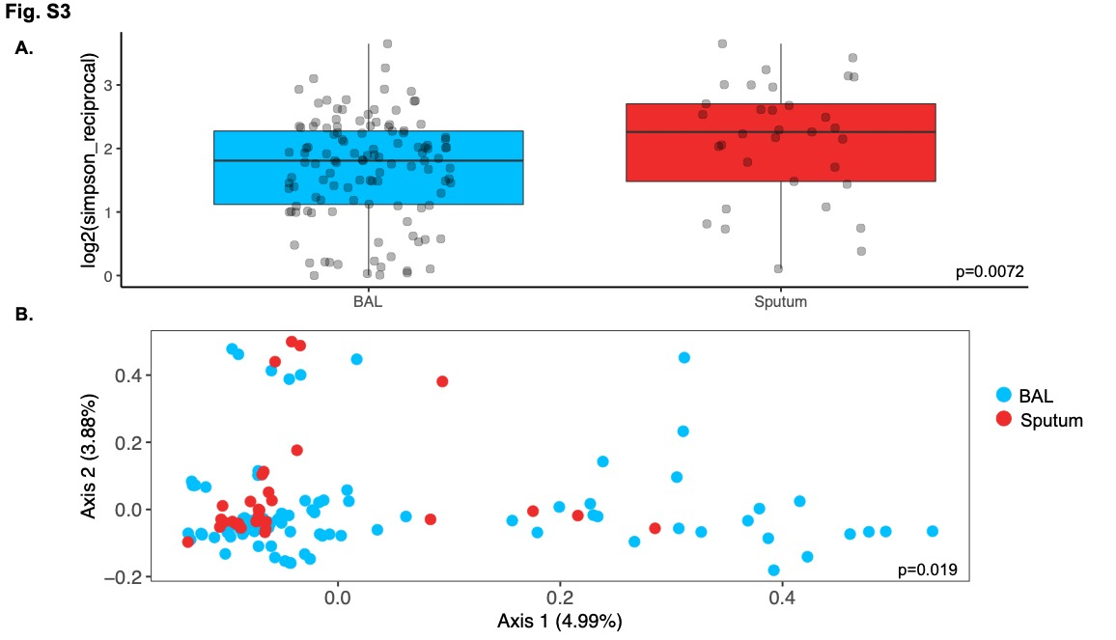
Fig S3: Comparison of fungal diversity by sample type. A) Comparison of alpha-diversity (measured using the Inverse Simpson index) in sputum (n=33) versus BALF (n=120 samples; 60 subjects). p-value by Wilcoxon ranksum test. B) Ordination of beta-diversity Bray-Curtis distances by principal coordinate analysis (p=0.019). p-value by ANOSIM 999 permutations.

Differences in microbiome diversity by sample type were observed when considering all subjects (n=68) and only those who contributed both sample types (n=27) (Fig. S4). This suggests that only the bacterial community structure in BALF is distinct from that of sputum and that microbiome readouts from these two sample types should be considered independently.
Fig S4: Comparison of bacterial diversity by sample type in subjects who provided both sample types. A) Alpha-diversity (measured using the Inverse Simpson index) in sputum (n=27) versus BALF (n=54 samples; 27 subjects). p-value by Wilcoxon ranksum test. B) Ordination of beta-diversity Bray-Curtis distances by principal coordinate analysis (p=0.001). p-value by ANOSIM 999 permutations.

Of note, there were no differences in bacterial alpha- or beta- diversity by patient groups by either BAL (Fig S5 A & C) or sputum (Fig S6). There were also no differences in bacterial diversity by lobe of the lung from which BALF was sampled (Fig S5 B & D).

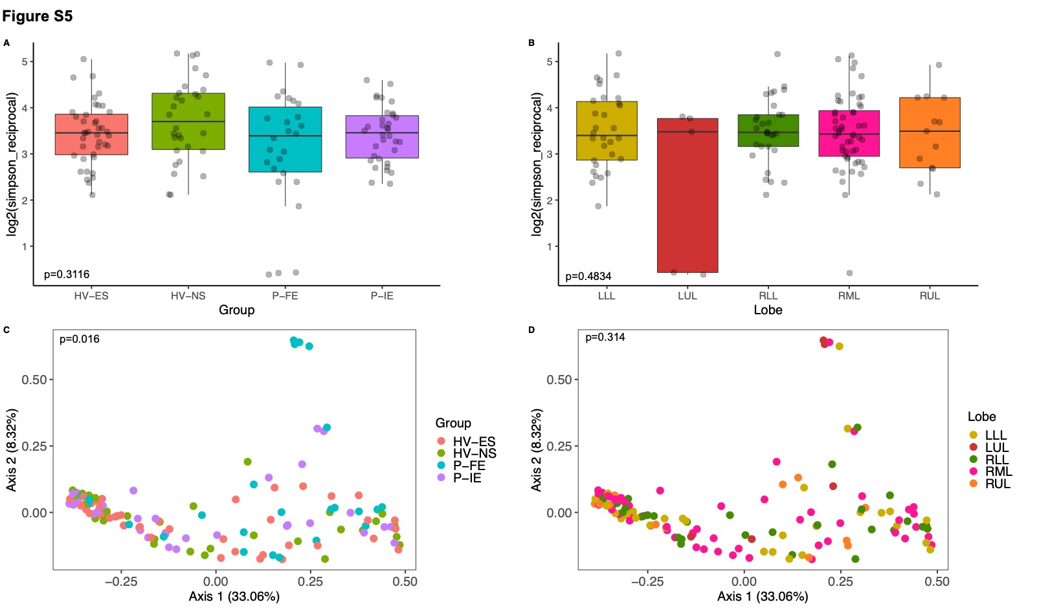
Fig S5: Comparison of bacterial diversity in BALF by lobe of lung and patient subgroup. A) Comparison of alpha-diversity (measured using the Inverse Simpson index by A) patient subgroup (HV-NS: n=30 samples–15 patients; HV-ES: n=40 samples–20 patients; P-IE: n=34 samples–17 patients; P-FE: n=26 samples–13 patients) and B) lobe of lung (LLL n=30; LUL n=5; RLL n=30; RML n=52; RUL n=13). P-value by Kruskal Wallis test. Ordination of beta-diversity (Bray-curtis) distances by principal coordinate analysis by C) patient subgroup and D) lobe of lung. P-value by ANOSIM 999 permutations. LLL: Left lower lobe; LUL: Left upper lobe; RLL: Right lower lobe; RRML: Right middle lobe; RUL: Right upper lobe.
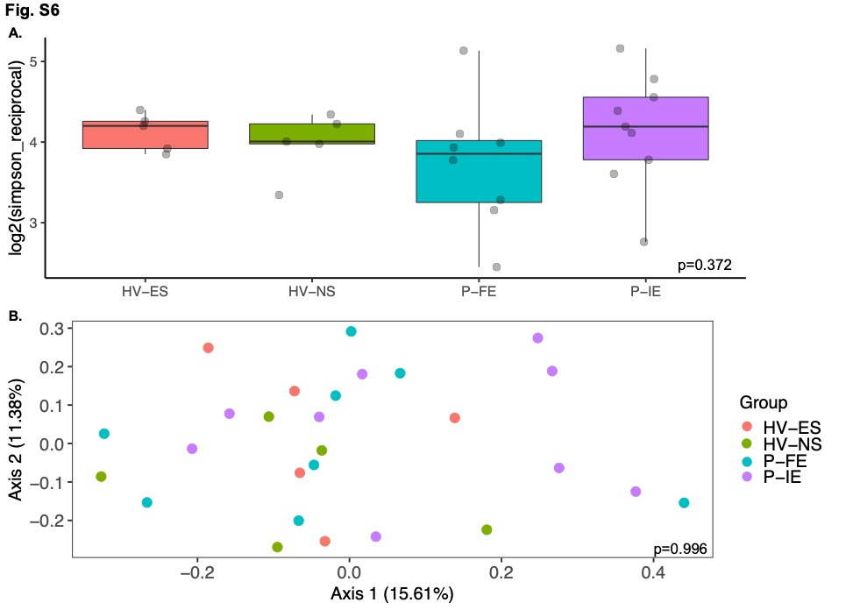
Fig S6: Comparison of bacterial diversity in sputum. A) Comparison of alpha-diversity (measured using the Inverse Simpson index) in sputum by patient subgroup (HV-NS n=5; HV-ES n=5; P-IE n=9; P-FE n=8). P-value by Kruskal Wallis test. B) Ordination of beta-diversity distances (Bray-Curtis) by principal coordinate analysis (p=0.996). p-value by ANOSIM (999 permutations).

Next, we characterized the taxonomic landscape (both bacteria and fungi) across all samples. The BAL samples were dominated by Proteobacteria with very little Bacteroidetes in all subject groups, whereas the sputum samples had lesser abundance of Proteobacteria and greater abundance of Firmicutes and Bacteroidetes (Fig. 1C & D). At the order level, Betaproteobacteriales and Pseudomonadales were prevalent across all groups; Lactobacillales was more abundant in P compared to HV (p=0.014) (Fig. 1E & F). In terms of fungi, both BAL and sputum samples were predominated by Ascomycota and Basidiomycota, whereas at lower levels the fungal niche was primarily composed of low abundance taxa, that were collapsed into the other category (Fig. S7)

Fig S7: Characterization of fungal diversity in sputum samples. Stacked bar plot by patient subgroup at the A) order and B) phylum levels. (HV-ES: n=5; HV-NS: n=5; P-FE: n=8; P-IE: n=11)

To evaluate microbiome signatures by patient groups, differential abundance analyses were performed using LEfSe to compare the relative abundances of microbial taxa. We found more differences in the BAL samples (Fig. 2A), (as opposed to sputum; Fig 2B) of COPD patients versus HV. Bacteria belonging to the Actinobacteria and Bacilli phyla; and specifically, those belonging to the Micrococcales and Lactobacillales orders were more abundant in BALF of COPD patients, whereas members of the Bacteroidetes phylum were more abundant in HV (Fig 2A). Therefore, in the setting of less-severe COPD disease, while the overall microbiome composition in the BALF was comparable between groups (Fig. S5C), differences were more apparent when comparing the abundances of individual bacterial taxa. There were also limited differences when comparing BAL samples for COPD patients who were frequent (P-FE) vs. infrequent (P-IE) exacerbators (Fig. S8).

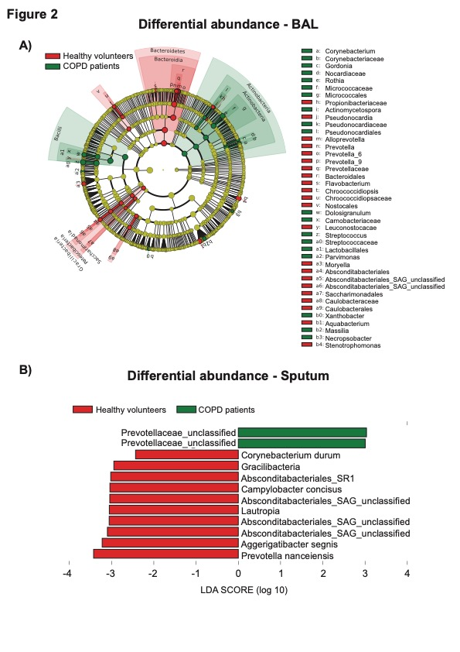
Figure 2: Differential abundance comparisons. A) Taxonomic cladogram and B) LDA score plot by LEfSe (LDA score minimum=2.0, p=0.05) displaying differential taxa in COPD patients in A) BAL (P; n=30 patients, 60 samples) vs healthy volunteers (HV; n=35 patients,70 samples), B) sputum (P; n=17) vs healthy volunteers (HV; n=10).
Fig. S8: Differential abundance comparisons in BALF – 16S rRNA sequencing. LEfSe LDA score plot for bacteria by anti-NTHi killing activity in frequent (n=26 samples, 13 patients) vs infrequent exacerbators (n=34 samples, 17 patients). (LDA score minimum=2.0, p=0.05).

Interestingly, upon examining the abundance of the Haemophilus genus, which has been previously implicated in COPD patients, we noted that it tended to have the highest abundance in the P-FE group (Fig. S9). Lastly, there were fewer differences with the mycobiome, with trends for taxa such as Penicillium and Tremellomycetes to be higher in the BALF of COPD patients (Fig S10).
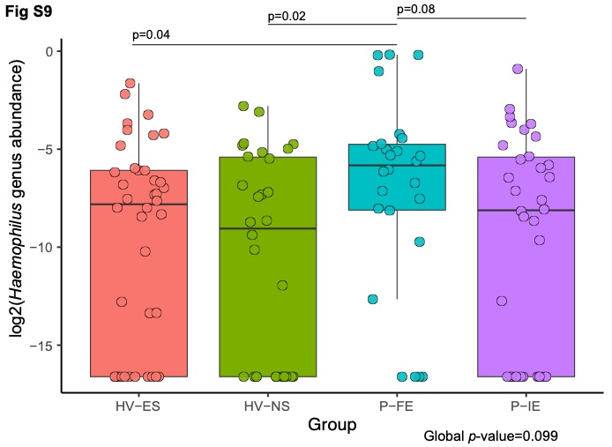
Fig. S9: Comparison of Haemophilus abundance in BAL between study groups . Box plot showing median, interquartile range, and range of Haemophilus abundance in study groups. Global p-value by Kruskal- Wallis test. Pairwise p-values are from the Wilcoxon ranksum test. (HV-ES: n=40 samples–20 patients; HV-NS: n=30 samples–15 patients; P-FE: n=26 samples–13 patients; P-IE: n=34 samples–17 patients)
Fig. S10: Differential abundance comparisons in BALF – ITS. LefSe LDA score plot for fungi in COPD patients (n=55 samples, 30 patients) versus healthy volunteers (n=64 samples, 35 patients). No differentially enriched fungi were identified in HV. (LDA score minimum=2.0, p=0.05).

Building on these observed microbiome differences, we sought to investigate any potential links with immune activity in the context of COPD. For this, we developed a multiplex assay with Meso Scale Discovery (Rockville, MD) to evaluate antibody responses in serum to antigens derived from bacteria that are known contributors of COPD pathogenesis, namely NTHi, Mcat and Streptococcus pneumoniae. In these studies, we observed a higher trend towards reactivity in COPD patients for ubiquitous NTHi derived antigens only (Fig. 3A & Fig. S11). When evaluating individual antibody isotypes, significant differences were observed for IgA titers against P6, Protein D and Protein F when comparing all four subject groups with the highest titers observed in P-IE (unadjusted p= 0.03, 0.03, p=0.01 for P6, Protein D & Protein F, respectively, Fig 3 B-D). Pairwise comparisons using the Dunn’s test further revealed that the P-IE group was driving the significant differences between the groups.

Figure 3: Serum immunological response to NTHi. A) Unsupervised hierarchical clustering heatmap of antibody titers to NTHi antigens. Significantly different antibodies are highlighted. Comparison of IgA titers to B) P6, C) Protein D and D) Protein F by subject group. p-value by Kruskal-Wallis test. HV-NS n=15; HV-ES n=20; P-IE n=14; P-FE n=12.

Fig S11: Serum immunological response to Moraxella catarrhalis and Streptococcus pneumoniae antigens. Unsupervised hierarchical clustering heatmap of antibody titers to A) M. catarrhalis and B) S. pneumoniae antigens. (HV-ES: n=20; HV-NS: n=16; P-FE: n=13; P-IE: n=14)

Lastly, we determined killing activity against NTHi from BALF of subjects in this cohort using a high throughput NTHi killing assay. Consistent with our finding of enhanced immune activity in COPD patients, we found that the odds of observing killing activity was 5.64 times more likely in BALF obtained from COPD patients (n=30 patients) when compared to HV (n=36 patients) (OR=5.64, 95% C.I. = 1.75 – 20.20; p=0.0012, Fig. 4A, Fig S12). When we stratified COPD patients based on NTHi killing activity, we noted a differential microbiome signature wherein Firmicutes and Actinobacteria were more abundant in patients with observable killing activity while Proteobacteria were more abundant in patients with no killing activity (Fig. 4B-C).
Figure 4: NTHi killing activity in BALF. A) Contingency plot of killing activity between COPD patients and healthy volunteers. B) Taxonomic landscape at the family level by killing activity (With killing activity: n=22 patients,44 samples; No killing activity: n=7 patients, 14 samples). C) LEfSe LDA score plot by NTHi killing activity (LDA score minimum=2.0, p=0.05; With killing activity: n=22 patients,44 samples ; No killing activity: n=7 patients, 14 samples). D) A bubble plot depicting top and bottom 20 differentially expressed proteins ranked by the log fold-changes (With killing activity: n=19 patients, 33 samples; No killing activity: n=7 patients, 13 samples). E) Comparison of Haptoglobin protein expression by killing activity (With killing activity: n=19 patients, 33 samples; No killing activity: n=7 patients, 13 samples).

Fig S12: Associations of anti-NTHi killing activity by patient subgroup. P-value by Fishers exact test

In addition, we also noted differences in host characteristics, specifically the proteome, when we compared BAL samples from COPD patients with NTHi killing activity versus those without. Of note, the protein haptoglobin (HP), which is synthesized by the lung epithelial cells and alveolar macrophages, and has been linked to increased disease severity in COPD, was found to be significantly enriched in patients with observeable NTHi killing activity in BALF (Fig. 4D-E). Interestingly, HP was also significantly inversely correlated with lung function parameters such as post-FEV1% and post-FEV1/FVC (Fig S13 A-D), while there was no apparent correlation with Gammaproteobacteria abundance (Fig. S13E). Taken together, these data point to ongoing host immune activity against NTHi in this patient population despite the low-severity of disease seen in most participants, and is therefore suggestive of a potential link between microbial dynamics and host immune responses.
Fig S13: Association of Haptoglobin expression with A) to D) lung function parameters E) Gammaproteobacteria abundance

Discussion
Herein, we have comprehensively characterized the microbiome and mycobiome in a unique cohort of ex-smoker COPD patients versus healthy volunteers. We also report a higher trend towards reactivity to NTHi antigens driven by infrequent exacerbators in the serum, and significantly enhanced NTHi killing activity in the BALF of COPD patients compared to healthy volunteers. Consistent with others [42, 43], we also report a demonstrable immunological response to known COPD pathogens in an observational cohort. However, in addition, we also report unique microbiome and proteomic signatures associated with NTHi killing, thereby suggesting a close interplay between functional activity against NTHi, microbial dynamics and immunological responses in the host.

NTHi is an airway commensal that can become a pathobiont although the mechanisms by which it does so is unclear. The Proteobacteria phylum (of which NTHi is a member) is a chronic colonizer of the COPD airway and detection of this bacteria is increased in exacerbations [19] and associated with increased COPD mortality [44]. In this study, although Proteobacteria was the most abundant phylum detected in the BAL samples, we did not observe any difference in abundance between COPD patients and controls. Consistent with our findings (Fig. 2A-B), this may reflect a difference between COPD microbiome studies that use sputum and those that use BAL with all the various caveats this difference implies, not least increased upper respiratory tract contamination in sputum [45]. However, there is little difference in the predominant bacteria seen between those studies that have used sputum and those that use BAL [46]. A further explanation might be that many previous COPD microbiome studies included current smokers [19, 47-49], whereas our cohort are all ex-smokers, although a recent study demonstrated no significant differences at the phylum and genus level in sputum derived from COPD ex-smokers and current smokers [50]. Changes in the COPD microbiome have been shown to change as disease severity increases [51]. For safety reasons, we sampled a mild-moderate patient cohort and this difference in disease severity may be a further factor in the lack of detection of NTHi in our cohort. Another potential reason for this miss could be the lack of sensitivity of 16S rRNA sequencing with regards to NTHi species detection.

Despite this inability to detect NTHi, there is a clear echo of prior airway infection with NTHi in the increased serum IgA titres against NTHi-associated proteins (Fig. 4), which is in line with a previous study demonstrating increased concentrations of both IgA and sIgA in BAL from COPD patients [52]. In further support of such prior NTHi infection, BAL samples derived from COPD patients demonstrated increased NTHi-killing ability (Fig. 4). Moreover, there was greater detection of Gammaproteobacteria in those samples that exhibited no ability to kill NTHi (Fig. 4B-C). This association may be a result of either no prior NTHi exposure or a defect in the ability of the individual to mount an effective immune response to NTHi. If the latter, it is tempting to speculate that the lower IgA titers to NTHi targets in frequent exacerbators could be a reflection of such a defect and could be an indicator for future colonization and exacerbation. However, such supposition requires further investigation in a longitudinal cohort to prospectively investigate an association with exacerbations.

We have also identified decreased pulmonary Haptoglobin as a further potential biomarker of decreased NTHi killing and detection of Gammaproteobacteria. Haptoglobin is an acute phase protein that complexes with haemoglobin facilitating haemoglobin uptake by macrophages via the scavenger receptor, CD163 [53]. Thus a reduction in haptoglobin might result in the increased free iron observed in the COPD airway [54], promoting overgrowth of pathogenic bacteria, such as NTHi. Additionally, this reduction in haptoglobin may be a function of the individual genotype of the volunteer, as those individuals with a haptoglobin genotype of 2-1 or 2-2 had lower haptoglobin concentrations in their sputum than individuals with a 1-1 genotype [55]. Further work to confirm this possible link between airway free iron, haptoglobin levels, bacterial colonization and COPD exacerbations is therefore warranted.

We recognize that this study is not without its limitations. Due to the deep characterization of subjects and intensive sampling, the cohort is small, and the study captured only cross-sectional measures, providing no insight into changes in BAL microbiome or proteome over time and disease states (e.g. stable vs exacerbation). We thus cannot fully rule out that lack of differences between healthy volunteers and COPD patients is not due to cohort size. Relatedly, this also precluded us from performing adjustment for multiple hypothesis testing in several of our statistical comparisons. Furthermore, exacerbation history was determined retrospectively at enrolment and largely based on patient recall rather than documented events. Additionally, sputum data was not available from all subjects making direct comparisons between BAL and sputum difficult, and due to limited sample availability, we were not able to determine the factors responsible for increased NTHi killing activity from COPD BALF. Lastly, our study included mild-moderate COPD patients and gives insights about earlier disease. Comparison of our findings with those in more severe disease in future studies is warranted as microbiome diversity is known to decrease with disease severity [51].

Our study demonstrates a clear increase in NTHi-killing in COPD compared to health in BAL. Furthermore, we demonstrate that this killing ability was associated with decreased detection of Proteobacteria. We have identified haptoglobin as a differentially expressed protein that associated with this NTHi-killing ability and the presence of Gammaproteobacteria. Further investigation of how these observations can be combined to enable better phenotyping of COPD patients to allow optimal targeting of existing (e.g. antibiotics) and novel (e.g. vaccines, monoclonal antibodies) therapies to modify the outcomes of this important condition is warranted.

Declarations

Ethics Approval
All subjects gave written informed consent. The study was approved by National Research Ethics Service South Central – Hampshire A and Oxford C Committees (LREC no: 15/SC/0528) and complied with the Declaration of Helsinki.

Consent for publication
Not applicable

Author Contributions
AD, TMAW, KS, designed the study. VG, BS, CM, AD, BRS, TMAW, KS planned and conducted the gut microbiome analyses. LO, BA, JHK and JW planned and conducted the proteomics analysis. AD, JHK, MK, TK, CC, PW, VAH, SW, HS, AB, AR, SH, CT, BRS planned and performed the experiments and conducted subsequent data analysis. CM, AP, DM, KO, MGB conceptualized parts of the project, analysis, supervised the project, and contributed to writing of the manuscript. VG, AD, JHK and BS prepared all figures. VG and AD drafted the first version of the manuscript. All authors contributed to data interpretation, and critical review of the manuscript and gave final approval of the version to be published.

Funding
Not applicable

Availability of Data and Materials
All microbiome and mycobiome sequencing data have been made available through PRJNA1108737

Conflict of Interest
This work was funded by AstraZeneca. Vancheswaran Gopalakrishnan, Ben Sparklin, Jung Hwan Kim, Margaret Kehl, Tara Kenny, Christopher Morehouse, Carolina Caceres, Paul Warrener, Ventzislava A. Hristova, Susan Wilson, Harini Shandilya, Arnita Barne, Alexey Ruzin², Junmin Wang, Lisa Oberg, Bastian Angermann, Christopher McCrae, Adam Plat, Daniel Muthas, Sonja Hess, Christine Tkaczyk, Bret R. Sellman, Kristoffer Ostridge, Maria G. Belvisi, Tom M.A. Wilkinson, Karl J. Staples, and Antonio DiGiandomenico are/were employees of AstraZeneca and owns stocks/shares. Vancheswaran Gopalakrishnan is a co-inventor on US patent PCT/US17/53,717 and on a provisional US patent WO2020106983A1.

References

1. Negewo NA, Gibson PG, McDonald VM. COPD and its comorbidities: Impact, measurement and mechanisms. Respirology 2015; 20:1160-71.
2. Mannino DM, Buist AS. Global burden of COPD: risk factors, prevalence, and future trends. Lancet 2007; 370:765-73.
3. Fricker M, Goggins BJ, Mateer S, et al. Chronic cigarette smoke exposure induces systemic hypoxia that drives intestinal dysfunction. JCI Insight 2018; 3.
4. Naghavi M, Abajobir AA, Abbafati C, et al. Global, regional, and national age-sex specific mortality for 264 causes of death, 1980–2016: a systematic analysis for the Global Burden of Disease Study 2016. The lancet 2017; 390:1151-210.
5. Tashkin DP, Strange C. Inhaled corticosteroids for chronic obstructive pulmonary disease: what is their role in therapy? Int J Chron Obstruct Pulmon Dis 2018; 13:2587-601.
6. Herath SC, Normansell R, Maisey S, Poole P. Prophylactic antibiotic therapy for chronic obstructive pulmonary disease (COPD). Cochrane Database of Systematic Reviews 2018.
7. Rabe KF, Fabbri LM, Vogelmeier C, et al. Seasonal distribution of COPD exacerbations in the prevention of exacerbations with tiotropium in COPD trial. Chest 2013; 143:711-9.
8. Vestbo J, Anderson W, Coxson HO, et al. Evaluation of COPD Longitudinally to Identify Predictive Surrogate End-points (ECLIPSE). Eur Respir J 2008; 31:869-73.
9. Mayhew D, Devos N, Lambert C, et al. Longitudinal profiling of the lung microbiome in the AERIS study demonstrates repeatability of bacterial and eosinophilic COPD exacerbations. Thorax 2018; 73:422-30.
10. Sethi S. Chronic obstructive pulmonary disease and infection. Disruption of the microbiome? Ann Am Thorac Soc 2014; 11 Suppl 1:S43-7.
11. Sze MA, Dimitriu PA, Suzuki M, et al. Host response to the lung microbiome in chronic obstructive pulmonary disease. American journal of respiratory and critical care medicine 2015; 192:438-45.
12. Wang Z, Maschera B, Lea S, et al. Airway host-microbiome interactions in chronic obstructive pulmonary disease. Respir Res 2019; 20:113.
13. Pragman AA, Kim HB, Reilly CS, Wendt C, Isaacson RE. The lung microbiome in moderate and severe chronic obstructive pulmonary disease. PLoS One 2012; 7:e47305.
14. Ren L, Zhang R, Rao J, et al. Transcriptionally Active Lung Microbiome and Its Association with Bacterial Biomass and Host Inflammatory Status. mSystems 2018; 3.
15. Hirschmann JV. Do Bacteria Cause Exacerbations of COPD? Chest 2000; 118:193-203.
16. Wilkinson TMA, Schembri S, Brightling C, et al. Non-typeable Haemophilus influenzae protein vaccine in adults with COPD: A phase 2 clinical trial. Vaccine 2019; 37:6102-11.
17. Nakou A, Papaparaskevas J, Diamantea F, Skarmoutsou N, Polychronopoulos V, Tsakris A. A prospective study on bacterial and atypical etiology of acute exacerbation in chronic obstructive pulmonary disease. Future Microbiology 2014; 9:1251-60.
18. King PT, Sharma R. The Lung Immune Response to Nontypeable Haemophilus influenzae (Lung Immunity to NTHi). J Immunol Res 2015; 2015:706376.
19. Wilkinson TMA, Aris E, Bourne S, et al. A prospective, observational cohort study of the seasonal dynamics of airway pathogens in the aetiology of exacerbations in COPD. Thorax 2017; 72:919-27.
20. Thuan Tong T, Mörgelin M, Forsgren A, Riesbeck K. Haemophilus influenzae Survival during Complement-Mediated Attacks Is Promoted by Moraxella catarrhalis Outer Membrane Vesicles. The Journal of Infectious Diseases 2007; 195:1661-70.
21. Schaar V, Nordström T, Mörgelin M, Riesbeck K. Moraxella catarrhalis outer membrane vesicles carry β-lactamase and promote survival of Streptococcus pneumoniae and Haemophilus influenzae by inactivating amoxicillin. Antimicrobial agents and chemotherapy 2011; 55:3845-53.
22. Leroux-Roels G, Van Damme P, Haazen W, et al. Phase I, randomized, observer-blind, placebo-controlled studies to evaluate the safety, reactogenicity and immunogenicity of an investigational non-typeable Haemophilus influenzae (NTHi) protein vaccine in adults. Vaccine 2016; 34:3156-63.
23. Van Damme P, Leroux-Roels G, Vandermeulen C, et al. Safety and immunogenicity of non-typeable Haemophilus influenzae-Moraxella catarrhalis vaccine. Vaccine 2019; 37:3113-22.
24. Arora AK, Chinsky K, Keller C, et al. A detailed analysis of possible efficacy signals of NTHi-Mcat vaccine against severe COPD exacerbations in a previously reported randomised phase 2b trial. Vaccine 2022; 40:5924-32.
25. Andreas S, Testa M, Boyer L, et al. Non-typeable Haemophilus influenzae–Moraxella catarrhalis vaccine for the prevention of exacerbations in chronic obstructive pulmonary disease: a multicentre, randomised, placebo-controlled, observer-blinded, proof-of-concept, phase 2b trial. The Lancet Respiratory Medicine 2022; 10:435-46.
26. Day K, Ostridge K, Conway J, et al. Interrelationships Among Small Airways Dysfunction, Neutrophilic Inflammation, and Exacerbation Frequency in COPD. Chest 2021; 159:1391-9.
27. Watson A, Spalluto CM, McCrae C, et al. Dynamics of IFN-β Responses during Respiratory Viral Infection. Insights for Therapeutic Strategies. Am J Respir Crit Care Med 2020; 201:83-94.
28. Ostridge K, Gove K, Paas KHW, et al. Using Novel Computed Tomography Analysis to Describe the Contribution and Distribution of Emphysema and Small Airways Disease in Chronic Obstructive Pulmonary Disease. Ann Am Thorac Soc 2019; 16:990-7.
29. Hurst JR, Vestbo J, Anzueto A, et al. Susceptibility to exacerbation in chronic obstructive pulmonary disease. N Engl J Med 2010; 363:1128-38.
30. Hurst JR, Han MK, Singh B, et al. Prognostic risk factors for moderate-to-severe exacerbations in patients with chronic obstructive pulmonary disease: a systematic literature review. Respiratory Research 2022; 23:213.
31. Bourne S, Cohet C, Kim V, et al. Acute Exacerbation and Respiratory InfectionS in COPD (AERIS): protocol for a prospective, observational cohort study. BMJ Open 2014; 4:e004546.
32. Kozich JJ, Westcott SL, Baxter NT, Highlander SK, Schloss PD. Development of a Dual-Index Sequencing Strategy and Curation Pipeline for Analyzing Amplicon Sequence Data on the MiSeq Illumina Sequencing Platform. Applied and Environmental Microbiology 2013; 79:5112-20.
33. Op De Beeck M, Lievens B, Busschaert P, Declerck S, Vangronsveld J, Colpaert JV. Comparison and Validation of Some ITS Primer Pairs Useful for Fungal Metabarcoding Studies. PLOS ONE 2014; 9:e97629.
34. Callahan BJ, McMurdie PJ, Rosen MJ, Han AW, Johnson AJ, Holmes SP. DADA2: High-resolution sample inference from Illumina amplicon data. Nat Methods 2016; 13:581-3.
35. Quast C, Pruesse E, Yilmaz P, et al. The SILVA ribosomal RNA gene database project: improved data processing and web-based tools. Nucleic Acids Res 2013; 41:D590-6.
36. Nilsson RH, Larsson KH, Taylor AFS, et al. The UNITE database for molecular identification of fungi: handling dark taxa and parallel taxonomic classifications. Nucleic Acids Res 2019; 47:D259-d64.
37. Bolyen E, Rideout JR, Dillon MR, et al. Reproducible, interactive, scalable and extensible microbiome data science using QIIME 2. Nature Biotechnology 2019; 37:852-7.
38. Segata N, Izard J, Waldron L, et al. Metagenomic biomarker discovery and explanation. Genome Biol 2011; 12:R60.
39. Hristova VA, Watson A, Chaerkady R, et al. Multiomics links global surfactant dysregulation with airflow obstruction and emphysema in COPD. ERJ Open Res 2023; 9.
40. Phipson B, Lee S, Majewski IJ, Alexander WS, Smyth GK. ROBUST HYPERPARAMETER ESTIMATION PROTECTS AGAINST HYPERVARIABLE GENES AND IMPROVES POWER TO DETECT DIFFERENTIAL EXPRESSION. Ann Appl Stat 2016; 10:946-63.
41. Ritchie ME, Phipson B, Wu D, et al. limma powers differential expression analyses for RNA-sequencing and microarray studies. Nucleic Acids Res 2015; 43:e47.
42. Abe Y, Murphy TF, Sethi S, et al. Lymphocyte proliferative response to P6 of Haemophilus influenzae is associated with relative protection from exacerbations of chronic obstructive pulmonary disease. Am J Respir Crit Care Med 2002; 165:967-71.
43. Bandi V, Jakubowycz M, Kinyon C, et al. Infectious exacerbations of chronic obstructive pulmonary disease associated with respiratory viruses and non-typeable Haemophilus influenzae. FEMS Immunol Med Microbiol 2003; 37:69-75.
44. Dicker AJ, Huang JTJ, Lonergan M, et al. The sputum microbiome, airway inflammation, and mortality in chronic obstructive pulmonary disease. J Allergy Clin Immunol 2021; 147:158-67.
45. Whiteside SA, McGinniss JE, Collman RG. The lung microbiome: progress and promise. J Clin Invest 2021; 131.
46. Tiew PY, Jaggi TK, Chan LLY, Chotirmall SH. The airway microbiome in COPD, bronchiectasis and bronchiectasis-COPD overlap. The Clinical Respiratory Journal 2021; 15:123-33.
47. Hilty M, Burke C, Pedro H, et al. Disordered microbial communities in asthmatic airways. PLoS One 2010; 5:e8578.
48. Erb-Downward JR, Thompson DL, Han MK, et al. Analysis of the lung microbiome in the "healthy" smoker and in COPD. PLoS One 2011; 6:e16384.
49. Wang Z, Bafadhel M, Haldar K, et al. Lung microbiome dynamics in COPD exacerbations. European Respiratory Journal 2016; 47:1082-92.
50. Haldar K, George L, Wang Z, et al. The sputum microbiome is distinct between COPD and health, independent of smoking history. Respiratory Research 2020; 21:183.
51. Mayhew D, Devos N, Lambert C, et al. Longitudinal profiling of the lung microbiome in the AERIS study demonstrates repeatability of bacterial and eosinophilic COPD exacerbations. Thorax 2018; 73:422-30.
52. Staples KJ, Taylor S, Thomas S, et al. Relationships between Mucosal Antibodies, Non-Typeable Haemophilus influenzae (NTHi) Infection and Airway Inflammation in COPD. PLOS ONE 2016; 11:e0167250.
53. di Masi A, De Simone G, Ciaccio C, D'Orso S, Coletta M, Ascenzi P. Haptoglobin: From hemoglobin scavenging to human health. Mol Aspects Med 2020; 73:100851.
54. Zhang WZ, Oromendia C, Kikkers SA, et al. Increased airway iron parameters and risk for exacerbation in COPD: an analysis from SPIROMICS. Scientific Reports 2020; 10:10562.
55. Higham A, Dungwa J, Pham T-H, McCrae C, Singh D. Increased mast cell activation in eosinophilic chronic obstructive pulmonary disease. Clinical & Translational Immunology 2022; 11:e1417.

MICA II Study group:

Vancheswaran Gopalakrishnan ¹
Christopher Morehouse ¹
Jerome Bouquet ¹
Bret Sellman ²
Paul Warrener ²
Carolina Caceres ⁴
Ventzislava A. Hristova ⁵
Sonja Hess ⁵
Raghothama Chaerkady ⁵
Matthew S. Glover ⁵
Steven Novick ⁷
Junmin Wang ⁷
Bairu Zhang ⁷
Tianhui Zhang ⁷
Natalie van Zuydam ⁷
Bastian Angerman ⁸
Christopher McCrae ⁸
Daniel Muthas ⁸
Michael Hühn ⁸
Lisa Öberg ⁸
Hanna Duàn ⁸
Glenda Lassi ⁸
Gary Sims ⁸
Kristoffer Ostridge ^{8,11}
Alex Mackay ^{8,16}
Adam Platt ⁹
Antonio DiGiandomenico ¹⁰
Jodie Ackland ¹¹
Ashley I. Heinson ¹¹
D. Cellura ¹¹
Anthony D. Postle ¹¹
C. Mirella Spalluto ¹¹
Kerry Day ¹¹
Alex Hicks ¹¹
Nicholas P. Williams ¹¹
Karl J. Staples ^{11,13}
Tom M.A Wilkinson ^{11, 13} (nominated consortia representative)
Hannah Burke ^{11,13}
Anna Freeman ^{11,13}
Maria G. Belvisi ¹²
Sarah Bawden ¹³
Esther Nyimbili ¹³
Laura Presland ¹³
Nicola Rayner ¹³
Pedro Rodrigues ¹³
Andria Staniford ¹³
Alastair Watson ¹⁴
Graham Belfield ¹⁵
Stephanie Ashenden ¹⁵
Damla Etal ¹⁵
Aurelie Bornot ¹⁵
Fredrik Karlsson ¹⁵
Karl Nordström ¹⁵
Outi Vaarala ¹⁷
Chia-Chien Chiang ¹⁸
Shameer Khader ¹⁸
Wen Yu ¹⁸
Xiaotao Qu ¹⁸
Bruce Thompson ¹⁹
Ulrika Edvardsson ²⁰ and
Stephen Harden ²¹

¹ Bioinformatics, Research and Early Development, Vaccines and Immune Therapies, BioPharmaceuticals R&D, AstraZeneca, Gaithersburg, USA
² Bacteriology, Research and Early Development, Vaccines and Immune Therapies, BioPharmaceuticals R&D, AstraZeneca, Gaithersburg, USA
³ Virology and Vaccine Discovery, Research and Early Development, Vaccines and Immune Therapies, BioPharmaceuticals R&D, AstraZeneca, Gaithersburg, USA
⁴ Translational Scientific Management, Research and Early Development, Vaccines and Immune Therapies, BioPharmaceuticals R&D, AstraZeneca, Gaithersburg, USA
⁵ Dynamic Omics, Centre for Genomics Research (CGR), Discovery Sciences, BioPharmaceuticals R&D, AstraZeneca, Gaithersburg, MD, USA
⁶ Biologics Engineering, Oncology R&D, AstraZeneca, Gaithersburg, USA
⁷ Quantitative Biology, Data Sciences and Quantitative Biology, Discovery Sciences, BioPharmaceuticals R&D, AstraZeneca, Gaithersburg, MD, USA
⁸ Translational Science and Experimental Medicine, Research and Early Development, Respiratory & Immunology, BioPharmaceuticals R&D, AstraZeneca, Gothenburg, Sweden
⁹ VP and Head of Translational Science and Experimental Medicine, Research and Early Development, Respiratory & Immunology, BioPharmaceuticals R&D, AstraZeneca, Cambridge, UK
¹⁰ Bacterial Antibodies, Research and Early Development, Vaccines and Immune Therapies, BioPharmaceuticals R&D, AstraZeneca, Gaithersburg, USA
¹¹ Clinical & Experimental Sciences, University of Southampton Faculty of Medicine, Southampton, UK
¹² SVP and Head of Research and Early Development, Respiratory and Immunology, BioPharmaceuticals R&D, AstraZeneca, Gothenburg, Sweden
¹³ NIHR Southampton Biomedical Research Centre, University Hospital Southampton, Southampton, UK
¹⁴ Faculty of Medicine, University of Southampton, Southampton, and School of Clinical Medicine, University of Cambridge, Cambridge, UK
¹⁵ Translational Genomics, Discovery Biology, Discovery Sciences, BioPharmaceuticals R&D, AstraZeneca, Gothenburg, Sweden
¹⁶ NHLI, Imperial College, London, UK
¹⁷ Faculty of Medicine, University of Helsinki, Helsinki, Finland
¹⁸ Data Science and Artificial Intelligence, BioPharmaceuticals R&D, AstraZeneca, Gothenburg, Sweden
¹⁹ Swinburne University of Technology Melbourne, Australia
²⁰ Business Development and Licensing, BioPharmaceuticals R&D, AstraZeneca, Gothenburg, Sweden
²¹ University Hospital Southampton NHS Foundation Trust, Southampton, UK

