Running Header: Y-maze responses associated with working memory

Behavioral evidence that repetitive responses in a Free-Movement Pattern Y-maze are associated with ageing-related deficit in working memory
Edward S. Redhead1
Jude Rolfe-Tarrant1
Antony Wood1
Matthew O. Parker2

1 School of Psychology, University of Southampton
² Surrey Sleep Research Centre, University of Surrey

Author Note
Edward S. Redhead https://orcid.org/0000-0002-7771-1228
Antony Wood https://orcid.org/0000-0002-1257-1877
Matthew O. Parker https://orcid.org/0000-0002-7172-5231
Corresponding author: Edward Redhead, School of Psychology, University of Southampton, Highfield, Southampton, SO17 1BJ, UK. Email: er2@soton.ac.uk

Word count 5132

Abstract
Visuospatial working memory (VSWM) is crucial for navigating complex environments and is known to decline with ageing. The Free-Movement Pattern (FMP) Y-maze, used in animal studies, provides a robust paradigm for assessing VSWM via analyses of individual differences in repeated alternating sequences of left (L) and right (R) responses (LRLR, etc.), the predominant search pattern in many species. Previous human studies have used a honeycomb-shaped maze, designed for continuous search and trajectory-based navigation, and have shown ageing-related decline in performance of alternating responses. To date, there has been no examination of responses in the closed Y-maze in humans, faithfully replicating the discrete arm entry conditions of animal experiments. Experiment 1 replicated results observed in the honeycomb Y-maze: younger participants (18–40 years) displayed higher levels of alternating turns (LRLR/RLRL), while older participants (70+ years) exhibited predominantly sequential repetitive responses (i.e. LLLL/RRRR). Experiment 2 demonstrated that alternations reflect VSWM. Specifically, there was a significant correlation between proportion of alternating responses and higher scores on the digital Corsi test, a validated measure of VSWM. When alternating responses were reinforced in Experiment 3, older participants still alternated less and repeated more than younger participants. These findings suggest that age-related declines in VSWM underpin the repetitive search patterns observed in older adults. By faithfully replicating the conditions of animal studies, the closed FMP Y-maze offers a simple, scalable tool for assessing VSWM in humans. Its design is particularly suited for gamification, enhancing motivation, reducing stress, and personalizing interventions to improve performance in older populations.
Key words: Free-movement pattern (FMP) Y-maze; spatial working memory; age-related decline; alternating pattern of responding; computer generated maze

Quick, simple, and reliable tasks assessing cognitive abilities such as working memory are vital for timely cognitive evaluations, aiding early interventions. If these tasks can be closely modelled in animals, studies can be carried out that may offer insights into underlying neural mechanisms and potential therapeutic strategies. We, and others, have demonstrated translation of behavioral patterns within a Free movement pattern (FMP) Y-maze, in which research animals were free to explore a Y-shaped maze for 1h, across vertebrates (zebrafish, mice, xenopus [Cleal et at., 2021b; Ismail et al., 2022]) and invertebrates (drosophila [Akhund-Zade et al., 2019; Buchanan et al., 2015; Cleal et al., 2021b]). At the junction of the maze, in a high proportion of trials, vertebrates (invertebrates typically show either strong alternating or repeating sequences) tend to alternate choices, first taking the right (R) path and then the left (L). Alternations have been proposed as an operational measure of working memory, as they require participants to recall their previous choice to inform their next decision. Supporting the role of working memory in this search pattern, several studies have independently found that this pattern of alternations is abolished following exposure to memory-blocking drugs (e.g., NMDA-receptor antagonist MK-801 in zebrafish [Cleal et al. 2021b] and Xenopus [Ismail et al., 2022]). Using a virtual honeycomb-shaped version of the maze (in which participants were faced with repeating ‘Y’ shaped junctions) Cleal et al. (2021b) found that humans would also fall into this alternating pattern of responses when exposed to the choices at the junctions.
In follow-up studies, Cleal et al. (2021a) demonstrated that in both older fish (24+ months) and humans (70+ years), this alternating pattern of responding was muted. Both the older fish and older humans exhibited fewer alternations and more 'random' responses throughout the session. Cleal et al. (2021a) suggested that this shift toward random responding could be attributed to ageing-related decline in working memory. Supporting this hypothesis, they found that administering a cognitive enhancer (dopamine receptor D1/5 agonist) to the older fish restored alternating behavior to levels comparable to younger fish. However, these, and more recent (Parker et al., 2024¹) findings from the honeycomb maze in humans highlighted that reduced alternations may not exclusively reflect working memory deficits, as the continuous search format of the task could also engage other cognitive processes such as exploratory drive. The aim of the current paper is to provide behavioral evidence that the alternating pattern of behavior is specifically associated with spatial working memory in humans.
Cleal et al. (2021a) demonstrated that older participants made fewer alternating responses in the honeycomb version of the FMP Y-maze (See Figure 1a-b). Experiment 1 aimed to test whether this alternating search pattern was retained in a closed version of the virtual FMP Y-maze, which restricted participants to the three arms used in the zebrafish paradigm (See Figure 1c-d). Unlike the honeycomb maze, the closed FMP Y-maze provides a more controlled environment, allowing for discrete arm entries and manipulation of search strategies, while closely replicating conditions from animal studies. This design minimizes the influence of continuous search trajectories and exploratory drive, which may have contributed to differences between younger and older participants in the honeycomb maze (Cleal et al., 2021a). Exploratory drive, referring to an individual's intrinsic motivation to seek out and engage with novel environments (Montgomery, 1955), declines with age due to decreased cognitive flexibility and dopamine-related senescence (Düzel et al., 2010). To address these factors, Experiment 1 aimed to rule out exploratory drive as a confounding variable and to explore translational similarities in search patterns between humans and other species using the enclosed FMP Y-maze.
Footnote ¹
Parker et al (2024) is under review having been re-submitted following minor revisions

Experiment 2 seeks to validate the virtual FMP Y-maze as a measure of spatial working memory by comparing the results with those of a virtual Corsi test (Corsi, 1972), an established and validated (Eysenck, Payne, & Derakshan, 2005) measure of spatial working memory. Experiment 3 sought to reinforce alternating responses to test if older participants were able to learn to make these responses, to rule out if older participants were simply using an alternative strategy. None of the studies in this paper was pre-registered.
Experiment 1
Participants were placed into a virtual closed Y-maze (Figure1 c and d), the same design as that used in the animal studies of Cleal et al. (2021), to see if the humans made alternating responses. In pilot studies in the FMP Y-maze, human participants were found to quickly stop searching. Therefore, to motivate participants to continue searching targets were placed at the end of each arm, in the form of a green mat, which participants were told might contain a coin. If a coin was collected by crossing a mat then another coin could not be collected from that mat until participants had crossed another mat in another arm. Participants were encouraged to collect as many coins as possible in the set time of 5 minutes to gain a high score in the game.
Participants
Ethical approval for this, and all studies, was obtained from the University of Southampton Psychology ethics committee. One-hundred-and-five participants were recruited via an online participant recruitment platform, prolific.co, in return for remuneration of £2. The younger participants (28 female, 24 male) were aged between 18-40 (M = 26.38; SD = 4.43). Participants were asked their ethnicity, 27 described themselves as White, 11 described themselves as Black, 9 described themselves as Mixed Race, 4 described themselves as Other, and 1 described themselves as Asian. The older participants (22 female, 31 male) were aged between 70-85 (M = 73.87; SD = 3.64). Regarding ethnicity, 47 described themselves as White, 4 described themselves as Black, and 2 described themselves as mixed race. We based the sample size on an a priori power analysis based on Cleal et al. (2021b) study on human participants. For our effect-size estimate calculation we used the between x within factor interaction effect (f = 0.5). Achieving 80% power to detect an effect of this magnitude requires 34 participants, given α = .05 (G*Power 3.1; Faul et al., 2007). We exceeded this recruitment target. We report how we determined our sample size, all data exclusions (if any), all manipulations, and all measures in the study.
Apparatus
The model was run from a University of Southampton site which was accessed on each participant’s computer via a link from the Prolific Academic site. Participants were only able to access the site using their laptop rather than any other mobile devices to restrict variability in size of image viewed by participants. Speed of movement was to some extent dependant on participants internet speed. The model was created and developed within the Psychology department in University of Southampton, using 3DSMax 2012. The environment presented on the computer was entirely virtual and was based on a ‘cave’ with three identical arms and a central junction point. There were no dissociable physical elements or cues within the environment. The programme placed the participants at the junction of the Y-maze and offered a first-person perspective (See Figure 1d). A standalone version of the experimental task is freely available via the Open Science Framework https://osf.io/4cym2/
Procedure
When selecting the study on prolific, participants were asked first to give their consent to take part in the study. They were told they would be placed in a virtual cave, and they could explore the cave by pressing the arrow keys on their computer: Up arrow to go forward; Right arrow to go right; Left arrow to go left. Participants could not move backwards using the down key. Participants were informed that they should collect coins within the maze to gain points. The coins could be collected by stepping on a green mat at the end of each arm of the maze. Participants were told once they had collected a coin from an arm they must move to another arm before they could collect another coin from the original arm. In that way participants could not remain in one arm to collect coins. The participants were then placed at the centre of the Y-maze facing the junction. On touching a mat participants would be alerted via a message on the screen as to whether they had received a coin or not and then rotated so they were facing the junction again to begin the next trial. Over the course of the session stepping on the mats would result in a coin on 50% of occasions (randomly distributed across the session). The session lasted 5 minutes. In this time participants could complete as many trials as they were able and were encouraged to continue searching for coins throughout the session to gain a high score. At the end of the session participants were debriefed as to the nature of the experiment.
Design
The design of the experiment was a mixed-design, 2 response type (repeating or alternating; within) x 2 age group (young or old; between). All analysis was completed using SPSS v. 28.1 statistical software. In accordance with Cleal et al. (2021a) and Parker et al (2024), sequential repetitions were recorded when participants made four consecutive Left (L) or Right (R) responses at the junction (e.g., LLLL or RRRR). A sequential alternating response, on the other hand, was recorded if participants made LRLR or RLRL patterns on four consecutive visits to the Y-maze junction. Any response sequence that did not conform to these patterns was classified as random. The use of tetragrams (sequences of four responses) provides a mathematically robust framework to analyze patterns of navigation while balancing complexity and practicality (Frith & Done, 1983). Tetragrams offer sufficient sequence length to capture meaningful patterns of alternation and repetition, while avoiding excessive computational demands or interpretive ambiguity that might arise with longer sequences. Furthermore, the classification into alternating, repeating, and random responses helps us to understand the predictable nature of spatial navigation in structured mazes, providing a clear operationalization of visuospatial working memory. There were 16 possible tetragrams that could be recorded (all combinations of LLLL – RRRR), but we combined each similar pattern (eg LLLL+RRRR, LLLR+RRRL, etc) to create 8 pairs of tetragrams (ie LLLL/RRRR, LLLR/RRRL, etc)
The dependent variables were the proportion of alternating (LRLR/RLRL) and repeating (LLLL/RRRR) responses, and were calculated to quantify navigation strategies. For alternating responses, this proportion was obtained by dividing the number of tetragrams classified as alternating (LRLR/RLRL) by the total number of tetragrams. Similarly, the proportion of repeating responses (LLLL/RRRR) was calculated as the number of repeating tetragrams divided by the total tetragrams. By focusing on these proportions, the analysis provides a straightforward and interpretable measure of spatial working memory and navigation strategy consistency.
Results
Figure 2 illustrates the proportion of trials in which participants made all possible eight tetragram pairs. As seen in all our previous studies, there is only a clear difference between either the repeating or alternating responses. For the younger participants the proportion of responses that are alternating (M = 0.30; SD = 0.27) is larger than are repeating (M = 0.16; SD =0.19). For the older participants the opposite is true: the proportion of responses that are repeating (M = 0.25; SD = 0.21) is larger than are alternating (M = 0.14; SD = 0.16).
A mixed design analysis of variance (ANOVA) 2 (response type) x 2 (age group) was performed on the proportion of responses. The main effect of response type was not significant F<1. The main effect of age group was also not significant F(1, 103) = 2.61, p = .109, η_{p}² = .03, 90% CI = [.000, .0923]. The response type x age group interaction was, however, significant, F(1, 103) = 11.11, p = .001, η_{p}² = .10, 90% CI = [.025, .193]. Further analysis of the interaction via the use of simple main effects revealed a significant effect of response type both in the younger participant age group, F(1, 103) = 6.59, p = .012, η_{p}² = .06, 90% CI = [.007, .146], where the proportion of alternating responses was larger than the proportion of repeating responses, and in the older participant age group, F(1, 103) = 4.60, p = .034, η_{p}² = .04, 90% CI = [.002, .121] where the opposite was true, that the proportion of repeating responses was larger than the proportion of alternating responses.
The results of Experiment 1 illustrate that older participants also make more repeating responses in a virtual FMP Y-maze which constrains the participants to the 3 arms of the simple Y-maze, while younger participants make more alternating responses. This extends the findings of Parker et al (2024) where both young and older participants showed similar patterns with respect to alternations in the honeycomb Y-maze.
We have previously argued that older people carry out repetitions as opposed to alternations in the FMP Y-maze because alternations are more cognitively demanding (Cleal et al 2021a; Parker et al, 2024). Repeating the same choice (RRRR/LLLL) is cognitively less demanding as it requires establishing and following a single, unchanging pattern: alternation (LRLR/RLRL) requires the participant to remember and execute a changing pattern. Similarly, in the repetitive pattern, the participant only needs to remember one piece of information (e.g., always turn right), whereas in the alternating pattern, the participant needs to remember not only which direction to turn next, but also the sequence of previous turns to maintain the alternating pattern. This adds to the cognitive load and requires better working memory. Therefore, the repetitive pattern observed in the older adults here may be associated with easier encoding and retrieval from memory due to its simplicity and consistency. If alternation patterns on the FMP Y-maze are related to working memory capacity, it would be predicted that participants would produce a similar level of performance in other measures of working memory. The aim of Experiment 2, therefore, is to assess whether there is a correlation between the proportion of responses that are alternating and an established (validated) measure of spatial working memory.
Experiment 2
Cleal et al. (2021b) suggested that the FMP Y-maze was an indication of working memory, with animals exposed to memory-blocking drugs performing fewer alternations and more ‘random’ responses. To validate the FMP Y-maze as a measure of working memory, Experiment 2 compared the results from the maze with those of an established measure of visuospatial working memory, a digital version of the Corsi block tapping task (Siddi et al., 2020). Participants were asked to do both the FMP Y-maze and a digital version of the Corsi task.
Participants
There were 120 (63 female) participants aged between 20-79 (M = 39.83; SD = 15.41). Regarding ethnicity, 95 participants described themselves as White, 12 described themselves as Black, 7 described themselves as Asian, 3 described themselves as Mixed Race and 3 described themselves as Other. We based the sample size on an a priori power analysis using a medium effect size of 0.3. Achieving 80% power to detect a medium effect size requires 84 participants, given α = .05 (G*Power 3.1; Faul et al., 2007). We exceeded this recruitment target. Participants were recruited via an online participant recruitment platform, prolific.co, for a remuneration of £3.
Apparatus
The details of the apparatus were the same as Experiment 1.
Procedure
The details of the procedure were the same as Experiment 1 except after completing the FMP Y-maze task participants were asked to complete a digital version of the Corsi block tapping task. Nine blue blocks were displayed on the screen in a random array (Please see Figure 3 for screen display during Corsi test).
On trial 1 three blocks were individually highlighted by being turned yellow for 1 second each. Participants were then asked to click on each block in the order they were highlighted. Participants were informed if they had made the correct selection. On trial 2 a different three blocks in a different array were highlighted. On trial 4 four new blocks were highlighted. The number of blocks highlighted increase every two trials until either all nine blocks were highlighted in the final two trials or a participant selected the wrong blocks on two consecutive trials. The highest number of blocks correctly selected was recorded and taken as the Corsi score.
Results
Figure 4 depicts the mean proportion of responses across all participants that were classified as one of the eight possible tetragrams. As in Experiment 1, numerically the highest proportion of responses were classified as Repeating responses (LLLL/RRRR) or Alternating responses (LRLR/RLRL). Using a Pearson’s correlation there was found to be a significant positive correlation between the Corsi score of number of blocks correctly highlighted (M = 5.67; SD = 1.62), and the number of Alternating responses (M = 8.34; SD = 12.48), r(120) = .41, p < .001, 90% CI = [.271, .524] (See Figure 5a for a scatter plot of depicting the association between these two variables) and between the Corsi score and the number of Alternating responses as a proportion of the overall number of responses (M = .16; SD = 0.21), r(120) = .33, p < .001, 90% CI = [.185, .455] (See Figure 5b). There was also a significant negative correlation between the Corsi score and the proportion of Repeating responses (M = 0.24; SD = 0.22), r(120) = -.19, p = .037, 90% CI = [-.332, -.041] (See Figure 5c).
The results of Experiment 2 confirm that participants with better visuospatial working memory make more alternating responses. From this it might be presumed that the reason older participants do not make alternating responses is that they have poor spatial working memory. However, it's possible that older participants can make the alternating responses, but choose not to for some other reason, or simply use an alternative strategy. Experiment 3 used two conditions, in one, points were preferentially given for alternating responses, in the other points were given to repeating responses. If older participants are unable to make alternating responses due to poor spatial working memory then reinforcing alternating responses should not make a difference. If, on the other hand, older participants simply choose to use a repeating strategy, punishing this strategy and rewarding the alternating strategy might lead them to switch to an alternating strategy.
Experiment 3
Method
Participants
There were 118 participants in the study (for power analysis, see Exp 1 – here, we over-recruited again), elicited via an online participant recruitment platform, prolific, for a remuneration of £2. The younger participants (28 female, 32 male) were aged between 18-40 (M = 27.15; SD = 5.98). 27 Regarding ethnicity, 39 participants described themselves as White, 15 described themselves as Black, 4 described themselves as Mixed Race, and 2 described themselves as Asian. The older participants (30 female, 28 male) were aged between 70-87 (M = 73.83; SD = 3.53). Regarding ethnicity, 56 participants described themselves as White, 2 described themselves as Black, and 1 described themselves as Asian.
Apparatus
Details were the same as for Experiment 1
Procedure
The procedure details were identical to Experiment 1, except that here, for half the participants, 85% of alternating responses earned a coin, while only 15% of repeating responses did (Alternation condition). For the other half, the rewards were reversed: 85% of repeating responses were rewarded, and only 15% of alternating responses received a coin (Repetion condition). As before, coins were earned following the participant reaching the end of the arm and crossing the green platform.
Results
Figures 6a and b depict the mean proportion of responses that were classified as one of the eight possible tetragrams. Figure 6a depicts these values during the Alternation condition and Figure 6b during the Repetition condition. As with Experiments 1 and 2 the highest proportion of responses were classified as either an alternating response (LRLR/RLRL) or a repeating response (LLLL/RRRR). Given this, Figure 7 and the subsequent analysis focusses on these two response types. Figure 7 illustrates the proportion of trials that participants made either a repeating or alternating response in the two conditions. For the younger participants in the Repetition condition the proportion of responses that are repeating (M = 0.46; SD = 0.28) was larger than the proportion of alternating responses (M = 0.10; SD = 0.18) and in the Alternation condition the proportion of alternating responses (M = 0.53; SD = 0.38) were larger than the proportion of repeating responses (M = 0.07; SD = 0.09). For the older participants there was a similar pattern in the Repetition condition, where the proportion of responses that are repeating (M = 0.37; SD = 0.28) was larger than alternating (M = 0.11; SD = 0.18). However, in the Alternation condition the proportion of alternating responses (M = 0.28; SD = 0.24) though larger than the repeating responses (M = 0.15; SD = 0.18), did not show such a robust difference.
A mixed design analysis of variance (ANOVA) 2 (response type) x 2 (age group) x 2 (condition) was performed on the proportion of responses. The main effect of age group was significant F(1, 114) = 6.66, p = .011, η_{p}² = .06, 90% CI = [.007, .134] with the younger participants having a higher proportion of responses being classified as either alternating or repeating. Critically, there was a significant response type x age group x condition interaction, F(1, 114) = 8.76, p = .004, η_{p}² = .07, 90% CI = [.139, .156]. Further analysis of the interaction via the use of simple main effects revealed differences between the age groups in terms of the impact of the differential reinforcement of repeating and alternations. Specifically, there was a significant effect of response type for the younger participants in both the Alternating condition, F(1, 114) = 40.47, p < .001, η_{p}² = .26, 90% CI = [.152, .363], where the proportion of alternating responses was larger than the proportion of repeating responses, and in the Repeating condition, F(1, 114) = 24.0, p < 0.001, η_{p}² = .17, 90% CI = [.080, .275], where the proportion of repeating responses was larger than the alternating responses. In the older participants there was a significant effect of response type in the Repeating condition, F(1, 114) = 11.75, p < 0.001, η_{p}² = .09, 90% CI = [.025, .184], where the proportion of repeating responses was larger than the alternating responses. However, in the Alternating condition the proportion of alternating responses was not significantly larger than the proportion of repeating responses, F(1, 114) = 2.99, p = 0.087, η_{p}² = .03, 90% CI = [.000, .090]. Finally, response type x age group interaction was not significant, Fs<1. The response type x age group interaction was not significant, F(1, 114) = 2.34, p = .129, η_{p}² = .02, 90% CI = [.000, .080]. However, the response x condition was significant, F(1, 114) = 67.03, p < 0.001, η_{p}² = .370, 90% CI = [.255, .465]. The main effects of response type and condition were not significant, Fs<1.
The results of Experiment 3 confirmed that older participants struggled to make alternating responses even when alternating responses had been preferentially rewarded. This finding aligns with the hypothesis that the reduced tendency of older participants to alternate in the FMP Y-maze reflects deficits in working memory, rather than the adoption of an alternative strategy that could be easily switched based on reinforcement contingencies.
Older participants demonstrated a less robust difference between alternating and repeating responses in the Alternation condition compared to younger participants. This suggests that, although they were capable of increasing alternation rates when rewarded, their improvement was less pronounced and may not reflect a flexible adjustment of strategy. If older participants were using an alternative, easily adaptable strategy (e.g., systematically favouring one type of response) we would expect a more significant shift in response patterns when the reinforcement schedule changed. Instead, the results suggested that older adults might be constrained by cognitive limitations, particularly in working memory or response inhibition, which impact their ability to integrate and adapt to task demands. This would be consistent with broader evidence of age-related declines in cognitive flexibility and working memory capacity (Peltz et al, 2011). It is also possible that older participants required more trials to learn the contingency or relied on a less effortful strategy, such as repeating previous responses, which may reflect a preference for strategies that minimise cognitive load (Salthouse, 1996).
General Discussion
In a series of three experiments, we examined the search patterns of older adults during a free search of a virtual closed Y-maze, and tested the hypothesis that alterations in search patterns could be related to visual working memory. We found that, compared to younger adults (18-40), who show a predominance of alternating choices, older adults (75-87) show a reduction in alternating choices and, instead, a predominance of repetitive turn patterns, replicating what we saw in a continuous search, honeycomb version of this maze. Second, we tested the hypothesis that alternations in the Y-maze were a measure of spatial working memory by comparing performance with an existing, validated test of spatial working memory, the Corsi test. We found a positive correlation between the two, confirming that alternations in the FMP Y-maze were indeed related to visual working memory. To further investigate whether the observed predominance of repetitions in older adults reflected memory impairments or a deliberate alternative strategy (e.g., simplifying search patterns to minimize cognitive effort), we implemented a differential reinforcement paradigm. This approach allowed us to reinforce alternating responses explicitly, which should promote this pattern if it were accessible and adaptable as a strategy. Younger adults readily increased their use of alternations as expected, indicating that the reinforcement effectively shaped behavior. However, older adults did not adopt alternations as their predominant search strategy, even with reinforcement.
One possible explanation is that alternations may require a higher level of visual-spatial working memory capacity to track previously visited locations, making this strategy less feasible for older adults with memory deficits. This hypothesis is supported by the fact that older adult readily increase repetitions when this response pattern is differentially reinforced, suggesting that older adults can learn and adapt their behavior when the strategy aligns with their cognitive capacity. However, their difficulty adopting alternations, even with reinforcement, implies that it is not a matter of preference or strategy selection but rather an inability to implement and maintain this behavior efficiently due to older adults’ limitations in working memory. These findings provide evidence that the FMP Y-maze effectively captures visual-spatial working memory deficits, as the demands of the task (including monitoring past choices to alternate choices effectively) are sensitive to age-related cognitive declines. This sensitivity supports the utility of the FMP Y-maze for studying memory impairments in older adults.
Previously, we have demonstrated that animals show, predominantly, a pattern of repeated alternations (L,R,L,R, etc.) in the FMP Y-maze assay, a pattern that is abolished completely with memory-blocking drugs (Cleal et al, 2021a), and is reduced in older animals (Cleal et al 2021a), and those with a genetic background linked to severe cognitive disability in humans (Ishmail et al., 2023). We have also shown that older humans, in a virtual honeycomb version of this visuospatial searching task, show lower rates of alternations. Here, we replicated this in an enclosed version of the FMP Y-maze – a design more similar to that used by animals and removing the potential for externally guided search. As we have previously seen (Parker et al, 2024), older adults preferred repetitive patterns of search (ie RRRR, LLLL). This preference may be related to task demands, as older adults find the process of alternation relatively more cognitively demanding and, as a result, adopt simpler, repetitive patterns. Although differential reinforcement strengthens repetitive patterns, it does not make alternations the predominant strategy, suggesting that alternations might rely more heavily on cognitive resources such as visual working memory. However, the impact of reinforcement also indicates that the natural tendency for repetitive patterns can be modified. This nuanced interaction between task demands and reinforcement warrants further exploration, particularly with more precise measures of working memory capacity. For example, while the use of the Corsi test here provided an initial assessment, future studies could incorporate a broader range of neuropsychological evaluations to better understand how working memory capacity influence search strategies in older adults, especially given the wide age range of our participants (70–85).
Gamification, the integration of game design elements in non-game contexts, has been increasingly applied in various fields, including education, and health. The application of gamification in cognitive evaluations can offer numerous benefits, enhancing both the experience and outcomes of such assessments (Lumsden et al., 2016). Gamification can be particularly useful in the evaluation of cognitive abilities in older adults, detecting cognitive impairments and improving their abilities through various digital applications (Rienzo et al., 2021). Here we demonstrate a task that could be useful both for gamification of cognitive evaluation in older adults, but also, potentially, in cognitive training. For example, using this approach, older adults could practice different search strategies following training (eg differential reinforcement of different search strategies) to improve visual spatial working memory (Wang et al, 2021).
There were several limitations that should be acknowledged. First, the participants here were recruited via a crowd-sourced recruitment platform. This means that they may have been distracted during testing, thus interfering with performance. It also means that variables such as movement speed would vary depending on the parameters of the participants computer and internet connection. For this reason, we used the proportion of total trials completed that were classified as different response types in the analysis to limit the impact of differing number of trials completed. These factors hold for both young and old participants, however, and as such is unlikely to be a major concern. In addition, it underscores the potential utility of the assay here as a measure of working memory that is portable and scalable. Second, we have not fully ruled out the possibility that the changes in search strategy were, at least in part, related to differences in exploratory drive (i.e. rather than purely differences in visual working memory) (Montgomery, 1955). For example, it may be that this reduction in drive to explore a novel environment reduces but remains, even in an enclosed environment. Further detailed experiments in the honeycomb FMP Y-maze may help to disentangle the two.
In summary, these findings demonstrate the potential of the FMP Y-maze as a practical, scalable, and accessible measure of visuospatial working memory in both research and applied settings. The closed design of the maze closely mirrors animal paradigms, enhancing its translational relevance while allowing for targeted manipulations, such as reinforcement-based interventions. The task also holds promise for gamification, which could transform cognitive assessments into engaging and motivational tools, particularly for older populations. By refining and extending the use of the FMP Y-maze, we can better understand the mechanisms underlying age-related cognitive changes and develop targeted interventions to maintain cognitive function and independence in older adults.

Author’s statement

Funding details: This research did not receive any specific grant from funding agencies in the public, commercial, or not-for-profit sectors.

Disclosure statement: The authors report there are no competing interests to declare.

Disclosure of interest: The authors report no conflict of interest

Ethics Statement: All three experiments reported in the paper were approved by the University of Southampton’s Ethics Committee.

Data availability statement: Raw data were generated at University of Southampton. Derived data supporting the findings of this study are available from the corresponding author ESR on request.

References
Akhund-Zade, J., Ho, S., O'Leary, C., & de Bivort, B. (2019). The effect of environmental enrichment on behavioral variability depends on genotype, behavior, and type of enrichment. Journal of Experimental Biology, 222(19), jeb202234.
Buchanan, S. M., Kain, J. S., & De Bivort, B. L. (2015). Neuronal control of locomotor handedness in Drosophila. Proceedings of the National Academy of Sciences, 112(21), 6700-6705.
Cleal, M., Fontana, B.D., Double, M., Mezabrovschi, R., Parcell, L., Redhead, E., Parker, M.O. (2021a) Dopaminergic Modulation of Working Memory and Cognitive Flexibility in a Zebrafish Model of Aging-Related Cognitive Decline. Neurobiology of Aging, 102, 1-16. doi.org/10.1101/2020.06.05.136077
Cleal, M., Fontana, B. D., Ranson, D. C., McBride, S. D., Swinny, J. D., Redhead, E. S., & Parker, M. O. (2021b) The Free-movement pattern Y-maze: A cross-species measure of working memory and executive function. Behavior Research Methods, 53, 536-557. doi.org/10.3758/s13428-020-01452-x
Corsi, P.M. (1972). Human memory and the medial temporal region of the brain (Ph.D.). McGill University.
Düzel, E., Bunzeck, N., Guitart-Masip, M., & Düzel, S. (2010). NOvelty-related motivation of anticipation and exploration by dopamine (NOMAD): implications for healthy aging. Neuroscience & Biobehavioral Reviews, 34(5), 660-669.
Eysenck, M., Payne, S., & Derakshan, N. (2005). Trait anxiety, visuospatial processing, and working memory. Cognition and Emotion, 19, 1214 - 1228. https://doi.org/10.1080/02699930500260245.
Frith, C. D., & Done, D. J. (1983). Stereotyped responding by schizophrenic patients on a two-choice guessing task. Psychological medicine, 13(4), 779-786.
Ismail, V., Zachariassen, L. G., Godwin, A., Sahakian, M., Ellard, S., Stals, K. L., ... & Baralle, D. (2022). Identification and functional evaluation of GRIA1 missense and truncation variants in individuals with ID: An emerging neurodevelopmental syndrome. The American Journal of Human Genetics, 109(7), 1217-1241.
Lumsden, J., Edwards, E. A., Lawrence, N. S., Coyle, D., & Munafò, M. R. (2016). Gamification of cognitive assessment and cognitive training: a systematic review of applications and efficacy. JMIR serious games, 4(2), e5888.
Montgomery, K. C. (1955). The relation between fear induced by novel stimulation and exploratory drive. Journal of comparative and physiological psychology, 48(4), 254.
Parker, M. O., Rolfe-Tarrant, J., Wood, A., & Redhead, E. (2024). Exploring Age-Related Differences in Virtual Maze Navigation: The Impact of External Cues on Search-Strategy. https://doi.org/10.31234/osf.io/hm5p8
Peltz, C.B., Gratton, G., & Fabiani, M. (2011). Age-related changes in electrophysiological and neuropsychological indices of working memory, attention control, and cognitive flexibility. Frontiers in psychology, 2, p.190.
Rienzo, A., Cubillos, C., & Soto, G. (2021). Gamification Elements in Digital Applications for the Evaluation and Cognitive Training of Older Adults. 2021 IEEE International Conference on Automation/XXIV Congress of the Chilean Association of Automatic Control (ICA-ACCA), 1-8. https://doi.org/10.1109/ICAACCA51523.2021.9465207.
Salthouse, T. A. (1996). The processing-speed theory of adult age differences in cognition. Psychological review, 103(3), 403-428.
Siddi, S. Preti, A. Lara, E., Breion, G., Vila, R., Iglesias, M., Cuevas-Estaban, J., Lopez-Carrilero, R., Butjosa, A., & Haro, J. M. (2020) Comparison of the touch-screen and traditional versions of the Corsi block-tapping test in patients with psychosis and healthy controls. BMC Psychiatry, 20. https://doi.org/10.1186/s12888-020-02716-8
Wang, G., Zhao, M., Yang, F., Cheng, L.J. & Lau, Y. (2021). Game-based brain training for improving cognitive function in community-dwelling older adults: A systematic review and meta-regression. Archives of Gerontology and Geriatrics, 92, 104260.

Open practices This study was not preregistered. The data for the study and the software (i.e., the Unity package, including a Windows executable) are available in a third-party archive https://osf.io/4cym2/

Figure Captions
Figure 1a and 1b. Top down view and First person view at start point in the honeycomb maze used in Cleal et al. (2021).
Figure 1c and 1d. Top down view and First person view at start point in the Y- maze presented to participants in Experiment 1.
Figure 2. Mean proportion of responses that were classified as one of the eight possible tetragrams for participants in Experiment 1, separated into Young (age < 40 years) and Old (age > 70 years). Error bars represent the estimated standard error of the mean.
Figure 3. Example of screen presented to participants in Experiment 2 during Corsi blocking test. The figure depicts nine blocks presented on the screen in a random array. One of the blocks is a presented as a different colour for one second before returning to the original colour. On trial 1 three blocks, one after each other, are highlighted in this way. Once all blocks have returned to the original colour, participants are asked to click on the blocks that were highlighted in the order they were highlighted. On subsequent trials the number of blocks highlighted is increase by one each time.
Figure 4. Mean proportion of responses that were classified as one of the eight possible tetragrams for participants in Experiment 2. Error bars represent the estimated standard error of the mean.
Figure 5a-c. Scatter plots depicting relationship between Individual Corsi Scores and Number of responses classified as Alternating (Figure 5a); Proportion of responses classified as Alternating (Figure 5b); Proportion of responses classified as Repeating (Figure 5c).
Figure 6a and b. Mean proportion of responses deemed as each of the eight tetragrams in Experiment 3 by the Young participants (age < 40 years) and Old participants (age > 70 years) in the Alternation condition (Figure 6a) and the Repetition condition (Figure 6b). Error bars represent the estimated standard error of the mean.

Figure 7. Mean proportion of responses that were classified as Alternating or Repetitive for participants in the Alternating condition and the Repeating condition in Experiment 3. The Participants are separated into Young (age < 40 years) and Old (age > 70 years). Error bars represent the estimated standard error of the mean.

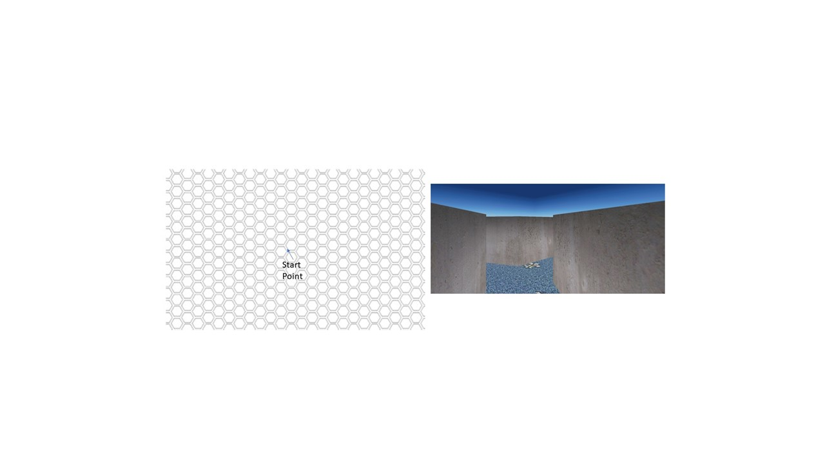

Figure 1 a and b

Figure 1 c and d

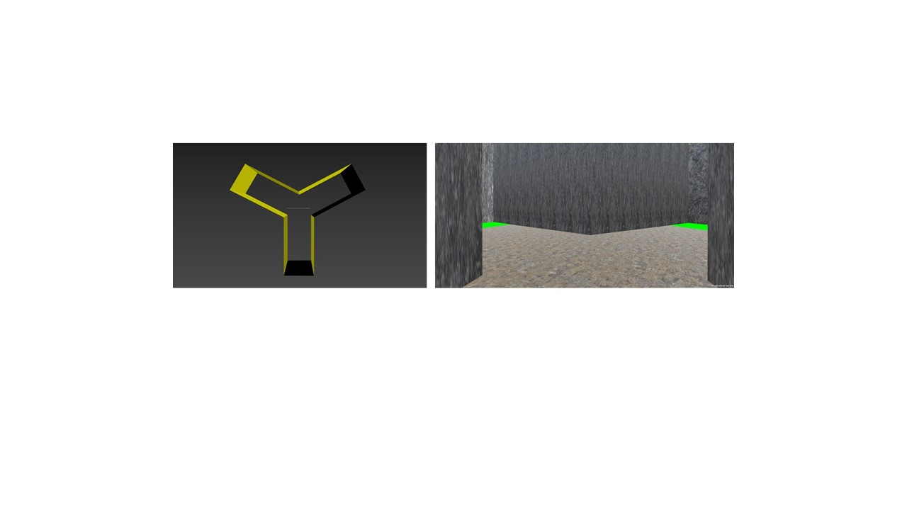

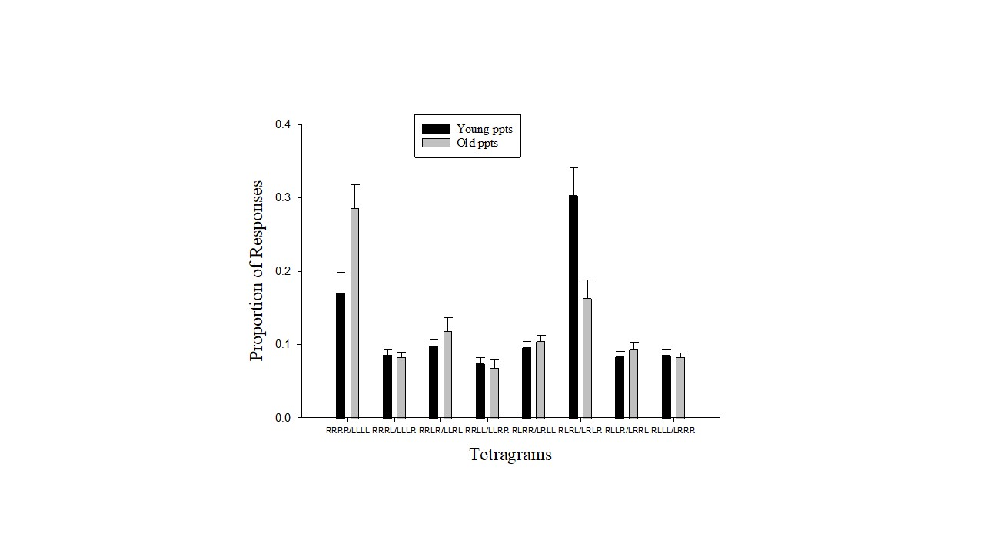

Figure 2

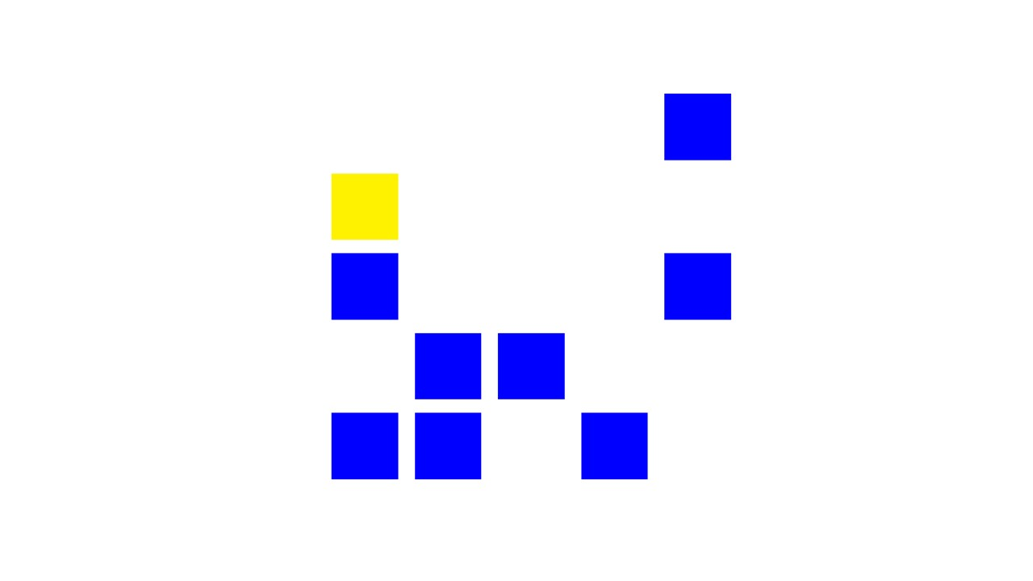

Figure 3

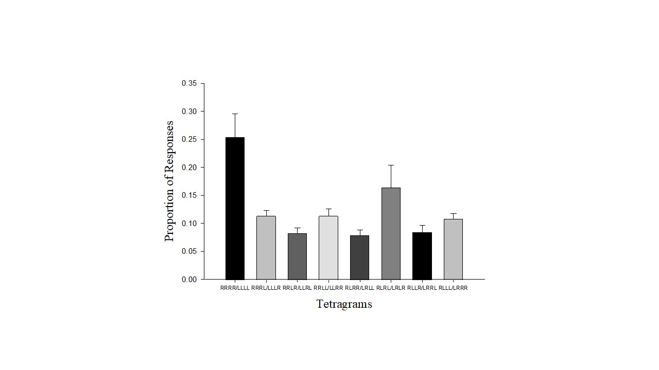

Figure 4

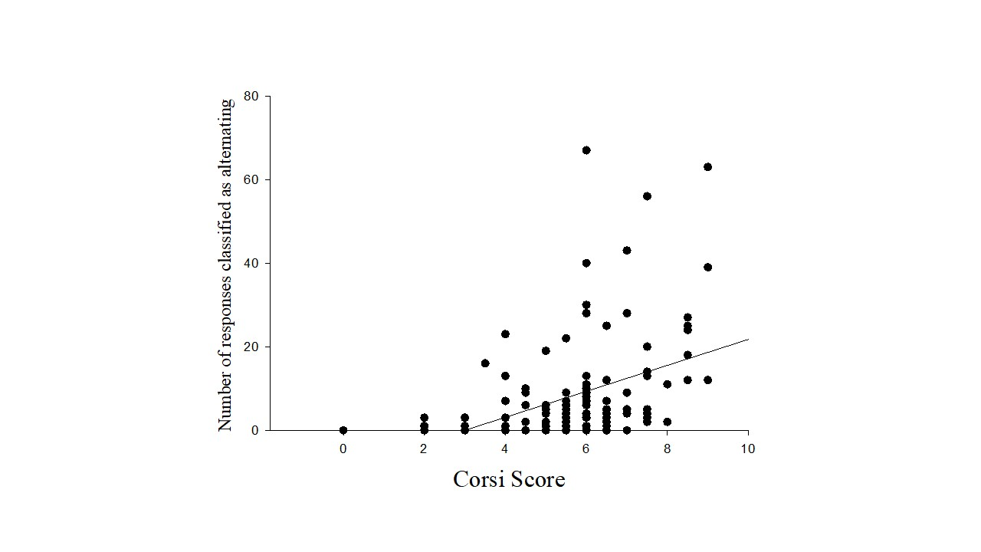
Figure 5a

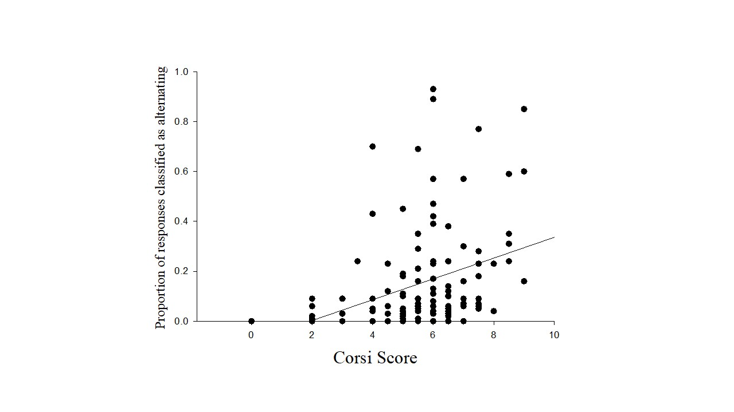

Figure 5b

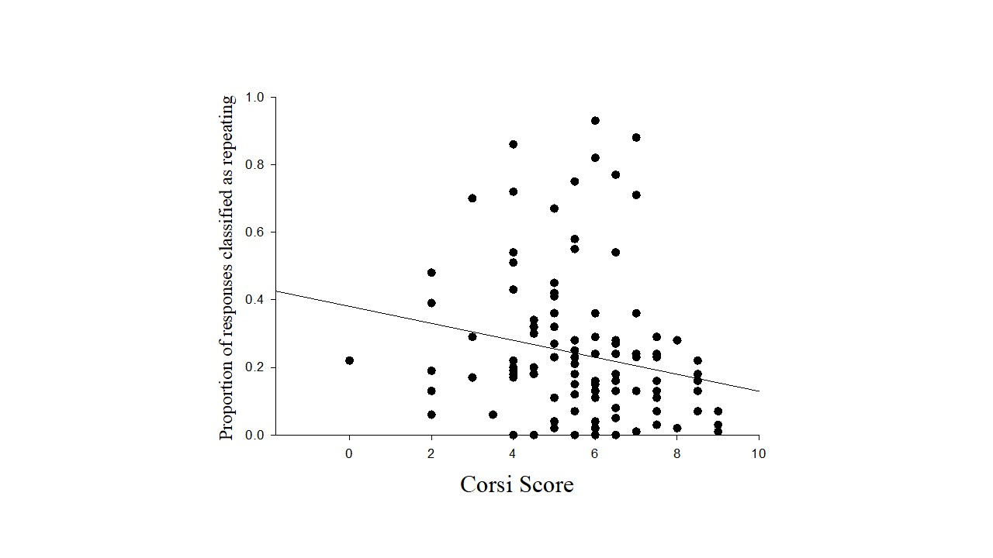

Figure 5c
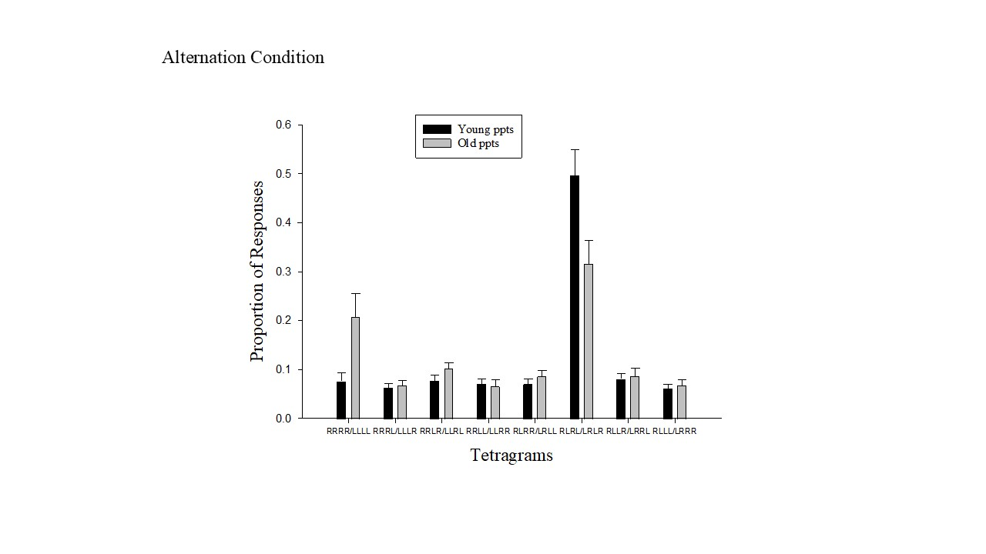

Figure 6a

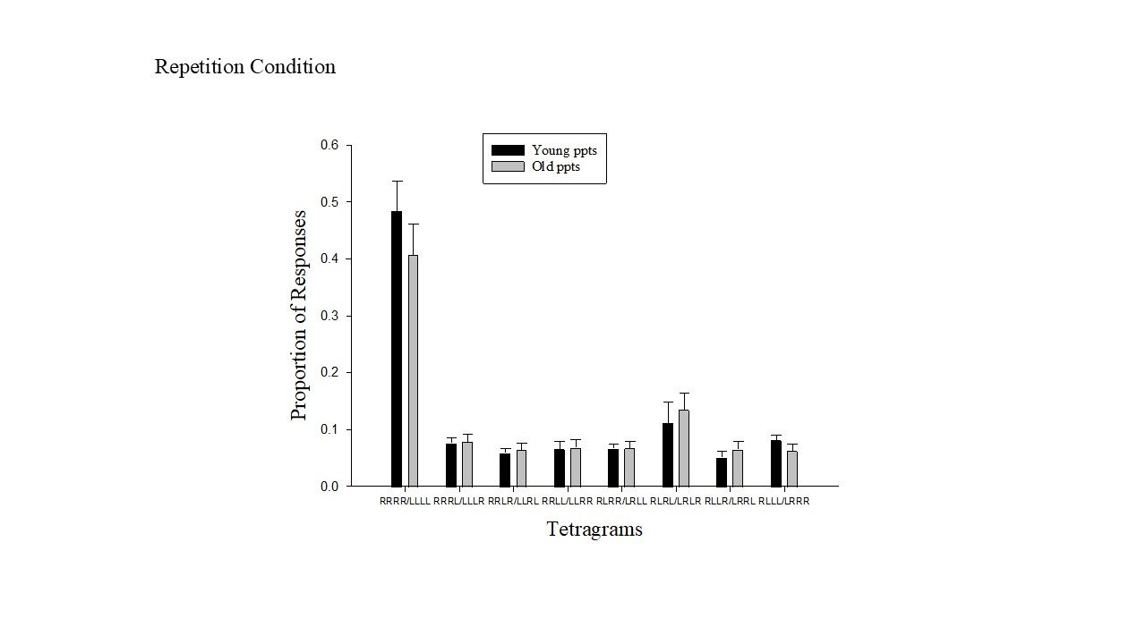

Figure 6b

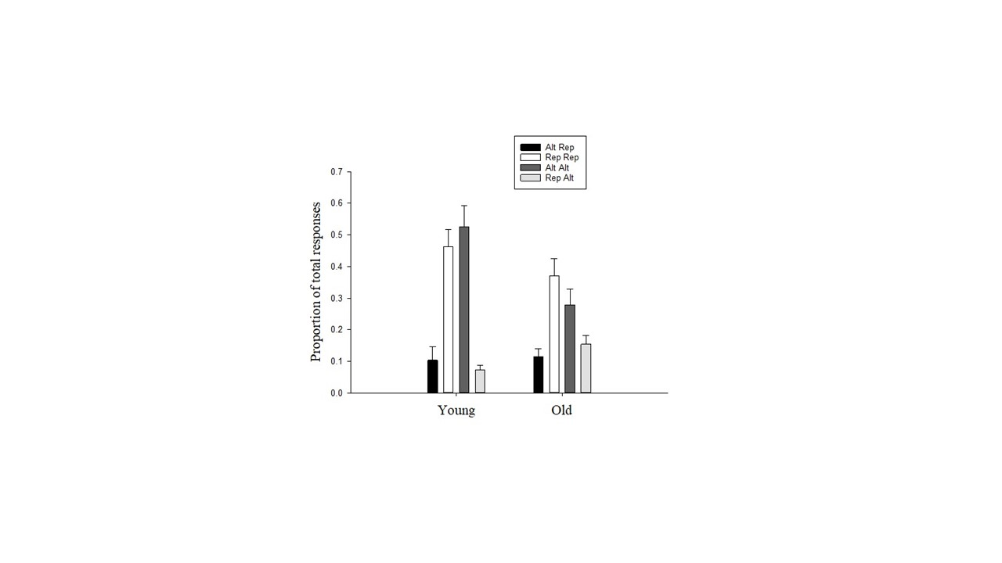

Figure 7

