Version 3 Submitted 2 January 2025 Words 13,704
‘TOO LONG MERE FOOD FOR POWDER’: THE BRITISH ARMY IN PUNCH 1841 – 1861
ABSTRACT. The place of the British Army in Victorian society has been a popular subject for historical enquiry. Scant attention has been paid to the mid-nineteenth century, however, other than studies of the Crimean War and the Indian Mutiny. To illustrate the importance of the wider period, this article surveys the depiction of the Army in the comic periodical Punch, or the London Charivari between 1841 and 1861. It notes a lasting interest in the Army’s role at home and abroad and traces a radical tradition that lasted well into Punch’s so-called ‘respectable’ years.

*
Britain’s attitude towards its Army changed dramatically in the nineteenth century. In the decades that followed the Battle of Waterloo, mistrust of the Army was widespread and the Burkean conviction that an armed, disciplined force was ‘dangerous to liberty’ died hard. Nascent enthusiasm for the Army as a citizen force evaporated in the age of the Peterloo Massacre, the Six Acts, and an oppressively expensive peacetime establishment. The association between professional armies and continental despotism became so deep-rooted that the Duke of Wellington, who concluded that ‘the only way to maintain an army in this country is to keep it out of sight’, was forced to scatter single-battalion regiments across colonial garrisons to curtail demands for military retrenchment. In stark contrast to ‘Jack Tar’, the stereotypical sailor who was lauded as a moral hero, the British ranker was looked upon with deep suspicion. As late as 1869, The Contemporary Review described him as ‘the refuse of the beer shop’ and ‘the sweepings of the gaol’.
By 1900, however, at the close of a century of imperial expansion, the Army was celebrated as a national institution. While certain pubs and parks continued to bar ‘men in uniform’, the soldier was no longer regarded as a tool of state oppression. The establishment of national policing had relocated the Army’s role in quelling unrest to the colonial periphery, where it became shrouded in an aura of moral authority. Imperial heroes like Havelock and Gordon, who combined Christian fervour with military zeal, featured in countless paintings, biographies, and poems. Concurrently, an increased sensitivity to the plight of the ranker underpinned a series of reforms that steadily improved his welfare. Jack Tar, it seemed, had met his match in the form of Tommy Atkins: the soldier lionized by Kipling and fêted in music hall numbers. ‘Anyone’, The Westminster Review observed in 1891, ‘may notice the crowd which always collects in front of the windows of a picture shop displaying any stirring episode of military life’.
Historians of Victorian Britain have discerned much that is of inherent value from studying this changing relationship between the Army and its ‘parent society’. Historians of imperial culture, for example, have used the Army to contest the notion that enthusiasm for empire was an elite concern that ‘did not weigh particularly heavily on European peoples’. In Popular Imperialism and the Military, John MacKenzie argued that colonial wars, which had ‘too often been depicted simply as wars of conquest’, gave the Army a new role as the promoters of Christian civilisation. To MacKenzie, ‘climactic events’ like the Indian Mutiny transformed officers into ‘heroic saviours’ of national honour and soldiers into ‘evangelical shock troops’ of empire. A tendency prevails across a range of cognate fields, however, for scholars to prioritize the Army’s place in late-Victorian popular culture, after the ‘watershed’ of the Crimean War. The ‘climactic events’ of the mid-century are certainly no stranger to analysis, but the scope of enquiry requires broadening. Much has been written about the ‘visual complement’ to the Crimean War that existed in art and political caricature, characterized as it was by a more realistic depiction of the impact of war on the private soldier. Yet how this compared to the depiction of other conflicts remains unclear. Mid-century invasion scares are another example: more could be done to locate such debates in the broader context of changing attitudes towards warfare and the Army. Nor have other ‘climactic events’ of the period been awarded the attention that surrounds the Crimean War and the Indian Mutiny. This is surprising considering the extent of colonial warfare in the period. By the mid-century, colonial military expenditure had increased to record levels and in the 1890s, the late Victorians reflected with pride on how the days of their forefathers had been defined by ‘the most successful and best carried out of England’s little wars’. While such panegyrics tended to ignore military blunders at Kabul, Chillianwala and elsewhere it is undeniable that, to quote Byron Farwell, continual colonial warfare became ‘an accepted way of life’ in the mid-nineteenth century.
Historical understanding of the Army’s place in mid-Victorian society therefore requires a broader level of engagement with the period. To illustrate this point, this article examines the depiction of the Regular Army in the weekly comic periodical Punch, or the London Charivari, between 1841 and 1861. Punch is ideally placed for such an exercise. Its first edition appeared in July 1841 and within a few years Punch had amassed the endorsement of The Times, a circulation of over 30,000 and a total readership – due to a combination of public reading and the availability of printed media in public spaces – of up to five times that number. Punch’s influence was greater still. Not only can its authors and illustrators be credited with the origin of the very word ‘cartoon’, but they also influenced the growth of cartoon styles overseas. The 1850s and 1860s saw the launch of Punch in Canada, Melbourne Punch, five separate magazines with the title of New Zealand Punch, and even a short-lived Confederate periodical, Southern Punch. Outside the English-speaking world, Punch à Paris appeared in 1850, Russian caricaturists copied Punch during the Crimean War, and the launch by British emigrants of Japan Punch in 1862 gave rise to a new Japanese artform, the Ponchi-e picture, an ancestor of contemporary manga.
The Army was a popular subject among the Punch staff in this period. It also underwent a considerable change in its depiction. In 1844, Gilbert à Beckett, one of Punch’s most prolific writers, was full of praise for ‘the glory of the Navy’ but could think of no reason to envy the soldier aside from the ‘jealousy felt by policemen at the superiority of the bayonet over the wooden staff’. By 1856, however, Punch’s opinion had changed dramatically. A rendition of ‘The British Grenadiers’ that Tom Taylor, another prominent writer, composed to mark the introduction of the Victoria Cross, attests to the transformation that had taken place:
Too long mere food for powder
We’ve deem’d our rank and file
Now higher hopes and prouder
Upon the soldier smile
And if no Marshal’s baton
Private Smith in his knapsack bears,
At least in the war his chance of the star
With his General he shares.
Yet no comprehensive survey exists of the Army’s depiction in Punch, despite the potential of such an exercise. This is especially true of the periodical’s first twenty years from 1841 to 1861. The melodrama of late nineteenth-century foreign policy has ensured a ready supply of chapters and monographs on the magazine’s portrayal of specific crises, including the American Civil War, the Scramble for Africa, and the Boer War. Yet from M.H. Spielmann’s foundational 1895 The History of “Punch” to Mark Bryant’s 2005 ‘graphic scrapbook’ of the wars of the British Empire, comparative chronologies of the Army in Punch are few and far between. The best work available on the subject is a chapter in Charles. L. Graves’s 1921 Mr. Punch’s History of Modern England. Graves, however, was himself a member of the Punch staff. His brief was celebration, not criticism, of the periodical’s history and his jaunty four-volume History downplayed the biting radicalism of Punch’s early years. Graves was also more interested in ‘post war parallels’ with the Crimean War – ‘the charges of incompetence in the conduct of war…have a painfully familiar ring’ – than with a broader consideration of the Army’s depiction. His conclusion that ‘anti-militaristic tirades’ were ‘mainly directed against…needless pomp and pageantry’ made no allowance for Punch’s moral outrage at the First Opium War or its exasperation with the expense of colonial campaigns. Conversely, many of the themes that Graves traced were downplayed by later historians. The jollity of his prose notwithstanding, Graves was correct in identifying a ‘strongly anti-militaristic’ and ‘distinctly pacifistic’ strain in Punch. Yet Cap and Bell, the edited compendium of cartoons and prose by Asa and Susan Briggs, contained little on the Army aside from the occasional remark that Punch was ‘passionately involved in support of Britain entering the Crimean War’. Richard Altick’s 1997 history of Punch’s ‘lively youth’ similarly concluded that Punch ‘had no quarrel with the armed forces as an institution’ and that ‘none of Punch’s thrusts at the military…could have been interpreted as outcroppings of antimilitarism, even less so of pacifism’.
The case for this article, however, is not based solely on the grounds of its novelty. The lack of work on the Army’s depiction in Punch would be inconsequential were it not for the value of Punch to the historian of Victorian Britain. This has admittedly been called into question by recent arguments that, since Punch tended to focus on ‘the high politics of Westminster and the passing social fads of London’, claims that its cartoons reflected public opinion are ‘overdone’. A suitable counter charge is the increased sensitivity that scholars have paid to the importance of visual communication in the nineteenth century. A greater willingness to treat cartoons as ‘cultural artefacts’ has led to complaints that the medium has been ‘poorly served’ by historians, and of the ‘want of a global perspective on comic art’, which has led in turn to a renewed focus on Punch. Anthony Cross and Richard Scully, for instance, located Punch’s depiction of the Crimean War and of Napoleon III in a ‘pan-European’, transnational form of caricature. The most significant addition to this field was The Punch Brotherhood, by Patrick Leary. Leary noted that historians had tended to reference ‘Punch’s’ attitude towards historical events as a ‘single-authored phenomenon’, even when the cartoons used to illustrate such events were drawn by different artists at different times. His response was to recontextualize Punch as a product of a close-knit ‘literary brotherhood’ of artists and authors.
Punch, if not a national paper, at the very least came closer to becoming one than any other satirical journal or illustrated periodical of its day. As Leary noted, Punch’s success owed much to the efforts of its staff to ensure that their doggerel and cartoons reflected what they understood as public opinion. They may not always have reflected the opinions of provincial Britain, but they were certainly capable of bridging the gap between metropole and province. Spielmann’s History contains numerous examples of this, including a postman who recognized Lord Palmerston on a visit to Wales because he had ‘seen your picture in Punch, my lord’. Nor can London ‘fads’ be regarded as the sum total of Punch’s worldview, which extended overseas to incorporate America, the British Empire, and Europe. A cartoon produced during the Indian Mutiny – ‘The British Lion’s Vengeance on the Bengal Tiger’ – became a popular Victorian print and a favourite of Winston Churchill, while both Napoleon III and Wilhelm II were wont to ban Punch from their court when its cartoons met with their disapproval. Indeed, the global worldview of Punch has been a recurrent theme in recent years among historians of imperial culture. Richard Scully and Andrekos Varnava argued in Comic Empires that cartoons were ‘a key means by which British readers encountered and engaged with issues of empire’, from the Scramble for Africa to decolonization. Scully has continued to push this argument and to locate Punch firmly in the context of the ‘shared humour’ that linked Britain with its colonies. A recent monograph by Amy Matthewson, Cartooning China, likewise attempted to fill ‘a gap in the historiography of Punch-ology’ characterized by the absence of China and the Chinese, an exercise which this article seeks to repeat for the British Army.
The depiction of the Army in Punch between 1841 and 1861 was the product of eight writers: Gilbert à Beckett, Shirley Brooks, Douglas Jerrold, Percival Leigh, Horace Mayhew, William Makepeace Thackeray, Henry Silver, and Tom Taylor. These men worked with three comic artists: Richard Doyle, John Leech, and John Tenniel, who replaced Doyle when he resigned in 1850. These men were subordinate to the editorship of Horace’s brother Henry Mayhew and, when he resigned in 1846, to Mark Lemon. Matthewson described this group in Cartooning China as a collection of ‘white men from the bourgeoisie’, but such criticism masks a wide range of backgrounds. Lemon was born to a family of hop-merchants and Jerrold to an itinerant actor. Leigh and Leech began their careers in medicine and Taylor and à Beckett at the Inns of Court. Thackeray, meanwhile, would later become a household name as the author of Vanity Fair. Nor did these men share the same worldview. Jerrold, Lemon, and the Mayhew brothers all belonged to a radical political tradition, which was balanced by Thackeray’s conservatism and Leech’s imperialism. Doyle, meanwhile, was a Roman Catholic who resigned when Punch adopted a ‘no-Popery’ campaign in 1850. Each man made his own contributions to the weekly issue. The one truly collective effort was the full-page cartoon, or ‘large cut’, the subject of which was decided by the group at a weekly dinner. Aside from the hieroglyphic-like ‘signatures’ that its artists hid in the corners of their cartoons, however, the Punch ‘brotherhood’ maintained a consistent anonymity. Punch never identified its contributors and aside from the use of the proprietary possessive – in ‘Punch’s Labours of Hercules’, for example – the editorial nosism was always employed. The result was a unified Punch outlook that comprised a multiplicity of voices and political opinions.
The findings of this article are grouped thematically into four parts. The first part discusses the Army as a domestic institution, a subject that Punch treated with frivolity in the 1840s until a more serious campaign for administrative reform developed in the 1850s, although a desire for military economy remained undiminished. The second part examines Punch’s opinion of the Army as a fighting force and notes a persistent strain of antimilitarism, even while the best of England’s ‘little wars’ were still being fought. It also questions the significance of the Crimean War as a watershed in attitudes towards the British Army which, in Punch at least, did not pivot exclusively around the events of 1854 to 1856. The third part discusses the officer class and the ‘military snob’, a trope that Punch used to pillory idleness and incompetence among the Army’s leadership. Finally, part four examines Punch’s attitude towards the ranker and traces a consistent interest in his welfare, albeit one couched increasingly in terms of his bravery rather than his status as a downtrodden wretch, who needed to be distracted from the evils of the wars in which he was called to fight. Together, these four parts suggest that narratives of Punch having ‘abandoned its basic radicalism by the end of the (eighteen) forties’ to become a ‘pillar of the establishment’ cannot be applied to its depiction of the Army. By 1861, Punch was far more willing to praise the Army’s role at home and abroad than it had been twenty years earlier. Yet its irritation with Britain’s military establishment, its unease at the expense of war, its disdain for aristocratic ineptitude, and its outrage at the lot of the common soldier remained as strong in 1861 as in 1841.

*
There is no better place to begin than with the British Army’s raison d'être: national defence. This role was never taken seriously in Punch, even when the nation appeared to be under threat of a French invasion. The first major panic occurred in January 1848, when a letter from Wellington, which cast doubt on the effectiveness of Britain’s defences, was leaked to the press. Over the next two months, Punch poured scorn on the invasion scare. Leech’s cartoon ‘A Silly Trick’ depicted the whole affair – literally – as a joke. The cartoon depicted John Bull’s amusement at a small boy dressed up in a ghostly costume and the shako of a French soldier, with a sign hanging from his neck labelled ‘Invasion by the French’. Three weeks later, Richard Doyle produced a six-page parody of the Bayeux Tapestry, in which a flotilla of sea-sick Frenchmen crossed the Channel and advanced ‘upon ye Capitale bye an earlye train’ before being arrested by policemen and chased back into the sea by Mr. Punch and his dog. In 1852, Louis Napoleon’s coup d'état prompted another invasion scare. Though concerns over the inadequacy of defence expenditure led to the downfall of Lord Derby’s Conservative government, Punch remained unfazed. ‘We have had England threatened so often lately’, à Beckett noted in February, that ‘no method of disembarking the French on our shores seems too absurd’. The nation’s alarmists, he added, would soon be predicting ‘an invasion by balloons’. Punch’s response to these invasion scares forms an intriguing point of departure, for the Army was conspicuously absent. It was butchers’ boys and tradesmen who did battle with cowardly Frenchmen, while the Army’s role as a domestic institution was ridiculed and caricatured.
Punch’s lampooning of the Army’s relationship with the monarchy – and especially of Prince Albert’s prediction for designing impractical military uniforms – typifies the gentler extreme of this ridicule. In 1843, Gilbert à Beckett applauded the Prince Consort for designing ‘a hat which may spare the effusion of blood’ on the grounds that, when enemy forces caught sight of ‘the British soldier in a machine which seem(s) a cross between a muff, a coal-scuttle and a slop-pail… they will instantly take to their heels’. Two months later, ‘à Beckett informed Punch’s readers that ‘the brave fellows who never flinched at the sight of Napoleon’s battalions’ had been rendered ‘panic-stricken at a report that His Royal Highness is going into the hat line.’
Punch’s authors and illustrators reserved a harsher line of critique for contemporary debate on Army reform, a subject which prompted a complex response. On paper, the chaotic system of mid-nineteenth century military administration – the Army was managed by thirteen separate department heads – was a perfect target for satire. Punch, however, refused to take the matter seriously until the system’s failings were exposed in the Crimea. Before 1855, its writers and artists were content to poke fun at both sides of the debate. In 1845, when Wellington attempted to regulate smoking in messrooms, to the anger of many officers, à Beckett invented the story of a soldier being cashiered for smoking a cigar and suggested that ‘the Articles of War’ would shortly be re-written ‘for the purpose of declaring the smoking of a cigar to be an offence, for which any officer may be brought to a Court Martial’. The large cut for the week, ‘Mrs. Wellington and the Military Nursery’, depicted Wellington as a governess in nursery full of moustachioed babies, one of whom cried ‘I want my pipe’ [Figure 1]. In 1847, proposals which then abounded for superseding the musket were satirized through bogus reports of a ‘portable cannon’. According to Horace Mayhew, this was such a ‘wonderful invention’ that it would soon feature in ‘portraits of Field Marshals…as the instrument to point the way to glory’ in lieu of a sword. Five years later, Leigh caricatured the opponents of the adoption to the Minié rifle in ‘Opinions of a Crack Officer on Military Fire-Arms’:
How odd that ev’wy fella thinks
We wun such wisk in case of waw!
Why, shawly, British troops can do
Again what they have done befaw;
We licked the French at Waterloo,
And what’s the use of saying maw?
It was not until the Crimean War that Punch turned on the Army’s administration. Some of the resulting satire was relatively gentle, such as ‘The Administration of the Army’, a fictitious memorandum which asked ‘the Commander-in-Chief to tell the Secretary at War to tell the Secretary of State for the Home Department to tell the Secretary of the Commissariat Department, that the troops are required to march immediately and are waiting for shoes’. The majority, however, was not. The large cut ‘Scene from a Midsummer Night’s Dream’, for example, parodied Edwin Landseer’s painting, with Titania – played by Queen Victoria – decorating Bottom – dressed in military uniform and played by ‘General Mismanagement’ – with flowers. Punch’s ‘speciality’ of risibly parodying nursery rhymes through a careful insertion of contemporary references was also used to criticize the Army. A poem by à Beckett, ‘Nursery Rhymes for Field Marshals’, was typical:
Hush-a-by, Marshal, on the tree top,
When the storm blows the System will rock:
When the shock comes the System will fall;
Down will come System, Field-Marshal and all.
Much of this satire drew on the radical traditions of earlier decades. A good example is the popularity of the nursery rhyme ‘The House that Jack Built’, which possessed the longest association of any rhyme with early nineteenth-century radical pamphleteering. In 1855, Taylor penned ‘The Steamer That None Stowed’, to castigate the Army’s chronic supply problems:
Here is the steamer that None stow’d
Here is the Freight, Higgle-Piggledy placed,
Aboard the Steamer that None Stow’d
Taylor’s rhyme continued for two full pages, documenting the calamitous journey of the steamer to the Crimea, featuring ‘the Ordnance Department, standing aghast’ at ‘the Crew drunk as fiddlers, before the mast’ and concluding with ‘John Bull atoning by prayer and fast’, at ‘England’s best Blood, that (had) run to waste’. Parliamentary interest in military reform diminished after 1856, yet Punch’s authors refused to revert to their earlier indifference.
The Army’s inability to provide value for money was another regular theme in Punch, occupying a position midway between its gentle lampooning of the monarchy and its outrage at the Army’s failure in the Crimea. Military economy was a prominent issue in contemporary politics, due to the tension between the defence spending that invasion scares necessitated and the radical belief that heavy service estimates oppressed commerce. In 1849, an article by Leigh proposed ‘to confer new titles upon certain regiments, to be borne until a due economy shall have been effected in our Military Estimates’. The Horse Guards were to be renamed ‘the Heavy Expensive(s)’, the Grenadier Guards ‘the Extravagant’ and the Household Troops were to ‘generally be styled the Ruination Brigade’. During the Indian Mutiny, the large cut ‘Mr Bull’s Expensive Toys’ depicted two ‘swells’ mounted on children’s hobby horses outside Horse Guards Parade, unwilling to undertake the soldiering which they were paid for on the grounds that a soldier’s life was ‘a baw’ [Figure 2]. That same year, Taylor complained of the nation’s military estimates in a parody of ‘Johnny’s So Long at the Fair’:
Of course, with the staff we can’t tamper
Of course, we can’t touch the Horse-Guards
We must stand by our friends and relations
And not meddle with well-earned rewards.
Yet while Punch continued to deplore the Army’s expense, it did moderate its opinion of the Purchase System. Purchase required officers to buy their commissions, with prices typically reaching £9,000 for a Lieutenant-Colonelcy, although Lord Cardigan is believed to have paid £40,000 to command the 11th Light Dragoons. While the 1850s are often viewed by historians as the beginning of Punch’s ‘respectable’ years, its loathing of Purchase continued well into its second decade. In 1845, à Beckett’s entry in the comic series ‘Punch’s Political Dictionary’ for ‘Commission’ read: ‘an outward sign of military merit that may be had by paying for’. Bravery in battle did nothing to aid the young cornet’s chances of promotion, à Beckett explained, ‘unless he can follow up the act of drawing his sword upon the enemy, by drawing his cheque upon a banker’. In 1846, Thackeray’s serial ‘The Snobs of England’ looked forward to the day ‘when epaulettes are not sold’ and the ‘Corporal has a chance to have his gallantry rewarded as well as that of (the) Lieutenant’. In 1850, learning that a colonelcy had been bought for £16,000, Henry Mayhew despaired at how ‘the English gentleman becomes a lieutenant-colonel, not by merit, but by money’. The failings of aristocratic officers in the Crimea provided further proof of the system’s inadequacies. In 1855, a large cut entitled ‘Shopping’ juxtaposed an experienced veteran unable to afford his captaincy with a mother buying her infant son a colonelcy [Figure 3].
In September 1857 Punch reversed its position, despite a Royal Commission having concluded that Purchase was ‘vicious in principle, repugnant to the public sentiment of the present day (and) irreconcilable with justice’. Tom Taylor’s full-page response to the Commission, ‘Mr. Punch on Purchase’, however, argued that Purchase was ‘worth the money’. ‘It would cost £7,000,000 to get rid of it’, Taylor complained, adding that ‘if we get rid of purchase, it must either be for seniority or selection’, neither of which was desirable. Seniority would ‘give us captains as grey and gouty as our generals used to be’, while selection would lead to nepotism and senior officers, anxious to avoid favouritism, ‘will fall back in practice on seniority’. John Bull, Taylor concluded, preferred ‘cobbling his old shoes, to flinging them away on the strength of the first advertiser, who promises him first rate stuff for next to nothing’. Changes to the composition of the Punch staff may have contributed to this volte-face. Gilbert à Beckett was dead by September 1857, while Henry Mayhew and William Thackeray had both resigned. Yet Taylor had been a member of the Punch staff since 1844 and was no reactionary. As will be discussed below, he shared his colleagues’ outrage at the mismanagement of the Crimean War and frequently criticized expensive colonial wars.
If the Punch staff were at odds over Purchase, they were united in their indifference to an even more damning aspect of the British Army’s domestic role: the use of military force to quell civil unrest. With the police force in its infancy, the mainstay of public peace in the 1840s and 1850s, in the words of G. M. Young, ‘was not the constable but the yeoman, and behind the yeoman…the soldier.’ The growth of the railway network enabled troops to be rushed to suppress riots and industrial disturbances, from striking brickmakers in Ashton-under-Lyne to carpet weavers in Kidderminster, election day riots and, on one occasion, a crowd attempting to bait an ox on its way to market. Yet these actions only merited attention from Punch when they provided grounds for a clever pun. In August 1842, workers in the manufacturing districts of northern England rose in the ‘Plug Riots’, Britain’s first general strike. In Preston, a detachment of Highlanders opened fire on a crowd of strikers, killing four men. The only reference to Preston in Punch that summer, however, was a cartoon that depicted workers fighting with saucepans entitled ‘The Battle of Preston Pans’ – a reference to the battle of the same name that had taken place in the Jacobite Rebellion. In 1851, at the height of Punch’s ‘no-Popery’ campaign, magistrates in Liverpool summoned four companies of infantry to put down a riot of Irish Catholics. Jerrold and Leigh’s response to the riot, however, ignored the authorities’ use of troops and concentrated on blaming the Catholics for the riot, insisting that it was ‘an assault on the feelings of Protestant England’ for the ‘black-robed priesthood’ to ‘flaunt it in the streets’. In 1853, when a detachment of soldiers broke a weavers’ strike in Wigan, Brooks imagined the utilitarian millowners MPs Richard Cobden and John Bright attempting to disperse the weavers: ‘The missionaries of peace and political economy…reached Wigan, had the military sent away, and…offered to fight anybody who was irrational’. The use of military force to quell unrest, therefore, was one area in which Punch truly was a London-centric paper and visited the provinces only ‘for the sake of a laugh’. Ironically, for a periodical that paid such close attention to the Army’s role in colonial wars, the furthest into the provincial Britain that Punch ventured in pursuit of the Army was Chobham Common. The rain-soaked manoeuvres that the Army carried out in the summer of 1853, in which ‘the gallant fellows assembled under canvas’ proved ‘that they can not only stand fire, but they can stand water with an astonishing bravery’, gave Gilbert à Beckett no end of fun. That aside – and not counting the occasional references in Thackeray’s articles on ‘military snobs’ to fictitious reviews of the ‘North Diddlesex Regiment of Yeomanry Cavalry’ – the Army’s role in provincial Britain was a complete blank.
Punch’s depiction of the British Army ‘at home’ therefore attests to its refusal to be neatly synopsized with any exactitude. Of course, this should not be viewed in isolation from its stance on other issues. That Punch was quiet on matters relating to administrative reform in the 1840s does not mean that the same was applied, for instance, to the morality of war or the use of flogging. Yet Punch’s mockery of the Army’s organisation and administration was in many ways gentler and more ‘respectable’ in the 1840s than it became after the Crimean War. Furthermore, Punch maintained a consistent opposition to the Army’s cost and, for most of the period, to Purchase, all the while ignoring the Army’s role in quelling unrest. A similar degree of complexity characterized Punch’s attitude towards the Army’s role abroad.

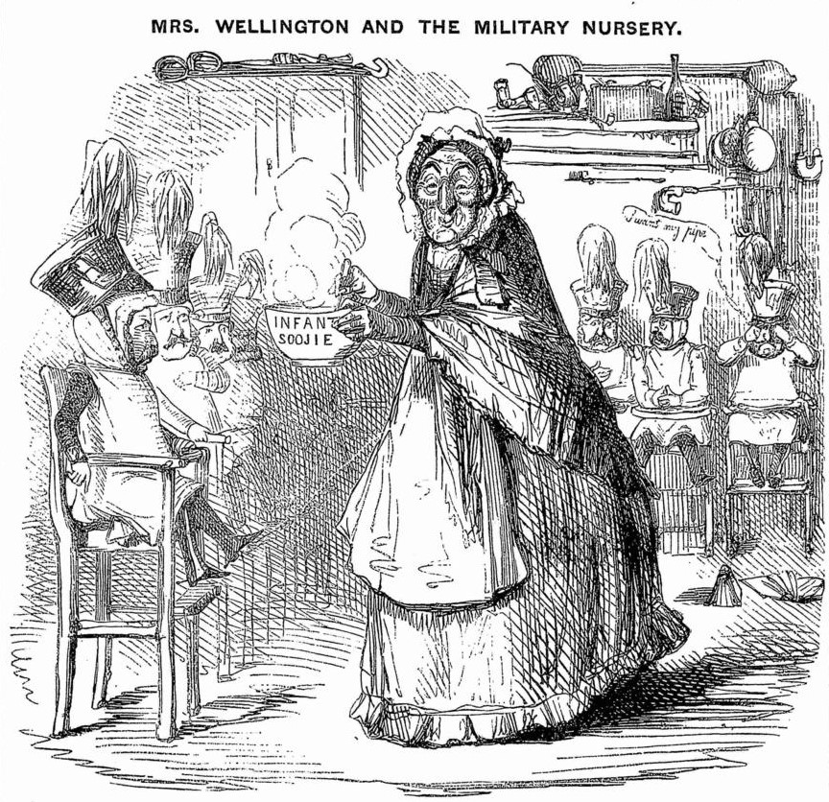
Figure 1. 'Mrs Wellington and the Military Nursery', Punch, 13 December 1845.

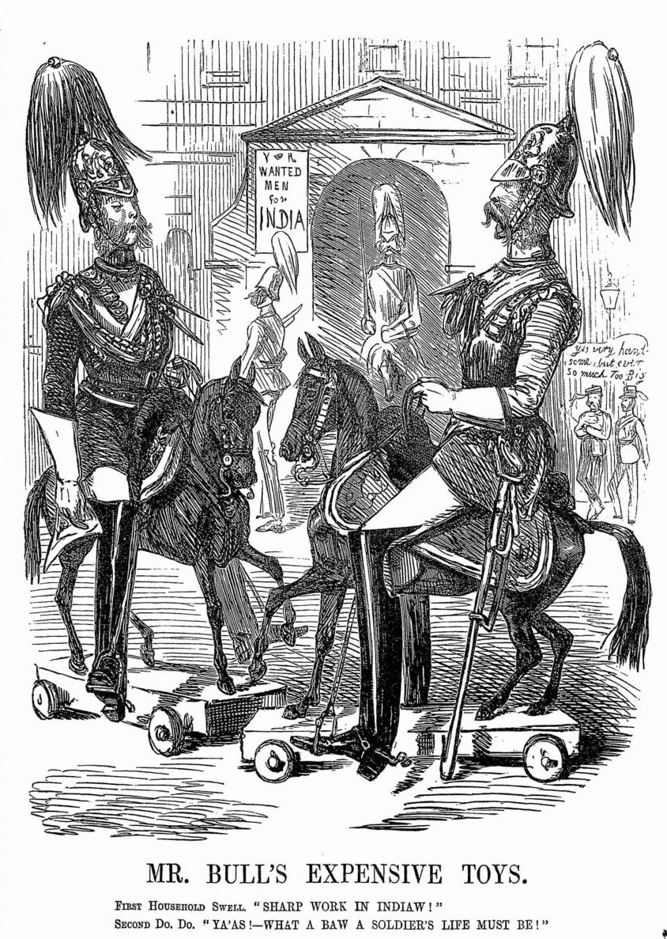
Figure 2. ‘Mr Bull's Expensive Toys’, Punch, 31 October 1847.
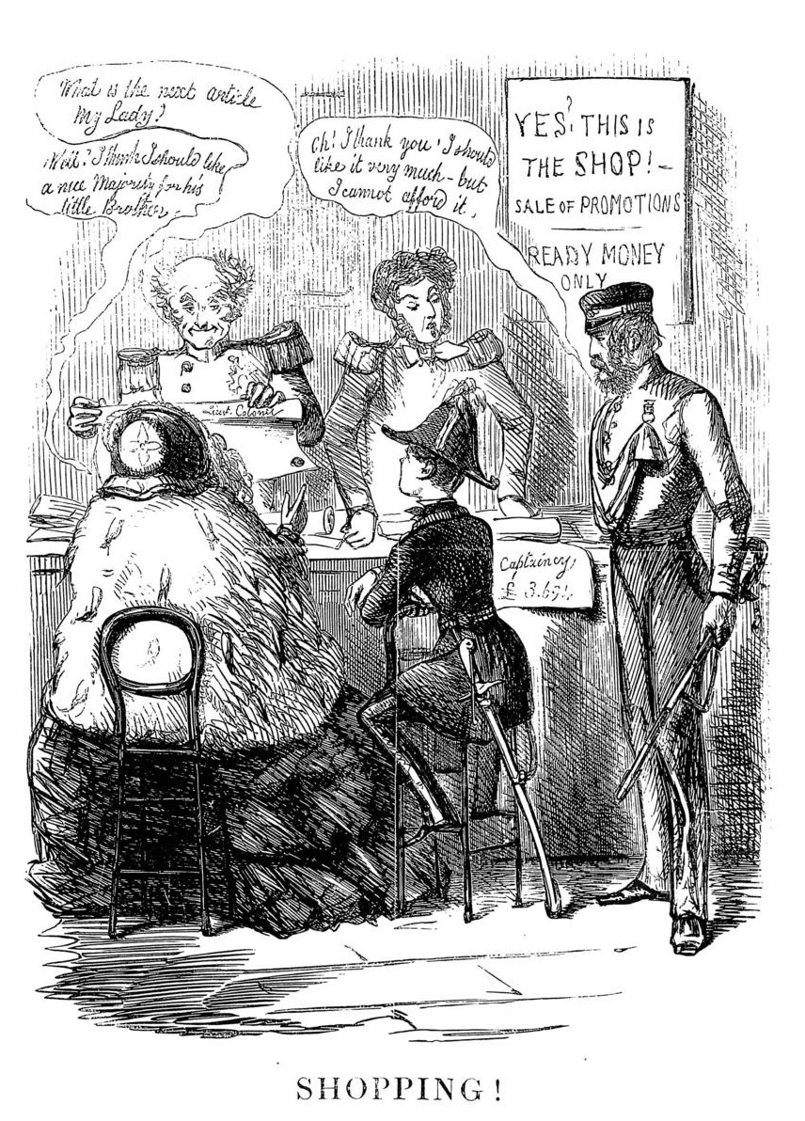
Figure 3. 'Shopping!', Punch, 24 February 1855.
*
The bellicosity with which Punch greeted the outbreak of war with Russia in 1853 is well known, as is the disillusionment that followed. In the first year of the Crimean War, Punch cartoons overflowed with martial fervour. ‘What it Has Come To’ depicted a hapless Aberdeen trying desperately to keep the British Lion from pouncing on the Russian Bear. ‘Our Guards’ compared an officer inviting a lady to dance at a ball with an image of the same man leading his regiment into a Russian battery. ‘They can play’, the caption read, ‘and by Jove they can fight too.’ Poems were similarly employed to extol the righteousness of the war. In ‘God Defend the Right’, Taylor waxed lyrical of England’s proud tradition of upholding right against wrong, asking:
What wonder then, if Englishmen are in this faith so bold?
That each man's hand grips to the brand his father drew of old?
What wonder that, with hearts elate, our soldiers seek the fight,
To the great cry —from the nation's heart — of "God defend the Right!
When the Allied fleet entered the Black Sea, Tenniel’s large cut ‘The United Service’, which depicted a British guardsman arm-in-arm with a French grenadier, became so popular that it appeared on packets of playing cards [Figure 4]. The war fever reached its zenith in the Leech cartoon ‘Victory of the Alma’, in which three Allied soldiers cheered as they planted their nation’s flags atop the captured Russian redoubts [Figure 5]. The victory also prompted another poem from Taylor:

Thank God, we still have something of the stout old Spartan strain;
What mother but would sooner learn how that her son was slain,
Face to the foe, than he should owe his life to flight or fear?
Better to spare a hero there, than have a coward here.
By the winter, Punch’s outlook had changed dramatically. In February 1855, Leech produced one of his most iconic cartoons, in which two ragged soldiers, identifiable as British only by a single bearskin helmet, discussed news from home in the Crimean winter: ‘We're to have a medal.’ ‘That's very kind. Maybe one of these days we'll have a coat to stick it on?’ [Figure 6] Taylor, dismayed at how Britain’s ‘starving army haunts us night and day’, concluded that war was ‘not a thing to be trifled with’. Its ‘horrors’, Gilbert à Beckett agreed in an article entitled ‘The Dangers of Playing at War’ argued, were ‘distasteful…to all persons of common sense, and common humanity’.
The Punch staff devoted over a hundred large cuts to the Crimean War, which have become a common sight in histories of the period. The narrative of Punch ‘reflect(ing) the nation's impatience at apparent inaction’ and ensuring that ‘public clamour for a vigorous opposition to autocracy’ forced Aberdeen’s Cabinet to declare war is all too familiar. ‘Before the war’, the argument runs, ‘the stereotypical soldier was an aristocratic fop. After it, he was a brave private’. The tale has been so well told that it is easy to view Punch’s transition from war fever to war weariness in 1855 as the epitome of its view on warfare. As recent studies have begun to acknowledge, the reality was more complex. The bellicosity that characterized Punch in the first year of the Crimean War was a marked deviation from the periodical’s norms, and at no other point in the mid-nineteenth century did Punch endorse a foreign war as unconditionally as it did between September 1853 and December 1854.
Throughout its first decade, Punch displayed a consistent hostility towards foreign warfare and military adventurism. In 1842, ‘Laurels at Ningpo’ described Britain’s involvement in the First Opium War (1839-1842) as ‘a bloody farce’ and ‘blush(ed) at the outlay of lead and powder’ in the nation’s ‘fight for opium’. Far from exuding what Matthewson described as a ‘sense of playful patriotism’ at the expense of the Chinese, Punch was convinced that British soldiers ‘compelled to cut the throat and blow out the brains of miserable wretches must feel mightily abashed as they pull the trigger’. In 1852, Punch’s coverage of the Eighth Xhosa War (1850-1853) produced no celebration of empire building or glorification of military adventurism. Instead, ‘A Suggestion for the War Office’ recommended that, ‘as an elementary lesson for raw recruits commencing practice with firearms, a figure, dressed as a British soldier, should be used as a target’, on the grounds that ‘it is proved by experience at the Cape, that nothing is easier to hit’. This hatred of warfare was not limited to instances in which British soldiers fought overseas. When the Archbishop of Canterbury blessed the colours of the 72nd Highlanders, Jerrold vilified the prelate for ‘invoking the spirit of Jesus to bless (and) consecrate the flag of bloodshed and spoilation’.
The best example of Punch’s radical antimilitarism, however, is ‘Punch’s Labours of Hercules’, an 1843 serial by Percival Leigh in which Hercules’ labours were analogous with society’s ills. The Augean Stables represented parliament – which Hercules scoured with public opinion – Tartarus represented the Workhouse and Pluto and Cerberus took the form of political economists. The Nemean Lion, meanwhile, featured as ‘a biped brute’ with ‘a scarlet coat’, who ‘had desolated Earth and scandalized Heaven for ages’ and whose ‘name was war’. Men, Leigh lamented, ‘committed idolatry to this Lion’ by singing ‘hymns to his glory’ and giving his ‘cubs’ grand names like ‘Colonels, Generals and Field Marshals’. Fortunately, Hercules, armed with his ‘Punch Club’, was on hand to drive ‘out of the heads of the nations the fallacy that there was anything fine in this beast.’ By the time Hercules was finished, ‘even the French perceived War to be a mistake’ and the lion was reduced to a ‘savage’, which Hercules ‘quietly choked’. If articles like this cannot be regarded as ‘outcroppings of antimilitarism’, it is hard to imagine what can. While the rapid substitution of war fever for antimilitarism might be seen as proof that Punch did change its view of warfare in the 1850s, it was extremely rare for Punch support a war so unconditionally in the mid-century. The period from 1853 to 1854 was an exception to the rule and even then, a heightened sense of patriotism soon gave way to pessimism when the misconduct of the Crimean War was exposed.
Punch continued to criticize the Army’s activities abroad after the Crimean War, albeit on the grounds of the expense of warfare rather than its inherent immorality. As alluded to above, this was in keeping with the laissez-faire spirit of the age, which regarded expensive foreign commitments as a direct cause of high prices at home. Punch was a party to this economy drive. In 1849, à Beckett used Major General Sir Hugh Gough’s tactical recklessness at the Battle of Chillianwala to criticize the expense of the Second Sikh War (1848-1849). ‘Lord Gough’, à Beckett wrote, ‘is the greatest military economist of the age, for by his operations in India he has carried into practice the principle of reducing the Army to an extent almost without precedent’. In 1853, before the excitement of the Crimean War fully took hold, Leigh criticized the cost of the war in ‘The Trumpet of Battle’:
Let the sword leap from the scabbard while the frantic bugles bray,
Draw, England, draw the purse as well that must be flung away,
Charge! And in charging never think how much you’ll have to pay;
To the Brave there will be time to talk of that another day!
In 1857, in ‘Here a War, There a War’, a poem ‘dedicated to John Bull’, Tom Taylor and Shirley Brooks reflected on four years of expensive conflict in Russia, India, and China:
Here a War, there a War, Wondering Johnny,
When you’ve done wondering, pay for the game:
Come, tell us frankly, you, John think it dear, eh?
Punch must inform you that he thinks the same.
In 1860, when Punch endorsed the Second Opium War (1856-1860) to a degree unimaginable twenty years previously, it was still uneasy about the expense of the campaign. In ‘Laurels at Ningpo’, Punch had talked of ‘a war without glory which, when ended, can give no laurels to the victors’, whose ‘most fitting chaplets will be wreaths of poppies’. In 1860, when an Anglo-French Army under Sir James Hope Grant routed the Tartar mercenary Sang Ko Lin Sin, Henry Silver penned the following poem:
If Bulls will rush into China-shops,
And with their jars get entangled
They should feel no dismay when they’re called on to pay
For the crockery they have mangled.
Even the large cut ‘What We Ought to Do in China’, which has been cited by Matthewson as proof that Punch’s early radicalism ‘subsided into nationalist sentiments and a belief in Britain’s superiority over other nations and races’, was accompanied by complaints about the cost of the war [Figure 7]. The cartoon depicted a classical figure on horseback wielding a flail of cannon balls against dragon with a ‘Mandarin’ moustache, in revenge for the torture of a British diplomat. Yet it was also accompanied by a poem by Taylor who, though delighted by the victory, was anxious for a swift end to the war and an indemnity to cover the cost:
The Tartar-heap are scattered like sheep
E’en San-ko-lin-tsin can’t find them
May the Allies come home and let Pekin alone
But not leave their taels behind them.
When reflecting on Punch’s attitude towards foreign warfare, therefore, the historian is presented with so apparently contradictory a set of attitudes that, at first glance, there appears little else to do but to ascribe to Punch’s editors a commitment to the ‘Fleet Street Formula’ espoused by contemporary journalists. ‘Preach war’, the saying went, and ‘John Bull will throw you down and call you mad. Preach peace and John will approve, but he will think you poor-spirited. But if you preach peace and war, John will praise you, buy you, and dub you his organ’. The key to solving this problem is to understand that Punch’s attitude towards foreign war was characterized, not by a sudden shift from antimilitarism to ultra-patriotism that pivoted on the Crimean War, or by a general disinterest in foreign affairs, but by a gradual process of transformation in which the bellicosity of 1854 was an aberration. It was very unusual for Punch not to find fault with a foreign war and even by the 1860s it remained deeply uneasy with the expense of colonial warfare. An equally popular subject for criticism was the Army’s leadership.

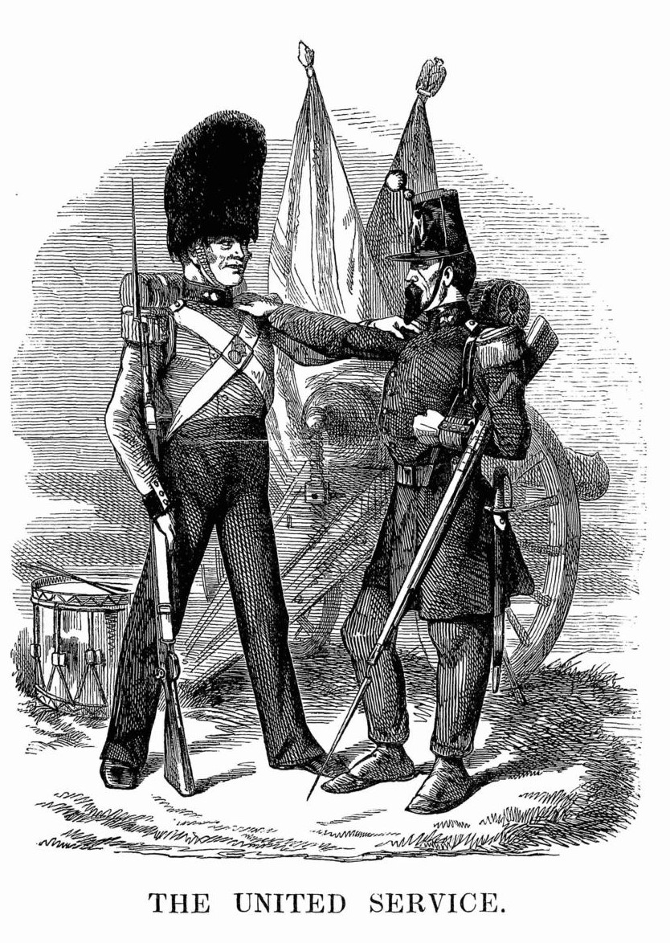
Figure 4. 'The United Service', Punch, 4 March 1854.
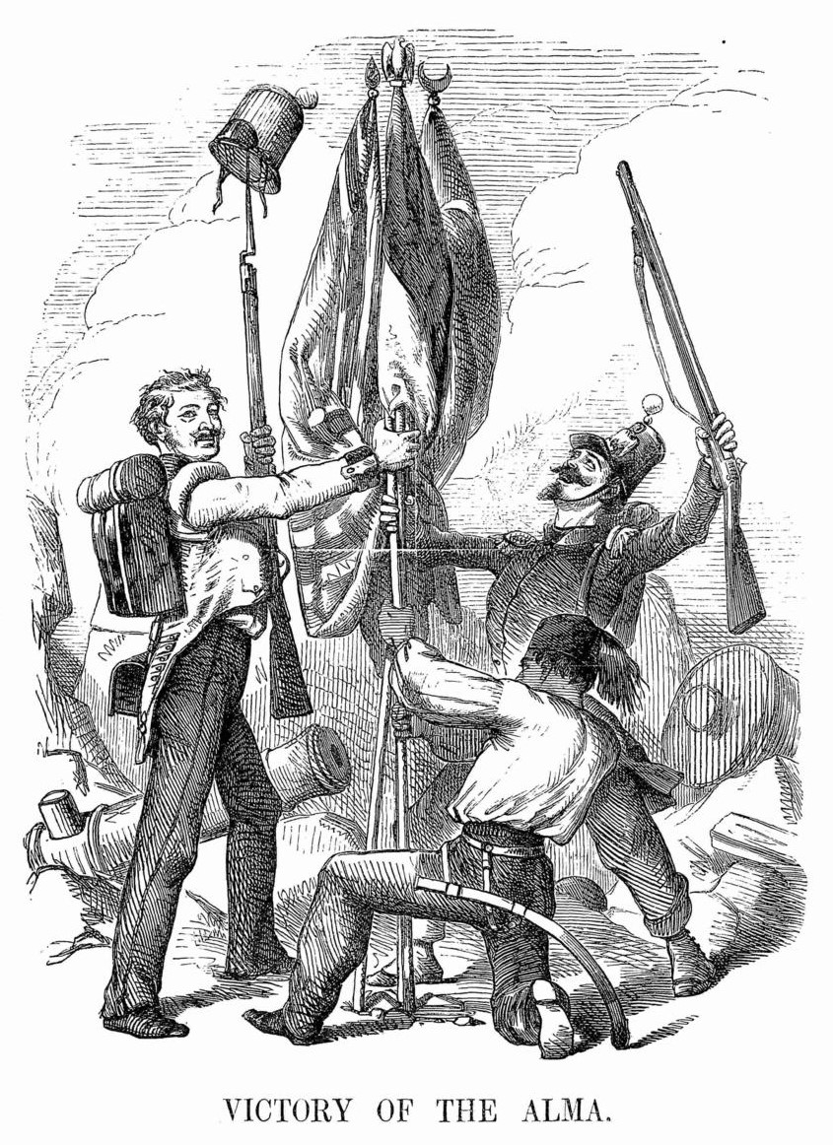
Figure 5. 'Victory at the Alma', Punch, 14 October 1854.
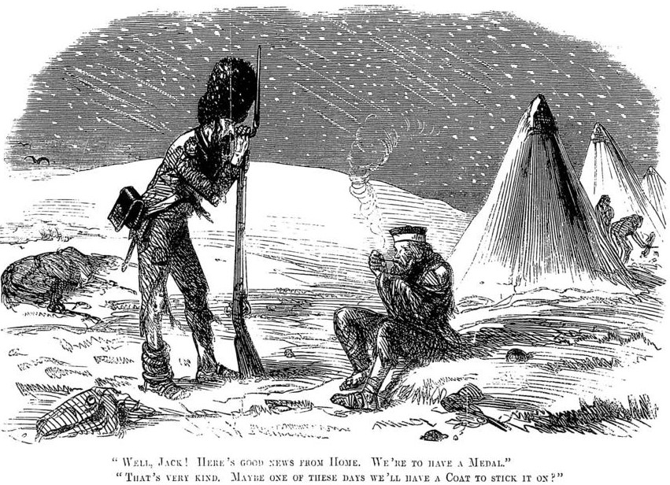
Figure 6. Punch, 15 February 1856.

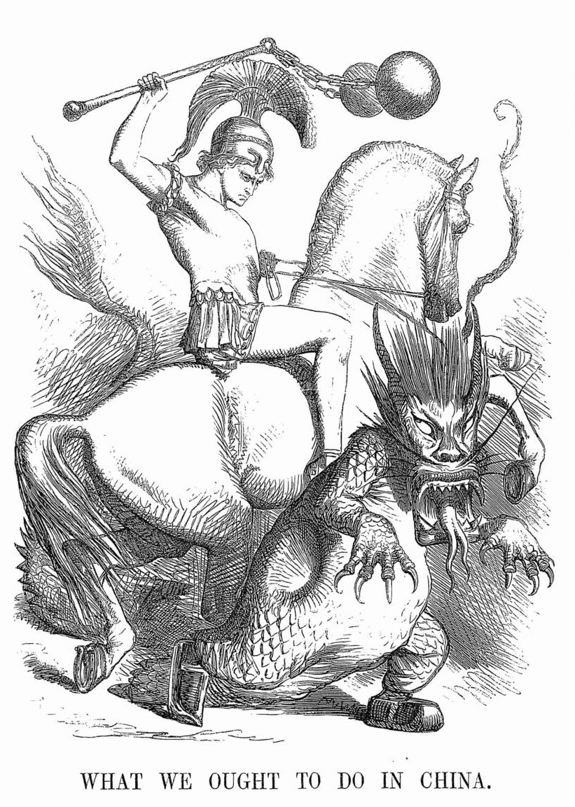
Figure 7. 'What we ought to do in China', Punch, 22 December 1860.
*
It is often suggested that Punch was ‘funny without giving offence’. This was not true of its depiction of the British officer. Throughout its first twenty years, Punch held the ‘military snob’ – the rakish, aristocratic ‘plunger’ who, in Taylor’s words, ‘came into the Army to idle, dress and dine’ – in contempt. Despite having paid a sizeable sum for his commission, the typical plunger displayed little enthusiasm for soldiering and preferred the delights of London Society to the shot and steel of the battlefield. A large cut entitled ‘The Drawing Room Captain’ was accompanied by a poem that described him as follows [Figure 8]:
…They say you ne’er smelt powder,
Save that call’d “violet” – that no prouder
Boast is thine of seeking “bubble reputation,”
By a cannon made at billiards; nor rely
On any services you’ve done the nation;
Except inventing a new hair-dye
Warranted to make moustaches stand caresses
Sans peur, especially from heiresses.
The tropes that Punch employed to vilify opulent military snobs remained consistent throughout the period, even after the departure of its more radical writers and artists. There was no better way of ‘training up our soldiers to face danger’, à Beckett joked in 1848, than through ‘the most formidable of all encounters, the unsatisfied creditor’. In 1857, learning of proposals to introduce examinations for officers’ commissions, Horace Mayhew speculated that the ‘chief points of examination’ would include the candidate’s ability ‘to make out his name to an I.O.U’ and to ‘prove an intimate acquaintance with the locality of all principal casinos’. In 1861, by which time he had moderated its tone on other issues, including the Purchase System, Leigh continued to complain of the number of ‘opulent men’ in ‘cavalry regiments’, hoping that the future would see an Army ‘which young men will enter with the view of serving their country, and not that of dressing magnificently and inducing in wasteful debauchery’.
Though military snobs were, as Thackeray complained, ‘of such number and variety, that a hundred weeks would not suffice to give an audience to them’, individuals were occasionally singled out. Lord Cardigan, Lieutenant-Colonel of the 11th Hussars and the most notorious plunger of the day, was one of Punch’s favourite targets. In 1841, when Cardigan was prosecuted for duelling with one of his officers, Punch recommended that he ‘follow the example of the officers of Ghent, who have introduced umbrellas into the Army’, on the grounds that ‘some men should gladly avail themselves of any opportunity of hiding their heads’. Cardigan’s willingness to spend vast sums of money to dress his regiment in brilliantly coloured uniforms was also mocked. Though not ‘particular to a shade’ when it came to clothes, Silver regarded the cherry-coloured trousers which the 11th Hussars wore and which made ‘the bearer look as though he had literally been walking through a cherry tart’, as fit ‘only for a pantomime’. Even when Punch was praising the Army as it departed for the Crimea, Leigh could not resist dedicating the following poem ‘without permission to the Earl of Cardigan’:

Oh, pantaloons of cherry!
Oh, redder than raspberry!
For men to fight in things so tight
It must be trying—very!
Punch’s contempt for military snobs was matched only by its refusal to forgive poor leadership in battle. While it has been suggested that the Victorian media tended to avoid overtly criticisms of military failure, preferring instead to reattribute failures ‘within the context of heroic and redemptive sacrifice rather than incompetence’, Punch showed no mercy to officers whose campaigns resulted in unnecessary loss of life. Occasionally, this led to awkward results, especially before the introduction of the telegraph. When news reached London of Gough’s repulse at Chillianwala, à Beckett insisted that his replacement by Sir Charles Napier was ‘indispensable to prevent further calamity.’ When Napier arrived in India, however, Gough had salvaged his reputation through a decisive victory at Gujarat. The Punch staff, to their credit, were happy to mock their own standards. ‘Having violently abused Lord Gough for losing the day at Chillianwala’, Leigh wrote, ‘Punch outrageously glorifies him for winning the fight at Gujarat…for Mr. Punch, like many other people, of course looks merely to results; and takes as his only criterion of merit, success’.
The most notorious example of Punch’s disdain for poor leadership was the anti-aristocratic sentiment that appeared during the Crimean War. At first, this attitude was relatively mild. Punch was at first willing to regard the Light Brigade’s doomed charge as a glorious and ultimately forgivable mistake. Leech depicted Cardigan in ‘A Trump Card(igan)’ as heroically leading his men into the Russian guns. Taylor asked:

Whose was the blame? Name not his name, but rather seek to hide
If he lives, leave him to conscience—to God, if he has died.
This attitude did not last long. When rumours began to circulate that Cardigan had abandoned his brigade to the Russian battery, Taylor went out of his way to destroy Cardigan’s image. In ‘Mr. Punch does penance’, he begged ‘to apologize for the blunder’ which, caused by ‘the blast of Lord Cardigan’s own trumpet’, had caused him to accidentally ‘represent…his Lordship as a hero’. 1855 and 1856 saw countless poems by Taylor attacking the Army’s leadership. ‘Pour Encourager Les Autres’ – the best example of Punch’s anger at military incompetence extending far beyond ‘humorous and gently amusing’ cartoons – pined for the bygone age of 1757, when Admiral Byng had been executed on the quarterdeck of his own ship after the loss of Minorca.
Simpsons, Cardigans, Lucans and Aireys and all,
On whose backs our Crimean discredits must fall –
Bless your stars you have fallen on days when The Times
Not Court-Martials and Commons, judge you and your crimes
We are soft now-a-days as our fathers were hard
“To encourage the rest” – where they shot, we reward.
Conversely, Punch held military success in high regard and was happy to praise victorious officers whenever the opportunity arose, especially if their heroism could be juxtaposed to the idleness of military snobs. During the First Sikh War, Thackeray complained of ‘military snobs…at home on sick leave’, who repaired their healthy ‘by being intoxicated every night’. Such men were contrasted with those ‘who fought with brilliant valour’ and who, Punch assured its readers, were ‘not snobs’ and were entirely deserving of praise. ‘Their country admires them, their Sovereign rewards them, and Mr. Punch takes off his hat and says Heaven save them!’ When the Parliament questioned the necessity of awarding Gough and Sir Henry Hardinge, the Governor-General of India, annuities for their victories against the Sikhs, on the grounds that the pair already received lavish grants from the East India Company, Punch depicted Wellington as a petulant child who, jealous of his toy box of medals and titles, ‘wouldn’t let Master Hardinge and Master Gough have any of the nice things’ [Figure 9]. Yet Wellington was no snob. After his death in 1852, the spartan Iron Duke was memorialised by Taylor as the embodiment of the qualities that a British officer ought to possess:
Linger long and learn how, Spartan-like and stern,
He wrote at that poor table and sat in that mean chair,
How, with secretary near, in close toil and severe
He laboured, nor his body nor his mind for age would spare.
‘Wellington’, Leigh added, never ‘conceived that there (was) anything to admire in… uniforms and parades’; he fought only ‘for the sake of that country which now blesses his memory’. It was not just plungers, however, whom Leigh used Wellington to attack, for Wellington died shortly after Louis Napoleon’s coup d’etat. Leigh’s dislike of Napoleon III was so intense that Wellington was recast as a soldier in the service of liberty, despite his infamous opposition to reform. When debate arose over whether the foreign standards captured by Wellington should be displayed in the presence of European dignitaries at his funeral, Leigh insisted that ‘now, when Liberty over all Europe is extinct’, it was meet and right to ‘advertise to Continental despots’ the ‘fire conserved and still blazing in this little island’, to which Wellington’s heroism had been in service.
It was also in the 1850s – especially during the Indian Mutiny – that British officers began to acquire a new kind of heroic status in the nation’s media and to embody the moral virtues of the empire. Of these, Major General Sir Henry Havelock, an intensely religious officer who died after relieving Lucknow, has been identified as the example par excellence. Punch played an active role in this myth-making process. Shirley Brooks’ poem ‘Havelock’ featured underneath a cartoon of the British Lion faithfully resting its head on the General’s coffin:
Guarded to a soldier's grave
By the bravest of the brave,
He hath gained a nobler tomb
Than in old Cathedral gloom.
England's banners o'er him waved.
Dead, he keeps the realm he saved.
Another officer who became a favourite of Punch was Field Marshal Sir Colin Campbell, the hero of the ‘Thin Red Line’ at Balaklava and the Commander-in-Chief of British forces during the Indian Mutiny. In July 1860, Campbell was the subject of Punch’s greatest outburst of approval for the Army since the Crimean War. The large cut ‘See the Conquering Hero Comes’ depicted Mr. Punch, Palmerston, and Russell dressed as Volunteers, presenting arms to Campbell as he returned home from India at the head of a marching pipe band [Figure 10]. Unsurprisingly, given Punch’s silence on the issue in the 1840s, the fact that Campbell had trained soldiers to suppress industrial unrest as part of Napier’s Northern Command was presented no obstacle to his depiction as a military hero.
‘The gentlemen of whom the Army is composed’, Wellington maintained, made ‘the best officers in the world’. Its glorification of Wellington after his death notwithstanding, there is little to suggest that Punch shared this opinion of the Army’s leadership. Indeed, one of the best examples of the prevalence of a radical streak in Punch is its depiction of British officers. By 1861, when Punch had modified its opinion of Purchase and was willing to endorse Grant’s victory in China, the plunger remained an object of contempt. It is true enough that attacks on military snobs did not constitute the entirety of Punch’s depiction of military officers. Yet it speaks to the periodical’s enduring radicalism that, in the 1840s and the 1850s, the successes of British officers abroad was so frequently used to highlight the idleness of snobs and plungers at home. This treatment of the foibles and failings of Victorian officers was accompanied by a notably sincere appreciation of the plight of the ranker under his command.

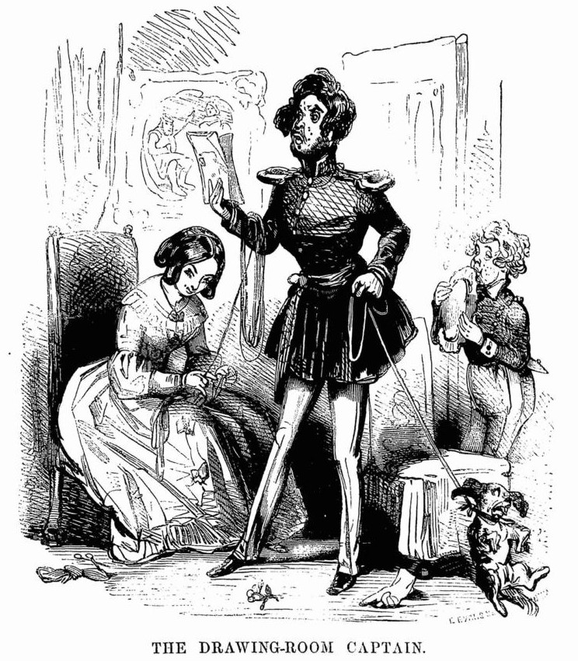
Figure 8. 'The Drawing Room Captain', Punch, 12 February 1842.

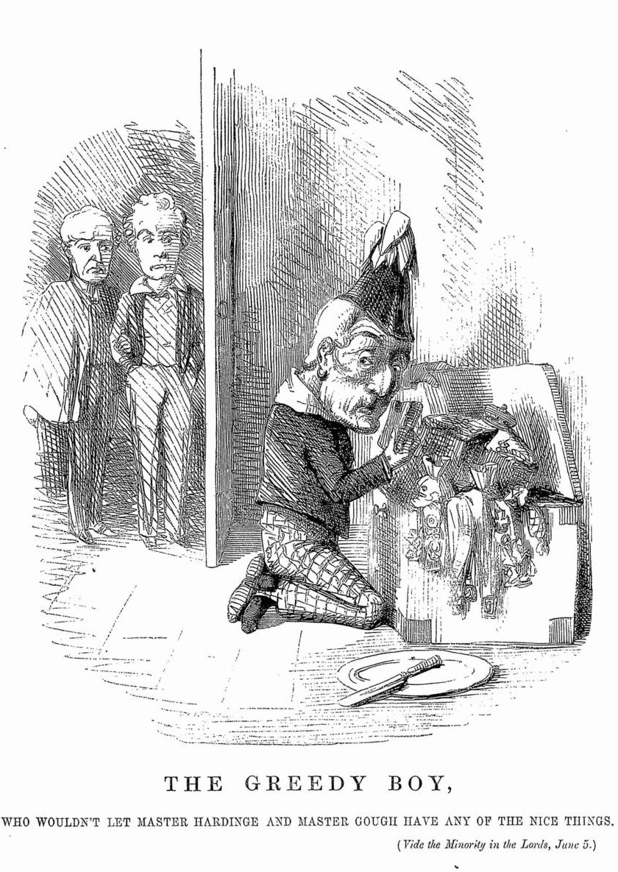
Figure 9. 'The Greedy Boy', Punch, 20 June 1846.
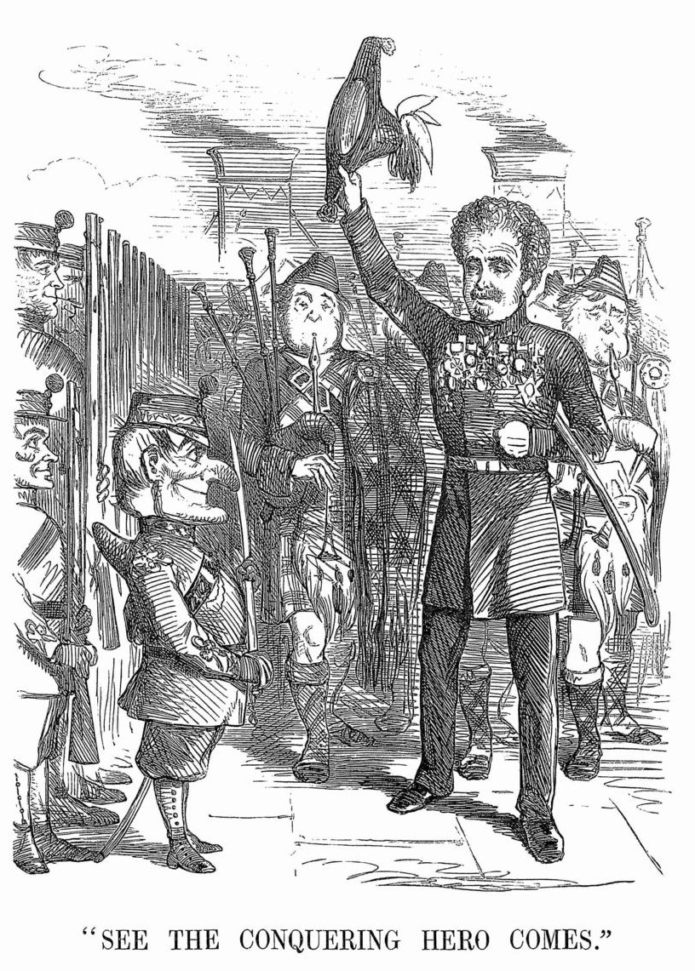
Figure 10. 'See the Conquering Hero Comes', Punch, 28 July 1860.
*
Punch’s consistent sympathy with the ranker presents the most significant challenge to arguments that the periodical had no quarrel with the armed forces as an institution, for it was with that institution’s treatment of its soldiers that Punch repeatedly quarrelled. This is exemplified by Punch’s stance on three issues: flogging, the leather stock which the soldier wore as part of his uniform, and the living conditions of barracks. Flogging was not limited to serious offences until 1859. Until then, it remained a common punishment in the Army for crimes as trivial as the failure to answer roll call. To Punch, this was nothing short of ‘military torture’ which, as Leigh complained after the Crimean War, caused Britain to differ ‘in barbarity from Russia only in extent and degree’. In 1845 Horace Mayhew, learning of ‘several revolting cases of military flogging’, proposed that ‘the figure of Justice be altered for the special use of the Army’, with ‘the cat-o’-nine-tails put into her hand’ instead of the sword. The ‘bandage over her eyes’, he decided, ought to remain, on the grounds that ‘it would never do for Justice to see cruelties that are practised in the Army under her name’. Punch repeatedly campaigned for an end to flogging and vilified those who supported its retention. This typically involved tirades against ‘old military fogies’ who ‘probably enjoy the sight of a flogging’ and would be ‘pleased to see a man’s limbs broken on the wheel’. These ‘fogies’, Leigh noted, had ‘predicted the ruin of the Army’ when flogging was limited to fifty lashes, when in fact the opposite had occurred and the Army had been ‘highly improved’. Aside from the punishment’s brutality, Punch attacked what it saw as the hypocrisy of its employment. In 1846, a cartoon depicted two heavily inebriated officers seated among port decanters, with one declaring ‘What D------- nawnsense it is of a parcel of people talking about doing away with Flogging in the Army! I should just like to know what’s to be done with a man who dwinks?’
The leather stock, which the Victorian soldier wore to keep his neck straight until its abolition in 1855 was, in Henry Silver’s words, yet another example of how ‘there are still instruments of torture left among us.’ Though à Beckett readily conceded that ‘it is desirable that the soldier should never bow (his) head to the enemy’, he took issue with the fact that ‘apoplexy or suffocation should be the price of his erect attitude’. Criticism of the stock featured heavily in Punch, even at the height of its support for the Crimean War. In 1854, in ‘Serenade for Head Quarters’, Leigh described the soldier en route to the Crimea:
In face he is almost black;
His eyeballs are like to crack:
To keep him upright,
As well you might
Drive a ramrod down his back.
An accompanying large cut, ‘The Black Choker’, depicted a guardsman barely able to breathe, let alone hold his rifle, because of his stock [Figure 11]. The large cut for the following week featured guardsmen collapsing and gasping for air, with a caption explaining that this was the ‘striking effect of choking and overloading our guards at a late review’ [Figure 12]. To flog the soldier and to simultaneously inflict the stock upon him was, to Silver, a ‘national disgrace’ for a nation that was not living ‘in the Middle Ages’.
Finally, Punch campaigned for better living conditions and rewards of service for the soldier. After the Crimean War, a series of Sanitation Committees investigated the conditions of barracks. Punch was aghast at their findings, particularly the revelation that prison cells provided more cubic feet of air per man than the average soldier’s barrack. Taylor rewrote ‘The British Grenadiers’ to praise the bravery of the ranker for surviving his own barracks:
Tis not for his defiance of steel or cannon ball,
For guarding of the trenches, or scaling of the wall,
But for living in his barracks, and breathing without fear,
The air that now, now, now, now, now, now, kills the British Grenadier.
In the late 1850s, Punch returned frequently to the notion that the soldier faced a greater risk of death in his barracks than on the battlefield. ‘To learn to face death’, an article in 1858 concluded, ‘the men must have death put before them, and to this end they are badly fed, badly housed and badly clothed’. The result was that ‘those who survive are the bravest of the brave’ since ‘they can have no fear of death, accustomed as they are to meet him regularly’.
This sympathy with the ranker may at first glance appear at odds with the distrust of the Army outlined above. Yet the reasons behind Punch’s sympathy changed considerably over time. For example, in 1858, Leigh responded to the Sanitation Committee’s report by suggesting that it would be a good plan to ‘convert all our barracks into gaols’ and ‘turn all our gaols into barracks’, since ‘a ‘British soldier ought to be rendered more comfortable than a British convict’. Only ten years previously, however, Leigh had detected so little difference between the soldier and the criminal, that he had recommended that the nation ‘do away with the enlistment system altogether, and sentence criminals to the Army’. The depiction of the ranker therefore existed in two phases, both of which stood opposed to the brutal treatment that he received.
In Punch’s early years, the soldier was depicted as a ‘hopeless drudge’ and an ‘ill-treated, ill-requited mechanic slave’, who was kept in a state of destitution to prevent him from questioning his surroundings and enabling him to murder at the beck and call of his officers. ‘Put a bayonet into a man’s hand’, Thackeray declared in 1846, and ‘he would not naturally thrust it into the belly of a Frenchman’. Rectifying this apparent fact with the realities of battle led Thackeray to conclude that soldiering was ‘not like other professions, which require intelligence’ and that a man ‘one degree removed from idiocy…may make a distinguished soldier’. To Punch, the Army’s brutal treatment of its soldiers was a deliberate attempt to keep the rank and file in a state of ignorance that would enable them to kill their fellow men without question. Military education schemes were mocked for their perceived inefficiency, with Leigh joking in 1849 that the ‘progress of education in the Army’ had finally enabled ‘the arithmetical class’ to reach ‘twelve times twelve’. In Punch’s ‘Labours of Hercules’, the Nemean Lion was accompanied by his ‘cubs’, who were ‘strictly prohibited from even attempting to think’ and were ‘never allowed to ‘move except to noisy and boisterous music, which kept them in a state of mental intoxication highly antagonistic to rationality’. Army education was therefore championed in Punch on the basis that, as Jerrold wrote in 1847, if the soldier was taught ‘to look upon himself as a machine’, he would at last ‘begin to question the utility’ and ‘the moral lawfulness of its application.’ In 1849, when Wellington declared that ignorance should cease in the Army, Horace Mayhew responded by asking that, ‘when the aforesaid ignorance ceases, how long will the Army last? Is it to be expected that some 40,000 men will quietly walk into a field to kill, or to be killed, when they are in a state to reason?’
By 1861, the soldier had become a heroic figure who, having risked death in serving his country, deserved far better treatment than he received from the state. It is often assumed that this process pivoted around the Crimean War: the ‘watershed’ that provided ‘the key to publicity for Army reform’. The war’s ability to challenge contemporary opinions was undoubtedly significant, but Punch’s modification of its depiction of the ranker was well underway when war broke out. Objections to the soldier’s treatment were couched increasingly in terms of the scanty reward which the soldier received for his years of service. In 1850, a poem by Leigh entitled ‘A Scarecrow to Frighten Recruits’ had the following to say about its chief character, a Peninsula veteran struggling to support his wife and children:
Now what should you imagine is the worn-out hero’s pay?
A war-medal, and fivepence to subsist on per day.
Out of this pittance, which can’t find them half enough to eat
Rent, and (of all things) taxes, this old soldier has to meet.
The Crimean War accelerated this transformation. In 1854, in ‘The Girls They Leave Behind Them’, Leigh emphasized the plight of soldiers’ families, and the lot of the ranker who ‘half starve(d)’ upon his pay and was left with ‘not the value of a crumb to be handed over to his wife and children.’ In April 1854, the large cut ‘The Soldier’s Dream’ – an illustrated accompaniment to a poem of the same name – reflected contemporary concerns about the fate of the Army’s widows and orphans: three exhausted riflemen dreamt of their families, who featured angelically at the top of the page, receiving philanthropic aid from the nation [Figure 13].
It was in this way that, although it sought redress for the same issues throughout the period, the reasons behind Punch’s sympathy for the common soldier changed substantially. To return to the example of flogging, Punch’s objection to the punishment in the wake of the Crimean War was grounded in the injustice of attempting to keep the soldier from deserting through force alone. Rather than imploring the ranker to question the ‘moral lawfulness’ of his occupation, Leigh asked in 1859 whether the Army was ‘so uncomfortable a sphere that, but for the terror of the lash, the soldiers would burst their confines, and break out of it?’ In stark contrast to his parable of 1843, in which the ‘whelps of the Red Lion’ needed to be ‘tie(d) up to a stake’ and have ‘the hide whipped off the (their) bones…even for a trifling misdemeanour’, Leigh asked whether desertions could be stopped by ‘encouraging soldiers to remain in the Army’ through ‘better permanent pay…the chance of promotion and comfortable quarters?’ Within a decade, therefore, the soldier had undergone a considerable transformation in Punch. While it had originally despaired at the presence of brutalized ‘drudges’ in the country, by 1856 Punch – literally, in the case of the large cut ‘Mr Punch Welcomes the Guards’ [Figure 14] – celebrated the return of the nation’s soldiers, hoping that, as Taylor wrote, England might in future ‘reckon sons as true, as these her sons have been’.

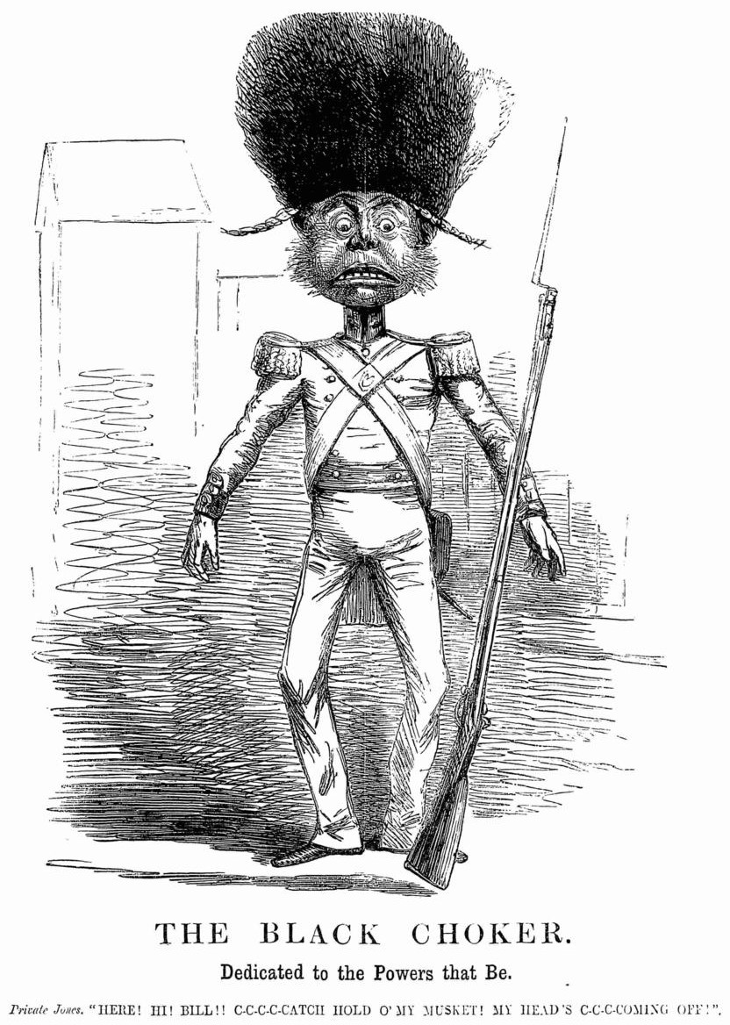
Figure 11. 'The Black Choker', Punch, 3 June 1854.
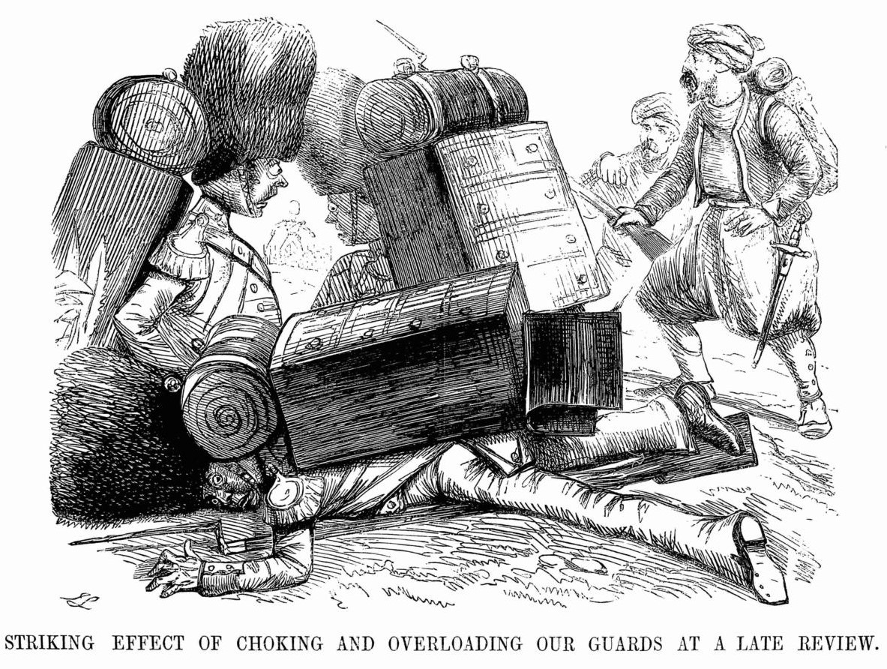
Figure 12. Punch, 10 June 1854.

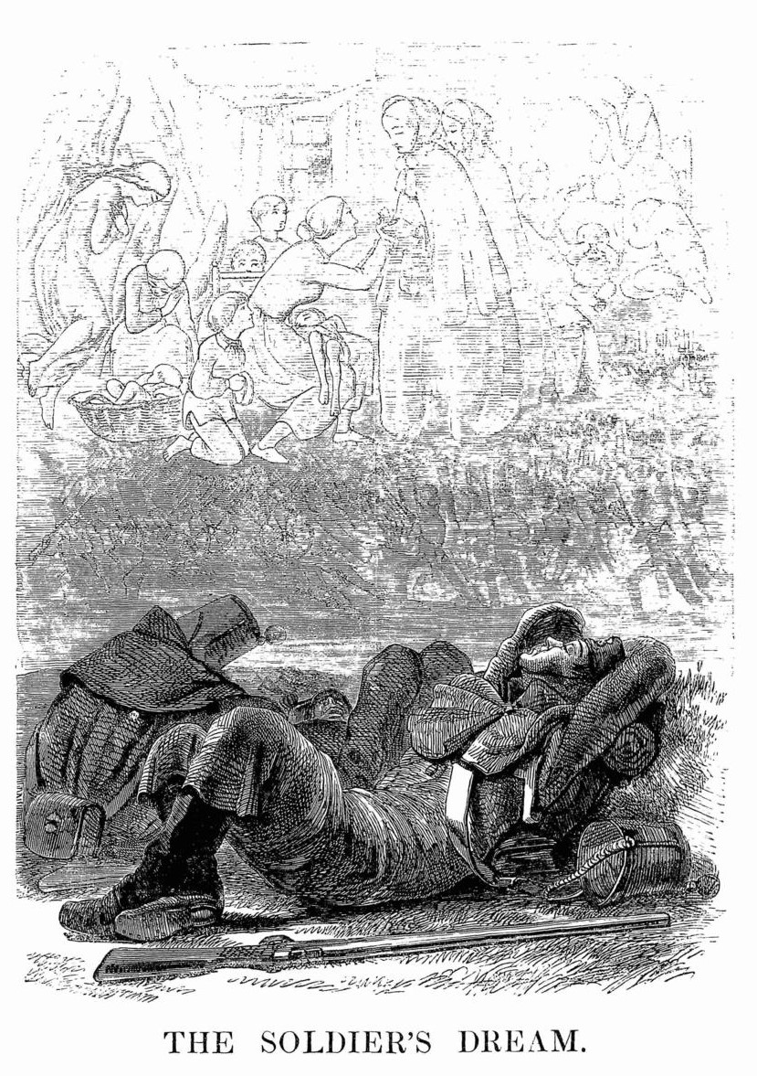
Figure 13. 'The Soldier's Dream', Punch, 1 April 1854.
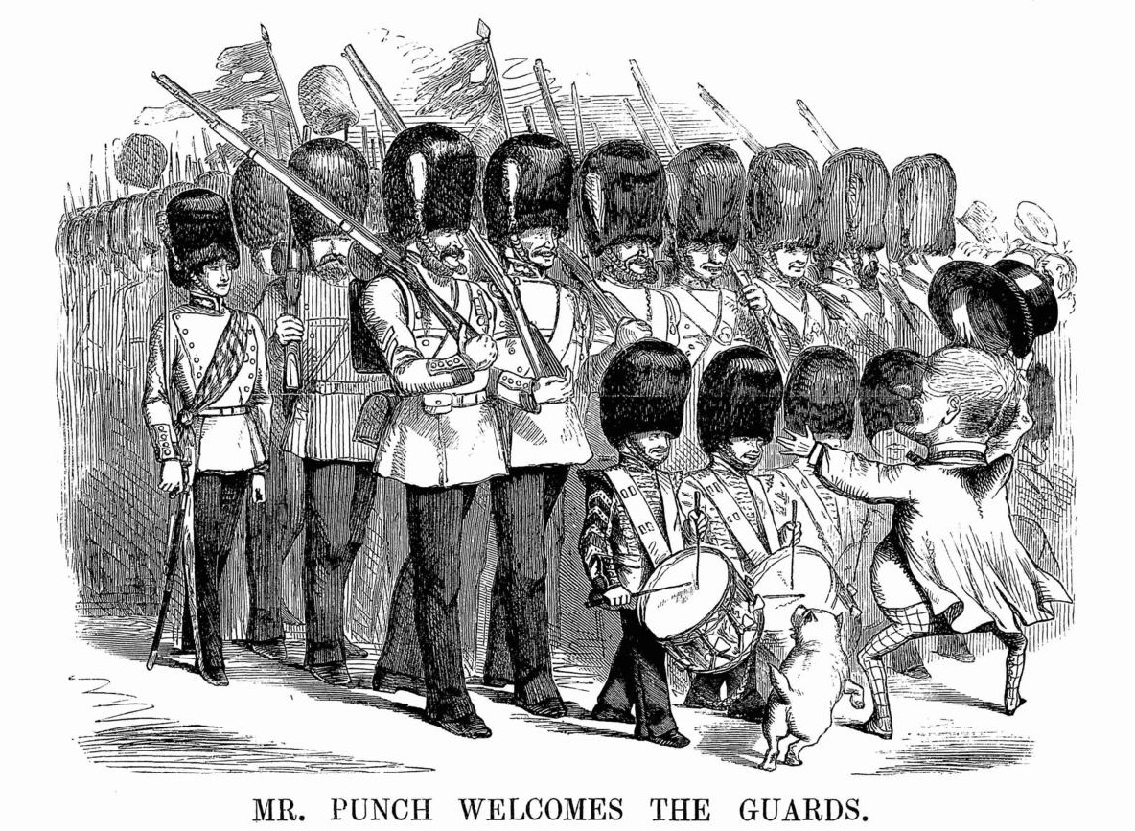
Figure 14. 'Mr. Punch Welcomes the Guards', Punch, 5 July 1856.

*
The nineteenth century was a busy time for the British Army, which fought more wars in the reign of Queen Victoria than it had done in the previous two centuries combined. This fact, and its implications for the evolving sense of values associated with the Army in Britain, has yet to be fully reflected in histories of Victorian popular culture, for whom the Crimean War, the Indian Mutiny, and the high noon of empire have proven all too alluring. While the significance of those climactic events is indisputable, this survey of the Army’s depiction in Punch between 1841 and 1861 offers little support to histories that pivot around the battlefields of the Alma, Balaclava, Inkerman, Delhi, Cawnpore, Lucknow, Jhansi, and Gwalior, a conclusion that ought not to be questioned on the grounds that Punch reflected little more than the social fads of London. It seems inexplicable for Punch to have amassed such widespread popularity at home and abroad if the topics which its authors and artists elected to pillory did not resonate with a variety of groups outside the capital. This has in turn preserved for posterity many of the prevailing trends in Victorian popular culture and allows the following three points to be stated with confidence.
Firstly, the anger that Punch directed towards the Army in its first twenty years cannot be understated. It has been suggested that ‘for anyone accustomed to the extremes of Georgian caricature’, Punch’s depiction of the Army was ‘mild and decorous’. This is true enough. Yet to dismiss Punch’s response to the military issues of the day as little more than gentle satire is an error. Nor is it true that, while ‘guardsmen, officers and (the) rank and file supplied fodder for amusing cartoons’, this did not alter Punch’s prevailing view that the Army was ‘indispensable to the nation’s security and pride’ and deserving of respect from ‘every true-born Englishman’. Gentle forms of satire directed against the Army’s relationship with the monarchy, debates on reform, and the mannerisms of ‘plungers’ coexisted in the 1840s with vehement attacks on the immorality of bloodshed and outrage at how the British soldier was compelled to ‘blow out the brains of miserable wretches’ in China. The failings of aristocratic leadership, the idiocy of ‘military snobs’, and the mistreatment of the ranker were similarly emphasized throughout the period with a degree of intensity that more than justifies the label of antimilitarism.
Secondly, the framing of the Crimean War as a watershed in attitudes towards the British Army should not be overdone. To claim that Punch ‘forgot much as he grew respectable’ and that in the 1850s, radicalism was replaced by ‘vague’ criticisms of society is to overlook the fact that, throughout the decade, Punch continued its attacks on ‘military snobs’ with all the vehemence of the 1840s and did not moderate its view of the Purchase System until 1857. Even its gleeful celebration of Hope Grant’s victories in 1860 was tempered by unease at the expense of the march on Pekin. This is not to dismiss the impact of the Crimean War outright. The Army’s system of administration was certainly treated with good humour until its failings were exposed in Russia, after which point it was ruthlessly attacked. Conversely, Punch’s enthusiasm for the common soldier appeared several years before 1854 and was amplified, not instigated, in the Crimea.
Finally, ‘England’s little wars’ loomed larger in the mid nineteenth century than is commonly believed. It is undeniable that domestic issues featured prominently in Punch. Yet in the face of the periodical’s outrage at the First Opium War, the juxtaposing of the victors of the Sikh Wars to London’s plungers, the large cuts that appeared during the Crimean War, the celebration and martyrization of imperial heroes, and the emphasis on the need for harsh measures towards China in 1860, it cannot be said that Westminster politics and London social fads epitomized Punch’s content. Punch was cognisant of virtually every foreign war in the period, which were used to call for better treatment of the common soldier and to highlight the failings of military snobs at home. In this regard, Punch offers an ideal visual accompaniment to the integration of foreign affairs into studies of domestic political and social debate.
What is particularly interesting about this changing depiction of the Army is how little it had to do with changes in authorship. As Patrick Leary has noted, one of the advantages of studying Punch’s first two decades is the homogeneity of its staff. While other periodicals relied on freelance writers, the Punch ‘brotherhood’ remained a self-contained, select group. It is true that Henry Mayhew left in 1845, as did Richard Doyle in 1850 and William Thackeray in 1851 (he was replaced by Shirley Brooks). Gilbert à Beckett and Douglas Jerrold died in 1856 and 1857, respectively. Yet the rest of the staff – Percival Leigh, Horace Mayhew, Henry Silver, John Tenniel, and Tom Taylor – had years and in most cases decades of writing and drawing ahead of them. Moreover, more than half of the prose and poems cited in this article were penned by Leigh and Taylor, who wrote for Punch throughout the period. Of course, this does not lessen the work of the rest. None of Punch’s military targets – warfare, invasion scares, reforms, institutions, snobs, plungers, stocks, floggings, barracks, heroes, military estimates, and the ranker – were the preserve of one man. Nor did the writers who spent less time on the Army than their colleagues lack the talent for satire and vitriol that Leigh and Taylor possessed. Douglas Jerrold’s parody of the Bayeux Tapestry is a perfect example. Put simply, the changing depiction of the Army in Punch did not correspond to changes in the Punch ‘brotherhood’. Attacks on snobs, for instance, were a speciality of Thackeray, but Punch’s attacks on opulent military wastrels were continued by Leigh and Horace Mayhew after 1851. Major fault lines in the depiction of the Army, therefore, either reflected external events, such as the waves of optimism and pessimism that were triggered by the Crimean War, or the Punch staff changing their minds. Taylor certainly changed his mind about Cardigan and Purchase. Leigh, to whom some of the fiercest antimilitarism of the 1840s – including ‘Punch’s Labours of Hercules’ – can be attributed, later became a defender of the Duke of Wellington’s memory and an advocate for the soldier’s welfare. If Punch often changed its mind, therefore, it rarely changed its staff.
In 1860, reflecting on how British military administration had fared in the previous two decades, the Victorian statesman Sir James Graham described the situation as ‘chaos’. While it is tempting to say the same of the British Army’s depiction in Punch, the following at least can be advanced with certainty: an antimilitaristic strain was present in Punch for over a decade before dissipating in the 1850s, but even so, military adventurism was never endorsed unconditionally, except in 1854. Punch deplored the immorality and the expense of colonial wars in China and India, and the Army’s incompetence in Russia and the Cape, but it never followed the Army any further into provincial Britain than Chobham Common and was silent on the use on the use of soldiers to shoot strikers in Preston. The Army’s contribution to the defence of the realm and its activities abroad constituted legitimate targets for ridicule, but military heroism was lauded, and the ranker was an object of sympathy. War was condemned as a moral and financial evil, but the officers responsible for imperial victories were celebrated. The ‘military snob’ and the incompetent officer were held in contempt, yet successful commanders and imperial heroes were lionized wherever they could be found and – in the case of Wellington and Campbell – regardless of their opposition to the nation’s liberties. As a proportion of its content in the mid-century, Punch’s depiction of the Army no doubt counted for relatively little. Yet for the historian of the British Army in the nineteenth century, there can be no show without Punch.

Edmund Burke, Works, v (London, 1815), p. 17.
For enthusiasm for the Army in the eighteenth century, see Linda Colley, Britons: Forging the Nation 1707-1837 (Yale, 1992), pp. 92-94, 257-288, 264-265; ‘The British Atlas, or John Bull supporting the peace establishment’ (1816), satirical print; BM Satires / Catalogue of Political and Personal Satires in the Department of Prints and Drawings in the British Museum (12786).
As quoted by Patricia Morton, ‘Another Victorian Paradox: Anti-Militarism in a Jingoistic Society’, Historical Reflections, viii (1981), p. 169. See also Hew Strachan, The Politics of the British Army (Oxford, 1997), p. 76. For pressure for retrenchment, see Miles Taylor, ‘The 1848 Revolutions and the British Empire’, Past and Present, clxvi (2000), pp. 158-159.
The Contemporary Review, xii (London, 1869), p. 548.
Byron Farwell, For Queen and Country: A Social History of the Victorian and Edwardian Army (London, 1981), p. 93. In 1941, George Orwell was still able to write that ‘within living memory it was common for ‘the redcoats’ to be booed in the streets and for the landlords of respectable public houses to refuse to allow soldiers on the premises.’ George Orwell, The Lion and the Unicorn: Socialism and the English Genius (London, 1941; 3rd edn, London, 1982), p. 41.
The Westminster Review, cxxxvi (London, 1891), pp. 624-642.
Gwyn Harries-Jenkins, ‘The Development of Professionalism in the Victorian Army’, Armed Forces and Society, i (1975), p. 488. See also Brian Bond, ‘The Late-Victorian Army’, History Today, xi (1961), pp. 616-662; I.F. Clarke, Voices Prophesying War 1763-1984 (London, 1966); Alan Ramsay Skelly, The Victorian Army at Home: The Recruitment and Terms and Conditions of the British Regular, 1859-1899 (London, 1977); Edward Spiers, Army and Society 1815-1914 (London, 1980); John Gooch, The Prospect of War: Studies in British Defence Policy 1847-1942 (London, 1981); David French, The British Way in Warfare, 1688-2000 (London, 1990).
Bernard Porter, ‘Popular Imperialism: Broadening the Context’, Journal of Imperial and Commonwealth History, xxxix (2011), p. 843.
John MacKenzie, (ed.), Popular Imperialism and the Military: 1850-1950 (Manchester, 1992), pp. 3-4; MacKenzie, ‘The Press and the Dominant Ideology of Empire’, in Simon Potter (ed.), Newspapers and Empire in Ireland and Britain: Reporting the British Empire, c.1857-1921 (Dublin, 2004), p. 29; MacKenzie, Popular Imperialism and the Military, p. 281, 4. See also See Berny Sѐbe, Heroic Imperialists in Africa: The promotion of British and French Colonial Heroes, 1870-1939 (Manchester, 2013);
MacKenzie, Popular Imperialism and the Military, p. 1. See also Andrew Thompson, The Empire Strikes Back? The Impact of Imperialism on Britain from the Mid-Nineteenth Century (Harlow, 2005); Mark Bryant, Wars of Empire in Cartoons (London, 2008).
See for example Olive Anderson, A Liberal State at War: English Politics and Economics during the Crimean War (London, 1967).
See Matthew Lalumia, ‘Realism and Anti-Aristocratic Sentiment in Victorian Depictions of the Crimean War’, Victorian Studies, xxvii (1983), pp. 25-51; J.W.M Hichberger, Images of the Army: The Military in British Art 1815-1914 (Manchester, 1988); Anthony Cross, ‘The Crimean War and the Caricature War’, The Slavonic and East European Review, lxxxiv (2006), pp. 460-480.
For invasion scares, see Gooch, The Prospect of War, p. 35; Andrew Lambert, ‘The Ultimate Test: The Fourteenth Earl, the Admiralty and the Ministry of 1852’, in Geoffrey Hicks, Conservatism and British Foreign Policy, 1820-1920: The Derbys and their World (Farnham, Sr., 2011), pp. 41-58; Jonathan Parry, ‘The Impact of Napoleon III on British Politics’, Transactions of the Royal Historical Society, xi (2001), 147-175. For broader assessments of the period, see Andrew Lambert, ‘The Tory World View: Sea Power, Strategy and Party Politics, 1815-1914’, in Jeremy Black (ed.), The Tory World: Deep History and the Tory Theme in British Foreign Policy, 1679-2014 (Farnham, Sr., 2015), pp. 122-148; Karuna Mantena, ‘The Crisis of Liberal Imperialism’, in Duncan Bell (ed.), Victorian Visions of Global Order: Empire and International Relations in Nineteenth-Century Political Thought (Cambridge, 2007).
Taylor, ‘The 1848 Revolutions and the British Empire’, p. 148; Leslie Stephen (ed.), Oxford Dictionary of National Biography, xxii (London, 1890), p. 393. For the domestic repercussions of such ‘little wars’, see Hew Strachan, ‘The Early Victorian Army and the Nineteenth-Century Revolution in Government’, English Historical Review, xcv (1980), pp. 785-786; Taylor, ‘The 1848 Revolutions’, p. 167.
Byron Farwell, Queen Victoria's Little Wars (London, 1973), p. 1.
For similar studies of the auxiliary and Volunteer forces, see Mark Bennett, ‘Portrayals of the British Militia, 1852-1916’, Historical Research, xci (2018), pp. 333-352; Morton, ‘Another Victorian Paradox’.
Richard D. Altick, Punch: The Lively Youth of a British Institution (Ohio, 1997), pp. 37-38; John M. Mackenzie, ‘The Press and the Dominant Ideology of Empire’, in Simon J. Potter (ed.), Newspapers and Empire in Ireland and Britain: Reporting the British Empire, c.1857-1921 (Dublin, 2004), p. 26.
Amy Matthewson, Cartooning China: Punch, Power, & Politics in the Victorian Era (Oxford, 2022), p. 53; Bryant, Wars of Empire in Cartoons, p. 8.
Richard Scully, ‘“For gorsake, stop laughing! This is serious”: The British World as a Community of Cartooning and Satirical Art’, in Jatinder Mann and Iain Johnston-White (eds), Revisiting the British World: New Voices and Perspectives, (New York, 2022), pp. 145-154.
Richard Scully, ‘The Cartoon Emperor: The Impact of Louis Napoleon Bonaparte on European Comic Art, 1848-1870’, European Comic Art, iv (2011), p. 163; Cross, ‘The Crimean War’, p. 460; Matthewson, Cartooning China, p. 16; Scully, ‘“For gorsake, stop laughing!”’, p. 150
Punch, or The London Charivari, 17 February 1844.
Punch, 23 February 1856.
For some of the more selective studies of late-nineteenth century empire-building and Punch, see Roy Douglas, ‘Great Nations Still Enchained’, The Cartoonists’ Vision of Empire 1848-1918 (London, 1993) and Bryant, Wars of Empire in Cartoons.
M.H Spielmann, The History of “Punch” (New York, 1895); Bryant, Wars of Empire in Cartoons, p. 9.
Charles L. Graves, Mr. Punch’s History of Modern England, i (London, 1921), pp. 112-140.
Graves, Mr. Punch’s History, i p. 129.
Graves, Mr. Punch’s History, i p. 114.
Graves, Mr. Punch’s History, i, p. 112.
Susan and Asa Briggs (eds.), Cap and Bell: Punch’s Chronicle of English History in the Making, 1841-61 (London, 1971), p. xxvi.
Altick, Punch, pp. 429, 216.
Henry Miller, ‘The Problem with Punch’, Historical Research, lxxii (2009), p. 286.
Matthew Roberts, ‘Election Cartoons and Political Communication in Victorian England’, Cultural and Social History, x (2015), p. 370; Scully, ‘“For gorsake, stop laughing!”’, p. 140. See also See Miles Taylor, John Bull and the Iconography of Public Opinion in England c. 1712-1929’, Present, cxxxiv (1992); James Thompson ‘Pictorial Lies? Posters, and Politics in Britain, c.1880-1914’, Past and Present, cxcvii (2007); Richard Scully and Marian Quartly (eds.), Drawing the Line: Using Cartoons as Historical Evidence (Victoria, 2009); Benedict Anderson, Imagined Communities: Reflections on the Origin and Spread of Nationalism (New York, 2016). For the historiography of cartoons, see Scully and Varnava, Comic Empires, pp. 7-13.
Cross, ‘The Crimean War’, p. 460; Scully, ‘The Cartoon Emperor’, p. 161. See also Bryant, Wars of Empire in Cartoons; Stefanie Markovits, The Crimean War in the British Imagination (Cambridge, 2009).
Leary, The Punch Brotherhood: Table Talk and Print Culture in Mid-Victorian London (London, 2010), p. 4.
Patrick Leary, The Punch Brotherhood, p. 15.
Leary, The Punch Brotherhood, pp. 39-44.
Spielmann, The History of “Punch”, p. 203.
Spielmann., The History of “Punch”, pp. 191-194; Bryant, Wars of Empire in Cartoons, p. 9; Scully, ‘The Cartoon Emperor’, p. 165; Cartooning China, p. 12.
Scully, Richard, and Varnava, Andrekos (eds.), Comic Empires: Imperialism in Cartoons, Caricature and Satirical Art (Manchester, 2020), p. 3.
Scully, ‘“For gorsake, stop laughing!”’, pp. 142-143.
Matthewson, Cartooning China, p. 17. See also Brian Maidment, ‘The Presence of Punch in the Nineteenth Century’, in Hans Harder and Barbara Mittler, Barbara, Asian Punches: A Transcultural Affair (2013), pp. 15-46.
Leary, The Punch Brotherhood, pp. 18-28.
Matthewson, Cartooning China, p. 5.
Altick, Punch, p. 44; Leary, The Punch Brotherhood, pp. 18-28.
Leary, The Punch Brotherhood, p. 7.
Briggs, Cap and Bell, p. xxxvi; Punch, 13 May 1843.
Altick, Punch, p. 737; Miller, ‘The Problem with Punch’, p. 288.
The same was true of other publications, including The Economist and The Illustrated London News. Gooch, The Prospect of War, p. 1; Altick, Punch, p. 421.
Punch, 8 January 1848.
Punch, 29 January 1848.
Punch, 7 February 1852.
See ‘French Sympathisers’, Punch, 22 April 1848 and ‘How To Treat a Foreign Propagandist’, Punch, 29 April 1848.
For the monarchy, see Anthony Taylor, Down with the Crown: British anti-monarchism and debates about royalty since 1790 (London, 1999); R. Williams, The Contentious Crown: Public Discussion of the British Monarchy in the reign of Queen Victoria (Aldershot, 1997).
Punch, 17 February 1843.
Punch, 14 April 1843.
Strachan, ‘The Early Victorian Army’, p. 782.
Punch, 13 December 1845.
Punch, 13 December 1845.
Punch, 4 September 1847.
Punch, 31 January 1852.
Punch, 3 June 1854.
Punch, 23 February 1856.
Altick, Punch, p. 92.
Punch, 3 November 1856.
Altick, Punch, p. 95. William Hone’s satire, ‘The Political House That Jack Built’, for example, ran through over 27 editions in the aftermath of the Peterloo Massacre. William Hone, ‘The Political House That Jack Built’, The John Rylands Library, University of Manchester, R106162.1.
Punch, 5 May 1855.
Strachan, ‘The Early Victorian Army’, p. 792; Jonathan Parry, The Politics of Patriotism: English Liberalism, National Identity and Europe, 1830-1886 (Cambridge, 2006), pp. 160-170.
Punch, 3 February 1849.
Punch, 31 October 1857.
Punch, 7 March 1857.
Farwell, For Queen and Country, pp. 56-59.
Altick, Punch, p. 734.
Punch, 13 December 1845.
Punch, 2 May 1846.
Punch, 30 November 1850.
Punch, 24 February 1855.
As quoted by Farwell, For Queen and Country, p. 57.
Punch, 5 September 1857.
G. M. Young, Victorian England: Portrait of an Age (London, 1936; 2nd edn, London, 1968), p. 38.
See David Kent, ‘Controlling Disorder in the ‘Age of Equipoise’: Troops, Trains, and the Telegraph’, Social History, xxxviii (2013), pp. 316-322; Young, Portrait of An Age, p. 38.
Punch, 27 August 1842.
Punch, 11 January 1851.
Punch, 12 November 1853.
Briggs, Cap and Bell, p. xxix.
Punch, 30 July 1853.
Punch, 29 November 1845.
Punch, 18 February 1854.
Punch, 25 February 1854.
Punch, 4 March 1854.
Punch, 4 March 1857; Bryant, Wars of Empire in Cartoons, p. 15.
Punch, 14 October 1854.
Punch, 7 October 1854.
Punch, 17 February 1855.
Punch, 17 February 1855.
Punch, 24 August 1855.
Cross, ‘The Crimean War’, p. 471.
Cross, ‘The Crimean War’, p. 464; Parry, The Politics of Patriotism, p. 9.
Markovits, The Crimean War in the British Imagination p. 4.
Scully, ‘The Cartoon Emperor’, p. 165.
Punch, 17 September 1842.
Matthewson, Cartooning China, p. 80; Punch, 17 September 1842.
Punch, 12 June 1852.
Punch, 5 February 1842.
Punch, 13 May 1843.
Parry, Politics of Patriotism, p. 185.
Punch, 17 March 1849.
Punch, 15 October 1853.
Punch, 8 August 1857.
Punch, 17 February 1842.
Punch, 21 July 1860.
Altick, Punch, p. xix; Punch, 22 December 1860; Matthewson, Cartooning China, p. 106.
A tael was a Chinese unit of currency. Punch, 5 January 1851.
Stephen E. Koss, The Rise and Fall of the Political Press in Britain, i (London, 1981), p. 90.
Miller, ‘The Problem with Punch’, p. 287.
Cecil Woodham Smith, The Reason Why (Harmondsworth, 1968) p. 140; Punch, 11 July 1857.
Punch, 12 February 1842.
Punch, 12 August 1848.
Punch, 11 April 1857.
Punch, 2 February 1861.
Punch, 9 May 1846.
Punch, 14 August 1841.
Punch, 30 September 1854.
Punch, 6 May 1854.
MacKenzie, ‘Heroic Myths of Empire’, p. 221.
Punch, 7 April 1849.
Punch, 5 May 1849.
See Anthony Taylor, Lords of Misrule: Hostility to Aristocracy in the Late Nineteenth- and Early Twentieth-Century Britain (Basingstoke, 2004), pp. 36-37.
Punch, 25 November 1854. For more on this cartoon, see Markovits, The Crimean War in the British Imagination, pp. 184-186.
Punch, 2 December 1854.
Punch, 16 February 1856.
Cross, ‘The Crimean War’, p. 471.
Punch, 16 February 1856.
Punch, 9 May 1846.
Punch, 20 June 1846.
Punch, 29 January 1853.
Punch, 2 October 1852.
For Punch’s depiction of Napoleon III, see Scully, ‘The Cartoon Emperor’, p. 161.
Punch, 27 November 1852.
MacKenzie, ‘Heroic Myths of Empire’, pp. 112-114; Sѐbe, Heroic Imperialists, p. 2.
Mackenzie, ‘Heroic Myths of Empire’, p. 118.
Punch, 16 January 1858.
Punch, 28 July 1860.
MacKenzie, ‘Heroic Myths of Empire’, p. 117.
As quoted by Farwell, For Queen and Country, p. 49.
Farwell, For Queen and Country, p. 96.
Punch, 13 March 1858.
Punch, 23 August 1845.
Punch, 9 April 1859.
Punch, 22 August 1856.
Punch, 27 November 1858.
Punch, 3 June 1854.
Punch, 3 June 1854.
Punch, 3 June 1854.
Punch, 10 June 1854.
Punch, 27 November 1854.
Farwell, For Queen and Country, p. 186.
Punch, 27 February 1858.
Punch, 27 March 1858.
Punch, 28 August 1858.
Punch, 3 April 1847.
Punch, 3 April 1847.
Punch, 1 August 1846.
Punch, 5 September 1846.
Punch, 13 May 1843.
Punch, 13 March 1847.
Punch, 15 February 1849.
Markovits, The Crimean War in the British Imagination, p. 5; Strachan, ‘The Early Victorian Army’, p. 808.
Punch, 29 June 1850.
Punch, 4 March 1854.
Punch, 1 April 1854. See also Tai-Chun Ho, ‘The Afterlife of Thomas Campbell and ‘The Soldier’s Dream’ in the Crimean War’, Interdisciplinary Studies in the Long Nineteenth Century, xx (2015).
Punch, 24 September 1859.
Punch, 13 May 1843; Punch, 24 September 1859.
Punch, 5 July 1856; Punch, 19 July 1856.
Farwell, Queen Victoria's Little Wars, p. 1.
Cross, ‘The Crimean War’, p. 471.
Altick, Punch, p. 216.
Punch, 17 September 1842.
Briggs, Cap and Bell, p. xxvii; Miller ‘The Problem with Punch’, p. 289.
See for example William Mulligan and Brendan Simms (eds), The Primacy of Foreign Policy in British History, 1660–2000: How Strategic Concerns Shaped Modern Britain (Basingstoke, 2010), p. 260.
Leary, The Punch Brotherhood, pp. 14, 28.
As quoted by Bond, ‘The Late-Victorian Army’, p. 617.

