Supplementary Material

Demystifying Authenticity: Behavioral and Neurophysiological Signatures of Self-Positivity for Authentic and Presented Selves

The PDF file includes:

Supplementary Results for Experiment 1 and 2
Supplementary Study S1 to S3
Figure S1 to S3
Tables S1 to S12
References

Contents
Experiment 1 3
Results 3
Trait Endorsement 3
Reaction Time 3
Experiment 2 4
Results 4
Trait Endorsement 4
Reaction Time 5
P1 5
N170 6
LPP 7
Study S1: Is the Presented Self More Sanitized Than the Authentic Self? 8
Study S2: Is the Authentic Self More Robust Than the Presented Self? 9
Study S3: Is the Authentic Self More Significant Than the Presented Self? 10
Supplementary Figures and Tables 11
Reference 26

Experiment 1

Results

Trait Endorsement
Self-Positivity for the Authentic Self and Presented Self. The Self × Valence × Endorsement interaction was significant, F(1, 221) = 47.85, p < 0.001, ƞ_{p}² = 0.18. We examined the Valence × Endorsement interaction separately for the authentic self and the presented self, asking whether self-positivity was evident for both kinds of self. In the case of the authentic self, participants endorsed more positive traits (65.48 ± 9.74) than negative traits (18.09 ± 9.63) as descriptive, t(221) = 44.70, p < 0.001, 95% CI = [45.30, 49.48], Cohen’s d = 3.00, but judged more negative traits (63.78 ± 10.83) than positive traits (16.16 ± 8.04) as non-descriptive, t(221) = 45.59, p < 0.001, 95% CI = [45.56, 49.68], Cohen’s d = 3.06. Similarly, in the case of the presented self, participants endorsed more positive traits (66.71 ± 8.76) than negative traits (12.58 ± 8.06) as descriptive, t(221) = 57.95, p < 0.001, 95% CI = [52.29, 55.97], Cohen’s d = 3.89, but judged more negative traits (69.79 ± 8.86) than positive traits (15.40 ± 7.81) as nondescriptive, t(221) = 58.23, p < 0.001, 95% CI = [52.55, 56.23], Cohen’s d = 3.91. Self-positivity was evident for both the authentic self and the presented self.

Reaction Time
Model Settings. We aimed to test the difference in self-positivity, as reflected in RT, between the authentic self and the presented self; thus, the dependent variable was RT for each valid trial. Three variables and their interactions (i.e., self, valence, endorsement, Self × Valence, Self × Endorsement, Endorsement × Valence, Self × Valence × Endorsement) were level-1 predictors (i.e., fixed effects); for self: authentic self = 1, presented self = -1; for valence: positive traits = 1, negative traits = -1; for endorsement: yes (self-descriptive) = 1, no (non-self-descriptive) = -1. Following Volpert-Esmond et al.’s (2018, 2021) model specification procedures, we also calculated each participant’s mean RT based on the average of all relevant trials for the level-2 factor and treated it as a grouping variable (“random factor”); given individual differences in RTs, we estimated random intercepts of mean RT for each participant; also, given that the effect of mean RT on the outcome varied across participants, we estimated a random slope for each participant’s mean RT.
Self-Positivity for the Authentic and Presented Self. The Self × Valence × Endorsement interaction was significant, β = 8.76, t₇₂₆₂₇ = 2.48, p = 0.013. We examined the Valence × Endorsement interaction separately for the authentic self and the presented self, asking whether self-positivity was evident for both kinds of self. In the case of the authentic self, participants responded faster to endorse positive traits (1283.66 ± 317.32) than negative traits (1518.55 ± 404.04) as descriptive, γ = -105.20, z = -15.73, p < 0.001, but responded faster to judge negative traits (1349.25 ± 290.88) than positive traits (1639.01 ± 454.81) as non-descriptive, γ = -129.27, z = -18.48, p < 0.001. Likewise, in the case of the presented self, participants responded faster to endorse positive traits (1261.61 ± 280.48) than negative traits (1592.39 ± 446.82) as descriptive, γ = -152.52, z = -19.98, p < 0.001, but responded faster to judge negative traits (1332.29 ± 282.78) than positive traits (1597.69 ± 472.48) as non-descriptive, γ = -116.88, z = -16.77, p < 0.001. We observed self-positivity both for the authentic self and the presented self.

Experiment 2

Results

Trait Endorsement
Self-Positivity for the Authentic and Presented Self. The Self × Valence × Endorsement interaction was significant, F(1, 120) = 57.50, p < 0.001, ƞ_{p}² = 0.32. We examined the Valence × Endorsement interaction separately for the authentic self and the presented self, asking whether self-positivity was evident for both kinds of self. In the case of the authentic self, participants endorsed more positive traits (141.83 ± 25.01) than negative traits (41.35 ± 23.02) as descriptive, t(120) = 25.72, p < 0.001, 95% CI = [92.75, 108.22], Cohen’s d = 2.34, but judged more negative traits (154.81 ± 24.90) than positive traits (53.14 ± 24.72) as nondescriptive, t(120) = 25.58, p < 0.001, 95% CI = [93.80, 109.54], Cohen’s d = 2.33. Similarly, in the case of the presented self, participants endorsed more positive traits (150.61 ± 24.03) than negative traits (27.88 ± 17.66) as descriptive, t(120) = 37.63, p < 0.001, 95% CI = [116.27, 129.19], Cohen’s d = 3.42, but judged more negative traits (167.08 ± 19.27) than positive traits (43.83 ± 22.31) as nondescriptive, t(120) = 39.26, p < 0.001, 95% CI = [117.04, 129.47], Cohen’s d = 3.57. Self-positivity manifested itself both for the authentic self and presented self.

Reaction Time
Model Settings. The model settings are the same as Experiment 1.
Self-Positivity for the Authentic and Presented Self. The Self × Valence × Endorsement interaction was significant, β = 21.75, t₉₄₃₂₉ = 7.74, p < 0.001. We examined the Valence × Endorsement interaction separately for the authentic self and the presented self, asking whether self-positivity was evident for both kinds of self. With regard to the authentic self, participants responded faster to endorse positive traits (1326.18 ± 337.71) than negative traits (1624.60 ± 423.74) as descriptive, γ = -116.86, z = -20.98, p < 0.001, but responded faster to judge negative traits (1297.50 ± 327.94) than positive traits (1683.54 ± 413.92) as non-descriptive, γ = -170.33, z = -34.08, p < 0.001. In a similar vein, with regard to the presented self, participants responded faster to endorse positive traits (1304.22 ± 353.80) than negative traits (1726.73 ± 456.19) as descriptive, γ = -165.70, z = -26.07, p < 0.001, but responded faster to judge negative traits (1287.29 ± 364.70) than positive traits (1734.97 ± 445.94) as non-descriptive, γ = -192.90, z = -36.93, p < 0.001. Self-positivity characterized both the authentic self and the presented self.

P1
Model Settings. We aimed to test the difference in self-positivity, as reflected in P1 amplitudes, between the authentic self and the presented self. We examined in particular how P1 amplitudes varied as function of each variable (participants, electrodes, self, valence, endorsement). The last three variables and their interactions (Self × Valence, Self × Endorsement, Endorsement × Valence, Self × Valence × Endorsement) were level-1 predictors (i.e., fixed effects)—self: authentic self = 1, presented self = -1; valence: positive = 1, negative = -1; endorsement: endorse = 1, reject = -1. We also calculated each participant’s mean P1 amplitude, indicated by the average of all trials for that participant, as a level-2 factor. Finally, participants and electrodes were grouping variables or random factors. Following Volpert-Esmond et al.’s (2018, 2021) model specification procedures, we specified participants and electrodes as independent factors (i.e., a cross-classified model), allowed the intercept and slope of mean amplitude to vary by participants (i.e., random intercept, random slope), and allowed the intercept to vary by electrode (i.e., random intercept).
P1 in Judging the Non-Self-Descriptiveness of Positive and Negative Traits. The model revealed a significant Self × Valence × Endorsement interaction, β = 0.06, t₇₆₁₆ = 3.93, p < 0.001 (Fig. 3a). We proceeded with simple slope tests to test whether the simple slopes of P1 on self and valence were significant in the endorsement (YES) or rejection (NO) conditions, respectively. We found a significant simple slope only in regard to endorsement of negative traits: the elicited P1 was larger when endorsing negative traits as descriptive of the presented self than the authentic self (γ = 0.26, z = 9.20, p < 0.001). The elicited P1 was equivalent when judging negative traits as non-descriptive of the presented self and the authentic self (γ = -0.03, z = -0.93, p = 0.350), was equivalent when endorsing positive traits as descriptive of the presented self and the authentic self (γ = -0.01, z = -0.15, p = 0.882), and was equivalent when judging positive traits as non-descriptive of the presented self and the authentic self (γ = 0.01, z = 0.27, p = 0.791). We display in Tables S7 detailed results for fixed effects. The results were comparable for Ns of 107 and 61 (Table S7 and Table S8).

N170
Model Settings. The model settings are the same as P1.
N170 in Judging the Non-Self-Descriptiveness of Positive and Negative Traits. The model revealed a significant Self × Valence × Endorsement interaction, β = 0.03, t₁₃₅₄₄ = 2.94, p = 0.003 (Fig. 3b). We proceeded with simple slope tests to test whether the simple slopes of N170 on self and valence were significant in the endorsement (YES) or rejection (NO) conditions, respectively. We found a significant simple slope only in regard to endorsement of positive traits: the elicited N170 was larger when endorsing positive traits as descriptive of the presented self than the authentic self (γ = 0.06, z = 3.35, p < 0.001), whereas the elicited N170 tended to be larger when endorsing negative traits as descriptive of the authentic self than the presented self (γ = 0.03, z = 1.72, p = 0.085). However, the elicited N170 was equivalent when judging positive traits as non-descriptive of the presented self and the authentic self (γ = 0.03, z = 1.59, p = 0.113), and the elicited N170 was equivalent when judging negative traits as non-descriptive of the presented self and the authentic self (γ = 0.01, z = 0.78, p = 0.435). We display in Table S9 detailed results for the fixed effects. The results were comparable for Ns of 107 and 61 (Tables S9 and Table S10).

LPP
Model Settings. The model settings are the same as P1.
LPP in Judging the Non-Self-Descriptiveness of Positive and Negative Traits. The model revealed a significant Self × Valence × Endorsement interaction, β = 0.04, t₁₂₆₉₈ = 2.54, p = 0.011 (Fig. 3c). We proceeded with simple slope tests to test whether the simple slopes of LPP on self and valence were significant in the endorsement (YES) or rejection (NO) conditions, respectively. We found significant simple slopes in the endorsement condition: the elicited LPP was larger when judging positive traits as descriptive of the authentic self than the presented self (γ = 0.14, z = 4.72, p < 0.001), and the elicited LPP was larger when judging negative traits as descriptive of the authentic self than the presented self (γ = 0.19, z = 6.35, p < 0.001). These results are consistent with a stimulus significance view of the LPP (Hajcak & Foti, 2020). In the rejection condition, the elicited LPP was larger when judging negative traits as non-descriptive of the authentic self than the presented self (γ = 0.16, z = 5.21, p < 0.001), but the elicited LPP was equal when judging positive traits as non-descriptive of the presented self and the authentic self (γ = -0.05, z = -1.49, p = 0.136). We display in Table S11 the detailed results of fixed effects. The results were comparable for Ns of 107 and 61 (Table S11 and Table S12).

Study S1: Is the Presented Self More Sanitized Than the Authentic Self?
In Study S1, we examined how sanitized participants consider their presented and authentic selves. We hypothesized that they would consider their presented self as more sanitized than their authentic self. We operationalized “sanitized” in terms of the trait adjectives polished, refined, sleek, glossy, and smooth.
To test our hypothesis, we recruited 52 [NATIONALITY MASKED] Prolific workers ranging in age from 18 to 69 years (M = 39.88, SD = 14.80). Thirty four of them (65.38%) identified as female, 17 (32.69%) as male, and 1 (1.92%) as non-binary/third gender. Participants’ ethnic backgroud was as follows: White (n = 48, 92.31%), Black (n = 1, 1.92%), Asian (n = 2, 3.85%), Mixed (n = 1, 1.92%).
Participants learned that they would make judgments about two different versions of the self. One version, the presented self, was defined as “the self you present to others,” whereas the other version, the authentic self, was defined as your “true, real, genuine self.” Next, participants rated how polished, refined, sleek, glossy, and smooth they regarded their presented self (α = .95) and their authenic self (α = .94) and on a scale ranging from 1 (not at all) to 7 (very much). In line with our hypothesis, participants considered their presented self (M = 3.43, SD = 1.45) as more sanitized than their authentic self (M = 2.86, SD = 1.29), t(51) = 3.13, p = .003, Cohen’s d = -0.44, 95%CI [-0.72, -0.15]. Sensitivity analysis in G*Power indicated that 52 participants gave us 80% power to detect effects as small as d = ± 0.40.

Study S2: Is the Authentic Self More Robust Than the Presented Self?
In Study S2, we examined how robust participants regarded their authentic and presented selves. We hypothesized that they would regard their authentic self as more robust than their presented self. We operationalized “robustness” in terms of the trait adjectives variable, changeable, malleable, fluctuating, and shifting.
To test this hypothesis, we recruited 59 [NATIONALITY MASKED] Prolific workers ranging in age between 20 and 77 years (M = 41.86, SD = 14.50). Forty of them (67.80%) identified as female, 16 (27.12%) as male 2 (3.39%) as non-binary/third gender, and 1 (1.69%) preferred not to disclose their gender. Participants’ ethnic backgroud was as follows: White (n = 47, 79.66%), Black (n = 1, 1.69%), Asian (n = 9, 15.25%), Mixed (n = 1, 1.69%), Prefer not to say (n = 1, 1.69%).
Participants were informed that that they would make judgements about two different versions of the self. One version, the presented self, was defined as “the self you present to others.” The other version, the authentic self, was defined as your “true, real, genuine self.” Subsequently, participants rated how variable, changeable, malleable, fluctuating, and shifting they regarded the authenic self (α = .91) and presented self (α = .95) on a scale ranging from 1 (not at all) to 7 (very much). Higher scores on this composite reflect less robustness, whereas lower scores reflect more robustness. In accord with our hypothesis, participants rated their authentic self (M = 3.30, SD = 1.24) as more robust than their presented self (M = 4.58, SD = 1.41), t(58) = -5.81, p < .001, Cohen’s d = -0.76, 95%CI [-1.04, -0.46]. Sensitivity analysis in G*Power indicated that 59 participants gave us 80% power to detect effects as small as d = ± 0.37.

Study S3: Is the Authentic Self More Significant Than the Presented Self?
In Study S3, we examined how significant participants deemed their authentic and presented selves. We hypothesized that they would deem their authentic self as more significant than their presented self. We operationalized significance in terms of the trait adjectives important, significant, and valuable.
To test our hypothesis. We recruited 50 [NATIONALITY MASKED] Prolific workers aged between 18 and 26 years (M = 21.22, SD = 1.87). Twenty five of them (50%) identified as male, 23 (46.00%) as female, and 2 (4.00%) as non-binary/third gender. Participants’ ethnic backgroud was as follows: White (n = 32, 64.00%), Black (n = 4, 8.00%), Asian (n = 9, 18.00%), Mixed (n = 2, 4.00%), Other (n = 2, 4.00%), Prefer not to say (n = 1, 2.00%).
Participants were instructed that they would make judgements about two different versions of the self. One version, the authentic self, was defined as your “true, real, genuine self.” The other version, the presented self, was defined as “the self you present to others.” Participants then rated how important, significant, and valuable they found the authenic self (α = .85) and presented self (α = .95) on a scale ranging from 1 (not at all) to 7 (very much). Congruent with our hypothesis, participants deemed their authentic self (M = 5.77, SD = 1.04) as more significant than their presented self (M = 4.67, SD = 1.59), t(49) = 4.57, p < .001, Cohen’s d = 0.65, 95%CI [0.34, 0.95]. Sensitivity analysis in G*Power indicated that 50 participants gave us 80% power to detect effects as small as d = ± 0.40.

Supplementary Figures and Tables

Figure S1
Neural Manifestations of Self-positivity for the Authentic Self and Presented Self in Experiment 2
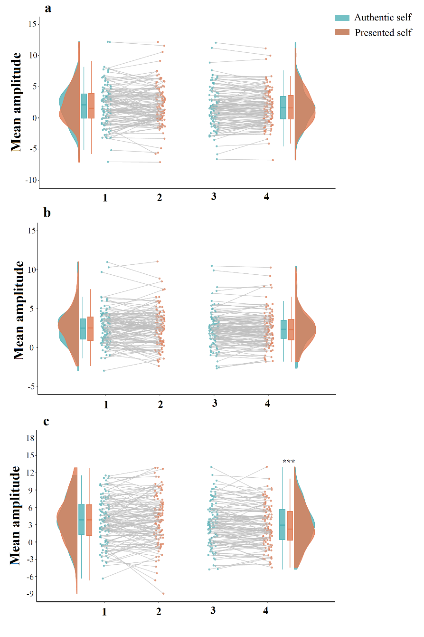
Note. (a) P1 mean amplitude for the authentic self and the presented self in judging the non-self-descriptiveness of positive and negative traits. (b) N170 mean amplitude for the authentic self and the presented self in judging the non-self-descriptiveness of positive and negative traits. (c) LPP mean amplitude for the authentic self and the presented self in judging the non-self-descriptiveness of positive and negative traits (see Table S7 to S12 for fixed effects of self, valence, endorse, and their interactions on P1, N170, and LPP). 1 = authentic self, positive traits, non-self-descriptiveness; 2 = presented self, positive traits, non-self-descriptiveness; 3 = authentic self, negative traits, non-self-descriptiveness; 4 = presented self, negative traits, non-self-descriptiveness. ***p < .001.

Figure S2
Grand Averages for the ERPs of Self-positivity for the Authentic Self and Presented Self in Experiment 2
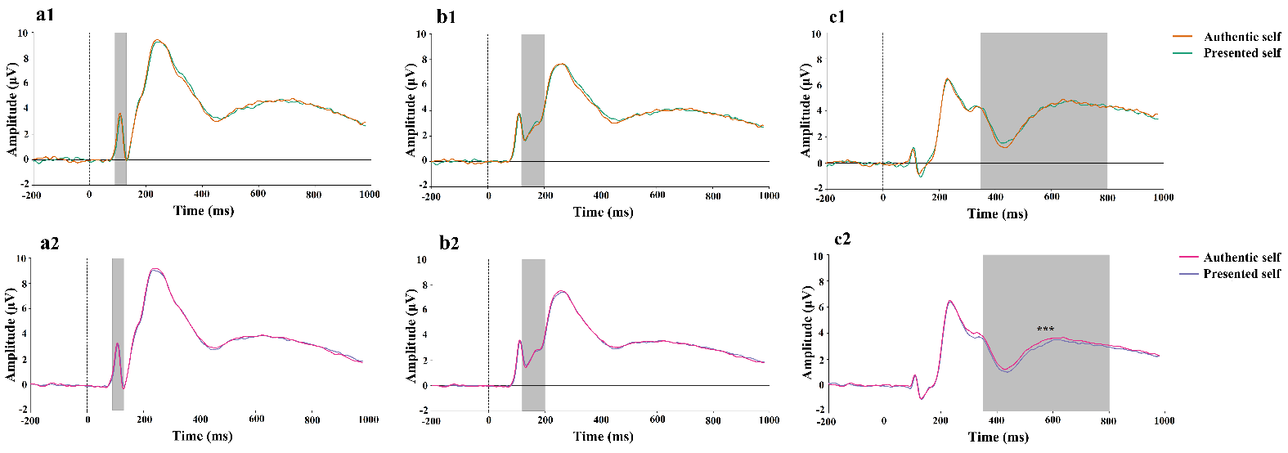
Note. (a1) Grand averages of P1 for the authentic self and presented self in judging the non-self-descriptiveness of positive traits. (a2) Grand averages of P1 for the authentic self and presented self in judging the non-self-descriptiveness of negative traits. (b1) Grand averages of N170 for the authentic self and presented self in judging the non-self-descriptiveness of positive traits. (b2) Grand averages of N170 for the authentic self and presented self in judging the non-self-descriptiveness of negative traits. (c1) Grand averages of LPP for the authentic self and presented self in judging the non-self-descriptiveness of positive traits. (c2) Grand averages of LPP for the authentic self and presented self in judging the non-self-descriptiveness of negative traits.

Figure S3
Topological Maps of Self-positivity for the Authentic Self and Presented Self in Experiment 2
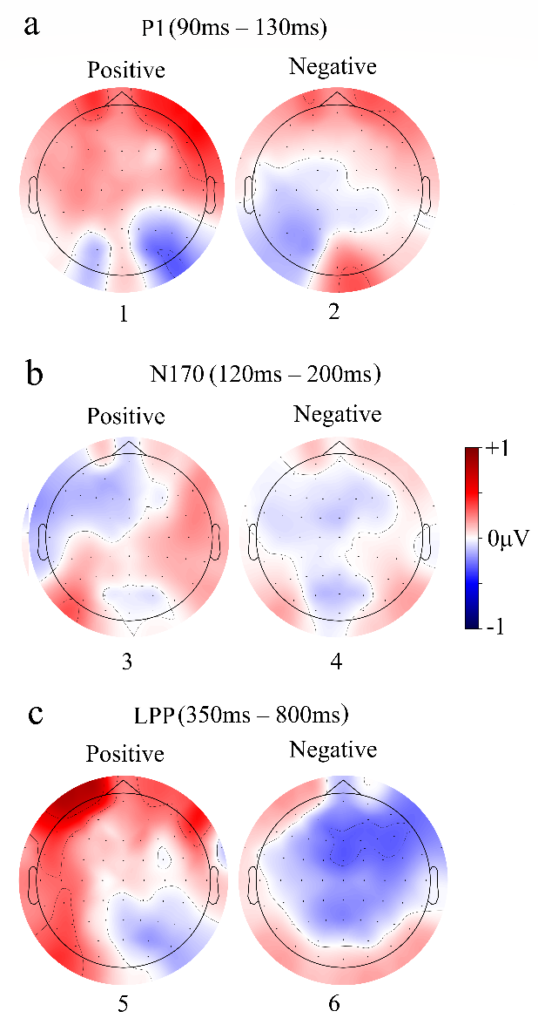
Note. (a) P1 amplitude difference between the presented self and authentic self in judging the non-self-descriptiveness of positive and negative traits. (b) N170 amplitude difference between the presented self and authentic self in judging the non-self-descriptiveness of positive and negative traits. (c) LPP amplitude difference between the presented self and authentic self in judging the non-self-descriptiveness of positive and negative traits. 1 = P1 amplitude of non-descriptiveness judgments on positive traits for the presented self minus P1 amplitude of non-descriptiveness judgments on positive traits for the authentic self; 2 = P1 amplitude of non-descriptiveness judgments on negative traits for the presented self minus P1 amplitude of non-descriptiveness judgments on negative traits for the authentic self; 3 = N170 amplitude of non-descriptiveness judgments on positive traits for the presented self minus N170 amplitude of non-descriptiveness judgments on positive traits for the authentic self; 4 = N170 amplitude of non-descriptiveness judgments on negative traits for the presented self minus N170 amplitude of non-descriptiveness judgments on negative traits for the authentic self; 5 = LPP amplitude of non-descriptiveness judgments on positive traits for the presented self minus LPP amplitude of non-descriptiveness judgments on positive traits for the authentic self; 6 = LPP amplitude of non-descriptiveness judgments on negative traits for the presented self minus LPP amplitude of non-descriptiveness judgments on negative traits for the authentic self.

Table S1
Coefficient Estimation of Self, Valence, Endorsement, and Their Interactions on Reaction Time in Experiment 1
Effect | Estimate | SE | t | p
Intercept | 1427.15 | 18.59 | 76.78 | < .001
Self ª | 0.09 | 3.52 | 0.03 | .979
Valence ^{b} | -3.29 | 3.52 | -0.94 | .350
Endorse ^{c} | -31.75 | 3.54 | -8.97 | < .001
Self ª × Valence ^{b} | 15.21 | 3.52 | 4.33 | < .001
Self ª ×Endorsement ^{c} | -14.18 | 3.52 | -4.03 | < .001
Valence × Endorsement ^{c} | -126.53 | 3.58 | -35.40 | < .001
Self ª × Valence ^{b} × Endorsement ^{c} | 8.76 | 3.53 | 2.48 | .013
Note. We display unstandardized betas. We used Satterthwaite approximations to estimate degrees of freedom for calculating p-values.
ª authentic self = 1, presented self = −1. ^{b} positive = 1, negative = −1. ^{c} yes = 1, no = −1.

Table S2
Number of Retained EEG Trials in Each Condition in Experiment 2
Condition | Mean | Max | Min
Authentic self, positive traits / Yes | 133.59 | 194 | 52
Authentic self, positive traits / No | 50.82 | 133 | 6
Authentic self, negative traits / Yes | 39.28 | 108 | 5
Authentic self, negative traits / No | 146.93 | 190 | 54
Presented self, positive traits / Yes | 141.72 | 191 | 71
Presented self, positive traits / No | 41.74 | 97 | 5
Presented self, negative traits / Yes | 26.83 | 75 | 5
Presented self, negative traits / No | 158.63 | 193 | 103
Note. Yes = self-descriptive; No = non-self-descriptive

Table S3
Effects of Self, Valence, Endorsement, and Their Interactions on Trait Endorsement for Ns of 121, 107, and 61 in Experiment 2
 | N = 121 |  |  | N = 107 |  |  |  | N = 61
Variable | F | p | ƞ_{p}² | F | p | ƞ_{p}² | F |  | p | ƞ_{p}²
Self | 1.95 | .165 | 0.02 | 1.45 | .231 | 0.01 | 1.41 |  | .241 | 0.02
Valence | 3.09 | .081 | 0.03 | 2.69 | .104 | 0.03 | 2.51 |  | .118 | 0.04
Endorsement | 66.54 | < .001 | 0.36 | 51.42 | < .001 | 0.33 | 28.18 |  | < .001 | 0.32
Self × Valence | 0.74 | .391 | 0.01 | 0.22 | .644 | 0.002 | 0.07 |  | .790 | 0.01
Self ×Endorsement | 5.24 | .024 | 0.04 | 6.67 | .011 | 0.06 | 3.15 |  | .081 | 0.05
Valence × Endorsement | 1172.22 | < .001 | 0.91 | 1044.20 | < .001 | 0.91 | 488.14 |  | < .001 | 0.89
Self × Valence × Endorsement | 57.50 | < .001 | 0.32 | 49.08 | < .001 | 0.32 | 24.07 |  | < .001 | 0.29

Table S4
Pairwise Comparisons of the Authentic Self and Presented Self in the Context of the Three-Way Interaction for Ns of 121, 107, and 61 in Experiment 2
Variable | Mean Difference (SE) | p | 95% CI
 | 121 participants
1 | -8.78 (1.75) | < .001 | [-12.24, -5.31]
2 | 9.31 (1.75) | < .001 | [5.84, 12.24]
3 | 13.46 (1.57) | < .001 | [10.36, 16.57]
4 | -12.27 (1.75) | < .001 | [-15.74, -8.81]
 | 107 participants
1 | -8.61 (1.91) | < .001 | [-12.40, -4.81]
2 | 9.23 (1.92) | < .001 | [5.43, 13.04]
3 | 14.02 (1.73) | < .001 | [10.58, 17.46]
4 | -13.01 (1.92) | < .001 | [-16.82, -9.20]
 | 61 participants
1 | -8.71 (2.48) | < .001 | [-13.67, -3.74]
2 | 9.51 (2.45) | < .001 | [4.60, 14.42]
3 | 13.48 (2.49) | < .001 | [8.50, 18.45]
4 | -12.49 (2.71) | < .001 | [-17.92, -7.06]

1 = authentic-self, positive descriptive endorsements minus presented-self, positive descriptive endorsements
2 = authentic-self, negative descriptive endorsements minus presented-self, negative descriptive endorsement
3 = authentic-self, positive non-descriptive endorsements minus presented-self, positive non-descriptive endorsements
4 = authentic-self, negative non-descriptive endorsements minus presented-self, negative non-descriptive endorsement

Table S5
Coefficient Estimation of Self, Valence, Endorsement, and Their Interactions on Reaction Time for Ns of 121, 107, and 61 in Experiment 2
 | 121 participants |  |  | 107 participants |  |  | 61 participants
Effect | Coefficient (SE) | t | p | Coefficient (SE) | t | p | Coefficient (SE) | t | p
Intercept | 1460.55 (26.99) | 54.12 | < .001 | 1458.11 (27.65) | 52.74 | < .001 | 1460.92 (39.97) | 60.19 | < .001
Self ª | -13.58 (2.80) | -4.85 | < .001 | -14.71 (2.91) | -5.05 | < .001 | -6.35 (3.52) | -1.81 | .071
Valence ^{b} | 20.88 (2.81) | 7.45 | < .001 | 17.06 (2.91) | 5.85 | < .001 | 8.62 (3.52) | 2.45 | .014
Endorsement ^{c} | -10.63 (2.82) | -3.77 | < .001 | -12.35 (2.93) | -4.22 | < .001 | -23.80 (3.53) | -6.97 | < .001
Self ª × Valence ^{b} | 4.29 (2.80) | 1.53 | .125 | 3.26 (2.91) | 1.12 | .263 | 3.73 (3.51) | 1.06 | .289
Self ª ×Endorsement ^{c} | 2.19 (2.80) | 0.78 | .434 | 0.40 (2.91) | 0.14 | .891 | 0.41 (3.52) | 0.12 | .907
Valence × Endorsement ^{c} | -166.94 (2.87) | -58.22 | < .001 | -156.92 (2.97) | -52.87 | < .001 | -126.63 (3.57) | -35.50 | < .001
Self ª × Valence ^{b} × Endorsement ^{c} | 21.75 (2.81) | 7.74 | < .001 | 21.17 (2.92) | 7.25 | < .001 | 16.93 (3.53) | 4.80 | < .001
Note. We display unstandardized betas. We used Satterthwaite approximations to estimate degrees of freedom for calculating p-values.
ª authentic self = 1, presented self = −1. ^{b} positive = 1, negative = −1. ^{c} yes = 1, no = −1.

Table S6
Simple Slopes (γ) of the Authentic self and The Presented Self Regarding the Three-Way Interaction on Reaction Time for Ns of 121, 107, and 61 in Experiment 2
 | 121 participants |  |  | 107 participants |  |  | 61 participants
Variable | Mean (SD) | z | p | Mean (SD) | z | p | Mean (SD) | z | p
1 | 14.65 (3.66) | 4.00 | < .001 | 10.12 (3.95) | 2.56 | .010 | 14.72 (5.22) | 2.82 | .005
2 | -37.43 (7.69) | -4.87 | < .001 | -38.73 (2.91) | -4.93 | < .001 | -26.60 (9.01) | -2.80 | .003
3 | -33.23 (6.40) | -5.19 | < .001 | -33.02 (6.66) | -4.96 | < .001 | -19.96 (8.03) | -2.49 | .013
4 | 1.69 (3.49) | 0.48 | .629 | 2.81 (3.77) | 0.75 | .456 | 6.45 (5.01) | 1.29 | .198
Note. We display unstandardized betas. We effect coded Self (authentic self = 1, presented self = −1).
1 = authentic self, positive traits, self-descriptiveness versus presented self, positive traits, self-descriptiveness
2 = authentic self, negative traits, self-descriptiveness versus presented self, negative traits, self-descriptiveness
3 = authentic self, positive traits, non-descriptiveness versus presented self, positive traits, non-self-descriptiveness
4 = authentic self, negative traits, non-descriptiveness versus presented self, negative traits, non-self-descriptiveness

Table S7
Coefficient Estimation of Self, Valence, Endorsement, and Their Interactions on P1 for Ns of 121, 107, and 61 in Experiment 2
 | 121 participants |  |  | 107 participants |  |  | 61 participants
Effect | Estimate (SE) | t | p | Estimate (SE) | t | p | Estimate (SE) | t | p
Intercept | 1.43 (0.13) | 11.42 | < .001 | 1.20 (0.14) | 8.77 | < .001 | 0.19 (0.18) | 1.02 | .307
Self ª | -0.08 (0.01) | -5.01 | < .001 | -0.07 (0.01) | -4.82 | < .001 | -0.15 (0.02) | -9.30 | < .001
Valence ^{b} | 0.11 (0.01) | 7.31 | < .001 | 0.14 (0.01) | 9.64 | < .001 | 0.07 (0.02) | 4.22 | < .001
Endorsement ^{c} | 0.02 (0.01) | 1.72 | .086 | -0.01 (0.01) | -0.68 | .497 | 0.03 (0.02) | 1.68 | .094
Self ª × Valence ^{b} | 0.07 (0.01) | 5.13 | < .001 | 0.05 (0.01) | 3.49 | < .001 | 0.06 (0.02) | 3.86 | < .001
Self ª ×Endorsement ^{c} | 0.06 (0.01) | -4.34 | < .001 | 0.04 (0.01) | 2.53 | .011 | -0.05 (0.02) | -3.24 | .001
Valence × Endorsement ^{c} | -0.04 (0.01) | 3.12 | .002 | -0.02 (0.01) | -1.74 | .081 | -0.11 (0.02) | -6.61 | < .001
Self ª × Valence ^{b} × Endorsement ^{c} | 0.06 (0.01) | 3.93 | < .001 | 0.03 (0.01) | 2.17 | .030 | 0.05 (0.02) | 2.96 | .003
Note. We display unstandardized betas. We used Satterthwaite approximations to estimate degrees of freedom for calculating p-values.
ª authentic self = 1, presented self = −1. ^{b} positive = 1, negative = −1. ^{c} yes = 1, no = −1.

Table S8
Simple Slopes (γ) of the Authentic Self and The Presented Self Regarding the Three-Way Interaction on P1 for Ns of 121, 107, and 61 in Experiment 2
 | 121 participants |  |  | 107 participants |  |  | 61 participants
Variable | γ | z | p | γ | z | p | γ | Z | p
1 | -0.004 (0.03) | -0.14 | .882 | -0.02 (0.03) | -0.84 | .399 | -0.09 (0.03) | -2.86 | .004
2 | -0.26 (0.03) | -9.20 | < .001 | -0.19 (0.03) | -6.50 | < .001 | -0.31 (0.03) | -9.68 | < .001
3 | 0.01 (0.03) | 0.27 | .791 | -0.01 (0.03) | -0.49 | .625 | -0.08 (0.03) | -2.58 | .010
4 | -0.03 (0.03) | -0.93 | .350 | -0.05 (0.03) | -1.80 | .072 | -0.11 (0.03) | -3.48 | < .001
Note. We used unstandardized betas. We effect coded Self (authentic self = 1, presented self = −1).
1 = authentic self, positive traits, self-descriptiveness versus presented self, positive traits, self-descriptiveness
2 = authentic self, negative traits, self-descriptiveness versus presented self, negative traits, self-descriptiveness
3 = authentic self, positive traits, non-descriptiveness versus presented self, positive traits, non-self-descriptiveness
4 = authentic self, negative traits, non-descriptiveness versus presented self, negative traits, non-self-descriptiveness

Table S9
Coefficient Estimation of Self, Valence, Endorsement, and Their Interactions on N170 for Ns of 121, 107, and 61 in Experiment 2
 | 121 participants |  |  | 107 participants |  |  | 61 participants
Effect | Estimate (SE) | t | p | Estimate (SE) | t | p | Estimate (SE) | t | p
Intercept | 2.36 (0.15) | 15.55 | < .001 | 2.31 (0.16) | 14.40 | < .001 | 2.48 (0.14) | 17.83 | < .001
Self ª | -0.01 (0.01) | -0.37 | .714 | -0.01 (0.01) | -1.27 | .204 | -0.02 (0.01) | -2.18 | .030
Valence ^{b} | 0.10 (0.01) | 11.11 | < .001 | 0.11 (0.01) | 12.15 | < .001 | 0.05 (0.01) | 4.55 | < .001
Endorsement ^{c} | -0.05 (0.01) | -4.90 | < .001 | -0.05 (0.01) | -5.59 | < .001 | 0.01 (0.01) | 0.22 | .822
Self ª × Valence ^{b} | 0.02 (0.01) | 2.14 | .033 | 0.02 (0.01) | 1.80 | .072 | 0.02 (0.01) | 2.05 | .041
Self ª ×Endorsement ^{c} | 0.02 (0.01) | 2.00 | .045 | 0.02 (0.01) | 1.95 | .050 | -0.01 (0.01) | -0.20 | .844
Valence × Endorsement ^{c} | -0.01 (0.01) | -0.40 | .693 | -0.01 (0.01) | -1.49 | .136 | -0.07 (0.01) | -6.20 | < .001
Self ª × Valence ^{b} × Endorsement ^{c} | 0.03 (0.01) | 2.94 | .003 | 0.03 (0.01) | 3.36 | < .001 | 0.03 (0.01) | 2.56 | .010
Note. We presented unstandardized betas. We used Satterthwaite approximations to estimate degrees of freedom for calculating p-values.
ª authentic self = 1, presented self = −1. ^{b} positive = 1, negative = −1. ^{c} yes = 1, no = −1.

Table S10
Simple Slopes (γ) of the Authentic self and The Presented Self Regarding the Three-Way Interaction on N170 for Ns of 121, 107, and 61 in Experiment 2
 | 121 participants |  |  | 107 participants |  |  | 61 participants
Variable | γ | z | p | γ | z | p | γ | z | p
1 | 0.06 (0.02) | 3.35 | < .001 | 0.06 (0.02) | 2.39 | .017 | 0.03 (0.02) | 1.12 | .264
2 | -0.03 (0.02) | -1.72 | .085 | -0.04 (0.01) | -3.17 | .002 | -0.08 (0.02) | -3.49 | < .001
3 | -0.06 (0.02) | -1.59 | .113 | -0.05 (0.01) | -3.38 | < .001 | -0.03 (0.02) | -1.25 | .213
4 | -0.01 (0.02) | -0.78 | .435 | -0.02 (0.02) | -0.68 | .497 | -0.02 (0.02) | -0.73 | .463
Note. We presented unstandardized betas. We effect coded Self (authentic self = 1, presented self = −1).
1 = authentic self, positive traits, self-descriptiveness versus presented self, positive traits, self-descriptiveness
2 = authentic self, negative traits, self-descriptiveness versus presented self, negative traits, self-descriptiveness
3 = authentic self, positive traits, non-descriptiveness versus presented self, positive traits, non-self-descriptiveness
4 = authentic self, negative traits, non-descriptiveness versus presented self, negative traits, non-self-descriptiveness

Table S11
Coefficient Estimation of Self, Valence, Endorsement, and Their Interactions on LPP for Ns of 121, 107, and 61 in Experiment 2
 | 121 participants |  |  | 107 participants |  |  | 61 participants
Effect | Estimate (SE) | t | p | Estimate (SE) | t | p | Estimate (SE) | t | p
Intercept | 3.05 (0.12) | 25.59 | < .001 | 2.49 (0.13) | 19.23 | < .001 | 2.36 (0.13) | 18.74 | < .001
Self ª | 0.11 (0.02) | 7.39 | < .001 | 0.08 (0.02) | 5.58 | < .001 | 0.07 (0.02) | 4.54 | < .001
Valence ^{b} | 0.14 (0.02) | 9.56 | < .001 | 0.19 (0.02) | 12.15 | < .001 | 0.13 (0.02) | 8.79 | < .001
Endorsement ^{c} | 0.26 (0.02) | 17.15 | < .001 | 0.25 (0.02) | 18.73 | < .001 | 0.33 (0.02) | 20.35 | < .001
Self ª × Valence ^{b} | -0.06 (0.02) | -4.16 | < .001 | -0.04 (0.02) | -1.05 | 0.004 | -0.06 (0.02) | -0.76 | < .001
Self ª ×Endorsement ^{c} | 0.06 (0.02) | 3.68 | < .001 | 0.05 (0.02) | 2.38 | < .001 | 0.02 (0.02) | 1.58 | .194
Valence × Endorsement ^{c} | -0.31 (0.02) | -20.57 | < .001 | -0.25 (0.02) | -16.38 | < .001 | -0.21 (0.02) | -11.10 | < .001
Self ª × Valence ^{b} × Endorsement ^{c} | 0.04 (0.02) | 2.54 | .011 | 0.04 (0.02) | 2.80 | 0.016 | 0.08 (0.02) | 5.67 | < .001
Note. We presented unstandardized betas are presented. We used Satterthwaite approximations to estimate degrees of freedom for calculating p-values.
ª authentic self = 1, presented self = −1. ^{b} positive = 1, negative = −1. ^{c} yes = 1, no = −1.

Table S12
Simple Slopes (γ) of the Authentic self and The Presented Self Regarding the Three-Way Interaction on LPP for Ns of 121, 107, and 61 in Experiment 2
 | 121 participants |  |  | 107 participants |  |  | 61 participants
Variable | γ | Z | p | γ | z | p | γ | z | p
1 | 0.14 (0.03) | 4.72 | < .001 | 0.13 (0.03) | 4.19 | < .001 | 0.11 (0.04) | 3.06 | .002
2 | 0.19 (0.03) | 6.35 | < .001 | 0.14 (0.03) | 4.65 | < .001 | 0.07 (0.04) | 1.86 | .063
3 | -0.05 (0.03) | -1.49 | .136 | -0.05 (0.03) | -1.62 | .105 | -0.10(0.04) | -2.74 | .006
4 | 0.16 (0.03) | 5.21 | < .001 | 0.11(0.03) | 3.69 | < .001 | 0.18 (0.04) | 5.06 | < .001
Note. We presented unstandardized betas. We effect coded Self (authentic self = 1, presented self = −1).
1 = authentic self, positive traits, self-descriptiveness versus presented self, positive traits, self-descriptiveness
2 = authentic self, negative traits, self-descriptiveness versus presented self, negative traits, self-descriptiveness
3 = authentic self, positive traits, non-descriptiveness versus presented self, positive traits, non-self-descriptiveness
4 = authentic self, negative traits, non-descriptiveness versus presented self, negative traits, non-self-descriptiveness

References
Volpert-Esmond, H. I., Merkle, E. C., Levsen, M. P., Ito, T. A., & Bartholow, B. D. (2018). Using trial-level data and multilevel modeling to investigate within-task change in event-related potentials. Psychophysiology, 55(5), Article e13044. https://doi.org/10.1111/psyp.13044
Volpert-Esmond, H. I., Page-Gould, E., & Bartholow, B. D. (2021). Using multilevel models for the analysis of event-related potentials. International Journal of Psychophysiology, 162, 145–156. https://doi.org/10.1016/j.ijpsycho.2021.02.006

