Original Article

CARDIOVASCULAR FUNCTION IN PEOPLE WITH CYSTIC FIBROSIS ON ELEXACAFTOR/TEZACAFTOR/IVACAFTOR: A CROSS-SECTIONAL, OBSERVATIONAL, SINGLE-CENTRE STUDY

Lauren J Clayton^{1,2}, Anthony I Shepherd¹, Jo Corbett¹, Maria Perissiou¹, Gary Connett^{2,3}, Julian Legg^{2,3}, Mark Allenby², Thomas Daniels^{2,3}, Don S Urquhart^{4,5}, Kelly A Mackintosh⁶, Melitta A McNarry⁶, Zoe L Saynor^{2,3,7*}

3,616 / 3,000 words

¹School of Psychology, Sport and Health Science, Faculty of Science and Health, University of Portsmouth, Portsmouth, UK
²University Hospital Southampton NHS Foundation Trust, Southampton, UK
³National Institute for Health and Care Research, Southampton Biomedical Research Centre, UK
⁴Department of Paediatric Respiratory and Sleep Medicine, Royal Hospital for Children and Young People, Edinburgh, Scotland, UK
⁵Department of Child Life and Health, University of Edinburgh, Scotland, UK
⁶Applied Sports, Technology, Exercise and Medicine (A-STEM) Research Centre, Swansea University, Swansea, Wales, UK.
⁷School of Health Sciences, Faculty of Environmental and Life Sciences, University of Southampton, UK

*Correspondence to Associate Professor Zoe L. Saynor, School of Health Sciences, Faculty of Environmental and Life Sciences, University of Southampton, UK, SO17 1BJ. Email: Z.L.Saynor@soton.ac.uk
ABSRACT
Background: Cystic fibrosis (CF) has been associated with impaired cardiovascular and endothelial function. CF transmembrane conductance regulator (CFTR) modulator therapy, most recently, Elexacaftor/Tezacaftor/Ivacaftor (ETI) has led to improved CFTR function and life expectancy, however, the rising prevalence of obesity in adults is concerning. This study assessed the micro- and macro-vascular endothelial function, cardiovascular disease (CVD) risk factors, and physical activity (PA) profiles in people with CF (pwCF) on ETI compared to healthy matched controls. Methods: In 15 pwCF and 15 age- and sex-matched controls, microvascular endothelial function (via transdermal delivery of insulin [INS] and acetylcholine [ACh] on the forearm), macrovascular endothelial function (via flow-mediated dilation [FMD] of the brachial artery), central haemodynamic parameters, including heart rate (HR), stroke volume index (SVi) and cardiac output index (Q̇I) (via thoracic impedance cardiography), body mass index (BMI), blood pressure (BP), and accelerometer-assessed PA, were measured. Results: There were no differences in INS or FMD-mediated vasodilation between the groups (P>0.05). However, a reduced vasodilatory response was evident in pwCF following ACh-mediated vasodilation (P=0.01) and FMD normalised for shear rate (P=0.03). No differences in resting HR, SVi, Q̇I, BP, BMI or PA were found (P>0.05). Conclusion: This study demonstrated reduced micro- and macrovascular function in pwCF. This dysfunction may have potential health implications, particularly regarding long-term cardiovascular risk and further longitudinal assessments are warranted.
219 / 250 words

Key words: (5 - 8 words): cardiovascular, CFTR modulator therapy, endothelial function, flow-mediated dilation, iontophoresis, physical activity
INTRODUCTION
Significant medical advances in cystic fibrosis (CF) have led to improved life expectancy [1]. However, extrapulmonary manifestations, including cardiovascular abnormalities, remain a concern [2]. The incidence of cardiovascular disease (CVD) is increasing globally [3], and people with cystic fibrosis (pwCF) are not exempt [2,4]. Factors that may contribute to this in pwCF include pulmonary hypertension [2], micro- and macro-vascular endothelial dysfunction [5,6], reduced nitric oxide (NO∙) bioavailability [7], insulin resistance [4], obesity [8], changes in lipid profiles, specifically, increases total cholesterol and low-density lipoproteins (LDL) [9], and severe pulmonary disease [10].
Cystic fibrosis transmembrane conductance regulator (CFTR) proteins are expressed and functionally active in smooth muscle cells, including cardiomyocytes [11]. Loss of these proteins leads to structural and functional abnormalities in both the heart [12] and vascular endothelium [13]. Defective CFTR proteins result in overactive vasoconstricting pathways [14], reduced NO∙ production [15], and endothelial dysfunction; even in pwCF who are clinically stable with mild-to-moderate lung disease [5,6]. Endothelial dysfunction in the pulmonary vasculature can result in irreversible pulmonary hypertension [2]. The co-existence of inflammation and oxidative stress in CF can further reduce NO∙ bioavailability [16], and increased inflammation has been associated with elevated pulmonary artery pressure [17].
Whilst several modifiable risk factors are critical for CVD prevention, such as maintaining optimal body mass index (BMI), blood pressure (BP), and physical activity (PA) behaviours [18], many pwCF do not meet recommended PA levels [19]. Additionally, obesity, ‘normal weight obesity’ (NWO), and CF-related diabetes (CFRD) [8] are becoming more prevalent. Persistent hyperglycaemia can impair myocardial contractility [20], and insulin resistance may further impair vascular function [15].
Limited research has explored micro- [5] and macro-vascular [6] endothelial function in pwCF, with much of the existing evidence pre-dating the availability of highly effective CFTR modulator therapy (HEMT). Currently, there are four licensed CFTR modulator treatments - Ivacaftor (Kalydeco), Lumacaftor combined with Ivacaftor (Orkambi), Tezacaftor combined with Ivacaftor (Symkevi) and Elexacaftor in combination with Tezacaftor and Ivacaftor (ETI). Two of these preparations have been designated as HEMT [21], namely Ivacaftor, which is licensed from 1-month of age for a limited range of CFTR gating mutations; and ETI which is licensed for pwCF with at least one copy of the ∆F508 mutation aged ≥2-years. Preliminary data suggest that CFTR modulator therapy may improve PA behaviours [22], likely due to enhanced lung function, nutritional status, a reduced treatment burden and incidence pulmonary exacerbations. CFTR modulator therapy has also been shown to improve glucose tolerance [23]. However, these findings are based on small case studies and may not fully capture the broader impact of newer CFTR modulators like ETI.
This study aimed to assess micro- and macro-vascular endothelial function, central haemodynamic parameters, and CVD risk factors in pwCF stable on ETI, compared to age- and sex-matched healthy controls (CON).

METHODS
Ethics and experimental design
Participants attended laboratories at the University of Portsmouth, UK for a cross-sectional, observational, single-centre study. The study was pre-registered on ClincalTrials.gov (NCT05857709) and received approval from the South Central – Berkshire B NHS Research Ethics Committee and Health Research Authority (22/SC/0168).
An a priori power calculation was conducted based on differences between pwCF and healthy controls for relative change % in acetylcholine (ACh)-mediated vasodilation data as previously reported [5]. Specifically, using mean values (416 ± 140 vs. 617 ± 143) and a significance level of P<0.05 (two-tailed), 12 participants per group were required to detect a difference with 90% power. We aimed to recruit 15 participants per group to account for drop-outs.

Participant characteristics
Fifteen pwCF (7 children/adolescents) and 15 age- and sex-matched healthy controls were recruited (Table 2). PwCF were recruited from the University Hospital Southampton NHS Foundation Trust if they: 1) had a CF diagnosis based on clinical features, supported by a history of an abnormal sweat test (sweat chloride >60 mmol·L⁻¹ >100 mg sweat); 2) were stable on ETI; 3) were ≥10 years old; and 4) had no increase in symptoms or weight loss in the preceding 2-weeks. Exclusion criteria included individuals ineligible or unable to tolerate ETI, those with unstable co-morbid asthma (daily pulmonary function variability >20%), pregnancy, contraindicated to perform exhaustive exercise, or vasoactive medication use. Healthy controls were recruited individually, with each control enrolled after a person with CF, ensuring they were matched for age and sex criteria. For individuals <18 years old or >40 years old, controls were matched within 3 years of age. For participants aged 18 – 39 years, controls were matched within 5 years. Healthy controls were recruited from the University of Portsmouth and surrounding areas, with exclusion criteria including pregnancy, other chronic health conditions, contraindications to exhaustive exercise, or an inability to understand or adhere to the protocol. All adult participants and caregivers of those <16-years provided fully informed written consent, with assent obtained from children/adolescents. Participants were asked to refrain from alcohol, caffeine, and vigorous exercise for 24-hours before visiting, and arrive ~2-hours post-prandial.

Table 1. Baseline clinical characteristics for the cystic fibrosis subgroup upon initiation into the study.
Variable | Values
Months on ETI (mean ± SD) | 25.8 ± 9.1
Genotype:
∆F508 Homozygote (n) | 7
∆F508 Heterozygote (n) | 7
c.1646G>A/∆c.3477 (n) | 1
Pancreatic insufficient (n) | 15
CF-related diabetes (n) | 3
CF-related liver disease (n) | 5
Pseudomonas aeruginosa infection (n) | 2
Mycobacterium abscessus infection (n) | 1
CF, cystic fibrosis; ETI, Elexacaftor/Tezacaftor/Ivacaftor; SD, standard deviation.

Clinical characteristics for pwCF were obtained from their most recent clinical assessment (Table 1). Stature was measured to the nearest 0.01 m (Seca 213 stadiometer, UK), and body mass to the nearest 0.01 kg (Seca 770 scales, UK). Pubertal stage was self-assessed using pubic hair classification for participants <18 years. Pulmonary function was assessed by spirometry using a turbine flow-meter system (COSMED Ltd, Rome, Italy), with values expressed as percentages of predicted normal and z-scores (Table 2).

Table 2. Baseline anthropometric and pulmonary function for participants with CF and healthy age- and sex-matched control participants upon initiation into the study.
Variable | CON (n=15) | PwCF (n=15) | P-value | Effect size
Sex (F/M) | 4 / 11 | 4 / 11 | - | -
Age (years) | 24.3 (28.5) | 24.4 (32.4) | 0.94 | 0.02
Maturational stage
Pre-pubertal (n) | 2 | 2 | - | -
Circumpubertal (n) | 3 | 3 | - | -
Post-pubertal (n) | 1 | 0 | - | -
Stature (m) | 1.69 ± 0.15 | 1.67 ± 0.14 | 0.72 | 0.13
Body mass (kg) | 66.2 ± 19.6 | 63.9 ± 17.2 | 0.74 | 0.12
MUAC (cm) | 27.93 ± 4.91 | 27.87 ± 3.83 | 0.97 | 0.01
Lung function
FVC (L) | 4.20 ± 1.41 | 3.98 ± 1.31 | 0.67 | 0.16
FVC (% predictedª) | 96.0 ± 12.0 | 95.9 ± 15.9 | 0.98 | 0.01
FVC z-score | -0.31 ± 0.88 | -0.36 ± 1.29 | 0.91 | 0.04
FEV₁ (L) | 3.30 ± 1.11 | 2.94 ± 1.08 | 0.37 | 0.33
FEV₁ (% predictedª) | 91.1 ± 9.8 | 85.7 ± 23.0 | 0.41 | 0.31
FEV₁ z-score | -0.71 ± 0.71 | -1.09 ± 1.76 | 0.45 | 0.28
FEF_{25-75%} (%) | 3.0 ± 1.1 | 2.6 ± 1.4 | 0.41 | 0.31
FEF_{25-75%} (% predictedª) | 81.6 ± 20.6 | 72.6 ± 33.6 | 0.38 | 0.32
FEF_{25-75%} z-score | -0.84 ± 0.82 | -1.27 ± 1.68 | 0.38 | 0.33
Parametric values are presented as means ± SD, where data were analysed using independent t-test and effect sizes were estimated using Cohen’s d. Effect size, 0.2 = small effect, 0.5 = medium effect, 0.8 = large effect. Non-parametric values are presented as median (interquartile range), where data were analysed using Mann-Whitney U-test and effect sizes were estimated using Rosenthal’s r. Effect size, 0.2 = weak effect, 0.4 = moderate effect, 0.6 = strong effect. CON, control group; FEF25-75%, forced mid-expiratory flow; FEV₁, forced expiratory volume in 1 s; F, female; FVC, forced vital capacity; M, male; MUAC, mid-upper arm circumference; PwCF, people with cystic fibrosis. ªAccording to Quanjer et al. (2012).

Outcome measures
Microvascular endothelial function
Insulin (INS) and ACh-mediated vasodilation in the forearm cutaneous microcirculation were measured using a laser Doppler probe with iontophoresis (see Supplementary Material). Following a 30-minute acclimation period in the supine position, the skin on the volar forearm was cleansed with sterile water. Two 20 mm Perspex drug chambers (Moor Instruments, Wilmington, DE) were attached to the skin with tape: one anode and one cathode (see Supplementary Material). Approximately 0.5 mL of 1% ACh (Braun, Melsungen, Germany) and 0.5 mL of 0.01% INS (Humulin S, Lilly, Spain) in water for injection were placed in the anode and cathode chambers, respectively. The electrodes were connected to the iontophoresis controller (MIC 2, Moor Instruments, UK). After a 2-minute baseline recording, ACh and INS were delivered via electrical pulses, as per our previously published protocol [24]. The pulses included: four at 25 μA, followed by a single pulse of 50 μA, 100 μA, 150 µA, and 200 µA, each lasting 20-seconds, with 120-second intervals, during which no current was applied. Resting brachial BP on the right arm was taken before and immediately following the iontophoresis protocol, to adjust for cutaneous vascular conductance (CVC) [24], which was presented as relative change %, maximum and area under the curve (AUC) for ACh and INS.

Macrovascular endothelial function
Brachial artery FMD, a reliable measure of NO∙ dependant endothelial function in pwCF [6], was assessed according to technical recommendations. Following 30-minutes of supine rest, duplex ultrasound for simultaneous high-resolution B-mode imaging, and pulse-waved doppler velocity signals, were captured using an ultrasound scanner (Terason Smart 3300 NexGen, Teratech Corporation, Burlington, MA, USA), paired with a 4–15 MHz multi-frequency linear array ultrasound probe (15L4 Smart MarkTM, Terason, Massachusetts, USA) (see Supplementary Material). The brachial artery boundaries were identified on the distal third of the upper right arm, with baseline images recorded upon obtaining an optimal image (see Supplementary Material). A forearm occlusion cuff on the olecranon process was rapidly inflated (moorVMS-PRES, Axminster, UK) to >220 mmHg for 5-minutes, to induce ischaemia, followed by rapid deflation to elicit a reactive hyperaemic response. Post-occlusive images were recorded for 3-minutes. Brachial artery diameter analysis was performed using custom-designed edge-detection and wall-tracking software (Cardiovascular Suite; Quipu, Pisa, Italy), with FMD presented as the percentage increase in peak diameter from the baseline, and relative to shear rate (FMD∙shear⁻¹).

Haemodynamic parameters
Resting heart rate (HR), stroke volume (SV), and cardiac output (Q̇) were measured via non-invasive thoracic impedance cardiography (PF07 Enduro, PhysioFlow, France). For adults, two electrodes were placed on the neck; for paediatric participants, one was placed on the forehead [25]. Two additional electrodes were placed on the back, and two on the chest. Participants remained seated for 3-minutes while data were collected second-by-second and averaged over 1-minute. SV and Q̇ were normalised to body surface area and reported as the SV index (SVi) and Q̇ index (Q̇I), respectively.

Blood pressure
Resting brachial BP was measured following 20-minutes supine rest, and immediately following the iontophoresis protocol, using an automated sphygmomanometer (Omron M2, Japan).

Body composition
Body composition was assessed using a whole-body dual-energy X-ray absorptiometry (DEXA) scan (Hologic densitometer, Hologic, Vertec, UK). Comprehensive DEXA outcomes for this cohort are reported elsewhere [26], while the android:gynoid ratio and fat mass (FM) percentage, particularly relevant to CVD risk [27], are presented here. BMI was calculated for all participants, and expressed as z-scores for those aged ≤20-years. Normal weight, overweight, and obesity were defined as BMI <25 kg∙m⁻², 25 kg∙m⁻² – 29.9 kg∙m⁻², and >30 kg∙m⁻², respectively, in line with recent guidelines. NWO was defined as BMI 20 – 24.9 kg∙m⁻², with FM >30% (women) and FM >23% (men) [28]. Mid-upper arm circumference (MUAC) was measured to the nearest 0.1 cm at the mid-point of the acromion and the olecranon of the relaxed left arm. Three measurements were taken, with the mean presented.
Device-based physical activity
Free-living PA was measured using a GENEActiv triaxial accelerometer (Activinsights Ltd, Cambridge, UK), worn on the dominant wrist for 7 consecutive days. Devices sampled at 100 Hz, and wear-time was cross-verified using a diary. Data were downloaded using GENEActiv software (Version 4.0.2, Activinsights Ltd, Cambridge, UK) and analysed using the GGIR package (v2.4.0) in R (http://cran.r-project.org). Data were auto-calibrated using local gravity, converted to omni-directional acceleration, and processed into 5-second epochs using the Euclidian Norm Minus One [29]. Data were subsequently averaged per day and then over all available days, with a minimum wear-time of ≥16-hours∙day⁻¹ on at least four days required for inclusion. Average acceleration, expressed in milligravity-based acceleration units (mg), represented overall PA volume, while the PA gradient indicated PA intensity distribution. A lower gradient reflected more time in lower-intensity PA, while a higher gradient reflected more across the range of intensities [29].

Statistical analyses
Data were analysed using IBM SPSS Statistics software (version 27.0, IBM Chicago, IL). Normality was assessed with the Shapiro-Wilk test. Normally distributed data are presented as means ± standard deviations (SD), and analysed with independent t-tests , with effect sizes (ES) estimated using Cohen’s d (d), classified as small (d=0.2), medium (d=0.5), or large (d=0.8). Non-normally distributed data are presented as medians and interquartile ranges (25th and 75th percentiles), analysed using Mann-Whitney U-tests, and Rosenthal’s r to estimate ES, classified as weak (r=0.2), moderate (r=0.4), or strong (r=0.6). Significance was accepted at P<0.05. Pearson’s and Spearman’s correlations were performed for parametric and non-parametric data, respectively, classified as negligible (r=0.00 – 0.10), weak (r=0.10 – 0.39) moderate (r=0.40 – 0.69), strong (r=0.70 – 0.89), and very strong (r=0.90 – 1.00), respectively.

RESULTS
Participant characteristics
Baseline clinical characteristics for pwCF upon initiation into the study are presented in Table 1 and all participant characteristics in Table 2. Six participants PA data were excluded; specifically, 2 participants were excluded due to insufficient wear-time, and 1 due to a calibration error; their matched control data were also excluded. Some individuals had high skin resistance during iontophoresis [24], preventing complete pulse delivery to the forearm. In such cases (n=1), data included an equivalent number of pulses for matched pairs between groups. The final anonymised dataset is freely available (DOI: 10.17029/261db0e6-37bc-4d67-97bb-7339cb7e3ca9).

Outcome measures
Microvascular function
Iontophoresis data are presented in Figure 1. ACh relative change % (CON: 2018 ± 948 %; pwCF: 1283 ± 530 %, P=0.01, t=-2.62, d=0.96) was significantly reduced in pwCF compared to controls. ACh maximum (CON: 3.62 ± 1.79 flux∙mmHg⁻¹; pwCF: 2.87 ± 1.19 flux∙mmHg⁻¹, P=0.19, t=-1.36, d=0.50), ACh AUC (CON: 17.9 ± 9.62 flux∙mmHg⁻¹; pwCF: 12.92 ± 6.39 flux∙mmHg⁻¹, P=0.11, t=-1.67, d=0.61), INS relative change % (CON: 1494.58 ± 863.12 %; pwCF: 1163.94 ± 606.41 %, P=0.25, t=-1.17, d=0.44), INS maximum (CON: 2.37 ± 1.22 flux∙mmHg⁻¹; pwCF: 2.21 ± 1.33 flux∙mmHg⁻¹, P=0.75, t=-0.33, d=0.12) and INS AUC (CON: 7.7 (6.32) flux∙mmHg⁻¹; pwCF: 6.35 (9.05) flux∙mmHg⁻¹, P=0.48, z=-0.74, r=0.14) were not different between groups. A representative trace of the ACh and INS iontophoresis data is presented in Figure 3 (see Supplementary Material).
Figure 1. Parameters for ACh and INS-mediated microvascular testing in pwCF and healthy control participants
N.B. Data are presented as mean ± SD for relative change % (A, B), area under the curve (AUC) (C) and maximum (E, F) cutaneous vascular conductance (CVC). Data are presented as median and interquartile range (25 and 75 percentiles) for AUC (D). Data were analysed using an independent samples t-test for A, B, C, E and F, data were analysed using a Mann Whitney-U test for D. ACh, acetylcholine; AUC, area under the curve; CON, controls; CVC, cutaneous vascular conductance; INS, insulin; Max, maximum; pwCF, people with cystic fibrosis.
Macrovascular function
Parameters for FMD are presented in Table 3 and Figure 2. FMD normalised for shear rate was significantly lower in pwCF (0.48 (0.47) % / S⁻¹_{AUC}) compared to CON (0.67 (0.46) % / S⁻¹_{AUC}); P=0.03, z=-2.14, r=0.39; Figure 2).

Figure 2. Parameters for flow-mediated dilation testing in pwCF and healthy control participants
N.B. Data are presented as mean ± SD for flow-mediated dilation (FMD) (A) and shear rate (area under the curve (AUC) to maximum dilation) (B), data are presented as median and interquartile ranges for FMD normalised for shear rate (AUC to maximum dilation) (C). Data were analysed using an independent samples t-test for A and B, data were analysed using a Mann Whitney-U test for C. *Significant difference (P≤0.05). AUC, area under the curve; CON, controls; FMD, flow-mediated dilation; PwCF, people with cystic fibrosis.

Haemodynamic parameters
Data for HR, SVi and Q̇I are presented in Table 3. There was no difference between groups for all variables (all P>0.05).

BMI, BP and PA
Data for BMI, the android:gynoid ratio, BP and PA are presented in Table 3. There were no differences between groups (all P>0.05).

Table 3. Parameters of cardiovascular disease risk markers and cardiovascular function in participants with CF and healthy age- and sex-matched control participants.
Variable | CON (n = 15) | PwCF (n = 15) | P-value | Effect size
Blood pressure | - | - | - | -
SBP (mmHg) | 114 (25) | 113 (12) | 0.47 | 0.14
DBP (mmHg) | 70 ± 10 | 69 ± 6 | 0.88 | 0.06
Body composition | - | - | - | -
BMI (kg·m²) | 22.8 ± 5.4 | 22.6 ± 3.4 | 0.88 | 0.06
BMI (z-score†) | -0.36 ± 0.78 | 0.38 ± 0.63 | 0.07 | 1.05#
Android:gynoid ratio (kg)††† | 0.87 ± 0.19 | 0.81 ± 0.16 | 0.33 | 0.37
Normal weight (n) | 10 | 8 | - | -
Overweight (n) | 1 | 2 | - | -
Obese (n) | 2 | 1 | - | -
NWO (n) | 2 | 4 | - | -
Cardiac function parameters | - | - | - | -
Heart rate (beats·min⁻¹) | 76 ± 13 | 84 ± 16 | 0.15 | 0.55
Stroke volume index (mL·beat·m²) | 49.04 (9.36) | 46.58 (10.60) | 0.46 | 0.14
Cardiac output index (l·min·m²) | 3.80 ± 0.66 | 4.19 ± 1.25 | 0.29 | 0.39
FMD parameters | - | - | - | -
Baseline diameter (mm) | 3.70 ± 0.80 | 3.88 ± 0.69 | 0.50 | 0.25
Peak diameter (mm) | 3.92 ± 0.81 | 4.11 ± 0.72 | 0.50 | 0.25
FMD absolute change (mm) | 0.22 ± 0.06 | 0.22 ± 0.11 | 0.80 | 0.09
Time to peak (s) | 60.5 (48) | 61 (35.1) | 0.55 | 0.11
PA parameters†† | - | - | - | -
Average acceleration (mg) | 28.75 (26.85) | 28.41 (23.93) | 0.11 | 0.33
Intensity gradient | -2.36 ± 0.33 | -2.42 ± 0.25 | 0.63 | 0.29
Most active 0.25-hour (mg) | 324.75 (268.71) | 208.43 (191.12) | 0.22 | 0.26
Most active 0.5-hour (mg) | 259.71 (222.57) | 164.62 (177.07) | 0.20 | 0.27
Most active 1-hour (mg) | 196.57 (168.88) | 120.18 (146.85) | 0.13 | 0.32
Parametric values are presented as means ± SD, where data were analysed using independent t-test and effect sizes were estimated using Cohen’s d. Effect size, 0.2=small effect, 0.5=medium effect, 0.8=large effect. Non-parametric values are presented as median (interquartile range), where data were analysed using Mann-Whitney U-test and effect sizes were estimated using Rosenthal’s r. Effect size, 0.2=weak effect, 0.4=moderate effect, 0.6=strong effect. # indicates a trend (P<0.10). AUC, area under the curve; BMI, body mass index; CON, control group; DBP, diastolic blood pressure; FMD, flow-mediated dilation; NWO, normal weight obesity; PA, physical activity; pwCF, people with cystic fibrosis; SBP, systolic blood pressure. † indicates a group where n=7; †† indicates a group where n=12; ††† indicates a group where n=14.

Relationships between vascular function and CVD risk factors
FMD% demonstrated a significant moderate negative correlation with android:gynoid ratio (P<0.01, r=-0.67) and a significant moderate positive correlation with average acceleration (P=0.04, r=0.59) in pwCF but not the control group (both P>0.05). Moreover, FMD normalised for shear rate demonstrated a significant strong positive correlation with average acceleration (P<0.01, r=0.76) in pwCF and a significant moderate positive correlation in the control group (P=0.049, r=0.58).
DISCUSSION
This study is the first to investigate both micro- and macro-vascular endothelial function, alongside additional CVD risk factors, in pwCF who are stable on ETI. Key findings were that ACh-mediated microvascular endothelial function is significantly reduced in pwCF treated with ETI compared to healthy age- and sex-matched controls. Additionally, while macrovascular function, measured through FMD percentage change, was not different between groups, pwCF exhibited a lower FMD response when adjusted for shear rate. This suggests residual macrovascular dysfunction despite HEMT. In contrast, insulin-mediated microvascular endothelial function, HR, SVi, Q̇I, BP, BMI and PA, in pwCF stable on ETI were not significantly different from healthy age- and sex-matched controls. These findings suggest that, while HEMT may confer some cardiovascular benefits, persistent vascular health challenges remain.
Our novel finding that ACh-induced NO∙-mediated microvascular endothelial function is reduced in pwCF on ETI compared to healthy controls agrees with previous research conducted before the availability of ETI [5]. Specifically, both the current study and Rodriguez-Miguelez et al., (2016) [5], observed a significantly reduced relative % change in ACh-mediated endothelial dependant vasodilation in pwCF compared to controls. Although no significant differences were found in maximum response or AUC, a medium effect size was observed. Whilst the clinical significance of the observed 21% and 29% reductions in maximum response and AUC, respectively, is uncertain, these findings reinforce the presence of residual microvascular dysfunction in pwCF.
Moreover, we assessed brachial artery endothelium-dependent function with the FMD technique, which reflects largely NO∙-mediated dilatation of conduit arteries in response to an imposed increase in blood flow and shear stress. FMD is widely used as a marker of endothelial dysfunction across various respiratory conditions [30]. Importantly, FMD relates to coronary artery endothelial function, and independently predicts cardiovascular disease outcome [31,32]. Earlier studies conducted before the availability of ETI in young pwCF with mild-to-moderate lung disease reported macrovascular dysfunction, measured using the FMD technique [6], whilst we found no significant differences in macrovascular function between pwCF and healthy controls in our study. However, the significant difference in FMD when adjusted for shear rate suggests that although both groups produced similar hyperaemic shear stress and time to peak diameter, pwCF had a reduced FMD response. Normalising FMD to shear rate has been recommended to improve detection sensitivity and reduce noise [33], which was evident in our findings. Although we found no significant difference in shear rate between the groups, shear rate was 29% higher in pwCF compared to controls. Chronic shear rate can adversely affect endothelial cells, driving cytoskeleton remodelling, hypertrophy, and an increase in Weibel-Palade bodies [34], which in turn promotes platelet aggregation and inflammation and may further contribute to CVD.
We found no differences in resting HR, SVi or Q̇I between pwCF on ETI and healthy controls. Previous studies have reported reduced resting SV in pwCF prior to CFTR modulator treatment, with compensation through an elevated HR [12].
The pathophysiology of CF presents several mechanisms that may contribute to cardiovascular dysfunction, including reduced NO∙ bioavailability [7], insulin resistance [8] and severe pulmonary disease [10], all of which provide potential targets for improvement with HEMT. In CF, defective CFTR proteins lead to elevated sphingosine-1 phosphate and endothelin-1, causing overactive vasoconstriction [14], while reduced levels of endothelial NO∙ synthase (eNOS) substrate L-arginine, crucial for endothelial-dependent vasodilation, may further impair NO∙ bioavailability and endothelial dysfunction. CFTR is known to regulate the phosphorylation of eNOS and AKT [15], and CFTR blockade supressed insulin-induced NO∙ production. Interestingly, CFTR blockade does not inhibit calcium ionophore-induced NO∙, suggesting that CFTR impacts insulin signalling. Ivacaftor, the first available HEMT, has been shown to improve insulin secretion and glucose tolerance in CFRD [23], which is consistent with our observation that insulin-induced NO∙-mediated microvascular endothelial function was similar between pwCF on ETI and healthy controls.
There are also other potential mechanisms by which HEMT may positively influence cardiovascular function in pwCF. Oxidative stress and inflammation, both common in CF, reduce NO∙ bioavailability and perpetuate endothelial dysfunction [7]. HEMT may reduce oxidative stress by decreasing intestinal inflammation and improving dietary fat absorption [35], thereby enhancing antioxidant protection. CFTR proteins are also expressed in cardiomyocytes, where they regulate contraction rate and influence calcium (Ca²⁺) signalling [11]. Correcting CFTR function with HEMT may improve heart contractility, consistent with our findings that show no significant differences in HR, SVi or Q̇I between pwCF and healthy controls.
We found no significant differences in BMI or the android:gynoid ratio between pwCF on ETI and healthy controls. Historically, pwCF have been characterised by low BMI compared to healthy individuals [36], due to factors like malabsorption from pancreatic insufficiency, and an elevated resting energy expenditure. Additionally, pwCF have typically demonstrated altered lipid metabolism, with reduced total cholesterol and LDL. However, with advances in nutritional interventions and HEMT, the prevalence of overweight and obesity among pwCF is rising [8] and these changes are associated with rising levels of total cholesterol and LDL [4]. In the present study, BMI in pwCF was comparable to that of healthy controls, reflecting these improvements. Moreover, we demonstrate a significant moderate negative correlation between FMD% and android:gynoid in pwCF, suggesting that an abdominal fat distribution is associated with reduced macrovascular function. A recent prospective study found that BMI, adipokine levels, apolipoprotein B and remnant cholesterol, key markers for assessing atherosclerosis and CVD risk, significantly increased following 6 months of ETI treatment, alongside a worsening lifetime CVD risk score [37]. The CFTR protein may play a direct role in the leptin signalling pathway [38]. Additionally, disturbances in adipose tissue results in dysregulated adipokine levels, including leptin, which has been linked to arterial stiffness [39] and shows a positive correlation with coronary artery disease [40].
We found no differences in systolic or diastolic BP. Previous research has shown that BP was lower in modulator-naïve pwCF compared to controls [41], with reports of increased BP in pwCF on ETI, which may be due to improved nutrition and salt preservation. We also observed a moderate positive correlation between systolic BP and BMI across all participants, suggesting that a higher BMI may be associated with less favourable cardiometabolic outcomes [8].
PA volume and intensity gradients of pwCF on ETI were not significantly different to those of healthy controls. In contrast, a recent study in modulator-naïve pwCF reported lower overall PA volume [42], reporting that healthy controls accumulated more higher-intensity PA compared to pwCF. Additionally, we found a significant strong positive correlation between FMD normalised for shear rate and average acceleration in pwCF and a significant moderate positive correlation in our control group, suggesting that an increased volume of PA is positively correlated with improved macrovascular function. The standardisation of raw accelerometer data analysis is critical for producing meaningful, interpretable, and comparable outputs. The use of gravity-corrected average acceleration (for volume) and intensity gradient (for intensity) offers a meaningful, cross-population, and cross-study approach that was recently used in pwCF for the first time [42]. These metrics avoid the reliance on intensity cut-points, which are unavailable for adults with CF and inconsistent between studies.

Limitations
Our study offers novel insight into cardiovascular function and CVD risk factors in pwCF on ETI but is not without limitations. As ETI was rapidly made available in the UK, we were unable to obtain pre- and post-ETI data, and there were insufficient numbers to form a control group of pwCF ineligible for ETI. Additionally, this study was part of the larger 'Understand-CF study', which was exercise-focused, potentially introducing selection bias towards those interested in health and exercise. Given the small sample size and inclusion of participants willing to engage in exercise-based protocols, the BMI distribution of our cohort may not be representative of the broader CF population. Future studies should aim for larger, multi-centre cohorts that better capture the diversity of BMI and body composition among pwCF, particularly those with higher rates of overweight and obesity. FMD measurements were conducted in a non-fasted state to minimise participant burden, given the study’s design, which included exercise protocols. However, to ensure consistency, all participants were instructed to eat ~2 hours prior to arriving at the laboratory. Finally, this study was limited to a single centre, with a relatively small sample size. While our primary outcome was adequately powered, detecting significant differences in FMD would have required a larger sample and warrants further exploration.
Conclusion
This study is the first to demonstrate that pwCF stable on ETI exhibit vascular dysfunction compared to their healthy counterparts. Further studies are needed to explore whether similar cardiovascular dysfunction is observed in pwCF with more severe disease phenotypes.

3616 / 3,000 words

ACKNOWLEDGEMENTS
We would like to thank our participants for being involved in this study. We thank the staff from the cystic fibrosis team at the University Hospital Southampton NHS Foundation Trust for their support and the Cystic Fibrosis Warriors Charity (Charity No. 1178063) for their financial support.

GRANTS
This study was funded by the Cystic Fibrosis Warriors Charity (Charity No. 1178063).

CONFLICT OF INTERESTS
JL, GC and DSU have all served as principal investigators on Vertex-sponsored studies evaluating the use of ETI in patients with cystic fibrosis. GC has received speaker honoraria and research grant funding from Vertex Pharmaceuticals. DSU has received speaker honoraria from Vertex Pharmaceuticals.

REFERENCES
[1] Lopez A, Daly C, Vega-Hernandez G, MacGregor G, Rubin JL. Elexacaftor/tezacaftor/ivacaftor projected survival and long-term health outcomes in people with cystic fibrosis homozygous for F508del. Journal of Cystic Fibrosis 2023;22:607–14. https://doi.org/10.1016/j.jcf.2023.02.004.
[2] Poore TS, Taylor-Cousar JL, Zemanick ET. Cardiovascular complications in cystic fibrosis: A review of the literature. Journal of Cystic Fibrosis 2021. https://doi.org/10.1016/j.jcf.2021.04.016.
[3] World Health Organization. The top 10 causes of death 2020.
[4] Frost F, Nazareth D, Fauchier L, Wat D, Shelley J, Austin P, et al. Prevalence, risk factors and outcomes of cardiac disease in cystic fibrosis: a multinational retrospective cohort study. European Respiratory Journal 2023;62. https://doi.org/10.1183/13993003.00174-2023.
[5] Rodriguez-Miguelez P, Thomas J, Seigler N, Crandall R, Mckie KT, Forseen C, et al. Evidence of microvascular dysfunction in patients with cystic fibrosis. Am J Physiol Heart Circ Physiol 2016;310:1479–85. https://doi.org/10.1152/ajpheart.00136.2016.-Cystic.
[6] Poore S, Berry B, Eidson D, McKie KT, Harris RA. Evidence of vascular endothelial dysfunction in young patients with cystic fibrosis. Chest 2013;143:939–45. https://doi.org/10.1378/chest.12-1934.
[7] Tucker MA, Fox BM, Seigler N, Rodriguez-Miguelez P, Looney J, Thomas J, et al. Endothelial dysfunction in cystic fibrosis: Role of oxidative stress. Oxid Med Cell Longev 2019;2019. https://doi.org/10.1155/2019/1629638.
[8] Bonhoure A, Boudreau V, Litvin M, Colomba J, Bergeron C, Mailhot M, et al. Overweight, obesity and significant weight gain in adult patients with cystic fibrosis association with lung function and cardiometabolic risk factors. Clinical Nutrition 2020;39:2910–6. https://doi.org/10.1016/j.clnu.2019.12.029.
[9] Petersen MC, Begnel L, Wallendorf M, Litvin M. Effect of elexacaftor-tezacaftor-ivacaftor on body weight and metabolic parameters in adults with cystic fibrosis. Journal of Cystic Fibrosis 2022;21:265–71. https://doi.org/10.1016/j.jcf.2021.11.012.
[10] Bright-Thomas RJ, Kevin MA, Frcp W. The heart in cystic fibrosis. J R Soc Med 2002;95:2–10.
[11] Sellers ZM, De Arcangelis V, Xiang Y, Best PM. Cardiomyocytes with disrupted CFTR function require CaMKII and Ca2+-activated Cl- channel activity to maintain contraction rate. Journal of Physiology 2010;588:2417–29. https://doi.org/10.1113/jphysiol.2010.188334.
[12] Pessoa BP, Velloso M, Inácio ÉP, Otoni C de O, de Fuccio MB, Rezende BA, et al. Subclinical vascular, hemodynamic and arterial stiffness changes in adults with cystic fibrosis: cross-sectional observational study. Sci Rep 2024;14. https://doi.org/10.1038/s41598-024-63904-0.
[13] Khalaf M, Scott-Ward T, Causer A, Saynor Z, Shepherd A, Górecki D, et al. Cystic Fibrosis Transmembrane Conductance Regulator (CFTR) in Human Lung Microvascular Endothelial Cells Controls Oxidative Stress, Reactive Oxygen-Mediated Cell Signaling and Inflammatory Responses. Front Physiol 2020;11. https://doi.org/10.3389/fphys.2020.00879.
[14] Malik FA, Meissner A, Semenkov I, Molinski S, Pasyk S, Ahmadi S, et al. Sphingosine-1-phosphate is a novel regulator of cystic fibrosis transmembrane conductance regulator (CFTR) activity. PLoS One 2015;10. https://doi.org/10.1371/journal.pone.0130313.
[15] Totani L, Plebani R, Piccoli A, Di Silvestre S, Lanuti P, Recchiuti A, et al. Mechanisms of endothelial cell dysfunction in cystic fibrosis. Biochim Biophys Acta Mol Basis Dis 2017;1863:3243–53. https://doi.org/10.1016/j.bbadis.2017.08.011.
[16] Tucker MA, Berry B, Seigler N, Davison GW, Quindry JC, Eidson D, et al. Blood flow regulation and oxidative stress during submaximal cycling exercise in patients with cystic fibrosis. Journal of Cystic Fibrosis 2018;17:256–63. https://doi.org/10.1016/j.jcf.2017.08.015.
[17] Labombarda F, Pellissier A, Ellafi M, Creveuil C, Ribault V, Laurans M, et al. Myocardial strain assessment in cystic fibrosis. Journal of the American Society of Echocardiography 2011;24:1037–45. https://doi.org/10.1016/j.echo.2011.06.004.
[18] Lloyd-Jones DM, Hong Y, Labarthe D, Mozaffarian D, Appel LJ, Van Horn L, et al. Defining and setting national goals for cardiovascular health promotion and disease reduction: The american heart association’s strategic impact goal through 2020 and beyond. Circulation 2010;121:586–613. https://doi.org/10.1161/CIRCULATIONAHA.109.192703.
[19] Puppo H, Torres-Castro R, Vasconcello-Castillo L, Acosta-Dighero R, Sepúlveda-Cáceres N, Quiroga-Marabolí P, et al. Physical activity in children and adolescents with cystic fibrosis: A systematic review and meta-analysis. Pediatr Pulmonol 2020;55:2863–76. https://doi.org/10.1002/ppul.25038.
[20] Zhi YF, Prins JB, Marwick TH. Diabetic cardiomyopathy: Evidence, mechanisms, and therapeutic implications. Endocr Rev 2004;25:543–67. https://doi.org/10.1210/er.2003-0012.
[21] Ramos KJ, Pilewski JM, Taylor-Cousar JL. Challenges in the use of highly effective modulator treatment for cystic fibrosis. Journal of Cystic Fibrosis 2021;20:381–7. https://doi.org/10.1016/j.jcf.2021.01.007.
[22] Savi D, Schiavetto S, Simmonds NJ, Righelli D, Palange P. Effects of Lumacaftor/Ivacaftor on physical activity and exercise tolerance in three adults with cystic fibrosis. Journal of Cystic Fibrosis 2019;18:420–4. https://doi.org/10.1016/j.jcf.2019.03.001.
[23] Tsabari R, Elyashar HI, Cymberknowh MC, Breuer O, Armoni S, Livnat G, et al. CFTR potentiator therapy ameliorates impaired insulin secretion in CF patients with a gating mutation. Journal of Cystic Fibrosis 2016;15:e25–7. https://doi.org/10.1016/j.jcf.2015.10.012.
[24] Shepherd A, Costello J, Bailey SJ, Bishop N, Wadley AJ, Young-Min S, et al. “Beet” the cold: beetroot juice supplementation improves peripheral blood flow, endothelial function, and anti-inflammatory status in individuals with Raynaud’s phenomenon. J Appl Physiol 2019;127:1478–90. https://doi.org/10.1152/japplphysiol.00292.2019.-Raynaud.
[25] Welsman J, Bywater K, Farr C, Welford D, Armstrong N. Reliability of peak VO2 and maximal cardiac output assessed using thoracic bioimpedance in children. Eur J Appl Physiol 2005;94:228–34.
[26] Clayton L, Shepherd A, Corbett J, Gruet M, Connett G, Allenby M, et al. Peripheral muscle function and body composition in people with cystic fibrosis on Elexacaftor/Tezacaftor/Ivacaftor: a cross-sectional, observational, single-centre study. Under Review 2024. https://doi.org/10.22541/au.173047683.38106078/v1.
[27] Rosito GA, Massaro JM, Hoffmann U, Ruberg FL, Mahabadi AA, Vasan RS, et al. Pericardial fat, visceral abdominal fat, cardiovascular disease risk factors, and vascular calcification in a community-based sample the framingham heart study. Circulation 2008;117:605–13. https://doi.org/10.1161/CIRCULATIONAHA.107.743062.
[28] Wilschanski M, Munck A, Carrion E, Cipolli M, Collins S, Colombo C, et al. ESPEN-ESPGHAN-ECFS guideline on nutrition care for cystic fibrosis. Clinical Nutrition 2024;43:413–45. https://doi.org/10.1016/j.clnu.2023.12.017.
[29] Rowlands A V., Edwardson CL, Davies MJ, Khunti K, Harrington DM, Yates T. Beyond Cut Points: Accelerometer Metrics that Capture the Physical Activity Profile. Med Sci Sports Exerc 2018;50:1323–32. https://doi.org/10.1249/MSS.0000000000001561.
[30] Abagnale L, Candia C, Motta A, Galloway B, Ambrosino P, Molino A, et al. Flow-mediated dilation as a marker of endothelial dysfunction in pulmonary diseases: A narrative review. Respir Med Res 2023;84. https://doi.org/10.1016/j.resmer.2023.101049.
[31] Ras RT, Streppel MT, Draijer R, Zock PL. Flow-mediated dilation and cardiovascular risk prediction: A systematic review with meta-analysis. Int J Cardiol 2013;168:344–51. https://doi.org/10.1016/j.ijcard.2012.09.047.
[32] Halcox JPJ, Donald AE, Ellins E, Witte DR, Shipley MJ, Brunner EJ, et al. Endothelial function predicts progression of carotid intima-media thickness. Circulation 2009;119:1005–12. https://doi.org/10.1161/CIRCULATIONAHA.108.765701.
[33] Padilla J, Johnson BD, Newcomer SC, Wilhite DP, Mickleborough TD, Fly AD, et al. Adjusting flow-mediated dilation for shear stress stimulus allows demonstration of endothelial dysfunction in a population with moderate cardiovascular risk. J Vasc Res 2009;46:592–600. https://doi.org/10.1159/000226227.
[34] Ballermann BJ, Dardik A, Eng E, Liu A. Shear stress and the endothelium. 1998.
[35] Stallings VA, Sainath N, Oberle M, Bertolaso C, Schall JI. Energy Balance and Mechanisms of Weight Gain with Ivacaftor Treatment of Cystic Fibrosis Gating Mutations. Journal of Pediatrics 2018;201:229-237.e4. https://doi.org/10.1016/j.jpeds.2018.05.018.
[36] Bolton CE, Ionescu AA, Evans WD, Pettit RJ, Shale DJ. Altered tissue distribution in adults with cystic fibrosis. Thorax 2003;58:885–9. https://doi.org/10.1136/thorax.58.10.885.
[37] Gramegna A, Ruscica M, Leonardi G, Macchi C, Fichtner I, Putti G, et al. Cardiometabolic risk factors in adults with cystic fibrosis undergoing elexacaftor/tezacaftor/ivacaftor therapy. Journal of Cystic Fibrosis 2024. https://doi.org/10.1016/j.jcf.2024.11.009.
[38] Bederman IR, Pora G, O’reilly M, Poleman J, Spoonhower K, Puchowicz M, et al. Absence of leptin signaling allows fat accretion in cystic fibrosis mice. Am J Physiol Gastrointest Liver Physiol 2018;315:685–98. https://doi.org/10.1152/ajpgi.00344.2017.-Negative.
[39] D’Elia L, Giaquinto A, Iacone R, Russo O, Strazzullo P, Galletti F. Serum leptin is associated with increased pulse pressure and the development of arterial stiffening in adult men: results of an eight-year follow-up study. Hypertension Research 2021;44:1444–50. https://doi.org/10.1038/s41440-021-00718-x.
[40] Zhao S, Kusminski CM, Scherer PE. Adiponectin, Leptin and Cardiovascular Disorders. Circ Res 2021;128:136–49. https://doi.org/10.1161/CIRCRESAHA.120.314458.
[41] Reverri EJ, Morrissey BM, Cross CE, Steinberg FM. Inflammation, oxidative stress, and cardiovascular disease risk factors in adults with cystic fibrosis. Free Radic Biol Med 2014;76:261–77. https://doi.org/10.1016/j.freeradbiomed.2014.08.005.
[42] Shelley J, Boddy L, Knowles Z, Stewart C, Frost F, Nazareth D, et al. Physical activity assessment and vascular function in adults with cystic fibrosis and their non-CF peers. J Sports Sci 2022. https://doi.org/10.1080/02640414.2022.2115224.

Supplementary Material

Figure 3. Experimental set up for assessment of micro- and macrovascular endothelial function
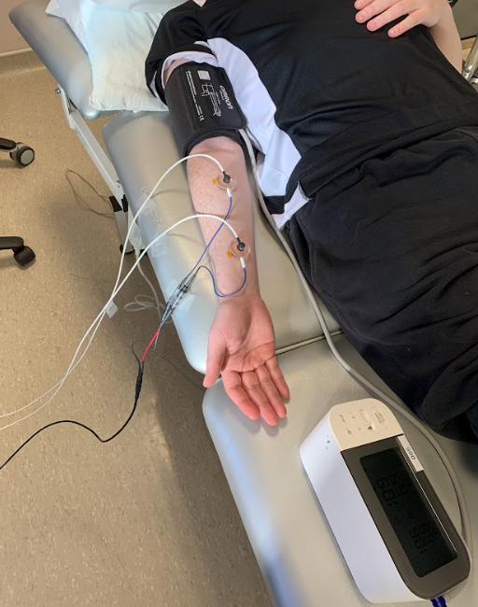
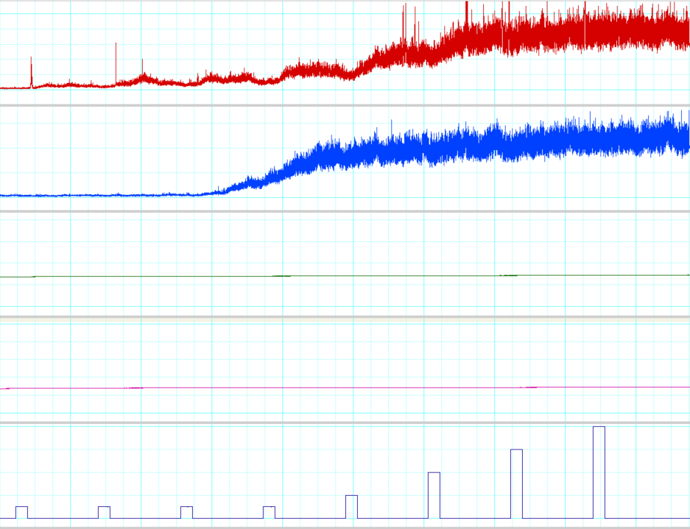

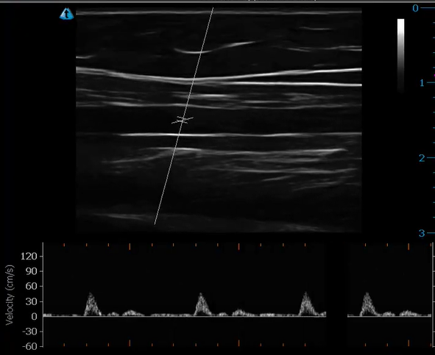
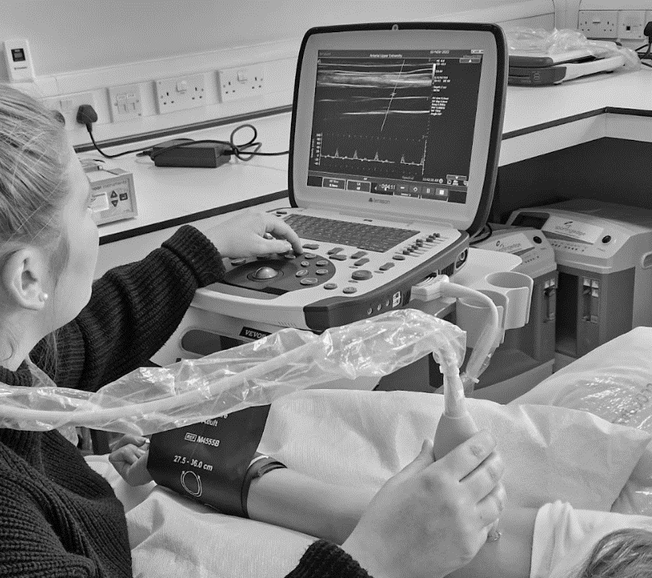
N.B. A. Experimental setup of microvascular function assessment via iontophoresis using laser Doppler with two Perspex drug chambers containing insulin and acetylcholine; B. Typical cutaneous flux measurement using a laser Doppler imager from an adult with cystic fibrosis (Male; 29.9 years old); C. Experimental set up of the brachial artery flow-mediated dilation (FMD) technique; D. Image of the brachial artery during the FMD technique.
A
B
C
D

