**Manuscript Title:**

Physical and theoretical modelling of embedded mooring line-seabed interaction in sands

**Authors:**

Katherine Kwa, Senior Research Fellow

Civil Maritime, Civil, Maritime & Environmental Engineering, University of Southampton, UK

ORCID: 0000-0002-4675-8736

[k.a.kwa@soton.ac.uk](mailto:k.a.kwa@soton.ac.uk)

Conleth O’Loughlin, Professor

Centre for Offshore Foundation Systems, Oceans Graduate School, University of Western Australia

ORCID: 0000-0002-5823-6265

conleth.oloughlin@uwa.edu.au

David White, Professor of Infrastructure Geotechnics

Civil Maritime, Civil, Maritime & Environmental Engineering, University of Southampton, UK

ORCID: 0000-0002-2968-582X

david.white@soton.ac.uk

Colm O’Beirne, Geotechnical Project Engineer

Centre for Offshore Foundation Systems, Oceans Graduate School, University of Western Australia

ORCID: ORCID: 0000-0003-1945-3918

[colm.obeirne@uwa.edu.au](mailto:colm.obeirne@uwa.edu.au)

Sebastiaan Frankenmolen, Civil/Structure Lead

The Shell Petroleum Development Company of Nigeria Limited

ORCID: 0009-0003-3322-6903

s.frankenmolen@shell.com

**Word Count in main text:** 4126

**Number of Figures:**17

**Number of Tables:** 5

**Number of typeset pages:** 11.83

**Abstract**

The most common mooring configuration for floating facilities is a catenary system. The final section of the mooring line is embedded in the seabed and forms an inverse catenary between the seafloor and anchor padeye. The inverse catenary absorbs part of the mooring load through friction and influences the magnitude and inclination of the load transferred to the anchor.

This study sets out an improved model for embedded mooring line – seabed interaction in sand, based on model scale experiments conducted in a geotechnical centrifuge. The experiments reveal the influence of embedded line dimensions and sand density on the inverse catenary shape and resistance. This information is used to calibrate and refine the improved theoretical model that uses cone penetration test tip resistance as the input, to estimate the embedded line shape and tensioning response.

The value of the new model is illustrated by a case study that highlights the influence of mooring line-seabed interaction on anchor capacity, due to the strong influence of the embedded line dimensions on the inverse catenary shape. Careful selection of the anchor and embedded line combination allows the anchor loading direction to be optimised, and the embedded mooring line – anchor system capacity increased for a given anchor size, allowing improved reliability.

**Notation**

$a$ cone penetrometer fitting parameter

$b$ passive resistance factor

$d_{bar}$ chain link bar diameter

$d$ fibre rope diameter

$d_{c}$ cone penetrometer diameter

$d_{50}$ mean particle size

*Dr* relative density

$E_{n}$, $E_{t}$ chain geometric factors

|| Mean error

$\overline{E_{b}}$ bias

$F$ sliding (or frictional) resistance per unit length

$g$ Earth’s acceleration due to gravity

$K_{p}$ passive resistance factor

$l_{link}$ link width

$m$ mass per unit length

$n$ cone penetrometer fitting parameter

$N$ normal resistance per unit length

$N_{q}$ chain bearing factor

$p_{a}$ atmospheric pressure

$q_{c1N}$ stress normalised cone penetration resistance

$q_{c,ssn}$ steady-state stress-normalised cone penetration resistance

$q_{c}$ cone penetration resistance

$R_{a}$ chain link surface roughness

$s$ position along chain length

$s_{u}$ undrained shear strength

$T$ tension

$T_{a}$ tension at anchor padeye

$T_{0}$ tension at seafloor

$w_{link}$ chain link length

$x$ horizontal distance

$x_{0}$ horizontal displacement at seafloor

$z$ depth

$z_{a}$ depth to anchor padeye

$α$ chain interface friction ratio

$β$ dimensionless scaling factor for normal resistance

$β_{θ}$ dimensionless scaling factor for normal resistance with dependency on local chain angle

$β_{0}$ scaling factor on $β_{θ}$

$ϕ'$ effective friction angle

$θ$ local chain inclination

$θ_{a}$ chain inclination at anchor padeye

$μ$ friction coefficient

$σ_{v}^{'}$ vertical effective stress

$ξ$ dimensionless scaling factor for sliding resistance

# Introduction

Floating facilities are held in place by mooring lines that consist of chain and wire or synthetic rope connected to anchors. The mooring lines originate at the floating unit and terminate at an anchor located on seafloor or within the seabed. The most common mooring configuration is a catenary shape in the water column, arriving at the seafloor horizontally, with a length of line lying on the seafloor. The final section is embedded in the seabed forming an inverse catenary between the seafloor and the anchor load attachment point, termed the padeye (Figure 1).

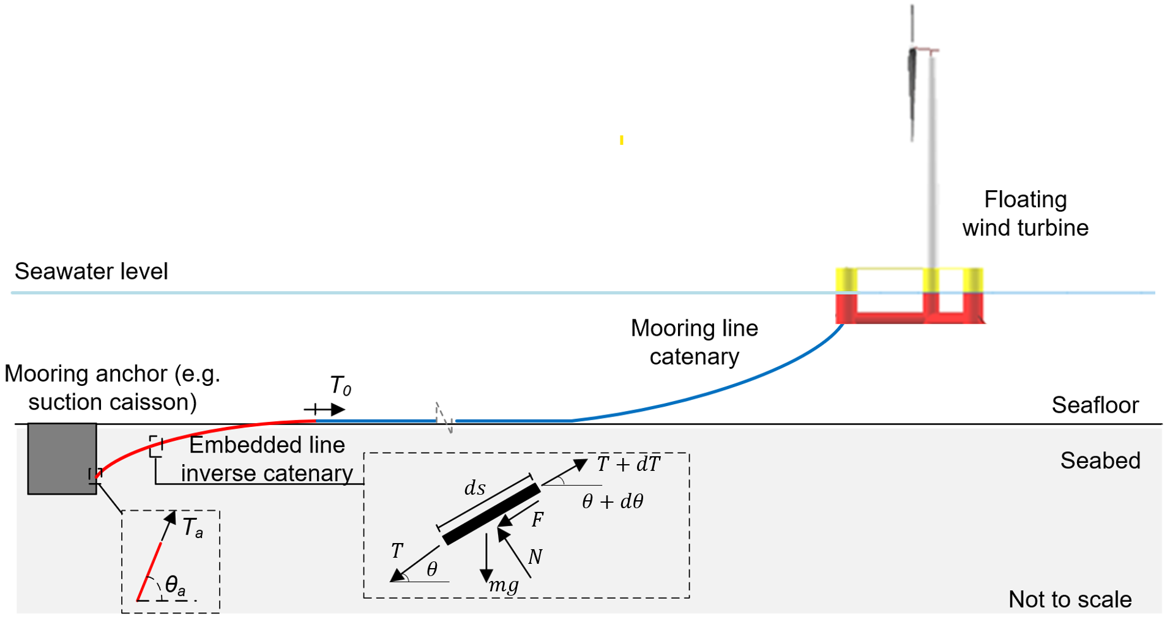

Figure 1. Chain seabed interactions and force equilibrium of chain element.

The embedded mooring line that forms an inverse catenary controls the fraction of the mooring load, $T_{0}$, that is resisted, and hence the load at the padeye, $T_{a}$, and its inclination, $θ_{a}$. Predicting the shape and load-carrying response of the embedded line is an integral part of the anchor geotechnical and structural design.

Also, the embedded mooring line’s inverse catenary shape changes under increased loading, releasing additional ‘slack’ into the mooring system. Excessive movement of the floating unit can occur if additional chain slack is released during operation (e.g., Neubecker and O’Neill 2004).

The embedded mooring line’s inverse catenary shape and tension profile is modelled via the chain equilibrium equations (e.g. Vivatrat et al. (1982), Degenkamp & Dutta (1989a-c)). The normal, $N$, and sliding (or frictional) resistance, $F$,as well as the weight , $mg$, per unit length on the embedded chain, affect the tension, $T$ (Figure 1). Integration of the chain equations gives the shape and the changing tension from seafloor to anchor. The governing equations are:

|  |  |
| --- | --- |
| $$\frac{dT}{ds}=F+mg\sin{θ}$$ | Eq 1 |
| $$T\frac{dθ}{ds}=-N+mg\cos{θ}$$ | Eq 2 |

where $s$ is the position along the chain length and $θ$ is the local chain inclination (Vivatrat et al., 1982).

In fine-grained soils, $N$ and $F$ are linked to the undrained strength, $s_{u}$ (Degenkamp & Dutta, 1989a-c). Corresponding parameters for the normal and sliding resistance in coarse-grained sediments are less well-established (Neubecker & Randolph, 1995; Frankenmolen et al. 2016). Conventional bearing capacity theory suggests $N$ is proportional to depth, $z$, and can be calculated via a conventional bearing factor, $N_{q}$, combined with a friction coefficient, $μ$ (Neubecker & Randolph 1995), such that:

|  |  |
| --- | --- |
| $$F=μN$$ | Eq 3 |
| $$N=N_{q}γ^{'}z{ E}_{n}d_{bar}$$ | Eq 4 |

where the bearing stress $N_{q}γ^{'}z$ acts on an area per unit length that is scaled from the bar diameter, $d_{bar}$, by the factor $E_{n}$, which has been estimated as $E_{n}=2.5$ from model tests.

However, assessment of $N_{q}$ requires selection of an appropriate effective friction angle, $ϕ'$, and an expression for $N_{q}=f\left(ϕ'\right)$, and does not allow for any inclination of the chain relative to the ground surface. There is therefore uncertainty in the shape of the embedded mooring line inverse catenary and the resulting loading direction at the anchor padeye, with the consequence that mooring and anchor designs may be non-optimal. Any potential optimisations of anchor design could have significant benefit as floating wind energy is upscaled because projects require of the order of three hundred anchors and mooring lines per gigawatt of installed capacity (based on 10 megawatt turbines anchored with three mooring lines/anchors; Cerfontaine et al. 2023).

This uncertainty is addressed through a program of chain-seabed interaction experiments conducted in a geotechnical centrifuge using carbonate and siliceous sand under drained conditions. The testing provides new data of the inverse catenary shape and load distribution in the embedded chain which is used to calibrate and refine an improved model for the chain shape and tensioning response based on cone penetration test (CPT) tip resistance. The paper firstly describes the experiments and then validates the improved theoretical model against the test data. Finally, the implications of this improved model for anchor and embedded mooring line design are illustrated by a case study.

# Experimental arrangement

## Introduction

The experiments were conducted at a testing acceleration of 40g using the 3.6 m diameter 40 g-tonne beam centrifuge located at the National Geotechnical Centrifuge Facility in the University of Western Australia. The tests used carbonate and silica sands at different density states and used studless chain with two different bar link diameters.

## Model chains and instrumentation

Model chains with bar diameters, $d_{bar}$ = 4 and 6 mm were tested, equivalent to prototype chain with $d_{bar}$ = 160 and 240 mm, which is typical for mooring applications. The chain link dimensions, masses and surface roughness data are given in Figure 2 and Table 1. The relative roughness is Ra/d50 = 0.007 - 0.008 for the two sands, making the interface of intermediate roughness (Lings & Dietz, 2005).

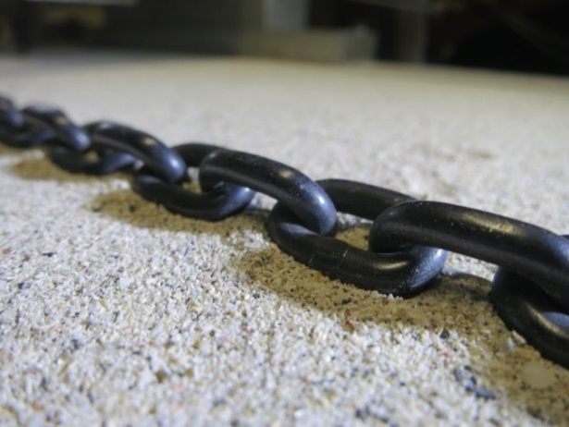 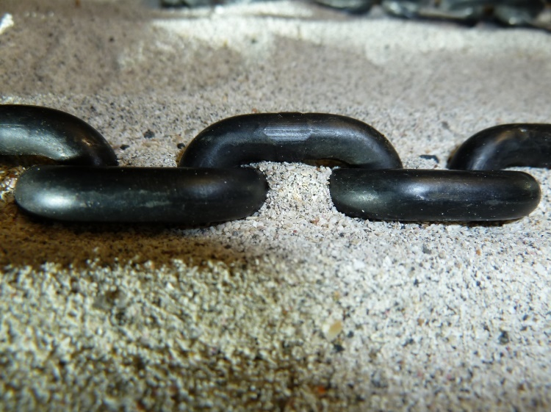

(a)

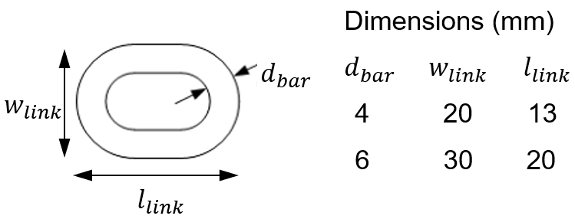

(b)

Figure 2: Model chains and dimensions: (a) 4 mm and 6 mm bar diameter chains (b) chain link dimensions (model scale units)

As shown in Figure 3, one end of the chain was attached to a fixed padeye located at a depth, $z_{a}$ = 125 mm. Two orthogonal load cells were pin-connected between the padeye and the container walls, giving the tensions $T_{aH}$ and $T_{aV}$, from which the anchor load, $T_{a}$ and inclination, $θ_{a}$ are found. The other end of the chain was on the sand surface and connected to a steel cable via a third load cell measuring $T_{0}$.

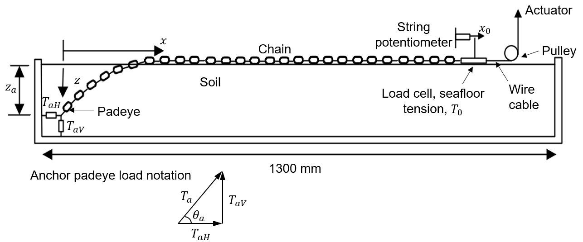

Figure 3: Experimental arrangement.

Table 1. Characteristics of model chains

|  |  |  |  |  |
| --- | --- | --- | --- | --- |
| **Parameter** | **Symbol** | **Units** | **Values** (prototype scale in brackets) | |
| Small chain | Large chain |
| Bar diameter | $$d_{bar}$$ | mm  (mm) | 4  (160) | 6  (240) |
| Mass per unit length | $$m$$ | g/m  (kg/m) | 336.4  (538) | 779.9  (1248) |
| Link length | $$l_{link}$$ | mm  (mm) | 20 (800) | 30 (1200) |
| Link width | $$w_{link}$$ | mm  (mm) | 13 (520) | 20  (800) |
| Link surface roughness  (stylus profilometer, 5 mm track) |  | mm | 1.5  (mean of several measurements, all in range 0.8-2mm. Ra/d50 = 0.01) | |

## Sand properties and sample preparation

The experiments used a carbonate and a siliceous sand, with properties shown in Figure 4 and Table 2. The $d_{50}$ values correspond to a minimum $d_{bar}/d_{50}$ ratio of 18, which is sufficient to neglect particle size effects (Bolton et al. 1999), noting that particle breakage around the chain would increase this ratio further.

Figure 4: Particle size distributions of the carbonate and silica sand

Table 2: Material parameters for carbonate and silica sand

|  |  |  |  |
| --- | --- | --- | --- |
| **Parameter** | **Units** | **Value** | |
| Carbonate sand | Silica sand |
| Minimum void ratio, $e_{min}$ | (-) | 0.986 | 0.499* |
| Maximum void ratio, $e_{max}$ | (-) | 1.404 | 0.777* |
| Critical state friction angle $ϕ_{cs}^{'}$ | ($°$) | 35 | 32.7 |
| Specific gravity, $G_{s}$ | (-) | 2.74 | 2.67 |
| Mean particle size, $d_{50}$ | (mm) | 0.22 | 0.18 |
| Carbonate content | (-) | 90% | - |

* Chow et al., (2019)

The sand samples were prepared by air pluviation with adjustments made to the fall height, hopper slot opening and travelling velocity to achieve dense and loose samples. During sample preparation the chain was connected to the anchor padeye and oriented vertically and draped over the edge of the box. The sand was filled flush to the top of the sample container and levelled with a straight edge so the sample height equaled the container depth of 225 mm. As drained behaviour was the focus in the experiments the samples were dry.

Even though the prototype situation is offshore, the use of dry sand is convenient for modelling purposes, although it introduces an increase in the vertical effective stress level in the model compared to a saturated prototype, due to the sand having a dry effective weight rather than a saturated effective weight. A consequence is that the stiffness and strength response of the sand corresponds to behaviour over a wider range of stress level than would apply in the field over the depth range from the surface to the anchor padeye. However, any influence on the soil response will affect both the chain-soil behaviour and also the CPT that is used for the sand characterisation in the accompanying prediction model, so this difference in effective weight is not a concern.

The use of dry sand in centrifuge studies is a common approach that has been adopted for various offshore foundation systems (Cerfontaine et al. 2023, Nicolai et al. 2017, Cox et al. 2014, White & Lehane 2004). When using these studies or the present work for further analysis or to validate prediction methods, it may be important to recognize that the geostatic stresses are higher than at an equivalent depth offshore (or onshore in saturated soil), with a resulting influence on strength and stiffness due to stress-dependency of these properties.

Prior to the first stage of loading the chain was fixed at a point above the anchor padeye to ensure it remained vertical. Cone penetrometer tests used a cone with diameter, $d_{c}$ = 7 mm and gave repeatable profiles of *qc* confirming the lateral homogeneity (Figure 5). Fitted and adjusted profiles of *qc* were generated to represent field-scale *qc* profiles following Lehane et al. (2023). These adjustments take into account the effects of stress level and relative density on the measured cone tip resistance, and also adjust for the shallow embedment effects that influence centrifuge CPT data due to the large penetrometer diameter relative to the sample depth. The Lehane et al. (2023) approach uses the stress-normalised cone tip resistance:

|  |  |
| --- | --- |
| $$q_{c1N}=\left(\frac{q_{c}}{p_{a}}\right){\left(\frac{p_{a}}{σ_{v}^{'}}\right)}^{n}$$ | Eq 5 |

where $p_{a}$ is atmospheric pressure, $σ_{v}^{'}$ is the vertical effective stress and $n$ is a constant equal to 0.5 in carbonate sands and 0.7 in silica sands (Lehane et al. 2023). In soil with depth-constant relative density, the shallow embedment effect causes $q_{c1N}$ to vary with depth, $z$, in the following form:

|  |  |
| --- | --- |
| $$q_{c1N}=q_{c,ssn}\tanh\left(\frac{az}{d_{c}}\right)$$ | Eq 6 |

where $q_{c,ssn}$ is a steady-state stress-normalised cone penetration resistance at large penetration depths, $z/d_{c}$ and $a$ is an empirical curve fitting parameter that fits the increase in $q_{c1N}$ with increasing penetration depth. The CPT fitting parameters, $q_{c,ssn}$ and $a$ that were adopted to provide the fitted *qc* profiles on Figure 5 are listed in Table 3. The values of $q_{c,ssn}$ and $a$ are within the range of published values for carbonate and silica sands included in Lehane et al. (2023). The adjustment is more significant for the dense sample, because the effect of the shallow cone embedment persists to a greater depth in denser soils. The adjusted $q_{c}$ profiles were used in the subsequent $q_{c}$-based chain-seabed interaction analysis, which are relevant to field scale conditions. The presence of the load cells and chain within the samples meant that estimation of the sample density from sample mass and volume measurements was unreliable. As such, relative density was inferred for each sample using the approach outlined in Lehane et al. (2023). This gave relative densities of *Dr* = 0.93 and 0.25 for the dense and loose carbonate samples and *Dr* = 0.82 and 0.20 for the dense and loose silica samples, albeit that the relative densities inferred for the loose samples are lower than the range adopted to develop the Lehane et al. (2023) approach.

Table 3: Sample IDs, test IDs and CPT fitting parameters

|  |  |  |  |  |  |
| --- | --- | --- | --- | --- | --- |
| **Sample ID** | **Test ID** | **Chain $d_{bar}$ (mm)** | **Sand** | **Steady state normalised cone tip resistance, $q_{c,ssn}$ (-)** | **Fitting parameter, $a$ (-)** |
| CaD | CaD_IC4  CaD_IC6 | 4  6 | Carbonate | 220 | 0.12 |
| CaL | CaL_IC4  CaL_IC6 | 4  6 | 75 | 0.22 |
| SiD | SiD_IC4 | 4 | Silica | 260 | 0.06 |
| SiL | SiL_IC4 | 4 | 36.5 | 0.45 |

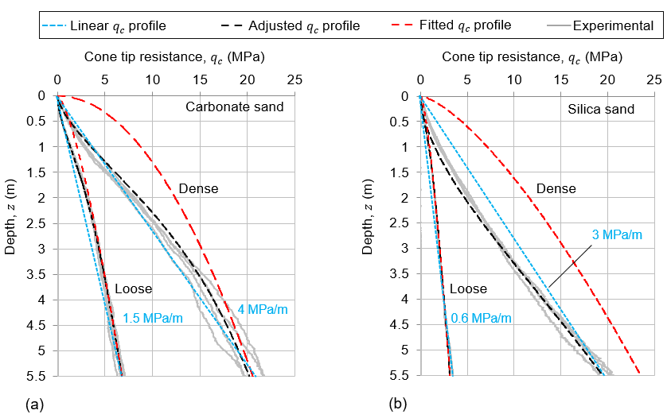

|  |  |
| --- | --- |
|  |  |

Figure 5. Profiles of measured and fitted cone resistance with depth for the: (a) carbonate sands; and (b) silica sands.

## Experimental programme and procedures

Six tests were conducted, each in a separate soil sample, with the test IDs given in Table 3. The free chain end was pulled by an electro-mechanical actuator at ~0.5 mm/s, causing the embedded chain to cut through the soil and form the inverse catenary. Each test was continued up to $T_{0}$ = 11.25 kN ( $T_{0}$ = 18 MN at prototype scale), with unloading stages where the centrifuge was stopped and the chain profile observed.

These tests involve only monotonic loading, but in offshore installations, chains are subjected to cyclic loads over their operational lifetime. Further cyclic testing and model development is required to characterise this response, which is beyond the scope of this study. However, the relative performance of different chains in different soil conditions under monotonic loading, which is the focus of the present study, might be expected to also apply to cyclic loading conditions.

# Typical test results

This section outlines typical results for a single test. The full set of results are set out later when compared to the predictive model. Figure 6 shows a typical seafloor load-displacement response ( $T_{0}$ vs $x_{0}$), and the loads at the padeye ( $T_{aH}, T_{aV}$ and $T_{a}$). Unload-reload loops show when the centrifuge was stopped for observations. Figure 6b shows the load transfer to the padeye as a proportion of the seafloor load (i.e. $T_{a}/T_{0}$, $T_{aV}/T_{0}$ and $T_{aH}/T_{0}$). Spikes arise from $T_{0}$ reducing to zero during unloading, when the mobilised friction reverses to lock in load at the padeye.

Reloading after unloading led to subsequent increases in $T_{a}$ that were a continuation of the maximum $T_{a}$ profile measured in the previous loading stage. This suggests that any release in locked in load or shear stress from the single unload-reload cycle had minimal effect on the load-displacement response.

The load-displacement responses are highly non-linear, with a rapid increase in tangent stiffness as the chain becomes straighter. The proportion of load transmitted to the padeye was typically $T_{a}/T_{0}$ = 0.75 to 0.85 at high loads, and slightly higher ratios in the looser soils and for the larger chain. This ratio increases with increasing seafloor load, showing that the embedded chain sustains a reducing proportion of the mooring load as it straightens.

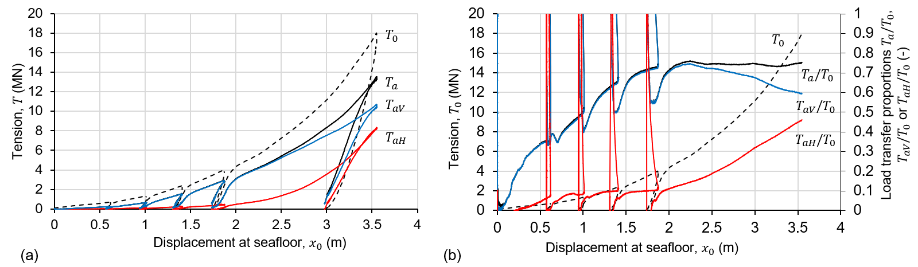

Figure 6: Typical load mobilisation response (test CaD_IC4). In Figure 6b, the dashed black line representing $T_{0}$ refers to values on the left axis, while the solid lines representing $T_{a}/T_{0}$, $T_{av}/T_{0}$ and $T_{aH}/T_{0}$ refer to values on the right axis.

A greater displacement, $x_{0}$, occurred in the loose samples under a given tension, confirming that the lower density allowed easier penetration by the chain, leading to a lower chain angle at the anchor padeye and a reduced vertical uplift, $T_{aV}$. This is evident in Figure 7, which shows the load components at the anchor padeye, $T_{aH}$ and $T_{aV}$, for each test. The axes of Figure 7a are scaled equally, so the load vector ($T_{aH}$, $T_{aV}$) is aligned in the true direction, which is colinear with the chain at the padeye.

The resultant padeye load is initially vertical, consistent with the chain shape, and progressively rotates as the inverse catenary is mobilised. The path varies between tests consistent with the chain displacement being closer to vertical for the denser sample and the larger chain. The padeye chain angle, $θ_{a}$, is also indicated in Figure 7a and ends in the range $θ_{a}$ = 27.5 to 64.5°. This same effect is evident in Figure 7b, which shows the variation of the load inclination at the anchor padeye, $θ_{a}$, as the seafloor load, $T_{0}$, is mobilised. In all tests, this inclination is initially close to 90°, but falls as the seafloor load increases towards the maximum value and the inverse catenary develops.

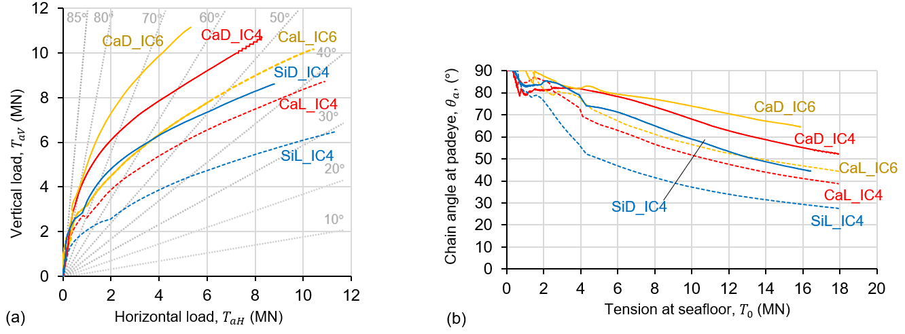

Figure 7: Results for all tests: (a) load vector, (b) padeye chain angle.

# Definition of qc-based embedded mooring line inverse catenary prediction model

## Formulation using cone penetrometer tip resistance, $q_{c}$

For coarse-grained soils under drained conditions, the normal and tangential chain-soil resistance can be estimated by scaling from the cone penetration resistance, $q_{c}$ (Frankenmolen et al., 2016). The resulting expressions for $N$ and $F$ are:

|  |  |
| --- | --- |
| $$N=E_{n}d_{bar}βq_{c}$$ | Eq 7 |
| $$F=E_{t}d_{bar}ξq_{c}$$ | Eq 8 |

where $β$ and $ξ$ are dimensionless scaling factors for normal and tangential resistance that replace the bearing and interface friction factors used for an undrained response.

Combining Eq 7 and Eq 8 leads to the friction coefficient between the chain and soil:

|  |  |
| --- | --- |
| $$μ=\frac{F}{N}=\frac{E_{t}}{E_{n}} \frac{ξ}{β}$$ | Eq 9 |

Rather than treating $ξ$ and the ratio ${E_{t}/E}_{n}$, as model inputs, it is more appropriate to use $μ$ since this has physical meaning as a friction coefficient. The basis for defining these two inputs, $β$ and $μ$, is set out in the following sections.

## Definition of normal resistance scaling parameter, $β$

A horizontal element of chain (i.e. $θ\sim$ 0 $°$) is analogous to an embedded strip foundation, while a chain element oriented vertically (i.e. $θ\sim 90°$) is analogous to a laterally-loaded pile. Vertical penetration of horizontal chain is therefore analogous to CPT tip penetration, with differences due to their shape. It can be assumed that the normal stress acting on the effective chain width scales directly with $q_{c}$.

However, as the chain inclination increases towards the padeye ($θ→$ 90 $°$), the interaction changes towards the laterally-loaded pile case, for which the ultimate lateral resistance is only a small fraction of $q_{c}$ (e.g. Dyson & Randolph, 2001, Suryasentana & Lehane, 2014). A formulation commonly used for the limiting lateral bearing stress is $σ_{h}^{'}=K_{p}^{2}σ_{v}^{'}$ (Fleming et al., 2009, Barton, 1982) where $K_{p}=\frac{1+\sin{ϕ_{cs}}}{1-sin⁡ϕ_{cs}}$. To allow for this dependence of the normal resistance on chain inclination, the scaling factor on $q_{c}$ becomes a function, $β_{θ}\left(θ\right)$:

|  |  |
| --- | --- |
| $$β_{θ}=β_{0}\exp\left(\frac{2θ}{π}\ln\left(\frac{bK_{p}^{2}σ_{v}^{'}}{β_{0}q_{c}}\right)\right)$$ | Eq 10 |

Combining Eq 7 and Eq 10 leads to:

|  |  |
| --- | --- |
| $$N=E_{n}d_{bar}β_{θ}q_{c}=E_{n}d_{bar}β_{0}\exp\left(\frac{2θ}{π}\ln\left(\frac{bK_{p}^{2}σ_{v}^{'}}{β_{0}q_{c}}\right)\right)q_{c}$$ | Eq 11 |

For horizontal chain ($θ=0°)$, Eq 11 reduces to the original formulation in Frankenmolen et al., (2016) with a simple scaling factor, $β_{0}$ on $q_{c}$; $N=E_{n}d_{bar}β_{0}q_{c}$. For vertical chain, $(θ$ = $\frac{π}{2}$ in radians or $90°$), Equation Eq 11 reduces to $N=E_{n}d_{bar}(bK_{p}^{2}σ_{v}^{'})$. The variation in normal stress with chain inclination, $θ$, follows an exponential trend, which is consistent with the change in mean stress through rotation of the principal stress direction in frictional materials (e.g. Bolton 1979, Powrie 2014).

Figure 8 plots the relationship between the vertical and horizontal components of the normalised pressure acting on the chain, $p_{N}=\left(\frac{N}{E_{n}d_{bar}}\right)/q_{c}$ (i.e., $p_{NV}$ = $p_{N}\sin{θ}$ and $p_{NH}=p_{N}\cos{θ}$) for different combinations of $β_{0}$ and $b$, together with the original Frankenmolen et al. (2016) formulation in Eq 7 where $β$ = 0.625. The passive resistance factor, $b,$ controls the normal resistance as the chain rotates towards a vertical orientation. The selected combinations of $β_{0}$ and $b$ provide a good fit to the load paths measured in the experiments, as discussed later in the paper.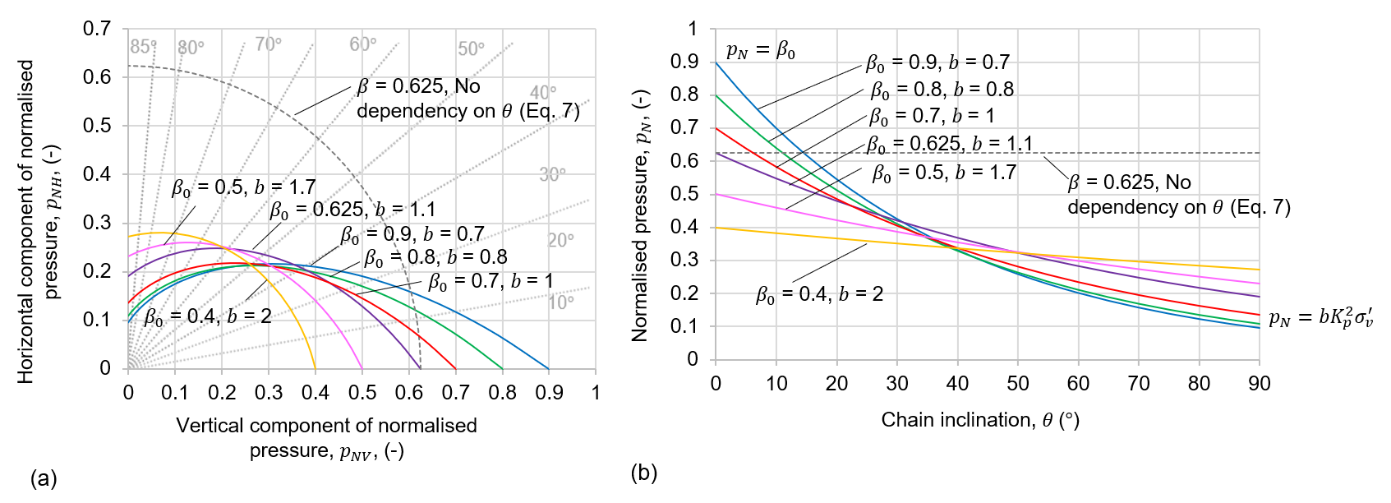

Figure 8: Variation in chain-soil normal pressure, $p_{N}$, with $q_{c}$ scaling term, $β_{0}$, and passive resistance factor, $b$: (a) in terms of $p_{NH}$ and $p_{NV}$ and (b) chain inclination, $θ$.

## Definition of friction coefficient, $μ$

The mobilised friction coefficient, $μ$, in an embedded chain with an inverse catenary shape can be estimated from the tension and inclination at each end of the chain, ignoring the chain self-weight, using the ‘capstan’ (or Euler-Eytelwein) equation, which is (Neubecker & Randolph, 1995):

|  |  |
| --- | --- |
| $$T_{0}=T_{a}e^{μ\left(θ_{a}-θ_{0}\right)}$$ | Eq 12 |

For a catenary mooring, for which $θ_{0}=0°$, Eq 12 gives:

|  |  |
| --- | --- |
| $$μ=\ln\left(\frac{T_{0}}{T_{a}}\right)/θ_{a}$$ | Eq 13 |

As Eq 13 neglects the weight of the chain it is less accurate at lower chain loads when the self-weight is higher relative to the imposed tensions. This is evident in Figure 9, which shows the evolution of $μ$ with increasing $T_{0}$. For $T_{0}$ > 2 MN the friction coefficient stabilises at $μ \sim$ 0.25.

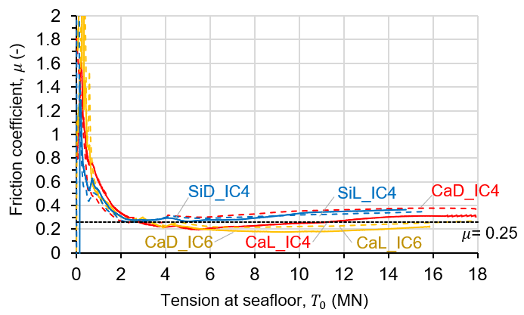

Figure 9: Friction coefficient, $μ$, inferred from the inverse catenary tests (Eq 13)

The inferred friction coefficients at high load on Figure 9 are significantly lower than the range of friction coefficient, $μ$ = 0.65 to 0.75, measured in chain surface drag tests (Frankenmolen et al. (2016). However, during the early loading stages, when more of the chain remains on the soil surface, higher values are inferred, which is consistent with the chain being pulled horizontally. The lower values of $μ$ in the embedded chain are linked to the higher level of mobilized normal resistance – i.e. full bearing failure, leading to penetration into the soil (Frankenmolen et al. 2016). This normal failure causes a reduction in the available frictional capacity, as found in other forms of combined multi-directional loading, such as the shape of vertical-horizontal combined loading envelopes in sand (e.g. Butterfield & Gottardi, 1994). For different seabed and chain or mooring-line combinations, selection of $μ$ could be based on model tests or tests on segments or elements of a line. It is interesting to note that in this study, $μ$ showed only small variation between dense and loose carbonate and silica sands, suggesting that $μ$ = 0.25 could be used more generally for inverse catenary chain-sand applications. However, further testing is needed to validate this.

## Calculated qc-based embedded chain catenary shapes

Figure 10 shows calculated chain profiles for $d_{bar}$ = 4 mm at $T_{0}$ = 18 MN in loose carbonate sand with the adjusted $q_{c}$ profiles shown in Figure 5b and the same sets of $β_{0}$ and $b$ shown in Figure 8. The different profiles show that the $β_{0}\left(θ\right)$ model causes the chain to cut more deeply because of the lower resistance, $p_{N}$, on the vertical portion, which allows the chain to rotate to a flatter angle close to the padeye (see inset Figure 10, and the corresponding $p_{N}$ profiles in Figure 8). Also, the chain cuts deeper for lower values of $β_{0}$, which is due to the lower normal resistance on the near-horizontal portion of the chain (as also illustrated in Figure 8).

The impact of varying the values of $β_{0}$ and $b$ on the shape of the chain profile is small but variations in $β_{0}$ and $b$ have a greater effect on the load path responses at the anchor padeye and the chain tensioning responses. These are discussed in the following section.

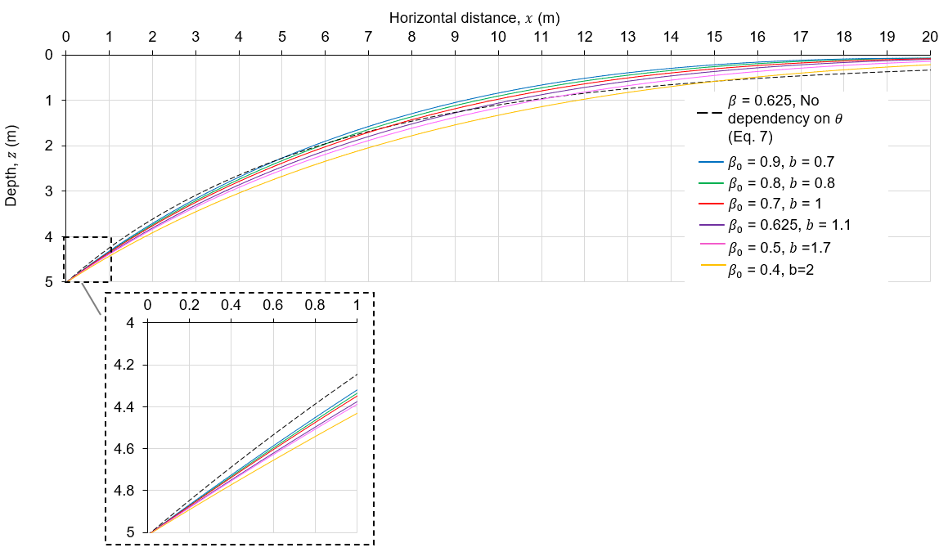

Figure 10: Effect of varying the CPT scaling factor, $β_{0}$ and the passive resistance factor, $b$, on chain profiles: full chain profile and inset close up at padeye.

# Calibration and benchmarking of embedded mooring line inverse catenary prediction model

## Load path response

In this section, the theoretical model is calibrated to the experimental results by fitting the measured load paths at the anchor padeye (Figure 11a and b). These load paths describe the chain-anchor interaction and influence the combined chain-anchor system capacity. The unload-reload loops in the experimental data were omitted during the calibration process.

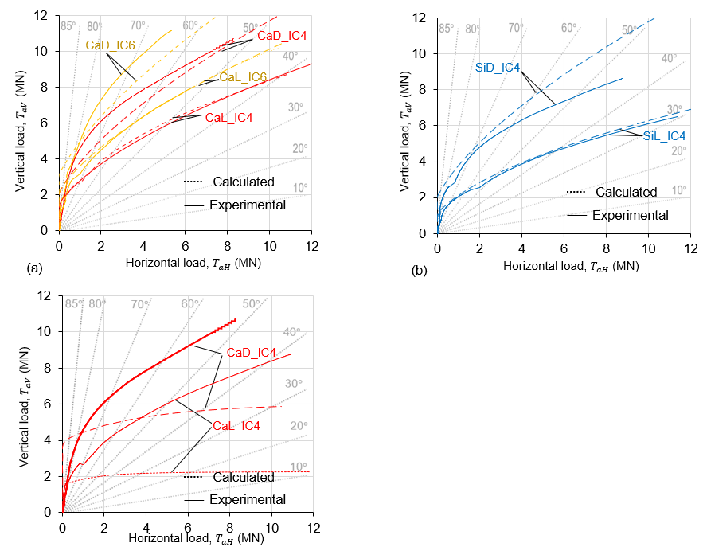

Figure 11: Calculated and measured load paths for tests in (a) carbonate and (b) silica sands based on the calibrated theoretical model and field-scaled qc profile

The calculated load paths in the improved theoretical model were fitted by minimising the mean error, $\left|\overline{E}\right|$, by varying the model parameters $β_{0}$ and $b$. This mean error, $\left|\overline{E}\right|$, is defined as the sum of mean errors, $\left|\overline{E}\right| =\sum{\left|\overline{E_{i}}\right|}$, over all tests, where $\left|\overline{E_{i}}\right|$ is the normalized area between the calculated and measured load paths (Figure 12).

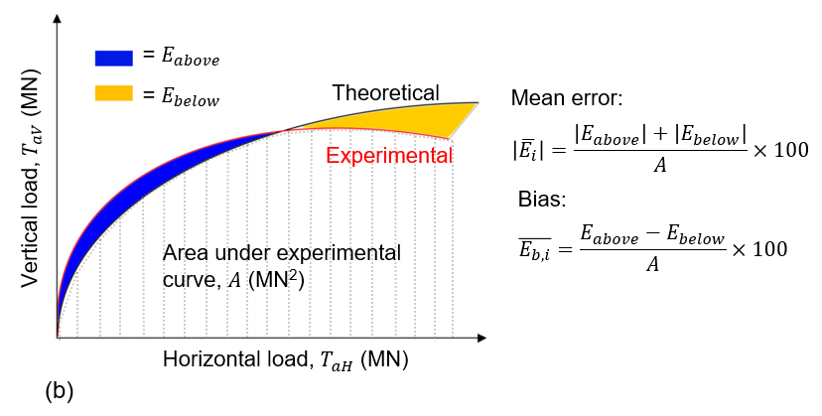

Figure 12: Definition of mean error, ||, and bias, $\overline{E_{b,i}},$ between calculated and measured load paths for one test

Values of mean error, $\left|\overline{E}\right|,$ across all tests are shown in Figure 12a for different combinations of $β_{0}$ and $b$. Optimal $β_{0}$ and $b$ sets give $\left|\overline{E}\right|$ = 5 to 7%, which is much better than $\left|\overline{E}\right|$ = 25% using the original formulation ($β$ = 0.625). Other values of $β$ were also trialed, with the minimum $\left|\overline{E}\right|$ = 16% obtained using $β$ = 0.5 (see Figure 12a), which is more than double the error from the modified $β_{0}-b$ formulation.

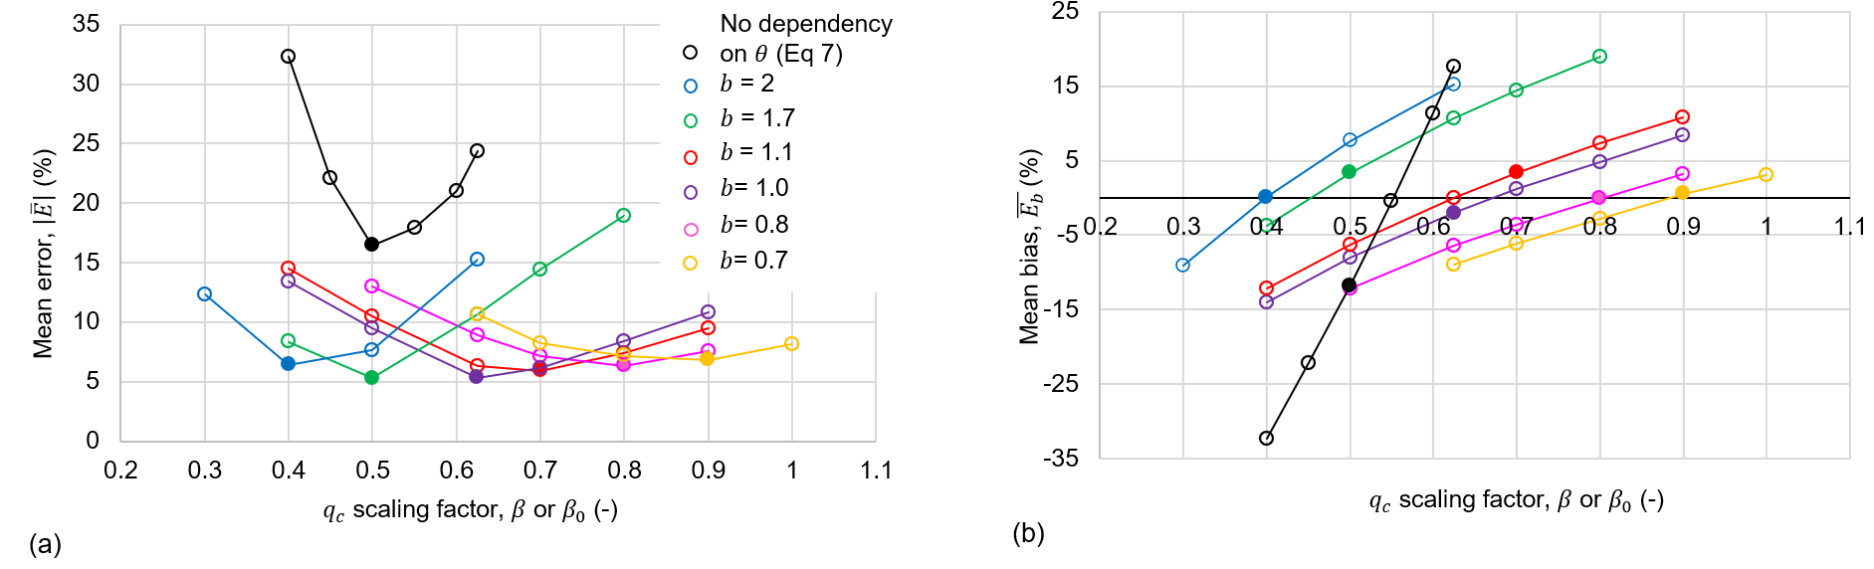

Figure 13: Summary of (a) mean errors and (b) mean bias over all tests for a range of $β_{0}$ and $b$ compared with original formulation with $β$ with no dependency on $θ$

The bias error for a single test, $\overline{E_{b,i}}$, is defined as the difference between the over- and under-predicted regions of the load paths (Figure 12). For the optimal $β_{0}-b$ pairs (i.e. with minimum $\left|\overline{E}\right|$ in Figure 12a), the bias $\overline{E_{b}}$ was within $±$ 4% (represented by solid symbols in Figure 12b). This compares to $\overline{E_{b}}$ = 12% obtained with the original formulation and $β$ = 0.5 (which gave the lowest $\left|\overline{E}\right|$).

The optimal parameter choice is $β_{0}$ = 0.7 and $b$ = 1, such that $p_{N}$ decreases to a minimum of $K_{p}^{2}σ_{v}^{'}$ as $θ→$ 90 $°$ (consistent with lateral pile analysis, e.g. Fleming et al. 2009). This combination of $β_{0}$ and $b$ gives minimum error and bias (Figure 13).

The padeye load path data can also be compared with the embedded chain solution adopted by Neubecker and Randolph (1995) which features a linear variation in chain-soil resistance with depth, following a bearing factor approach (Equation 4). The bearing factor, $N_{q}$, for chains embedded in sands is not well defined, but the solutions shown in Figure 14 adopt values of $N_{q}$ which correspond to a pressure on the equivalent chain width ($N/Ed_{bar}$) that increases at the relevant rate, $k_{qc}$, as shown in Figure 5 (i.e. equating Equations 4 and 7 ). This leads to values of $N_{q}$ in the range of 40 to 292 which are consistent with bearing capacity theory (e.g. Brinch Hansen 1970) for the relevant friction angles. This solution did not fit the measured load paths as well as the improved theoretical model, underpredicting the horizontal load, $T_{aH}$ at low $T_{a}$ and overpredicting $T_{aH}$ at high $T_{a}$ (Figure 12)

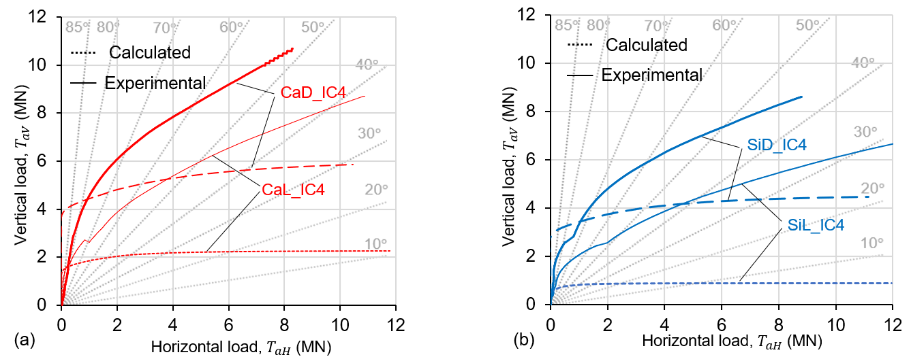

Figure 14: Calculated and measured load paths in carbonate sands based on linear variation in chain-soil resistance with depth following Neubecker & Randolph (1995) in (a) carbonate and (b) silica sands.

## Chain tension response

Figure 15 compares the chain tensioning response in the experiments with this modified formulation ( $β_{0}$ = 0.7 and $b$ = 1) and the original Frankenmolen et al. (2016) formulation with $β$ = 0.625. The resulting mean error for each test is $\left|\overline{E_{i}}\right|$ ≤ 7% and ≤ 10% using the modified and original formulations, respectively, when $\left|\overline{E_{i}}\right|$ is defined as in Figure 13, but using tension and displacement rather than horizontal and vertical load components. Typically, the calculated chain tensions match the measurements well at lower displacements but tended to underestimate the displacement at high loads. This could be attributed to stretch of the chain, which is not accounted for in the inverse catenary model.

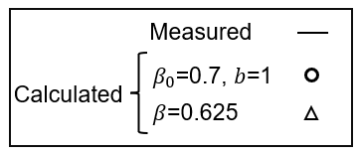

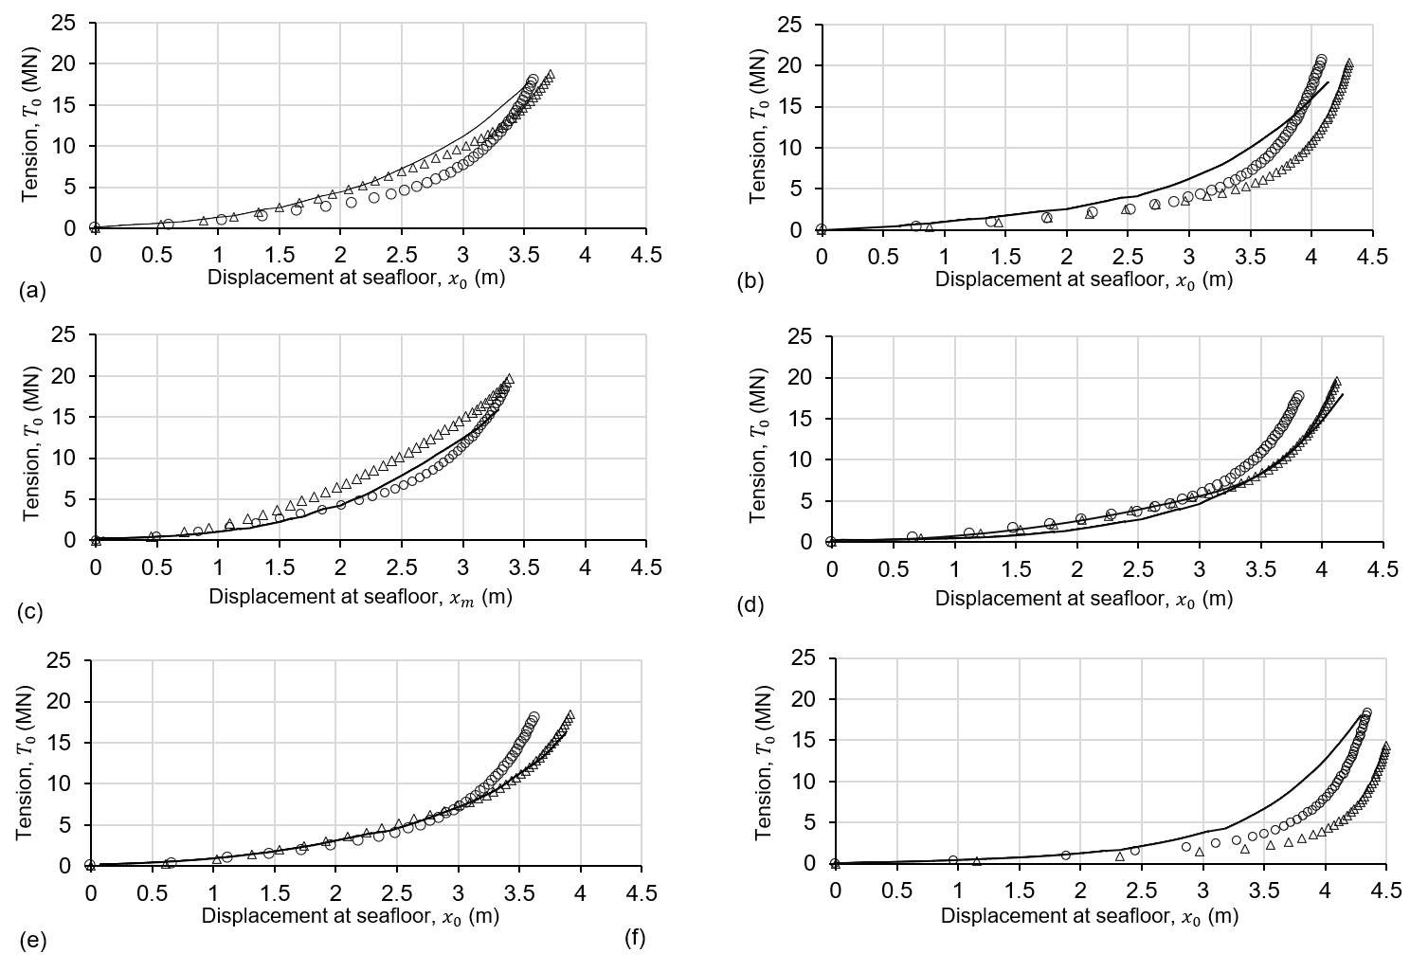

Figure 15: Calculated and measured chain tension mobilisation responses: (a) CaD_IC4, (b) CaL_IC4, (c) CaD_IC6, (d) CaL_IC6, (e) SiD_IC4, (f) SiL_IC4.

Figure 16 compares the calculated and measured loads at the padeye as a proportion of the seafloor load (i.e. $T_{a}/T_{0}$, $T_{aV}/T_{0}$ and $T_{aH}/T_{0}$). The modified formulation gives better agreement, particularly for smaller displacements and lower tensions. This is because in the modified formulation, the normal resistance on the chain is lower for higher chain inclinations than in the original formulation, causing more chain rotation at the padeye (as shown in Figure 8). This results in higher $T_{a}/T_{0}$, consistent with the simplified analysis of Eq 12.

Both the measurements and calculated responses show that $T_{aV}$ develops initially, consistent with the initial vertical orientation of the chain, and significant $T_{aH}$ is only mobilized at higher displacements (Figure 16). Although some of the profiles show a reduction in $T_{aV}/T_{0}$ with increasing displacement, the absolute value of $T_{aV}$ always increases.

The modified model matches the measured growth in $T_{a}/T_{0}$ better than the original model. It also shows an earlier growth in $T_{aH}/T_{0}$, with rotation of the chain at the padeye beginning at lower values of displacement $x_{0}$. These two effects result from the lower normal resistance on the vertical chain elements, permitting the chain to rotate at the padeye under lower tensions. These improvements from the modified formulation are important, as the load inclination at the padeye influences the anchor capacity, as explored in the following section.

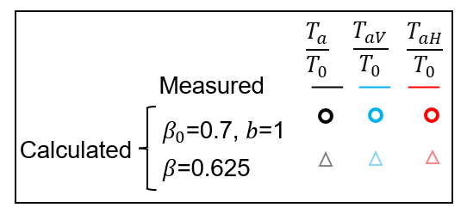 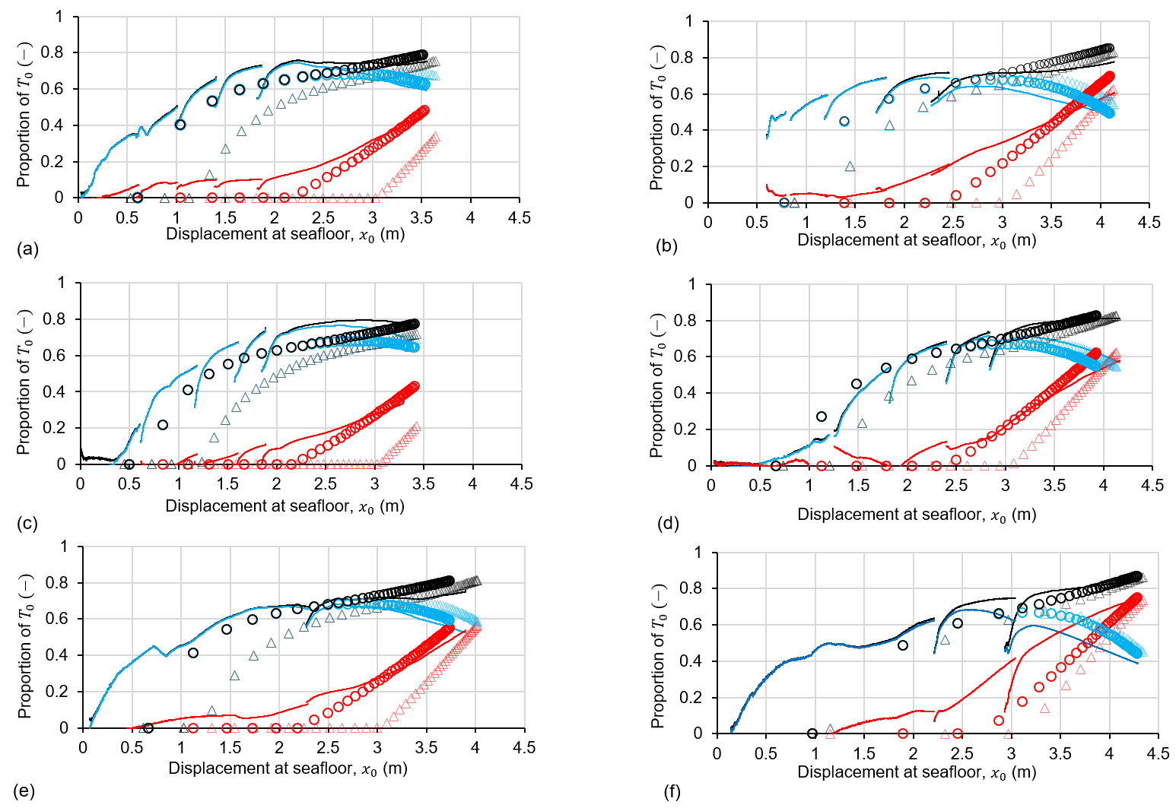

Figure 16: Calculated and measured padeye loading: (a) CaD_IC4, (b) CaL_IC4, (c) CaD_IC6, (d) CaL_IC6, (e) SiD_IC4, (f) SiL_IC4.

# Example application of combined embedded mooring line-anchor interactions

## Overview

In this section, the embedded mooring line inverse catenary model is applied in an example application where the chain is connected to a suction caisson anchor with skirt length, $L$, equal to the diameter, $D$ (i.e., $L/D=1$) and the padeye is located at $z/L =2/3$. The capacity of the caisson is assessed using the failure envelope formulations from Zhao et al. (2019), calculated for sands with the same properties as the tests in this paper (Tables 2 and 3). The only adjustment from the Zhao et al. (2019) approach is that a rough caisson surface is assumed, with a normalised interface friction angle, $\frac{δ}{ϕ}$ = 0.765, consistent with interface strength data from Potyondy (1961) and Westgate (2021), whereas Zhao et al. (2019) modelled a smooth model caisson surface with $\frac{δ}{ϕ}$ = 0.5 to 0.7. The embedded mooring line-anchor system interaction at the anchor padeye is found by comparing the capacity envelope to the load paths created by the mooring line inverse catenary as it is tensioned. The ultimate capacity of the embedded mooring line – anchor system is governed by the intersection of the embedded mooring line load paths with the anchor failure envelope.

The simulated embedded mooring lines included chains with the same dimensions as the experiments (Table 4) and also a synthetic fibre rope, since these are emerging as a mooring line option due to enhanced abrasion resistance using jackets or sheathes (Pillai et al. 2022). As the scaling factor for a rope is $E_{n}$ $=1$, the effective diameter of the rope is lower than that of the chains, which means that the rope has a higher potential for cutting into the seabed when tensioned. The synthetic rope properties (Table 4) were selected based on a Bridon Bekaert MoorLine Polyester rope (Bridon-Bekaert, 2021) that has a comparable minimum breaking strength (MBS) to the $d_{bar}$ = 0.185 mm chain adopted in the mooring of a reference 15 MW turbine catenary mooring system (Pillai et al. 2022; Allen et al. 2020).

Table 4: Model parameters and embedded chain/rope model properties adopted in the example simulations

|  |  |  |  |  |  |  |  |
| --- | --- | --- | --- | --- | --- | --- | --- |
|  | Chain link diameter, $d_{bar}$ or rope diameter, *d* (m) | Unit weight of chain or rope, (kN/m3) | Minimum breaking strength, $MBS$ (MN) | Friction coefficient, $μ$ (-) | Normal resistance factor, $E_{n}$ (-) | Normal resistance scaling factor, $β_{0}$ (-) | Passive resistance scaling factor, $b$ (-) |
| Chain | 0.16 | 5.38 | 21.9 | 0.25 | 2.5 | 0.7 | 1.0 |
| 0.24 | 12.48 | 39.1 |
| Rope | 0.266 | 0.456 | 20.6 | 0.40* | 1.0 |

* Brown (1977)

## Results

Each embedded mooring line was tensioned to $T_{0}$ = 18 MN, matching the limit in the experiments and below the lowest MBS (20.6 MN, see Table 4). The calculated load paths are provided on Figure 17 for the two sand types and density states considered in the experiments, together with the caisson failure envelope based on Zhao et al. (2019). The embedded mooring line-anchor system capacity for each case is given in Table 5.

Table 5: Mooring line-anchor system capacity (MN)

|  |  |  |  |  |  |  |
| --- | --- | --- | --- | --- | --- | --- |
| **Case** | **Embedded mooring line** | **Tension** | **Carbonate sand** | | **Silica sand** | |
| **Dense** | **Loose** | **Dense** | **Loose** |
| **A** | Chain, $d_{bar}$ = 0.16 m | $$T_{a}$$ | 6.73 | 7.10 | 8.19 | 13.10 |
| $$T_{0}$$ | 9.01 | 8.95 | 13.64 | 15.64 |
| **B** | Chain, $d_{bar}$ = 0.24 m | $$T_{a}$$ | 6.01 | 6.37 | 7.47 | 10.73 |
| $$T_{0}$$ | 8.54 | 8.54 | 10.35 | 12.98 |
| **C** | Rope, $d$ = 0.266 m | $$T_{a}$$ | 7.46 | 8.91 | 9.28 | 17.64 |
| $$T_{0}$$ | 10.91 | 11.74 | 13.24 | 20.58 |

As the effective embedded mooring line diameter ($E_{n}d_{bar}$ for the chains or $E_{n}d$ for the fibre rope) reduces, the load paths flatten and intersect the anchor envelope at higher $T_{a}$ and $T_{0}$, such that embedded mooring line-anchor system capacity is highest for the fibre rope, followed by the $d_{bar}$ = 0.16 m chain and the $d_{bar}$ = 0.24 m chain. This arises because a lower effective diameter allows the embedded mooring line to cut further into the seabed, reducing the load inclination at the padeye. The simulations show that this mechanism causes the fibre rope to provide a 23 – 65% improvement in system capacity compared to the larger chain and a 23 – 33% improvement compared to the smaller chain. Lower effective diameters also lead to higher displacements at the seafloor, $x_{0}$ (Figure 18).

The embedded mooring line – anchor interaction is also influenced by soil density. Mooring lines cut further into the looser sands, making the padeye load angle flatter than in the denser sands. In most cases, this causes the embedded mooring-line anchor system capacity in loose sand to exceed that in dense sand for the same anchor and mooring line combination, even though the failure envelope is larger for the anchor in the denser soil. This occurs because the reduction in anchor capacity due to the lower density is eclipsed by the increase in $T_{a}$ at failure due to the lower padeye load inclination. The higher $T_{a}$ at failure also leads to a higher tension at the seafloor, $T_{0}$ (Table 5). This effect is not properly captured by other models for the embedded mooring line shape because the reduced lateral resistance on the vertical part of the mooring line is not captured.

These results highlight the potential for fibre rope or steel wire embedded mooring lines to form a flatter inverse catenary shape at lower mooring line tensions, allowing additional anchor capacity to be mobilised compared to an equivalent chain.

These tests involve only monotonic loading, but in offshore installations, chains are subjected to cyclic loads over their operational lifetime. Further cyclic testing and model development is required to characterise this response, which is beyond the scope of this study. However, the relative performance of different chains in different soil conditions under monotonic loading, which is the focus of the present study, might be expected to also apply to cyclic loading conditions.

Figure 17: Combined embedded chain or rope-anchor responses in dense and loose: (a) carbonate sand and (b) silica sand.

Figure 18: Mobilisation of embedded mooring line tension and comparison of embedded mooring line – anchor system capacities: (a) dense carbonate sand, (b) loose carbonate sand, (c) dense silica sand and (d) loose silica sand.

# Conclusions

This paper develops an improved CPT-based model for the response of embedded mooring lines, calibrated from model tests conducted in a geotechnical centrifuge, and demonstrates the resulting influence on embedded mooring line – anchor system design.

The test data provide new insights on the transmission of mooring line tension from the horizontal on-bottom position through the embedded line inverse catenary to the padeye of an anchor as the mooring line is progressively tensioned. The tests spanned two different sand types and density states, under drained conditions, and used two sizes of embedded mooring chain.

An improved theoretical model for the embedded mooring line-sand interaction based on CPT tip resistance, $q_{c}$, is introduced. A new feature of the model is the influence of line inclination on the limiting normal and sliding resistance through a scaling factor on $q_{c}$ that varies with line inclination. This model was calibrated to the experimental data and was shown to give better agreement than models without inclination-dependence of the embedded line-soil interaction forces. In particular, the improved model better captures the onset of chain rotation at the padeye, by recognizing that the normal resistance on a vertical chain element is lower than on a horizontal element. This matches the observed flattening of the padeye load observed in the experiments.

This improved model provides a more rigorous basis to assess mooring line – anchor interaction. Example simulations show that this improved theoretical model provides a simple basis to assess embedded mooring line – anchor system capacity when combined with combined loading failure envelopes for the attached anchor. These simulations demonstrate important interaction effects that could be harnessed for more efficient embedded mooring line and anchor designs.

A smaller diameter of embedded mooring line (or chain) leads to a flatter load inclination at the padeye, which is a more optimal loading direction for most anchors. For the example case of a suction caisson, a smaller diameter embedded mooring line led to higher embedded mooring line – anchor system capacity due to the change in padeye load inclination and the intersection point with the failure envelope. Emergent wire or rope-type mooring lines, which have a smaller effective diameter than chains of the same breaking strength, lead to flatter embedded catenaries and a lower load inclination at the padeye. As a result, these new mooring line types offer the potential to raise the holding capacity provided by a given size of anchor.

Soil density affects the anchor capacity and the embedded mooring line inverse catenary in ways that have opposite effects on the system capacity. In looser soil, the anchor capacity envelope is smaller compared to in denser soil due to the lower soil strength, but the embedded mooring line inverse catenary cuts to a more favourable flatter orientation at the padeye, which mobilises higher horizontal anchor capacity. The simulations show that in many cases the latter effect eclipses the former effect, so the embedded mooring line – anchor system capacity is greater in loose sand than in dense sand.

Overall, the new embedded mooring line – sand interaction model developed in this paper provides a more rigorous basis to assess mooring and anchor interaction. This allows more optimal designs involving smaller and cost-effective mooring line and anchor systems to support the development of floating wind facilities, and other moored offshore facilities.

# Acknowledgements

The experiments reported in this paper were partly funded by Shell Australia. This work was supported by the Royal Academy of Engineering under the Research Fellowship Programme, and by the UK EPSRC via the EPSRC Supergen Offshore Renewable Energy (ORE) Hub (Grant EPSRC EP/Y016297/1). Katherine Kwa is supported by an RAEng Research Fellowship.

# References

Allen C., Viselli A., Dagher H., Goupee A., Gaertner E., Abbas N., Hall M., Barter G. (2020). Definition of the UMaine Volturn US-S Reference Platform Developed for the IEA Wind 15-Megawatt Offshore Reference Wind Turbine: Report, NREL and IEA Wind

Barton, Y.O. (1982), Laterally loaded model piles in sand: centrifuge tests and finite element analyses. PhD thesis, University of Cambridge

Bridon-Bekaert (2021). MoorLine polyester data sheet. Retrieved: [www.bridon-bekaert.com/en-gb/steel-and-synthetic-ropes/marine/mooring/offshore-mooring-lines/moorline-polyester](http://www.bridon-bekaert.com/en-gb/steel-and-synthetic-ropes/marine/mooring/offshore-mooring-lines/moorline-polyester)

Brown (1977). Friction coefficients of synthetic ropes, Ocean Technology Department, Naval Undersea Centre, San Diego.

Bolton, M. D., Gui, M. W., Garnier, J., Corte, J. F., Bagge, G., Laue, J., & Renzi, R. (1999). Centrifuge cone penetration tests in sand. Géotechnique, 49(4), 543-552.

Cerfontaine, B., Brown, M. J., Knappett, J. A., Davidson, C., Sharif, Y. U., Huisman, M., Ottolini, M. & Ball, J. D. (2023). Control of screw pile installation to optimise performance for offshore energy applications. Géotechnique, 73(3), 234-249.

Cerfontaine, B., White, D., Kwa, K., Gourvenec, S., Knappett, J., & Brown, M. (2023). Anchor geotechnics for floating offshore wind: Current technologies and future innovations. Ocean Engineering, 279, 114327.

Chow, S.H., Roy, A. Herduin, M., Heins, E. King, L., O’Loughlin, C. Gaudin, C. & Cassidy, M. (2019) Characterisation of UWA superfine silica sand, Oceans School, University of Western Australia.

Cox, J. A., O'Loughlin, C. D., Cassidy, M., Bhattacharya, S., Gaudin, C., & Bienen, B. (2014). Centrifuge study on the cyclic performance of caissons in sand. International Journal of Physical Modelling in Geotechnics, 14(4), 99-115.

Frankenmolen, S., White., D. & O’Loughlin, C. (2016). Chain-soil interaction in carbonate sand, Offshore Technology Conference, D041S055R001

Dutta, A., & Degenkamp, G. (1989a). Behaviour of embedded mooring chains in clay during chain tensioning. In Offshore Technology Conference, OTC 6031

Dutta, A., & Degenkamp, G. (1989b). Soil resistances to embedded anchor chain in firm clay. Journal of the Geotechnical Engineering Division.

Degenkamp, G., & Dutta, A. (1989c). Soil resistances to embedded anchor chain in soft clay. Journal of Geotechnical Engineering, 115(10), 1420-1438.

Dyson, G. J. & Randolph, M. F. (2001). Monotonic lateral loading of piles in calcareous

sand. Journal of Geotechnical and Geoenvironmental Engineering, 127, 346-352.

Hansen, J.B. (1970) A revised and extended formula for bearing capacity, Danish Geotechnical Institute Bulletin, No. 28. 5-11.

Lehane, B. M., Zania, V., Chow, S. H., & Jensen, M. (2023). Interpretation of centrifuge CPT data in normally consolidated silica and carbonate sands. Géotechnique, 73(10(, 907-916. https://doi.org/10.1680/jgeot.21.00177 .

Neubecker, S. R., & O'Neill, M. P. (2004). Study of chain slippage for embedded anchors. In Offshore Technology Conference (pp. OTC-16445). OTC.

Neubecker, S. R., & Randolph, M. F. (1995). Profile and frictional capacity of embedded anchor chains. Journal of geotechnical engineering, 121(11), 797-803.

Nicolai, G., Ibsen, L-B., O’Loughlin C.D. & White D.J. 2017. Quantifying the increase in lateral capacity of monopiles in dense sand due to cyclic loading. Géotechnique Letters 7(3):245-252

Pillai, A. C., Gordelier, T. J., Thies, P. R., Cuthill, D., & Johanning, L. (2022). Anchor loads for shallow water mooring of a 15 MW floating wind turbine—Part II: Synthetic and novel mooring systems. Ocean Engineering, 266, 112619.

Potyondy, J. G. (1961). Skin friction between various soils and construction materials, Géotechnique 11 (4): 339–353. https://doi.org/10.1680/geot.1961.11.4.339.

Powrie, W. (2018). Soil mechanics: concepts and applications. CRC Press. Chapter 10, pp 533 to 539.

Randolph, M., & Gourvenec, S. (2017). Offshore geotechnical engineering. CRC press.

Stanier, S.A., White, D.J., Chatterjee, S., Brunning, P. & Randolph, M.F., (2015). A tool for ROV-based seabed friction measurement, Applied Ocean Research 50 (155-162).

Schneider, J. A., and Lehane, B. M. (2006). Effects of width for square centrifuge displacement piles in sand.” Proc. 6th Int. Conf. Physical Modelling in Geotechnics, Vol. 2, Taylor & Francis, London, 867–873.

Suryasentana, S., & Lehane, B. (2014). Numerical derivation of CPT-based p-y curves for piles in sand. Géotechnique, 64(3), 186-194. https://doi.org/10.1680/geot.13.P.026

Vivatrat, V., Valent, P.J., & Ponterio, A.A. (1982). The influence of chain friction on anchor pile design, Proc. 14th Offshore Technology Conference, OTC 4178: Houston

Westgate, Z., Argiolas, R., Wallerand, R., & Ballard, J. C. (2021). Experience with Interface Shear Box Testing for Pipe-Soil Interaction Assessment on Sand. In Offshore Technology Conference (p. D011S012R004). OTC.

White D.J. & Lehane B.M. 2004. Friction fatigue on displacement piles in sand. Géotechnique 54(10):645-658

Zhao, L., Gaudin, C., O’Loughlin, C. D., Hambleton, J. P., Cassidy, M. J., & Herduin, M. (2019). Drained capacity of a suction caisson in sand under inclined loading. Journal of Geotechnical and Geoenvironmental Engineering, 145(2), 04018107.

# Tables and Figures

1. Table 1: Characteristics of model chains
2. Table 2: Material parameters for carbonate and silica sand
3. Table 3: Chain-soil- simulation parameters
4. Table 4: Sample IDs, test IDs and CPT fitting parameters
5. Table 5: Model parameters and chain/rope model properties adopted in the example simulations
6. Figure 1: Chain seabed interactions and force equilibrium of chain element
7. Figure 2: Model chains and dimensions: (a) 4 mm and 6 mm bar diameter chains (b) chain link dimensions (model scale units)
8. Figure 3: Experimental arrangement.
9. Figure 4: Particle size distributions of the carbonate and silica sand
10. Figure 5: Profiles of measured and fitted cone resistance with depth for the dense and loose (a) carbonate sands and (b) silica sands.
11. Figure 6: Typical load mobilization in inverse catenary tests (test CaD_IC4).
12. Figure 7: Results for all centrifuge tests: (a) load vector, (b) padeye chain angle
13. Figure 8: Relationships between normal pressure, $p_{N}$, cone penetration resistance scaling term, $β_{0}$, and passive resistance factor, $b$: (a) in terms of horizontal and vertical $p_{NH}$ and $p_{NV}$ components and (b) chain inclination, $θ$
14. Figure 9: Friction coefficient, μ, inferred during inverse catenary tests (Eq 13)
15. Figure 10: Effect of varying the CPT scaling factor, β_0 and the passive resistance factor, b, on chain profiles: (a) full chain profile and (b) inset close up at padeye.
16. Figure 11: Calculated and measured load paths for tests in (a) carbonate and (b) silica sands.
17. Figure 12: Definition of mean error, ||, and bias, $\overline{E_{b,i}},$ between calculated and measured load paths for one test
18. Figure 13: Summary of (a) mean errors and (b) mean bias over all centrifuge tests for a range of $β_{0}$ and $b$ compared with original formulation with $β$ with no dependency on $θ$
19. Figure 14: Calculated and measured chain tension mobilisation responses: (a) CaD_IC4, (b) CaL_IC4, (c) CaD_IC6, (d) CaL_IC6, (e) SiD_IC4, (f) SiL_IC4
20. Figure 15: Calculated and measured padeye loading: (a) CaD_IC4, (b) CaL_IC4, (c) CaD_IC6, (d) CaL_IC6, (e) SiD_IC4, (f) SiL_IC4
21. Figure 16: Combined embedded chain or rope-anchor responses in dense and loose: (a) carbonate sand and (b) silica sand.
22. Figure 17: Mobilisation of mooring line tension and comparison of embedded mooring line – anchor system capacities (a) dense carbonate sand, (b) loose carbonate sand, (c) dense silica sand and (d) loose silica sand.