# Educational trends in cohort fertility by birth order: A Comparison of England & Wales, Scotland, and Northern Ireland

Bernice Kuang[1], Ann Berrington1, Sarah Christison[2], Hill Kulu2

Corresponding author: Bernice Kuang, [bernicekuang@gmail.com](mailto:bernicekuang@gmail.com) & b.kuang@soton.ac.uk

**Background:** Over the past few decades, cohort fertility rates in the different countries of the UK (England and Wales, Scotland, and Northern Ireland) have diverged, yet the role of parity specific patterns, including childlessness, is not known. Studies across Europe have found a reversal in the educational gradient of childlessness, from positive to negative, attributed to economic uncertainty, new patterns of parity progression, and increased polarization of behaviours across educational subgroups, raising questions about how the UK fits into these emerging trends.

**Objective:** This paper uses linked administrative and census data from each of the UK’s countries to identify how childlessness and childbearing at higher birth orders are driving these differences and to explore potential socio-economic explanations.

**Results:** For the birth cohorts 1956-1978, we find a persistently positive educational pattern of childlessness across all UK’s countries, albeit with smaller educational differences in Northern Ireland. We also find, across educational groups, divergent country trends in family size distributions, with Scotland trending towards smaller families but not higher levels of childlessness, and Northern Ireland with larger families. England and Wales remains firmly entrenched in the two-child norm. Family size differences between countries are not explained by large differences in mean age at first birth.

**Contribution:** Our findings show that the UK’s countries have unique fertility regimes, emphasizing the value of examining countries separately for their different empirical contributions to the unfolding patterns of contemporary cohort fertility change in Europe.

## Introduction

In most reviews of European trends in childbearing, the UK is described as a country with average to high levels of fertility (Wood, Neels and Kil 2014, Vignoli, Guetto et al. 2020) and yet also exhibits relatively high levels of childlessness (Berrington 2017). Recent comparative research (which has not included the UK) has highlighted cross-national differences in parity progression ratios and hence different trajectories of cohort fertility decline (Zeman, Sobotka et al. 2018, Lazzari, Mogi and Canudas-Romo 2021). Individual country studies have examined sub-group differences in parity progression and identified an emerging demographic regime whereby rates of childlessness have been increasing fastest among the most socio-economically disadvantaged (Comolli, Neyer et al. 2021, Jalovaara, Andersson and Miettinen 2021, Ohlsson-Wijk and Andersson 2022), which is consistent with recent theoretical debates about the role of economic uncertainty in fertility decline (Vignoli, Guetto et al. 2020). Previous attempts at examining parity progression in the UK have relied on survey data (Wood, Neels and Kil 2014, Berrington, Stone and Beaujouan 2015, Ermisch 2021). A historical lack of birth order information in UK birth registries and comparatively small survey sample sizes meant that it was difficult to examine sub-group differences in fertility by birth order as well as cross-national fertility differences between the constituent countries of the UK.

Both period and cohort fertility are markedly lower in Scotland and higher in Northern Ireland than in England or Wales, raising questions about what aspects of fertility behavior are driving these differences. In this paper, we examine time trends in family size, which are the outcome of changes in parity progression ratios, and timing of first birth, their educational patterns, and how they are moderated by country context for the 1956-1978 birth cohorts. Our study is the first to do so, using a largescale dataset comprised of linked administrative and census data which enables both sub-group and cross-national analysis. Thus, we are able to address questions such as whether lower completed family sizes in Scotland are because of higher rates of childlessness, or fewer women with higher order births (or both). Knowing which educational groups have led divergences in childbearing between the countries of the UK may help identify possible causes. In the next section, we briefly review childbearing trends in Britain and outline theories which relate levels of education to parity progression and family size distribution and suggest that educational gradients are likely to be different for first, second, and higher order births. Subsequently we put forward hypotheses as to why these educational effects may be moderated by country context, specifically with respect to the countries of the UK.

1.1 Childbearing trends in the UK context

From birth cohorts of the 1950s onwards, the completed family size or cohort fertility rate (CFR) increasingly diverged between England and Wales, where it changed relatively little, and Scotland, where it dropped steadily. At the same time, the historically higher levels of completed family size in Northern Ireland declined, converging toward the rest of the UK (Figure 1). Fertility intentions were broadly consistent between Scotland and England and Wales in the 1980s and 1990s (Berrington, Kuang et al. 2023), suggesting that a higher proportion of Scottish women do not fulfil their childbearing intentions, as also highlighted in recent Scottish Population Policy Documents (2021).

#### Figure 1. Cohort total fertility, at age 40 in the UK, 1956-1980/1982 female birth cohorts

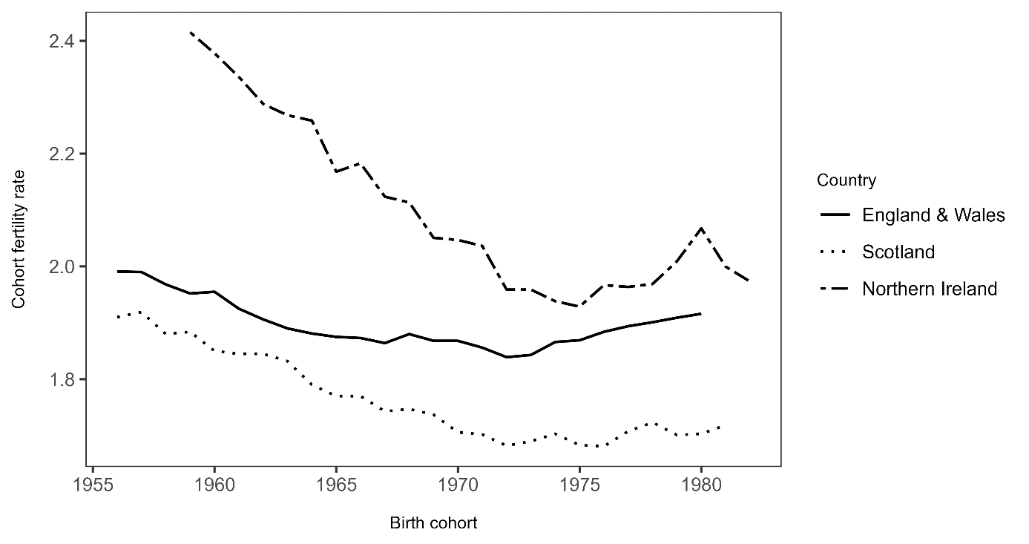

*Sources: Office for National Statistics (ONS), National Records of Scotland (NRS) 1981 female birth cohort shown for Scotland, Northern Ireland Statistics and Research Agency (NISRA) and Human Fertility Database, 1981 and 1982 female birth cohorts shown for Northern Ireland*

Recent analysis of survey data for England and Wales has highlighted further postponement of childbearing from 2010 to 2020 and found similar fertility declines across women from different family backgrounds, though small sample sizes made sub-group comparisons difficult (Ermisch 2023). Examining changes in fertility by birth order is crucial because childbearing decisions are made sequentially across the life course. The decision to become a parent differs from the decision to have additional children, meaning trends in childlessness may not be shaped by the same forces that influence ultimate family size (Brzozowska, Beaujouan and Zeman 2022). Moreover, it is important to know which sub-groups of the population are most associated with divergences in fertility behavior across the countries of the UK. Education is a key component of fertility sub-group analysis (Balbo, Billari and Mills 2013) and particularly germane in examining completed family size distributions since educational patterns of fertility often vary by parity (Wood, Neels and Kil 2014, Van Bavel, Klesment et al. 2018, Brzozowska, Beaujouan and Zeman 2022). Analysis by educational level also provides insight into the obstacles to achieving desired fertility and help target any intervention onto those subgroups most affected.

## Theoretical background

We first discuss theoretical and empirical literature on educational gradients in parity progression and family size distribution, before examining how UK country context might moderate these relationships.

### 2.1 Educational patterns of parity progression

In many high-income countries, high education is associated with the postponement of first birth (Ní Bhrolcháin and Beaujouan 2012) and increased childlessness (Wood, Neels and Kil 2014). Because postponement shortens the time window for family formation, particularly for women, increased education may lead to lower completed fertility (Kohler, Billari and Ortega 2002, Berrington, Stone and Beaujouan 2015, Sobotka, Beaujouan and Brzozowska 2017). However, if births are squeezed into a shorter time span, those with higher education may, in fact, transition more quickly to second and higher order births and therefore have higher birth rates at these orders (Frejka 2012, Bartus, Murinkó et al. 2013). Moreover, past research has identified selection effects whereby those women with high levels of education who become parents are more selective of traits, including being more family oriented, meaning that they are more likely to progress to the next birth (Kreyenfeld 2002).

#### 2.1.1 Education, childlessness, and progression to first birth

Becoming a parent generally happens at a later age for those with higher levels of education due to both an enrollment and attainment effect. Role incompatibility between being a student and parent means that longer enrollment in education postpones the transition to parenthood (Blossfeld and Huinink 1991, Ní Bhrolcháin and Beaujouan 2012, Vasireddy, Berrington et al. 2023). At the same time, a reverse causation may exist whereby becoming a parent at a young age can curtail educational progression (Timaeus and Moultrie 2015, Gorry 2019). Higher levels of educational attainment are associated with increased levels of childlessness and postponement of first birth as a result of economic, structural, and ideational factors. Micro-economic theory argues that higher educational attainment increases both the labor force participation and earning potential of women, thus raising the economic opportunity costs of childbearing (Becker 1981). Thus, more educated women tend to delay childbearing to a time they perceive would be less disruptive to their careers or forego childbearing altogether. Moreover, highly educated women may have more trouble finding a partner with the desired educational attainment and financial resources due to a smaller pool of potential partners compared to women with low and medium education (Grow and Van Bavel 2015, Chudnovskaya and Kashyap 2019) which can also postpone or depress fertility.

Second Demographic Transition theory focuses on the role of high education in encouraging ideational change and the acceptance of childlessness. The elite and highly educated are more likely to postpone or forego childbearing due to a prioritization of self-actualization and individual autonomy (Maslow 1943, Lesthaeghe 2010). Expectations and authority of the family, state, patriarchy, and church are rejected in favor of personal preferences (Surkyn and Lesthaeghe 2004, Lesthaeghe 2010).

#### 2.1.2 Education and progression to second birth

There are several reasons why educational differences in the transition to second birth are likely to be small, as was found for the UK by Wood, Neels and Kil (2014). Firstly, there remains a strong two-child norm in the UK (Sobotka and Beaujouan 2014, Beaujouan and Berghammer 2019). If this norm exists across educational groups, the likelihood of having a second child will be similar across groups. Secondly, while it remains the case that less educated UK women have weaker labor market attachment (Härkönen 2018) lowering opportunity costs of childbearing, the higher economic opportunity costs of having further children for more educated women might be offset by direct income effects, for example making childcare more affordable (Joshi 2002, Sigle-Rushton 2008). Moreover, more educated women may work in the type of jobs which have more flexible work arrangements allowing work and motherhood to be more easily combined (Kravdal 1992). Women with high education may be more likely to achieve a desired two-child family because they have greater partnership stability; partnership instability can be associated with both stopping at one child and having additional (higher order) births with new partners (Jalovaara, Andersson and Miettinen 2021). Finally, the selection of the highly educated into parenthood means that those at risk of a second birth (i.e. women who have had one birth already) tend to be women who are more family oriented, or who have other characteristics (such as being married) which make them more likely to have further children (Kravdal 2001).

#### 2.1.3 Education and progression to third and fourth birth

There are multiple reasons to expect a negative educational gradient in transition to third or higher-order births. Firstly, on average those with lower education have an earlier age at entry into motherhood and thus have more time to achieve higher order births prior to the end of the reproductive period (Berrington, Stone and Beaujouan 2015). Secondly, past research has shown that low educated women are more likely to have an unintended birth, which is often of higher order (Wellings, Jones et al. 2013, Patrick and Andersen 2023). Furthermore, low-educated women are more likely to have complex family trajectories, such as multiple partners and children across relationships, making third births more likely (Thomson, Lappegård et al. 2014, Jalovaara and Kreyenfeld 2020, Jalovaara, Andersson and Miettinen 2021). Brzozowska, Beaujouan and Zeman (2022) found an increase in third birth rates among the low educated across multiple Western countries, arguing that as the progression to first and second births declined, those at risk for a third birth have become more selective and thus more family oriented, increasing the likelihood of progression to a third birth and creating a polarization of family size, especially among the least educated. Brzozowska, Beaujouan and Zeman (2022) concluded that rising polarization of family size is consistently a hallmark of high-income low fertility countries, regardless of country context. Previous empirical evidence for the UK suggests that the educational gradient of progression to third birth was historically small (Wright, Ermisch et al. 1988). However, educational differences may have increased for more recent birth cohorts (Berrington, Stone and Beaujouan 2015).

An income effect could offset some of the aforementioned mechanisms. Due to assortative mating, higher educated people may have more household earnings (Esping-Andersen 2009, Konietzka and Kreyenfeld 2010), and thus resources, for example to pay for private childcare, (Joshi 2002, Köppen 2006). Higher educated people are also more able to outsource labor (Rindfuss, Guilkey et al. 2007, Raz-Yurovich 2016) or may have access to occupations with increased temporal and spatial work flexibility (Kossek and Lautsch 2018), allowing for easier combination of work and family.

### 2.2. Country context as a moderator

Educational patterns of parity progression vary by context (Nisén, Klüsener et al. 2021). For UK cohorts born between the 1940s and 1960s, there has been a strengthening of the positive relationship between education and childlessness (Berrington, Stone and Beaujouan 2015). However, in some other countries there has been a marked convergence in levels of childlessness across educational groups. In France and Spain, levels of childlessness among the least educated have caught up to the levels of those highly educated (Reher and Requena 2019, Compans 2021). Compans (2021) suggests that this may be because individualistic values toward childbearing have spread among lower educated groups leading them postpone first births, without the same circumstances or resources at later ages (i.e job security, partnership stability, access to assisted reproductive technology) to recuperate fertility as more privileged groups do.

In some Nordic countries, the educational gradient of women’s childlessness has completely reversed over time from positive to negative (Jalovaara, Neyer et al. 2019, Hellstrand, Nisen and Myrskyla 2020). Higher socio-economic status is now positively related to fertility (Kolk 2019) and it is more advantaged women who are in a better position to shoulder the cost of starting a family. While improved gender equality and supportive work-family policies in the Nordic countries may have helped highly educated groups with strong attachment to the labor market achieve their fertility desires, barriers to starting a family increasingly selectively burden women with lower educational levels in more precarious economic circumstances (Neyer 2013). Moreover, this is not the whole picture of changing educational patterns of fertility in some of the Nordic countries. In Finland and Sweden, for example, patterns of childbearing have become more varied *within* educational groups. Over historical time, low educated women are not only more likely to remain childless but are also more likely to have third or fourth births, often due to serial partnering, creating a polarity in parity progression behaviors (Jalovaara, Andersson and Miettinen 2021). Such trends raise the possibility that similar changes could have occurred in the UK and highlights the need to take a parity specific approach.

### 2.3 UK Country contexts

Reproductive and family policy, economic, religious, and migrant differences between the UK countries are likely to cause differences in the educational gradient of childbearing within the UK. Since Devolution in 1998 Scotland, Wales[3], and Northern Ireland can now all legislate through their own Parliaments/Assembly in devolved policy areas which could potentially make a difference in fertility. We start with contraception and abortion as important proximate determinants of fertility. Little research has examined cross-national differences in reproductive health policies, contraceptive provision and use, and abortion, but extant literature suggests that from the 1970s, sexually active people in Scotland were more likely to adopt methods more effective at preventing pregnancy – specifically higher use of female sterilization and less use of barrier or traditional methods (Bone 1985, Kuang and Berrington 2023), which we would expect to lower fertility (particularly the progression to higher order births). Compton and Coward (1989) found lower contraceptive use rates in Northern Ireland than in Britain, and specifically higher use of less effective natural contraceptive methods (i.e. withdrawal, periodic abstinence) and lower use of male sterilization, which is more effective at preventing pregnancy. Abortion regulations and service use also differ between countries, with more restrictions yet higher abortion rates in England and Wales than in Scotland, and the most restrictive environment in Northern Ireland, where abortion was criminalized until 2019 (Aiken and Bloomer 2019) though significant numbers of women travelled to the rest of the UK for terminations (Aiken, Johnson and Broussard 2019). Thus, differential patterns of contraceptive and abortion will tend to reduce fertility rates in Scotland and increase them in Northern Ireland.

Micro-economic theories highlight the direct costs of childbearing, of which childcare is a significant component. There have been persistent differences between UK countries in childcare provision and Government subsidies which could potentially affect childbearing decisions, although direct comparisons of costs are lacking. England, Wales, and Scotland have provided between 10-30 hours per week of funded childcare for 3-4 year-olds and some 2 year-old children, while Northern Ireland has not provided any Government funded early years childcare. Instead, 3-4 year olds in Northern Ireland have been entitled to 12 hours per week of pre-school, which most children attend (Gray and Bruegel 2003). The lack of early years funded childcare in Northern Ireland might be expected to place a downward pressure on childbearing there, especially for low-income households but this effect may have been offset however, by the tendency in Northern Ireland to rely on friends and family for childcare (Gray and Bruegel 2003).

With respect to welfare policies, following the election of the Labour Government in 1997, several family-friendly policies were introduced or expanded across the whole of the UK (Sigle 2016), with a focus on poverty-reduction to target those on low incomes with children (Pezer 2022), meaning those with low levels of education and earning capacity had few incentives to delay childbearing (Rendall, Couet et al. 2005, Sigle-Rushton 2008). Family policy changes announced as part of the Government’s austerity measures following the 2008 recession were also consistent across the UK, and evidence suggests the targeted withdrawal of support for third and higher order children had a very marginal effect on childbearing (Reader, Portes and Patrick 2022), possibly due to a lack of knowledge about the policy, unplanned childbearing, or other socio-constraints influencing third and fourth births among low income women (Patrick and Andersen 2023).

Cross-national differences in the uptake of higher education likely shape patterns of postponement and achieved family size. Devolution created distinct higher education systems in the UK’s countries, and students tend to stay within their own country for education (Donnelly and Gamsu 2018). The Scottish, Welsh, and Northern Irish approaches contrast with England’s which explicitly links higher education as a means to achieve larger social and economic aims (Atherton, Lewis and Bolton 2023). The education system in Scotland takes a more comprehensive approach aiming to keep people in education for as long as possible (Shattock and Horvath 2020). University tuition is free in Scotland for students normally resident in Scotland and the population is more highly educated than in Wales, Northern Ireland, and most regions of England (Atherton, Lewis and Bolton 2023). Higher education in Northern Ireland was historically more prevalent among wealthier Protestants, who also tended to have smaller families. The 1947 Education Act established state-funded grammar (selective) schools, opening pathways to higher education for Catholics and working class Protestants (Walker 2017). Nonetheless, Northern Ireland has seen the smallest increases in the percent of people going into higher education (Atherton, Lewis and Bolton 2023). Given these differences in higher education enrollment, we might expect first births to be postponed more often in Scotland and less often in Northern Ireland, with England and Wales holding an intermediate position.

For many young adults, entry into higher education also coincides with a first departure from the parental home, but this varies considerably across the UK. In Scotland, over one third of higher education students remain living with a parent while at university, while the figure for Wales is 22% and just 11% for students from the Southwest of England (Donnelly and Gamsu, 2018b). Given that living away from the parental home facilitates partnership formation (Berrington and Diamond 2000) we might expect the greater numbers living away from the parental home in England and Wales to be associated with an earlier transition to parenthood.

Economic and housing uncertainty increased in all the UK countries, but with some differences. Significant deindustrialization occurred in the latter half of the 20th century, especially in urban centres and the coalmining areas of the Midlands, North, Scotland, and Wales (Beatty and Fothergill 2020). While industries in many areas of England shifted toward information technology, finance and research, the job market in Scotland did not recalibrate similarly. From the 1990s until the 2008 recession, unemployment was higher in Scotland than in England and Wales (2008). Since the 2008 recession, unemployment in Scotland has generally been at a lower level than in England but persistently higher household worklessness has offset the improvements in individual employment rates (Phillips, Waters and Wernham 2023). In terms of housing, Scotland has historically had a higher share of social renters than the rest of the UK, a tenure type associated with higher fertility (Tocchioni, Berrington et al. 2021), but this share was significantly reduced with the Right to Buy scheme introduced in the 1980s. Housing prices increased, nearly doubling in areas such as Edinburgh and Aberdeen, (Graham, Fiori and McKee 2017), and tenement buildings historically for families were converted into flats aimed at childless couples, corresponding with clusters of low fertility; the continued high house prices and economic benefits of owning such properties may discourage residential mobility among young owners and thus family building, including both first births and higher order births (Boyle, Graham and Feng 2007). We might expect therefore that these housing and economic pressures act to decrease fertility in Scotland. In the 1980s and 1990s, Northern Ireland contended with high unemployment, sectarian violence and political unrest, as well as severe housing price inflation (McKenna 2023). Comparison of tenure between Northern Ireland and Britain in the 1990s showed more social renting in Northern Ireland. However, rates of home ownership increased substantially in the 1980s and 1990s, along with a proportionately larger increase in overall housing, compared to the rest of the UK stock (McKenna 2023), both of which may encourage family formation.

Religion plays a particular role in influencing reproductive behavior in Northern Ireland, where there are large Protestant and Catholic communities who have historically demonstrated different fertility regimes. Compton and Coward (1989) draw parallels between the Northern Irish Catholic fertility practices and pre-demographic transition Irish fertility, which is characterized by less than universal marriage but high marital fertility, and also between Northern Irish Protestant fertility and the British regime, which is characterized by nearly universal marriage but lower, planned fertility. While the gap between Catholic and Protestant fertility has narrowed in other European countries and the US, it has persisted in Northern Ireland due to higher levels of religiosity, particularly among the medium educated (McGregor and McKee 2016), and because religion acts as a larger marker of national identity, with Catholics identifying more as Irish and Protestants more as British. The strong and persistent influence of religion, which has been shown to be linked to fertility preferences (Compton and Coward 1989, McGregor and McKee 2016, Peri-Rotem 2016), has sustained consistently higher fertility in Northern Ireland, compared with the rest of the UK.

The impact of international migration on fertility depends on both the level of migration, how distinct the fertility behavior of migrants is compared to the host population, and whether the childbearing patterns of the descendants of immigrants converges to non-migrants in the host country. There are higher levels of migration to England and Wales than other countries of the UK and international migrants to England and Wales, particularly those from Pakistan and Bangladesh, tend to have higher fertility than UK-born people (Coleman and Dubuc 2010). Migrants from Europe (who dominate migration streams to Scotland) tend to have lower fertility rates than other migrant groups (Marczak, Sigle and Coast 2018) and thus do not contribute as much to overall levels of fertility. There are also persistent differences in childbearing behaviors for some migrant groups, such as the Pakistani population who are likelier to proceed to higher order births, even across migrant generations (Harrison, Kulu et al. 2023, Mikolai and Kulu 2023). Thus, differential migration would tend to increase completed family sizes in England and Wales, and particularly the number of fourth and higher order births as compared to other regions of the UK.

4. Research Questions

1. Are there differences in average family size, mean age at first birth, childlessness, and family size distributions across the countries of the UK and have they changed across cohorts in the same way?

2. Have the educational patterns of fertility changed across UK cohorts and does this differ by country?

## Data and methods

We used linked administrative data from the Office for National Statistics Longitudinal Study (ONS LS), the Scottish Longitudinal Study (SLS), and the Northern Ireland Longitudinal Study (NILS). The latest data available for all three datasets were the 2011 censuses and 2017 vital events data. The ONS LS was initiated in 1971 and contains linked census and vital events data on a 1 percent sample of the population of England and Wales and currently contains more than 1 million records (ONS LS website). The dataset is advantageous for fertility research as it contains full fertility histories for women who entered the study in 1971 at age 15, and for those who became 15 in subsequent years, as well as key demographic characteristics, including educational attainment from census records. The ONS LS thus allows us to construct full fertility histories standardized for education starting from the 1956 cohort (i.e. study members who were 15 in 1971), up until the 1978 birth cohort.

The SLS was initiated in 1991 by National Records of Scotland(NRS) and contains linked census and vital events data on a 5.3 percent sample of the population of Scotland and currently contains more than 250,000 individuals (SLS Website). The datasets allow the construction of fertility histories for women who entered the study in 1991 and for those who became 16 in subsequent years. Because the SLS was initiated 20 years after the ONS LS, to match the cohorts analyzed using the ONS LS, we used the Own Child Method to establish the parity of women in the sample at 1991. This was made possible using the household grid available as part of the SLS. As the oldest cohort were aged 35 in 1991 (1956 birth cohort), we assumed that all children born to these women were still living in the same household as their mothers. We included children listed as son/daughter of sample members when constructing birth histories and excluded stepchildren. Dates of birth for the children living in households of sample members allowed us to assign birth order to each child. The births to women in the sample that occurred from 1991 onwards were linked to the SLS as vital events. This allowed us to create continuous birth histories for sample members who were present in the 1991 census onwards.

The NILS was initiated in 2001 by Northern Ireland Statistics and Research Agency (NISRA) and contains Health Registration Card data linked to census data, vital events, and migration and property data on a 28 percent sample of the population of Northern Ireland, approximately 500,000 individuals (NILS website). The dataset allows the construction of fertility histories for women who lived in Northern Ireland between 2001 and 2017, but links census data starting from the 1981 census and vital events birth data from 1974. NILS allows us to calculate fertility histories, standardized for education starting from the 1966 cohort (i.e study members who were 15 in 1981).

We restricted our sample to women who were continuously present in the country according to the census from ages 15-40, so that we have information on their entire fertility history and can correctly assign birth order. Since birth order data were not historically collected in the birth registration data on which the LS, SLS, and NILS are based, we instead identified birth order by linking all children born to one mother and ordering them by their dates of birth. This means that we cannot include migrants or people who leave the country (as indicated by absence in the census) who may have had births outside of the country because we would not be able to correctly ascertain birth order. The only migrants in each country’s sample are those who entered the country before age 15 and then stayed continuously in the country, as indicated by the census, until age 40, to ensure their reproductive window was fully captured. The small share of migrants in our samples addresses the questions about whether country differences are due mainly to cross national variation in migration. Table 1 shows the sample size of each cohort from each dataset.

#### Table 1. Sample sizes, by cohort

|  |  |  |  |  |  |
| --- | --- | --- | --- | --- | --- |
|  | 1956-59 | 1960-64 | 1965-69* | 1970-74 | 1975-78 |
| ONS LS | 11,471 | 15,607 | 15,227 | 13,226 | 8,568 |
| SLS | 6,665 | 8,551 | 7,084 | 5,456 | 3,512 |
| NILS |  |  | 9,312 | 11,682 | 11,202 |

* The first NILS cohort analysed in this study is the 1966-69 birth cohort

Using the LS, SLS, and NILS, we calculated cohort average family size, mean age at first childbearing, levels of childlessness at age 40, and family size at age 40 by country. We then investigated their cross-national educational patterns in the last two decades by comparing levels of average family size, mean age at first birth, childlessness, and family size by educational groups in each country, across time. In addition to family sizes, we also calculated parity progression ratios (PPRs, shown in Appendix 2.) and discuss them alongside family size distributions. PPRs are distinct but related to the family size distribution and both provide insight on patterns by birth order. For example, the share of one child families may increase because of either a decline in the transition from first to second births or an increase in the transition from childlessness to the first birth. PPR patterns describe changes from a behavioral point of view while the distributions provide a perspective on the outcome of behavioral changes.

For each country, we used educational attainment information from the census taken closest to age 30, to account for non-continuous higher education and recall bias as education completion becomes a more distant event. We used either the 2001 and 2011 census depending on whether the respondent was closer to age 30 in 2001 or 2011 and because these censuses were most comparable across countries and across census years. We are also aware that notions of education may change over time, which may influence how respondents report their own education over the lifecourse – for example, certain occupations like teaching or nursing may not have required a university degree historically, even though they now do. We specify three levels of educational attainment – low (secondary), medium (upper secondary and vocational training), and high (bachelors or higher), respectively. Details may be found in Appendix 1.

Over time, cohorts have become more educated across all constituent countries (Figure 2). It is likely that the low educated in the most recent cohorts are a more selective group than those in older cohorts. Scotland is generally more educated than England and Wales and Northern Ireland slightly less. This is consistent with the differences in the Scottish and English education systems discussed in the background section.

#### Figure 2. Educational attainment distribution by birth cohort

1966-69

*Sources: ONS Longitudinal Study, Scottish Longitudinal Study, Northern Ireland Longitudinal Study (NB NILS earliest data point is for 1966-69 birth cohort)*

## Results

### 4.1 Average family size

We first present the average family size at age 40 of each educational group, across cohorts, for each country (Figure 3, top panel). We also show average family size calculated among parents only (Figure 3, bottom panel). Calculating average family size for only parents adjusts for the depressive effect of childlessness and gives us a better understanding of typical family sizes among those who do have children. It also shows us to what extent educational differences in family size are attributed to educational differences in childlessness. Corresponding tables may be found in Appendix 2.

Figure 3 shows marked and widening educational differences in family size in Scotland and England and Wales. Additionally, family size levels and patterns across cohorts are relatively similar among the highly educated in Scotland and England and Wales. In Northern Ireland, not only is average family size higher than in the rest of the UK, but the educational differences are narrower and family size has remained more consistent. In all the countries, less educated women have bigger families and more educated women have smaller families and each country shows decline in family size with a trough at the 1970-74 cohort, which roughly corresponds with the period of lowest total fertility rates (2000).

Figure 3 also shows average family size among parents only; educational differences in average family size narrow once childlessness is accounted for, meaning childlessness drives some of the educational patterns of average family size, albeit not all. In other words, educational differences in childlessness translate into educational differences in average completed family size.

#### Figure 3. Average family size at age 40, by educational attainment and birth cohort

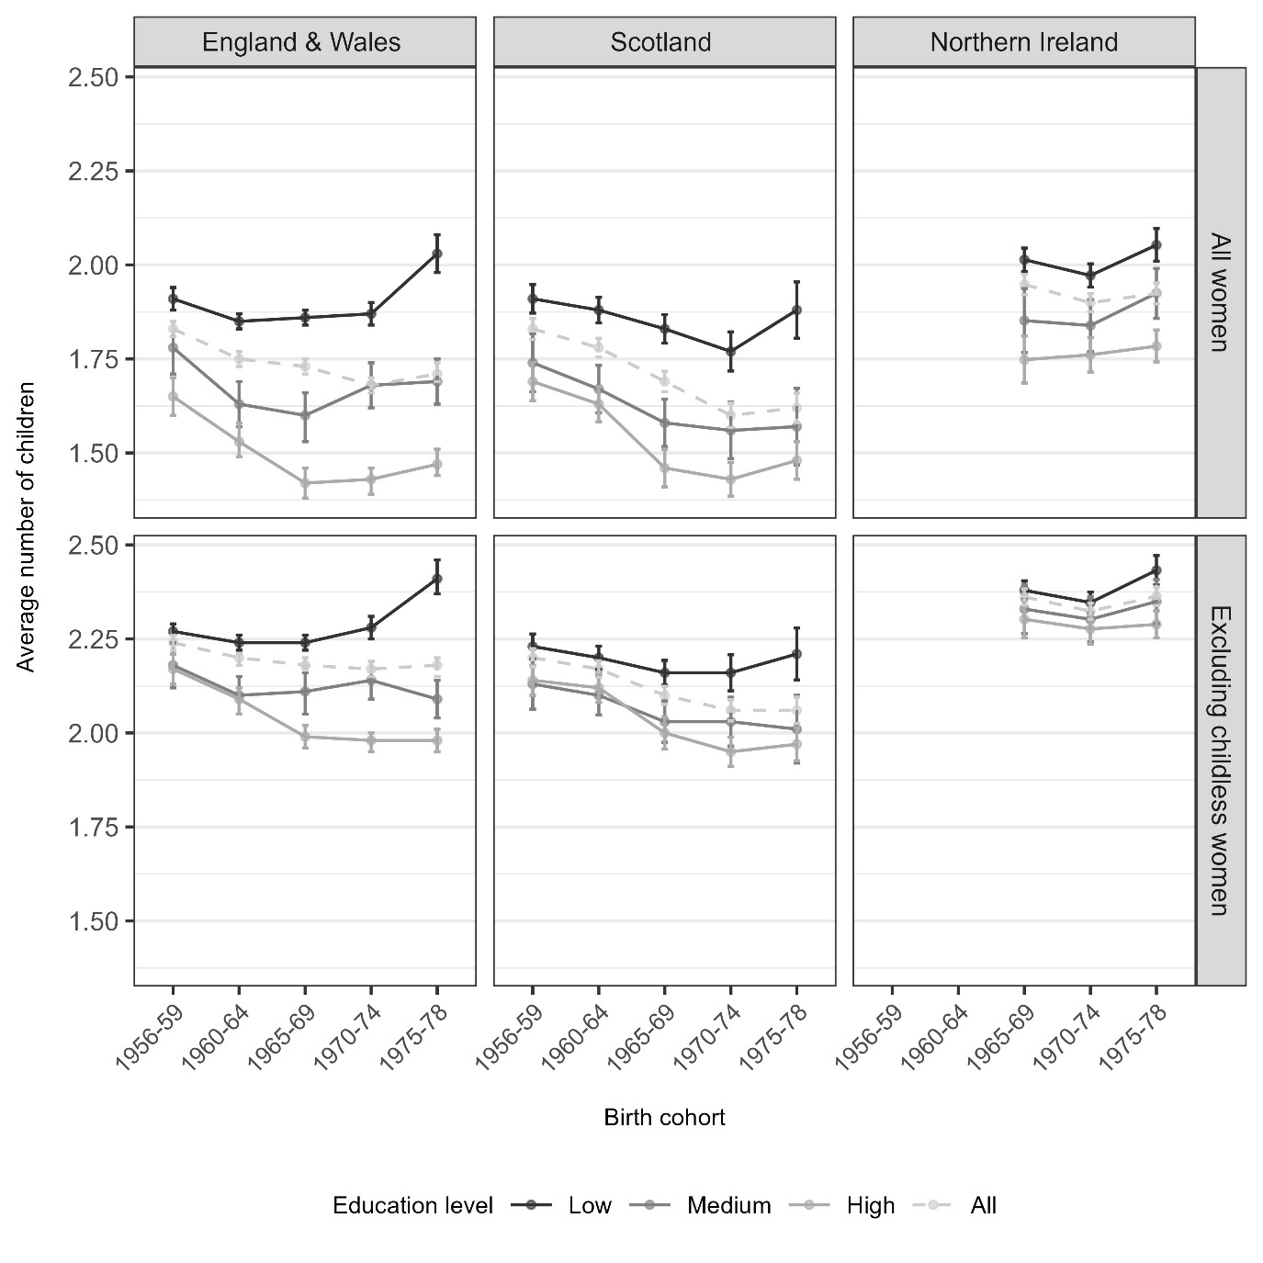

1966-69

*Sources: ONS Longitudinal Study, Scottish Longitudinal Study, Northern Ireland Longitudinal Study (NB NILS earliest data point is for 1966-69 birth cohort)*

### 4.2 Mean age at first birth

#### Figure 4. Mean age at first birth, by educational attainment and birth cohort

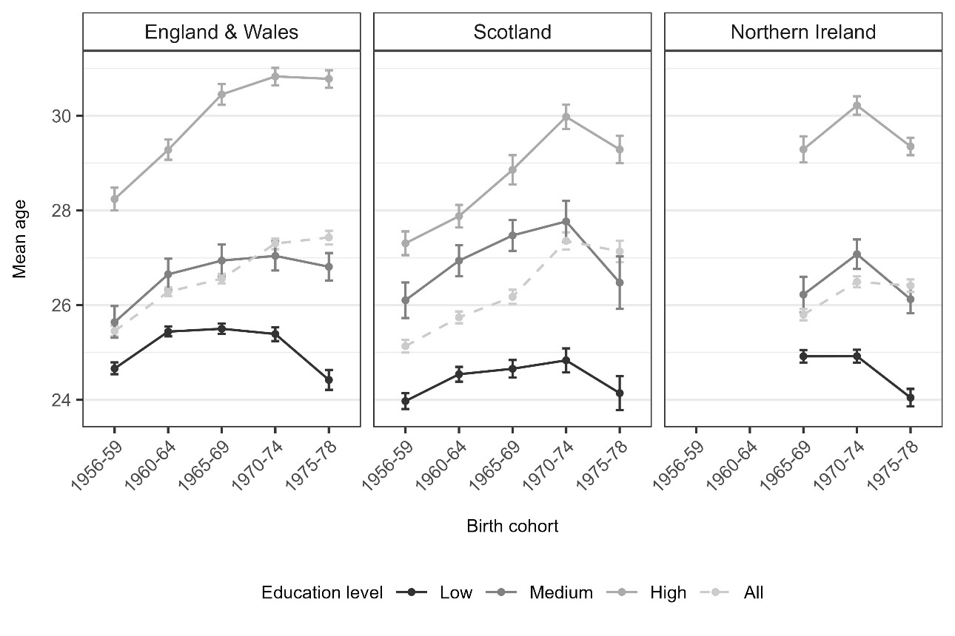

1966-69

*Sources: ONS Longitudinal Study, Scottish Longitudinal Study, Northern Ireland Longitudinal Study*

Overall, the mean age at first birth has increased across cohorts for all the UK’s countries (Figure 4, Appendix 3). However, there are persistent, significant, and widening educational differences in the mean age at first birth. Broadly, there has been only limited (if any) increase in mean age at first birth among the least educated, while medium and highly educated groups have experienced consistent increase or stabilization. The one exception is for the youngest highly and medium educated cohorts in Scotland and Northern Ireland, whose mean age at first birth decreased. Interestingly, the overall mean age at first birth has increased across each cohort for all countries, despite some decreases or stabilization in individual educational groups, presumably due to shifting composition of population towards being higher educated. Across the countries, the overall average mean age at first birth was lower in Northern Ireland, compared with the rest of the UK as well as lower in each educational group when compared with England and Wales, meaning larger families in Northern Ireland (Figure 3) may be linked to earlier entry into motherhood.

### 4.3 Childlessness

Figure 5 shows the proportion of women without children at age 40, by cohort and by educational attainment. Overall childlessness was historically highest in England and Wales but the youngest Scottish cohorts have caught up and now have similar levels of childlessness. Both peaked at about 23% and then declined slightly for the youngest cohort. This tells us that although cohort fertility is lower in Scotland, it is not because of childlessness. Northern Ireland has lower overall childlessness than the other countries but childlessness has also been rising to a high of nearly 20%; however, it does not decrease with the youngest cohort like in England and Wales and Scotland and the rise across cohorts is not significant. The PPR from childless to first birth also shows a similar pattern across countries (Appendix 4, Table 1).

#### Figure 5 – Proportion of women without children at age 40, by birth cohort and educational attainment with 95% confidence interval

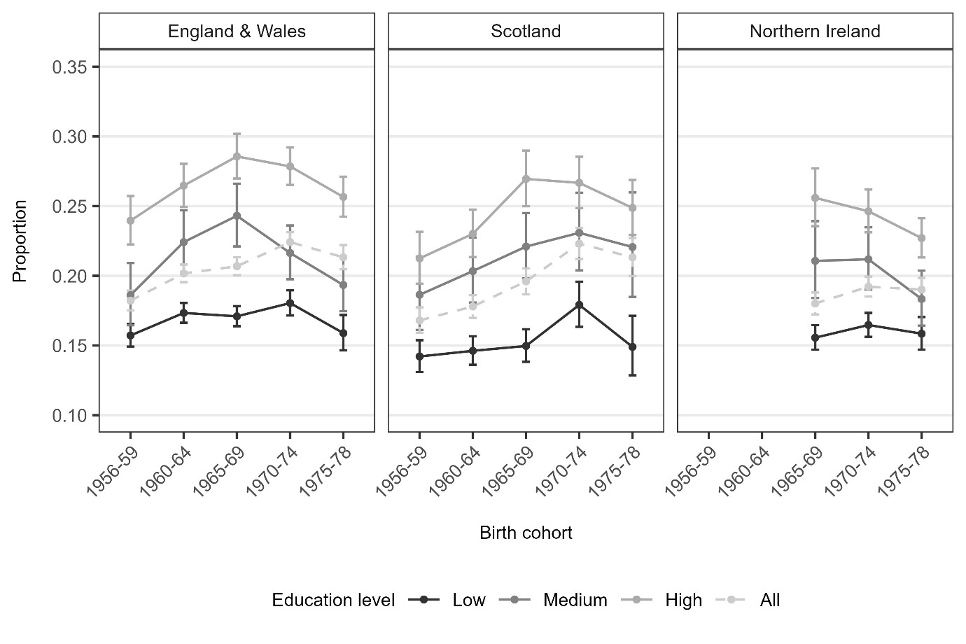

1966-69

*Sources: ONS Longitudinal Study, Scottish Longitudinal Study, Northern Ireland Longitudinal Study (NB NILS earliest data point is for 1966-69 birth cohort)*

However, childlessness followed different patterns depending on educational group (Figure 5). For all countries, there is a significant difference in childlessness between educational groups, showing a positive educational gradient of childlessness- the more educated being more likely to be childless, also reflected in a persistently negative educational pattern of parity progression from childless to first birth. In both Scotland, and England and Wales, there was an upside-down U-shaped pattern for highly and medium educated groups where the proportion childless peaked and then came back down. For low educated people, the pattern of change across cohorts was flatter and did not have the same distinct upside-down U shape. Childlessness trends among the low educated in Scotland remained generally flat with one peak in the 1970-74 birth cohort. In Northern Ireland, trends for the 1966-1979 cohorts correspond with those of the comparable cohorts in England and Wales. Although overall childlessness has increased in Northern Ireland, within each educational group, childlessness has declined or been flat. Similar to the patterns of mean age at childbearing, this is likely because the population in Northern Ireland has become compositionally more highly educated, bringing the population share of childlessness up, even while childlessness levels within individual educational groups are dropping.

### 4.4 Family size distribution

Figure 6 shows the distribution of family sizes at age 40 and their change across cohorts for each of the UK’s countries. Strikingly, in Scotland, there have been significant changes at all parities which show how family size has decreased across cohorts, with an increasing share of both smaller families (childless women and one child families) and a decrease in families with two or more children. There is also a very slight rebound in two and four child families with the youngest cohort, which may be attributed to the least and most educated, whose average family sizes have increased slightly (Figure 3). Conversely, in England and Wales, the only significant change in family size (barring increased childlessness) is a declining share of 3 child families. There is a small decline in two child families in Northern Ireland but no significant changes in the family size distribution, including in childlessness, which is consistent with the average family size trends from Figure 3.

#### Figure 6 – Distribution of completed family size at age 40, by birth cohort with 95% confidence interval Sources: ONS Longitudinal Study, Scottish Longitudinal Study, Northern Ireland Longitudinal Study (NB NILS’ oldest birth cohort is 1966-69)

### 4.5 Educational differences in family size

Figures 7 through 10 show the cohort trends in family size by educational group, separately for each country, starting from 1 child families and ending with 4 or more child families. In contrast to average family size, mean age at first birth, and childlessness, for the share of one child families, there has not been a clear, consistent educational gradient for any country; similarly, the PPR from 1 to 2 births has not had a clear educational pattern either (Appendix 4, Table 2). This is evident from Figure 7 where the lines intersect with each other, meaning the educational gradient is shifting over cohorts, with no consistency. However, the country patterns in the share of one child families are different. In Scotland, there has been a rise in one child families (and a decline in PPR from one to two births) for all educational groups that has not been as marked in either England and Wales nor Northern Ireland, echoing the overall rise in Scottish one child families in figure 6; not only are one child families on the rise in Scotland but the rise is attributable to increases across educational groups. Compared to Britain, Northern Ireland also has a consistently higher overall PPR from one to two births (Appendix 4, Table 2).

#### Figure 7 – Proportion of 1 child families at age 40, by birth cohort and educational attainment with 95% confidence interval

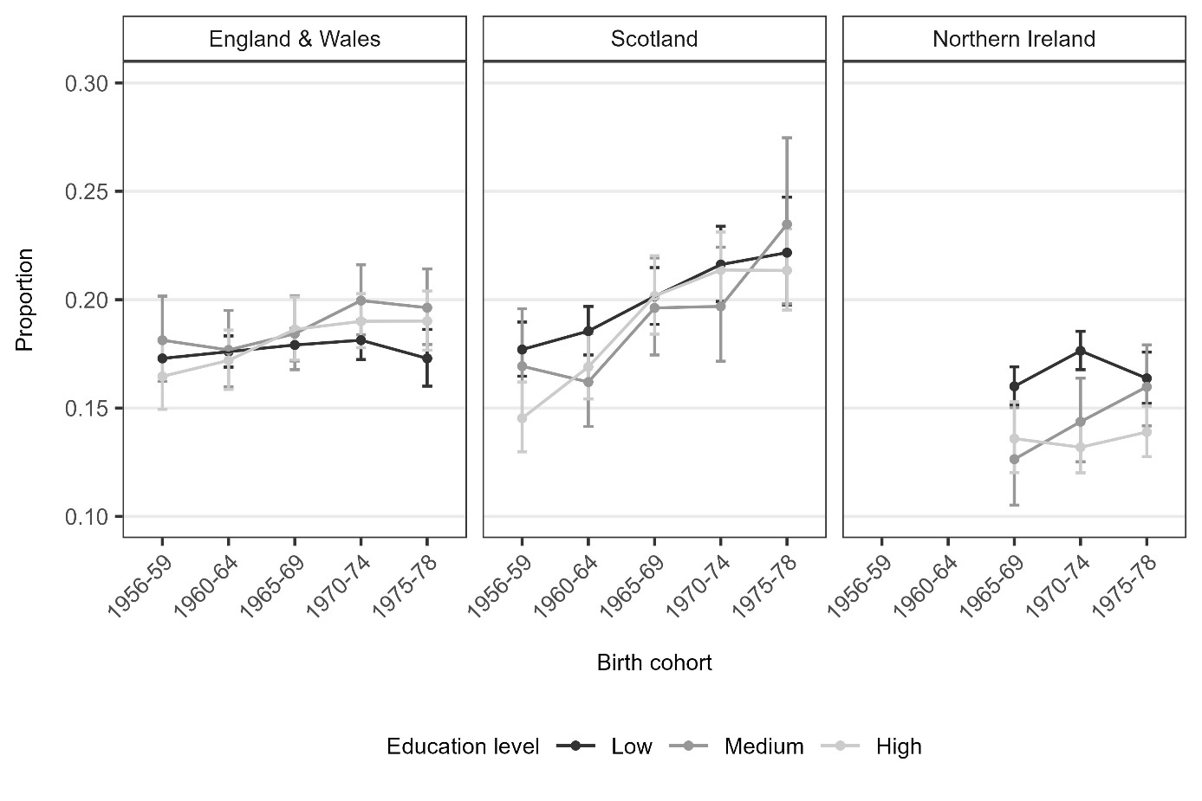

1966-69

*Sources: ONS Longitudinal Study, Scottish Longitudinal Study, Northern Ireland Longitudinal Study (NB NILS earliest data point is for 1966-69 birth cohort)*

Among women with two children at age 40, there is also no clear and stable educational gradient (Figure 8). However, like one child families (Figure 7), there are differences between countries. The share of two child families has declined in low and medium educated groups in Scotland and Northern Ireland and rebounded among highly educated people. Therefore, the (small, not significant) rebound in two child families among the youngest cohort in Scotland (Figure 6) has likely been driven by highly educated women having more two child families, which is also reflected in declining PPR from two to three births among the highly educated (Appendix 4, Table 3). Additionally, the (small, not significant) decline in two child families in Northern Ireland has likely been attributable to the less educated.

For the youngest cohort in England and Wales, there has been a decline in two child families for the lowest educated group which is not evident in the other educational other groups. At the same time, the PPR from two to three births has increased among the low educated (Appendix 4, Table 3), leading to an offsetting increase in larger families (Figures 9 and 10), which has then led to increased average family size among the youngest cohorts. Opposite to the low educated, medium and highly educated groups have experienced an increase in two child families and decreased PPR from two to three births so that in sum, the overall share of two child families has remained stable (Figure 6), despite polarization of behaviors between educational groups.

#### Figure 8 – Proportion of 2 child families at age 40, by birth cohort and educational attainment with 95% confidence interval

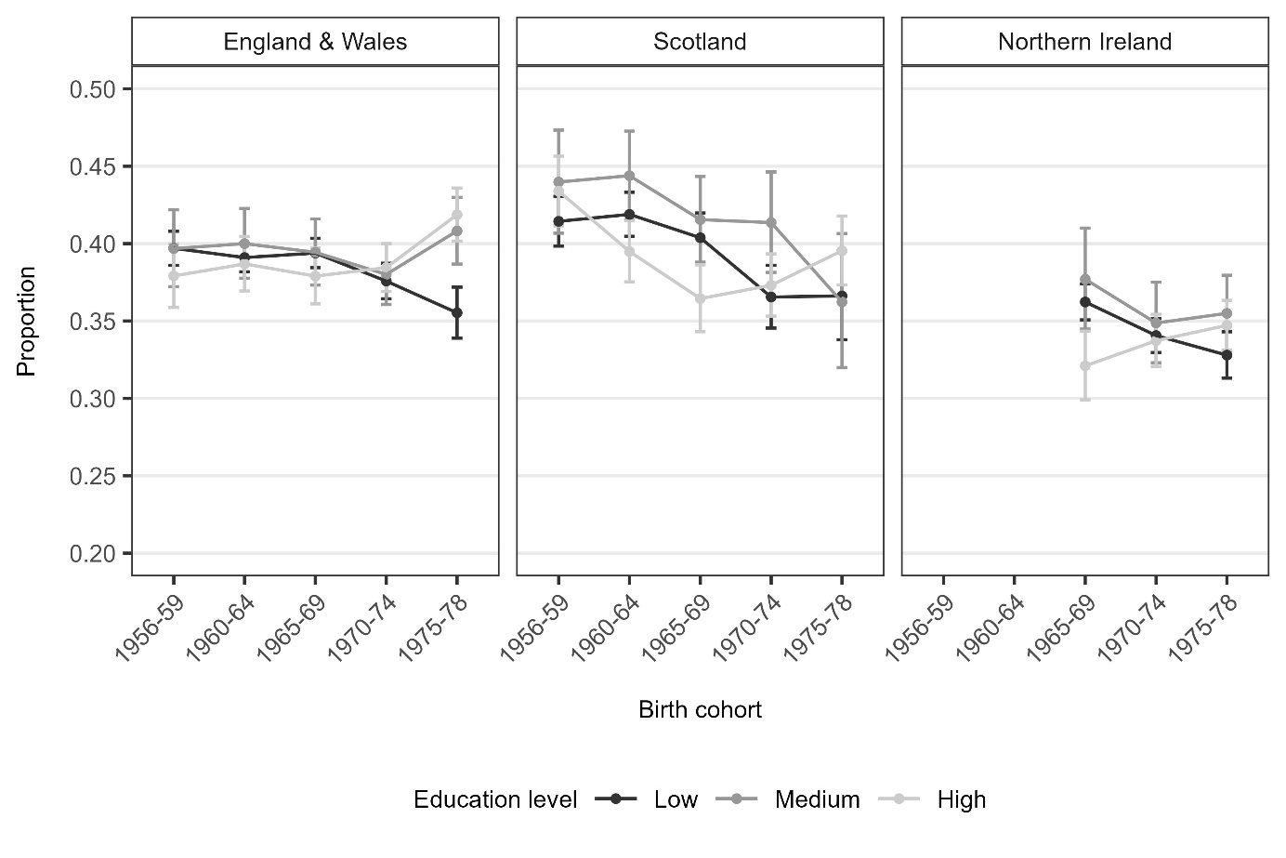

1966-69

*Sources: ONS Longitudinal Study, Scottish Longitudinal Study, Northern Ireland Longitudinal Study (NB NILS earliest data point is for 1966-69 birth cohort)*

In England and Wales and Scotland, medium and highly educated women in both countries have experienced a clear decline in three child families, across cohorts (Figure 9). At the same time, there has been much more gradual decline in three child families among the lowest educated women. The youngest cohort of low and medium educated women in Scotland have even increased their share of three child families and the PPR from two to three births (Appendix 4, Table 3). The decline in two child families (Figure 8) has indeed been offset by the increase in 3 child families in these same groups.

Moreover, the educational gradient of the proportion of three child families has been widening for both Scotland and England and Wales, especially when compared with the lack of educational pattern for one and two child families. However, in Northern Ireland, there is not a comparable educational gradient in the proportion of three child families. For the two older cohorts in Northern Ireland, the share of three child families was the same across educational groups, whereas for the youngest cohort, the lowest and highest educated women experienced an increase in three child families while the medium educated group had a decline. This pattern is very distinct from Scotland and England and Wales and suggests that perhaps there is a three-child norm or ideal in Northern Ireland, absent in the other constituent countries, which may relate to higher levels of religiosity.

#### Figure 9 – Proportion of 3 child families age 40, by birth cohort and educational attainment with 95% confidence interval

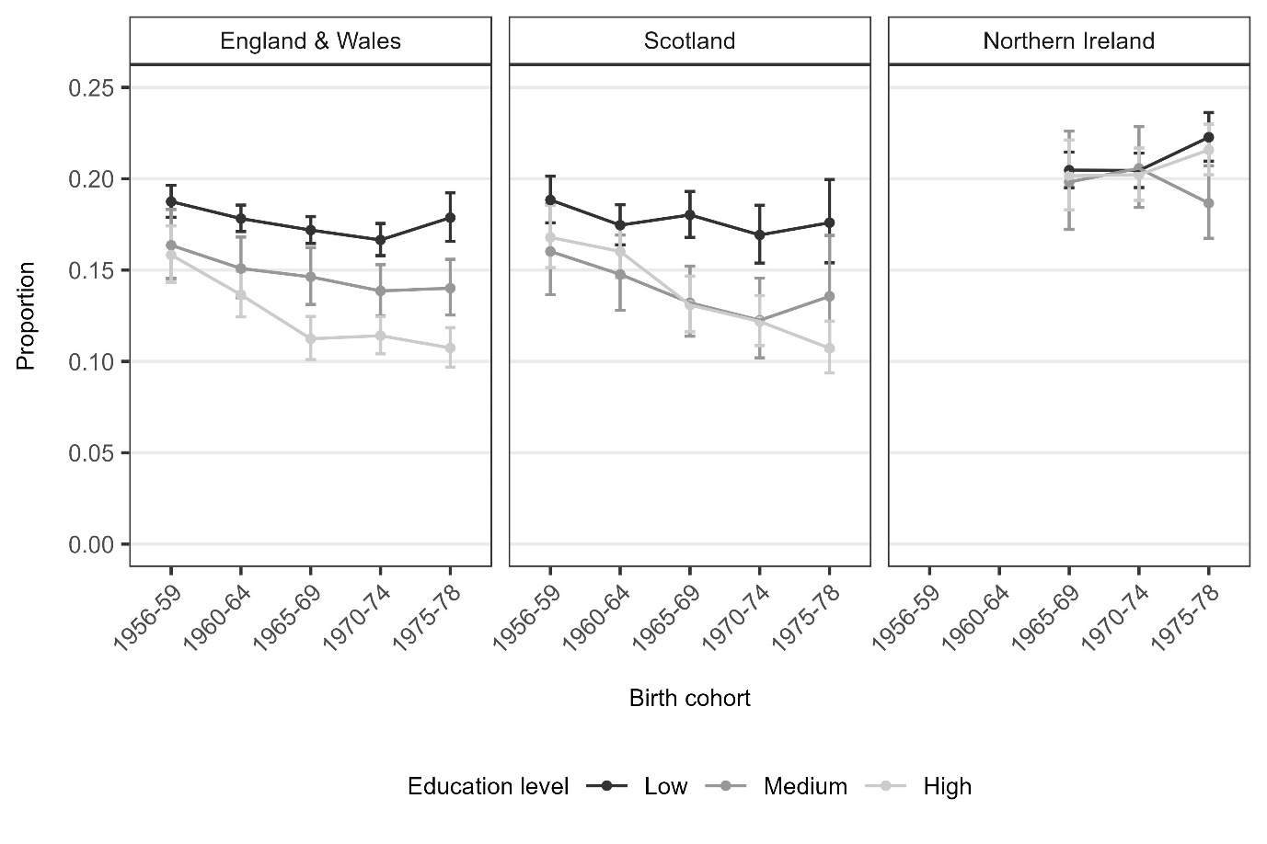

1966-69

*Sources: ONS Longitudinal Study, Scottish Longitudinal Study, Northern Ireland Longitudinal Study (NB NILS earliest data point is for 1966-69 birth cohort)*

Lastly, in all countries, the share of women with four or more children has increased for low and medium educated groups, while for the highly educated, there has been a consistent decline (Figure 10). At this parity, there is an educational gradient for all countries and it is widening in England and Wales and Northern Ireland. The one exception is that the youngest cohort of highly educated women in Scotland have seen a rise in families with four or more children, indicating that the slight (not significant) overall rebound in families with four or more children in the youngest cohort (Figure 6) was driven by all educational groups in Scotland. In contrast, the stability of families with four or more children in England and Wales is attributable to rises and declines in different educational groups offsetting each other.

#### Figure 10 – Proportion of 4+ child families age 40, by birth cohort and educational attainment with 95% confidence interval

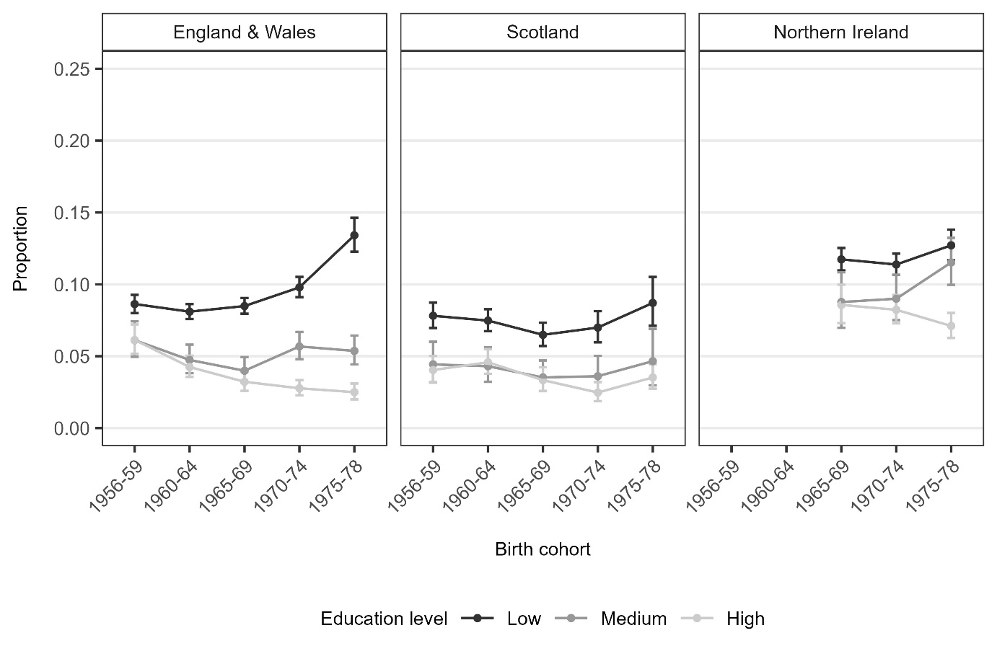

1966-69

*Sources: ONS Longitudinal Study, Scottish Longitudinal Study, Northern Ireland Longitudinal Study (NB NILS earliest data point is for 1966-69 birth cohort)*

## Discussion

For all UK countries, the clearest educational differences in family size are observed in the share of childlessness, which is consistent with past UK trends but contrasts with recent narrowing of educational differences in childlessness seen in other European countries (Reher and Requena 2019, Jalovaara, Andersson and Miettinen 2021, Compans, Beaujouan and Dutreuilh 2022). There is also an educational gradient of the proportion of 3 and 4 child families, albeit not as steep as the pattern for childlessness, which does echo the higher transition to additional births among the less educated in Nordic countries (Jalovaara, Andersson and Miettinen 2021), and provides some evidence for rising polarization of family size in high-income low fertility countries, as predicted by (Brzozowska, Beaujouan and Zeman 2022). To date however, there is no evidence of both increased childlessness and higher order births within lower educated groups, and no tendency at all for rising childlessness among this group either in any UK country.

Compared to Scotland and England and Wales, educational differences in Northern Ireland are narrower, but have widened at higher parities and narrowed for childlessness. A narrowing educational pattern of childlessness in Northern Ireland is in direct contrast with the rest of the UK and more similar to aforementioned European countries. However, in this case the narrowing is due to decreased childlessness among the highly educated, not increases among the low educated.

There are very clear, sometimes widening, educational differences in average family size and educational differences in the mean age at first birth for cohorts born between 1956-59 and 1975-78. Some of the educational differences in average family size are due to educational differences in childlessness, but not all. However, across countries, the mean ages at first birth (overall and for each educational group) are not that different. This suggests that differences in entry into motherhood are unlikely to drive differences in cohort fertility between countries, especially the lower fertility in Scotland and higher fertility in Northern Ireland. And even though the Scottish population has higher levels of education than the rest of the UK, which is usually linked to delayed first births, in fact, the highly educated in Scotland have a younger mean age at first birth, compared to the rest of the UK.

We found country differences in family size distribution that suggest country context may play a role in family building. There are clearly smaller family sizes in Scotland, with an increasing proportion of one child families for all educational groups. In England and Wales and Northern Ireland, the share of two child families has been relatively consistent across educational groups, while it has declined in Scotland for all educational groups. Despite similar fertility intentions across the UK countries (Berrington, Kuang et al. 2023), smaller families are an emerging feature of Scottish fertility and are a more important driver of Scotland’s lower fertility rates than childlessness. Northern Ireland on the other hand shows higher shares of 3 and 4 child families, perhaps a “three child norm”, compared with England and Wales and Scotland, in some cases double the proportion, which together with relatively lower levels of childlessness explain the higher fertility level in Northern Ireland. Moreover, the generally flatter educational pattern of family size distribution in Northern Ireland (excluding childlessness) suggests that once the decision to become a parent is made, ultimate family size is not a feature of disadvantage in the way it may be in England and Wales.

The UK’s countries each display different fertility patterns with respect to parity and education. The two-child norm in England and Wales seems firmly entrenched and has not changed noticeably across cohorts. Instead, fertility decline is due to increased childlessness and a declining share of 3 and 4 child families particularly among the highly educated; in contrast, the less educated have increasingly had 3 and 4 child families across cohorts. The persistently wide educational differences in England and Wales indicate that fertility behavior, particularly with respect to birth order differences, remains strongly tied to disadvantage and features of family complexity such as multi partner fertility and nonmarital fertility. In Scotland, it is not higher levels of childlessness or later age at first birth but smaller families across educational groups which drive the lower fertility rate, suggesting that low fertility does not reflect exclusion from family life among the less advantaged as in other European countries. Otherwise, the highly educated in Scotland have broadly similar behaviors to the highly educated in England and Wales. In contrast is Northern Ireland where larger families are significantly more common, despite the high cost of housing, higher levels of unemployment, and political conflict in the 1990s. Furthermore, levels of childlessness are lower and fertility patterns generally have a weaker educational pattern, suggesting a norm of larger families across social groups possibly attributable to religiosity, high valuation of children, and lack of abortion access.

There are some things to keep in mind with respect to interpreting these results. One, our sample population is largely composed of non-migrants, due to data limitations of collecting full fertility histories for a large sample of migrant women from each UK country, which to date is not available as we are unable to accurately record births which may have occurred overseas. However, this paper confirms that fertility differences between the UK’s countries are not due solely to the fact that England has a larger immigrant and ethnic minority population, since country differences remain in our predominantly non-migrant analysis. Second, the compositions of the populations are also changing over time. This is evident when you see childlessness rising in Northern Ireland yet declining for most individual educational groups. This means that childlessness has increased because the population is becoming more highly educated, which is typically perceived as a positive social development. Moreover, Scotland is more educated so some of the lower cohort and total fertility may be a compositional effect.

The findings of this paper can be used to inform policy making and demonstrate the need for policies to consider heterogeneities in childbearing behavior. For example, the Scottish Government’s concern over persistently low levels of fertility has led to the implementation of a population strategy with the objective of removing barriers to parenthood – such as building more affordable homes, providing additional childcare places, and introducing the Scottish Child Payment (Scottish Government, 2021). This work has highlighted a rise in one child families unique to Scotland, suggesting that policies also need to support parents’ transition to second birth higher order births where they are desired.

## Acknowledgements

**ONS Longitudinal Study**The permission of the Office for National Statistics to use the Longitudinal Study is gratefully acknowledged, as is the help provided by staff of the Centre for Longitudinal Study Information & User Support (CeLSIUS). CeLSIUS is funded by the ESRC under project ES/V003488/1. The authors alone are responsible for the interpretation of the data. This work contains statistical data from ONS which is Crown Copyright. The use of the ONS statistical data in this work does not imply the endorsement of the ONS in relation to the interpretation or analysis of the statistical data. This work uses research datasets which may not exactly reproduce National Statistics aggregates.

**Scottish Longitudinal Study**The help provided by staff of the Longitudinal Studies Centre - Scotland (LSCS) is acknowledged. The LSCS is supported by the ESRC, National Records of Scotland and the Scottish Government. The authors alone are responsible for the interpretation of the data. Census output is Crown copyright and is reproduced with the permission of the Controller of HMSO and the Queen's Printer for Scotland.

**Northern Ireland Longitudinal Study**The help provided by the staff of the Northern Ireland Longitudinal Study/Northern Ireland Mortality Study (NILS/NIMS) and the NILS Research Support Unit is acknowledged. The NILS/NIMS is funded by the Health and Social Care Research and Development Division of the Public Health Agency (HSC R&D Division) and NISRA. The NILS-RSU is funded by the ESRC and the Northern Ireland Government. The authors alone are responsible for the interpretation of the data and any views or opinions presented are solely those of the author and do not necessarily represent those of NISRA/NILS.

Dermot O’Reilly, Michael Rosato, Gemma Catney, Fiona Johnston, Maire Brolly. Cohort description: The Northern Ireland Longitudinal Study (NILS), International Journal of Epidemiology, Volume 41, Issue 3, June 2012, Pages 634–641, <https://doi.org/10.1093/ije/dyq271>

The authors thank the four peer reviewers of earlier versions of this paper for their helpful comments and suggestions. We also thank Dr. Joanne Ellison for her editorial assistance and analytical support with earlier versions of this manuscript.

## References

"Human Fertility Database." Retrieved June 25, 2024, from Available at www.humanfertility.org.

(2008). Labour Force Survey, Office for National Statistics.

(2021). A Scotland for the Future E. A. Directorate, Scottish Government

Aiken, A. R. and F. Bloomer (2019). "Abortion decriminalised in Northern Ireland." Bmj **367**: l6330.

Aiken, A. R. A., D. M. Johnson and K. Broussard (2019). "Abortion in Ireland and Northern Ireland." Obstetrics, Gynaecology & Reproductive Medicine **29**(11): 326-327.

Atherton, G., J. Lewis and P. Bolton (2023). Higher education in the UK: Systems, policy approaches, and challenges. Commons Library Research Briefing, House of Commons Library. **9640**.

Balbo, N., F. Billari and M. Mills (2013). "Fertility in advanced societies: A review of research " European Journal of Population **29**: 1-38.

Bartus, T., L. Murinkó, B. Szél and I. Szalma (2013). "The effect of education on second births in Hungary: A test of the time-squeeze, self-selection and partner-effect hypotheses." Demographic Research **28**(1): 1-32.

Beatty, C. and S. Fothergill (2020). "The Long Shadow of Job Loss: Britain's Older Industrial Towns in the 21st Century." Front Sociol **5**: 54.

Beaujouan, E. and C. Berghammer (2019). "The Gap Between Lifetime Fertility Intentions and Completed Fertility in Europe and the United States: A Cohort Approach." Population Research and Policy Review **38**(4): 507-535.

Becker, G. (1981). A treatise on marriage, Cambridge: Harvard University Press.

Berrington, A. (2017). Childlessness in the UK. Childlessness in Europe: Contexts, causes, and consequences Springer**:** 57-76.

Berrington, A., B. Kuang, S. Christison and H. Kulu (2023) "Understanding fertility trends in Britain: Do fertility intentions differ across England, Wales and Scotland?" ESRC Centre for Population Change Working Paper Series.

Berrington, A., J. Stone and E. Beaujouan (2015). "Educational differences in timing and quantum of childbearing in Britain: A study of cohorts born 1940−1969." Demographic Research **33**(23): 733-764.

Berrington, A. M. and I. Diamond (2000). "Marriage or cohabitation: a competing risks analysis of first‐partnership formation among the 1958 British birth cohort." Journal of the Royal Statistical Society: Series A (Statistics in Society) **163**.

Blossfeld, H. P. and J. Huinink (1991). "Human capital investments or norms of role transition? How women's schooling and career affect the process of family formation." American journal of Sociology **97**(1): 143-168.

Bone, M. (1985). Family planning in Scotland in 1982 : a survey carried out on behalf of the Scottish Home and Health Department. London, Home Health Department.

Boyle, P. J., E. Graham and Z. Feng (2007). Contextualizing demography: The significance of local clusters of fertility in Scotland. MPIDR Working Paper. M. Planck. Rostock.

Brzozowska, Z., E. Beaujouan and K. Zeman (2022). "Is Two Still Best? Change in Parity-Specific Fertility Across Education in Low-Fertility Countries." Population Research and Policy Review **41**(5): 2085-2114.

Chudnovskaya, M. and R. Kashyap (2019). "Is the End of Educational Hypergamy the End of Status Hypergamy? Evidence from Sweden." European Sociological Review **36**(3): 351-365.

Coleman, D. A. and S. Dubuc (2010). "The fertility of ethnic minorities in the UK, 1960s–2006." Population Studies **64**(1): 19-41.

Comolli, C. L., G. Neyer, G. Andersson, L. Dommermuth, P. Fallesen, M. Jalovaara, A. K. Jónsson, M. Kolk and T. Lappegård (2021). "Beyond the Economic Gaze: Childbearing During and After Recessions in the Nordic Countries." Eur J Popul **37**(2): 473-520.

Compans, M.-C. (2021). "Late motherhood, late fatherhood, and permanent childlessness: Trends by educational level and cohorts (1950–1970) in France." Demographic Research **45**(10): 329-344.

Compans, M.-C., É. Beaujouan and C. Dutreuilh (2022). "From union formation to first birth: The role of age at first cohabitation in the transition to motherhood and fatherhood." Population **77**(3): 411-436.

Compton, P. and J. Coward (1989). Fertility and family planning in Northern Ireland. Aldershot, Avebury.

Donnelly, M. and S. Gamsu (2018). "Regional structures of feeling? A spatially and socially differentiated analysis of UK student im/mobility." British Journal of Sociology of Education **39**(7): 961-981.

Ermisch, J. (2021). "English fertility heads south." Demographic Research **45**: 903-916.

Ermisch, J. (2023). "The recent decline in period fertility in England and Wales: Differences associated with family background and intergenerational educational mobility." Population Studies: 1-15.

Esping-Andersen, G. (2009). Incomplete revolution: Adapting welfare states to women's new roles, Polity.

Frejka, T. (2012). "The Role of Contemporary Childbearing Postponement and Recuperation in Shaping Period Fertility Trends." Comparative Population Studies **36**(4).

Gorry, D. (2019). "Heterogeneous Consequences of Teenage Childbearing." Demography **56**(6): 2147-2168.

Graham, E., F. Fiori and K. McKee (2017). Household Changes and Housing Provision in Scotland Scotland’s Population 2016 – The Registrar General’s Annual Review of Demographic Trends. Edinburgh, National Records of Scotland**:** 85-109.

Gray, A. and P. Bruegel (2003). "The availability, use of, and demand for Childcare Services among the parents of children aged 0-14 in Northern Ireland."

Grow, A. and J. Van Bavel (2015). "Assortative Mating and the Reversal of Gender Inequality in Education in Europe: An Agent-Based Model." PLOS ONE **10**(6).

Härkönen, J. (2018). Single-mother poverty: how much do educational differences in single motherhood matter? The triple bind of single parent families: resources, employment and policies to improve wellbring. R. Nieuwenhuis and L. Maldonado. Bristol, Policy Press**:** 31-50.

Harrison, J., H. Kulu, K. L. Keenan and F. Sullivan (2023). "Union formation and fertility amongst immigrants from Pakistan and their descendants in the United Kingdom: A multichannel sequence analysis." Demographic Research **48**(10): 271-320.

Hellstrand, J., J. Nisen and J. Myrskyla (2020). "All-time low period fertility in Finland: Demographic drivers, tempo effects, cohort implications." Population Studies **74**(3): 315-329.

Jalovaara, M., L. Andersson and A. Miettinen (2021). "Parity disparity: Educational differences in Nordic fertility across parities and number of reproductive partners." Population Studies: 1-18.

Jalovaara, M. and M. Kreyenfeld (2020). Childbearing Across Partnerships in Finland and Germany. Divorce in Europe: New Insights in Trends, Causes and Consequences of Relation Break-ups. D. Mortelmans. Cham, Springer International Publishing**:** 315-335.

Jalovaara, M., G. Neyer, G. Andersson, J. Dahlberg, L. Dommermuth, P. Fallesen and T. Lappegård (2019). "Education, gender, and cohort fertility in the Nordic countries." European Journal of Population **35**(3): 563-586.

Joshi, H. (2002). "Production, Reproduction, and Education: Women, Children, and Work in a British Perspective." Population and Development Review **28**(3): 445-474.

Kohler, H.-P., F. C. Billari and J. A. Ortega (2002). "The Emergence of Lowest-Low Fertility in Europe during the 1990s." Population and Development Review **28**(4): 641-680.

Kolk, M. (2019). "The relationship between lifecourse accumulated income and childbearing of Swedish men and women born 1940-1970."

Konietzka, D. and M. Kreyenfeld (2010). "The growing educational divide in mothers’ employment: an investigation based on the German micro-censuses 1976-2004." Work, Employment and Society **24**(2): 260-278.

Köppen, K. (2006). "Second births in western Germany and France." Demographic Research **14**(14): 295-330.

Kossek, E. E. and B. A. Lautsch (2018). "Work–life flexibility for whom? Occupational status and work–life inequality in upper, middle, and lower level jobs." The Academy of Management Annals **12**(1): 5-36.

Kravdal, Ø. (1992). "The Weak Impact of Female Labour Force Participation on Norwegian Third-Birth Rates." European Journal of Population / Revue Européenne de Démographie **8**(3): 247-263.

Kravdal, Ø. (2001). "The High Fertility of College Educated Women in Norway: An Artefact of the Separate Modelling of Each Parity Transition." Demographic Research **5**(6): 187-216.

Kreyenfeld, M. (2002). "Time Squeeze, Partner Effect or Self-Selection?: An Investigation into the Positive Effect of Women’s Education on Second Birth Risks in West Germany." Demographic Research **7**(2): 15-48.

Kuang, B. and A. Berrington (2023). "Cross-national differences in the use of contraception and abortion services between England, Wales, and Scotland." BMJ Sex Reprod Health **49**(2): 143-144.

Lazzari, E., R. Mogi and V. Canudas-Romo (2021). "Educational composition and parity contribution to completed cohort fertility change in low-fertility settings." Population Studies **75**(2): 153-167.

Lesthaeghe, R. (2010). "The Unfolding Story of the Second Demographic Transition." Population and Development Review **36**(2): 211-251.

Marczak, J., W. Sigle and E. Coast (2018). "When the grass is greener: Fertility decisions in a cross-national context." Population Studies **72**(2): 201-216.

Maslow, A. H. (1943). "A theory of human motivation." Psychological Review **50**: 370-396.

McGregor, P. and P. McKee (2016). "Religion and Fertility in Contemporary Northern Ireland." European Journal of Population **32**: 599-622.

McKenna, F. (2023). "Background Information on Northern Ireland- Housing." from <https://cain.ulster.ac.uk/ni/housing.htm>.

Mikolai, J. and H. Kulu (2023). "Partnership and fertility trajectories of immigrants and descendants in the United Kingdom: A multilevel multistate event history approach." Population Studies **77**(3): 359-378.

Neyer, G. (2013). Welfare states, family policies, and fertility in Europe. The Demography of Europe. G. Neyer, G. Andersson, H. Kulu, L. Bernardi and C. Buhler. Dordrecht, Springer.

Ní Bhrolcháin, M. and E. Beaujouan (2012). "Fertility postponement is largely due to rising educational enrolment." Population Studies **66**(3): 311-327.

Nisén, J., S. Klüsener, J. Dahlberg, L. Dommermuth, A. Jasilioniene, M. Kreyenfeld, T. Lappegård, P. Li, P. Martikainen, K. Neels, B. Riederer, S. Te Riele, L. Szabó, A. Trimarchi, F. Viciana, B. Wilson and M. Myrskylä (2021). "Educational Differences in Cohort Fertility Across Sub-national Regions in Europe." Eur J Popul **37**(1): 263-295.

Ohlsson-Wijk, S. and G. Andersson (2022). "Disentangling the Swedish fertility decline of the 2010s." Demographic Research **47**: 345-358.

Patrick, R. and K. Andersen (2023). "The two-child limit and fertility decision making: When policy narratives and lived experiences collide." Social Policy & Administration **57**(5): 580-595.

Peri-Rotem, N. (2016). "Religion and Fertility in Western Europe: Trends Across Cohorts in Britain, France and the Netherlands." European Journal of Population **32**(2): 231-265.

Pezer, M. (2022). "Public policies supporting families with children across welfare regimes: An empirical assessment of six European countries." Journal of European Social Policy **32**(3): 254-269.

Phillips, D., T. Waters and T. Wernham (2023). Employment, earnings, and incomes in Scotland, Institute for Fiscal Studies

Raz-Yurovich, L. (2016). "Outsourcing of Housework and the Transition to a Second Birth in Germany." Population Research and Policy Review **35**(3): 401-419.

Reader, M., J. Portes and R. Patrick (2022). Does cutting child benefits reduce fertility in larger families? Evidence from the UK's two-child limit. Bonn, Germany, IZA Institute of Labor Economics. **15203**.

Reher, D. and M. Requena (2019). "Childlessness in twentieth-century Spain: A cohort analysis for women born 1920–1969." European Journal of Population **35**: 133-160.

Rendall, M., C. Couet, T. Lappegard, I. Robert-Bobée, M. Rønsen and S. Smallwood (2005). "First births by age and education in Britain, France and Norway." Popul Trends(121): 27-34.

Rindfuss, R. R., D. Guilkey, S. P. Morgan, K. øystein and G. Karen Benjamin (2007). "Child Care Availability and First-Birth Timing in Norway." Demography **44**(2): 345-372.

Shattock, M. and A. Horvath (2020). "The decentralisation of the governance of UK higher education: the effects of devolution to Scotland, Wales and Northern Ireland, and on England." Policy Reviews in Higher Education **4**(2): 164-178.

Sigle-Rushton, W. (2008). "England and Wales

Stable fertility and pronounced social status differences." Demographic Research **19**: 455-502.

Sigle, W. (2016). Fertility and Population Change in the United Kingdom. Low Fertility, Institutions, and their Policies: Variations Across Industrialized Countries. R. R. Rindfuss and M. K. Choe. Cham, Springer International Publishing**:** 77-98.

Sobotka, T. and É. Beaujouan (2014). "Two Is Best? The Persistence of a Two-Child Family Ideal in Europe." Population and Development Review **40**(3): 391-419.

Sobotka, T., E. Beaujouan and Z. Brzozowska (2017). Reversals, diminishing differentials, or stable patterns? Long-term trends in educational gradient in fertility across developed countries. International Population Conference (IUSSP). Cape Town, South Africa.

Surkyn, J. and R. Lesthaeghe (2004). "Value Orientations and the Second Demographic Transition (SDT) in Northern, Western and Southern Europe: An Update." Demographic Research **S3**: 45-86.

Thomson, E., T. Lappegård, M. Carlson, A. Evans and E. Gray (2014). "Childbearing Across Partnerships in Australia, the United States, Norway, and Sweden." Demography **51**(2): 485-508.

Timaeus, I. M. and T. A. Moultrie (2015). "Teenage Childbearing and Educational Attainment in South Africa." Stud Fam Plann **46**(2): 143-160.

Tocchioni, V., A. Berrington, D. Vignoli and A. Vitali (2021). "The Changing Association Between Homeownership and the Transition to Parenthood." Demography **58**(5): 1843-1865.

Van Bavel, J., M. Klesment, E. Beaujouan, Z. Brzozowska, A. Puur, D. Reher, M. Requena, G. Sandström, T. Sobotka and K. Zeman (2018). "Seeding the gender revolution: Women's education and cohort fertility among the baby boom generations." Popul Stud (Camb) **72**(3): 283-304.

Vasireddy, S., A. Berrington, B. Kuang and H. Kulu (2023). "Education and Fertility: A Review of Recent Research in Europe." Comparative Population Studies **48**.

Vignoli, D., R. Guetto, G. Bazzani, E. Pirani and A. Minello (2020). "A reflection on economic uncertainty and fertility in Europe: The Narrative Framework." Genus **76**(1): 28.

Walker, G. (2017) "The 1947 Education Act – a landmark in Northern Ireland’s history." Queen's Policy Engagement.

Wellings, K., K. G. Jones, C. H. Mercer, C. Tanton, S. Clifton, J. Datta, A. J. Copas, B. Erens, L. J. Gibson, W. Macdowall, P. Sonnenberg, A. Phelps and A. M. Johnson (2013). "The prevalence of unplanned pregnancy and associated factors in Britain: findings from the third National Survey of Sexual Attitudes and Lifestyles (Natsal-3)." Lancet **382**(9907): 1807-1816.

Wood, J., K. Neels and T. Kil (2014). "The educational gradient of childlessness and cohort parity progression in 14 low fertility countries." Demographic Research **31**: 1365-1416.

Wright, R. E., J. F. Ermisch, P. R. Hinde and H. E. Joshi (1988). "The third birth in Great Britain." J Biosoc Sci **20**(4): 489-496.

Zeman, K., T. Sobotka, E. Beaujouan and Z. Brzozowska (2018). "Cohort fertility decline in low fertility countries: Decomposition using parity progression ratios." Demographic Research **38**(25): 651-690.

## Appendix

### Appendix 1. Education variable construction

Educational attainment variable, based on 2011 census



Educational attainment variable, based on 2001 census



### Appendix 2. Average family size, by educational attainment and birth cohort

#### England and Wales

|  |  |  |  |  |  |
| --- | --- | --- | --- | --- | --- |
|  | Birth cohort | | | | |
| All women | 1956-59 | 1960-64 | 1965-69 | 1970-74 | 1975-78 |
| Low | 1.91 | 1.85 | 1.86 | 1.87 | 2.03 |
| Medium | 1.78 | 1.63 | 1.60 | 1.68 | 1.69 |
| High | 1.65 | 1.53 | 1.42 | 1.43 | 1.47 |
| All | 1.83 | 1.75 | 1.73 | 1.68 | 1.71 |
|  |  |  |  |  |  |
| Excluding childless women |  |  |  |  |  |
| Low | 2.27 | 2.24 | 2.24 | 2.28 | 2.41 |
| Medium | 2.18 | 2.10 | 2.11 | 2.14 | 2.09 |
| High | 2.17 | 2.09 | 1.99 | 1.98 | 1.98 |
| All | 2.24 | 2.20 | 2.18 | 2.17 | 2.18 |

*Source: ONS Longitudinal Study*

#### Scotland

|  |  |  |  |  |  |
| --- | --- | --- | --- | --- | --- |
|  | Birth cohort | | | | |
| All women | 1956-59 | 1960-64 | 1965-69 | 1970-74 | 1975-78 |
| Low | 1.91 | 1.88 | 1.83 | 1.77 | 1.88 |
| Medium | 1.74 | 1.67 | 1.58 | 1.56 | 1.57 |
| High | 1.69 | 1.63 | 1.46 | 1.43 | 1.48 |
| All | 1.83 | 1.78 | 1.69 | 1.60 | 1.62 |
|  |  |  |  |  |  |
| Excluding childless women |  |  |  |  |  |
| Low | 2.23 | 2.20 | 2.16 | 2.16 | 2.21 |
| Medium | 2.13 | 2.10 | 2.03 | 2.03 | 2.01 |
| High | 2.14 | 2.12 | 2.00 | 1.95 | 1.97 |
| All | 2.20 | 2.17 | 2.10 | 2.06 | 2.06 |

*Source: Scottish Longitudinal Study*

#### Northern Ireland

|  |  |  |  |  |  |
| --- | --- | --- | --- | --- | --- |
|  | Birth cohort | | | | |
| All women | 1956-59 | 1960-64 | 1966-69 | 1970-74 | 1975-78 |
| Low |  |  | 2.01 | 1.97 | 2.05 |
| Medium |  |  | 1.85 | 1.84 | 1.93 |
| High |  |  | 1.75 | 1.76 | 1.78 |
| All |  |  | 1.95 | 1.90 | 1.92 |
|  |  |  |  |  |  |
| Excluding childless women |  |  |  |  |  |
| Low |  |  | 2.38 | 2.35 | 2.43 |
| Medium |  |  | 2.33 | 2.30 | 2.35 |
| High |  |  | 2.30 | 2.28 | 2.29 |
| All |  |  | 2.36 | 2.32 | 2.36 |

*Source: Northern Ireland Longitudinal Study*

### Appendix 3. Mean age at first birth

#### Mean age at first birth, by educational attainment and birth cohort

|  |  |  |  |  |  |
| --- | --- | --- | --- | --- | --- |
|  | Birth cohort | | | | |
|  | 1956-59 | 1960-64 | 1965-69 | 1970-74 | 1975-78 |
| England & Wales | |  |  |  |  |
| Low | 24.7 | 25.4 | 25.5 | 25.4 | 24.4 |
| Medium | 25.6 | 26.7 | 26.9 | 27 | 26.8 |
| High | 28.2 | 29.3 | 30.5 | 30.8 | 30.8 |
| All | 25.5 | 26.3 | 26.6 | 27.3 | 27.4 |
|  |  |  |  |  |  |
| Scotland |  |  |  |  |  |
| Low | 24 | 24.5 | 24.7 | 24.8 | 24.1 |
| Medium | 26.1 | 26.9 | 27.5 | 27.8 | 26.5 |
| High | 27.3 | 27.9 | 28.9 | 30 | 29.3 |
| All | 25.1 | 25.7 | 26.2 | 27.4 | 27.1 |
|  |  |  |  |  |  |
| Northern Ireland | |  |  |  |  |
| Low |  |  | 24.9 | 24.9 | 24.0 |
| Medium |  |  | 26.2 | 27.1 | 26.1 |
| High |  |  | 29.3 | 30.2 | 29.4 |
| All |  |  | 25.8 | 26.5 | 26.4 |

*Sources: ONS Longitudinal Study, Scottish Longitudinal Study, Northern Ireland Longitudinal Study (NB NILS earliest data point is for 1966-69 birth cohort)*

### Appendix 4. Parity Progression ratios

#### Table 1 – Parity progression ratios, transition from childless to first birth by educational attainment and country

|  |  |  |  |  |  |
| --- | --- | --- | --- | --- | --- |
| England & Wales | 1956-59 | 1960-64 | 1965-69 | 1970-74 | 1975-78 |
| Low | 0.84 | 0.83 | 0.83 | 0.82 | 0.84 |
| Medium | 0.81 | 0.78 | 0.76 | 0.78 | 0.81 |
| High | 0.76 | 0.74 | 0.71 | 0.72 | 0.74 |
| Scotland | 1956-59 | 1960-64 | 1965-69 | 1970-74 | 1975-78 |
| Low | 0.86 | 0.85 | 0.85 | 0.82 | 0.85 |
| Medium | 0.81 | 0.80 | 0.78 | 0.77 | 0.78 |
| High | 0.79 | 0.77 | 0.73 | 0.73 | 0.75 |
| Northern Ireland | 1956-59 | 1960-64 | 1966-69 | 1970-74 | 1975-78 |
| Low |  |  | 0.84 | 0.84 | 0.84 |
| Medium |  |  | 0.79 | 0.79 | 0.82 |
| High |  |  | 0.74 | 0.75 | 0.77 |

*Sources: ONS Longitudinal Study, Scottish Longitudinal Study, Northern Ireland Longitudinal Study*

#### Table 2 – Parity progression ratios, transition from first to second birth, by educational attainment and country

|  |  |  |  |  |  |  |  |  |  |
| --- | --- | --- | --- | --- | --- | --- | --- | --- | --- |
| England & Wales | 1956-59 | 1960-64 | | 1965-69 | | 1970-74 | | 1975-78 | |
| Low | 0.79 | 0.79 | | 0.78 | | 0.78 | | 0.79 | |
| Medium | 0.77 | 0.77 | | 0.76 | | 0.76 | | 0.75 | |
| High | 0.79 | 0.77 | | 0.73 | | 0.73 | | 0.75 | |
| Scotland | 1956-59 | | 1960-64 | | 1965-69 | | 1970-74 | | 1975-78 | |
| Low | 0.79 | | 0.78 | | 0.76 | | 0.74 | | 0.74 | |
| Medium | 0.79 | | 0.80 | | 0.75 | | 0.74 | | 0.70 | |
| High | 0.81 | | 0.78 | | 0.72 | | 0.71 | | 0.72 | |
| Northern Ireland | 1956-59 | | 1960-64 | | 1966-69 | | 1970-74 | | 1975-78 | |
| Low |  | |  | | 0.81 | | 0.79 | | 0.81 | |
| Medium |  | |  | | 0.84 | | 0.82 | | 0.80 | |
| High |  | |  | | 0.82 | | 0.82 | | 0.82 | |

*Sources: ONS Longitudinal Study, Scottish Longitudinal Study, Northern Ireland Longitudinal Study*

#### Table 3 – Parity progression ratios, transition from second to third birth, by educational attainment and country

|  |  |  |  |  |  |  |
| --- | --- | --- | --- | --- | --- | --- |
| England & Wales | | 1956-59 | 1960-64 | 1965-69 | 1970-74 | 1975-78 |
| Low | | 0.41 | 0.40 | 0.39 | 0.41 | 0.47 |
| Medium | | 0.37 | 0.34 | 0.35 | 0.35 | 0.33 |
| High | | 0.36 | 0.32 | 0.27 | 0.27 | 0.25 |
| Scotland | 1956-59 | | 1960-64 | 1965-69 | 1970-74 | 1975-78 |
| Low | 0.39 | | 0.37 | 0.38 | 0.40 | 0.42 |
| Medium | 0.31 | | 0.30 | 0.29 | 0.28 | 0.33 |
| High | 0.32 | | 0.34 | 0.31 | 0.28 | 0.26 |
| Northern Ireland | | 1956-59 | 1960-64 | 1966-69 | 1970-74 | 1975-78 |
| Low | |  |  | 0.47 | 0.48 | 0.51 |
| Medium | |  |  | 0.43 | 0.46 | 0.46 |
| High | |  |  | 0.47 | 0.46 | 0.45 |

*Sources: ONS Longitudinal Study, Scottish Longitudinal Study, Northern Ireland Longitudinal Study*

#### Table 4 – Parity progression ratios, transition from third to fourth, by educational attainment and country

|  |  |  |  |  |  |  |
| --- | --- | --- | --- | --- | --- | --- |
| England & Wales | | 1956-59 | 1960-64 | 1965-69 | 1970-74 | 1975-78 |
| Low | | 0.31 | 0.31 | 0.33 | 0.37 | 0.43 |
| Medium | | 0.30 | 0.25 | 0.22 | 0.31 | 0.29 |
| High | | 0.27 | 0.24 | 0.22 | 0.20 | 0.19 |
| Scotland | 1956-59 | | 1960-64 | 1965-69 | 1970-74 | 1975-78 |
| Low | 0.29 | | 0.30 | 0.26 | 0.29 | 0.33 |
| Medium | 0.21 | | 0.22 | 0.21 | 0.23 | 0.26 |
| High | 0.20 | | 0.22 | 0.20 | 0.17 | 0.25 |
| Northern Ireland | | 1956-59 | 1960-64 | 1966-69 | 1970-74 | 1975-78 |
| Low | |  |  | 0.36 | 0.36 | 0.36 |
| Medium | |  |  | 0.31 | 0.30 | 0.38 |
| High | |  |  | 0.30 | 0.29 | 0.25 |

*Sources: ONS Longitudinal Study, Scottish Longitudinal Study, Northern Ireland Longitudinal Study*

## Declarations

### Availability of data and material

The datasets used in this research are available through application at the respective Longitudinal Study offices, ONS, NRS, and NISRA. More information may be found on their websites.

## Funding

We acknowledge the Economic and Social Research Council as the funders of this research (grant number ES/S009477/1).

1. University of Southampton, Department of Social Statistics & Demography, United Kingdom
2. University of St. Andrews, School of Geography & Sustainable Development, United Kingdom
3. England and Wales collect their census and vital data together and due to internal migration between England and Wales, it is difficult to disentangle Welsh and English events/data. This is because there are several country linked factors – place of mother’s birth, place of mother’s residence, place of child’s birth and then differences in mother’s residence across time and birth order – which may occur across countries. Moreover, Wales is 5% of the UK population and England and Wales’ total fertility rates are very similar.