Co-occurring Impairments in several domains of Memory following Neonatal Hypoxic-Ischaemic Encephalopathy have Real-life Implications

Abby Holder1, Rina Cianfaglione1, Jade Burns2, Brigitte Vollmer1,4,Caroline Edmonds3*

1Clinical Neurosciences, Clinical and Experimental Sciences, Faculty of Medicine, University of Southampton, UK

2 Children’s Clinical Trials Assistant (CTA), National Institute for Health Research, University Hospital Southampton NHS Foundation Trust

3 School of Psychology, University of East London, London, UK

4Neonatal and Paediatric Neurology, Southampton Children’s Hospital, University Hospital Southampton NHS Foundation Trust, Southampton, UK

*Corresponding author.

Email address: [c.edmonds@uel.ac.uk](mailto:c.edmonds@uel.ac.uk)

Postal address: School of Psychology, University of East London, Water Lane, Stratford, London, E15 4LZ, UK

Abstract

Background

Neonatal Hypoxic-Ischaemic Encephalopathy (HIE) increases risk for neurodevelopmental impairment. Information on school-age memory function is limited in children who received hypothermia treatment (TH) for neonatal HIE.

Objectives

To evaluate memory function in school-aged children who had neonatal HIE and TH and survived without major neuromotor impairment.

Method  
Fifty-one children with neonatal HIE and 41 typically developing (TD) peers participated. At age 6-8 years general cognitive abilities (FSIQ) were assessed with Wechsler Intelligence Scale for Children (WISC-V), immediate and delayed visual and verbal memory with Children’s Memory Scale (CMS), everyday memory with Rivermead Behavioural Memory Test for Children (RBMT-C), working memory with WISC-V. Real-life implications were assessed with Behaviour Rating Inventory for Executive Function (BRIEF; Parent and Teacher). Between group differences were examined and correlations performed to assess associations between memory measures. Relationship maps illustrate co-occurring impairments.

Results

FSIQ was in the normal range for both groups but significantly lower in the HIE group. Children with HIE had significantly more deficits in working memory (20.4% vs 0%), verbal immediate (20.0% vs 2.5%), verbal delayed (17.8% vs 2.5%), visual immediate (28.9% vs 7.5%), and everyday memory (38.8% vs 5.6%). Relationship maps identified more co-occurring clinical/borderline impairments in children with HIE (45.1% vs 4.9%) and more frequent clinical impairments in real-world memory measures.

Conclusion

Despite hypothermia treatment, and with general cognitive abilities in the normal range, children with neonatal HIE are at risk of co-occurring memory impairments, affecting everyday functioning at home and school. Timely identification is important for individually targeted support.

**Keywords**

Neonatal hypoxic-ischaemic encephalopathy, Therapeutic hypothermia, School-age outcomes, Memory function

**1. Introduction**

Moderate to severe neonatal hypoxic-ischaemic encephalopathy (HIE) following perinatal asphyxia affects 0.5–3/1000 live births in high-income countries, more in low- and middle-income countries 1,2. Infants experiencing neonatal HIE are at increased risk of neurodevelopmental impairment 3. The introduction of therapeutic hypothermia (TH) as standard treatment for moderate to severe HIE has successfully reduced mortality and severe neurodevelopmental disability 4. Despite these positive outcomes, there is evidence that subtle cognitive and behavioural impairments may persist even in those who survive without severe neurodisability 5–8.

Memory impairments have been observed following neonatal HIE and have been associated with injury to the hippocampus, a region highly susceptible to hypoxic-ischaemic damage 9. Prior to introduction of TH, De Haan et al (2006) reviewed memory outcomes in children with a history of perinatal asphyxia (PA) who did not undergo hypothermia treatment 10. These children often experienced compromised episodic memory, long-term verbal, and, occasionally, visual memory; this was associated with smaller hippocampal volumes. Conversely, semantic and immediate memory typically remained within normal ranges.

Following TH introduction, some studies observed preserved memory functioning in infants who underwent TH for HIE. For example, Pfister et al (2016) reported preserved auditory memory at two weeks of age using event-related potentials 11, while another study assessed memory function using elicited imitation in pre-verbal children aged 12 months, revealing similar episodic memory functioning in the HIE group and a control group 12. There is a lack of research in the TH era extending into later childhood, despite evidence that neurodevelopmental deficits, including memory problems, may only manifest at school-age 3 andmay only emerge once cognitive load increases at school level 3,7. For example, a follow-up study using the sample which initially showed preserved memory recognition at two weeks 11 revealed, by age five years, deficits in memory functioning, notably sentence recall and narrative memory which was correlated with reduced hippocampal volumes 13.

In the few studies that have focused on school-age outcomes of those treated with TH, deficits in working memory, long-term episodic memory and visuospatial memory are reported, regardless of TH treatment 6,14–16.To our knowledge, no existing studies have investigated potential real-life implications of memory impairment following HIE. Given that neonatal HIE is known to have negative effects upon school readiness and performance 6,17, using measures which emulate real-life settings and accurately reflect everyday demands is important for a comprehensive understanding of how these impairments impact on daily functioning.

In this study, we investigate memory functioning in school-aged children who had neonatal HIE, were treated with TH, and survived without major neurodisability. We aimed to visualise co-occurring memory impairments using relationship maps, such that commonly affected domains of memory can be identified. We further aimed to identify whether memory impairments following neonatal HIE have real-life implications at school-age through employing both formal and real-world assessment measures.

**2. Methods**

*2.1 Participants*

Participants were children aged 6-8 years, born between 01/08/2011 and 31/03/2016, who had been treated with TH for neonatal HIE at Princess Anne Hospital (PAH), Southampton, UK, a tertiary level neonatal centre (for criteria for TH at PAH) 18 and survived without severe motor impairment (normal neurology or CP with Gross Motor Function Classification System, GMFCS 19 functional level≤ 2). Exclusion criteria were metabolic/chromosomal disorders, congenital malformations of the brain, perinatal or later brain infections and/or injuries.

A comparison of demographic and perinatal characteristics between the study sample and the whole cohort of infants who received TH between 01/08/2011 and 31/03/2016 and survived without major neurodisability is presented in Table 1. The study sample was representative, including for hypoxic-ischaemic injury assessment based on neonatal clinical MRI, using the Barkovich (1998) scoring system 20, except for sex with a greater proportion of females than males in the study sample. There were six infants in the whole cohort born before 36+6 weeks of gestation, two of those were participants in the study.

Typically developing (TD) children without a history of neonatal HIE were recruited using a friends and family approach, and from local schools and clubs. Children were matched on age, sex, and postcode, as closely as possible. Children were excluded if they had a significant medical condition or neurodevelopmental impairment, and if the child was born before 36+6 weeks of gestation. Exclusion criteria for both groups were if the family and child did not understand the English language sufficiently to complete written questions or take part in assessments conducted in English. Figure 1 illustrates the recruitment process for the HIE group. Table 2 shows the characteristics of the HIE and the control group. There were some differences between the groups: Mean age of the control group participants and parental educational level was higher in the control group. There was a higher proportion of left-handed children in the HIE group than in the control group.

*2.2 Measures*

Children were assessed either at home (n=16), school (n=2), or at the Clinical Research Facility at University Hospital Southampton, CRF (n=68), or combined home/school or CRF sessions (n=7). Data collection for this study took place during the COVID-19 pandemic (between February 2020 and July 2022), which affected where the assessments were conducted. The children completed formal and real-world assessments of general cognitive abilities and memory function. As opposed to formal assessments, designed to measure memory in a controlled setting, real-world assessments, in the form of parent and teacher questionnaires, are designed to observe everyday, authentic behaviour in real-life settings. Parents completed questionnaires on the same day that the assessments were conducted. Teachers were sent an electronic or paper version of the questionnaires after participating families consented for the teacher to be contacted.

*2.2.1 Formal Measures*

General cognitive abilities and working memory were assessed using the Wechsler Intelligence Scale for Children, Fifth Edition (WISC-V) 21. Full-scale IQ score (FSIQ, mean of 100 and standard deviation of 15) was used to assess general cognitive abilities. The Working Memory Index measures children’s attention and concentration skills, including the ability to register and maintain visual and auditory information. The Working Memory Index has a range of 45-155, with an average of 100 and a standard deviation of 15; scores between 90-109 are within the normal range. Clinically significant impaired performances range between 45-69, with borderline performances ranging between 70-79.

The Children’s Memory Scale (CMS) 22 was used to assess verbal/auditory and visual/non-verbal memory. Each subtest in the verbal and visual categories provides an immediate and delayed recall measure, thereby assessing long-term and immediate memory. We report five Index scores: Verbal Delayed, Verbal Immediate, Visual Delayed, Visual Immediate, and General Memory. General Memory is a measure of global memory functioning, generated using the four Index scores, which range from 50-150, with an average of 100 and a standard deviation of 15. Clinically impaired performances are those ≤69, with borderline scores ranging between 70-79.

The Rivermead Behavioural Memory Test for Children (RBMT-C) 23 uses memory tasks involved in normal daily life. We report the overall RBMT-C Standardised Profile score. Scores (0-22) are adapted depending on the child’s age. For children aged 5 years – 6 years 11 months, scores between 0-11 indicate clinically impaired performance, and scores between 12-15 indicate borderline impaired performance. For children aged 7 years – 7 years 11 months, scores between 0-13 indicate clinically impaired performance, and scores between 14-17. In the case of children aged 8 years – 10 years 11 months, clinically impaired performance is represented by scores between 0-15 and borderline impaired performance by scores between 16-19.

*2.2.2 Real-World Measures (measures of everyday functioning)*

Information on real-world working memory in the home and in school environments was collected using parent and teacher ratings from the Behaviour Rating Inventory for Executive Function(BRIEF) 24. We report the Working Memory Index from both the parent (BRIEF-P) and teacher (BRIEF-T) versions. BRIEF T-scores ≥ 65 indicate clinically impaired performance.

*2.3 Ethics*

This study was approved by the NHS Health Research Authority Ethics Committee, Liverpool, UK (REC ref 19/NW/0478). Each family was sent an electronic copy of the Parent Information Sheet and Child Information Sheet. Signed consent and assent was received from the parents and children respectively when they attended the first appointment.

*2.4 Statistical Analysis*

Data analyses were performed using IBM SPSS statistics version 28. All data were categorised as “clinically impaired”, “borderline” and “normal”, using the test-specific guidelines. The frequency of impaired performances was calculated and used to construct relationship maps. Performance on memory tests and the frequency of impaired performances are the outcome variables. The Shapiro-Wilk test for normality revealed that data were not normally distributed, therefore group differences were tested with Mann-Whitney *U* tests. The *p* value for statistical significance was set at 0.05. The frequency of children who were showing clinically significant impairment was compared between the HIE group and control group, and then analysis was broadened to include borderline performances. This allows for identification of subtle impairments, which may worsen with time.

*2.5 Relationship Maps*

To visualise co-occurring memory impairments, relationship maps were created using frequencies of impaired performances. First, relationship maps are displayed with only the formal measures, and second, with real world measures included. Formal measures included: CMS general memory, Verbal Immediate, Verbal Delayed, Visual Immediate, Visual Delayed; WISC-V Working Memory Index; RBMT-C Standardised Profile score. The second set incorporated the BRIEF-P and BRIEF-T. Each domain is represented as an individual node on the relationship map, with the corresponding number of children impaired in that domain annotated next to it. A line connecting two nodes represents a co-occurring impairment in both those domains, with a number on the line indicating the frequency of that co-occurring impairment. Line thickness corresponds to frequency, such that a thicker line indicates a more frequent co-occurring impairment.

**3. Results**

Some children found the clinical testing setting intimidating, and a few children and families did not complete the whole battery of tests. The number of children completing each test are reported in the tables.

**3.1 General cognitive abilities**

Although within the normal range, children with HIE had significantly lower IQ scores compared to TD peers (FSIQ: mean = 93.92, SD = 16.90 vs mean = 109.45, SD = 9.93, *p* < 0 .001).

**3.2 Performance on memory tests**

*3.2.1 Formal assessments*

The HIE group performed significantly worse in five of the seven formal measures of memory compared to their TD peers (Table 3). Significant differences were seen in CMS Verbal Immediate, Verbal Delayed, Visual Delayed and General Memory Index Scores; on the RBMT-C score; and on the WISC-V Working Memory Index, but not in the CMS Visual Immediate scale. Effect sizes are also reported; they are medium for all except Visual Immediate, Visual Delayed and Brief Teacher ratings, in which cases they are small.

*3.2.2 Parental and Teacher questionnaires*

Children with HIE had significantly higher scores in comparison to the control group on both the BRIEF-P and the BRIEF-T.

**3.3 Clinically impaired performances**

*3.3.1 Formal Assessments*

Table 4 reports the frequencies of clinically significant impairments in each group. Although there were no statistically significant differences on any of the individual memory indices, a greater proportion of children with HIE scored within the clinically impaired range compared to their TD peers. Of children with HIE, 21.6% had at least one test result that would put them in the clinically significant impaired group, compared to 7.3% of TD children. There were no clinically significant impairments on CMS Delayed Visual Memory in the HIE group, with one child in the TD group scoring in the clinically significant impaired range.

Figure 2 shows that children with HIE had more co-occurring clinically significant impairments compared to TD children on formal assessments of memory. In the HIE group, 11.8% had at least one co-occurring clinically significant impairment, contrasting with one child in the TD group (2.4%).

*3.3.2 Real-world assessments*

Children with HIE displayed significantly more frequent clinically significant impairments affecting daily functioning in working memory, in both home and school setting, than their TD peers (BRIEF-P 30.0% vs 2.4%, *p* < 0.001); BRIEF-T (31.3% vs 7.9%, *p* = 0.009). In the HIE group, 43.1% were clinically impaired in daily functioning in at least one of the BRIEF measures, compared to 9.8% in the control group.

Integrating the BRIEF measures into the relationship maps increased the frequency of co-occurring clinical impairments from 11.8% to 23.5% in the HIE cohort (Figure 3). The most prominent co-occurring clinical impairment existed between BRIEF-P working memory and BRIEF-T working memory, where 8/50 (16.0%) of children with HIE scored in the clinically significant impaired range both in a home and a school setting. None of the TD children had co-occurring impairment in both BRIEF-P and BRIEF-T domains. Each formally measured domain had at least one co-occurrence with the real-world measures, with the exception of CMS Visual Delayed Memory.

**3.4 Borderline and clinically impaired performances combined**

To investigate more subtle difficulties that children with HIE may face, analysis was broadened to include borderline performances.

*3.4.1 Formal Assessments*

Table 5 reports the frequencies of combined borderline and clinical impairments in each group. Across the formal assessments, children with HIE had significantly more frequent rates of impairments in the CMS subscales of General Memory, Verbal Immediate, Verbal Delayed and Visual Immediate memory. Significantly more impairments were seen in the RBMT-C measure of everyday memory, and 20.4% of children with HIE had impairments in the Working Memory index of the WISC-V, whilst no child in the control group had impairment in this area. Of the children with HIE, 22% scored in the borderline or clinically significant impairment range on formal measures, compared to 4.0% in the TD peers group. Overall, in the HIE group, 56.9% had at least one performance categorised as borderline or clinically impaired, compared to 12.2% in the control group.

Children with HIE showed significantly more co-occurring memory impairments across formal measures when including borderline performances (Figure 4). In the HIE group, 27.5% had at least one co-occurring memory impairment, compared to one child in the TD children group (2.5%).

*3.4.2 Real-world assessments*

Including real-world measures in the relationship maps increased the rates of co-occurring borderline or clinically significant memory impairments from 27.5% to 45.1%, whilst the control group remains at 4.9% (Figure 5).

**4. Discussion**

Our findings show that school-aged children with HIE who survived without severe neurodisability, and have IQ within normal range, exhibit poorer memory functioning compared to typically developing peers. Children with HIE performed more poorly than controls in multiple domains of memory. In line with previous research, verbal memory was affected more than visual memory 10. Consistent with Cainelli et al (2021) and Halpin et al (2022) , in our sample, children with HIE performed similarly to their TD peers in visual immediate memory 25,26.

Currently, few studies in the TH era have focused on memory outcomes comprehensively or included real life measures. Many only report memory as a general subtest within the context of global cognitive assessment or report few specific domains. Prior to TH, Van Handel et al (2012) investigated memory in detail in a sample of school-aged children with moderate neonatal HIE, who did not have CP 27. Their sample of non-cooledchildren had specific deficits in verbal working memory, and compromised maintenance and retrieval of verbal, visuospatial and verbal associative episodic memory, irrespective of a global effect of HIE on IQ. Earlier studies in the pre-TH era matched these findings, identifying impairments in delayed recall of verbal and visual information in samples with moderate HIE 17,28,29. Our results extend these findings in a cohort of children who underwent TH. This supports findings that have highlighted the vulnerability of memory functions in those with severe HIE 17. There is evidence from animal studies that shows disruption of prefrontal-hippocampal networks and reduced hippocampal volume after early hypoxic ischaemic insults 30, which are linked to memory and executive functions and are long-lasting 31. While semantic memory relies upon the temporal cortices, episodic memory is more reliant on hippocampal structures and related networks, and therefore may be more susceptible to hippocampal injury caused by hypoxic-ischaemic events 10,32. Neuroimaging studies in children with neonatal HIE have reported links between injured elements of the Papez circuit (hippocampus, mamillary bodies (MB), and thalamus) and memory deficits following HIE. For example, smaller hippocampal volumes were associated with poorer long-term episodic memory, lower IQ, and poorer long-term visuospatial memory in children with HIE who were not treated with TH 15. Spencer et al (2022)reported that, when compared to children with TH treated HIE who had normal MB and controls, those with abnormal MB had smaller hippocampal volumes as a proportion of total brain volume, and poorer working memory 33. These findings, along with ours, support the idea that the hippocampus and associated memory networks may not respond well to the hypothermia treatment alone, and that a combination of TH with other neuroprotective agents is necessary for further prevention of cognitive impairments.

In the HIE group, we observed a significantly higher frequency of co-occurring memory impairments, particularly for real-world working memory measures. This highlights the challenges faced by children with HIE in daily functioning and learning. Borderline and clinically significant impairment of memory function was more frequent in the HIE group. Thus, our findings show that the HIE group is characterised by both severe and subtle impairments in memory.

We found that the children with HIE displayed more difficulties in verbal memory, in particular in areas assessing episodic memory, confirming findings from recent research investigating cognitive outcomes in samples that had undergone TH that have reported significantly worse performance on both immediate and delayed recall on the RBMT-C 6, lower working memory scores in the WISC-V working memory index 16, and memory deficits, specifically story recall on the NEPSY-2 34.

While our cohort displayed IQ levels lower than their peers, IQ scores were still within normal ranges. The Working Memory Index contributes to the calculation of Full Scale IQ. In our sample, all children with a WMI score below 89 (below the normal range), also had a FSIQ below the normal range. Even with IQ in the normal range, children may be affected in their daily lives. One study focusing on childhood outcomes following TH treatment following neonatal HIE, reported that 20% of children with IQ in the normal range received special education support in school 8. This emphasises the need to adapt teaching to the individual cognitive profile of the child.

A key aim of our study was to examine how the memory difficulties observed on formal tests are reflected in the everyday functioning of children with HIE. Studies using real-world measures such as the BRIEF are scarce. One study in children who had mild HIE and did not receive TH, found that performances were within clinically significant impairment ranges in 13.9% of the BRIEF-P, and 23.3% of the BRIEF-T in their sample of non-cooled children with mild encephalopathy 34. Pfister et al used only the parent version of the BRIEF and found no differences between their sample of 5-year-olds with HIE and matched controls, but their sample was very small, which may explain the lack of group difference 13 . Assessing behaviour ecologically through the BRIEF, in addition to formal tests of memory, allows for a more realistic understanding of how memory impairments influence everyday functioning following neonatal HIE.

A novel aspect of our study involved the use of relationship maps to visualise co-occurring memory impairments. In our sample of children with HIE, over 25% have co-occurring clinically significant memory impairments, and nearly half of the sample have co-occurring impairments in the borderline or clinical region. Understanding the interplay between co-occurring memory impairments is important. Even if subtle, it may be that, in combination, specific memory deficits interact to manifest in everyday life. Children with multiple co-occurring memory impairments may be at an increased risk of increasing and/or more prominent memory difficulties with age, as school and social demands on memory increase. This notion is supported by others, with children with neonatal HIE treated with TH who showed seemingly favourable outcome in early childhood, later emerging with several difficulties in early adolescence 35. Further, deficits in episodic memory become increasingly noticeable only at school-age, due to its later development relative to semantic memory 36.

There are potential limitations to our study. Mean age in the control group was higher than in the HIE group; this, however, should not have affected the findings from the psychometric cognitive tests since these are age-standardised. There is a possibility that cognitive function differences between the HIE and the control group may have been affected to some degree by a significant difference in parental educational level between the groups. However, our findings are overall in line with existing knowledge and therefore we believe that while this may have led to differences between the two groups being emphasised, the pattern of findings is sound. There was a higher proportion of children who were left-handed in the HIE group. While there is a suggestion of a correlation between handedness and aspects of memory function, current evidence is weak and partly inconsistent, in particular when related to brain development after early injury 37,38; therefore, with the current knowledge available, it is not possible to judge whether this may have affected the findings of our study. An interesting observation was that mean head size in the HIE group was slightly smaller than in the control group. Whether this might be a consequence of the early experienced hypoxia-ischaemia with subsequent poorer brain growth or whether there are genetic influences of head size, can not be answered with our current study, but will need to be considered in future work. A double-blind procedure was not adopted, so assessors were aware if children belonged to the HIE or the control group. However, a standardised protocol was followed, and all children were administered the standardised assessments in the same order, so bias is substantially reduced.

**5. Conclusions**

Our findings show that even with hypothermia treatment, children with HIE who survive without severe neurodisability continue to experience significant memory impairments at school-age, even whilst general cognitive abilities remain in normal range. The presence of co-occurring memory deficits in childhood may become more evident as children progress through school and the cognitive demands increase.

**Acknowledgments:** This study was funded by a project grant from Action Medical Research, UK (GN2759)

**References**

1. Shipley L., Gale C., Sharkey D. Trends in the incidence and management of hypoxic-ischaemic encephalopathy in the therapeutic hypothermia era: A national population study. *Arch Dis Child Fetal Neonatal Ed* 2021;**106**(5):529–34. Doi: 10.1136/archdischild-2020-320902.

2. McIntyre S., Nelson KB., Mulkey SB., Lechpammer M., Molloy E., Badawi N. Neonatal encephalopathy: Focus on epidemiology and underexplored aspects of etiology. *Semin Fetal Neonatal Med* 2021;**26**(4):e101265. Doi: 10.1016/j.siny.2021.101265.

3. Gadian DG. Developmental amnesia associated with early hypoxic-ischaemic injury. *Brain* 2000;**123**(3):499–507. Doi: 10.1093/brain/123.3.499.

4. Jacobs SE., Berg M., Hunt R., Tarnow-Mordi WO., Inder TE., Davis PG. Cooling for newborns with hypoxic ischaemic encephalopathy. *Cochrane Database Syst Rev* 2013;**1**:CD003311. Doi: 10.1002/14651858.CD003311.pub3.

5. Schreglmann M., Ground A., Vollmer B., Johnson MJ. Systematic review: long‐term cognitive and behavioural outcomes of neonatal hypoxic–ischaemic encephalopathy in children without cerebral palsy. *Acta Paediatr* 2020;**109**(1):20–30. Doi: 10.1111/apa.14821.

6. Edmonds CJ., Cianfaglione R., Cornforth C., Vollmer B. Children with neonatal Hypoxic Ischaemic Encephalopathy (HIE) treated with therapeutic hypothermia are not as school ready as their peers. *Acta Paediatr Int J Paediatr* 2021;**110**(10):2756–65. Doi: 10.1111/apa.16002.

7. Lee BL., Glass HC. Cognitive outcomes in late childhood and adolescence of neonatal hypoxic-ischemic encephalopathy. *Clin Exp Pediatr* 2021;**64**(12):608–18. Doi: 10.3345/cep.2021.00164.

8. Pappas A., Shankaran S., McDonald SA., Vohr BR., Hintz SR., Ehrenkranz RA., et al. Cognitive Outcomes After Neonatal Encephalopathy. *Pediatrics* 2015;**135**(3):e624–34. Doi: 10.1542/peds.2014-1566.

9. Dzieciol AM., Bachevalier J., Saleem KS., Gadian DG., Saunders R., Chong WKK., et al. Hippocampal and diencephalic pathology in developmental amnesia. *Cortex* 2017;**86**:33–44. Doi: 10.1016/j.cortex.2016.09.016.

10. De Haan M., Wyatt JS., Roth S., Vargha‐Khadem F., Gadian D., Mishkin M. Brain and cognitive‐behavioural development after asphyxia at term birth. *Dev Sci* 2006;**9**(4):350–8. Doi: 10.1111/j.1467-7687.2006.00499.x.

11. Pfister KM., Zhang L., Miller NC., Hultgren S., Boys CJ., Georgieff MK. ERP evidence of preserved early memory function in term infants with neonatal encephalopathy following therapeutic hypothermia. *Pediatr Res* 2016;**80**(6):800–8. Doi: 10.1038/pr.2016.169.

12. Zorn EP., Zhang L., Sandness K., Miller N., Riggins T., Georgieff MK., et al. Preserved speed of processing and memory in infants with a history of moderate neonatal encephalopathy treated with therapeutic hypothermia. *J Perinatol* 2018;**38**(12):1666–73. Doi: 10.1038/s41372-018-0253-1.

13. Pfister KM., Stoyell SM., Miller ZR., Hunt RH., Zorn EP., Thomas KM. Reduced Hippocampal Volumes in Children with History of Hypoxic Ischemic Encephalopathy after Therapeutic Hypothermia. *Children* 2023;**10**(6):1005. Doi: 10.3390/children10061005.

14. Annink K V., de Vries LS., Groenendaal F., Eijsermans RMJC., Mocking M., van Schooneveld MMJ., et al. Mammillary body atrophy and other MRI correlates of school-age outcome following neonatal hypoxic-ischemic encephalopathy. *Sci Rep* 2021;**11**(1):5017. Doi: 10.1038/s41598-021-83982-8.

15. Annink K V., de Vries LS., Groenendaal F., van den Heuvel MP., van Haren NEM., Swaab H., et al. The long-term effect of perinatal asphyxia on hippocampal volumes. *Pediatr Res* 2019;**85**(1):43–9. Doi: 10.1038/s41390-018-0115-8.

16. Lee-Kelland R., Jary S., Tonks J., Cowan FM., Thoresen M., Chakkarapani E. School-age outcomes of children without cerebral palsy cooled for neonatal hypoxic–ischaemic encephalopathy in 2008–2010. *Arch Dis Child - Fetal Neonatal Ed* 2020;**105**(1):8–13. Doi: 10.1136/archdischild-2018-316509.

17. Marlow N., Rose AS., Rands CE. Neuropsychological and educational problems at school age associated with neonatal encephalopathy. *Arch Dis Child - Fetal Neonatal Ed* 2005;**90**(5):F380–7. Doi: 10.1136/adc.2004.067520.

18. Edmonds CJ., Helps SK., Hart D., Zatorska A., Gupta N., Cianfaglione R., et al. Minor neurological signs and behavioural function at age 2 years in neonatal hypoxic ischaemic encephalopathy (HIE). *Eur J Paediatr Neurol* 2020;**27**:78–85. Doi: 10.1016/j.ejpn.2020.04.003.

19. Rosenbaum PL., Palisano RJ., Bartlett DJ., Galuppi BE., Russell DJ. Development of the Gross Motor Function Classification System for cerebral palsy. *Dev Med Child Neurol* 2008;**50**(4):249–53. Doi: 10.1111/j.1469-8749.2008.02045.x.

20. Barkovich AJ., Hajnal BL., Vigneron D., Sola A., Partridge JC., Allen F., et al. Prediction of neuromotor outcome in perinatal asphyxia: evaluation of MR scoring systems. *Am J Neuroradiol* 1998;**19**(1):143–9.

21. Wechsler D (2014). . *The Wechsler intelligence scale for children*. 5th ed. 2014.

22. Cohen MJ. Children’s Memory Scale. *Encyclopedia of Clinical Neuropsychology*. New York, NY: Springer New York; 2011. p. 556–9.

23. Aldrich FK., Wilson B. Rivermead Behavioural Memory Test for Children (RBMT‐C): A preliminary evaluation. *Br J Clin Psychol* 1991;**30**(2):161–8. Doi: 10.1111/j.2044-8260.1991.tb00931.x.

24. Gioia G., Isquith PK., Guy SC., Kenworthy L. *Behaviour Rating Inventory of Executive Function*. Lutz, FL: PAR Inc; 2000.

25. Cainelli E., Vedovelli L., Mastretta E., Gregori D., Suppiej A., Bisiacchi PS. Long-Term Outcomes after Neonatal Hypoxic-Ischemic Encephalopathy in the Era of Therapeutic Hypothermia: A Longitudinal, Prospective, Multicenter Case-Control Study in Children without Overt Brain Damage. *Children* 2021;**8**(11):1076. Doi: 10.3390/children8111076.

26. Halpin S., McCusker C., Fogarty L., White J., Cavalière E., Boylan G., et al. Long-term neuropsychological and behavioral outcome of mild and moderate hypoxic ischemic encephalopathy. *Early Hum Dev* 2022;**165**:105541. Doi: 10.1016/j.earlhumdev.2022.105541.

27. van Handel M., de Sonneville L., de Vries LS., Jongmans MJ., Swaab H. Specific Memory Impairment Following Neonatal Encephalopathy in Term-Born Children. *Dev Neuropsychol* 2012;**37**(1):30–50. Doi: 10.1080/87565641.2011.581320.

28. Mañeru C., Junqué C., Botet F., Tallada M., Guardia J. Neuropsychological long-term sequelae of perinatal asphyxia. *Brain Inj* 2001;**15**(12):1029–39. Doi: 10.1080/02699050110074178.

29. de Vries LS., Jongmans MJ. Long-term outcome after neonatal hypoxic-ischaemic encephalopathy. *Arch Dis Child - Fetal Neonatal Ed* 2010;**95**(3):F220–4. Doi: 10.1136/adc.2008.148205.

30. Brockmann MD., Kukovic M., Schönfeld M., Sedlacik J., Hanganu-Opatz IL. Hypoxia-Ischemia Disrupts Directed Interactions within Neonatal Prefrontal-Hippocampal Networks. *PLoS One* 2013;**8**(12):e83074. Doi: 10.1371/journal.pone.0083074.

31. Domnick NK., Gretenkord S., De Feo V., Sedlacik J., Brockmann, M.D. Hanganu-Opatz IL. Neonatal hypoxia-ischemia impairs juvenile recognition memory by disrupting the maturation of prefrontal-hippocampal networks. Nov;. Epub 2015 Sep 1.. *Exp Neurol* 2015;**273**:202–14. Doi: 10.1016/j.expneurol.2015.08.017.

32. Sweatman H., Lewis-de Los Angeles, C.P. Zhang J., de Los Angeles C., Ofen N., Gabrieli JDE., Chai XJ. Development of the neural correlates of recollection. *Cereb Cortex* 2023;**33**(10):6028–37. Doi: 10.1093/cercor/bhac481.

33. Spencer APC., Lee‐Kelland R., Brooks JCW., Jary S., Tonks J., Cowan FM., et al. Brain volumes and functional outcomes in children without cerebral palsy after therapeutic hypothermia for neonatal hypoxic‐ischaemic encephalopathy. *Dev Med Child Neurol* 2023;**65**(3):367–75. Doi: 10.1111/dmcn.15369.

34. Hayes BC., Doherty E., Grehan A., Madigan C., McGarvey C., Mulvany S., et al. Neurodevelopmental outcome in survivors of hypoxic ischemic encephalopathy without cerebral palsy. *Eur J Pediatr* 2018;**177**(1):19–32. Doi: 10.1007/s00431-017-3028-3.

35. Robertsson Grossmann K., Eriksson Westblad M., Blennow M., Lindström K. Outcome at early school age and adolescence after hypothermia-treated hypoxic–ischaemic encephalopathy: an observational, population-based study. *Arch Dis Child - Fetal Neonatal Ed* 2023;**108**(3):295–301. Doi: 10.1136/archdischild-2022-324418.

36. Mechie IR., Plaisted-Grant K., Cheke LG. How does episodic memory develop in adolescence? *Learn Mem* 2021;**28**(6):204–17. Doi: 10.1101/lm.053264.120.

37. Sahu A., Christman S., Propper RE. The contributions of handedness and working memory to episodic memory. *Mem Cognit* 2016;**44**:1149–56. Doi: https://doi.org/10.3758/s13421-016-0625-8.

38. Sha Z., Pepe A., Schijven D., Carrión-Castillo A., Roe JM., Westerhausen R., et al. Handedness and its genetic influences are associated with structural asymmetries of the cerebral cortex in 31,864 individuals. *Proc Natl Acad Sci U S A* 2021;**118**(47):e2113095118. Doi: 10.1073/pnas.2113095118.

**Figures**

157 admitted with HIE following PA, considered for TH

Born August 2011 – March 2016

HIE subsequent to PA not primary diagnosis= 15

142 infants with a primary diagnosis of HIE following PA

No TH= 24

118 infants received TH

Died= 10

Lost during Covid19= 1

 Lost contact= 1

Final sample= 51

No reply/contact = 37

Declined= 13

CP with GMFCS>2 = 5

53 families agreed to participate

103 infants eligible for study participation

Figure 1. Flowchart of the recruitment process for the HIE sample

HIE: Hypoxic-Ischaemic Encephalopathy; PA: Perinatal Asphyxia; TH: Therapeutic Hypothermia

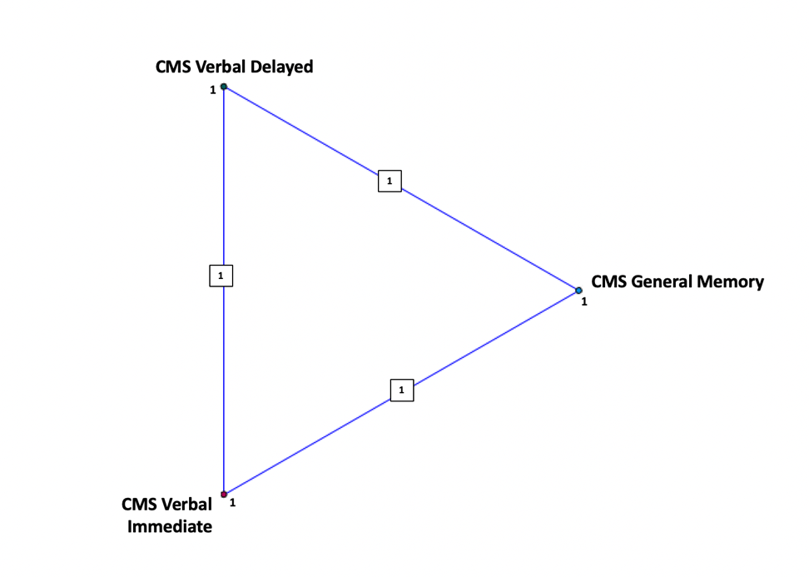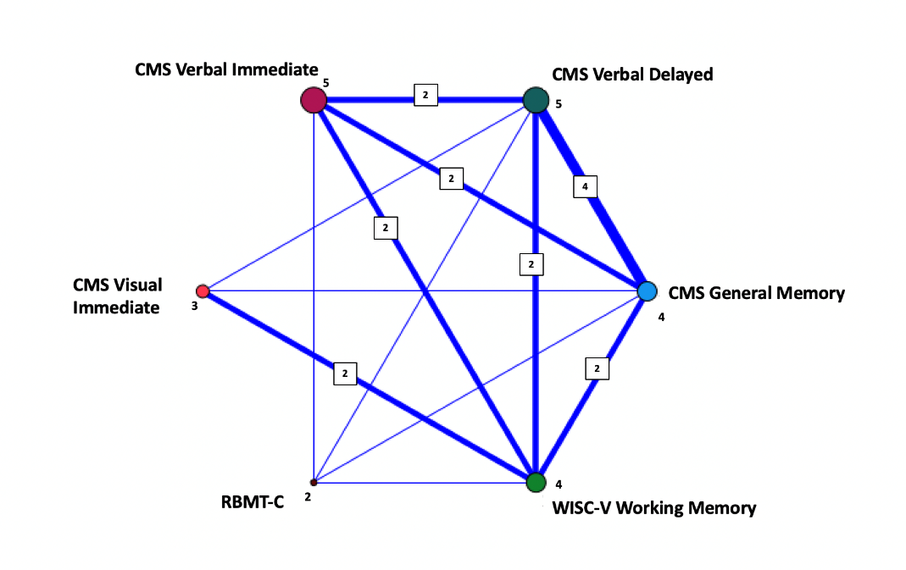

Figure 2. Relationship maps, illustrating co-occurring clinically significant memory impairments in the two groups across the formal measures of memory function. Findings for the HIE group are shown on the left, findings for the control group are shown on the right. Each node represents a memory domain and the number of children impaired in each domain. The line connecting the nodes, represents the frequency of co-occurring impairment. Line thickness corresponds to the number of co-occurring impairments.

.

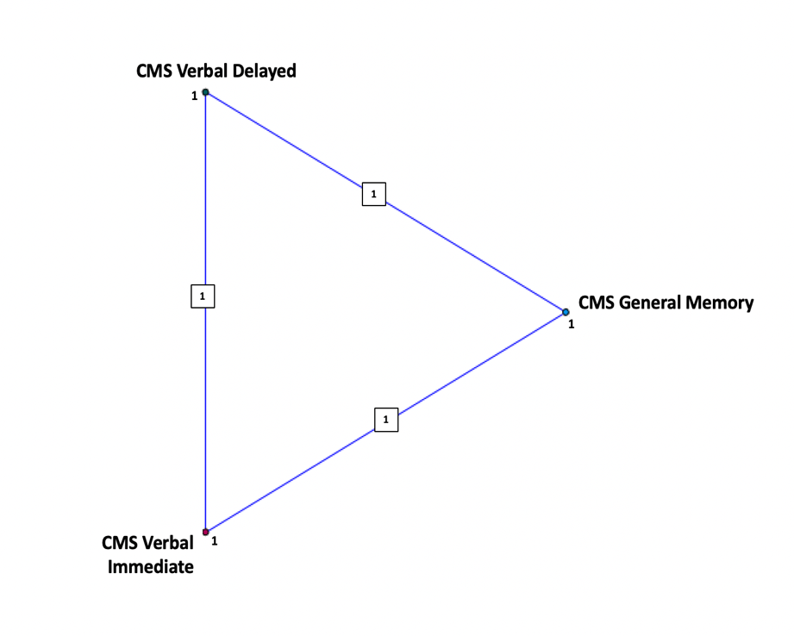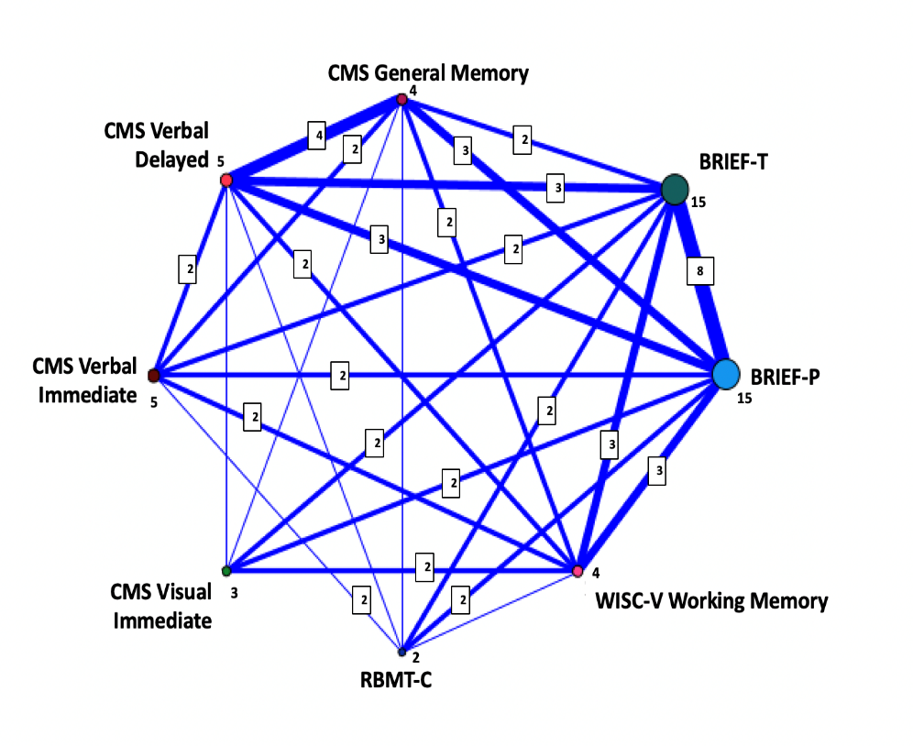

Figure 3. Relationship maps, illustrating co-occurring clinically significant memory impairments in the two groups across formal and real-life measures of memory function. Findings for the HIE group are shown on the left, findings for the control group are shown on the right. Each node represents a domain and the number of children impaired in each domain. The line connecting the nodes, represents the frequency of co-occurring impairment. Line thickness corresponds to the number of co-occurring impairments.

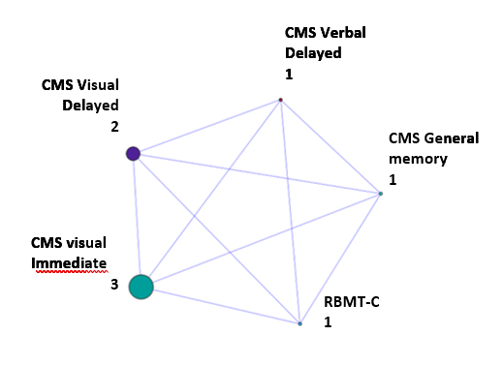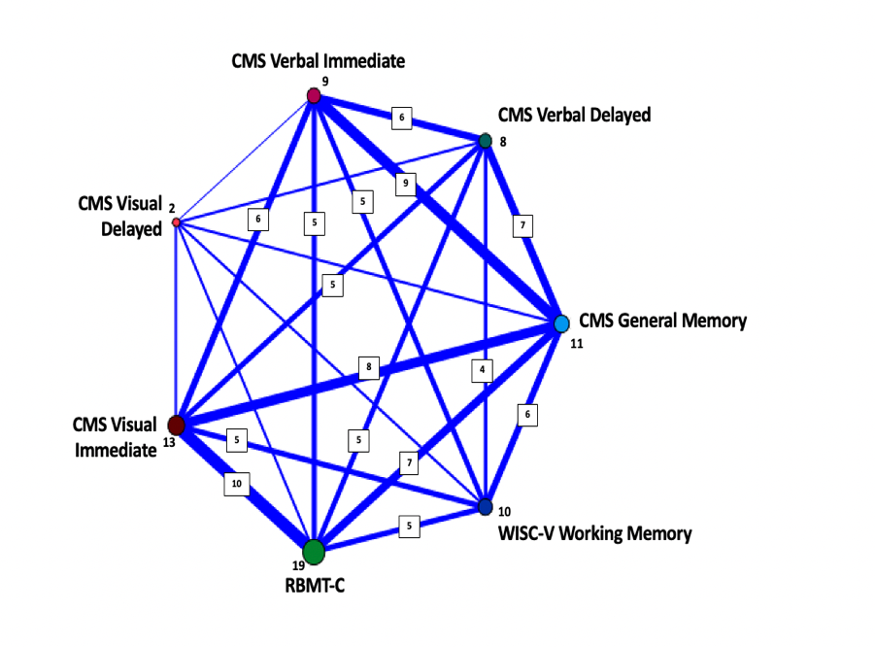

Figure 4. Relationship maps, illustrating co-occurring clinically significant and borderline memory impairments in the two groups across formal measures of memory function. Findings for the HIE group are shown on the left, findings for the control group are shown on the right. Each node represents a domain and the number of children impaired in each domain. The line connecting the nodes, represents the frequency of co-occurring impairment. Line thickness corresponds to the number of co-occurring impairments.

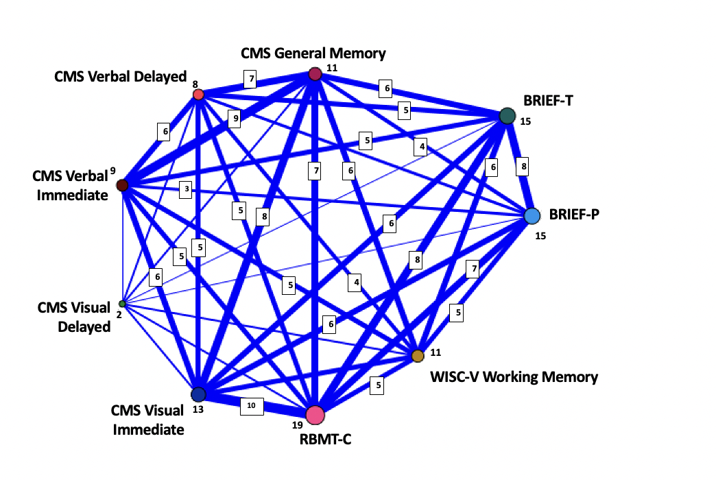

Figure 5. Relationship maps, illustrating co-occurring clinically significant and borderline memory impairments in the two groups across the formal memory function measures and real-life assessments. Findings for the HIE group are shown on the left, findings for the control group are shown on the right. Each node represents a domain and the number of children impaired in each domain. The line connecting the nodes, represents the frequency of co-occurring impairment. Line thickness corresponds to the number of co-occurring impairments.

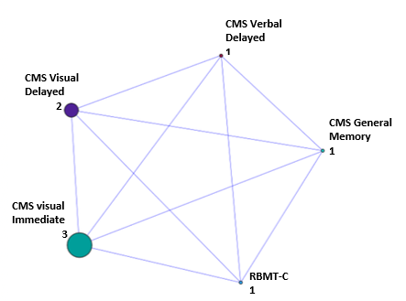

**Table 1**

*Perinatal characteristics. Comparison of the study sample and the whole cohort of those who survived without major neurodisability born between 01/08/2011 and 31/03/2016*

|  |  |  |  |
| --- | --- | --- | --- |
|  | **Cohort of newborns undergoing TH for neonatal HIE, who survived without developing CP GMFCS>2^ n=103** | **Study sample^^**  **n=51** | **p-value\*** |
|  |  |  |  |
|  |  |  |  |
| *Birth weight (grams*); mean (SD); min-max | 3372.58 (656.79)  1540-4870 | 3362.91(701.71)  1540 – 4870 | 0.937 |
| *Gestational age (weeks*); mean (SD); min-max | 39.60 (1.82)  34 – 42.20 | 39.80 (1.80)  34 – 42.20 | 0.312 |
| *Sex* male/female; n (%) | 47/56 (45.6/54.4) | 19/32 (37.3/62.7) | 0.029 |
| *Mode of delivery*; n (%)  Spontaneous vaginal  Forceps  Ventouse  Planned Caesarean  Emergency Caesarean | 42 (40.8)  13 (12.6)  4 (3.9)  2 (1.9)  42 (40.8) | 17 (33.3)  9 (17.6)  1 (2.0)  1 (2.0)  23 (45.1) | 0.306 |
| *Apgar at 10 minutes*; mean (SD); min-max | 5.40 (2.24)  0-10 | 5.56 (2.27)  0 -10 | 0.445 |
| *Cord pH (arterial) or pH from blood gases within first 60 min*; mean (SD); min-max | 6.99 (0.17)  6.64-7.36 | 6.96 (0.16)  6.64 – 7.29 | 0.057 |
| *Cord BE (arterial) or BE from blood gases within first 60 min*; mean (SD); min-max | -14.84 (7.14)  -30; 4 | -14.96 (6.82)  -30; -2 | 0.890 |
| *Days of ventilation*, mean (SD); min-max | 3.04 (2.89)  0-12 | 2.98 (2.91)  0-9 | 0.799 |
| *Neonatal seizures*; n (%) | 42 (40.8) | 18 (35.3) | 0.511 |
| *Neonatal MRI*; n(%)  No MRI  Normal/Signs of HI-injury$  White matter/Watershed zones  Basal Ganglia/Thalami  BG/Thalami & Perirolandic/Insular Cortex  BG/Thalami/WM  WM/Cortex  BG/Thalami/WM/Cortex | 16 (15.5)  19/68 (18.4/81.6)  8 (7.8)  13 (12.6)  15 (14.6)  13 (12.6)  10 (9.7)  9 (8.7) | 6 (11.8)  13/32 (25.4/74.6)  2 (3.9)  6 (11.8)  9 (17.6)  6 (11.8)  4 (7.8)  5 (9.8) | 0.351 |
| *Cerebral Palsy with GMFCS≤2*, n (%) | 7 (6.8) | 3 (5.9) |  |

*Non-parametric statistics (Mann-Whitney-U test) for continuous variables; Chi Square/Fisher’s Exact for categorical variables

BG=Basal Ganglia; WM= White Matter

^Information missing for whole sample: 1 for Apgar10 (home birth); 8 for cord pH; 15 for cord BE; 2 for days of ventilation

^^Information missing for study sample: 2 for cord pH; 4 for cord BE (1 postnatal collapse, 1 born in birth centre, 1 home birth); 1 for days of ventilation; $ HI – hypoxic-ischaemic injury; assessed based on neonatal clinical MRI, using the Barkovich (1998) scoring system; MRI assessed for signal abnormalities on T1-weighted, T2-wighted, and diffusion MRI.

**Table 2**

Clinical characteristics of the HIE and the control group

|  |  |  |  |
| --- | --- | --- | --- |
| **Characteristics** | **HIE group (n=51)** | **Control group (n=41)** | ***p*-level\*** |
| Sex, male/female n, (%) | 19/32 (37.3/63.7) | 16/25 (39.0/61.0) | 0.862 |
| Age (years);  median (IQR) | 6.4m (1.0) | 7.2m (1.1) | <.001 |
| Birth weight (grams);  mean (SD) | 3431.35 (636.31) | 3362.91 (701.71) | 0.637 |
| Gestational age (weeks)  mean (SD) | 39.53 (1.90) | 39.80 (1.80) | 0.460 |
| Visual function; n, (%)  Normal vision  Corrected with glasses | 36 (70.6)  15 (29.4) | 35 (85.4)  6 (14.6) | 0.093 |
| Hearing function; n, (%)  Normal hearing  Impaired; corrected with aids^ | 49 (96.1)  2 (3.9) | 41 (100)  - | 0.200 |
| Head Circumference (cm);  mean (SD) | 51.45 (2.02) | 52.46 (1.97) | .061 |
| Handedness (r/l); n(%) | 39/11 (78.0/22) | 38/3 (92.7/7.3) | .055 |
| English first language; n (%) | 48 (96.0) | 41 (100) | .200 |
| English Index of Multiple Deprivation“ (IMD); n (quintile)  1 – most deprived  2  3  4  5 – least deprived | 5 (9.8)  8 (15.7)  8 (15.7)  15 (29.4)  15 (29.4) | 2 (4.9)  13 (31.7)  11 (26.8)  5 (12.2)  10 (24.4) | .200 |
| Education (mother); n (%)  Doctoral/Master degree  University degree  3 or more A levels&  5 or more GCSE%  <5 GCSE  No formal education | 5 (10.6)  5 (31.9)  7 (14.9)  13 (27.7)  6 (12.8)  1 (2.1) | 6 (15.8)  22 (57.9)  9 (23.9)  1 (2.6)  -  - | .003 |
| Education (father); n (%)  Doctoral/Master degree  University degree  3 or more A levels  5 or more GCSE  <5 GCSE  No formal education | 3 (7.3)  6 (14.6)  10 (24.4)  12 (29.3)  9 (22)  1 (2.4) | 7 (19.4)  16 (44.4)  4 (11.1)  5 (13.9)  4 (11.1)  - | .014 |

* Non-parametric statistics (Mann-Whitney-U test) for continuous variables; Chi Square/Fisher’s Exact for categorical variables; “ English Index of Multiple Deprivation (IMD): These are indices of multiple deprivation, a measure of relative deprivation for small, fixed geographic areas in England. Areas are classified into 5 quintiles based on relative disadvantage; Quintile 1: most deprived; quintile 5 least deprived area; ^Mild and not corrected with hearing aids for 1 child – this did not affect test performance;; permanent sensorineural hearing loss (right mild left moderate), corrected with hearing aids for 1 child; % GCSE: General Certificate of Secondary Education; qualifications at end of Year 11 schooling; usually at age 15-16.& A Levels: Advanced level qualifications. Subject-based qualifications; taken age 16 and above, that can lead to university, further study, training, or work, in the UK.

**Table 3**

Performance on tests of memory function

|  |  |  |  |  |  |
| --- | --- | --- | --- | --- | --- |
| **Assessment** | **HIE group**  **(n=51)** | **Control group(n=41)** | ***p-value\**** | ***Effect size r*** | ***Effect strength*** |
|  | Median (IQR) | Median (IQR) |  |  |  |
| CMS (Index scores) |  |  |  |  |  |
| General Memory | 96.00 (29.00) | 112.00 (25.50) | 0.001 | 0.35 | Medium |
| Verbal Immediate | 97.00 (22.50) | 109.00 (27.25) | <.001 | 0.36 | Medium |
| Verbal Delayed | 97.00 (22.50) | 112.00 (17.25) | <.001 | 0.42 | Medium |
| Visual Immediate | 91.00 (31.00) | 95.50 (20.25) | 0.352 | 0.10 | Small |
| Visual Delayed | 94.00 (15.00) | 100.00 (12.00) | 0.027 | 0.23 | Small |
| RBMT-C |  |  |  |  |  |
| Standardised Profile Score | 17.00 (3.00) | 20.00 (3.00) | <.001 | 0.50 | Medium |
| WISC |  |  |  |  |  |
| Working Memory Index | 97.00 (31.50) | 112.00 (14.00) | <.001 | 0.36 | Medium |
| BRIEF (T-scores) |  |  |  |  |  |
| Parent | 52.00 (25.00) | 46.00 (9.00) | 0.001 | 0.33 | Medium |
| Teacher | 50.00 (26.00) | 44.00 (9.00) | 0.019 | 0.25 | Small |

Data expressed as a median (interquartile range, IQR; *Mann-Whitney-U test

Abbreviations. CMS = Children's Memory Scale; RBMT-C = Rivermead Behavioural Memory Test for Children; WISC-V = Wechsler Intelligence Scale for Children, Fifth Edition; BRIEF = Behaviour Rating Inventory for Executive Function.

Missing data note. In the HIE group, missing data from each test included: 6 from CMS, 4 from BRIEF-T testing, 2 from RBMT-C and the WISC-V, and 1 from BRIEF-P. Of the control population, 1 was missing from the RBMT-C, 3 from BRIEF-T, and 1 from both CMS and WISC-V. These data points were coded as missing and excluded from analysis.

**Table 4**

Frequencies and percentages of children in the impaired range in memory function *(clinically significant range only)*

|  |  |  |  |
| --- | --- | --- | --- |
| **Assessment** | **HIE group (N=51)** | **Control group (N=41)** | ***p-value\**** |
|  | n/N (%) | n/N (%) |  |
| CMS (Index Scores) |  |  |  |
| General Memory | 4/45 (8.9%) | 1/40 (2.5%) | 0.214 |
| Verbal Immediate | 5/45 (11.1%) | 1/40 (2.5%) | 0.124 |
| Verbal Delayed | 5/45 (11.1%) | 1/40 (2.5%) | 0.124 |
| Visual Immediate | 3/45 (6.7%) | 0/40 (0.0%) | 0.098 |
| Visual Delayed | 0/45 (0.0%) | 1/40 (4.4%) | 0.131 |
| RBMT-C |  |  |  |
| Standardised Profile Score | 2/49 (4.1%) | 0/40 (0%) | 0.223 |
| WISC-V |  |  |  |
| Working Memory Index | 4/49 (8.2%) | 0/40 (0%) | 0.066 |

*Mann-Whitney-U test

Abbreviations. CMS = Children’s Memory Scale; RBMT-C = Rivermead Behavioural Memory Test for Children; WISC-V = Wechsler Intelligence Scale for Children, Fifth edition; BRIEF = Behaviour Rating Inventory of Executive Function.

**Table 5**

Frequencies and percentages of children in the impaired range in memory function (*clinically significant and borderline performances combined)*

|  |  |  |  |
| --- | --- | --- | --- |
| **Assessment** | **HIE group**  **(N-51)** | **Control group (N=41)** | ***p-value\**** |
|  | n/N (%) | n/N (%) |  |
| CMS (Index Scores) |  |  |  |
| General Memory | 11/45 (24.4%) | 1/40 (2.5%) | 0.004 |
| Verbal Immediate | 9/45 (20.0%) | 1/40 (2.5%) | 0.013 |
| Verbal Delayed | 8/45 (17.8%) | 1/40 (2.5%) | 0.023 |
| Visual Immediate | 13/45 (28.9%) | 3/40 (7.5%) | 0.012 |
| Visual Delayed | 2/45 (4.4%) | 2/40 (5.0%) | 0.552 |
| RBMT-C |  |  |  |
| Standardised Profile Score | 19/49 (38.8%) | 1/40 (5.6%) | <.001 |
| WISC |  |  |  |
| Working Memory Index | 10/49 (20.4%) | 0/40 (0%) | 0.001 |

*Mann-Whitney-U test Abbreviations. CMS = Children’s Memory Scale; RBMT-C = Rivermead Behavioural Memory Test, children’s version; WISC-V = Wechsler Intelligence Scale for Children, fifth edition.