# Placebo and nocebo effects in gambling disorder pharmacological trials: a meta-analysis

## Konstantinos Ioannidisa, b, Nathan T.M. Hunekea, Jeremy E Sollyb,c, Guilherme Fusetto-Veronesia, Charidimos Tzagarakisd, Valeria Parlatinie, Samuel J. Westwoodf, Cinzia Del Giovaneg, David S. Baldwina, Jon E Granth, Samuele Cortesei, Samuel R Chamberlaina

## Author details

a Department of Psychiatry, Clinical and Experimental Sciences, Faculty of Medicine, University of Southampton, UK; andHampshire and Isle of Wight Healthcare NHS Foundation Trust, Southampton, UK

b Cambridgeshire and Peterborough NHS Foundation Trust, Cambridge, UK

c Department of Psychiatry, University of Cambridge, UK

d Organization Against Drugs (OKANA), Athens, Greece and Department of Neuroscience, University of Minnesota, Minneapolis, MN, United States

eDepartment of Child and Adolescent Psychiatry, Institute of Psychiatry, Psychology and Neuroscience, King’s College London, London, UK and Department of Forensic and Neurodevelopmental Sciences, Institute of Psychiatry, Psychology and Neuroscience, King’s College London, London, UK and Centre for Innovation in Mental Health, School of Psychology, Faculty of Environmental and Life Sciences, University of Southampton, Southampton, UK; Hampshire and Isle of Wight Healthcare NHS Foundation Trust, UK

fDepartment of Psychology, Institute of Psychiatry, Psychology and Neuroscience, King’s College London, London, UK

g Department of Medical and Surgical Sciences for Children and Adults, University of Modena and Reggio Emilia, Modena, Italy and Institute of Primary Health Care (BIHAM), University of Bern, Bern, Switzerland

h Department of Psychiatry and Behavioral Neuroscience, University of Chicago, Chicago, IL, USA

i Centre for Innovation in Mental Health, School of Psychology, Faculty of Environmental and Life Sciences, University of Southampton, Southampton, UK; Clinical and Experimental Sciences (CNS and Psychiatry), Faculty of Medicine, University of Southampton, Southampton, UK; Solent NHS Trust, Southampton, UK; DiMePRe-J-Department of Precision and Rigenerative Medicine-Jonic Area, University of Bari "Aldo Moro", Bari, Italy; Department of Child and Adolescent Psychiatry, New York University Grossman School of Medicine, New York

**Corresponding author**; Email: k.ioannidis@soton.ac.uk Dr Konstantinos Ioannidis PhD, Consultant Psychiatrist, Clinical Lead, Southern Gambling Service, College Keep, 4-12 Terminus Terrace, Southampton. SO14 3DT.

**Word count**: 4513

## ABSTRACT

**Background**: Placebo and nocebo effects are widely reported across psychiatric conditions, yet have seldom been examined in the context of gambling disorder. Through meta-analysis, we examined placebo effects, their moderating factors, and nocebo effects, from available randomized, controlled pharmacological clinical trials in gambling disorder.

**Methods**: We searched, up to 19 February 2024, a broad range of databases, for double-blind randomised controlled trials (RCTs) of medications for gambling disorder. Outcomes were gambling symptom severity and quality of life (for efficacy), and drop outs due to medication side-effects in the placebo arms.

**Results:** We included 16 RCTs (n = 833) in the meta-analysis. The overall effect size for gambling severity reduction in the placebo arms was 1.18 (95%CI 0.91-1.46) and for quality of life improvement was 0.63 (0.42-0.83). Medication class, study sponsorship, trial duration, baseline severity of gambling and publication year significantly moderated effect sizes for at least some of these outcome measures. Author conflict of interest, placebo run-in, gender split, severity scale choice, age of participants or unbalanced randomization did not moderate effect sizes. Nocebo effects leading to drop out from the trial were observed in 6% of participants in trials involving antipsychotics, while this was less for other medication types.

**Conclusion**: Placebo effects in trials of pharmacological treatment of gambling disorder are large, and there are several moderators of this effect. Nocebo effects were measureable and may be influenced by medication class being studied. Practical implications of these new findings for the field are discussed, along with recommendations for future clinical trials.

**Key words:** Gambling; placebo, meta-analysis; pharmacotherapy; treatment

|  |
| --- |
| **SIGNIFICANT OUTCOMES** |
| Placebo effects in trials of pharmacological treatment of gambling disorder are large |
| Medication class, study sponsorship, trial duration, baseline severity of gambling and publication year significantly moderated the placebo effect |
| Nocebo effects were measurable and may be influenced by medication class being studied. |

|  |
| --- |
| **SIGNIFICANT LIMITATIONS** |
| The number of RCTs available for the pharmacological management of gambling disorder is relatively limited to date, as compared to other areas of mental ill health |
| The presence or not of co-morbidities was not comprehensively assessed in those RCTs, which limited the possibility of those being identified as moderators. |
| Meta-regression was not possible for blinding integrity, as this was not measured in those RCTs. |

# INTRODUCTION

Gambling disorder is a complex mental disorder characterized by persistent and recurrent gambling despite the evidence of negative consequences. It is classified as a behavioural addiction in the International classification of Disease 11th Edition (ICD-11) (ICD-11, 2021) and as a Substance-Related and Addictive Disorder in the Diagnostic and Statistical Manual 5th Edition, text revised (DSM-5-TR) (American Psychiatric Association, 2022). Gambling Disorder has a substantial impact on those affected, as well as those around them. For example, it can lead to interpersonal conflict, serious financial problems, homelessness, bankruptcy, and elevated risk of suicide (Ioannidis & Bowden-Jones, 2023; The Lancet Public Health, 2021; Wardle & McManus, 2021) with substantial public health implications worldwide (The Lancet Public Health, 2021).

Psychological treatments (i.e., mainly in the form of gambling focused cognitive-behavioural therapy –CBT–, in its many variants) comprise the current mainstay approach for the treatment of gambling disorder. Pharmacological treatments are also available, with opioid receptor antagonists (nalmefene, naltrexone) currently having the best evidence (Ioannidis et al., 2024), although no pharmacological treatment is licensed for this indication (as is the case for many neglected mental disorders). In the emerging body of randomized clinical trials (RCTs) for gambling disorder, most active medication treatments have been compared against placebo treatment. Placebo and nocebo effects may have occurred in these trials. Placebo and nocebo are effects of patients’ positive and negative expectations relevant to an anticipated intervention; they are pertinent influencers in pharmacological trials in many areas of medicine (Colloca & Barsky, 2020). While under-studied (Huneke, Van Der Wee, Garner, & Baldwin, 2020), it is likely that placebo and nocebo effects can occur due to a variety of mechanisms (e.g. expectations, interactions with the study team, therapeutic milieu, the choice of self-report vs. objective measures (Huneke et al., 2024)), and particular neurobiological pathways (Ashar, Chang, & Wager, 2017; Barsky, Saintfort, Rogers, & Borus, 2002; Flaten, Simonsen, & Olsen, 1999; Wager & Atlas, 2015). It is argued that, particularly in psychiatry, the predictors and moderators of the placebo response are multiple, diverse and still to be discovered (Weimer, Colloca, & Enck, 2015).

It is known from empirical evidence (Huneke et al., 2024) that the placebo effect has variable magnitude, which differs by disorder (e.g. RCTs of medication treatments for generalized anxiety disorder or depression have reported much larger placebo effects as compared to other disorders such as obsessive-compulsive disorder [OCD] or schizophrenia spectrum conditions). At the same time there has not been any comprehensive and in depth investigation of the size and moderating parameters for the placebo effects in gambling pharmacological RCTs.

To our knowledge, only two previous studies have explored potential moderators of placebo response in pharmacological trials for gambling disorder. First, in a previous synthesis of data from n=152 patients (not systematically collected), placebo ‘responders’ (defined using a cut-off of 35% reduction in symptom severity on the Gambling Symptom Assessment Scale) remained in treatment for significantly longer, were more likely to report "enjoyment" as a trigger for gambling, and were less likely to state that "boredom" or "loneliness" triggered their gambling, compared with ‘non-responders’ (J. Grant & Chamberlain, 2017). Second, in a previous meta-analysis of individual patient data from a selected subset of RCTs (6 studies, n placebo=67) of the pharmacological management of gambling disorder, decreased baseline symptoms of anxiety, increased baseline symptoms of depression, and non-Caucasian ethnicity were associated with larger placebo response (Huneke, Chamberlain, Baldwin, & Grant, 2021). Intriguingly, these moderators differed from moderators associated with larger treatment response. Although these studies have identified possible important moderators of placebo responses in gambling disorder, they are based on an incomplete analysis exploring only a subset of the available data.

# In the present study we sought to synthesise data from all the available literature to address the following key questions related to the placebo effect in pharmacological RCTs of gambling disorder: 1) what is the magnitude of placebo effect in available trials and does it differ across outcome measures 2) what factors moderate the placebo effect, 3) what is the magnitude of nocebo effect and does this differ depending on the medication class being examined?

# MATERIAL AND METHODS

For the identification of available RCTs for the pharmacological management of gambling disorder, the study followed methods described in the pre-registered protocol published on the PROSPERO International prospective register of systematic reviews [Registration number: CRD42022329520 Available from: https://www.crd.york.ac.uk/prospero/display_record.php?RecordID=329520]. This study reporting followed the PRISMA guidelines (Shamseer et al., 2015).

### Search strategy

We searched up to 19 February 2024, a broad range of databases, including MEDLINE, EMBASE, PsycINFO, PubMed, CINAHL, AMED, and the Cochrane Database of Systematic Reviews, ERIC and Web of Science (including Science Citation Index Expanded (SCI-EXPANDED), Social Science Citation Index (SSCI), Conference Proceedings Citation Index-Science (CPCI-S) and Conference Proceedings Citation Index-Social Science and Humanities (CPCI-SSH)) via Web of Knowledge and the WHO International Trials Registry Platform (including ClinicalTrials.gov. The search strings used and full list of electronic databases and clinical trial registries in which the search was conducted are available in the previous publication (Ioannidis et al., 2024).

### Eligibility criteria

We included published or unpublished RCTs comparing an active medication vs. placebo, for the treatment of Gambling Disorder/Pathological Gambling. Trials with a cross-over design were included if data from the pre cross-over phase were available, to avoid carry-over effects.We included only studies of adults (>18yrs) with a primary DSM (III onwards) or ICD (9 onwards) diagnosis of Gambling Disorder/Pathological Gambling.

### Data extraction and outcomes

Details on data extraction were described in previous work and are available online (Ioannidis et al., 2024). Additional information about the ascertainment of placebo control processes were collected in this dataset, including 1) the presence of a placebo run in process (“Yes/No/Unclear”), use of independent investigators (not involved in clinical care) to assess side effects (“Yes/No/Unclear”), prevention of side effects (“Yes/No/Unclear”) and assessment of blinding success (“Yes/No/Unclear”), 2) full details of nocebo effects (specific side effects produced by placebo, attributed to medication effects) 3) the presence of industry-related influences, including the presence of industry sponsorship (“Yes/No/Unclear”) and the presence of declared industry related conflict of interest from the manuscript authors in each respective publication (“Yes/No/Unclear”).

### Clinical measures of efficacy

The primary efficacy outcome was gambling symptom severity measured by well-established and validated instruments, namely the Yale-Brown Obsessive Compulsive Scale adapted for Pathological Gambling (PG-YBOCS), (Pallanti, DeCaria, Grant, Urpe, & Hollander, 2005) the Gambling Symptom Assessment Scale (G-SAS), (Kim, Grant, Adson, & Shin, 2001) and the Clinical Global Impression-Improvement scale (CGI-I) (Busner & Targum, 2007). If a study reported results from multiple scales, we used the following hierarchy in the choice of the scale: PG-YBOCS as first preference; G-SAS as next preference, CGI-I as third preference. This was done to prioritize structured clinical instruments against unstructured or self-report instruments. The secondary efficacy outcome was the improvement in quality of life and functioning as measured by validated instruments including but not limited to the Sheehan Disability Scale (SDS) (Sheehan, Harnett-Sheehan, & Raj, 1996) and other quality of life metrics. Further information about the selection of severity metrics are presented in previous work (Ioannidis et al., 2024).

### Nocebo outcomes

Nocebo effects were calculated by the percentage of drop outs from perceived “medication side effects” from the placebo arms, in the RCTs.

### Data synthesis

Data were analyzed using statistical software R version 4.2.1. Meta-analysis was performed using packages of “robumeta” and “metafor” (Fisher, Tipton, & Zhipeng, 2017; Viechtbauer, 2020). The R code used for this analysis is shared in the supplement. We performed analyses for gambling severity, using all types of outcomes, using a hierarchical approach described above, and then for each type of clinical severity outcome separately. We also performed a meta-analysis for quality of life outcomes; all the above were performed separately for the placebo and the treatment arms. We calculated the within-group Standardized Mean Change using Change score standardization (Gibbons, Hedeker, & Davis, 1993) (SMCC), in active medication and placebo arms separately, to measure the efficacy outcomes. For the calculations of SMCC, we first imputed a correlation of 0.50 between baseline and end-of-treatment within groups. We performed sensitivity analyses with correlations of 0.25 and 0.75 to ascertain any impact on the analyses. The measure of effect for nocebo was the dropout rate due to medication side effects (or attributed to medication side effects in the placebo arm, i.e., nocebo effects), expressed as percentage of drop out, in the placebo arms. Study arms randomizing the same compound at different dose were merged into a single arm in line with the recommendations in the Cochrane handbook (The Cochrane Collaboration, 2011). We meta-analysed these outcomes through a random-effects model (REM) in all cases to provide a more generalizable model estimate. We ascertained heterogeneity by calculating the Q-statistic, which is the ratio of observed variation to within-study variance, formulated in a null hypothesis test (the null hypothesis here being that all individual studies measure/examine the same effect). The test indicates how much of the overall heterogeneity can be attributed to true between-studies variation. We also assessed the heterogeneity within each comparison visually by considering the forest plot, and quantitatively with the I² statistic and the τ2. (Higgins et al., 2019). Moderator meta-regression analysis was conducted considering the following regressors: year of publication, medication class, presence of company sponsor, duration of the study, gambling severity scale choice, mean age of participants, percentage of gender split, baseline gambling severity scores, presence of declared conflict of interest in the authors and study design with unbalanced randomization and placebo run in phase. We calculated the correlation between the placebo effect sizes and the respective effect sizes for the treatment arms in each meta-analysis.

### Publication Bias assessment

We examined publication bias with the use of funnel plots (visual/graphic inspection for asymmetry), as well as with regression tests for funnel plot asymmetry. Where appropriate we used the trim and fill method to provide an updated effect size estimate.

### Risk of bias assessment

For within-study bias, and to assess the methodological quality of each individual RCT included in our meta-analysis we used the Cochrane Risk of Bias tool version 2 (RoB2) (Cochrane, 2023).

# RESULTS

The search yielded 4261 references from electronic databases and 71 hits from clinical trial registries. A final set of 16 eligible RCTs were selected for inclusion in the meta-analyses. Full details about the search results are presented in the PRISMA flowchart (Figure 1). Randomized participants across the included RCTs were ~47% males (394/833), and their ages ranged from 36.2 to 51.5 years (Mean=43.30; standard deviation SD=3.38). Each of the 16 RCTs included in the meta-analysis (total participants: 833) contributed to one pairwise comparison (active treatment vs. placebo), totalling 16 pairwise comparisons across studies (16 for gambling severity, five for quality of life).

[INSERT FIGURE 1 ABOUT HERE]

### Placebo response

Placebo response (baseline to end-of-treatment) for the severity of gambling (all scales) was SMCC = 1.18 (95%CI 0.91-1.46), whereas for the specific gambling severity scales the effect sizes were 1.24 (95%CI 0.91-1.57) for PG-YBOCS, 1.05 (95%CI 0.79-1.31) for GSAS and 0.79 (95%CI 0.46-1.13) for CGI-I. Quality of life effect sizes were SMCC = 0.63 (95%CI 0.42-0.83) (see Figure 1). For reference, under active treatment arms, overall gambling severity effect size was SMCC = 1.49 (95%CI 1.18-1.80), whereas quality of life effect was g = 0.69 (95%CI 0.55-0.84). Full details are available in the online supplement (paragraph §S1).

[FIGURE 2 ABOUT HERE]

### Heterogeneity within placebo arms

We identified moderate to high variance from heterogeneity measures within the analysed studies of the placebo arms, which was particularly prominent in the studies that used the PG-YBOCS instrument (see Table 1). Heterogeneity in the treatment arms followed a similar pattern (paragraph §S2).

### Publication bias assessment

Publication bias was identified graphically and statistically in the case of quality of life, in which the trim and fill method suggested a more conservative placebo effect estimate (0.50 vs. 0.65), which was not present in the treatment arms. Publication bias assessment for treatment arms is presented in the supplement (paragraph §S3).

[INSERT FIGURE 3 ABOUT HERE]

### Meta-regression analysis

Meta-regression results are presented in detail in Table 2. For gambling severity, recency of publication, supplement medication class and the absence of company sponsorship were associated with higher placebo effect sizes. For gambling severity using PG-YBOCS only, recency of publication, supplement medication class, as well as higher severity of baseline symptoms were associated with higher placebo effect sizes. For gambling severity using GSAS only, supplement and opiate receptor antagonist medication classes and the absence of company sponsorship were associated with higher placebo effect sizes. For CGI, antipsychotics and supplement medication classes were associated with lower placebo response. In the moderation analysis of quality of life, shorter trial duration was associated with larger placebo response, whereas longer duration was associated with lower response. Lower baseline of symptoms was associated with lower placebo response. No other parameters were statistically associated with moderating effect sizes in relation to placebo response on symptom severity or quality of life. Full results for the treatment arms are presented in the supplementary materials (paragraph §S4).

[INSERT TABLE 2 ABOUT HERE]

### Correlation between the placebo effects and the treatment effects

We calculated the correlation between the placebo effect sizes and the respective effect sizes for the treatment arms in each meta-analysis. For gambling severity the placebo and treatment effect sizes were highly correlated in all analyses (see Table 3); however, this was not true for quality of life meta-analyses, in which the placebo and treatment effect sizes were weakly correlated.

[INSERT TABLE 3 ABOUT HERE]

### Sensitivity Analyses

Full results at r=0.25 and r=0.75 are presented in the supplementary materials (paragraph §S6 & §S7). Sensitivity analyses did not substantially alter the results (see also Table 2 in which meta-regression analysis results maintained in sensitivity analyses are shown in tabularized format). The effect sizes were notably lower ‘overall’ at lower imputed correlations and higher overall at higher imputed correlation (i.e. SMCC for gambling severity was 1.00, 1.18 and 1.55 at r=0.25, 0.50 and 0.75 respectively and SMCC for QOL was 0.51, 0.63 and 0.87 at r=0.25, 0.50 and 0.75 respectively), however remained large in size for gambling severity and moderate-large for quality of life. Heterogeneity results were effectively similar in sensitivity analyses. Publication biases became more prominent at higher imputed correlations and the trim and fill method was required to produce more conservative (lower) effect estimates at r=0.75 for most of the effect size estimates (see supplementary material §S7). The direction of correction from trim and fill was always towards the effects reported in the main paper (with r=0.50).

### Nocebo effects

Due to paucity of data, those were calculated for each pharmacological class separately. Results indicated 2.4% drop outs from placebo arms in the antidepressant trials (fluvoxamine, paroxetine), 6.1% placebo drop outs for antipsychotics (olanzapine), 1.9% placebo drop outs for opiate receptor antagonists (naltrexone, nalmefene, naloxone), 1.6% placebo drop outs for mood stabilizers (topiramate, lithium) and 0% placebo drop outs for supplements (NAC, silymarin). Detailed results are presented in the supplement (paragraph §S8)

### Quality assessment

We completed RoB2 for all papers under scope. All domains had “low concern” as the most common outcome, apart from Domain 5 (bias in selection of the reported result) in which “some concern” was the predominant outcome. Consequently, the majority of papers scored as “some concern” in the overall risk of bias. Full RoB2 scores are reported in the supplement (paragraph §S9).

# DISCUSSION

This is the first systematic review and meta-analysis of placebo effects in RCTs for the pharmacological management of gambling disorder. Our findings indicate that placebo effects are prominent and of large magnitude for clinical efficacy outcomes of gambling severity (across scales), and of moderate-large magnitude for quality of life clinical efficacy measures. We first consider the implications of these high placebo effects, and then discuss moderating factors, and nocebo effects.

Placebo response rates can be influenced by the condition being studied. For example, placebo response rates in clinical trials are generally relatively high for depression, panic disorder, or generalized anxiety disorder but are typically low for certain other mental health conditions such as OCD or schizophrenia (e.g., see (Bernstein, Brown, Professor of Psychiatry, & Behavior, 2017; Cao et al., 2021; Huneke et al., 2024; Jones et al., 2021)). Our finding of a relatively high placebo response rate for gambling disorder bears similarity with what has been found for other addictions such as alcohol use disorder, where high placebo response rates have been noted (Anton et al., 2006; Del Re, Maisel, Blodgett, Wilbourne, & Finney, 2013; Scherrer et al., 2021), and places gambling disorder among the mental disorders with the largest placebo effect sizes (Huneke et al., 2024). The finding of a high placebo response rate for gambling disorder has a number of implications. Firstly, the results suggest that people who seek treatment for gambling disorder experience notable symptom improvement that is not directly related to the active medication compound being examined – from the perspective of patient outcomes this is a positive, and highlights the potential importance of factors such as therapeutic alliance and non-specific support from research and clinical teams. Secondly, large placebo response potentially represents a design problem for pharmacological clinical trials of gambling disorder, by making it challenging to detect a true active effect of medication. Intriguingly, we found that quality of life measures show a greater disparity between placebo and treatment response. How different outcome measures affect estimates of treatment effect size needs to be further understood. The high placebo response also highlights a disparity in the literature for how different gambling disorder treatment modalities are compared (or contrasted) with each other. In particular, many psychological intervention clinical trials in gambling disorder have used waiting list control (Petry, Ginley, & Rash, 2017). In practical terms, this suggests that pharmacological options should be considered more often in clinical practice, as they have had to pass a higher clinical standard to show their efficacy in trials. It is likely that randomisation to wait list results in reduced symptom improvement compared with a placebo due to fewer clinical interactions and lower expectations of benefit and/or ‘disappointment’(Bandelow et al., 2015), thereby substantially inflating effect sizes for active therapy versus control. This issue of inflating treatment effect sizes by using a weak control condition has also been noted for other compulsive conditions such as OCD (Laws, Pellegrini, Reid, Drummond, & Fineberg, 2022). In contrast, controlled clinical trials of medications have used placebo control, which is much more conservative and scientifically rigorous. This issue needs to be considered when weighing the balance in favour of particular treatment modalities for gambling disorder. Another consideration is around risks – with both medications and therapies being associated with adverse effects for some individuals, yet adverse events are almost always documented in pharmacological trials but rarely in psychological trials in the field (Klatte, Strauss, Flückiger, Färber, & Rosendahl, 2023).

Little is yet known about the neurobiological determinants of the placebo effects in pharmacological trials of gambling disorder. We know that, in general, the placebo effect is mediated by diverse neurobiological processes, including learning, expectation and social cognition (Wager & Atlas, 2015). Commonalities in the neurobiological characteristics of gamblers e.g. heightened impulsivity (Ioannidis, Hook, Wickham, Grant, & Chamberlain, 2019) or a dysregulated anticipatory dopaminergic response (Linnet, 2020) could predispose to heightened placebo or nocebo responses, by altering underlying learning and reward expectation processes. Future studies could further investigate those neurobiological processes involved in the production of placebo and nocebo effects in gambling disorder.

### Study design elements, including blinding integrity

Study duration significantly moderated placebo response specifically for one symptom severity measure (CGI) and also for quality of life: with shorter duration linked to lower placebo effect on CGI, and linked to larger placebo effect on quality of life. The reasons for these results are unclear. We did not find that unbalanced randomization moderated any of the meta-analyses effects.

In addition, placebo run-in (present in 38.9% or 7 out of 18 studies) did not significantly moderate the placebo response, indicating that inclusion of such a run-in did not help minimise placebo effect size - contrary to what might be anticipated. Nonetheless, this accords with findings in antidepressant trials, where placebo run-in periods are associated with reductions in treatment response in *both* arms and thereby not altering the efficacy comparison between medication and placebo (Scott, Sharpe, Quinn, & Colagiuri, 2022). Given that using placebo run-in periods does not minimise placebo effect size, could affect the external validity of the trial, and necessarily involves deception which could be considered unethical, we would recommend against their use in pharmacological trials for gambling disorder.

We also found that none of the studies assessed blinding success (i.e. through debriefing of participants and/or research staff). One study made a specific effort to prevent side effects (J. E. Grant, Suck, & Hartman, 2008) and utilized an independent investigator at expected peak of side effects to avoid un-blinding due to common side effects.

### Medication class

Turning now to significant moderators of placebo effects in this study, we found that the supplements medication class, here including n-acetyl cysteine (NAC) and silymarin, moderated a higher placebo effect size for symptom severity measures overall. This is interesting in that supplement medications are often perceived by service users as “innocuous” or not likely to have any side effects (Ernst, 1998). Stronger placebo responses might occur because individuals perceive supplements as a ‘more natural’ way to correct symptoms or more acceptable. Another possibility is that due to relatively good side effect profiles observed for these supplements in clinical trial conditions, blinding may have been ‘truer’ as compared to studies of other classes of medications that are more likely to have side effects. However, we currently do not have the data to make inferences regarding the effect that side-effects or beliefs might have on blinding and thus estimates of efficacy. Future studies could address the success or otherwise of blinding by debriefing both study participants and investigators after trial completion with standard instruments such as the ‘guess of treatment’ questionnaire (Haq, Molteni, & Huneke, 2024; Szigeti, Nutt, Carhart-Harris, & Erritzoe, 2024).

### Recency of publication

We found that later year of publication predicted higher placebo effect sizes, for symptom severity measures overall. One could expect that newer studies would follow more rigorous approaches to standardizing placebo procedures, leading to diminished or stable placebo effects, however this is not the case here. Interestingly, across psychiatric disorders in general, it has been shown that placebo effects have been larger with more recent publications (Huneke et al., 2024; Weimer et al., 2015). The reasons for this change are simply not known, but findings herein for gambling disorder are consistent with those in many other mental health conditions.

### Industry influence

We found that the absence of company sponsorship was associated with higher effect sizes in the placebo arms for symptom severity measures overall. This is a novel result with a lot of interesting implications. It is possible that participants being aware of company sponsorship are negatively influenced towards the beneficial effects of the medication treatment, thus generating a lesser placebo response. However, it has also been shown that industry sponsorship is associated with higher effect sizes in RCTs in general (Lundh, Lexchin, Mintzes, Schroll, & Bero, 2017), in which case this applies to both treatment and placebo arms, which are highly correlated in this dataset. Another possibility is that clinical trials conducted in academic settings may offer more additional support (irrespective of randomisation) as contrasted to commercial studies potentially involving generic / non-specialist recruitment sites, such as spending time with expert clinicians who take time to speak with patients or offer formal psychological support. Interestingly, self-reported industry related conflict of interest from the manuscripts authors did not moderate any effect sizes, meaning that we did not find any evidence that those declared relationships from the authors were associated with the effect sizes reported. It is possible that moderation by absence of industry sponsorship was related to the moderation by medication class, as both studies which included supplements were unsponsored.

### Choice of severity instrument, baseline severity

While placebo effects were numerically larger in the studies which assessed gambling severity improvements via clinician structured instruments, than self-reported instruments, or unstructured clinical instruments, choice of severity instrument was not statistically significant in moderation analyses, suggesting that approaches similarly capture placebo effects, in terms of gambling severity. However, those scales had differences as well; for example, we found higher baseline symptom severity leading to higher placebo response, using the PG-YBOCS instrument, which was also true for the treatment arms, using both PG-YBOCS and GSAS. That is an interesting finding, which may suggest that some placebo effects follow a “regression to the mean” pattern (Cummings et al., 2004) i.e. can be attributed to statistical artefacts which are unequally distributed across levels of baseline severity, or that they are impacted by floor effects. Furthermore, it is interesting that the reverse has been shown prior to the current study, for placebo effects in alcohol dependence RCTs (Scherrer et al., 2021) and quality of life followed the same reverse pattern (lower baseline was associated with higher effect seizes) so this result merits exploration in future work.

### Nocebo effects

In terms of nocebo effects, low placebo dropout rates (<2%) were found for clinical trials focusing on supplements (NAC, silymarin), mood stabilizers, and opioid receptor antagonists; slightly higher for SSRIs (2.4%); and higher rates were observed for placebo drop outs for antipsychotic (olanzapine) studies (6.1%). This variability could reflect expectation (e.g. people may anticipate ‘worse’ side effects for olanzapine had they read about it in advance, not knowing if they were then assigned to active or placebo treatment (Faasse et al., 2019)). Low nocebo effects is useful because it reduces clinical trial drop out, which can undermine the integrity of clinical trials.

### Limita**t**ions

Several possible limitations should be considered, reflecting both limitations of the included RCTs and of our meta-analysis. In terms of the included RCTs, the number available for gambling disorder is relatively limited to date, as compared to other areas of mental ill health (e.g. depression). The reasons for this are multi-fold, and include a historical (and persisting) lack of funding for gambling disorder research from independent national funding schemes globally. Available RCTs also have a number of methodological issues such as relatively small sample sizes (in many cases) as compared to other areas of mental ill health. The available studies did not generally examine views towards medications (e.g. pharmaceuticals versus nutraceuticals), expectation, or other variables (e.g. personality) that may relate to placebo response. We also identified a moderate-high degree of heterogeneity, particularly in the meta-analyses of gambling severity using the PG-YBOCS scale; this might reflect differences in other elements of study design (e.g. duration, presence of co-morbidities etc). Specifically, when it comes to the placebo effect, the presence of comorbidities may play a role. Particularly axis-II issues may influence placebo responses (Yadav, 2020) and those have been under-investigated in gambling disorder RCTs.

In terms of limitations of the meta-analysis, we could not consider time course of placebo responses – for example, we could not establish who responded to placebo for the whole of a given study as opposed to responding just at the end. The meta-regression analyses could not be conducted for all *a priori* hypothesised predictors due to lack of data in given categories (e.g. no study assessed blinding integrity); and it should also be considered that the number of studies in the explored moderator categories was small in some cases (e.g., having only one RCT with unbalanced randomization), potentially limiting power to detect effects of moderators. The other limitation of the moderation analyses is that those were not corrected for multiple comparisons, which suggests that those should be considered as exploratory, requiring further investigation once (if) a substantially larger number of clinical trials become available for analysis in the future. Finally, one of the limitations of examining nocebo effects in this analysis is that we were only able to explore the aspect of nocebo effect which led to drop out from the trials. Other, potentially more minor nocebo effects, which may though influence clinical efficacy or blinding success, were not consistently reported to allow for robust examination. Future studies should maintain a consistent study design and reporting, to allow for the reduction of heterogeneity, but also to include study design elements like the assessment of comorbidities, assessment of blinding success and nocebo effect details, to aid the interpretation of future findings.

## Conclusions and implications for future research

The current meta-analysis provides insights into the importance of placebo effects in pharmacological RCTs for gambling disorder. Considering these effects is also of relevance to routine clinical practice, for example, being aware of placebo effects may encourage clinicians to spend more time addressing a patient’s beliefs and attitudes around medication before starting treatment to enhance chances they positively respond. We found that placebo effects are prominent (large) across these trials and that there are several moderators, on at least some outcome measures of these placebo effects (year of publication, medication class, duration of treatment, company sponsorship status). Nocebo effects were measurable and may be influenced by medication class being studied in a particular trial. The study also found a lack of assessment of blinding integrity across the available RCTs and unclear use of independent raters. Future studies should consider those parameters when designing RCTs for the assessment of clinical efficacy for the pharmacological management of gambling disorder. It remains unclear how best to minimize (or at least make predictable) placebo effects in clinical trials for gambling disorder, because placebo ‘run-in’ did not significantly moderate placebo response herein. Finally, we recommend that future RCTs of psychological interventions for gambling disorder adopt rigorous control conditions and measure adverse events – to ensure parity with the standards already being set by pharmacological RCTs in the field.

## Data availability

The data that support the findings of this study are available upon reasonable request from the corresponding author (e.g. for peer review purposes) and will be published upon acceptance of the manuscript.

## Analytic code availability

Example R code and package information for meta-analysis can be found in the supplementary material (§S10).

## Acknowledgement

We would like to thank authors of published papers included in this meta-analysis who responded to requests for additional information to enable the meta-analysis.

## Funding

This study was supported by unrestricted grant funds to Professor Chamberlain held at the University of Southampton, originating from the NHS. The funding source had no role in the design, conduct, or reporting of the study.

## Declaration of interest

Dr Ioannidis is clinical lead for the Southern Gambling Service and receives a stipend from Elsevier for journal editorial work. Professor Chamberlain is service director for the NHS Southern Gambling Service. Professor Chamberlain receives a stipend from Elsevier for journal editorial work. Drs Solly and Fusetto Veronesi are NIHR Academic Clinical Fellows, and Dr Huneke is an NIHR Clinical Lecturer. Professor Baldwin receives a stipend from Wiley for journal editorial work. Cinzia del Giovane’s time on the project was funded partly through the grant funding to SRC. Dr. Grant has received research grants from Janssen and Biohaven Pharmaceuticals. He receives yearly compensation from Springer Publishing for acting as Editor-in-Chief of the Journal of Gambling Studies and has received royalties from Oxford University Press, American Psychiatric Publishing, Inc., Norton Press, and McGraw Hill. None of the authors have conflicts of interest in relation to the gambling or gaming industry. Samuele Cortese, NIHR Research Professor (NIHR303122) is funded by the NIHR for this research project. Samuele Cortese is also supported by NIHR grants NIHR203684, NIHR203035, NIHR130077, NIHR128472, RP-PG-0618-20003 and by grant 101095568-HORIZONHLTH- 2022-DISEASE-07-03 from the European Research Executive Agency. Prof. Cortese has declared reimbursement for travel and accommodation expenses from the Association for Child and Adolescent Central Health (ACAMH) in relation to lectures delivered for ACAMH, the Canadian AADHD Alliance Resource, the British Association of Psychopharmacology, and from Healthcare Convention for educational activity on ADHD, and has received honoraria from Medice. The views expressed in this publication are those of the author(s) and not necessarily those of the NIHR, NHS or the UK Department of Health and Social Care. None of the authors accept voluntary donations from the gambling or gaming industry either personally or in terms of institutional funds held in their name.

## Author contributions

KI, CT, JES, SC, SRC contributed to the design of the study; CT and JES led the search and screening process; KI, CDG, JES, SRC, GFV contributed to data collection. KI, JES, and SRC had access to the data. VP and SJW conducted the RoB2 and contributed equally to the manuscript. KI conducted the meta-analysis and takes responsibility for the integrity and accuracy of the data analysis itself. All authors have intellectually contributed and reviewed the final submitted manuscript. All authors accept responsibility for the conduct of the study and its integrity.

## REFERENCES

American Psychiatric Association. (2022). Diagnostic and Statistical Manual of Mental Disorders, Fifth Edition, Text Revision (DSM-5-TR). *Diagnostic and Statistical Manual of Mental Disorders*. https://doi.org/10.1176/APPI.BOOKS.9780890425787

Anton, R. F., O’Malley, S. S., Ciraulo, D. A., Cisler, R. A., Couper, D., Donovan, D. M., … Zweben, A. (2006). Combined pharmacotherapies and behavioral interventions for alcohol dependence: the COMBINE study: a randomized controlled trial. *JAMA*, *295*(17), 2003–2017. https://doi.org/10.1001/JAMA.295.17.2003

Ashar, Y. K., Chang, L. J., & Wager, T. D. (2017). Brain Mechanisms of the Placebo Effect: An Affective Appraisal Account. *Annual Review of Clinical Psychology*, *13*, 73–89. https://doi.org/10.1146/ANNUREV-CLINPSY-021815-093015

Bandelow, B., Reitt, M., Röver, C., Michaelis, S., Görlich, Y., & Wedekind, D. (2015). Efficacy of treatments for anxiety disorders: a meta-analysis. *International Clinical Psychopharmacology*, *30*(4), 183–192. https://doi.org/10.1097/YIC.0000000000000078

Barsky, A. J., Saintfort, R., Rogers, M. P., & Borus, J. F. (2002). Nonspecific medication side effects and the nocebo phenomenon. *JAMA*, *287*(5), 622–627. https://doi.org/10.1001/JAMA.287.5.622

Bernstein, M. H., Brown, W. A., Professor of Psychiatry, C., & Behavior, H. (2017). The placebo effect in psychiatric practice. *Current Psychiatry*, *16*(11), 29. Retrieved from /pmc/articles/PMC6003660/

Busner, J., & Targum, S. D. (2007). The Clinical Global Impressions Scale: Applying a Research Tool in Clinical Practice. *Psychiatry (Edgmont)*, *4*(7), 28. Retrieved from /pmc/articles/PMC2880930/

Cao, B., Liu, Y. S., Selvitella, A., Librenza-Garcia, D., Passos, I. C., Sawalha, J., … Greenshaw, A. (2021). Differential power of placebo across major psychiatric disorders: a preliminary meta-analysis and machine learning study. *Scientific Reports 2021 11:1*, *11*(1), 1–9. https://doi.org/10.1038/s41598-021-99534-z

Cochrane. (2023). RoB 2: A revised Cochrane risk-of-bias tool for randomized trials | Cochrane Bias. Retrieved June 25, 2023, from https://methods.cochrane.org/bias/resources/rob-2-revised-cochrane-risk-bias-tool-randomized-trials

Colloca, L., & Barsky, A. J. (2020). Placebo and Nocebo Effects. *New England Journal of Medicine*, *382*(6), 554–561. https://doi.org/10.1056/NEJMRA1907805/SUPPL_FILE/NEJMRA1907805_DISCLOSURES.PDF

Cummings, J. L., Tractenberg, R. E., Gamst, A., Teri, L., Masterman, D., & Thal, L. J. (2004). Regression to the Mean: Implications for Clinical Trials of Psychotropic Agents in Dementia. *Current Alzheimer Research*, *1*(4), 323. https://doi.org/10.2174/1567205043332027

Del Re, A. C., Maisel, N., Blodgett, J. C., Wilbourne, P., & Finney, J. W. (2013). Placebo group improvement in trials of pharmacotherapies for alcohol use disorders: a multivariate meta-analysis examining change over time. *Journal of Clinical Psychopharmacology*, *33*(5), 649–657. https://doi.org/10.1097/JCP.0B013E3182983E73

Ernst, E. (1998). Harmless Herbs? A Review of the Recent Literature. *The American Journal of Medicine*, *104*(2), 170–178. https://doi.org/10.1016/S0002-9343(97)00397-5

Faasse, K., Huynh, A., Pearson, S., Geers, A. L., Helfer, S. G., & Colagiuri, B. (2019). The Influence of Side Effect Information Framing on Nocebo Effects. *Annals of Behavioral Medicine : A Publication of the Society of Behavioral Medicine*, *53*(7), 621–629. https://doi.org/10.1093/ABM/KAY071

Fisher, Z., Tipton, E., & Zhipeng, H. (2017). robumeta: An R-package for robust variance estimation in meta-analysis. Retrieved June 27, 2020, from CRAN Repository website: https://github.com/zackfisher/robumeta

Flaten, M. A., Simonsen, T., & Olsen, H. (1999). Drug-related information generates placebo and nocebo responses that modify the drug response. *Psychosomatic Medicine*, *61*(2), 250–255. https://doi.org/10.1097/00006842-199903000-00018

Gibbons, R. D., Hedeker, D. R., & Davis, J. M. (1993). Estimation of Effect Size From a Series of Experiments Involving Paired Comparisons. *Http://Dx.Doi.Org/10.3102/10769986018003271*, *18*(3), 271–279. https://doi.org/10.3102/10769986018003271

Grant, J., & Chamberlain, S. (2017). The placebo effect and its clinical associations in gambling disorder. *Ann Clin Psychiatry*, *3*, 167–172. Retrieved from https://pubmed.ncbi.nlm.nih.gov/28738096/

Grant, J. E., Suck, W. K., & Hartman, B. K. (2008). A double-blind, placebo-controlled study of the opiate antagonist naltrexone in the treatment of pathological gambling urges. *Journal of Clinical Psychiatry*, *69*(5), 783–789. https://doi.org/10.4088/JCP.v69n0511

Haq, R., Molteni, L., & Huneke, N. (2024). The Relationship Between Blinding Integrity and Treatment Efficacy in Randomised-Controlled Trials in Patients with Anxiety Disorders: A Systematic Review and Meta-Analysis. *OSF (Pre-Print)*. https://doi.org/doi:10.31219/osf.io/fp3gs

Higgins, J., Thomas, J., Chandler, J., Cumpston, M., Li, T., Page, M., & Welch, V. (2019). *Cochrane Handbook for Systematic Reviews of Interventions* (2nd Editio). Chichester (UK): John Wiley & Sons.

Huneke, N. T. M., Amin, J., Baldwin, D. S., Bellato, A., Brandt, V., Chamberlain, S. R., … Cortese, S. (2024). Placebo effects in randomized trials of pharmacological and neurostimulation interventions for mental disorders: An umbrella review. *Molecular Psychiatry*. https://doi.org/10.1038/S41380-024-02638-X

Huneke, N. T. M., Chamberlain, S. R., Baldwin, D. S., & Grant, J. E. (2021). Diverse predictors of treatment response to active medication and placebo in gambling disorder. *Journal of Psychiatric Research*, *144*, 96–101. https://doi.org/10.1016/J.JPSYCHIRES.2021.09.053

Huneke, N. T. M., Van Der Wee, N., Garner, M., & Baldwin, D. S. (2020). Why we need more research into the placebo response in psychiatry. *Psychological Medicine*, *50*(14), 2317. https://doi.org/10.1017/S0033291720003633

ICD-11. (2021). ICD-11 for Mortality and Morbidity Statistics. Retrieved September 19, 2021, from https://icd.who.int/browse11/l-m/en#/http%3A%2F%2Fid.who.int%2Ficd%2Fentity%2F263852475

Ioannidis, K., & Bowden-Jones, H. (2023). Online gambling among young men: a rising tide? *Trends in Urology & Men’s Health*, *14*(5), 6–9. https://doi.org/10.1002/TRE.929

Ioannidis, K., Del Giovane, C., Tzagarakis, C., Solly, J. E., Westwood, S. J., Parlatini, V., … Chamberlain Author details, S. R. (2024). Pharmacological Management of Gambling Disorder: A Systematic Review and Network Meta-Analysis. *MedRxiv*, 2023.10.20.23297314. https://doi.org/10.1101/2023.10.20.23297314

Ioannidis, K., Hook, R., Wickham, K., Grant, J. E., & Chamberlain, S. R. (2019). Impulsivity in Gambling Disorder and problem gambling: a meta-analysis. *Neuropsychopharmacology*, *44*(8), 1354–1361. https://doi.org/10.1038/s41386-019-0393-9

Jones, B. D. M., Razza, L. B., Weissman, C. R., Karbi, J., Vine, T., Mulsant, L. S., … Daskalakis, Z. J. (2021). Magnitude of the Placebo Response Across Treatment Modalities Used for Treatment-Resistant Depression in Adults: A Systematic Review and Meta-analysis. *JAMA Network Open*, *4*(9). https://doi.org/10.1001/JAMANETWORKOPEN.2021.25531

Kim, S. W., Grant, J. E., Adson, D. E., & Shin, Y. C. (2001). Double-blind naltrexone and placebo comparison study in the treatment of pathological gambling. *Biological Psychiatry*, *49*(11), 914–921. https://doi.org/10.1016/S0006-3223(01)01079-4

Klatte, R., Strauss, B., Flückiger, C., Färber, F., & Rosendahl, J. (2023). Defining and assessing adverse events and harmful effects in psychotherapy study protocols: A systematic review. *Psychotherapy (Chicago, Ill.)*, *60*(1), 130–148. https://doi.org/10.1037/PST0000359

Laws, K. R., Pellegrini, L., Reid, J. E., Drummond, L. M., & Fineberg, N. A. (2022). The Inflating Impact of Waiting-List Controls on Effect Size Estimates. *Frontiers in Psychiatry*, *13*, 877089. https://doi.org/10.3389/FPSYT.2022.877089

Linnet, J. (2020). The anticipatory dopamine response in addiction: A common neurobiological underpinning of gambling disorder and substance use disorder? *Progress in Neuro-Psychopharmacology and Biological Psychiatry*, *98*, 109802. https://doi.org/10.1016/J.PNPBP.2019.109802

Lundh, A., Lexchin, J., Mintzes, B., Schroll, J. B., & Bero, L. (2017). Industry sponsorship and research outcome. *The Cochrane Database of Systematic Reviews*, *2017*(2). https://doi.org/10.1002/14651858.MR000033.PUB3

Pallanti, S., DeCaria, C. M., Grant, J. E., Urpe, M., & Hollander, E. (2005). Reliability and validity of the pathological gambling adaptation of the Yale-Brown Obsessive-Compulsive Scale (PG-YBOCS). *Journal of Gambling Studies*, *21*(4), 431–443. https://doi.org/10.1007/S10899-005-5557-3

Petry, N. M., Ginley, M. K., & Rash, C. J. (2017). A systematic review of treatments for problem gambling. *Psychology of Addictive Behaviors : Journal of the Society of Psychologists in Addictive Behaviors*, *31*(8), 951. https://doi.org/10.1037/ADB0000290

Scherrer, B., Guiraud, J., Addolorato, G., Aubin, H. J., de Bejczy, A., Benyamina, A., … Spanagel, R. (2021). Baseline severity and the prediction of placebo response in clinical trials for alcohol dependence: A meta‐regression analysis to develop an enrichment strategy. *Alcoholism, Clinical and Experimental Research*, *45*(9), 1722. https://doi.org/10.1111/ACER.14670

Scott, A. J., Sharpe, L., Quinn, V., & Colagiuri, B. (2022). Association of Single-blind Placebo Run-in Periods With the Placebo Response in Randomized Clinical Trials of Antidepressants: A Systematic Review and Meta-analysis. *JAMA Psychiatry*, *79*(1), 42–49. https://doi.org/10.1001/JAMAPSYCHIATRY.2021.3204

Shamseer, L., Moher, D., Clarke, M., Ghersi, D., Liberati, A., Petticrew, M., … Whitlock, E. (2015, January 2). Preferred reporting items for systematic review and meta-analysis protocols (prisma-p) 2015: Elaboration and explanation. *BMJ (Online)*, Vol. 349. https://doi.org/10.1136/bmj.g7647

Sheehan, D. V., Harnett-Sheehan, K., & Raj, B. A. (1996). The measurement of disability. *International Clinical Psychopharmacology*, *11 Suppl 3*(SUPPL. 3), 89–95. https://doi.org/10.1097/00004850-199606003-00015

Szigeti, B., Nutt, D., Carhart-Harris, R., & Erritzoe, D. (2024). Guess of Treatment questionnaire. *OSF Pre-Print*. https://doi.org/10.31234/OSF.IO/WQPD2

The Cochrane Collaboration. (2011). Cochrane Handbook, 7.7 Extracting study results and converting to the desired format. Retrieved from 5.1.0 website: https://handbook-5-1.cochrane.org/chapter_7/7_7_extracting_study_results_and_converting_to_the_desired.htm

The Lancet Public Health. (2021). Gambling: a neglected public health issue. *The Lancet Public Health*, *6*(1), e1. https://doi.org/10.1016/S2468-2667(20)30290-5

Viechtbauer, W. (2020). Package ‘metafor’; Meta-Analysis Package for R.

Wager, T. D., & Atlas, L. Y. (2015). The neuroscience of placebo effects: connecting context, learning and health. *Nature Reviews. Neuroscience*, *16*(7), 403. https://doi.org/10.1038/NRN3976

Wardle, H., & McManus, S. (2021). Suicidality and gambling among young adults in Great Britain: results from a cross-sectional online survey. *The Lancet Public Health*, *6*(1), e39–e49. https://doi.org/10.1016/S2468-2667(20)30232-2

Weimer, K., Colloca, L., & Enck, P. (2015). Placebo effects in psychiatry: mediators and moderators. *The Lancet Psychiatry*, *2*(3), 246–257. https://doi.org/10.1016/S2215-0366(14)00092-3

Yadav, D. (2020). Prescribing in borderline personality disorder – the clinical guidelines. *Progress in Neurology and Psychiatry*, *24*(2), 25–30. https://doi.org/10.1002/PNP.667

### Figure 1 – PRISMA Flowchart

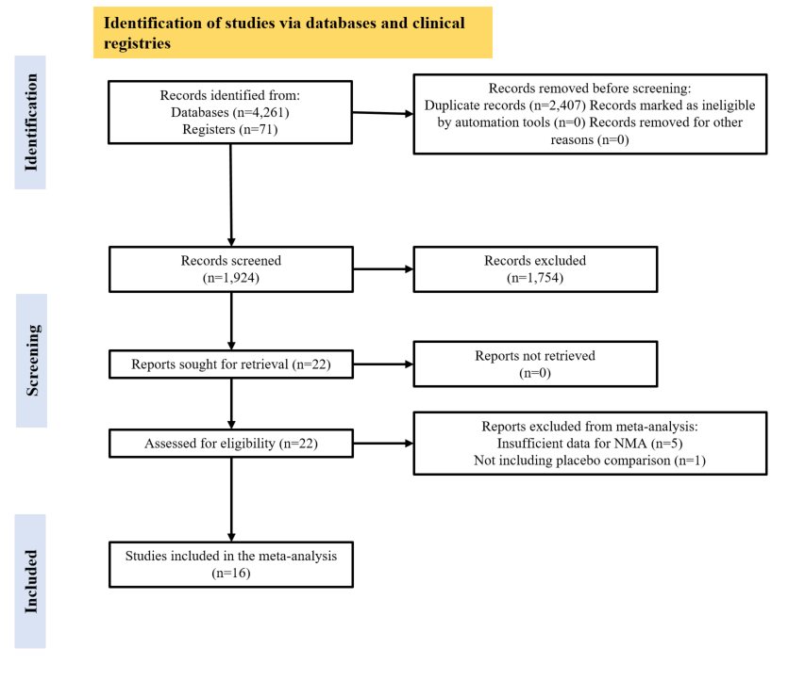

**Legend**: PRISMA flowchart

Comparisons included in the meta-analysis comprised eleven different medications grouped in six classes: three opioid receptor antagonists (naltrexone, nalmefene, naloxone); two selective serotonin reuptake inhibitors (SSRIs - paroxetine and fluvoxamine); two mood stabilizers (topiramate, lithium); one norepinephrine–dopamine reuptake inhibitor (NDRI, bupropion); one antipsychotic (olanzapine); and two supplements (N-acetyl-cysteine, silymarin).

### Figure 2 – Forest plots

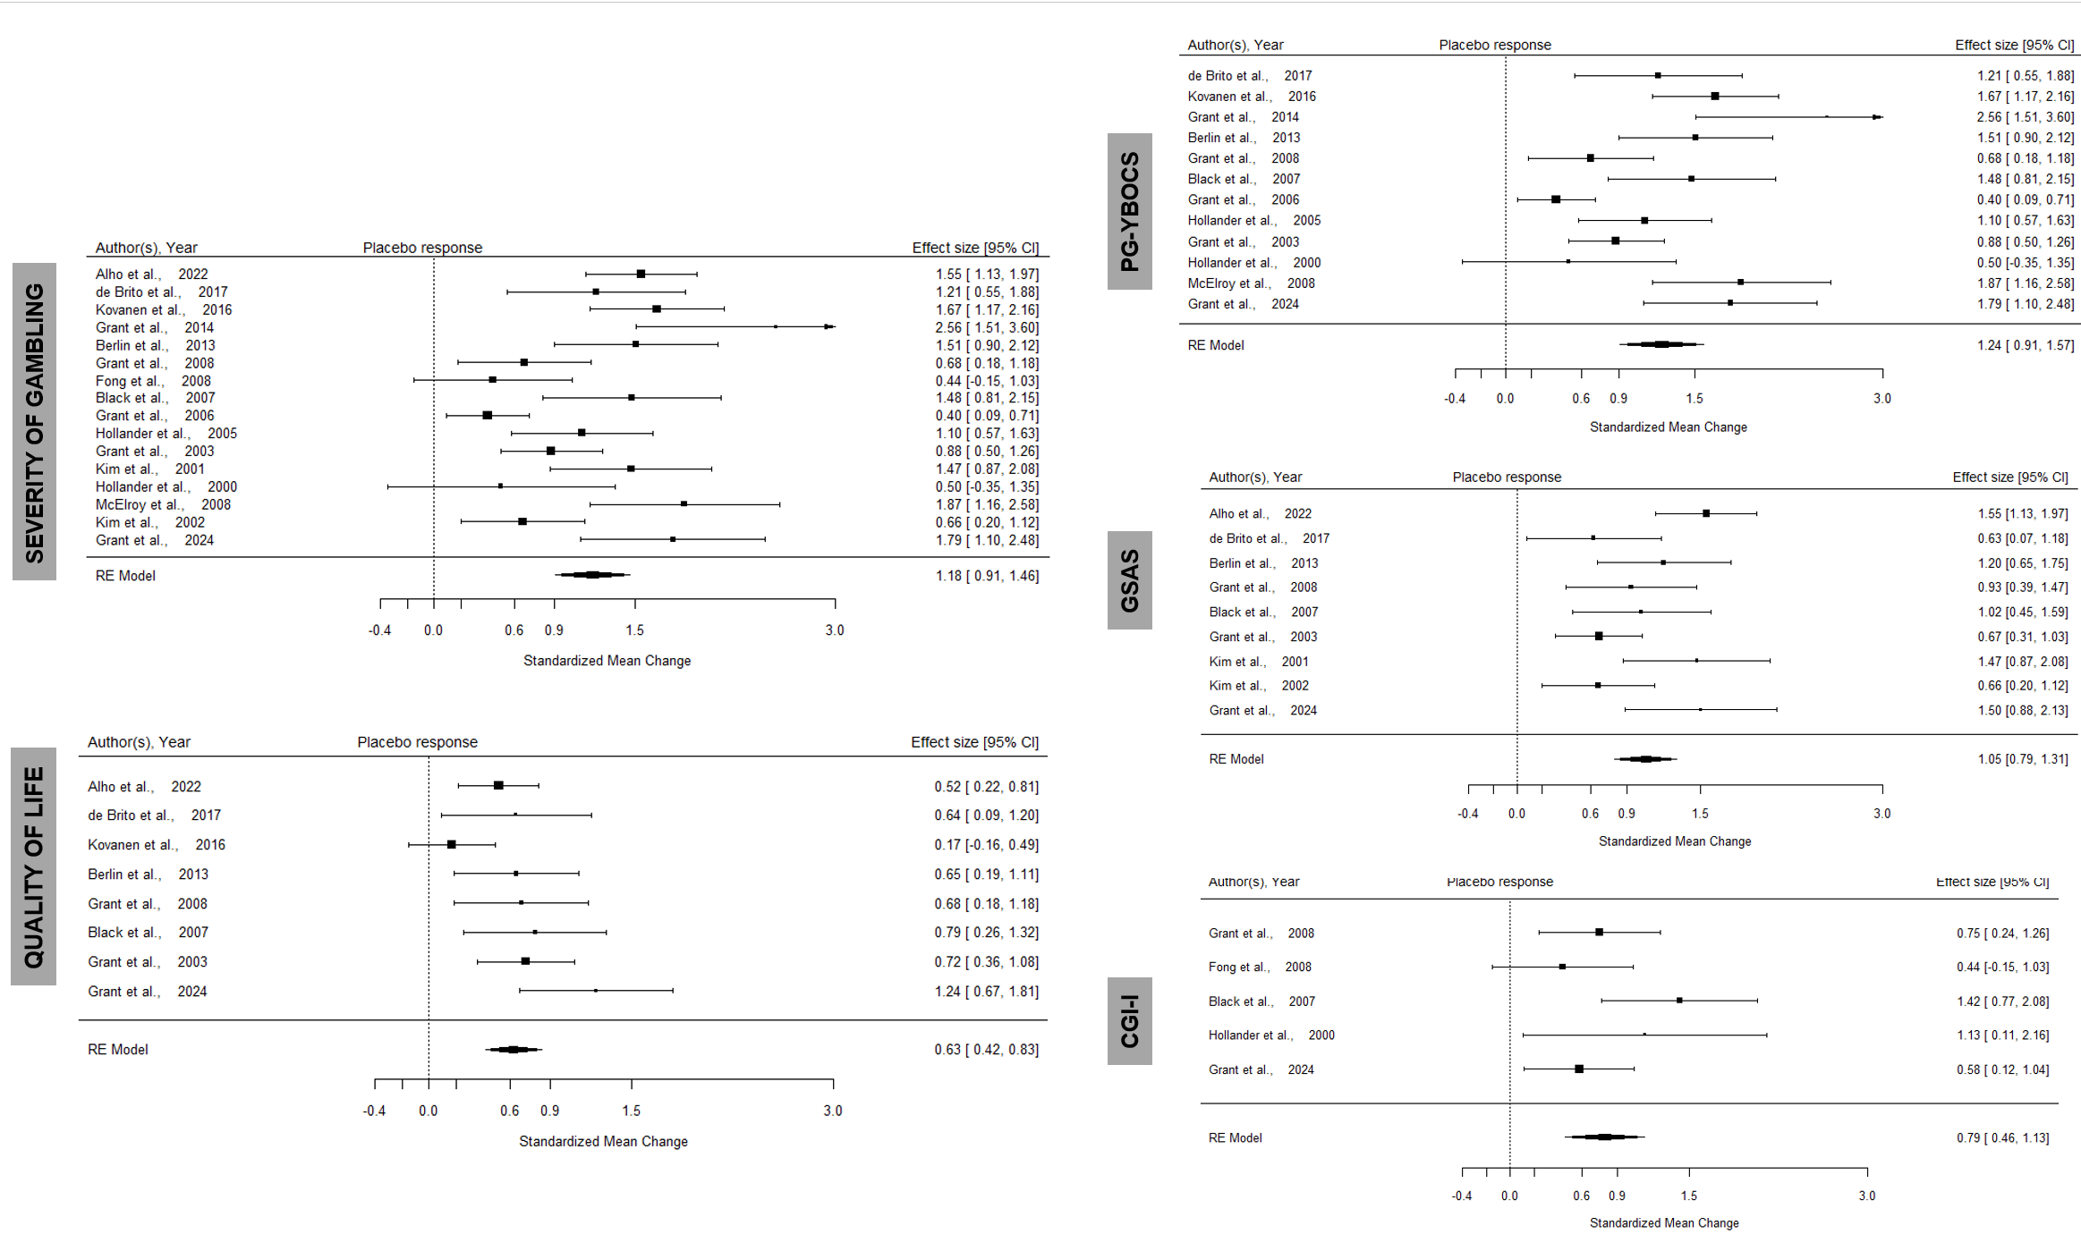

**Legend**: Meta-analysis of placebo effect in gambling severity (all studies, top left, per specific scale on the right hand side) in RCTs of pharmacological management of Gambling Disorder; “higher response” indicates improvement in gambling symptom severity compared to baseline; placebo effect for quality of life outcomes (bottom left) in RCTs of pharmacological management of Gambling Disorder; “higher response” indicates improvement in quality of life compared to baseline.

### Figure 3 – Funnel plots

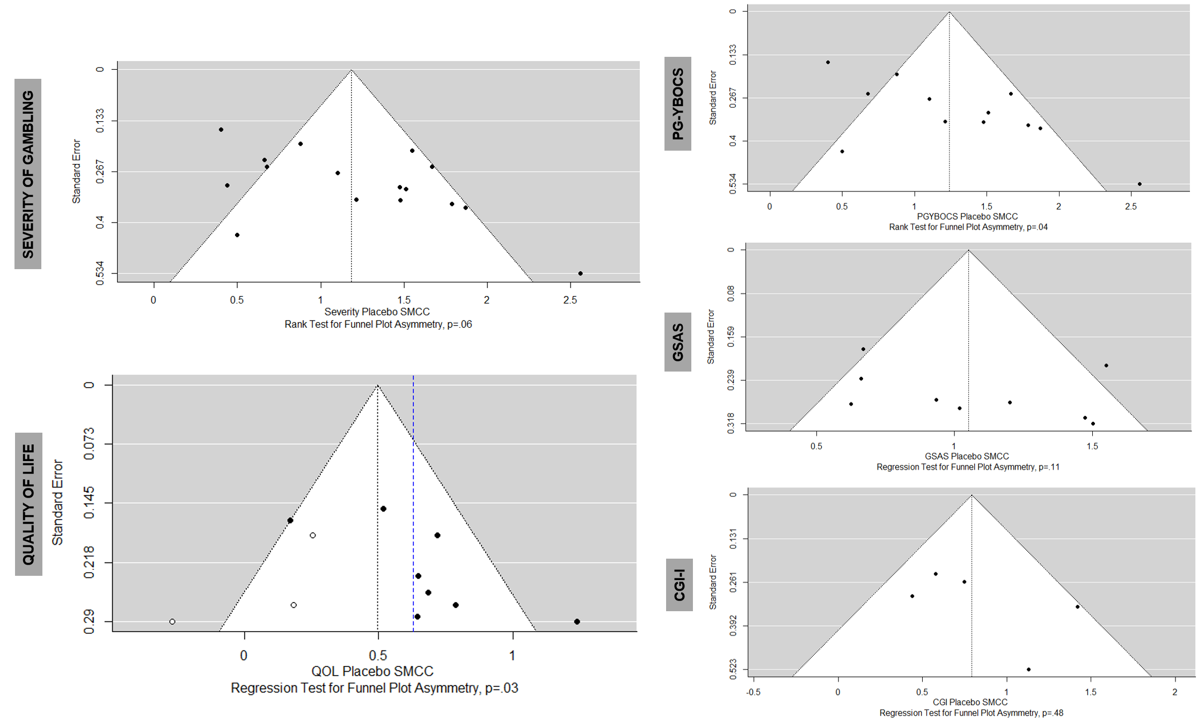

**Legend** – Funnel plots with regression for funnel plot asymmetry p-values. PG-YBOCS = Yale-Brown Obsessive Compulsive Scale adapted for Pathological Gambling, GSAS = Gambling Symptom Assessment Scale, CGI-I = Clinical Global Impression-Improvement scale. Publication bias identified in the Quality of life analysis and the trim and fill method was used to provide a new effect size estimate.

## §S1 Forest plots for treatment arms

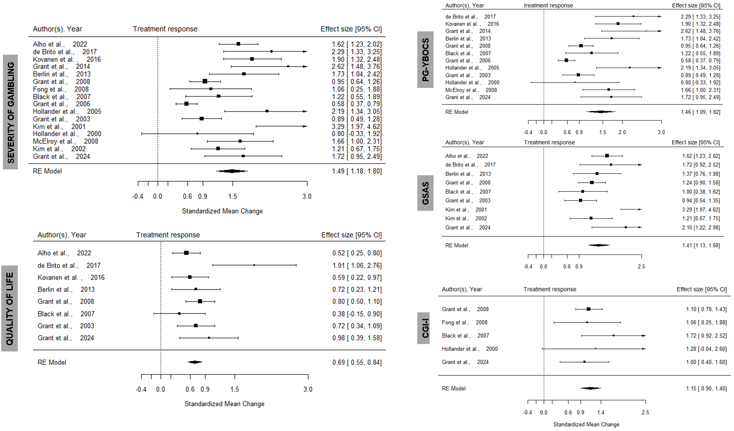

## §S2 Heterogeneity measures for treatment arms

|  |  |  |  |  |  |
| --- | --- | --- | --- | --- | --- |
|  | **tau^2 (estimated amount of total heterogeneity):** | **tau (square root of estimated tau^2 value):** | **I^2 (total heterogeneity / total variability):** | **H^2 (total variability / sampling variability):** | **Test for Heterogeneity:** |
| **Treatment gambling severity** | 0.2709 (SE = 0.1421) | 0.5205 | 79.37% | 4.85 | Q(df = 15) = 78.1221, p-val < .0001 |
| **Treatment QOL** | 0.0028 (SE = 0.0221) | 0.0534 | 6.14% | 1.07 | Q(df = 7) = 12.3856, p-val = 0.0886 |
| **Treatment PGYBOCS** | 0.2859 (SE = 0.1718) | 0.5347 | 80.77% | 5.20 | Q(df = 11) = 59.1895, p-val < .0001 |
| **Treatment GSAS** | 0.0839 (SE = 0.0837) | 0.2896 | 52.83% | 2.12 | Q(df = 8) = 19.4638, p-val = 0.0126 |
| **Treatment CGI** | 0  (SE = 0.0638) | 0 | 0.00% | 1.00 | Q(df = 4) = 2.3691, p-val = 0.6682 |

**Legend**: PG-YBOCS = Yale-Brown Obsessive Compulsive Scale adapted for Pathological Gambling, GSAS = Gambling Symptom Assessment Scale, CGI-I = Clinical Global Impression-Improvement scale; SE = standard error; df = degrees of freedom

## §S3 Publication bias in the treatment arms

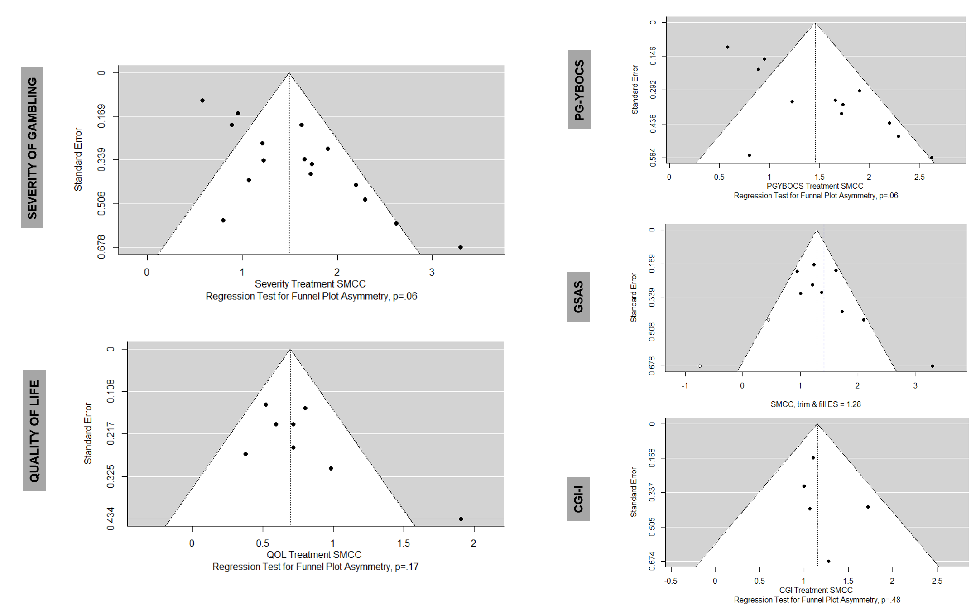

**Legend** – Funnel plots with regression for funnel plot asymmetry p-values. PG-YBOCS = Yale-Brown Obsessive Compulsive Scale adapted for Pathological Gambling, GSAS = Gambling Symptom Assessment Scale, CGI-I = Clinical Global Impression-Improvement scale. Publication bias identified in the Quality of life analysis and the trim and fill method was used to provide a new effect size estimate.

## §S4 Meta-regression analyses (meta-regression) – TREATMENT effects

|  |  |  |  |  |  |  |  |  |  |  |  |
| --- | --- | --- | --- | --- | --- | --- | --- | --- | --- | --- | --- |
| **Analysis** | **Publication Year** | **Medication type (class)** | **Sponsored study (Y/N)** | **Participant age (mean)** | **%gender** | **Duration of study** | **Unbalanced randomization** | **Baseline severity** | **Severity scale** | **Author COI (Y/N)** | **Placebo run in 1 week** |
| **Severity (all measures)** | n.s. | * MS higher E.S.  ·  supplement higher E.S. | n.s. | n.s. | n.s. | ** 16-weeks, lower E.S. * 17-weeks lower E.S. | n.s. | NA | n.s. | n.s. | n.s. |
| **PGYBOCS** | *  Recent higher E.S. | * MS higher E.S.  * supplement higher E.S. | n.s | n.s. | n.s. | ** 16-weeks, lower E.S. * 17-weeks, lower E.S. | n.s. | *** higher baseline higher E.S. | NA | n.s. | n.s. |
| **GSAS** | *  Recent higher E.S. | * supplement higher E.S. | n.s. | n.s. | n.s. | ** 11-week (the shortest) duration higher E.S. | NA | * higher baseline higher E.S. | NA | n.s. | n.s. |
| **CGI** | n.s | n.s. | n.s | n.s. | n.s. | n.s. | n.s. | n.s. | NA | n.s. | n.s. |
| **QoL** | n.s | n.s. | n.s | * higher age higher E.S. | n.s. | n.s. | NA | NA | n.s. | *  Presence of COI lower E.S. | n.s. |

**Legend**: PGYBOCS=Problematic Gambling Yale-Brown Obsessive Compulsive Scale (clinician rated, structured); GSAS = Gambling Symptom Assessment Scale (self-reported); CGI = Clinical Global Improvement (clinician scored – unstructured); QoL = Quality of life; E.S = effect size; n.s.= non-significant statistically; ORAs = Opiate receptor antagonists; MS = mood stabilizers; AP = antipsychotics; AD = antidepressants; statistical significance: n.s. = non-significant; ‘.’ <.10 (trend); ‘*’ <.05; ‘**’ <0.01; ‘***’ <0.001; NA = not available/not applicable

## §S5 Correlation between effect sizes (Pearson)

|  |  |  |  |  |  |
| --- | --- | --- | --- | --- | --- |
|  | **Placebo gambling severity** | **Placebo QOL** | **Placebo PGYBOCS** | **Placebo GSAS** | **Placebo CGI** |
| **Treatment gambling severity** | r=0.669  ** |  |  |  |  |
| **Treatment QOL** |  | r=0.198  n.s. |  |  |  |
| **Treatment PGYBOCS** |  |  | r=0.735  ** |  |  |
| **Treatment GSAS** |  |  |  | r=0.672  * |  |
| **Treatment CGI** |  |  |  |  | r=0.96  *** |

## §S6 Sensitivity analysis with correlation 0.25

### Forest plots

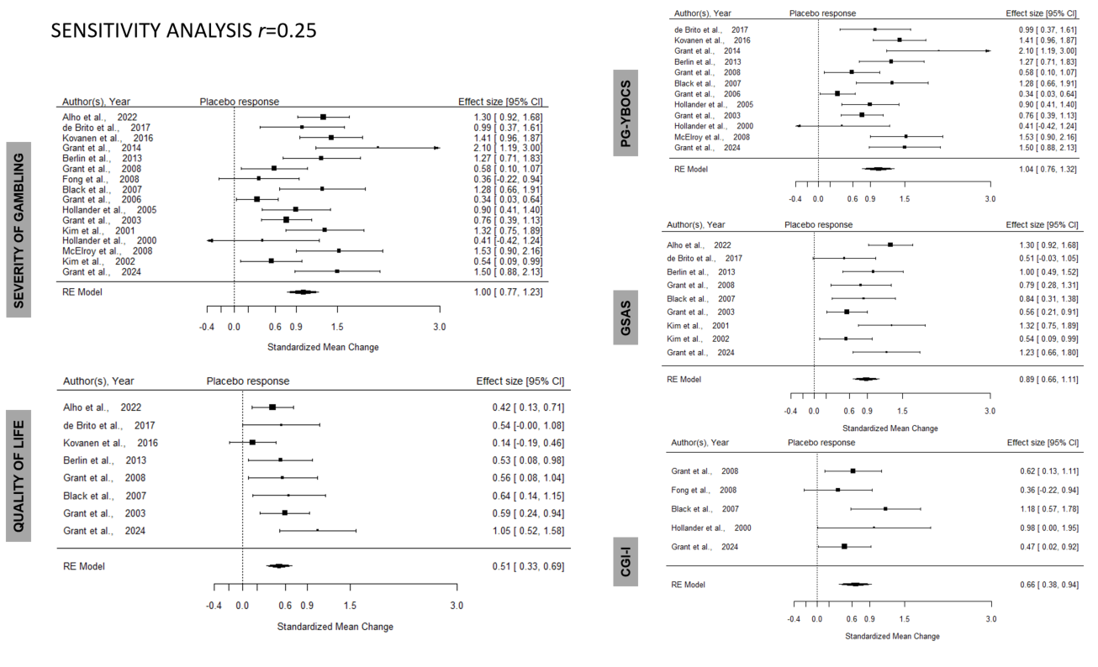

### Funnel plots

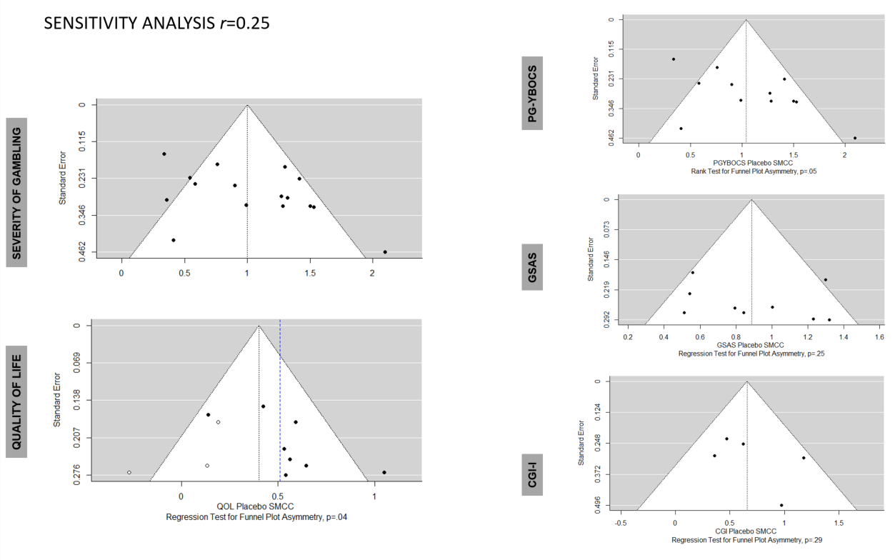

**Legend** – Funnel plots with regression for funnel plot asymmetry p-values. PG-YBOCS = Yale-Brown Obsessive Compulsive Scale adapted for Pathological Gambling, GSAS = Gambling Symptom Assessment Scale, CGI-I = Clinical Global Impression-Improvement scale. Publication bias identified in the Quality of life analysis and the trim and fill method was used to provide a new effect size estimate.

### Heterogeneity placebo with r=0.25

|  |  |  |  |  |  |
| --- | --- | --- | --- | --- | --- |
|  | **tau^2 (estimated amount of total heterogeneity):** | **tau (square root of estimated tau^2 value):** | **I^2 (total heterogeneity / total variability):** | **H^2 (total variability / sampling variability):** | **Test for Heterogeneity:** |
| **Placebo gambling severity** | 0.1464 (SE = 0.0808) | 0.3826 | 69.19% | 3.25 | Q(df = 15) = 51.0825, p-val < .0001 |
| **Placebo QOL** | 0.0191 (SE = 0.0333) | 0.1383 | 30.57% | 1.44 | Q(df = 7) = 9.7669, p-val = 0.2022 |
| **Placebo PGYBOCS** | 0.1565 (SE = 0.1010) | 0.3956 | 69.57% | 3.29 | Q(df = 11) = 39.0654, p-val < .0001 |
| **Placebo GSAS** | 0.0572 (SE = 0.0586) | 0.2391 | 49.47% | 1.98 | Q(df = 8) = 16.0486, p-val = 0.0417 |
| **Placebo CGI-I** | 0.0183 (SE = 0.0713) | 0.1352 | 17.54% | 1.21 | Q(df = 4) = 4.9326, p-val = 0.2943 |

**Legend**: PG-YBOCS = Yale-Brown Obsessive Compulsive Scale adapted for Pathological Gambling, GSAS = Gambling Symptom Assessment Scale, CGI-I = Clinical Global Impression-Improvement scale; SE = standard error; df = degrees of freedom

### Meta-regression, placebo with r=0.25

|  |  |  |  |  |  |  |  |  |  |  |  |
| --- | --- | --- | --- | --- | --- | --- | --- | --- | --- | --- | --- |
| **Analysis** | **Publication Year** | **Medication type (class)** | **Sponsored study (Y/N)** | **Participant age (mean)** | **%gender** | **Duration of study** | **Unbalanced randomization** | **Baseline severity** | **Severity scale** | **Author COI (Y/N)** | **Placebo run in 1 week** |
| **Severity (all measures)** | *  Recent higher E.S. | *  supplement higher E.S. | n.s. | n.s. | n.s. | n.s. | n.s. | NA | n.s. | n.s. | n.s. |
| **QoL** | n.s | n.s. | n.s | n.s | n.s. | n.s. | NA | ** lower baseline higher E.S. | n.s. | n.s. | n.s. |
| **PGYBOCS** | *  Recent higher E.S. | * supplement higher E.S. | n.s | n.s. | n.s. | n.s. | n.s. | ** higher baseline higher E.S. | NA | n.s. | n.s. |
| **GSAS** | n.s. | **  ORA higher E.S. | ** no sponsor higher E.S. | n.s. | n.s. | n.s. | NA | n.s. | NA | n.s. | n.s. |
| **CGI** | n.s | n.s. | n.s | n.s. | n.s. | n.s. | n.s. | n.s. | NA | n.s. | n.s. |

**Legend**: PG-YBOCS = Yale-Brown Obsessive Compulsive Scale adapted for Pathological Gambling, GSAS = Gambling Symptom Assessment Scale, CGI-I = Clinical Global Impression-Improvement scale; QoL = Quality of life; E.S = effect size; n.s.= non-significant statistically; NA = not available/not appropriate; ORAs = Opiate receptor antagonists; MS = mood stabilizers; AP = antipsychotics; AD = antidepressants; COI = Conflict of Interest (defined as the presence of any declared industry related conflict of interest by the authors in any section of the published manuscript); statistical significance: n.s. = non-significant; ‘.’ <.10 (trend); ‘*’ <.05; ‘**’ <0.01; ‘***’ <0.001; NA = not available/not applicable;

## §S7 Sensitivity analysis with correlation 0.75

### Forest plots

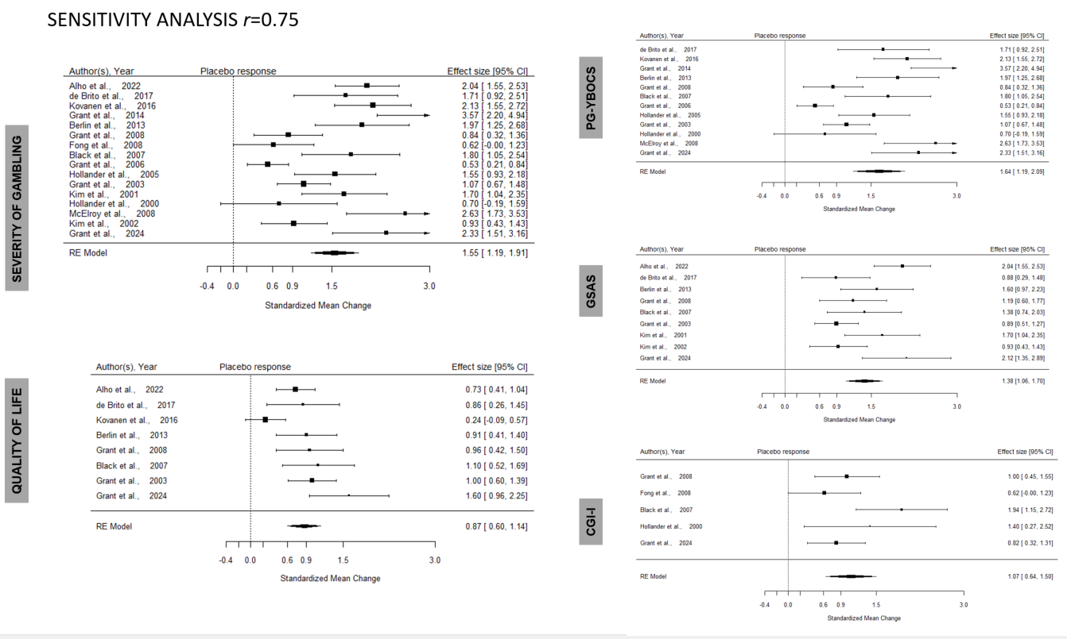

### Funnel plots

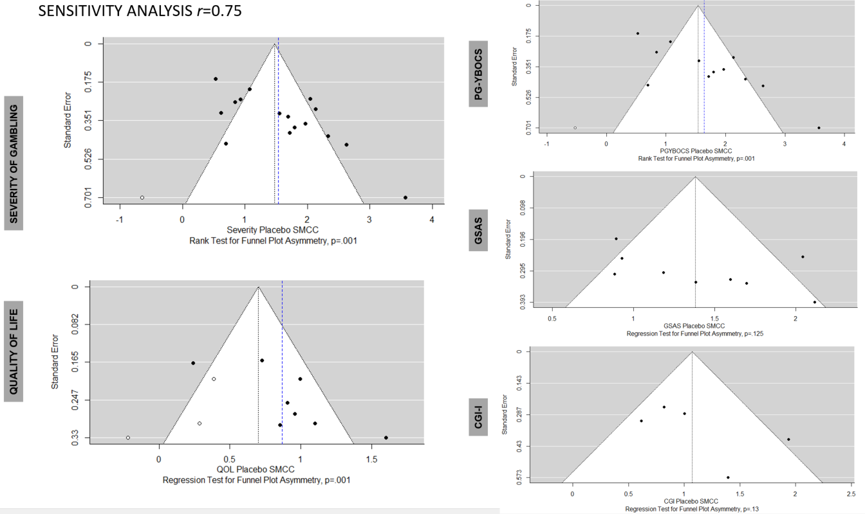

**Legend** – Funnel plots with regression for funnel plot asymmetry p-values. PG-YBOCS = Yale-Brown Obsessive Compulsive Scale adapted for Pathological Gambling, GSAS = Gambling Symptom Assessment Scale, CGI-I = Clinical Global Impression-Improvement scale. Publication bias identified in the Quality of life analysis and the trim and fill method was used to provide a new effect size estimate.

### Heterogeneity placebo with r=0.75

|  |  |  |  |  |  |
| --- | --- | --- | --- | --- | --- |
|  | **tau^2 (estimated amount of total heterogeneity):** | **tau (square root of estimated tau^2 value):** | **I^2 (total heterogeneity / total variability):** | **H^2 (total variability / sampling variability):** | **Test for Heterogeneity:** |
| **Placebo gambling severity** | 0.4269 (SE = 0.1989) | 0.6534 | 82.64% | 5.76 | Q(df = 15) = 85.3534, p-val < .0001 |
| **Placebo QOL** | 0.0908 (SE = 0.0797) | 0.3014 | 63.37% | 2.73 | Q(df = 7) = 19.8945, p-val = 0.0058 |
| **Placebo PGYBOCS** | 0.4976 (SE = 0.2690) | 0.7054 | 83.89% | 6.21 | Q(df = 11) = 68.1753, p-val < .0001 |
| **Placebo GSAS** | 0.1507 (SE = 0.1185) | 0.3882 | 65.07% | 2.86 | Q(df = 8) = 23.8891, p-val = 0.0024 |
| **Placebo CGI-I** | 0.1215 (SE = 0.1686) | 0.3486 | 52.30% | 2.10 | Q(df = 4) = 7.9725, p-val = 0.0926 |

**Legend**: PG-YBOCS = Yale-Brown Obsessive Compulsive Scale adapted for Pathological Gambling, GSAS = Gambling Symptom Assessment Scale, CGI-I = Clinical Global Impression-Improvement scale; SE = standard error; df = degrees of freedom

### Meta-regression, placebo with r=0.75

|  |  |  |  |  |  |  |  |  |  |  |  |
| --- | --- | --- | --- | --- | --- | --- | --- | --- | --- | --- | --- |
| **Analysis** | **Publication Year** | **Medication type (class)** | **Sponsored study (Y/N)** | **Participant age (mean)** | **%gender** | **Duration of study** | **Unbalanced randomization** | **Baseline severity** | **Severity scale** | **Author COI (Y/N)** | **Placebo run in 1 week** |
| **Severity (all measures)** | **  Recent higher E.S. | *  supplement higher E.S. | n.s. | n.s. | n.s. | n.s. | n.s. | NA | n.s. | n.s. | n.s. |
| **QoL** | n.s | n.s. | n.s | n.s | n.s. | * 8 weeks higher E.S.  ** 20-weeks lower E.S. | NA | *** lower baseline higher E.S. | n.s. | n.s. | n.s. |
| **PGYBOCS** | **  Recent higher E.S. | * supplement higher E.S. | n.s | n.s. | n.s. | n.s. | n.s. | *  higher baseline higher E.S. | NA | n.s. | n.s. |
| **GSAS** | *  Recent higher E.S. | *  ORA higher E.S.  * supplement higher E.S. | **  no sponsor higher E.S. | n.s. | n.s. | n.s. | NA | n.s. | NA | * absence of COI higher E.S. | n.s. |
| **CGI** | n.s | *  AP lower E.S.  * supplement lower E.S. | n.s | n.s. | n.s. | ** 6-weeks, *8-weeks lower E.S. | n.s. | n.s. | NA | * absence of COI higher E.S. | n.s. |

**Legend**: PG-YBOCS = Yale-Brown Obsessive Compulsive Scale adapted for Pathological Gambling, GSAS = Gambling Symptom Assessment Scale, CGI-I = Clinical Global Impression-Improvement scale; QoL = Quality of life; E.S = effect size; n.s.= non-significant statistically; NA = not available/not appropriate; ORAs = Opiate receptor antagonists; MS = mood stabilizers; AP = antipsychotics; AD = antidepressants; COI = Conflict of Interest (defined as the presence of any declared industry related conflict of interest by the authors in any section of the published manuscript); statistical significance: n.s. = non-significant; ‘.’ <.10 (trend); ‘*’ <.05; ‘**’ <0.01; ‘***’ <0.001; NA = not available/not applicable;

## §S8 Nocebo effects

|  |  |  |  |  |
| --- | --- | --- | --- | --- |
|  | type | n | drop outs from ‘medication’ attributed side effects | % nocebo for drop out outcomes |
| 1 | AD | 83 | 2 | 0.02409639 |
| 2 | AP | 33 | 2 | 0.06060606 |
| 3 | MS | 59 | 1 | 0.01694915 |
| 4 | ORA | 152 | 3 | 0.01973684 |
| 5 | Supplement | 21 | 0 | 0.00000000 |

## §S9 Quality assessment (Risk of bias)

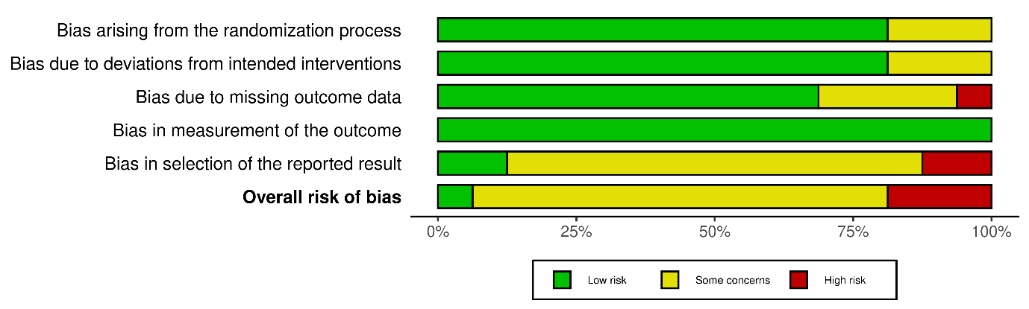

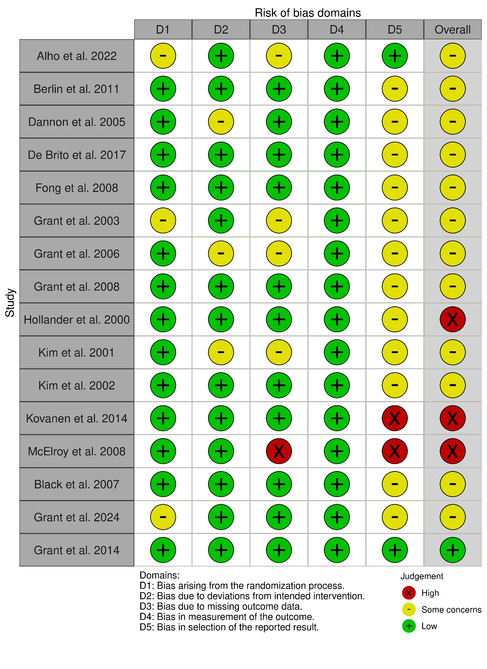

## §S10 R code

R version 4.2.1 (2022-06-23 ucrt) Platform: x86_64-w64-mingw32/x64 (64-bit) Running under: Windows 10 x64 (build 22631)

library(data.table)

library(metafor)

library(readxl)

library(meta)

library(robumeta)

library(dplyr)

df<- read.csv("~/Dataset.csv", head = TRUE, stringsAsFactors = FALSE)

df <- as.data.table(df); df <- df %>% filter(to.be.included == "1")

#placebo response of mixed severity of gambling results; follow similar for other domains/analyses.

placebo_meta <- df %>% filter(arm=="Placebo") %>% filter(symptom_sd_t0 != 0) %>%

dplyr::select(study_id, RCT_design_1, Publication.Year, type, sponsor, age_mean, perc_male, duration, scale, authors_COI, run_in, first_author, n_itt, symptom_mean_t0:sd_change..t1.t0.)

dat <- escalc(measure="SMCC", m1i=symptom_mean_t0, sd1i=symptom_sd_t0, m2i=symptom_mean_t1, sd2i=symptom_sd_t1, ni=n, ri=c(rep(0.50, 16)), data=placebo_meta, slab=paste(first_author, Publication.Year, sep=", ")) #impute correlation for sensitivity analyses

res <- rma(yi, vi, data=dat) ; predict(res, digits=3); confint(res)

forest(res, xlim=c(-2.6,4.6),

at=(c(-.4,-.2,0,.2,.6,.9, 1.5, 3)), digits=c(2,1), cex=.8)

text(-2.6, 17.5, "Author(s), Year", pos=4, cex=.9)

text(-0.6, 17.5, "Placebo response", pos=4, cex=.9)

text( 4.6, 17.5, "Effect size [95% CI]", pos=2, cex=.9)

plb1.yi <- res$yi; plb1.slab <- res$slab; b_res <- rma(yi, vi,data=dat, slab=study_id) #save results for further comparisons

#baujat(b_res); inf <- influence(res); print(inf); plot(inf) # influence diagnostics

### funnel plot

funnel(res, xlab = "Severity Placebo SMCC \nRank Test for Funnel Plot Asymmetry, p=XXX") #Tests for bias

regtest(res); ranktest(res); #for trim and fill if necessary

res.tf <- trimfill(res); res.tf

funnel(res.tf, xlab = "Severity Placebo SMCC \nRank Test for Funnel Plot Asymmetry, p=.XXX")

abline(v=1.54, col="blue", lwd=1, lty = 2)

#Meta-regression analysis for publication year, type, sponsor, age_mean, perc_male, duration, scale, authors_COI

res.modage <- rma(yi, vi, mods = ~ Publication.Year, data=dat)

res.modage

## List of papers included in the meta-analysis

|  |  |  |  |  |  |  |  |  |  |  |  |  |  |
| --- | --- | --- | --- | --- | --- | --- | --- | --- | --- | --- | --- | --- | --- |
| **#** | **First Author** | **Year** | **Journal** | **Study Type and Design** | **Arms** | **N randomized** | **Age (mean) /arm** | **%Male /arm** | **Route/ dosing scheme** | **Min. dose†** | **Max. dose†** | **Duration** | **Sponsorship** |
| **1** | Alho et al.(Alho et al., 2022) | 2022 | Add Behav | Double Blind RCT Parallel design, 2 arms | naloxone vs. placebo | 62/64 | 44.0 /  45.2 | 72% / 67% | Intranasal QDS/PRN | 4mg | 16mg | 12-weeks | No |
| **2** | De Brito et al.(de Brito et al., 2017) | 2017 | J Gambl Studies | Double Blind RCT Parallel design, 2 arms | topiramate vs. placebo | 18/20 | 50.6 /  45.8 | 53% / 53% | Oral BD | 25mg | 300mg | 12-weeks | Yes |
| **3** | Kovanen et al.(Kovanen et al., 2016) | 2016 | Eur Addict Res | Double Blind RCT Parallel design, 2 arms | naltrexone vs. placebo | 50/51 | 47.4 /  44.5 | 66% / 71% | Oral OD/PRN | 50mg | 50mg | 20-weeks | Yes |
| **4** | McElroy et al.(McElroy, Nelson, Welge, Kaehler, & Keck, 2008) | 2008 | J Clin Psychiatry | Double Blind RCT Parallel design, 2 arms | olanzapine vs. placebo | 21/21 | 51.5 /  46.8 | 38% / 48% | Oral, flexible | 2.5mg | 15mg | 12-weeks | Yes |
| **5** | Berlin et al.(Berlin et al., 2013) | 2013 | WJBP | Double Blind RCT Parallel design, 2 arms | topiramate vs. placebo | 20/22 | 50.5 /  44.9 | 50% / 45% | Oral, flexible | 25mg | 300mg | 14-weeks | Yes |
| **6** | Grant et al.(Grant, Kim, Hollander, & Potenza, 2008) | 2008 | J Clin Psychiatry | Double Blind RCT Parallel design, 2 arms | naltrexone vs. placebo | 58/19 | 47.8 /  44.7 | 36% / 47% | Oral, titration | 25mg | 150mg | 17-weeks | No |
| **7** | Fong et al.(Fong, Kalechstein, Bernhard, Rosenthal, & Rugle, 2008) | 2008 | Pharm Bio Beh | Double Blind RCT Parallel design, 2 arms | olanzapine vs. placebo | 11/12 | 46.6  43.6 | 55% / 50% | Oral, titration | 2.5mg | 10mg | 6-weeks | Yes |
| **8** | Black et al. (Black et al., 2007) | 2007 | J Clin Pharmacol | Double Blind RCT Parallel design, 2 arms | bupropion vs. placebo | 18/21 | 42.8  43.5 | 61% / 81% | Oral, flexible | 150mg | 375mg | 12-weeks | No |
| **9** | Grant et al.(Grant et al., 2006) | 2006 | Am J Psychiatry | Double Blind RCT Parallel design, 4 arms | nalmefene vs. placebo | 156/51 | 47.0 /  45.3 /  44.9 /  45.7/  46.3 | 54% / 56% / 50% / 67% | Oral, OD | 25mg | 100mg | 16-weeks | Yes |
| **10** | Kim et al.(Kim, Grant, Adson, & Zaninelli, 2002) | 2002 | J Clin Psychiatry | Double Blind RCT Parallel design, 2 arms | paroxetine vs. placebo | 23/22 | 49.3 /  49.3 | 43% / 28% | Oral, flexible | 20mg | 60mg | 8-weeks | Yes |
| **11** | Grant et al. (Grant et al., 2003) | 2003 | Int Clin Psychopharmacol | Double Blind RCT Parallel design, 2 arms | paroxetine vs. placebo | 36/40 | 47.0 /  42.0 | 44% / 75% | Oral, flexible | 10mg | 60mg | 16-weeks | Yes |
| **12** | Kim et al.(Kim, Grant, Adson, & Shin, 2001) | 2001 | Biol Psychiatry | Double Blind RCT Parallel design, 2 arms | naltrexone vs. placebo | 20/25 | 48.0 /  49.0 | 30% / 40% | Oral, flexible | 25mg | 250mg | 11-weeks | No |
| **13** | Hollander et al. (Eric Hollander et al., 2000) | 2000 | Biol Psychiatry | Double Blind RCT Cross-over design, 2 arms | fluvoxamine vs. placebo | 6/7 | 43.0 /  36.2 | 100% / 100% | Oral, fixed & cross-over | 50mg | 250mg | 8-weeks | Yes |
| **14** | Grant et al.(Grant et al., 2014) | 2014 | J Clin Psychiatry | Double Blind RCT Parallel design, 2 arms | NAC vs. placebo | 13/15 | N/A | N/A | Oral, clinical judgement | 1200mg | 3gr | 12-weeks | No |
| **15** | Hollander et al. (E Hollander, Pallanti, Allen, Sood, & Rossi, 2005) | 2005 | Am J Psychiatry | Double Blind RCT Parallel design, 2 arms | lithium vs placebo | 18/22 | 40.0 /  47.7 | 50% / 64.7% | Oral, flexible | 300mg sust. release | 1200mg sust. release | 10-weeks | Yes |
| **16** | Grant et al. (Grant, Driessens, & Chamberlain, 2024) | 2024 | Clinical Neuropharm | Double Blind RCT Parallel design, 2 arms | silymarin vs placebo | 17/26 | 48.2/ 50.5 | 41.2% / 72% | Oral, titration | 300mg | 600mg | 8-weeks | No |

## References

**Alho, H., Mäkelä, N., Isotalo, J., Toivonen, L., Ollikainen, J., & Castrén, S**. (2022). Intranasal as needed naloxone in the treatment of gambling disorder: A randomised controlled trial. *Addictive Behaviors*, *125*. https://doi.org/10.1016/J.ADDBEH.2021.107127

**Berlin, H. A., Braun, A., Simeon, D., Koran, L. M., Potenza, M. N., McElroy, S. L., … Hollander, E.** (2013). A double-blind, placebo-controlled trial of topiramate for pathological gambling. *The World Journal of Biological Psychiatry : The Official Journal of the World Federation of Societies of Biological Psychiatry*, *14*(2), 121–128. https://doi.org/10.3109/15622975.2011.560964

**Black, D. W., Arndt, S., Coryell, W. H., Argo, T., Forbush, K. T., Shaw, M. C., … Allen, J**. (2007). Bupropion in the treatment of pathological gambling: a randomized, double-blind, placebo-controlled, flexible-dose study. *Journal of Clinical Psychopharmacology*, *27*(2), 143–150. https://doi.org/10.1097/01.JCP.0000264985.25109.25

**de Brito, A. M. C., de Almeida Pinto, M. G., Bronstein, G., Carneiro, E., Faertes, D., Fukugawa, V., … Tavares, H**. (2017). Topiramate Combined with Cognitive Restructuring for the Treatment of Gambling Disorder: A Two-Center, Randomized, Double-Blind Clinical Trial. *Journal of Gambling Studies*, *33*(1), 249–263. https://doi.org/10.1007/S10899-016-9620-Z/METRICS

**Fong, T., Kalechstein, A., Bernhard, B., Rosenthal, R., & Rugle, L.** (2008). A double-blind, placebo-controlled trial of olanzapine for the treatment of video poker pathological gamblers. *Pharmacology, Biochemistry, and Behavior*, *89*(3), 298–303. https://doi.org/10.1016/J.PBB.2007.12.025

**Grant, J. E., Driessens, C., & Chamberlain, S. R.** (2024). Milk Thistle (Silymarin) Treatment of Adults with Gambling Disorder: A Double-Blind, Placebo-Controlled Trial. *Clinical Neuropharmacology*, *in press*. Retrieved from https://ichgcp.net/clinical-trials-registry/NCT02337634

**Grant, J. E., Kim, S. W., Hollander, E., & Potenza, M. N.** (2008). Predicting response to opiate antagonists and placebo in the treatment of pathological gambling. *Psychopharmacology*, *200*(4), 521–527. https://doi.org/10.1007/s00213-008-1235-3

**Grant, J. E., Kim, S. W., Potenza, M. N., Blanco, C., Ibanez, A., Stevens, L., … Zaninelli, R**. (2003). Paroxetine treatment of pathological gambling: a multi-centre randomized controlled trial. *International Clinical Psychopharmacology*, *18*(4), 243–249. https://doi.org/10.1097/00004850-200307000-00007

**Grant, J. E., Odlaug, B. L., Chamberlain, S. R., Potenza, M. N., Schreiber, L. R. N., Donahue, C. B., & Kim, S. W.** (2014). A randomized, placebo-controlled trial of N-acetylcysteine plus imaginal desensitization for nicotine-dependent pathological gamblers. *The Journal of Clinical Psychiatry*, *75*(1), 39–45. https://doi.org/10.4088/JCP.13M08411

**Grant, J. E., Potenza, M. N., Hollander, E., Cynningham-Williams, R., Nurminen, T., Smits, G., & Kallio, A**. (2006). Multicenter investigation of the opioid antagonist nalmefene in the treatment of pathological gambling. *The American Journal of Psychiatry*, *163*(2), 303–312. https://doi.org/10.1176/APPI.AJP.163.2.303

**Hollander, E, Pallanti, S., Allen, A., Sood, E., & Rossi, N.** (2005). Does sustained-release lithium reduce impulsive gambling and affective instability versus placebo in pathological gamblers with bipolar spectrum disorders? *The American Journal of Psychiatry*, *162*(1), 137–145. https://doi.org/10.1176/APPI.AJP.162.1.137

**Hollander, Eric, Decaria, C. M., Finkell, J. N., Begaz, T., Wong, C. M., & Cartwright, C.** (2000). A randomized double-blind fluvoxamine/placebo crossover trial in pathologic gambling. *Biological Psychiatry*, *47*(9), 813–817. https://doi.org/10.1016/S0006-3223(00)00241-9

**Kim, S. W., Grant, J. E., Adson, D. E., & Shin, Y. C.** (2001). Double-blind naltrexone and placebo comparison study in the treatment of pathological gambling. *Biological Psychiatry*, *49*(11), 914–921. https://doi.org/10.1016/S0006-3223(01)01079-4

**Kim, S. W., Grant, J. E., Adson, D. E., & Zaninelli, R.** (2002). A Double-Blind Placebo-Controlled Study of the Efficacy and Safety of Paroxetine in the Treatment of Pathological Gambling. *The Journal of Clinical Psychiatry*, *63*(6), 4776. Retrieved from https://www.psychiatrist.com/jcp/ocd/pathological-gambling/double-blind-placebo-controlled-study-efficacy-safety-paroxetine-pathological-gambling

**Kovanen, L., Basnet, S., Castrén, S., Pankakoski, M., Saarikoski, S. T., Partonen, T., … Lahti, T.** (2016). A Randomised, Double-Blind, Placebo-Controlled Trial of As-Needed Naltrexone in the Treatment of Pathological Gambling. *European Addiction Research*, *22*(2), 70–79. https://doi.org/10.1159/000435876

**McElroy, S. L., Nelson, E. B., Welge, J. A., Kaehler, L., & Keck, P. E**. (2008). Olanzapine in the treatment of pathological gambling: a negative randomized placebo-controlled trial. *The Journal of Clinical Psychiatry*, *69*(3), 433–440. https://doi.org/10.4088/JCP.V69N0314

## PRISMA-P

Preferred reporting items for systematic review and meta-analysis protocols) 2015 checklist:

| **Section and topic** | **Item No** | **Checklist item** |
| --- | --- | --- |
| **Administrative information** | | |
| Title: |  |  |
| Identification | 1a | Identify the report as a protocol of a systematic review *(identified as meta-analysis)* |
| Update | 1b | If the protocol is for an update of a previous systematic review, identify as such *(not applicable)* |
| Registration | 2 | If registered, provide the name of the registry (such as PROSPERO) and registration number *(PROSPERO registration provided)* |
| Authors: |  |  |
| Contact | 3a | Provide name, institutional affiliation, e-mail address of all protocol authors; provide physical mailing address of corresponding author *(in title page)* |
| Contributions | 3b | Describe contributions of protocol authors and identify the guarantor of the review *(see author contributions p20 line 434)* |
| Amendments | 4 | If the protocol represents an amendment of a previously completed or published protocol, identify as such and list changes; otherwise, state plan for documenting important protocol amendments *(not applicable)* |
| Support: |  |  |
| Sources | 5a | Indicate sources of financial or other support for the review *(see p18 line 407)* |
| Sponsor | 5b | Provide name for the review funder and/or sponsor  *(see p18 line 407)* |
| Role of sponsor or funder | 5c | Describe roles of funder(s), sponsor(s), and/or institution(s), if any, in developing the protocol  *(not applicable)* |
| **Introduction** | | |
| Rationale | 6 | Describe the rationale for the review in the context of what is already known *(see p5-6)* |
| Objectives | 7 | Provide an explicit statement of the question(s) the review will address with reference to participants, interventions, comparators, and outcomes (PICO) *(see p6-7)* |
| **Methods** | | |
| Eligibility criteria | 8 | Specify the study characteristics (such as PICO, study design, setting, time frame) and report characteristics (such as years considered, language, publication status) to be used as criteria for eligibility for the review *(see materials and methods lines 126-140)* |
| Information sources | 9 | Describe all intended information sources (such as electronic databases, contact with study authors, trial registers or other grey literature sources) with planned dates of coverage *(see materials and methods lines 118-125)* |
| Search strategy | 10 | Present draft of search strategy to be used for at least one electronic database, including planned limits, such that it could be repeated *(see materials and methods lines 118-125)* |
| Study records: |  |  |
| Data management | 11a | Describe the mechanism(s) that will be used to manage records and data throughout the review *(see materials and methods lines 132-154)* |
| Selection process | 11b | State the process that will be used for selecting studies (such as two independent reviewers) through each phase of the review (that is, screening, eligibility and inclusion in meta-analysis) *(see materials and methods line 132)* |
| Data collection process | 11c | Describe planned method of extracting data from reports (such as piloting forms, done independently, in duplicate), any processes for obtaining and confirming data from investigators *(see materials and methods line 132)* |
| Data items | 12 | List and define all variables for which data will be sought (such as PICO items, funding sources), any pre-planned data assumptions and simplifications *(see materials and methods line 132 and 133-154)* |
| Outcomes and prioritization | 13 | List and define all outcomes for which data will be sought, including prioritization of main and additional outcomes, with rationale *(see materials and methods line 132 and 133-154* |
| Risk of bias in individual studies | 14 | Describe anticipated methods for assessing risk of bias of individual studies, including whether this will be done at the outcome or study level, or both; state how this information will be used in data synthesis *(see materials and methods line 132 and 133-140)* |
| Data synthesis | 15a | Describe criteria under which study data will be quantitatively synthesised *(see materials and methods line 132 and 156-180)* |
| 15b | If data are appropriate for quantitative synthesis, describe planned summary measures, methods of handling data and methods of combining data from studies, including any planned exploration of consistency (such as I2, Kendall’s τ) *(see materials and methods line 132 and 156-180)* |
| 15c | Describe any proposed additional analyses (such as sensitivity or subgroup analyses, meta-regression) *(see materials and methods line 132 and 156-180)* |
| 15d | If quantitative synthesis is not appropriate, describe the type of summary planned *(not applicable)* |
| Meta-bias(es) | 16 | Specify any planned assessment of meta-bias(es) (such as publication bias across studies, selective reporting within studies) *(see materials and methods line 132 and 181-184)* |
| Confidence in cumulative evidence | 17 | Describe how the strength of the body of evidence will be assessed (such as GRADE) (*(see materials and methods line 132 and 181-184, also see limitations)* |