Community, Inclusivity and Context: Exploring the factors that shape cultural policy in Iran

Abstract
Background: The meaning, practice and experience of cultural policy is highly context-dependent and shaped by local communities and cultural values. Although existing studies focus on cultural policy in western contexts there is a need for more research on regions, countries, cities and communities within the Global South such as Africa and the Middle East.
Objectives: The co-production of cultural policy draws attention to processes of inclusivity and community involvement at the stages of planning and implementation. This paper aims to understand the ethos, values and structure of policymaking in Iran and the missing role of local communities in decision-making at local and national levels.
Method: This research draws on qualitative data from multiple qualitative sources, informed by the positionality and experience of the first author who has lived, studied and worked in Iran for over 30 years. The experience involved four projects: (1) exploring culture-led regeneration in Rasht city, Iran; (2) reviewing a ten-step bottom-up community-led regeneration scheme; (3) surveys with 128 users of cultural places and creative activities in Rasht city, Iran; and (4) 20 semi-structured interviews with key informants in public institutions.
Results: Despite concentration on cultural citizenship, the top-down policies and practices of the Iranian government undermine participatory processes and democratic values. Yet, there is also evidence that the cultural identities and practices of local communities remain visible and vibrant.
Conclusion: The paper demonstrates how policies in the post-revolutionary period limit the country’s adoption of cultural models while suppressing forms of community participation and democratic values.
Contribution: The paper nuances our understanding of the gap between the universal model of cultural policy and what happens in practice. By focussing on the understudied case of Iran, the paper also highlights how cultural policy, in non-western contexts, is shaped by a range of factors including cultural values and political imperatives.
Keywords:
Culture, Iran, cultural policy, inclusivity, urban regeneration, local communities

Introduction
Just as the meaning of culture is difficult to pin down (Oni et al., 2020), cultural policy is a fuzzy concept with different definitions depending on time period, location, scale and context. Understandings and applications of such policy vary across countries and regions in the Global North, such as Europe, and the Global South including Africa and the Middle East (Comunian et al., 2021). Garcia (2004) frames cultural policy as governmental activities related to promoting the production of arts and cultural industries, heritage, and humanities. Others include a wider range of actors including public bodies, NGOs and community organisations who endeavour to position people’s satisfaction in line with their cultural needs and consent for social transformation (Bordat-Chauvin, 2022). Cultural policy is also framed as a tool to promote a specific idea of community (Gray, 2010). In Barcelona, for example, cultural policy encourages the creation of cultural value to attract the attention of local and international communities, including tourists, to the city’s cultural identity and outputs (Patricio Mulero & Rius-Ulldemolins, 2017). Here, scale matters and cultural policies, which often conflict, can be articulated at the national or local level.
Cultural policy, on the other hand, is naturally collaborative and community-dependent, with diversity and inclusion serving as key attributes of both culture and policy. While scholarship on the concept of collaborative cultural policies is growing, there is a need for cities to be more transparent and develop policies that inform the public of what aims, individuals and kinds of culture are supported (Bennett & Silva, 2011). The term inclusive is commonly associated with cities and cultural policies but this concept is also contested by scholars debating which individuals and social groups should be included in planning processes and policies and what spaces, activities and cultural content should be included (Alsayel et al., 2022). While some focus on including certain groups within wider populations, such as low-income households or individuals with disabilities (Rebernik et al., 2019), others consider collaborative and inclusive governance as a form of decision-making based on the consent of a wide range of stakeholders comprising public and private actors from diverse backgrounds and various interests (Ansell & Gash, 2018).
Therefore, more conceptual work related to cultural policy and in particular greater attention to inclusivity and community engagement at the planning and action stages is required. By extension, there is a need to consider the role of local specificity and context with respect to culture, cultural policies and community. As most studies and debates focus on Western contexts such as the UK, US, Europe and Australia more research is needed on regions, countries, cities and communities within the Global South such as Africa, South America and the Middle East (Bayliss, 2007; Borén & Young, 2013; van Hek & Kraaykamp, 2013)​.
Iran is a particularly unique case in the Global South, due to its large size, geography and demographic diversity of ethnicities and cultures, which constitutes an extreme and understudied case in cultural policy. A nation with a rich history of art, culture, and liberal values that has informed and aligned with Western culture for many decades. Since the 1979 Revolution, the transformation of the state from liberal to conservatism led to a parallel transformation of its national and cultural identity from outward-looking to inward-looking and protectionist (Aghaeimehr, 2020). Before 1979 cultural policy a centralised priority and much of the cultural practices, architecture and built environments in Iran followed European Modernism in art, architecture and cultural venues (Mehan, 2017). By contrast the current state of top-down policy planning and economic dependence on oil revenue has resulted in urban development and civic engagement issues. Indeed, Iranian citizens believe that they only need to maintain their private spaces and that the maintenance of public properties is the duty of the government. Unlike Europeans, Iranians see themselves as separate from the state (Pakzad, 2017) which increases the conflict. In recent years, processes of globalisation and the rise of digital technologies and social media in particular has brought Iranians into direct contact with Western cultures, practices and values, limiting the impact of the state’s control and undermining its authority over policies and practices (Mashhadi Moghaddam & Rafieian, 2020). This had a similar impact on the application of cultural policy. As it becomes more difficult to control urban societies through national policies, local authorities and structures are enabling greater levels of community participation (Pourzakarya & Fadaei Nezhad Bahramjerdi, 2021).
This paper sheds light on the Iranian context as the country grapples modern approaches to0 cultural policy which contrast with its restrictive, centralised and highly controlled national level approach. It investigates the notion of cultural policy, its evolution, and the dichotomy of control vs liberty through the lens of community participation in Iran. Our research pays particular attention to the structure of policymaking and the missing role of local communities in decision-making in Iran at different levels (national and local). Drawing on 20 interviews with national and local public organisations and observation of policy planning processes at different levels, it demonstrates the unique context of post-revolutionary Iran, whose cultural values, have shaped the aims, planning process and delivery of its cultural policy over time. The paper attempts to understand planning structures in Iran and their obstacles by exploring the theoretical background of inclusive cultural policy in different contexts. This is followed by a consideration of the challenges associated with a centralised policy planning process and possible recommendations for inclusive cultural policy planning in Iran. In so doing, the paper contributes to our collective understanding of cultural policy, diverse local cultures, processes of inclusivity, community engagement and the important role of context.

Conceptualising inclusive cultural policy
There is no single theory that can explain the history of planning in Iran from the perspective of power, rationality, politics, civic engagement or urban planning. Therefore, this paper brings together a range of relevant and useful theories including inclusivity and empowerment.
A socially inclusive cultural policy could be defined as a program that promotes distinctive development in arts and culture alongside innovation by employing cultural and creative activities of artists, entrepreneurs, and other groups of people (Sasaki, 2010). The moral obligation to endorse social inclusion and resist exclusion from mainstream culture appeared in the twentieth century as a result of democratisation and growing support for multiple identities (Alsayel et al., 2022). It started by promoting the ability of disadvantaged people to engage with socio-economic and cultural aspects of life. In recent years, decision-makers have incorporated inclusion into urban policy schemes with the idea that it can advance creativity and economic progress (Lindberg, 2018). Aspects of inclusivity can involve a range of factors including age, disability, location, income, race, ethnicity, religion, gender and sexuality. For example, social inclusion policies in Scottland were developed with the aim of promoting opportunities and removing barriers to inclusion to strengthen the full participation of different groups and generations in community life (McCall, 2009). These groups can include but are not limited to elites and educated people, less-advantaged groups, those living in the capital and small cities, and residents of neighbourhoods with significant historical or cultural heritage values. Therefore, an inclusive city can be described as a healthy and flourishing city which has eliminated all preventable obstacles to liberty and value creation (Anttiroiko & de Jong, 2020).
Based on its sub-dimensions, ‘capabilities’, ‘participation’, and ‘access’, cultural policies can be evaluated through the discourse of empowerment. Inclusive cultural empowerment is a shared capability to stimulate personal and social development through access to cultural facilities, recognising cultural actions in the community, and participation in inclusive cultural policy planning processes (Campagna, 2017). Participation in cultural life intends to encompass the right to act freely in choosing one’s own identity, engage in cultural practices and creative activities, and develop self-expression with a focus on minority and indigenous groups. In the Nordic context, for example, the principal idea of democratising culture was to make the greatest artworks accessible to every person in a democratic society including the working class as well as those living in slums or peripheral areas (Mangset, 2020). Citizen-centred access to cultural life involves the right of individuals and communities to understand their own and others’ culture as well as cultural heritage through education, training, and information (Odello, 2011).
In this respect, Comunian et al. (2021) highlighted the role of creative intermediaries in the African context in supporting Cultural and Creative Industries (CCIs). They assert that cultural intermediaries are particularly able to support creative individuals, groups, and projects by providing access to networks, skills and information (soft infrastructure) alongside physical or organisational resources (hard infrastructure) (Comunian et al., 2021). Another example of community participation comes from Argentina where after 2015, the state established the Points of Culture (PdC) program to stimulate cultural engagement between underprivileged and marginalised people through funding projects of community-based cultural organisations (Bordat-Chauvin, 2022). The program directs cultural policies towards ‘community culture’ which is described as every culture and the means to develop the world embedded in each community, neighbourhood, region, etc. This can be regarded as a very different orientation from the paradigm of cultural policy or culture as a vehicle for economic development.
Within the context of inclusivity, an important debate surrounds whose cultural heritage and values are celebrated, supported and represented. Indeed, the inclusivity of local communities is reliant on the extent to which a group or an individual’s cultural values, heritage, and traditions are represented to share beliefs and knowledge with others within the mainstream culture (Olivares & Piatak, 2022). While race refers to the physical characteristics of people, ethnicity expresses the national and local cultural features of a group or community. This can be reflected in how significant ethnicity is to experience social practices, events, and artistic activities as well as food and crafts through strengthening a sense of belonging and enriching mutual understanding (UNESCO, 2016). Engagement with cultural values contributes to people’s level of education, skill development, health, and social cohesion in societies since education and culture are fundamentally interconnected (Bourdieu, 2008). Thus, inclusive policies aiming at reducing unequal access to cultural activities and social assets can help to decrease inequalities in knowledge, education, capacities, and well-being (Dorpalen & Gallou, 2023). To enhance cultural and social opportunities for different ethnicities different measures need to be taken into account. The cultural policies must enable the engagement of different social groups with cultural heritage and provide equal opportunities for diverse ethnicities to access cultural and social assets through the support of investment in urban regeneration projects.
There are some examples in Western cities such as Amsterdam and Toronto, which have adopted goals, for instance, a democratic city and a collective sense of belonging by focusing on diversity, equal opportunities, income level, and ideological and geographical discrimination (Alsayel et al., 2022). These include but are not limited to religion, age, race and ethnicity, sexuality, disability, and so on. Likewise, many US cities have moved toward inclusion and racial identity initiatives to address polarised environments (Anttiroiko & de Jong, 2020). Indeed, trying to display or promote culture without real social inclusion or representation is problematic (Gray, 2009; Burke, 2019). There are ongoing debates about promoting and displaying high culture which may not appeal to or resonate with most citizens or importing works by talented outsiders, especially from Western to non-Western contexts, rather than celebrating local creatives and culture (Vestheim, 2012; Grodach, 2017). For example, cultural plans in Dubai mainly focus on developing policies to safeguard the rights of vulnerable groups such as children and individuals with disabilities while also empowering senior citizens (Zakzak et al., 2019). However, less is known about relevant programs and initiatives in non-western cities, especially in the Middle East.

Data and research method
The paper draws on qualitative data from multiple sources, including interviews, focus groups, surveys, observation and document analysis. It is also informed by the positionality and experience of the first author who has lived, studied and worked in Iran for over 30 years. During this time, they explored and evaluated related policies and actors in place as well as the relationship between urban and regional organisations and central hubs in the country’s capital city. The main issue was the existence of an uncooperative environment between different organisations when it came to implementing urban regeneration projects. Moreover, only one organisation was responsible for learning about the needs and preferences of local communities’ and including them in their projects. All of this led to neglect of local demands and meeting basic facilities requirements. The first author also observed the conditions of public spaces before and after the implementation of urban regeneration projects. Through experiencing cultural policies and branding schemes as a citizen, they understood different perspectives of users and whether diverse groups within the community react positively or negatively to specific cultural activities in the city.
For this paper in particular, the authors conducted a literature review which focussed on theoretical aspects of cultural policy as well as some examples from non-western cases. For instance, how cultural policy is perceived in different contexts or how it would affect the participation of local communities in decision-making processes. To evaluate the cultural policy and decision-making structure in the context of Iran a further data set was created based on documents such as online national reports and national development plans published before and after the Iranian revolution, and regional and urban policy documents. These were analysed by investigating the notions of ‘culture’, ‘cultural policy’, ‘cultural strategies’, ‘cultural activities’, ‘cultural heritage’, ‘historic cities’, ‘urban revitalisation’ and ‘urban regeneration’. We also evaluated the cultural policy planning structure at different levels through ethnographic fieldwork, including observation of the implementation of urban regeneration projects in cities. Key questions included: who are the main actors behind cultural policy planning in Iran? Which individuals or groups directly or indirectly affect the decisions? And what is the participation level of local communities in these processes? The results were semiotically analysed (Attarzadeh & Seyfodini, 2023) and thematically grouped together (Yi et al., 2021) to narrow down and articulate different levels and approaches.
The first author also conducted related projects in Iran. The first project explored the development of a cultural and creative quarter in Rasht’s central square and the impacts of cultural and creative activities on inclusive placemaking. In this project, several rows of Rasht Great Bazaar were visited by the first author to collect survey responses from 116 of marketers to assess their needs and preferences regarding the regeneration of derelict buildings and the socio-economic values of the city (Pourzakarya & Fadaei Nezhad Bahramjerdi, 2019). The second project included a ten-step bottom-up community-led regeneration scheme in the Gilan region which aimed to communicate directly with residents. Through facilitators, they were able to represent their needs and goals for the neighbourhood leading to the establishment of a Neighbourhood Development Centre and a multi-functional park (Pourzakarya & Fadaei Nezhad Bahramjerdi, 2021).
The third project, which is in progress, involves conducting surveys with 128 users of cultural places and creative activities in the city of Rasht to understand their level of engagement, demands and desires to improve urban public spaces. It also builds on the fourth project which involves the analysis of government documents and 20 semi-structured interviews with key informants in public institutions (Pourzakarya & Fadaei Nezhad Bahramjerdi, 2023). The interviewees comprised 11 workers at the General Directorate of the Ministry of Roads and Urban Development (MRUD) including the deputy of Urban Regeneration and Housing, head of the Urban Regeneration department, head of the Housing department, urban regeneration coordinators, and architecture and urban planning specialists. A further, 5 included the deputy of Urban Regeneration and urban planning specialists at in municipalities and 4 participants from environmental NGOs to examine the decision-making process at different levels. The questions addressed their vision as well as the structure of current projects regarding cultural policies and urban regeneration, communications with relevant public/private stakeholders, the level of community participation and how they approach citizens, and the means they adopt to raise awareness among communities. The interviews were analysed qualitatively searching for the goals of public and private organisations for cultural policies, community involvement, and cultural citizenship. The findings were then modelled and structured to understand the different actors and their roles in the decision-making process and how these can be improved. Ultimately, a model was developed to highlight the top-down policy planning process, the organisations and companies involved, budget controls, and the role of local communities (Figures 1 and 2).

Cultural structure and cultural policy in Iran
The ways in which developing countries approach cultural policies are often different from developed countries since they are mostly related to tourism, local crafts-making and food with little connection to intellectual property (Fahmi et al., 2016). Like Europe, the geographical and climate conditions of Iran have shaped the social behaviour of individuals as part of a natural society throughout history (Pakzad, 2017). By contrast, the agricultural difficulties and economic circumstances in most parts of Iran have forced people to adopt a nomadic life in the past leading to the creation of diverse societies. Therefore, with the expansion of cities and technologies, different social classes have emerged, although much later in Eastern societies compared to Europe. Another difference is that in Iran, social classes are dependent on the government and the level of the class directly depends on the level of the dependency on the state. A content analysis of relevant documents and policies reveals a dramatic transformation in cultural policy directions over time.
There are several issues in defining what cultural policy means or encompasses in Iran. National Iranian culture consists of different elements including (1) the Persian (Farsi) language, (2) shared historical knowledge of Iranians, (3) the territorial geography of the country throughout history, (4) shared political views among Iranians which cultivate unity in plurality, (5) tolerance that has inspired people’s acceptance of diverse religions and local social values in the country, and (7) traditions, symbols, and heritages (Attarzadeh & Seyfodini, 2023). Culture and cultural policy in Iran are heavily influenced by the country’s long and rich history. Although it is beyond the scope of the paper to chronicle this history, the following sections highlight some key features which can help explain cultural policy planning in the context of Iran. In Iran, the majority of people believe that culture is a precious creature equal only to history and local traditions which cannot be criticised (Pakzad, 2017). However, they also believe that modern culture, especially elements related to city life and technology, needs to be flexibly developed. With reference to the previous nomadic life of people, citizens treat the natural and built environment carelessly regardless of religion and ethnicity. Poor economic conditions have also reduced the willingness of people to care about preserving and maintaining surrounding environments and to forget about long-term plans and sustainable futures.
With a population of around 88 million people, Iran has a diverse society in terms of ethnic groups and cultures. Among the 20 different ethnic groups, the five major clusters of Azeris, Kurds, Baluch, Turkmen, and Arabs have received the most political undermining. The political history of ethnic groups in Iran demonstrates how cultural diversity has been observed as a security challenge by the Iranian state. Studies have argued that the Persian-centric nationalist elites’ perception of minorities has never been unitary, however, they have adopted a Persian-centric definition of Iranian-ness which has harmed the role of minorities in society and politics. Thus, to create a clear national identity for Iranians, the elites continued the promotion of the Persian language, especially in the educational system, as a uniting element to connect different ethnic groups in Iran (Elling & Saleh, 2016). Nevertheless, the extent to which the Iranian government has been successful in creating a coherent national identity remains a matter of debate. The findings do suggest that there is a need Iranian cultural policy to better understand and address the needs of local communities and diverse ethnic groups within society.
Modern cultural policy in Iran started during the Pahlavi dynasty (1925-1979) through several measures. It began with the development of a contemporary national character through promoting ancient Iranian practices (Tajmazinani, 2017). This continued through processes of Westernisation including cultural measures such as a mixed and modern schooling and university system and a new Western-style dress code (Habibi, 2020). Western cinema, media, and music were also introduced. The second step was secularisation due to conflicts between the Shah (monarch) and religious leaders, which led to the limiting of religious rituals and figures and the promotion of pre-Islamic elements and history (Aghaeimehr & Gharehbaglou, 2020). Other steps involved cultural assimilation to preserve national solidarity and to develop an integrated national identity through a strong centralised state (Fazeli, 2006). There were also a variety of cultural policy instruments and cultural initiatives, including six five-year development plans. In the Fifth Development Plan in 1972 and its Revised Plan in 1974, several measures in the field of cultural industries including the enhancement of technology, creativity and community initiatives, the maintenance of cultural heritage, and the establishment of regional development banks were addressed. These plans aimed to attract local small-scale investments, and exports of textiles and rural craft industries (Plan and Budget Organisation, 1974; Plan and Budget Organization, 1972).
The Iranian Revolution of 1979, during which the imperial state, led by the Shah (monarch), was replaced by the Islamic Republic of Iran, was a crucial turning point in the country’s history and influence on cultural policy. Since the Islamic Revolution in 1979, the cultural landscape of Iran has transformed thoroughly in terms of national structures (Ghabouli et al., 2023). The most significant change with respect to cultural policy development was the establishment of the ‘Supreme Council of Cultural Revolution’ in 1984 and undertaking a cultural revolution in different parts of the society. This was followed by wide-ranging changes in the educational system as well as other domains (Tajmazinani, 2017). The primary aim of this council was to mitigate the manifestations of Westernisation in everyday culture while spreading the idea of Islamic cultural independence. In the following years, other adjustments including structural privatisation, promotion of cultural consumption, and more international cultural collaborations were made. Between 2005 and 2013, a new scheme of ‘cultural engineering’ was proposed to highlight the ideological understanding of Islam, the religious characteristics of culture and the development of cultural facilities (Attarzadeh & Seyfodini, 2023). Above all, since 2003, changes have taken place to improve the role of NGOs as representatives of public society and to foster open culture and cultural diplomacy.
More recently, Iran has tried to launch different initiatives by establishing cultural institutions. For instance, culture centres have been created inside and outside the country e.g., Pakistan and Afghanistan to promote Persian language and literature (Mozaffari & Akbar, 2023). Another example is cultural embassies in foreign countries attempting to foster Iranian culture through engaging in specific events and cultural activities such as the Persian New Year. There is also a vision for the year 2025 (Plan and Budget Organisation, 2003b) which supports a strategy for the dialogue between civilisations and cultures at national, regional and international levels. This vision accentuates the development of new science and technology as well as creativity and innovation. In this sense, the aim of Iranian cultural policy is to support Iranian culture in the communication and cultural domains by raising awareness of and investment in small and traditional markets (Plan and Budget Organisation, 2003a).

Decision-making structures and cultural citizenship in Iranian policies
In Iran, cultural policy planning is approached and implemented through urban regeneration projects in different cities that support national Persian heritage while incorporating further practices from the local values. Our understanding of the decision-making structures comes from project 2 and 4 and interviews with a range of stakeholders and workers at relevant ministries and institutions (Figures 1 & 2). At the top of the policy planning structure in Iran is the president and ministries work under their supervision. In terms of cultural policy and urban planning, three Ministry of Interiors (MI), the Ministry of Roads and Urban Development (MRUD), and the Ministry of Cultural Heritage, Tourism, and Handicrafts (MCTH) are involved. The MI is responsible for managing policies and supervising elections of city councils and duties of municipalities. MRUD devises leverage policies on the topics of urban regeneration, housing, and transportation and through liaising with the Plan and Budget Organisation of Iran, it provides the annual budget for construction projects and distributes it through various regions. MRUD also manages and supervises General Directorates in different regions through meetings and online systems. The Urban Regeneration Corporation of Iran (URCI) is part of the MRUC’s arrangements and focuses solely on urban regeneration projects and distributes loans for housing renovation in historic fabrics. The Ministry of Cultural Heritage, Tourism, and Handicrafts (MCTH) deals with all the matters related to cultural heritage and historic sites including both tangible and intangible heritage; it also provides funds, supervision, and handles national and world heritage registrations.

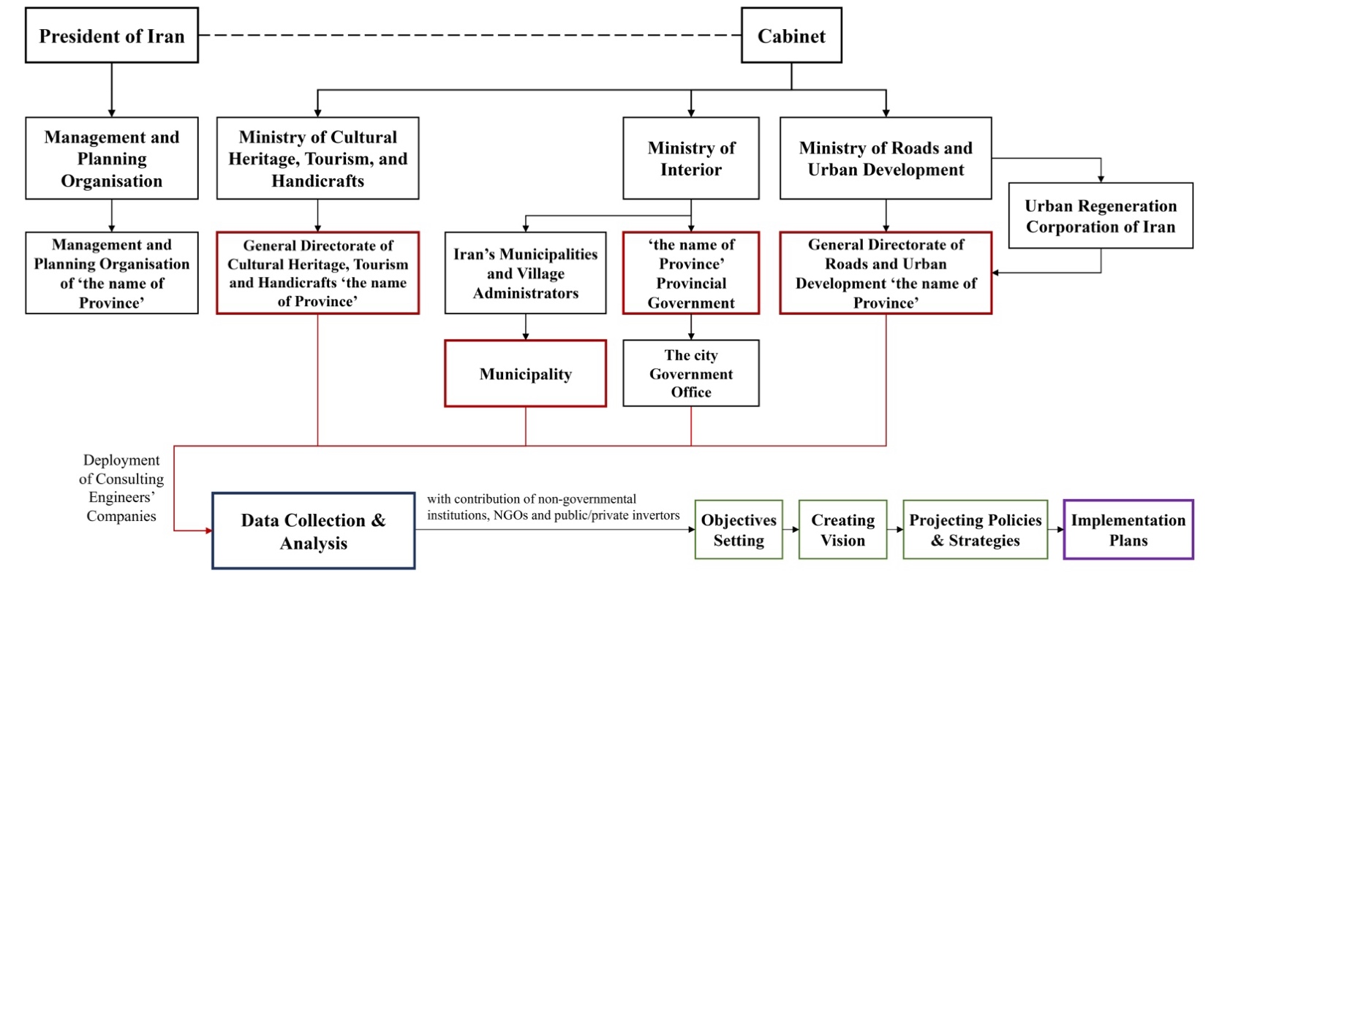
Figure 1. The structure of urban cultural policy planning in Iran. Source: authors.

There are 31 regions in the country, each of which has its own Provincial Government. Since all the cultural policy and urban regeneration schemes need registration with the MI, this institution holds monthly or quarterly meetings to record and confirm proposed schemes by involved organisations. It works closely with all regional institutions including the General Directorates of MRUD and MCTH and municipalities. The General Directorate of Roads and Urban Development negotiates with MRUD and URCI as the central public institutions to grant budgets and funds for urban projects proposed by the municipality. It also oversees the municipality to ensure that urban projects are implemented to the agreed standard. If urban regeneration projects are executed in a historic part of the city, they need the confirmation of the General Directorate of Cultural Heritage, Tourism and Handicrafts to make sure that the projects do not damage local heritage.
Based on findings from the first project, we know that the Municipality is responsible for the majority of urban policy planning projects in Iran and plans regeneration schemes through communication with national (central) institutions, private organisations, NGOs, and the local community. Schemes are formulated by an Engineering Advisory Company, employed by the municipality or similar public institutions which possess the funds. It is also in charge of implementing agreed actions in the city including the regeneration projects, events, occasional markets, and revitalising urban spaces. This section demonstrates that Iran monitors and incorporates practices related to cultural policies and community engagement from wider international bodies such as the UN. Indeed, based on findings from project 1, the Iranian government, particularly at the local level, attempts to adjust policies adopted from UNESCO’s cultural strategies and the UN’s cultural sustainable development documents to fit with Iran’s specific context and imperatives in the practice of urban regeneration projects (Pourzakarya & Fadaei Nezhad Bahramjerdi, 2023).

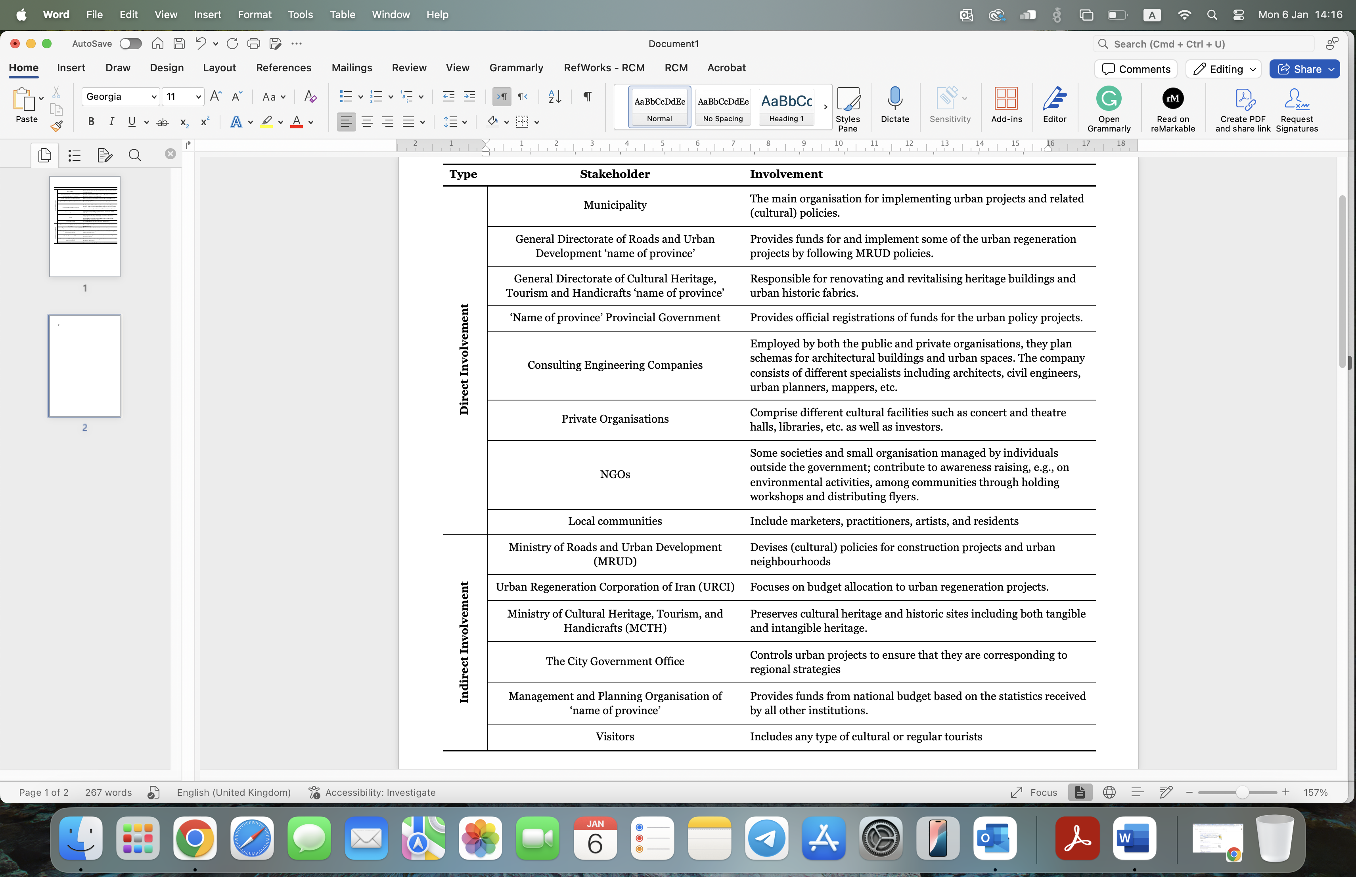
Figure 2. Evaluation of different stakeholders’ involvement in the cultural policy planning process in Iran. Source: authors.

As part of project 1 and 3 different national documents on culture-led regeneration in Iran have been examined. The analysis reveals that culture in Iranian cities was initially addressed in the national regulation of ‘Revitalising and Upgrading of Urban Historic Fabrics’, adopted in 2014 (MRUD, 2014). The document was prepared by MRUD in close collaboration with MCTH and the Supreme Council of Provinces and was approved by the honourable government board based on Article 138 of the Constitution. The policy planning structure in Iran is a centralised system and top-down process at both national and local (regional and urban) levels (Mozaffari & Akbar, 2023). It is collaboratively managed by MRUD, MCTH, the MI, and Planning and Budget Organisations. Nevertheless, there is an identifiable strategy aimed at promoting and encouraging cultural citizenship with the collaboration of local institutions and public/private organisations in urban regeneration projects. The main objective is to address the demands of residents as well as socio-economic and physical factors in the regeneration of cultural and historical heritage and cultural identities (MRUD, 2014). The regeneration strategy can involve different approaches from the promotion of quality-of-life and community empowerment to the revitalisation or rehabilitation and capacity-building of the local communities in the historic areas (Plan and Budget Organisation, 2015). These aims can be applied through local governance in a strategic direction and are integrated among all related factors at the national and local level including the approach of urban planning standards to Iranian-Islamic architecture.
The necessity of protecting authenticity and integrity in the process of revitalising historical districts was articulated in the instructions on the ‘Conservation of Historical and Cultural Fabrics’, ratified by the Supreme Council for Urbanism and Architecture of Iran (SCUAI, 2017). In this context, historical-cultural areas have distinct public spaces and cultural-social structures that have always been the place of events and the realm of social interactions. Examples of these urban regeneration and pedestrianisation projects can be found across many cities in Iran including Tehran, Shiraz, and Isfahan as well as Rasht which was examined in the first project (Figure 3). The projects facilitated the exhibition of both Persian cultural events, such as Norouz (Persian New Year) and Yalda (the celebration of the longest night of the year), alongside local cultural heritage, including traditional craft-making techniques, regional cuisines, and literature. This process requires the inclusive participation of all relevant and effective institutions and actors, representatives of non-governmental organizations, academics, and more importantly local residents. Subsequently, the Sixth Development Plan (2016-2020) emphasised the economy of culture and its growth and development through cultural and artistic products, media, and multicultural activities (Ramezani & Partovi, 2020) by providing the groundwork for the promotion of creativity in cultural and artistic activities (Plan and Budget Organisation, 2015). Additionally, the preservation and introduction of cultural diversity as a factor for the sustainable development of the tourism industry was raised.
The evaluation of relevant documents indicated that Iranian policies have concentrated on cultural activities and related factors that are seen as effective in stimulating urban regeneration (MRUD, 2014). However, highlighting the importance of context, the preservation and reinforcement of Iranian culture and identity are only considered prominent if they are compatible with, or at least not in conflict with, Islamic principles (Tajmazinani, 2017). This means that cultural activities related to the history of Islam, or any Islamic figures receive more funds than other categories. Moreover, there are regulations to promote Iranian cultural landscapes within cities including indigenous features of architecture. In this sense, the less-respected cultural diversity and cultural rights need to be strengthened through cultural policy instruments. With no specific documents with the title of CCIs, the Iranian government supports traditional activities, such as music, handicrafts, and gastronomy, in certain regions, where they profit from community creativity (Pourzakarya & Fadaei Nezhad Bahramjerdi, 2023). The general goal is to promote culture for social and economic benefit and to contribute to raising awareness among locals (SCUAI, 2017).

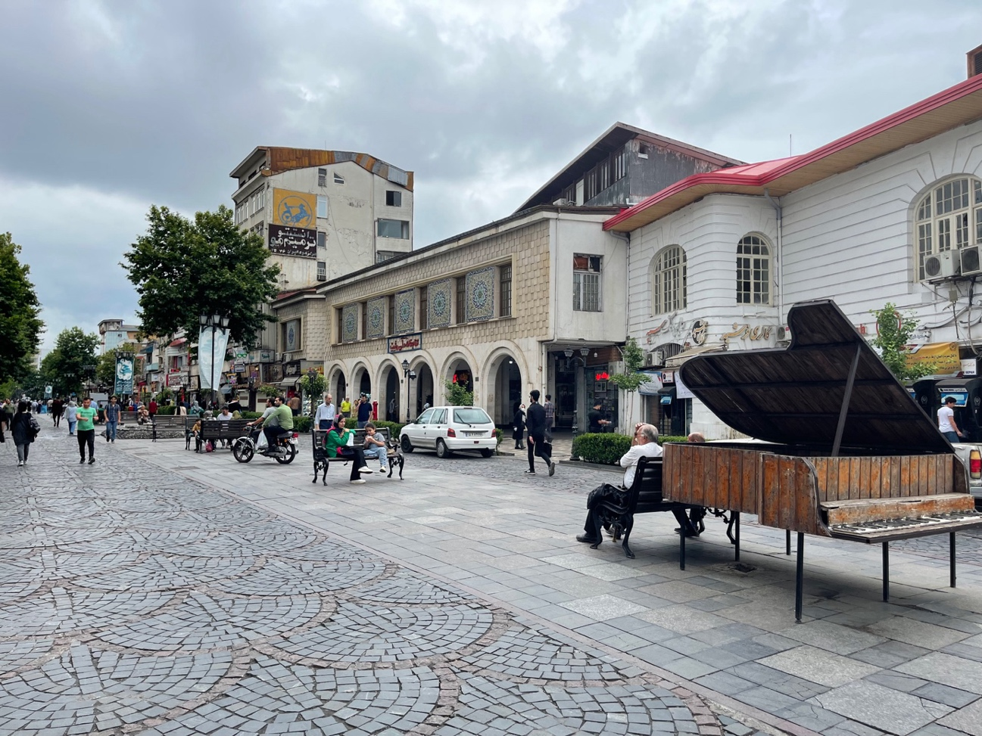
Figure 3. Shah Street in the city of Rasht, northern Iran, after an urban regeneration project in 2013. Source: author(s)

The position of Iranian communities
In keeping with the first project, there are different plans and approaches in terms of governance and urban cultural policy in Iran. We discuss the role of communities in each plan and more importantly where the societies stand. Introduced in 1998 and implemented in 2005 in Qazvin City, the City Development Strategy (CDS) was considered as an instrument to improve urban management, employment, and economic growth (Rasoolimanesh et al., 2014). The problem with CDS is that compared to master plans, it has no legal standing, so the definite position of communities is missed. A master plan is a spatial plan that employs social, economic and cultural transformations of the society to improve the spatial and physical structure of cities by responding to people’s social comfort (Mashhadi Moghaddam & Rafieian, 2020). However, due to the shortcomings of strategic-structural (master) plans, the issue of communities’ participation was reassigned to a newly established ‘Neighbourhood Council’. As the representatives of the people, the Council is responsible for learning about residents’ demands and needs and suggesting remedies to the main city council to solve urban problems. The main issue is that in this approach, people are dependent on the representatives to understand and address their needs and with diverse ethnic groups, classes, and minorities, this approach created many new obstacles (Kathi & Cooper, 2005). Indeed, the Council’s failure to communicate issues and requests to higher authorities led to a lack of trust from local communities.
In practice, the first example of successful community participation in planning in Iran is the Bandar-Abbas City Informal Settlements Upgrading Project (BACISU) from 2001 to 2004. Besides including all possible public and private organisations in the initial stages of the urban plan, they also created a working group and a coordination office to empower unofficial stakeholders (Mashhadi Moghaddam & Rafieian, 2020). The main objectives were to promote the participation of citizens in all stages through financial support and backing volunteer social groups such as women’s and youth groups. The method included many interviews with local communities and NGOs through an intermediator – a planner that helped the public interest. Another good example is the community-led regeneration project of Bandar Anzali in northern Iran. Similarly, a facilitator organisation acted as an intermediator to follow a ten-step bottom-up guideline by UDRC (Pourzakarya & Fadaei Nezhad Bahramjerdi, 2021). It starts with social and cultural awareness-raising among residents and identifying skilled individuals for capacity-building through participatory workshops. It ended with the establishment of a Neighbourhood Development Centre and suggesting community-prioritised urban regeneration projects to the regional General Directorates and municipality.
In terms of regional strategies, policies have shifted towards collaboration between public and private sectors through raising private investment in cultural and entrepreneurial projects (Municipality of Rasht, 2016). The spatial planning schemes are developed through collaboration between national organisations, regional governance, and cities. These plans mainly aim to develop and promote regional commerce, whether it is agriculture or heritage, and its supporting industries including but not limited to tourism and trade (MPOGL, 2016). For instance, regions employed different approaches including creating or supporting national events, festivals or weekly Bazaars to emphasise the culture of the region and to pursue cultural policies and urban regeneration approaches. A good example here is the local crafts and food bazaar in the region of Guilan where locals can sell their cultural products (Figure 4). Another example involves parallel sub-national schemes which have been concentrating on developing national parks and preserving forests. They similarly aim to boost economic conditions through weekly markets. To evaluate cultural citizenship and inclusivity, local vendors were surveyed during the first project (Pourzakarya & Fadaei Nezhad Bahramjerdi, 2019). As they were not directly involved in policy planning processes, they sought to have their demands recognised by urban governance through intermediaries, specifically the board of trustees of the local mosque. This resulted in several positive developments within the urban regeneration project in the city centre, including the redesign of transportation and access routes. From the second project, we also learned that to avoid challenges such as over-tourism, these plans call for the creation of adequate tourism facilities and services including accommodations, restrooms, and garbage collection stations with a decent distance from protected areas and national environments. Within Iran, inflation and economic stagnation are significant problems in many city-regions and these conditions negatively affect culture and social security. There is a need for municipalities to generate new sources of funding such as public/private investments and these aims are included in policy-making processes (Maxwell & Miller, 2017). Alongside the regeneration of urban public spaces, improving economic conditions is linked to enhancing social security and quality-of-life.

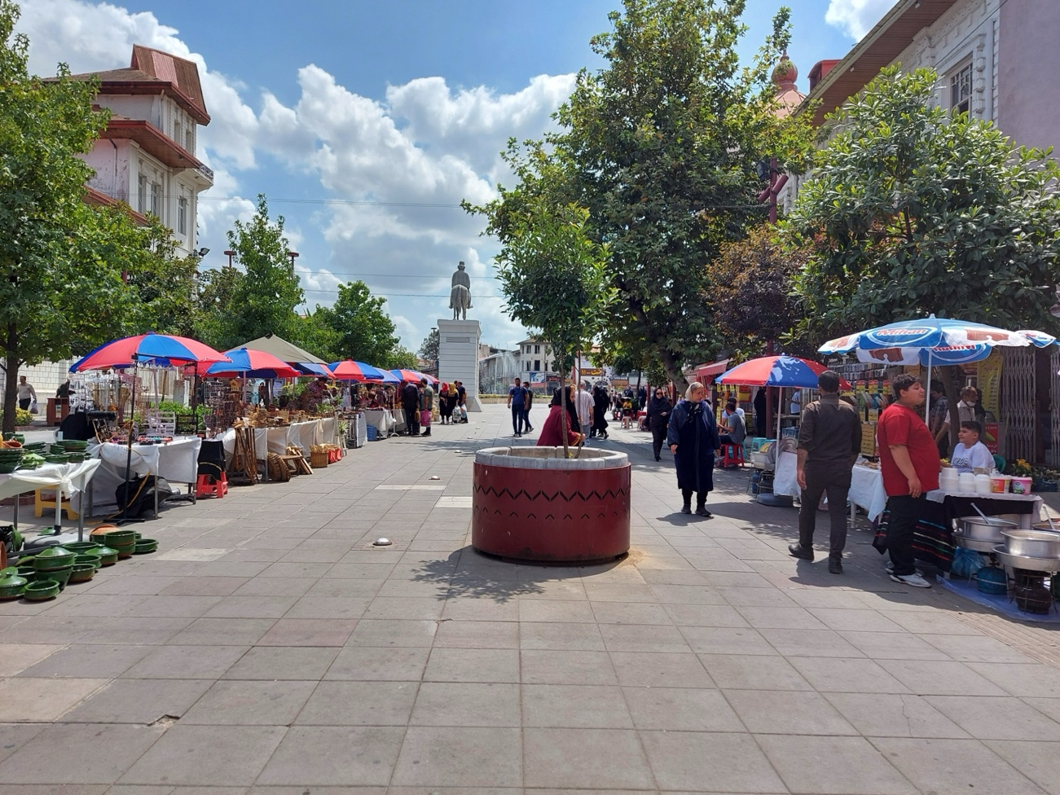
Figure 4. Temporary bazaar of crafts and food in Saadi Street, Rasht, northern Iran. Source: author(s)

In Iran, five cities have been registered on UNESCO’s Creative City Network (UCCN) to date. This scheme asserts the importance of preserving and celebrating culture and creativity at the local level and stimulating and supporting creative professionals and cultural participation and engagement by local citizens. As outlined in the third project, for Iranian cities, the scheme has been a great incentive to develop their regional cultural policy, tourism, and creative landscape. The registration process starts at the local level by the mayors of cities through establishing a memorandum of cooperation with the National Commission of UNESCO in Iran. The procedure also involves launching a cooperation office at the level of urban governance as the Municipal Cooperation Office. The final documents declaring the cultural potential and values of the cities are then sent to the UNESCO headquarters in Paris for evaluation (Pourzakarya & Fadaei Nezhad Bahramjerdi, 2019). Following cities’ registration on UCCN, a Creative and Innovation Centre is established at the city level to formulate the pertinent effective functions of a creative city. The mission of these centres is to promote tourism and city branding as well as encourage the participation of local communities in socio-cultural activities (Pourbehi et al., 2023). Other aims include creating jobs, raising income levels and enhancing economic development and levels of human capital. For instance, creativity rooms were set up in neighbourhood development centres to engage residents in urban decision-making and to improve and change their way of thinking and observing urban issues. Specific projects for the development of cultural and creative activities in the city-centre involve (Municipality of Rasht, 2016):
- Planning to promote the pedestrian pathways through existing dominant activities based on their historical background.
- Creating spaces appropriate to the climatic conditions for the supply of creative products on the central pedestrian route by prioritising the activities of homeless women and marginalised people.
- Spatial and time planning of public walks, especially on holidays and official occasions on the pedestrian route for the direct display and supply of artworks, handicrafts, and other creative products.
- Organising artistic events with an emphasis on the rich indigenous and local culture (in the form of street shows, story writing contests, memory writing, visual arts, painting, music, etc.)
As for the residents of cities, they seem very confused with public spaces as they consider these spaces to be owned by the government. As a result, although a small number of individuals participate in preserving both the natural and built environment through volunteering activities and helping NGOs, the majority of society believes that they have no obligation to preserve or maintain them. The reason is the conflict between impatient residents and urban governance and the unclear articulation of urban rights. Numerous abandoned construction projects have also added to this problem (Pakzad, 2017). Therefore, municipalities are attempting to approach citizens by systematic means. They aim to familiarise local communities with the concept of cultural policy through training, meetings, and workshops such as mental mapping and brainstorming. These activities are implemented at the neighbourhood level attempting to engage as many people from different groups whose voices and needs want to be heard (Pourzakarya & Fadaei Nezhad Bahramjerdi, 2021). Moreover, municipalities try to identify experienced individuals through neighbourhood trustees, cultural centres, foundations, and various societies. Ideas are screen for feasibility and often trialled through through festivals, exhibitions, or meetings before a final evaluation.

Discussion: challenges and recommendations
The paper has focussed on Iranian cultural policies in the context of inclusiveness and cultural citizenship. With respect to cultural citizenship, Iranian cultural policies encompass policies for protecting national identities despite different ethnicities to strengthen national grounds; however, these policies are undermining democratic values. Accordingly, first, there is a gap between theoretical concepts and what happens in practice. Before the Iranian Revolution, the governor attempted to modernise cities through the physical transformation of routes based on his knowledge of best practices compared to urban communities. This was an example of centralised power where one person manages the whole society towards his desires. To solve this issue, master plans and CDSs were created to enhance living quality. Again, the main problem was the missing consideration of citizen’s participation in urban policy planning during the preparation and implementation stages although the vision was there. The positive outcome of these plans seems to be the slow transition away from centralised power to greater inclusivity (Mashhadi Moghaddam & Rafieian, 2020). As for neighbourhood councils, people had no connection with urban governance, and they had to go through their representatives. According to findings from the second project, this increased mistrust and communication failure because even when representatives accurately conveyed information to urban governance, the perceived inefficacy of the urban governance led citizens to believe that these representatives were indifferent and unresponsive to their responsibilities. The prioritisation of infrastructure projects over the preservation of cultural heritage by urban governance, driven by budgetary constraints, further worsens this issue.
With the widespread state intervention after the Iranian Revolution, a need for limiting it to only the level of policymaking and decentralising implementation to local public/private organisations was raised. However, even after the Iran-Iraq war between 1980 and 1988, which caused massive social, economic and infrastructural hardship, the policy instruments have remained largely state-orientated. The centralised system of policy planning is continuing with its approach although there is a need for experts’ views and more delegation of authority to local levels of governance in cities. This lack of decentralisation along with the economy’s dependence on oil exports has led to chaotic and unsustainable development. The second major issue in developing an Iranian cultural policy scheme is the existence of multiple and similar cultural institutions in the country. In this sense, forming a united and strategic cultural planning system in Iran could promote the regulations and monitoring of the cultural sector and enhance the interactions between different stakeholders. The third issue is the government’s preference to pursue short-term projects instead of long-term programs. This is due to the short management life of directors which leads to a focus on policies that are quantifiably measurable and achievable rather than long-term qualitative actions.
By investigating the cultural policy planning structure at the local level in Iran, it is clear that local governance is pursuing a democratisation of the culture agenda. For instance, there have been actions to develop public cultural facilities and services in cities and spread cultural knowledge (Tajmazinani, 2017). However, in these projects, there has been a lack of consideration of cultural diversity, cultural representation and involvement, and democratic mechanisms of cultural life. As a result, young people are nurtured through cultural activities preferred by the Islamic system. Therefore, the Iranian cultural policy model is argued to prioritise and use culture as a tool for political education. Nevertheless, members of Iranian society appear to be keen to practice a mixed identity of ancient and modern elements and values with a few Islamic components, regardless of strict cultural engineering strategies.
The emergence of CCIs and the cultural market has been a double challenge to Iranian cultural policy not only because of the ideology behind it but also because of the ability of commodified culture and cultural practices. Iranian cities mostly adopt strategic shifts through urban branding policies which act as enablers of policy transformation. During these transformations, cities do not always fully accomplish what they initially aimed for. The underperformance of urban governance is typically due to insufficient knowledge and ineffective implementation. Moreover, those responsible for implementing policies tend to support some elements while ignoring others such as elements that do not generate economic returns or those meant to support marginalised groups such as the disabled or elderly. While the selected and supported policies may produce benefits in the short term, over the long term, they tend to increase levels of inequality between different groups within society.
In line with the argument of some scholars such as Pratt (2021), policymakers and people need to be equally involved in both the challenges and opportunities of cultural policy. Cultural policy itself, while being allocated a small budget, is immensely complex, especially in a country like Iran which features conflicting agendas. Indeed, the sector involves a large mix of individuals, groups, and organisations collaborating on the creation, implementation, and preservation of artefacts, heritage, and leisure activities. Moreover, Iranian cultural policy is not necessarily an outcome of direct financial support but rather a broad set of interventions which may not even be communicated through policy intentions. Cultural policymaking in Iran is required to find solutions to the contradictions of these issues and to the complex diversity of socio-economic and political actors.
With respect to the challenges of localising the national policies in Iran which shape cultural policymaking, the first recommendation is to incorporate local knowledge and practices into the design and consultation process. The lack of representation of various ethnic groups is another problem in regions of Iran which decreases their incentive for participating in the policy-making process. Community participation can be different in distinct case studies. However, in most cases, the local cultural consultants express that attracting communities to participate in cultural and regeneration schemes is difficult because people have conflicting expectations and demands of each project (Kortbek, 2019). In this manner, instead of only using quantitative socio-economic indicators, it is better to incorporate qualitative-based factors of local cultures including cultural policy legislation efficiency, for instance, based on core arts or cultural heritage and less on cultural industries.
There are actions which can be taken by the Iranian government at the core of cultural policymaking. First, despite several criticisms, the appropriate participation of the state in the enhancement of cultural and creative activities could increase those cultural areas with marginal interest in CCIs and promote high-valued culture as a major policy goal. Second, it is important to find effective means for protecting and supporting public access to cultural facilities in different Iranian regions with respect to their cultural norms. The cultural policy which is established to promote the public availability of cultural services could deliver an effective balance in contrast to the marketisation of cultural work which only pursues cultural consumption for profit. Third, another critical action for the Iranian government is to upgrade the country’s cultural identity and its soft power internationally instead of the ongoing isolation of its culture and economy. Finally, decentralised governmental management of Iranian cultural activity alongside governmental investment in the cultural sectors, especially in regions with large ethnic minorities can facilitate the development of the cultural life of minority groups. This can lead to the establishment of cultural as well as educational institutions at the regional and local levels. The support can also nurture indigenous cultural practices.

Conclusions and limitations
This paper addressed gaps related to cultural policy-making by discussing the concept of cultural policy and exploring its structural evolution and challenges within the non-western context of Iran which we position as an extreme and understudied case. It investigated approaches related to inclusivity in cultural policy, democratisation of culture and the role of communities in different contexts. The findings shed light on the Iranian case but also contribute broader lessons and examples which can be applied to comparable cities in the Middle East and Arab world such as Turkey, Iraq, and Saudi Arabia where governments also take a top-down policy approach towards cultivating a particular national identity and cultural value.
The paper demonstrated that although specific measures have been taken by the Iranian government to alter cultural values, the cultural identity of local communities has been able to be preserved over time. These cultures can have a great impact on the quality-of-life of people; hence, they must be protected and promoted for community empowerment through measures such as cultural citizenship. Moreover, despite limited political appetite in Iran to support the inclusivity of different ethnicities in Iranian cultural policy, the local governments have acknowledged that if they want policies and projects to be more effective, they need to understand and respond to people’s needs by including them in decision-making processes. On this basis, the Iranian government must focus more on international cultural recognition and particularly the decentralisation of cultural policymaking processes to give more space to local regions. The involvement of urban and local authorities is significant in stimulating cultural identity and the social values of regions and the country as a whole.
In Iran, cultural policy planning is trying to become localised and more flexible and attuned to diverse regions and cultures. As these developments continue to unfold, more local case studies are needed to examine the planning, implementation and outcomes of such specific policies and initiatives. Part of this includes exploring the roles and influence of different stakeholders, and local cultures. Finally, in an increasingly global, interconnected and digital world, we should also not forget to consider the role of social media in developing different cultural and creative activities through advertising schemes.

References
Aghaeimehr, M., & Gharehbaglou, M. (2020). Identity-Based Contemporization; Case Study: Iran Contemporary Urban Districts in Pahlavi Era. Naqshejahan, 10(1), 11–18. https://doi.org/10.1080/13556207.2018.1537028
Alsayel, A., de Jong, M., & Fransen, J. (2022). Can creative cities be inclusive too? How do Dubai, Amsterdam and Toronto navigate the tensions between creativity and inclusiveness in their adoption of city brands and policy initiatives? Cities, 128(June), 103786. https://doi.org/10.1016/j.cities.2022.103786
Ansell, C., & Gash, A. (2018). Collaborative platforms as a governance strategy. Journal of Public Administration Research and Theory, 28(1), 16–32. https://doi.org/10.1093/jopart/mux030
Anttiroiko, A.-V., & de Jong, M. (2020). The inclusive city: The theory and practice of creating shared urban prosperity (1st Edition). Palgrave Pivot.
Attarzadeh, B., & Seyfodini, H. S. (2023). National identity, transnational ideology, and cultural policy in Iran. International Journal of Cultural Policy, 29(7), 807–827. https://doi.org/10.1080/10286632.2022.2151591
Bayliss, D. (2007). The rise of the creative city: Culture and creativity in Copenhagen. European Planning Studies, 15(7), 889–903. https://doi.org/10.1080/09654310701356183
Bennett, T., & Silva, E. (2011). Introduction: Cultural capital-Histories, limits, prospects. Poetics, 39(6), 427–443. https://doi.org/10.1016/j.poetic.2011.09.008
Bordat-Chauvin, E. (2022). (De)politicising Argentinian cultural policy? an analysis of Macri’s cultural policy (2015–19). Cultural Trends, 31(2), 169–184. https://doi.org/10.1080/09548963.2021.1996204
Bourdieu, P. (2008). Key Concepts (M. Grenfell, Ed.). Acumen Publishing Limited.
Campagna, D. (2017). Implementing the Human Right to Take Part in Cultural Life: Trends and Perspectives of Inclusive Cultural Empowerment. Peace Human Rights Governance, 1(2), 169–193. https://doi.org/10.14658/pupj-phrg-2017-2-2
Comunian, R., Hracs, B. J., & England, L. (2021). Higher Education and Policy for Creative Economies in Africa; Developing Creative Economies. In Higher Education and Policy for Creative Economies in Africa. London, Routledge. https://doi.org/10.4324/9781003127802
Dorpalen, B. D., & Gallou, E. (2023). How does heritage contribute to inclusive growth? Journal of Cultural Heritage Management and Sustainable Development. https://doi.org/10.1108/JCHMSD-03-2022-0050
Elling, R. C., & Saleh, A. (2016). Ethnic Minorities and the Politics of Identity in Iran. Iranian Studies, 49(1), 159–171. https://doi.org/10.1080/00210862.2016.1118949
Fahmi, F. Z., Koster, S., & van Dijk, J. (2016). The location of creative industries in a developing country: The case of Indonesia. Cities, 59, 66–79. https://doi.org/10.1016/j.cities.2016.06.005
Fazeli, N. (2006). Politics of Culture in Iran (1st Edition). New York: Routledge.
Ghabouli, E., Soltani, A., & Ranjbar, E. (2023). Heritage and the Regeneration of Urban Brownfields: Insights on Public Perception in Tehran, Iran. Heritage 2023, Vol. 6, Pages 4451-4471, 6(5), 4451–4471. https://doi.org/10.3390/HERITAGE6050235
Gray, C. (2009). Managing cultural policy: Pitfalls and prospects. Public Administration, 87(3), 574–585. https://doi.org/10.1111/j.1467-9299.2008.01748.x
Gray, C. (2010). Analysing cultural policy: Incorrigibly plural or ontologically incompatible? International Journal of Cultural Policy, 16(2), 215–230. https://doi.org/10.1080/10286630902935160
Habibi, R. (2020). Modern Middle-Class Housing in Tehran: Reproduction of an Archetype: Episodes of Urbanism 1945–1979. In A. Gheissari, J. Landau, & C. Werner (Eds.), Modern Middle-Class Housing in Tehran (Vol. 21). Iran Studies. https://doi.org/10.1163/9789004443709
Kathi, P. C., & Cooper, T. L. (2005). Democratizing the Administrative State: Connecting Neighborhood Councils and City Agencies. Public Administration Review, 65(5), 559–567. https://doi.org/10.1111/J.1540-6210.2005.00483.X
Kortbek, H. B. (2019). Contradictions in Participatory Public Art: Placemaking as an Instrument of Urban Cultural Policy. Journal of Arts Management Law and Society, 49(1), 30–44. https://doi.org/10.1080/10632921.2018.1473310
Lindberg, M. (2018). Relating inclusiveness and innovativeness in inclusive innovation. International Journal of Innovation and Regional Development, 8(2), 103. https://doi.org/10.1504/IJIRD.2018.092083
Mangset, P. (2020). The end of cultural policy?1. International Journal of Cultural Policy, 26(3), 398–411. https://doi.org/10.1080/10286632.2018.1500560
Mashhadi Moghaddam, S. N., & Rafieian, M. (2020). From the kingdom lash to participation: The tale of urban planning in Iran. Social Sciences & Humanities Open, 2(1), 100022. https://doi.org/10.1016/J.SSAHO.2020.100022
Maxwell, R., & Miller, T. (2017). Greening cultural policy. International Journal of Cultural Policy, 23(2), 174–185. https://doi.org/10.1080/10286632.2017.1280786
McCall, V. (2009). Social Policy and Cultural Services: A Study of Scottish Border Museums as Implementers of Social Inclusion. Social Policy and Society, 8(3), 319–331. https://doi.org/10.1017/s1474746409004874
Mozaffari, A., & Akbar, A. (2023). Heritage diplomacy and soft power competition between Iran and Turkey: competing claims over Rumi and Nowruz. International Journal of Cultural Policy. https://doi.org/10.1080/10286632.2023.2241872
MPOGL. (2016). Gilan Spatial Planning: Gilan, the northern gateway for progress.
MRUD. (2014). National Strategy Document on Revitalizing, Upgrading, Renovating and Enabling Deteriorated and Underutilized Urban Fabrics.
Municipality of Rasht. (2016). Regeneration of Municipality Square as Cultural Passageway of Rasht.
Odello, M. E. (2011). The Right to Take Part to Cultural Life: General Comment No. 21 of the United Nations Committee on Economic, Social and Cultural Rights. Anuario Espanol de Derecho Internacional, 27, 493–521. https://www.researchgate.net/publication/297667307_The_Right_to_Take_Part_to_Cultural_Life_General_Comment_No_21_of_the_United_Nations_Committee_on_Economic_Social_and_Cultural_Rights
Olivares, A., & Piatak, J. (2022). Exhibiting Inclusion: An Examination of Race, Ethnicity, and Museum Participation. Voluntas, 33(1), 121–133. https://doi.org/10.1007/s11266-021-00322-0
Oni, D., Onyekaba, C., & Husseini, S. (2020). Importance of arts and culture in community development in Nigeria : The place of the Councils for Arts and Culture. In R. Comunian, B. J. Hracs, & L. England (Eds.), Higher Education and Policy for Creative Economies in Africa (pp. 81–96). Routledge. https://doi.org/10.4324/9781003127802-8
Pakzad, J. (2017). Historical Obstacles Preventing Public Participation in Iran: A Planning Practitioner’s Point of View. In H.-Luidger. Dienel, M. Reza. Shirazi, & Sabine. Schröder (Eds.), Citizens’ participation in urban planning and development in Iran. Routledge.
Patricio Mulero, M., & Rius-Ulldemolins, J. (2017). From creative city to generative governance of the cultural policy system? The case of Barcelona’s candidature as UNESCO City of Literature. City, Culture and Society, 10(May), 1–10. https://doi.org/10.1016/j.ccs.2017.05.001
Plan and Budget Organisation. (1974). Revised Version of the Fifth Development Plan of the Country.
Plan and Budget Organisation. (2003a). General Policies of the System in the Vision Period.
Plan and Budget Organisation. (2003b). The Vision of the Islamic Republic of Iran on the Horizon of 2025.
Plan and Budget Organisation. (2015). The Document Plan of the Sixth Economic, Social and Cultural Development Plan. https://doi.org/10.15713/ins.mmj.3
Plan and Budget Organization. (1972). The Fifth Development Plan of the Country. https://mpb.mporg.ir/FileSystem/View/File.aspx?Mode=File&ObjectType=DataItem&ObjectId=c6930675-cf3c-48c4-b474-2f833b292c4f
Pourbehi, T., Jafarinia, G., Shamsoddini, A., & Jafarpour Ghalehteimouri, K. (2023). Introducing Creative City Factors as a Solution in Sustainable Urban Development: A Case Study from Bushehr City in Iran. Journal of Urban Culture Research, 26.
Pourzakarya, M., & Fadaei Nezhad Bahramjerdi, S. (2019). Towards developing a cultural and creative quarter: Culture-led regeneration of the historical district of Rasht Great Bazaar, Iran. Land Use Policy, 89(December), 104218. https://doi.org/10.1016/j.landusepol.2019.104218
Pourzakarya, M., & Fadaei Nezhad Bahramjerdi, S. (2021). Community-led regeneration practice in Ghalam Gudeh District, Bandar Anzali, Iran: A participatory action research (PAR) Project. Land Use Policy, 105(March), 105416. https://doi.org/10.1016/j.landusepol.2021.105416
Pourzakarya, M., & Fadaei Nezhad Bahramjerdi, S. (2023). Reviewing the role of cultural and creative industries in developing an urban cultural policy platform in Rasht city, Iran. Journal of Place Management and Development, 16(2), 145–162. https://doi.org/10.1108/JPMD-09-2021-0087
Pratt, A. C. (2011). The cultural contradictions of the creative city. City, Culture and Society, 2(3), 123–130. https://doi.org/10.1016/j.ccs.2011.08.002
Pratt, A. C. (2021). Creative hubs: A critical evaluation. City, Culture and Society, 24(February), 100384. https://doi.org/10.1016/j.ccs.2021.100384
Ramezani, M., & Partovi, A. (2020). An Analysis of the Cultural Policy Making of the Islamic Republic of Iran: disadvantages and strategies; Emphasizing the concept of “authority” (Marjaiyyat). Political Science, 23(89), 161–180. https://doi.org/10.22081/psq.2019.67718
Rasoolimanesh, S. M., Jaafar, M., & Badarulzaman, N. (2014). Examining the contributing factors for the successful implementation of city development strategy in Qazvin City, Iran. Cities, 41(PA), 10–19. https://doi.org/10.1016/J.CITIES.2014.05.002
Rebernik, N., Goličnik Marušić, B., Bahillo, A., & Osaba, E. (2019). A 4-dimensional model and combined methodological approach to inclusive Urban planning and design for ALL. Sustainable Cities and Society, 44(February 2018), 195–214. https://doi.org/10.1016/j.scs.2018.10.001
Sasaki, M. (2010). Urban regeneration through cultural creativity and social inclusion: Rethinking creative city theory through a Japanese case study. Cities, 27(SUPPL. 1), S3–S9. https://doi.org/10.1016/j.cities.2010.03.002
SCUAI. (2017). Ratification by the Supreme Council for Urbanism and Architecture of Iran-Announcing the Historical Contexts of 168 Cities of the Country and Determining General Approaches to Conservation and Revitalization of Historical Cultural Areas in the Procurement.
Tajmazinani, A. A. (2017). From Cultural Revolution to cultural engineering; Cultural policy in post-Revolutionary Iran. In V. Durrer, T. Miller, & D. O’Brien (Eds.), The Routledge Handbook of Global Cultural Policy: Vol. 1st Edition (pp. 503–519). Routledge.
UNESCO. (2016). Culture & Development, 2030 Agenda-Regional Work Plan for Culture in Latin America and the Caribbean, UNESCO LAC 2016-2021 (Issue October).
Yi, X., Throsby, D., & Gao, S. (2021). Cultural policy and investment in China: Do they realize the government’s cultural objectives? Journal of Policy Modeling, 43(2), 416–432. https://doi.org/10.1016/j.jpolmod.2020.09.003
Zakzak, L., Willis, S., & Pineda, V. (2019). Inclusive urban development: Strategic policy directions Dubai and the race to become the world’s most accessible and inclusive city. Mohammed Bin Rashid School of Government, 14(14).

