**Devensian glacial history of the Shap granite exposure**

Paul A. Carling, *School of Geography & Environmental Science, University of Southampton, Southampton, SO17 1BJ, UK* (p.a.carling@soton.ac.uk)

**Introduction**

The outcrop of the lower Devonian Shap granite pluton (*c*., 7 km2) (Loughlin, 1999) in the eastern Lake District, UK, extends from Sleddale Pike in the west eastwards to the rounded summit of Long Fell; the two peaks separated by a broad dip occupied by the northward flowing Longfell Gill (Fig. 1). The pluton is the source of Shap granite glacial erratic dispersal plumes related to the Dimlington Stadial (equivalent to Marine Isotope Stage 2; Ehlers and Gibbard, 2013) of the Devensian glaciation. The main plume extended eastward across the Pennine hills as far as the east coast of England (Carling *et al*., 2023). The erratics are readily identified in the field as consisting of a pink and grey biotite monzogranite with frequent Carlsbad-twinned orthoclase–perthite megacrysts, set within a coarse-grained groundmass composed of orthoclase, plagioclase, quartz and biotite (see <https://earthwise.bgs.ac.uk/images/1/12/P519145.jpg>). The character of the rock affected the mechanisms of entrainment of blocks of granite from the outcrop (Carling, 2024). Despite the importance of the pluton as a source for Shap granite erratics, the Dimlington glacial history of the granite exposure has not been considered prior. Herein, a description is provided of the evidence for glacial processes formerly active on the outcrop, notably ice direction indicators.

There is no definitive evidence of glaciations prior to the Devensian in the immediate surroundings of the granite exposure (Carling *et al*., 2023), rather the field evidence is considered to related to the Dimlington Stadial. Previous investigations of regional ice flow patterns, in the English Lake District and northern Pennine hills, proposed that ice flow was initially eastwards (ST1 ice flow; Fig. 1) during the early phase of the Dimlington Stadial (*c*., 29-25 ka BP; Livingstone *et al*., 2012; Merritt *et al*., 2019) resulting in an easterly-directed Shap granite erratic plume. Around the Late Glacial Maximum (LGM: 26.5 ka BP to 19 ka BP, Clark *et al*., 2009), ice-flow appears to have switched to a southerly direction (ES1 ice flow; Fig. 1) and two lesser Shap granite erratic plumes extended south; one into Lancashire via the Mint valley and one penetrated the northern end of the Lune gorge. After the LGM (*c*., 19 ka), indications are that the local ice flow (LT6; Fig. 1) in the upper Lune valley (Livingstone *et al*., 2012; Merritt *et al*., 2019), just east of the granite exposure and over the Birkbeck Fells Common (Fig. 1), was northerly whilst ice flow from the Lake District (LT7) was to the NE, resulting in Shap granite erratics being dispersed generally northwards (Carling *et al*., 2023). Consequently, evidence for both the sustained easterly ice flow, southerly ice flow and the final northerly ice flow might be expected to occur on the exposure.

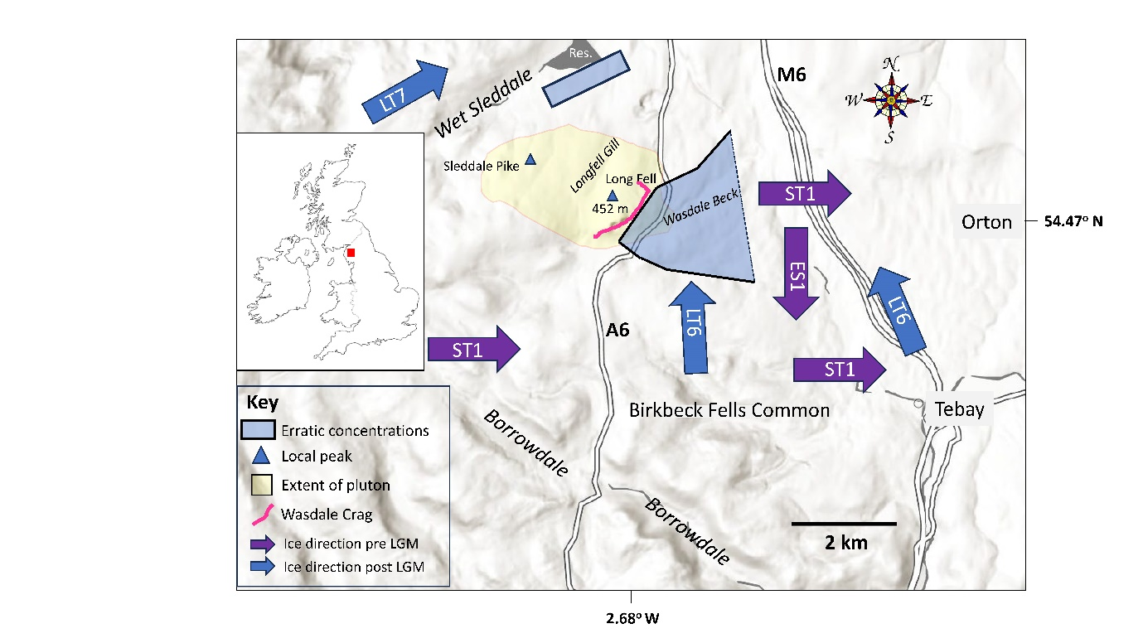

*Figure 1: The extent of the exposure of the Shap granite in Northern England relative to neighbouring Dimlington ice flow directions.* *The central portion of the ice-plucked outcrop (Wasdale Crag) has been destroyed by quarrying (Shap ‘Pink’ Quarry). World Base Map scale 1:150,000. The extent of the granite exposure is from the British Geological Survey Geoindex (*[*https://www.bgs.ac.uk/map-viewers/geoindex-onshore/*](https://www.bgs.ac.uk/map-viewers/geoindex-onshore/)*). The two locations of significant erratic concentrations are only indicative and do not reflect the actual spread of erratics in the region.*  *Ice flow direction codes are in accordance with Livingstone et al. (2012).*

**Wasdale Crag**

The most prominent and important glacial feature on the granite exposure is Wasdale Crag, an ice-plucked cliff on the eastern side of Long Fell (Fig. 1); the latter constitutes a km-scale rôche moutonnée. Much of the natural cliff has been quarried and the original appearance of the full length of the outcrop is unrecorded. Continued quarry, which may destroy further evidence of glaciation, is one motivation for this study. Commercial quarrying (Holland, 1959) commenced from 1864 (Johnson, 2018) and mapping in 1897 by the Ordnance Survey (OS), published in 1899 as the OS 6-inch series, shows a 400m long working quarry-face developed below a natural outcrop of similar extent with a further natural outcrop to the SW some 200m in length. This SW outcrop (Fig. 2A) is extant (2025) and exhibits evidence of small-scale quarrying by plug and feather (<https://en.wikipedia.org/wiki/Plug_and_feather>), probably for field-gate stoops and other local building materials before commercial quarrying, but otherwise the rock outcrops are ice-smoothed. Isolated small buttresses facing SE extend some 130m to the north of the quarry (Fig. 2B) before the outcrop swings round to face NE (Fig. 1). Photographs, dated 1898, indicate that 19th C quarrying took advantage of the presence of a natural bedrock exposure (Bingley, 1898). If the unquarried exposures at the SW end of the quarry are typical of the original outcrop (Fig. 2A), then the quarried slope consisted of a series of prominent isolated buttresses, 20 to 30m high, interspersed with grassy rakes. It is probable that the highest part of the crag occurred within the main quarry working area as an unpublished geological map (**Sedgwick** Museum of Geology, Cambridge University) produced by Adam Sedgwick between 1822 and 1824 shows the crag to be at its highest centrally (Fig. 2C).

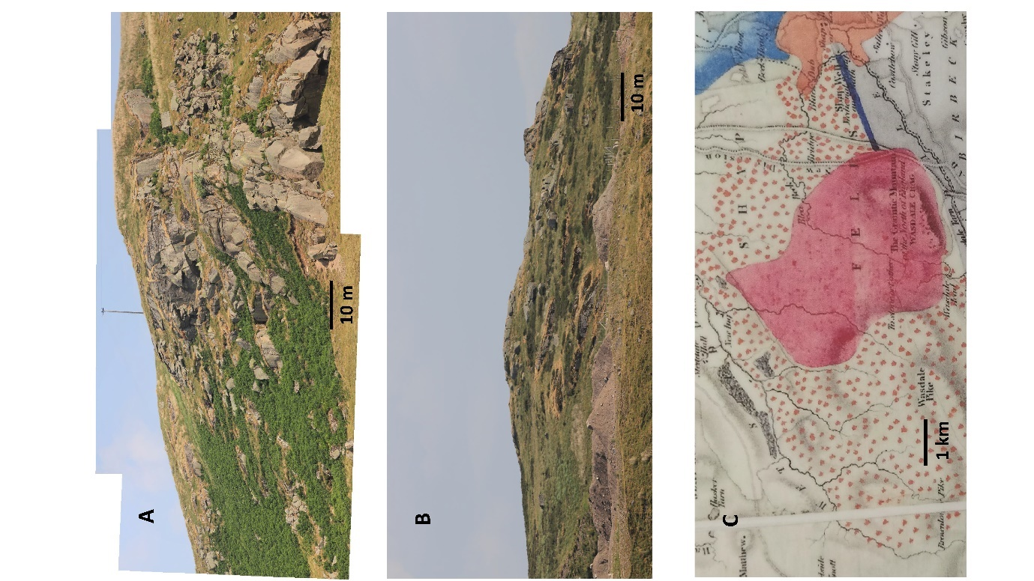

*Figure 2: Detail of extant portions of Wasdale Crag and the general extent in 1822. A) South-westerly outcrops (view from the SE); B) northern outcrops with quarry waste tips below (view from SE); C) portion of the Sedgwick map, dated 1822-1824, showing the Shap granite outcrop (pink), the contact aureole (stippled) and the Wasdale Crag as a continuous rocky cliff on the south side of the exposure (copy of Sedgwick map in Kendal Museum). Scale bars in A and B refer to the foreground. NB: to view the modern interpretation of the geology go to ‘https://mapapps2.bgs.ac.uk/geoindex/home.html?’*

**Palaeo Ice Flow Directions**

*Orientations indicating easterly ice flow*

The forms of the outcrops of the Shap granite reflect the local ice dynamics. The orientations of the SE-facing outcrops of Wasdale Crag are consistent with ice flow predominately to the E and SE before and during the LGM, plucking the SE margin of the exposure, with the western side of Long Fell being ice-smoothed. Extensive ice-smoothed surfaces (totalling 2000 m2) above the quarry, just to the east of the summit of Long Fell (452 m above sea level: asl), were exposed in 2022 (NY 55706 08560; 54.470462° N; 2.684945° W) when a 1 m thick peat cover was stripped to extend the quarry. There are no glacial striations on this surface but plucked steps occur facing roughly due east. The lack of striation might indicate the ice flow over the summit was largely debris-free such that the clean ice imposed a polish (Budd *et al*., 1979). At an unspecified location within the curtilage of the quarry, Nicolson (1868) reported W.S.W. to E.N.E. orientated striations on the granite and striations were photographed in 1898 at an unspecified location (Fig. 3). Similarly, Goodchild (1875) mapped

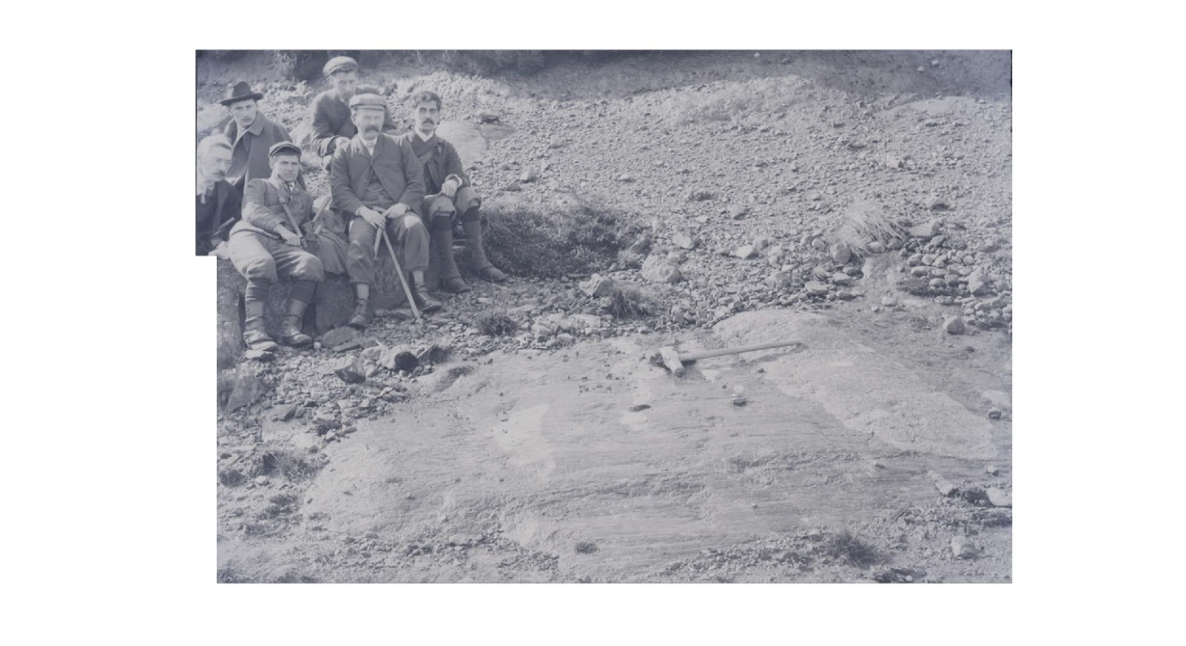

*Figure 3: Geological field party survey an ice-smoothed and striated Shap granite surface in the vicinity of Shap ‘Pink’ Quarry. Persons unknown; figure 2nd from right may be Professor Edmund Johnston Garwood, a colleague of John Marr and Alfred Harker and a member of the Sedgwick Club (Anderson, 2014). Photograph taken by Godfrey Bingley on 12 April 1898, is reproduced with permission of Special Collections, Leeds University Library, Godfrey Bingley Photographic Archive, MS 1788/22/4426.*  
  
striae that had been recorded in 1863 at four locations at the eastern margin of the exposure indicating that late-stage ice flow generally was north to north-east (Table S1; https://github.com/paulc-boop/Shap/blob/main/README.md?plain=1).

Outcrops in the NE of Long Fell lack steep faces and tend to be scalloped and convex-concave in profile reflecting a considerable degree of abrasive ice smoothing without the ice detaching in the lee of the outcrops (Fig. 4B, C). The larger of these outcrops face due east and the convex-concave profiles are interrupted by small near-vertical steps (Fig. 5) from which blocks have been plucked. From the abraded convex-concave profiles, it appears that ice, descending to the east in contact with the outcrop, separated from the bedrock surface at the upper margins of the steps and reattached at some distance below the steps, allowing plucking of blocks from the step margins.

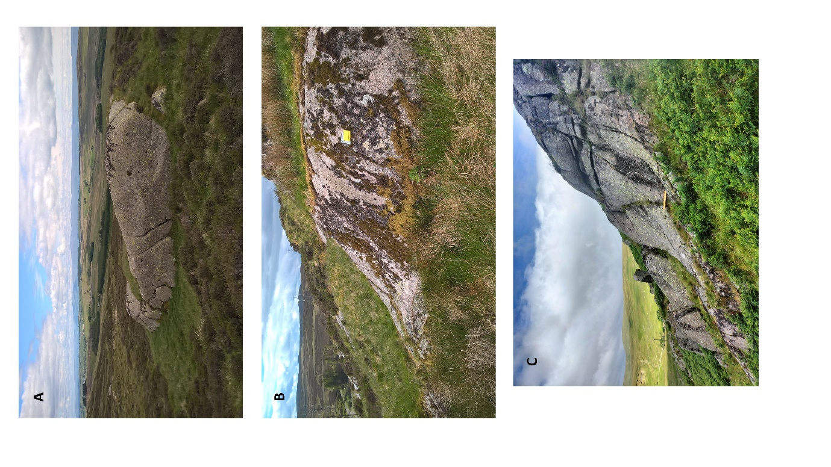

*Figure 4: Examples of ice smoothed buttresses. A) 10m-long outcrop on the northern side of Long Fell looking northwards. Note the distinct ice-induced scalloping mid-image. Buttresses in this vicinity tend to be ice-smoothed to the south with steep ice-plucked faces in the north; B) Buttress on the north-eastern side of Long Fell displays a NE-facing convex upper slope transforming to a lower concave slope. Yellow notebook is 14cm long; C) As for B, ice-abraded buttresses facing to the east often exhibit upper convex slopes and lower concave slopes. Yellow scale bar, 1m long, is placed close to the local transition in slope profile.*

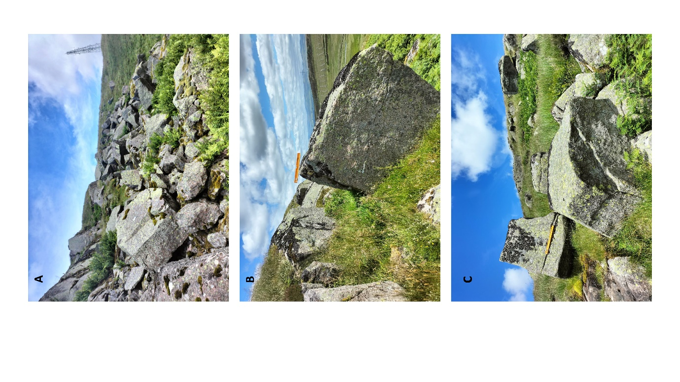

*Figure 5: A) Roughly cubic blocks (in the south of Wasdale Crag), just below the SE-facing outcrop of origin which is visible top-left; B) Cubic block entrained from SE-facing re-entrant in the outcrop immediately to the left. Scale bar is 0.5m in length; C) Cubic blocks strewn below the source outcrop on the skyline. Scale bar is 0.5m in length.*

There is a scattering of ice-transported blocks over the granite exposure to the west of Wasdale Crag, yet the ice-smoothed surface is remarkably free of blocks. Most blocks consist of Shap granite although, along the northern margins of the exposure especially, local andesitic boulders from the Borrowdale Volcanic Group occur sparingly on the granite surface (*e.g*., Locations 11 & 15; Table S1). To the west of Long Fell, the few minor outcrops exhibit evidence of block entrainment, yet the greatest density of entrained Shap granite blocks (close to outcrop) is on the east facing slopes of Long Fell below Wasdale Crag (Fig. 1), indicating sustained pre-LGM easterly glacial transport (Carling, 2024). Many blocks are located immediately below the source outcrops (Fig. 5B). The density of blocks around the A6 highway remains high, despite many having been removed since the early 19th C for road metal (Anon, 1833) and during the construction of a branch railway, which once served the quarry.

*Orientations indicating northerly ice flow*

The north side of Wasdale Crag exhibits several decametre-scale rôches moutonnées (Nicolson, 1868) (Fig. 4A) orientated N to NE indicate ice flow to the NE over Long Fell after the LGM. These outcrops can be smoothed on the SW sides and exhibit steep or vertical ice-plucked faces to the NE. An extensive concentrated Shap granite erratic blockfield occurs to the north, on the north-facing valley-side of Wet Sleddale (Fig. 1). The concentration of blocks here may be attributed to ice decompression and reduced transport competence, as the late-stage northerly ice flow expanded towards the valley base (Carling *et al*., 2023). In contrast there are few Shap granite blocks on the south-facing valley-side immediately to the north, where ice would have been in compression and thus more competent to remove blocks. A general northerly ice flow is further indicated by striations on an outcrop on Wet Sleddale Moor (Location 4; Table S1) orientated to the NW (*i.e*., 315o), whilst several boulders displaced within the northern or eastern leeside of ice-streamlined outcrops (Locations 5 to 9: Table S1) can be retrofitted to the structure of the outcrop, indicating roughly NE ice motion shortly before final ice wasting. As was noted above, the Shap granite blockfield immediately below the Wasdale Crag outcrop was emplaced by easterly flowing ice. Although the long axes of ice-transported blocks can be aligned parallel or transverse to the ice flow direction (Carling, 2024), the orientation of most of the blocks below Wasdale Crag provide no indication of the former direction of the ice-flow, due to blocks being oriented on the steep slopes by gravity and along the course of Wasdale Beck by water. However, a Shap granite block (Location 15; Table S1), on level terrain, exhibits two shallow faint striated grooves and chatter marks. One stria is straight for the full length of the block surface, orientated 355o. If the block is assumed to have lodged before being striated (*i.e*., it has not rotated since deposition), then the orientations of the striae are consistent with post-LGM northerly ice flow. A neighbouring block exhibits a tensile fracture line approximately transverse to the expected ice flow direction (Carling, 2024) as determined from the striations found on the companion block.

*Glacial landmarks on the granite exposure*

To the west of Long Fell a broad hollow, drained by Longfell Gill (Fig. 1), exists below the eastern slopes of Sleddale Pike. In the south, this hollow exhibits frequent small, isolated, ice-plucked buttresses and ice-smoothed slabs of the exposed bedrock and scattered ice-transported Shap granite blocks. The northern portion of the valley of Longfell Gill is partially infilled by till that otherwise only occurs as thin patches over the exposure. Elsewhere, the terrain is largely featureless, but three Shap granite blocks are recorded on the OS series of maps as they provided landmarks for navigation. Firstly, a prominent block is marked as “Thunderstone” (Location 2; Table S1) and secondly, the ‘Gray Bull’ (Fig. 6A; Location 12, Table S1) is a prominent Shap granite block (3.3 m long; 2.2 m wide and 2.45 m high) which resembles a bull in profile when viewed at a distance from the NE. Finally, a former rocking stone known as ‘To Stone or To’ther’ (Fig. 6A; Location 13, Table S1) completes the landmarks.

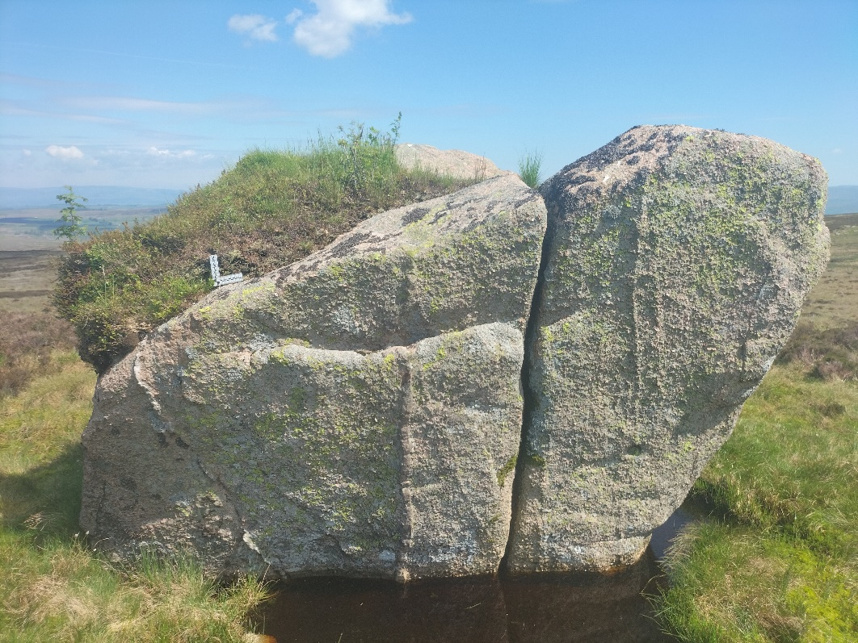

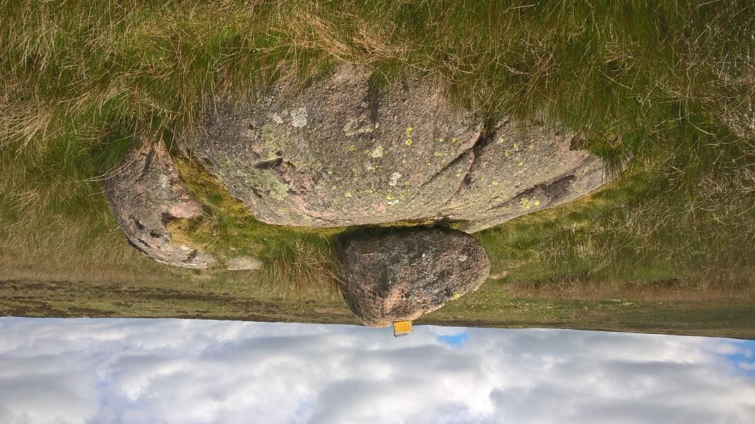

*Figure 6: A) The Shap granite “Gray Bull”, scale bar is 10 cm. Note the mineral veins standing proud due to preferential weathering of the granite; B) The Shap granite rocking-stone named ‘To Stone or To’ther’ sits on top of a larger ice-rounded Shap granite block which may be bedrock. Yellow notebook is 14cm long*

**Structural control on block entrainment**

Detached blocks on the exposure tend to be cuboids with sharp or slightly rounded corners, reflecting the angularity and the spacing of the joints seen within the fractured natural outcrop of Wasdale Crag (Carling, 2024). Examples of cuboids, including slabs, exist which appear to have been moved only a few metres and can be traced to the outcrop of origin and retrofitted into the alcoves from which they originate. The paucity of large slabs indicates that blocks of this shape, when entrained into the ice flow, soon fractured to produce more isometric forms (Carling, 2024). Figure 7 illustrates examples of structural control on block entrainment. The primary control is the intersection within the granite of sub-vertical joints (Firman, 1953) and horizontal expansion joint planes (Fig. 7A, B & C) which lead to the release of residual stresses accumulated at depth (Berger & Pitcher, 1970). Unloading, leading to joint development, began with post-orogenic Devonian erosion of the overburden above the pluton (Caunt, 1986; Miles *et al*., 2016). Horizontal joint planes also may have formed due to glacial unloading (Jahnes, 1943) as well as glacial related surface erosion (Westaway, 2009) leading to glacio-isostatic rebound. Lineaments within the granite can be found in various stages of opening (Fig. 7D) due to pressure release. The occasional curved horizontal joint planes surfaces (Fig. 7E) are typical of homogeneous granite subject to pressure unloading (Wang *et al*., 2022).

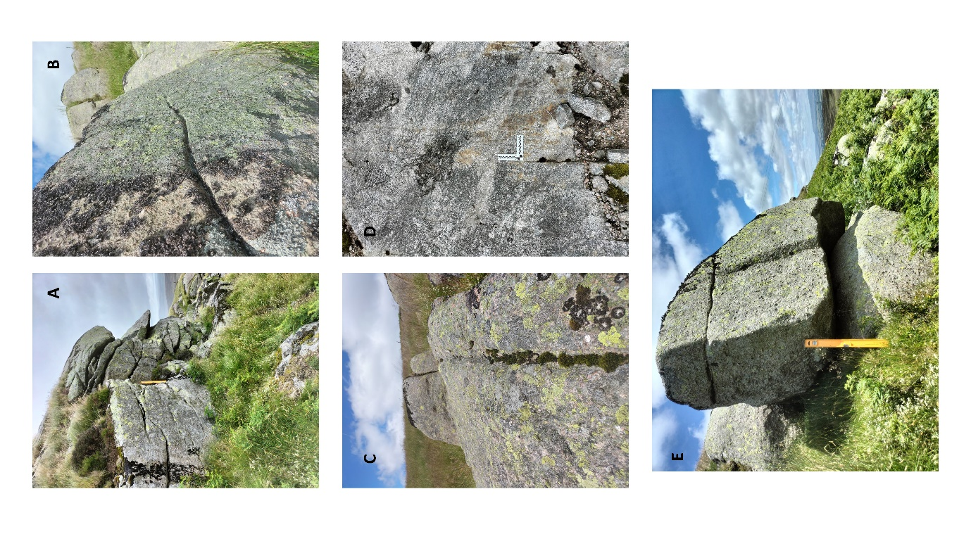

*Figure 7: Structural controls on block entrainment. A) Horizontal decompression joints in the Shap granite outcrop. Yellow scale bar is 0.5m placed in vertical joint; B) Oblique view of incipient horizontal fracture in detached cubic block (note vertical joint in block in background); C) Closed joint in granite outcrop in foreground extends to open joint in the background; D) Fine scale vertical lineation in granite outcrop may constrain size of entrained blocks. Note vertical lineation at left margin of scale bar and vertical lineation at the right tip of the scale bar, amongst others; E) In situ block susceptible to entrainment at outcrop. Main face of outcrop is c., 2m behind the block. Note the curvilinear ‘horizontal’ joint at the base of the block as well as the horizontal joint above. A vertical joint plane is evident in the centre of the front face of the block. Scale bar is 0.5m in length.*

Where the rock structure and ice interactions on buttresses result in smoothed convex-concave surfaces then erosion is interpreted as primarily due to surface abrasion. However, these surfaces occasionally exhibit large locally entrained tabular slabs where the horizontal joint spacing near the surface was small (*c*., 1 to 1.5m). More usually entrainment was of smaller near-isotropic blocks from the face of the steep lee-side steps (Figs. 6 & 7). Given the small area of the outcrop, and the small elevation difference (*c*., 113 m) between the base of the outcrop and the summit, supraglacial entrainment of weathered blocks falling from sub-aerial outcrops onto the ice surface during final deglaciation likely would have been minor.

**Discussion**

Consideration of the palaeo ice flow directions (Fig. 8) indicates both easterly ice flow and subsequent northerly ice flow which is consistent with the regional ice flow history (Carling *et al*., 2023); indicators of southerly ice flow (ES1), if it occurred over the exposure, have been erased by the subsequent northerly ice flow, as none were found. The severely ice-plucked exposures associated with Wasdale Crag predominantly face east whilst the high concentration of blocks below Wasdale Crag indicates that erosion of the bedrock was sustained during pre-LGM easterly ice (ST1) movement. However, the considerable denudation of the granite mass that must have occurred to provide the vast number of Shap granite erratics (Goodchild, 1887) remains unmeasured. The evidence of displaced Shap granite blocks (Table S1) from outcrop must be treated with caution as post-glacial periglacial conditions can be associated with block movements, especially on steep slopes, yet all reported examples are on level terrain; directed northwards they are regarded as post-LGM indicators of LT6 ice flow. Some outcrops on the exposure, and around the immediate margins, have crude rôche moutonnée forms smoothed by ice flow on the stoss side and irregular on the leeside; the majority of these forms are aligned roughly south to north and so can be related to post-LGM northerly ice flow. The lee-side irregularity is due to blocks having been removed by ice plucking in the lee. The preferred mechanism for block movement is that tensile forces caused vertical fractures on the leeside of the exposure. These fractures intersected with horizontal bedrock joint planes, resulting in individual blocks separating from the main body of the granite and becoming entrained in the basal ice flow. In the leesides of small bedrock steps, such as near the summit point of Long Fell (Fig. 1), blocks evidently pivoted from sockets (Fig. 5B; see also Hall *et al.*, 2021) due to the stress imposed by the ice/till overburden. Large-scale ripping along subglacial meltwater corridors (Hall & Van Boekel, 2024) is not favoured as a cause of block entrainment as melt was unlikely to have been concentrated on the slopes and summits of Sleddale Pike and Long Fell and within the minor channel of Longfell Gill. Nevertheless, some blocks may have been removed into subglacial cavities by localized occurrences of pressurized meltwater ripping the blocks from the outcrops (Cohen *et al*., 2006; Ugelvig *et al*., 2016; Glasser *et al*., 2020; Hall *et al*., 2021).

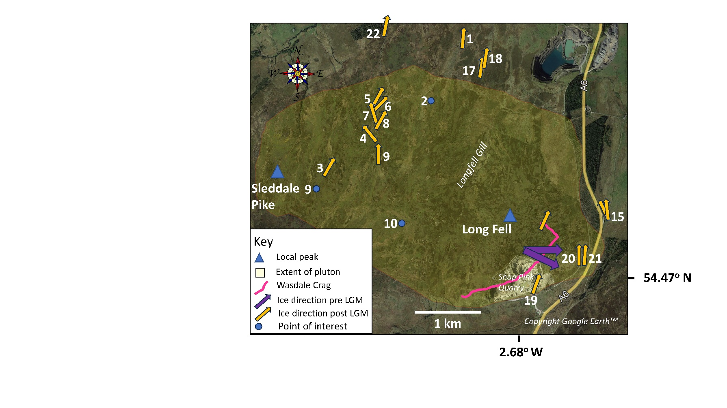

*Figure 8: Summary of ice flow direction indicators and points of interest on the Shap granite exposure. The E-facing outcrops and the high concentration of Shap granite blocks to the E and SE of Wasdale Crag are the sole indicators of prolonged pre-LGM easterly ice flow. Post-LGM ice flow indicators are not discriminated by type in this figure (see Table S1 for details). Base map is from OS Map Local© data and the extent of the granite exposure is from the British Geological Survey Geoindex (* [*https://www.bgs.ac.uk/map-viewers/geoindex-onshore/*](https://www.bgs.ac.uk/map-viewers/geoindex-onshore/)*).*

Ice flow sufficient to entrain blocks from the outcrop was sustained until close to final deglaciation as blocks are found concentrated immediately below Wasdale Crag and many of the larger examples exhibit unopened joints and fissures. If ice flow, incompetent to pluck blocks from the outcrop but competent to transport entrained blocks, had continued in the final stages of glaciation there would have been a gap between the outcrop and the position of the nearest displaced erratics (Bouchard & Salonen, 1990). However, this potential situation is not supported by the field evidence. The preferred interpretation of the disposition of blocks is as follows. The sparse scatter of blocks across the exposure to the west of Wasdale Crag, reflects occasional entrainment and sustained transport of blocks, especially on adverse slopes where pressure would have been high. The bulk of this material was removed eastwards by ST1 ice flow to below Wasdale Crag before the LGM. Blocks also were released from Wasdale Crag in large numbers by ST1 ice but were difficult to entrain into the ice flow as the pressure below the outcrop likely was low because the ice was expanding eastwards downslope. Thus, immediately east of the outcrop many blocks are deposited in a dense array (Fig. 1). There is no evidence on the exposure of southerly ES1 ice flow but the erratic plume, extending into Lancashire via the Mint valley, is an indicator that blocks were moved southwards (Carling *et al.,* 2023). Post-LGM LT6 ice flow over the exposure was roughly N to NE and Shap granite blocks were transported in similar directions (Carling *et al*., 2023) to give the concentration noted within Wet Sleddale (Fig. 1). Although there are indicators of post-glacial weathering of Shap granite surfaces, this has been slight.

**Acknowledgements**

Emma Armstrong (Armstrongs Group) for access to the Shap (Pink) Quarry. Geoff Brambles for the initial date of quarrying at Wasdale Crag. GPS coordinates for locations 19-24 in Table S1 were supplied by Leslie Knight. The commentaries of Ian Jackson and the editor, Ian Francis, were appreciated in shaping the final presentation.

**References**

Anderson, L.I., 2014. Before the Scottish Survey: Alfred Harker the Geologist. *Proceedings of the Geologists’ Association*, 125, 350-358. https://doi.org/10.1016/j.pgeola.2014.02.004

Anon., 1833. Untitled, *Gentleman’s Magazine*, 103 (1), January, 4-5. <https://babel.hathitrust.org/cgi/pt?id=inu.30000080772951&seq=18>

Berger, A.R., Pitcher, W.S., 1970. Structures in granitic rocks: a commentary and a critique on

## granite tectonics. [*Proceedings of the Geologists' Association*](https://www.sciencedirect.com/journal/proceedings-of-the-geologists-association)*,* 81, 441-461. <https://doi.org/10.1016/S0016-7878(70)80006-2>

## BGS, 2008. <https://www.bgs.ac.uk/map-viewers/geoindex-onshore/>

## Bingley, G., 1898. Godfrey Bingley Photographic Archive, Leeds University. <https://explore.library.leeds.ac.uk/special-collections-explore/12653>).

## Bouchard, M.A., Salonen, V.-P., Block transport in shield areas. 87-108 In: Kujansuu, R., Saarnisto, M.: Glacial Indicator Tracing, Balkema, Rotterdam, 252pp, ISBN 833 9781003079415, 1990.

## Budd, W.F., Keage, P.L., Blundy, N.A., 1979. Empirical studies of ice sliding. *Journal of Glaciology*, 23, 157-170. <https://doi.org/10.3189/S0022143000029804>

Carling, P.A., Su, T., Meshkova, L., 2023. Distribution of Devensian glacial erratics and related evidence elucidate complex ice flow changes across a former ice divide: Northern England. *Proceedings of the Geologists’ Association*, 134, 139-165. <https://doi.org/10.1016/j.pgeola.2023.01.002>

Carling, P.A., 2024. Coevolving edge rounding and shape of glacial erratics; the case of Shap granite, UK. *Earth Surf. Dynam*., 12, 381-397. <https://doi.org/10.5194/esurf-12-381-2024>

Caunt, S.L., 1986. Igneous and Metamorphic Processes in the Sap Granite and its Aureole, Unpublished PhD thesis, University of Leeds, 337pp, https://etheses.whiterose.ac.uk/522/, 1986.

Clark, P.U., Dyke, A.S., Shakun, J.D., Carlson, A.E., Clark, J., Wohlfarth, B., Mitrovica, J.X., Hostetler, S.W., McCabe, M.: The Last Glacial Maximum. *Science*, 325, 710-714. https://doi.org/10.1126/science.1172873, 2009.

Cohen, D., Hooyer, T.S., Iverson, N.R., Thomason, J.F., Jackson, M., 2006. Role of transient water pressure in quarrying: A subglacial experiment using acoustic emissions. J*ournal of Geophysical Research*, 111, F03006, doi:10.1029/2005JF000439.

Ehlers, J., Gibbard, P.L., 2013. Overview. In: Elias, S.A. (Ed.), Encyclopedia of Quaternary

Science, vol. 2. Elsevier, Amsterdam, pp. 143–150.

Firman, R. J., 1953. Metamorphism and metasomatism around the Shap and Eskdale granites, Durham theses, Durham University. Available at Durham E-Theses Online: <http://etheses.dur.ac.uk/9565/>

Goodchild, J.G., 1875. The glacial phenomena of the Eden valley and the western part of

the Yorkshire Dales District. *Quarterly Journal of the Geological Society*, 31, 55–99. https://www.lyellcollection.org/doi/abs/10.1144/GSL.JGS.1875.031.01-04.04

Hall, A.M., Krabbendam, M., van Boeckel, M., Goodfellow, B.W., Hättestrand, C., Heyman, J. *et al*., 2020. Glacial ripping: geomorphological evidence from Sweden for a new process of glacial erosion. *Geografiska Annaler: Series A, Physical Geography,* A102, 333–353. doi/full/10.1080/04353676.2020.1774244

Hall, A.M., van Boekel, M., 2024. Hydraulic damage in subglacial conduits: Evidence from rock hydrofracture and hydraulic jacking for high ﬂuid pressures during rapid melt of the

Fennoscandian Ice Sheet. *Quaternary Science Reviews*, 343, 108917. https://doi.org/10.1016/j.quascirev.2024.108917

Holland, E.G., 1959. Shap Granite – Part 1. *Mine and Quarry Engineering*, 25, 2-15. http://www.dmm.org.uk/minequar/5908-01.htm

Glasser, N.F.; Roman, M.; Holt, T.O.; Žebre, M.; Patton, H.; Hubbard, A.L., 2020. Modification of bedrock surfaces by glacial abrasion and quarrying: Evidence from North Wales. *Geomorphology*, 365, 107283. <https://doi.org/10.1016/j.geomorph.2020.107283>.

Goodchild, J.G., 1875. The glacial phenomena of the Eden valley and the western part of the Yorkshire Dales District. *Quarterly Journal of the Geological Society*, 31, 55-99.

Goodchild, J.G., 1887. Ice work in Edenside and some adjoining parts of north-west England. *Transactions of the Cumberland and Westmorland Association for the Advancement of Literature and Science*, 11 pp. 111–167.

Jahns, R. H., 1943. Sheet structure in granites, its origin and use as a measure of glacial erosion in New England. *Journal of Geology*, 51, 71– 98. <https://www.jstor.org/stable/30068274>

Johnson, D., 2018. Quarrying in Cumbria, Amberley Publishing, Stroud.

Livingstone, S.J., Evans, D.J.A., Ó Cofaigh, C., Davies, B.J., Merritt, J.W., Huddart, D., Mitchell, W.A., Roberts, D.H., Yorke, L., 2012. Glaciodynamics of the central sector of the last British-Irish Ice Sheet in Northern England. *Earth-Science Reviews*, 111, 25-55. https://doi.org/10.1016/j.earscirev.2011.12.006, 2012.

Loughlin, S.C., 1999. Shap Fell Crags. In: Stephenson, D., Bevins, R.E., Millward, D., Highton,

A.J., Parsons, I., Stone, P., Wadsworth, W.J. (Eds.), Caledonian Igneous Rocks of the

British Isles. Joint Nature Conservation Committee, Peterborough. http://www.jncc.gov.uk/page-2731

Merritt, J.W., Hall, A.M., Gordon, J.E., Connel, E.R., 2019. Late Pleistocene sediments, landforms and events in Scotland: a review of the terrestrial stratigraphic record. *Earth and Environmental Science Transactions of the Royal Society of Edinburgh*, 110, 39-91. https://doi.org/10.1017/S1755691018000890

Miles, A.J., Woodcock, N.H., Hawkesworth, C.J., 2016. Tectonic controls on post-subduction granite genesis and emplacement: the late Caledonian suite of Britian and Ireland. *Gondwana Research*, 39, 250-260. https://doi.org/10.1016/j.gr.2016.02.006

Nicholson, H.A., 1868. On the Shap granite of Westmoreland. *Transactions of the*

*Edinburgh Geological Society*, 1, 133–137. https://doi.org/10.1144/transed.1.2.133

Ugelvig, S. V., Egholm, D.L., Iverson, N.R., 2016. Glacial landscape evolution by subglacial quarrying:

A multiscale computational approach. *Journal of Geophysical Research: Earth Surface*,

121. https://doi:10.1002/2016JF003960.

Wang, X.-Y., Yin, Y.-C., Xing, M.-L., Zhang, D.-D., Chen, Y., Wang, E.-C., 2022. Microsimulation study on energy release and rock block ejection force of granite under different unloading conditions. *Frontiers in Earth Science*, 10:909371. https://doi: 10.3389/feart.2022.909371.

Westaway, R., 2009. Quaternary uplift of northern England. *Global and Planetary Change*, 68, 357-382. https://doi.org/10.1016/j.gloplacha.2009.03.005