Substantial in situ Ti isotope variations in rutile record source and fluid evolution of porphyry copper mineralization systems

Xiaojia Jiang¹, Xin Chen^{1,†}, Liam Hoare^{2,3}, Hans-Peter Schertl², Martin R. Palmer⁴, Wen Zhang¹, Pengjie Cai⁵, Hong Liu¹, Youye Zheng¹, and Shunbao Gao¹
1 State Key Laboratory of Geological Processes and Mineral Resources and School of Earth Resources, China University of Geosciences, Wuhan 430074, China
2 Ruhr-University Bochum, Faculty of Geosciences, Institute of Geology, Mineralogy and Geophysics, 44780 Bochum, Germany
3 Department of Geosciences, University of Tübingen, Schnarrenbergstraße 94-96, 72076 Tübingen, Germany
4 School of Ocean and Earth Science, University of Southampton, Waterfront Campus, Southampton SO14 3ZH, UK
5 State Key Laboratory for Mineral Deposits Research, School of Earth Sciences and Engineering, Nanjing University, 210023 Nanjing, China

ABSTRACT
Titanium (Ti) and its stable isotopes have been widely used as tracers for magmatic processes. However, our understanding of Ti isotope behavior in magmatic-hydrothermal systems remains limited. Hence, the in situ Ti isotope composition (δ⁴⁹Ti) of magmatic titanite and hydrothermal rutile associated with magnetite and chalcopyrite mineralization was determined for the first time in four well-characterized porphyry copper deposits in southern Tibet. The rutile formed through the alteration of primary Ti-rich minerals during fluid-rock interaction in the early high-temperature magnetite and later moderate-temperature chalcopyrite stages of mineralization. Hydrothermal rutile, altered from magmatic titanite, exhibits δ⁴⁹Ti values similar to those of residual magmatic titanite. This suggests that hydrothermal rutile inherited the Ti isotope composition of magmatic titanite. The average δ⁴⁹Ti values of rutile are negatively correlated with whole-rock ε_{Nd}(t) and zircon ε_{Hf}(t) data, and positively correlated with whole-rock (⁸⁷Sr/⁸⁶Sr)_{i} values, which suggests that the initial Ti isotope compositions of hydrothermal rutile in porphyry copper deposits primarily reflect their source. Rutile from the Qulong deposit sometimes exhibits fractionation of δ⁴⁹Ti at levels exceeding 0.5‰, displaying a negative correlation with Zr and FeO, which may be attributed to the formation of magnetite and rutile at an early potassic alteration stage. Isotopically light Ti is preferentially incorporated into magnetite and rutile. Thus, the rutile associated with sulfide mineralization that formed from the remaining fluids during a later stage of phyllic alteration is enriched in heavy δ⁴⁹Ti. These findings contribute to the understanding of how rutile fractionates Ti isotopes in hydrothermal systems related to porphyry copper deposits. In local contexts, the substantial crystallization of magnetite, along with the preferential incorporation of isotopically light Ti during the early stages, leads to a decrease in oxygen fugacity within the ore-bearing fluid. This, in turn, facilitates the formation of sulfides during later stages. The results of this study demonstrate the efficacy of in situ Ti isotope analysis as a powerful tool for tracking fluid and metal sources, and can be used to help interpret ore precipitation throughout different stages of magmatic-to-hydrothermal ore-forming processes.

1. INTRODUCTION
Titanium (Ti), being a refractory lithophile element, is widely distributed in Earth’s crust (Van Baalen, 1993; McDonough and Sun, 1995; Wedepohl, 1995). It is incompatible and remains immobile in fluids during processes such as partial melting, magmatic differentiation, and fluid-rock interaction (Jiang, 2000; Lei et al., 2021; Chen et al., 2022a, 2022b). Furthermore, Ti exhibits geochemical similarities with other high field strength elements (HFSEs) such as Nb, Ta, Zr, and Hf (Jiang et al., 2005; Hou et al., 2024). As a result, Ti has been used extensively as a petrogenetic tool for classifying the sources and evolution of magmatic rocks and their tectonic environments (Pearce and Cann, 1973; Klemme et al., 2006). It is also employed to distinguish the protoliths of altered or metamorphic rocks (Force, 1980; Klaver et al., 2021) and to trace water/rock interactions and metallogenic processes (Jiang, 2000; Lei et al., 2021; Chen et al., 2022a).
On the other hand, recent advancements have highlighted the significant impact of Ti isotope studies (given as δ⁴⁹Ti = [(⁴⁹Ti/⁴⁷Ti)_{sample}/ (⁴⁹Ti/⁴⁷Ti)_{OL-Ti} − 1] × 1000; OL-Ti represents the Origins Lab reference material; Millet and Dauphas, 2014; Millet et al., 2016) utilizing both bulk and in situ analytical methods. These studies have shed light on various genetic aspects of Ti isotope fractionation in terrestrial samples, particularly in relation to Fe-Ti oxides such as rutile, Ti-bearing magnetite, ilmenite, and titanite (Johnson et al., 2019; Zhao et al., 2020; Hoare et al., 2022; Emproto et al., 2022; He et al., 2018, 2022; Liu et al., 2023a, 2023b; Storck et al., 2023). Based on the theory of mass-dependent isotope fractionation, it is understood that heavier stable isotopes tend to form shorter and stiffer bonds with a lower coordination number at thermodynamic equilibrium (Schauble, 2004; Young et al., 2015). Studies in experimental petrology and analysis of natural samples have revealed that Fe-Ti oxide undergoes isotopic “lightening” compared to the melt from which it crystallizes. This phenomenon results in the residual liquid becoming “heavier” in composition during the crystallization process (Wang et al., 2020b; Rzehak et al., 2021, 2022; Hoare et al., 2022; Johnson et al., 2023). Consequently, there is an increase in δ⁴⁹Ti from basaltic to rhyolitic compositions during the magma fractionation (Millet et al., 2016; Johnson et al., 2019; Deng et al., 2019; Hoare et al., 2020). Due to their unique geochemical properties, Ti isotopes offer significant potential as a novel tool for studying the evolution of magmatic rocks and the interaction between the crust and mantle (Deng et al., 2019; Zhao et al., 2020; Greber et al., 2021; Johnson et al., 2023). Moreover, they serve as powerful indicators for deciphering the magmatic-hydrothermal evolution of ore-forming systems (Emproto et al., 2022). However, the precise mechanisms underlying the fractionation of Ti isotopes during metallogenic cycles in magmatic-hydrothermal systems remain poorly understood.
Rutile is an extremely stable mineral and can be found in various rock types that include high-grade metamorphic, sedimentary, and igneous rocks. It is also prevalent in different types of magmatic to hydrothermal deposits, such as orogenic gold, volcanogenic massive sulfide, porphyry Cu-Au-Mo, greisen Cu-Mo-W, and granite-related W-Sn systems (Scott, 2005; Rabbia et al., 2009; Pe-Piper et al., 2019; Schirra and Laurent, 2021; Yang et al., 2021). The trace element and isotopic compositions of rutile provide valuable information about the ore-forming processes, which makes it a widely utilized mineral for tracing the source of ore-forming materials and recording the evolution of ore-forming fluids. Hydrothermal rutile formation in various alteration zones within porphyry copper systems occurs simultaneously with hydrothermal alteration and results from the breakdown of Ti-rich minerals (Williams and Cesbron, 1977; Czamanske et al., 1981). Potassic alteration events (400–500 °C) generally destroy titanite (e.g., titanite + SO₂-rich fluid ⇒ anhydrite + quartz + rutile) but may not significantly affect magnetite and biotite. Later quartz-sericite events (∼300 °C) primarily target biotite (Rabbia et al., 2009). Consequently, superimposed episodes of different alteration processes (mainly potassic and phyllic) acting on contrasting lithologies (felsic and mafic) result in different generations of hydrothermal rutile derived from various precursor mineral phases (Scott, 2005; Rabbia et al., 2009). Its sufficient U content makes it useful for dating purposes (e.g., Zack et al., 2011; Schirra and Laurent, 2021), whereas its trace element composition serves as a systematic petrogenetic indicator for understanding hydrothermal processes (e.g., Rabbia et al., 2009). Rutile is also extensively employed in studies related to porphyry-style mineralization (e.g., Kelley et al., 2011; Schirra and Laurent, 2021; Yang et al., 2021). Due to its abundance and distinct trace element signatures in porphyry systems (e.g., Czamanske et al., 1981; Plavsa et al., 2018; Agangi et al., 2019), it provides an exceptional natural sample for investigating Ti isotope fractionation in porphyry hydrothermal systems.
To investigate such processes, in situ Ti isotope compositions of rutile within various ore-bearing porphyries from the Qulong, Chongjiang, Zhunuo, and Beimulang deposits and the Gangdese magmatic arc (Fig. 1) in southern Tibet were examined. This investigation was conducted using high-precision femtosecond–laser ablation–multicollector–inductively coupled plasma–mass spectrometry (FS-LA-MC-ICP-MS). In addition, systematic petrographic and textural observations, as well as major and trace element analysis of different generations of rutile, were performed to elucidate their textures and the conditions that led to their formation. The objective of this study was to examine the fractionation of in situ Ti isotopes during the interaction between fluids and rocks, and to trace the sources and variations of these fluids. With the aid of these data, another aim was to decipher the processes involved in the precipitation of Cu mineralization. The results obtained are expected to provide new insights into the potential applications of titanium isotopes in the investigation of metallogenic systems.

2. GEOLOGICAL SETTING AND ORE DEPOSIT GEOLOGY
2.1. General Geological Background
The Tibetan Plateau is comprised of four continental fragments: the Songpan-Ganzi, Qiangtang, Lhasa, and Himalaya terranes. These fragments are arranged from north to south and are delimited by the Jinsha River suture zone, Banggong-Nujiang suture zone, and Indus–Yarlung Zangbo suture zone (Fig. 1A; Yin and Harrison, 2000). Within the Lhasa terrane, between the Banggong-Nujiang suture zone to the north and the Indus–Yarlung Zangbo suture zone to the south, there are three distinct subterranes: northern, central, and southern. These subterranes exhibit different crustal architectures (Fig. 1B; Hou et al., 2015a, 2015b) and are separated by the Shiquan River–Nam Tso mélange zone and the Luobadui-Milashan fault (Yin and Harrison, 2000; Zhu et al., 2011; Hou et al., 2015a, 2015b).
The Gangdese porphyry copper metallogenic belt, which is situated in the southern Lhasa subterrane (Yin and Harrison, 2000), is recognized as the largest continental collision orogenic system worldwide and serves as a natural laboratory for the study of magmatic-hydrothermal metallogenic processes. A series of giant porphyry deposits that are predominantly rich in Cu, Cu-Mo, and Cu-Au has developed within this belt. Notable examples include the Qulong, Jiama, Zhunuo, Beimulang, Jiru, and Chongjiang deposits (Zheng et al., 2014; Hu et al., 2017; Sun et al., 2018; Liu et al., 2022). These occurrences represent significant Cu polymetallic resources within China (Hou et al., 2013; Tang et al., 2019; Wang et al., 2020a).
2.2. Ore Deposit Geology
For this study, four porphyry copper deposits (PCDs) located along the Gangdese belt were selected as examples for in situ Ti isotope analysis of rutile. These deposits are, from west to east, the Beimulang, Zhunuo, Chongjiang, and Qulong PCDs. The proven and/or inferred resources of these deposits are 0.5 Mt Cu@0.46%, 2.3 Mt Cu@0.57%, 1.8 Mt Cu@0.4% and 27 Mt Cu@0.5%, respectively (Zheng et al., 2004, 2024a, 2024b; Xiao et al., 2012; Li et al., 2017; Liu et al., 2022; Lin et al., 2024). All of the deposits investigated share common features in terms of rock- and ore-forming ages, alteration patterns, and mineralization styles. The mineralization is associated with monzogranitic porphyry, and their formation ages are approximately 14 Ma (Beimulang), 14 Ma (Zhunuo), 15 Ma (Chongjiang), and 16 Ma (Qulong), aligning with the metallogenic ages determined by molybdenum Re-Os isotope dating (Li et al., 2017; Sun et al., 2018; Liu et al., 2022). The hydrothermal alteration in these deposits comprises potassic, phyllic, and minor propylitic zones, which are typical examples of alteration zoning found in porphyry copper deposits worldwide (Sillitoe, 2010). Potassic alteration is characterized by the occurrence of hydrothermal K-feldspar, biotite, and quartz in the central depths of ore-related intrusions. Phyllic alteration occurs in the shallower areas, overprinting earlier alteration assemblages and unaltered rocks (Zheng et al., 2004; Zeng et al., 2017). The propylitic alteration overlays the potassic and phyllic alteration zones and extends into the wall rock. Copper mineralization is mainly associated with potassic and phyllic alterations, which are characterized by stockwork and disseminated mineralization consisting primarily of chalcopyrite, bornite, pyrite, and molybdenite (Zheng et al., 2004, 2024a, 2024b; Qu et al., 2007; Yang and Hou, 2009; Hu et al., 2017; Sun et al., 2018; Lin et al., 2024).

3. SAMPLING AND METHODOLOGY
3.1. Samples and Petrographic Data
Surface and drill core samples were collected from four large porphyry Cu deposits, namely Beimulang, Zhunuo, Chongjiang, and Qulong (from west to east of the Gangdese porphyry copper metallogenic belt; Fig. 1B). Approximately 50 thin sections of rutile-bearing porphyries exhibiting various types of alteration were chosen for petrographic observation and backscattered electron (BSE) image analysis. Rutile and zircon grains from ore-forming porphyries in all four deposits were selected for zircon U-Pb dating, Hf isotope analysis, in situ rutile trace element studies, and Ti isotope analysis. Titanite was found in the Beimulang and Qulong PCDs, but not in the Zhunuo and Chongjiang samples. Therefore, titanium isotope analysis was conducted for titanite in these two deposits for comparison.
All of the titanites and rutiles investigated in the different deposits exhibit similar textures and are part of similar mineral assemblages. Most individual grains display a prismatic morphology and vary in diameter from 20 μm to 1000 μm (Fig. 2). Diamond-shaped titanite, which ranges in size at the millimeter level, coexists with magnetite in fresh porphyries from the Beimulang and Qulong deposits (Fig. 2A). Rutile grains can cluster together to form aggregates with diameters of up to a few millimeters. These clusters may also host igneous titanite and biotite, and the morphology of some clusters resembles cross sections of titanite crystals (Figs. 2B and 2C). Based on petrographic observations, two types of rutile can be identified in these PCDs. One type coexists with magnetite and biotite (Figs. 2D–2H) or is hosted within high-temperature hydrothermal veins filled with anhydrite, biotite, and quartz, which suggests its association with the potassic alteration. The other type is part of an assemblage comprising chalcopyrite, chlorite, and sericite, and is genetically linked to the phyllic alteration (Figs. 2J and 2K). Individual rutile grains associated with chalcopyrite, pyrite, and sericite, which belong to the second type of rutile that is genetically linked to the phyllic alteration, were observed in the sulfide-quartz veins present in Beimulang–Zhunuo–Chongjiang–Qulong ore-forming porphyries (Figs. 2I–2K). However, the first type of rutile associated with potassic alteration is observed in the Qulong and Beimulang deposit but not in the Zhunuo or Chongjiang deposits (Figs. 2D–2H). Notably, the absence of the first type of rutile in the Zhunuo and Chongjiang deposits may not indicate its non-existence but rather that these rare samples may have been overprinted by subsequent alteration, which is why they were not detected.
3.2. Methodology
Major and trace element analysis of rutile were performed using LA-ICP-MS at the laboratory of the Guangzhou Tuoyan Analytical Technology Co., Ltd., in Guangzhou, China. In situ Ti isotope measurements were conducted at the State Key Laboratory of Geological Processes and Mineral Resources, China University of Geosciences in Wuhan, using a Neptune Plus MC-ICP-MS (Thermo Fisher Scientific, Bremen, Germany). The laser ablation system used was a 300 fs Yb:KGW femtosecond laser amplifier (PHAROS, Light Conversion Ltd., Vilnius, Lithuania) with a wavelength of 257 nm and an ESI NWR-Femto laser ablation platform. The signal intensity on the mass of ⁴⁹Ti was ≈1.1 V using a laser spot of 30 μm and a low ablation frequency of 2 Hz on titanite, while the background signal on ⁴⁹Ti for the mass spectrometer was ≈0.004 V (Liu et al., 2023a). The ⁴⁸Ti signal intensity was ≈20 V using a laser spot of 20–25 μm and a low ablation frequency of 1 Hz on rutile, while the background signal on ⁴⁸Ti for the mass spectrometer was ≈0.04 V (Liu et al., 2023b). In situ U-Pb dating of zircon and Hf was conducted using LA-MC-ICP-MS at the Wuhan Sample Solution Analytical Technology Co., Ltd., China. Further details regarding the calibration process, analytical procedures, specific parameters, and data collected are provided in Text S1 in the Supplemental Material.
To assess the extent of Ti isotope fractionation during the partial melting of juvenile lower crust and the crystallization differentiation of calc-alkaline magma, we employed rhyolite-MELTS models combined with relevant mineral-melt Ti isotope fractionation factors and the force constant of the Ti bonds in the mineral. A detailed summary of our results and modeling can be found in Text S1, and comprehensive data related to these methods are provided in Tables S1–S7.

S7.4. RESULTS
4.1. Trace Element Systematics
The in situ major and trace element analyses of rutile are summarized in Table S1. To identify similarities and differences in major and trace elements, as well as trace element intercorrelations of rutile, principal component analysis (PCA) was employed. This analysis was performed to examine the variations between different porphyry copper localities and distinct types of alteration (Fig. 3). The PCA analysis reveals that the concentrations of trace elements in rutile in the porphyry systems we studied exhibit variations between and within the different deposits.
When considering rutile grains from the Qulong Cu deposit, the first two principal components (rutile intergrowth with magnetite in the high-temperature potassic alteration versus rutile intergrowth with chalcopyrite during moderate-temperature phyllic alteration) capture ∼56% of the data variability, with PC1 accounting for 40.8% and PC2 for 15.1% (Fig. 3A). Rutile associated with the magnetite stage displays a positive loading on PC1 (right side of the diagram in Fig. 3A), whereas rutile that formed in the chalcopyrite stage exhibits a negative loading on PC1 (left side of the diagram) and predominantly a positive loading on PC2 (upper part of the diagram). Rutile intergrowth with magnetite is characterized by high concentrations of rare earth elements (REEs), Zr, FeO, Co, and Sr, and low concentrations of V, Mo, and Cu (Fig. 3A). Notably, rutile that formed during the potassic alteration stage exhibits high concentrations of REEs (6.75–2870 ppm; mean of 542 ppm), Zr (188–1330 ppm; mean of 650 ppm), and FeO (1.42–4.78 wt%; mean of 3.09 wt%). Rutile intergrown with chalcopyrite shows negative PC1 loadings and demonstrates significant variations in concentrations of W (221–38,400 ppm), Sc (8.95–407 ppm), and V (1320–8720 ppm) compared to rutile from the high-temperature alteration stage (Fig. 3A; Table S1).
Figure 3B illustrates the results of the PCA conducted on rutile from the four deposits in the Gangdese arc. Rutile from the Beimulang deposit shows positive loading on PC2 and relatively high concentrations of In and Sn, 10.1–14.6 ppm and 2370–3820 ppm, respectively. Rutile from the potassic alteration stage in the Qulong deposit lies in the lower right quadrant of the diagram and demonstrates distinct variations in concentrations of Co (0.75–2.21 ppm), Pb (1.52–217 ppm), Y (0.63–33.8 ppm), and the heavy REEs (0.22–97.3 ppm). Rutile from Zhunuo, Chongjiang, and the phyllic alteration stage in the Qulong deposit are positioned closer to the center of the diagram and display similar patterns (Fig. 3B; Table S1).
4.2. Titanium Isotope Composition
The δ⁴⁹Ti values of all of the titanite samples range from −0.032‰ to +0.523‰ (n = 32; Table S2), with those from Beimulang (+0.148‰ ± 0.089‰ to +0.523‰ ± 0.082‰, mean +0.225‰ ± 0.076‰) having significantly heavier δ⁴⁹Ti values than those from the Qulong deposit (−0.032‰ ± 0.081‰ to +0.066‰ ± 0.066‰, mean +0.028‰ ± 0.069‰).
The δ⁴⁹Ti values of all of the rutile samples range from −0.690‰ to +1.207‰ (n = 116; Fig. 4, Table S4). The relative variations in rutile δ49Ti values in the four deposits are shown in Fig. 4A. Notably, within the Qulong deposit, rutile associated with magnetite from the early potassic alteration stage has relatively low δ⁴⁹Ti values (−0.690‰ ± 0.070‰ to +0.010‰ ± 0.050‰; mean of −0.203‰ ± 0.080‰) compared to those from the late phyllic alteration stage (−0.230‰ ± 0.070‰ to +0.247‰ ± 0.090‰; mean of +0.067‰ ± 0.066‰). Note also that the δ⁴⁹Ti values of rutile surrounding residual titanite are similar to the titanite in both the Qulong deposit (titanite: +0.028‰ ± 0.069‰; rutile: +0.036‰ ±0.061‰) and Beimulang deposit (titanite: +0.225‰ ± 0.076‰; rutile: +0.303‰ ± 0.088‰; Fig. 5; Tables S2–S5).
4.3. Zircon U-Pb Ages and Hafnium Isotopes
CL images of zircons from all of the PCDs are shown in Figure 6. Zircons used for U-Pb dating and hafnium isotope analysis are predominantly subhedral to euhedral and exhibit oscillatory growth zoning (Fig. 6). Zircon U-Pb dating results are detailed in Table S6 and illustrated in Figure 6. Analyses from Beimulang (samples ZK0201 and ZK0701) yield ²⁰⁶Pb/²³⁸U ages ranging from 13.3 Ma to 15.5 Ma, with weighted mean ages of 14.1 ± 0.1 Ma (mean square of weighted deviates [MSWD] = 0.3) and 14.3 ± 0.2 Ma (MSWD = 1), respectively (Figs. 6A and 6B). Sixteen analyses from Zhunuo (sample ZK1502) are concordant, producing ²⁰⁶Pb/²³⁸U ages of between 11.8 Ma and 16.5 Ma, with a weighted mean age of 14.2 ± 0.2 Ma (MSWD = 0.7; Fig. 6C). Twenty zircon grains from Chongjiang (sample ZK1539) show ²⁰⁶Pb/²³⁸U ages ranging from 14.3 Ma to 15.2 Ma, with a weighted mean age of 14.6 ± 0.2 Ma (MSWD = 0.17; Fig. 6D). Eighteen analyses from Qulong (sample QL-1) yield ²⁰⁶Pb/²³⁸U ages of 15.3–16.7 Ma, with a weighted mean age of 16.1 ± 0.3 Ma (MSWD = 0.01; Fig. 6E).
The ε_{Hf}(t) values of zircon from the four deposits analyzed in this and previous studies (Hu et al., 2015a, 2017; Huang et al., 2017; Sun et al., 2018) range from +12.8 to −5.50 (n = 189, Table S7), with systematic variations among the different porphyry deposits (Fig. 4B). Specifically, zircons from the Beimulang porphyry Cu deposit display ε_{Hf}(t) values ranging from +0.5‰ to −4.1‰, with a mean of −1.8‰ (Table S7). Zircons from the Zhunuo porphyry Cu deposit exhibit relatively heterogeneous ε_{Hf}(t) that varies between −0.5‰ and −5.5‰, with a mean of −2.8‰ (Huang et al., 2017; Sun et al., 2018), which is slightly lower than the ε_{Hf}(t) values of zircons from the Chongjiang deposit, which range from −0.1‰ to +7.6‰, with a mean of +4.0‰ (Fig. 4B). Zircons from the Qulong deposit display positive Hf isotopic compositions, with ε_{Hf}(t) values varying from +12.8‰ to +5.1‰, and a mean of +8.1‰ (Fig. 4B).

5. DISCUSSION
5.1. Magmatic Controls over Ti Isotope Variations
Despite all four of the porphyry copper deposits being present within a similar tectonic setting in the Gangdese arc, titanite and rutile from the four deposits show distinct Ti isotope compositions (Figs. 4A and 5).
In general, the alteration of magmatic titanite into hydrothermal rutile is common in porphyry copper systems, which signifies a clear genetic relationship between them (Fig. 2A; Rabbia et al., 2009). Indeed, several samples of rutile altered from titanite were found in the Qulong and Beimulang deposits, and Ti isotopes were measured in the closely related titanite and rutile. Our results reveal a relative consistency in the average δ⁴⁹Ti values of titanite and its derivative rutile within the Qulong (titanite: +0.028‰ ± 0.069‰; rutile: +0.036‰ ± 0.063‰) and Beimulang (titanite: +0.225‰ ± 0.076‰; rutile: +0.303‰ ± 0.088‰) deposits (Fig. 5; Tables S2–S5). This observation strongly suggests that the hydrothermal rutile inherited the Ti isotope composition of the magmatic titanite.
Previous studies have suggested that partial melting has a limited influence on Ti isotope fractionation (Deng et al., 2018; Millet et al., 2016; Hoare et al., 2022). Our results from the rhyolite-MELTS model substantiate the aforementioned findings (Fig. 7), establishing the Ti isotope fractionation resulting from the partial melting of juvenile lower crust and depleted mantle to be below 0.1‰. Conversely, the fractional crystallization process of calc-alkaline magma can engender fractionation exceeding 0.6‰. This result exhibits relative concordance with prior experimental observations (Fig. 7). During fractional crystallization, the enrichment of heavy Ti isotopes exhibits a strong positive correlation with increasing SiO2 content (especially >63 wt%) during magmatic evolution (Millet et al., 2016; Deng et al., 2019; Zhao et al., 2020; Hoare et al., 2020). However, the fertile porphyry samples from the four PCDs studied here exhibit similar SiO₂ contents (averaging between 66.0 wt% and 67.7 wt%), and comparable magmatic temperatures and oxygen fugacity (Hou et al., 2015a; Hu et al., 2015a, 2017; Wu, 2016; Sun et al., 2018; Liu et al., 2022; Wu et al., 2022), which indicates that magmatic evolution is not a critical factor controlling Ti isotope variations in these porphyry Cu deposits.
In addition to primary magmatic processes, different magmatic sources and/or the involvement of sedimentary rocks and fluids during magma generation in source regions may play a role in controlling Ti isotope compositions (Deng et al., 2019; He et al., 2018, 2022; Emproto et al., 2022). To further investigate the potential role of distinct sources in defining the δ⁴⁹Ti values of the rutile and titanite, zircon Hf isotopes and wholerock Sr-Nd isotopes were measured (Figs. 4 and 5). The results from this study and previously published studies (Fig. 5; Hou et al., 2015a; Wu, 2016; Sun et al., 2018; Hu et al., 2015a, 2017; Liu et al., 2022) show distinct radiogenic isotope compositions in the four deposits that are indicative of heterogeneity in the magmatic sources (Figs. 4B and 5; Table S5).
Thus, the differences in the Ti isotope composition of rutile from the four porphyry copper deposits most likely reflect (1) their inherited magmatic melt/fluid source derived from an upper-crustal magma chamber, and (2) hydrothermal alteration processes. The average Ti isotope values of rutile from the porphyries exhibit a negative correlation with average zircon ε_{Hf}(t) (R² = 0.87) and whole-rock ε_{Nd}(t) values (R² = 0.96), while showing a positive correlation with whole-rock (⁸⁷Sr/⁸⁶Sr)_{i} values (R² = 0.99; Figs. 4 and 5). These correlations are also shown by the average Ti isotope values of titanite from the Qulong and Beimulang deposits (Fig. 5A).
There is also a geographic pattern in the Ti isotope composition of the Gangdese porphyry deposits, with a depletion in heavy Ti isotopes from east to west. Again, this suggests that the Ti isotope composition of rutile in the deposits is primarily controlled by the nature of the magmatic source. Previous studies have suggested that the ore-forming porphyries mainly originate from the partial melting of a thickened lower crust, with significant input from lithospheric mantle trachytic magmas. The Ti isotope values of the Qulong metallogenic porphyry approaching zero, coupled with the subtle Ti isotope fractionation within the juvenile lower crust simulated by the rhyolite-MELTS model, further support the above conclusions (Figs. 7 and 8). Additionally, the mantle component is gradually enhanced by fluids released from the subducting Indian continental plate in a west-to-east direction (Hou et al., 2015a; Sun et al., 2018; Wang et al., 2018; Luo et al., 2022; Wu et al., 2022). The continental crust characterized by a higher abundance of felsic minerals is richer in silicon and aluminum than an oceanic crust enriched in mafic minerals (Wedepohl, 1995). The Ti isotope values of the Qulong metallogenic porphyry approach zero and are close to the δ49Ti values of uncontaminated mantle (Millet et al., 2016; Greber et al., 2017; Deng et al., 2019; Hoare et al., 2020). It is worth noting that the continental crust consisting of sedimentary rocks and intermediate to highly evolved felsic rocks (δ⁴⁹Ti ∼0.3‰–2.4‰ at SiO₂ ≥ 65 wt%; Greber et al., 2017; Deng et al., 2019; Aarons et al., 2020; Zhao et al., 2020; Hoare et al., 2020, 2023; Zhang et al., 2023) exhibits heavier Ti isotope compositions than mid-oceanic-ridge basalts, island-arc basalts, and chondritic compositions (δ⁴⁹Ti ∼0‰; Fig. 8; data from Millet et al., 2016; Greber et al., 2017; Deng et al., 2019; Hoare et al., 2020). Hence, the heavier δ⁴⁹Ti values observed in the western porphyry deposits (at Beimulang and Zhunuo) likely reflect a higher proportion of material from the subducting Indian continental plate, and the near zero or negative δ⁴⁹Ti values observed in the eastern deposits (Chongjiang and Qulong) may indicate that the magma involved in the ore-forming processes likely derived from juvenile and thickened lower crust (Fig. 8). But we do not rule out the possibility of it originating from the mantle.
5.2. Hydrothermal Controls over Ti Isotope Variations
Variations of >0.5‰ in δ⁴⁹Ti values within individual rutile grains in different porphyry deposits were observed in this study (Figs. 9–11). While previous studies have indicated that magmatic factors such as oxidation state, temperature, and fractional crystallization play a critical role in defining the magnitude of Ti isotope variability, they do not predict this magnitude of δ⁴⁹Ti variability at the microscale (Millet et al., 2016; Hoare et al., 2020; Zhao et al., 2020; Rzehak et al., 2022; Emproto et al., 2022). To explore the potential for Ti isotope variations during hydrothermal processes, we utilize data from the Qulong and Beimulang deposits by comparing the Ti isotope compositions of rutile intergrowths with magnetite during the early potassic alteration stage and intergrowths with chalcopyrite formed during the phyllic alteration stage.
Rutile within the Qulong and Beimulang deposits was formed during both the initial magnetite phase and the subsequent chalcopyrite stage. Rutile from the chalcopyrite stage is characterized by heavy δ⁴⁹Ti values; low concentrations of FeO, Zr, and Co; and high Cu concentrations, relative to rutile formed in the magnetite stage (Figs. 9 and 10). Although experimental studies have indicated that the Zr-in-rutile geothermometer can be used in magmatic settings (Zack et al., 2004; Watson et al., 2006), comparison with fluid inclusion data suggests that quantification of this relationship is more complex in hydrothermal rutile (Cabral et al., 2015). Nevertheless, the decrease in Zr content in rutile from the early potassic to late phyllic stage (Figs. 9B and 10A) is compatible with a temperature decrease during this process. While there is empirical, experimental, and theoretical evidence that Fe-Ti oxide minerals have lighter δ⁴⁹Ti values than equilibrium silicate melt (e.g., Wang et al., 2020b; Johnson et al., 2019; Rzehak et al., 2021, 2022; Hoare et al., 2022), there have been few studies on Ti isotope fractionation during mineral precipitation from hydrothermal fluids (cf. Emproto et al., 2022). Hence, unless Δ⁴⁹Ti_{fluid-mineral} is <0 ‰, the decrease in δ⁴⁹Ti values from the potassic to phyllic stages is not driven simply by cooling of the hydrothermal fluid. Further evidence that temperature may not be the sole factor controlling Ti isotope fractionation is provided by the observation that there is no significant correlation between Zr and Ti isotopes in the other porphyry copper deposits such as Zhunuo and Chongjiang (Fig. 10).
In the potassic stage, the main mineral assemblage consists of Ti-bearing biotite, rutile, and magnetite, whereas the phyllic stage is characterized by the presence of pyrite, chalcopyrite, and rutile (Fig. 2). This evolution, marked by the transition from oxide-dominated to sulfide-dominated minerals, is consistent with the decrease in FeO and Co content in rutile from the potassic to phyllic stages (Figs. 9A, 9C, and 10B). If the preference for lighter isotopes of Ti in Fe-Ti oxides (such as rutile and magnetite) precipitated from hydrothermal fluids is similar to that observed for silicate melts, then Rayleigh isotope fractionation effects would be expected to lead to progressively heavier δ⁴⁹Ti values in the remaining fluid. Hence, late-stage Fe-Ti oxides would also be expected to trend toward heavier δ⁴⁹Ti values. This hypothesis is supported by the zoning profiles of coarse-grained rutile in the potassic stage of the Qulong deposit (Fig. 11). The Ti isotope profile exhibits a light core and gradually heavier rim compositions (Fig. 11B). The enrichment of heavy Ti isotopes during the late phyllic stage may result from the crystallization of magnetite and rutile in the early potassic stage, as these minerals preferentially incorporate isotopically light Ti, thereby gradually enriching the residual fluid with heavy Ti isotopes.
5.3. Implications for Other Magmatic-Hydrothermal Deposits
The understanding of metal and fluid sources, and fluid evolution in various types of magmatic-hydrothermal deposits, is crucial for comprehending their genesis (Nadeau et al., 2010; Richards, 2011; Jiang et al., 2020, 2022; Ma and Jiang, 2023). Magmatic-hydrothermal deposits are typically associated with metals dissolved in fluids that are derived from an upper-crustal magma chamber (Richards, 2003; Cooke et al., 2005). Therefore, minerals that precipitated from the fluids at different stages of their development can provide valuable information about the magmatic source. Because Ti-rich minerals preserve distinct Ti isotope signatures, the different growth zones can be correlated with various stages of magmatic and hydrothermal-related ore-forming processes. The δ⁴⁹Ti values of rutile (Qulong: +0.036‰; Beimulang: +0.303‰) surrounding residual titanite (Qulong: +0.028‰; Beimulang: +0.225‰) are similar to those of the titanite. Moreover, individual rutile grains exhibit a 0.2‰ increase in δ⁴⁹Ti isotope values from the core to the rim (Fig. 11). These findings, in turn, can offer insights into the nature and evolution of the ore-forming fluids and metal sources.
During the evolution of fluids, magnetite crystallization, often referred to as the “magnetite crisis,” plays a significant role in the magmatic-hydrothermal processes and metal precipitation of PCDs (Sun et al., 2004; Jenner et al., 2010; Clark, 2014). The magma responsible for porphyry ore formation typically has high oxygen fugacity (fO₂; Jugo, 2009; Jugo et al., 2010). Elevated fO₂ enhances the solubility of sulfur in silicate melts and facilitates the introduction of fluid-mobile Cu into the shallow metallogenic system from the lower crust, mantle wedge, or associated subducted plate (Richards, 2003; Cooke et al., 2005; Yang et al., 2016; Wang et al., 2018). Studies have increasingly demonstrated that a decrease in fO2 during magma or fluid fractionation promotes Cu saturation (Sun et al., 2004; Sillitoe, 2010; Zajacz et al., 2012), and the abrupt reduction in metal concentrations observed during the late-stage magmatism or in the related fluids coincides with magnetite crystallization. This crystallization helps to convert SO₄²⁻ to H₂S, which thereby facilitates porphyry copper mineralization (Mungall, 2002; Sun et al., 2004, 2013). Observations of the Qulong porphyry Cu deposit provide strong support for this process. The crystallization of magnetite during the early potassic alteration stage leads to lower fO₂ conditions during the subsequent phyllic alteration stage and favors the precipitation of sulfides (Figs. 2 and 9). This process is also crucial for the observed Ti isotope variation at a local scale (Fig. 9). Crystallization of magnetite and the associated Ti-bearing minerals is commonly observed in magmatic-hydrothermal metallogenic systems, including porphyry, skarn, and iron oxide copper-gold deposits (Sun et al., 2004; Meinert et al., 2005; Huang and Beaudoin, 2019). Rutile associated with magnetite from the early potassic alteration stage has relatively low δ⁴⁹Ti values (−0.690‰ to +0.010‰; mean of −0.203‰) compared those from the late phyllic alteration stage (−0.230‰ to +0.247‰; mean of +0.067‰) in the Qulong deposit. Hence, in situ Ti isotope studies, along with an investigation of oxygen fugacity variations, can serve as important tracers of fluid and metal sources, and aid in the reconstruction of the magmatic to hydrothermal evolution of metal precipitation in magmatic-hydrothermal systems.

6. CONCLUSIONS
Synthesis of petrographic observations, BSE analyses, zircon U-Pb dating, and Hf isotope data has allowed for the interpretation of in situ Ti isotope analyses of magmatic titanite and hydrothermal rutile in four well-characterized collisional PCDs in the Gangdese arc, southern Tibet. Based on this analysis, the following conclusions can be drawn.
(1) Large variations in the δ⁴⁹Ti values, ranging from −0.690‰ to +1.207‰, are observed in rutile grains from different deposits, which indicates significant fractionation of ⁴⁹Ti stable isotopes at a level of >0.5‰ within each deposit.
(2) The hydrothermal rutile altered from magmatic titanite shows δ⁴⁹Ti values similar to those of residual magmatic titanite, which indicates that hydrothermal rutile inherited the Ti isotope composition of magmatic titanite. Thus, initial Ti isotope compositions of hydrothermal rutile may reflect the Ti isotope composition of ore-forming magmas in PCDs.
(3) The average δ⁴⁹Ti isotopes of rutile from four fertile Cu porphyry deposits exhibit a negative correlation with zircon ε_{Hf}(t) and whole-rock ε_{Nd}(t) values, while showing a positive correlation with whole-rock (⁸⁷Sr/⁸⁶Sr)_{i} values. This suggests that the initial Ti isotope composition of rutile in porphyry Cu deposits is primarily influenced by its source.
(4) In the Qulong porphyry copper deposit, rutile is influenced by contributions from the juvenile crust/mantle and displays light Ti isotope compositions that are similar to those of the mantle. On the other hand, rutile from the Zhunuo and Beimulang deposits reflects the involvement of material from the old subducted Indian continental crust, which results in a relatively heavy δ⁴⁹Ti composition.
(5) Hydrothermal rutile associated with magnetite in the Qulong and Beimulang deposits, which formed during the early high-temperature magnetite alteration stage, exhibits lighter Ti isotope compositions than rutile coexisting with chalcopyrite formed during the later moderate-temperature chalcopyrite stage. This highlights the significant role of hydrothermal magnetite and rutile crystallization in driving Ti isotope fractionation within the remaining fluids, with a preference for retaining isotopically light Ti. Consequently, rutile formed from these remaining fluids during late phyllic alteration becomes enriched in heavy Ti isotopes. Therefore, crystallization of Fe-Ti oxides acts as both a tracer for Ti isotopic fractionation in metallogenetic systems and fluid evolution.
Given the abundance of rutile in various geological settings, studying the in situ Ti stable isotope composition of different generations of Ti-bearing minerals, particularly rutile, can serve as a novel and valuable isotopic tool. This tool not only allows for the investigation of potential metal sources and the evolution of fluid/melt history in magmatic-hydrothermal metallogenetic systems but also provides key insights into the detailed magmatic differentiation processes of the silicate Earth.

ACKNOWLEDGMENTS
We express our sincere gratitude to the science editor and associate editor for their efficient handling and valuable constructive comments. Anna Gumsley and three anonymous reviewers provided invaluable feedback that significantly enhanced the manuscript, offering crucial insights into porphyry copper deposits and Ti isotope simulations. We thank Shaoyong Jiang for providing invaluable assistance in data interpretation, as well as the other members of our team for their dedicated support during fieldwork. We express our gratitude to the employees of Wuhan Sample Solution Analytical Technology Company and Guangzhou Tuoyan Analytical Technology Company, Ltd., for their assistance in conducting rutile trace element and zircon Hf isotope analyses. Funding for this study was provided by the National Natural Science Foundation of China (grants 42372092 and U22A20572), the National Key R&D Program of Xizang (grant XZ202401ZY0026), the Postdoctoral Science Foundation of China (grants BX20220277 and 2022M722938), and the MOST Special Fund from State Key Laboratory of Geological Processes and Mineral Resources, China University of Geosciences (GPMR202434).

REFERENCES CITED
Aarons, S.M., Reimink, J.R., Greber, N.D., Heard, A.W., Zhang, Z., and Dauphas, N., 2020, Titanium isotopes constrain a magmatic transition at the Hadean-Archean boundary in the Acasta Gneiss Complex: Science Advances, v. 6, no. 50, p. 1–8, https://doi.org/10.1126 /sciadv.abc9959.
Agangi, A., Reddy, S.M., Plavsa, D., Fougerouse, D., Clark, C., Roberts, M., and Johnson, T.E., 2019, Antimony in rutile as a pathfinder for orogenic gold deposits: Ore Geology Reviews, v. 106, p. 1–11, https://doi.org/10 .1016/j.oregeorev.2019.01.018.
Anguelova, M., Vilela, N., Kommescher, S., Greber, N.D., Fehr, M.A., and Schönbächler, M., 2024, Constraining the mass-dependent Ti isotope composition of the chondritic reservoir–An inter-laboratory comparison study: Geochimica et Cosmochimica Acta, v. 372, p. 171–180, https://doi.org/10.1016/j.gca.2024.01.026.
Cabral, A.R., Rios, F.J., de Oliveira, L.A.R., de Abreu, F.R., Lehmann, B., Zack, T., and Laufek, F., 2015, Fluidinclusion microthermometry and the Zr-in-rutile thermometer for hydrothermal rutile: International Journal of Earth Sciences, v. 104, p. 513–519, https://doi.org/10 .1007/s00531-014-1120-8.
Chen, L., Chen, Y., Guo, H., Zhao, H., Miao, P., Li, J.G., Feng, X., Yu, X., and Tang, C., 2022a, Characteristics of altered ilmenite in uranium-bearing sandstone and its relationship with uranium minerals in the northeastern Ordos Basin: Journal of Earth Science, v. 33, no. 2, p. 342–357, https://doi.org/10.1007/s12583-021 -1468-1.
Chen, X., Schertl, H.P., Hart, E., Majka, J., Cambeses, A., Hernández-Uribe, D., and Zheng, Y., 2022b, Mobilization and fractionation of Ti-Nb-Ta during exhumation of deeply subducted continental crust: Geochimica et Cosmochimica Acta, v. 319, p. 271–295, https://doi.org /10.1016/j.gca.2021.11.024.
Clark, D.A., 2014, Magnetic effects of hydrothermal alteration in porphyry copper and iron-oxide copper–gold systems: A review: Tectonophysics, v. 624–625, p. 46– 65, https://doi.org/10.1016/j.tecto.2013.12.011.
Cooke, D.R., Hollings, P., and Walshe, J.L., 2005, Giant porphyry deposits: Characteristics, distribution, and tectonic controls: Economic Geology, v. 100, no. 5, p. 801–818, https://doi.org/10.2113/gsecongeo.100 .5.801.
Czamanske, G.K., Force, E.R., and Moore, W.J., 1981, Some geologic and potential resource aspects of rutile in porphyry copper deposits: Economic Geology, v. 76, no. 8, p. 2240–2246, https://doi.org/10.2113/gsecongeo.76 .8.2240.
Deng, Z., Moynier, F., Sossi, P.A., and Chaussidon, M., 2018, Bridging the depleted MORB mantle and the continental crust using titanium isotopes: Geochemical Perspectives Letters, v. 9, p. 11–15, https://doi.org/10 .7185/geochemlet.1831.
Deng, Z., Chaussidon, M., Savage, P., Robert, F., Pik, R., and Moynier, F., 2019, Titanium isotopes as a tracer for the plume or island arc affinity of felsic rocks: Proceedings of the National Academy of Sciences of the United States of America, v. 116, no. 4, p. 1132–1135, https://doi.org/10.1073/pnas.1809164116.
Deng, Z., Schiller, M., Jackson, M.G., Millet, M.A., Pan, L., Nikolajsen, K., Saji, N.S., Huang, D., and Bizzarro, M., 2023, Earth’s evolving geodynamic regime recorded by titanium isotopes: Nature, v. 621, p. 100–104, https://doi.org/10.1038/s41586-023-06304-0.
Emproto, C., Mathur, R., Simon, A., Bindeman, I., Godfrey, L., Dhnaram, C., and Lisitsin, V., 2022, Integrated O, Fe, and Ti isotopic analysis elucidates multiple metal and fluid sources for magnetite from the Ernest Henry iron oxide copper gold (IOCG) deposit, Queensland, Australia: Ore Geology Reviews, v. 150, https://doi.org /10.1016/j.oregeorev.2022.105170. Force, E.R., 1980, The provenance of rutile: Journal of Sedimentary Research, v. 50, no. 2, p. 485–488, https://doi.org /10 .1306 /212F7A31-2B24-11D7 -8648000102C1865D.
Greber, N.D., Dauphas, N., Puchtel, I.S., Hofmann, B.A., and Arndt, N.T., 2017, Titanium stable isotopic variations in chondrites, achondrites and lunar rocks: Geochimica et Cosmochimica Acta, v. 213, p. 534–552, https://doi .org/10.1016/j.gca.2017.06.033.
Greber, N.D., Pettke, T., Vilela, N., Lanari, P., and Dauphas, N., 2021, Titanium isotopic compositions of bulk rocks and mineral separates from the Kos magmatic suite: Insights into fractional crystallization and magma mixing processes: Chemical Geology, v. 578, https://doi.org/10 .1016/j.chemgeo.2021.120303.
He, X., Ma, J.L., and Wei, G.J., 2018, Advances in titanium isotope analytical methods and their applications in geological studies: Bulletin of Mineralogy, Petrology and Geochemistry, v. 37, p. 870–879, https://doi.org/10 .19658/j.issn.1007-2802.2018.37.106 [in Chinese with English abstract].
He, X., Ma, J., Wei, G., Wang, Z., Zhang, L., Zeng, T., and Zhang, Z., 2022, Mass-dependent fractionation of titanium stable isotopes during intensive weathering of basalts: Earth and Planetary Science Letters, v. 579, https://doi.org/10.1016/j.epsl.2021.117347.
Hoare, L., Klaver, M., Saji, N.S., Gillies, J., Parkinson, I.J., Lissenberg, C.J., and Millet, M.-A., 2020, Melt chemistry and redox conditions control titanium isotope fractionation during magmatic differentiation: Geochimica et Cosmochimica Acta, v. 282, p. 38–54, https://doi.org /10.1016/j.gca.2020.05.015.
Hoare, L., Klaver, M., Muir, D.D., Klemme, S., Barling, J., Parkinson, I.J., Lissenberg, C.J., and Millet, M.-A., 2022, Empirical and experimental constraints on Fe-Ti oxide-melt titanium isotope fractionation factors: Geochimica et Cosmochimica Acta, v. 326, p. 253–272, https://doi.org/10.1016/j.gca.2022.02.011.
Hoare, L., Rzehak, L.J.A., Kommescher, S., Jansen, M., Rosing, M.T., Nagel, T., Millet, M.A., Hoffmann, J.E., and Fonseca, R.O.C., 2023, Titanium isotope constraints on the mafic sources and geodynamic origins of Archean crust: Geochemical Perspectives Letters, v. 28, p. 37– 42, https://doi.org/10.7185/geochemlet.2342.
Hou, X., Yu, Z., Chen, S., Liu, L., and Xiao, Y., 2024, Trace element mobility in subducted marble and associated eclogite: Constraints from UHP rocks in the Shuanghe area, central-east China: Journal of Earth Science, v. 35, no. 1, p. 1–15, https://doi.org/10.1007/s12583 -022-1692-3.
Hou, Z., Zheng, Y., Yang, Z., Rui, Z., Zhao, Z., Jiang, S., and Sun, Q., 2013, Contribution of mantle components within juvenile lower-crust to collisional zone porphyry Cu systems in Tibet: Mineralium Deposita, v. 48, p. 173–192, https://doi.org/10.1007/s00126-012 -0415-6. Hou, Z., Duan, L., Lu, Y., Zheng, Y., Zhu, D., Yang, Z., and McCuaig, T.C., 2015a, Lithospheric architecture of the Lhasa terrane and its control on ore deposits in the Himalayan-Tibetan orogen: Economic Geology, v. 110, no. 6, p. 1541–1575, https://doi.org/10.2113/econgeo .110.6.1541.
Hou, Z., Yang, Z., Lu, Y., Kemp, A., Zheng, Y., Li, Q., Tang, J., Yang, Z., and Duan, L., 2015b, A genetic linkage between subduction- and collision-related porphyry Cu deposits in continental collision zones: Geology, v. 43, p. 247–250, https://doi.org/10.1130/G36362.1.
Hu, Y.B., Liu, J.Q., Ling, M.X., Ding, W., Liu, Y., Zartman, R.E., Ma, X., Liu, D., Zhang, C., Sun, S., Zhang, L., Wu, K., and Sun, W.D., 2015a, The formation of Qulong adakites and their relationship with porphyry copper deposit: Geochemical constraints: Lithos, v. 220–223, p. 60–80, https://doi.org/10.1016/j.lithos .2014.12.025.
Hu, Y.B., Liu, J.Q., Ling, M.X., Liu, Y., Ding, X., Liu, D.Y., and Sun, W.D., 2017, Constraints on the origin of adakites and porphyry Cu-Mo mineralization in Chongjiang, southern Gangdese, the Tibetan Plateau: Lithos, v. 292–293, p. 424–436, https://doi.org/10.1016/j.lithos .2017.09.012.
Hu, Z.C., Zhang, W., Liu, Y.S., Gao, S., Li, M., Zong, K.Q., Chen, H.H., and Hu, S.H., 2015b, “Wave” signal-smoothing and mercury-removing device for laser ablation quadrupole and multiple collector ICPMS analysis: Application to lead isotope analysis: Analytical Chemistry, v. 87, no. 2, p. 1152–1157, https://doi .org/10.1021/ac503749k.
Huang, X.W., and Beaudoin, G., 2019, Textures and chemical compositions of magnetite from iron oxide copper-gold (IOCG) and Kiruna-type iron oxide-apatite (IOA) deposits and their implications for ore genesis and magnetite classification schemes: Economic Geology, v. 114, no. 5, p. 953–979, https://doi.org/10.5382 /econgeo.4651.
Huang, Y., Li, G., Ding, J., Dai, J., Yan, G., Dong, S., and Huang, H., 2017, Origin of the newly discovered Zhunuo porphyry Cu-Mo-Au deposit in the western part of the Gangdese porphyry copper belt in the southern Tibetan Plateau, SW China: Acta Geologica Sinica (English Edition), v. 91, p. 109–134, https://doi.org/10 .1111/1755-6724.13066.
Jenner, F.E., O’Neill, H.S.C., Arculus, R.J., and Mavrogenes, J.A., 2010, The magnetite crisis in the evolution of arc-related magmas and the initial concentration of Au, Ag and Cu: Journal of Petrology, v. 51, no. 12, p. 2445– 2464, https://doi.org/10.1093/petrology/egq063. Jiang, S., Zhao, K., Jiang, H., Su, H., Xiong, S., Xiong, Y., Xu, Y., Zhang, W., and Zhu, L., 2020, Spatiotemporal distribution, geological characteristics and metallogenic mechanism of tungsten and tin deposits in China: An overview: Chinese Science Bulletin, v. 65, no. 33, p. 3730–3745.
Jiang, S., Su, H., Zhu, X., Zhu, K., and Duan, Z., 2022, A new type of Li deposit: Hydrothermal crypto-explosive breccia pipe type: Journal of Earth Science, v. 33, no. 5, p. 1095–1113, https://doi.org/10.1007/s12583-022 -1736-8.
Jiang, S.Y., 2000, Controls on the mobility of high field strength elements (HFSE), U, and Th in an ancient submarine hydrothermal system of the Proterozoic Sullivan Pb-Zn-Ag deposit, British Columbia, Canada: Geochemical Journal, v. 34, p. 341–348, https://doi.org /10.2343/geochemj.34.341.
Jiang, S.Y., Wang, R.C., Xu, X.S., and Zhao, K.D., 2005, Mobility of high field strength elements (HFSE) in magmatic-, metamorphic-, and submarine-hydrothermal systems: Physics and Chemistry of the Earth, Parts A/B/C, v. 30, no. 17–18, p. 1020–1029, https://doi.org /10.1016/j.pce.2004.11.004.
Johnson, A.C., Aarons, S.M., Dauphas, N., Nie, N.X., Zeng, H., Helz, R.T., and Anbar, A.D., 2019, Titanium isotopic fractionation in Kilauea Iki lava lake driven by oxide crystallization: Geochimica et Cosmochimica Acta, v. 264, p. 180–190, https://doi.org/10.1016/j.gca .2019.08.022.
Johnson, A.C., Zhang, Z.J., Dauphas, N., Rudnick, R.L., Foden, J.D., and Toc, M., 2023, Redox and mineral controls on Fe and Ti isotopic fractionations during calc-alkaline magmatic differentiation: Geochimica et Cosmochimica Acta, v. 355, p. 1–12, https://doi.org/10 .1016/j.gca.2023.06.016.
Jugo, P.J., 2009, Sulfur content at sulfide saturation in oxidized magmas: Geology, v. 37, p. 415–418, https://doi .org/10.1130/G25527A.1.
Jugo, P.J., Wilke, M., and Botcharnikov, R.E., 2010, Sulfur K-edge XANES analysis of natural and synthetic basaltic glasses: Implications for S speciation and S content as function of oxygen fugacity: Geochimica et Cosmochimica Acta, v. 74, no. 20, p. 5926–5938, https://doi .org/10.1016/j.gca.2010.07.022.
Kelley, K.D., Eppinger, R.G., Lang, J., Smith, S.M., and Fey, D.L., 2011, Porphyry Cu indicator minerals in till as an exploration tool: Example from the giant Pebble porphyry Cu-Au-Mo deposit, Alaska, USA: Geochemistry: Exploration, Environment, Analysis, v. 11, no. 4, p. 321–334, https://doi.org/10.1144/1467-7873/10 -IM-041.
Klaver, M., MacLennan, S.A., Ibañez-Mejia, M., Tissot, F.L., Vroon, P.Z., and Millet, M.A., 2021, Reliability of detrital marine sediments as proxy for continental crust composition: The effects of hydrodynamic sorting on Ti and Zr isotope systematics: Geochimica et Cosmochimica Acta, v. 310, p. 221–239, https://doi.org/10.1016 /j.gca.2021.05.030.
Klemme, S., Günther, D., Hametner, K., Prowatke, S., and Zack, T., 2006, The partitioning of trace elements between ilmenite, ulvospinel, armalcolite and silicate melts with implications for the early differentiation of the moon: Chemical Geology, v. 234, no. 3–4, p. 251– 263, https://doi.org/10.1016/j.chemgeo.2006.05.005.
Lei, X.F., Jiang, S.Y., Su, H.M., and Ying, Y.C., 2021, Hydrothermal titanite U–Pb age and geochemistry as a reliable chronometer and genetic tracer for quartz veintype tungsten deposit at Qipangou of Qinling orogenic belt, Central China: Ore Geology Reviews, v. 135, https://doi.org/10.1016/j.oregeorev.2021.104246.
Li, Y., Selby, D., Condon, D., and Tapster, S., 2017, Cyclic magmatic-hydrothermal evolution in porphyry systems: High-precision U-Pb and Re-Os geochronology constraints on the Tibetan Qulong porphyry Cu-Mo deposit: Economic Geology, v. 112, no. 6, p. 1419–1440, https://doi.org/10.5382/econgeo.2017.4515.
Lin, H., Chen, X., Schertl, H.P., Palmer, M.R., Zheng, Y.Y., Su, H., Gao, S., Ci, Q., and Jiang, J.S., 2024, Mobilization and fractionation of Ti-Nb-Ta at the giant Qulong porphyry Cu-Mo mineralization system, Xizang: Ore Geology Reviews, v. 172, https://doi.org/10.1016/j .oregeorev.2024.106181.
Liu, H., Deng, Z., Hu, Z., Zhang, W., Schiller, M., Bizzarro, M., Liu, Y., Wang, Z., Feng, L., and Li, M., 2023a, Natural Ti-rich mineral (ilmenite, titanite and perovskite) reference materials for in situ Ti isotopic measurement by LA-MC-ICP-MS: Geostandards and Geoanalytical Research, v. 48, no. 1, p. 269–287, https://doi.org/10 .1111/ggr.12525.
Liu, H., Zhang, W., Deng, Z., Hu, Z., Schiller, M., Bizzarro, M., Liu, Y., Luo, T., Feng, Y., and Feng, L., 2023b, Determination of titanium isotopes in rutiles with high spatial resolution by femtosecond laser ablation multicollector inductively coupled plasma mass spectrometry: Spectrochimica Acta Part B: Atomic Spectroscopy, v. 202, https://doi.org/10.1016/j.sab.2023.106646.
Liu, P., Wu, S., Zheng, Y., Wang, X., Kang, Y., Yan, J., Gu, Y., Liu, X., Gong, F., Zhao, Y., Ci, Q., and Chen, L., 2022, Geology and factors controlling the formation of the newly discovered Beimulang porphyry Cu deposit in the western Gangdese, southern Tibet: Ore Geology Reviews, v. 144, https://doi.org/10.1016/j.oregeorev .2022.104823.
Luo, C.H., Wang, R., Weinberg, R.F., and Hou, Z., 2022, Isotopic spatial-temporal evolution of magmatic rocks in the Gangdese belt: Implications for the origin of Miocene post-collisional giant porphyry deposits in southern Tibet: Geological Society of America Bulletin, v. 134, p. 316–324, https://doi.org/10.1130/B36018.1.
Ma, Y., and Jiang, S.Y., 2023, An Early Cretaceous magmatic-hydrothermal origin of the Shanhou stratabound Pb-Zn deposit in Fujian Province of Southeast China: Constraints from hydrothermal titanite U-Pb dating and C-O-S-Pb isotope: Ore Geology Reviews, v. 157, https://doi.org/10.1016/j.oregeorev.2023.105435.
McDonough, W.F., and Sun, S.S., 1995, The composition of the Earth: Chemical Geology, v. 120, no. 3–4, p. 223– 253, https://doi.org/10.1016/0009-2541(94)00140-4.
Meinert, L.D., Dipple, G.M., and Nicolescu, S., 2005, World skarn deposits, in Hedenquist, J.W., Thompson, J.F.H., Goldfarb, R.J., and Richards, J.P., eds., One Hundredth Anniversary Volume: Society of Economic Geologists, p. 299–336, https://doi.org/10.5382/AV100.11. Millet, M.A., and Dauphas, N., 2014, Ultra-precise titanium stable isotope measurements by double-spike high resolution MC-ICP-MS: Journal of Analytical Atomic Spectrometry, v. 29, no. 8, p. 1444–1458, https://doi.org /10.1039/C4JA00096J.
Millet, M.A., Dauphas, N., Greber, N.D., Burton, K.W., Dale, C.W., Debret, B., Macpherson, C.G., Nowell, G.M., and Williams, H.M., 2016, Titanium stable isotope investigation of magmatic processes on the Earth and Moon: Earth and Planetary Science Letters, v. 449, p. 197–205, https://doi.org/10.1016/j.epsl.2016.05.039.
Mungall, J.E., 2002, Roasting the mantle: Slab melting and the genesis of major Au and Au-rich Cu deposits: Geology, v. 30, p. 915–918, https://doi.org/10.1130 /0091-7613(2002)0302.0.CO;2.
Nadeau, O., Williams-Jones, A.E., and Stix, J., 2010, Sulphide magma as a source of metals in arc-related magmatic hydrothermal ore fluids: Nature Geoscience, v. 3, no. 7, p. 501–505, https://doi.org/10.1038/ngeo899.
Pearce, J.A., and Cann, J.R., 1973, Tectonic setting of basic volcanic rocks determined using trace element analyses: Earth and Planetary Science Letters, v. 19, no. 2, p. 290–300, https://doi.org/10.1016/0012 -821X(73)90129-5.
Pe-Piper, G., Nagle, J., Piper, D.J.W., and McFarlane, C.R.M., 2019, Geochronology and trace element mobility in rutile from a Carboniferous syenite pegmatite and the role of halogens: The American Mineralogist, v. 104, p. 501–513, https://doi.org/10.2138/am-2019 -6668. Plavsa, D., Reddy, S.M., Agangi, A., Clark, C., Kylander-Clark, A., and Tiddy, C.J., 2018, Microstructural, trace element and geochronological characterization of TiO2 polymorphs and implications for mineral exploration: Chemical Geology, v. 476, p. 130–149, https://doi.org /10.1016/j.chemgeo.2017.11.011.
Qu, X., Hou, Z., Zaw, K., and Li, Y., 2007, Characteristics and genesis of Gangdese porphyry copper deposits in the southern Tibetan Plateau: Preliminary geochemical and geochronological results: Ore Geology Reviews, v. 31, p. 205–223, https://doi.org/10.1016/j.oregeorev .2005.03.012.
Rabbia, O.M., Hernández, L.B., French, D.H., King, R.W., and Ayers, J.C., 2009, The El Teniente porphyry Cu– Mo deposit from a hydrothermal rutile perspective: Mineralium Deposita, v. 44, p. 849–866, https://doi.org /10.1007/s00126-009-0252-4.
Richards, J.P., 2003, Tectono-magmatic precursors for porphyry Cu-(Mo-Au) deposit formation: Economic Geology, v. 98, no. 8, p. 1515–1533, https://doi.org/10.2113 /gsecongeo.98.8.1515.
Richards, J.P., 2011, High Sr/Y arc magmas and porphyry Cu ± Mo ± Au deposits: Just add water: Economic Geology, v. 106, no. 7, p. 1075–1081, https://doi.org /10.2113/econgeo.106.7.1075.
Rzehak, L.J., Kommescher, S., Kurzweil, F., Sprung, P., Leitzke, F.P., and Fonseca, R.O., 2021, The redox dependence of titanium isotope fractionation in synthetic Ti-rich lunar melts: Contributions to Mineralogy and Petrology, v. 176, p. 1–16, https://doi.org/10.1007 /s00410-020-01769-y.
Rzehak, L.J.A., Kommescher, S., Hoare, L., Kurzweil, F., Sprung, P., Leitzke, F.P., and Fonseca, R.O.C., 2022, Redox-dependent Ti stable isotope fractionation on the Moon: Implications for current lunar magma ocean models: Contributions to Mineralogy and Petrology, v. 177, https://doi.org/10.1007/s00410-022-01947-0.
Schauble, E.A., 2004, Applying stable isotope fractionation theory to new systems: Reviews in Mineralogy and Geochemistry, v. 55, no. 1, p. 65–111, https://doi.org /10.2138/gsrmg.55.1.65. Schirra, M., and Laurent, O., 2021, Petrochronology of hydrothermal rutile in mineralized porphyry Cu systems: Chemical Geology, v. 581, https://doi.org/10.1016/j .chemgeo.2021.120407.
Scott, K.M., 2005, Rutile geochemistry as a guide to porphyry Cu-Au mineralization, Northparkes, New South Wales, Australia: Geochemistry: Exploration, Environment, Analysis, v. 5, p. 247–253, https://doi.org/10 .1144/1467-7873/03-055.
Sillitoe, R.H., 2010, Porphyry copper systems: Economic Geology, v. 105, no. 1, p. 3–41, https://doi.org/10.2113 /gsecongeo.105.1.3.
Storck, J.-C., Greber, N.D., Duarte, J.F.V., Lanari, P., Tiepolo, M., and Pettke, T., 2023, Molybdenum and titanium isotopic signatures of arc-derived cumulates: Chemical Geology, v. 617, https://doi.org/10.1016/j.chemgeo .2022.121260.
Sun, W., Arculus, R.J., Kamenetsky, V.S., and Binns, R.A., 2004, Release of gold-bearing fluids in convergent margin magmas prompted by magnetite crystallization: Nature, v. 431, no. 7011, p. 975–978, https://doi.org/10 .1038/nature02972.
Sun, W., Liang, H.Y., Ling, M.X., Zhan, M.Z., Ding, X., Zhang, H., and Fan, W.M., 2013, The link between reduced porphyry copper deposits and oxidized magmas: Geochimica et Cosmochimica Acta, v. 103, p. 263–275, https://doi.org/10.1016/j.gca.2012.10.054.
Sun, X., Lu, Y.-J., McCuaig, T.C., Zheng, Y.-Y., Chang, H.- F., Guo, F., and Xu, L.-J., 2018, Miocene ultrapotassic, high-Mg dioritic, and adakite-like rocks from Zhunuo in southern Tibet: Implications for mantle metasomatism and porphyry copper mineralization in collisional orogens: Journal of Petrology, v. 59, p. 341–386, https://doi.org/10.1093/petrology/egy028. Tang, P., Tang, J.X., Lin, B., Wang, L.Q., Zheng, W.B., Leng, Q.F., and Tang, X.Q., 2019, Mineral chemistry of magmatic and hydrothermal biotites from the Bangpu porphyry Mo (Cu) deposit, Tibet: Ore Geology Reviews, v. 115, https://doi.org/10.1016/j.oregeorev.2019 .103122.
Van Baalen, M.R., 1993, Titanium mobility in metamorphic systems: A review: Chemical Geology, v. 110, no. 1–3, p. 233–249, https://doi.org/10.1016/0009 -2541(93)90256-I.
Wang, R., Weinberg, R.F., Collins, W.J., Richards, J.P., and Zhu, D.C., 2018, Origin of post-collisional magmas and formation of porphyry Cu deposits in southern Tibet: Earth-Science Reviews, v. 181, p. 122–143, https://doi .org/10.1016/j.earscirev.2018.02.019.
Wang, R., Zhu, D., Wang, Q., Hou, Z., Yang, Z., Zhao, Z., and Mo, X., 2020a, Porphyry mineralization in the Tethyan orogen: Science China Earth Sciences, v. 63, p. 2042– 2067, https://doi.org/10.1007/s11430-019-9609-0.
Wang, W., Huang, S., Huang, F., Zhao, X., and Wu, Z., 2020b, Equilibrium inter-mineral titanium isotope fractionation: Implication for high-temperature titanium isotope geochemistry: Geochimica et Cosmochimica Acta, v. 269, p. 540–553, https://doi.org/10.1016/j.gca.2019.11.008.
Watson, E.B., Wark, D.A., and Thomas, J.B., 2006, Crystallization thermometers for zircon and rutile: Contributions to Mineralogy and Petrology, v. 151, no. 4, p. 413–433, https://doi.org/10.1007/s00410-006-0068-5.
Wedepohl, K.H., 1995, The composition of the continental crust: Geochimica et Cosmochimica Acta, v. 59, no. 7, p. 1217–1232, https://doi.org/10.1016/0016 -7037(95)00038-2.
Williams, S., and Cesbron, F., 1977, Rutile and apatites: Useful prospecting guides for porphyry copper deposits: Mineralogical Magazine, v. 41, p. 288–292, https://doi .org/10.1180/minmag.1977.041.318.18.
Workman, R.K., and Hart, S.R., 2005, Major and trace element composition of the depleted MORB mantle (DMM): Earth and Planetary Science Letters, v. 231, no. 1–2, p. 53–72, https://doi.org/10.1016/j.epsl.2004 .12.005.
Wu, S., 2016, The super-large Zhunuo porphyry Cu deposit in the Gangdese belt, Southern Tibet: Magmatism and mineralization [Ph.D. thesis]: Beijing, China University of Geosciences, 141 p. [in Chinese with English abstract].
Wu, S., Zheng, Y., Xu, B., Jiang, G., Yi, J., Liu, X., and Li, L., 2022, Heterogeneous mantle associated with asthenosphere and Indian slab metasomatism: Constraints on fertilization of porphyry Cu mineralization in Tibetan orogen: Ore Geology Reviews, v. 140, https://doi.org /10.1016/j.oregeorev.2021.104601.
Xiao, B., Qin, K., Li, G., Li, J., Xia, D., Chen, L., and Zhao, J., 2012, Highly oxidized magma and fluid evolution of Miocene Qulong giant porphyry Cu-Mo deposit, southern Tibet, China: Resource Geology, v. 62, no. 1, p. 4– 18, https://doi.org/10.1111/j.1751-3928.2011.00177.x.
Yang, M.Z., Jiang, S.Y., Zhao, K.D., Zhou, Y.Y., and Zhang, D., 2021, Two episodic Au–Mo mineralization in the Laowan district from the Tongbai orogenic belt of China: Constraints from U–Pb dating of zircon, rutile, and REE phosphate, and Re–Os dating of molybdenite: Gondwana Research, v. 96, p. 142–162, https://doi.org /10.1016/j.gr.2021.05.003.
Yang, Z.M., and Hou, Z.Q., 2009, Genesis of giant porphyry Cu deposit at Qulong, Tibet: Constraints from fluid inclusions and H–O isotopes: Acta Geologica Sinica, v. 83, p. 1838–1859 [in Chinese with English abstract].
Yang, Z.M., Goldfarb, R., and Chang, Z.S., 2016, Generation of post-collisional porphyry copper deposits in southern Tibet triggered by subduction of the Indian continental plate, in Richards, J.P., ed., Tectonics and Metallogeny of the Tethyan Orogenic Belt: Society of Economic Geologists Special Publication 19, p. 279–300.
Yin, A., and Harrison, T.M., 2000, Geologic evolution of the Himalayan-Tibetan orogen: Annual Review of Earth and Planetary Sciences, v. 28, no. 1, p. 211–280, https://doi.org/10.1146/annurev.earth.28.1.211.
Young, E.D., Manning, C.E., Schauble, E.A., Shahar, A., Macris, C.A., Lazar, C., and Jordan, M., 2015, High-temperature equilibrium isotope fractionation of nontraditional stable isotopes: Experiments, theory, and applications: Chemical Geology, v. 395, p. 176–195, https://doi.org/10.1016/j.chemgeo.2014.12.013.
Zack, T., Moraes, R.D., and Kronz, A., 2004, Temperature dependence of Zr in rutile: Empirical calibration of a rutile thermometer: Contributions to Mineralogy and Petrology, v. 148, p. 471–488, https://doi.org/10.1007 /s00410-004-0617-8.
Zack, T., Stockli, D.F., Luvizotto, G.L., Barth, M.G., Belousova, E., Wolfe, M.R., and Hinton, R.W., 2011, In situ U–Pb rutile dating by LA-ICP-MS: 208Pb correction and prospects for geological applications: Contributions to Mineralogy and Petrology, v. 162, p. 515–530, https://doi.org/10.1007/s00410-011-0609-4.
Zajacz, Z., Candela, P.A., Piccoli, P.M., and Sanchez-Valle, C., 2012, The partitioning of sulfur and chlorine between andesite melts and magmatic volatiles and the exchange coefficients of major cations: Geochimica et Cosmochimica Acta, v. 89, p. 81–101, https://doi.org /10.1016/j.gca.2012.04.039.
Zeng, Y.-C., Chen, J.-L., Xu, J.-F., Lei, M., and Xiong, Q.- W., 2017, Origin of Miocene Cu-bearing porphyries in the Zhunuo region of the southern Lhasa subterrane: Constraints from geochronology and geochemistry: Gondwana Research, v. 41, p. 51–64, https://doi.org/10 .1016/j.gr.2015.06.011.
Zhang, Z., Dong, X., Xiang, H., He, Z., and Liou, J.G., 2014, Metagabbros of the Gangdese arc root, south Tibet: Implications for the growth of continental crust: Geochimica et Cosmochimica Acta, v. 143, p. 268–284, https://doi.org/10.1016/j.gca.2014.01.045.
Zhang, Z.J., Dauphas, N., Johnson, A.C., Aarons, S.M., Bennett, V.C., Nutman, A.P., MacLennan, S., and Schoene, B., 2023, Titanium and iron isotopic records of granitoid crust production in diverse Archean cratons: Earth and Planetary Science Letters, v. 620, https://doi.org/10 .1016/j.epsl.2023.118342.
Zhao, X., Tang, S., Li, J., Wang, H., Helz, R., Marsh, B., Zhu, X., and Zhang, H., 2020, Titanium isotopic fractionation during magmatic differentiation: Contributions to Mineralogy and Petrology, v. 175, p. 1–16, https://doi .org/10.1007/s00410-020-01704-1.
Zheng, Y., Sun, X., Gao, S., Zhao, Z., Zhang, G., Wu, S., and Li, J., 2014, Multiple mineralization events at the Jiru porphyry copper deposit, southern Tibet: Implications for Eocene and Miocene magma sources and resource potential: Journal of Asian Earth Sciences, v. 79, p. 842–857, https://doi.org/10.1016/j.jseaes.2013 .03.029.
Zheng, Y., Chen, X., Palmer, M.R., Zhao, K., HernándezUribe, D., Gao, S., and Wu, S., 2024a, Magma mixing and magmatic-to-hydrothermal fluid evolution revealed by chemical and boron isotopic signatures in tourmaline from the Zhunuo–Beimulang porphyry Cu-Mo deposits: Mineralium Deposita, v. 59, no. 6, p. 1133–1153, https://doi.org/10.1007/s00126-024 -01255-6.
Zheng, Y., Chen, X., Luo, S., Ci, Q., Zhang, L., Wei, J., Gao, S., and Lin, H., 2024b, A modified genetic model for multiple pulsed mineralized processes at the giant Qulong porphyry Cu-Mo mineralization system: The American Mineralogist, v. 109, p. 1705–1716, https://doi.org/10.2138/am-2023-9145.
Zheng, Y.Y., Gao, S.B., Cheng, L.J., Li, G.L., Feng, N.P., Fan, Z.H., Zhang, H.P., Guo, J.C., and Zhang, G.Y., 2004, Finding and significances of Chongjiang porphyry copper (molybdenum, aurum) deposit, Tibet: Earth Science, v. 29, p. 333–339 [in Chinese with English abstract].
Zhu, D.C., Zhao, Z.D., Niu, Y., Dilek, Y., and Mo, X.X., 2011, Lhasa terrane in southern Tibet came from Australia: Geology, v. 39, p. 727–730, https://doi.org/10 .1130/G31895.1.

Figures
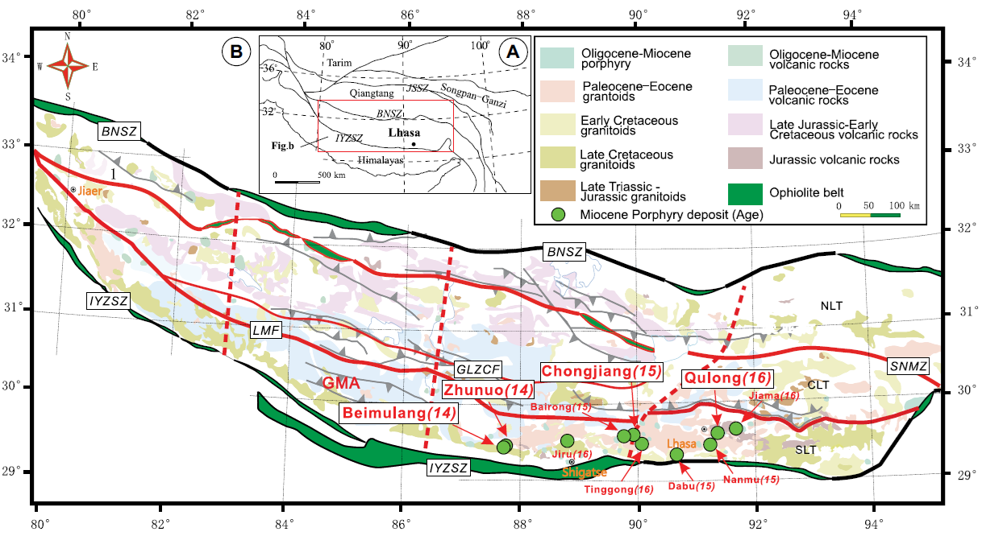
Figure 1. (A) Simplified structure of the Tibetan plateau (Zhu et al., 2011); (B) distribution of granitoids, tectonic framework, and porphyry copper deposits of the Lhasa terrane (modified after Hou et al., 2015a). IYZSZ—Indus–Yarlung Zangbo suture zone; BNSZ—Bangong-Nujiang suture zone; JSSZ—Jinsha suture zone; GLZCF—Gar–Lunggar–Zhari Nam Tso–Comai fault; LMF—Luobadui-Milashan fault; SNMZ—Shiquanhe–Nam Tso mélange zone; SLT—southern Lhasa terrane; CLT—central Lhasa terrane; NLT—northern Lhasa terrane; GMA—Gangdese magmatic arc.
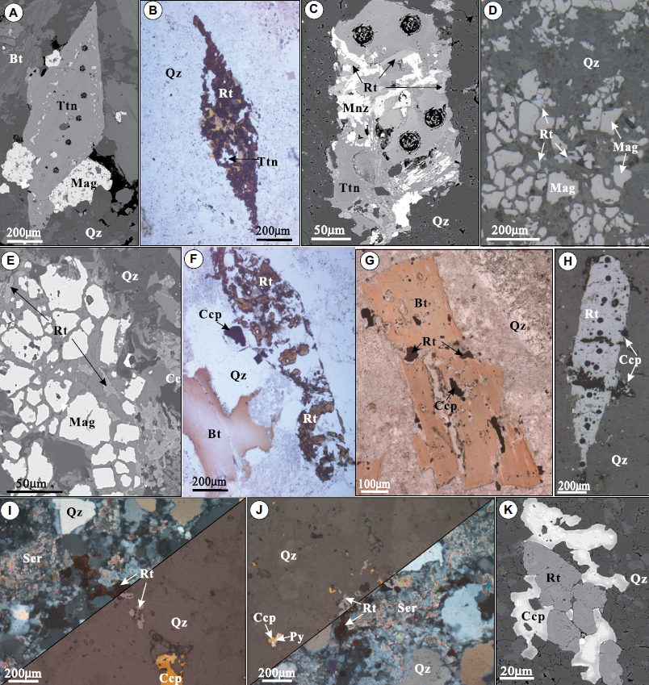
Figure 2. Photomicrographs of rutile and its mineral assemblages from the Qulong, Chongjiang, Zhunuo, and Beimulang deposits of the Gangdese belt in the southern Lhasa subterrane. (A) Diamond-shaped titanite (Ttn) intergrowth with magnetite (Mag); (B) diamond-shaped rutile (Rt)-pseudomorph replacing previous titanite; (C) rutile and monazite (Mnz) replacing previous titanite; (D, E) subhedral rutile associated with magnetite and quartz (Qz); (F, G) subhedral rutile grains are hosted by quartz and completely or partially replace previous magmatic biotite (Bt); (H) quartz vein exhibiting euhedral rutile crystal; (I, J) rutile associated with sericite (Ser), quartz, and chalcopyrite (Ccp) in phyllic alteration; (K) euhedral rutile intergrowth with chalcopyrite. Py—pyrite.

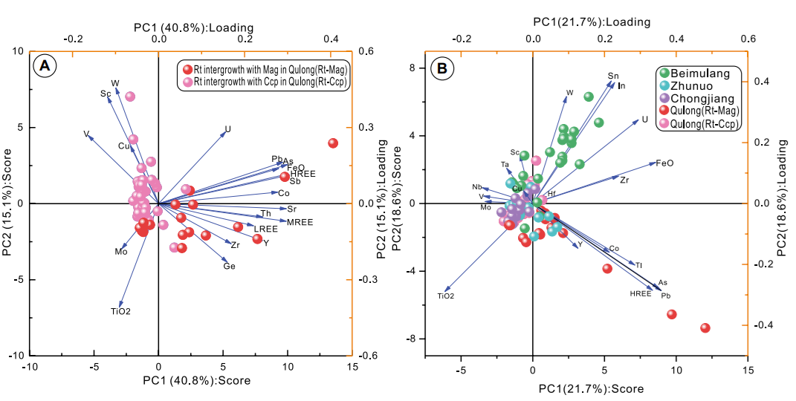
Figure 3. (A) Principal component (PC) score and loading plots for Qulong deposit rutile associated with magnetite (Rt-Mag) in the early potassic alteration stage and Qulong deposit rutile associated with chalcopyrite (Rt-Ccp) in the later phyllic alteration stage. (B) PC score and loading plots for rutile in the ore-forming porphyries of the Beimulang, Zhunuo, Chongjiang, and Qulong deposits.

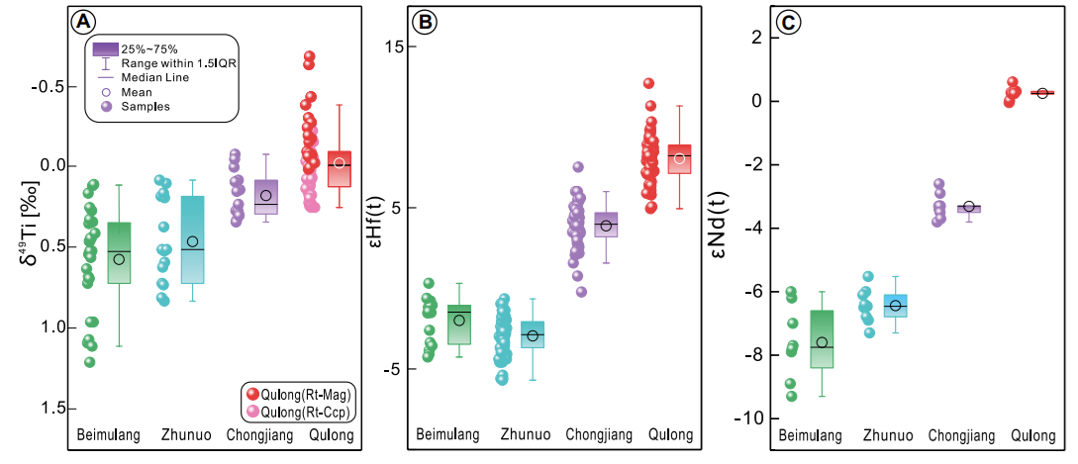
Figure 4. Plot of variations in (A) δ⁴⁹Ti isotope, (B) ε_{Hf}(t) isotope, and (C) ε_{Nd}(t) isotope compositions from the Qulong, Chongjiang, Zhunuo, and Beimulang deposits. Hf isotope and Nd isotope data are from Liu et al. (2022), Hu et al. (2015b, 2017), Sun et al. (2018), Zeng et al. (2017), and Huang et al. (2017). Rt-Mag—rutile associated with magnetite; Rt-Ccp—rutile associated with chalcopyrite.

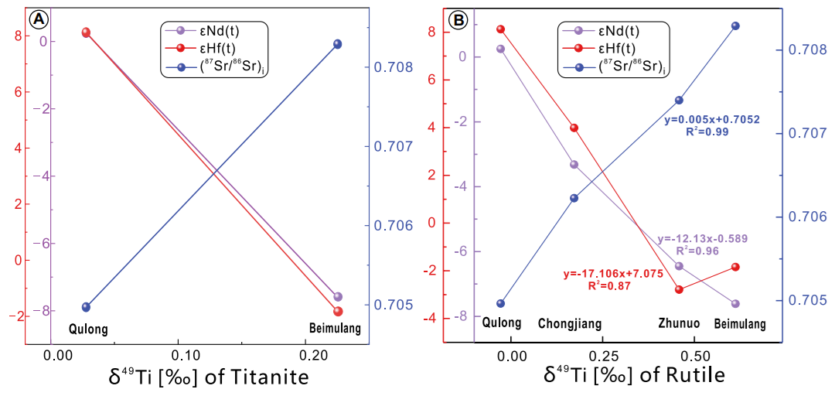
Figure 5. Correlation diagrams of Nd, Hf, and Sr isotope data versus δ⁴⁹Ti for (A) titanite and (B) rutile. Hf isotope, Sr isotope, and Nd isotope data are from Liu et al. (2022), Hu et al. (2015b, 2017), Sun et al. (2018), Zeng et al. (2017), and Huang et al. (2017).

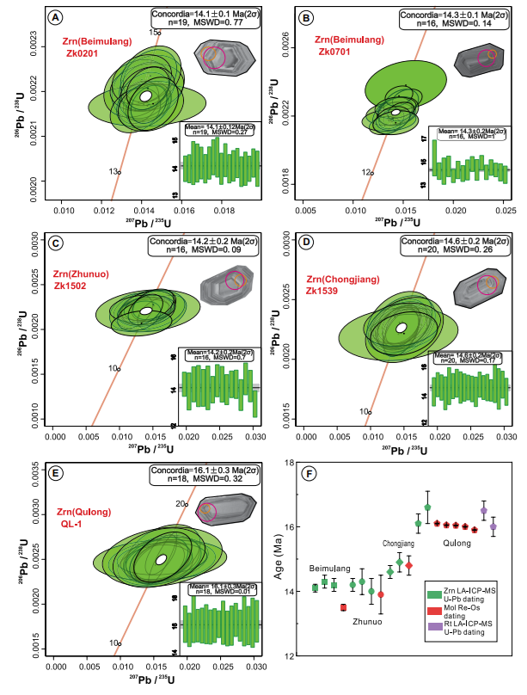
Figure 6. Cathodoluminescence images and U-Pb concordia diagrams of zircons from the (A, B) Beimulang (samples ZK0201 and ZK0701), (C) Zhunuo, (D) Chongjiang, and (E) Qulong deposits. (F) Box plot of age from zircon (Zrn), molybdenite (Mol), and rutile (Rt) in the four principal component analysis diagrams. U-Pb ages of zircon and rutile are from Liu et al. (2022), Sun et al. (2018), Hu et al. (2015a, 2015b, 2017), and Lin et al. (2024). Re-Os dating of molybdenite ages are from Liu et al. (2022), Zheng et al. (2004), and Li et al. (2017). Error ellipses represent 2σ. MSWD—mean square of weighted deviates.
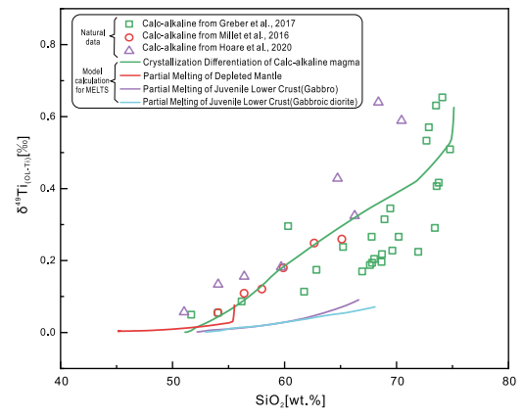
Figure 7. Titanium isotopic evolution of melt during magmatic differentiation of calc-alkaline magma (green line), partial melting of depleted mantle (red line), and juvenile lower crust (gabbro: purple line; gabbroic diorite: cyan line) as modeled by relevant mineral-melt Ti isotope fractionation factors and force constant of the Ti bonds in the mineral. Starting compositions are primitive calc-alkaline, juvenile lower crust, and depleted mantle from Johnson et al. (2019), Zhang et al. (2014), and Workman and Hart (2005), respectively. Ti isotope data from the existing literature are plotted for comparison. Diverse calc-alkaline rock data represented by green squares, red circles, and purple triangles are from Greber et al. (2017), Millet et al. (2016), and Hoare et al. (2020), respectively.

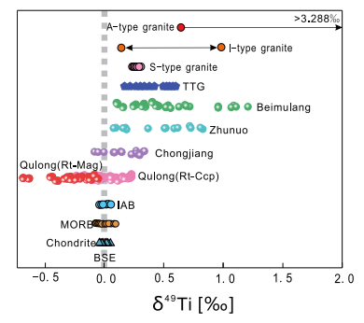
Figure 8. Comparison of δ⁴⁹Ti isotopic compositions of bulk silicate earth (BSE), igneous rocks, chondrites, and rutile from ore-forming porphyries of the Gangdese belt. BSE and island-arc basalt (IAB) data are from Millet et al. (2016), Hoare et al. (2020), and Deng et al. (2023); chondrite data are from Greber et al. (2017), Deng et al. (2023), and Anguelova et al. (2024); mid-oceanicridge basalt (MORB) data are from Deng et al. (2019), Millet et al. (2016), Hoare et al. (2020), and Zhao et al. (2020); A-type, I-type, and S-type granite data are from Greber et al. (2017); tonalite-trondhjemite-granodiorite (TTG) data are from Greber et al. (2017), Aarons et al. (2020), Zhang et al. (2023), and Hoare et al. (2023). Rt-Mag—rutile associated with magnetite; Rt-Ccp—rutile associated with chalcopyrite.

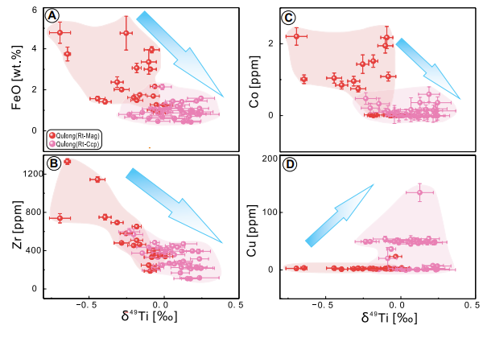
Figure 9. Plots of δ⁴⁹Ti isotope versus (A) FeO, (B) Zr, (C) Co, and (D) Cu for the rutiles formed in the potassic and phyllic alteration stages in the Qulong deposit. Rt-Mag—rutile associated with magnetite; Rt-Ccp—rutile associated with chalcopyrite.

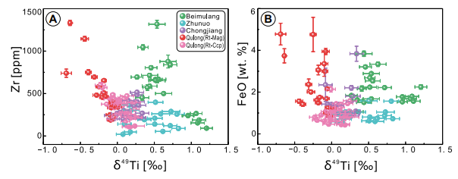
Figure 10. Zr versus δ⁴⁹Ti and FeO versus δ⁴⁹Ti binary plots of rutiles in the Beimulang, Zhunuo, Chongjiang, and Qulong deposits. Rt-Mag—rutile associated with magnetite; Rt-Ccp—rutile associated with chalcopyrite.

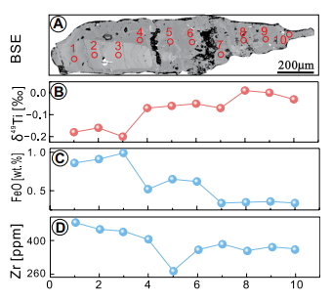
Figure 11. (A) Backscattered electron (BSE) image of a coarse-grained rutile from the Qulong deposit, with corresponding profiles of (B) δ⁴⁹Ti, (C) FeO, and (D) Zr.

