Can Cryptocurrency or Gold Rescue BRICS Stocks Amid the Russia-Ukraine Conflict?

Abstract
This study examines whether cryptocurrency markets offer more resilient safe haven properties than gold for stock markets in the BRICS economies from 28th April 2013 to 27th September 2024. Unlike traditional studies that primarily focus on Bitcoin or top-market cap cryptocurrencies, we introduce a novel Crypto index that includes 9,468 active and defunct cryptocurrencies, providing a comprehensive view of daily market fluctuations across all listed crypto assets. We also investigate the impact of the Russia-Ukraine military conflict on the safe haven status of these assets. Using a time-varying robust Granger causality framework, we analyse the dynamic relationships between potential safe haven assets and BRICS stocks. Additionally, we explore the network structure of gold, cryptocurrencies, and BRICS stocks across different quantiles. Our results show limited evidence of time-invariant causality, but strong evidence of time-varying causality, suggesting that neither gold nor cryptocurrencies act as safe havens for BRICS stocks over the entire sample period. We find increased market interconnectedness during extreme conditions, with gold and cryptocurrencies initially acting as net receivers of shocks, but gold shifting to a net transmitter during the conflict, indicating stronger safe haven properties for gold. Portfolios favour gold over crypto, and small-cap cryptocurrencies are cheaper but less efficient hedges compared to large-cap cryptos, with Bitcoin emerging as the optimal investment for returns. These findings offer valuable insights for investors and policymakers, particularly for optimizing portfolio management and supporting financial stability during market turbulence.

Keywords: Crypto Index; Safe haven assets; BRICS; Time-varying causality; 2022 Russia-Ukraine conflict
JEL: C32; G15; Q02

1.Introduction
Gold has long been considered a safe haven asset during times of market turmoil (see, Baur and Lucey, 2010; Baur and McDermott, 2010; Hood and Malik, 2013; Bekiros et al., 2017; He et al., 2018; Ren et al., 2022; Ming et al., 2023). In fact, recently, there has been a growing interest in the role of traditional safe haven assets for risk management, particularly due to the outbreak of the COVID-19 pandemic and the subsequent 2022 Russia-Ukraine and 2023 Israel–Hamas military conflicts (see, Ji et al., 2020; Salisu et al., 2021; Wen et al., 2022; Karamti and Jeribi, 2023; Qin et al., 2023; Gunay et al., 2024; Khan et al., 2024). However, several studies have shown that gold can serve as a safe haven asset in certain situations, but not in all (see, Akhtaruzzaman et al., 2021; Wang and Lee, 2022; Enilov et al., 2023; Ustaoglu, 2023). In particular, there has been growing interest in alternative assets with similar safe-haven properties to gold, particularly digital currencies (see, Urquhart and Zhang, 2019; Conlon et al., 2020; Li and Miu, 2023; Xu and Kinkyo, 2023; Liu and Yuan, 2024). As a prominent component of digital assets, cryptocurrency has significantly impacted the traditional financial system, emerging as a distinct and vital asset class (Liu and Yuan, 2024). Thanks to its decentralized nature and the underlying blockchain technology, cryptocurrencies offer the potential to hedge against economic uncertainty and inflation (Conlon et al., 2024), while also providing investors with opportunities for diversification (Duan et al., 2023). As a result, investors may lose faith in traditional assets, such as gold, and shift toward cryptocurrencies during periods of financial instability. Consequently, this paper addresses the following question: Can cryptocurrencies or gold act as a safe haven for BRICS stocks during the 2022 Russia-Ukraine military conflict?
Undoubtedly, numerous studies in the existing literature have explored the potential of cryptocurrencies as safe-haven assets. Unlike conventional studies that primarily focus on Bitcoin (see, Urquhart and Zhang, 2019; Wen et al., 2022; Huang et al., 2023; Xu, and Kinkyo, 2023; Liu and Yuan, 2024) or other top market-cap crypto assets (see, Katsiampa et al., 2022; Ren and Lucey, 2022; Rubbaniy et al., 2024; Ali et al., 2025), our research is one of the few to consider the cryptocurrency market as a whole by constructing a novel Crypto index, including 9,468 active and defunct cryptocurrencies, that reflects the daily market fluctuations of all listed crypto assets. This approach enables our study to provide generalized evidence, rather than being asset-specific (see, Enilov and Mishra, 2023, for a discussion). Furthermore, we disaggregate the Crypto index into sub-indexes representing small-cap and large-cap cryptocurrencies. In line with conventional finance theories, small-cap stocks tend to exhibit higher systematic risk compared to large-cap stocks (Bauman et al., 1998), making them more volatile but potentially more rewarding during market upturns (Eun et al., 2008). Our study aims to provide novel evidence on whether conventional finance theories, which are primarily based on centralized markets like stocks, also apply to decentralized markets such as digital currencies.
In order to deepen our understanding of the safe haven characteristics of both cryptocurrency and gold, we examine the influence of the Russia-Ukraine military conflict on the safe haven status of these assets for leading emerging markets. Specifically, our study focuses on the stock markets of BRICS countries (Brazil, Russia, India, China, and South Africa), as some are directly involved in the conflict, while others are influenced indirectly. Gökgöz et al. (2024) discover that the economic sanctions imposed on Russia as a result of the Russia-Ukraine conflict have significantly impacted the Russian stock market, and this effect has spread to other BRICS stock markets (Ahmed et al., 2023). Chinese stock market has shown some resilience, with investors turning to Chinese assets as a safe haven (Zhou and Lu, 2023) but has been indirectly affected by fluctuations in energy and commodity prices (Zhang and Sun, 2023; Lin and Wang, 2024). Bhattacharjee et al. (2024) identify that the Indian stock market experienced initial volatility due to the conflict onset but has gradually recovered, supported by strong domestic fundamentals. Cui et al. (2024) find that, alongside Indian stocks, both the Brazilian and South African markets act as net transmitters of spillovers. Lawrence et al. (2024) confirm that while the South African stock market is relatively insulated from the direct impact of the military conflict, it has been affected by changes in international capital flows and the global economic slowdown. Given that the BRICS countries represent a significant portion of the global economy, examining the effects of the Russia-Ukraine military conflict on their stock markets is key for assessing broader global financial stability, which is the central focus of this study.
Our study contributes to the existing literature in the following ways. First, past studies in the safe-haven literature that examine cryptocurrencies' relationship with stocks typically focus on a single cryptocurrency, such as Bitcoin, or a small selection of top-market-cap assets. This approach provides asset-specific insights but lacks broader, generalized evidence. Our study addresses this gap by constructing an innovative crypto index that includes 9,468 active and defunct cryptocurrencies, capturing the daily market fluctuations of all listed crypto assets. Second, our study contributes to the military finance literature by examining whether the Russia-Ukraine military conflict has affected the safe-haven properties of cryptocurrencies for stocks, and comparing these properties with those of gold to assess whether gold has lost its long-standing position as the leading safe haven during periods of economic instability. Third, most of these studies have primarily focused on major developed economies rather than emerging markets, such as BRICS. In fact, BRICS countries together account for more than 40% of the global population and a significant portion of the world’s GDP. As such, any shifts in their economic path have major implications for trade, investment, and geopolitics, making it crucial for policymakers and investors to understand the factors influencing their development (Yu et al., 2024). Therefore, our study offers new evidence on the impact of the Russia-Ukraine conflict on the leading emerging economies within the BRICS group, where some are directly involved in the conflict, such as Russia, while others are affected indirectly. Last but not least, the past studies in the literature discover that the relationship between stocks and potential safe haven assets may vary over time (Wen et al., 2022; Zhao and Zhang, 2023; Liu and Yuan, 2024) and often changes its strength during extreme market events (Corbet et al., 2020; Billah et al., 2022; Kayani et al., 2024). To capture these dynamics in the relationships among gold, cryptocurrencies, and BRICS stock markets, we employ quantile-connectedness and time-varying parameter robust Granger causality (TVP-GC) methods. These approaches help us identifying the periods when gold and cryptocurrencies act as safe havens for BRICS stocks, such as when reduced connectivity or no causality from the BRICS markets to the potential safe haven asset is observed. Additionally, the time-varying causality approach allows determining the persistence of the two assets in their role of safe havens, how this role varies across different BRICS markets and the impact of the military conflict on it.
To further support our findings, we examine potential variations in the safe haven properties of cryptocurrency markets based on crypto asset capitalizations, specifically focusing on small-cap and large-cap cryptocurrencies. Our research seeks to offer new insights into whether traditional finance theories, which are mainly based on centralized markets like stocks, also hold true for decentralized markets such as digital currencies.
Our paper contributes to the existing literature on the safe haven behaviour of gold and cryptocurrency markets, as a whole, during periods of conflict-driven economic uncertainty. This is crucial for investors, portfolio managers, and financial advisors looking to hedge risks during market turmoil, as well as for policymakers striving to reduce the adverse effects of such events on the economy, particularly in large emerging markets.
The remainder of the paper is organized as follows. Section 2 introduces the research methodology and outlines the construction of the Crypto index. Section 3 describes the data and conducts a preliminary analysis. Section 4 discusses the empirical results. Section 5 provides robustness check. Section 6 concludes the paper.

2. Methodology
2.1. Quantile connectedness
This study adopts the quantile connectedness approach of Ando et al. (2022) to estimate the return spillovers between stocks, gold and cryptocurrency markets across different quantiles. This method extends Diebold and Yilmaz (2012, 2014), by integrating the quantile regression technique of Koenker and Xiao (2006), enabling us to capture connectedness dynamics under both normal and extreme market conditions. In fact, past studies determine an increased dependence between BRICS stocks with gold (see, Patra and Panda, 2021; Chen et al., 2022; Abid et al., 2023) and cryptocurrencies (Shahzad et al., 2022; BenSaïda, A., 2023; Khalfaoui et al., 2023a; Ali et al., 2024; Xie and Cao, 2024) during extreme market conditions. Given that our sample period includes several high-uncertainty events impacting the leading emerging markets, such as the COVID-19 pandemic, the 2023 Israeli-Hamas conflict, and the 2024 China stock market crash, along with the advantages of Ando et al.'s (2022) approach over traditional mean-based connectedness methods, our study follows previous research in adopting this approach to examine directional spillover effects between BRICS stocks, gold, and cryptocurrencies (see Yousaf et al., 2022; Khalfaoui et al., 2023b; Pham et al., 2024).
Therefore, the infinite order-based vector moving average specifications of quantile vector autoregressive $QVAR(τ,p)$ model, with $τ$ being the quantile, $τ∈\left[0,1\right]$, and $p$ is the autoregressive order, is defined as:
$Y_{τ}=μ_{τ}+\sum_{j=1}^{p}{Ψ_{j,τ}}Y_{t-j}+u_{t,τ}=η_{τ}+\sum_{i=0}^{∞}{Ω_{i,τ}}u_{t-i,τ}$ (1)
where $Y_{τ}$ is $m$-dimensional vector of dependent variables, $η_{τ}$ and $μ_{τ}$ are $m×1$vectors of intercepts, $t$ denotes time, $Ψ_{j,τ}$ and$Ω_{i,τ}$ are both $m×m$ matrixes of lag coefficients, $u_{t,τ}$ is a $m×1$ vector of error disturbances. Moreover, we address the issue of Cholesky-factor ordering, where the sequence of variables in the decomposition can influence the results, by following the findings and observations of Koop et al. (1996) and Pesaran and Shin (1998). In particular, the $F$-step ahead generalized forecast error variance decomposition (GFEVD) shows how a shock to variable $j$ impacts variable $i$, and is defined as:
$Θ_{i←j,τ}^{g}\left(F\right)=\frac{∑{\left(τ\right)}_{jj}^{-1}\sum_{f=0}^{F-1}{{\left(e_{i}^{'}Ω_{h,τ}∑\left(τ\right)e_{j}\right)}^{2}}}{\sum_{f=0}^{F-1}{\left(e_{i}^{'}Ω_{h,τ}∑\left(τ\right){Ω_{h,τ}}^{'}e_{i}\right)}}$ (2)
where $e_{i}$ is a zero vector with unity on the $i$-th position, and ${\tilde{Θ}}_{i←j}^{g}\left(F\right)$ normalizes the unscaled GFEVD as:
${\tilde{Θ}}_{i←j,τ}^{g}\left(F\right)=\frac{Θ_{i←j,τ}^{g}\left(F\right)}{\sum_{j=1}^{m}{Θ_{i←j,τ}^{g}}\left(F\right)}$ (3)
where ${\tilde{Θ}}_{i←j}^{g}\left(F\right)$ is the pairwise directional connectedness from variable $j$ to variable $i$, $\sum_{j=1}^{m}{{\tilde{Θ}}_{i←j,τ}^{g}}\left(F\right)=1$and$\sum_{i,j=1}^{m}{{\tilde{Θ}}_{i←j,τ}^{g}}\left(F\right)=m$.
Subsequently, we derive the following four connectedness measures for each quantile, τ:
$TO_{•←i,τ}\left(F\right)=\sum_{j=1,i≠j}^{m}{{\tilde{Θ}}_{j←i,τ}^{g}}\left(F\right)$ (4)
$FROM_{•→i,τ}\left(F\right)=\sum_{j=1,i≠j}^{m}{{\tilde{Θ}}_{i←j,τ}^{g}}\left(F\right)$ (5)
$NET_{i,τ}\left(F\right)=TO_{•←i,τ}\left(F\right)-FROM_{•→i,τ}\left(F\right)$ (6)
$TCI_{τ}\left(F\right)=\frac{\sum_{i,j=1,i≠j}^{m}{{\tilde{Θ}}_{i←j,τ}^{g}}\left(F\right)}{m-1}$ (7)
$TO_{•←i,τ}$ represents the influence of variable $j$ on variable $i$ at quantile $τ$. $FROM_{•→i,τ}$ indicates the effect of $i$ on $j$ at quantile $τ$. $NET_{i,τ}$ reflects the difference between $TO_{•←i,τ}$ and $FROM_{•→i,τ}$, where a negative (positive) value indicates that $i$ is the net recipient (transmitter) of the spillover. $TCI_{τ}$ captures the overall average level of connectedness.
The connectedness measures employ a lag length of 1 based on the Bayesian Information Criterion (BIC) and a forecast horizon of one day. To accommodate potential time variability, a rolling-window technique with a window size of 40 is adopted (see, Zhou et al., 2024).
2.2. Time-varying robust Granger causality approach
To determine the existence of causal relationship from gold and cryptocurrency markets to BRICS stocks, we apply the time-varying parameter robust Granger causality method (TVP-GC) proposed by Rossi and Wang (2019). This method offers a key advantage over traditional Granger causality tests by accounting for instabilities (Balcilar et al., 2022). In fact, the past literature on the topic determines a time-varying relations between BRICS stock markets, gold and cryptocurrencies (Kang et al., 2016; Raza et al., 2016: Mensi et al., 2018; Dahir et al., 2020; Shahzad et al., 2022; Dash et al., 2024). Considering that our sample includes periods affected by events such as the Syrian civil war, the 2014-15 Petrobras collapse, the COVID-19 pandemic and the 2022 Russia-Ukraine military conflict, which have caused instability in stock markets, the TVP-GC method allows us to more precisely capture any existing time-varying causal relationships among BRICS stocks, gold and cryptocurrencies. Therefore, we specify the following TVP-VAR model:
$Y_{t}=θ_{1,t}Y_{t-1}+θ_{2,t}Y_{t-2}+…+θ_{p,t}Y_{t-p}+ϵ_{t}$ (8)
where $Y_{t}=[y_{1,t},y_{2,t}…,y_{m,t}]'$ is a $m×1$ vector, $θ_{j,t}$ are functions of time-varying coefficient matrixes, where $j=1,2,…p$ for lag length $p$, and $ϵ_{t}$ are heteroscedastic and serially correlated idiosyncratic shocks. The null hypothesis is that Gold/Crypto (Stocks) does not Granger cause Stocks (Gold/Crypto), i.e., $H_{0}:Θ_{t}=0$, for $∀t=1,2,…T$, where $Θ_{t}⊂(θ_{1,t},θ_{2,t},…,θ_{p,t})$, against its corresponding alternative. In line with Rossi (2005), we employ the mean Wald (MeanW), Nyblom (Nyblom), and Quandt Likelihood Ratio (SupLR) test statistics to confirm the outcome of the null hypothesis. As rule of thumb, if at least two of the three test statistics either reject or fail to reject the null hypothesis, we conclude whether causality exists or not, respectively. The BIC is used to select the lag length for the TVP-VAR model and a standard trimming parameter of 0.10 is applied (see, Akyildirim et al., 2022).
2.3. Portfolio strategies and hedging effectiveness
By constructing optimal hedge ratios and portfolio weights, we extend our empirical findings and assess the hedging costs and portfolio diversification properties of gold and cryptocurrencies for BRICS stocks. The hedge ratios determine the cost of hedging a $1 long position in variable $i$ with a $β_{ijt}$ $1 short position in variable $j$. For this purpose, we apply the method of Kroner and Sultan (1993) to calculate the hedge ratio:
$β_{ij,t}=\frac{h_{ij,t}}{h_{jj,t}}$ (9)
where $h_{ij,t}$ denotes the conditional covariance between variables $i$ and $j$, while $h_{jj,t}$ is the conditional variance of asset $j$. This indicates that greater conditional variance reduces the hedging costs for long positions, whereas higher conditional covariance increases these hedging costs.
Next, we follow Kroner and Ng (1998) to construct the optimal bilateral portfolio weights between variables i and j. The optimal bilateral portfolio weights are calculated as:
$ω_{ij,t}=\frac{h_{jj,t}-h_{ij,t}}{h_{ii,t}-2h_{ij,t}+h_{jj,t}}$ (10)
This calculation, however, permits weights to be greater than one or less than zero (Antonakakis et al., 2020). As we are focusing solely on long positions, we apply constraints to the weights, ensuring they remain within the range of $[0,1]$.
$ω_{ij,t}=\left\{\begin{aligned}0 \\ ω_{ij,t} \\ 1\end{aligned} \begin{matrix}if ω_{ij,t}<0 \\ if 0≤ω_{ij,t}≤1 \\ if ω_{ij,t}>1\end{matrix} \right.$ (11)
where $ω_{ij,t}$is the weight of variable i in a 1 USD portfolio of two variables i and j at time t. Analogously, the weight regarding variable j in the same portfolio is $ω_{ji,t}=1-ω_{ij,t}$.
Last but not least, it is crucial to assess the effectiveness of the hedging and portfolio strategies. This is achieved by calculating the hedging effectiveness (HE) as outlined by Ederington (1979), which can be expressed as:
$ν_{β}=y_{i,t}-β_{ij,t}y_{j,t}$ (12)
$ν_{ω}=w_{ij,t}y_{i,t}-(1-ω_{ij,t})y_{j,t}$ (13)
$HE_{i}=1-\frac{Var(ν_{β,ω})}{Var(ν_{unhedged})}$ (14)
where $Var(ν_{unhedged}$​) denotes the variance of unhedged position between variables $i$ and $j$, $Var(ν_{β,ω})$ is the variance of a portfolio that has been hedged using either the optimal dynamic hedge ratio or the optimal dynamic portfolio weight approach. Hence, $HE_{i}$ denotes the percentage reduction in the variance of the unhedged position. A higher value of $HE_{i}$ indicates a greater reduction in the portfolio’s risk. Alongside, we also report the significance levels for both the optimal portfolio weight strategy and the hedging strategy.
2.4. Global Cryptocurrency Index (Crypto)
The investigation of hedging and safe haven characteristics of cryptocurrencies is typically linked to top-traded crypto assets such as Bitcoin, Ethereum, and Ripple (see, Katsiampa et al., 2022; Sharma, 2023). However, since the COVID-19 pandemic, cryptocurrencies have not only gained popularity as high-return investments but also as a refuge during periods of market turbulence, such as the subsequent 2022 Russia-Ukraine conflict. This growing interest has led to a rise in the number of new crypto assets, challenging the dominance of established ones. In this study, we focus on a diverse set of 9,468 active and defunct cryptocurrencies to construct a new index (Crypto) that reflects the global cryptocurrency market. Our dataset, which encompasses both active and defunct cryptocurrencies, addresses potential concerns about survivorship bias (Carpenter and Lynch, 1999) arising from sample selection (Gemayel and Preda, 2021). This is particularly relevant in the cryptocurrency market, where the high attrition rate leads to the presence of survivorship and delisting biases (Ammann et al., 2022). Objectively, one of the main driving forces for high delisting rate in the cryptocurrency markets is the regulatory challenges (Fang et al., 2022). In particular, cryptocurrencies often face legal and regulatory uncertainties in many jurisdictions and if a cryptocurrency does not comply with local regulations, it may be delisted by exchanges to avoid legal issues (Cumming et al., 2019). As a result, our study follows Liu et al. (2022) to include both active and defunct cryptocurrencies in our analysis, in particular, in the construction of our Crypto index.
Following Enilov and Mishra (2023), our index relies exclusively on actual numerical data, excluding news-based information that may be influenced by speculation and potentially distort the index patterns. To construct the Global Cryptocurrency Index (Crypto) at day $t$, we apply the following formula:
$Crypto_{t}=\sum_{i=1}^{N}{w_{it}P_{it}}$, where $w_{it}=\frac{MC_{it}}{\sum_{l=1}^{N}{{MC}_{lt}}}$ (15)
where $N$ is the total number of traded cryptocurrencies at day $t$, $P_{it}$ is the closing price of cryptocurrency $i$ at day $t$, $w_{it}$ is the weights share of cryptocurrency $i$ at day $t$, where, $\sum{w_{it}}=1$, $MC_{it}$ is the market capitalization for $i$ at day $t$, $∃i,l$ such that $i≡l$. Hence, the cryptocurrency weight $w_{it}$ is calculated by dividing the market capitalization value of $i$ by total market capitalization value for all $N$ cryptocurrencies at day $t$.

3. Data and preliminary analysis
To examine the hedging and safe haven characteristics of cryptocurrencies and compare them to gold within the context of BRICS stock markets, we use daily closing prices from 28th April 2013 to 27th September 2024. The sample period is determined by the data availability on cryptocurrencies. The study considers the stock market indexes for all BRICS economies: Brazil (Bovespa), Russia (MICEX 10), India (Nifty 50), China (Shanghai SE A Share) and South Africa (FTSE/JSE Top 40). As a proxy for gold price, we use Gold Bullion LBM prices (i.e., Gold Bullion LBM $/t oz). The sample is further divided into pre- and post-conflict announcement periods, based on February 24, 2022, the date marking the start of the Russia-Ukraine military conflict (see, Zhou et al., 2024). Specifically, the pre-conflict period spans from 28th April 2013 to 23rd February 2022, while the conflict period extends from 24th February 2022 to 27th September 2024. The data are obtained from Thomson Reuters Datastream database. All series are calculated as log returns, $Y_{t}$, where $Y_{t}=(ln\left(P_{t}\right)-\ln\left(P_{t-1}\right))×100$, and $P_{t}$ is the closing price at day $t$.
Figure 1 shows the raw stock prices of BRICS markets and the gold series for the full sample period. Evidently the periods of global instability, such as the 2015–2016 stock market selloff, the COVID-19 pandemic and the 2022 Russia-Ukraine military conflict seem to have a significant impact on both BRICS stock markets and gold prices. Most of the BRICS stock markets show significant resilience and recovery following the initial downturn caused by the COVID-19 pandemic, with a noticeable upward trend starting as early as 2020. Specifically, the markets in Brazil, India, and South Africa, in particular, experience strong growth through 2023, reflecting global economic recovery and policy interventions (see, Naeem et al., 2022; Shahzad et al., 2022). In meantime, the Chinese market shows somewhat downward trend in the aftermath of the COVID-19 pandemic period, whereas the Russian market has struggled to recover to its pre-pandemic levels, with recovery still lagging as of early 2024, likely influenced by the onset of 2022 Russia-Ukraine military conflict and the subsequent international sanctions. Actually, the Russia-Ukraine conflict in 2022 is reflected in market volatility, particularly in Russia, which experienced a sharp dip and subsequent recovery in stock prices. Other BRICS markets also show sensitivity to this geopolitical instability, as the conflict has led to economic disruptions and heightened uncertainty across the emerging markets (Karamti and Jeribi, 2023). Nonetheless, gold prices exhibit a steady increase, with noticeable peaks around mid-2015 and 2020, reflecting their safe-haven status during uncertain times (Baur and McDermott, 2010; Mensi et al., 2022; Xu and Kinkyo, 2023). Furthermore, gold experienced a strong upsurge after the onset of the 2022 Russia-Ukraine military conflict, reaffirming its role as a safe-haven asset amid geopolitical-induced risks (see Qin et al., 2023; Biswas et al., 2024). Such evidence provides further support for investigating the safe-haven properties of gold, particularly in relation to BRICS stocks during times of market turbulence.
[Figure 1]
Our cryptocurrency dataset is constructed through a rigorous procedure, outlined as follows (see, Enilov and Mishra, 2023). First, we gather data on 9,581 cryptocurrencies from coinmarketcap.com, a comprehensive publicly available source for price and market capitalization data (see, Momtaz, 2021; Vidal-Tomás, 2022). This platform includes both active and defunct cryptocurrencies, hence, effectively reducing survivorship bias (Huang et al., 2022). Second, we exclude any data points with market capitalization of zero or less, as their inclusion could distort weight calculations in our index. Correspondingly, the price series associated with these excluded market capitalization values for each cryptocurrency asset have also been removed from the dataset. Third, price data with negative or zero values has been excluded, as well, their corresponding market capitalization values. Fourth, stablecoins, as classified by coinmarketcap.com, are removed due to their inherent stability mechanisms (see, Katsiampa et al., 2022; Hui et al., 2025). As a result of this selection process, our sample captures 93% of the total cryptocurrency market capitalization as of 27th September 2024. The final dataset consists of daily closing prices for 9,468 active and defunct cryptocurrencies, which are used in the calculation of the Global Cryptocurrency Index (Crypto). Consistent with the other variables, the Crypto series are calculated as log returns.
Table 1 provides the descriptive statistics for the price returns of stocks, gold and Crypto series before and after the 2022 Russia–Ukraine conflict announcement in Panels A and B, respectively. Focusing on the results from Panel A, Crypto and gold markets provide the highest and lowest average returns, respectively. After the 2022 Russia–Ukraine conflict announcement, Crypto maintains its leading position as provider of the highest average returns, whereas the average returns are negative only for the Chinese market. The latter evidence aligns with the past studies, which show that the Chinese market exhibits downward trends in the post-conflict announcement period (see, Wang et al., 2023). Moreover, gold has the lowest standard deviation of 0.899, whereas the highest standard deviation belongs to Crypto, of 4.753, in the pre-conflict times. After the onset of the conflict, the Crypto remains the most volatile asset across all markets in the sample, with standard deviation of 16.202, whereas the least volatile asset is Indian stocks, with standard deviation of 0.848, followed by gold of 0.868. Overall, the cryptocurrency market is found to be the most volatile market in both sub-periods, whereas gold market provides reasonable returns with lower risk, consistent with Salisu et al. (2021). The skewness is predominantly negative, while the kurtosis is much above three suggesting the existence of non-normality in our data series. Last but not least, the test statistics of the augmented Dickey–Fuller (ADF) (Dickey and Fuller, 1979) and Fourier ADF by Enders and Lee (2012) unit root tests are statistically significant at 1%, indicating stationarity for all series.
[Table 1]
Table 2 presents the correlation coefficients between Crypto, gold and BRICS stocks, reflecting the pre- and post-conflict announcement periods. In the pre-conflict times, it can be noticed that gold serves as hedge for Russia and India stock markets, whereas Crypto acts as hedge for Russian market. In fact, gold is less connected than Crypto for all markets but Chinese one before the onset of the conflict. This finding suggests that gold serves as better hedge than Crypto for all BRICS stocks but Chinese market. It is somewhat contradictory to the findings of Shahzad et al. (2022), who claim that gold have higher and more stable diversification benefits in China than Bitcoin itself. After the conflict announcement, it can be noticed that gold has increased its correlation with the BRICS stocks, showing all positive coefficients, compared to the pre-conflict times. This finding suggests that the conflict potentially weaken the safe haven properties of gold (see, Naeem et al., 2024). Compared to gold, Crypto is found to be less connected with all stock markets but Brazil, implying that cryptocurrency market may serve as a better safe haven than gold in times of geopolitical uncertainty, such as the 2022 Russia-Ukraine military conflict. This finding is somewhat consistent with Rizvi et al. (2022) and Zheng et al. (2023), who suggest that cryptocurrencies have become a preferred choice for investors amid bearish trends, positioning them as safe haven assets.
The correlation results bring important implications for conservative and speculative investors. In fact, cryptocurrencies show slightly higher correlations with most BRICS markets, except Russia, during the conflict times indicating some degree of relationship between crypto assets and these economies, though still weak. These weak correlations suggest that, while not a perfect hedge, cryptocurrencies may be used as a speculative asset to capitalize on price movements independent of traditional markets. For conservative investors, the low correlations suggest that gold will likely remain a preferred asset during times of geopolitical instability, particularly with ongoing tensions involving Russia and China. However, the decentralized nature of cryptocurrencies might be considered a supplementary hedge in the future, though with more caution. On the other hand, speculative investors may find the low correlation between crypto assets and traditional markets appealing, as it presents an opportunity to exploit volatility in different assets during market stress.
[Table 2]
4. Empirical results
4.1. Safe haven characteristics
In order to initially assess the safe haven (post-conflict announcement) and hedging (pre-conflict announcement) properties of cryptocurrencies and gold for BRICS stock returns, we consider the following model:
${BRICS}_{t}=β_{1}+β_{2}{SH}_{t}+u_{t}$, (16)
where ${BRICS}_{t}$ denotes the stock returns at time $t$, i.e., $BRICS_{t}=\{Brazil_{t},Russia_{t},India_{t},China_{t}, South Africa_{t}\}$,${SH}_{t}$ refers to gold and cryptocurrencies returns at time $t$, i.e., ${SH}_{t}=\{Crypto_{t},Gold_{t}\}$, and $u_{t}$ is the error term. In line with previous research, if the estimated parameter $β_{2}$​ in Equation (16) is either insignificant (irrespective of its sign) or significantly positive, the asset can be identified as a safe haven for BRICS stocks (see, Baur and Lucey, 2010; Baur and McDermott, 2010). Conversely, if $β_{2}$​ is significantly negative, the asset does not qualify as a safe haven for BRICS stocks.
Table 3 displays the outcomes from the time-invariant safe haven models of Equation (16), for the pre- and post-conflict announcement periods, respectively, in Panels A and B. In fact, both gold and cryptocurrency markets act as safe haven for BRICS stocks in both sub-periods. In Panel A, our findings show predominantly insignificant $β_{2}$ coefficients, which came out significantly positive only for South Africa. The result is preserved after the start of the conflict, when most estimates retain their insignificance. This finding highlights the role of gold to serve as hedge and safe haven for stocks (Bekiros et al., 2017) but also the uprising importance of cryptocurrency markets in investors’ portfolios (Rizvi et al., 2022). Furthermore, gold emerges as a stronger safe haven after the onset of the conflict for Chinese stocks than it has been before the conflict. In particular, its estimates become four times larger and emerging significant at the 1% level. Similarly, gold (Crypto) reinforces its position as a safe haven asset for stock market in South Africa after the conflict outbreak, having significantly positive coefficients at 1% (5%) significance level. Last but not least, the impact of cryptocurrencies on BRICS stocks has decreased after the post-conflict announcement, becoming closer to negligible compared to the pre-conflict period. In contrast, gold has strengthened its impact on most markets, specifically India, China, and South Africa.
[Table 3]
The model given in Equation (16) does not consider the possibility that the effect of gold or cryptocurrency assets on BRICS stocks may change over time. In fact, numerous studies determine that gold and cryptocurrencies may act as a safe haven in some periods but not others (Hood and Malik, 2013; He et al., 2018; Ming et al., 2023). To address this, we extend Equation (16) into a time-varying model. Specifically, we estimate the following rolling-window regression:
${BRICS}_{t,t+ξ}=β_{1,t+ξ}+β_{2}{SH}_{t,t+ξ}+u_{t,t+ξ}$, (17)
where ${BRICS}_{t,t+ξ}={BRICS}_{t},{BRICS}_{t+1},…,{BRICS}_{t+ξ}$; ${SH}_{t,t+ξ}={SH}_{t},{SH}_{t+1},…,{SH}_{t+ξ}$; $u_{t,t+ξ}=u_{t},u_{t+1},…,u_{t+ξ}$, where $ξ$ is the size of the rolling window. In line with the past studies the size of rolling window is set to 40 (see, Wang et al., 2024).
Table 4 reports the percentage frequency of significant negative $β_{2}$ coefficients from Equation (17). Panel A reveals the percentage frequencies before the conflict, while Panel B provides those frequencies in the post-conflict announcement period. To address the potential impact that the chosen significance level may have on our final conclusions, we evaluate the results at both the 5% and 10% levels of significance. The percentage frequency is calculated as the total number of significant negative coefficients $β_{2}$ is divided by the total number of rolling window tests. In fact, the higher the percentage frequency of negative and significant coefficients, the poorer safe haven the asset is for the given stock market. In particular, the post-conflict impact of gold on Brazilian stocks is 0.036 at the 5% significance level, indicating that gold acts as a safe haven for the Brazilian stock market 96.4% of the time, as shown in Panel B. In general, gold is found to be poorer safe haven for BRICS stocks relative to Crypto before the conflict, as shown in Panel A of Table 4. In fact, the percentage frequencies of gold are higher than those for Crypto not only at the 5%, but also at the 10% significance level, with the exemption of the marginally better performance of gold for Chinese stocks at the 10% level. This finding provides reassurance of the robustness of our results for the lengthier persistency of Crypto to act as hedge for BRICS stocks than gold. Even though Crypto outperforms gold before the conflict, BRICS investors change their behaviour since the conflict started (see, Xu and Kinkyo, 2023). This is seen from the changing relative dynamics of the percentage frequencies in Panel B relative to Panel A of Table 4. After the conflict has started, Crypto outperforms gold in Brazil only, as seen from its smaller percentage frequency at both 5% and 10% significance levels. However, for all other BRICS markets, Crypto shows a larger percentage frequency than gold in the post-conflict announcement period, indicating the diminishing safe haven properties of cryptocurrency market and the resurgence of gold as a safe haven for BRICS investors during the 2022 Russia-Ukraine military conflict.
[Table 4]

4.2. Granger causality test results
This section outlines the outcomes from our Granger causality tests. We begin by applying a standard time-invariant Granger causality test, followed by the time-varying robust Granger causality test proposed by Rossi and Wang (2019) to address parameter instability. Both tests evaluate the null hypothesis of non-causality against the alternative hypothesis of causality, using the BIC for lag selection. Our study assumes that an asset serves as a safe haven if there is no evidence of causality or causality is found only in the case from the potential safe haven asset, either gold or crypto, to the BRICS stocks, but not vice versa. From an investor’s perspective, if causality exists in both directions or if causality is observed from BRICS stocks to the potential safe haven asset, it suggests that the asset is not truly serving as a hedge or safe haven. This would imply that the asset does not effectively protect the investor from market downturns or volatility. In such cases, investors would need to reconsider their strategies as relying on such assets for risk mitigation could expose them to greater market risks rather than providing the expected protection.
Table 5 reports the results from the standard time-invariant Granger causality test for both pre- and post-conflict announcement periods, in Panels A and B, respectively. In particular, Panel A of Table 5 provides significant evidence for bi-directional causality only in the case of Crypto with the stock markets for Brazil and India. Further to that, for the period before the conflict, evidence of uni-directional causality is determined from Brazilian and Chinese stocks to gold, and from South African stocks to Crypto. Thus, the hedging properties of gold are observed only for the Russian, Indian, and South African stocks, while those of cryptocurrencies are seen for the Russian and Chinese markets. For the period after the onset of the conflict, evidence of causality is far weaker, with the significant test statistics emerging only from South African stocks to gold. This evidence implies that both gold and cryptocurrency market improve their safe haven properties for BRICS stocks in periods of high geopolitical uncertainty, such as the 2022 Russia-Ukraine military conflict. As South African stocks have impact on gold in the post-conflict announcement period, we can infer that Crypto’s safe have properties mildly outperform those of gold during the military conflict.
[Table 5]
Table 6 presents the results from time-varying robust Granger causality test of Rossi and Wang (2019). The results are divided into two panels: pre- and post-conflict announcement periods. Here, we use three distinct test statistics to ensure the robustness of our results: Mean Wald (MeanW), Nyblom (Nyblom), and Quandt Likelihood Ratio (SupLR). As a rule of thumb, if at least two out of the three statistics are significant at the 10% significance level, we infer the existence of causality and conclude that the asset does not act as a safe haven (see, Zhou et al., 2024). Consistent with the time-invariant Granger causality tests, our study assumes that an asset serves as a safe haven if there is no evidence of causality, or if causality is found only in the direction from the potential safe haven asset (either gold or crypto) to the BRICS stocks, but not the other way round. Therefore, the following discussion focuses on the causality results from stock returns to the potential safe haven asset. The results in Panel A of Table 6 show causality from the potential safe haven asset to BRICS stocks for all series in the pre-conflict period. In contrast, the post-conflict announcement period is marked by causality for all cases except the Crypto-China pair. These findings are supported by the MeanW, Nyblom, and SupLR statistics at the 10% significance level. As such, our results indicate that cryptocurrencies, represented by Crypto, serve as a safe haven for Chinese stocks during the 2022 Russia-Ukraine military conflict. For the other cases, causality exists at least temporarily, suggesting that there are periods when these assets do not serve as safe havens for BRICS stocks. This finding adds to study of Li and Miu (2023) who determine that cryptocurrency is far from a safe haven asset considering the four most liquid cryptocurrencies – Bitcoin, Dash, Litecoin, and Ripple.
In summary, the results from the time-invariant Granger causality tests in Table 5 indicate increased evidence of safe haven properties during the conflict period. Specifically, cryptocurrencies are found to serve as a safe haven for all stock markets, while gold serves as a safe haven for all markets except South Africa. In contrast, the results from the time-varying causality tests, presented in Table 6, reveal substantial evidence of temporal dependence between the BRICS stocks and potential safe haven assets during the conflict period. In fact, the China-Crypto pair is the only case where safe haven status is confirmed by at least two of the three statistics, suggesting that conservative investors may disproportionately benefit from considering cryptocurrencies as a safe haven for Chinese stocks in times of crisis. Furthermore, our results highlight the advantage of the time-varying causality tests, which are capable of uncovering temporal causality in places where the standard time-invariant tests fail.
[Table 6]
4.3. Time-varying causal graphical inferences
In this section, we determine the specific periods during which a causal relationship exists between BRICS stocks and the potential safe haven asset. In line with the Granger causality tests, our study defines an asset as not being a safe haven if evidence of causality exists from the BRICS stocks to the potential safe haven asset (either gold or crypto). Consequently, the presented results, in Figures 2 and 3, are for null hypothesis of that BRICS stock returns do not Granger cause the potential safe haven asset, i.e., gold or Crypto. As such, the exact periods when cryptocurrencies and gold serve as a safe haven for BRICS stocks are determined from the outcomes of TVP-GC tests by Rossi and Wang (2019).
Figure 2 presents the time-varying Wald test statistics for the period before the 2022 Russia-Ukraine conflict, highlighting significant differences in the safe haven properties of gold and Crypto across the BRICS stock markets. Our findings indicate that neither gold nor Crypto acts as a persistent safe haven for any of the stock markets. In fact, gold predominantly acts as a safe haven for Russia and South Africa markets in the period of around 2015 up to the outbreak of the COVID-19 pandemic. Interestingly, gold has lost its safe haven properties for the two stock markets during the COVID-19 pandemic. This finding is consistent with Bentes (2023) who finds that the safe haven property of gold vanishes during the COVID-19 pandemic. Nonetheless, gold can be seen as a safe haven for the Indian market in 2015 and shortly after the outbreak of the COVID-19 pandemic, suggesting its significant role for investors in this market as a safe haven during periods of turbulence. Similarly, gold has been barely found as a safe haven in the cases of Brazilian and Chinese markets. Focusing on cryptocurrencies, they are not found to serve as safe haven for any of the periods for Brazil, whereas cryptocurrencies are seen as safe haven during majority of the time for the Chinese stocks. Similarly, gold has rarely been found to act as a safe haven for the Brazilian and Chinese markets. Regarding cryptocurrencies, they are not found to serve as a safe haven for Brazil, whereas cryptocurrencies are seen as a safe haven for the Chinese stocks for the majority of the time. This finding adds to the previous studies of Conlon et al. (2020) and Ji et al. (2020) who discover that Bitcoin may only act as weak safe haven, if at all. In similar manner, crypto is not found to act as safe haven for Indian and South African stock markets at any point of time before the conflict. Regardless of this, our results show that cryptocurrencies serve as a safe haven for Russian stocks after the 2014 Commodity Crash, with its effect fading in 2017 and reappearing when the COVID-19 pandemic began. This suggests that cryptocurrencies may act as a safe haven against adverse stock movements in the Russian market during health pandemics, particularly at times when gold does not serve as a safe haven, as shown in the graph. Overall, our findings determine that the hedge and safe haven behaviour of gold and cryptocurrencies varies across BRICS stocks. Therefore, policymakers may consider implementing country-specific policies to protect and promote financial stability, rather than adopting a uniform approach.
[Figure 2]
Figure 3 displays the time-varying Wald test statistics for the post-conflict announcement period, highlighting, on average, a significant weakening of gold's role as a safe haven. In contrast, cryptocurrencies show more frequent periods of acting as a safe haven across the BRICS stock markets compared to the pre-conflict times. In particular, gold has acted frequently as safe haven for South African market at the pre-conflict announcement period, whereas after the conflict onset gold lost its safe-haven property for this market. In contrast, the cryptocurrencies do not serve as safe haven before the conflict for South Africa stocks, whereas they show evidence of such property after its announcement, specifically, from mid-2023 to early 2024. The enhanced role of the Crypto as safe haven after the conflict announcement can also be noticed in other markets, such as Brazil and India. Our findings add to the study of Chibane and Janson (2024) who find that Bitcoin acts as safe haven for US stocks against geopolitical risk but gold does not, that the same is valid for emerging stock markets. For Russian stocks, we observe a weakening of the safe haven properties of both gold and cryptocurrencies during the conflict, compared to the preceding period. Although a similar trend can be observed for Chinese stocks and gold, its cryptocurrency counterpart reinforces its position as a safe haven for the Chinese market throughout the entire period after the conflict announcement, underscoring the implications for conservative investors outlined earlier (see, also, Li et al., 2025). Therefore, investors in Chinese stocks should be aware that the safe haven properties of traditional assets like gold may diminish in times of military conflict, prompting them to adjust their strategies and potentially incorporate alternative assets such as cryptocurrencies. Overall, policymakers might want to advise investors in emerging stocks to include a broader range of assets in their portfolios, especially during times of global uncertainty. Our finding that cryptocurrencies can act as a safe haven during military conflicts could influence recommendations for national investment strategies, ensuring that emerging markets are more resilient to external shocks. They could also affect the way both conservative and speculative investors change their portfolio strategies in response to conflicts.
In a nutshell, the results from the time-varying causal graphical inferences reveal substantial evidence of temporal dependence between the BRICS stocks and potential safe haven assets during the conflict period. The only exception is China, where cryptocurrencies remain a safe haven asset throughout the entire conflict period, unlike gold. Thus, our study concludes that the causal relationship between BRICS stocks and gold/cryptocurrencies is time-varying and differs across BRICS markets. Equally important, we find that during periods of conflict when gold is not a safe haven asset, for markets such as South Africa, cryptocurrencies may fulfil this role, and conversely, when cryptocurrencies are not a safe haven, for markets such as Russia, gold may serve as an alternative hedge.
[Figure 3]
4.4. Dynamic total spillover connectedness
Figure 4 shows the Total Connectedness Index (TCI) across the median ($τ$ = 0.5), left ($τ$ = 0.05), and right ($τ$ = 0.95) tails of the distribution. Panels A and B present the findings from pre- and post-conflict announcement periods, respectively. Our findings determine substantial differences in the connectedness during normal and extreme times. In fact, the TCI is almost tripled, on average, during extreme periods compared to normal times, as shown in Figure 4. This finding suggests higher market interconnectedness during extreme market conditions, which may impact the safe haven properties of assets and create favourable conditions for spillover effects. As markets become more interconnected during periods of geopolitical tension, such as the 2022 Russia-Ukraine military conflict, the ability of individual assets to act as effective hedges may diminish. This requires portfolio managers to actively restructure portfolios to adapt to changing risk dynamics and ensure effective risk management in such turbulent times. Nonetheless, a slight but not substantial decrease in the connectedness between both periods is observed. In general, our findings show a certain level of consistency in the overall connectedness between both periods, while also highlighting asymmetric behaviour in stock market reactions to shocks within the network across different quantiles.
[Figure 4]
4.5. Quantile directional spillover effects and connectedness
Table 7 provides the outcomes from quantile directional spillover analysis across pre- and post-conflict announcement periods. Panel A reports the quantile spillovers at the median quantile ($τ$ = 0.5), Panel B at the lower quantile ($τ$ = 0.05), and Panel C at the upper quantile ($τ$ = 0.95). This approach allows us to detect asymmetries in spillovers and analyse the connectedness between gold, cryptocurrencies and BRICS stocks at the extreme tails of the distribution. In fact, we discover that the pre-conflict TCI at the lower (upper) quantile is 68.25% (68.27%) compared to only 23.72% at the median quantile, indicating that the interdependence within the network of variables is significantly stronger during extreme events. The post-conflict announcement period suggests slightly lower but nonetheless very similar TCI values. Further to that, our results show that the potential safe haven assets, gold and cryptocurrencies, have a higher forecast error variance attributed to internal market shocks compared to stock markets. As a result, gold and cryptocurrencies are less susceptible to external shocks compared to BRICS stocks, maintaining a lower level of connection to the equity markets. Moreover, our analysis discovers that South Africa is the most impacted market within the network. At the extreme lower (upper) quantile, 70.76% (70.07%) of its variance and 70.64% (70.24%) of its variance is driven by interactions within the stock market network in the pre- and post-conflict announcement periods, respectively. Interesting to notice is that the conflict results in generally increased spillovers, particularly within the gold and Crypto markets. Russia and India exhibit larger spillover effects during the 2022 Russia-Ukraine military conflict, whereas Brazil and China spillovers remain largely unaffected. This underscores the heightened safe haven properties of both gold and cryptocurrencies in turbulent times, suggesting that conservative investors may want to reconsider their adversity to the cryptocurrencies.
The results of net shocks transmitters and receivers reveal key differences across pre- and post-conflict announcement periods, as shown in Table 7. Russia, India and South Africa act as net shocks transmitters pre-conflict across all quantiles, spreading shocks to other markets. Although South African stocks remain transmitters of shocks during the conflict, the Russian market become a receiver of shocks regardless the quantile. Unsurprisingly, this finding suggests that the military conflict has a substantial impact on Russian stocks. The conflict triggers rather mixed results for the Indian market, which becomes a net receiver of shocks at the extreme quantiles, while it remains a net transmitter in normal times. Focusing on the results from Brazil, the market acts as a net shocks transmitter across all quantiles but the lower one before the conflict onset. In contrast, the Chinese market acts as net receiver of shocks for all quantiles but the upper one after the onset of the conflict. Last but not least, both gold and cryptocurrencies act as net receivers of shocks in pre-conflict times. This tendency remains unchanged for cryptocurrency market, whereas gold becomes a net transmitter of spillover during the conflict. Such evidence suggests potentially better safe haven properties of gold compared to Crypto. This is somewhat consistent with the findings of Long et al. (2021). In sum, our findings discover differences across quantile directional spillovers and imply that net transmitter like South Africa may play an amplifying role during market stress, increasing systemic risks. On the other hand, net receiver like China can act as buffer, reducing systemic risk but also potentially adding to the uncertainty if the shock propagation is significant. Understanding which markets function as net transmitters or net receivers is essential for effective risk management and the development of favourable trading strategies by portfolio managers. The fact that gold retains its safe haven properties in general, while improving them relative to the cryptocurrencies in turbulent times implies that conservative portfolio managers may still find gold preferrable to crypto.
[Table 7]
Figure 5 visually illustrates the net directional connectedness during the pre- and post-conflict announcement periods, presented in Panel A and B, respectively. The yellow (blue) nodes represent net receivers (transmitters), and the size of nodes refers to the corresponding net estimates. The direction of the arrows indicates the direction of spillovers, while their thickness reflects the intensity of the spillovers. The graphical analysis in Figure 5 allows to observe the changes in the shock transmission in and out of the two potential safe haven asset classes before and after the start of the conflict. Specifically, before the conflict, both Gold and Crypto act as large receivers of shocks, particularly from India, Russia and South Africa. Chinese stocks are also receivers of shocks before the conflict, whereas they show some evidence of net transmitters at the upper quantile after the conflict announcement. Consistent with the past study of Lin and Wang (2024), our findings determine that Russian stocks change their role after the conflict, operating as a growing a net receiver of shocks. This can be seen across all quantiles. In addition, Brazilian stocks are mainly a net receiver of shocks for all quantiles and periods but the median quantile before the conflict. Interestingly, the only spillover between gold and cryptocurrencies across the six cases occurs at the lower quantile during the conflict period, flowing from gold to cryptocurrencies. Both assets are disconnected in all other cases. This finding implies that gold and cryptocurrencies may serve as hedges for each other in certain situations. Lastly, the results from both panels suggest that markets are less connected at the median than at the extreme tails of the distribution, confirming the suitability of the quantile-based methodology. Thus, our graphical analysis reinforces earlier findings about the asymmetric impact of the 2022 Russia-Ukraine conflict on asset returns, not only in agricultural commodity markets (see, Just and Echaust, 2022) but also across equity, gold, and cryptocurrency markets.
[Figure 5]
4.6. Portfolio implications
Table 8 provides the optimal portfolio weights and optimal hedge ratios between the potential safe haven assets (gold and cryptocurrencies) and BRICS stocks for the pre- and post-conflict announcement periods, respectively, in Panels A and B. The pre-conflict optimal portfolio weight of the India/Gold portfolio is 0.456, demonstrating that, for a $10 portfolio, $4.56 should be invested in Indian stocks, while the other $5.44 should be invested in gold. The average pre-conflict portfolio weights, including gold, are all lower than 45.6%, implying that more gold should be included in gold-stocks portfolios. In contrast, the results from crypto portfolios show an average pre-conflict portfolio weights of over 90.8%, indicating that a larger proportion of the portfolio must be invested in stocks for any crypto-stock combination. The results from the post-conflict period are qualitatively consistent. Nonetheless, it is notable that the 2022 Russia-Ukraine conflict led to increased investment in stocks rather than safe haven assets like gold and cryptocurrencies. The only exceptions are South Africa, for gold, and Russia, for both crypto and gold, where higher optimal weights are allocated to safe haven assets than to stocks. This suggests that both gold and crypto enhanced their roles as safe haven assets in countries directly involved in the conflict, such as Russia.
An alternative diversification strategy to optimal portfolio weights is the optimal hedge ratios. The results of the dynamic optimal hedge ratios for two-asset portfolios, consisting of stocks and one of the safe haven assets, gold or crypto, are presented at the right column of Table 8. The optimal hedge ratio evaluates the hedging potential of gold and cryptocurrencies. A value of 1 indicates an effective hedge, while a value of 0 signifies no hedging properties. Our results show that the hedge ratio values are low in general, for both pre- and post-conflict announcement periods. During the pre-conflict period, the hedge ratio values range from -0.029 (India/Gold) to 0.080 (Brazil/Gold). The most costly hedging is found with gold, particularly for Brazil (0.080), followed by South Africa (0.073). This suggests that investment strategies based on cryptocurrencies are generally less expensive. However, the evidence is somewhat mixed. In contrast, cryptocurrencies emerge as the more cost-effective hedge compared to gold for all BRICS stocks after the onset of the conflict.
Regarding hedging effectiveness, our results reveal that strategies involving cryptocurrencies provide higher hedging effectiveness for Brazil and Russia, while gold is a more effective hedge for stocks from India, China, and South Africa in the pre-conflict announcement period. In contrast, after the onset of the military conflict, gold offers higher hedging effectiveness than cryptocurrencies for all stocks. Nonetheless, significance is observed for all cryptocurrency-based hedging strategies, while none of the gold-based strategies are statistically significant. This finding is partially consistent with Xu and Kinkyo (2023), who discover that gold is a better risk hedging instrument than bitcoin for G-7 stocks, and that hedging effects are stronger during the 2022 Russia-Ukraine military conflict. Our results align with the first finding but show that for BRICS stocks, the hedging effects of both gold and cryptocurrencies decline after the onset of the conflict.
[Table 8]

5. Robustness check
Modern Portfolio Theory (MPT) plays a pivotal role in explaining how investors can mitigate risk by diversifying their investment portfolios (Markowitz, 1952). MPT posits that incorporating assets with imperfect correlations, like small-cap and large-cap stocks, can decrease the overall risk of a portfolio. The theory underscores the importance of diversification across different asset classes, such as small and large stocks, in reducing risk. Since the correlation between small-cap and large-cap stocks is typically not perfect, a diversified portfolio can safeguard against market declines while preserving growth prospects in positive market conditions.
Developed by Sharpe (Sharpe, 1964), Lintner (Lintner, 1975), and Mossin (Mossin, 1966), the Capital Asset Pricing Model (CAPM) offers valuable insights into the relationship between risk and expected return for individual securities, considering their systematic risk. In this framework, small-cap stocks often exhibit higher systematic risk compared to large-cap stocks, indicating their greater sensitivity to market fluctuations and higher volatility. This characteristic makes small-cap stocks more risky but also potentially more lucrative during market upturns. To hedge against the higher risk associated with small-cap stocks, investors may incorporate large-cap stocks, which typically have lower systematic risks. By maintaining a balance between these two types of stocks, investors can manage their overall portfolio risk while striving for attractive returns.
To evaluate the validity of conventional finance theories during periods of military-induced market turbulence, we disaggregate the Crypto index into the following sub-indexes: ${Crypto}_{T}^{10}$, ${Crypto}_{T}^{100}$, ${Crypto}_{T}^{500}$, ${Crypto}_{B}^{10}$, ${Crypto}_{B}^{100}$, ${Crypto}_{B}^{500}$. Specifically, the first three sub-indexes represent large-cap crypto assets, including the top 10 (${Crypto}_{T}^{10}$), 100 (${Crypto}_{T}^{100}$) and 500 (${Crypto}_{T}^{500}$) crypto assets, ranked by daily market capitalization, and are constructed in the same manner as the overall Crypto index. In contrast, the latter three sub-indexes correspond to small-cap crypto assets, including the bottom 10 (${Crypto}_{B}^{10}$), 100 (${Crypto}_{B}^{100}$) and 500 (${Crypto}_{B}^{500}$) crypto assets. Additionally, our study includes Bitcoin, as the largest cryptocurrency by market share (see, Harris et al., 2024).
Table 9 presents the optimal portfolio weights between potential safe haven assets (gold and cryptocurrencies) and BRICS stocks for the pre- and post-conflict announcement periods, displayed in Panels A and B, respectively. Focusing on the returnability aspect of the portfolio strategy, the average portfolio weights for gold remain relatively consistent across all crypto sub-indexes for any of the given stocks. However, our results indicate that, on average, optimal portfolio weights for large-cap crypto assets are higher than those for small-cap crypto assets, implying that a larger share should be allocated to large-cap crypto assets rather than their small-cap counterparts. This finding holds for both the pre- and post-conflict announcement periods. Interestingly, our results also suggest that a larger portion of the portfolio should be devoted to Bitcoin rather than any of the large-cap crypto sub-indexes. This implies that investing in Bitcoin is the optimal strategy for achieving portfolio returnability in both pre- and post-conflict announcement periods.
[Table 9]
Table 10 gives the optimal hedge ratios between the potential safe haven assets and BRICS stocks for the pre- and post-conflict announcement periods, respectively, in Panels A and B. Our results suggest that Bitcoin is the most expensive hedge across all crypto combinations, with this outcome holding for both the pre- and post-conflict announcement periods. In fact, the onset of the military conflict increases the cost of hedging with Bitcoin for all BRICS stocks. At a more disaggregated level, our findings indicate that all large-cap crypto assets are more expensive hedges than any of their small-cap counterparts. Specifically, $Crypto_{B}^{10}$ is found to be the cheapest hedge for all stocks except South Africa. An exception to this is the Indian stock market during the conflict period, where both $Crypto_{B}^{100}$ and $Crypto_{B}^{500}$ provide the cheapest hedge. In a nutshell, gold remains a more costly hedging strategy than cryptocurrencies.
[Table 10]
Table 11 presents the hedge effectiveness of the diversification strategies. Our findings confirm conventional finance theories that large-cap crypto assets are more effective hedgers than their small-cap counterparts. However, this effectiveness comes at a higher cost, as shown in Table 10. Further to that, the effectiveness of crypto assets largely declines during the conflict, whereas Bitcoin increases its hedge effectiveness for all BRICS stocks compared to the pre-conflict period. In contrast, gold has enhanced its hedge effectiveness for all BRICS stocks, except Brazil, during the conflict. Overall, the results remain consistent with our main findings.
[Table 11]
6. Conclusion
This paper makes a significant contribution to the literature by investigating whether the safe haven properties of cryptocurrency markets are more resilient than those of gold for stock markets in the leading emerging economies, BRICS, covering the period from 28th April 2013 to 27th September 2024. In order to deepen our understanding of the safe haven characteristics of both cryptocurrency and gold, we also examine the influence of the Russia-Ukraine military conflict on the safe haven status of these assets. To achieve this, we apply a novel time-varying robust Granger causality framework to analyse the dynamic relationship between potential safe haven assets and BRICS stocks. Furthermore, we explore the network structure of gold, cryptocurrencies, and BRICS stocks across different quantile regimes. Additionally, we compute optimal hedge ratios and portfolio weights to assess the hedging costs and diversification potential of gold and cryptocurrencies in relation to BRICS stocks. This study is particularly relevant in the context of global portfolio management and asset reallocation, offering valuable insights for investors navigating markets that experience heightened volatility due to military-induced market turbulence.
Given this framework, our time-invariant results present mixed evidence. Our sample estimates indicate that both gold and cryptocurrencies serve as hedges and safe havens for most BRICS stocks, with the exception of South Africa. Notably, Chinese stocks are shown to rely on gold as a safe haven during the conflict period. Analysing the time-invariant causality results, we find that gold does not act as a safe haven for South Africa, while cryptocurrencies do not serve as safe havens for Brazil and India before the conflict. During the conflict, neither gold nor cryptocurrencies have a significant impact on BRICS stocks, meaning they both act as safe havens.
Expanding our framework to a time-varying setting, we observe heterogeneous findings across different stock markets. Our sample estimates show that cryptocurrencies act as a hedge for BRICS stocks for a longer period than gold. After the 2022 Russia-Ukraine conflict began, cryptocurrencies outperform gold in Brazil, reflecting the diminishing safe haven properties of cryptocurrencies and the resurgence of gold as a safe haven for BRICS investors during the conflict. Similarly, the time-varying causality results show that causality runs from the potential safe haven asset to BRICS stocks for all series in the pre-conflict period. In contrast, the post-conflict announcement period reveals causality for all markets except the Crypto-China pair, suggesting that the cryptocurrency market acts as a safe haven for Chinese stocks during the Russia-Ukraine conflict.
Furthermore, our results from the time-varying causal graphical inferences determine significant differences in the safe haven properties of gold and Crypto across the BRICS stock markets. In particular, our results show a significant weakening of gold’s role as a safe haven during the post-conflict announcement period, while cryptocurrencies exhibit more frequent periods of serving as a safe haven across BRICS stock markets compared to the pre-conflict period. Gold frequently act as a safe haven for the South African market before the conflict but lost this property afterward, whereas cryptocurrencies, which do not serve as a safe haven for South Africa before the conflict, start to exhibit such behaviour after the conflict announcement, particularly from mid-2023 to early 2024. This trend is also evident in markets like Brazil and India, where cryptocurrencies increase their role as safe haven assets. For Russian stocks, both gold and cryptocurrencies weaken as safe havens during the conflict. However, cryptocurrencies maintain their safe haven role for the Chinese market throughout the entire post-conflict period, suggesting that traditional assets like gold may lose their safe haven properties during military conflicts, prompting investors to consider alternatives like cryptocurrencies. These findings highlight the need for policymakers to advise investors in emerging markets to diversify their portfolios, especially during times of global uncertainty.
Exploring the dynamic quantile connectedness, we determine a higher market interconnectedness during extreme market conditions, which may impact the safe haven properties of assets and create favourable conditions for spillover effects. In particular, Russia, India, and South Africa act as net transmitters of shocks before the conflict, with South Africa continuing as a transmitter during the conflict, while Russia becomes a net shocks receiver. India's role is mixed, acting as a net receiver at extreme quantiles and a transmitter under normal conditions. Brazil transmits shocks across most quantiles before the conflict, whereas China becomes a net receiver after the conflict begins. Both gold and cryptocurrencies are net receivers of shocks before the conflict, but gold shifts to a net transmitter during the conflict, suggesting stronger safe haven properties for gold compared to crypto. Overall, our findings highlight the varying roles of markets as net transmitters or receivers of shocks, which is crucial for risk management and portfolio strategies.
Moreover, we find that portfolios including gold tend to favour higher gold allocations, while crypto-based portfolios prioritize stocks. Further to that, on average, portfolios with large-cap crypto have lower optimal portfolio weights assigned to stocks compared to those with small-cap digital assets. As such, hedging BRICS stocks with small-cap crypto assets is less expensive but more inefficient than large-cap cryptos, which confirms that cryptocurrency markets are similar to centralized markets like stocks for which small-cap assets are normally seen as riskier. Interestingly, our results also suggest that a larger portion of the portfolio should be devoted to Bitcoin rather than any of the large-cap crypto sub-indexes. This implies that investing in Bitcoin is the optimal strategy for achieving portfolio returnability in both pre- and post-conflict announcement periods.
Our findings provide valuable insights for both investors and policymakers, particularly in the context of emerging markets during periods of military-induced market turbulence. For investors, the analysis highlights the relative advantages of small-cap versus large-cap cryptocurrencies in portfolio construction and hedging strategies, with small-cap assets offering lower costs and larger allocations, yet large-cap assets like Bitcoin proving more effective for long-term returns. Additionally, the study underscores the role of gold and cryptocurrencies as safe haven assets, revealing shifting patterns in asset allocation during periods of geopolitical instability. For policymakers, these findings emphasize the importance of understanding the evolving dynamics of safe haven assets, particularly in volatile markets, and the need for adaptive strategies to manage risk. By considering these insights, both investors and policymakers can better navigate the uncertainties of emerging market conditions, optimizing portfolio management and developing policies that support financial stability during times of conflict.
Moreover, our results offer several key policy implications, particularly for conservative investment strategies in the context of evolving global dynamics affecting the BRICS economies. Notably, we find that the cryptocurrencies have developed safe-haven properties independently of gold, a finding that is increasingly important as geopolitical instability, such as the ongoing Russia-Ukraine conflict, affects market behaviour. For BRICS countries, this has important implications. First, these nations, particularly Russia, face heightened economic and political risks due to ongoing geopolitical tensions, while China is also exposed to significant risks, especially as a result of the US-China trade war. In this context, the growing role of crypto assets as a potential alternative safe haven becomes increasingly relevant. The decentralized nature of crypto assets offers a unique advantage for investment managers, especially in regions where traditional financial systems may be under strain or where political instability threatens the value of conventional assets. This shift could provide a new avenue for diversifying portfolios and hedging against the risks associated with both regional and global instability through cryptocurrencies.
However, while crypto assets present new hedging opportunities, they are not a one-size-fits-all solution. Our robustness checks show that not all crypto assets are equally effective as hedges for BRICS stocks, with large-cap cryptocurrencies offering more robust protection compared to their small-cap counterparts. Yet, the higher cost of large-cap assets, especially Bitcoin, which our results show to be the most expensive hedge in the entire crypto market, suggests that more speculative investors may find small-cap cryptos a more affordable alternative. Gold, however, retains its status as a reliable safe-haven asset, particularly during extreme market stress, providing reassurance for conservative strategies during periods of significant global instability.
Future research can explore the safe haven properties of cryptocurrency markets in relation to other asset classes, such as fossil fuels, government bonds, or even real estate. Additionally, it can be expanded to include traditional safe haven assets like gold, as well as agricultural commodities, which have also been found by past studies to act as safe havens during times of market turmoil.

References
Ahmed, S., Hasan, M.M. and Kamal, M.R., 2023. Russia–Ukraine crisis: The effects on the European stock market. European Financial Management, 29(4), pp.1078-1118.
Akhtaruzzaman, M., Boubaker, S., Lucey, B.M. and Sensoy, A., 2021. Is gold a hedge or a safe-haven asset in the COVID–19 crisis?. Economic Modelling, 102, p.105588.
Akyildirim, E., Cepni, O., Pham, L. and Uddin, G.S., 2022. How connected is the agricultural commodity market to the news-based investor sentiment?. Energy Economics, 113, p.106174.
Ali, F., Khurram, M.U. and Sensoy, A., 2025. Safe havens for Bitcoin and Ethereum: evidence from high-frequency data. Financial Innovation, 11(1), p.61.
Ali, S., Umar, M., Naveed, M. and Shan, S., 2024. Assessing the impact of renewable energy tokens on BRICS stock markets: a new diversification approach. Energy Economics, 134, p.107523.
Ammann, M., Burdorf, T., Liebi, L. and Stöckl, S., 2022. Survivorship and delisting bias in cryptocurrency markets. Available at SSRN 4287573.

Ando, T., Greenwood-Nimmo, M. and Shin, Y., 2022. Quantile connectedness: modeling tail behavior in the topology of financial networks. Management Science, 68(4), pp.2401-2431.
Antonakakis, N., Cunado, J., Filis, G., Gabauer, D. and de Gracia, F.P., 2020. Oil and asset classes implied volatilities: Investment strategies and hedging effectiveness. Energy Economics, 91, p.104762.
Balcilar, M., Berisha, E., Çepni, O. and Gupta, R., 2022. The predictive power of the term spread on inequality in the United Kingdom: an empirical analysis. International Journal of Finance & Economics, 27(2), pp.1979-1988.
Bauman, W.S., Conover, C.M. and Miller, R.E., 1998. Growth versus value and large-cap versus small-cap stocks in international markets. Financial Analysts Journal, 54(2), pp.75-89.
Baur, D.G. and Lucey, B.M., 2010. Is gold a hedge or a safe haven? An analysis of stocks, bonds and gold. Financial review, 45(2), pp.217-229.
Baur, D.G. and McDermott, T.K., 2010. Is gold a safe haven? International evidence. Journal of Banking & Finance, 34(8), pp.1886-1898.
Bekiros, S., Boubaker, S., Nguyen, D.K. and Uddin, G.S., 2017. Black swan events and safe havens: The role of gold in globally integrated emerging markets. Journal of International Money and Finance, 73, pp.317-334.
BenSaïda, A., 2023. The linkage between Bitcoin and foreign exchanges in developed and emerging markets. Financial Innovation, 9(1), p.38.
Bentes, S.R., 2023. Is gold a safe haven for the CIVETS countries under extremely adverse market conditions? Some new evidence from the MF-DCCA analysis. Physica A: Statistical Mechanics and its Applications, 623, p.128898.
Bhattacharjee, A., Gaur, D. and Gupta, K., 2024. Russia–Ukraine war and the impact on Indian economy. Journal of Economic Studies, 51(4), pp.841-858.
Billah, M., Karim, S., Naeem, M.A. and Vigne, S.A., 2022. Return and volatility spillovers between energy and BRIC markets: Evidence from quantile connectedness. Research in International Business and Finance, 62, p.101680.
Biswas, P., Jain, P. and Maitra, D., 2024. Are shocks in the stock markets driven by commodity markets? Evidence from Russia-Ukraine war. Journal of Commodity Markets, 34, p.100387.
Carpenter, J.N. and Lynch, A.W., 1999. Survivorship bias and attrition effects in measures of performance persistence. Journal of Financial Economics, 54(3), pp.337-374.
Chen, Y., Xu, J. and Hu, M., 2022. Asymmetric volatility spillovers and dynamic correlations between crude oil price, exchange rate and gold price in BRICS. Resources Policy, 78, p.102857.
Chibane, M. and Janson, N., 2024. Is Bitcoin the Best Safe Haven Against Geopolitical Risk?. Finance Research Letters, p.106543.
Conlon, T., Corbet, S. and McGee, R.J., 2020. Are cryptocurrencies a safe haven for equity markets? An international perspective from the COVID-19 pandemic. Research in International Business and Finance, 54, p.101248.
Conlon, T., Corbet, S. and Oxley, L., 2024. Investor Sentiment, Unexpected Inflation, and Bitcoin Basis Risk. Journal of Futures Markets, 44(11), pp.1807-1831.
Corbet, S., Katsiampa, P. and Lau, C.K.M., 2020. Measuring quantile dependence and testing directional predictability between Bitcoin, altcoins and traditional financial assets. International Review of Financial Analysis, 71, p.101571.
Cui, J., Maghyereh, A. and Liao, D., 2024. Risk connectedness between international oil and stock markets during the COVID-19 pandemic and the Russia-Ukraine conflict: Fresh evidence from the higher-order moments. International Review of Economics & Finance, 95, p.103470.
Cumming, D.J., Johan, S. and Pant, A., 2019. Regulation of the crypto-economy: Managing risks, challenges, and regulatory uncertainty. Journal of Risk and Financial Management, 12(3), p.126.
Dahir, A.M., Mahat, F., Amin Noordin, B.A. and Hisyam Ab Razak, N., 2020. Dynamic connectedness between Bitcoin and equity market information across BRICS countries: Evidence from TVP-VAR connectedness approach. International Journal of Managerial Finance, 16(3), pp.357-371.
Dash, A.K., Mishra, A., Tomar, R. and Hota, L., 2024. Investigating the dynamic relationship of the Indian stock market with global crude oil and Bitcoin price movement. International Journal of Monetary Economics and Finance, 17(6), pp.469-488.
Dickey, D.A. and Fuller, W.A., 1979. Distribution of the estimators for autoregressive time series with a unit root. Journal of the American statistical association, 74(366a), pp.427-431.
Diebold, F.X. and Yilmaz, K., 2012. Better to give than to receive: Predictive directional measurement of volatility spillovers. International Journal of Forecasting, 28(1), pp.57-66.
Diebold, F.X. and Yılmaz, K., 2014. On the network topology of variance decompositions: Measuring the connectedness of financial firms. Journal of Econometrics, 182(1), pp.119-134.
Duan, K., Zhao, Y., Urquhart, A. and Huang, Y., 2023. Do clean and dirty cryptocurrencies connect with financial assets differently? The role of economic policy uncertainty. Energy Economics, 127, p.107079.
Ederington, L.H., 1979. The hedging performance of the new futures markets. The Journal of Finance, 34(1), pp.157-170.
Enders, W. and Lee, J., 2012. A unit root test using a Fourier series to approximate smooth breaks. Oxford bulletin of Economics and Statistics, 74(4), pp.574-599.
Enilov, M. and Mishra, T., 2023. Gold and the herd of Cryptos: Saving oil in blurry times. Energy Economics, 122, p.106690.
Enilov, M., Mensi, W. and Stankov, P., 2023. Does safe haven exist? Tail risks of commodity markets during COVID-19 pandemic. Journal of Commodity Markets, 29, p.100307.
Eun, C.S., Huang, W. and Lai, S., 2008. International diversification with large-and small-cap stocks. Journal of Financial and Quantitative Analysis, 43(2), pp.489-524.
Fang, F., Ventre, C., Basios, M., Kanthan, L., Martinez-Rego, D., Wu, F. and Li, L., 2022. Cryptocurrency trading: a comprehensive survey. Financial Innovation, 8(1), p.13.
Farid, S., Naeem, M.A., Paltrinieri, A. and Nepal, R., 2022. Impact of COVID-19 on the quantile connectedness between energy, metals and agriculture commodities. Energy Economics, 109, p.105962.
Gemayel, R. and Preda, A., 2021. Performance and learning in an ambiguous environment: A study of cryptocurrency traders. International Review of Financial Analysis, 77, p.101847.

Gökgöz, H., Ben Salem, S., Bejaoui, A. and Jeribi, A., 2024. Connectedness Structure and Volatility Dynamics Between BRICS Markets and International Volatility Indices: An Investigation. International Journal of Finance & Economics.
Gunay, S., Kirimhan, D. and Cevik, E.I., 2024. Commodity market downturn: Systemic risk and spillovers during left tail events. Journal of Commodity Markets, 36, p.100445.
Harris, R.D., Mazibas, M. and Rambaccussing, D., 2024. Bitcoin replication using machine learning. International Review of Financial Analysis, 93, p.103207.
He, Z., O'Connor, F. and Thijssen, J., 2018. Is gold a Sometime Safe Haven or an Always Hedge for equity investors? A Markov-Switching CAPM approach for US and UK stock indices. International Review of Financial Analysis, 60, pp.30-37.
Hood, M. and Malik, F., 2013. Is gold the best hedge and a safe haven under changing stock market volatility?. Review of Financial Economics, 22(2), pp.47-52.
Huang, X., Han, W., Newton, D., Platanakis, E., Stafylas, D. and Sutcliffe, C., 2023. The diversification benefits of cryptocurrency asset categories and estimation risk: pre and post Covid-19. The European Journal of Finance, 29(7), pp.800-825.
Huang, Y., Duan, K. and Urquhart, A., 2023. Time-varying dependence between Bitcoin and green financial assets: A comparison between pre-and post-COVID-19 periods. Journal of International Financial Markets, Institutions and Money, 82, p.101687.
Hui, C.H., Wong, A. and Lo, C.F., 2023. Stablecoin Price Dynamics Under a Peg-Stabilising Mechanism. Journal of International Money and Finance.
Ji, Q., Zhang, D. and Zhao, Y., 2020. Searching for safe-haven assets during the COVID-19 pandemic. International Review of Financial Analysis, 71, p.101526.
Just, M. and Echaust, K., 2022. Dynamic spillover transmission in agricultural commodity markets: What has changed after the COVID-19 threat?. Economics Letters, 217, p.110671.
Kang, S.H., McIver, R. and Yoon, S.M., 2016. Modeling time-varying correlations in volatility between BRICS and commodity markets. Emerging Markets Finance and Trade, 52(7), pp.1698-1723.
Karamti, C. and Jeribi, A., 2023. Stock markets from COVID-19 to the Russia–Ukraine crisis: structural breaks in interactive effects panels. The Journal of Economic Asymmetries, 28, p.e00340.
Katsiampa, P., Yarovaya, L. and Zięba, D., 2022. High-frequency connectedness between Bitcoin and other top-traded crypto assets during the COVID-19 crisis. Journal of International Financial Markets, Institutions and Money, 79, p.101578.
Kayani, U., Ullah, M., Aysan, A.F., Nazir, S. and Frempong, J., 2024. Quantile connectedness among digital assets, traditional assets, and renewable energy prices during extreme economic crisis. Technological Forecasting and Social Change, 208, p.123635.
Khalfaoui, R., Hammoudeh, S. and Rehman, M.Z., 2023a. Spillovers and connectedness among BRICS stock markets, cryptocurrencies, and uncertainty: Evidence from the quantile vector autoregression network. Emerging Markets Review, 54, p.101002.
Khalfaoui, R., Mefteh-Wali, S., Dogan, B. and Ghosh, S., 2023b. Extreme spillover effect of COVID-19 pandemic-related news and cryptocurrencies on green bond markets: A quantile connectedness analysis. International Review of Financial Analysis, 86, p.102496.
Khan, N., Mejri, S. and Hammoudeh, S., 2024. How do global commodities react to increasing geopolitical risks? New insights into the Russia-Ukraine and Palestine-Israel conflicts. Energy Economics, 138, p.107812.
Koenker, R. and Xiao, Z., 2006. Quantile autoregression. Journal of the American Statistical Association, 101(475), pp.980-990.
Koop, G., Pesaran, M.H. and Potter, S.M., 1996. Impulse response analysis in nonlinear multivariate models. Journal of Econometrics, 74(1), pp.119-147.
Kroner, K.F. and Ng, V.K., 1998. Modeling asymmetric comovements of asset returns. The Review of Financial Studies, 11(4), pp.817-844.
Kroner, K.F. and Sultan, J., 1993. Time-varying distributions and dynamic hedging with foreign currency futures. Journal of Financial and Quantitative Analysis, 28(4), pp.535-551.
Lawrence, B., Obalade, A.A., Tita, A.F. and French, J.J., 2024. Stock market connectedness during an energy crisis: Evidence from South Africa. Emerging Markets Review, 63, p.101194.
Li, L., Gan, Y., Bi, S. and Fu, H., 2025. Substantive or strategic? Unveiling the green innovation effects of pilot policy promoting the integration of technology and finance. International Review of Financial Analysis, 97, p.103781.
Li, L. and Miu, P., 2023. Are cryptocurrencies a safe haven for stock investors? A regime-switching approach. Journal of Empirical Finance, 70, pp.367-385.
Lin, Y. and Wang, Y., 2024. The impact of the Russia–Ukraine war on volatility spillovers. International Review of Financial Analysis, 93, p.103194.
Liu, P. and Yuan, Y., 2024. Is Bitcoin a hedge or safe-haven asset during the period of turmoil? Evidence from the currency, bond and stock markets. International Review of Financial Analysis, 96, p.103663.
Liu, Y., Tsyvinski, A. and Wu, X., 2022. Common risk factors in cryptocurrency. The Journal of Finance, 77(2), pp.1133-1177.
Long, S., Pei, H., Tian, H. and Lang, K., 2021. Can both Bitcoin and gold serve as safe-haven assets?—A comparative analysis based on the NARDL model. International Review of Financial Analysis, 78, p.101914.
Mensi, W., Hkiri, B., Al-Yahyaee, K.H. and Kang, S.H., 2018. Analyzing time–frequency co-movements across gold and oil prices with BRICS stock markets: A VaR based on wavelet approach. International Review of Economics & Finance, 54, pp.74-102.
Mensi, W., Yousaf, I., Vo, X.V. and Kang, S.H., 2022. Asymmetric spillover and network connectedness between gold, BRENT oil and EU subsector markets. Journal of International Financial Markets, Institutions and Money, 76, p.101487.
Ming, L., Yang, P. and Liu, Q., 2023. Is gold a hedge or a safe haven against stock markets? Evidence from conditional comoments. Journal of Empirical Finance, 74, p.101439.
Momtaz, P.P., 2021. The pricing and performance of cryptocurrency. The European Journal of Finance, 27(4-5), pp.367-380.
Naeem, M.A., Hamouda, F. and Karim, S., 2024. Tail risk spillover effects in commodity markets: A comparative study of crisis periods. Journal of Commodity Markets, 33, p.100370.
Naeem, M.A., Pham, L., Senthilkumar, A. and Karim, S., 2022. Oil shocks and BRIC markets: Evidence from extreme quantile approach. Energy Economics, 108, p.105932.
Newey, W.K. and West, K.D., 1987. Hypothesis testing with efficient method of moments estimation. International Economic Review, pp.777-787.
Newey, W.K. and West, K.D., 1994. Automatic lag selection in covariance matrix estimation. The Review of Economic Studies, 61(4), pp.631-653.
Patra, S. and Panda, P., 2021. Spillovers and financial integration in emerging markets: Analysis of BRICS economies within a VAR‐BEKK framework. International Journal of Finance & Economics, 26(1), pp.493-514.
Pesaran, H.H. and Shin, Y., 1998. Generalized impulse response analysis in linear multivariate models. Economics Letters, 58(1), pp.17-29.
Pham, S.D., Nguyen, T.T. and Do, H.X., 2024. Impact of climate policy uncertainty on return spillover among green assets and portfolio implications. Energy Economics, 134, p.107631.
Qin, M., Su, C.W., Pirtea, M.G. and Peculea, A.D., 2023. The essential role of Russian geopolitics: A fresh perception into the gold market. Resources Policy, 81, p.103310.
Raza, N., Shahzad, S.J.H., Tiwari, A.K. and Shahbaz, M., 2016. Asymmetric impact of gold, oil prices and their volatilities on stock prices of emerging markets. Resources Policy, 49, pp.290-301.
Ren, B. and Lucey, B., 2022. A clean, green haven?—Examining the relationship between clean energy, clean and dirty cryptocurrencies. Energy Economics, 109, p.105951.
Ren, X., Wang, R., Duan, K. and Chen, J., 2022. Dynamics of the sheltering role of Bitcoin against crude oil market crash with varying severity of the COVID-19: A comparison with gold. Research in International Business and Finance, 62, p.101672.
Rizvi, S.K.A., Naqvi, B., Mirza, N. and Umar, M., 2022. Safe haven properties of green, Islamic, and crypto assets and investor's proclivity towards treasury and gold. Energy Economics, 115, p.106396.
Rossi, B., 2005. Optimal tests for nested model selection with underlying parameter instability. Econometric Theory, 21(5), pp.962-990.
Rossi, B. and Wang, Y., 2019. Vector autoregressive-based Granger causality test in the presence of instabilities. The Stata Journal, 19(4), pp.883-899.
Rubbaniy, G., Khalid, A.A., Syriopoulos, K. and Polyzos, E., 2024. Dynamic returns connectedness: Portfolio hedging implications during the COVID‐19 pandemic and the Russia–Ukraine war. Journal of Futures Markets, 44(10), pp.1613-1639.
Salisu, A.A., Raheem, I.D. and Vo, X.V., 2021. Assessing the safe haven property of the gold market during COVID-19 pandemic. International Review of Financial Analysis, 74, p.101666.
Shahzad, S.J.H., Bouri, E., Rehman, M.U. and Roubaud, D., 2022. The hedge asset for BRICS stock markets: Bitcoin, gold or VIX. The World Economy, 45(1), pp.292-316.
Sharma, A.K., 2023. Asymmetric impact of economic policy uncertainty on cryptocurrency market: Evidence from NARDL approach. The Journal of Economic Asymmetries, 27, p.e00298.
Urquhart, A. and Zhang, H., 2019. Is Bitcoin a hedge or safe haven for currencies? An intraday analysis. International Review of Financial Analysis, 63, pp.49-57.
Ustaoglu, E., 2023. Diversification, hedge, and safe-haven properties of gold and bitcoin with portfolio implications during the Russia–Ukraine war. Resources Policy, 84, p.103791.
Vidal-Tomás, D., 2022. Which cryptocurrency data sources should scholars use?. International Review of Financial Analysis, 81, p.102061.
Wang, J., Enilov, M. and Kizys, R., 2024. Does M&A activity spin the cycle of energy prices?. Energy Economics, 137, p.107781.
Wang, K.M. and Lee, Y.M., 2022. Is gold a safe haven for exchange rate risks? An empirical study of major currency countries. Journal of Multinational Financial Management, 63, p.100705.
Wang, Z.X., Liu, B.Y. and Fan, Y., 2023. Network connectedness between China's crude oil futures and sector stock indices. Energy Economics, 125, p.106848.
Wen, F., Tong, X. and Ren, X., 2022. Gold or Bitcoin, which is the safe haven during the COVID-19 pandemic?. International Review of Financial Analysis, 81, p.102121.
Xie, W. and Cao, G., 2024. Volatility and returns connectedness between cryptocurrency and China’s financial markets: A TVP-VAR extended joint connectedness approach. The North American Journal of Economics and Finance, 74, p.102231.
Xu, L. and Kinkyo, T., 2023. Hedging effectiveness of bitcoin and gold: Evidence from G7 stock markets. Journal of International Financial Markets, Institutions and Money, 85, p.101764.
Yousaf, I., Youssef, M. and Goodell, J.W., 2022. Quantile connectedness between sentiment and financial markets: evidence from the S&P 500 twitter sentiment index. International Review of Financial Analysis, 83, p.102322.
Yu, W., Gan, Y., Zhou, B. and Dai, J., 2024. Revisiting the economic policy uncertainty and resource rents nexus: Moderating impact of financial sector development in BRICS. International Review of Financial Analysis, 94, p.103324.
Zhang, Y. and Sun, Y., 2023. Did US and Chinese investors respond differently to the exogenous shocks from COVID-19 and the war in Ukraine?. International Review of Financial Analysis, 88, p.102710.
Zhao, J. and Zhang, T., 2023. Exploring the time-varying dependence between Bitcoin and the global stock market: Evidence from a TVP-VAR approach. Finance Research Letters, 58, p.104342.
Zheng, J., Wen, B., Jiang, Y., Wang, X. and Shen, Y., 2023. Risk spillovers across geopolitical risk and global financial markets. Energy Economics, 127, p.107051.
Zhou, H. and Lu, X., 2023. Investor attention on the Russia-Ukraine conflict and stock market volatility: Evidence from China. Finance Research Letters, 52, p.103526.
Zhou, X., Enilov, M. and Parhi, M., 2024. Does oil spin the commodity wheel? Quantile connectedness with a common factor error structure across energy and agricultural markets. Energy Economics, 132, p.107468.

Table 1. Descriptive statistics
 | Brazil | Russia | India | China | South Africa | Gold | Crypto
Panel A: Pre-conflict announcement
Mean | 0.031 | 0.020 | 0.046 | 0.021 | 0.030 | 0.011 | 0.172
Std. Dev. | 1.590 | 1.219 | 1.070 | 1.306 | 1.138 | 0.899 | 4.753
Skewness | -0.984 | -1.060 | -1.333 | -1.144 | -0.638 | -0.210 | -0.220
Kurtosis | 17.128 | 13.917 | 23.161 | 11.257 | 10.794 | 7.340 | 12.444
ADF | -54.042*** | -47.143*** | -17.808*** | -45.917*** | -49.543*** | -48.637*** | -48.059***
Fourier ADF | -54.081*** | -47.154*** | -17.969*** | -46.007*** | -49.549*** | -48.658*** | -26.440***
№ obs. | 2303 | 2303 | 2303 | 2303 | 2303 | 2303 | 2303
Panel B: Post-conflict announcement
Mean | 0.025 | 0.010 | 0.063 | -0.018 | 0.022 | 0.049 | 0.102
Std. Dev. | 1.084 | 2.087 | 0.848 | 0.929 | 1.144 | 0.868 | 16.202
Skewness | 0.068 | -7.634 | -0.799 | -0.164 | 0.279 | -0.010 | 0.167
Kurtosis | 4.137 | 146.890 | 9.520 | 6.913 | 4.501 | 4.353 | 282.397
ADF | -24.399*** | -18.980*** | -28.11*** | -24.693*** | -24.559*** | -27.587*** | -18.237***
Fourier ADF | -24.603*** | -15.668*** | -28.303*** | -24.721*** | -24.621*** | -27.746*** | -18.296***
№ obs. | 677 | 677 | 677 | 677 | 677 | 677 | 677
Note: The table has two panels, A and B, corresponding to pre- and post-conflict announcement periods, respectively. It provides the mean returns (Mean), standard deviation of the returns (Std. Dev.), skewness (Skewness), kurtosis (Kurtosis) and the number of observations (№ obs.). The test statistics from ADF and Fourier ADF tests are given. The ADF tests the null hypothesis of a unit root, while Fourier ADF tests the null hypothesis of a unit root series with the unknown number of level breaks, against their corresponding alternatives. The lag length is selected by using the BIC. *** denotes statistical significance at the 1% level.

Table 2. Correlation matrix
pre\post | Brazil | Russia | India | China | South Africa | Gold | Crypto
Brazil | 1 | 0.020 | 0.155 | 0.073 | 0.290 | 0.074 | 0.160
Russia | 0.273 | 1 | 0.024 | 0.081 | 0.094 | 0.085 | 0.042
India | 0.164 | 0.273 | 1 | 0.133 | 0.330 | 0.084 | 0.036
China | 0.084 | 0.136 | 0.182 | 1 | 0.311 | 0.115 | 0.048
South Africa | 0.253 | 0.406 | 0.351 | 0.250 | 1 | 0.221 | 0.119
Gold | 0.008 | -0.003 | -0.019 | 0.029 | 0.033 | 1 | 0.097
Crypto | 0.052 | 0.055 | -0.030 | 0.011 | 0.039 | 0.047 | 1
Note: the table provides the correlation coefficients between the variables in our sample for the pre- and post-conflict announcement periods. The results from the post-conflict announcement period are in bold.

Table 3. Full sample estimates and relevant statistics
 | Gold |  | Crypto
 | $$β_{2}$$ | (s.e.) | $$β_{2}$$ | (s.e.)
Panel A: Pre-conflict announcement
Brazil | 0.091 | (0.068) | 0.036 | (0.018)
Russia | 0.026 | (0.050) | 0.020 | (0.010)
India | -0.005 | (0.044) | 0.006 | (0.010)
China | 0.031 | (0.036) | 0.009 | (0.006)
South Africa | 0.114* | (0.062) | 0.019* | (0.010)
Panel B: Post-conflict announcement
Brazil | 0.088 | (0.058) | 0.002 | (0.003)
Russia | 0.012 | (0.133) | -0.002 | (0.002)
India | 0.058 | (0.045) | 0.001 | (0.001)
China | 0.125*** | (0.047) | 0.000 | (0.001)
South Africa | 0.305*** | (0.076) | 0.005** | (0.003)
Note: This table presents the $β_{2}$ coefficients from Equation (16) and their relative statistics, to determine the safe haven properties of gold and cryptocurrencies for BRICS stocks. The table contains two panels, A and B, referring to pre- and post-conflict announcement periods, respectively. The standard error (s.e.) and significance of the coefficients are provided. *, **, *** denote statistical significance at the 10%, 5% and 1% level, respectively.

Table 4. Time-varying sample estimates and relevant statistics
 | Brazil | Russia | India | China | South Africa
Panel A: Pre-conflict announcement
Gold
5% | 0.072 | 0.132 | 0.141 | 0.076 | 0.105
10% | 0.098 | 0.162 | 0.186 | 0.102 | 0.142
Crypto
5% | 0.033 | 0.028 | 0.095 | 0.074 | 0.042
10% | 0.055 | 0.039 | 0.133 | 0.107 | 0.057
Panel B: Post-conflict announcement
Gold
5% | 0.036 | 0.003 | 0.038 | 0.017 | 0.003
10% | 0.053 | 0.024 | 0.083 | 0.019 | 0.003
Crypto
5% | 0.013 | 0.045 | 0.045 | 0.063 | 0.005
10% | 0.030 | 0.064 | 0.086 | 0.088 | 0.011
Note: The table provides the percentage frequency of significant negative coefficients $β_{2}$ from Equation (17), based on 5% and 10% level of significance.

Table 5. Results from standard time-invariant Granger causality tests
 | Gold |  | Crypto
 | H₀: BRICS ⇏ Gold | H₀: Gold ⇏ BRICS | H₀: BRICS ⇏ Crypto | H₀: Crypto ⇏ BRICS
Panel A: Pre-conflict announcement
Brazil | 6.670*** | 0.738 | 4.897** | 3.585*
Russia | 0.732 | 0.233 | 0.024 | 1.950
India | 1.286 | 1.876 | 6.219** | 2.865*
China | 3.285* | 0.001 | 0.002 | 0.268
South Africa | 0.163 | 3.358* | 7.455*** | 2.694
Panel B: Post-conflict announcement
Brazil | 0.773 | 0.141 | 0.385 | 0.104
Russia | 2.089 | 0.314 | 0.647 | 1.455
India | 0.000 | 0.423 | 0.173 | 0.116
China | 0.638 | 0.303 | 0.034 | 0.230
South Africa | 7.369*** | 0.445 | 1.573 | 0.947
Note: The table provides the chi-square statistic, $χ^{2}$, of time-invariant Granger causality tests. The lag length is selected via BIC. $H_{0}:BRICS⇏Gold$ (⇏ means “does not Granger-cause”). *, **,*** denote statistical significance at the 10%, 5% and 1% level, respectively.

Table 6. Results from time-varying parameter Granger causality tests
 | Gold |  |  | Crypto
 | MeanW | Nyblom | SupLR | MeanW | Nyblom | SupLR
Panel A: Pre-conflict announcement
Brazil | 46.341*** | 0.594 | 140.792*** | 151.258*** | 1.269 | 299.997***
Russia | 19.979*** | 0.841 | 99.700*** | 24.112*** | 0.323 | 110.149***
India | 45.042*** | 2.940** | 148.722*** | 235.656*** | 0.679 | 606.147***
China | 17.427*** | 0.597 | 50.081*** | 24.340*** | 0.476 | 1098.556***
South Africa | 30.890*** | 0.849 | 348.879*** | 49.149*** | 0.952 | 67.112***
Panel B: Post-conflict announcement
Brazil | 49.130*** | 0.424 | 180.189*** | 27.808*** | 2.065 | 74.209***
Russia | 43.205*** | 1.748 | 281.382*** | 86.806*** | 2.127* | 240.327***
India | 31.958*** | 0.679 | 373.029*** | 31.748*** | 0.374 | 90.751***
China | 24.977*** | 0.526 | 81.574*** | 5.228 | 1.519 | 13.665*
South Africa | 158.048*** | 2.099 | 400.615*** | 82.106*** | 0.384 | 279.168***
Note: Entries correspond to the mean Wald (MeanW), Nyblom (Nyblom), and Quandt Likelihood Ratio (SupLR) test statistics from TVP-GC test of Rossi and Wang (2019). The null hypothesis is that stock returns do not Granger cause the potential safe haven asset, i.e., gold or Crypto. We assume heteroskedastic and serially correlated idiosyncratic shocks. ***, **, and * denote 1%, 5%, and 10% statistical significance levels, respectively.

Table 7. Quantile directional spillovers
 | Pre-conflict announcement |  |  |  |  |  |  |  | Post-conflict announcement
 | Brazil | Russia | India | China | South Africa | Gold | Crypto | FROM | Brazil | Russia | India | China | South Africa | Gold | Crypto | FROM
Panel A. Spillover at median quantile (τ =0.5)
Brazil | 75.94 | 6.26 | 4.26 | 2.35 | 6.30 | 2.33 | 2.57 | 24.06 | 75.39 | 2.69 | 2.72 | 2.87 | 6.64 | 4.99 | 4.70 | 24.61
Russia | 5.95 | 71.06 | 4.95 | 2.59 | 10.03 | 2.95 | 2.47 | 28.94 | 3.01 | 82.39 | 2.87 | 2.13 | 3.92 | 2.18 | 3.51 | 17.61
India | 4.06 | 5.00 | 73.56 | 3.98 | 8.13 | 3.16 | 2.11 | 26.44 | 2.83 | 2.84 | 79.88 | 2.41 | 5.78 | 3.42 | 2.83 | 20.12
China | 2.50 | 2.81 | 4.34 | 79.91 | 5.82 | 2.44 | 2.17 | 20.09 | 3.01 | 2.18 | 2.44 | 79.94 | 6.79 | 3.24 | 2.40 | 20.06
South Africa | 5.60 | 9.53 | 7.54 | 5.04 | 67.33 | 2.99 | 1.96 | 32.67 | 6.36 | 3.35 | 4.91 | 5.73 | 69.64 | 6.77 | 3.24 | 30.36
Gold | 2.50 | 3.30 | 3.56 | 2.48 | 3.66 | 81.79 | 2.72 | 18.21 | 5.07 | 1.99 | 3.15 | 3.00 | 7.17 | 75.93 | 3.68 | 24.07
Crypto | 2.80 | 2.93 | 2.40 | 2.32 | 2.41 | 2.79 | 84.36 | 15.64 | 5.03 | 3.45 | 2.77 | 2.32 | 3.56 | 3.77 | 79.09 | 20.91
TO | 23.41 | 29.83 | 27.04 | 18.75 | 36.35 | 16.65 | 14.01 | 166.04 | 25.30 | 16.5 | 18.85 | 18.48 | 33.86 | 24.37 | 20.36 | 157.73
NET | -0.65 | 0.89 | 0.59 | -1.34 | 3.69 | -1.56 | -1.63 | TCI=23.72 | 0.69 | -1.11 | -1.27 | -1.58 | 3.50 | 0.31 | -0.54 | TCI=22.53
Panel B. Spillover at extreme lower quantile (τ =0.05)
Brazil | 30.94 | 12.88 | 11.97 | 10.82 | 13.30 | 9.93 | 10.15 | 69.06 | 31.24 | 10.10 | 11.25 | 10.56 | 13.38 | 11.87 | 11.61 | 68.76
Russia | 12.66 | 30.47 | 12.24 | 10.66 | 14.11 | 9.66 | 10.21 | 69.53 | 10.82 | 33.36 | 11.04 | 11.42 | 11.64 | 11.29 | 10.42 | 66.64
India | 11.93 | 12.42 | 30.91 | 11.69 | 14.02 | 9.54 | 9.49 | 69.09 | 11.40 | 10.54 | 31.76 | 11.11 | 13.18 | 11.57 | 10.43 | 68.24
China | 11.25 | 11.31 | 12.19 | 32.27 | 12.79 | 10.21 | 9.98 | 67.73 | 10.85 | 11.07 | 11.27 | 32.15 | 12.91 | 11.81 | 9.94 | 67.85
South Africa | 12.60 | 13.62 | 13.31 | 11.65 | 29.24 | 10.01 | 9.56 | 70.76 | 12.89 | 10.49 | 12.46 | 12.09 | 29.93 | 12.18 | 9.97 | 70.07
Gold | 10.85 | 10.79 | 10.48 | 10.81 | 11.51 | 34.19 | 11.37 | 65.81 | 11.93 | 10.66 | 11.42 | 11.48 | 12.66 | 31.28 | 10.56 | 68.72
Crypto | 11.06 | 11.43 | 10.41 | 10.54 | 11.01 | 11.32 | 34.23 | 65.77 | 12.52 | 10.58 | 10.90 | 10.28 | 10.98 | 11.15 | 33.59 | 66.41
TO | 70.36 | 72.45 | 70.58 | 66.17 | 76.74 | 60.67 | 60.77 | 477.75 | 70.42 | 63.44 | 68.32 | 66.93 | 74.75 | 69.87 | 62.94 | 476.68
NET | 1.30 | 2.92 | 1.49 | -1.55 | 5.98 | -5.14 | -5.00 | TCI=68.25 | 1.66 | -3.20 | 0.08 | -0.92 | 4.68 | 1.16 | -3.46 | TCI=68.10
Panel C. Spillover at extreme upper quantile (τ =0.95)
Brazil | 30.88 | 12.95 | 12.00 | 10.66 | 13.15 | 9.96 | 10.40 | 69.12 | 31.71 | 9.85 | 11.06 | 11.14 | 13.01 | 11.71 | 11.53 | 68.29
Russia | 12.78 | 30.50 | 12.31 | 10.59 | 14.35 | 9.56 | 9.90 | 69.50 | 10.54 | 34.08 | 10.46 | 11.16 | 11.89 | 10.79 | 11.08 | 65.92
India | 11.97 | 12.45 | 30.71 | 11.66 | 13.99 | 9.70 | 9.52 | 69.29 | 11.26 | 9.94 | 32.16 | 11.27 | 13.32 | 11.42 | 10.63 | 67.84
China | 11.13 | 11.27 | 12.25 | 32.39 | 12.97 | 10.12 | 9.87 | 67.61 | 11.06 | 10.42 | 11.05 | 31.60 | 13.69 | 11.63 | 10.55 | 68.40
South Africa | 12.58 | 13.90 | 13.37 | 11.81 | 29.36 | 9.49 | 9.49 | 70.64 | 12.19 | 10.42 | 12.25 | 12.86 | 29.76 | 12.23 | 10.28 | 70.24
Gold | 10.99 | 10.71 | 10.69 | 10.67 | 10.97 | 34.21 | 11.76 | 65.79 | 11.80 | 10.19 | 11.12 | 11.79 | 12.96 | 31.95 | 10.19 | 68.05
Crypto | 11.41 | 11.06 | 10.47 | 10.38 | 10.91 | 11.70 | 34.08 | 65.92 | 12.01 | 10.83 | 10.86 | 11.02 | 11.40 | 10.52 | 33.35 | 66.65
TO | 70.85 | 72.34 | 71.10 | 65.77 | 76.34 | 60.54 | 60.95 | 477.88 | 68.87 | 61.65 | 66.80 | 69.24 | 76.27 | 68.30 | 64.26 | 475.39
NET | 1.73 | 2.84 | 1.81 | -1.84 | 5.69 | -5.26 | -4.98 | TCI=68.27 | 0.58 | -4.28 | -1.04 | 0.84 | 6.04 | 0.25 | -2.39 | TCI=67.91
Note: The table presents the estimates from the quantile directional spillover analysis for pre- and post-conflict announcement periods across different quantiles, $τ$. TCI refers to the Total Connectedness Index.

Table 8. Hedge ratios, portfolio weights, and hedging effectiveness
 | Optimally weighted portfolio |  |  | Hedging portfolio
 | Mean | Std. Dev. | HE | Mean | Std. Dev. | HE
Panel A: Pre-conflict announcement
Brazil/Gold | 0.251 | 0.088 | 0.768*** | 0.080 | 0.184 | 0.040
Brazil/Crypto | 0.908 | 0.058 | 0.112*** | 0.034 | 0.061 | 0.070***
Russia/Gold | 0.377 | 0.100 | 0.669*** | 0.006 | 0.195 | 0.034
Russia/Crypto | 0.955 | 0.032 | 0.072*** | 0.025 | 0.045 | 0.048***
India/Gold | 0.456 | 0.093 | 0.623*** | -0.029 | 0.120 | 0.040
India/Crypto | 0.952 | 0.032 | 0.088*** | 0.006 | 0.021 | 0.027***
China/Gold | 0.379 | 0.143 | 0.715*** | 0.014 | 0.141 | 0.020
China/Crypto | 0.920 | 0.084 | 0.155*** | 0.012 | 0.024 | 0.015***
South Africa/Gold | 0.396 | 0.130 | 0.620*** | 0.073 | 0.242 | 0.076
South Africa/Crypto | 0.953 | 0.035 | 0.057*** | 0.019 | 0.040 | 0.048***
Panel B: Post-conflict announcement
Brazil/Gold | 0.384 | 0.092 | 0.604*** | 0.069 | 0.107 | 0.022
Brazil/Crypto | 0.971 | 0.023 | 0.023*** | 0.023 | 0.012 | 0.019***
Russia/Gold | 0.284 | 0.115 | 0.852*** | 0.110 | 0.110 | 0.005
Russia/Crypto | 0.942 | 0.026 | 0.048** | 0.007 | 0.015 | 0.002***
India/Gold | 0.557 | 0.071 | 0.476*** | 0.039 | 0.061 | 0.016
India/Crypto | 0.983 | 0.019 | 0.032*** | 0.006 | 0.01 | 0.007***
China/Gold | 0.486 | 0.067 | 0.490*** | 0.112 | 0.062 | 0.026
China/Crypto | 0.974 | 0.022 | 0.036*** | 0.004 | 0.012 | 0.007***
South Africa/Gold | 0.328 | 0.089 | 0.569*** | 0.304 | 0.154 | 0.074
South Africa/Crypto | 0.966 | 0.035 | 0.030*** | 0.018 | 0.017 | 0.016***
Note: ***, **, and * denote 1%, 5%, and 10% statistical significance levels, respectively.

Table 9. Optimal portfolio weights
 |  | Bitcoin | $$Crypto_{T}^{10}$$ | $$Crypto_{T}^{100}$$ | $$Crypto_{T}^{500}$$ | $$Crypto_{B}^{500}$$ | $$Crypto_{B}^{100}$$ | $$Crypto_{B}^{10}$$
Panel A: Pre-conflict announcement
Brazil | Gold | 0.251 | 0.251 | 0.251 | 0.251 | 0.251 | 0.251 | 0.252
 |  | (0.087) | (0.088) | (0.088) | (0.088) | (0.088) | (0.087) | (0.087)
 | Crypto | 0.901 | 0.907 | 0.908 | 0.908 | 0.908 | 0.998 | 0.999
 |  | (0.066) | (0.058) | (0.058) | (0.058) | (0.058) | (0.005) | (0.001)
Russia | Gold | 0.377 | 0.377 | 0.377 | 0.377 | 0.377 | 0.376 | 0.377
 |  | (0.1) | (0.1) | (0.1) | (0.1) | (0.1) | (0.101) | (0.101)
 | Crypto | 0.951 | 0.955 | 0.955 | 0.955 | 0.955 | 0.998 | 1
 |  | (0.037) | (0.032) | (0.032) | (0.032) | (0.032) | (0.005) | (0.001)
India | Gold | 0.456 | 0.456 | 0.456 | 0.456 | 0.456 | 0.457 | 0.456
 |  | (0.093) | (0.093) | (0.093) | (0.093) | (0.093) | (0.092) | (0.092)
 | Crypto | 0.949 | 0.951 | 0.952 | 0.952 | 0.952 | 0.999 | 1
 |  | (0.034) | (0.033) | (0.032) | (0.032) | (0.032) | (0.001) | (0.001)
China | Gold | 0.379 | 0.379 | 0.379 | 0.379 | 0.379 | 0.379 | 0.379
 |  | (0.143) | (0.143) | (0.143) | (0.143) | (0.143) | (0.143) | (0.143)
 | Crypto | 0.915 | 0.92 | 0.92 | 0.92 | 0.92 | 0.998 | 0.999
 |  | (0.094) | (0.084) | (0.084) | (0.084) | (0.084) | (0.005) | (0.001)
South Africa | Gold | 0.397 | 0.396 | 0.396 | 0.396 | 0.396 | 0.395 | 0.396
 |  | (0.13) | (0.13) | (0.13) | (0.13) | (0.13) | (0.131) | (0.131)
 | Crypto | 0.949 | 0.953 | 0.953 | 0.953 | 0.953 | 0.999 | 1
 |  | (0.042) | (0.035) | (0.035) | (0.035) | (0.035) | (0.002) | (0.001)
Panel B: Post-conflict announcement
Brazil | Gold | 0.384 | 0.384 | 0.384 | 0.384 | 0.384 | 0.383 | 0.382
 |  | (0.09) | (0.092) | (0.092) | (0.092) | (0.091) | (0.091) | (0.091)
 | Crypto | 0.939 | 0.971 | 0.971 | 0.971 | 0.999 | 0.999 | 0.996
 |  | (0.041) | (0.024) | (0.023) | (0.023) | (0.001) | (0.001) | (0.004)
Russia | Gold | 0.284 | 0.284 | 0.284 | 0.284 | 0.285 | 0.284 | 0.284
 |  | (0.115) | (0.115) | (0.115) | (0.115) | (0.115) | (0.114) | (0.113)
 | Crypto | 0.854 | 0.944 | 0.943 | 0.942 | 0.998 | 1 | 0.994
 |  | (0.058) | (0.025) | (0.026) | (0.026) | (0.002) | (0) | (0.004)
India | Gold | 0.562 | 0.557 | 0.557 | 0.557 | 0.556 | 0.557 | 0.553
 |  | (0.068) | (0.071) | (0.071) | (0.071) | (0.071) | (0.072) | (0.071)
 | Crypto | 0.962 | 0.984 | 0.983 | 0.983 | 0.999 | 1 | 1
 |  | (0.025) | (0.019) | (0.019) | (0.019) | (0) | (0) | (0.001)
China | Gold | 0.487 | 0.487 | 0.486 | 0.486 | 0.487 | 0.485 | 0.485
 |  | (0.068) | (0.068) | (0.067) | (0.067) | (0.067) | (0.066) | (0.066)
 | Crypto | 0.94 | 0.974 | 0.974 | 0.974 | 0.998 | 1 | 0.997
 |  | (0.022) | (0.024) | (0.022) | (0.022) | (0.001) | (0) | (0.001)
South Africa | Gold | 0.330 | 0.328 | 0.328 | 0.328 | 0.329 | 0.327 | 0.325
 |  | (0.087) | (0.089) | (0.089) | (0.089) | (0.088) | (0.086) | (0.087)
 | Crypto | 0.93 | 0.966 | 0.966 | 0.966 | 0.999 | 0.999 | 0.999
 |  | (0.042) | (0.035) | (0.035) | (0.035) | (0.001) | (0.001) | (0.001)
Note: Standard deviations are provided in brackets.

Table 10. Optimal hedge ratios
 |  | Bitcoin | $$Crypto_{T}^{10}$$ | $$Crypto_{T}^{100}$$ | $$Crypto_{T}^{500}$$ | $$Crypto_{B}^{500}$$ | $$Crypto_{B}^{100}$$ | $$Crypto_{B}^{10}$$
Panel A: Pre-conflict announcement
Brazil | Gold | 0.08 | 0.08 | 0.08 | 0.08 | 0.087 | 0.083 | 0.08
 |  | (0.184) | (0.184) | (0.184) | (0.184) | (0.191) | (0.189) | (0.184)
 | Crypto | 0.04 | 0.036 | 0.035 | 0.034 | 0.004 | 0.002 | 0.04
 |  | (0.066) | (0.063) | (0.061) | (0.061) | (0.009) | (0.004) | (0.066)
Russia | Gold | 0.005 | 0.006 | 0.006 | 0.006 | 0.005 | 0.011 | 0.005
 |  | (0.194) | (0.195) | (0.195) | (0.195) | (0.193) | (0.201) | (0.194)
 | Crypto | 0.028 | 0.026 | 0.025 | 0.025 | 0.005 | 0 | 0.028
 |  | (0.047) | (0.046) | (0.045) | (0.045) | (0.015) | (0.003) | (0.047)
India | Gold | -0.029 | -0.029 | -0.029 | -0.029 | -0.032 | -0.03 | -0.029
 |  | (0.12) | (0.12) | (0.12) | (0.12) | (0.119) | (0.121) | (0.12)
 | Crypto | 0.007 | 0.006 | 0.006 | 0.006 | 0 | 0 | 0.007
 |  | (0.023) | (0.022) | (0.021) | (0.021) | (0.008) | (0.002) | (0.023)
China | Gold | 0.014 | 0.014 | 0.014 | 0.014 | 0.014 | 0.013 | 0.014
 |  | (0.141) | (0.141) | (0.141) | (0.141) | (0.144) | (0.145) | (0.141)
 | Crypto | 0.015 | 0.013 | 0.013 | 0.012 | 0.002 | 0.001 | 0.015
 |  | (0.026) | (0.024) | (0.024) | (0.024) | (0.015) | (0.001) | (0.026)
South Africa | Gold | 0.072 | 0.073 | 0.073 | 0.073 | 0.071 | 0.078 | 0.072
 |  | (0.242) | (0.242) | (0.242) | (0.242) | (0.242) | (0.247) | (0.242)
 | Crypto | 0.021 | 0.02 | 0.019 | 0.019 | -0.001 | 0.001 | 0.021
 |  | (0.044) | (0.041) | (0.04) | (0.04) | (0.01) | (0.003) | (0.044)
Panel B: Post-conflict announcement
Brazil | Gold | 0.069 | 0.069 | 0.069 | 0.069 | 0.07 | 0.069 | 0.069
 |  | (0.107) | (0.106) | (0.106) | (0.107) | (0.107) | (0.107) | (0.107)
 | Crypto | 0.068 | 0.022 | 0.023 | 0.023 | 0.001 | 0 | 0.068
 |  | (0.032) | (0.011) | (0.012) | (0.012) | (0.001) | (0.001) | (0.032)
Russia | Gold | 0.111 | 0.109 | 0.11 | 0.11 | 0.109 | 0.111 | 0.111
 |  | (0.107) | (0.11) | (0.11) | (0.11) | (0.109) | (0.107) | (0.107)
 | Crypto | 0.032 | 0.006 | 0.007 | 0.007 | 0 | 0.001 | 0.032
 |  | (0.024) | (0.015) | (0.015) | (0.015) | (0.003) | (0.003) | (0.024)
India | Gold | 0.04 | 0.039 | 0.039 | 0.039 | 0.039 | 0.038 | 0.04
 |  | (0.062) | (0.061) | (0.061) | (0.061) | (0.06) | (0.059) | (0.062)
 | Crypto | 0.022 | 0.006 | 0.006 | 0.006 | 0 | 0 | 0.022
 |  | (0.026) | (0.009) | (0.01) | (0.01) | (0.001) | (0.001) | (0.026)
China | Gold | 0.11 | 0.112 | 0.112 | 0.112 | 0.113 | 0.112 | 0.11
 |  | (0.062) | (0.062) | (0.062) | (0.062) | (0.064) | (0.064) | (0.062)
 | Crypto | 0.018 | 0.003 | 0.004 | 0.004 | -0.001 | 0 | 0.018
 |  | (0.021) | (0.012) | (0.012) | (0.012) | (0.001) | (0.001) | (0.021)
South Africa | Gold | 0.304 | 0.303 | 0.304 | 0.304 | 0.303 | 0.303 | 0.304
 |  | (0.156) | (0.154) | (0.154) | (0.154) | (0.154) | (0.154) | (0.156)
 | Crypto | 0.06 | 0.018 | 0.018 | 0.018 | 0 | 0 | 0.06
 |  | (0.039) | (0.015) | (0.016) | (0.017) | (0.001) | (0.001) | (0.039)
Note: Standard deviations are provided in brackets.

Table 11. Hedging effectiveness of the diversification strategies
 |  | Dynamic portfolio weights |  |  |  |  |  |  | Dynamic hedge ratios
 |  | Bitcoin | $$Crypto_{T}^{10}$$ | $$Crypto_{T}^{100}$$ | $$Crypto_{T}^{500}$$ | $$Crypto_{B}^{500}$$ | $$Crypto_{B}^{100}$$ | $$Crypto_{B}^{10}$$ | Bitcoin | $$Crypto_{T}^{10}$$ | $$Crypto_{T}^{100}$$ | $$Crypto_{T}^{500}$$ | $$Crypto_{B}^{500}$$ | $$Crypto_{B}^{100}$$ | $$Crypto_{B}^{10}$$
Panel A: Pre-conflict announcement
Brazil | Gold | 0.768 | 0.768 | 0.768 | 0.768 | 0.768 | 0.768 | 0.768 | 0.04 | 0.04 | 0.04 | 0.04 | 0.04 | 0.04 | 0.04
 | p-value | 0 | 0 | 0 | 0 | 0 | 0 | 0 | 0.402 | 0.398 | 0.394 | 0.393 | 0.773 | 0.851 | 0.704
 | Crypto | 0.115 | 0.113 | 0.112 | 0.112 | 0.112 | 0.006 | 0.009 | 0.077 | 0.072 | 0.071 | 0.07 | 0.012 | 0.011 | 0.015
 | p-value | 0 | 0 | 0 | 0 | 0 | 0 | 0 | 0 | 0 | 0 | 0 | 0 | 0 | 0
Russia | Gold | 0.669 | 0.669 | 0.669 | 0.669 | 0.669 | 0.668 | 0.669 | 0.034 | 0.034 | 0.034 | 0.034 | 0.032 | 0.032 | 0.032
 | p-value | 0 | 0 | 0 | 0 | 0 | 0 | 0 | 0.402 | 0.398 | 0.394 | 0.393 | 0.773 | 0.851 | 0.704
 | Crypto | 0.072 | 0.071 | 0.072 | 0.072 | 0.072 | 0.01 | 0.005 | 0.053 | 0.05 | 0.048 | 0.048 | 0.011 | 0.009 | 0.008
 | p-value | 0 | 0 | 0 | 0 | 0 | 0 | 0 | 0 | 0 | 0 | 0 | 0 | 0 | 0
India | Gold | 0.623 | 0.623 | 0.623 | 0.623 | 0.623 | 0.623 | 0.623 | 0.04 | 0.04 | 0.04 | 0.04 | 0.039 | 0.039 | 0.038
 | p-value | 0 | 0 | 0 | 0 | 0 | 0 | 0 | 0.402 | 0.398 | 0.394 | 0.393 | 0.773 | 0.851 | 0.704
 | Crypto | 0.088 | 0.088 | 0.088 | 0.088 | 0.088 | 0.007 | 0.006 | 0.028 | 0.028 | 0.027 | 0.027 | 0.013 | 0.008 | 0.015
 | p-value | 0 | 0 | 0 | 0 | 0 | 0 | 0 | 0 | 0 | 0 | 0 | 0 | 0 | 0
China | Gold | 0.715 | 0.715 | 0.715 | 0.715 | 0.715 | 0.715 | 0.715 | 0.021 | 0.02 | 0.02 | 0.02 | 0.021 | 0.02 | 0.021
 | p-value | 0 | 0 | 0 | 0 | 0 | 0 | 0 | 0.402 | 0.398 | 0.394 | 0.393 | 0.773 | 0.851 | 0.704
 | Crypto | 0.168 | 0.155 | 0.154 | 0.155 | 0.155 | 0.007 | 0.005 | 0.016 | 0.015 | 0.015 | 0.015 | 0.012 | 0.004 | 0.007
 | p-value | 0 | 0 | 0 | 0 | 0 | 0 | 0 | 0 | 0 | 0 | 0 | 0 | 0 | 0
South Africa | Gold | 0.62 | 0.62 | 0.62 | 0.62 | 0.62 | 0.62 | 0.621 | 0.076 | 0.076 | 0.076 | 0.076 | 0.076 | 0.075 | 0.076
 | p-value | 0 | 0 | 0 | 0 | 0 | 0 | 0 | 0.402 | 0.398 | 0.394 | 0.393 | 0.773 | 0.851 | 0.704
 | Crypto | 0.06 | 0.057 | 0.057 | 0.057 | 0.057 | 0.005 | 0.008 | 0.051 | 0.049 | 0.048 | 0.048 | 0.012 | 0.012 | 0.016
 | p-value | 0 | 0 | 0 | 0 | 0 | 0 | 0 | 0 | 0 | 0 | 0 | 0 | 0 | 0
Panel B: Post-conflict announcement
Brazil | Gold | 0.604 | 0.604 | 0.604 | 0.604 | 0.604 | 0.604 | 0.603 | 0.023 | 0.022 | 0.022 | 0.022 | 0.022 | 0.023 | 0.022
 | p-value | 0 | 0 | 0 | 0 | 0 | 0 | 0 | 0.684 | 0.851 | 0.848 | 0.847 | 0.903 | 0.914 | 0.835
 | Crypto | 0.047 | 0.024 | 0.023 | 0.023 | 0.004 | 0.004 | 0.027 | 0.059 | 0.016 | 0.018 | 0.018 | 0.007 | 0.003 | 0.022
 | p-value | 0 | 0 | 0 | 0 | 0 | 0 | 0 | 0 | 0 | 0 | 0 | 0 | 0 | 0
Russia | Gold | 0.852 | 0.852 | 0.852 | 0.852 | 0.852 | 0.852 | 0.852 | 0.005 | 0.005 | 0.005 | 0.005 | 0.005 | 0.005 | 0.005
 | p-value | 0.038 | 0.039 | 0.039 | 0.039 | 0.039 | 0.038 | 0.038 | 0.684 | 0.851 | 0.848 | 0.847 | 0.903 | 0.914 | 0.835
 | Crypto | 0.244 | 0.045 | 0.047 | 0.048 | 0.005 | 0.001 | 0.008 | 0.006 | 0.002 | 0.002 | 0.002 | 0.008 | 0.007 | 0.005
 | p-value | 0 | 0 | 0 | 0 | 0 | 0 | 0 | 0 | 0 | 0 | 0 | 0 | 0 | 0
India | Gold | 0.476 | 0.477 | 0.477 | 0.476 | 0.476 | 0.476 | 0.476 | 0.017 | 0.016 | 0.016 | 0.016 | 0.016 | 0.016 | 0.018
 | p-value | 0 | 0 | 0 | 0 | 0 | 0 | 0 | 0.684 | 0.851 | 0.848 | 0.847 | 0.903 | 0.914 | 0.835
 | Crypto | 0.057 | 0.033 | 0.032 | 0.032 | 0.004 | 0.008 | 0.005 | 0.028 | 0.007 | 0.007 | 0.007 | 0.005 | 0.009 | 0.017
 | p-value | 0 | 0 | 0 | 0 | 0 | 0 | 0 | 0 | 0 | 0 | 0 | 0 | 0 | 0
China | Gold | 0.493 | 0.491 | 0.49 | 0.49 | 0.492 | 0.493 | 0.492 | 0.026 | 0.026 | 0.026 | 0.026 | 0.026 | 0.026 | 0.027
 | p-value | 0 | 0 | 0 | 0 | 0 | 0 | 0 | 0.684 | 0.851 | 0.848 | 0.847 | 0.903 | 0.914 | 0.835
 | Crypto | 0.062 | 0.036 | 0.036 | 0.036 | 0.013 | 0.002 | 0.028 | 0.016 | 0.006 | 0.006 | 0.007 | 0.01 | 0.014 | 0.022
 | p-value | 0 | 0 | 0 | 0 | 0 | 0 | 0 | 0 | 0 | 0 | 0 | 0 | 0 | 0
South Africa | Gold | 0.569 | 0.569 | 0.569 | 0.569 | 0.57 | 0.569 | 0.569 | 0.074 | 0.074 | 0.074 | 0.074 | 0.075 | 0.074 | 0.074
 | p-value | 0 | 0 | 0 | 0 | 0 | 0 | 0 | 0.684 | 0.851 | 0.848 | 0.847 | 0.903 | 0.914 | 0.835
 | Crypto | 0.055 | 0.03 | 0.03 | 0.03 | 0.007 | 0.003 | 0.009 | 0.056 | 0.015 | 0.016 | 0.016 | 0.009 | 0.005 | 0.012
 | p-value | 0 | 0 | 0 | 0 | 0 | 0 | 0 | 0 | 0 | 0 | 0 | 0 | 0 | 0

Figure 1. Time-series graph of raw stock and gold series.

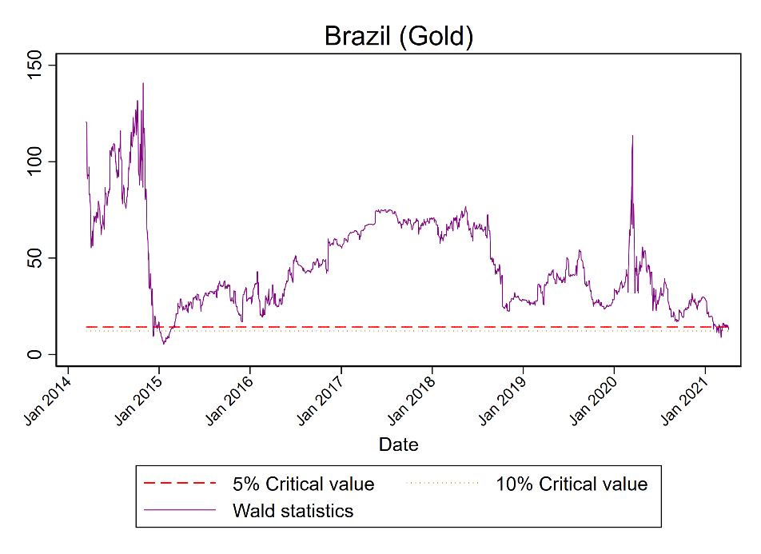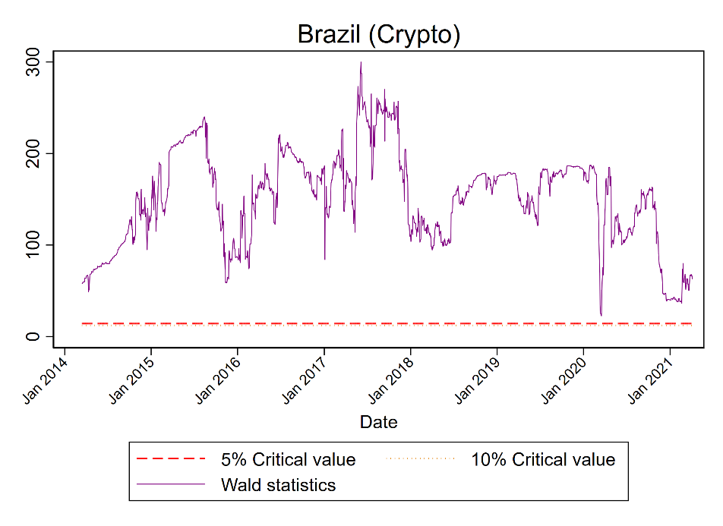
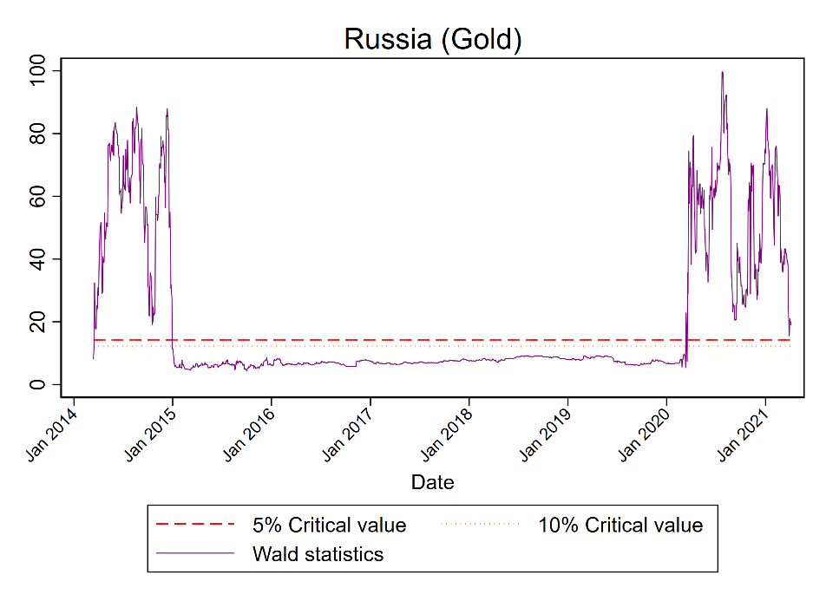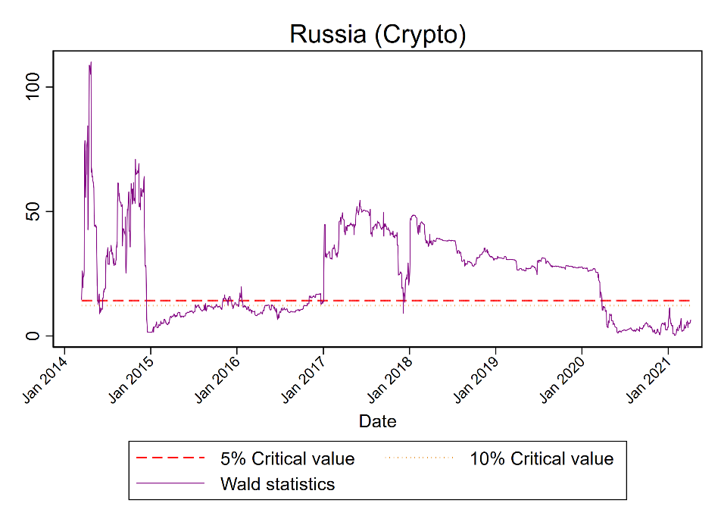
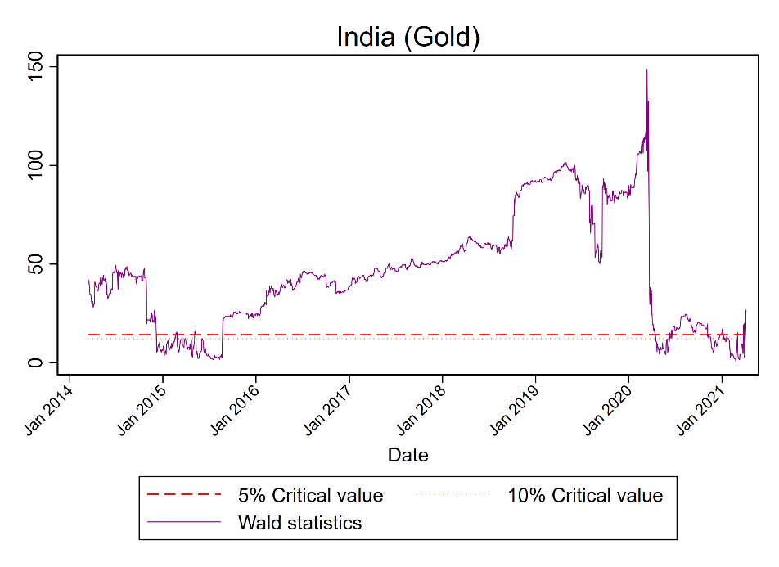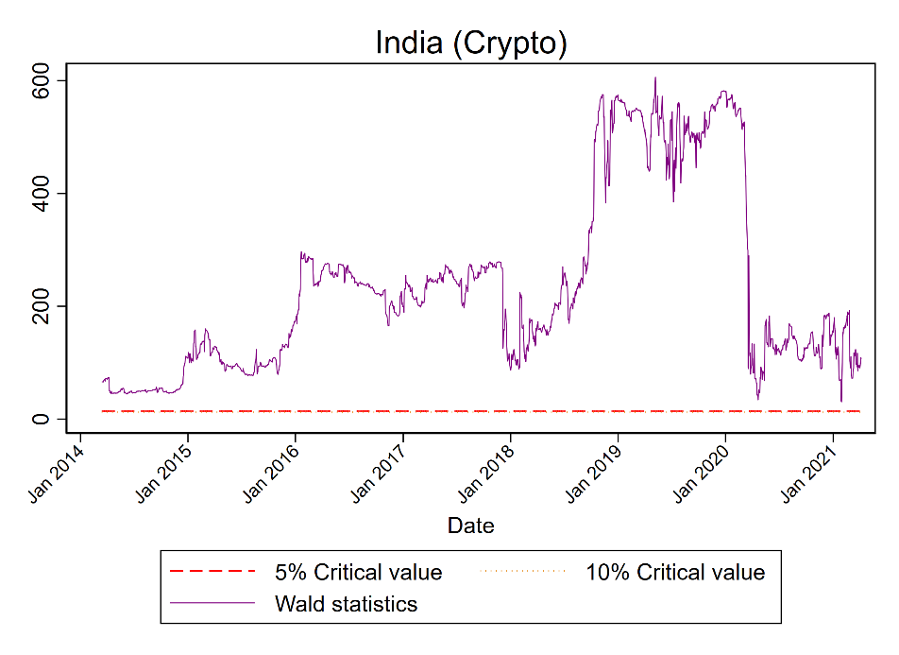
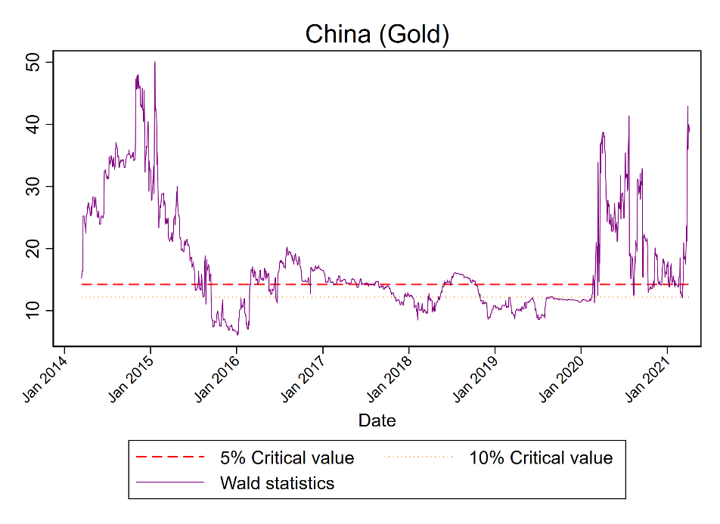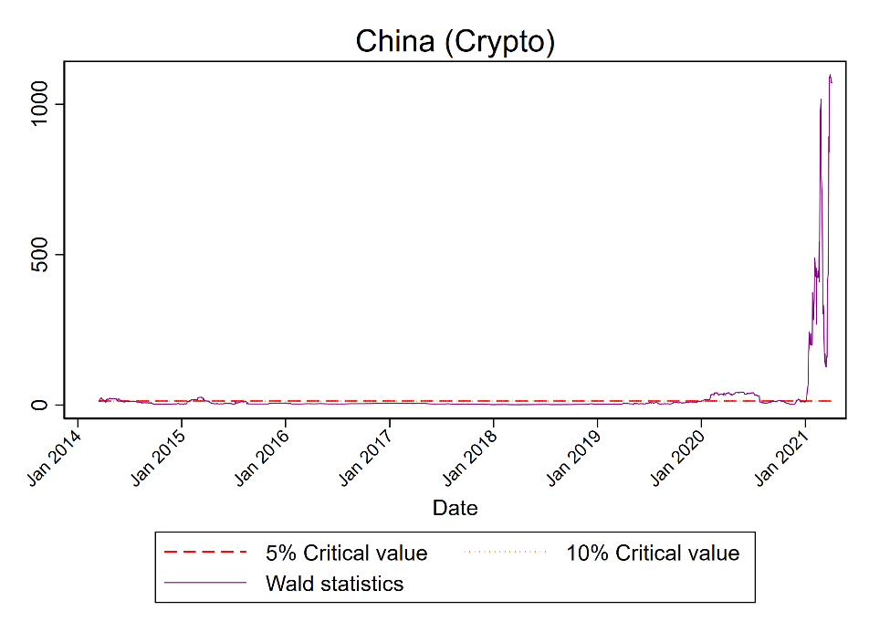

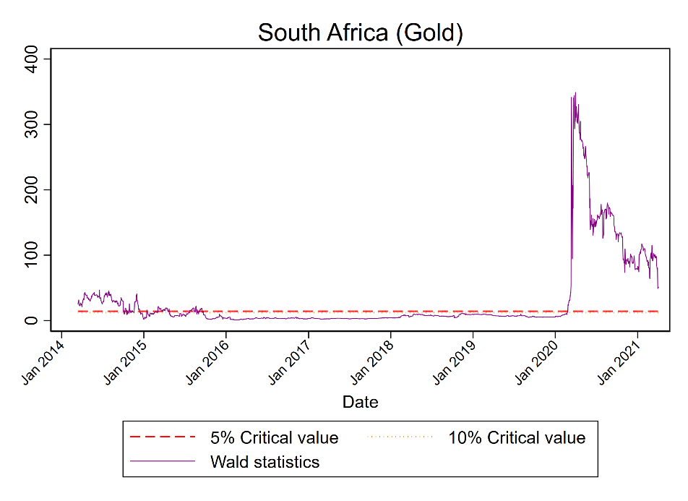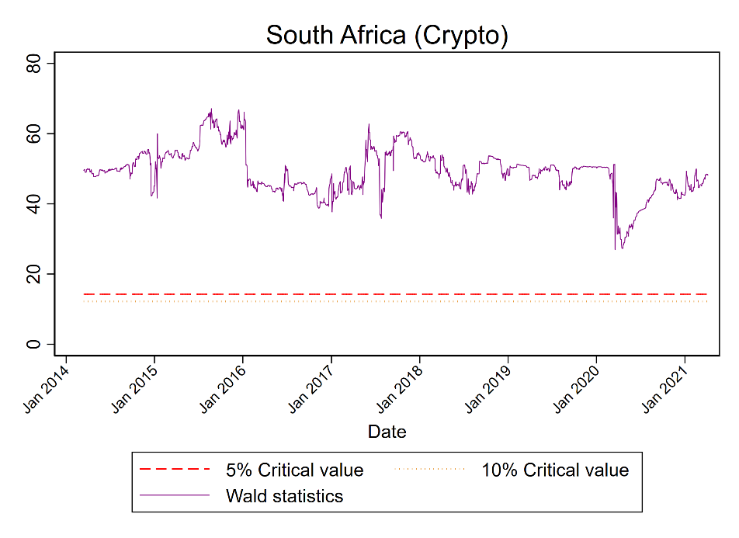
Figure 2. Time-varying Wald test statistics: pre-conflict announcement

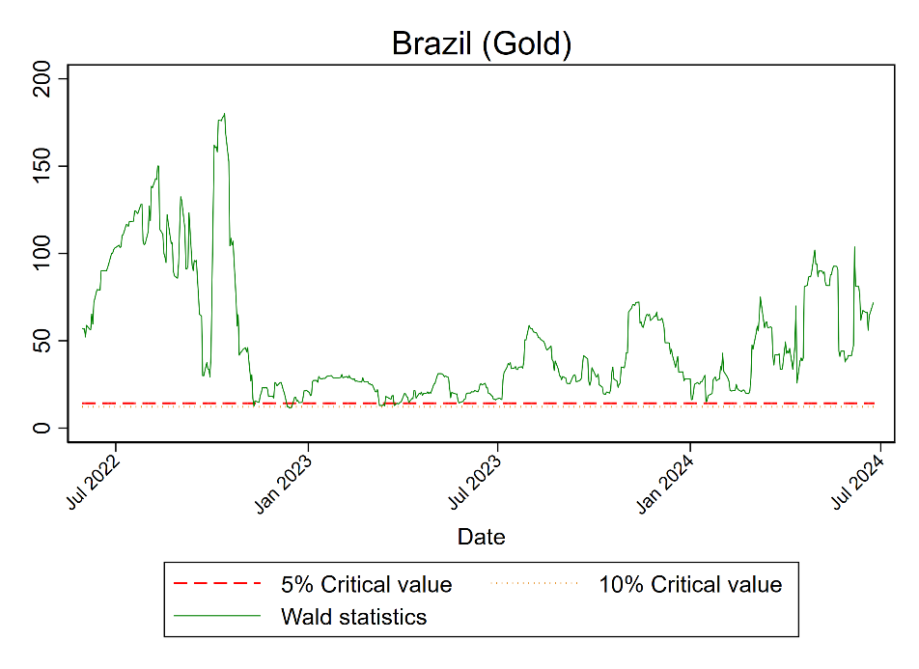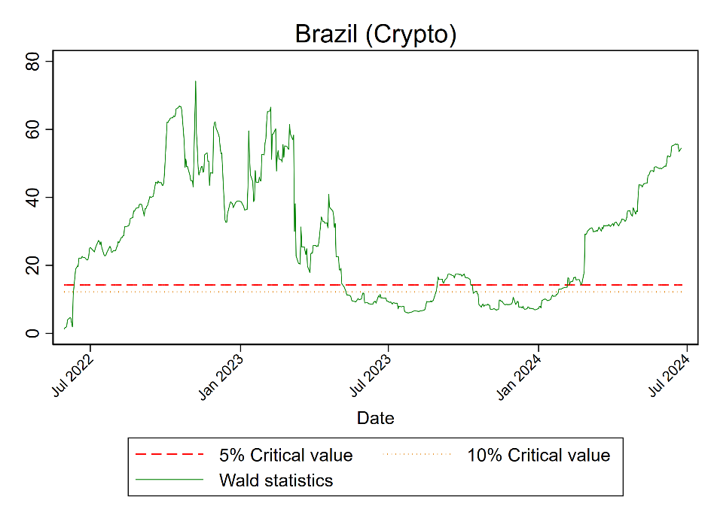
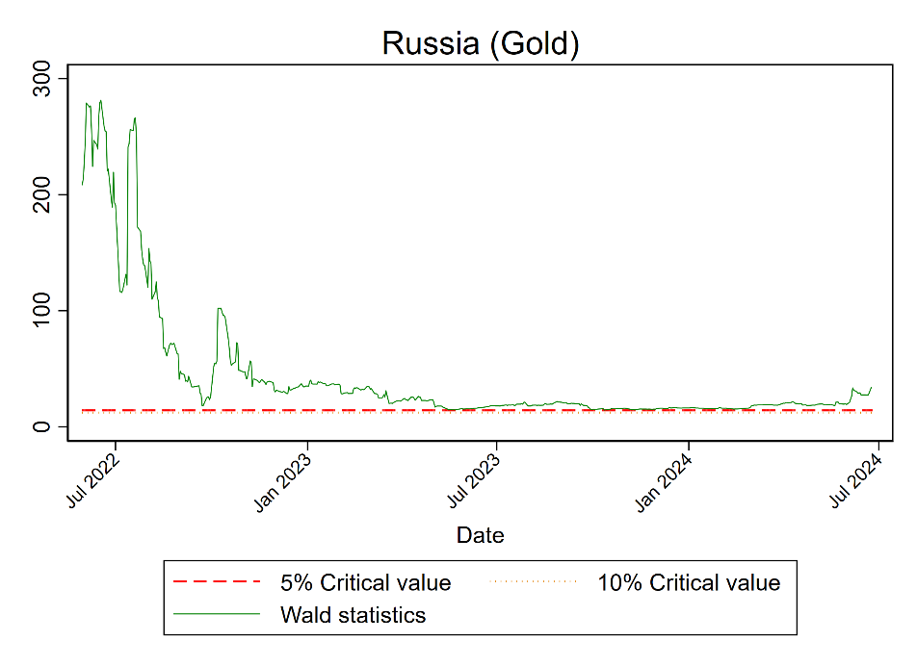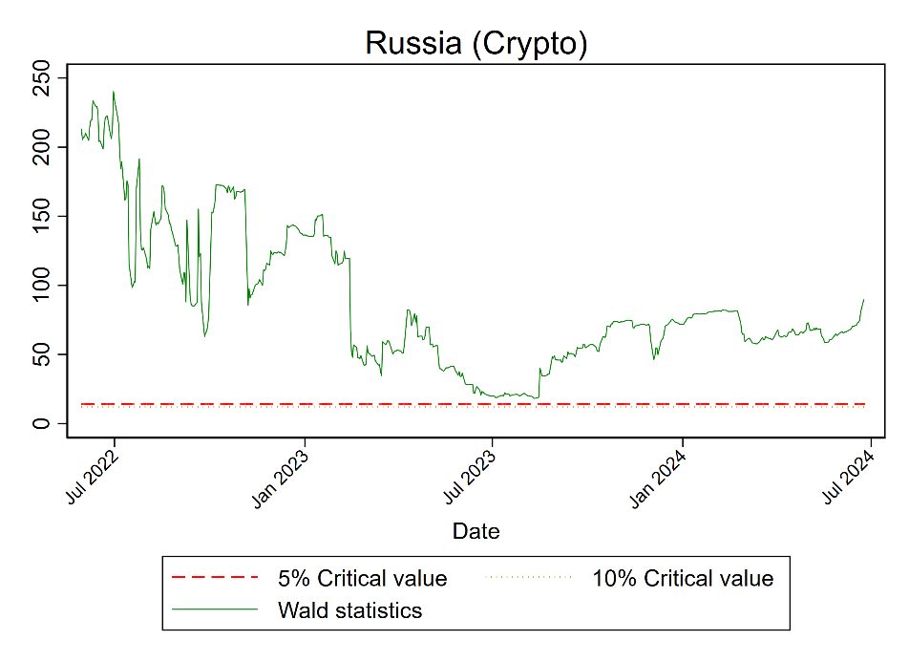
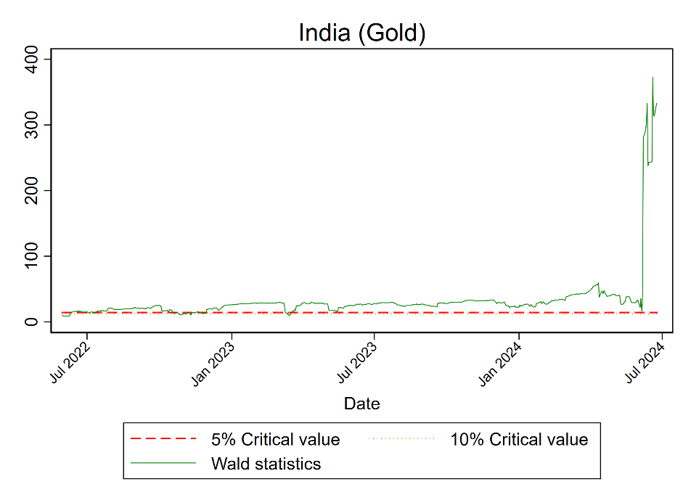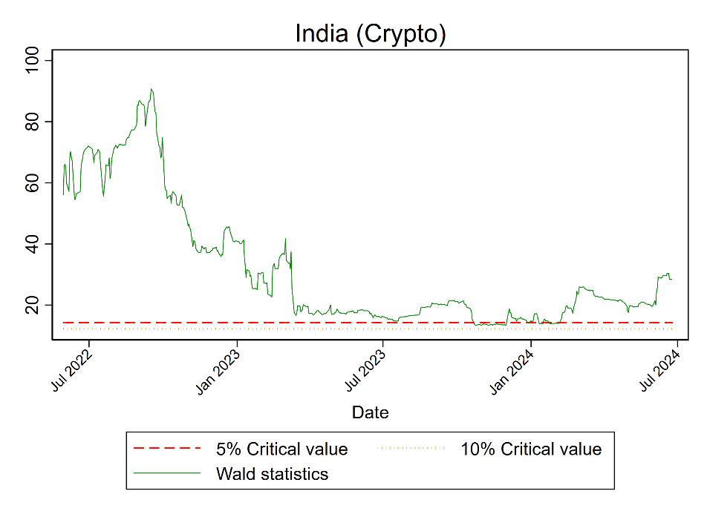

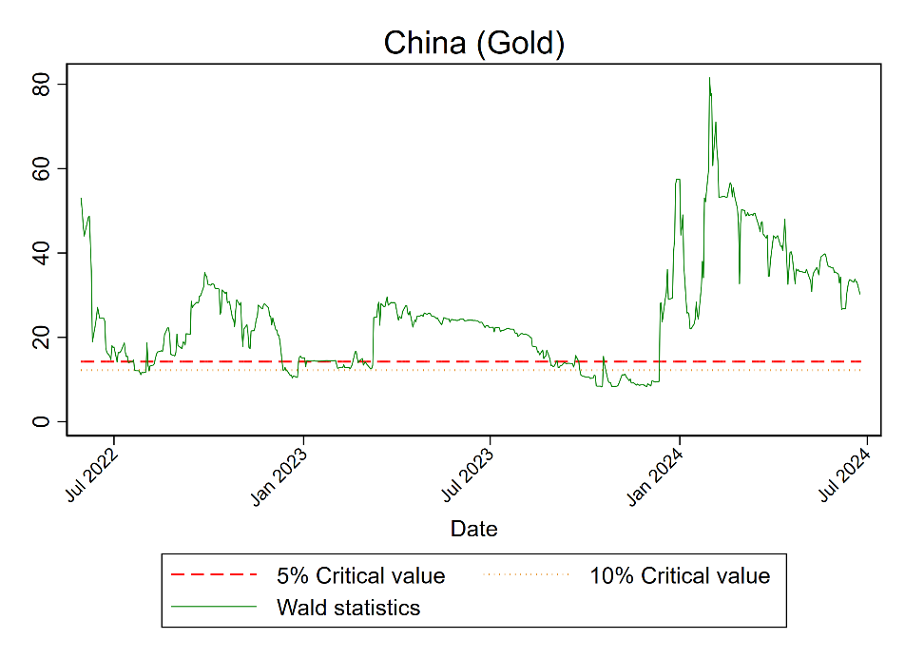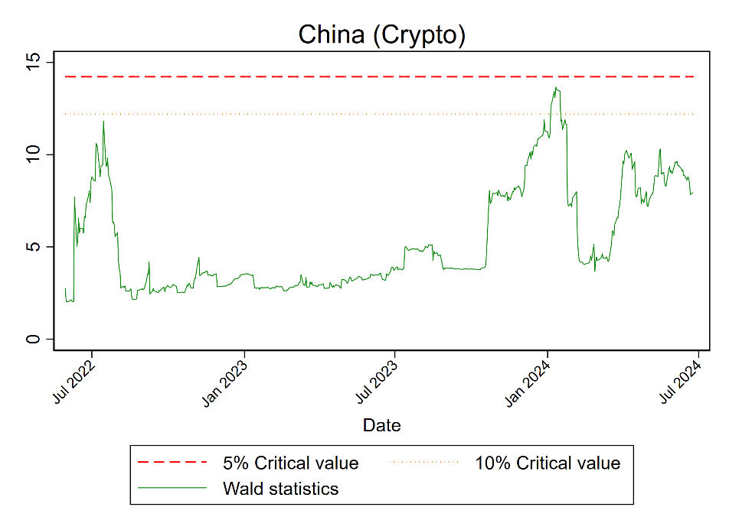

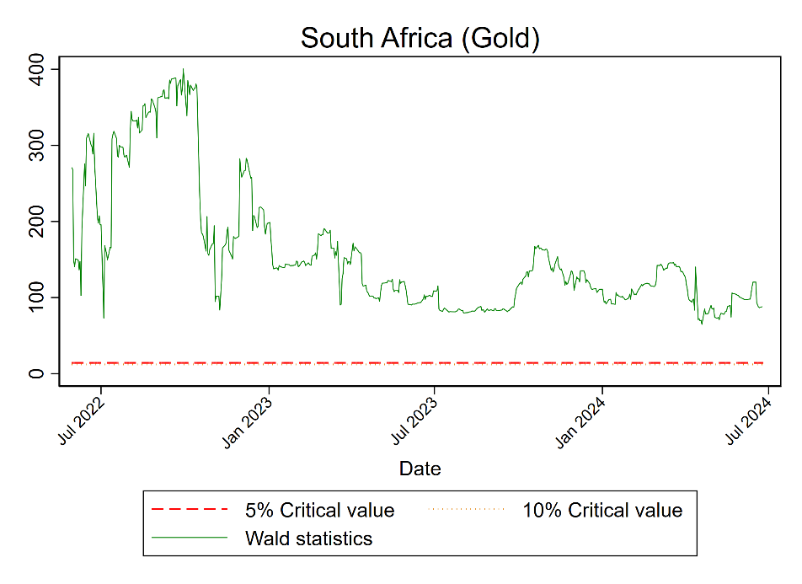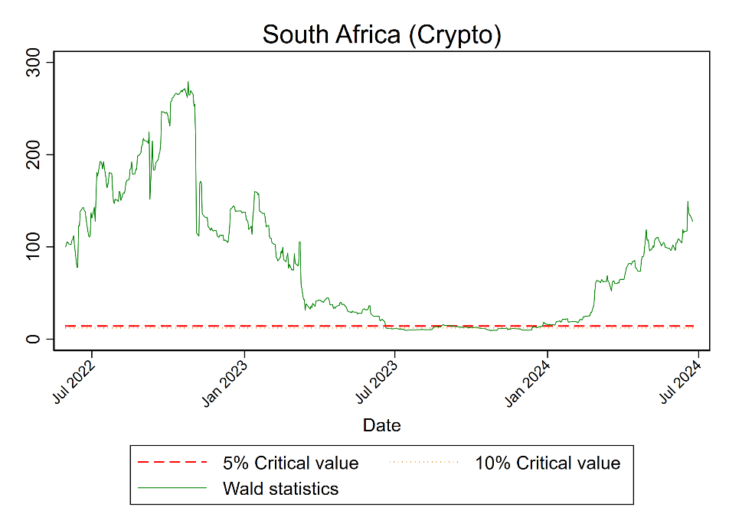

Figure 3. Time-varying Wald test statistics: post-conflict announcement

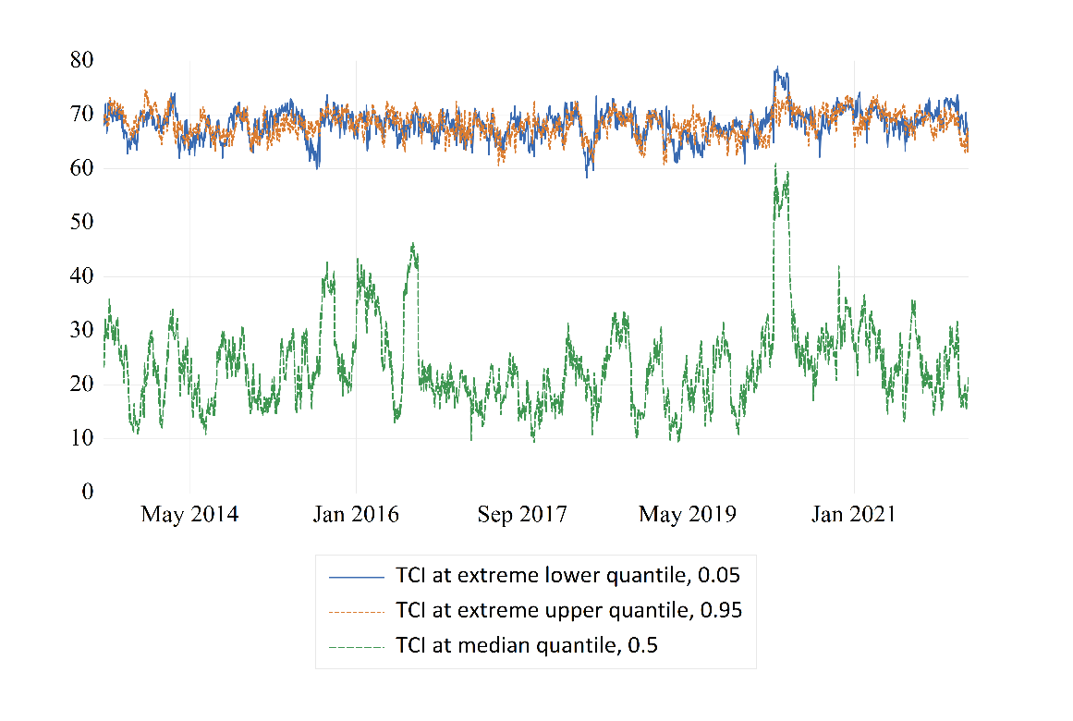

Panel A: Pre-conflict announcement

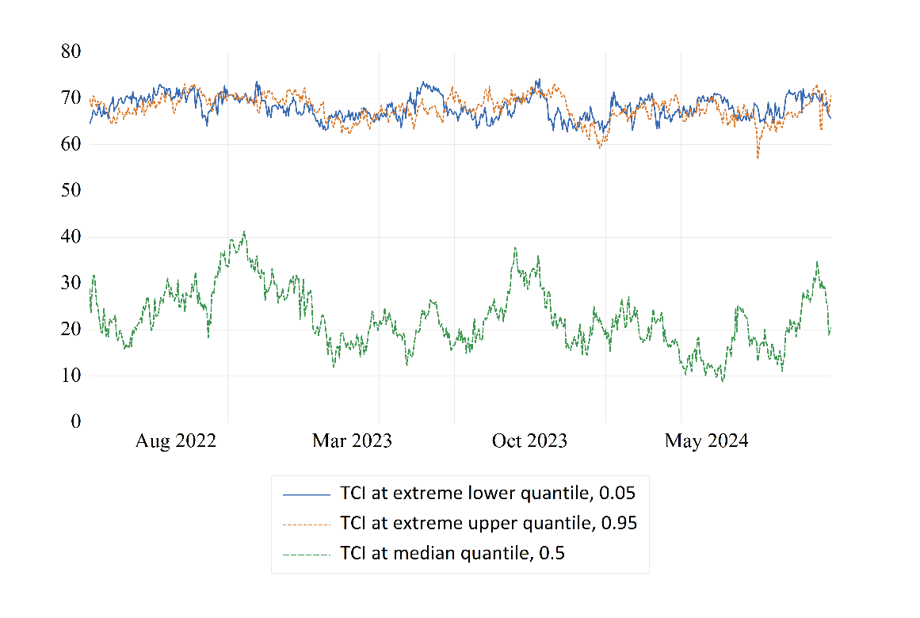
Panel B: Post-conflict announcement
Figure 4. Total Connectedness Index (TCI) across different quantiles

Panel A: Pre-conflict announcement Panel B: Post-conflict announcement

Lower Quantile ($τ=0.05$)

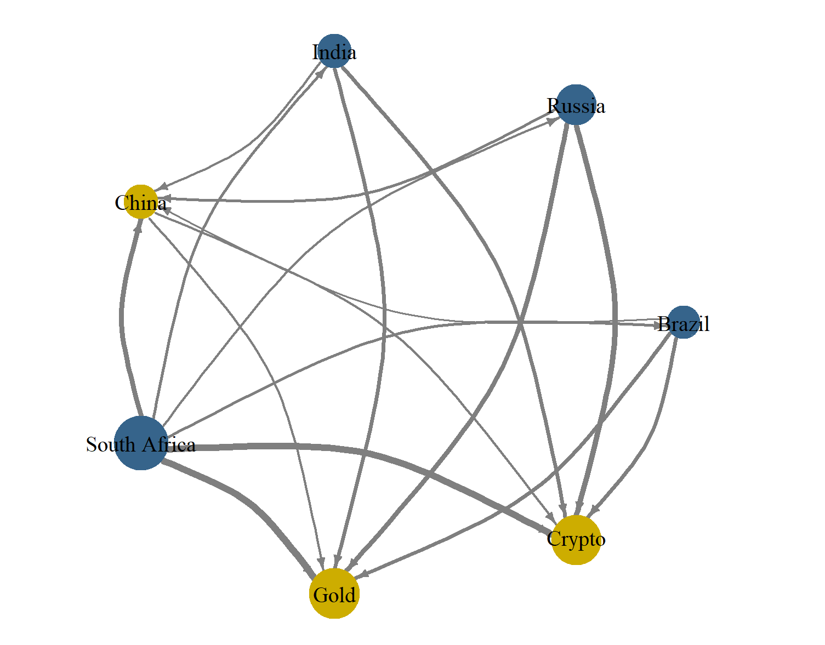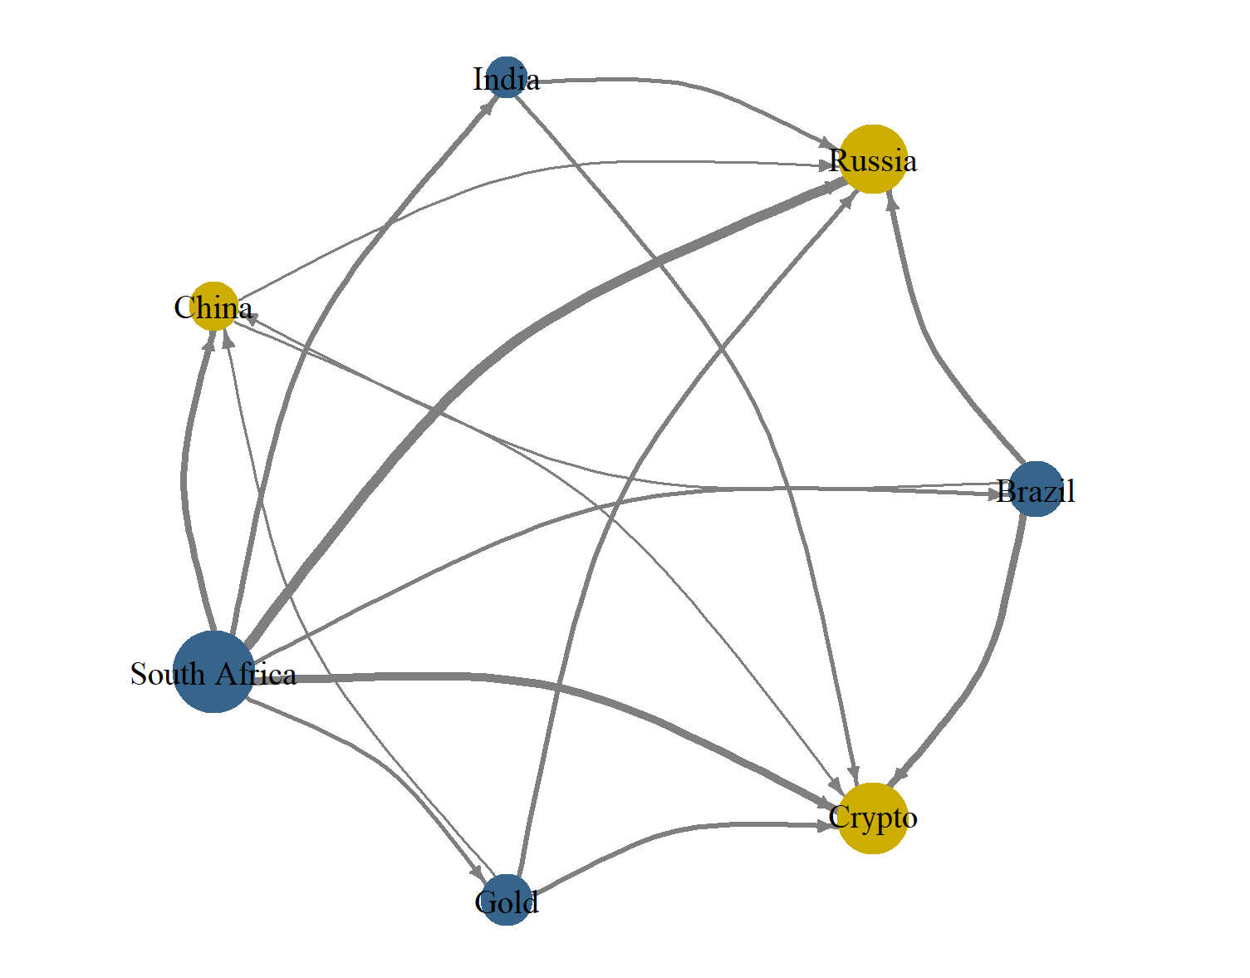

Median Quantile ($τ=0.5$)
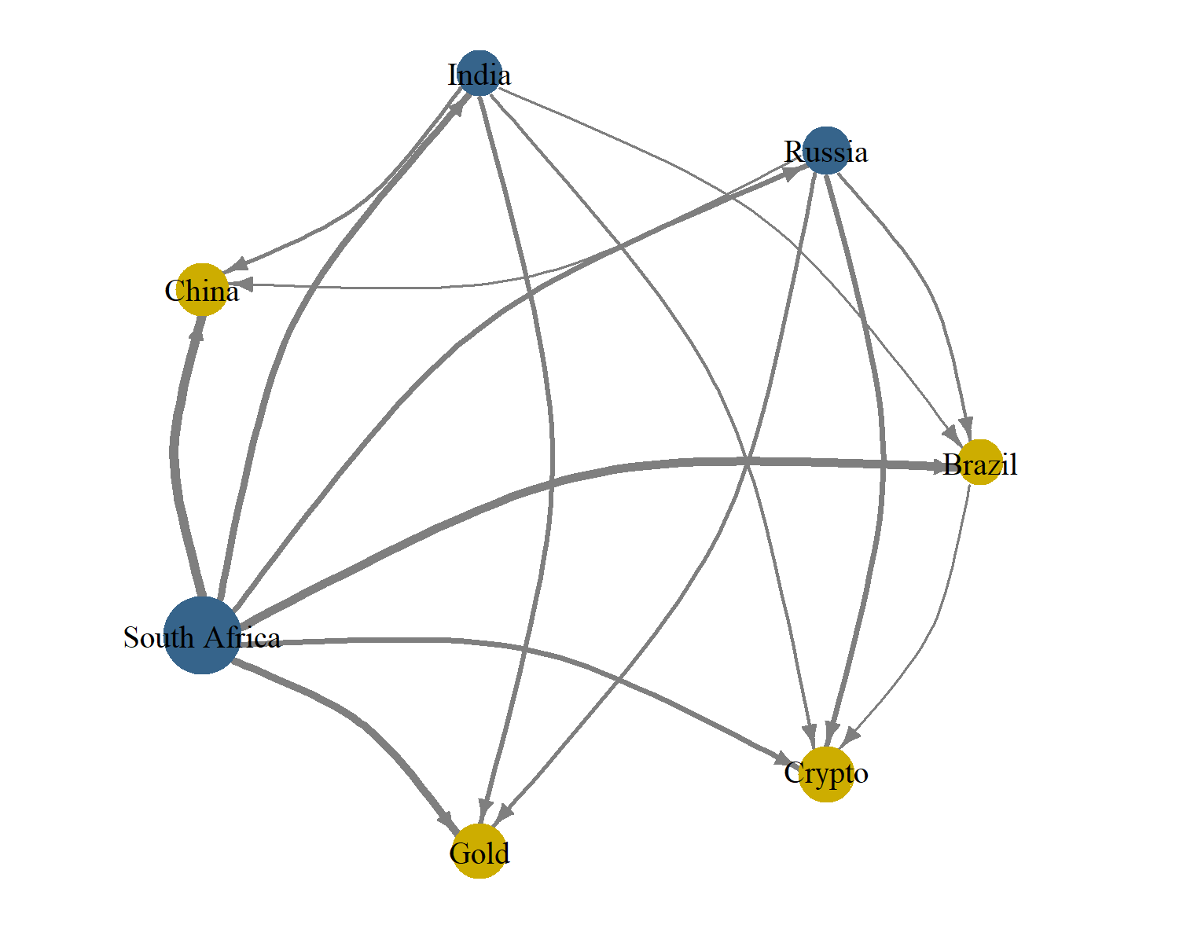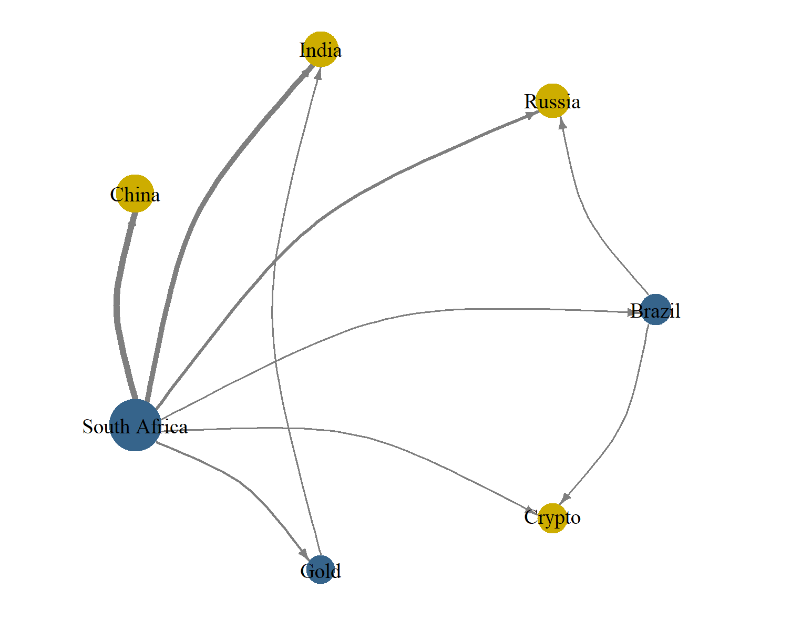

Upper Quantile ($τ=0.95$)

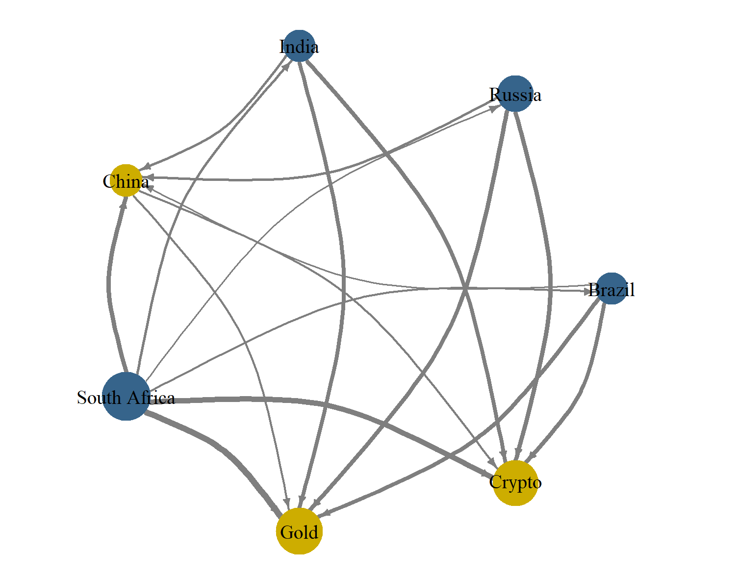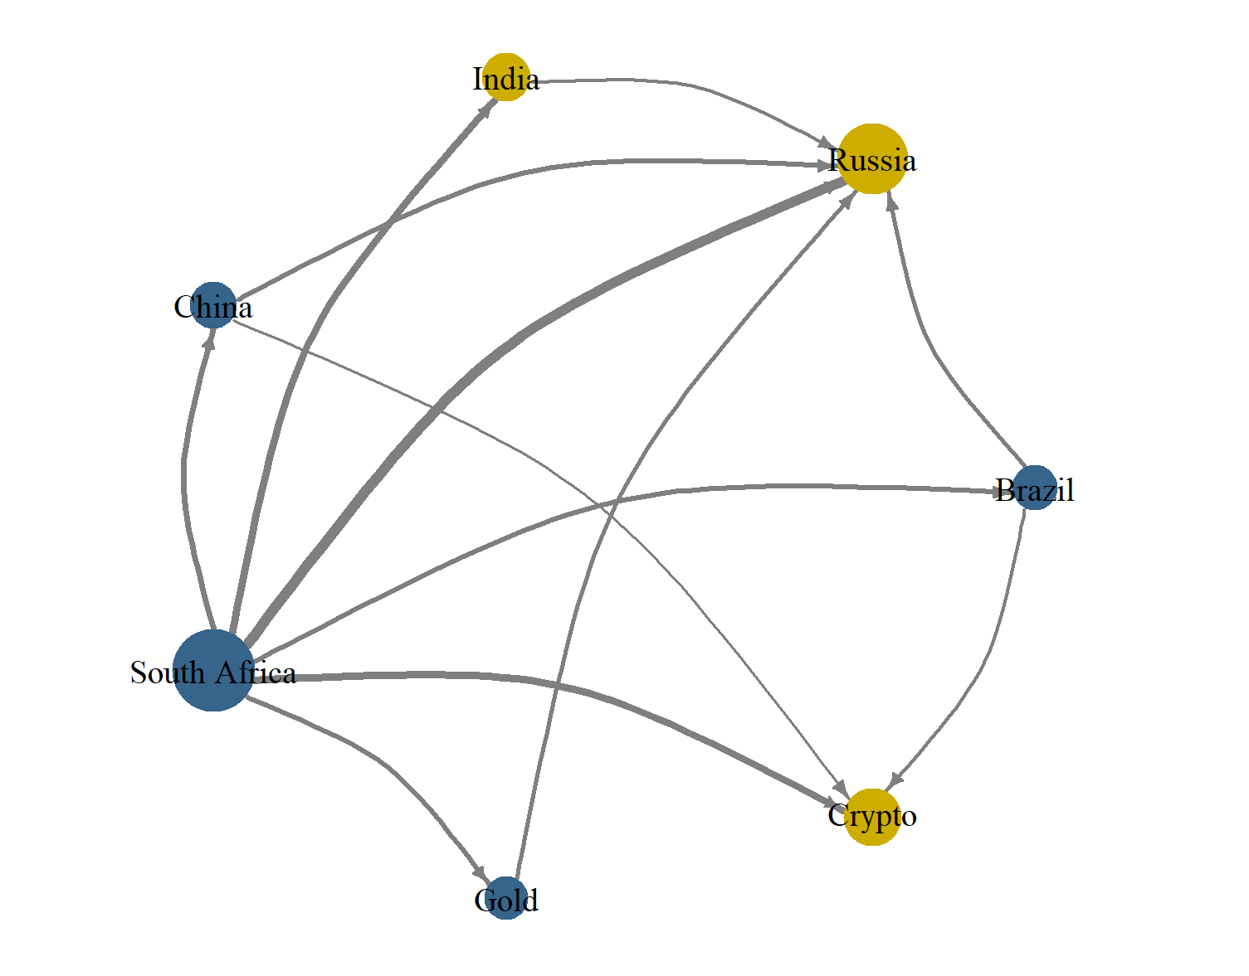

Figure 5. Spillover Network

Appendix

Table A.1. Results from time-varying parameter Granger causality tests
 | Gold |  |  | Crypto
 | MeanW | Nyblom | SupLR | MeanW | Nyblom | SupLR
Panel A: Pre-conflict announcement
Brazil | 23.332*** | 2.027 | 128.579*** | 27.576*** | 1.112 | 69.714***
Russia | 73.173*** | 1.854 | 160.771*** | 28.790*** | 0.687 | 103.853***
India | 87.720*** | 1.039 | 206.874*** | 55.410*** | 1.382 | 475.787***
China | 37.857*** | 0.720 | 267.264*** | 128.609*** | 1.263 | 472.752***
South Africa | 49.771*** | 0.134 | 682.413*** | 91.762*** | 0.146 | 295.578***
Panel B: Post-conflict announcement
Brazil | 2.766 | 0.767 | 67.722*** | 199.222*** | 0.661 | 598.955***
Russia | 32.487*** | 1.979 | 110.059*** | 621.936*** | 1.522 | 1454.539***
India | 19.173*** | 0.474 | 208.330*** | 256.859*** | 5.145*** | 900.680***
China | 67.730*** | 0.711 | 413.004*** | 195.843*** | 0.816 | 480.718***
South Africa | 47.985*** | 5.049*** | 338.735*** | 429.223*** | 1.005 | 773.644***
Note: Entries correspond to the mean Wald (MeanW), Nyblom (Nyblom), and Quandt Likelihood Ratio (SupLR) test statistics from TVP-GC test of Rossi and Wang (2019). The null hypothesis is that potential safe haven (gold or Crypto) does not Granger cause stock returns. We assume heteroskedastic and serially correlated idiosyncratic shocks. ***, **, and * denote 1%, 5%, and 10% statistical significance levels, respectively.

Our study employs Newey and West's (1987) kernel-based HAC covariance estimator with Newey and West's (1994) automatic bandwidth selection to handle possible heteroskedasticity and autocorrelation in the error term.
The results for the reverse causality are available in Table A.1 in the Appendix.

