Nostalgia, Social Connectedness, and Acculturation Orientation
Among Syrian Refugees

Constantine Sedikides¹, Mai Alkhatib², Azzam Amin²,
Tim Wildschut¹, Hisham M. Abu-Rayya^{*3,4}

¹School of Psychology, University of Southampton, United Kingdom
²Doha Institute for Graduate Studies, Qatar
³School of Social Work, University of Haifa, Israel
⁴School of Psychology and Public Health, La Trobe University, Australia

Author Note

Constantine Sedikides https://orcid.org/0000-0002-7563-306X
Mai Alkhatib https://orcid.org/0009-0005-7618-6117
Azzam Amin https://orcid.org/0000-0002-9220-8831

Tim Wildschut https://orcid.org/0000-0002-6499-5487
Hisham M. Abu-Rayya https://orcid.org/0000-0003-2352-7414
Conflict of Interests Disclosure: The authors declare that there are no potential conflicts of interest with research, authorship, and/or publication of this article.
Funding Statement: This research did not receive funding.
Ethics Approval Statement: The study was reviewed and approved by the Internal Review Board at Doha Institute for Graduate Studies. All participants provided written informed consent.
Data Availability Statement: The data are available on the OSF (https://osf.io/4md3s).
Corresponding author: Hisham M. Abu-Rayya, University of Haifa, Israel, Email: haburayya@univ.haifa.ac.il
Nostalgia, Social Connectedness, and Acculturation Orientation
Among Syrian Refugees

Abstract
We addressed in a cross-sectional study the role of nostalgia in refugee psychological acculturation orientation toward both home and host cultures, as well as the intervening role of social connectedness. We defined home orientation as efforts to maintain one’s original culture and identity, whereas we defined host orientation as efforts to engage with and adopt features of the host culture. We tested 915 Syrian refugees (56.2% women), aged 17 to 78 years (M = 35.94, SD = 10.64), who were settled in Western countries. Participants’ nostalgia for life in their home country was directly associated with higher home orientation and host orientation. Further, nostalgia was indirectly positively associated with home orientation through stronger social connectedness with their Syrian community, and it was indirectly negatively associated with host orientation through weaker social connectedness with the host community. We consider theoretical implications.
Keywords: nostalgia, refugees, Syrian refugees, acculturation orientation, social connectedness, home orientation, host orientation, culture

Psychological acculturation refers to changes experienced by refugees, immigrants, sojourners, or members of ethnocultural groups following intercultural contact (Sam & Berry, 2016). As they adapt to a new cultural environment, individuals face the challenge of how to relate to or identify with their home culture, host culture, or both. These challenges influence how well they psychologically (feeling well) and socio-culturally (doing well) adapt to the acculturation process (Sam & Berry, 2016).
Acculturation orientation may entail two non-mutually exclusive forms: home orientation and host orientation (Demes & Geeraert, 2014). Home orientation refers to individuals’ efforts to maintain their original culture and identity, whereas host orientation refers to their efforts to engage with and adopt features of the host culture (Sam & Berry, 2016). Refugees, in particular, often occupy a liminal space—dislocated from their country of origin yet not fully incorporated into the host society. Consequently, they are likely to experience a heightened tension between home orientation and host orientation, as increased commitment to one may impede engagement with the other.
Nostalgia is a sentimental longing for one’s past, characterized by fond and tender reflections on personally meaningful experiences accompanied by a yearning for them (Hepper et al., 2012; Sedikides et al., 2015). Although nostalgia entails a bittersweet affective tone—combining contentment and happiness with sadness—it is predominantly a positive emotion, generating more positive than negative affect (Leunissen et al., 2021). It also exhibits a distinct appraisal profile, triggered by temporally distant, unique, and pleasant yet irrevocable life events (Van Tilburg et al., 2019). Nostalgia is a common and universal experience, occurring frequently (several times per week) across individuals of all ages and cultural backgrounds (Juhl et al., 2020; Hepper et al., 2021; Sedikides & Wildschut, 2022). The nostalgic past is deeply personal and social, often centering on momentous life events such as birthday celebrations, weddings, childbirth, or culturally significant rituals (e.g., folkloric festivals; Wildschut et al., 2006; Yin et al., 2025).
Given its strong emotional and cultural resonance, nostalgia may play a pivotal role in the acculturation experiences of refugees, that is, the extent to which they relate to or identify with their home culture or engage with the host culture (Petkanopoulou et al., 2021; Sedikides et al., 2009). Importantly, however, nostalgia contributes to social connectedness selectively: It primarily strengthens bonds with familiar others associated with the nostalgized past (Wildschut et al., 2006), reinforcing ingroup identities (Smeekes, 2015) rather than promoting universal sociality. Thus, in refugee contexts, nostalgia for the home country may deepen ties with co-ethnics while potentially weakening engagement with host-society members, thereby intensifying the tension between home and host orientations.
We asked in the article whether and how nostalgia is associated with refugees’ home and host orientations. We examined, in particular, the role that “nostalgia for life in Syria” plays in the home and host orientations of Syrian refugees, with a specific focus on social connectedness as a key mechanism in this process.
As mentioned above, nostalgia is a social emotion: Nostalgizers feel socially connected (i.e., supported, trusting of others; Sedikides & Wildschut, 2024). But connected with whom, exactly? In H1 (Figure 1), we propose that nostalgizing about life in Syria contributes to social connectedness with members of the Syrian refugee community in the host country (Syrian-community connectedness). In turn, Syrian-community connectedness is associated with stronger home orientation, implying that refugees remain embedded in the attitudes, values, and customs of their home country. Yet, refugees who nostalgize about Syria might show weaker connectedness with community members of the host country (host-community connectedness), struggling to adjust and integrate in the new country. Host-community connectedness may be related to weaker home orientation, as refugees become conversant with the values and practices of the host country. H1 thus specifies two positive indirect pathways: Syria nostalgia is associated with higher home orientation via stronger Syrian-community connectedness (H1a) and via weaker host-community connectedness (H1b).
In H2 (Figure 1), we consider the outcome of host orientation, mirroring H1. Just as host-community connectedness contributes to weaker Syria acculturation, so will Syrian-community connectedness contribute to weaker host orientation. Further, just as Syrian-community connectedness contributes to stronger home orientation, so will host-community connectedness contribute to stronger host orientation. H2, then, specifies two negative indirect pathways: Syria nostalgia is associated with lower host orientation via stronger Syrian-community connectedness (H2a) and via weaker host-community connectedness (H2b).
Figure 1
Research Hypotheses
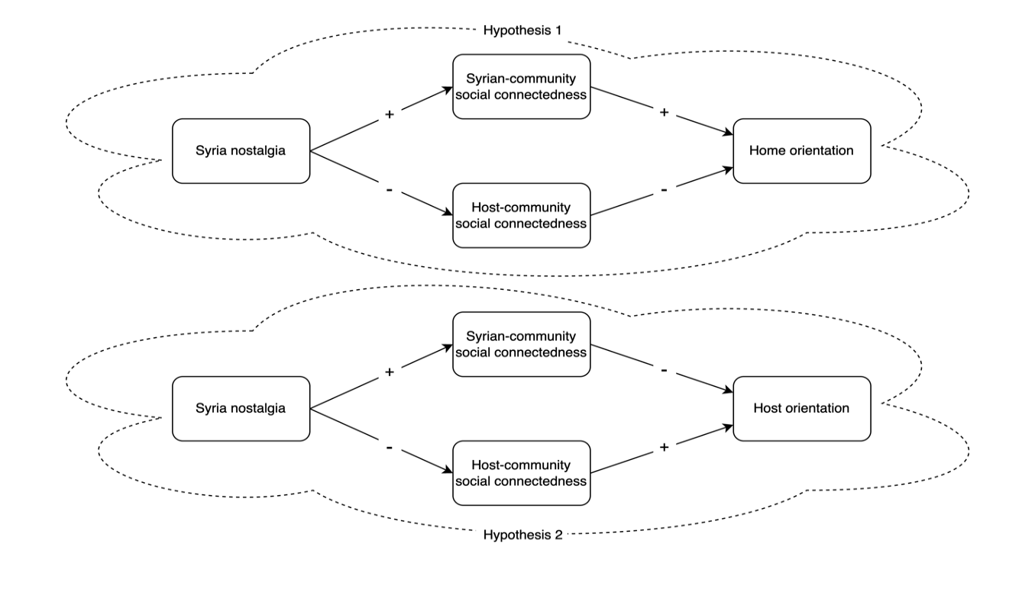
Method
We obtained ethical approval from the Doha Institute for Graduate Studies and collected the data from October 2022–February 2023. We administered the questionnaire in participants’ native language, Arabic. The second and third authors, proficient in both English and Arabic, carried out the translation from English to Arabic. A bilingual outsider reviewed and edited it. Finally, the last author, also a bilingual, checked and verified its accuracy.

Participants
We placed an advertisement on online platforms (i.e., Syrian refugee forums, blogs, chat rooms, LinkedIn, Facebook), encouraging participants to share it with their social networks (snowball sampling), and distributing it via our social networks. We recruited 1,126 Syrian refugees. We concluded recruitment when responses became increasingly rare. We excluded 74 participants for completing the survey in less than one-third of the median time (Vishkin et al., 2021) and 137 for providing incomplete responses on one or more of the main study variables. Our final sample consisted of 915 participants (514 women, 392 men, 9 unreported), aged 17 to 78 years (M = 35.94, SD = 10.64). All resided in Western countries, with an average length of stay in the host country of 6.51 years (SD = 4.21). For additional demographic information and all scales, see Supplementary Materials.
Measures
We assessed nostalgia about life in Syria. Participants read a definition of nostalgia (“feeling sentimental for a fond and valued event from one’s personal past”) and rated how nostalgic they felt (1 = not at all nostalgic, 5 = very nostalgic) for 14 objects from their life in Syria (e.g., “music,” “friends”; α = .87).
We modified Hepper et al.’s (2012) 4-item connectedness measure of social to assess Syrian-community connectedness and host-community connectedness. Participants stated how socially connected they felt to their Syrian community in the host country (7 items; α = .82) and how connected they felt to the host (non-Syrian) community (7 items; α = .71). Items were preceded by the stem “When nostalgic for my life in Syria, I feel” (e.g., “connected to people in my Syrian community/the host community”). We used this stem not only to ensure measurement precision but also to provide theoretical clarity: it directed participants to the questions within the context of their nostalgia for Syria.
We adapted the 8-item Brief Acculturation Orientation Scale (Demes & Geeraert, 2014; 1 = strongly disagree, 5 = strongly agree). Four items gauged home orientation (e.g., “it is important for me to do things the way Syrian people do”; α = .79) and four gauged host orientation (e.g., “it is important for me to do things the way [host country] people do”; α = .77).
Results
We present descriptive statistics and correlations in Table 1. All correlations were significant and in the expected direction, with the exception of a null correlation between nostalgia and host orientation (i.e., total effect). However, a significant total effect is not a prerequisite for testing indirect effects (Kenny & Judd, 2014). We tested our hypotheses with the PROCESS macro (Model 4; Hayes, 2022), with Syrian-community connectedness and host-community connectedness as parallel mediators. We report standardized indirect effects (ab). Figure 2 presents standardized regression coefficients. In Supplementary Materials, we present standard errors, 95% confidence intervals, t-values, and p-values for standardized and unstandardized coefficients (Tables S1–S2).
Results supported H1. Syria nostalgia was associated with higher home orientation via stronger Syrian-community connectedness (H1a), ab = .15, 95% CI [.12, .18]), and via weaker host-community connectedness (H1b), ab = .02, 95% CI [.01, .04]). The residual direct effect on home orientation was positive.
Results also supported H2. Syria nostalgia was associated with lower host orientation via stronger Syrian-community connectedness (H2a), ab = -.04, 95% CI [-.07, -.02]), and via weaker host-community connectedness, ab = -.05, 95% CI [-.08, -.03]). Unexpectedly, the direct effect on host orientation was also positive.

Table 1
Descriptive Statistics and Zero-Order Correlations Among Study Variables
 | M | SD | 1 | 2 | 3 | 4
1. Syria Nostalgia | 3.21 | 0.83
2. Syrian-community social connectedness | 3.40 | 0.82 | .39*
3. Host-community social connectedness | 3.20 | 0.71 | -.13* | -.14*
4. Home orientation | 3.43 | 0.88 | .52* | .54* | -.28*
5. Host orientation | 3.48 | 0.76 | .04 | -.11* | .39* | -.09*
Note. N = 915. * p < .005.
Figure 2
Direct and Indirect Effects: Standardized Regression Coefficients
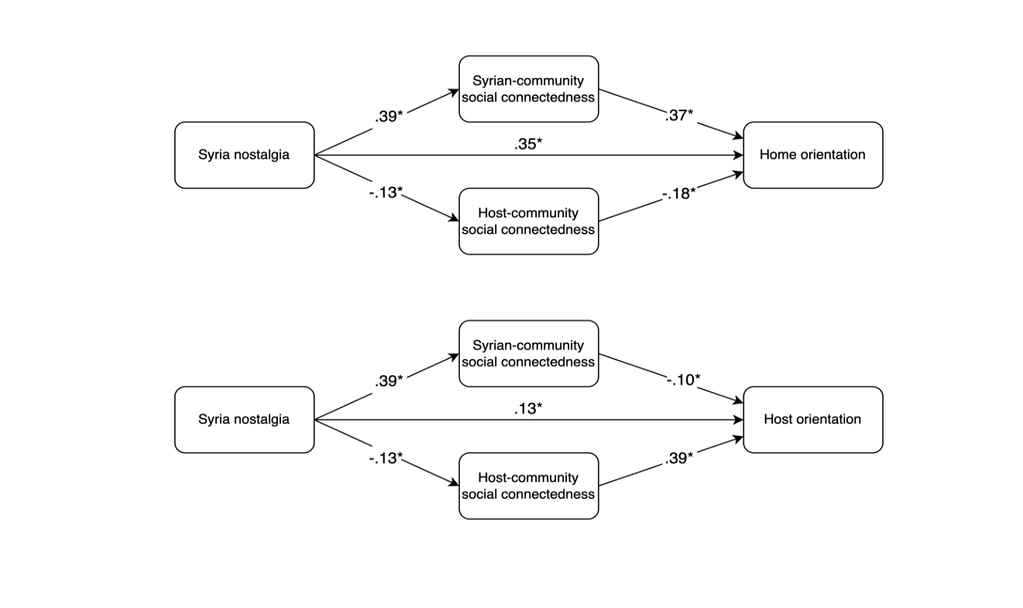
Note. N = 915. * p < .005.
Discussion
Nostalgia is relevant to Syrian refugees’ home and host orientations. However, social connectedness, a central correlate of nostalgia, was differentially associated with home and host orientations. Specifically, nostalgia for Syria was indirectly linked to higher home orientation via stronger social connectedness with the Syrian community and via weaker social connectedness with the home-country community. Conversely, nostalgia was indirectly linked to lower host orientation via stronger Syrian-community social connectedness and via weaker host-community social connectedness. Together, the type of social connectedness—whether it pertains to the Syrian community or the host community—matters. That is, as an intervening pathway, social connectedness can contribute to stronger or weaker home and host orientations. The results were unaffected by refugees’ length of stay in the host country (Supplementary Materials).
The findings are generative. Future research may examine whether home and host orientations, as linked to nostalgia and social connectedness, contribute to more effective adaptation—though the literature suggests that host orientation is more strongly associated with adaptive outcomes (Abu-Rayya et al., 2023). Also, future research may specify the mechanisms through which social connectedness is serially linked to home and host orientation—potentially through meaning in life (Sedikides & Wildschut, 2018). Relatedly, the positive direct effects of Syria nostalgia on both home and host orientation suggest the operation of unmeasured intervening mechanisms. This possibility is intriguing in the case of host orientation, where the direct effect was directionally opposite to the negative indirect effects, implying a beneficial countervailing process.
Follow-up work can address limitations of this research. By using the terms direct effect and indirect effect, we adopted the parlance of mediation analysis but did not wish to make causal claims. Indeed, we tested our hypotheses with a cross-sectional design, preventing unambiguous causal inferences. Longitudinal, ecological momentary assessment, or experimental designs can address this issue, while testing social connectedness in general, rather than nostalgia-specific, settings. Future research should also examine a variety of refugee contexts to enhance the generalizability of findings. Overall, the acculturation literature stands to gain from integrating nostalgia and its association (via social connectedness) with both home orientation and host orientation.
References
Abu-Rayya, H.M., Berry, J., Grigoryev, D., & Sam, D. (2023). The integration hypothesis: A meta-analysis of the ICSEY project data using new methods. British Journal of Psychology, 114(2), 819-837. https://doi.org/10.1111/bjop.12656
Demes, K. A., & Geeraert, N. (2014). Measures matter: Scales for adaptation, cultural distance, and acculturation orientation revisited. Journal of Cross-Cultural Psychology, 45, 91–109. https://doi.org/10.1177/0022022113487590
Hayes, A. F. (2022). Introduction to mediation, moderation, and conditional process analysis: A regression-based approach (3rd ed.). Guilford Press.
Hepper, E. G., Ritchie, T. D., Sedikides, C., & Wildschut, T. (2012). Odyssey’s end: Lay conceptions of nostalgia reflect its original Homeric meaning. Emotion, 12(1), 102–119. https://doi.org/10.1037/a0025167
Hepper, E. G., Wildschut, T., Sedikides, C., Robertson, S., & Routledge, C. D. (2021). Time capsule: Nostalgia shields psychological wellbeing from limited time horizons. Emotion, 21(3), 644–664. https://doi.org/10.1037/emo0000728
Juhl, J., Wildschut, T., Sedikides, C., Diebel, T., Cheung, W. Y., & Vingerhoets, A. J. J. M. (2020). Nostalgia proneness and empathy: Generality, underlying mechanism, and implications for prosocial behavior. Journal of Personality, 88(3), 485–500.
Kenny, D. A., & Judd, C. M. (2014). Power anomalies in testing mediation. Psychological Science, 25(2), 334–339. https://doi.org/10.1177/0956797613502676
Leunissen, J. M., Wildschut, T., Sedikides, C., & Routledge, C. (2021). The hedonic character of nostalgia: An integrative data analysis. Emotion Review, 13(2), 139–156.
Petkanopoulou, K., Wildschut, T., & Sedikides, C. (2021). Nostalgia and biculturalism: How host-culture nostalgia fosters bicultural identity integration. Journal of Cross-Cultural Psychology, 52(2), 184–191. https://doi.org/10.1177/0022022120988345
Sam, D. L., & Berry, J. W. (Eds.). (2016). The Cambridge handbook of acculturation psychology. Cambridge University Press.
Sedikides, C., & Wildschut, T. (2018). Finding meaning in nostalgia. Review of General Psychology, 22(1), 48–61. https://doi.org/10.1037/gpr0000109
Sedikides, C., & Wildschut, T. (2022). Nostalgia across cultures. Journal of Pacific Rim Psychology, 16, 1–16. https://doi.org/10.1177/18344909221091649
Sedikides, C., & Wildschut, T. (2024). Trait nostalgia. Personality and Individual Differences, 221, Article 112554. https://doi.org/10.1016/j.paid.2024.112554
Sedikides, C., Wildschut, T., Routledge, C., Arndt, J., Hepper, E. G., & Zhou, X. (2015). To nostalgize: Mixing memory with affect and desire. Advances in Experimental Social Psychology, 51, 189–273. https://doi.org/10.1016/bs.aesp.2014.10.001
Sedikides, C., Wildschut, T., Routledge, C., Arndt, J., & Zhou, X. (2009). Buffering acculturative stress and facilitating cultural adaptation: Nostalgias as a psychological resource. In R. S. Wyer, Jr., C.-y. Chiu, & Y.-y. Hong (Eds.), Understanding culture: Theory, research, and application (pp. 361–378). Psychology Press.
Van Tilburg, W. A. P., Bruder, M., Wildschut, T., Sedikides, C., & Göritz, A. S. (2019). An appraisal profile of nostalgia. Emotion, 19(1), 21–36.
Vishkin, A., Horenczyk, H., & Pazit Ben-Nun Bloom, P. B. N (2021). A motivational framework of acculturation. Brain and Behaviour, 11, Article e2267.
Wildschut, T., Sedikides, C., Arndt, J., & Routledge, C. (2006). Nostalgia: Content, triggers, functions. Journal of Personality and Social Psychology, 91(5), 975–993. https://doi.org/10.1037/0022-3514.91.5.975
Smeekes, A. (2015). National nostalgia: A group-based emotion that benefits the in-group but hampers intergroup relations. International Journal of Intercultural Relations, 49, 54–67.
https://doi.org/10.1016/j.ijintrel.2015.07.001
Yin, Y., Jiang, T., Thomas, S., Wildschut, T., & Sedikides, C. (2025). Nostalgia promotes parents’ tradition transfer to children: The role of self-child overlap. Personality and Social Psychology Bulletin, 51(3), 394–408. https://doi.org/10.1177/0146167223118733

The home orientation and host orientation subscales contained an item (i.e., “It is important for me to have Syrian/Host country friends”) whose meaning overlapped with the social connectedness measure. We re-analyzed the data excluding this item and obtained nearly identical results (Supplementary Materials, Figure S1).

