**A randomly structured composite PDMS/PTFE ferroelectret soft smart material**

M. Zhang1, J. Shi2, X. Sun1, S. Yong1, S P. Beeby1

1 Centre for Flexible Electronics and E-Textiles, School of Electronics and Computer Science, University of Southampton, Southampton, UK

Corresponding author email: spb@ecs.soton.ac.uk

2 PragmatIC Semiconductor Ltd., Cambridge, UK

**Abstract**

Polydimethylsiloxane (PDMS) based ferroelectrets are an attractive material for the fabrication of human-based applications given their soft and compliant mechanical properties. The typical fabrication approach is to exploit specifically engineered void geometries fabricated by moulding and bonding layers together. Charge instability can be addressed by the addition of Polytetrafluoroethylene (PTFE) particles but this prevents the bonding of PDMS films. This paper illustrates a new approach to obtaining PDMS ferroelectret with random voids by promoting and trapping bubbles to create cavities within a PDMS film. A mathematical model is presented to explore the connection between the percentage of trapped bubbles in the PDMS and the equivalent piezoelectric coefficient, d33e. The process is compatible with the addition of PTFE powder to the PDMS formulation and a ratio of PTFE to PDMS of 1:3 by weight was found to increase performance achieving an initial d33e of 384 pC/N which reached a steady state value of 186 pC/N measured after 2 months after poling. The energy harvesting potential of the random void PDMS/PTFE ferroelectret was explored by cyclically compressing with a force of 300 N applied at 1 Hz. The output of the ferroelectret was found to charge a 10μF capacitor to 0.26 V after 40 seconds. The ferroelectret's performance as a pressure sensor from 0 to 300 N was explored, and the optimum formulation achieved a sensitivity of 25.2 mV/N, a nonlinearity of 4%, and hysteresis of 4.2%, demonstrating a considerable improvement over the pure PDMS ferroelectret.

Keywords: Ferroelectret, PDMS, smart material, energy harvesting, pressure sensing

1. Introduction

A ferroelectret is a material which contains trapped charges on the surface of internal voids that present strong quasi-piezoelectric properties after electrical charging. Early examples of ferroelectret materials were thin polymer propylene electret foams where the charge was stored on the randomly formed internal void surfaces [[1], [2], [3]]. This trapped charge results in an electric field across each void within the polymer foam forming dipoles throughout the material. The foam structure can be easily compressed or expanded perpendicular to the plane of the voids and this produces a change in the internal dipole moment which is accompanied by a corresponding change in the compensation charge on the surface electrode, as shown in Figure 1(a) [[4]]. This produces a macroscopic behaviour across the film that appears identical to that of a piezoelectric material although the charge generation process is very different [[5], [6]]. Voided polymer ferroelectrets are soft materials that result in quasi-piezoelectric properties that typically exceed those demonstrated by traditional rigid (e.g., crystalline) materials [[7], [8]]. The large piezoelectric properties and soft, compliant mechanical properties enable ferroelectrets to be widely used in wearables [[9], [10], [11]]. Example applications include heart rate monitoring [[12]], integration within textiles to detect hand gestures [[13]], human motion sensing [[14]], monitoring muscle activity [[15]] and mechanical energy harvesting [[16]].

Different ferroelectret fabrication methods have been summarised by Wang et al [[17]]. The voids formed within the ferroelectret material can be randomly or formally arranged depending upon the fabrication process. Random voids can be formed using various foaming technologies, such as the use of blowing agents and extrusion foaming, which have been applied to create polymer-based cellular structures for ferroelectrets [3]. Other example processes include the creation of a microporous cellular structure using additives such as magnesium salt (MgCl2·6H2O) to a poly(vinylidine-hexafluoropropylene) (P(VDF-HFP) copolymer [[18]]. Stretching particulate-filled polymers, where the voids originate from interfacial delamination between different materials can also form cellular polymeric films [[19]]. Ferroelectret output can be enhanced by stacking foam layers within an alternating electrode arrangement shown in Figure 1(b) placing the layers mechanically in series and electrically in parallel [[20], [21], [22], [23]]. This reduces the optimal load resistance and increases charge output.

|  |  |
| --- | --- |
|  |  |

Figure 1: (a) The working principle of a single-layer ferroelectret with random voids [4]; (b) Multistack ferroelectret arrangement connected electrically in parallel [16].

In contrast to the random voids associated with foams, controlled formalised void layouts and geometries have been realised using polydimethylsiloxane (PDMS). PDMS has been used to fabricate ferroelectrets due to the straightforward material processing methods and high levels of flexibility of the PDMS material [[24], [25]]. The controlled void layout with pre-defined geometries has been achieved using a PDMS moulding process [[26], [27]]. A variety of different structures have been demonstrated such as rectangular and parallelogram voids fabricated using a micromachined silicon mould [[28]] (Figure 2a, Figure 2b), circular voids fabricated using a dry film photoresist [[29]] (Figure 2c) and rectangular voids formed using a 3D printed mould [20] (Figure 2d). Another approach demonstrated is to laser cut the voids within the middle layer of a triple silicone (Ecoflex) stack [[30]]. The ordered and defined void array facilitates the quantitative analysis of the relationship between the PDMS structure and the ferroelectret performance [21]. Voids are formed in one PDMS film and sealed by bonding to an additional flat PDMS film. The moulding procedure increases the complexity of the PDMS manufacturing process and limits the void geometry to the shape of the mould. Other techniques for fabricating stretchable elastomer-based piezoelectret materials include adding polar polynorbornene nanoparticles to a PDMS matrix [[31]]. Thin films of this material formed by doctor blading demonstrated a reversible piezoelectric coefficient d31 of 37 pC/N.

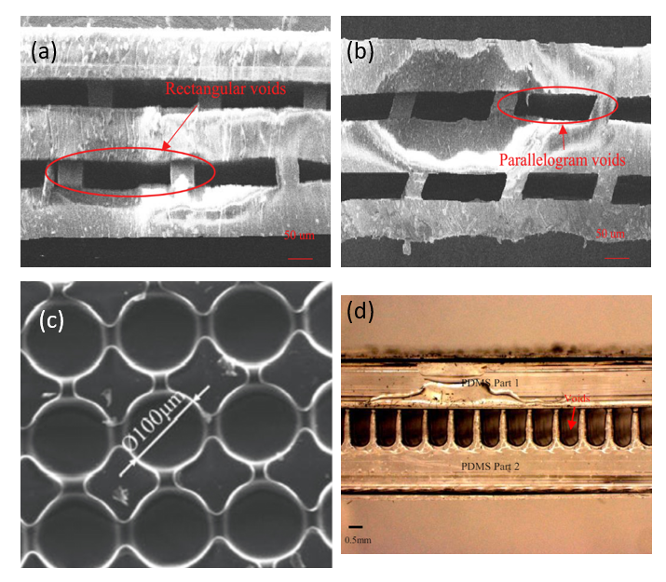

Figure 2: PDMS ferroelectret with controlled void layouts: (a) rectangular voids and (b) parallelogram voids fabricated using micromachined silicon wafer moulds [21]; (c) circular voids fabricated using a dry film photoresist mould. Reproduced from [22]. © IOP Publishing Ltd; (d) rectangular voids fabricated using a 3D printed mould [20].

This work presents an investigation into the fabrication parameters associated with a simplified method to synthesize PDMS ferroelectrets containing random voids formed using a bubble-forming stirring process [[32]]. Although this technique does not control the geometry of the voids with a high level of precision, it is nonetheless a rapid and straightforward technique to achieve a PDMS ferroelectret film with voids. The ferroelectret properties can be adjusted by the stirring process parameters (stirring speed and duration) and the PDMS process conditions (pre-heating temperature, curing temperature), providing some control over the formation of the voids and the number of bubbles (bubble percentage). This process avoids the need for bonding multiple PDMS layers and exploits the attractive mechanical properties and biocompatible nature of PDMS making it highly suitable for wearable applications. The addition of Polytetrafluoroethylene (PTFE) particles to the PDMS is also investigated to improve charge density, stability, and ferroelectret longevity [[33], [34]]. PTFE exhibits excellent charge stability and charge density, and the combination of this with PDMS has been shown to improve the ferroelectret properties (voltage and power output) whilst maintaining the soft and flexible mechanical properties of the PDMS. Previous work has identified that the PDMS/PTFE composite material cannot be easily bonded [25] and therefore the bubble-forming random void process is particularly relevant to the PDMS/PTFE composite.

1. Mathematical Model

The ferroelectret properties measured by the equivalent piezoelectric properties such as the d33 relating the charge induced to the applied stress are determined by the void geometry, elastic modulus and charge density [[35]]. The following analysis uses a simplified cellular structure (Figure 3) to develop a model relating the effective piezoelectric coefficient d33e of a PDMS film with random voids to a bubble percentage (the amount of bubbles trapped in the PDMS film) that depends upon the material preparation and stirring parameters. The structure is composed of alternating solid and void layers sandwiched between electrodes on the top and bottom surfaces and the model is an extension of that presented in [24].

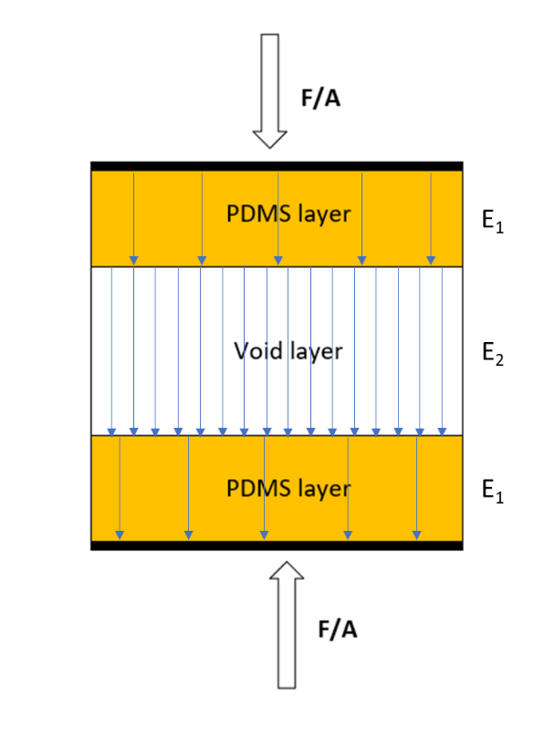

Figure 3: A simplified model of a PDMS cellular structure

For this simplified model, the electric field in the PDMS layers (E1) and porous layer (E2) can be obtained from Gauss’s law for the interfaces:

$E_{1}=\frac{σ_{m}}{ε_{1}ε_{0}}$ and $E_{2}=\frac{σ_{m}-σ}{ε_{0}}$ (1)

Where sm and s are the charge densities on the electrodes and on the void surfaces respectively, and e0 and e1 are the dielectric constant of air and the relative dielectric constant of PDMS respectively. According to the Gauss’s law, the normal component of the electric displacement field D is continuous across the PDMS-void interface. From the definition of D, there is a boundary condition across the PDMS and void interface:

${ { ε}_{1}E}_{1}=E_{2}ε_{0}$ (2)

The electric potential ($V$) across the top electrode and bottom electrode can be obtained from Kirchhoff’s second law:

$V=\int{E}dx=\left(n+1\right)x_{1}E_{1}+nx_{2}E_{2}=0$ (3)

Equation (3) also serves as another boundary condition to ensure the internal electric field is balanced and no potential difference between two electrode boundaries under static equilibrium state. Figure 3 has 1 void layer and 2 solid layers where $x_{1}$ and $x_{2}$ are the thickness of the solid and void layers respectively. Combining equation 1 and 3, the charge density on the electrodes can be described by:

$σ_{m}=\frac{nε_{1}σx_{2}}{[\left(n+1\right)x_{1}+nε_{1}x_{2}]}$ (4)

The change in charge density on the electrodes (${∆σ}_{m}$) is determined by thickness variations ${∆x}_{1}$ and ${∆x}_{2}$ as follows:

${∆σ}_{m}=\frac{∂σ_{m}}{∂x_{1}}∆x_{1}+\frac{∂σ_{m}}{∂x_{2}}∆x_{2}=\frac{n(n+1)ε_{1}σx_{2}}{{[\left(n+1\right)x_{1}+nε_{1}x_{2}]}^{2}}∆x_{1}+\frac{n(n+1)ε_{1}σx_{1}}{{[\left(n+1\right)x_{1}+nε_{1}x_{2}]}^{2}}∆x_{2}$ (5)

Assuming that an external force is applied normally to the PDMS electrode surfaces, the relationship between stress and strain can be obtained from:

$\frac{F}{A}=c_{33}\frac{∆x_{1}}{x_{1}}=c_{33}\frac{∆x_{2}}{x_{2}}$ (6)

Where $c_{33}$ is the elastic modulus of the material, and A is the surface area. Combining equations 4 to 6, the effective piezoelectric property d33e can be obtained from:

$d_{33e}=\frac{∆σ_{m}}{F/A}=\left(\frac{n(n+1)ε_{1}σx_{2}}{{[\left(n+1\right)x_{1}+nε_{1}x_{2}]}^{2}}x_{1}\right.+\left.\frac{n(n+1)ε_{1}σx_{1}}{{[\left(n+1\right)x_{1}+nε_{1}x_{2}]}^{2}}x_{2}\right)\frac{1}{c_{33}}$ (7)

Given a bubble percentage of *k* where *k* should be equal to the ratio of all voids to the total volume, which can be described as:

$k$ = $\frac{nx_{2}A}{\left(n+1\right)x_{1}A}$ (8)

$x_{2}$ = $\frac{\left(n+1\right)x_{1}}{n}k$ (9)

Combining equations 7 and 9, enables d33e to be obtained from:

$d_{33e}=\frac{∆σ_{m}}{F/A}=\left(\frac{{(n+1)}^{2}ε_{1}σk}{{(n+1+nε_{1}k+ε_{1}k)}^{2}}\right.+\left.\frac{ε_{1}σk}{{(1+ε_{1}k)}^{2}}\right)\frac{1}{c_{33}}$ (10)

According to equation (10), the $d_{33e}$ of the PDMS ferroelectret structure is determined by the bubble percentage ($k$), elastic modulus ($c_{33}$) charge density (σ) and the relative dielectric constant of the cellular material ($ε_{1}$). For a given structure, the value of the layer thicknesses can be considered as constant and therefore the $d_{33e}$ coefficient only varies with the material properties and the number and size of the voids.

1. Material Preparation

The engineered ferroelectret structure is fabricated using PDMS molding techniques to realize a PDMS sample of dimensions 2.8 cm × 2.8 cm × 3 mm thickness (Figure 4a). A 3D printed mould was baked in an oven at 80 °C for 24 hours and exposed to a silane vapour for 1 hour to enable the PDMS to be easily released [24]. The mould and liquid PDMS were then pre-heated in an oven for 1 minute at temperatures between 40 and 100oC. Pre-heating can accelerate the curing time of the PDMS and reduce the amount of trapped bubbles that escape. The liquid PDMS and curing agent (Sylgard 184 from Dow Corning, MI, USA) were mixed at a 10:1 weight ratio and the resulting gelatinous liquid was stirred at a variety of speeds (from 500 to 200 rpm) and times (from 20 to 60 s) using an overhead stirrer. The stirring process ensures the liquid PDMS and curing agent are fully and evenly mixed and that the bubbles generated by the reaction between liquid PDMS and curing agent are evenly distributed throughout the solution. The stirring process also draws in more air during mixing enhancing the bubble percentage. After stirring, the PDMS solution was poured into the mould and cured at between 80 and 180°C for 30 minutes after which it can be peeled away from the mould. Samples fabricated from the PDMS/PTFE composite material were prepared by adding PTFE powder average particle size 1 µm diameter (Sigma Aldrich, MO, USA) to the PDMS at a weight ratio of 3:1.

* 1. Testing

To investigate the relationship between bubble percentage and piezoelectric properties, the bubble percentage of samples was calculated from experimental measurements by equation 10.

$ρ_{air}V_{m}k+ρ_{PDMS}V_{m}(1-k)={m }_{m}$ (11)

Where $ρ_{air}$ and $ρ_{PDMS}$ are the density of the air and PDMS respectively, $V_{m}$ is the measured sample volume and ${m }_{m}$ is the measured sample weight and $k$ is the bubble percentage.

To charge the void surfaces and activate the piezoelectrical properties of the PDMS ferroelectret, samples were polarized using identical corona charging parameters (charging voltage 25 kV applied for 2 minutes with a probe separation distance of 4 cm) [[36]]. Surface charge density is related to d33e which can be measured using a PiezoMeter Systems (PM300, Piezotest Ltd). The generated output voltage across the resistive load *R* can be expressed by equation (11) where *R* is the resistance, $∆Q$ is the variation in charge, and *t* is the time taken to apply the force.

$V=\frac{∆Q}{t}R$ (12)

An Instron ElectroPuls E1000 was used to apply cyclical compressive forces of 300 N at 1 Hz to the test samples to determine the output voltage and charge transferred to a storage capacitor to evaluate the energy harvesting potential. Material durability was explored using a bending rig with the test samples being placed within a pocket on a textile ribbon and cyclically deformed around a 3 cm diameter cylinder (bending radius of 1.5 cm) and with a weight of 1 kg applied to provide tension in the material (see Figure 4). The electrical characteristics of the samples were measured after a predetermined number of compression/bending cycles.

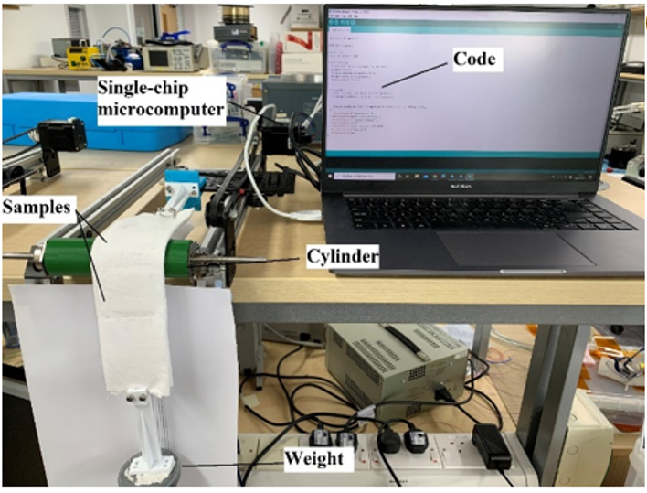

Figure 4: The bending test rig.

1. Results and Discussion

Pre-heating temperatures of 40ºC, 60ºC, 80ºC and 100ºC were evaluated and a general increase in bubble percentage with temperature can be observed in Figure 5(a). Figure 5(b) shows the cross-section view of the sample pre-heated at 80o C (sample 3). To confirm the actual void distribution across the composite material, a statistical distribution analysis was performed as shown in Figure 6. Figure 6(a) shows the histogram of void diameters with an average diameter of 12.41±2.45 μm. The inset image displays the visual representation of the voids used to analyse the distribution derived by processing the cross-sectional photograph (Fig. 5b) by ImageJ software. The relatively broad range of diameters, from 6-18m, suggests a non-uniform size distribution of voids within the PDMS matrix, while most void diameters are within 10-16 m. Figure 6(b) depicts the distribution of void curvature, with an average curvature of 0.67±0.14. The higher curvature (close to 1) implies more circular and symmetric voids, whereas lower curvature suggests elongated or irregular shapes. Most voids tend toward higher values, which means they are essentially circular. The average value has been reduced by the optical analysis where 2 or more voids are in close proximity artificially lowers the value for void curvature. Figure 6(c-d) display the spatial distribution of voids along the X and Y axes respectively showing they are randomly located across the matrix.”

Figure 7 (a) shows the bubble percentage vs the initial pre-heating temperatures with a curing temperature of 150ºC and stirring time of 40 s at 1000 rpm stirring speed. The bubble percentage increases with temperature until it reaches 8.7% at a pre-heating temperature of 80 ºC, after which there is a small reduction in bubble percentage at 100ºC. The bubble percentage is determined by the number and size of the bubbles and if the pre-heating temperature is too high the viscosity of the mixed PDMS liquid increases and begins solidifying before the stirring process is completed resulting in smaller bubble sizes. Figure 7(b) presents the bubble percentage after curing at 80ºC, 120ºC, 150ºC and 180ºC following pre-heating at 80ºC and a stirring time 40 s at 1000 rpm. The trapped air can escape after stirring and therefore the speed of curing is important to minimise the amount of air escaping from uncured material. The Sylgard 184 PDMS data sheet states the samples will be cured in 10 minutes at 150oC but will not be cured after 30 minutes at 80oC. A bubble percentage of 8.7% was achieved at 150ºC curing temperature with negligible further increase with increasing temperature indicating the curing time at this temperature is sufficient. The failure of the PDMS to cure at 80oC is reflected by the negligible bubble percentage observed at this temperature. Figure 7(c) shows the influence of stirring times of 20, 40 and 60 s with a stirring speed of 1000 rpm on samples pre-heated at 80ºC and cured at 150ºC. The stirring time of 40 seconds provides the optimum time required to draw air into the mixture and increasing this further provides no additional benefit. Figure 7(d) presents the bubble percentage with different stirring speeds of 500, 1000 and 2000 rpm for 40 s on samples pre-heated at 80ºC and cured at 150ºC. The maximum bubble percentage of 9% was achieved with a stirring speed of 2000 rpm which introduces the most air into the mixture, but overall the stirring conditions were found to have a significantly smaller effect on the bubble percentage compared with the process temperatures used.

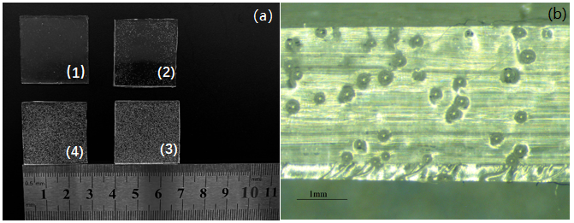

Figure 5: Photograph of a PDMS samples (2.8 cm × 2.8 cm × 3 mm) with random voids; (a) top view of the PDMS samples pre-heated at 40ºC, 60ºC, 80ºC and 100ºC (from 1 to 4 respectively) and a curing temperature of 150 ºC; (b) scanning electron microscope cross-section view of PDMS ferroelectret sample 3. Reproduced from [24]. © IEEE.

Figure 6: The size distribution (a), geometry distribution; (b), spatial distribution along (c) X axes and (d) Y axes.

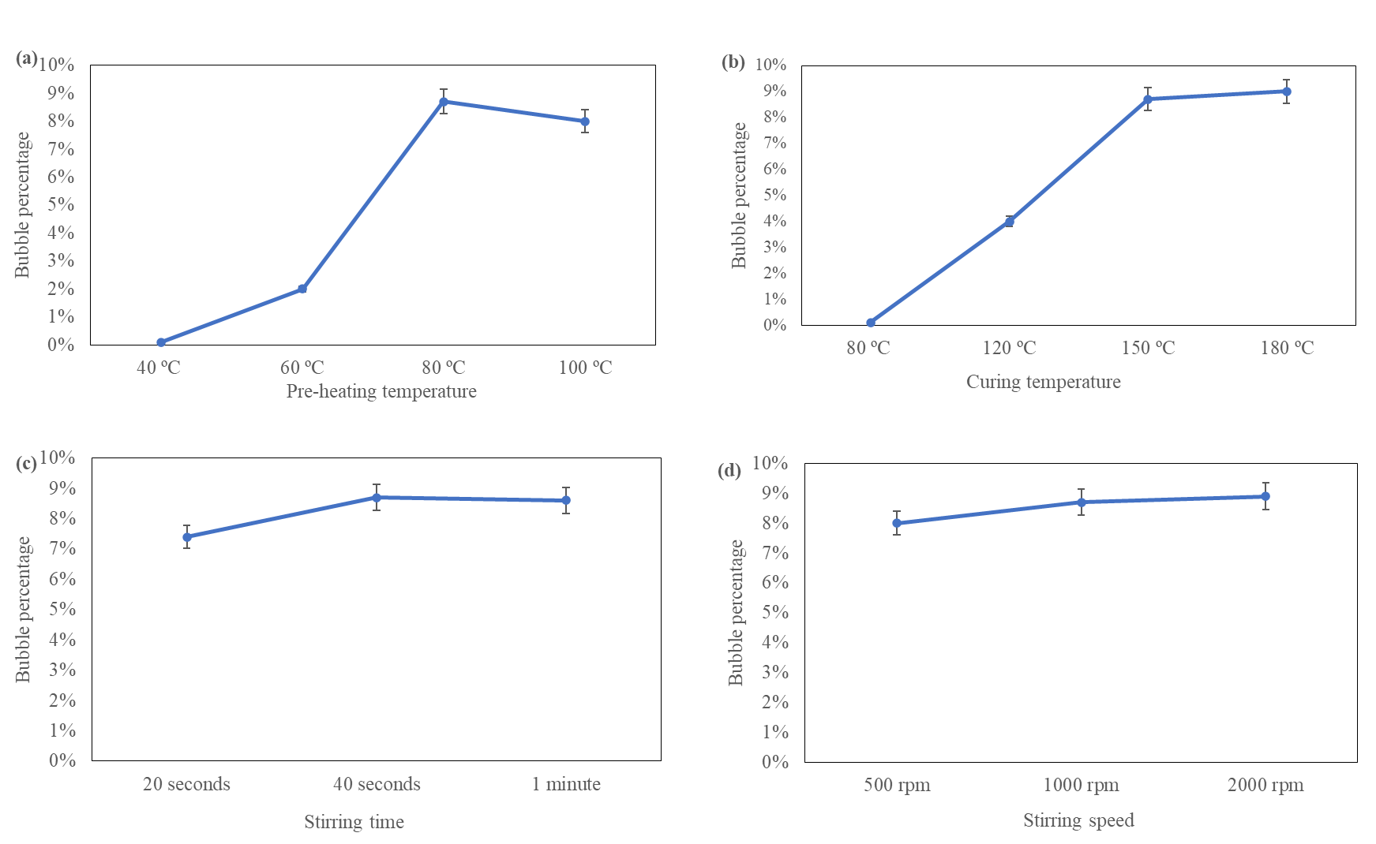

Figure 7: Variation in bubble percentage by process parameter; (a) influence of pre-heating temperature (stirring time 40 s at 1000 rpm, curing at 150 ºC); (b) influence of curing temperature (pre-heated at 80 ºC, stirred for 40 s at 1000 rpm); (c) influence of stirring time (pre-heated at 80 ºC, stirred at 1000 rpm, curing temperature 150ºC); (d) influence of stirring speed (pre-heated at 80 ºC, stirred for 40 s, curing temperature 150ºC).

The measured actual piezoelectric constant value and the theoretical calculated d33e from equation 9 for the different bubble percentages obtained are shown in Figure 8. The effective piezoelectric coefficient increases with an increasing bubble percentage up to the maximum achieved of 9%. When the bubble percentage is 0%, there are no voids in the composite material, resulting in the loss of quasi-piezoelectric properties, and d33​ is 0. However, when the bubble percentage increases to 4%, the measured value and theoretical value of d33 reaches 40 pC/N and 66 pC/N , and it further increases significantly to 235 pC/N and 266 pC/N respectively at a 9% bubble percentage. This improvement highlights the importance of maximising the bubble percentage. Mathematically, based on the correlation equation: $r=\frac{∑(x_{i}-x)(y_{i}-y)}{\sqrt{∑{(x_{i}-x)}^{2}∑{(y_{i}-y)}^{2}}}$, and the data from Figure 8, r≈0.997, indicating a very strong positive correlation between the bubble percentage and the d33 values. This is because the bubbles introduce air phases with lower dielectric constants than PDMS, causing electric field variations under stress. As the bubble percentage increases, the polarization within the composite material strengthens. Additionally, a higher bubble percentage softens the material, making it more flexible and easier to deform under the same force, thus further enhancing d33.

The mechanical robustness of the samples and the material fatigue resistance are also important considerations for the ferroelectret structure which was tested up to 1000 compression cycles and bending test cycles with no measurable deterioration in d33e.

Figure 8: The measured actual and theoretically calculated effective piezoelectric constant d33e value for different bubble percentages.

Despite its attractive mechanical properties for wearable applications, PDMS is not a good electret material having a relatively poor ability to trap and store charge at its surface. As shown in Figure 9(a), the effective piezoelectric coefficient of pure PDMS samples to falls below 50 pC/N from an initial peak of 235 pC/N in two months when stored at room temperature. Previous work has demonstrated the addition of PTFE powder to the PDMS solution to enhance both the initial charge density and improve the charge stability in the composite PDMS/PTFE material [25]. A visual comparison between the pure PDMS and composite PDMS/PTFE samples is shown in Figure 9(a) with the additional PTFE powder making the sample more opaque and white in colour. The impact on the measured d33e is shown in Figure 9(b) with the composite PDMS/PTFE ferroelectret achieving an initial d33e of around 384 pC/N, an increase of 63% compared with the pure PDMS sample. Charge stability is also improved with a fall in d33e of 52% after 2 months for the composite material (384 to 186 pC/N) compared with a reduction of 80% for the pure PDMS sample (235 to 47 pC/N). In both cases, the d33e had levelled off and no further deterioration was observed after 1 month.

The output voltage of the PDMS and PDMS/PTFE composite ferroelectret samples was also compared under a cyclical compressive force of 300 N at 1 Hz with the peak voltages being given in Figure 9(c). The maximum peak voltages measured 1 hour after corona charging for PDMS ferroelectret and PDMS/PTFE ferroelectret were about 4 V and 8 V respectively and after 2 months these had fallen to around about 0.13 V and 3.5 V respectively. The output voltage of the pure PDMS sample had reduced by 97% compared with a reduction in the case of the composite material of 56%.

To explore the impact of the bubbles on the mechanical strength and flexibility of the composite materials, PDMS/PTFE samples (3:1 by weight ratio) with and without voids have been tensile tested. As shown in Figure 9(d), the Youngs modulus is lower and the elongation at failure of samples with bubbles is around 10% higher than that of the sample without voids. This indicates the samples with bubbles are more flexible. However, the Young’s modulus does vary among the different samples with bubbles, as seen in the plots for voided samples 1 to 3. This variation arises from the random bubble size and distribution, which leads to variations in the mechanical properties across samples. However, the addition of the PTFE decreases the surface energy making multilayer ferroelectrets difficult to assemble, which motivates this work. The impact of the additional PTFE on surface energy is shown in Figure 9(e).

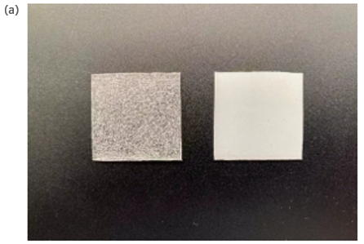

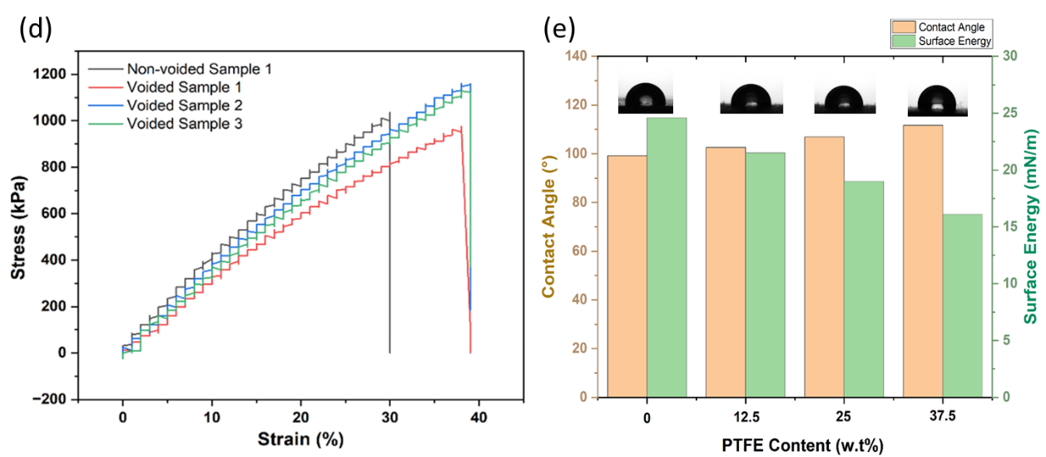

Figure 9: Comparison between the pure PDMS ferroelectret and composite PDMS/PTFE ferroelectret samples; (a) Photo of samples, pure PDMS (left) and composite PDMS/PTFE (right); (b) The effective piezoelectric coefficient d33e of the PDMS and PDMS/PTFE samples tested over a period of 2 months; (c) The peak output voltage of the PDMS and PDMS/PTFE samples under compressive force of 300 N tested over 2 months; (d) the tensile tests results of composite materials with and without voids; (e) Contact angle and surface energy variation of ferroelectrets with different PTFE content.

The peak output voltage of the pure PDMS and composite PDMS/PTFE samples was monitored under different compressive forces ranging from 50 to 400 N. Results were averaged over 20 cycles applied at a frequency of 1 Hz and are shown in Figure 10(a). The peak output voltage increases linearly with increasing force from 50 to 300 N after which it remains constant despite increased pressure. This indicates that at around 300 N the inner voids in the ferroelectret have been fully compressed. To explore the sensitivity and linearity of each ferroelectret, the least square method was used to form the straight-line approximations shown in Figure 10(a) [[37]]. Sample sensitivity can be determined from the slope of the dotted straight-line approximations and are 25.2 and 12.4 mV/N for the composite PDMS/PTFE and the pure PDMS ferroelectret samples respectively.

Nonlinearity error, δ, can be expressed by Equation (12) [[38]],

(13)

where ${∆Y}_{max}$ is the maximum deviation between measuring results and the straight-line approximation and $Y$ is the full scale. The nonlinearity error for the pure PDMS and composite PDMS/PTFE ferroelectret samples was 9.6% and 4% respectively. In addition, the linearity can also be characterized by the R2 coefficient of determination where the closer R2 is to 1 the better the linearity. The nonlinearity error correlates with the R2 values given in Figure 10(a) and indicate the PDMS/PTFE has improved linearity compared to the PDMS ferroelectret.

Hysteresis is shown in Figure 10(b) and Figure 10(c) where the applied force has been incrementally increased and then decreased in 50 N steps. The hysteresis error $h^{'}$ can be calculated by Equation (13),

$h^{'}=\frac{{∆h}_{max}}{Y}×100\%$ (14)

where ${∆h}_{max}$ is the maximum difference between the outputs in the increasing and decreasing directions. The hysteresis error of the pure PDMS and the PDMS/PTFE composite ferroelectret are 13.8% and 4.2% respectively. The hysteresis occurs due to nonlinearities in the sample stiffness and the surface energy of the materials which affects how the bubble surfaces release as the force is removed. The drift in the hysteresis curves occurs due to charge accumulation where the material does not fully discharge between cycles. This leads to residual charge buildup and the electric displacement field D is not perfectly continuous, resulting in the shifting of the curves. The composite PDMS/PTFE ferroelectret has improved sensing properties possessing higher sensitivity, improved linearity and reduced hysteresis error. Also considering the improved charge stability, the composite material is most promising for use in sensing applications.

Figure 10: (a) The peak output voltage versus compressive force applied 1 Hz on samples within 10 minutes of corona poling with a least square fitted curve in the linear region; (b) the hysteresis loop of the composite PDMS/PTFE ferroelectret; (c) the hysteresis loop of the pure PDMS ferroelectret,

Figure 11: (a) The power management circuit and the capacitor charging curve up to 40 s; (b) Current and voltage output as a function of load resistance; (c) Output power as a function of load resistance. For graphs (a) to (c) a compressive force of 300 N was applied at 1 Hz.

The decay over time in the output voltage of the PDMS ferroelectret prevents its use in practical energy harvesting applications. The power output of the composite PDMS/PTFE ferroelectret and its potential for use in energy harvesting applications has been explored when subject to a cyclical mechanical compressive load of 300 N at 1 Hz for 40 s. The electrical output was connected to a 10 μF capacitor via a full bridge rectifier power management circuit shown in Figure 11(a). The voltage across the capacitor increased to 0.26 V after 40 cycles equating to a total stored energy of 0.338 μJ. The average energy stored is 8.45 nJ per cycle i.e. 8.45 nW. The power output is low, but the power management circuit is not optimized. Strategies for improving circuit efficiency for high-impedance energy harvesters have been presented that have demonstrated an increase in the energy stored in a 1 mF capacitor by a factor of 128 times when compared with a full bridge rectifier circuit [[39]]. The output current, voltage and power versus load resistance are given in Figure 11(b) and Figure 11(c). Maximum output power occurs at a load resistance of 20 MΩ, with a peak power output of 5.2 μW.

1. Conclusions

This work presents a simplified method to obtain PDMS ferroelectrets containing a large number of random voids formed using a high-speed stirring process. Although this method does not precisely control the geometry of the voids inside the ferroelectret, it is a very rapid and convenient method of fabrication. This paper has demonstrated that the approach for forming bubbles does result in a ferroelectret structure and the ferroelectret properties improve with increasing bubble percentage. The bubble percentage can be increased significantly by the correct processing warm-up and curing temperatures whilst the stirring parameters do not have a significant effect on the bubble percentage. Optimum process parameters were identified to be warm-up temperature of 80oC with the PDMS stirred for 40 s at 2000 rpm and then cured at 150oC. Due to the random nature of the bubble size and location, there is some variability between sample properties and alternative approaches to bubble formation should be investigated to improve repeatability.

PDMS is not a good electret material and the surface charge stability on the void surfaces of the PDMS is poor, causing the effective piezoelectric coefficient of samples to fall from 235 pC/N to 50 pC/N after two months. The addition of PTFE powder does improve charge density and stability considerably but its impact on the surface energy of the PDMS prevents the bonding of multiple layers typically used to form the void geometries within the PDMS. The bubble-forming process does not require any bonding steps and therefore can therefore be used to rapidly fabricate composite PDMS/PTFE ferroelectrets. This enables the benefits of the PDMS/PTFE composition including the improved and more stable d33e to 384 pC/N which falls and levels off at 186 pC/N after 2 months. The composite PDMS/PTFE ferroelectret also demonstrated superior properties for sensing applications with improved sensitivity, reduced nonlinearity and reduced hysteresis when compared with the pure PDMS ferroelectret. The energy harvesting potential of the PDMS/PTFE ferroelectret was explored experimentally and found to deliver average output power of 8.45 nW to a capacitive load after rectification. This is limited by the power management circuit which requires optimisation.

**Acknowledgements**

This work was supported in part by the Engineering and Physical Sciences Research Council under grant EP/P010164/1. The work of Steve Beeby was supported by the Royal Academy of Engineering under the Chairs in Emerging Technologies Scheme.

**Data availability statement**

All data that support the findings of this study are included in the article.

**Conflict of interest**

The authors declare that they have no conflict of interest.

**Ethical statement**

The work was carried out using commercially available materials, did not involve human subjects and did not require review by the research ethics committee.

**References**

1. [] Gerhard-Multhaupt R 2002 Less can be more. Holes in polymers lead to a new paradigm of piezoelectric materials for electret transducers. *IEEE Transactions on Dielectrics and Electrical Insulation*, 9, 850-859, doi: 10.1109/TDEI.2002.1038668.
2. [] Bauer S, Gerhard-Multhaupt R and Sessler G M, 2004. Ferroelectrets: Soft Electroactive Foams for Transducers. *Physics Today*, 57(2), pp.37-44.
3. [] Zhang, Y., Bowen, C.R., Ghosh, S.K., Mandal, D., Khanbareh, H., Arafa, M. and Wan, C., 2019. Ferroelectret materials and devices for energy harvesting applications. *Nano Energy*, 57, pp.118-140.
4. [] Mellinger, A., Wegener, M., Wirges, W., Mallepally, R. R., & Gerhard-Multhaupt, R., 2006. Thermal and Temporal Stability of Ferroelectret Films Made from Cellular Polypropylene/Air Composites. *Ferroelectrics*, 331(1), 189–199. https://doi.org/10.1080/00150190600737933.
5. [] Qiu, X., 2010. Patterned piezo-, pyro-, and ferroelectricity of poled polymer electrets. *Journal of Applied Physics*, 108(1), p.8.
6. [] Moreira, M. M. A. C., Soares, I. N., Assagra, Y. A. O., Sousa, F. S. I., Nordi, T. M., Dourado, D. M., Gounella, R. H., Carmo, J. P., Altafim, R. A. C., Altafim, R. A. P., 2021. Piezoelectrets: A Brief Introduction. *IEEE Sensors Journal*, 21(20), 22317-22328.
7. [] Bauer, S., 2006. Piezo-, pyro-and ferroelectrets: soft transducer materials for electromechanical energy conversion. *IEEE Transactions on Dielectrics and Electrical Insulation, 13*(5), pp.953-962.
8. [] Mohebbi, A., Mighri, F., Ajji, A., and Rodrigue, D. (2018). Cellular polymer ferroelectret: a review on their development and their piezoelectric properties. *Advances in Polymer Technology*, 37(2), 468-483.
9. [] González-Losada, P., Yang, H., Pinto, R. M. R., Faraji, M., Dias, R., and Vinayakumar, K., 2022. Flexible ferroelectret for zero power wearable application," *IEEE International Conference on Flexible and Printable Sensors and Systems (FLEPS)*, Vienna, Austria, pp. 1-4, doi: 10.1109/FLEPS53764.2022.9781488.
10. [] Yong, S., Shi, J. and Beeby, S., 2019. Wearable Textile Power Module Based on Flexible Ferroelectret and Supercapacitor. *Energy Technol.,* 7: 1800938. https://doi.org/10.1002/ente.201800938
11. [] Xiang, X., Ma, X., Zhou, L., Sessler, G.M., von Seggern, H., Dali, O.B., Kupnik, M., He, P., Dai, Y. and Zhang, X., 2023. Threadlike Piezoelectric Sensors Based on Ferroelectrets and Their Application in Washable and Breathable Smart Clothing. *Adv. Mater. Technol.,* 8: 2202130. https://doi.org/10.1002/admt.202202130
12. [] Altmann, A. A., et al., 2024. Flexible Shielded Sensors Based on Biocompatible Ferroelectrets for Heart Rate Monitoring, 2024 IEEE International Conference on Flexible and Printable Sensors and Systems (FLEPS), Tampere, Finland, 2024, pp. 1-4, doi: 10.1109/FLEPS61194.2024.10603940
13. [] Altmann, A. A., et al., 2024, Flexible 3D Printed Ferroelectret Sensors Integrated into Smart Textiles for Unobtrusive Monitoring, 2024 IEEE International Conference on Flexible and Printable Sensors and Systems (FLEPS), Tampere, Finland, 2024, pp. 1-4, doi: 10.1109/FLEPS61194.2024.10604067.
14. [] Liu, Y., Wu, C., Qiu, X., Xu, P., Xiang, Y., Xuan, F.-Z., 2024. Air-cavity-free multiphase composite piezoelectrets with high piezoelectric sensitivity for self-powered flexible sensors and energy harvesters, *Appl. Mater. Today*, Vol 37, 102096, https://doi.org/10.1016/j.apmt.2024.102096.
15. [] Schäfer N., et al., 2024. Wearable Ferroelectret Sensors for Muscle Activity Measurements, 2024 IEEE Ultrasonics, Ferroelectrics, and Frequency Control Joint Symposium (UFFC-JS), Taipei, Taiwan, pp. 1-4, doi: 10.1109/UFFC-JS60046.2024.10793709.
16. [] Holzmann H et al 2023 Design and optimization of lightweight bending strain energy harvesters using irradiation cross-linked polypropylene ferroelectret, *Smart Mater. Struct.* 32 125013
17. [] Wang, N., Zhang, H., Qiu, X., Gerhard, R., van Turnhout, J., Cressotti, J., Zhao, D., Tang, L., Cao, Y., 2024. Recent Advances in Ferroelectret Fabrication, Performance Optimization, and Applications. *Adv. Mater.*, 36, 2400657. https://doi.org/10.1002/adma.202400657
18. [] Adhikary, P., Garain, S. and Mandal, D., 2015. The co-operative performance of a hydrated salt assisted sponge like P (VDF-HFP) piezoelectric generator: an effective piezoelectric based energy harvester. *Physical Chemistry Chemical Physics*, 17(11), pp.7275-7281.
19. [] Ansari, M.A. and Somdee, P. 2022. Piezoelectric Polymeric Foams as Flexible Energy Harvesters: A Review. *Adv. Energy Sustainability Res*., 3: 2200063. https://doi.org/10.1002/aesr.202200063
20. [] Ray, C.A. and Anton, S.R., 2015, April. Evaluation of piezoelectret foam in a multilayer stack configuration for low-level vibration energy harvesting applications. In Active and Passive Smart Structures and Integrated Systems 2015 (Vol. 9431, pp. 328-338). SPIE.
21. [] Luo, Z., Zhu, D., Shi, J., Beeby, S., Zhang, C., Proynov, P., Stark, B., 2015. Energy harvesting study on single and multilayer ferroelectret foams under compressive force. *IEEE Transactions on Dielectrics and Electrical Insulation*, 22(3), pp. 1360-1368, doi: 10.1109/TDEI.2015.7116323.
22. [] Luo, Z., Zhu, D., Beeby, 2015. Multilayer ferroelectret-based energy harvesting insole. J*. Phys.: Conf. Ser.,* 660, 012118. DOI 10.1088/1742-6596/660/1/012118
23. [] Wang, N. et al 2024. Macro-dipoles in soft/hard expanded-polytetrafluoroethylene + fluoroethylenepropylene (ePTFE + FEP) fluoropolymer-film systems for high-output piezoelectric ferroelectret-transducer applications, *J. Phys. D: Appl. Phys.* 57 145502
24. [] Wang J.J., Hsu, T.H., Yeh, C.N., Tsai, J.W. and Su, Y.C., 2011. Piezoelectric polydimethylsiloxane films for MEMS transducers. *Journal of Micromechanics and Microengineering*, 22(1), p.015013.
25. [] Wang, Z., Volinsky, A. A., & Gallant, N. D., 2014. Crosslinking effect on polydimethylsiloxane elastic modulus measured by custom‐built compression instrument. *Journal of Applied Polymer Science*, 131(22), 41050.
26. [] Zhukov, S., Fedosov, S. and von Seggern, H., 2011. Piezoelectrets from sandwiched porous polytetrafluoroethylene (ePTFE) films: influence of porosity and geometry on charging properties. *Journal of Physics D: Applied Physics*, 44(10), p.105501
27. [] Shi, J., Zhu, D., and Beeby, S.P., 2014. An investigation of PDMS structures for optimized ferroelectret performance. *J. Phys.: Conf. Ser*. 557, 012104. DOI 10.1088/1742-6596/557/1/012104
28. [] Shi, J., Luo, Z., Zhu, D., Beeby, S., 2019. Optimization a structure of MEMS based PDMS ferroelectret for human body energy harvesting and sensing. *Smart Mater. Struct.* 28 075010. DOI 10.1088/1361-665X/ab1ce2
29. [] Kachroudi A., Basrour S., Rufer L., Sylvestre A., Jomni F. 2016. Micro-structured PDMS piezoelectric enhancement through charging conditions. *Smart Mater. Struct*. 25 105027
30. [] Song, Z.; Cai, X.; Chen, Z.; Zhu, Z.; Cao, Y.; Li, W. Ultrathin, Stretchable, and Twistable Ferroelectret Nanogenerator for Facial Muscle Detection. *Nanoenergy Adv*. 2024, 4, 344-354. https://doi.org/10.3390/nanoenergyadv4040021
31. [] F. Owusu, F. A. Nüesch, D. M. Opris, 2022. Stretchable High Response Piezoelectric Elastomers Based on Polable Polynorbornene Fillers in a Polydimethylsiloxane Matrix. *Adv. Funct. Mater.* 32, 2207083.
32. [] M. Zhang, J. Shi and S. P. Beeby, "A new approach for obtaining PDMS ferroelectrets with random voids," 2021 IEEE 20th International Conference on Micro and Nanotechnology for Power Generation and Energy Conversion Applications (PowerMEMS), Exeter, United Kingdom, 2021, pp. 184-187, doi: 10.1109/PowerMEMS54003.2021.9658404.
33. [] M. Zhang, J. Shi, S.P. Beeby, 2023 Improved charge density and stability in PDMS ferroelectrets using PDMS/PTFE composite materials, *Sensors and Actuators A: Physical* 364, 114763, https://doi.org/10.1016/j.sna.2023.114763.
34. [] G.Z. Li, G.G. Wang, D.M. Ye, X.W. Zhang, Z.Q. Lin, H.L. Zhou, F. Li, B.L. Wang, J.C. Han 2019. High‐performance transparent and flexible triboelectric nanogenerators based on PDMS‐PTFE composite films, *Adv. Electron. Mater*., 5 (4) p. 1800846
35. [] Paajanen, M., Lekkala, J. and Valimaki, H., 2001. Electromechanical modeling and properties of the electret film EMFI. *IEEE Transactions on Dielectrics and Electrical Insulation* 8(4), pp.629-636.
36. [] Zhukov S, Fedosov S, von Seggern H, 2011 Piezoelectrets from sandwiched porous polytetrafluoroethylene (ePTFE) films: influence of porosity and geometry on charging properties. *J. Phys. D: Appl. Phys.* 44, 105501
37. [] Abdi, H. and Williams, L.J., 2013. Partial least squares methods: partial least squares correlation and partial least square regression. In Computational toxicology (pp. 549-579). Humana Press, Totowa, NJ.
38. [] Huang, Y., Zhang, S., Gao, L. and Zheng, Y., 2020. Angle measurement technology based on magnetization vector for narrow space applications. *Nanotechnology and Precision Engineering* 3(3), pp.167-173.
39. [] F. Xi, Y. Pang, W. Li, T. Jiang, L. Zhang, T. Guo, G. Liu, C. Zhang, Z.L. Wang 2017 Universal power management strategy for triboelectric nanogenerator, *Nano Energy*, 37 (), pp. 168-176.