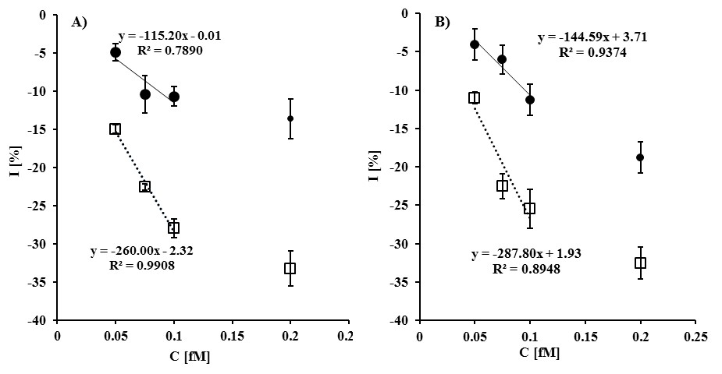
AgNSs 1/10 |  |  |  |  | AgNSs 1/200
C [fM] | nc-ssDNA |  | c-ssDNA |  | C [fM] | nc-ssDNA |  | c-ssDNA
C [fM] | I, % | SD | I , % | SD | C [fM] | I, % | SD | I,% | SD
0.05 | -4.91 | 2.44 | -14.96 | 0.4 | 0.05 | -4.05 | 2.07 | -11.04 | 0.76
0.075 | -10.37 | 1.27 | -22.54 | 1.21 | 0.075 | -6.05 | 1.88 | -22.51 | 1.62
0.1 | -10.67 | 2.62 | -27.96 | 0.97 | 0.1 | -11.28 | 2.05 | -25.43 | 2.53
0.2 | -13.61 | 2.6 | -33.25 | 2.33 | 0.2 | -18.79 | 2.05 | -32.53 | 2.06

