Error Assessment of a Three-Dimensional Underwater Motion Capture

Author Information

**Dr Isobel M. Thompson** (PhD). Research Fellow, Performance Sports Engineering Laboratory, Faculty of Engineering and Physical Sciences, University of Southampton, Southampton, UK

ORCID ID: https://orcid.org/0000-0002-2788-1675

LinkedIn: www.linkedin.com/in/isobelmargaretthompson

Twitter: @IsobellThompson

Dorian A. G. Audot, Research Fellow, Performance Sports Engineering Laboratory, Faculty of Engineering and Physical Sciences, University of Southampton, Southampton, UK

ORCID ID: https://orcid.org/0000-0003-1538-7562

LinkedIn: www.linkedin.com/in/dorian-audot

Twitter: @AudotDorian

Dr Martin B. Warner (PhD). Associate Professor in Musculoskeletal Biomechanics. Performance Sports Engineering Laboratory, School of Health Sciences, University of Southampton, Southampton, UK

ORCID ID: https://orcid.org/0000-0002-1483-0561

LinkedIn: www.linkedin.com/in/martin-warner-a2992a16

Twitter: @MartinBWarner

Dr Joseph Banks (PhD). Associate Professor in Maritime Engineering. Performance Sports Engineering Laboratory, Faculty of Engineering and Physical Sciences, University of Southampton, Southampton, UK

ORCID ID: https://orcid.org/0000-0002-3777-8962

LinkedIn: www.linkedin.com/in/joe-banks-05b35382

Oliver Logan. Head of Innovation, Biomechanics and Performance Analysis, Aquatics GB, Sportpark, Loughborough University, Loughborough, UK

ORCID ID: https://orcid.org/0000-0003-3871-4079

LinkedIn: www.linkedin.com/in/oliver-logan-aa60573a/

Twitter: @ollylogo

Professor Dominic Hudson (PhD). Shell Professor of Ship Safety and Efficiency, Performance Sports Engineering Laboratory, Faculty of Engineering and Physical Sciences, University of Southampton, Southampton, UK

ORCID ID: https://orcid.org/0000-0002-2012-6255

LinkedIn: www.linkedin.com/in/dominic-hudson-580b743

Corresponding Author Contact Details:

Isobel Thompson

Email Address: i.m.thompson@soton.ac.uk, Phone: 02380596616

Methodology

Disclaimers:

The views expressed in this article are the author’s own and not an official position of the institution

or funder.

Disclosure Statement:

The authors report there are no competing interests to declare.

Word Count (excluding abstract, acknowledgements, tables, figures, and references): **4294**

# ABSTRACT

Motion analysis technology is used in various settings to assess human kinematics. Assessing human movement underwater presents many challenges, making it important to understand measurement error associated with the setup and calibration of the system ensuring accuracy in resulting kinematics. This study assessed the accuracy across the entire domain of a submerged motion capture methodology. Six Qualisys cameras created an underwater capture volume of 6.9 x 2.1 x 2.1 m3. Average error levels were acceptable in four uncertainty trials (< 5 mm error). By selecting an area of interest that excluded areas with low accuracy near domain borders, measurement error reduced by up to 0.13 mm, up to 1.27 mm lower than outside this area. Interpolated error indicated that intracyclic measurement error may alter measured kinematics by up to 13.80 mm, with error greater than 5 mm affecting over 50 % of the kick cycle. Investigating error levels across the domain can inform researchers whether a recalibration is necessary or help to identify areas where high error levels would affect kinematics. This study highlights the need to investigate error levels across a motion capture domain, particularly when this is a large volume, to ensure results obtained from investigations are reliable.

# INTRODUCTION

Three-dimensional optoelectronic motion capture systems are frequently utilised to assess human

movement in sports biomechanics (Atack et al., 2019; Sado et al., 2020; Shimojo et al., 2019). This

technology is considered the gold standard method of kinematic acquisition (Corazza et al., 2010; Kruk & Reijne, 2018). It is important to assess human sporting motion in a representative setting to

the sporting field to best replicate realistic movement and ensure relevant practical application of

results (Kruk & Reijne, 2018). In applied swimming settings, these methods are commonly used to

assess and improve athletes’ performance (Atkison et al., 2014; Higgs et al., 2017; McCabe et al., 2015). Measuring kinematics underwater can provide valuable information about how the body

moves when submerged. However, this can present challenges regarding the implementation of

motion capture methods.

There are a limited number of motion capture systems capable of capturing submerged kinematics. Those available are costly and require increased resources to set up; these systems are not usually permanently installed in the pool environment and must be set up for each data collection session. When recording aquatic-based motion, there is increased refraction (Gourgoulis et al., 2008; Kwon & Casebolt, 2006), reflection (Phillips et al., 2014) and bubbles (Kadi et al., 2022; Monnet et al., 2014), which all affect the accuracy of kinematic capture. These occurrences can cause interference and disrupt signals between the cameras and markers, leading to inaccuracies within data.

When assessing human motion underwater it is necessary to capture multiple movement cycles for

analysis, which will require a longer calibrated volume. An example of a fully submerged human motion is underwater fly kick, performed at the start and turns of competitive swimming events, where undulatory waves propagate from the fingertips to the toes to generate forward propulsion (Connaboy et al., 2010; Pacholak et al., 2014; Ruiz-Navarro et al., 2022). For reliable analysis of this motion, it has been suggested that three to six complete cycles are required (Connaboy et al., 2010). Athletes typically travel between 0.58 m and 0.81 m per cycle (Arellano et al., 1999; Shimojo et al., 2014; Wądrzyk et al., 2017; Wądrzyk et al., 2021), and the whole body must be inside the domain to capture kinematics (2.5 m streamlined body length, (Novais et al., 2012; Von Loebbecke et al., 2009)). According to these estimates, the domain length must be a minimum of 4.93 m to capture three complete kick cycles and 7.36 m to capture six full cycles.

In freestyle swimming, an athlete typically travels between 1.96 and 2.35 m per stroke cycle (Gonjo et al., 2022; Morais et al., 2023; Pelayo et al., 1996). Again, considering a typical 2.5 m body length (Novais et al., 2012; Von Loebbecke et al., 2009) the domain length required to capture two stroke cycles for a full body would be 7.20 m, increasing to 11.90 m for four stroke cycles. Where reported, previous assessments of free swimming typically cover a domain length of 4.50 m to 7.50 m (Andersen et al., 2020; Kudo et al., 2017; McCabe et al., 2015; Psycharakis & Sanders, 2008), and fully submerged studies between 4.37 m and 5.00 m (Higgs et al., 2017; Wądrzyk et al., 2017). Shorter domain lengths do not allow for variations in movement patterns (Mooney et al., 2015) and the capture of consistent cycles (Connaboy et al., 2010) to be fully observed. However, as domain volume increases, the levels of accuracy decrease (Kruk & Reijne, 2018). The accuracy of a measurement system is inversely proportional to the size of the measurement volume (Kruk & Reijne, 2018). Measurement error for three-dimensional analysis of less than 5 mm is considered acceptable in swimming applications (Mooney et al., 2015).

Increasing the domain length will also allow for the capture of more consistent cycles, as velocity has been shown to change throughout the underwater phase (Gonjo & Olstad, 2020). Researchers have used flumes (Narita et al., 2018; Shimojo et al., 2019) to overcome the issue of increasing domain length, however it is unclear whether this method alters kinematics. There are also limited facilities available for researchers to use this method. Another similar approach is tethered swimming, where an athlete is attached to a rope secured to the wall, allowing them to swim at a constant location. This technique has been shown to alter observed kinematics (Amaro et al., 2017; Samson et al., 2019).

Measurement error encountered within motion capture domains is not always reported. Where it is, this is typically either a mean measurement error calculated by the researcher or reported by the motion capture system (Kudo et al., 2017; McCabe et al., 2015; Psycharakis & Sanders, 2008). The effects on varying levels of error throughout an entire motion capture domain on cyclical movements has not previously been considered. Due to the importance of maintaining domain length in submerged environments, assessing and maintaining high accuracy across all domain areas becomes important to ensure reliable resulting kinematics. Only a few studies have attempted to investigate submerged motion capture domain error.

Previous assessments of accuracy in submerged motion capture domains have included discussions about error variations across the capture domain (Bernardina et al., 2016; Monnet et al., 2014; Silvatti et al., 2012). These studies detail methodologies evaluating error relative to wand or marker positions within the working volume, employing techniques such as wand-based calibration and nonlinear distortion modelling (Bernardina et al., 2016; Silvatti et al., 2012) to achieve error equalisation, ensuring error is consistent throughout the calibration domain. However, previous work has typically investigated relatively small capture volumes, up to 4.5 m with two wide-angle cameras (Silvatti et al., 2012), which may not represent the larger volumes required to capture complex cyclical human motion. Furthermore, the influence of measurement error on the accuracy and interpretation of kinematic outputs has not been considered.

This study aims to assess the accuracy levels across the entire domain of a fully submerged three-dimensional optoelectronic motion capture methodology, considering the potential impacts of observed error upon measured kinematics within movement cycles. It is hypothesised that although the average measurement error of the domain will be acceptable, variations in accuracy throughout the capture volume will lead to alterations in measured kinematics, producing imprecise results. This paper contributes to our understanding of how high measurement error areas in a large calibrated volume affect the kinematics of an underwater fly kick trial.

# MATERIALS AND METHODS

A six-camera optoelectronic Qualisys system (Qualisys Oqus 510+ Underwater, Göteborg, Sweden) was used for this methodology. Cameras were placed beneath the surface of the water spaced between 5-20 meters along one side of the swimming pool (Figure 1). The cameras were located only on one side of the pool since the motion captured in this example, underwater fly kick, is symmetrical across the body only one side of the body is captured. Calibration processes were completed as specified by the manufacturer (Qualisys, 2022a) 30 minutes after the cameras were installed and turned on. A static L-frame with four markers of known distance was placed at the bottom of the pool at the centre of the domain. In this instance, the pool floor was level without a downward slope. A wand with two 16 mm super spherical underwater markers of known distance from one another (601.3 mm) was then waved continuously and in a variety of directions throughout the capture domain, recorded as a 120 second calibration trial. Following the calibration procedure, the Qualisys system automatically provided the average difference between the actual and tracked wand length.

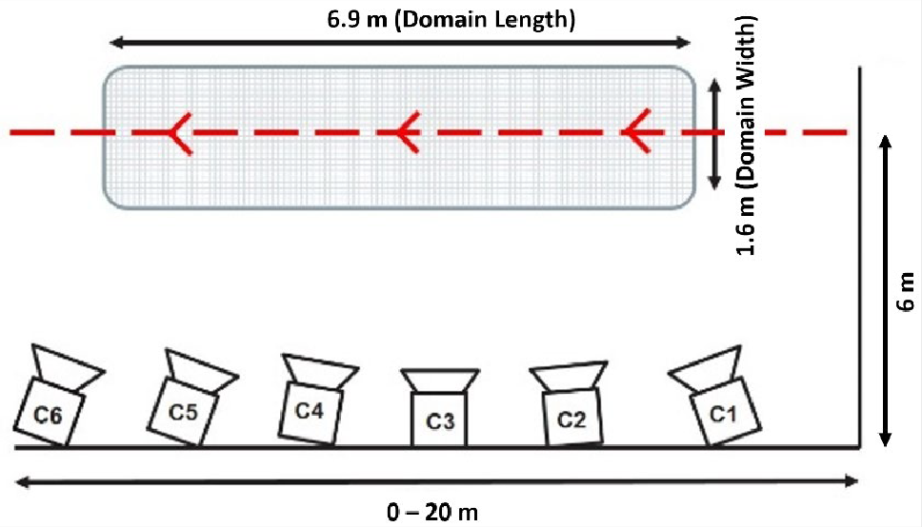

*Figure 1. Camera placement set up for underwater fly kick kinematic acquisition. Red line indicates the swimming path of*

*the participant through the capture domain (greyed area). Camera orientations depicted are a general indication rather*

*than measured location.*

Following calibration, the investigator completed four uncertainty trials as follows: 1) initial random wand wave completed before testing, 2) systematic domain length trial 3) systematic domain sectioning trial and 4) secondary random wand wave completed post-testing. The testing session consisted in gathering kinematic data of various athletes performing underwater motion. For this reason, the secondary random wand wave trial was completed approximately three hours after the initial random wand wave trial. During these random wand waving trials, the investigator used sweeping motions with the wand throughout the capture volume. This process was completed immediately before and after an experimental testing session to determine whether the calibration remained valid over a three-hour data collection session. For the domain length trial, the wand was presented up and down the length of the domain at proximal, mid, and distal distances from the camera system. During the systematic domain length trial, the operator used sweeping motions every one metre, resulting in an analysis of seven sections of the domain. In all cases, the operator was informed when the markers left the view of the cameras at each end of the domain. Each trial was 120 seconds in duration.

The global coordinate system was defined with the X, Y and Z axes representing the domain length, domain width and domain height, respectively. The trajectories of the two wand markers were reconstructed and labelled only when both markers were in view. Reconstructed trajectories were not gap-filled to ensure any errors observed were related to measurement errors rather than errors due to gap filling techniques. The distance between the remaining trajectories of the reconstructed markers was then calculated as a function of time and was compared to the known distance between the markers on the calibration wand. Mean measurement error, standard deviation (SD), minimum and maximum errors were calculated and expressed as measurement differences to the known length of the calibration wand. The wand coordinate data from the random wand waving trial and systematic sectioning trial were combined, and a linear interpolation of the inter-marker distance absolute error data was completed. Wand velocity was calculated as the derivative of the resultant wand mid-point trajectory.

The dimensions of the calibrated volume border in the X, Y and Z planes were recorded every 0.5 m, and this was reconstructed as a three-dimensional volume of interest (Figure 2). Any trajectories falling outside the dimensions of the reconstructed calibrated volume of interest were excluded.

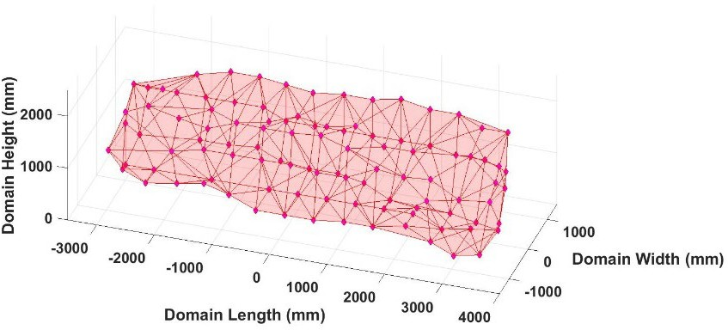

*Figure 2. Submerged calibrated volume of interest estimated from the X, Y and Z border coordinate data at every 0.5 m.*

To assess the tracking accuracy and volume of data collected in each set up condition, one trained male swimmer was recruited to participate in a simple data collection session (age 21 years, height 1.93 m, weight 87.10 kg, FINA points score 651). All data was collected under approval from the University of Southampton Faculty of Engineering and Physical Sciences Ethics Committee (ethics number: 62029), and the participant provided informed consent. The studied human movement was the underwater fly kick, as this is a motion performed when fully immersed, allowing for the analysis of effects of error in a fully submerged motion capture domain. A single 16 mm super-spherical reflective Qualisys marker was placed on the fifth metatarsal to identify the number of underwater fly kick cycles captured. A kick cycle is defined as the maximum toe location to the following maximum toe location, and kick amplitude as the average vertical displacement (mm) of the toe from its maximum to minimum vertical position. Vertical toe velocity was calculated as the derivative of the vertical toe trajectory. The marker was attached to the skin using black kinesiology tape (Rocktape, Durham, UK) and skin-safe special effects glue (Telesis 8 Silicone Adhesive, Mouldlife, Suffolk, UK). Following a self-directed warm-up, the participant performed three maximum-paced underwater fly kick trials from a push off the wall. The participant was asked to swim through the centre of the capture domain up to a distance of 20 m.

The trials were reconstructed and labelled within QTM (Qualisys Track Manager 2023.2), and any gaps in the toe trajectory were filled. The maximum gap length for all trials was five frames, and the number of gaps ranged from one to five. As swimming velocity was consistent for all trials, the trial with the minimum number of gaps was selected for analysis to reduce the effects of gap-filling techniques on measurement error. Following a residual analysis (Yu et al., 1999), the toe trajectory from the selected trial was filtered using a low pass second order Butterworth filter with a cut off frequency of 39.2 Hz.

# RESULTS

The volume of the capture domain at maximum limits measured 6.9 x 2.1 x 2.1 m3 with cameras located an average of 6 m from the path of the swimmer. Mean measurement error reported by the Qualisys system following calibration was 1.43 mm. This set up captured six underwater fly kick cycles. Average vertical kick amplitude was 582.20 mm, and peak toe vertical velocity was 3.78 m/s. Average wand velocities were recorded at 1.90 m/s ( 0.64 m/s) for initial random wand wave, 2.12 m/s ( 0.80 m/s) for domain sectioning, 2.26 m/s ( 0.82 m/s) for domain length and 2.08 ( 0.79 m/s) for secondary random wand wave uncertainty trials. Across all trials, maximum wand velocity was 3.81 ( 0.20 m/s).

Figure 3 (A-D) presents the domain error encountered in each wand-waving condition. Measurement error levels displayed are limited to 15 mm and -15 mm to prevent oversaturation of results due to extreme values. Deep red and blue areas, mainly located towards the left of the domain indicate overestimation and underestimation of measurement respectively. Although the average measurement error in each condition is acceptable (Table 1), the maximum and minimum levels are both high.

Once cropped to exclude points outside the calibrated volume of interest (Figure, 4 A-D) the domain volume was decreased (6.6 x 2.1 x 1.8 m3). This presented a 4 % decrease in domain length, a 14 % decrease in domain height and no change in domain width. Some areas of higher error towards the left side of the domain were excluded. The average error level was improved in all four conditions (Table 1), however, maximum and minimum measurement error remained similar. Average measurement error outside the calibrated volume of interest was larger than the average measurement error inside the calibrated volume in every condition (Table 2).

It is important to note that the volume of interest is a complex and irregular shape which is difficult to define. Domain depth, particularly towards the left-hand side of the domain, measured a minimum of 0.4 m. This coincides with an area of large underestimation of wand length towards the left of the domain (Figures 3 and 4).

*Table 1. Measurement error levels (mm) across the entire motion capture domain and cropped volume of interest during initial random wand waving, systematic domain length, systematic sectioning and secondary random wand waving uncertainty trials.*

|  |  |  |  |  |
| --- | --- | --- | --- | --- |
|  |  | Average Error ± SD | Maximum Error (mm) | Minimum Error (mm) |
| Entire Domain | Initial Random Wand Wave | 0.04  2.92 | 21.24 | -23.09 |
| Systematic Domain Length | 0.82  1.34 | 2.26 | -4.73 |
| Systematic Domain Sectioning | 0.23  2.79 | 23.78 | -12.25 |
| Secondary Random Wand Wave | 0.17  2.93 | 21.76 | -25.13 |
| Volume of Interest | Initial Random Wand Wave | 0.01  2.69 | 21.24 | -23.09 |
| Systematic Domain Length | 0.69  1.14 | 2.26 | -4.34 |
| Systematic Domain Sectioning | 0.15  2.74 | 9.46 | -12.25 |
| Secondary Random Wand Wave | 0.05  2.59 | 21.76 | -25.13 |

*Table 2. Measurement error levels (mm) encountered outside of the volume of interest boundary during initial random wand waving, systematic domain length, systematic sectioning and secondary random wand waving uncertainty trials.*

|  |  |
| --- | --- |
|  | Average Error   SD (mm) |
| Initial Random Wand Wave | 0.22  3.56 |
| Systematic Domain Length | 1.96  1.93 |
| Systematic Domain Sectioning | 0.81  2.97 |
| Secondary Random Wand Wave | 0.51  3.17 |

|  |
| --- |
| **A)** |
| **B)** |
| **C)** |
| **D)** |

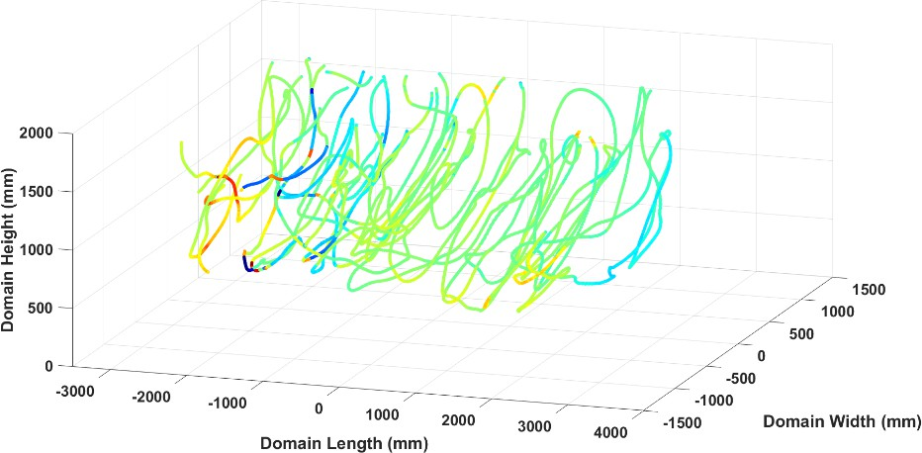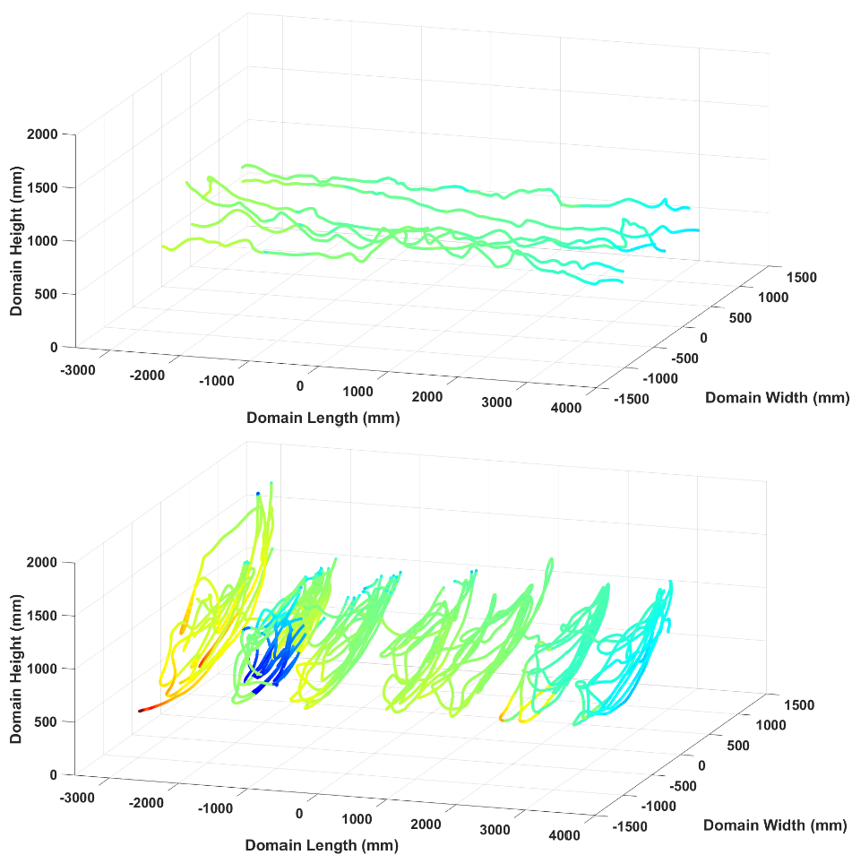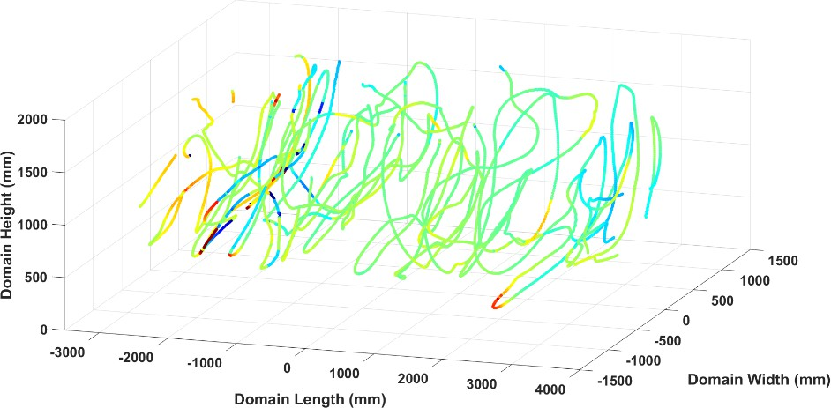

*Figure 3. Measurement error encountered (mm) throughout the entire motion capture domain (left to right) during initial random wand waving (A) systematic domain length (B), systematics domain sectioning (C) and secondary random wand waving (D) trials.*

*Figure 4. Measurement error encountered (mm) within a cropped volume of interest (left to right) during initial random wand waving (E) systematic domain length (F), systematics domain sectioning (G) and secondary random wand waving (H) trials with grey areas representing points excluded outside the volume of interest.*

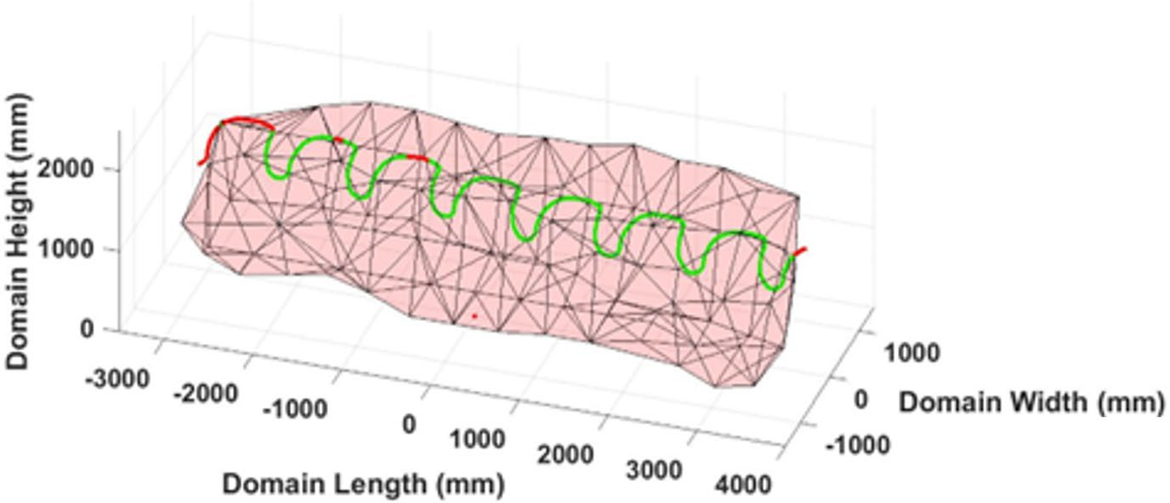

*Figure 5. Underwater fly kick cycle trajectory through the estimated submerged calibrated volume (left to right). Red points represent toe locations outside the calibrated volume of interest, with green points located inside the calibrated volume of interest.*

Once data was cropped to exclude areas outside the calibrated volume of interest three cycles included areas which left the top of the domain boundary (Figure 5). Kick cycle one presented 19% of the kick cycle outside the domain boundaries, kick cycle two presented 12% outside the domain boundaries and kick cycle three presented 6% outside the domain boundaries. The final three kick cycles remained within the domain boundaries for the duration. Kick cycles two and three were heavily affected by elevated levels of error (Figure 6), with a high proportion of points associated with error levels above 5 mm (Table 3). A section of the domain coinciding with these two kick cycles presents a dark red area of substantial error above 5 mm through the vertical plane (Figure 6).

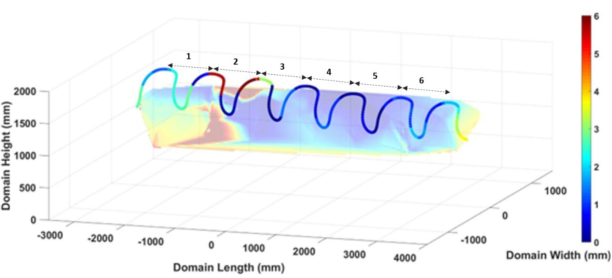

*Figure 6. Interpolated absolute measurement error (mm) of combined random wand wave and systematic sectioning trials at a slice coinciding with the average path of the participant, with kick cycles overlaid (left to right). The colour of the toe trajectory corresponds to the nearest error point in the interpolated uncertainty data.*

*Table 3. Impact of encountered error levels on independent kick cycles within the capture domain.*

|  |  |  |  |  |  |  |
| --- | --- | --- | --- | --- | --- | --- |
|  | Kick Cycle 1 | Kick Cycle 2 | Kick Cycle 3 | Kick Cycle 4 | Kick Cycle 5 | Kick Cycle 6 |
| Measurement Error Above 5 mm (%) | 3.85 | 53.70 | 0 | 0 | 0 | 0 |
| Measurement Error Below 1 mm (%) | 21.15 | 43.59 | 55.56 | 74.07 | 94.34 | 30.91 |
| Average Measurement Error (mm) | 2.15 | 4.76 | 0.97 | 0.66 | 0.43 | 1.23 |
| Maximum Measurement Error (mm) | 5.69 | 13.80 | 3.13 | 1.38 | 1.25 | 1.92 |
| Minimum Measurement Error (mm) | 0.29 | 0.20 | 0.06 | 0.06 | 0.02 | 0.90 |

# DISCUSSION AND IMPLICATIONS

This study aimed to assess measurement accuracy across the entire domain of a fully submerged three-dimensional optoelectronic motion capture methodology. The presented results consider the potential impacts of observed measurement error on measured kinematics within movement cycles.

In all conditions, the absolute measurement error levels indicate that the accuracy of the presented methodology was appropriate (Mooney et al., 2015), and are consistent with previous measurement error encountered in underwater motion capture methodologies using various systems (Bernardina et al., 2016; Monnet et al., 2014; Silvatti et al., 2012, 2013). Previous investigations have indicated that error less than 1 mm may not be relevant when compared to the magnitude of error reported due to marker placement or soft tissue artefact (Raghu et al., 2019). However, the present results demonstrate that the error levels increase up to 25.13 mm in some areas of the domain, highlighting the importance of assessing accuracy across the entire domain rather than relying on average error alone in order to manage any controllable errors. Further, the results of error assessment immediately before and following a testing session provides evidence that the calibration was valid throughout the entire three-hour testing session.

Observation of error across the entire domain reveals that there are areas which present higher levels of error, particularly near the domain boundaries. Three-dimensional motion capture systems require that each marker be seen by at least two cameras, and preferably by three or more (Qualisys, 2022b; Rahimian & Kearney, 2017). Regions of increased error at the two ends of the domain are covered by only two cameras’ fields of view and therefore the accuracy might be compromised. The boundaries of the volume may be near the edges of the image, where lens barrel distortion will be greatest. This, combined with vignetting, may affect the accuracy around the boundaries of the calibrated volume. This phenomenon of spatial distortion in border areas was reported previously when assessing systematic accuracy of land-based motion capture systems (Aurand et al., 2017; Windolf et al., 2008), highlighting the need to provide adequate calibration for all relevant regions of interest. Researchers should consider the expected path of the participant through the water, as well as the proportions of the recorded motion and calibrate accordingly.

A total of six complete kick cycles were captured in a 6.9 m domain length. However, to ensure accuracy in kinematic results the initial two kick cycles should be cropped from analysis as either a substantial portion of the cycle is outside the volume of interest, or the error encountered during the cycle is high. Where reported previously, investigations into the accuracy of submerged motion capture have covered a short domain length between 1.1 m - 4.5 m (Bernardina et al., 2019; Monnet et al., 2014; Silvatti et al., 2012, 2013). In the case of underwater fly kick, these domain volumes may not provide enough coverage to collect the minimum required movement cycles for reliable motion analysis. This certainly would not be possible if areas were cropped due to regions of high error.

The setup presented utilized six cameras, more than in the previous studies cited where two to four cameras were used (Bernardina et al., 2019; Silvatti et al., 2012, 2013), creating volumes between 6.75 m3 and 12 m3. Monnet et al., (2014) used eight Vicon T-40 cameras arranged behind glass windows but produced the smallest domain volume (1.1 m3). Theoretically, researchers can create an increased domain volume more easily with increased camera number, demonstrated by the 38.81 m3 volume presented. This presents a minimum of a 223 % increase in domain volume compared to previous studies. However, a larger domain volume risks increasing measurement and tracking error levels (Kruk & Reijne, 2018), making the evaluation of these imperative for reliable motion analysis.

Considering the peak and minimum measurement error encountered at the participant's path, the measured underwater fly kick amplitude could be altered by up to 13.80 mm if the swimmer's path intersects an area where accuracy is considerably reduced. This value represents 2.37 % of the measured average kick amplitude. The impact of this error will become amplified when calculating within cycles kinematics, especially for metrics where markers are close to one another such as ankle joint angular kinematics, which recent investigations have shown to be critical in underwater fly kick performance (Matsuda et al., 2021). Additionally, three of the six observed kick cycles had their maximum toe location outside the calibrated volume. These critical data points define the start and end of successive movement cycles and may therefore have significant knock-on effects as other within cycle metrics are calculated.

The speed at which the carbon fibre calibration wand is waved may be important in understanding system accuracy. When the wand is moved at high speeds underwater, vortices shed

by this structure induce vibration, causing deformation of the wand shape. Consideration of the

speed of this motion is therefore necessary to accurately represent the target movement, whilst not

introducing errors due to high wand speed. During underwater fly kick the fastest moving body

location is the toe, where vertical velocity is reported within the literature between 3.28 m/s and

4.10 m/s (Higgs et al., 2017; Tanaka et al., 2022; Yamakawa et al., 2017, 2022). The average wand

speed reported of 2.09 m/s is therefore appropriate to the motion. No previous studies have

reported the calibration wand speed in direct relation to the target motion captured.

Once the domain was cropped to include only the calibrated volume of interest, the impact of

spatial distortion near calibration boundaries was reduced. Analysis of measurement error inside

and outside the domain revealed a small decrease of up to 0.13 mm in average error encountered. A

restriction of the motion capture software is the lack of ability to export the dimensions of

the calibrated volume directly. As these shapes are often irregular, it is not accurate to rely on the maximum boundary dimensions alone. An analysis of the domain error immediately post-calibration may inform researchers whether there are areas of the calibrated volume with high error levels, which may require repeated calibration. Further, manipulation of the volume of interest post-testing may be useful for researchers to decide from where to collect reliable data.

Despite observing similarly high levels of error near domain boundary edges, the analysis of accuracy

in a land-based Vicon-460 system revealed improved accuracy than reported within the present

study; the minimum accuracy reported was 0.13 mm and the highest accuracy was 0.08 mm, varying depending upon camera set up and calibration method (Windolf et al., 2008). Further, using a forty-

two camera OptiTrack Prime 41 system, (Aurand et al., 2017) recorded error levels of 0.20 mm. This

is likely due to the inherent differences between capturing laboratory-based data on land and field-

based data in water. A previous comparison between the accuracy of motion capture in air and water

revealed a 5.73 mm increase in error within water-based assessment (Monnet et al., 2014).

In comparing three wand-waving techniques, Bernardina et al., (2016) reported that up-down motions produced significantly higher error (2.63 mm) compared to zigzag (1.17 mm) and circular (1.28 mm) motions (p < 0.001). The random wand wave trials presented in the current study included a combination of these movements, likely influencing the error observed. Moving the wand systematically through the capture volume will lead to the best accuracy results (Bernardina et al., 2016). The benefit of using a systematic approach to calibration is also reflected in the land-based results of Windolf et al., (2008), where a robot driven systematically along a programmed motion path produced increased calibration accuracy levels compared to a manual wand waving technique (0.08 mm compared to 0.12 mm respectively). The systematic trials in the present study did yield improved accuracy levels when compared to random wand waving both in the entire domain and cropped volume of interest.

The duration of the uncertainty capture trials was longer in duration than in previous reports of

error estimation. Where reported, these have been between 5 - 15 seconds in duration (Bernardina

et al., 2016; Monnet et al., 2014; Silvatti et al., 2012, 2013), however a longer calibration duration is

necessary to fully calibrate the desired volume with respect to the human motion measured, and to

understand fully the error change across the entire domain length. This will potentially increase the

chance of marker drop out at domain boundaries and therefore reduce the observed accuracy.

Previously, larger makers have been shown to reduce the error levels encountered within a land-

based motion capture domain due to increased pixels and resolution (Windolf et al., 2008).

However, when capturing submerged motion researchers should consider the effects of drag due to

makers (Washino et al., 2019), and the potential influence of increased marker size on this.

Furthermore, not all systems have markers designed for aquatic motion capture; default markers

provided by manufacturers lose their retro-reflective properties once submerged (Raghu et al.,

2019), potentially leading to increases in measurement error as the system struggles to track marker

locations.

Although all average error levels presented are acceptable and within levels previously reported, this

study has highlighted the importance of assessing the error across the entire domain in order to crop

areas with high measurement error from analysis. This is not done solely to reduce error, but to

ensure captured kinematics are reliable. The results presented highlight the need for researchers to

ensure that the full capture domain is calibrated thoroughly, producing an adequate volume of

interest, to ensure maximum accuracy in subsequent results. This should carefully consider

the route that the participant will take through the domain, and extremities of the movement

patterns captured, to track and capture multiple full movement cycles accurately.

# CONCLUSION

The results of this study indicate that the methodology outlined in capable of accurately capturing

three-dimensional data in a fully submerged environment. However, this is only possible through the

careful investigation of error levels across the entire domain. By cropping data to only include points

inside the calibrated volume of interest, measurement error was reduced by up to 0.13 mm. Although initial analysis may present acceptable results, interpolated error revealed a section of the domain with high error levels above 5 mm, which may significantly impact kinematics calculated from within this region. Measurement error levels above 5 mm affected over 50 % of the coinciding kick cycle,

altering underwater fly kick amplitude by up to 13.80 mm. The knock-on effects of these high levels

of measurement error on other critical metrics such as angular kinematics may result in inaccurate

conclusions.

Researchers should consider the domain error with respect to the motion being measured, taking

into account the required volume length, expected path and speed of motion. This will provide

evidence for either recalibration or for the cropping of obtained kinematics to achieve accuracy in

results. This process will ensure not only robust scientific findings, but that decisions taken in sport

are informed by the most reliable results possible.

# DECLARATION OF INTEREST

The authors declared no potential conflicts of interest with respect to the research, authorship,

and/or publication of this article.

**REFERENCES**

Amaro, N. M., Morouço, P. G., Marques, M. C., Fernandes, R. J., & Marinho, D. A. (2017). Biomechanical and bioenergetical evaluation of swimmers using fully-tethered swimming: A qualitative review. *Journal of Human Sport and Exercise*, *12*(4), 1346–1360. https://doi.org/10.14198/jhse.2017.124.20

Andersen, J. T., Sinclair, P. J., McCabe, C. B., & Sanders, R. H. (2020). Kinematic differences in shoulder roll and hip roll at different front crawl speeds in national level swimmers. *Journal of Strength and Conditioning Research*, *34*(1), 20–25. https://doi.org/10.1519/JSC.0000000000003281

Arellano, R., Gavilan, A., & Garcia, F. (1999). A comparison of the underwater undulatory swimming technique in two different body conditions. *Biomechanics and Medicine of Swimming VII*, *January*, 25–28.

Atack, A. C., Trewartha, G., & Bezodis, N. E. (2019). A joint kinetic analysis of rugby place kicking technique to understand why kickers achieve different performance outcomes. *Journal of Biomechanics*, *87*, 114–119. https://doi.org/10.1016/j.jbiomech.2019.02.020

Atkison, R. R., Dickey, J. P., Dragunas, A., & Nolte, V. (2014). Importance of sagittal kick symmetry for underwater dolphin kick performance. *Human Movement Science*, *33*, 298–311. https://doi.org/10.1016/j.humov.2013.08.013

Aurand, A. M., Dufour, J. S., & Marras, W. S. (2017). Accuracy map of an optical motion capture system with 42 or 21 cameras in a large measurement volume. *Journal of Biomechanics*, *58*, 237–240. https://doi.org/10.1016/j.jbiomech.2017.05.006

Bernardina, G. R. D., Cerveri, P., Barros, R. M. L., Marins, J. C. B., & Silvatti, A. P. (2016). Action sport cameras as an instrument to perform a 3D underwater motion analysis. *PLoS ONE*, *11*(8), 1–14. https://doi.org/10.1371/journal.pone.0160490

Bernardina, G. R. D., Monnet, T., Pinto, H. T., De Barros, R. M. L., Cerveri, P., & Silvatti, A. P. (2019). Are action sport cameras accurate enough for 3D motion analysis? A comparison with a commercial motion capture system. *Journal of Applied Biomechanics*, *35*(1), 80–86. https://doi.org/10.1123/jab.2017-0101

Connaboy, C., Coleman, S., Moir, G., & Sanders, R. (2010). Measures of reliability in the kinematics of maximal undulatory underwater swimming. *Medicine and Science in Sports and Exercise*, *42*(4), 762–770. https://doi.org/10.1249/MSS.0b013e3181badc68

Corazza, S., Mündermann, L., Gambaretto, E., Ferrigno, G., & Andriacchi, T. P. (2010). Markerless motion capture through visual hull, articulated ICP and subject specific model generation. *International Journal of Computer Vision*, *87*(1–2), 156–169. https://doi.org/10.1007/s11263-009-0284-3

Gonjo, T., & Olstad, B. H. (2020). Start and turn performances of competitive swimmers in sprint butterfly swimming. *Journal of Sports Science and Medicine*, *19*, 727–734.

Gonjo, T., Polach, M., Olstad, B. H., Romann, M., & Born, D. P. (2022). Differences in race characteristics between world-class individual-medley and stroke-specialist swimmers. *International Journal of Environmental Research and Public Health*, *19*(20), 1–10. https://doi.org/10.3390/ijerph192013578

Gourgoulis, V., Aggeloussis, N., Kasimatis, P., Vezos, N., Boli, A., & Mavromatis, G. (2008). Reconstruction accuracy in underwater three-dimensional kinematic analysis. *Journal of Science and Medicine in Sport*, *11*(2), 90–95. https://doi.org/10.1016/j.jsams.2007.02.010

Higgs, A. J., Pease, D. L., & Sanders, R. H. (2017). Relationships between kinematics and undulatory underwater swimming performance. *Journal of Sports Sciences*, *35*(10), 995–1003. https://doi.org/10.1080/02640414.2016.1208836

Kadi, T., Wada, T., Narita, K., Tsunokawa, T., Mankyu, H., Tamaki, H., & Ogita, F. (2022). Novel method for estimating propulsive force generated by swimmers’ hands using inertial measurement units and pressure sensors. *Sensors*, *22*(17). https://doi.org/10.3390/s22176695

Kruk, E. Van Der, & Reijne, M. M. (2018). Accuracy of human motion capture systems for sport applications; state-of-the-art review. *European Journal of Sport Science*, *18*(6), 806–819. https://doi.org/10.1080/17461391.2018.1463397

Kudo, S., Sakurai, Y., Miwa, T., & Matsuda, Y. (2017). Relationship between shoulder roll and hand propulsion in the front crawl stroke. *Journal of Sports Sciences*, *35*(10), 945–952. https://doi.org/10.1080/02640414.2016.1206208

Kwon, Y. H., & Casebolt, J. B. (2006). Effects of light refraction on the accuracy of camera calibration and reconstruction in underwater motion analysis. *Sports Biomechanics*, *5*(1), 95–120. https://doi.org/10.1080/14763141.2006.9628227

Matsuda, Y., Kaneko, M., Sakurai, Y., Akashi, K., & Yasuo, S. (2021). Three-dimensional lower-limb kinematics during undulatory underwater swimming. *Sports Biomechanics*, 1–15. https://doi.org/10.1080/14763141.2021.1995475

McCabe, C. B., Sanders, R. H., & Psycharakis, S. G. (2015). Upper limb kinematic differences between breathing and non-breathing conditions in front crawl sprint swimming. *Journal of Biomechanics*, *48*(15), 3995–4001. https://doi.org/10.1016/j.jbiomech.2015.09.012

Monnet, T., Samson, M., Bernard, A., David, L., & Lacouture, P. (2014). Measurement of three-dimensional hand kinematics during swimming with a motion capture system: a feasibility study. *Sports Engineering*, *17*, 171–181. https://doi.org/10.1007/s12283-014-0152-4

Mooney, R., Corley, G., Godfrey, A., Osborough, C., Quinlan, L., & OLaighin, G. (2015). Application of video-based methods for competitive swimming analysis: A systematic review. *Sports and Exercise Medicine*, *1*(5), 133–150.

Morais, J. E., Barbosa, T. M., Bragada, J. A., Nevill, A. M., & Marinho, D. A. (2023). Race analysis and determination of stroke frequency – stroke length combinations during the 50-m freestyle event. *Journal of Sports Science and Medicine*, *22*(1), 156–165. https://doi.org/10.52082/jssm.2023.156

Narita, K., Nakashima, M., & Takagi, H. (2018). Effect of leg kick on active drag in front-crawl swimming: Comparison of whole stroke and arms-only stroke during front-crawl and the streamlined position. *Journal of Biomechanics*, *76*, 197–203. https://doi.org/10.1016/j.jbiomech.2018.05.027

Novais, M., Silva, A., Mantha, V., Ramos, R., Rouboa, A., Vilas-Boas, J., Luís, S., & Marinho, D. (2012). The effect of depth on drag during the streamlined glide: A three-dimensional CFD analysis. *Journal of Human Kinetics*, *33*(2012), 55–62. https://doi.org/10.2478/v10078-012-0044-2

Pacholak, S., Hochstein, S., Rudert, A., & Brücker, C. (2014). Unsteady flow phenomena in human undulatory swimming: a numerical approach. *Sports Biomechanics*, *13*(2), 176–194. https://doi.org/10.1080/14763141.2014.893609

Pelayo, P., Sidney, M., Kherif, T., Chollet, D., & Tourny, C. (1996). Stroking characteristics in freestyle swimming and relationships with anthropometric characteristics. *Journal of Applied Biomechanics*, *12*(2), 197–206. https://doi.org/10.1123/jab.12.2.197

Phillips, C. W. G., Forrester, A. I. J., Hudson, D. A., & Turnock, S. R. (2014). Comparison of kinematic acquisition methods for musculoskeletal analysis of underwater flykick. *10th Conference of the International Sports Engineering Association*, *72*, 56–61. https://doi.org/10.1016/j.proeng.2014.06.012

Psycharakis, S. G., & Sanders, R. H. (2008). Shoulder and hip roll changes during 200-m front crawl swimming. *Medicine and Science in Sports and Exercise*, *40*(12), 2129–2136. https://doi.org/10.1249/MSS.0b013e31818160bc

Qualisys. (2022a). *Calibrating your system*. Setting up Your System. https://docs.qualisys.com/getting-started/content/getting_started/running_your_qualisys_system/calibrating_your_system/calibrating_your_system.htm

Qualisys. (2022b). *Volume of Interest*. Setting up Your System. https://docs.qualisys.com/getting-started/content/getting_started/setting_up_your_system/planning_your_volume/volume_of_interest.htm

Raghu, S. L., Kang, C. kwon, Whitehead, P., Takeyama, A., & Conners, R. (2019). Static accuracy analysis of Vicon T40s motion capture cameras arranged externally for motion capture in constrained aquatic environments. *Journal of Biomechanics*, *89*, 139–142. https://doi.org/10.1016/j.jbiomech.2019.04.029

Rahimian, P., & Kearney, J. K. (2017). Optimal Camera Placement for Motion Capture Systems. *IEEE Transactions on Visualization and Computer Graphics*, *23*(3), 1209–1221. https://doi.org/10.1109/TVCG.2016.2637334

Ruiz-Navarro, J. J., Cuenca-Fernández, F., Sanders, R., & Arellano, R. (2022). The determinant factors of undulatory underwater swimming performance: A systematic review. *Journal of Sports Sciences*, *40*(11), 1243–1254. https://doi.org/10.1080/02640414.2022.2061259

Sado, N., Yoshioka, S., & Fukashiro, S. (2020). Three-dimensional kinetic function of the lumbo-pelvic-hip complex during block start. *PLoS ONE*, *15*(3), 1–13. https://doi.org/10.1371/journal.pone.0230145

Samson, M., Monnet, T., Bernard, A., Lacouture, P., & David, L. (2019). Comparative study between fully tethered and free swimming at different paces of swimming in front crawl. *Sports Biomechanics*, *18*(6), 571–586. https://doi.org/10.1080/14763141.2018.1443492

Shimojo, H., Gonjo, T., Sakakibara, J., Sengoku, Y., Sanders, R., & Takagi, H. (2019). A quasi three-dimensional visualization of unsteady wake flow in human undulatory swimming. *Journal of Biomechanics*, *93*, 60–69. https://doi.org/10.1016/j.jbiomech.2019.06.013

Shimojo, H., Sengoku, Y., Miyoshi, T., Tsubakimoto, S., & Takagi, H. (2014). Effect of imposing changes in kick frequency on kinematics during undulatory underwater swimming at maximal effort in male swimmers. *Human Movement Science*, *38*, 94–105. https://doi.org/10.1016/j.humov.2014.09.001

Silvatti, A., Cerveri, P., Telles, T., Dias, F. A. S., Baroni, G., & Barros, R. M. L. (2013). Quantitative underwater 3D motion analysis using submerged video cameras: Accuracy analysis and trajectory reconstruction. *Computer Methods in Biomechanics and Biomedical Engineering*, *16*(11), 1240–1248. https://doi.org/10.1080/10255842.2012.664637

Silvatti, A., Salve Dias, F. A., Cerveri, P., & Barros, R. M. L. (2012). Comparison of different camera calibration approaches for underwater applications. *Journal of Biomechanics*, *45*(6), 1112–1116. https://doi.org/10.1016/j.jbiomech.2012.01.004

Tanaka, T., Hashizume, S., Sato, T., & Isaka, T. (2022). Competitive-Level Differences in Trunk and Foot Kinematics of Underwater Undulatory Swimming. *International Journal of Environmental Research and Public Health*, *19*(7), 3998. https://doi.org/10.3390/ijerph19073998

Von Loebbecke, A., Mittal, R., Fish, F., & Mark, R. (2009). A comparison of the kinematics of the dolphin kick in humans and cetaceans. *Human Movement Science*, *28*(1), 99–112. https://doi.org/10.1016/j.humov.2008.07.005

Wądrzyk, Ł., Nosiadek, L., & Staszkiewicz, R. (2017). Underwater dolphin kicks of young swimmers-evaluation of effectiveness based on kinematic analysis. *Human Movement*, *18*(4), 23–29. https://doi.org/10.1515/humo-2017-0030

Wadrzyk, L., Staszkiewicz, R., Zeglen, M., & Kryst, L. (2021). Relationship between somatic build and kinematic indices of underwater undulatory swimming performed by young male swimmers. *International Journal of Performance Analysis in Sport*, *21*(3), 435–450. https://doi.org/10.1080/24748668.2021.1909450

Washino, S., Mayfield, D. L., Lichtwark, G. A., Mankyu, H., & Yoshitake, Y. (2019). Swimming performance is reduced by reflective markers intended for the analysis of swimming kinematics. *Journal of Biomechanics*, *91*, 109–113. https://doi.org/10.1016/j.jbiomech.2019.05.017

Windolf, M., Götzen, N., & Morlock, M. (2008). Systematic accuracy and precision analysis of video motion capturing systems-exemplified on the Vicon-460 system. *Journal of Biomechanics*, *41*(12), 2776–2780. https://doi.org/10.1016/j.jbiomech.2008.06.024

Yamakawa, K. K., Shimojo, H., Takagi, H., & Sengoku, Y. (2022). Changes in kinematics and muscle activity with increasing velocity during underwater undulatory swimming. *Frontiers in Sports and Active Living*, *4*(April), 1–12. https://doi.org/10.3389/fspor.2022.829618

Yamakawa, K. K., Shimojo, H., Takagi, H., Tsubakimoto, S., & Sengoku, Y. (2017). Effect of increased kick frequency on propelling efficiency and muscular co-activation during underwater dolphin kick. *Human Movement Science*, *54*, 276–286. https://doi.org/10.1016/j.humov.2017.06.002

Yu, B., Gabriel, D., Noble, L., & An, K.-N. (1999). Estimate of the Optimum Cutoff Frequency for the Butterworth Low-Pass Digital Filter. *Journal of Applied Biomechanics*, *15*, 318–329.