# **Warming Accelerates Global Drought Severity**

Solomon H. Gebrechorkos1,2, Justin Sheffield2, Sergio M. Vicente-Serrano3, Chris Funk4, Diego G. Miralles5, Jian Peng6,7, Ellen Dyer1, Joshua Talib8,9, Hylke E. Beck10, Michael B. Singer11,12,13, Simon J. Dadson1,9

1School of Geography and the Environment, University of Oxford, OX1 3QY Oxford, UK

2School of Geography and Environmental Science, University of Southampton, Southampton, SO17 1BJ, UK

3Instituto Pirenaico de Ecología, Consejo Superior de Investigaciones Científicas (IPE-CSIC) Zaragoza, Spain

4Santa Barbara Climate Hazards Center, University of California, Santa Barbara, USA

5Hydro-Climatic Extremes Lab (H-CEL), Ghent University, Ghent, Belgium

6Department of Remote Sensing, Helmholtz Centre for Environmental Research - UFZ, 04318 Leipzig, Germany

7Remote Sensing Centre for Earth System Research – RSC4Earth, Leipzig University, 04103 Leipzig, Germany

8European Centre for Medium-Range Weather Forecasts, Reading, UK

9UK Centre for Ecology and Hydrology, Wallingford, OX10 8BB UK

10Climate and Livability Initiative, King Abdullah University of Science and Technology, Thuwal 23955, Saudi Arabia

11School of Earth and Environmental Sciences, Cardiff University, Cardiff, CF10 3AT, United Kingdom

12Earth Research Institute, University of California, Santa Barbara, USA

13Water Research Institute, Cardiff University, Cardiff, CF10 3AX, United Kingdom

# **Abstract:**

Drought is one of the most common and complex natural hazards affecting the environment, economies, and populations globally1–4. However, there are significant uncertainties in global drought trends4–6, and a limited understanding of the extent to which a key driver, Atmospheric Evaporative Demand (AED), impacts the recent evolution of the magnitude, frequency, duration, and areal extent of droughts. Here, by developing an ensemble of high-resolution global drought datasets for 1901–2022, we found an increasing trend in drought severity worldwide. Our findings suggest that AED has increased drought severity by an average of 40% globally. Not only are typically dry regions becoming drier, but wet areas are also experiencing drying trends. During the last five years (2018–2022), the areas in drought have expanded by 72% compared to 1981–2017, with AED contributing to 58% of this increase.. The year 2022 was record-breaking, with 30% of global land area affected by moderate and extreme droughts, 42% of which was attributed to increased AED. Our findings indicate that AED plays an increasingly important role in driving severe droughts, and that this tendency will likely continue under future warming scenarios.

# **Main**

Water availability plays a critical role in shaping ecosystems, economic activities, and human livelihoods. Water is an essential resource for agriculture, energy, industry, and domestic use, influencing the overall sustainability and development of societies7,8. Droughts are also detrimental for vegetation, reducing the carbon uptake of ecosystems, causing widespread plant mortality9–11, and leading to significant disruptions in ecosystem functioning and biodiversity loss12. They also negatively affect the productivity of annual and perennial crops, exacerbating food insecurity and economic instability11. With climate change, there is an expectation that droughts will be more frequent and intense13, with increased impacts on agricultural, environmental, and hydrological systems14,15. Observational evidence indicates an increase in hydrological and agricultural drought severity in several regions over the past decades, due to the widespread increase in AED as well as regional declines in precipitation16,17.Future projections from climate models also suggest a heightened severity of droughts in some regions due to decreases in precipitation and enhanced AED18.

While numerous studies have focused on estimating drought trends and their drivers at global scale, they have been limited by the quality of available global data3,4,19,17, which adds uncertainties in the assessment of these trends. Crucially, the extent of the effect of increased AED on drought severity as a consequence of global warming remains inadequately explored25. AED intensifies water deficits by enhancing evaporation11, particularly under low soil moisture conditions. Moreover, land-atmosphere interactions can lead to positive feedback whereby drying soils and plants decrease latent heat fluxes, leading to increases in temperature and AED, and further increasing drought severity13. Whilst drought can be characterized in many ways to reflect different meteorological, hydrological and ecological drivers, consideration of the influence of AED with respect to precipitation is crucial to understand how climate change is impacting on changes in drought. Some studies suggest that AED-based drought metrics may overestimate severity compared to hydrological and ecological indicators21. However, this mainly stems from uncertainties in Earth system model projections and the physiological effects of atmospheric CO2 on evaporation17,22. Methodological challenges also affect comparisons between drought metrics, but applying consistent statistical approaches shows stronger agreement between AED-inclusive indices 23. Increasing evidence highlights AED’s role in amplifying ecological drought severity via evaporation24. Given AED’s recent rise and projected increase due to anthropogenic warming17,18, assessing its contribution to drought severity is essential for adaptation planning.

Nevertheless, previous studies had highlighted significant uncertainties in global-scale drought assessments and in the determination of the role of AED on drought severity, largely due to the choice of models for AED and meteorological forcing dataset3,4,25,26. Thus, in previous studies, the selection of methods and datasets have resulted in conflicting results in global drought patterns4,5,25 highlighting the need for further research to reduce uncertainties induced by varying methods and forcing datasets. For example, simpler temperature-based methods overestimate AED in humid regions, whereas more comprehensive models such as Penman-Monteith, which consider both radiative and thermodynamic terms, offer more accurate results across different climates and seasons27,28. Also, reliable and accurate observations of precipitation are crucial for realistic drought quantification. Over the last few decades, numerous precipitation datasets have been developed based on gauge, reanalysis, and satellite data. Nevertheless, differences in annual mean global precipitation between datasets can be up to 300 mm year-1 and the error can reach up to 100 mm month-1 when compared to gauge observations29,30. Finally, it is necessary to mention that drought assessments depend on the selected index and calculation methodology. For example, selecting a calibration period for drought index models like the Palmer Drought Severity Index (PDSI) can significantly influence global drought trend interpretation, amplifying extreme drought areas by up to 15%28. Overall, uncertainties in datasets, methods, and model structure introduce substantial uncertainty in assessing drought and its trends, as highlighted in the AR6 IPCC report25,13.

Here, given the existing critical priority of reducing uncertainties in the quantification of recent trends in drought severity, we used the most accurate global precipitation datasets29,30 and computed AED using the comprehensive Penman-Monteith method. For our drought index model, we applied the Standardized Precipitation Evapotranspiration Index (SPEI)31, which balances complexity and utility by effectively representing the supply–demand dynamics of drought through the difference between precipitation and AED, allowing spatial and temporal comparability and quantification of the sensitivity of the index to variations of AED in different world regions and climate conditions32. Moreover, the SPEI method generates estimates of drought variability across multiple timescales (1–48 months) without requiring a calibration period, which allows an objective assessment of the recent trends in drought severity and quantification of the influence of increased AED. Numerous studies have analyzed drought trends at the regional and national scales using SPEI, demonstrating its ability to identify drought trends linked to anthropogenic forcing33,34. While some studies have explored drought projections using SPEI35,36, only a few have examined global-scale trends, indicating an increase in drought severity associated with global warming37. Other global studies have assessed drought trends using SPEI with observational data but did not evaluate the influence of AED on drought severity or address uncertainties in precipitation and AED datasets—critical limitations for drawing robust conclusions17,38,39. Only one study2 has examined the role of anthropogenic climate change on drought severity using CMIP6 simulations, but it introduces significant uncertainties due to the limitations of model-based approaches. While SPEI has been widely used to assess drought trends, this study is the first to quantify, at a global scale and based on observations, the role of increasing AED in drought severity. Additionally, it evaluates uncertainties in global datasets, offering a more comprehensive perspective on this critical issue.

## **Global drought trends**

We developed four global, high-resolution (0.05°) SPEI datasets for 1981–2022 using precipitation from CHIRPS or MSWEP, combined with AED from Global Land Evaporation Amsterdam Model (GLEAM)40 or hourly Potential Evapotranspiration (hPET)41. While both precipitation products perform well29,30, the inputs and methods used to produce CHIRPS and MSWEP are quite different. Similarly, the widely-used GLEAM and hPET AED datasets rely primarily on satellite and reanalysis data sources. Hence using combinations of all four builds a robust foundation for assessing trends. To assess global trends before the 1980s, we also developed two additional SPEI datasets based on ERA5 (~25 km) and CRU-TS (~50 km), covering 1950–2022 and 1901–2022, respectively. By incorporating multiple datasets and different periods, we aim to capture a broader range of potential uncertainties in the forcing data and provide a more comprehensive assessment of drought patterns. Through using climatological AED and precipitation, we developed equivalent datasets that enable us to quantify contributions of AED and precipitation changes to the SPEI trend, as well as to the frequency, duration, and magnitude of drought events. Here, we focus on the 6-month SPEI, as it captures prevalent short- to medium-term drought conditions.

Based on the mean of the four high-resolution SPEI datasets (HRSPEI) datasets, the quasi-global average (50°S to 50°N) 6-month SPEI shows a decreasing trend, indicating drying conditions during the period 1981–2022 (**Fig. 1**). The 6-month HRSPEI demonstrates a significant (P-value <0.05) decreasing trend of –0.0055 ± 0.002 year-1 (**Fig. 1a**). The quasi-global area in drought (SPEI < -1) shows a commensurate significant increasing trend of 0.36 ± 0.03% year-1. For severe (SPEI < –1.4) and extreme (SPEI < –1.8) droughts, the area in drought shows a significant increasing trend of 0.17 ± 0.02% year-1 and 0.047 ± 0.022% year-1, respectively. Based on CRU-TS and ERA5, the period from 1950 to 1980 shows significant increasing trends in 6-month SPEI of 0.00120 z-units year⁻¹ and 0.012 z-units year⁻¹, respectively. A summary of the 6-month SPEI trend is provided in Extended Data Fig. 1f.

**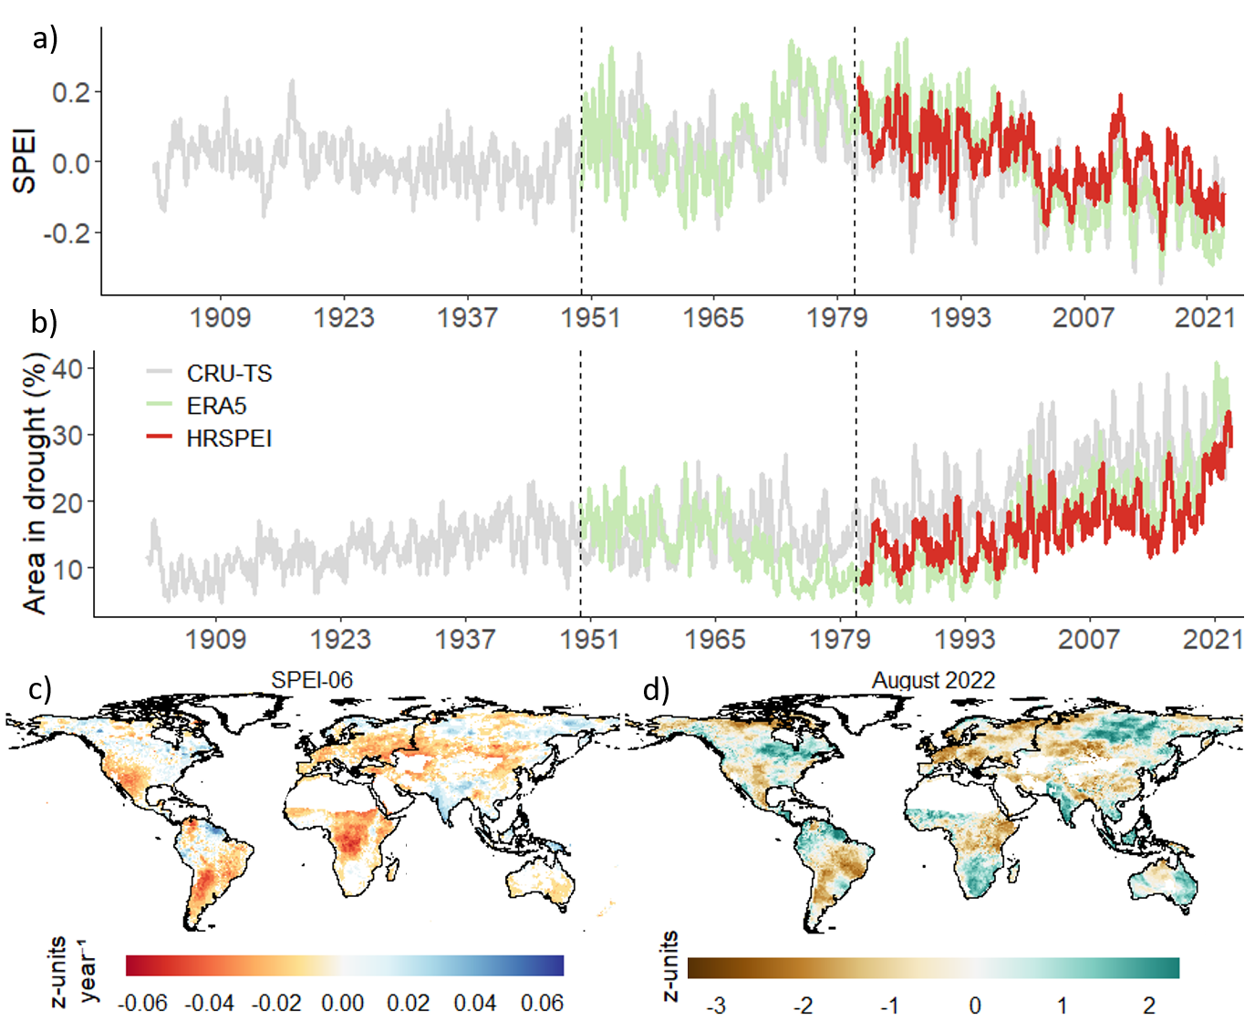**

**Fig. 1: Monthly time series of average SPEI and percentage area in drought, map of trends in 6-month SPEI during 1981**–**2022, and map of the SPEI during the 2022 drought event.** Figures a) and b) show the quasi-global (50°S to 50°N) average HRSPEI and global percentage of area in droughts (%), respectively. Figure c) indicates the trend in 6-month HRSPEI for 1981–2022 (z-units year-1), with non-significant trends (P-value > 0.05) set to zero for visualization. Figure d) shows the values of the 6-month HRSPEI for the record-breaking drought in August 2022 (z-units). The time series uses HRSPEI (0.05°), CRU-TS (0.5°), and ERA5 (0.25°), with HRSPEI being the ensemble mean of MSWEP\_hPET, MSWEP\_GLEAM, CHIRPS\_hPET, and CHIRPS\_GLEAM (1981–2022). CRU-TS covers 1901–2022, and ERA5 spans 1950–2022. The time series are averaged over tropical and subtropical land areas (50°S to 50°N), excluding regions with average annual rainfall below 180 mm. For regions above 50°N, the spatial trend is based on the mean of MSWEP\_hPET and MSWEP\_GLEAM, as CHIRPS is available up to 50°N.

Spatially, the 6-month HRSPEI shows a drying trend across large parts of the world such as in Europe, Africa, Western North America, and South America during 1981–2022 (**Fig. 1c**), with a drying trend of up to -0.08 z-units year-1. Conversely, regions such as South and Southeast Asia, the Guyanas in South America, central Southern Africa, and Eastern North America demonstrate an increasing wetting trend over the same period. The trends for individual datasets that constitute the HRSPEI and ERA5 and CRU-TS datasets are provided in Extended Data Fig. 1 and Extended Data Fig. 2, respectively.

The trend in magnitude, frequency, and duration of individual droughts has increased in different parts of the world during 1981–2022 (**Fig. 2**). The drought magnitude (**Fig. 2a**) and frequency (**Fig. 2b**) exhibit a significant increasing trend in various regions, particularly in the southern parts of South America, eastern and central Africa, southern Europe, and the western USA. In comparison to much of the world, parts of Africa and South America exhibit a greater increase and decrease in drought magnitude and frequency, respectively, highlighting that these trends are primarily driven by precipitation deficits. Similarly, drought duration shows an increasing trend in different parts of the world, reaching up to 0.2 months year⁻¹, with a decreasing trend observed in parts of the Amazon Basin in South America (Extended Data Fig. 3).

Of note is the acceleration in the decrease in SPEI and increase in areas experiencing drought during the last five years, with 2022 recording the highest percentage of impacted areas (Extended Data Fig. 4). During this period, the global extent of severe and extreme drought increased threefold and fivefold, respectively, compared to 1981–2022. In Europe, 82% of land experienced drought, with 50% under moderate to severe drought (**Fig. 1c**). In 2022, annual precipitation across Europe dropped by up to 35% below the 1981–2022 average, while AED rose by up to 40% (Extended Data Fig. 5).

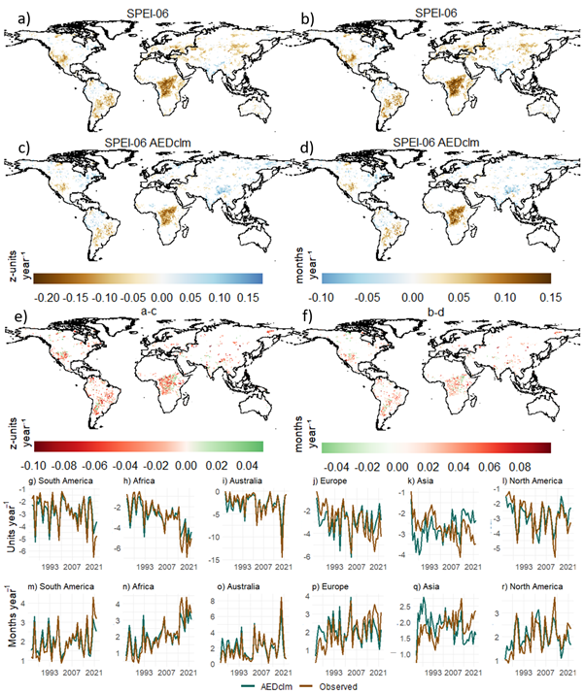

**Fig. 2. Trends in drought magnitude and frequency for 6-month SPEI based on observed and AEDclm during 1981**–**2022.** Figure a) shows the trend in magnitude (z-units year⁻¹) and b) the frequency (months year⁻¹) of droughts (SPEI < -1) for the period 1981–2022 based on MSWEP\_hPET. The trend in magnitude and frequency based on observed precipitation and AEDclm is displayed in c) and d), respectively. Figures e) and f) show the difference in trend between the observed data and AEDclm for drought magnitude and frequency, respectively. Non-significant trends (P-value > 0.05) are set to zero for clarity. Magnitude is calculated as the cumulative sum of SPEI < -1 values during a drought event for each year, while frequency represents the number of events in a year with SPEI < –1. The lower time series panels show the average magnitude (g-i, units year⁻¹) and frequency (m-r, months year⁻¹) of droughts averaged over South America (g and m), Africa (h and n), Australia (i and o), Europe (j and p), Asia (k and q), and North America (l and r). The trend and regional average exclude dry land areas with average annual rainfall below 180 mm.

## **Drivers of changes in drought**

To assess how changes in AED and precipitation affect drought, we compare SPEI trends calculated from observed AED and precipitation variations to those based on climatological means of AED (AEDclm) and precipitation (Prclm). The quasi-global average 6-month SPEI trend, based on observed precipitation and AEDclm, is 0.002 z-units year⁻¹, which is about 131% higher than the observed trend (**Fig. 3),** indicating that holding AED to its climatological value results in a positive trend. When using observed AED and Prclm, the SPEI trend is –0.02 z-units year⁻¹, which is 300% more negative than the observed trend (**Fig. 3a)**. Similarly, the trend in areas in drought based on the observed precipitation and AEDclm is -0.004% year-1, which is 96% lower than the observed trend. These findings indicate that AED changes from 1981 to 2022 intensified both the downward trend in SPEI and the expansion of drought-affected areas. Before 2000, the time series based on Prclm shows positive SPEI values, becoming negative after 2000 (Fig. 3a). Additionally, SPEI values based on ERA5 are positive from 1960–2000, shifting to negative from 2000–2022 (Extended Data Fig. 6), highlighting the increased impact of AED as precipitation remains fixed at its climatological value.

Regionally, the results indicate a notable contribution of AED to the negative SPEI trend (up to –0.06 year-1) in large parts of Europe (excluding Norway and Sweden), Asia, Australia, the Western USA, and Southern parts of South America (**Fig. 3b)**. Additionally, in parts of East and South Africa, changes in AED have exacerbated the negative SPEI trend by up to -0.04 z-units year-1. On the other hand, AED has minimal or no effect on drought trends in North America (Canada, Midwest, and Southeast USA), Northern South America (Amazon River Basin), and Central Africa. However, AED appears to have increased the SPEI trend (up to +0.02 z-units year-1) in South (India) and Southeast Asia. This change can be attributed to the observed increasing trend in precipitation and decreasing trend in AED (Extended Data Fig. 7). When using Prclm, the 6-month SPEI shows a significantly more negative trend (up to –0.1 z-units year-1) compared to the observed trend globally, except in South and Southeast Asia (**Fig. 3c)**.

C:\PostDoc3\Papers\Global_drought_trend\Version_v2\Final\Revision#1\Figure3_finalUpdate.tif

**Fig. 3. Monthly time series and trend differences for 6-month SPEI based on observed and climatological AED (AEDclm) and precipitation (Prclm) during 1981**–**2022.** Panel a) presents the quasi-global average (50°S-50°N) 6-month SPEI based on AEDclm, Prclm, and HRSPEI. MSWEP\_AEDclm and CHIRPS\_AEDclm refer to the average SPEI based on MSWEP and CHIRPS precipitation and AEDclm (mean of GLEAM and hPET). GLEAM\_Prclm and hPET\_Prclm show the average SPEI based on AED from GLEAM and hPET and Prclm (mean of MSWEP and CHIRPS). Panel b) shows the trend difference between SPEI based on observations (observed precipitation and AED) and SPEI based on observed precipitation and the climatology of AED (AEDclm). Figure c) shows the trend difference between SPEI based on observations and SPEI based on observed AED and climatology of precipitation (Prclm). Non-significant trends (P-value > 0.05) are set to zero to enhance clarity. The trend excludes dry land areas with average annual rainfall below 180 mm. For regions above 50°N, the trend is based on the mean of MSWEP\_hPET and MSWEP\_GLEAM, as CHIRPS is available up to 50°N.

Observed changes in AED have also intensified the magnitude and frequency of droughts globally (**Fig. 2**). Compared to AEDclm, observed trends show a more negative drought magnitude (up to –0.2 z-units year⁻¹) and a more positive frequency trend (up to +0.16 months year⁻¹). Similarly, the duration of drought is amplified by the observed change in AED in different parts of the world (Extended Data Fig. 3). Regional averages reveal that drought magnitude, based on observed AED, exhibits a significant decreasing trend between -0.1 to -0.05 year⁻¹, while the trend is not statistically significant with AEDclm in South and North America, Africa, Europe, and Australia (**Figs. 2g-r**). Drought frequency shows a significant increasing trend between 0.02 and 0.07 months year⁻¹ with observed AED, while the trend is very low and not significant using AEDclm. In Asia, AEDclm shows a significant increase in drought magnitude (0.03 z-units year⁻¹) and a decrease in frequency (-0.02 months year⁻¹). In contrast, observed AED indicates a decrease in magnitude (-0.03 z-units year⁻¹) and an increase in frequency (0.02 months year⁻¹).

Overall, even though precipitation accounts for 60% of the global average SPEI trend during 1981–2022, the role of AED, contributing 40%, is substantial (**Fig. 4**). This is especially notable considering the stronger sensitivity of SPEI to precipitation than to AED in most land regions32. In Africa, Australia, and the drylands of North and South America, the influence of AED is particularly pronounced, contributing up to 65% to drought trends during 1981–2022. Specifically, AED accounts for 44% of the drought trend in Africa and 51% in Australia, playing a significant role in intensifying drought severity in these regions. In contrast, the contribution of AED to drought trends in North and South America, Europe, and Asia is around 30%.

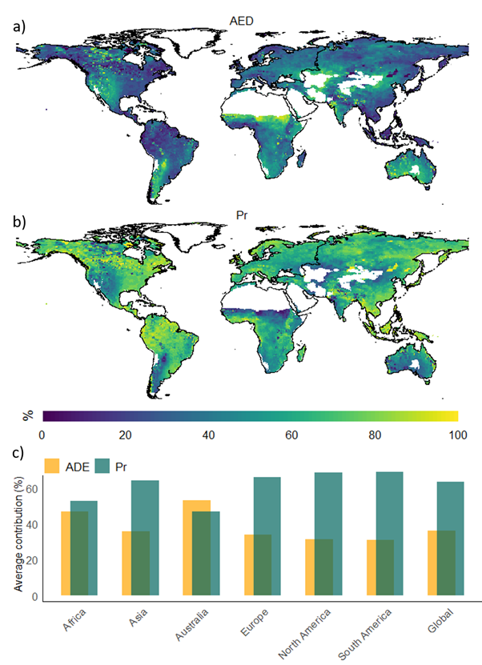

**Fig. 4: Percentage of contribution (%) of AED and precipitation (Pr) to 6-month SPEI trends.** Figures a) show the percentage of contribution of AED and b) show the percentage of contribution of precipitation for the observed changes in 6-month HRSPEI during 1981–2022. The contributions are computed by calculating the difference between the observed trend and the trend based on the climatological values of AED (AEDclm) and precipitation (Prclm). The contribution of AED is determined by the difference between the trend using observed AED and precipitation and the trend using observed precipitation and AEDclm. Similarly, the contribution of precipitation is calculated as the difference between the trend using observed precipitation and AED and the trend using observed AED and Prclm. The percentage contribution of each factor is then calculated as the absolute value of the difference divided by the total absolute difference, providing a relative measure of each factor’s influence on the observed trend. The lower panel (c) provides the regional and global average contribution of precipitation and AED to the changes in SPEI.

## **Acceleration of Droughts and Record-Breaking Drought of 2022**

The area affected by drought has expanded significantly, with a notable increase in the last five years (Extended Data Fig. 4). Globally, during the last five years (2018–2022) the observed area in drought was on average 27%, which is 74% higher than during 1981-2017 and 58% higher compared to AEDclm for 2018–2022. Regionally, drought-affected areas increased by 119% in Australia, 163% in Southern South America, and 141% in the Western USA from 2018–2022 compared to 1981–2017 (Extended Data Fig. 8). Similarly, in the past five years, drought areas increased by 75%, 80%, and 56% in East Africa, Northern Asia, and Europe, respectively. In contrast, when using AEDclm, the increases were substantially lower in Australia (36%), Southern South America (62%), Western USA (58%), and Northern Asia (0.5%), while Europe and East Africa experienced a decrease of about 8%. A summary of these changes is provided in Extended Data Fig. 8h.

Drought severity in 2022 was record-breaking relative to the 1981–2022 period (Extended Data Fig. 8). 2022 had the highest drought area (30%), which is 42% higher than AEDclm. As shown in Fig. 1d, the 6-month SPEI for August 2022 indicates moderate to extreme droughts across Europe, East Africa, Western USA, and Southern South America, with drought-affected areas approximately 34–67% greater than AEDclm. Additionally, the average SPEI was -0.85 units year⁻¹, compared to 0.52 units year⁻¹ based on AEDclm. Overall, due to the observed increase in AED, the trends in SPEI and areas in drought during 1981–2022 indicate that not only are drier regions becoming drier, but also wet areas are experiencing drying trends.

# **Discussion**

According to the Standardized Precipitation Evapotranspiration Index (SPEI), over the past 42 years (1981–2022), global drought severity has intensified. In the last 5–10 years, this trend has accelerated as a consequence of the strong increase in AED, which is directly related to global warming and increased vapour pressure deficit18, as the water supply to the atmosphere is not enough to compensate for the large temperature increase. Some recent studies had also suggested an increase in the severity of drought events over large land areas based on metrics like modelled soil moisture11 and the Palmer Drought Severity Index43,44, all of them sensitive to changes in the AED. Nevertheless, in our study, we have quantified the contribution of AED to worsening drought conditions, which has been up to 60% in some regions, particularly in Africa, Australia, Western USA, and Southern South America. Moreover, changes in AED have exacerbated the drying trend globally, particularly in the last decade. The year 2022 specifically was a record-breaking year for drought severity and extent in Europe and East Africa. In Europe, the severity of the 2022 drought event can be largely attributed to anthropogenic warming, since the anomalies observed in streamflow and soil moisture cannot be explained by the precipitation deficit alone, but mostly by enhanced AED, which increased water losses by evaporation23,24. Moreover, ecological drought severity recorded in Europe’s natural forests cannot be fully explained without considering the influence of high temperatures and AED on plant physiology. In the absence of formal attribution studies in other regions of the world that experienced drought in 2022, the attribution in Europe and the increase in severity globally driven by enhanced AED as shown in this study, suggests that it is reasonable to conclude that anthropogenic global warming likely contributed to exacerbate global drought severity in 2022.

In comparison to previous studies analysing recent drought trends based on atmospheric drought indices that use AED in calculations2,17,43,44, this study has isolated for the first time the effect of AED on drought severity and in addition our study has also reduced uncertainties given the use of high spatial resolution and multi-source data, which allows for a clearer understanding of drought intensification. The observed increase in drought severity aligns with associated impacts on agricultural, environmental, and hydrological systems, as seen in events like the 2022 European drought, which contributed to enhanced tree mortality, increased forest fires, and long-term soil moisture decline11,45. Although the SPEI is an atmospheric drought index that effectively captures the effects of precipitation and AED on drought severity, it may represent drought-related impacts very effectively46. However, further studies are needed, considering variables such as soil moisture, vegetation stress, and hydrological flows for better understanding of the broader impacts of the observed changes on ecosystems and human activities17. Moreover, the observed acceleration of drought trends in the past few years aligns with future climate projections that indicate further increases in drought severity due to projected warming35,47, which warns of the need for better socioeconomic and environmental adaptation measures to reduce drought impacts and improve global drought.

# **Methods**

## **Drought index**

The Standardized Precipitation–Evapotranspiration Index (SPEI)31 is a widely-utilized drought assessment tool that incorporates both AED and precipitation to evaluate drought severity across different time scales. SPEI values are computed by subtracting AED from precipitation. These differences are standardized using a log-logistic probability distribution to ensure consistency across regions, seasons and time-scales. This distribution model involves three parameters (α, β, and γ), which are estimated using the L-moment procedure. The SPEI indices were calculated using the entire 1981–2022 period as a baseline, ensuring that the full range of variability in the input data is captured. Unlike other drought indices, SPEI does not require a predefined baseline or calibration period, as it standardizes the data directly from the input time series, ensuring consistency across datasets and time scales. The SPEI values provide categories for wet and dry events (Table 1).

Using SPEI, we developed four high-resolution SPEI indices using a combination of two precipitation datasets and two potential evapotranspiration (i.e., AED) datasets. The precipitation datasets used were the Multi-Source Weighted-Ensemble Precipitation (MSWEP)48 and Climate Hazards Group InfraRed Precipitation with Station Data (CHIRPS)49 precipitation and the AED datasets were the Global Land Evaporation Amsterdam Model version 4.2a (GLEAM)40 and hourly Potential Evapotranspiration (hPET)41. The resulting four indices: MSWEP\_GLEAM, MSWEP\_hPET, CHIRPS\_GLEAM, and CHIRPS\_hPET, were developed at a spatial resolution of 0.05° for the period 1981–2022. The 0.1° resolution datasets were first interpolated to match the resolution of CHIRPS using bilinear interpolation. Additionally, we developed an ensemble mean (HRSPEI) based on all four datasets. For latitudes above 50°N, the mean is derived from MSWEP\_GLEAM and MSWEP\_hPET, as CHIRPS data is only available up to ±50° latitude. AED and AED variability in high-latitude areas > 50°N is generally small, and changes in AED, even at high percentages, result in low absolute magnitudes, making SPEI less sensitive to AED in these regions32.

To assess the contributions of precipitation and AED, we developed additional indices based on observed (i.e., actual values from hPET and GLEAM) AED with monthly climatological precipitation (Prclm), and observed (i.e., a combination of gauge and satellite and reanalysis data) precipitation with climatological AED (AEDclm) for the period 1981–2022. Using AEDclm and Prclm allows us to quantify the impact of precipitation and AED changes and variability on droughts over the past 42 years. To further assess changes in drought during the early and mid-1990s, we developed two coarse resolution SPEI indices based on ERA5 (0.25°) and Climatic Research Unit Time-series (CRU-TS, 0.5°). The SPEI based on ERA5 was computed using monthly precipitation and AED derived from ERA5 meteorological datasets using the Penman-Monteith equation (Eq. 1) for the period 1950–2022. Similarly, the SPEI based on CRU-TS was calculated using monthly precipitation and AED derived from CRU-TS meteorological datasets using the Penman-Monteith equation (Eq. 1) for the period 1901-2022.

In this study, we use SPEI < -1 as the threshold to define a drought, with values between -1 and 1 considered near-normal conditions and values > 1 indicating wet conditions (Table 1). Using SPEI < -1 values, we assessed key drought metrics: magnitude, duration, intensity, and frequency. We follow the classic approach and widely adopted methods to define these metrics 50. Drought magnitude is calculated as the cumulative sum (running total) of SPEI < -1 values during a drought event. Drought intensity, on the other hand, is defined as the maximum negative value of SPEI observed during the event. Duration represents the run length of consecutive months with SPEI < -1, and frequency is the total number of drought events within a given period50. Finally, severity is used as an overarching term to refer to all aspects of drought: intensity, magnitude, duration and extent.

**Table 1:** Categories of wet and dry events

|  |  |
| --- | --- |
| SPEI categories | SPEI values50 |
| Extremely wet | >1.83 |
| Very wet | 1.43 to 1.82 |
| Moderate wet | 1.0 to 1.42 |
| Near Normal | -0.99 to 0.99 |
| Moderately dry | -1.0 to -1.42 |
| Severely dry | -1.43 to -1.82 |
| Extremely dry | < -1.83 |

## **Global climate and AED datasets**

The Multi-Source Weighted-Ensemble Precipitation (MSWEP, version 2.8) dataset offers global 3-hourly, daily, and monthly precipitation estimates at a 0.1° spatial resolution from 1979 to present48. Similarly, the Climate Hazards group Infrared Precipitation with Stations (CHIRPS, version 2.0) dataset provides daily, decadal, and monthly precipitation estimates over land, with a spatial resolution of 0.05° for latitudes below 50°, covering the period from 1981 to present49. Both MSWEP and CHIRPS are high-resolution precipitation datasets developed by integrating ground station observations, satellite data, and reanalysis products.

CHIRPS and MSWEP were chosen as they generally out-perform other similar gridded precipitation datasets when compared to ground observations29,30. CHIRPS (0.05°) is particularly designed for monitoring droughts and detecting environmental changes, providing daily precipitation estimates from 1981 to present. It combines satellite-derived Climate Hazards Center Infrared Precipitation (CHIRP) and the Climate Hazards Group Precipitation Climatology (CHPclim) with ground station data from the Global Historical Climate Network (GHCN) and many other sources. The CHIRPS product benefits from a high degree of homogeneity, provided by its simple but consistent foundation of geostationary thermal infrared satellite observations. CHIRPS also incorporates unique observation inputs from Africa, Latin America and Central America. MSWEP (0.1°) has been designed with both accuracy and homogeneity in mind, providing 3-hourly precipitation estimates from 1979 to present. It integrates daily observations from over 77,000 stations from various national and international data sources, satellite estimates from infrared- and microwave-based satellite datasets, and reanalysis data, offering accurate global precipitation data from 1979 to present. Both CHIRPS and MSWEP have previously been evaluated globally using statistical metrics such as Kling–Gupta Efficiency (KGE) and Nash-Sutcliffe Efficiency (NSE), as well as various bias and error metrics29,30. For instance, MSWEP outperformed 22 other global precipitation datasets in capturing daily precipitation from 76,086 gauging stations and in driving hydrological models across 9,053 catchments29. Additionally, both MSWEP and CHIRPS were found to outperform other high-resolution gauge-based datasets in modelling daily, monthly, and annual streamflow across 1,825 streamflow gauges30. However, both datasets remain subject to inherent uncertainties, and therefore, considering both helps reduce biases and obtain more reliable estimates, given that they are somewhat independent. For example, they differ in their data sources with CHIRPS using only geostationary thermal infrared observations, whilst MSWEP also uses microwave observations, and they use different sets of station data to correct locally. Despite these differences, the monthly correlation between MSWEP and CHIRPS shows a high correlation across most regions, except for Central Asia (Extended Data Fig. 9a). The average monthly difference between the two datasets varies spatially, reaching up to ±40 mm (Extended Data Fig. 9c). Notably, larger discrepancies occur in regions such as the Amazon, Central Africa, and parts of Southeast Asia. Such convergence between the two products helps reduce concerns about the uncertainties due to different approaches and changes in the constellation of Earth-observing satellites that can affect the robustness of their representation of changes over time.

The hourly Potential Evapotranspiration (hPET) is a global hourly AED dataset developed using ERA5-Land reanalysis (ERA5) climate datasets and the FAO’s Penman-Monteith equation (Eq. 1). hPET is available for the global land surface at 0.1° spatial resolution covering the period 1981–202241. In addition, the AED from the Global Land Evaporation Amsterdam Model (GLEAM, version 4.2a) is a global dataset derived using Penman's original equation (Eq. 2), using satellite and reanalysis datasets40. GLEAM is available at a 0.1° spatial resolution and covers the period 1980–2023. hPET is based on the FAO Penman-Monteith equation, which computes reference crop evaporation by assuming certain surface and aerodynamic characteristics that are constant in time. In contrast, GLEAM calculates aerodynamic conductance as a dynamic variable depending on ecosystem characteristics and local meteorology and therefore is space and time-dependent. Nonetheless, given the dominant influence of radiative forcing and atmospheric aridity in both computations, their estimates are overall similar. The correlation between GLEAM and hPET exceeds 0.9 across 91% of the global land surface (Extended Data Fig. 9b), while the monthly average difference between the two is up to ±3 mm (Extended Data Fig. 9d).

The global AED and precipitation data from the Climate Research Unit Time Series (CRU-TS) dataset are available at a spatial resolution of 0.5°, covering the period from 1901 to present. Similarly, the ERA5 reanalysis dataset, representing the fifth-generation reanalysis from the European Centre for Medium-Range Weather Forecasts (ECMWF), is available at a spatial resolution of 0.25° from 1940 to present.

## **Atmospheric Evaporative Demand (AED)**

hPET is estimated using the FAO-56 Penman-Monteith equation (Eq. 1), while GLEAM PET (potential evapotranspiration, AED) is calculated using Penman's equation, including aerodynamic conductance (Eq. 2). Additionally, the FAO-56 Penman-Monteith method is applied to calculate AED from ERA5 climate datasets for the period 1950–2022 and CRU-TS climate datasets for 1901–2022. The Penman and FAO-56 Penman-Monteith methods consider various meteorological variables such as wind speed, air temperature, radiation and humidity to estimate AED.

${PET}_{pm}= \frac{0.408∆*\left(R_{n- }G\right)+γ*\frac{900}{T+273}*u_{2}(e_{s}-e_{a})}{Δ+γ(1+0.34u_{2})}$ (1)

${PET}_{p}=\frac{Δ(R_{n}-G)+ρ_{a}* c_{p}* g_{a} * {(e}_{s}-e_{a})}{λ*(Δ+γ)}$ (2)

Where $∆$ is the slope of the plot of saturation vapour pressure-temperature relationship, $R_{n}$ is the net radiation, $G$ is the soil heat flux, $γ$ is the psychrometric constant, $T$ is the mean daily air temperature at 2 meters height, $u_{2}$ is the wind speed at 2 meters height, ${(e}_{s}-e_{a})$ is the vapour pressure deficit of the air (difference between saturation vapour pressure and actual vapour pressure), $ρ_{a}$ is the air density, $c_{p}$ is the specific heat capacity of air at constant pressure, $g_{a}$ is the aerodynamic conductance, and $λ_{v}$ is the latent heat of vaporization.

## **Trend analysis**

The trend in SPEI is assessed using the non-parametric Mann–Kendall test and Sen's slope estimator. The Mann–Kendall test identifies upward or downward trends in the SPEI time series for each pixel. Sen's slope estimator calculates the slope of change in the SPEI series by computing the median of all possible slopes between data points. This method provides a robust estimate of the trend, particularly in the presence of outliers or non-linear patterns. To identify drought events at the pixel scale, we utilize SPEI categories (Table 1). SPEI values less than –1.0 are used to identify areas affected by droughts. We evaluate the frequency, duration, and magnitude of these drought events (SPEI < –1) by analysing the number of occurrences, the length of consecutive periods, and the intensity of SPEI values during the period from 1981 to 2022.

# **Data Availability**

The high-resolution SPEI datasets are freely accessible through the Centre for Environmental Data Analysis (CEDA) at <https://doi.org/10.5285/ac43da11867243a1bb414e1637802dec> and on JASMIN at /badc/hydro-jules/data/Global\_drought\_indices. The CHIRPS data can be accessed via the Climate Hazards Group (CHG) at <https://www.chc.ucsb.edu/data/chirps/>. The MSWEP precipitation dataset is available from the GloH2O website at <https://www.gloh2o.org/mswep/>. The hPET dataset is hosted by the University of Bristol at <https://data.bris.ac.uk/data/dataset/qb8ujazzda0s2aykkv0oq0ctp>. The AED data from the GLEAM4 can be accessed at <https://www.gleam.eu/>. The CRU-TS precipitation and AED datasets are available through CEDA at <https://data.ceda.ac.uk/badc/cru/data/cru_ts/cru_ts_4.08/>. The ERA5 dataset is available for download from the Copernicus Climate Change Service's Climate Data Store at <https://cds.climate.copernicus.eu/datasets>.

# **Code Availability**

This study utilized the Standardized Precipitation Evapotranspiration Index (SPEI) code to calculate drought indices. The SPEI code is publicly available on GitHub at <https://github.com/sbegueria/SPEI/>. For trend analysis, the Trend package in R was used, which is publicly available at <https://github.com/cran/trend>.

# **References**

1. Pokhrel, Y. *et al.* Global terrestrial water storage and drought severity under climate change. *Nat. Clim. Change* **11**, 226–233 (2021).

2. Chiang, F., Mazdiyasni, O. & AghaKouchak, A. Evidence of anthropogenic impacts on global drought frequency, duration, and intensity. *Nat. Commun.* **12**, 2754 (2021).

3. Sheffield, J., Wood, E. F. & Roderick, M. L. Little change in global drought over the past 60 years. *Nature* **491**, 435–438 (2012).

4. Trenberth, K. E. *et al.* Global warming and changes in drought. *Nat. Clim. Change* **4**, 17–22 (2014).

5. Seneviratne, S. I. Historical drought trends revisited. *Nature* **491**, 338–339 (2012).

6. Lu, J., Carbone, G. J. & Grego, J. M. Uncertainty and hotspots in 21st century projections of agricultural drought from CMIP5 models. *Sci. Rep.* **9**, 4922 (2019).

7. Tarroja, B., Chiang, F., AghaKouchak, A. & Samuelsen, S. Assessing future water resource constraints on thermally based renewable energy resources in California. *Appl. Energy* **226**, 49–60 (2018).

8. Forrest, K., Tarroja, B., Chiang, F., AghaKouchak, A. & Samuelsen, S. Assessing climate change impacts on California hydropower generation and ancillary services provision. *Clim. Change* **151**, 395–412 (2018).

9. Greve, P., Gudmundsson, L. & Seneviratne, S. I. Regional scaling of annual mean precipitation and water availability with global temperature change. *Earth Syst. Dyn.* **9**, 227–240 (2018).

10. Greve, P., Roderick, M. L. & Seneviratne, S. I. Simulated changes in aridity from the last glacial maximum to 4xCO2. *Environ. Res. Lett.* **12**, 114021 (2017).

11. Padrón, R. S. *et al.* Observed changes in dry-season water availability attributed to human-induced climate change. *Nat. Geosci.* **13**, 477–481 (2020).

12. Mahecha, M. D. *et al.* Biodiversity loss and climate extremes — study the feedbacks. *Nature* **612**, 30–32 (2022).

13. Seneviratne, S. *et al.* Chapter 11: Weather and climate extreme events in a changing climate. **2021**, U13B-11 (2021).

14. Zhu, P. *et al.* Warming reduces global agricultural production by decreasing cropping frequency and yields. *Nat. Clim. Change* **12**, 1016–1023 (2022).

15. Bauman, D. *et al.* Tropical tree mortality has increased with rising atmospheric water stress. *Nature* **608**, 528–533 (2022).

16. Kikstra, J. *et al.* *The IPCC Sixth Assessment Report WGIII Climate Assessment of Mitigation Pathways: From Emissions to Global Temperatures*. (2022). doi:10.5194/egusphere-2022-471.

17. Vicente-Serrano, S. M. *et al.* Global drought trends and future projections. *Philos. Trans. R. Soc. Math. Phys. Eng. Sci.* **380**, 20210285 (2022).

18. Douville, H. & Willett, K. M. A drier than expected future, supported by near-surface relative humidity observations. *Sci. Adv.* **9**, eade6253 (2023).

19. Dai, A. Increasing drought under global warming in observations and models. *Nat. Clim. Change* **3**, 52–58 (2013).

20. Allen, C. D., Breshears, D. D. & McDowell, N. G. On underestimation of global vulnerability to tree mortality and forest die-off from hotter drought in the Anthropocene. *Ecosphere* **6**, art129 (2015).

21. Berg, A. & Sheffield, J. Climate Change and Drought: the Soil Moisture Perspective. *Curr. Clim. Change Rep.* **4**, 180–191 (2018).

22. Cook, B. I. *et al.* Twenty-First Century Drought Projections in the CMIP6 Forcing Scenarios. *Earths Future* **8**, e2019EF001461 (2020).

23. Garrido-Perez, J. M. *et al.* Examining the outstanding Euro-Mediterranean drought of 2021–2022 and its historical context. *J. Hydrol.* **630**, 130653 (2024).

24. Bevacqua, E. *et al.* Direct and lagged climate change effects intensified the 2022 European drought. *Nat. Geosci.* **17**, 1100–1107 (2024).

25. Pachauri, R. K. *et al.* *Climate Change 2014: Synthesis Report. Contribution of Working Groups I, II and III to the Fifth Assessment Report of the Intergovernmental Panel on Climate Change*. *EPIC3Geneva, Switzerland, IPCC, 151 p., pp. 151, ISBN: 978-92-9169-143-2* 151 (IPCC, Geneva, Switzerland, 2014).

26. IPCC. *Climate Change 2022: Impacts, Adaptation, and Vulnerability. Contribution of Working Group II to the Sixth Assessment Report of the Intergovernmental Panel on Climate Change [H.-O. Pörtner, D.C. Roberts, M. Tignor, E.S. Poloczanska, K. Mintenbeck, A. Alegría, M. Craig, S. Langsdorf, S. Löschke, V. Möller, A. Okem, B. Rama (Eds.)].* 3056 doi:10.1017/9781009325844 (2022).

27. Kingston, D. G., Todd, M. C., Taylor, R. G., Thompson, J. R. & Arnell, N. W. Uncertainty in the estimation of potential evapotranspiration under climate change. *Geophys. Res. Lett.* **36**, (2009).

28. van der Schrier, G., Barichivich, J., Briffa, K. R. & Jones, P. D. A scPDSI-based global data set of dry and wet spells for 1901–2009. *J. Geophys. Res. Atmospheres* **118**, 4025–4048 (2013).

29. Beck, H. E. *et al.* Global-scale evaluation of 22 precipitation datasets using gauge observations and hydrological modeling. *Hydrol. Earth Syst. Sci.* **21**, 6201–6217 (2017).

30. Gebrechorkos, S. H. *et al.* Global-scale evaluation of precipitation datasets for hydrological modelling. *Hydrol. Earth Syst. Sci.* **28**, 3099–3118 (2024).

31. Vicente-Serrano, S. M., Beguería, S. & López-Moreno, J. I. A Multiscalar Drought Index Sensitive to Global Warming: The Standardized Precipitation Evapotranspiration Index. *J. Clim.* **23**, 1696–1718 (2010).

32. Tomas-Burguera, M. *et al.* Global Characterization of the Varying Responses of the Standardized Precipitation Evapotranspiration Index to Atmospheric Evaporative Demand. *J. Geophys. Res. Atmospheres* **125**, e2020JD033017 (2020).

33. Haile, G. G. *et al.* Long-term spatiotemporal variation of drought patterns over the Greater Horn of Africa. *Sci. Total Environ.* **704**, 135299 (2020).

34. Kamruzzaman, M. *et al.* Spatiotemporal drought analysis in Bangladesh using the standardized precipitation index (SPI) and standardized precipitation evapotranspiration index (SPEI). *Sci. Rep.* **12**, 20694 (2022).

35. Spinoni, J. *et al.* Future Global Meteorological Drought Hot Spots: A Study Based on CORDEX Data. *J. Clim.* **33**, 3635–3661 (2020).

36. Wang, T., Tu, X., Singh, V. P., Chen, X. & Lin, K. Global data assessment and analysis of drought characteristics based on CMIP6. *J. Hydrol.* **596**, 126091 (2021).

37. Spinoni, J. *et al.* A new global database of meteorological drought events from 1951 to 2016. *J. Hydrol. Reg. Stud.* **22**, 100593 (2019).

38. Beguería, S., Vicente-Serrano, S. M., Reig, F. & Latorre, B. Standardized precipitation evapotranspiration index (SPEI) revisited: parameter fitting, evapotranspiration models, tools, datasets and drought monitoring. *Int. J. Climatol.* **34**, 3001–3023 (2014).

39. Wang, Q. *et al.* Temporal-spatial characteristics of severe drought events and their impact on agriculture on a global scale. *Quat. Int.* **349**, 10–21 (2014).

40. Miralles, D. G. *et al.* GLEAM4: global land evaporation dataset at 0.1° resolution from 1980 to near present. (2024).

41. Singer, M. B. *et al.* Hourly potential evapotranspiration at 0.1° resolution for the global land surface from 1981-present. *Sci. Data* **8**, 224 (2021).

42. Lenssen, N. J. L. *et al.* Improvements in the GISTEMP Uncertainty Model. *J. Geophys. Res. Atmospheres* **124**, 6307–6326 (2019).

43. Dai, A. & Zhao, T. Uncertainties in historical changes and future projections of drought. Part I: estimates of historical drought changes. *Clim. Change* **144**, 519–533 (2017).

44. Song, X., Song, Y. & Chen, Y. Secular trend of global drought since 1950. *Environ. Res. Lett.* **15**, 094073 (2020).

45. Alizadeh, M. R. *et al.* Warming enabled upslope advance in western US forest fires. *Proc. Natl. Acad. Sci.* **118**, e2009717118 (2021).

46. Bachmair, S., Tanguy, M., Hannaford, J. & Stahl, K. How well do meteorological indicators represent agricultural and forest drought across Europe? *Environ. Res. Lett.* **13**, 034042 (2018).

47. Naumann, G. *et al.* Global Changes in Drought Conditions Under Different Levels of Warming. *Geophys. Res. Lett.* **45**, 3285–3296 (2018).

48. Beck, H. E. *et al.* MSWEP V2 Global 3-Hourly 0.1° Precipitation: Methodology and Quantitative Assessment. *Bull. Am. Meteorol. Soc.* **100**, 473–500 (2019).

49. Funk, C. *et al.* The climate hazards infrared precipitation with stations—a new environmental record for monitoring extremes. *Sci. Data* **2**, 150066 (2015).

50. Agnew, C. T. Using the SPI to Identify Drought. *Drought Netw. News 1994-2001* (2000).

# **Acknowledgements**

We acknowledge the financial support provided by the UK Foreign, Commonwealth and Development Office (FCDO, grant no. 201880) and the UK Natural Environment Research Council (NERC, grant no. NE/S017380/1). We also thank the Centre for Environmental Data Analysis (CEDA, <https://www.ceda.ac.uk/>) for hosting the global drought datasets.

# **Contributions**

S.G developed the drought datasets, conducted trend assessments, and drafted the manuscript. S.D led the project, and S.G and S.D designed the study with input from all authors. C.F, H.B, D.A, and M.S provided and developed the CHIRPS, MSWEP, GLEAM, and hPET datasets, respectively. S.V.S provided the SPEI index. J.S, S.V.S, D.M, and J.P contributed to the experimental design, research questions, and dataset selection. E.D and J.T supported the data analysis and edited the manuscript. All authors contributed to the development of the paper.

# **Competing interests**

The authors declare no competing interests.