ADHD pharmacotherapy and risk of suicidal behaviours, substance misuse, accidental injuries, transport accidents, and criminality: emulation of target trials
Authors
Le Zhang, postdoctoral researcher¹, Nanbo Zhu, postdoctoral researcher², Arvid Sjölander, professor¹, Mikail Nourredine, junior statistician^{3,4,5}, Lin Li, postdoctoral researcher¹, Miguel Garcia-Argibay, senior research fellow^{1,3,6,7}, Ralf Kuja-Halkola, statistician¹, Isabell Brikell, assistant professor^{1,8,9}, Paul Lichtenstein, professor¹, Brian M. D’Onofrio, professor^{1,10}, Henrik Larsson, professor^{1,3,6}, Samuele Cortese, professor ^{3,11-14 *}, Zheng Chang, associate professor¹ *
*co-senior authors
Affiliations
¹ Department of Medical Epidemiology and Biostatistics, Karolinska Institutet, Stockholm, Sweden
² Division of Clinical Geriatrics, Department of Neurobiology, Care Sciences and Society, Karolinska Institutet, Stockholm, Sweden
³ Centre for Innovation in Mental Health, School of Psychology, Faculty of Environmental and Life Sciences, and Clinical and Experimental Sciences (CNS and Psychiatry), Faculty of Medicine, University of Southampton, Southampton, UK
⁴ Department of Biostatistics-Bioinformatics, Hospices Civils de Lyon, Lyon, France
⁵ Université Claude Bernard Lyon 1, LBBE, UMR 5558, CNRS, VAS, Villeurbanne, France
⁶ School of Medical Sciences, Faculty of Medicine and Health, Örebro University, Örebro, Sweden
⁷ Centre for Population Health, Research Department, Division for Mental Health, Haukeland University Hospital, Bergen, Norway
⁸ Department of Global Public Health and Primary Care, University of Bergen, Årstadveien 17, 5009 Bergen, Norway
⁹ Department of Biomedicine, Aarhus University, 8000, Aarhus C, Denmark
¹⁰ Department of Psychological and Brain Sciences, Indiana University, Bloomington, USA
¹¹ Clinical and Experimental Sciences (CNS and Psychiatry), Faculty of Medicine, University of Southampton, Southampton, UK
¹² Hampshire and Isle of Wight Healthcare NHS Foundation Trust, Southampton, UK
¹³ Hassenfeld Children’s Hospital at NYU Langone, New York University Child Study Center, New York City, New York, USA
¹⁴ DiMePRe-J-Department of Precision and Regenerative Medicine-Jonic Area, University of Bari "Aldo Moro", Bari, Italy

Correspondence to:
Zheng Chang, PhD, Department of Medical Epidemiology and Biostatistics, Karolinska Institutet, Nobels väg 12A, Stockholm 17177, Sweden. E-mail: zheng.chang@ki.se. Phone: +46-(0)8-524 824 12 (ORCID: 0000-0002-8087-1417)
Word count: abstract 395 words, main text 4135 words, 1 table, 6 figures, 70 references
ABSTRACT

Objective: To examine the effects of ADHD medication on five outcomes including suicidal behaviours, substance misuse, accidental injuries, transport accidents, and criminality.

Design: Target trial emulations using cloning, censoring and weighting.

Setting: Linkage of national registers in Sweden, 2007-2020.

Participants: Individuals aged 6 to 64 years with a new diagnosis of ADHD, who either initiated or did not initiate ADHD medication within three months of diagnosis.

Main outcome measures: Following consultation with individuals with lived experience, we assessed first and recurrent events of five outcomes over two years after ADHD diagnosis: suicidal behaviours, substance misuse, accidental injuries, transport accidents, and criminality.
Results: Of 148 581 individuals with ADHD (median age, 17.4 years; 41.3% women), 84 282 (56.7%) individuals initiated ADHD medication, with methylphenidate being the most commonly prescribed at initiation (88.5%). The use of ADHD medication was associated with reduced rates in the first occurrence of suicidal behaviours (weighted incidence rates: 14.5 per 1 000 person-years in the initiation group vs. 16.9 in the non-initiation group; adjusted incidence rate ratio [IRR], 0.83, 95% confidence interval, 0.78 to 0.88), substance misuse (58.7 vs. 69.1 per 1 000 person-years; IRR, 0.85 [0.83 to 0.87]), transport accidents (24.0 vs. 27.5 per 1 000 person-years; IRR, 0.88 [0.82 to 0.94]), and criminality (65.1 vs. 76.1 per 1 000 person-years; IRR, 0.87 [0.83 to 0.90]), whereas the reduction was not statistically significant for accidental injuries (88.5 vs. 90.1 per 1 000 person-years; IRR, 0.98 [0.96 to 1.01]). The reduced rates were more pronounced among individuals with prior events, with IRR ranging from 0.79 (0.72 to 0.86) for suicidal behaviours to 0.97 (0.93 to 1.00) for accidental injuries. When considering recurrent events, ADHD medication was significantly associated with reduced rates of all five outcomes, with IRR of 0.85 (0.77 to 0.93) for suicidal behaviours, 0.75 (0.72 to 0.78) for substance misuse, 0.96 (0.92 to 0.99) for accidental injuries, 0.84 (0.76 to 0.91) for transport accidents, and 0.75 (0.71 to 0.79) for criminality.
Conclusions: Use of ADHD medication was associated with beneficial effects in reducing the risks of suicidal behaviours, substance misuse, transport accidents, and criminality, but not accidental injuries when considering first event rate. The risk reductions were more pronounced considering recurrent events, with reduced rates for all five outcomes. This target trial emulation study using national register data provides evidence that is representative of patients in routine clinical settings.
SUMMARY BOX
What is already known on this topic
- ADHD is associated with many adverse outcomes, e.g., suicidal behaviours, substance misuse, accidental injuries, transport accidents, and criminality.
- Many individuals with ADHD experience adverse outcome events multiple times.
- Available randomised controlled trials (RCTs) have not evaluated the effects of ADHD medication on broader clinical outcomes, and may have limited generalisability to the entire ADHD population.

What this study adds
- In this target trial emulation study using national register data from Sweden, ADHD medication was associated with significantly reduced rates of first occurrences of suicidal behaviours, substance misuse, transport accidents, and criminality, but not accidental injuries.
- When considering recurrent events, ADHD medication was statistically associated with reduced rates of all five outcomes.
- This is the first target trial emulation study showing beneficial effects of ADHD medication on broader clinical outcomes in the entire ADHD population, generating evidence representative of patients seen in routine clinical settings.

Introduction
Attention-deficit/hyperactivity disorder (ADHD) is a prevalent neurodevelopmental disorder, affecting approximately 5% of children and 2.5% of adults worldwide.¹⁻³ Although typically diagnosed in childhood, its impairing symptoms often persist into adulthood.⁴ Beyond core symptoms, ADHD is linked to a range of adverse functional outcomes, including increased risks of suicidal behaviours, substance misuse, accidental injuries, transport accidents, and criminality.¹ ⁵ Treatment for ADHD includes pharmacologic, nonpharmacologic, or combined approaches. While nonpharmacologic treatment is often recommended for younger children or milder cases, pharmacological treatment (including stimulants and non-stimulants) is commonly used in ADHD management of school-aged and older individuals. Prescriptions of ADHD medication have risen markedly in recent years worldwide, sparking intense debate on their effectiveness and safety.⁶ ⁷
Randomised controlled trials (RCTs) have demonstrated the beneficial effects of ADHD medication in alleviating core symptoms.⁸ However, evidence from RCTs remains limited or inconclusive for broader and important clinical outcomes such as suicidal behaviours and substance use disorder.⁹⁻¹² Moreover, RCTs often exclude a substantial population of individuals seen in clinical practice—around half of those receiving ADHD medication,¹³ thereby limiting the generalisability to the entire ADHD populations. In this context, pharmacoepidemiological studies using routinely collected data offer opportunities to assess the benefits and risks of ADHD medication on broader outcomes.¹⁴ ¹⁵ In particular, within-individual designs have linked ADHD medication use to reduced risks of suicidal behaviours,¹⁶⁻¹⁸ substance misuse,¹⁹ ²⁰ accidental injuries,²¹ transport accidents²² ²³ and criminality.²⁴ While effectively control for time-invariant confounders, these studies remain susceptible to time-varying confounding and carryover effects,²⁵ and their reliance on treated individuals who have experienced the outcomes of interest limits both generalisability and comparability to trial findings. Thus, rigorous population-based studies using routine clinical data, designed to ensure representativeness and comparability to trials, are needed.
To address these limitations, the present study for the first time applied a target trial emulation framework to examine the effects of ADHD medication on five critical outcomes, namely suicidal behaviours, substance misuse, accidental injuries, transport accidents, and criminality. This approach enhances causal inference by mimicking the design principles of an RCT within an observational context, and provides estimates of treatment effects for the entire ADHD population from routine practice. Leveraging Swedish national registers, we examined both first and recurrent events, reflecting the recurrent nature of these outcomes. The selection of outcomes was in consultation with people with lived experience, aligning with the practical needs of those affected by ADHD.

METHODS
Data sources
Data were obtained by linking multiple Swedish registers using the unique personal identification number assigned to every resident in Sweden.²⁶ The Swedish Total Population Register²⁷ covers demographic information on all Swedish inhabitants since 1968. It also contains information on all migrations in or out of Sweden. The National Patient Register²⁸ includes data on inpatient care since 1973 and outpatient care since 2001, based on the International Classification of Diseases (ICD) in its eighth (ICD-8; 1969-1986), ninth (ICD-9; 1987-1996), and tenth (ICD-10; since 1997) revisions. The Prescribed Drug Register²⁹ includes detailed information on all dispensed medications in Sweden since July 1st 2005, based on the Anatomical Therapeutic Chemical (ATC) classification. The Cause of Death Register³⁰ contains information on all registered deaths since 1952, including underlying and contributing causes of death. The National Crime Register provides information on convicted crime since 1973.³¹ The Longitudinal Integration Database for Health Insurance and Labor Studies³² integrates data from the labour market, and educational and social sectors, covering the entire Swedish population aged 16 or older since 1990.
Study design and study cohort
We applied the target trial emulation framework to estimate the effects of ADHD medication on five outcomes (see supplemental table S1 for the protocol of the target trials). We identified all Swedish residents aged 6 to 64 years who had an incident diagnosis of ADHD (ICD-10 code: F90) between January 1, 2007, and December 31, 2018. In Sweden, individuals referred for or seeking care for ADHD undergo a thorough neuropsychiatric assessment at specialist psychiatric services, using diagnostic criteria in line with the Diagnostic and Statistical Manual of Mental Disorders.³³ ³⁴ To exclude prevalent users, we included only individuals who had no ADHD medication dispensed for at least 18 months prior to their ADHD diagnosis.³⁵ Analyses of criminality and transport accidents were conducted in a sub-cohort aged 15 to 64 years, as the minimum legal age for criminal responsibility and driving in Sweden is 15 (fig 1).
We compared two treatment strategies “initiating ADHD medication within three months after diagnosis and remaining on the prescribed medication” versus “not initiating ADHD medication during the follow-up”. We focused on the effect of sustained treatment, i.e., the observational analogue of 'per-protocol' effects (detailed in the statistical analysis), up to two years of follow-up. We a priori chose a per-protocol analysis, given that treatment discontinuation is common with ADHD medication,³⁶ and that a true intention-to-treat effect cannot be fully emulated without randomisation.³⁷ Medications licensed for ADHD treatment in Sweden during the study period include amphetamine (ATC code: N06BA01), atomoxetine (N06BA09), dexamphetamine (N06BA02), guanfacine (C02AC02), lisdexamfetamine (N06BA12) and methylphenidate (N06BA04).
This study was pre-registered in the Open Science Framework (https://osf.io/y7fhj/) and is reported in line with the REporting of studies Conducted using Observational Routinely collected health Data- PharmacoEpidemiological research (RECORD-PE) guidelines.³⁸
Outcomes and Follow-up
We included five outcomes: suicidal behaviours (ICD-10 codes X60-X84, Y10-Y34), substance misuse (F10-F19, T36-T51, X40-X49), accidental injuries (V, W, X00-X59), transport accidents (V01-V99), and criminality (any crime conviction). These outcomes were identified from the National Patient Register, the Cause of Death Register, and the National Crime Register (see supplemental table S2 for details). The National Patient Register has demonstrated good diagnostic accuracy, with a median positive predictive value of 84% (interquartile range 72–93%);³⁹ the Cause of Death Register captures over 99% of deaths;⁴⁰ and the Swedish Crime Register exhibits near-complete national coverage, with convictions reflecting adjudicated cases due to the absence of plea bargaining.⁴⁰ ⁴¹
Follow-up began at the time of ADHD diagnosis, i.e., time zero, and continued until the outcome of interest, death, emigration, two years after baseline, or December 31, 2020, whichever came first.
Covariates
We included pre-specified covariates to control for potential confounding factors, guided by prior knowledge, previous studies⁴² ⁴³ and a directed acyclic graph (supplemental fig S1). Baseline covariates included demographics (age at ADHD diagnosis, calendar year, sex, country of birth, highest education level [primary or lower secondary/upper secondary/post-secondary or postgraduate/unknown; using parents' education level for those younger than 25 years]), psychiatric diagnoses (anxiety disorder, autism spectrum disorder, bipolar disorder, conduct disorder, depressive disorder, eating disorder, intellectual disability, personality disorder, schizophrenia, alcohol use disorder, and substance use disorders), physical conditions (cardiovascular disease, epilepsy, type 2 diabetes, and hyperlipidemia), history of the outcome event (suicidal behaviours, substance misuse, accidental injuries, transport accidents, or criminality), dispensations of other psychotropic medications (antipsychotics, anxiolytics, hypnotics, and sedatives, antidepressants, antiepileptic drugs, anti-addiction drugs, and opioids), and health care utilisation (number of outpatient visits and hospitalisations for psychiatric and non-psychiatric reasons; table 1). We also defined time-varying covariates from the previous month including the aforementioned diagnoses, dispensations, and healthcare utilisation. These potential confounders were defined according to ICD and ATC codes (supplementary table S3).
Statistical analysis
The two treatment strategies considered in our main analysis were “initiating ADHD medication within three months of diagnosis and remaining on the prescribed medication” versus “not initiating ADHD medication during the follow-up”. To estimate the average treatment effect of sustained ADHD medication treatment on five outcomes over the two-year period for the entire study population, we applied a three-step approach—cloning, censoring, and inverse probability weighting—designed to emulate the key features of RCTs and eliminate immortal time bias (supplementary fig 2).⁴⁴ ⁴⁵ First, in the cloning step, we created a dataset with two identical copies (clones) of each eligible individual at baseline. One clone was assigned to the treatment strategy of initiating ADHD medication within three months of diagnosis and remaining on treatment, while the other one was assigned to the strategy of not initiating ADHD medication during the follow-up. This step ensured alignment of treatment assignment with the start of follow-up and eliminated baseline confounding.⁴⁵ ⁴⁶ Second, in the censoring step, we assessed whether each clone adhered to their assigned treatment strategy at monthly intervals, and censored them when they deviated from the assigned treatment strategy. Clones in the initiation group were censored if they had not initiated treatment by the end of grace period or discontinued/switched medication after the grace period. Clones in the non-initiation group were censored upon receiving any ADHD medication. Third, in the weighting step, we applied pooled logistic regression models to calculate time-varying inverse probability of censoring weights. These models included time and all time-fixed and time-varying covariates described above, to account for potential selection bias induced by the artificial censoring in the second step.⁴⁷ Weights were truncated at the 99.5th percentile to reduce the influence of extreme values (see supplementary Methods for details).
To assess covariate balance at the end of the grace period (three months after ADHD diagnosis), we calculated standardized mean differences (SMD), with an SMD <0.10 indicating sufficient balance.⁴⁸ We fitted separate models for the five outcomes of interest using weighted pooled logistic regression, regressing the outcome on treatment and time, which approximates the incidence rate ratio (IRR).⁴⁹ We applied nonparametric bootstrapping with 500 full resamples of individuals from the cohort to compute the 95% confidence intervals (CIs).
In secondary analyses, we examined the association between ADHD medication and recurrent events of these five outcomes. To minimize misclassifying recurring treatment visits as outcome events, we allowed a maximum of one event per month. In these recurrent event analyses, follow-up was not censored at the occurrence of the outcomes, allowing us to study the rates of recurrent events over time while otherwise applying the same criteria for determining the end of follow-up as in the main analysis. To compare the effects of stimulant and non-stimulant medications, we emulated a head-to-head trial comparing the initiation of stimulants (methylphenidate, amphetamine, dexamphetamine and lisdexamfetamine) with the initiation of non-stimulants (atomoxetine and guanfacine) on the outcomes of interest. Follow-up began at the initiation of ADHD medication and ended according to the same criteria used in the main analysis. All analyses were performed using SAS 9.4 (SAS Institute, Cary, NC) and R version 4.4.0 (R Foundation) and statistical significance was defined as a two-tailed P value of ≤0.05.
Subgroup analyses and sensitivity analyses
We conducted subgroup analyses based on sex, age (children and youths [<25 years], adults [≥25 years]) and individuals with and without a history of events. To test the robustness of our findings, we further conducted the following sensitivity analyses. First, we extended the grace period to six months after diagnosis to account for potential variations in clinical practice and patient adherence. Second, we allowed medication switches during follow-up by not censoring individuals who switched between ADHD medications. This approach enabled us to estimate the causal contrast between “initiating ADHD medication within three months after diagnosis and sustaining any ADHD medication (i.e., allow switching between ADHD medications)” versus “not initiating ADHD medication during the follow-up”. Third, we applied negative outcome control to assess potential biases and residual confounding.⁵⁰ We used type 1 diabetes as a negative outcome given that previous studies did not find any significant effect of ADHD medication on glycaemic management for type 1 diabetes.⁵¹
Patient and public involvement
The aim and design of this study were discussed with representatives of individuals with lived experience of ADHD from ADHD Europe, the largest association of people with lived experience of ADHD in Europe. The board of ADHD Europe noted the importance of this research and the need for evidence from routine clinical settings. Their feedback guided the selection of outcomes and informed the interpretation of the findings.

RESULTS
Baseline characteristics of study populations
We identified 148 581 individuals with a new ADHD diagnosis (41.3% female; median age 17.4 years [interquartile range: 11.6 to 29.1 years]) (fig 1; table 1). During the two-year follow-up, 4 502 individuals had suicidal behaviours, 17 347 had substance misuse, and 24 065 had accidental injuries. In those ADHD diagnosed after age 15 (n=89 672; 49.8% female), 4 345 experienced transport accidents and 11 248 had criminality (supplemental table S4). Within 3 months of an ADHD diagnosis, 84 282 individuals (56.7%) initiated ADHD medication; 64 377 did not (fig 1). During the grace period, 78 individuals who died or emigrated contributed to both treatment strategies. Methylphenidate was the most prescribed medication at initiation (74 515 [88.5%]), followed by atomoxetine (6 676 [7.9%]) and lisdexamfetamine (2 749 [3.3%]). Baseline characteristics by treatment strategy are shown in table 1, and covariate balance after weighting between strategies was adequate (SMD <0.1; supplementary table S5-S9).
ADHD medication and first events
The cumulative incidence of the outcomes within two years after ADHD diagnosis in the initiation and non-initiation groups is shown in fig 2. ADHD medication was associated with a statistically significant decreased rate of four out of the five outcomes (fig 3), including suicidal behaviours (weighted incidence rates [IR]: 14.5 per 1 000 person-years in the initiation group vs. 16.9 in the non-initiation group; adjusted IRR, 0.83, 95% confidence interval 0.78 to 0.88), substance misuse (IR, 58.7 vs. 69.1; IRR, 0.85 [0.83 to 0.87]), transport accidents (IR, 24.0 vs. 27.5; IRR, 0.88 [0.82 to 0.94]), and criminality (IR, 65.1 vs. 76.1; IRR, 0.87 [0.83 to 0.90]), whereas the estimates for accidental injuries were not statistically significant (IR, 88.5 vs. 90.1; IRR, 0.98 [0.96 to 1.01]).
ADHD medication and recurrent events
For the secondary analyses of recurrent events, ADHD medication was associated with statistically significantly lower rates for all outcomes (fig 3), with IRRs of 0.85 (0.77 to 0.93) for suicidal behaviours, 0.75 (0.72 to 0.78) for substance misuse, 0.96 (0.92 to 0.99) for accidental injuries, 0.84 (0.76 to 0.91) for transport accidents, and 0.75 (0.71 to 0.79) for criminality. The weighted event rates among initiation and non-initiation groups are shown in fig 4.
Comparison between stimulants and non-stimulants
Stimulants were associated with lower event rates compared to non-stimulants, with IRRs ranging from 0.74 (0.72 to 0.76) for substance misuse to 0.95 (0.93 to 0.98) for accidental injuries in the case of first events, and ranging from 0.71 (0.69 to 0.73) for criminality to 0.97 (0.95 to 0.99) for accidental injuries when considering recurrent events (table S10).
Subgroup analyses
Of the study population, 12 917 (8.7%) had prior suicidal behaviour, 30 919 (20.8%) had prior substance misuse, 78 915 (53.1%) had prior accidental injury, 16 877 (18.8%) had prior transport accident, and 33 420 (37.3%) had prior criminality (fig 5). Among those without a prior event, ADHD medication was linked to reduced rates of suicidal behaviours (IRR, 0.87 [0.79 to 0.95]) and transport accidents (0.91 [0.83 to 0.99]). In contrast, for those with a prior event, reductions were more pronounced and significant across all outcomes, with IRRs ranging from 0.79 (0.72 to 0.86) for suicidal behaviours to 0.97 (0.93 to 1.00) for accidental injuries. The risk reduction was statistically stronger for those with a history of substance misuse (p<0.01) and criminality (p=0.02), compared to those without a history (fig 5).
When examining the associations by sex and age, rate reductions were more pronounced in adults than in children and youths for substance misuse (IRR, 0.83 [0.80 to 0.86] vs 0.92 [0.88 to 0.96], p<0.01) and criminality (IRR, 0.81 [0.77 to 0.85] vs 0.90 [0.85 to 0.95], p<0.01), and more pronounced in females than in males for criminality (IRR, 0.81 [0.74 to 0.87] vs 0.90 [0.86 to 0.94], p<0.01; tables S11 and S12). For recurrent events, the rate reduction was significant for suicidal behaviours (IRR, 0.80, [0.70 to 0.91]) in children and youths, but not in adults (IRR, 0.96 [0.80 to 1.10]; table S13). No significant sex differences were found for recurrent outcomes (table S14).
Sensitivity analyses
In sensitivity analyses, extending the grace period to six months or allowing switches between ADHD medications during follow-up showed similar associations between ADHD medication use and rates of first event as the main analysis (fig 6). In the negative control analysis, we observed no statistically significant association between ADHD medication and type 1 diabetes (IRR,1.06 [0.98 to 1.14]; fig 6), suggesting that the risk of bias from unmeasured confounding (e.g., greater health awareness, social engagement and support) is unlikely to explain the associations between treatment and studied outcomes.

DISCUSSION

In these emulated trials using a nationwide ADHD sample, we found for the first time that ADHD medication was associated with reduced rates of first occurrence of suicidal behaviours, substance misuse, transport accidents, and criminality over two years of follow-up. The estimate for first occurrence of accidental injuries was not statistically significant; however, when considering recurrent events, ADHD medication was statistically associated with a reduced rate for all five outcomes. Additionally, ADHD medication was associated with stronger risk reduction in individuals with a history of the outcome event, and for repeated suicidal behaviour events in children and youths. Stimulant medications were associated with lower rates for all five outcomes compared to non-stimulant medications.
Comparison with previous studies
The beneficial effects of ADHD medication observed in our study may be explained by reductions in impulsivity and improvements in attention and executive functions, in line with findings from RCTs.¹⁴ ⁵² For instance, reduced impulsivity may lower criminality by curbing aggressive behaviour, while enhanced attention may decrease the risk of transport accidents by minimizing distractions. These findings are consistent with prior observational studies using within-individual designs.¹⁷⁻²⁴ However, the magnitude of rate reduction observed in our study is smaller. For suicidal behaviour, a meta-analysis of within-individual studies reported a 31% reduction,⁵³ whereas we observed a 15% rate reduction in recurrent suicidal events. Similarly, prior studies found reductions in criminality ranging from 32% to 41%,²⁴ while our results showed a 25% rate reduction in recurrent events. For accidental injuries, previous meta-analysis reported a 12% rate reduction,²¹ compared to a 4% reduction in recurrent events in our data. Although no significant association was found for first accidental injuries, the modest reduction in repeated accidental injury rates remains clinically relevant, given their high prevalence (over 16% of the sample affected during follow-up). Overall, the smaller effects observed in our study may partly reflect differences in study design. Unlike prior within-individual studies focusing only on individuals exposed to ADHD medication and experienced events,⁵⁴ our emulated trials compared initiators and non-initiators across the full ADHD population, providing average treatment effect more reflective of entire patient population and closer to estimates expected from RCTs.¹³ ⁵⁵ ⁵⁶
The increasing ADHD medication use over the past decades,⁶ ⁷ particularly notable among adults and females,⁶ ⁷ has likely led to the inclusion of individuals with fewer impairments and a less severe ADHD population,⁵⁷ which may also contribute to the smaller effect sizes observed in our study. We found similar reduced risks among males and females, consistent with previous research.¹⁷ ¹⁸ The only notable exception was a stronger reduction in first crime convictions among females, although no significant sex difference was observed in recurrent analyses. While males with ADHD have a higher absolute risk of criminal convictions, prior studies suggest that females exhibit a higher relative risk,⁵⁸ ⁵⁹ potentially contributing to the stronger association with criminality among females shown in our study.
It is important to note that many individuals with ADHD experience adverse outcome events multiple times. We found that the rate reductions associated with ADHD medication use were more pronounced for recurrent events compared to first occurrences. This may be because individuals with multiple occurrences of such events typically experience more severe ADHD, making them more likely to benefit from medication.⁶⁰ This is further supported by our analyses in individuals with a previous history of events. Additionally, the cumulative effect of ADHD medication may lead to additive improvements over time,⁶¹ while negative consequences may accumulate the longer an individual goes untreated.⁶² ⁶³ Together, these factors likely account for the greater rate reduction observed for recurrent events compared to first occurrences in our study. This pattern also suggests that ADHD medication may be associated with a true reduction in event rates rather than simply postponing the occurrence of these outcomes.
The more pronounced effects of stimulants compared to non-stimulants observed are in line with evidence from RCTs and align with current clinical guidelines. RCTs have shown that stimulants are generally more effective than non-stimulants in reducing core ADHD symptoms.⁸ Improved symptom control could, in turn, reduce the risk of adverse outcomes over time. This finding is consistent with most guidelines that generally recommend stimulants as the first-line pharmacological treatment, followed by non-stimulants.⁶⁴ Our results strengthen this recommendation by providing supporting evidence from population-based, routinely collected clinical data.
Strengths and limitations of the study
A key strength of this study is the use of national registers combined with the target trial emulation design, providing evidence representative of patients in routine clinical settings. Additionally, the broad age range allowed for the examination of associations in both children and adults. The robustness of our findings was supported through sensitivity analyses and the negative control analysis. However, the study has several limitations. First, data on non-pharmacologic treatment was not available, so our comparisons reflect ADHD medication use relative to “care as usual”, which may include psychotherapy. Unlike RCTs that typically compare ADHD medication to placebo, this may lead to conservative estimates of treatment effects. Future research incorporating data on both pharmacologic and non-pharmacologic treatment is needed. Second, exposure misclassification is possible, as some individuals might not have consistently taken their medication as prescribed, potentially bias the association towards the null. Third, we were unable to assess the impact of medication dosage, which can vary over time based on individual response and tolerability to ADHD medication, introducing variability that our study could not account for. Fourth, although register-based data offer comprehensive national coverage, our analyses might not capture less severe outcomes that are not brought to medical or legal attention. Fifth, data on the symptomatic predominance of ADHD (inattention, hyperactivity/impulsivity, or combined) were not available, limiting our ability to perform subgroup analyses. However, given the limited longitudinal stability of these presentations and the lack of evidence for differential treatment response,⁶⁵ ⁶⁶ their clinical utility, particularly in informing treatment strategies and predicting treatment outcomes, remains a matter of ongoing debate. Sixth, while we aimed to examine causal effects of ADHD medication on the outcomes by using a target trial emulation design, negative control, and multiple sensitivity analyses, residual confounding from unmeasured factors, such as ADHD severity, genetic predispositions, and lifestyle factors may still exist. Finally, the findings may not be generalisable to other settings due to differences in healthcare access, diagnostic criteria, and prescribing practices across populations; for example, in our study, 88.5% of ADHD medication users started with methylphenidate; while this is similar to many European countries, the treatment context may differ from other countries.³⁶
Clinical implications
This study provides evidence on the effects of initiating and sustaining ADHD medication on important clinically relevant outcomes. These findings are applicable to individuals with ADHD in routine clinical settings, who face challenges across different domains and throughout different phases of their lives.⁶⁷ ⁶⁸ For example, youths with ADHD exhibit high rates of self-harm,⁶⁹ with nearly 13% in our study, highlighting the urgent need for effective interventions during this critical developmental stage. Additionally, our findings indicating that stimulants were associated with greater reductions compared to non-stimulants, contribute to informing decision-making in the selection of medication in clinical practice. Furthermore, our results highlight the need for well-powered, long-term, and representative trials that assess outcomes beyond ADHD core symptoms, to ensure that clinical guidelines for ADHD based on such trials are applicable to the populations seen in routine practice. Addressing this need will require integrated research efforts, including pragmatic trials, i.e. those nested within registries and administrative databases, that complement conventional RCTs by capturing diverse patient populations often excluded from them. Overall, our study provides relevant information on additional benefits that are not captured in current RCTs, offering valuable insights for patients, clinicians, guideline developers, and other stakeholders weighing the benefits and risks of treatment. For instance, these findings are particularly important in informing the ongoing discussion regarding the inclusion of methylphenidate in the WHO model list of essential medications.⁷⁰
Conclusion
In conclusion, in this nationwide study using target trial emulation design, ADHD medication was associated with reduced rates of first occurrence of suicidal behaviours, substance misuse, transport accidents, and criminality over a two-year follow-up, whereas the estimate for accidental injuries was not statistically significant. When considering recurrent events, ADHD medication was statistically associated with reduced rates of all these outcomes, including accidental injuries. The observed reduced rates were more pronounced among patients with a history of outcome events and for stimulants versus non-stimulants. These results provide evidence on the effects of ADHD medication on important health-related and social outcomes that should inform clinical practice and the debate on the pharmacological treatment of ADHD.

Contributors
LZ, HL, SC and ZC conceived and designed the study. LZ analysed the data and drafted the manuscript. NZ, AS, MN, MG and LL assisted with the methods and analysis. RKH, IB, PL, HL, BMD and ZC were involved in data curation. All authors commented on the draft and contributed to the writing of the final manuscript and interpretation of the data. ZC and SC contributed equally to this work and are the joint last authors. LZ, SC and ZC are the guarantors and attest that all listed authors meet authorship criteria and that no others meeting the criteria have been omitted.
Funding
The project was supported by the Swedish Research Council for Health, Working Life and Welfare (2022-01111) and the Swedish Research Council (2024-02766). LZ is supported by ìShizu Matsumuraîs Donation (2024-02228) and KI Research Grants (024-02570). LL was supported by the Swedish Heart-Lung Foundation (20230452), the Söderström König Foundation, and Fredrik och Ingrid Thurings Stiftelse. BD was supported by a grant from the American Foundation for Suicide Prevention (AFSP). SC, National Institute for Health and Care Research (NIHR) Research Professor (NIHR303122), is funded by the NIHR for this research project. The views expressed in this publication are those of the author(s) and not necessarily those of the NIHR, AFSP, NHS or the UK Department of Health and Social Care. SC is also supported by NIHR grants NIHR203684, NIHR203035, NIHR130077, NIHR128472, RP-PG-0618-20003 and by grant 101095568-HORIZONHLTH- 2022-DISEASE-07-03 from the European Research Executive Agency. The funders had no role in considering the study design or in the collection, analysis, interpretation of data, writing of the report, or decision to submit the article for publication.
Competing interests
All authors have completed the ICMJE uniform disclosure form at www.icmje.org/coi_disclosure.pdf and declare: support from the Swedish Research Council for Health, Working Life and Welfare; the Swedish Research Council; ìShizu Matsumuraîs Donation; KI Research Grants; the Swedish Heart-Lung Foundation; the Söderström König Foundation; Fredrik och Ingrid Thurings Stiftelse; the American Foundation for Suicide Prevention; the National Institute for Health and the Care Research; and the European Research Executive Agency. HL reports receiving grants from Shire Pharmaceuticals; personal fees from, and serving as a speaker for Medici, Shire/Takeda Pharmaceuticals and Evolan Pharma AB; and sponsorship for a conference on ADHD from Shire/Takeda Pharmaceuticals and Evolan Pharma AB, all outside the submitted work. SC reports reimbursement for travel and accommodation expenses from the Association for Child and Adolescent Mental Health (ACAMH) in relation to lectures delivered for ACAMH, the Canadian ADHD Alliance Resource, the British Association of Psychopharmacology, and the Healthcare Convention and CCM Group team for educational activity on ADHD. SC has also received honoraria from Medice and serves as Chair of the European ADHD Guidelines Group, all outside the submitted work. ZC received speaker fees from Takeda Pharmaceuticals, all outside the submitted work. No other relationships or activities that could appear to have influenced the submitted work.
Ethical approval
This study was approved by the Swedish Ethical Review Authority (reference number 2020-06540). Informed consent is not required for pseudo-anonymized register-based research according to Swedish law (Act [2003:460] on Ethical Review of Research Involving Humans).
Data sharing
No additional data available. The Public Access to Information and Secrecy Act in Sweden prohibits individual level data being publicly available. Researchers who are interested in replicating this study can apply for individual level data through Statistics Sweden (https://www.scb.se/en/services/ordering-data-and-statistics/ordering-microdata/) and the National Board of Health and Welfare (https://www.socialstyrelsen.se/en/statistics-and-data/registers/). The underlying code is freely available at https://osf.io/y7fhj/.
Transparency
The lead author (the manuscript’s guarantor) affirms that the manuscript is an honest, accurate, and transparent account of the study being reported, that no important aspects of the study have been omitted, and that any discrepancies from the study as planned (and, if relevant, registered) have been explained.
Dissemination to participants and related patient and public communities
Since this is a register-based study, there was no direct contact with patients or participants at any stage. However, through public discourse, media coverage, and interactions with individuals affected by ADHD, it becomes evident that many patients and caregivers lack awareness of the risks and benefits of ADHD medication, leading to uncertainty in treatment decisions. This knowledge gap served as a key motivation for our research. To ensure broad dissemination, we will engage with ADHD Europe, and issue press releases jointly with CHADD, EUNETHYDIS, APSARD, Karolinska Institutet, and institution of co-authors, and share findings via social media (e.g., X, LinkedIn). By leveraging these channels, we aim to reach a diverse audience, including patients, caregivers, clinicians, policymakers and other stakeholders, and contribute to informed decision-making in ADHD treatment.
Provenance and peer review: Not commissioned; externally peer reviewed.
This is an Open Access article distributed in accordance with the terms of the Creative Commons Attribution (CC BY 4.0) license, which permits others to distribute, remix, adapt and build upon this work, for commercial use, provided the original work is properly cited. See: http://creativecommons.org/licenses/by/4.0/.
References
1. Faraone SV, Banaschewski T, Coghill D, et al. The world federation of ADHD international consensus statement: 208 evidence-based conclusions about the disorder. Neuroscience & Biobehavioral Reviews 2021
2. Polanczyk G, De Lima MS, Horta BL, et al. The worldwide prevalence of ADHD: a systematic review and metaregression analysis. Am J Psychiatry 2007;164(6):942-48.
3. Cortese S, Song M, Farhat LC, et al. Incidence, prevalence, and global burden of ADHD from 1990 to 2019 across 204 countries: data, with critical re-analysis, from the Global Burden of Disease study. Mol Psychiatry 2023;28(11):4823-30. doi: 10.1038/s41380-023-02228-3 [published Online First: 20230908]
4. Faraone SV, Bellgrove MA, Brikell I, et al. Attention-deficit/hyperactivity disorder. Nat Rev Dis Primers 2024;10(1):11. doi: 10.1038/s41572-024-00495-0
5. Shaw M, Hodgkins P, Caci H, et al. A systematic review and analysis of long-term outcomes in attention deficit hyperactivity disorder: effects of treatment and non-treatment. BMC Med 2012;10:1-15.
6. Raman SR, Man KK, Bahmanyar S, et al. Trends in attention-deficit hyperactivity disorder medication use: a retrospective observational study using population-based databases. Lancet Psychiatry 2018;5(10):824-35.
7. Chan AYL, Ma T-T, Lau WCY, et al. Attention-deficit/hyperactivity disorder medication consumption in 64 countries and regions from 2015 to 2019: a&#xa0;longitudinal study. eClinicalMedicine 2023;58 doi: 10.1016/j.eclinm.2022.101780
8. Cortese S, Adamo N, Del Giovane C, et al. Comparative efficacy and tolerability of medications for attention-deficit hyperactivity disorder in children, adolescents, and adults: a systematic review and network meta-analysis. Lancet Psychiatry 2018;5(9):727-38.
9. Bangs ME, Tauscher-Wisniewski S, Polzer J, et al. Meta-Analysis of Suicide-Related Behavior Events in Patients Treated With Atomoxetine. J Am Acad Child Adolesc Psychiatry 2008;47(2):209-18. doi: https://doi.org/10.1097/chi.0b013e31815d88b2
10. Bangs ME, Wietecha LA, Wang S, et al. Meta-analysis of suicide-related behavior or ideation in child, adolescent, and adult patients treated with atomoxetine. J Child Adolesc Psychopharmacol 2014;24(8):426-34. doi: 10.1089/cap.2014.0005 [published Online First: 20140714]
11. Molina BS, Hinshaw SP, Eugene Arnold L, et al. Adolescent substance use in the multimodal treatment study of attention-deficit/hyperactivity disorder (ADHD) (MTA) as a function of childhood ADHD, random assignment to childhood treatments, and subsequent medication. J Am Acad Child Adolesc Psychiatry 2013;52(3):250-63. doi: 10.1016/j.jaac.2012.12.014 [published Online First: 20130208]
12. Konstenius M, Jayaram-Lindström N, Guterstam J, et al. Methylphenidate for attention deficit hyperactivity disorder and drug relapse in criminal offenders with substance dependence: a 24-week randomized placebo-controlled trial. Addiction 2014;109(3):440-9. doi: 10.1111/add.12369 [published Online First: 20131201]
13. Garcia-Argibay M, Chang Z, Brikell I, et al. Evaluating ADHD medication trial representativeness: A Swedish population-based study comparing hypothetically trial-eligible and ineligible individuals. The Lancet Psychiatry 2024
14. Cortese S. Pharmacologic Treatment of Attention Deficit-Hyperactivity Disorder. N Engl J Med 2020;383(11):1050-56. doi: 10.1056/NEJMra1917069
15. Boland H, DiSalvo M, Fried R, et al. A literature review and meta-analysis on the effects of ADHD medications on functional outcomes. J Psychiatr Res 2020;123:21-30. doi: 10.1016/j.jpsychires.2020.01.006 [published Online First: 20200127]
16. Chang Z, Ghirardi L, Quinn PD, et al. Risks and Benefits of Attention-Deficit/Hyperactivity Disorder Medication on Behavioral and Neuropsychiatric Outcomes: A Qualitative Review of Pharmacoepidemiology Studies Using Linked Prescription Databases. Biol Psychiatry 2019;86(5):335-43. doi: 10.1016/j.biopsych.2019.04.009 [published Online First: 20190417]
17. Chen Q, Sjölander A, Runeson B, et al. Drug treatment for attention-deficit/hyperactivity disorder and suicidal behaviour: register based study. BMJ 2014;348
18. Chang Z, Quinn PD, O'Reilly L, et al. Medication for attention-deficit/hyperactivity disorder and risk for suicide attempts. Biological psychiatry 2020;88(6):452-58.
19. Chang Z, Lichtenstein P, Halldner L, et al. Stimulant ADHD medication and risk for substance abuse. J Child Psychol Psychiatry 2014;55(8):878-85. doi: 10.1111/jcpp.12164 [published Online First: 2014/08/28]
20. Quinn PD, Chang Z, Hur K, et al. ADHD Medication and Substance-Related Problems. American Journal of Psychiatry 2017;174(9):877-85. doi: 10.1176/appi.ajp.2017.16060686
21. Ruiz-Goikoetxea M, Cortese S, Aznarez-Sanado M, et al. Risk of unintentional injuries in children and adolescents with ADHD and the impact of ADHD medications: a systematic review and meta-analysis. Neuroscience & Biobehavioral Reviews 2018;84:63-71.
22. Chang Z, Lichtenstein P, D’Onofrio BM, et al. Serious transport accidents in adults with attention-deficit/hyperactivity disorder and the effect of medication: a population-based study. JAMA Psychiatry 2014;71(3):319-25.
23. Chang Z, Quinn PD, Hur K, et al. Association Between Medication Use for Attention-Deficit/Hyperactivity Disorder and Risk of Motor Vehicle Crashes. JAMA Psychiatry 2017;74(6):597-603. doi: 10.1001/jamapsychiatry.2017.0659 [published Online First: 2017/05/12]
24. Lichtenstein P, Halldner L, Zetterqvist J, et al. Medication for Attention Deficit–Hyperactivity Disorder and Criminality. New England Journal of Medicine 2012;367(21):2006-14. doi: doi:10.1056/NEJMoa1203241
25. Cadarette SM, Maclure M, Delaney JAC, et al. Control yourself: ISPE-endorsed guidance in the application of self-controlled study designs in pharmacoepidemiology. Pharmacoepidemiology and Drug Safety 2021;30(6):671-84. doi: https://doi.org/10.1002/pds.5227
26. Ludvigsson JF, Otterblad-Olausson P, Pettersson BU, et al. The Swedish personal identity number: possibilities and pitfalls in healthcare and medical research. European Journal of Epidemiology 2009;24(11):659-67.
27. Ludvigsson JF, Almqvist C, Bonamy A-KE, et al. Registers of the Swedish total population and their use in medical research. European Journal of Epidemiology 2016;31(2):125-36.
28. Ludvigsson JF, Andersson E, Ekbom A, et al. External review and validation of the Swedish national inpatient register. BMC Public Health 2011;11(1):450.
29. Wettermark B, Hammar N, Fored CM, et al. The new Swedish Prescribed Drug Register--opportunities for pharmacoepidemiological research and experience from the first six months. Pharmacoepidemiology and Drug Safety 2007;16(7):726-35. doi: 10.1002/pds.1294 [published Online First: 2006/08/10]
30. Brooke HL, Talbäck M, Hörnblad J, et al. The Swedish cause of death register. European journal of epidemiology 2017;32(9):765-73. doi: 10.1007/s10654-017-0316-1 [published Online First: 2017/10/07]
31. National Council for Crime Prevention. Kriminalstatistik 2010 [Criminal
statistics 2010]. National Council for Crime Prevention 2010
32. Ludvigsson JF, Svedberg P, Olén O, et al. The longitudinal integrated database for health insurance and labour market studies (LISA) and its use in medical research. Eur J Epidemiol 2019;34(4):423-37. doi: 10.1007/s10654-019-00511-8 [published Online First: 2019/04/01]
33. Pettersson R, Söderström S, Nilsson KW. Diagnosing ADHD in Adults: An Examination of the Discriminative Validity of Neuropsychological Tests and Diagnostic Assessment Instruments. J Atten Disord 2018;22(11):1019-31. doi: 10.1177/1087054715618788
34. American Psychiatric Association. Diagnostic and Statistical Manual of Mental Disorders (5th ed.). Washington, DC: American Psychiatric Publishing 2013
35. Moran LV, Ongur D, Hsu J, et al. Psychosis with Methylphenidate or Amphetamine in Patients with ADHD. New England Journal of Medicine 2019;380(12):1128-38. doi: doi:10.1056/NEJMoa1813751
36. Brikell I, Yao H, Li L, et al. ADHD medication discontinuation and persistence across the lifespan: a retrospective observational study using population-based databases. Lancet Psychiatry 2024;11(1):16-26. doi: https://doi.org/10.1016/S2215-0366(23)00332-2
37. Hernán MA, Robins JM. Using big data to emulate a target trial when a randomized trial is not available. American journal of epidemiology 2016;183(8):758-64.
38. Langan SM, Schmidt SA, Wing K, et al. The reporting of studies conducted using observational routinely collected health data statement for pharmacoepidemiology (RECORD-PE). BMJ 2018;363:k3532. doi: 10.1136/bmj.k3532
39. Everhov ÅH, Frisell T, Osooli M, et al. Diagnostic accuracy in the Swedish national patient register: a review including diagnoses in the outpatient register. European Journal of Epidemiology 2025 doi: 10.1007/s10654-025-01221-0
40. Fazel S, Wolf A, Palm C, et al. Violent crime, suicide, and premature mortality in patients with schizophrenia and related disorders: a 38-year total population study in Sweden. Lancet Psychiatry 2014;1(1):44-54. doi: 10.1016/S2215-0366(14)70223-8
41. Fazel S, Grann M. The population impact of severe mental illness on violent crime. Am J Psychiat 2006;163(8):1397-403. doi: 10.1176/ajp.2006.163.8.1397
42. Li L, Zhu N, Zhang L, et al. ADHD pharmacotherapy and mortality in individuals with ADHD. JAMA 2024;331(10):850-60.
43. Shin JY, Roughead EE, Park BJ, et al. Cardiovascular safety of methylphenidate among children and young people with attention-deficit/hyperactivity disorder (ADHD): nationwide self controlled case series study. BMJ 2016;353:i2550. doi: 10.1136/bmj.i2550 [published Online First: 2016/06/02]
44. Hernán MA, Wang W, Leaf DE. Target Trial Emulation: A Framework for Causal Inference From Observational Data. Jama 2022;328(24):2446-47. doi: 10.1001/jama.2022.21383
45. Maringe C, Benitez Majano S, Exarchakou A, et al. Reflection on modern methods: trial emulation in the presence of immortal-time bias. Assessing the benefit of major surgery for elderly lung cancer patients using observational data. International Journal of Epidemiology 2020;49(5):1719-29. doi: 10.1093/ije/dyaa057
46. Hernán MA, Sauer BC, Hernández-Díaz S, et al. Specifying a target trial prevents immortal time bias and other self-inflicted injuries in observational analyses. J Clin Epidemiol 2016;79:70-75. doi: https://doi.org/10.1016/j.jclinepi.2016.04.014
47. Cole SR, Hernán MA. Constructing inverse probability weights for marginal structural models. American journal of epidemiology 2008;168(6):656-64.
48. Austin PC. Balance diagnostics for comparing the distribution of baseline covariates between treatment groups in propensity‐score matched samples. Statistics in medicine 2009;28(25):3083-107.
49. Greenland S. Quantitative methods in the review of epidemiologic literature. Epidemiol Rev 1987;9:1-30. doi: 10.1093/oxfordjournals.epirev.a036298
50. Lipsitch M, Tchetgen ET, Cohen T. Negative controls: a tool for detecting confounding and bias in observational studies. Epidemiology 2010;21(3):383-88.
51. Zare Dehnavi A, Elmitwalli I, Alsharif HOH, et al. Effects of ADHD and ADHD treatment on glycemic management in type 1 diabetes: A systematic review and meta-analysis of observational studies. Diabetes Res Clin Pract 2024;209:111566. doi: https://doi.org/10.1016/j.diabres.2024.111566
52. Isfandnia F, El Masri S, Radua J, et al. The effects of chronic administration of stimulant and non-stimulant medications on executive functions in ADHD: A systematic review and meta-analysis. Neurosci Biobehav Rev 2024;162:105703. doi: 10.1016/j.neubiorev.2024.105703 [published Online First: 20240506]
53. Liu Wj, Mao Hj, Hu Ll, et al. Attention‐deficit/hyperactivity disorder medication and risk of suicide attempt: A meta‐analysis of observational studies. Pharmacoepidemiology and drug safety 2020;29(11):1364-72.
54. Petersen I, Douglas I, Whitaker H. Self controlled case series methods: an alternative to standard epidemiological study designs. BMJ 2016;354:i4515. doi: 10.1136/bmj.i4515
55. Kraemer HC, Frank E, Kupfer DJ. Moderators of treatment outcomes: clinical, research, and policy importance. Jama 2006;296(10):1286-89.
56. Sobel ME. Causal inference in randomized and non-randomized studies. The Sage handbook of quantitative methods in psychology 2009:1.
57. Rydell M, Lundström S, Gillberg C, et al. Has the attention deficit hyperactivity disorder phenotype become more common in children between 2004 and 2014? Trends over 10 years from a Swedish general population sample. J Child Psychol Psychiatry 2018;59(8):863-71. doi: 10.1111/jcpp.12882 [published Online First: 20180227]
58. Ångström A-K, Andersson A, Garcia-Argibay M, et al. Criminal convictions in males and females diagnosed with attention deficit hyperactivity disorder: A Swedish national registry study. JCPP Advances 2024;4(1):e12217. doi: https://doi.org/10.1002/jcv2.12217
59. Mohr-Jensen C, Steinhausen H-C. A meta-analysis and systematic review of the risks associated with childhood attention-deficit hyperactivity disorder on long-term outcome of arrests, convictions, and incarcerations. Clin Psychol Rev 2016;48:32-42.
60. Dalsgaard S, Nielsen HS, Simonsen M. Consequences of ADHD medication use for children's outcomes. J Health Econ 2014;37:137-51. doi: https://doi.org/10.1016/j.jhealeco.2014.05.005
61. Fredriksen M, Halmøy A, Faraone SV, et al. Long-term efficacy and safety of treatment with stimulants and atomoxetine in adult ADHD: a review of controlled and naturalistic studies. Eur Neuropsychopharmacol 2013;23(6):508-27. doi: 10.1016/j.euroneuro.2012.07.016 [published Online First: 20120820]
62. Harpin V, Mazzone L, Raynaud JP, et al. Long-Term Outcomes of ADHD: A Systematic Review of Self-Esteem and Social Function. J Atten Disord 2016;20(4):295-305. doi: 10.1177/1087054713486516 [published Online First: 20130522]
63. Shaw M, Caci H, Hodgkins P, et al. Review of studies of ADHD: Long-term outcomes with and without treatment. Eur Psychiatry 2011;26(S2):579-79. doi: 10.1016/S0924-9338(11)72286-6 [published Online First: 2020/04/16]
64. National Institute for Health and Care Excellence (NICE). Attention deficit hyperactivity disorder: diagnosis and management 2018 [Available from: https://www.nice.org.uk/guidance/ng87.
65. Todd RD, Huang H, Todorov AA, et al. Predictors of Stability of Attention-Deficit/Hyperactivity Disorder Subtypes From Childhood to Young Adulthood. J Am Acad Child Adolesc Psychiatry 2008;47(1):76-85. doi: 10.1097/chi.0b013e31815a6aca
66. Mattingly G, Weisler R, Dirks B, et al. Attention deficit hyperactivity disorder subtypes and symptom response in adults treated with lisdexamfetamine dimesylate. Innov Clin Neurosci 2012;9(5-6):22-30.
67. Sasser T, Schoenfelder EN, Stein MA. Targeting Functional Impairments in the Treatment of Children and Adolescents with ADHD. CNS Drugs 2017;31(2):97-107. doi: 10.1007/s40263-016-0400-1
68. Kosheleff AR, Mason O, Jain R, et al. Functional impairments associated with ADHD in adulthood and the impact of pharmacological treatment. J Atten Disord 2023;27(7):669-97.
69. Balazs J, Kereszteny A. Attention-deficit/hyperactivity disorder and suicide: A systematic review. World J Psychiatry 2017;7(1):44-59. doi: 10.5498/wjp.v7.i1.44 [published Online First: 20170322]
70. Cortese S, Coghill D, Mattingly GW, et al. WHO Model Lists of Essential Medicines: methylphenidate for ADHD in children and adolescents. Lancet Psychiatry 2023;10(10):743-44. doi: 10.1016/s2215-0366(23)00292-4

Table 1. Characteristics of the study cohort at baseline.

Characteristics | Overallª | Initiation^{b} | Non-initiation^{b}
N | 148 581 | 84 282 | 64 377
Age at baseline (median, IQR) | 17.4 [11.6, 29.1] | 16.4 [11.5, 27.8] | 19.1 [11.9, 30.6]
Sex
Male | 87 225 (58.7) | 49 649 (58.9) | 37 631 (58.5)
Female | 61 356 (41.3) | 34 633 (41.1) | 26 746 (41.5)
Calendar year at baseline | 2014 [2011, 2016] | 2014 [2011, 2016] | 2014 [2011, 2016]
Country of birth
Sweden | 136 947 (92.2) | 78 195 (92.8) | 58 817 (91.4)
Other^{c} | 11 634 (7.8) | 6 087 (7.2) | 5 560 (8.6)
Education level at baseline^{d}
Primary or lower secondary | 24 784 (16.7) | 12 774 (15.2) | 12 023 (18.7)
Upper secondary | 75 256 (50.6) | 42 991 (51.0) | 32 299 (50.2)
Post-secondary or postgraduate | 47 340 (31.9) | 27 945 (33.2) | 19 411 (30.2)
Unknown | 1 201 (0.8) | 572 (0.7) | 644 (1.0)
Comorbidities at baseline
Anxiety disorders | 15 094 (10.2) | 7 415 (8.8) | 7 691 (11.9)
Autism spectrum disorder | 16 780 (11.3) | 7 856 (9.3) | 8 930 (13.9)
Bipolar disorder | 6 551 (4.4) | 2 973 (3.5) | 3 582 (5.6)
Conduct disorder | 4 806 (3.2) | 2 966 (3.5) | 1 840 (2.9)
Depressive disorder | 32 147 (21.6) | 16 695 (19.8) | 15 481 (24.0)
Eating disorder | 3 575 (2.4) | 1 842 (2.2) | 1 734 (2.7)
Intellectual disability | 3 849 (2.6) | 1 637 (1.9) | 2 215 (3.4)
Personality disorder | 8 835 (5.9) | 3 981 (4.7) | 4 867 (7.6)
Schizophrenia | 2 789 (1.9) | 1 102 (1.3) | 1 699 (2.6)
Epilepsy | 3 215 (2.2) | 1 344 (1.6) | 1 875 (2.9)
Alcohol use disorder | 12 991 (8.7) | 6 362 (7.5) | 6 663 (10.3)
Other drug use disorder | 13 951 (9.4) | 6 585 (7.8) | 7 407 (11.5)
Cardiovascular disease | 5 204 (3.5) | 2 300 (2.7) | 2 918 (4.5)
Type 2 diabetes | 1 135 (0.8) | 469 (0.6) | 669 (1.0)
Dyslipidemia | 586 (0.4) | 258 (0.3) | 330 (0.5)
Psychotropic medication use at baseline
Opioids^{e} | 30 785 (20.7) | 17 064 (20.2) | 13 754 (21.4)
Antiepileptic drugs | 11 255 (7.6) | 5 366 (6.4) | 5 899 (9.2)
Antipsychotics | 15 561 (10.5) | 7 767 (9.2) | 7 823 (12.2)
Anxiolytics, hypnotics, and sedatives | 60 212 (40.5) | 33 297 (39.5) | 26 964 (41.9)
Antidepressants | 52 967 (35.6) | 28 157 (33.4) | 24 860 (38.6)
Anti-addiction drugs^{f} | 7 673 (5.2) | 3 955 (4.7) | 3 740 (5.8)
Number of prior hospitalisations for psychiatric reasons
0 | 124 250 (83.6) | 72 331 (85.8) | 51 948 (80.7)
1-2 | 15 544 (10.5) | 7 924 (9.4) | 7 642 (11.9)
3-4 | 3 697 (2.5) | 1 769 (2.1) | 1 939 (3.0)
5+ | 5 090 (3.4) | 2 258 (2.7) | 2 848 (4.4)
Number of prior outpatient visits for psychiatric reasons
0 | 80 026 (53.9) | 47 341 (56.2) | 32 705 (50.8)
1-4 | 39 693 (26.7) | 22 062 (26.2) | 17 657 (27.4)
5-9 | 13 969 (9.4) | 7 328 (8.7) | 6 654 (10.3)
10+ | 14 893 (10.0) | 7 551 (9.0) | 7 361 (11.4)
Number of prior hospitalisations for non-psychiatric reasons
0 | 79 251 (53.3) | 46 449 (55.1) | 32 826 (51.0)
1-2 | 48 599 (32.7) | 27 450 (32.6) | 21 174 (32.9)
3-4 | 11 608 (7.8) | 6 130 (7.3) | 5 488 (8.5)
5+ | 9 123 (6.1) | 4 253 (5.0) | 4 889 (7.6)
Number of prior outpatient visits for non-psychiatric reasons
0 | 25 629 (17.2) | 14 317 (17.0) | 11 329 (17.6)
1-4 | 65 004 (43.7) | 37 541 (44.5) | 27 491 (42.7)
5-9 | 31 808 (21.4) | 18 223 (21.6) | 13 599 (21.1)
10+ | 26 140 (17.6) | 14 201 (16.8) | 11 958 (18.6)
Data are numbers (%) unless stated otherwise.
ª Assessed at baseline.
^{b} Assessed at baseline. Those who died or emigrated and did not initiate ADHD medication during the grace period (n = 78) contributed to both treatment strategies.
^{c} Including all countries other than Sweden.
^{d} For those younger than 25 years, education level was replaced by parents’ highest education level.
^{e} Refers to prescribed opioids in the Prescription Drug Register.
^{f} Including drugs used in nicotine dependence, drugs used in alcohol dependence, and drugs used in opioid dependence.

Figure 1. Selection of the study population.
197,063 individuals aged 6-64 with a new diagnosis of ADHD
identified between 2007-01-01 and 2018-12-31
148,581 eligible individuals in the study cohort
48,482 excluded
43,572 used ADHD medication before baseline
4,910 died or emigrated on the day or before baseline
148,581 eligible individuals for examining suicidal behaviours, substance misuse, and accidental injuries
89,672 eligible individuals aged >15 years for examining crime and transport accidents
64,377 in the non-initiation arm by the end of grace period
including 78 did not initiate and
died or emigrated during the grace period
84,282 in the initiation arm by the end of grace period
including 121 died or emigrated during the grace period
48,674 in the initiation arm by the end of grace period
including 111 died or emigrated during the grace period
41,072 in the non-initiation arm by the end of grace period
including 74 did not initiate and
died or emigrated during the grace period

Figure 2. Cumulative incidence of the first occurrence of the outcomes over two years of follow-up. (a) suicidal behaviours, (b) substance misuse, (c) accidental injuries, (d) transport accidents and (e) criminality, stratified by ADHD medication treatment strategy. The numbers reported are weighted and account for follow-up censoring, including treatment discontinuation or switching.

a) Suicidal behaviours
b) Substance misuse

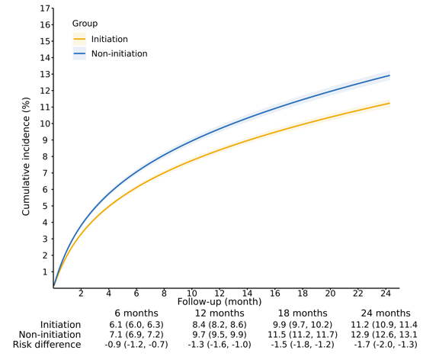
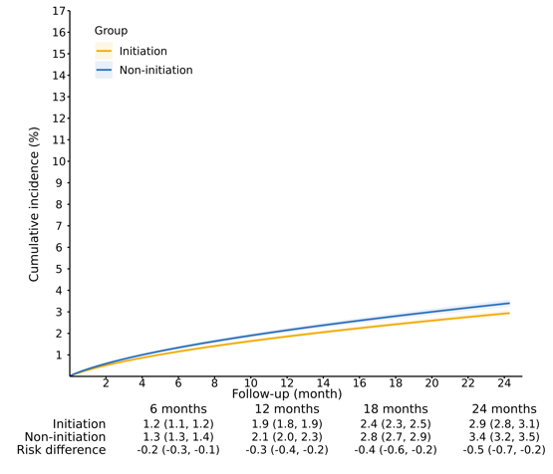

c) Accidental injuries
e) Criminality

d) Transport accidents

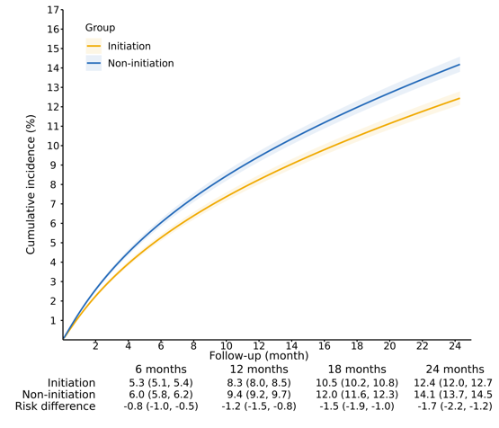
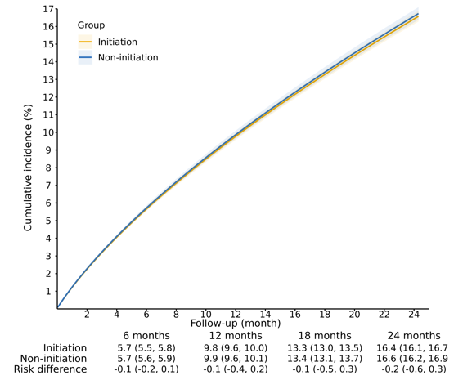
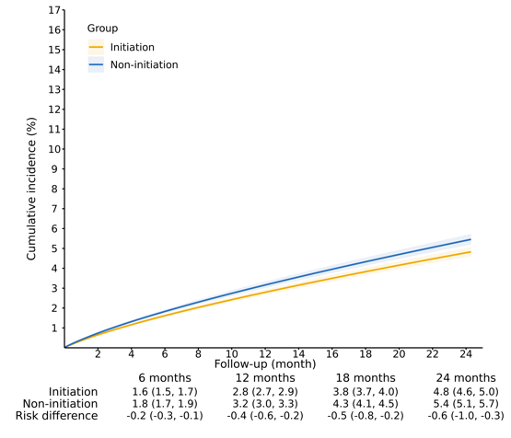

Figure 3. ADHD medication and rates of first and recurrent outcome events over a two-year follow-up among individuals with ADHD. Incidence rates were calculated per 1,000 person-years. The numbers reported are weighted and account for follow-up censoring, including treatment discontinuation or switching.

Initiation vs Non-initiation strategy | Initiation  Incidence rate | Non-initiation Incidence rate | Incidence rate ratio  (95% CI) | Favours no medication  Favours medication
First events
First events |  |  | 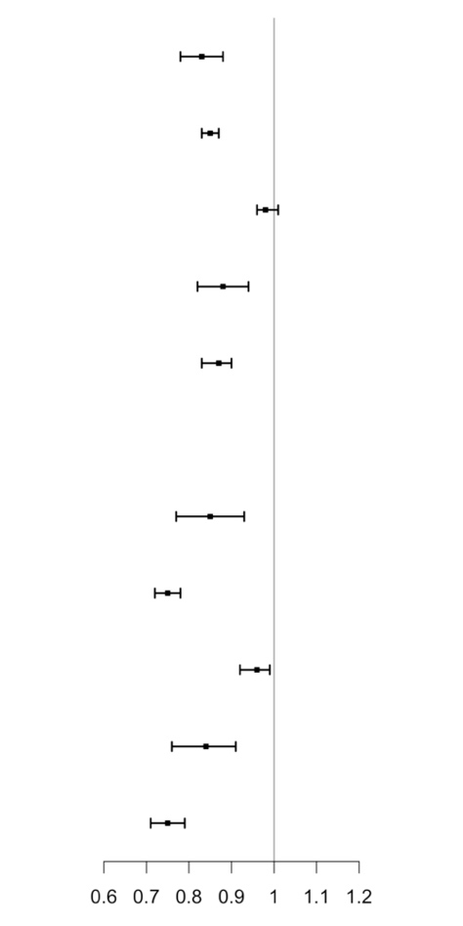
Suicidal behaviours | 14.5 | 16.9 | 0.83 (0.78 to 0.88)
Substance misuse | 58.7 | 69.1 | 0.85 (0.83 to 0.87)
Accidental injuries | 88.5 | 90.1 | 0.98 (0.96 to 1.01)
Transport accidents | 24.0 | 27.5 | 0.88 (0.82 to 0.94)
Criminality | 65.1 | 76.1 | 0.87 (0.83 to 0.90)
Recurrent events
Suicidal behaviours | 22.7 | 24.3 | 0.85 (0.77 to 0.93)
Substance misuse | 166.1 | 201.5 | 0.75 (0.72 to 0.78)
Accidental injuries | 119.4 | 122.8 | 0.96 (0.92 to 0.99)
Transport accidents | 31.6 | 37.2 | 0.84 (0.76 to 0.91)
Criminality | 111.3 | 143.4 | 0.75 (0.71 to 0.79)

Figure 4. Incidence rates of the recurrent events of the outcomes over two years of follow-up. Incidence rates were calculated per 1,000 person-years. The numbers reported are weighted and account for follow-up censoring, including treatment discontinuation or switching.

Figure 5. ADHD medication and rates of first outcome event over a two-year follow-up among individuals with ADHD, by history of events. Incidence rates were calculated per 1,000 person-years. The numbers reported are weighted and account for follow-up censoring, including treatment discontinuation or switching. Wald test for differences between the IRRs for individuals without history versus those with history of events across the five outcomes, i.e. suicidal behaviours, substance misuse, unintentional injuries, transport accidents and criminality, yielded the following p-values: 0.14, <0.01, 0.22, 0.40, and 0.02, respectively.

Outcomes | N (%) of the study population | Initiation Incidence rate | Non-initiation Incidence rate | Incidence rate ratio (95% CI)
Without a history of events |  |  |  | 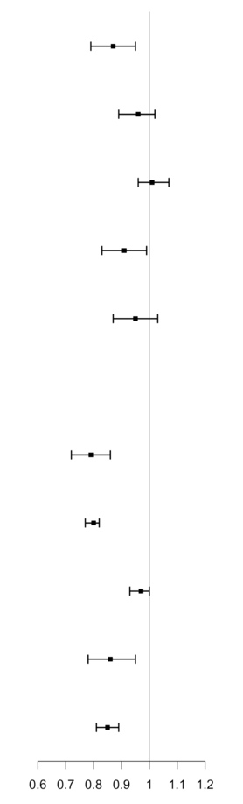  Favours medication | Favours no medication
Suicidal behaviours | 135 664 (91.3) | 9.6 | 10.8 | 0.87 (0.79 to 0.95)
Substance misuse | 117 662 (79.2) | 20.2 | 20.6 | 0.96 (0.89 to 1.02)
Accidental injuries | 69 666 (46.9) | 55.8 | 55.4 | 1.01 (0.96 to 1.07)
Transport accidents | 72 795 (81.2) | 16.0 | 17.7 | 0.91 (0.83 to 0.99)
Criminality | 56 252 (62.7) | 26.2 | 28.0 | 0.95 (0.87 to 1.03)
With a history of events
Suicidal behaviours | 12 917 (8.7) | 69.8 | 88.1 | 0.79 (0.72 to 0.86)
Substance misuse | 30 919 (20.8) | 281.9 | 363.1 | 0.80 (0.77 to 0.82)
Accidental injuries | 78 915 (53.1) | 119.5 | 123.3 | 0.97 (0.93 to 1.00)
Transport accidents | 16 877 (18.8) | 61.0 | 72.5 | 0.86 (0.78 to 0.95)
Criminality | 33 420 (37.3) | 142.0 | 170.2 | 0.85 (0.81 to 0.89)

 | Initiation  Incidence rate | Non-initiation  Incidence rate | Incidence rate ratio  (95% CI) | Favours medication
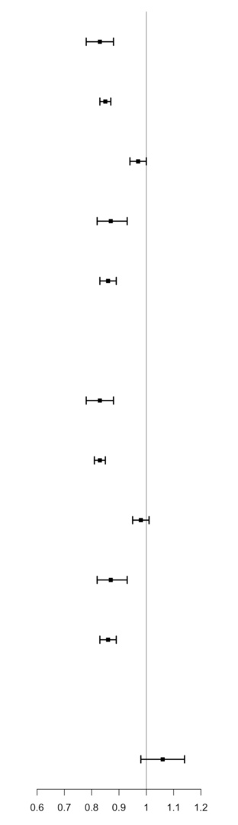
Extend the grace period to six months
Favours no medication
Suicidal behaviours | 14.5 | 16.9 | 0.83 (0.78 to 0.88)
Substance misuse | 58.7 | 69.1 | 0.85 (0.83 to 0.87)
Accidental injuries | 87.4 | 90.1 | 0.97 (0.94 to 1.00)
Transport accidents | 23.6 | 27.5 | 0.87 (0.82 to 0.93)
Criminality | 64.5 | 76.1 | 0.86 (0.83 to 0.89)
Allow switches between ADHD medications
Suicidal behaviours | 14.6 | 16.9 | 0.83 (0.78 to 0.88)
Substance misuse | 58.0 | 69.1 | 0.83 (0.81 to 0.85)
Accidental injuries | 88.8 | 90.1 | 0.98 (0.95 to 1.01)
Transport accidents | 23.7 | 27.5 | 0.87 (0.82 to 0.93)
Criminality | 65.0 | 76.1 | 0.86 (0.83 to 0.89)
Negative control outcome
Type 1 diabetes | 4.6 | 4.4 | 1.06 (0.98 to 1.14)
Figure 6. Sensitivity analyses of ADHD medication and rates of first outcome event over a two-year follow-up. Incidence rates were calculated per 1000 person-years. The numbers reported are weighted and account for follow-up censoring.

