**Characterising skin morphology at the sacrum and heel using non-invasive imaging.**

Ralph J. F. H. Gordon, Charlotte E. Stevens, Peter R. Worsley, Davide Filingeri.

Pressure ulcers (PU) arise from localised damage to the skin through a combination of sustained pressure and shearing forces, costing over £8 billion a year to treat in the UK (1). Two common sites affected by PUs are the skin of the sacrum and posterior heel, as such there is an unmet need to provide novel interventions to promote tissue viability at these anatomical sites. Characterising the microvasculature of these skin sites could provide insight on their morphological and physiological differences and changes that occur, for example from aging, and assist in the design of therapeutic interventions. Non-invasive imaging devices, such as optical coherence tomography (OCT), are promising tools for assessing spatial and temporal changes in skin morphology (2), yet there is a knowledge gap around the microvascular profiles of clinically relevant anatomical sites, susceptible to the development of PUs. This study aimed to characterise the morphological and structural properties of the skin at the sacrum and heel using OCT, in younger and older adults.

Forty-one healthy participants (21M/20F) were recruited to take part in the study. Ethical approval was granted by the University of Southampton Ethics Committee (ERGO 88984). Participants were categorised into two groups; younger healthy n=22 (25±4y; 71±9Kg; 17±9cm) and older healthy n=19 (65±4y; 70±14Kg; 171±10cm) to assess the effect of aging on vascular density and epidermal thickness of the skin of the sacrum and heel. Detailed accounts of the study protocols are publicly available (3, 4), in brief, the data presented here were collated from the pre- intervention measurements to provide a baseline characterisation. Vascular density (expressed as a % of tissue comprising blood vessels against the depth of detection) and epidermal thickness (µm) of the skin were measured via OCT at the sacrum and heel. Vascular density was analysed using a three-way ANOVA to assess the interaction between blood vessel depth, age, and anatomical site. Epidermal thickness was analysed using a two-way ANOVA to assess the interaction between age and anatomical site. Statistical significance was accepted as *P*<0.05.

There was a main effect of depth (*P*<0.001) on vascular density (Figure. 1) and an interaction between depth and the anatomical site (*P*<0.001), but no effect of age on either depth (*P=*0.810) or skin site (*P=*0.517). The epidermal thickness of the skin was greater in the heel than the sacrum (*P*<0.001, Figure. 2), but there was no effect of age (*P=*0.388).

Distinct differences in anatomical sites were observed for the vascular density profiles, across different depths. Taken together with the differences in epidermal thickness and an absence in age related differences, these data provide insight on the microvasculature at two clinically relevant sites and could aid in the design of therapeutic interventions to promote tissue viability and health, specifically in the prevention and treatment of PUs.

**\*, #**

**Figure. 1.** Characterisation of vascular density plotted against depth in the skin of the sacrum and heel. Data (n=41) are means±SD. *Main effect of depth (*P*<0.05). #Interaction between depth and anatomical site (*P*<0.05).

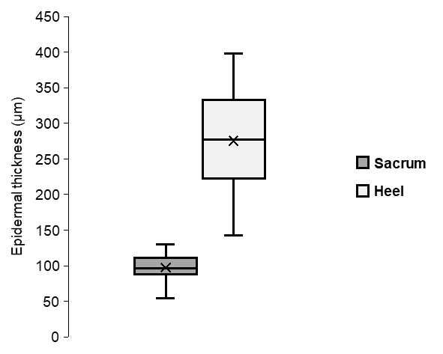

**\***

**Figure. 2.** Differences in epidermal thickness at two different skin sites. Due to technical issues obtaining epidermal thickness measurements, data are for n=25. Box plots show 1st and 3rd interquartile ranges. The solid line within the boxes denotes group means and the x denotes the median. *Main effect of anatomical site (*P*<0.05).

**References**

1. Guest JF, Ayoub N, McIlwraith T, Uchegbu I, Gerrish A, Weidlich D, et al. Health economic burden that wounds impose on the National Health Service in the UK. BMJ Open. 2015;5(12):e009283.

2. Chaturvedi P, Kroon W, Zanelli G, Worsley PR. An exploratory study of structural and microvascular changes in the skin following electrical shaving using optical coherence topography. Skin Res Technol. 2024;30(7):e13830.

3. Gordon R, Worsley PR, Filingeri D. An evaluation of the effects of localised skin cooling on microvascular, inflammatory, structural, and perceptual responses to sustained mechanical loading of the sacrum: A study protocol. PLoS One. 2024;19(5):e0303342.

4. Gordon R, Stevens C, Worsley P, Filingeri D. Evaluating the physiological and perceptual effects of localised skin cooling during repeated pressure and shear stress at the posterior heel: a study protocol. JMIR Preprints. 2025.