Tackling misinformation: where do educationalists need to target their efforts?

Chris Brown*a, Yin Wanga and Ruth Luzmorea

aSouthampton Education School, University of Southampton, Southampton, United Kingdom

Chris Brown, [Christopher.brown@soton.ac.uk](mailto:Christopher.brown@soton.ac.uk) <https://orcid.org/0000-0002-9759-9624>

Yin Wang [yin.wang@soton.ac.uk](mailto:yin.wang@soton.ac.uk) <https://orcid.org/0009-0004-9440-2410>

Ruth Luzmore [r.e.a.luzmore@soton.ac.uk](mailto:r.e.a.luzmore@soton.ac.uk) <https://orcid.org/0000-0002-2454-9407>

Tackling misinformation: where do educationalists need to target their efforts?

Misinformation, disinformation, and conspiracy theories pose growing challenges to educators world-wide. This study explores how education can help citizens embrace beneficial ideas while resisting those that are harmful. Using data from 7,000 respondents across seven European countries, it applies Latent Profile Analysis (LPA) and Factor Mixture Modelling (FMM) to examine how the varying nature of individuals’ social networks, prospective mindsets, and critical thinking influences their engagement with ideas. The findings identify four prospective mindset profiles, five social network profiles, and three critical thinking profiles. Individuals with a strong prospective mindset: characterized by future-oriented thinking and adaptive planning, as well as higher critical thinking ability, were more likely to engage with valid ideas and reject misinformation. Conversely, those embedded in dense, homophilic networks, valued ideas-engagement but showed greater vulnerability to misinformation: highlighting the risks of ‘information silos’. Lower education levels, routine-based jobs, and weaker critical thinking skills were linked to lower ideas-engagement and a greater belief in misinformation. The study highlights the need for targeted interventions to promote prospective mindsets, critical thinking, and balanced social networks:  those which combine strong, trusted ties with diverse, idea-rich connections. By identifying key profile characteristics, the research provides a basis for evidence-based strategies for educators and policymakers to support citizens in navigating an increasingly complex information landscape.

**Keywords:** [ideas](https://www.mdpi.com/search?q=ideas); [social networks](https://www.mdpi.com/search?q=social+networks); [prospection](https://www.mdpi.com/search?q=prospection); [misinformation](https://www.mdpi.com/search?q=misinformation); [education](https://www.mdpi.com/search?q=education); [ideas-engagement](https://www.mdpi.com/search?q=ideas-engagement)

# Introduction

Misinformation (false or misleading information shared regardless of intent), disinformation (deliberately spread false information), and conspiracy theories (claims that secret, powerful groups control events) are growing concerns worldwide (Commission into Countering Online Conspiracies in Schools, 2025; Jerome et al., 2024). While not exclusive to populist politicians, such figures often exploit these devices to mobilize supporters, discredit opponents, and create a sense of crisis. This tactic can involve ‘flooding the zone’: overwhelming the public and media with conflicting narratives, making it hard to focus on any one issue and letting falsehoods slip through unchecked (Clack, in press). Though these challenges are already significant, their effects are likely to intensify for the next generation. For instance, in a recent survey in England, focussing on extremism in the classroom, almost 90 percent of teachers had encountered conspiracy belief from students and 21 percent had such encounters fairly regularly (Taylor et al., 2021). In a subsequent online survey of 5,284 secondary school teachers (Jerome et al., 2024), 62 percent of teachers said they had heard students mention conspiracy theories in the past two years, with 41 percent citing some variation of a global secretive elite (e.g., the Illuminati or New World Order) and 25 percent mentioning climate scepticism.

Findings from the UK’s Commission into Countering Online Conspiracies in Schools (2025) suggest that young people and adults are now accessing news through vastly different sources. Among 11-18-year-olds, 41 percent rely on word of mouth and 38 percent on social media, whereas adults – 65 percent of parents and 51 percent of school staff – tend to trust national TV news. Further, platforms like TikTok also play a major role in shaping young people’s perspectives, with 36 percent reporting that social media changed their views on mainstream news, rising to 44 percent among 17-18-year-olds. Worryingly, however, is that social media’s design increases vulnerability to misinformation: with platforms like X (formerly Twitter) and Facebook prioritizing content that maximizes engagement – likes, shares, and comments – often at the expense of factual accuracy and diverse viewpoints. This amplification fosters filter bubbles and echo chambers, reinforcing users’ existing beliefs while limiting exposure to alternative ideas (Guess et al., 2018; Vosoughi et al., 2018). As a consequence, ‘information silos’ are clearly emerging, with young people encountering different conspiracy theories than adults. For example, UK students are more familiar with moon landing hoaxes and flat Earth theories, while adults are more aware of conspiracies about the death of Princess Diana and COVID-19. This disconnect complicates efforts to counter misinformation among young people, as educators and parents may remain unaware of the specific falsehoods circulating amongst yonger members of the population. Additionally, young people’s heavier social media use increases their exposure to influencers – including populist figures – who exploit algorithms to spread misleading content (Commission into Countering Online Conspiracies in Schools, 2025; Guess et al., 2018; Vosoughi et al., 2018). A critical question, therefore, is how educational policymakers and practitioners can equip young people with the skills to embrace positive ideas (those leading to beneficial outcomes) while rejecting harmful ones.

# Perspectives

Our previous work into the area of effective ideas-engagement (e.g. see: Brown et al., 2022a-d; Brown et al., 2024) resulted in the development and testing of a theoretical frame comprising three key factors that potentially influence individuals' ability to engage productively with ideas (Brown and Luzmore, 2024; Brown et al., 2025a, b). In brief, these factors are:

1. **Prospective mindset**: Possessing a forward-looking attitude enables individuals to value engaging with ideas and commit to actions aligned with positive, long-term outcomes (Baumeister et al., 2016; Baumeister & Lim, 2023). The notion of pragmatic prospection, meanwhile, represents one’s ability to anticipate future choices and actions - thus significantly increasing the perceived importance of engaging with new ideas (Brown et al., 2022b). As such, higher levels of pragmatic prospection support goal-oriented behaviours: everything from improving health habits to enhancing academic performance (Atance & O’Neill, 2001; Pawlak & Moustafa, 2023).
2. **Social network characteristics**: The nature of an individual’s inter-personal networks shapes how they access, perceive, and engage with ideas. For example, dense networks foster trust and cohesion but can limit exposure to new perspectives, while sparse networks and weak ties promote novelty and innovation (Burt, 2000; Granovetter, 1985; Christakis & Fowler, 2010). At the same time, homophily - the tendency to form connections with similar others - can enhance belonging but restrict cross-group idea exchange (Putnam, 2000; Singer et al., 2021).
3. **Critical thinking ability**: This includes curiosity, intellectual honesty, humility, empathy, sophisticated epistemic beliefs, information literacy, and general critical reasoning skills (Cramer et al., 2023; Bago et al., 2020). Together, these capacities help individuals assess the credibility, relevance, and implications of the ideas they encounter.

Our subsequent development of a structural equation model (see Brown et al., 2025a and below) confirmed that these factors interlink to support effective ideas-engagement through two main pathways. In the first, pragmatic prospection strengthens ideas-engagement through a fostering of networks rich in social capital and homophily. That is, pragmatic prospection leads individuals to build relationships within networks and communities that share their social identities and goals: this is because shared beliefs, values and interests foster collaboration, trust and motivation, making it easier to navigate obstacles and achieve one’s desired outcomes. In turn, belonging to a network of individuals with a shared identity creates a foundation for the meaningful exchange of ideas: being part of a likeminded community or group increases the likelihood of frequent discussions in relation to topics that matter, as well as the seeking out of ideas from different sources. Our second path links pragmatic prospection to enhancements in individuals’ capacity to critically evaluate, share, and apply ideas. In other words, pragmatic prospection leads to critical thinking, the identification of positive versus dark ideas, and a drive to acquire knowledge. This second pathway thus enables individuals to make informed decisions, distinguish beneficial ideas from harmful ones, and actively pursue intellectual exchanges through sharing and discussion.

Both pathways reinforce a cycle of meaningful, goal-oriented ideas engagement. Vitally, however, these pathways also help illustrate how ideas relating to misinformation and conspiracy can take root when critical thinking is lacking, social networks function ineffectively, and individuals fail to engage in pragmatic prospection. For instance, they align with research on epistemic networks that shows how beliefs, including misinformation and conspiracy theories, spread quickly through social circles and often persist even after being debunked (Feinstein & Baram-Tsabari, 2024). Likewise in terms of research on social dynamics and social media: with people tending to trust familiar individuals, especially when they share political views, over distant experts (Haran & Shalvi, 2019; Warner & Procaccino, 2007). or ‘official’ sources of knowledge (Marks et al., 2019; Jerome et al., 2024). Thus, we may believe the views of someone on, say, health related matters (such as Covid 19 vaccinations), even though the bond that connects us concerns an entirely different matter (e.g. political affiliation) (Stone, in press).

Moreover, there is alignment between our model and concepts such as of crippled epistemology, which explains how, without access to diverse, credible sources, people may rationally adopt false beliefs within their own cognitive framework, deepening distrust in institutional knowledge (Kerwer & Rosman, 2018; Sunstein & Vermeule, 2009). Other studies suggest that emotionally comforting beliefs can overpower rational thinking, making individuals resistant to evidence that contradicts their worldview (Griffin & Ohlson, 2001). Combined with low forward-thinking motivation, many can thus default to short-term, simplistic solutions from populist figures, heightening vulnerability to manipulation (Chong et al., 2018; Kool & Botvinick, 2014). This can be especially the case when trust in institutions is in decline (serving to further trap people in ideologically closed networks where misinformation thrives: Naughton, Leal et al., 2018; Valgarðsson et al., 2025).

Given these issues that arise from low levels of critical thinking, pragmatic prospection and from some of the ways that social networks can be structured, better understanding is thus needed to inform effective policy and practice in terms of developing effective interventions to promote ideas-engagement. Specifically, we need to better understand:

* **Research Question 1:** Which social demographic characteristics (e.g. gender, highest qualification attained, occupation status etc.) best account for the variability in individuals’ levels of prospective mindset, social network structures, and critical thinking abilities (so potentially identify those most likely to benefit from interventions designed to equip young people and other citizens with the skills to embrace positive ideas while rejecting harmful ones).
* **Research Question 2**: Based on the findings of RQ1, what ideas-related attitudes, beliefs, and behaviours (e.g., perceived value of engaging with ideas, actual engagement with ideas, and ability to engage effectively) offer promising targets or pathways for interventions designed to equip young people and other citizens with the skills to embrace positive ideas while rejecting harmful ones?

By answering these questions, we can thus help to better position educational policymakers and practitioners design evidence-based strategies to arm young people with the tools to navigate the complex, information-rich world they face – fostering resilience against misinformation and empowering them to pursue positive, well-informed futures.

# Methodology

The theoretical framework outlined above was originally operationalised and tested via development of a questionnaire (the ‘Ideas-engagement Networks Prospection and Education Survey’: INPES) and the collection and analysis of INPES data from some 7,000 participants across Europe (with nationally representative samples of 1,000 respondents aged 18+ collected from each of England, Finland, Italy, the Netherlands, Spain, Sweden, and Switzerland. A full account of our research approach can be found in Brown et al., (2025). Ethical approval for the project was obtained from University of Southampton’s Faculty for Social Sciences’ ethics committee (approval number ERGO II 93510. All research was conducted with participants’ full consent through a double opt-in panel registration process, ensuring ethical standards were maintained throughout the study.

Survey items were constructed for each variable comprising our three factors of prospective mindset, social networks, and critical thinking, along with a measure for ideas-engagement and relevant demographic variables (age, gender, highest level of qualification, occupation etc.) (Kline, 2011). Additionally, we introduced a calibration element, asking respondents to assess the veracity of statements that were either factual (i.e. proven by scientific method), conspiratorial (indicative of claims that secret, powerful groups control events), or false but populist (claims that make emotionally appeals and may ring true ‘intuitively’, but have no basis in fact). For instance, respondents were asked to rate the truth of statements like “there is evidence to suggest the Earth is actually flat, rather than round” (factually incorrect). For these calibration questions, a five point scale was utilised, which ranged from ‘I strongly believe this to be true’ to ‘I strong believe this to be untrue’). The calibration aspect of our approach thus intended to help us distinguish between respondents who engaged with valid ideas versus ‘dark’ ideas (i.e. those corresponding to misinformation, disinformation and conspiracy theory) and to explore whether engagement with valid ideas also corresponds to respondents rejecting dark ideas - or if respondents could engage with both.

In developing our questionnaire, we reviewed whether scales and items already existed for each of our variables, incorporating previously tested measures wherever possible. For example, for the calibration questions we drew on surveys undertaken by Jennings et al., 2023 and Kenny et al., (undated working paper). Once the survey was developed, two experts reviewed the questionnaire for face and content validity, and two laypersons tested it for clarity to identify any potential ambiguities. A pilot study with 100 respondents in each of the seven countries was also undertaken to confirm that questions were clear and effectively interpreted by respondents. A full copy of the survey can be found in Appendix A of Brown et al., 2025a).

A comprehensive description of the sample characteristics of our 7,000 respondents is provided in Table 1 of our supplementary materials (specifically, this Table provides detailed data on participant demographics - age, gender, qualifications, occupation - across our sampled seven countries). A full descriptive analysis of our sample can also be found in Brown et al., 2025b including analysis of country-level differences in demographic and ideas-related characteristics. Further, Tables 2 to 4 of the supplementary materials provide profiles of our samples’ levels of prospective mindset (ranging from high to very low), social network characteristics (from limited to exceptionally high homophily and social capital), and critical thinking ability (low, moderate, high). Each profile is cross-tabulated with demographic variables, offering a comparative view of how future-oriented thinking, network structures, and reasoning skills vary by demographic characteristic.

To address the cross-cultural consistency of our data, we tested measurement invariance across the seven countries using multi-group confirmatory factor analyses (MG-CFA) for six key constructs: Prospective Mindset, Critical Thinking Ability, Network Homophily, Network Social Capital, Positive Ideas, and Dark Ideas (Brown et al., 2017). For each, we estimated three nested models (configural, metric and partial scalar invariance) using robust maximum likelihood estimation (MLR) to account for non-normal data (Pan & Fang, 2002; Xu & Tracey, 2017). We assessed model fit using standard indices, including AIC, BIC, χ², RMSEA, CFI, TLI, and SRMR, applying established cut-offs (Cheung & Rensvold, 2002; Meade et al., 2008; Pendergast et al., 2017).

Results showed acceptable to good fit for configural and metric invariance across all constructs, supporting the comparability of factor structures and loadings across countries. While some deviations emerged at the scalar level (e.g., slightly elevated RMSEA for Critical Thinking Ability; a ΔCFI of 0.015 for Prospective Mindset), partial scalar invariance was established by freeing a small number of intercepts. This is acceptable in cross-cultural research, where minor item-level differences are expected (Byrne et al., 1989; Steenkamp & Baumgartner, 1998). Crucially, as this study focuses on structural relationships rather than cross-national mean comparisons, the partial invariance achieved provides a robust foundation for interpreting constructs consistently across cultural contexts.

To analyse our data as part of our original analyis (i.e. that reported Brown et al., 2025), we utilized a multi-step process that combined exploratory factor analysis (EFA), confirmatory factor analysis (CFA), and structural equation modelling (SEM) to identify latent constructs and examine the hypothesized relationships between constructs. The latent constructs that emerged from this process, and which provide the focus for this paper are detailed in Table 1, below:

Table 1: Latent constructs emerging from exploratory factor and multiple-group confirmatory factor analysis

|  |  |  |  |  |  |  |  |  |  |  |  |  |
| --- | --- | --- | --- | --- | --- | --- | --- | --- | --- | --- | --- | --- |
| **Aspect of theoretical frame** | **Name of factor following EFA/CFA** | **Survey questions corresponding to factor** | **Response options** | **Models** | **AIC** | **BIC** | **χ²** | **χ2(df)** | **RMSEA** | **CFI** | **TLI** | **SRMR** |
| Prospective mindset | Imagining Future Outcomes and Adaptive Planning | To what extent do you agree with the following statements: | Strongly Disagree | 1.a | 112014.378 | 113023.35 | 444.209* | 98 | 0.059 | 0.956 | 0.933 | 0.033 |
| Q1: I contemplate my ideal outcomes for the future. | Disagree | 1.b | 112033.251 | 112795.128 | 528.345* | 134 | 0.054 | 0.949 | 0.944 | 0.054 |
| Q2: I consider alternative paths toward a goal and choose the best one. | Neither agree nor disagree | 1.c | 112151.275 | 112720.967 | 686.781* | 162 | 0.056 | 0.934 | 0.939 | 0.067 |
| Q3: I make plans that specify different courses of action depending on how things progress. | Agree | *In the 1.c model, this study freed a subset of item intercepts in UK (Q6); Finland (Q1, Q2, Q6, Q7); Italy (Q4, Q6, Q5); Spain (Q4, Q2, Q1); Netherlands (Q6, Q2); Switzerland (Q6). | | | | | | | | |
| Q4: I envision the outcomes I want most. | Strongly Agree |
| Q5: I consider obstacles I might encounter on the way to my goal and plan how I will deal with them. |  |
| Q6: I identify the outcome I am hoping for among the possible future outcomes. |  |
| Q7: I imagine how I will feel after reaching my goal. |  |
| Social network characteristics | Network Homophily | To what extent do your close friends: | All do | 2.a | 94109.749 | 94686.304 | 48.287* | 14 | 0.049 | 0.989 | 0.966 | 0.017 |
| Q1: Share the same political views as you? | Most do | 2.b | 94104.214 | 94557.222 | 68.559* | 32 | 0.034 | 0.988 | 0.984 | 0.029 |
| Q2: Share something else in common with you (such as interests or hobbies)? | Some do | 2.c | 94122.313 | 94486.092 | 108.189* | 45 | 0.037 | 0.979 | 0.981 | 0.038 |
| Q3: Believe the same kinds of things to be true as you? | Very few do | In the 2.c model, this study freed a subset of item intercepts in the UK (Q3, Q4); Finland (Q3, Q4); Italy (Q3); Spain (Q3, Q2, Q1); Netherlands (Q4); Sweden (Q3); Switzerland (Q1). | | | | | | | | |
| Q4: Know one another? | None do |
|  | Don’t know |
|  | n/a |
| Social network characteristics | Network Social Capital | To what extent do your close friends: | All do | 3.a | 104079.57 | 104656.126 | 40.334* | 14 | 0.043 | 0.993 | 0.979 | 0.015 |
| Q1: Have the same occupation as you? | Most do | 3.b | 104106.5 | 104559.508 | 97.249* | 32 | 0.045 | 0.983 | 0.978 | 0.033 |
| Q2: Belong to the same clubs you belong to (such as a sports club)? | Some do | 3.c | 104129.646 | 104479.698 | 149.834* | 47 | 0.047 | 0.973 | 0.976 | 0.04 |
| Q3: Belong to the same groups or communities you belong to? | Very few do | In the 3.c model, this study freed a subset of item intercepts in the UK (Q3); Italy (Q4, Q1); Netherlands (Q1, Q2); Sweden (Q3, Q2); Switzerland (Q1, Q2). | | | | | | | | |
| Q4: Belong to the same religious group you belong to (such as church, mosque or synagogue)? | None do |
|  | Don’t know |
|  | n/a |
| Critical thinking ability | Critical thinking and engagement | To what extent do you agree with the following statements: | Strongly Disagree | 4.a | 83395.672 | 84260.506 | 593.96* | 63 | 0.091 | 0.929 | 0.881 | 0.04 |
| Q1: I can grasp the logical connections between different ideas. | Disagree | 4.b | 83372.741 | 84031.662 | 638.432* | 93 | 0.076 | 0.927 | 0.917 | 0.051 |
| Q2: I can interpret, evaluate, and analyse facts to make informed judgments. | Neither agree nor disagree | 4.c | 83411.261 | 83919.179 | 742.26* | 115 | 0.073 | 0.916 | 0.923 | 0.055 |
| Q3: If I am not sure about something, I will research to find out more. | Agree | In the 4.c model, this study freed a subset of item intercepts in each country: Italy (Q3, Q6); Netherlands (Q3); Sweden (Q1, Q4, Q2); Switzerland (Q1, Q4). | | | | | | | | |
| Q4: I am confident in my ability to assess the credibility of information sources. | Strongly Agree |
| Q5: I know how to search for reliable information to develop my knowledge of a topic. |  |
| Q6: It’s important that my opinions are influenced by evidence and not solely emotion or personal experience |  |
| Ideas-engagement | Value of ideas-engagement | How important is it for you to keep yourself well-informed? For example, by finding out more about different ideas or perspectives; learning more about scientific discoveries and new technology; and/or discovering more about different aspects of history and culture (including arts, literature etc.). | Very important |  |  |  |  |  |  |  |  |  |
| Important |  |  |  |  |  |  |  |  |  |
| Neither important or unimportant |  |  |  |  |  |  |  |  |  |
| Somewhat important |  |  |  |  |  |  |  |  |  |
| Not important |  |  |  |  |  |  |  |  |  |
| Calibration | Ability to identify Positive Ideas correctly | Please indicate the extent to which you believe the following statements to be true: | I strongly believe this to be true | 5.a | 102451.177 | 103171.872 | 225.39* | 35 | 0.073 | 0.952 | 0.904 | 0.03 |
| Q1: Participating in cultural activities – such as visiting museums or galleries – can have positive impacts, beyond just learning. | I believe this to be true | 5.b | 102527.183 | 103083.148 | 327.347* | 59 | 0.067 | 0.933 | 0.92 | 0.051 |
| Q2: Being obese can contribute to mental health issues like depression. | I need more information to be able to judge this statement | 5.c | 102523.881 | 103059.254 | 384.934* | 62 | 0.072 | 0.936 | 0.928 | 0.052 |
| Q3: Our outlook on life, (e.g. our attitudes and beliefs), is influenced by the those in our social circles. | I believe this to be untrue | In the 5.c model, this study freed a subset of item intercepts in UK (Q1, Q3); Finland (Q1, Q3); Italy (Q1, Q3, Q4); Spain (Q1, Q3, Q4, Q2); Netherlands (Q1, Q4, Q2); Sweden (Q3). | | | | | | | | |
| Q4: Global heating (climate change) is directly caused by human activity. | I strongly believe this to be untrue |
| Calibration | Ability to identify Dark Ideas correctly | Please indicate the extent to which you believe the following statements to be true: | I strongly believe this to be true | 6.a | 102451.177 | 103171.872 | 225.39* | 35 | 0.073 | 0.952 | 0.904 | 0.03 |
| Q1: There is currently no evidence to suggest vaping is bad for your health. | I believe this to be true | 6.b | 102527.183 | 103083.148 | 327.347* | 59 | 0.067 | 0.933 | 0.92 | 0.051 |
| Q2: Immigration is the biggest threat facing society and the economy | I need more information to be able to judge this statement | 6.c | 102523.881 | 103059.254 | 384.934* | 62 | 0.072 | 0.936 | 0.928 | 0.052 |
| Q3: Vaccines (such as MMR or the COVID-19 vaccine) are generally more dangerous to our health than the diseases they are designed to cure. | I believe this to be untrue | *In the 6.c model, this study freed the intercepts of Q1, Q2, Q3, and Q4 in all seven countries and the intercept of Q5 in Finland, Italy, and Sweden. | | | | | | | | |
| Q4: A number of terrorist attacks and incidents (such as 9/11) were carried about by national governments to provide an excuse to impose stricter and more prohibitive laws. | I strongly believe this to be untrue |
| Q5: There is evidence to suggest the Earth is actually flat, rather than round. |  |
| *\*Model X.a (configural invariance): the same factor‐indicator configuration was estimated in each country, with no equality constraints on factor loadings or item intercepts. This model establishes whether all groups share a common pattern of factor structure.* | | | | | | | | | | | | |
| *\*Model X.b (metric invariance): all factor loadings were constrained equal across the seven countries while intercepts and residual variances remained freely estimated. By fixing loadings to be identical, this model tests whether the constructs have the same measurement units across groups.* | | | | | | | | | | | | |
| *\*Model X.c (partial scalar invariance): starting from the metric model, this study further constrained most item intercepts to equality across countries but freed a small subset of intercepts (those flagged by modification indices) in specific groups. This approach secures comparability of both measurement units and most item thresholds, while allowing targeted intercepts to vary so that valid latent-mean comparisons can still be made.*  *\*Note. * p < .001.* | | | | | | | | | | | | |

**Analysis**

To address our two new research questions, we revisited these latent constructs alongside the demographic data collected from survey respondents. In this study, however, we applied Latent Profile Analysis (LPA) and Factor Mixture Modelling (FMM) to classify over 7,000 participants into distinct profiles - for example, those with high, medium, or low levels of critical thinking. By combining LPA and FMM, we were able to investigate subgroup differences across a range of variables, identify predictors of profile membership, and assess how key outcomes varied between profiles. Consequently, we have been able to both identify and describe the heterogeneity within our sample as well as explore more complex relationships between independent and dependent variables (via ensuring measurement model consistency). This, in turn, has provided a refined and accurate empirical basis for understanding not only how different levels of social network characteristics, prospective mindset, and critical thinking are associated with certain demographic characteristics, but also how different levels of social network characteristics, prospective mindset, and critical thinking subsequently impact on the value of ideas-engagement and the quality of ideas-engagement.

We began by applying LPA to examine the latent subgroup structure within the continuous variables of Network Homophily and Network Social Capital. To thoroughly explore the parameter space, the study set 7,000 random starting values, conducted 300 iterations for each, and retained the 200 best solutions for final stage optimization (Hipp and Bauer, 2006). This strategy helped avoid local optima and enhanced global convergence. Because the data showed a global structure, we accounted for residual correlations to improve model fit (Spurk et al., 2020). In LPA, high indicator correlations can mask distinct profiles, as they reflect the shared influence of an overarching network construct. If unaccounted for, this global effect can obscure differences in profile shapes, making it difficult to identify qualitatively distinct profiles. Consequently, scholars such as Morin and Marsh (2015) have recommended extracting latent class variables from the residual covariance or using factor mixture models that incorporate continuous factors to address these issues (Morin, et al., 2016; Morin and Marsh, 2015).

In addition, our original study employed several indicators of prospective mindset (see Table 1) alongside indicators of critical thinking ability, both of which are categorical variables and also influenced by the global network construct. To address this, we adopted the FMM approach, recommend by Morin and Marsh (2015), which integrates the strengths of latent class analysis (LCA) and confirmatory factor analysis (CFA). This method enabled us to uncover heterogeneity within the sample while ensuring consistency in the overall measurement structure (i.e., measurement invariance) across latent classes, thereby confirming that any differences in latent factors among the classes are genuine. To maintain consistency with the LPA setup, we configured 7,000 starting values, selected the 200 best solutions for final optimization, limited the maximum number of iterations to 300, and employed the Maximum Likelihood Robust (MLR) method to mitigate violations of the normality assumption and reduce estimation bias.

To determine the optimal number of classes and profiles, we utilized several fit indices and model selection criteria. Specifically, we assessed the Log-Likelihood (LL), Sample-Adjusted Bayesian Information Criterion (SABIC), Akaike Information Criterion (AIC), and Bayesian Information Criterion (BIC). While higher LL values indicate better fit, lower values of AIC, BIC, and SABIC generally suggest a better balance between model fit and complexity. Additionally, higher entropy values – ideally 0.80 or above, though values between 0.60 and 0.80 are acceptable – indicate superior classification quality (Clark and Muthén, 2009; Jung and Wickrama, 2008; Muthén, 2004). Furthermore, we employed the adjusted Lo-Mendell-Rubin (LMR) test; if a model with k + 1 profiles produces a non-significant p-value (p > .05), it does not significantly improve upon a model with k profiles, suggesting that the k-profile solution should be retained. It is important to note that while these statistical criteria serve as guidelines, the final determination of the optimal number of classes and profiles also depended on whether the resulting classifications revealed meaningful and practical differences within the sample, rather than solely on numerical indices. All analyses were conducted using Mplus 8.0.

Following the LPA and FMM analyses, we employed the ‘Most Likely Latent Class Membership’ method to assign individuals to classes. This method assigns each respondent to the latent class for which they have the highest posterior probability, a process often referred to as ‘hard assignment’. Using this technique, we achieved a clear classification of the sample. Subsequently, StataNow version 18.0 MP was used to analyze the distribution of these classes across various variables – including gender, age, occupation, income, and highest educational attainment – to further explore the relationships and differences among the classes.

As a last step, Cramér’s V tests were conducted to examine the effect sizes of associations between key variables and profile membership. Although the effect sizes were generally small (Cramér’s V < 0.2), indicating weak associations (Tomczak & Tomczak, 2014), they remain meaningful in the context of an exploratory study with a moderate sample size (N ≈ 7,000). The primary aim of this analysis is to describe observed distributional patterns rather than to draw inferential conclusions. While the small effect sizes are acknowledged as a limitation, they do not diminish the value of identifying preliminary trends – particularly in a cross-national context where even subtle associations may be theoretically relevant or guide future research. Accordingly, all findings are interpreted descriptively and should not be taken as evidence of strong or generalizable group-level differences.

# Results

For prospective mindset, we selected a four-profile solution (AIC = 108604.949, BIC = 108879.499, SABIC = 108752.389 and an entropy value of 0.814). The resultant characteristics for this profile solution can be found in Table 2, below. Since, with the construct of prospective mindset, observed variables exhibit a global structure, this study used FMM to estimate its characteristics across different latent classes, providing estimates of the Class-Specific Latent Factor Means for each class. As such, is important to note that the numerical values of these Class-Specific Latent Factor Means do not have direct practical significance, as they are not tied to specific units or scales. Instead, their relative relationships carry meaning. Specifically, the relative magnitudes of these means offer valuable insights into the differences in prospective mindset intensity across the latent classes. By comparing these relative values, we can infer which classes exhibit higher or lower levels of prospective mindset, providing a reference for understanding the varying degrees of this trait among the identified groups.

**Table 2: Prospective mindset profile characteristics**

|  |  |  |  |  |
| --- | --- | --- | --- | --- |
| **Latent Class** | **Number** | **Proportion** | **Prospective mindset**  **(Class-Specific Latent Factor Mean)** | **Class-Specific Name** |
| 1 | 478 | 0.07 | 2.276*** | Profile 1: high level of prospective mindset |
| 2 | 2809 | 0.40 | -1.846*** | Profile 2: average levels of prospective mindset |
| 3 | 173 | 0.02 | -4.705*** | Profile 3: low level of prospective mindset |
| 4 | 3611 | 0.51 | 0.000*** | Profile 4: very low level of prospective mindset |

*Statistical significance levels: * p < 0.05, ** p < 0.01, *** p < 0.001.

Table 2 shows that the FMM analysis identified four latent classes with distinct profiles of Prospective Mindset. Profile (Latent Class) 4, with a mean fixed at 0.00 (as the reference group), represents the baseline level of Prospective Mindset and includes the largest proportion of individuals (51 percent). In contrast, Profile (Latent Class) 3 exhibits the lowest Prospective Mindset intensity, with a mean of -4.705. Profile (Latent Class) 2, the second largest group (40 percent), shows a moderately lower mindset intensity (-1.846). Finally, Profile (Latent Class) 1 (7 percent), demonstrates the highest Prospective Mindset intensity (2.276). Correspondingly we refer to Profile 1 as those with a high level of prospective mindset; Profile 4 (the most common group) as average levels of prospective mindset; Profile 2 as those with low levels of prospective mindset; and Profile 3 as those with very low levels of prospective mindset. This classification thus enabling us to explore both how socio-demographic characteristics and ideas-engagement might differ amongst profile types.

For social network characteristics, we opted for a five-profile solution (AIC = 43055.402, BIC = 43165.223, SABIC = 43114.378 and an entropy value of 0.839). The characteristics of this profile solution can be found in Table 3, below. Here the mean scores – estimated during the model-fitting process using a probabilistic approach in Mplus – represent the average scores of individuals assigned to each latent profile on the observed variables of Network Homophily (indicating whether an individual belongs to a network of people with similar attitudes: see Table 1 for example survey questions used) and Network Social Capital (indicating whether an individual belongs to a network of people engaging in similar activities: again, survey questions used to determin this can be found in Table 1). By comparing the means across latent profiles, we can identify distinct profiles characterized by varying levels of network homophily and social capital. Profile 1 exhibits low scores on both network homophily (1.789) and network social capital (0.517), representing a group with limited homophily and minimal social capital. Profile 2 shows moderate homophily (4.821) but remains low in social capital (1.105), suggesting social capital is still restricted for profile members. Profile 3 demonstrates high scores on both dimensions, with homophily at 5.621 and social capital at 4.128, indicating strong homophily and substantial social capital. Profile 4 presents moderate-high homophily (5.134) and moderate social capital (2.777), reflecting a more balanced profile. Finally, Profile 5 displays exceptionally high scores on both measures, with homophily at 6.340 and social capital at 5.494, representing a group with pronounced homophily and extensive social capital. These profiles thus reveal a number of meaningful distinctions in how network homophily and social capital are distributed across groups.

Table 3: Social Network profile characteristics

|  |  |  |  |  |  |
| --- | --- | --- | --- | --- | --- |
| **Latent Profile** | **Number** | **Proportion** | **Network Homophily (NH) (mean)** | **Network Social Capital (SC) (mean)** | **Profile-Specific Name** |
| 1 | 365 | 0.05 | 1.789 *** | 0.517*** | Profile 1: limited NH and SC |
| 2 | 1922 | 0.27 | 4.821 *** | 1.105 *** | Profile 2: moderate NH and low SC |
| 3 | 1997 | 0.28 | 5.621 *** | 4.128 *** | Profile 3: strong NH and SC |
| 4 | 2471 | 0.35 | 5.134 *** | 2.777 *** | Profile 4: moderate-high NH and moderate SC |
| 5 | 316 | 0.04 | 6.340 *** | 5.494 *** | Profile 4: exceptionally high NH and SC |

*Statistical significance levels: * p < 0.05, ** p < 0.01, *** p < 0.001.

Finally, for critical thinking ability we selected a three-profile solution AIC = 80468.608, BIC = 80695.112, SABIC = 80590.245 and an entropy value of 0.827). As Table 4 shows, the Class-Specific Latent Factor Means reveal significant differences in critical thinking intensity across the profiles. Profile 3, with a mean fixed at 0.000 (as the reference group), represents the relatively highest level of critical thinking ability and includes 16 percent of the sample. Profile 2, the largest group (64 percent), exhibits moderately critical thinking ability (mean = -2.992). In contrast, Profile 1 demonstrates the lowest critical thinking intensity (mean = -5.706), comprising 20 percent of the sample.

Table 4: Critical thinking ability profile characteristics

|  |  |  |  |  |
| --- | --- | --- | --- | --- |
| **Profile** | **Number** | **Proportion** | **Critical thinking ability (Class-Specific Latent Factor Mean)** | **Class-Specific Name** |
| 1 | 1446 | 0.20 | -5.706*** | Profile 1: lowest level of critical thinking ability |
| 2 | 4510 | 0.64 | -2.992*** | Profile 2: moderate level of critical thinking ability |
| 3 | 1115 | 0.16 | 0.000*** | Profile 3: highest level of critical thinking ability |

*Statistical significance levels: * p < 0.05, ** p < 0.01, *** p < 0.001.

## Results for the prospective mindset profiles

The characteristics of the four prospective mindset profiles can be found in Tables 5 to 10 below. Here we examine differences between profiles in terms of age, gender, highest qualification attained, occupation type, the value profiles ascribe to ideas-engagement and the extent to which respondents believe in a representative example of one of our ‘dark ideas’ statements to be true (‘there is evidence to suggest the Earth is actually flat, rather than round’). In examining χ2 statistics for Figures 1 – 4 and Tables 5 and 6, it can be seen all have p-values below 0.05, indicating that age, gender, education, occupation, value of ideas-engagement and belief in Flat Earth theory each show strong statistical differences across profiles. For example, it can be seen in Figure 1 that Profile 1 – which has the highest mean for prospective mindset – also has a higher proportion of younger respondents (18-24: 14 percent, 25-44: 42 percent). Profiles 2 and 3 have older distributions, with notable percentages in the 55+ age range. This suggests that prospective mindset varies by age; with younger individuals having a different perspective on future planning. Women tend to have higher levels of prospective mindset than men: with Figure 2 highlighting a huge disparity between men and women Profile 3 (the profile with the lowest level of prospective mindset) comprised 60 percent men vs 35 percent women. In terms of qualifications (Figure 3), Profile 3 (which has the lowest mean for prospective mindset) also has the highest proportion of individuals with no qualifications and a relatively high number with only school-level education, whereas Profiles 1 and 4 (which have the two highest means for prospective mindset) have the highest percentage of postgraduate degree holders: indicating that higher levels of education are correlated with a stronger prospective mindset.

In terms of employment data (Figure 4), Profile 3 has a notable proportion of unemployed individuals (16 percent) and those in routine occupations (16 percent), while Profiles 1 and 4 have the highest number of professionals and higher-level professionals (38 and 39 percent respectively). This suggests that being in a situation of unemployment or employment of a routine nature (e.g. bar staff, cleaner, labourer, bus driver, lorry driver etc.) is likely less conducive to developing a prospective mindset. Potentially this is due to the low level of wages paid by such roles, which tends to focus the future-looking gaze of individuals to the most immediate and pressing needs (Bregman, 2018). Table 5, meanwhile, explores the value ascribed to ideas-engagement by each profile, Profiles 1 and 4 show the highest rates of considering ideas-engagement as ‘very important’ (70 percent and 44 percent, respectively). Profile 3, meanwhile, has the largest proportion of people who consider ideas-engagement as ‘not important or ‘somewhat important’ (with 27 percent considering ideas-engagement to be of no real importance, or presenting an indifferent response of ‘neither important or unimportant’): this highlighting a connection between a strong prospective mindset and valuing engagement with ideas. Finally, the spread of misinformation is somewhat linked to lower prospective mindset scores (Table 6), with Profile 3 showing a greater tendency to believe in the Flat Earth statement (11 percent) and Profile 2 (the profile with the second lowest mean score for prospective mindset) having the highest percentage who are unsure (with 17 percent indicating that they ‘need more information to be able to judge’). Those with high levels of prospective mindset, however, tend to be more strongly certain that there is no evidence to suggest the world is flat.

**Figure 1: Prospective Mindset – age distribution by profile**

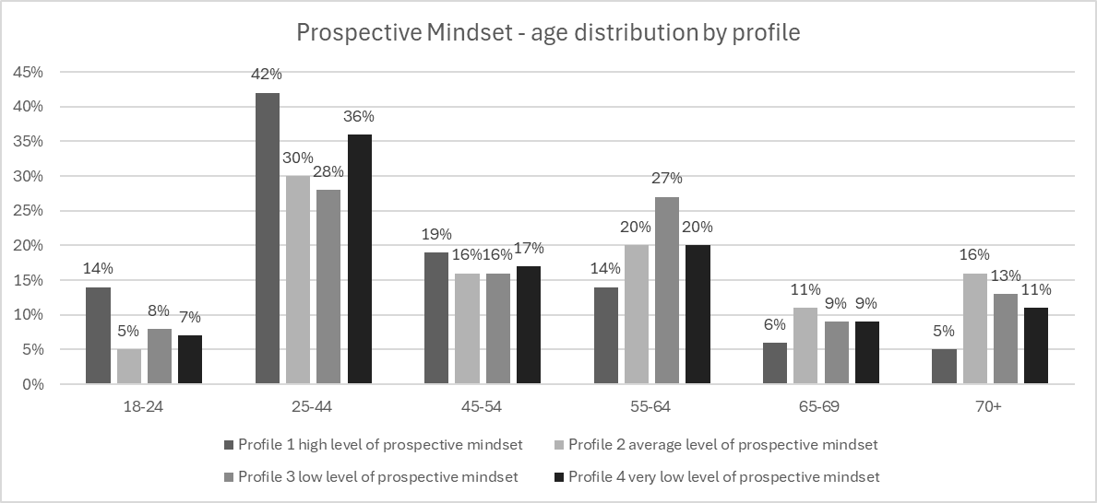**Figure 2: Prospective Mindset – gender distribution by profile**

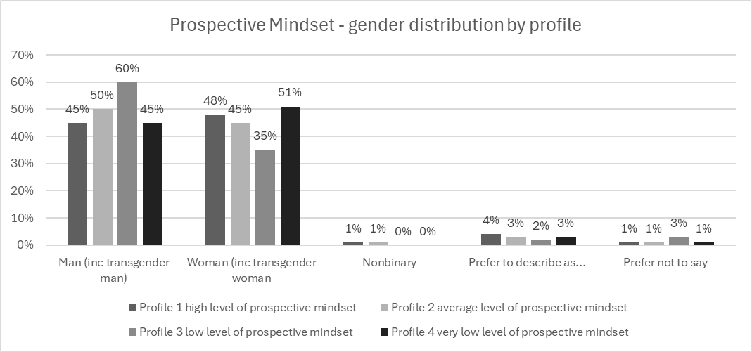**Figure 3: Prospective Mindset – qualification level distribution by profile**

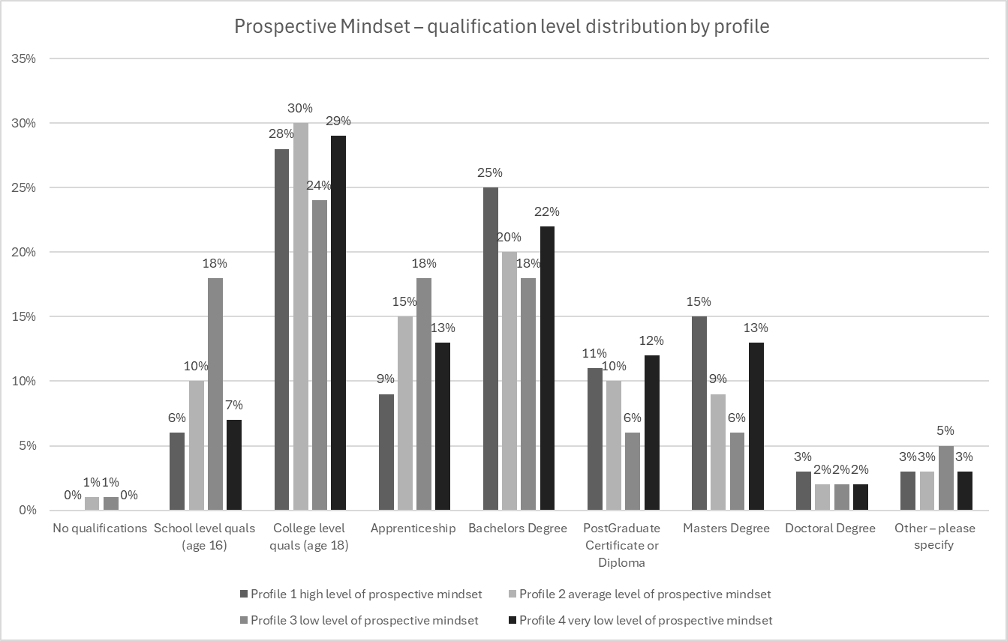

**Figure 4: Prospective Mindset – occupation distribution by profile**

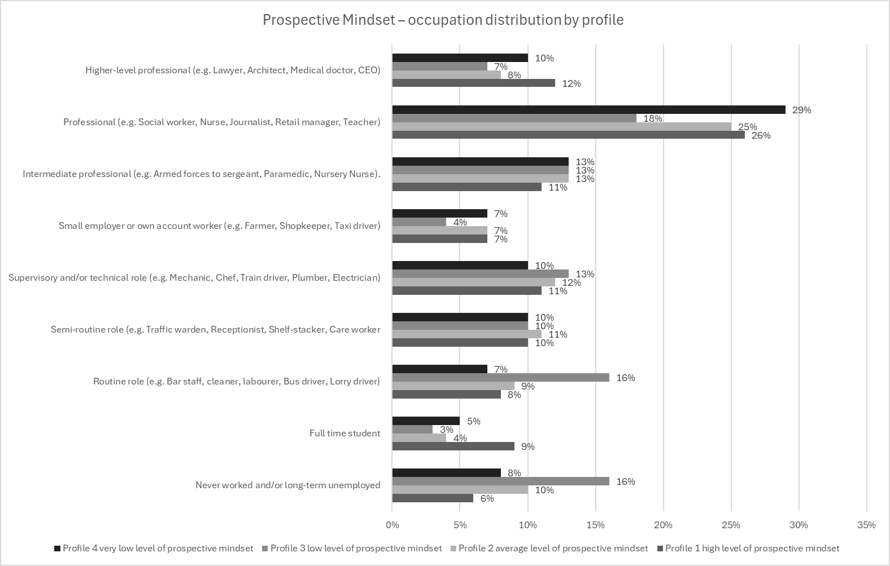Table 5: Prospective mindset importance of ideas-engagement by profile

|  |  |  |  |  |
| --- | --- | --- | --- | --- |
|  | **Profile 1**  high level of prospective mindset | **Profile 2** average levels of prospective mindset | **Profile 3**  low level of prospective mindset | **Profile 4**  very low level of prospective mindset |
| **Not important** | 0% | 1% | 6% | 0% |
| **Somewhat important** | 1% | 3% | 5% | 2% |
| **Neither important or unimportant** | 3% | 16% | 16% | 6% |
| **Important** | 26% | 54% | 41% | 47% |
| **Very important** | 70% | 27% | 32% | 44% |
| **Total** | 100% | 100% | 100% | 100% |

*χ2* = 611.05, *p* < 0.001, *df* = 15, Cramér's V = 0.160

Table 6: Prospective mindset – extent to which respondents believe the statement ‘there is evidence to suggest the Earth is actually flat, rather than round’ to be true.

|  |  |  |  |  |
| --- | --- | --- | --- | --- |
|  | **Profile 1**  high level of prospective mindset | **Profile 2** average levels of prospective mindset | **Profile 3**  low level of prospective mindset | **Profile 4**  very low level of prospective mindset |
| **I strongly believe this to be true** | 3% | 2% | 2% | 1% |
| **I believe this to be true** | 4% | 4% | 9% | 3% |
| **I need more information to be able to judge** | 13% | 17% | 12% | 9% |
| **I believe this to be untrue** | 6% | 12% | 12% | 13% |
| **I strongly believe this to be untrue** | 74% | 65% | 65% | 73% |
| **Total** | 100% | 100% | 100% | 100% |

*χ2* = 130.71, *p* < 0.001, *df* = 12, Cramér's V = 0.079

## Results for the social network characteristics profiles

The characteristics of the five social network characteristic profiles are set out in Figures 5 – 8 and Tables 7 and 8, below. Examining χ2 statistics for each reveal that all variables have p-values below 0.05; indicating that age, gender, education, occupation, value of ideas-engagement and belief in Flat Earth theory again exhibit strong statistical differences across profiles. For instance, examining the age distribution of each profile (Figure 5), reveals how Profile 5, which has the highest means for network homophily and network social capital, is more dominated by younger adults (49 percent aged 25-44 and 60 percent aged 18 to 44). Profile 1 (the lowest means for network homophily and network social capital), meanwhile, has the highest representation of older individuals (23 percent aged 70+ and 57 percent aged 55+). This suggests that older individuals may be less embedded in tightly-knit social networks; instead exhibiting greater diversity in terms of the characteristics of the individuals they are connected to. Figure 6 considers gender distribution by Profile type. Here it is apparent that men are more likely to be members of networks that are denser and more homogenous in nature, while women tend slightly to have networks with lower levels of social capital and homophily. With regards to the highest qualifications held by profile members (Figure 7) there is a trend where higher qualifications (Masters, Doctoral) are more prominent in Profiles 3-5; increasing in line with the means for network homophily and network social capital. These findings cohere with analysis by Putnam (2000), which found level of education to be positively correlated with more formal forms of social capital, such as joining an association or membership group and playing a leading role in such a group. In terms of occupation (Figure 8), Profile 1 has the highest proportion of long-term unemployed individuals (21%), while Profiles 3 to 5 (characterised by increasingly more dense social networks), have higher proportions of professionals and higher-level professionals (43 percent, 38 percent and 38 percent, respectively). Again, analysis by Putnam (2000) offers a potential explanation here, suggesting that the financial anxiety that can result from less well-paid roles (or from being unemployed), often equates to individuals spending less time with friends and less time engaging in social capital related activity, such as participation in clubs or attending religious institutions.

Table 7 explores the value ascribed to ideas-engagement by each profile: here there is a significant difference in attitudes toward ideas-engagement across network profiles. In particular, those in Profile 5 - where individuals are characterised by membership of networks with high homophily and high social capital - are more likely to consider ideas-engagement as ‘very important’ (55 percent)’ with 92 percent suggesting that ideas-engagement is either ‘important’ or ‘very important’. Profile 1, whose membership is characterised by more diverse and less tightly knit networks, has the highest proportion of respondents who find ideas-engagement ‘not important’, ‘somewhat important’ or ‘neither important nor unimportant’ (28 percent in total). Finally, in terms of level of belief in the Flat Earth statement (Table 8), what is clear is the existence of a highly significant relationship between social network profile and susceptibility to misinformation. Interestingly, however, it is members of Profile 5: the profile with the highest means for network homophily and network social capital (and those most strongly to agree that ideas-engagement is important) who are mostly likely to believe or strongly believe Flat Earth theory to be true (21 percent); with a further 23 percent suggesting that they would need more information to be able to judge (meaning that 44 percent of those in Profile 5 are not sure whether to believe, or do not believe the Earth to be a sphere). At the same time, Profile 1 (which has the lowest means for network homophily and network social capital) has the highest proportion of respondents who are unsure (27 percent). In Profiles 2 to 4, meanwhile, a range of 79 to 86 of members believe the statement relating to flat Earth to be ‘untrue’ or ‘strongly untrue’.

To explore this issue further we explored each profile’s idea-engagement activity, by examining responses to the question: ‘Thinking again about both staying up to date with current affairs and keeping yourself well informed, how often do you do the following…’. Response options comprised:

* Watch or listen to news programmes or channels
* Watch or listen to current affairs programmes
* Watch documentaries (of various genres)
* Listen to podcasts (of various genres)
* Read content from subscription emails
* Read newspapers (physical copies or online)
* Engage in other reading (such as magazines or books)
* Access social media and blogs for content
* Specific web searching
* Use Wikipedia
* Use a form of generative AI, such as ChatGTP
* Attend public lectures or talks
* Take courses (e.g. history of art, film etc.)
* Activities, such as going to an exhibition at a gallery, museum or science park; or visiting a place of interest, a cultural site or similar

Frequency options, meanwhile, comprised: i) Once a day or more; ii) Every few days; iii) About once a week; iv) Once a fortnight; v) Once a month; vi) Twice a year or less; and vii) Never. For this analysis we considered the combined responses by each Profile to the two most frequent options ‘Once a day or more’ and ‘Every few days’. This analysis revealed that those belonging to Profile 5 demonstrate significantly higher levels of engagement across multiple forms of media, including documentaries (45 percent), podcasts (37 percent), and subscription emails (59 percent), as well as alternative learning activities, such as attending public lectures (23 percent), taking courses (20 percent), and visiting cultural institutions (20 percent) (these values ranging from ten to 20 percent higher than any other profile). Further, they engage in significantly higher use of interactive and digital media, such as social media and blogs (63 percent), Wikipedia (42 percent) and generative AI tools like ChatGPT (32 percent). Traditional media consumption (such as TV news and newspapers, meanwhile, are used less by Profile 5 (with use levels on a par or lower than in other Profiles). This implies a use of newer, more interactive and non-conventional sources of information in comparison to other profiles. However, given that these alternative sources of knowledge (social media, generative AI, etc) potentially expose profile members to misinformation or fringe theories and given the closed nature of their networks – bearing in mind the high levels of belief in Flat Earth theory – it would seem that this group becomes more at risk to cleaving to misinformation, once a conspiracy enters their idea discussion network.

**Figure 5: Social Network characteristics – age distribution by profile**

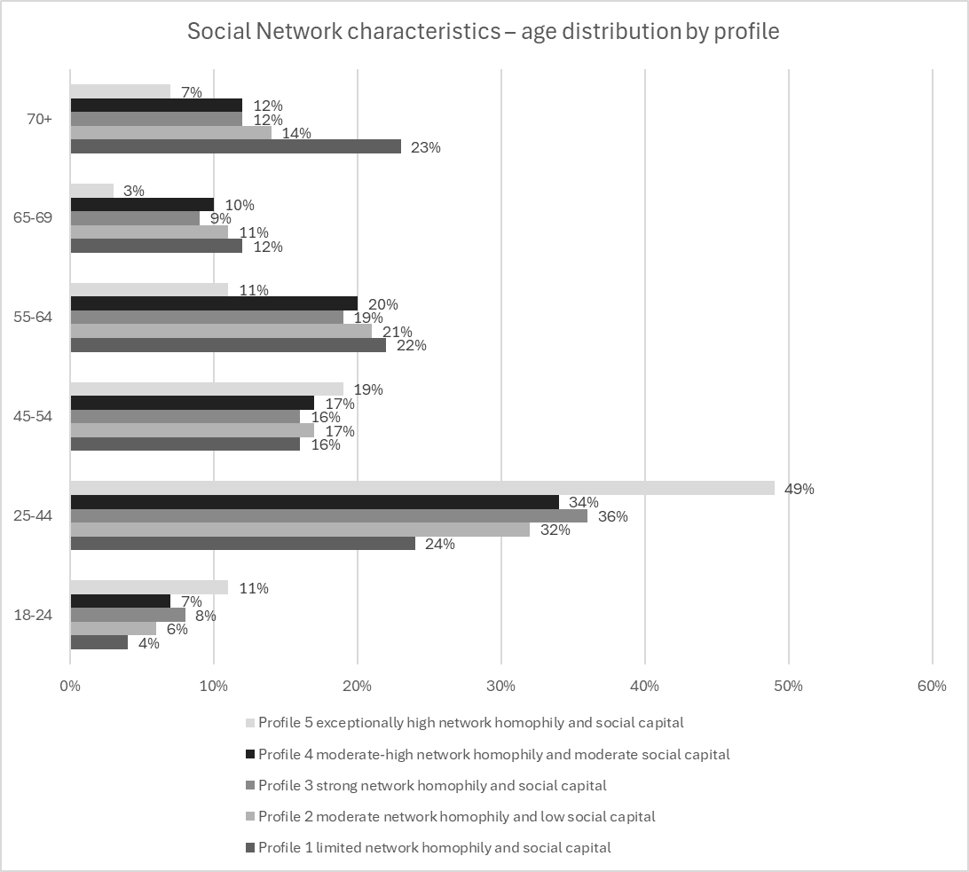

**Figure 6: Social Network characteristics – gender distribution by profile**

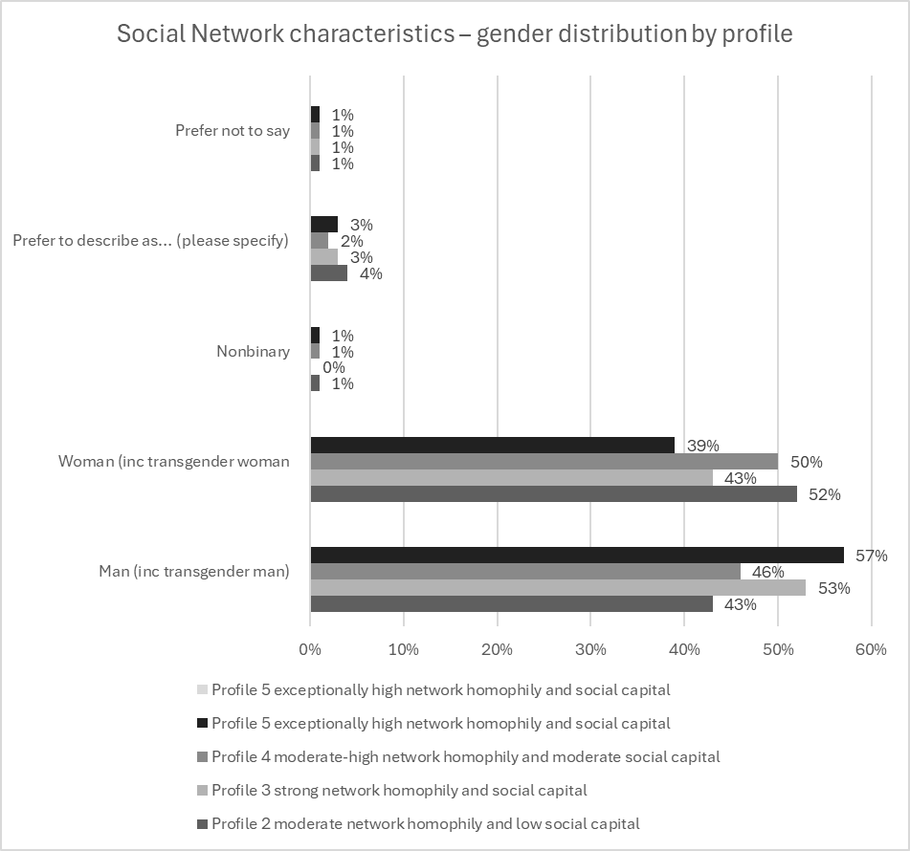

**Figure 7: Social Network characteristics – qualification level distribution by profile**

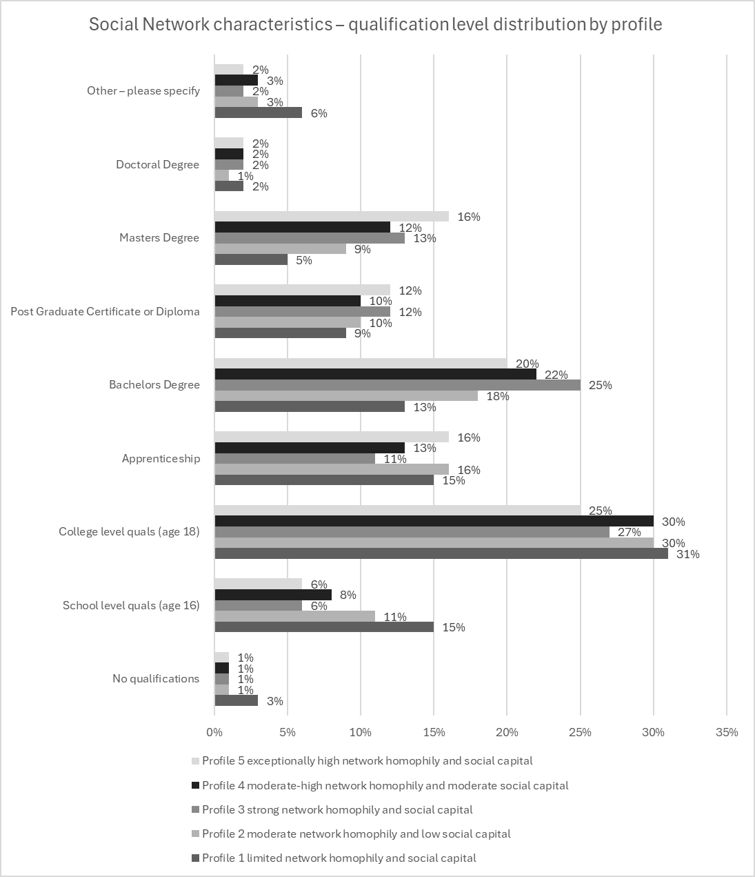

**Figure 8: Social Network characteristics – occupation distribution by profile**

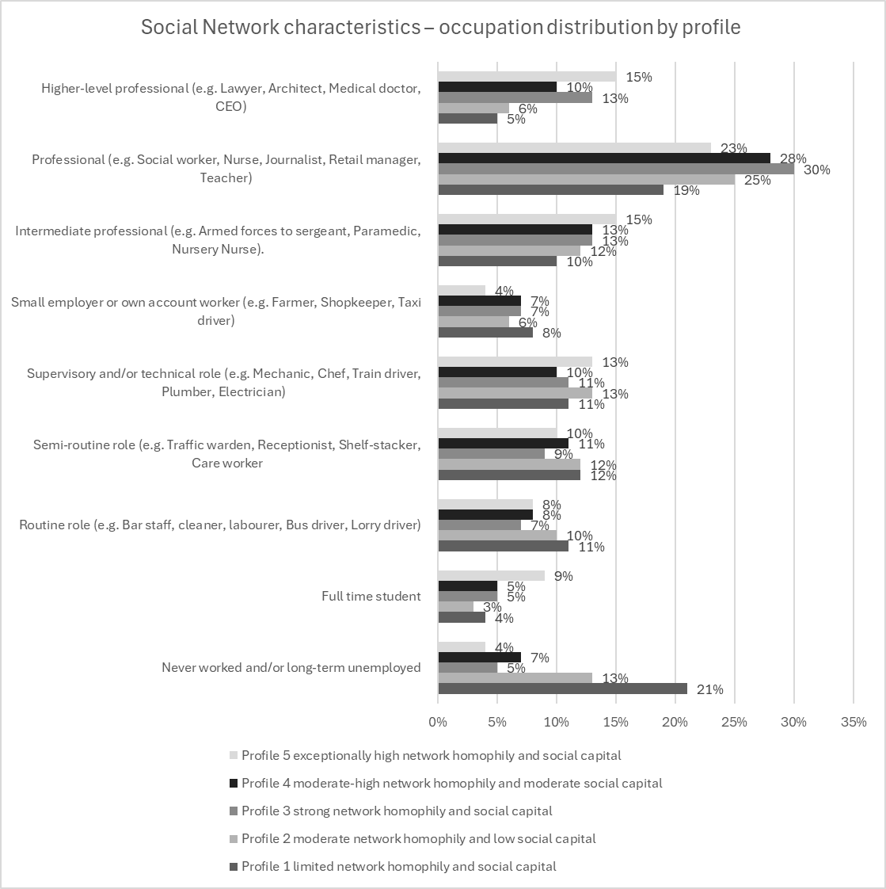

Table 7: Social network characteristics importance of ideas-engagement by profile

|  |  |  |  |  |  |
| --- | --- | --- | --- | --- | --- |
|  | **Profile 1**  limited NH and SC | **Profile 2**  moderate NH and low SC | **Profile 3**  strong NH and SC | **Profile 4**  moderate-high NH and moderate SC | **Profile 5**  exceptionally high NH and SC |
| **Not important** | 2% | 1% | 0% | 1% | 1% |
| **Somewhat important** | 4% | 3% | 2% | 2% | 2% |
| **Neither important or unimportant** | 22% | 12% | 7% | 10% | 4% |
| **Important** | 46% | 51% | 47% | 48% | 37% |
| **Very important** | 26% | 33% | 43% | 39% | 55% |
| **Total** | 100% | 100% | 100% | 100% | 100% |

*χ2* = 194.34, *p* < 0.001, *df* = 16, Cramér's V = 0.083

Table 8: Social network characteristics – extent to which respondents believe the statement ‘there is evidence to suggest the Earth is actually flat, rather than round’ to be true.

|  |  |  |  |  |  |
| --- | --- | --- | --- | --- | --- |
|  | **Profile 1**  limited NH and SC | **Profile 2**  moderate NH and low SC | **Profile 3**  strong NH and SC | **Profile 4**  moderate-high NH and moderate SC | **Profile 5**  exceptionally high NH and SC |
| **I strongly believe this to be true** | 2% | 1% | 2% | 1% | 8% |
| **I believe this to be true** | 2% | 2% | 5% | 3% | 13% |
| **I need more information to be able to judge** | 27% | 12% | 14% | 10% | 23% |
| **I believe this to be untrue** | 15% | 12% | 12% | 11% | 12% |
| **I strongly believe this to be untrue** | 55% | 74% | 67% | 75% | 44% |
| **Total** | 100% | 100% | 100% | 100% | 100% |

*χ2* = 384.65, *p* < 0.001, *df* = 16, Cramér's V = 0.117

## Results for the critical thinking ability characteristics profiles

The characteristics of the three critical thinking characteristic profiles are set out in Figure 9 – 12 and Tables 9 and 10, below. The χ2 statistics for each indicate that all variables have p-values below 0.05; indicating, as before, that age, gender, education, occupation, value of ideas-engagement and belief in Flat Earth theory all exhibit strong statistical differences across profiles. For instance, in terms of age, it can be seen that Profile 3 (which has the highest mean for critical thinking ability) has a slightly higher proportion of younger adults (25-44: 40 percent) compared to Profiles 1 and 2 (each with 33 percent). Likewise, older respondents (65+) are slightly underrepresented in Profile 3 (seven percent) compared to Profiles 1 and 2 (14 percent). This suggests that age is a strong determinant of critical thinking ability, with younger adults more likely to exhibit high critical thinking skills. Critical thinking by gender is set out in Figure 10. Here it can be seen that men are more likely to record higher (self-reported) means for critical thinking ability than women. In terms of highest qualification held (Figure 11), Profile 3 (highest mean for critical thinking ability) has a higher percentage of Master’s (19 percent) and Doctoral degrees (3 percent), compared to Profile 1 (8 percent and 2 percent, respectively). Profile 1 (lowest mean for critical thinking ability) has the highest percentage of respondents with only school-level qualifications (14 percent). These trends indicate that education plays an important role in shaping critical thinking. Figure 12, meanwhile, explores occupation type. Here, Profile 3 has a slightly higher proportion of higher-level professionals (14 percent) compared to Profile 1 (6 percent). Unemployed individuals are slightly more represented in Profile 1 (11 percent) compared to Profiles 2 and 3 (8 percent). Thus, our data indicates that professional roles correlate with higher critical thinking: although this trend could be bidirectional, since such roles may foster critical thinking, or critical thinking may have been required to secure them. For instance, analysis by Parcel and Bixby (2015) found that more complex jobs tend to involve more autonomy and serve to stimulate problem-solving and creative abilities. Less complex jobs, meanwhile tend to involve routine, repetition, are highly supervised and this can impede the use of the post-holder’s intellectual abilities (Parcel and Bixby, 2015).

In terms of the value ascribed to ideas-engagement (Table 9), a highly significant relationship exists between critical thinking and valuing ideas-engagement. Profile 3 has the highest proportion of respondents who find ideas-engagement ‘Very Important’ (66 percent). Profile 1 meanwhile has the largest proportion of those who find ideas-engagement ‘Neither Important nor Unimportant’ (20 percent). This suggests that higher critical thinking ability is strongly associated with valuing engagement with ideas. Likewise, in terms of the level of belief in the flat Earth statement, there is a highly significant relationship between critical thinking and belief in misinformation. Specifically, Profile 3 (highest critical thinking) overwhelmingly rejected the flat Earth claim (84%), while Profile 1 (lowest critical thinking) had the most uncertainty (27%) or belief (10%). This reinforces critical thinking’s potential protective role against misinformation.

**Figure 9: Critical Thinking Ability – age distribution by profile**

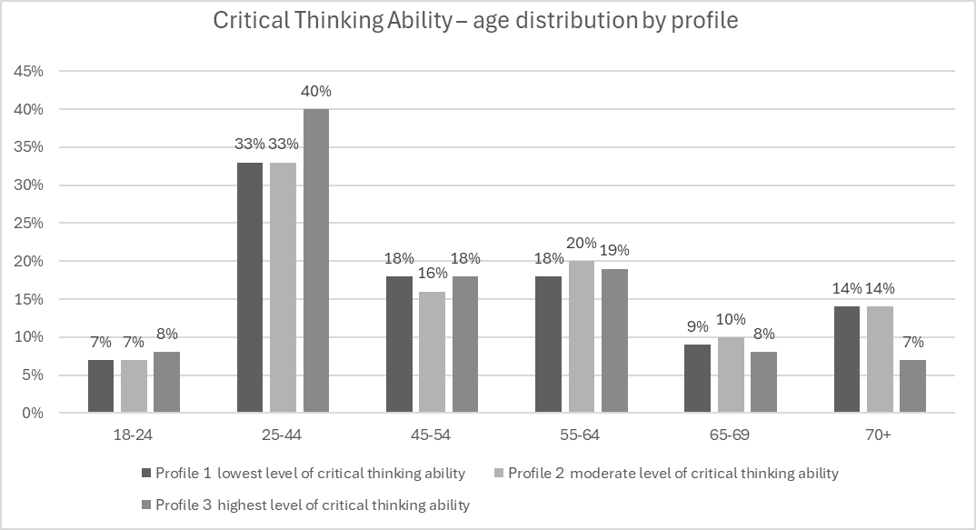

**Figure 10: Critical Thinking Ability – gender distribution by profile**

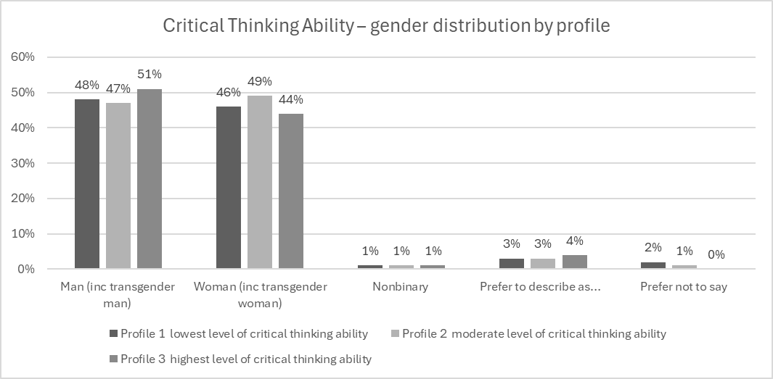**Figure 11: Critical Thinking Ability – qualification level distribution by profile**

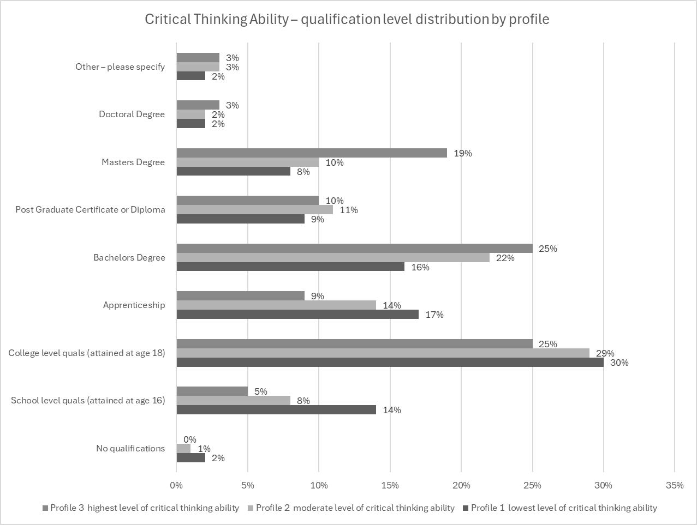

**Figure 12: Critical Thinking Ability – occupation distribution by profile**

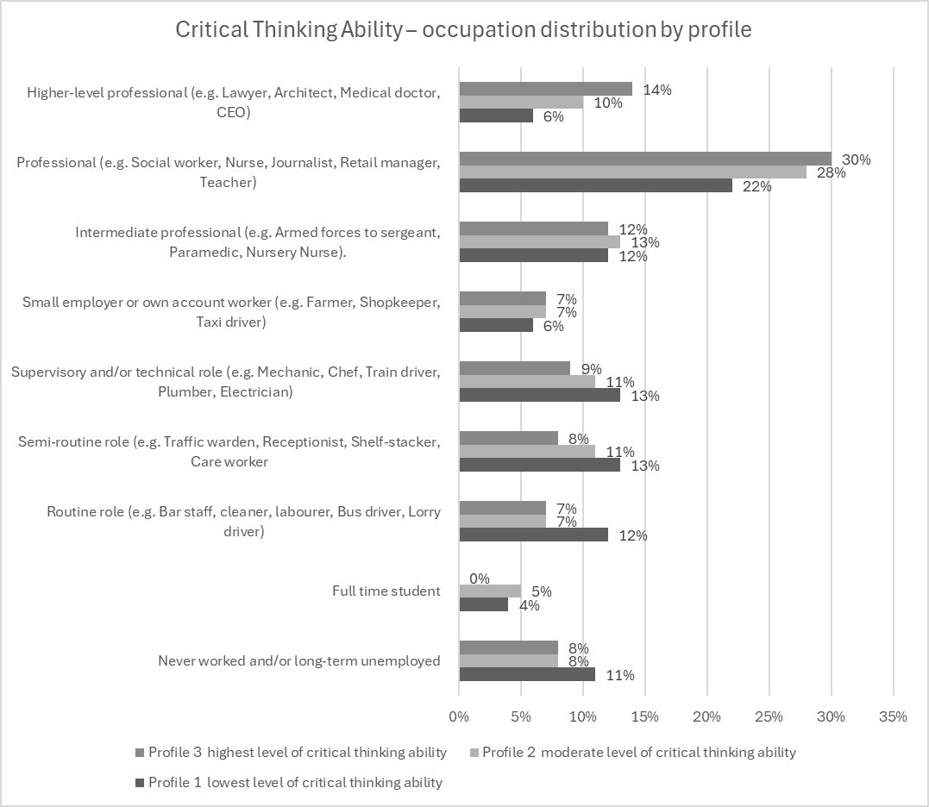Table 9: Critical thinking ability importance of ideas-engagement by profile

|  |  |  |  |
| --- | --- | --- | --- |
|  | **Profile 1**  lowest level of critical thinking ability | **Profile 2**  moderate level of critical thinking ability | **Profile 3**  highest level of critical thinking ability |
| **Not important** | 2% | 0% | 0% |
| **Somewhat important** | 3% | 2% | 2% |
| **Neither important or unimportant** | 20% | 9% | 3% |
| **Important** | 51% | 52% | 29% |
| **Very important** | 24% | 37% | 66% |
| **Total** | 100% | 100% | 100% |

*χ2* = 656.14, *p* < 0.001, *df* = 8, Cramér's V = 0.215

Table 10: Critical thinking ability – extent to which respondents believe the statement ‘there is evidence to suggest the Earth is actually flat, rather than round’ to be true.

|  |  |  |  |
| --- | --- | --- | --- |
|  | **Profile 1**  lowest level of critical thinking ability | **Profile 2**  moderate level of critical thinking ability | **Profile 3**  highest level of critical thinking ability |
| **I strongly believe this to be true** | 2% | 1% | 2% |
| **I believe this to be true** | 8% | 3% | 2% |
| **I need more information to be able to judge** | 27% | 10% | 8% |
| **I believe this to be untrue** | 16% | 13% | 4% |
| **I strongly believe this to be untrue** | 48% | 74% | 84% |
| **Total** | 100% | 100% | 100% |

*χ2* = 582.97, *p* < 0.001, *df* = 8, Cramér's V = 0.203

# Discussion

The findings of this study illuminate the complex interplay between individual characteristics, social networks, and belief in misinformation. Specifically, by using a combination of LPA and FMM across a large, multi-national dataset, it offers crucial insights into how ideas-engagement flourishes or falters: a vital topic for the current epoch in which we find ourselves. Returning to the research questions, the data reveal compelling narratives about who engages with ideas, who falls prey to conspiracy beliefs, and what interventions might shift these dynamics. For Research Question One, for instance, clear patterns emerge: younger respondents, particularly those aged 18 - 44, were more likely to possess a more highly prospective mindset, where they envision future possibilities and embrace new ideas. This aligns with prior research on future-oriented thinking’s role in goal-directed behaviour (Atance and O’Neill, 2001) and academic success (Pawlak and Moustafa, 2023). Education, too, proved pivotal: higher degrees correlated with stronger prospective mindsets, supporting the notion that advanced learning cultivates openness to ideas (Brown et al., 2022a-d). Employment status further shaped mindset profiles, with professionals and higher-level professionals featuring prominently among those most likely to value ideas-engagement, while those in routine or unemployed roles were overrepresented among low-mindset groups. This finding perhaps echoing Bregman’s (2018) argument that low-wage, precarious jobs often narrow individuals' mental horizons to immediate, survival-focused concerns.

Social network characteristics added further texture to the analysis. Respondents embedded in dense, high-homophilic, high-social-capital networks (Profile 5) exhibited a striking paradox: they placed high value on ideas-engagement but simultaneously showed the greatest susceptibility to flat Earth beliefs (21 percent). This suggests a ‘Goldilocks’ effect may be at play – where social capital and homophily, if too strong, create closed networks that nurture and protect misinformation. Conversely, weak or fragmented networks leave individuals without the trust or community needed for meaningful engagement. The ideal, then, lies somewhere in the middle: networks that foster trust and cohesion while remaining sufficiently open to diverse perspectives, enabling misinformation to be challenged rather than entrenched. At the same time, however, the current analysis focused primarily on the closeness and homogeneity of social networks, rather than on the criticality or intellectual engagement that takes place within them. Prior work (e.g. Erisen & Erisen, 2012) indicates that even homogenous networks can foster constructive challenge and critical discussion if their members possess high cognitive sophistication and intellectual humility. Yet, other evidence (Rathje et al., 2023) suggests that even well-educated individuals may selectively share misinformation if it aligns with their social or political identity. These contrasting factors thus underline the need for future research to investigate not just network structure but also the epistemic practices and discussion norms operating within networks and the interplay between the two. Such research could also help us better understand the role and of critical thinking within networks, which did emerge as a powerful protective factor against dark ideas. Specifically, the highest critical thinking profile (Profile 3) – characterized by younger adults, higher education levels, and professional occupations – overwhelmingly rejected flat Earth beliefs (84 percent). This finding reinforcing previous work highlighting critical thinking’s role in immunizing against misinformation (Brown et al., 2025b; Sunstein and Vermeule, 2009), suggesting that interventions targeting this skillset could yield substantial benefits.

Turning to Research Question Two and our study points to promising directions for interventions. Strengthening critical thinking abilities, particularly among older adults and those with lower education levels, could significantly reduce susceptibility to misinformation. Likewise, fostering a prospective mindset – especially among individuals in routine jobs or facing unemployment – may cultivate a greater appreciation for ideas-engagement, echoing Baumeister and Lim’s (2023) findings on prospection’s motivational benefits. Yet there is limited clarity on how to effectively deliver such interventions. Potential routes include college or workplace based initiatives that embed problem-solving, future focused and reflective activities into job tasks, or adult education programs focused on media literacy and cognitive flexibility. Intergenerational learning models, which pair older adults with younger, more digitally literate cohorts, could also help build criticality and resilience in populations more vulnerable to misinformation (Grossnickle Peterson, 2020). Promoting optimal semi-open networks, or the Goldilocks Zone, is another critical but underexplored area. Yet responsibility for fostering balanced networks does not lie solely with individuals: educational institutions can create environments that encourage cross-group collaborations, workplaces can promote diverse team interactions, and local governments can facilitate public forums or citizen assemblies designed to mix individuals from varied demographic and ideological backgrounds. Institutional design is key, however, not just in ensuring not just diversity of contact but also the conditions under which all voices can be heard and respected.

This study is, of course, not without limitations. A key one is that, while we report statistically significant differences between profiles - often using percentage comparisons - we did not consistently apply standardized effect sizes (such as Cohen’s d, Cramér’s V thresholds, or odds ratios) to assess the *practical* significance of these differences. As a result, some findings that are statistically significant may reflect small, trivial effects when interpreted substantively. For instance, we note above that Cramér’s V values were generally below 0.2, which conventionally indicates weak associations (Tomczak & Tomczak, 2014). Although small effect sizes can still be meaningful in large, cross-national samples (given the exploratory nature of the study), we acknowledge that future research should systematically apply and report standardized measures of practical significance to help prioritize which subgroup differences are most impactful for designing interventions.

A second limitation is that, while we conducted measurement invariance testing to ensure constructs were measured consistently across the seven countries, we recognize that this does not fully explore country-specific cultural, political, or institutional factors that might shape patterns of ideas engagement, critical thinking, or susceptibility to misinformation. For example, national differences in media systems, political polarization, educational curricula, or trust in institutions could moderate the relationships identified in this study. Future research should thus explicitly investigate how cultural and contextual factors interact with individual-level traits to influence engagement with ideas and vulnerability to misinformation, ideally using multi-level models or country-specific qualitative analyses.

Nonethless, despite these limitations and the future research directions they point to, we feel our findings clearly build upon the broader misinformation and education literature. For instance, the UK Commission into Countering Online Conspiracies in Schools (2025) has highlighted how young people are often exposed to distinct forms of online misinformation unknown to adults or teachers. Our results extend such insights by showing how prospective mindset and critical thinking operate as protective factors across multiple countries and social groups, offering empirical grounding for intervention design. Additionally, our findings contribute to debates on the role of social capital and network openness (Putnam, 2000; Granovetter, 1985), proposing a nuanced framework – the Goldilocks Zone – that identifies not just structural conditions but also, potentially, the quality of information exchange within networks as crucial to resisting misinformation.

Finally, we claim our findings are substantive enough to underscore a vital truth: fostering critical thinking, prospective mindsets, and balanced networks is an urgent societal imperative. Moreover, that combating misinformation is a shared societal responsibility. In response we contend that governments must now step up and play a critical role in setting regulatory frameworks and funding public education campaigns; media organizations must double down on upholding high standards of journalistic integrity and resisting false balance; social media companies must recognise their responsibility to curb algorithmic amplification of falsehoods and (re-)introduce frictions such as fact-checking or share-delay features; and educational institutions must more actively integrate critical thinking, media literacy, and civic education throughout the life course – from schools to adult education – ensuring that citizens are prepared to navigate today’s information ecosystem. It is only when each of these stakeholders takes appropriate action in accordance with their share responsibility that we can create a future where ideas-engagement flourishes, and misinformation finds no fertile ground.

# Disclosure statement

No potential conflict of interest was reported by the author(s).

# Data Availability Statement

Data will be made available on request.

# References

Allen, Summer. 2019. “*Future-mindedness*.” Greater Good Science Center at UC Berkeley. John Templeton Foundation. [https://www.templeton.org/discoveries/future-mindednessn](https://www.templeton.org/discoveries/future-mindedness)

Atance, Cristina M., and Daniela K. O'Neill. 2001. "Episodic future thinking." *Trends in Cognitive Sciences* 5 (12): 533-539.

Bago, Bence, David G. Rand, and Gordon Pennycook. 2020 "Fake news, fast and slow: Deliberation reduces belief in false (but not true) news headlines." *Journal of Experimental Psychology: General* 149 (8): 1608.

Baer, Andrea. 2020. “What intellectual empathy can offer information literacy education.” In *Informed Societies: Why information literacy matters for citizenship, participation and democracy* edited by Stéphane Goldstein*,* 47-68. London, UK: Facet Publishing.

Baumeister, Roy F., Kathleen D. Vohs, and Gabriele Oettingen. 2016. "Pragmatic prospection: How and why people think about the future." *Review of General Psychology* 20 (1): 3-16.

Brown, Chris, and Jana Gross Ophoff. 2022a. "Exploring effective approaches for stimulating ideas-engagement amongst adults in England: results from a randomised control trial." *Emerald Open Research* 4 (39) <https://doi.org/10.35241/emeraldopenres.14914.1>

Brown, Chris, Jana Groß Ophoff, Kim Chadwick, and Sharon Parkinson. 2023. "Achieving the “ideas-informed” society: results from a structural equation model using survey data from England." *Emerald Open Research* 4 (4) <https://doi.org/10.35241/emeraldopenres.14487.1>

Brown, Chris, Ruth Luzmore, and Jana Groß Ophoff. 2022c "Anomie in the UK? Can cultural malaise threaten the fruition of the ideas-informed society?." *Emerald Open Research* 4 (28). <https://doi.org/10.35241/emeraldopenres.14786.1>

Brown, Chris, Ruth Luzmore, and Jana Groß Ophoff. 2022d. "Facilitating the ideas-informed society: a systematic review." *Emerald Open Research* 4 (25) <https://doi.org/10.35241/emeraldopenres.14729.1>

Brown, Chris, Jana Gross Ophoff, and Graham Handscomb. 2024. "Quality education for all in an ideas-informed society: exploring idea-engagement amongst friendship networks and how education can prevent idea “echo-chambers”." *Quality Education for All* 1 (1): 70-85. <https://doi.org/10.1108/QEA-10-2023-0003>

Brown, Chris, and Ruth Luzmore. 2024. “An educated society is an ideas-informed society: a proposed theoretical framework for effective ideas-engagement*.” British Educational Research Journal.* 00:1–21*.* <http://doi.org/10.1002/berj.4110>

Brown, Chris, Ruth Luzmore, and Yin Wang. 2025a “Making better decisions, eschewing conspiracy, populism and science denial: analysing the attributes of individuals who engage effectively with ideas.” *Information.* 16(3): 248 <https://doi.org/10.3390/info16030248>

Brown, Chris, Ruth Luzmore, and Yin Wang. 2025ba. “Education, prospection and social-networks: surveying ideas-engagement amongst 7,000 respondents across seven European countries.” *Quality Education for All*. 1: 289-320 <https://doi.org/10.1108/QEA-11-2024-0128>

Burt, Ronald S. 2000. “Decay functions.” *Social Networks*. 22 (1): 1–28.

Castells, Manuel. 2010. *The Rise of the Network Society*. 2nd ed. West Sussex, United Kingdom: Wiley-Blackwell.

Christakis, Nicholas. and James Fowler. 2010. *Connected: The Amazing Power of Social Networks and how they Shape our Lives.* London, United Kingdom: Harper Press.

Chong, Trevor T-J., Matthew AJ Apps, Kathrin Giehl, Stephanie Hall, Callum H. Clifton, and Masud Husain. 2018. “Computational modelling reveals distinct patterns of cognitive and physical motivation in elite athletes.” *Sci Rep*. 8(1):11888. <https://doi.org/10.1038/s41598-018-30220-3>

Clack, Beverley. In press. Embracing Uncertainty in a Chaotic Age, In *Demagogues, Populism and Misinformation: A Guide To Combating Dark Ideas*, edited by Chris Brown, and Graham Handscomb. London, United Kingdom: Emerald.

Clark, Shaunna L., and Bengt Muthén. 2009. “Relating latent class analysis results to variables not included in the analysis.” <https://www.statmodel.com/download/relatinglca.pdf>

Coleman, James, S. 1988. “Social capital in the creation of human capital.” *American Journal of Sociology*, 94: 95–S120.

Commission into Countering Online Conspiracies in Schools. 2025. “Commission into Countering Online Conspiracies in Schools.” Pears Foundation. <https://counteringconspiracies.publicfirst.co.uk/Commission_into_Countering_Online_Conspiracies_in_Schools.pdf>

Cramer, Colin, Chris Brown, and David Aldridge. 2023. “Meta-reflexivity and teacher professionalism: Facilitating multi-paradigmatic teacher education to achieve a future-proof profession.” *Journal of Teacher Education*, 74(5): 467-480 <https://doi.org/10.1177/00224871231162295>

Erisen, Elif, and Cengiz Erisen. 2012. “The effect of social networks on the quality of political thinking.” *Political Psychology*. 33(6): 839-865.

Facione, Peter. 1990. Critical thinking: A statement of expert consensus for purposes of educational assessment and instruction. Research Findings and Recommendations.

Feinstein, Noah Weeth, and Ayelet Baram‐Tsabari. 2024. “Epistemic networks and the social nature of public engagement with science*.” J. Res. Sci. Teach*. 61 (9): 2049–2068. <https://doi.org/10.1002/tea.21941>.

Granovetter, Mark. 1985. “Economic action and social structure: The problem of embeddedness.” *American Journal of Sociology*. 91(3): 481–510. [https://doi.org/10.1086/228311](https://psycnet.apa.org/doi/10.1086/228311)

Griffin, Thomas D., and Stellan Ohlsson. 2001. Beliefs Versus Knowledge: A Necessary Distinction for Explaining, Predicting, and Assessing Conceptual Change. *Proceedings of the Annual Meeting of the Cognitive Science Society*, 23.

Grossnickle Peterson, Emily. 2020. “Supporting curiosity in schools and classrooms.” *Current Opinion in Behavioral Sciences*, 35: 7–13. <https://doi.org/10.1016/j.cobeha.2020.05.006>

Guess, Andrew, Brendan Nyhan, and Jason Reifler. 2018. "Selective exposure to misinformation: Evidence from the consumption of fake news during the 2016 US presidential campaign.” European Research Council, Brussels. 3: 4 Accessed February 28, 2025. <https://www.readkong.com/page/selective-exposure-to-misinformation-evidence-from-the-8348264>

Haran, Uriel, and Shaul Shalvi. 2020. “The implicit honesty premium: Why honest advice is more persuasive than highly informed advice.” *Journal of Experimental Psychology: General*. 149 (4):757.

Hipp, John R., and Daniel J. Bauer. 2006. Local solutions in the estimation of growth mixture models. *Psychological Methods*. 11(1): 36–53. [https://doi.org/10.1037/1082-989X.11.1.36](https://psycnet.apa.org/doi/10.1037/1082-989X.11.1.36)

Jerome, Lee, Ben Kisby, and Steve McKay 2024. “Combatting Conspiracies in the Classroom: Teacher Strategies and Perceived Outcome.” *British Educational Research Journal*. 50 (3): 1106-1126. <https://doi.org/10.1002/berj.3955>

Jung, Tony, and Kandauda AS Wickrama. 2008. “An introduction to latent class growth analysis and growth mixture modelling.” *Social and Personality Psychology Compass.* 2(1): 302–317. [https://doi.org/10.1111/j.1751-9004.2007.00054.x](https://psycnet.apa.org/doi/10.1111/j.1751-9004.2007.00054.x)

Kerwer, Martin, and Tom Rosman. 2018. “Mechanisms of Epistemic Change—Under Which Circumstances Does Diverging Information Support Epistemic Development?” *Front. Psychol*. 9: 2278. <https://doi.org/10.3389/fpsyg.2018.02278>.

Kline, Rex B. 2011. Principles and practice of structural equation modelling. New York, NY, Guilford Press.

Kool, Wouter, and Matthew Botvinick. 2014. “A labor/leisure tradeoff in cognitive control.” *J Exp Psychol Gen.* 143(1):131–41. <https://doi.org/10.1037/a0031048>.

Marks, Joseph, Eloise Copland, Eleanor Loh, Cass R. Sunstein, and Tali Sharot. 2019. “Epistemic spillovers: Learning others’ political views reduces the ability to assess and use their expertise in nonpolitical domains.” *Cognition*. 188: 74–84.

Markey, Amanda, and George Loewenstein. 2014. Curiosity. In *International Handbook Of Emotions In Education* edited by R. Pekrun and L. Linnenbrink-Garcia. 228–245. Routledge.

Morris, Andrew. In press. Science beats misinformation. In *Demagogues, Populism and Misinformation: A Guide To Combating Dark Ideas*, edited by Chris Brown, and Graham Handscomb. Handscomb. London, United Kingdom: Emerald.

Morin, Alexandre JS, and Herbert W. Marsh. 2015. “Disentangling shape from level effects in person-centered analyses: An illustration based on university teachers’ multidimensional profiles of effectiveness.” *Structural Equation Modeling.* 22(1): 39–59.

Morin, Alexandre JS, Jean-Sébastien Boudrias, Herbert W. Marsh, Isabelle Madore, and Pascale Desrumaux. 2016. “Further reflections on disentangling shape and level effects in person-centered analyses: An illustration exploring the dimensionality of psychological health.” *Structural Equation Modeling: A Multidisciplinary Journal*. 23(3): 438-454.

Muthén, Bengt. 2004. Latent Variable Analysis: Growth Mixture Modeling and Related Techniques for Longitudinal Data. In *Handbook of Quantitative Methodology for the Social Sciences*, edited by David Kaplan. Newbury Park, CA: Sage. 345-368 <https://doi.org/10.4135/9781412986311.n19>

Naughton, John., Hugo Leal. et al (2018) “Brexit and Trump voters more likely to believe in conspiracy theories, survey shows.” University of Cambridge. Accessed March 21, 2025. <https://www.crassh.cam.ac.uk/blog/brexit-and-trump-voters-more-likely-to-believe-in-conspiracy-theories-surve/>

Neal, Zachary. 2013. The Connected City: how networks are shaping the modern metropolis London, United Kingdom: Routledge.

Parcel, Toby L., and Monica S. Bixby. 2015. “The ties that bind: social capital, families and children’s wellbeing.” *Child Development Perspectives*. 10(2): 87-92.

Pawlak, Simon, and Ahmed A. Moustafa. 2023. “A systematic review of the impact of future-oriented thinking on academic outcomes.” *Frontiers in Psychology*. 14: 1190546.

Putnam, Robert. D. 2000. Bowing alone: The collapse and revival of the American community. US: Simon and Schuster.

Rathje, Steve, Jon Roozenbeek, Jay J. Van Bavel, and Sander Van Der Linden. 2023. “Accuracy and social motivations shape judgements of (mis) information.” *Nat. Hum. Behav.* 7: 892–903.

Ryan, Bruce., Peter Cruickshank and Marina Milosheva. 2023. Information Literacy and Society. London, United Kingdom: MILA.

Schelling, Thomas C. 1971. “Dynamic Models of Segregation.” *Journal of Mathematical Sciences*. 1: 143-186. <https://doi.org/10.1080/0022250X.1971.9989794>.

Singer, Daniel J., Patrick Grim, Aaron Bramson, Bennett Holman, Jiin Jung, and William J. Berger. 2021. Epistemic networks and polarization. In *The Routledge Handbook of Political Epistemology*. Edited by Michael Hannon and Jeroen de Ridder. London, UK: Routledge. 133–144.

Spurk, Daniel, Andreas Hirschi, Mo Wang, Domingo Valero, and Simone Kauffeld. 2020. “Latent profile analysis: A review and “how to” guide of its application within vocational behavior research.” Journal of Vocational Behavior. 120: 103445.

Stone, Anna. In press. Why are some ideas easy to believe on little evidence. In *Demagogues, Populism and Misinformation: A Guide To Combating Dark Ideas*, edited by Chris Brown, and Graham Handscomb. London, United Kingdom: Emerald.

Sunstein, Cass R., and Adrian Vermeule. 2009. “Conspiracy theories: Causes and cures.” *J. Political Philos.* 17: 202–227. <https://doi.org/10.1111/j.1467-9760.2008.00325.x.>

Taylor, B., M. Mills, A. Elwick, C. Pillinger, G. Gronland, J. Hayward, I. Hextall, and F. Panjwani. 2021. *Addressing Extremism Through the Classroom.* Centre for Teachers and Teaching Research, London: UCL Institute of Education. <https://discovery.ucl.ac.uk/id/eprint/10133809/>

UNESCO. 2005. *Towards knowledge societies*. <https://unesdoc.unesco.org/ark:/48223/pf0000141843>

Van Prooijen, Jan-Willem, Giuliana Spadaro, and Haiyan Wang.  2022. “Suspicion of institutions: How distrust and conspiracy theories deteriorate social relationships.” *Current Opinion in Psychology.* 43: 65- 69.  <https://doi.org/10.1016/j.copsyc.2021.06.013>

Vosoughi, Soroush, Deb Roy, and Sinan Aral. 2018. "The spread of true and false news online." *Science*, 359(6380): 1146-1151.

Warner, Dorothy, and J. Drew Procaccino. 2007. “Women seeking health information: distinguishing the web user.” *Journal of Health Communication*, 12(8): 787-814.

Woolcock, Michael. 2001. “The place of social capital in understanding social and economic outcomes.” *Canadian Journal of Policy Research*. 2(1): 11–17.