# Long-term Clinical Outcomes of Prophylaxis With a rFVIIIFc or rFIXFc in Adults ≥50 Years of Age With Hemophilia A or B

Doris Quon,1 Shannon Jackson,2 María Teresa Alvarez-Román,3 Umer Khan,4 Sandra Casiano5, Margaret V. Ragni,6 Savita Rangarajan7

1Luskin Orthopaedic Institute for Children, Los Angeles, CA, USA; 2Providence Health Care, St. Paul’s Hospital, Vancouver, BC, Canada; 3University Hospital La Paz, Madrid, Spain; 4Sanofi, Cambridge, MA, USA; 5Sanofi, San Diego, CA, USA; 6University of Pittsburgh Medical Center, Division of Hematology/Oncology, Pittsburgh, PA, USA; 7Faculty of Medicine, University of Southampton, Southampton, UK

**Running title:** A rFVIIIFc/rFIXFc in older adults with hemophilia [49/50 characters]

**Target journal:** *Blood Advances* <https://ashpublications.org/bloodadvances/pages/manuscript-prep>

**Main text word count:** 1326/1200

**Figures and tables:** 2/2

**References:** 21/25

**Corresponding author:**

Dr Doris Quon  
Address: Luskin Orthopaedic Institute for Children, 403 West Adams Boulevard, Los Angeles, CA 90007  
Email: [dquon@mednet.ucla.edu](mailto:dquon@mednet.ucla.edu)   
Phone: (213) 742-1000

## Data sharing statement

Qualified researchers may request access to data and related study documents. Patient level data will be anonymized and study documents will be redacted, including to protect the privacy of our trial participants. Further details on Sanofi's data sharing criteria, eligible studies, and process for requesting access can be found at <https://www.vivli.org>.

Older people with hemophilia (PwH) who did not receive prophylaxis from a young age are at increased risk of developing hemophilic arthropathy.1-5 Advancements in hemophilia care since the 1970s, alongside improvements in general healthcare, has led to an increased life expectancy and resultant challenges in management of older PwH.2,6-9 Limited guidance exists for managing this population.6,8

Efmoroctocog alfa, a recombinant FVIII Fc fusion protein (referred to herein as rFVIIIFc), and eftrenonacog alfa (recombinant FIX Fc fusion protein [rFIXFc]), are extended half-life factor replacements for hemophilia A or B, respectively, with demonstrated long-term safety and efficacy among individuals of all ages, however, there are limited data on older PwH.10-17

This post hoc analysis of A-LONG/ASPIRE and B-LONG/B-YOND studies assessed comorbidities and long-term efficacy and safety in those with severe hemophilia aged ≥50 years. As previously reported, all protocols had local ethics board approvals and were conducted in accordance with the International Conference on Harmonization Guidelines for Good Clinical Practice and the Declaration of Helsinki; participants provided informed consent.10-13 Briefly, A-LONG enrolled previously treated males aged ≥12 years with severe hemophilia A receiving prophylaxis, or on on-demand therapy with a history of ≥12 bleeding events in the 12 months prior to the study, and no history of inhibitors.10B-LONG enrolled previously treated males aged ≥12 years with severe hemophilia B, on a prior prophylaxis regimen or with a history of ≥8 bleeding events in the 12 months prior to the study, and no history of inhibitors.11Eligible participants could enroll in the respective extension studies (ASPIRE or B-YOND).12,13 Outcomes included annualized bleed rates (ABRs), target joint resolution, modified Hemophilia Joint Health Score (mHJHS) (in A-LONG/ASPIRE only), Haemophilia Quality of Life Questionnaire for Adults (Haem‑A-QoL), factor consumption, cumulative exposure, and safety. Descriptive statistics are presented for participants with an efficacy period. Additional details of the methods are defined in Supplementary Material.

There were 21 participants aged ≥50 years in A-LONG, 20 of which participated in ASPIRE. At baseline, participant median age was 57 years and 81% had a target joint (**Supplementary** **Table 1**). The FVIII regimen in this subgroup prior to A-LONG was prophylaxis for 29% (n=6/21) and on-demand (OD) treatment for 71% (n=15/21) of participants. Participants had a median (interquartile range [IQR]) duration of rFVIIIFc treatment of 4.3 (3.1-5.4) years and 318 (257-425) exposure days (EDs). In B-LONG there were 26 participants aged ≥50 years, 16 of which also participated in B-YOND. The median age of participants at baseline was 56 years, 62% had a target joint (**Supplementary** **Table 2**). Prior to B-LONG enrollment, 42% (n=11/26) of participants were treated with prophylaxis and 58% (n=15/26) were treated OD. Median (IQR) duration of rFIXFc treatment was 3.4 (1.0-5.4) years; 54% of participants had ≥3 years of treatment. The median (IQR) number of rFIXFc EDs was 101 (44-220).

Approximately half of participants in both A-LONG/ASPIRE (n=10/21, 48%) and   
B-LONG/BYOND (62%, n=16/26) had ≥1 concomitant health condition at baseline (**Supplementary** **Table 1 and 2**). The most common conditions in participants in   
A-LONG/ASPIRE were depression (n=5/21, 24%), hypertension (n=4/21, 19%), and pain (n=4/21, 19%), and in B-LONG/B-YOND were hypertension (n=13/26, 50%) and pain (n=7/26, 27%). Baseline comorbidities were similar to those reported previously, highlighting physical and mental health conditions affecting aging PwH.6,9 Of note, the prevalence of hypertension reported here is lower than reported elsewhere6,18,19; in the HUGS VII study, 57% of PwH A/B of all severities and ≥50 years of age in the US had hypertension.6

More than half of participants were taking ≥1 concomitant medication at baseline (62%, n=13/21 in A-LONG/ASPIRE; 69%, n=18/26 in B-LONG/B-YOND) (**Supplementary Table 1 and 2**). For both subgroups, the most common indications were pain (largely related to arthropathy/joint pain) and hypertension. Acute and chronic pain are common features of hemophilia due to bleeds and/or arthropathy. Older individuals face the burden of both hemophilia-related and age-related joint degeneration, likely due to receiving sub-optimal management for their hemophilia in earlier years. Thus far, only the timely administration of FVIII/FIX early in life has demonstrated efficacy in preserving joint health among individuals with severe hemophilia.5,20 Furthermore, while several participants in this analysis experienced depression or anxiety, no medications for these conditions were reported, suggesting PwH may not receive adequate treatment for these conditions. Depression is common in older people with physical health conditions; it significantly impacts quality of life (QoL) and is associated with poorer treatment outcomes.21 It is important that PwH receive effective treatment and support for mental health conditions, to cope with the burden of hemophilia and age-related comorbidities.

Prophylaxis with rFVIIIFc and rFIXFc resulted in low overall and joint ABRs in participants ≥50 years of age, including those with target joints at baseline (**Figure 1**). As expected, pre-study ABRs were higher in participants treated OD compared with prior prophylaxis, and ABRs were higher in those receiving rFIXFc OD compared to rFIXFc prophylaxis. These results are consistent with adults/adolescents in the overall study populations.10-13

In addition to improved bleed protection, joint health also improved. For participants always on prophylaxis, with an mHJHS at each time point (n=10), the mean (standard deviation [SD]) mHJHS was 50.10 (15.79) at A-LONG baseline and 41.70 (11.48) at the last available visit in ASPIRE; mean (SD) change from baseline was −8.40 (10.87). All 42 evaluable target joints in 12 participants from A-LONG/ASPIRE, and all 19 in 6 participants from B-LONG/

B-YOND, resolved with prophylaxis.

For participants always on prophylaxis, mean (SD) change in total Haem-A-QoL score from A-LONG/B-LONG baseline to the last visit was −2.1 (12.11) and −4.9 (6.83), respectively (**Figure 2A** **and 2B**). Subdomains with greatest improvement were Sports and Leisure in A-LONG/ASPIRE, and View of Yourself in B-LONG/B-YOND. Although there is a difference in the scale and direction of change in Haem-A-QoL domain scores between participants with hemophilia A and B, we hesitate to draw conclusions about these differences due to the limited sample size. QoL among PwH worsens with age, highlighting the burden of age-related health conditions.6 Here, we report sustained QoL in participants aged ≥50 years on prophylaxis with rFVIIIFc/rFIXFc with improvements in some domains, including Physical Health and Sports and Leisure, demonstrating that bleed protection and joint health benefits of prophylaxis may enable older PwH to be more physically active.

Participants on prophylaxis did not require a significant increase in their dose of factor to maintain the low ABRs observed in the studies, with a mean (SD) change in dose at the end of A-LONG/B-LONG compared with the end of ASPIRE/B-YOND of 6.5 (10.6) IU/kg and 3. 9 (15.7) IU/kg, respectively (**Supplementary Table 3**).

Safety outcomes were consistent with the overall populations of the respective studies.10-13 No new safety concerns, deaths, or inhibitor development occurred in the older subpopulation. Treatment-emergent adverse events (TEAEs) were reported in 95% (n=20/21) and 89% (n=23/26) of participants aged ≥50 years in A-LONG/ASPIRE and B-LONG/B-YOND, respectively (**Supplementary Table 4**). For both groups, most TEAEs were mild or moderate and were as expected for this population (**Supplementary Tables 4, 5, and 6**). Serious TEAEs were reported in 8 participants in A-LONG/ASPIRE (including 1 serious TEAE of myocardial infarction in a participant with known cardiac risk factors), and 14 participants in B-LONG/B-YOND; no serious AEs were related to either rFVIIIFc or rFIXFc treatment (**Supplementary** **Tables 4, 7, and 8**).

Limitations of this analysis include the relatively small sample size, the exclusion of patients with certain comorbidities and medications, which may be more common in older PwH, the limited racial and ethnic diversity potentially affecting the spectrum of comorbidities, and that concomitant conditions and medications were only recorded at baseline, barring long-term assessments.This analysis also did not specifically assess the impact of HCV or HIV infection on patients.

The results for the ≥50 years subgroups are consistent with the overall study populations, suggesting that rFVIIIFc and rFIXFc provide long-term clinical benefits irrespective of age or presence of target joints in PwH. The results of this analysis highlight that the prevalence of concomitant conditions and reliance on medications in older PwH predominantly stems from the burden of pain and chronic arthropathy, underscoring the necessity of initiating prophylaxis at an early age. Further research is essential to developing best practices for management of aging PwH.

# Acknowledgments

This research was funded by Sanofi and Sobi who also reviewed and provided feedback on the manuscript. Medical writing and editorial support was provided by Lois Roberts-Grant, PhD and Ashleigh Pulkoski-Gross, PhD, CMPP, of Fishawack Communications Ltd, part of Avalere Health, and was funded by Sanofi and Sobi. The authors thank Alicia Mack, PharmD, and Hannah Kim, PharmD (Sanofi), for coordinating the development, facilitating author discussions, and review of this manuscript, and Sourav Sengupta and Anuja Pathak (Cytel) for statistical support.

# Authorship

**Contribution:** All authors contributed substantially to the study design, and/or acquisition, analysis, or interpretation of data. All authors provided critical revision of the manuscript and had final approval of the manuscript for publication.

**Conflict of Interest Disclosure:**

DQ reports consultancy and/or speaker’s bureau for Bayer, Sanofi, Genentech, Novo Nordisk, Octapharma, Biomarin, CSL Behring, and Takeda.

SJ reports consultancy for Bayer, Roche, Sanofi, and Takeda.

MTAR has received honoraria for consulting from Takeda, Bayer, BioMarin Pharmaceutical, CSL Behring, Grifols, NovoNordisk, Sobi, Roche, Octapharma, and Pfizer, and funds for research from Takeda, Bayer, Grifols, Novo Nordisk and Roche.

SC and UK are employees of Sanofi and may hold shares and/or stock options in the company.

MR reports personal fees/other from Alnylam, BeBio, BioMarin, Blood Advances Editorial Board, Foundation Women Girls Bleeding Disorders, HEMAB, HTRS, ICER, Sanofi, Spark, Takeda, and University Cincinnati, along with non-financial support from Takeda, outside the submitted work.

SR is a consultant for Reliance Life Sciences.

**Correspondence:**

Dr Doris Quon

Luskin Orthopaedic Institute for Children, 403 West Adams Boulevard, Los Angeles, CA 90007  
Email: [dquon@mednet.ucla.edu](mailto:dquon@mednet.ucla.edu)

# References

1. Srivastava A, Santagostino E, Dougall A, et al. WFH Guidelines for the Management of Hemophilia, 3rd edition. *Haemophilia*. 2020;26 Suppl 6:1-158.

2. Canaro M, Goranova-Marinova V, Berntorp E. The ageing patient with haemophilia. *Eur J Haematol*. 2015;94 Suppl 77:17-22.

3. Oldenburg J, Kulkarni R, Srivastava A, et al. Improved joint health in subjects with severe haemophilia A treated prophylactically with recombinant factor VIII Fc fusion protein. *Haemophilia*. 2018;24(1):77-84.

4. Manco-Johnson MJ, Abshire TC, Shapiro AD, et al. Prophylaxis versus episodic treatment to prevent joint disease in boys with severe hemophilia. *N Engl J Med*. 2007;357(6):535-544.

5. Warren BB, Thornhill D, Stein J, et al. Young adult outcomes of childhood prophylaxis for severe hemophilia A: results of the Joint Outcome Continuation Study. *Blood Adv*. 2020;4(11):2451-2459.

6. Curtis R, Manco-Johnson M, Konkle BA, et al. Comorbidities, Health-Related Quality of Life, Health-care Utilization in Older Persons with Hemophilia-Hematology Utilization Group Study Part VII (HUGS VII). *J Blood Med*. 2022;13:229-241.

7. Angelini D, Sood SL. Managing older patients with hemophilia. *Hematology*. 2015;2015(1):41-47.

8. Reding MT, Pabinger I, Holme PA, et al. Efficacy and safety of damoctocog alfa pegol prophylaxis in patients ⩾40 years with severe haemophilia A and comorbidities: post hoc analysis from the PROTECT VIII study. *Ther Adv Hematol*. 2023;14:20406207231166779.

9. Steen Carlsson K, Winding B, Astermark J, et al. People with haemophilia including female carriers in Nordic countries die at an earlier age and have significant co-morbidities. *Haemophilia*. 2021;27(S2):18-181.

10. Mahlangu J, Powell JS, Ragni MV, et al. Phase 3 study of recombinant factor VIII Fc fusion protein in severe hemophilia A. *Blood*. 2014;123(3):317-325.

11. Powell JS, Pasi KJ, Ragni MV, et al. Phase 3 study of recombinant factor IX Fc fusion protein in hemophilia B. *N Engl J Med*. 2013;369(24):2313-2323.

12. Nolan B, Mahlangu J, Pabinger I, et al. Recombinant factor VIII Fc fusion protein for the treatment of severe haemophilia A: Final results from the ASPIRE extension study. *Haemophilia*. 2020;26(3):494-502.

13. Pasi KJ, Fischer K, Ragni M, et al. Long-term safety and sustained efficacy for up to 5 years of treatment with recombinant factor IX Fc fusion protein in subjects with haemophilia B: Results from the B-YOND extension study. *Haemophilia*. 2020;26(6):e262-e271.

14. Fischer K, Kulkarni R, Nolan B, et al. Recombinant factor IX Fc fusion protein in children with haemophilia B (Kids B-LONG): results from a multicentre, non-randomised phase 3 study. *Lancet Haematol*. 2017;4(2):e75-e82.

15. Königs C, Ozelo MC, Dunn A, et al. First study of extended half-life rFVIIIFc in previously untreated patients with hemophilia A: PUPs A-LONG final results. *Blood*. 2022;139(26):3699-3707.

16. Nolan B, Klukowska A, Shapiro A, et al. Final results of the PUPs B-LONG study: evaluating safety and efficacy of rFIXFc in previously untreated patients with hemophilia B. *Blood Adv*. 2021;5(13):2732-2739.

17. Young G, Mahlangu J, Kulkarni R, et al. Recombinant factor VIII Fc fusion protein for the prevention and treatment of bleeding in children with severe hemophilia A. *J Thromb Haemost*. 2015;13(6):967-977.

18. Badescu MC, Badulescu OV, Butnariu LI, et al. Cardiovascular Risk Factors in Patients with Congenital Hemophilia: A Focus on Hypertension. *Diagnostics (Basel)*. 2022;12(12):2937.

19. von Drygalski A, Kolaitis NA, Bettencourt R, et al. Prevalence and risk factors for hypertension in hemophilia. *Hypertension*. 2013;62(1):209-215.

20. Oldenburg J, Zimmermann R, Katsarou O, et al. Controlled, cross-sectional MRI evaluation of joint status in severe haemophilia A patients treated with prophylaxis vs. on demand. *Haemophilia*. 2015;21(2):171-179.

21. Sivertsen H, Bjørkløf GH, Engedal K, Selbæk G, Helvik AS. Depression and Quality of Life in Older Persons: A Review. *Dement Geriatr Cogn Disord*. 2015;40(5-6):311-339.

# Figures

### Figure 1. ABRs by treatment regimen pooled from A-LONG/ASPIRE and B-LONG/ B-YOND.*, † (A) All participants ≥50 years of age in A-LONG/ASPIRE. (B) Participants with target joints at baseline ≥50 years of age in A-LONG/ASPIRE. (C) All participants ≥50 years of age in B-LONG/B-YOND. (D) Participants with target joints at baseline ≥50 years of age in B-LONG/B-YOND.

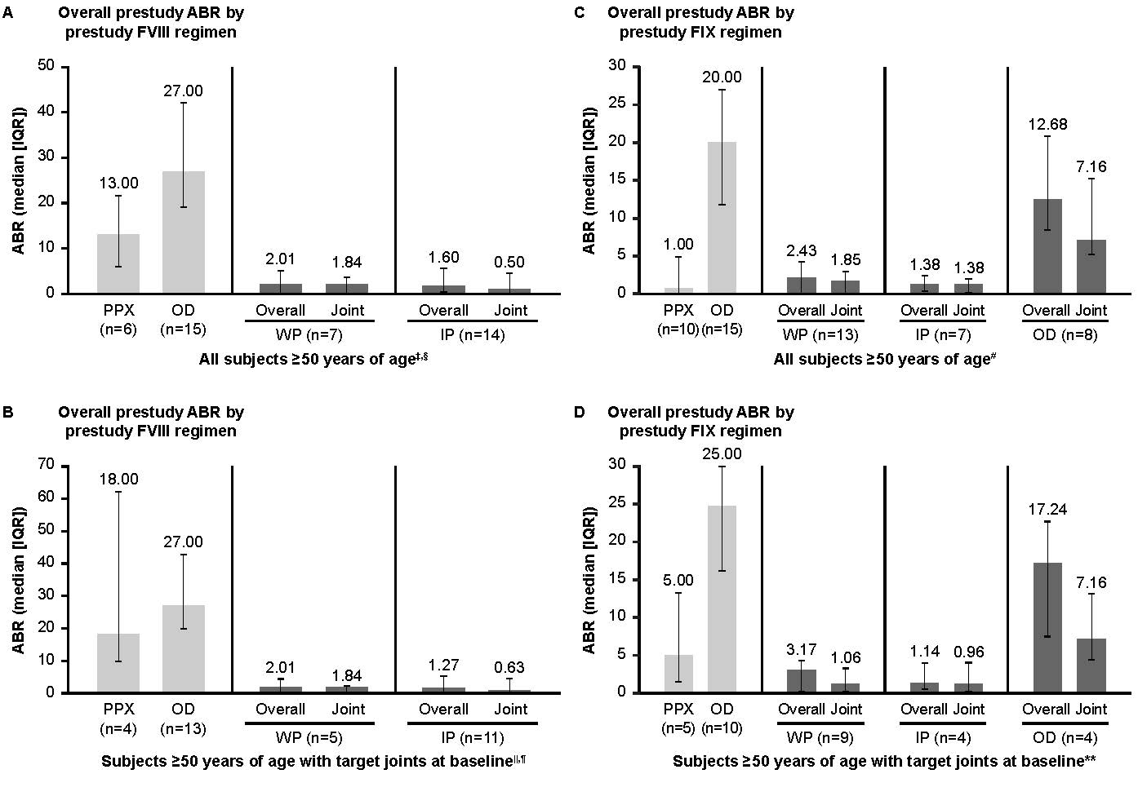

ABR, annualized bleed rate; FVIII, factor VIII; IP, individualized prophylaxis; IQR, interquartile range; OD, on-demand; PPX, prophylaxis; WP, weekly prophylaxis.

*Participants could change treatment regimens at any time during ASPIRE/B-YOND and may appear in ≥1 group; they are considered in each treatment regimen they participated in for the duration of time on that regimen. n is the number of participants in the specific treatment regimen and with an efficacy period. †One participant was missing prestudy ABR for the B-LONG study. ‡Among 3 participants on modified prophylaxis during the study, median (IQR) overall ABR was 4.61 (0.64-5.12); median (IQR) joint ABR was 2.84 (0.64-3.07) (data not shown in graph). §Among 3 participants receiving on-demand treatment during the study (data not shown in graph), median (IQR) overall ABR was 17.40 (9.81-81.54); median (IQR) joint ABR was 13.42 (5.89-72.86). ||Among 3 participants with target joints at baseline on modified prophylaxis during the study (data not shown in graph), median (IQR) overall ABR was 4.61 (0.64-5.12); median (IQR) target joint ABR was 2.84 (0.64-3.07). ¶Among 2 participants with target joints at baseline receiving on-demand treatment during the study (data not shown in graph), median (IQR) overall ABR was 49.47 (17.40-81.54); median (IQR) target joint ABR was 43.14 (13.42-72.86). #Among 4 participants on modified prophylaxis during the study (data not shown in graph), median (IQR) overall ABR was 7.07 (5.36-8.41); median (IQR) joint ABR was 3.99 (1.24-6.94). **Among 3 participants with target joints at baseline on modified prophylaxis during the study (data not shown in graph), median (IQR) overall ABR was 6.44 (4.28-7.70); median (IQR) target joint ABR was 1.56 (0.92-6.41).

### Figure 2. Health-related quality of life in participants ≥50 years of age on rFVIIIFc or rFIXFc prophylaxis. (A) Change in Haem-A-QoL score*from A-LONG baseline to the last visit with a score for participants who were always on a prophylaxis regimen. (B) Change in Haem-A-QoL score* from B‑LONG baseline to the last study visit with a score for participants who were always on a prophylaxis regimen.

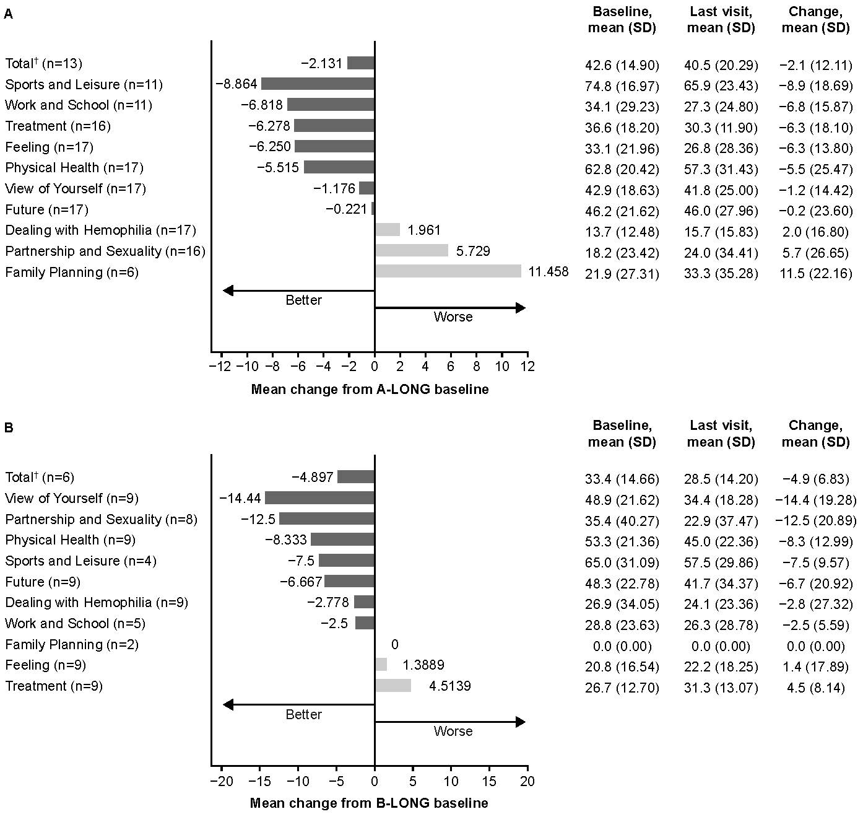

Haem-A-QoL, Haemophilia Quality of Life Questionnaire for Adults; rFIXFc, recombinant factor IX Fc fusion protein; rFVIIIFc, recombinant factor VIII Fc fusion protein; SD, standard deviation.

*Haem-A-QoL scores range from 0 to 100, with higher scores representing a higher impairment in quality of life for each sub-score and total score. †Last visit of few categories is not the same as last visit of Total category. Hence the Total value is not the sum of respective categories.