Individual variability in clothing thermal behaviour: a multidisciplinary review of physiological and ethnographic literature

Aislin Fields1, Sian Allen2, Adrian Lai2, Joanne Turney3, Davide Filingeri1

*1 ThermosenseLab, Skin Sensing Research Group, School of Health Sciences, The University of Southampton, Southampton, UK  
2 Lululemon Athletica Inc., Vancouver, BC V6J 1C7, Canada.  
3 Winchester School of Art, University of Southampton, Winchester, UK*

***Introduction***

Behavioural thermoregulation is understood to be a powerful and accessible component of human temperature regulation; crucial in increasingly extreme environmental conditions for maintaining health and facilitating safe access to physical activity. Choice of clothing has been shown to be an effective tool for behavioural thermoregulation which can be utilised by all. However, additional influences such as cultural or psychological factors may result in clothing behaviours contradictory to those which best facilitate heat exchange with the environment. Understanding the various factors additional to thermoregulation which influence clothing behaviour is key for identifying and understanding populations that could be at greater risk of adverse health events or limited access to exercise due to these factors. This review aims to combine current understanding of the individual physiological variables and mechanisms which underpin behavioural thermoregulation, with the additional dimension of ethnographic research into the cultural and psychological influences which may impact clothing behaviour.

***Methods***

A systematic review of physiological research was conducted in PubMed and Web of Science databases (Figure 1), before a modified keyword string to seek ethnographic research was used in Google Scholar. Outcomes and arising themes from the systematic review guided selection of ethnographic articles from the Google Scholar search output to add an additional dimension to the individual variables identified in physiological research. Additional individual variables represented in qualitative research were then identified from the remaining articles.

***Results***

The physiological search resulted in 164 studies, after screening 31 studies were included, and analysis of these studies is 50% complete at the time of writing. Screening of identified ethnographic studies is still in progress. Preliminary evaluations of physiological studies have identified variables affecting behavioural thermoregulation such as sex, age, and broadness of range of thermal comfort zone. Provisional ethnographic literature screening has also investigated variables such as age and sex, with additional consideration of subgroups such as transgender populations, and how gender affirming clothing choices may influence thermoregulation. In addition to this, the ethnographic literature has investigated variables such as culture and lifestyle which has not yet been discussed in the physiological studies included in the review.

***Conclusion***

Preliminary evaluation of physiological and ethnographic literature indicates that the inclusion of ethnographic studies can provide additional insight into individual variables which may impact behavioural thermoregulation. This review has identified some factors represented in both physiological and ethnographic studies such as sex and age, whilst other factors such as culture and lifestyle have so far only been represented by ethnographic studies. Future research into clothing thermal behaviour should adopt a multidisciplinary approach, integrating both physiological and ethnographic studies to provide a more holistic understanding of the multitude of factors which may influence the clothing behaviour of different populations to varying extents. This is crucial for identifying populations which may be at greater risk of adverse health events or limited access to physical activity due to climate change, and potential interventions which could be implemented to support these populations.

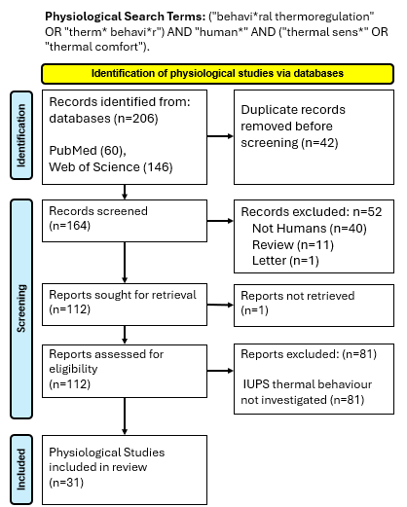

***Figure 1. PRISMA flow diagram for physiological searches.*** *Reports were excluded where they did not investigate a thermal behaviour as defined by the IUPS glossary of terms (2001).*

***References***

IUPS (International Union of Physiological Sciences), Commission for Thermal Physiology (2001). Glossary of terms for thermal physiology. *The Japanese Journal of Physiology 51, 245-280*