**Analytical equation for rapid estimation of pesticide leaching risk accounting for nonlinear sorption with bulk soil biodegradation - Supplementary Information**

S. Ruiz1**\***, S. Payvandi2*,P. Sweeney2#, T. Roose1

1Bioengineering Sciences Research Group, Department of Mechanical Engineering, School of Engineering, Faculty of Engineering and Physical Sciences, University of Southampton, Southampton, SO17 1BJ, UK

2Syngenta, Product Safety Department, Jealott’s Hill Research Centre, Bracknell, RG42 6EY, UK

*authors contributed equally to this work

# author is retired

**Description**

This document covers the more in depth derivations of the solutions we present in the main text. This document also provides a more exhaustive set of results covering explicitly all of the focus scenarios. We also provide a direct closed form solution for nonlinear binding consider only advective transport of pesticide compounds. Lastly, we also include an analytic solution for the time-dependent the linear binding scenario.

**List of expressions and variables**

Table S1 List of expressions and variables

|  |  |  |
| --- | --- | --- |
| Expression | Description | Units |
| $$α_{m}^{\left(n\right)}$$ | Corrections representing the nonlinear perturbation from linearity | [-] |
| $$β$$ | Fitting parameter for water flux | [-] |
| $${\tilde{c}}_{0}$$ | Effective Dirichlet surface boundary condition | [g mLl-1] |
|  | Concentration of bound and dissolved pesticide in the bulk soil domain | [g mLb-1] |
|  | Concentration of pesticide in the soil liquid phase | [g mLl-1] |
|  | Estimated dimensionless dissolved concentration for a sample window | [-] |
| $${\overline{c}}_{l, k}$$ | Ensemble average of the dimensionless dissolved concentration | [-] |
| $$c_{l}^{\left(n\right)}$$ | $O\left(ϵ^{n}\right)$ term in the pesticide concentration in solution | [-] |
| $${\tilde{c}}_{ref}$$ | Reference concentration for the Freundlich equation | [g mLl-1] |
|  | Concentration of pesticide bound to soil solids | [g gb-1] |
|  | term in the pesticide concentration bound on solids | [-] |
| $$δ_{cor}$$ | Empirical correction factor for water flux | [-] |
| $$Da$$ | Damkohler number | [-] |
| $${\tilde{D}}_{dif}$$ | Diffusivity of solutes through the soil pore space | [m3l m-1b day-1] |
|  | Time required for pesticide to reach the leaching depth | [day] |
| $$Δ\tilde{Z}$$ | Subdomain for leakage estimates | [m] |
| $$\tilde{DT50}$$ | Transformation half-life of a pesticide | [day] |
| $${\tilde{D}}_{tot}$$ | Effective pesticide diffusion-dispersion coefficient | [m2 day-1] |
|  | A small perturbation | [-] |
| $${\tilde{E}}_{evap}$$ | Evaporation rate | [m day-1] |
|  | Factor for depth influence on biodegradation | [-] |
| $$f_{T}$$ | Factor for temperature dependence on biodegradation | [-] |
| $$f_{w}$$ | Factor for moisture influence on biodegradation | [-] |
| $${\tilde{K}}_{f}$$ | Adsorption coefficient | [mLl gb-1] |
|  | Coefficient of sorption on soil organic matter | [mLl gom-1] |
|  | Saturated hydraulic conductivity | [m day-1] |
|  | Depth of the soil profile | [m] |
| $$λ$$ | Eigenvalue | [-] |
| $${\tilde{L}}_{leak}$$ | Leakage rate | [m day-1] |
|  | Dispersion length | [mb] |
|  | Biodegradation rate | [day-1] |
|  | Mass fraction of organic matter in soil | [gom gb -1] |
|  | Freundlich exponent | [-] |
| $$\tilde{Ω}$$ | Total soil profile | [m] |
| $$Pe$$ | Peclet number | [-] |
| $$ϕ$$ | Effective porosity | [mLl mLb-1] |
|  | Volumetric water flux | [mday-1] |
|  | Effective volumetric water flux for a given sample window | [m day-1] |
|  | Rainfall rate | [m day-1] |
|  | Soil bulk density | [gb mLb -1] |
|  | Relative saturation degree | [-] |
| $$S_{e}$$ | Sorption-Extinction coefficient | [mL gb-1 day-1] |
|  | Standard deviation of average dissolved concentrations | [-] |
| $$S_{fc}$$ | Saturation degree at field capacity | [-] |
| $$\tilde{t}$$ | Time | [day] |
| $$τ$$ | Delay factor | [-] |
| $$θ_{res}$$ | Residual water content | [mLl mLb-1] |
|  | Saturated water content | [mLl mLb-1] |
|  | Soil volumetric water content | [mLl mLb-1] |
|  | Estimated speed that pesticide moves through the soil | [m day-1] |
|  | Soil depth into the profile (from the surface) | [m] |

**Dimensionless equations**

We nondimensionalise the equations as this provides insight into the critical parameter combinations in the system. We use the following dimensional scaling for our length scale and time scale:

|  |  |  |
| --- | --- | --- |
|  | $$\tilde{z}=\tilde{L}z, \tilde{t}=\frac{\tilde{L}}{\tilde{q}}t,$$ | (S1) |

where $\tilde{L}$ [m] is the assumed depth of the soil profile, time is nondimensionalised with characteristic convection timescale $\frac{\tilde{L}}{\tilde{q}}$, and thus $z$ and $t$ are dimensionless space and time variables, respectively. Revisiting eq. (3) in the main text provides us with a useful scaling for pesticide concentrations:

|  |  |  |
| --- | --- | --- |
|  | $${\tilde{c}}_{l}={\tilde{c}}_{ref}{ c}_{l}, {\tilde{c}}_{s}={\tilde{K}}_{f}{\tilde{c}}_{ref}{ c}_{s},$$ | (S2) |

which enables us to express eq.1 from the main text in its dimensionless form as:

|  |  |  |
| --- | --- | --- |
|  | $$c_{s}={c_{l}}^{N}.$$ | (S3) |

Assuming a constant effective volumetric water flux, we can express eq.(1) in the main text as:

|  |  |  |
| --- | --- | --- |
|  | $$\frac{∂}{∂t}\left(θ_{v}c_{l}+{\tilde{ρ}}_{b}{\tilde{K}}_{f}{c_{l}}^{N}\right)=\frac{{\tilde{D}}_{tot}}{{\tilde{q}\tilde{L}}^{ }}\frac{∂^{2}c_{l}}{∂z^{2}}-\frac{∂c_{l}}{∂z}-\frac{\tilde{μ}\tilde{L}}{\tilde{q}}\left(θ_{v}c_{l}+{\tilde{ρ}}_{b}{\tilde{K}}_{f}{c_{l}}^{N}\right), z∈Ω.$$ | (S4) |

Here we can define dimensionless parameters Péclet number and Damköhler number

|  |  |  |
| --- | --- | --- |
|  | $$Pe=\frac{\tilde{q}\tilde{L}}{{\tilde{D}}_{tot}}, Da=\frac{\tilde{μ}{\tilde{L}}^{2}}{{\tilde{D}}_{tot}}.$$ | (S5) |

Péclet number shows the importance of advection compared to diffusion and Damköhler number shows the importance of reaction compared to diffusion. With these new dimensionless groupings, we re-write our equation as:

|  |  |  |
| --- | --- | --- |
|  | $$\frac{∂}{∂t}\left(θ_{v}c_{l}+{\tilde{ρ}}_{b}{\tilde{K}}_{f}{c_{l}}^{N}\right)=\frac{1}{Pe}\frac{∂^{2}c_{l}}{∂z^{2}}-\frac{∂c_{l}}{∂z}-\frac{Da}{Pe}\left(θ_{v}c_{l}+{\tilde{ρ}}_{b}{\tilde{K}}_{f}{c_{l}}^{N}\right), z∈Ω.$$ | (S6) |

As we are interested in the long-term leaching behaviour, we focus on the steady-state formulation of the equations (i.e. $\frac{∂c_{eq}}{∂t}→$ 0), resulting in the following equilibrium ordinary differential equation:

|  |  |  |
| --- | --- | --- |
|  | $$\frac{d^{2}c_{l}}{dz^{2}}-Pe\frac{dc_{l}}{dz}-Da\left(θ_{v}c_{l}+{\tilde{ρ}}_{b}{\tilde{K}}_{f}c_{s}\right)=0, z∈Ω.$$ | (S7) |

**Asymptotic expansion for estimating nonlinear binding**

Typical reported values of the Freundlich exponent for pestisides range from 0.7 and 1.1. To enable analytical progress, we exploit this fact that most Freundlich exponents are close to 1 and assume a small perturbation away from the linear case, i.e., we take

|  |  |  |
| --- | --- | --- |
|  | $$N=1-ϵ,$$ | (S8) |

where $ϵ$ [-] is our small perturbation from the linear case of $N=1$. As such, we investigate the linear case and cases that are weakly nonlinear (i.e. small perturbations form the linear case). We therefore re-write eq. (S3) as:

|  |  |  |
| --- | --- | --- |
|  | $${c_{s}}^{ }=e^{-ϵ\ln\left(c_{l}\right)}c_{l},$$ | (S9) |

where we can now express the amount of solid bound pesticide in terms of our perturbation away from the linear binding case. We apply asymptotic expansions to both bound and in solution pesticide:

|  |  |  |
| --- | --- | --- |
|  | $$c_{l}=c_{l}^{\left(0\right)}+ϵc_{l}^{\left(1\right)}+ϵ^{2}c_{l}^{\left(2\right)}+…ϵ^{n}c_{l}^{\left(n\right)}+O\left(ϵ^{n+1}\right),$$ | (S10) |
|  | $$c_{s}=c_{s}^{\left(0\right)}+ϵc_{s}^{\left(1\right)}+ϵ^{2}c_{s}^{\left(2\right)}+…ϵ^{n}c_{s}^{\left(n\right)}+O\left(ϵ^{n+1}\right),$$ | (S11) |

where $c_{l}^{\left(n\right)}$ and $c_{s}^{\left(n\right)}$ represents the $O\left(ϵ^{n}\right)$ term in the expansion of the pesticide concentration in solution and bound on solids, respectively. We then consider the Taylor series expansion of the solid bound pesticide:

|  |  |  |
| --- | --- | --- |
|  |  | (S12) |

where we differentiate with respect to $ϵ$ about $ϵ=0$ (i.e. the linear binding case). By equating equations (S11) to (S12) and matching the orders, we can determine an expression for each expanded term:

|  |  |  |
| --- | --- | --- |
|  |  | (S13) |

By substituting eq. (S10) into (S9) and then substituting eq. (S9) into (S13), we can express $c_{s}^{(m)}$ in terms of $c_{l}^{\left(n\right)}$, i.e.,

|  |  |  |
| --- | --- | --- |
|  | $$c_{s}^{\left(0\right)}=c_{l}^{\left(0\right)},$$ | (S14)a) |
|  | $$c_{s}^{\left(1\right)}=c_{l}^{\left(1\right)}-c_{l}^{\left(0\right)}\ln\left(c_{l}^{\left(0\right)}\right),$$ | (S14)b) |
|  | $$c_{s}^{\left(2\right)}=c_{l}^{\left(2\right)}-c_{l}^{\left(1\right)}-c_{l}^{\left(1\right)}\ln\left(c_{l}^{\left(0\right)}\right)+\frac{1}{2}c_{l}^{\left(0\right)}[ln{{\left(c_{l}^{\left(0\right)}\right)]}^{2}},$$ | (S14)c) |
|  | $$c_{s}^{\left(3\right)}=c_{l}^{\left(3\right)}-c_{l}^{\left(2\right)}+\ln\left(c_{l}^{\left(0\right)}\right)\left(c_{l}^{\left(1\right)}-c_{l}^{\left(2\right)}\right)-\frac{1}{2}{{[c}_{l}^{\left(1\right)}]}^{2}-[\ln{{\left(c_{l}^{\left(0\right)}\right)]}^{3}}\frac{c_{l}^{\left(0\right)}}{6}+[\ln{{\left(c_{l}^{\left(0\right)}\right)]}^{2}}\frac{c_{l}^{\left(1\right)}}{2}.$$ | (S14)d) |

We consider that the surface boundary condition only applies at the highest order, $O\left(ϵ^{0}\right)$ such that

|  |  |  |
| --- | --- | --- |
|  | $$c_{l,0}=c_{l,0}^{\left(0\right)}, z∈∂Ω.$$ | (S15) |

Finally we substitute our asymptotic expansions equations (S10) and (S11) into (S7) to get:

|  |  |  |
| --- | --- | --- |
|  | $$\frac{d^{2}}{dz^{2}}\sum_{m=0}^{n}{ϵ^{m}c_{l}^{\left(m\right)}}-Pe\frac{d}{dz}\sum_{m=0}^{n}{ϵ^{m}c_{l}^{\left(m\right)}}-Da\left(θ_{v}\sum_{m=0}^{n}{ϵ^{m}c_{l}^{\left(m\right)}}+{\tilde{ρ}}_{b}{\tilde{K}}_{f}{\sum_{m=0}^{n}{ϵ^{m}c_{s}^{\left(m\right)}}}^{ }\right)=O\left(ϵ^{n+1}\right),$$ | (S16) |

where we can now match the different orders (i.e. the different powers of $ϵ$) to find the series solution to the steady-state equation.

**Equations for $O(ϵ^{0})$- the linear case**

Isolating all the terms that are order $O(ϵ^{0})$ results in the following system of equations:

|  |  |  |
| --- | --- | --- |
|  | $$\frac{d^{2}c_{l}^{\left(0\right)}}{dz^{2}}-Pe\frac{dc_{l}^{\left(0\right)}}{dz}-Da\left(θ_{v}+{\tilde{ρ}}_{b}{\tilde{K}}_{f}\right)c_{l}^{\left(0\right)}=0, z∈Ω,$$ | (S17) a) |
|  | $$c_{l,0}^{\left(0\right)}=c_{l,0}, z∈∂Ω,$$ | (S17)b) |
|  | $$c_{l,0}^{\left(0\right)}<∞, z→∞,$$ | (S17)c) |

which represents the linear case for the steady-state equation for pesticide transport (i.e $N=1)$. We note that although we consider a leaching depth at 1 m below the soil surface, the analytic solution considers a semi-infinite domain ($Ω=[0,∞)$). This is formally an Eigenvalue problem, where the Eigenvalue $λ$ that will satisfy the two boundary conditions is given as:

|  |  |  |
| --- | --- | --- |
|  | $$λ=\frac{Pe}{2}-{\left({\left(\frac{Pe}{2}\right)}^{2}+Da\left(θ_{v}+{\tilde{ρ}}_{b}{\tilde{K}}_{f}\right)\right)}^{\frac{1}{2}},$$ | (S18) |

where the $O\left(ϵ^{0}\right)$ solution takes the form:

|  |  |  |
| --- | --- | --- |
|  | $$c_{l}^{\left(0\right)}=c_{l,0}^{\left(0\right)}e^{λz}, z∈Ω,$$ | (S19) |

We note here that if we expand the eigenvalue, we can rewrite it to include the Sorption-Extinction coefficient $S_{e}$

|  |  |  |
| --- | --- | --- |
|  | $$λ=\frac{\tilde{q}\tilde{L}}{2{\tilde{D}}_{tot}}-{\frac{\tilde{L}}{{\tilde{D}}_{tot}}\left({\left(\frac{\tilde{q}}{2}\right)}^{2}+f{\tilde{D}}_{tot}{\tilde{ρ}}_{b}{\tilde{m}}_{om}S_{e}\left(\frac{θ_{v}}{{\tilde{ρ}}_{b}{\tilde{K}}_{f}}+1\right)\right)}^{\frac{1}{2}}.$$ | (S20) |

**Equations for $O(ϵ^{1})$**

Isolating all the terms that are order $O(ϵ^{1})$ gives the following system of equations at $O\left(ϵ^{1}\right)$

|  |  |  |
| --- | --- | --- |
|  | $$\frac{d^{2}c_{l}^{\left(1\right)}}{dz^{2}}-Pe\frac{dc_{l}^{\left(1\right)}}{dz}-Da\left(θ_{v}c_{l}^{\left(1\right)}+{\tilde{ρ}}_{b}{\tilde{K}}_{f}c_{s}^{\left(1\right)}\right)=0, z∈Ω,$$ | (S21)a) |
|  | $$c_{l,0}^{\left(1\right)}=0, z∈∂Ω,$$ | (S21 b) |
|  | $$c_{l,0}^{\left(1\right)}<∞, z→∞.$$ | (S21 c) |

By substituting $c_{s}^{\left(1\right)}$ into (S21 a), we obtain a non-homogeneous equation consisting of mixed ordered terms:

|  |  |  |
| --- | --- | --- |
|  | $$\frac{d^{2}c_{l}^{\left(1\right)}}{dz^{2}}-Pe\frac{dc_{l}^{\left(1\right)}}{dz}-Da\left(θ_{v}+{\tilde{ρ}}_{b}{\tilde{K}}_{f}\right)c_{l}^{\left(1\right)}=-Da{\tilde{ρ}}_{b}{\tilde{K}}_{f}c_{l}^{\left(0\right)}\ln\left(c_{l}^{\left(0\right)}\right), z∈Ω.$$ | (S22) |

We first consider the right-hand side

|  |  |  |
| --- | --- | --- |
|  | $$r^{\left(1\right)}\left(z\right)=-Da{\tilde{ρ}}_{b}{\tilde{K}}_{f}c_{l}^{\left(0\right)}\ln\left(c_{l}^{\left(0\right)}\right),$$ | (S23) |

and substituting in the solution for $O(ϵ^{0})$ (eq.(S19)) into eq.(S22), we obtain the following:

|  |  |  |
| --- | --- | --- |
|  | $$r^{\left(1\right)}\left(z\right)=-Da{\tilde{ρ}}_{b}{\tilde{K}}_{f}c_{l,0}^{\left(0\right)}e^{λz}\left(λz+\ln\left(c_{l,0}^{\left(0\right)}\right)\right).$$ | (S24) |

The particular solution for this equation takes the form:

|  |  |  |
| --- | --- | --- |
|  | $$c_{l,p}^{\left(1\right)}=\left(α_{1}^{\left(1\right)}z+α_{2}^{\left(1\right)}z^{2}\right)e^{λz}, z∈Ω,$$ | (S25) |

where the terms $α_{i}^{\left(1\right)}$ are coefficients that have to be solved for. We do this by substituting eq. (S25) into eq.(S22), yielding the following equation:

|  |  |  |
| --- | --- | --- |
|  | $$\frac{d^{2}c_{l,p}^{\left(1\right)}}{dz^{2}}-Pe\frac{dc_{l,p}^{\left(1\right)}}{dz}-Da\left(θ_{v}+{\tilde{ρ}}_{b}{\tilde{K}}_{f}\right)c_{l,p}^{\left(1\right)}=-Da{\tilde{ρ}}_{b}{\tilde{K}}_{f}c_{l,0}^{\left(0\right)}e^{λz}\left(λz+\ln\left(c_{l,0}^{\left(0\right)}\right)\right), z∈Ω.$$ | (S26) |

Following the substitution of terms, we obtain a system of equations associated with the polynomial order $O(z^{n})$. As the boundary conditions will only yield a complimentary solution of 0, we can conclude that the solution for this order takes the form of the particular solution:

|  |  |  |
| --- | --- | --- |
|  | $$c_{l}^{\left(1\right)}=\left(α_{1}^{\left(1\right)}z+α_{2}^{\left(1\right)}z^{2}\right)e^{λz}, z∈Ω.$$ | (S27) |

**General equations for $O(ϵ^{n})$ and full solution**

We extend the procedure for $O(ϵ^{1})$ to higher orders $O(ϵ^{n})$, where $n>0$. The procedure of expanding $c_{s}^{\left(n\right)}$ will provide non-homogenous terms in the equation:

|  |  |  |
| --- | --- | --- |
|  | $$\frac{d^{2}c_{l}^{\left(n\right)}}{dz^{2}}-Pe\frac{dc_{l}^{\left(n\right)}}{dz}-Da\left(θ_{v}+{\tilde{ρ}}_{b}{\tilde{K}}_{f}\right)c_{l}^{\left(n\right)}=r^{\left(n\right)}(z), z∈Ω,$$ | (S28) |

where $r^{\left(n\right)}(z)$ will have terms of mixed order. We construct the particular polynomial based solution with:

|  |  |  |
| --- | --- | --- |
|  | $$c_{l,p}^{\left(n\right)}=e^{λz}\sum_{m=1}^{2n}{α_{m}^{\left(n\right)}z^{m}}, z∈Ω,$$ | (S29) |

where we again have the particular solution for order $O(ϵ^{n})$. Hence, our solution can be written as $c_{l}=\sum_{m=0}^{n}{ϵ^{m}c_{l}^{\left(m\right)}}$, i.e.,

|  |  |  |
| --- | --- | --- |
|  | $$c_{l}=\left(c_{l,0}+\sum_{m=1}^{n}{ϵ^{m}\sum_{m=1}^{2n}{α_{m}^{\left(n\right)}z^{m}}}\right)exp\left(\left(\frac{\tilde{q}\tilde{L}}{2{\tilde{D}}_{tot}}-{\frac{\tilde{L}}{{\tilde{D}}_{tot}}\left({\left(\frac{\tilde{q}}{2}\right)}^{2}+f{\tilde{D}}_{tot}{\tilde{ρ}}_{b}{\tilde{m}}_{om}S_{e}\left(\frac{θ_{v}}{{\tilde{ρ}}_{b}{\tilde{K}}_{f}}+1\right)\right)}^{\frac{1}{2}}\right)z\right),$$ | (S30) |

where the $α_{m}^{\left(n\right)}z^{m}$ terms act as the corrections for the $ϵ$ perturbation from linearity. The procedure for determining the $α_{m}^{(n)}$ was solved for symbolically in MATLAB (See subsequent sections for symbolic code); in this paper we considered an expansion up to $O(ϵ^{4})$. Two things to note are: firstly, if $ϵ=0$, we return to our linear solution which is exact, and secondly we retain the Sorption-Extinction coefficient in this formulation. Inspecting the solution, we note that $\frac{{\tilde{ρ}}_{b}{\tilde{K}}_{f}}{θ_{v}}$ represents a delay factor which we denote as $τ$; this represents the average proportion of time that a substance will spend bound to soil solid surfaces as opposed to the time a substance is in the soil water phase. In other words, the delay factor describes the distance that the pesticide will lag behind the movement of water. If we substitute $τ$ into eq. (S30), we come to the following expression:

|  |  |  |
| --- | --- | --- |
|  | $$c_{l}=\left(c_{l,0}+\sum_{m=1}^{n}{ϵ^{m}\sum_{m=1}^{2n}{α_{m}^{\left(n\right)}z^{m}}}\right)exp\left(\left(\frac{\tilde{q}\tilde{L}}{2{\tilde{D}}_{tot}}-{\frac{\tilde{L}}{{\tilde{D}}_{tot}}\left({\left(\frac{\tilde{q}}{2}\right)}^{2}+f{\tilde{D}}_{tot}{\tilde{ρ}}_{b}{\tilde{m}}_{om}S_{e}\left(τ^{-1}+1\right)\right)}^{\frac{1}{2}}\right)z\right).$$ | (S31) |

$τ$ in equation (S31) is a ratio of sorption to water content. When the sorption is very high (${\tilde{ρ}}_{b}{\tilde{K}}_{f}≫θ_{v}$), the delay factor $τ$ becomes large ($τ^{-1} small$), and the influence of water content ($θ_{v}$) on $c_{l}$ is negligible as $θ_{v}$ is only present in the $τ$ term. However, as the sorption becomes low, the water content plays a more important role in the leaching behaviour. We note that the limit $τ=1$ implies that most of the pesticide resides in the water phase.

Since the nonlinear analytical solution is an asymptotic expansion, it is an approximation to the nonlinear equation rather than exact solution. It is therefore important to determine when the solution is valid. Bounds of applicability can be determined by the assessing the magnitude of the corrections compared to leading order term. Specifically, the leading order solution must be larger than the corrections due to nonlinearity i.e. $c_{l}≫ϵc_{l}^{\left(1\right)}$. In other words, if the magnitude of the first order corrector $ϵc_{l}^{\left(1\right)}$ becomes a dominating factor, or the criteria $\frac{c_{l}}{c_{l}^{\left(1\right)}}≫ϵ$ is no longer satisfied, the asymptotic solution becomes invalid. We will highlight regimes when this occurs in the results section.

**Estimate of effective surface boundary condition**

The PEARL model calculates the surface flux based by equating the application rate with the amount of pesticide that can feasibly infiltrate into the soil in the liquid phase. Users prescribe the flux based on a total application quantity and rate of application:

|  |  |  |
| --- | --- | --- |
|  | $$\tilde{J}={\tilde{C}}_{app} \tilde{ω}, \tilde{z}∈{∂\tilde{Ω}}_{top},$$ | (S32) |

where [kg m-2] is the amount applied, and [s-1] is an application frequency, which can be prescribed with an application schedule. For analytic treatment of the formulation, we consider an effective time averaged constant surface concentration of pesticide (consistent with repeat applications used in PEARL) given as:

|  |  |  |
| --- | --- | --- |
|  | $$\tilde{J}= \tilde{q}{\tilde{c}}_{l,0}, \tilde{z}∈{∂\tilde{Ω}}_{top}.$$ | (S33) |

where ${\tilde{c}}_{l,0}$ is the surface concentration (where 0 denotes zero depth). Equating eq. (S33)to eq. (S32), we come to an expression to estimate the effective concentration at the soil surface:

|  |  |  |
| --- | --- | --- |
|  | $${\tilde{c}}_{l,0}=\frac{{\tilde{C}}_{app}\tilde{ω}}{\tilde{q}}, \tilde{z}∈{∂\tilde{Ω}}_{top}.$$ | (S34) |

This provides us with a Dirichlet equivalent boundary condition at the surface. This boundary condition effectively denotes the residence time of the applied mass averaged over repeated applications considering the net downward volumetric water flux.

**Estimating the time to reach steady-state**

While our method of estimating bounds of uncertainty can provide bounds for the expected dynamics of pesticide concentrations at the leaching depth, it remains unknown how much elapsed time is needed before the estimates are reliable. Using the set of effective volumetric water fluxes generated with eq. (52) from the main text and adopting Jury and Horton (2004), we estimate a range of front velocities as

|  |  |  |
| --- | --- | --- |
|  | $${\tilde{v}}_{front,i}=\frac{{\tilde{q}}_{win,i}}{θ_{v}\left(1+τ\right)}.$$ | (S35) |

We use this expression to generate a distribution of times when the constant water flux problem is expected to reach steady-state (i.e. when our analytic model is expected to hold). Alternatively, we interpret this as the time when the leaching depth concentrations in the time dependent model should be within the uncertainty bounds of our analytic solution:

|  |  |  |
| --- | --- | --- |
|  | $${\tilde{t}}_{∞,i}=\frac{\tilde{L}}{{\tilde{v}}_{front,i}}.$$ | (S36) |

In the results section we compare the distributions of times with the associated PEARL numerical results.

**Auxiliary biodegradation and sorption dependencies**

We opted to develop a parsimonious model that sufficiently described the system while minimising the degree of complexity to circumvent the need for direct numerical solution of the full nonlinear equations. PEARL includes, depending on the location, several layers/distributions of degradation. Regarding depth dependency of degradation, while PEARL includes several layers depending on a region of interest, we opted for three layers such that expression for depth dependency of degradation takes the following form:

|  |  |  |
| --- | --- | --- |
|  | $$f_{d}=\left\{\begin{aligned}f_{d_{0,1 }}=1.0, z∈Ω_{01} \\ f_{d_{1,2 }}=0.5, z∈Ω_{12} \\ f_{d_{2,3 }}=0.3, z∈Ω_{23},\end{aligned}\right.$$ | (S37) |

where $Ω_{n-1,n}=[z_{n-1},z_{n} )$ are separate layers across depth $z$ such that $Ω=\bigcup_{n=1}^{3}{Ω_{n-1,n}}$. The different layering requires updated boundary conditions at each layer interface. This is handled with a piecewise continuous solution:

|  |  |  |
| --- | --- | --- |
|  | $$c_{l}=\left\{\begin{aligned}{c_{l}}_{0,1}, z∈Ω_{01} \\ {c_{l}}_{1,2}, z∈Ω_{12} \\ {c_{l}}_{2,3}, z∈Ω_{23},\end{aligned}\right.$$ | (S38) |

where

|  |  |  |
| --- | --- | --- |
|  | $$c_{l_{n,n+1}}\left(0\right)=c_{n-1,n}\left(z_{n+1}-z_{n}\right), z∈Ω_{n,n+1}.$$ | (S39) |

In other words, to preserve continuity across the layers, we prescribe the value of the final depth of the previous layer as the boundary condition for the subsequent layer, effectively stitching the analytic solution together across the layers.

We include the temperature dependency of degradation by the Arrhenius equation:

|  |  |  |
| --- | --- | --- |
|  | $$f_{T}=\exp\left(-\frac{ΔH_{t}}{R}\left(\frac{1}{T}-\frac{1}{T_{r}}\right)\right)$$ | (S40) |

where [J mol-1] is the enthalpy or Arrhenius coefficient, [J mol-1 K-1] is the universal gas constant, $T_{r}$ [K] is the reference temperature (293 K), and $T$ [K] is taken as the average surface temperature as given from the weather file. We neglect the influence of conductive heat transfer or the influence of water content on soil thermal conductivity and instead assume that the surface temperature is representative of the whole domain temperature. PEARL also includes a moisture dependency on biodegradation through $f_{w}=min\left[1,{\left(\frac{θ_{v}}{θ_{ref}}\right)}^{β}\right]$ where $θ_{ref}$ is the field capacity and $β=0.7.$ For simplicity, we set $f_{w}=1$ for all cases, but similarly for $f_{T}$, the surface value of $θ_{v}$ could be used in $f_{w}$ as a refinement. Finally, we chose to incorporate depth dependency of sorption by setting the organic matter fraction for each layer as follows:

|  |  |  |
| --- | --- | --- |
|  | $${\tilde{m}}_{om}=\left\{\begin{aligned}{\tilde{m}}_{01}, z∈Ω_{01} \\ {\tilde{m}}_{12}, z∈Ω_{12} \\ {\tilde{m}}_{23}, z∈Ω_{23},\end{aligned}\right.$$ | (S41) |

where the values for ${\tilde{m}}_{n-1,n}$ [kgom kg-1b] are estimated from the PEARL regional files (Figure 1 D in the main text).

**Full results**

**Numerical and analytic comparison for fixed Se ratio and varying volumetric water flux**

While we can generate certain assessments based on fixed volumetric water fluxes, variable weather adds complexity to our calculations. Results comparing our ensemble analytical solution to PEARL for all FOCUS scenarios (see Table 1 of the main text) and varying factors (Table 2 of the main text) are shown in Figure S1 considering variable weather conditions. For each scenario, part A of each Figure displays the yearly-averaged PEARL leaching depth concentration over time. Generally it can be seen that for large $\tilde{DT50}$ and ${\tilde{K}}_{om}$ (i.e. f01), the concentration increases with time towards a plateau in a relatively smooth manner (i.e. approaching a steady-state concentration). As the factor increases to f10 (decreasing the absolute values of $\tilde{DT50}$ and ${\tilde{K}}_{om}$ by a factor of 10), the leaching concentrations fluctuate more with the largest fluctuation seen for f10. In addition, it appears that the mean value about which the concentration fluctuates decreases. Part B of each Figure displays the corresponding confidence interval of the ensemble steady-state analytical solution (obtained by calculating the analytical solution 100 times for different $\tilde{q}$  estimated from the weather files). Generally it can be seen that the mean of each confidence interval decreases as the factor increases, which agrees with Figure 4 which showed that steady-state concentrations decreased as ${\tilde{K}}_{om}$ decreased. In addition, the variability of analytic solution is lowest for f01 and increases for increasing factors. At f10, whilst the mean behaviour may be lower than that of f01, the confidence intervals are broader and can even extend to higher concentration values than the f01 prediction. For most scenarios there is a good agreement between the mean and confidence interval of the ensemble analytical solution and the PEARL numerical solution. However, there are large outliers for the f10 in both Porto and Piacenza (Figure S1 E-H) and there was poor agreement between the analytic solution and PEARL for Sevilla (Figure S1 Q-R).

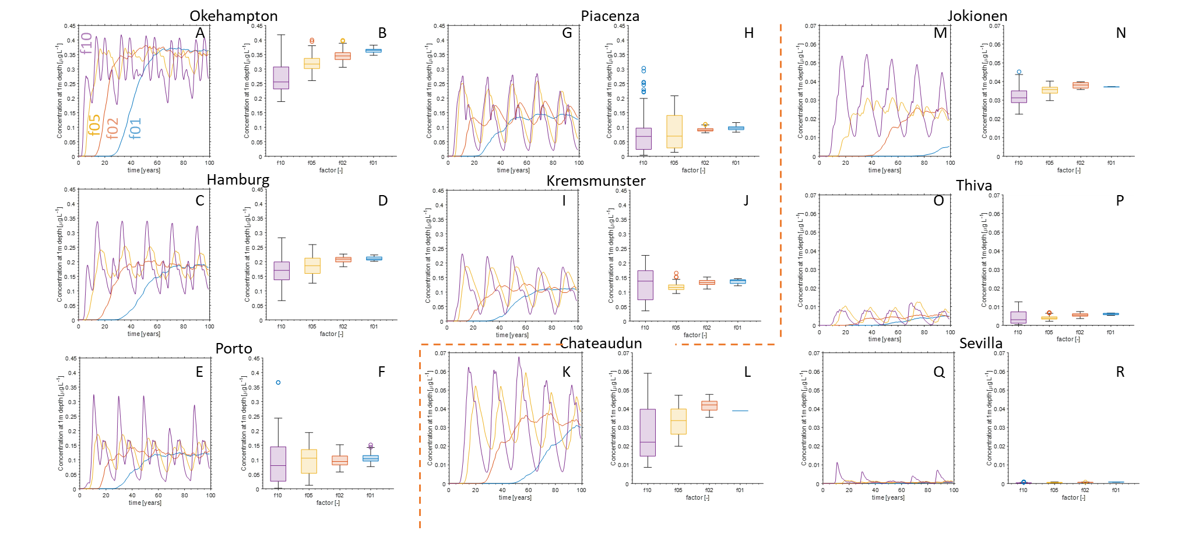

Figure S1: Model validation comparing PEARL simulations to analytic solution for fixed Se =1 but varying factors f10, f05, f02, and f01. PEARL simulations (A,C,E,G,I,K,M,O,Q) indicate the dynamics of the pesticide concentrations at the leaching depth over 100 years. The analytic model results (B,D,F,H,J,L,N,P,R) indicate the steady-state long term limit of the pesticide concentrations at the leaching depth, highlighting the mean values with the lines at the center of the box plots, the standard deviation presented by the whisker ranges, and potential outliers highlighted by point values outside of the whiskers. The figures compare the PEARL and analytic results for A-B: Okehampton, C-D: Hamburg, E-F: Porto, G-H: Piacenza, I-J: Kremsmunster, K-L: Chateaudun, M-N: Jokionen, O-P: Thiva, and Q-R: Sevilla. The orange line signifies a drop in maximum value on the y-axis scale bar. Note $δ_{cor}=0.112$.

**Time to leaching depth**

We estimated the time required to reach steady-state and compared it with PEARL results (Figure S2). Results show a consistent trend with the time required reducing with increasing factor value (f01-f10). For all cases, we see that our predicted bounds for f10, f05, and f02 highlight when the PEARL concentrations at the leaching depth will be are within 80% of the maximum concentration values.

We find that our time estimate for f01 was less consistent. For Okehampton, Hamburg, Piacenza, and Thiva (Figure S2 A, B, D, H), the analytic estimates indicate times associated with PEARL leaching depth concentrations that are within 80% of the maximum value. For Chateaudun, Jokionen, and Sevilla (Figure S2 F, G, I), the f01 PEARL predicted leaching depth concentrations do not appear to reach values bound by our analytic estimates in Figure S1. This suggests that the steady-state estimates should only be applicable after the 100 years. As such, our estimate for the elapsed time required does indicate times greater than 100 years (Figure S2 F, G, I), which is consistent with the PEARL results.

The f01 results for Porto (Figure S2 C) indicate that the time to steady-state should be between 20-30 years. However, the PEARL model results show that the leaching concentrations will be within the bounds 80% of the maximum value after 50 years. Finally, f01 results for Kremsmunster (Figure S2 E) remain difficult to interpret. While the PEARL predicted leaching depth concentrations appear to plateau at around 70 years, our estimate suggests estimate that this would occur after 80 years.

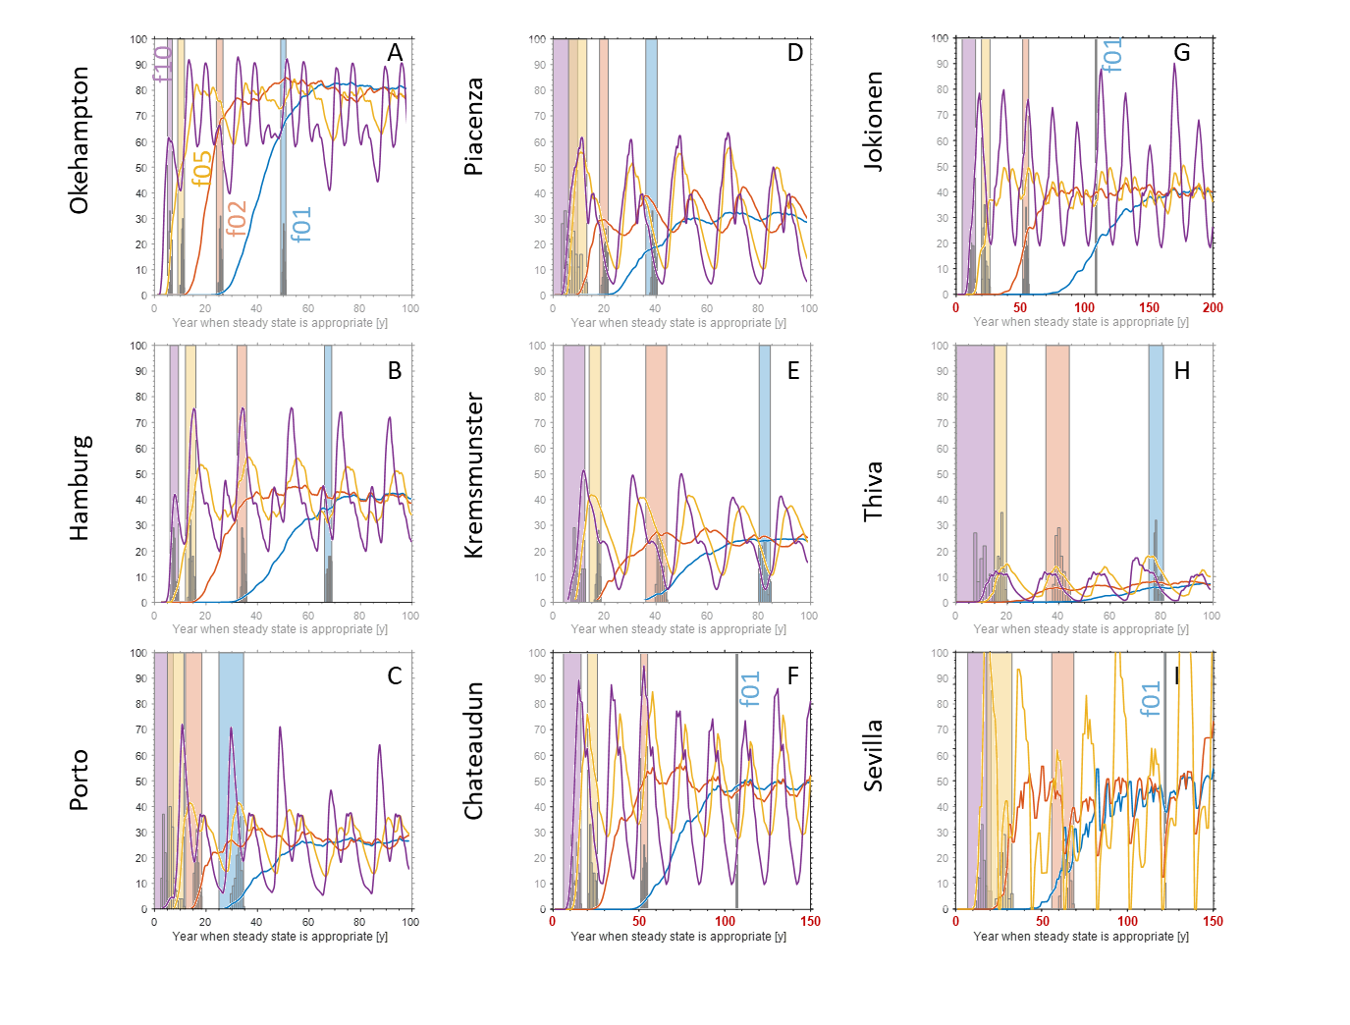

Figure S2: Estimating elapsed time for the applicability of our steady-state solution compared with 100 year PEARL runs for the focus scenarios considering factors f01, f02, f05, and f10. Distributions of the elapsed times are placed within the estimate bands. Note that the f10 PEARL result for Sevilla was not included as it was erratic and detracted from the time scale predictions. Note $δ_{cor}=0.112$.

As such, we demonstrate the utility and limitations of using our analytic expression for predicting the time required for our ensemble of steady-state solutions to be applicable (Figure S2). We found that the predicted time when our solution would be applicable was most accurate for higher factors (f10, f05, and f02). If a substance requires a long time scale to reach the leaching depth (i.e. f01), our model did not reliably predict the time required for the PEARL simulations to be consistent with our analytic ensemble solutions. This could possibly be attributed to more nuanced dynamics that our analytic solution fails to characterise. This might also be attributed to spikes in temperature or precipitation that cannot be adequately captured, as these are able to accumulate over longer periods of time for the f01 simulations.

**Broad scenario comparisons**

We compared a broader class of simulations considering the sorption and half-life values listed in Table 3 in the main text, i.e with varying $S_{e}$ and again compared the analytical solution of the long term leaching limit to PEARL. In Figure S3 we plot the maximum of the analytical solution from the ensemble runs against the PEARL 80th percentile (regulatory percentile of leachate concentrations in the EU EFSA ref) of the last 20 years of the numerical simulation, where each individual simulation is stratified by DT50. In Figure S4 the same results are plotted but now the data is instead stratified by KOM.

For the first column of scenarios (Figure S3 A-C), the leaching concentrations lie close to the 1:1 line indicating good agreement between the analytic and numerical results. In the second column (Figure S3 D-F), the data is more spread about the 1:1 line indicating a deviation of the steady-state solution from PEARL. However, the underestimation at 0.1 g L-1 (i.e. EU regulatory limit) is within an order of magnitude of the PEARL result. The final column of scenarios (Figure S3G-I) show that there are several instances where the analytic solution underestimates the numerical model by more than an order of magnitude. We note that the results plotted here were often outside of the asymptotic limit for Porto and Seville (Figure S3H-I). However, this is not the case for Piacenza (Figure S3G). This will be further explored later in the main discussion section.

When looking at the values of DT50 (Figure S3), we see that the points that fall above the 1:1 line (i.e. analytic solution underestimation) are often associated with values below 100 days. Points that fall below the 1:1 line (i.e. analytic solution overestimation) appear to be associated with DT50 values exceeding 800 days for all scenarios except for Piacenza and Sevilla. The trends are not as clear when looking at the 1:1 line in association with KOM (Figure S4). Points that lie above the 1:1 line are similarly associated with lower values of KOM (below 75 L kg-1). However, while many points below the 1:1 line are associated with KOM values exceeding 200 L kg-1, there are a few points associated with KOM< 50 L kg-1 (Figure S4 A,B,C,F, H). There also appears to be a gradient in overestimated KOM values from lower to higher leaching depth concentrations. While the trend is consistent amongst the different scenarios, the magnitude of the KOM values are different between the different scenarios.

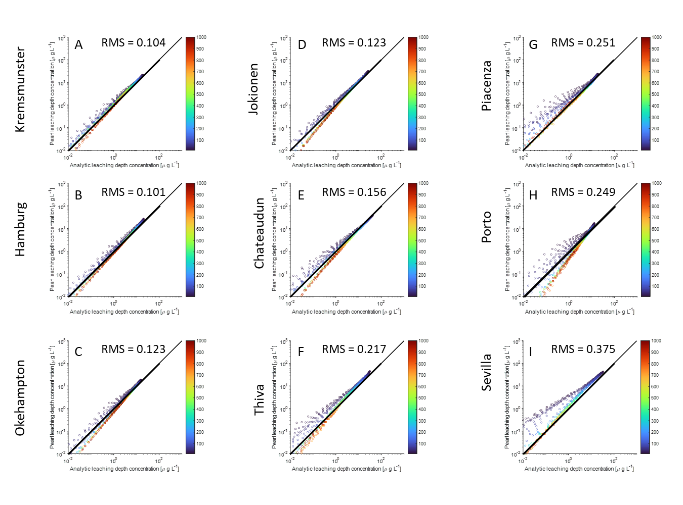

Figure S3: Extrapolating analytic solution comparison for PEARL simulation results for broad Se ratios considering default PEARL regional lower boundary conditions. Points indicate the value of the long-term pesticide concentrations at the leaching depth, with the x-axis representing the value of the maximum from the 100 realisations of the analytic solution and the y-axis representing the value of the 80th percentile from the 200 year PEARL simulation. The different colours of the points are associated with the values of DT50 in days (blue being shorter and red being longer). The comparison was carried out for scenarios A – Kremsmunster, B- Hamburg, C- Okehampton, D – Jokionen, E- Chateaudun, F – Thiva, G- Piacenza, H – Porto, and I – Sevilla. RMS denotes the root-mean-square distance of log10 concentrations from the 1:1 line. Note $δ_{cor}=0.316$.

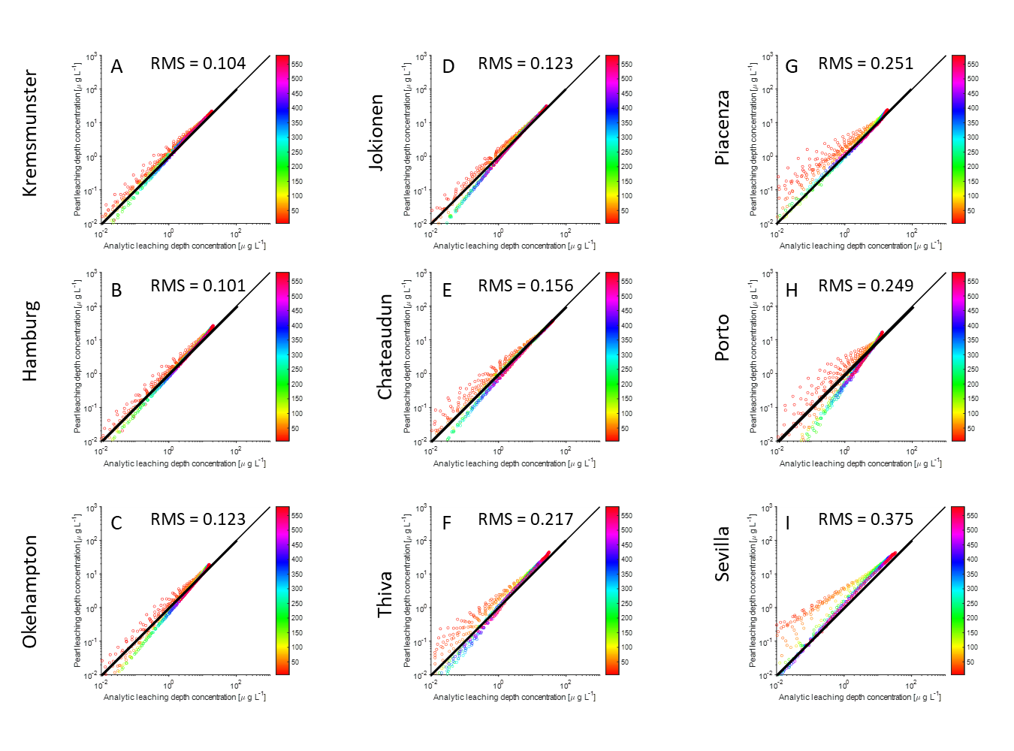

Figure S4: Extrapolating analytic solution comparison for PEARL simulation results for broad Se ratios considering default PEARL regional lower boundary conditions. Points indicate the value of the long-term pesticide concentrations at the leaching depth, with the x-axis representing the value of the maximum from the 100 realisations of the analytic solution and the y-axis representing the value of the 80th percentile of the last 20 years from the 200 year PEARL simulation. The different colours of the points are associated with the values of KOM [L kg-1] (orange being lower and violet being higher). The comparison was carried out for scenarios A – Kremsmunster, B- Hamburg, C- Okehampton, D – Jokionen, E- Chateaudun, F – Thiva, G- Piacenza, H – Porto, and I – Sevilla. RMS denotes the root-mean-square distance of log10 concentrations from the 1:1 line. Note $δ_{cor}=0.316$.

When looking at the overall spread of points across the 1:1 line, we can associate a trend between the RMS distance from the 1:1 line and the average temperature of the given regions (Figure S5). This suggests that, while there is a clear mathematical explanation as to why we see issues with regards to Porto and Seville (i.e. the asymptotic solution often fails the asymptotic validity criteria), there appears to be a link between high temperatures and spread along the 1:1 line.

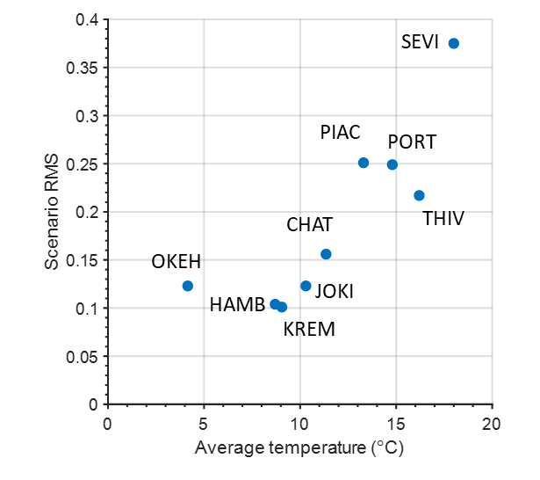

Figure S5: Root mean square distance of log10 leaching depth concentrations from the 1:1 line vs average temperature for the different FOCUS scenarios.

We then aggregated data within the asymptotic limit from all scenarios and plotted them together (Figure S6 A,D) and can see a spread of 8 fold about the 1:1 line. If we exclude Piacenza, Porto, and Sevilla based on Figure S5, we can see that the sets of results with the highest deviation from the 1:1 line are only out by a factor of 4 at the 0.1 g L-1 value (Figure S6 B,E). Finally we saturate the colour bars of the graphs in Figure S6 C and F such that the points associated with DT50 values > 100 days or KOM 100 > L/kg-1 appear red which allows us to identify the impacts of DT50 and Kom below these values. For example, considering DT50 first (Figure S6 C) we see a clear colour gradient showing that the deviation from the 1:1 line increases with decreasing DT50 , where the largest deviations from the 1:1 line at 0.1 L-1 pertains to values of DT50 below 20 days. At the EU threshold leaching depth concentration of 0.1 g L-1, we find that for DT50 values between 60-600 days, the analytical results are within a factor of 1.5 1:1 line.

Difficulties arose when trying to establish associations with the deviations and KOM values (Figure S6 D), for example the colour gradient with KOM above the 1:1 line is less clear than that for DT50. However, when looking specifically at the leaching depth concentration of 0.1 g L-1, for KOM values > 35 kg L-1 the analytic estimates are within 1.5 times that of the 1:1 line.

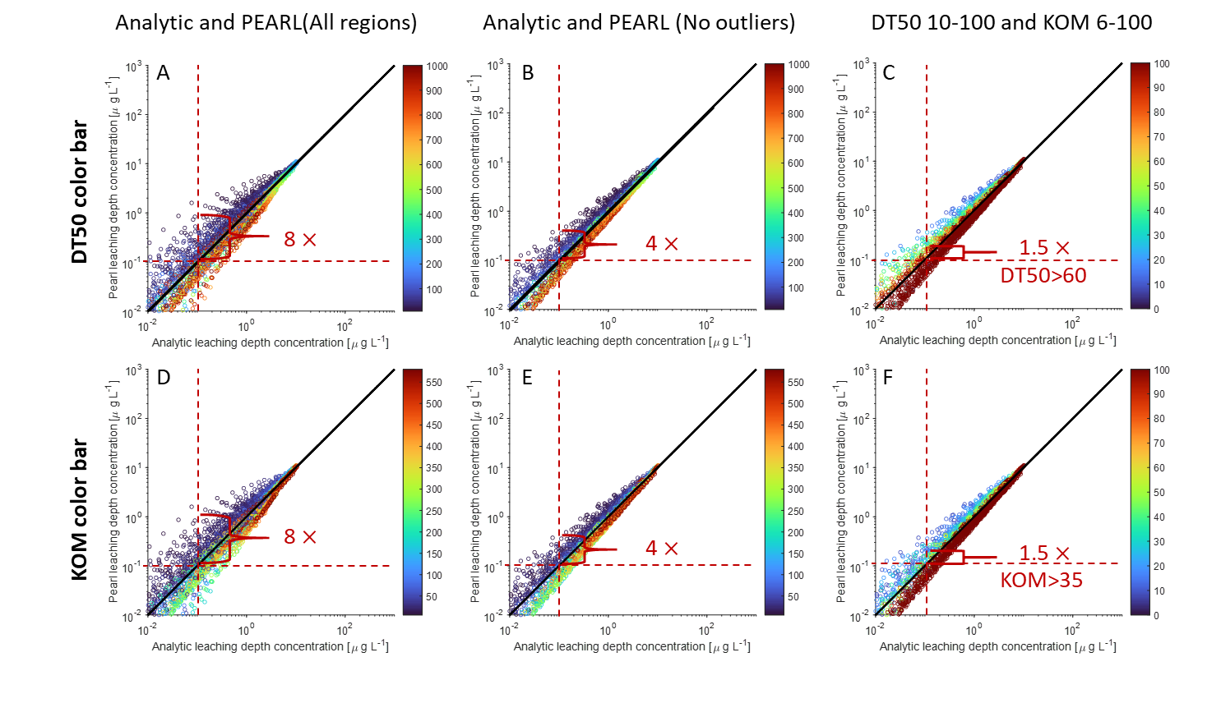Figure S: Regionally aggregated results comparing analytic solution to the PEARL simulation results. Points indicate the value of the long-term pesticide concentrations at the leaching depth, with the x-axis representing the value of the maximum from the 100 realisations of the analytic solution and the y-axis representing the value of the 80th percentile of the last 20 years from the 200 year PEARL simulation. Colour bar in A-C represent values of $\tilde{DT50}$ while colour bar in D-F represent ${\tilde{K}}_{om}$. A,C – all of the scenarios aggregated together. B,E – results excluding runs from Piacenza, Porto, and Sevilla. C,F – Saturating the range of $\tilde{DT50}$ above 100 days or ${\tilde{K}}_{om}$ values above 100 mL g-1. Note .

**Analytic solution for convection dominate nonlinear transport**

We had developed an analytic solution considering convection dominated transport even considering nonlinear binding. The dimensionless equations take the form:

|  |  |  |
| --- | --- | --- |
|  | $$-\frac{dc_{l}}{dz}-\frac{\tilde{μ}\tilde{L}}{\tilde{q}}\left(θ_{v}c_{l}+{\tilde{ρ}}_{b}{\tilde{K}}_{f}{c_{l}}^{N}\right)=0, z∈Ω.$$ | (S42) |

If we consider coefficients $a=\frac{\tilde{μ}\tilde{L}}{\tilde{q}}θ_{v}$ and $=\frac{\tilde{μ}\tilde{L}}{\tilde{q}}{\tilde{ρ}}_{b}{\tilde{K}}_{f}$, we can re-write the equation as:

|  |  |  |
| --- | --- | --- |
|  | $$-\frac{dc_{l}}{dz}-ac_{l}=b{c_{l}}^{N}, z∈Ω,$$ | (S43) |

which can be re-written as:

|  |  |  |
| --- | --- | --- |
|  | $$-{c_{l}}^{-N}\frac{dc_{l}}{dz}-a{c_{l}}^{1-N}=b, z∈Ω.$$ | (S44) |

We can use a dummy variable $u={c_{l}}^{1-N}⇒ du=(1-N){c_{l}}^{-N}dc_{l}$, which results in the equation:

|  |  |  |
| --- | --- | --- |
|  | $$\frac{1}{1-N}\frac{du}{dz}-au=b, z∈Ω.$$ | (S45) |

We can do one more substitution considering $w=au+b⇒ dw=adu$, which yields

|  |  |  |
| --- | --- | --- |
|  | $$-\frac{1}{a\left(1-N\right)}\frac{dw}{dz}=w, z∈Ω.$$ | (S46) |

From here, we can integrate the equation $\int{\frac{dw}{w}}=-a\left(1-N\right)\int{dz}+C$ and get

|  |  |  |
| --- | --- | --- |
|  | $$w=Cexp\left(-a\left(1-N\right)z\right).$$ | (S47) |

Substituting in for $w=au+b$ generates

|  |  |  |
| --- | --- | --- |
|  | $$u=\frac{Cexp\left(-a\left(1-N\right)z\right)-b}{a}.$$ | (S48) |

Finally, substituting $u={c_{l}}^{1-N}$ yields the convection solution:

|  |  |  |
| --- | --- | --- |
|  | $${c_{l}}^{ }={\left(\frac{Cexp\left(-a(1-N)z\right)-b}{a}\right)}^{\frac{1}{1-N}}.$$ | (S49) |

Considering $a$, $b$, $ϵ=1-N$, and a boundary condition of $c_{l}\left(z=0\right)=c_{l,0}^{ }$, we come to the closed form solution

|  |  |  |
| --- | --- | --- |
|  | $${c_{l}}^{ }={\left(\frac{\left({θ_{v}c}_{l,0}^{ϵ}+{\tilde{ρ}}_{b}{\tilde{K}}_{f}\right)exp\left(-ϵ\frac{\tilde{μ}\tilde{L}}{\tilde{q}}θ_{v}z\right)-{\tilde{ρ}}_{b}{\tilde{K}}_{f}}{θ_{v}}\right)}^{\frac{1}{ϵ}}.$$ | (S50) |

We note that this solution saw leaching depth concentrations at magnitudes half that of our diffusion-convection solution. Furthermore, this solution does not converge to the linear solution. However, this solution produced results on the orders of magnitude consistent with the diffusion-convection solution. As such, there is utility in this solution, as it can provide insights regarding the order of magnitude of leaching depth concentrations that one could expect using rudimentary software or even a calculator.

**Analytic time dependent solution for diffusion-convection linear transport**

By contrast with the utility gained from the relatively simple solution for the convection dominated steady-state nonlinear binding solution, we also worked to developed a time dependent solution considering linear binding. We revisit eq (S6) under linear conditions ($N=1$) to arrive at

|  |  |  |
| --- | --- | --- |
|  | $$\left(θ_{v}+{\tilde{ρ}}_{b}{\tilde{K}}_{f}\right)\frac{∂c_{l}}{∂t}=\frac{1}{Pe}\frac{∂^{2}c_{l}}{∂z^{2}}-\frac{∂c_{l}}{∂z}-\left(θ_{v}+{\tilde{ρ}}_{b}{\tilde{K}}_{f}\right)\frac{Da}{Pe}c_{l}, z∈Ω.$$ | (S51) |

We define $R=$ $\left(θ_{v}+{\tilde{ρ}}_{b}{\tilde{K}}_{f}\right)$, $D^{*}=1/(RPe)$, $μ^{*}=Da/Pe$ and $v^{*}=R^{-1}$ which yields:

|  |  |  |
| --- | --- | --- |
|  | $$\frac{∂c_{l}}{∂t}=D^{*}\frac{∂^{2}c_{l}}{∂z^{2}}-v^{*}\frac{∂c_{l}}{∂z}-μ^{*}c_{l}, z∈Ω.$$ | (S52) |

We define variables considering a moving reference frame, $x=z-v^{*}t$ and $t^{*}=t$ where, by chain rule, we get $\frac{∂x}{∂z}=1$, $\frac{∂\hat{t^{*}t}}{∂t}=1$, $\frac{∂x}{∂t}=-v^{*}$, and $\frac{∂t^{*}}{∂z}=0$. We use this to conduct a change of variables

|  |  |  |
| --- | --- | --- |
|  | $$\frac{∂c_{l}}{∂t^{*}}\frac{∂t^{*}}{∂t}+\frac{∂c_{l}}{∂x}\frac{∂x}{∂t}=\left(\left(\frac{∂x}{∂z}\frac{∂}{∂x}\right)\left(D^{*}\frac{∂x}{∂z}\frac{∂c_{l}}{∂x}\right)\right)-v^{*}\frac{∂x}{∂z}\frac{∂c_{l}}{∂x}-μ^{*}c_{l},$$ | (S53) |

which results in

|  |  |  |
| --- | --- | --- |
|  | $$\frac{∂c_{l}}{∂t^{*}}-v^{*}\frac{∂c_{l}}{∂x}=\left(\left(\frac{∂}{∂x}\right)\left(D^{*}\frac{∂c_{l}}{∂x}\right)\right)-v^{*}\frac{∂c_{l}}{∂x}-μ^{*}c_{l},$$ | (S54) |

and simplifies down to:

|  |  |  |
| --- | --- | --- |
|  | $$\frac{∂c_{l}}{∂t^{*}}=\left(\frac{∂}{∂x}\left(D^{*}\frac{∂c_{l}}{∂x}\right)\right)-μ^{*}c_{l}.$$ | (S55) |

As $t^{*}=t$, we will use only $t$. We want to solve the following problem considering the following initial and boundary conditions:

|  |  |  |  |
| --- | --- | --- | --- |
|  | $$\frac{∂c_{l}}{∂t}=\left(\frac{∂}{∂x}\left(D^{*}\frac{∂c_{l}}{∂x}\right)\right)-μ^{*}c_{l}, \left(x,t\right)∈R_{+}^{2}$$ | (S56) | a) |
|  | $$c_{l}\left(x,0\right)=0, t=0,$$ | (S56 | b) |
|  | $$c_{l}\left(0,t\right)=c_{l,0}\left(t\right), x=0.$$ | (S56 | c) |

Several steps have to be taken in order to solve this equation.

*Deriving an appropriate Green’s function for solving the initial value problem*

We first must derive an appropriate Green’s function for the given equations (i.e. diffusion-reaction equation) on the 1D spatial domain $Ω=R$, i.e. $Ω=\left(-∞,∞\right)$. We define a Green’s function, $G_{μ}(x,t)$, that solves the equations:

|  |  |  |  |
| --- | --- | --- | --- |
|  | $$\frac{∂G_{μ}}{∂t}=\left(\frac{∂}{∂x}\left(D^{*}\frac{∂G_{μ}}{∂x}\right)\right)-μ^{*}G_{μ}, \left(x,t\right)∈R×R_{+}$$ | (S57 | a) |
|  | $$G_{μ}\left(x,0\right)=δ(x), t=0,$$ | (S57 | b) |

where $δ(x)$ is the Dirac delta functional. The solution to the equation above only provides a solution to an initial pulse distribution and describes how that pulse diffuses. It does not yet have any of the boundary information needed to solve our equation. However, this solution will be used to obtain the boundary value problem. We obtain the solution by first applying a Fourier transformation on the above equations, which is defined as

|  |  |  |
| --- | --- | --- |
|  | $$F\left(G_{μ}\right)=\int_{-∞}^{∞}{G_{μ}\left(x,t\right)e^{-iκx}dx}={\hat{G}}_{μ}\left(κ,t\right),$$ | (S58) |

Which allows us to re-write eq. (S57 ) as

|  |  |  |  |
| --- | --- | --- | --- |
|  | $$\frac{d{\hat{G}}_{μ}}{dt}=-\left(D^{*}κ^{2}+μ^{*}\right){\hat{G}}_{μ}, \left(κ,t\right)∈R×R_{+}$$ | (S59 | a) |
|  | $${\hat{G}}_{μ}\left(x,0\right)=1, t=0,$$ | (S59 | b) |

The solution in the Fourier domain is given as

|  |  |  |
| --- | --- | --- |
|  | $${\hat{G}}_{μ}\left(κ,t\right)=\exp\left(-\left(D^{*}κ^{2}+μ^{*}\right)t\right).$$ | (S60) |

We define the inverse transform as:

|  |  |  |
| --- | --- | --- |
|  | $$F^{-1}\left({\hat{G}}_{μ}\right)=\frac{1}{2π}\int_{-∞}^{∞}{{\hat{G}}_{μ}\left(κ,t\right)e^{iκx}dκ}=G_{μ}\left(x,t\right),$$ | (S61) |

and if we re-write eq.(S60) as ${\hat{G}}_{μ}(κ,t)=e^{-μ^{*}t}e^{-D^{*}κ^{2}t}$, we can see that we can factor out $e^{-μ^{*}t}$ from the integral and we know from the heat equation kernel that

|  |  |  |
| --- | --- | --- |
|  | $$\frac{1}{2π}\int_{-∞}^{∞}{e^{-D^{*}κ^{2}t}}=\frac{1}{\sqrt{4πD^{*}t}}\exp\left(-\frac{x^{2}}{4D^{*}t}\right),$$ | (S62) |

thus substituting into our full equation, we obtain the appropriate Greens function for our equations

|  |  |  |
| --- | --- | --- |
|  | $$G_{μ}\left(x,t\right)=\frac{1}{\sqrt{4πD^{*}t}}\exp\left(-\left(\frac{x^{2}}{4D^{*}t}+μ^{*}t\right)\right).$$ | (S63) |

For a general initial value problem on $Ω=R$:

|  |  |  |  |
| --- | --- | --- | --- |
|  | $$\frac{∂c_{l}}{∂t}=\left(\frac{∂}{∂x}\left(D^{*}\frac{∂c_{l}}{∂x}\right)\right)-μ^{*}c_{l}, \left(x,t\right)∈R×R_{+}$$ | (S64 | a) |
|  | $$c_{l}\left(x,0\right)=f(x), t=0,$$ | (S64 | b) |

we know that our solution is the convolution of our initial condition with our equations Green’s function ($\ln\left(\frac{{\hat{c}}_{l}\left(κ,t\right)}{{\hat{c}}_{l}\left(κ,0\right)}\right)=-\left(D^{*}κ^{2}+μ^{*}\right)t⇒\frac{{\hat{c}}_{l}\left(κ,t\right)}{{\hat{c}}_{l}\left(κ,0\right)}=\exp\left(-\left(D^{*}κ^{2}+μ^{*}\right)t\right)⇒{\hat{c}}_{l}\left(κ,t\right)=\hat{f}\left(κ\right){\hat{G}}_{μ}\left(κ,t\right)⇒F^{-1}\left({\hat{G}}_{μ}⋅\hat{f}\right)=G_{μ}*f$), which explicitly takes the form

|  |  |  |
| --- | --- | --- |
|  | $$c_{l}(x,t)=\int_{-∞}^{∞}{G_{μ}\left(x-y,t\right)f\left(y\right)dy}.$$ | (S65) |

*Deriving a Green’s function for the initial value problem on the half space*

We have previously solved the initial value problem on the 1D domain of $R$. However, we are only considering the surface into the soil, and we consider the soil to have infinite depth. This changes our spatial domain to $Ω=R_{+}=[0,∞)$. While our equations are the same, our domain changes:

|  |  |  |  |
| --- | --- | --- | --- |
|  | $$\frac{∂c_{l}}{∂t}=\left(\frac{∂}{∂x}\left(D^{*}\frac{∂c_{l}}{∂x}\right)\right)-μ^{*}c_{l}, \left(x,t\right)∈R_{+}^{2}$$ | (S66 | a) |
|  | $$c_{l}\left(x,0\right)=f(x), t=0,$$ | (S66 | b) |
|  | $$c_{l}\left(0,t\right)=0, x=0,$$ | (S66 | c) |

which describes a surface Dirchlet boundary condition of 0 concentration. If we revisit the original full plane domain solution to the initial value problem in eq.(S65), we can split the integral to consider the following:

|  |  |  |
| --- | --- | --- |
|  | $$c_{l}\left(x,t\right)=\int_{0}^{∞}{G_{μ}\left(x-y,t\right)f\left(y\right)dy}+\int_{-∞}^{0}{G_{μ}\left(x-y,t\right)f\left(y\right)dy}.$$ | (S67) |

We can use the integral identity to re-write eq (S67) as:

|  |  |  |
| --- | --- | --- |
|  | $$c_{l}\left(x,t\right)=\int_{0}^{∞}{G_{μ}\left(x-y,t\right)f\left(y\right)dy}-\int_{0}^{∞}{G_{μ}\left(x-y,t\right)f\left(-y\right)dy}.$$ | (S68) |

We can use a change of variables to shift the minus sign:

|  |  |  |
| --- | --- | --- |
|  | $$c_{l}\left(x,t\right)=\int_{0}^{∞}{G_{μ}\left(x-y,t\right)f\left(y\right)dy}-\int_{0}^{∞}{G_{μ}\left(x+y,t\right)f\left(y\right)dy}.$$ | (S69) |

Finally, we can combine the integral again to obtain the half-space solution

|  |  |  |
| --- | --- | --- |
|  | $$c_{l}\left(x,t\right)=\int_{0}^{∞}{\left(G_{μ}\left(x-y,t\right)-G_{μ}\left(x+y,t\right)\right)f\left(y\right)dy},$$ | (S70) |

where we define the half-space greens function as

|  |  |  |
| --- | --- | --- |
|  | $$G_{μ,hs}(x,t;y)=G_{μ}\left(x-y,t\right)-G_{μ}\left(x+y,t\right),$$ | (S71) |

and we re-write the shorthand solution as:

|  |  |  |
| --- | --- | --- |
|  | $$c_{l}\left(x,t\right)=\int_{0}^{∞}{G_{μ,hs}(x,t;y)f\left(y\right)dy}.$$ | (S72) |

*Duhamel’s principle to solve the boundary value problem*

Now that we have our appropriate Green’s functions, we can now consider the boundary value problem. We define the following linear operator to describe our system as $L_{μ}\left(⋅\right)=\frac{∂}{∂t}\left(⋅\right)+μ^{*}\left(⋅\right)-\left(\frac{∂}{∂x}\left(D^{*}\frac{∂ }{∂x}(⋅)\right)\right)$ and re-write our equation of interest (eq. (S56)):

|  |  |  |  |
| --- | --- | --- | --- |
|  | $$L_{μ}c_{l}=0, \left(x,t\right)∈R_{+}^{2}$$ | (S73) | a) |
|  | $$c_{l}\left(x,0\right)=0, t=0.$$ | (S73 | b) |
|  | $$c_{l}\left(0,t\right)=c_{l,0}\left(t\right), x=0.$$ | (S73 | c) |

We define a new variable $w\left(x,t\right)=c_{l}\left(x,t\right)-c_{l,0}(t)$, and our equations become:

|  |  |  |  |
| --- | --- | --- | --- |
|  | $$L_{μ}w=-(c_{l,0}^{'}+μ^{*}c_{l,0}), \left(x,t\right)∈R_{+}^{2}$$ | (S74) | a) |
|  | $$w\left(x,0\right)=-c_{l,0}(0), t=0.$$ | (S74) | b) |
|  | $$w\left(0,t\right)=0, x=0.$$ | (S74) | c) |

We split this into two problems with $w=w_{1}+w_{2}$, where we have a homogenous initial value problem

|  |  |  |  |
| --- | --- | --- | --- |
|  | $$L_{μ}w_{1}=0, \left(x,t\right)∈R_{+}^{2}$$ | (S75) | a) |
|  | $$w_{1}\left(x,0\right)=-c_{l,0}(0), t=0.$$ | (S75) | b) |
|  | $$w_{1}\left(0,t\right)=0, x=0,$$ | (S75) | c) |

and a inhomogenous equation

|  |  |  |  |
| --- | --- | --- | --- |
|  | $$L_{μ}w_{2}=-(c_{l,0}^{'}+μ^{*}c_{l,0}), \left(x,t\right)∈R_{+}^{2}$$ | (S76) | a) |
|  | $$w_{2}\left(x,0\right)=-c_{l,0}(0), t=0.$$ | (S76) | b) |
|  | $$w_{2}\left(0,t\right)=0, x=0.$$ | (S76) | c) |

We already have the solution for the $w_{1}$ equations (S75)), as given by our half-space Green’s function:

|  |  |  |
| --- | --- | --- |
|  | $$w_{1}\left(x,t\right)=-\int_{0}^{∞}{G_{μ,hs}\left(x,t;y\right)c_{l,0}\left(0\right)dy}.$$ | (S77) |

For the $w_{2}$ problem (eq. (S76))), we have to invoke Duhamel’s principle, which is effectively shifting the inhomogenous term to the initial value in a clever manner and summing up the solutions. This takes the form:

|  |  |  |
| --- | --- | --- |
|  | $$w_{2}\left(x,t\right)=-\int_{0}^{t}{\left(\int_{0}^{∞}{G_{μ,hs}\left(x,t-s;y\right)(c_{l,0}^{'}(s)+μ^{*}c_{l,0}(s))dy}\right)ds}.$$ | (S78) |

Stitching the solutions together results in

|  |  |  |
| --- | --- | --- |
|  | $$w_{ }\left(x,t\right)=-\int_{0}^{∞}{G_{μ,hs}\left(x,t;y\right)c_{l,0}\left(0\right)dy}-\int_{0}^{t}{\left(\int_{0}^{∞}{G_{μ,hs}\left(x,t-s;y\right)\left(c_{l,0}^{'}(s)+μ^{*}c_{l,0}(s)\right)dy}\right)ds},$$ | (S79) |

and thus our full solution is $c_{l}\left(x,t\right)=c_{l,0}\left(t\right)+w(x,t)$, or

|  |  |  |
| --- | --- | --- |
|  | $$c_{l}\left(x,t\right)=c_{l,0}(t)-\int_{0}^{∞}{G_{μ,hs}(x,t;y)c_{l,0}(0)dy}-\int_{0}^{t}{\left(\int_{0}^{∞}{G_{μ,hs}\left(x,t-s;y\right)(c_{l,0}^{'}(s)+μ^{*}c_{l,0}(s))dy}\right)ds},$$ | (S80) |

We can clean up the solution by exchanging the two integrals in the last term:

|  |  |  |
| --- | --- | --- |
|  | $$c_{l}\left(x,t\right)=c_{l,0}(t)-\int_{0}^{∞}{G_{μ,hs}(x,t;y)c_{l,0}(0)dy}-\int_{0}^{∞}{\left(\int_{0}^{t}{G_{μ,hs}\left(x,t-s;y\right)(c_{l,0}^{'}(s)+μ^{*}c_{l,0}(s))ds}\right)dy},$$ | (S81) |

Using integration by parts, we know that:

|  |  |  |
| --- | --- | --- |
|  |  | (S82) |

Expanding the first term on the right hand side of the equation

|  |  |  |
| --- | --- | --- |
|  |  | (S83) |

$G_{μ,hs}\left(x,0;y\right)$ reduces down to a Dirac delta distribution. We can rewrite (S83) as

|  |  |  |
| --- | --- | --- |
|  |  | (S84) |

As such, eq(S81) expands to

|  |  |  |
| --- | --- | --- |
|  | $$c_{l}\left(x,t\right)=c_{l,0}\left(t\right)-\int_{0}^{∞}{G_{μ,hs}\left(x,t;y\right)c_{l,0}\left(0\right)dy}-\int_{0}^{∞}{\left(δ\left(x-y\right)\left(c_{l,0}^{ }\left(t\right)\right)-G_{μ,hs}\left(x,t;y\right)\left(c_{l,0}^{ }\left(0\right)\right)\right)dy}+\int_{0}^{∞}{\left(\int_{0}^{t}{\left(\left(\frac{{∂G}_{μ,hs}}{∂s}\left(x,t-s;y\right)-μ^{*}G_{μ,hs}\left(x,t-s;y\right)\right)c_{l,0}\left(s\right)\right)}ds\right)dy}.$$ | (S85) |

Given that

|  |  |  |
| --- | --- | --- |
|  | $$c_{l,0}\left(t\right)-\int_{0}^{∞}{G_{μ,hs}\left(x,t;y\right)c_{l,0}\left(0\right)dy}-\int_{0}^{∞}{\left(δ\left(x-y\right)\left(c_{l,0}^{ }\left(t\right)\right)-G_{μ,hs}\left(x,t;y\right)\left(c_{l,0}^{ }\left(0\right)\right)\right)dy}=0,$$ | (S86) |

our solution takes the form

|  |  |  |
| --- | --- | --- |
|  | $$c_{l}\left(x,t\right)=\int_{0}^{∞}{\left(\int_{0}^{t}{\left(\left(\frac{{∂G}_{μ,hs}}{∂s}\left(x,t-s;y\right)-μ^{*}G_{μ,hs}\left(x,t-s;y\right)\right)c_{l,0}\left(s\right)\right)}ds\right)dy}.$$ | (S87) |

We can do a change of variables $\frac{{∂G}_{μ,hs}}{∂t}\left(x,t-s;y\right)=-\frac{{∂G}_{μ,hs}}{∂s}\left(x,t-s;y\right)$ and substitute into eq.(S87) to get

|  |  |  |
| --- | --- | --- |
|  | $$c_{l}\left(x,t\right)=-\int_{0}^{∞}{\left(\int_{0}^{t}{\left(\left(\frac{{∂G}_{μ,hs}}{∂t}\left(x,t-s;y\right)+μ^{*}G_{μ,hs}\left(x,t-s;y\right)\right)c_{l,0}\left(s\right)\right)}ds\right)dy}.$$ | (S88) |

From $L_{μ}G_{μ,hs}=0$, we know

|  |  |  |
| --- | --- | --- |
|  | $$\frac{∂}{∂t}\left(G_{μ,hs}\right)+μ^{*}\left(G_{μ,hs}\right)=\left(\frac{∂}{∂y}\left(D^{*}\frac{∂ }{∂y}(G_{μ,hs})\right)\right),$$ | (S89) |

thus we simplify the equation down to

|  |  |  |
| --- | --- | --- |
|  | $$c_{l}\left(x,t\right)=-\int_{0}^{∞}{\left(\int_{0}^{t}{\left(\frac{∂}{∂y}\left(D^{*}\frac{∂ }{∂y}\left(G_{μ,hs}\right)\right)c_{l,0}\left(s\right)\right)}ds\right)dy},$$ | (S90) |

And if we re-arrange the integrals, we come to the final solution of

|  |  |  |
| --- | --- | --- |
|  | $$c_{l}\left(x,t\right)=\int_{0}^{t}{\left(D^{*}\frac{∂ }{∂y}G_{μ,hs}\left(x,t-s;0\right)c_{l,0}\left(s\right)\right)}ds.$$ | (S91) |

We can analytically determine the derivative of the Greens function to be:

|  |  |  |
| --- | --- | --- |
|  | $$\frac{∂ }{∂y}G_{μ,hs}\left(x,t-s;0\right)=\left(\frac{x}{D^{*}\sqrt{4πD^{*}{\left(t-s\right)}^{3}}}\right)\exp\left(-\left(\frac{x^{2}}{4D^{*}\left(t-s\right)}+μ^{*}\left(t-s\right)\right)\right),$$ | (S92) |

and thus substituting (S92) into (S91) results in

|  |  |  |
| --- | --- | --- |
|  | $$c_{l}\left(x,t\right)=\int_{0}^{t}{\left(\left(\frac{x}{\sqrt{4πD^{*}{\left(t-s\right)}^{3}}}\right)\exp\left(-\left(\frac{x^{2}}{4D^{*}\left(t-s\right)}+μ^{*}\left(t-s\right)\right)\right)c_{l,0}\left(s\right)\right)}ds.$$ | (S93) |

Substituting back in for $x=z-v^{*}(t-s)$ results in

|  |  |  |
| --- | --- | --- |
|  | $$c_{l}\left(x,t\right)=\int_{0}^{t}{\left(\left(\frac{z-v^{*}(t-s)}{\sqrt{4πD^{*}{\left(t-s\right)}^{3}}}\right)\exp\left(-\left(\frac{{\left(z-v^{*}\left(t-s\right)\right)}^{2}}{4D^{*}\left(t-s\right)}+μ^{*}\left(t-s\right)\right)\right)c_{l,0}\left(s\right)\right)}ds.$$ | (S94) |

We reintroduce our original parameters for $D^{*}= 1/R Pe$, $μ^{*}=Da/Pe$ and $v^{*}=R^{-1}$:

|  |  |
| --- | --- |
| $$c_{l}\left(x,t\right)=\int_{0}^{t}{\left(\left(\frac{z-R^{-1}(t-s)}{\sqrt{4π{\left(R Pe\right)}^{-1}{\left(t-s\right)}^{3}}}\right)\exp\left(-\left(\frac{{\left(z-R^{-1}\left(t-s\right)\right)}^{2}}{4{\left(R Pe\right)}^{-1}\left(t-s\right)}+\frac{Da}{Pe}\left(t-s\right)\right)\right)c_{l,0}\left(s\right)\right)}ds.$$ | (S95) |

Further expanding the terms results in:

|  |  |
| --- | --- |
| $$c_{l}\left(x,t\right)=\int_{0}^{t}{\left(\left(\frac{Rz-(t-s)}{\sqrt{4π{R\left(Pe\right)}^{-1}{\left(t-s\right)}^{3}}}\right)\exp\left(-\left(\frac{{\left(Rz-\left(t-s\right)\right)}^{2}}{4{\left(Pe\right)}^{-1}\left(t-s\right)}+\frac{Da}{Pe}\left(t-s\right)\right)\right)c_{l,0}\left(s\right)\right)}ds.$$ | (S96) |

If we substitute the terms $R=$ $\left(θ_{v}+{\tilde{ρ}}_{b}{\tilde{K}}_{f}\right)$, $Pe=\tilde{q}\tilde{L}/{\tilde{D}}_{tot},$ and $Da=\tilde{μ}{\tilde{L}}^{2}/{\tilde{D}}_{tot}$, we can re-write the solution as

|  |  |
| --- | --- |
| $$c_{l}\left(x,t\right)=\int_{0}^{t}{\left(\left(\frac{\left(θ_{v}+{\tilde{ρ}}_{b}{\tilde{K}}_{f}\right)z-(t-s)}{\sqrt{4π\left(θ_{v}+{\tilde{ρ}}_{b}{\tilde{K}}_{f}\right)\frac{{\tilde{D}}_{tot}}{\tilde{q}\tilde{L}}{\left(t-s\right)}^{3}}}\right)\exp\left(-\left(\frac{{\left(\left(θ_{v}+{\tilde{ρ}}_{b}{\tilde{K}}_{f}\right)z-\left(t-s\right)\right)}^{2}}{4\frac{{\tilde{D}}_{tot}}{\tilde{q}\tilde{L}}\left(t-s\right)}+\frac{\tilde{μ}{\tilde{L}}^{2}}{\tilde{q}\tilde{L}}\left(t-s\right)\right)\right)c_{l,0}\left(s\right)\right)}ds.$$ | (S97) |

With a bit of factoring, we can come to

|  |  |
| --- | --- |
| $$c_{l}\left(x,t\right)=\int_{0}^{t}{\left(\left(\frac{\tilde{L}\left(θ_{v}+{\tilde{ρ}}_{b}{\tilde{K}}_{f}\right)z-{\left(\frac{\tilde{L}}{\tilde{q}}\right)}^{ }\tilde{q}(t-s)}{\sqrt{4π\left(θ_{v}+{\tilde{ρ}}_{b}{\tilde{K}}_{f}\right){\tilde{D}}_{tot}{{\left(\frac{\tilde{L}}{\tilde{q}}\right)}^{3}}^{ }{\left(t-s\right)}^{3}}}\right)\exp\left(-\left(\frac{{\left(\tilde{L}\left(θ_{v}+{\tilde{ρ}}_{b}{\tilde{K}}_{f}\right)z-{\left(\frac{\tilde{L}}{\tilde{q}}\right)}^{ }\tilde{q}(t-s)\right)}^{2}}{4{\tilde{D}}_{tot}\left(\frac{\tilde{L}}{\tilde{q}}\right)\left(t-s\right)}+\tilde{μ}\frac{{\tilde{L}}^{ }}{\tilde{q}}\left(t-s\right)\right)\right)c_{l,0}\left(s\right)\right)}\frac{\tilde{L}}{\tilde{q}}ds.$$ | (S98) |

If we reintroduce our dimensional variables from eq.(S1) and multiply both sides by ${\tilde{c}}_{ref}$, we come to the form:

|  |  |
| --- | --- |
| $${\tilde{c}}_{l}\left(x,t\right)=\int_{0}^{\tilde{t}}{\left(\left(\frac{\left(θ_{v}+{\tilde{ρ}}_{b}{\tilde{K}}_{f}\right)\tilde{z}-\tilde{q}(\tilde{t}-\tilde{s})}{\sqrt{4π\left(θ_{v}+{\tilde{ρ}}_{b}{\tilde{K}}_{f}\right){\tilde{D}}_{tot}{\left(\tilde{t}-\tilde{s}\right)}^{3}}}\right)\exp\left(-\left(\frac{{\left(\left(θ_{v}+{\tilde{ρ}}_{b}{\tilde{K}}_{f}\right)\tilde{z}-\tilde{q}(\tilde{t}-\tilde{s})\right)}^{2}}{4{\tilde{D}}_{tot}\left(\tilde{t}-\tilde{s}\right)}+\tilde{μ}\left(\tilde{t}-\tilde{s}\right)\right)\right){\tilde{c}}_{l,0}\left(\tilde{s}\right)\right)}d\tilde{s}.$$ | (S99) |

We can re-arrange eq. (S99) to get:

|  |  |
| --- | --- |
| $${\tilde{c}}_{l}\left(x,t\right)=\int_{0}^{\tilde{t}}{\left(\left(\frac{\left(θ_{v}+{\tilde{ρ}}_{b}{\tilde{K}}_{f}\right)\tilde{z}-\tilde{q}(\tilde{t}-\tilde{s})}{\sqrt{4π\left(θ_{v}+{\tilde{ρ}}_{b}{\tilde{K}}_{f}\right){\tilde{D}}_{tot}{\left(\tilde{t}-\tilde{s}\right)}^{3}}}\right)\exp\left(-{\left(θ_{v}+{\tilde{ρ}}_{b}{\tilde{K}}_{f}\right)}^{-1}\left(\left(θ_{v}+{\tilde{ρ}}_{b}{\tilde{K}}_{f}\right)\frac{{\left(\left(θ_{v}+{\tilde{ρ}}_{b}{\tilde{K}}_{f}\right)\tilde{z}-\tilde{q}(\tilde{t}-\tilde{s})\right)}^{2}}{4{\tilde{D}}_{tot}\left(\tilde{t}-\tilde{s}\right)}+\tilde{μ}\left(θ_{v}+{\tilde{ρ}}_{b}{\tilde{K}}_{f}\right)\left(\tilde{t}-\tilde{s}\right)\right)\right){\tilde{c}}_{l,0}\left(\tilde{s}\right)\right)}d\tilde{s},$$ | (S100) |

and substituting $\tilde{μ}=f/\tilde{DT50}$, we come to

|  |  |
| --- | --- |
| $${\tilde{c}}_{l}\left(x,t\right)=\int_{0}^{\tilde{t}}{\left(\left(\frac{\left(θ_{v}+{\tilde{ρ}}_{b}{\tilde{K}}_{f}\right)\tilde{z}-\tilde{q}(\tilde{t}-\tilde{s})}{\sqrt{4π\left(θ_{v}+{\tilde{ρ}}_{b}{\tilde{K}}_{f}\right){\tilde{D}}_{tot}{\left(\tilde{t}-\tilde{s}\right)}^{3}}}\right)\exp\left(-\left(\frac{{\left(\left(θ_{v}+{\tilde{ρ}}_{b}{\tilde{K}}_{f}\right)\tilde{z}-\tilde{q}(\tilde{t}-\tilde{s})\right)}^{2}}{4{\tilde{D}}_{tot}\left(\tilde{t}-\tilde{s}\right)}+\frac{f\left(\frac{θ_{v}}{\tilde{DT50}}+{\tilde{ρ}}_{b}{\tilde{m}}_{om}S_{e}\right)}{\left(θ_{v}+{\tilde{ρ}}_{b}{\tilde{K}}_{f}\right)}\left(\tilde{t}-\tilde{s}\right)\right)\right){\tilde{c}}_{l,0}\left(\tilde{s}\right)\right)}d\tilde{s}.$$ | (S101) |

This solution matched up with the numerical solutions for a single layered soil considering linear binding. Many of the methods used to obtain this analytic solution required super positioning of solutions, which are not easily translatable for nonlinear equations.